A LITERATURE REVIEW ON MANIKKADAI NOOL
A TRADITIONAL DIAGNOSTIC TOOL IN SIDDHA MEDICINE

ABSTRACT:
Manikkadai Nool (wrist circumference diagnostic technique) is one of the ancient, noninvasive diagnostic methods described in Siddha medicine¹, ². It involves measuring the wrist circumference using finger units (viralkai alavu) to assess physiological and pathological conditions of an individual. ¹ This literature review aims to consolidate traditional references and clinical relevance of Manikkadai Nool in diagnosing Vatha, Pitham, and Kabha derangements and predicting prognosis ¹, ². The study compiles data from classical Siddha texts and traditional to interpret the correlation between wrist measurements and various disease states. Findings reveal that Manikkadai Nool serves as a valuable diagnostic and prognostic indicator reflecting the status of Uyir Thathukkal (vital humors) ². It emphasizes the holistic approach of Siddha medicine in assessing health without invasive procedures.

KEYWORDS: Manikkadai Nool, Siddha diagnostic tool, Finger breadths, Vital humor, Curable, Incurable.

INTRODUCTION:
Siddha medicine, one of the oldest traditional medical systems in India, emphasizes the interrelationship between the body, mind, and environment. ¹ Diagnostic methods in Siddha, Manikkadai Nool is an ancillary diagnostic tool used by Siddha physicians for assessing the prognosis and nature of diseases. The Manikkadai Nool technique involves measuring the wrist circumference of the patient using finger breadths¹, ². The measurement correlates with internal physiological derangements and predicts disease severity and life expectancy. This study reviews the traditional descriptions and clinical interpretations of Manikkadai Nool from classical Siddha literature. ²

PREVALENCE AND BACKGROUND:
Manikkadai Nool has been traditionally practiced in southern parts of Tamil Nadu, particularly among Siddha physicians in regions such as Tirunelveli, Madurai, and Thanjavur. Though its clinical application has declined due to the advent of modern diagnostics, many traditional healers continue to use this method as a quick prognostic tool. Historically, this diagnostic technique was
recorded in ancient Siddha palms¹. The prevalence of the method among Siddha practitioners emphasizes its relevance in noninvasive traditional diagnostic practices.

MATERIALS AND METHODS:
Type of Study: Literature Review Study based on traditional Siddha texts ².
Sources of Data: Noi Naadal Noi Mudhal Naadal
Methodology: Relevant literature was reviewed and categorized based on measurement range (finger breadths), corresponding signs and symptoms, prognostic interpretation, and association with Vatha, Pitha, and Kabha imbalances.
PROCEDURE:
The Manikkadai Nool examination is performed as follows:
The patient’s left wrist is encircled using a cotton thread. The length of the thread is then measured against the physician’s fingers to determine the viralkai alavu (finger breadth count). The obtained measurement (ranging from 4 to 11 finger breadths) is interpreted according to traditional literature¹. Each measurement corresponds to specific pathological or prognostic indications.
For instance: 10–9¾ fingers: mild Vaatha or Pitha disorders; 9–8¾: moderate derangements; 7½–6¼: severe systemic disturbances; below 6 fingers: fatal prognosis. ¹

STEP 1:
A Point 4 viraikadai distance from wrist crease is marked

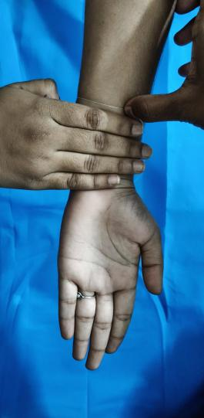

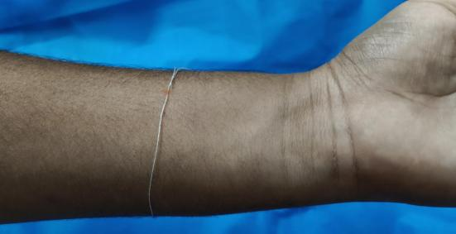

STEP 2 :
Measure viraikadai for the patient.

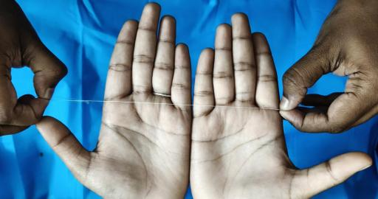

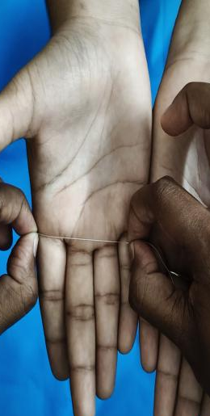

Review of literature (1,2)

FINGER BREADTH | SYMPTOMS
10 | Hyperthermia ,Rheumatoid arthritis  Intense pain the limbs (Neuralgia, Myalgia , Arthralgia, radiculopathy)  Peptic ulcer  Accumulation of gas in some parts of intestine  Fluffiness of body
9¾ | Inguinal bubo  Carbuncle  Dryness  Tussis (bronchial tube cough)
9½ | Inflammatory edema  Dryness of face  Diabetes mellitus  Fever  Burning eyes
9¼ | Dysuria with oliguria  Sleeplessness  Sinusitis
9 | Hypoacusis  Deafness  Fuming of eyes  Pain in flanks  Pain in thighs  Restriction of movements
8¾ | Febrile  Cataract  Sinusitis.  Blindness
8½ | Hyperthermia  Scabies  General ulcers  Fluffiness of face  Eczema  Tumor

8¼ | Fullness and intense pain all over the body  Dryness in head  Pain  Sinusitis  Breathlessness  Cough  Respiratory problems.
8 | Diabetic neuropathy  Indigestion  Belching  Dryness  Loss of appetite  Patient feels uneasiness and experience as his own body as others.
⁷¾ | Headache  Intoxication  Neck swelling will occur in 2 years  Epistaxis will occur in few days
7½ | Tuberculosis  Urinary disorders  Diabetes mellitus  Burning eyes  Bloated abdomen  Burning sensation and fever in 6 days.  Joint pain  Abscess.
7¼ | Low back ache  Pain  Spasm  Pitta in head  Eye pain  Anemia  Generalized swelling  Burning sensation in hands and feet  Excess sleep.
7 | Tuberculosis  Pitta in mouth  Emaciation  Burning sensation in hands and feet  Excess body heat.
6¾ | Orchitis  Ophthalmalgia  Syncope  Anuresis  Facia sweating/diaphoresis  Intense pain  PCOS  Pain in scrotum  Dizziness
6½ | Hyperthermia  Heat  Pricking pain  Aversion of food
6¼ | Emesis  Vomiting  Tumor in groin region  Irritable  Bowel syndrome
6 | Tuberculosis  Fatigue  Phlegm  Death expected in 20 days
5¾ | Note:  From 53/4 to 4 finer breadths leads to make the symptoms worse, the life will leave or soul will depart.  Delirium  Encephalopathy  Coma  Toxic encephalopathy  Fainting  Even if the patient drinks only gruel, death is inevitable
5½ | Diseases got worsen  Death will be expected in 10 days
5¼ | The extremities and body grow weak  The patient appears to be asleep and death follows by the next day
5 | Phlegm  When the body becomes severely distressed, death in inevitable.
4¾ | The condition of the body cannot be determined by us.  Tremulousness due to Xerostomia Death will be expected in next 7 days
4½ | Edema  Sunken eyes  Death will be expected in next 9 days
4¼ | Hyperpnea  Death will be expected in next 2 days
4 | Peripheral edema  Death will be expected in next 5 days
11 | Body will be stout and heavy  Know that unless death is destined by fate, neither Kalan (the god of time/death) normal Yama (the Hindu god of death) can claim a single day of your life.

DISCUSSION:
The Manikkadai Nool method highlights the Siddha system’s profound diagnostic wisdom based on physical observation and empirical knowledge. It reflects the balance of Uyir Thathukkal (Vatham, Pitham, Kabham)¹. The simplicity and non-invasive nature of this method make it a potential adjunct in preventive and prognostic evaluation, especially in rural and resource-limited settings. However, lack of standardization and scientific validation restrict its wider clinical use. Integrating Modern tools to correlate wrist circumference with physiological parameters may enhance Its acceptability and research potential.

CONCLUSION:

Manikkadai Nool is an ancient Siddha diagnostic tool offering insights into the body’s internal health Through wrist measurement. This literature review establishes its clinical and prognostic relevance as mentioned in Siddha s. Future research integrating modern anthropometric and biomedical data could scientifically validate its diagnostic significance. ¹, ²

REFERENCES:
1.Shanmugavelu M. Noi Naadal Noi Mudhal Naadal. Chennai: Directorate of Indian Medicine and Homoeopathy, Government of Tamil Nadu; 2006.
2.Sambasivam Pillai TV. Siddha medical dictionary. Vol. 1–5. Chennai: Directorate of Indian Medicine and Homoeopathy, Government of Tamil Nadu; 1991.
3.Rushmita Premanand, Swami Pranaka. Manikkadai Nool in Clinical Practice. World Ayurveda Congress; 2022 Dec. Available from: ResearchGate.

