SIDDHA NOSOLOGY: A LITERATURE REVIEW ON CLASSIFICATION OF 4448 DISEASES IN SIDDHA SYSTEM OF MEDICINE
ABSTRACT:
The Siddha system of medicine, one of the most ancient traditional medical sciences of India, presents a comprehensive and holistic approach to disease classification known as Siddha nosology. Classical Siddha literature describes a total of 4,448 diseases categorized based on physiological, pathological, psychological, and spiritual principles. Diseases are primarily understood as manifestations of imbalance in the three humour’s-Vatham, Pitham, and Kabam-along with disturbances in the Mukkutram, influenced by environmental, dietary, behavioral, and mental factors. This literature review aims to systematically analyze the Siddha nosological framework of 4,448 diseases as documented in classical texts and to evaluate its relevance to contemporary clinical practice. Primary Siddha manuscripts such as Yugi Vaithiya Chinthamani, Agathiyar Rathina Churukkam, Naadi Nool, and Siddha Vaithiya Thirattu were reviewed along with secondary sources including CCRS manuals and published research articles. The findings highlight that Siddha nosology emphasizes etiology, humoral dominance, disease progression, prognosis, and preventive principles rather than relying solely on symptom-based diagnosis. Revisiting and systematizing Siddha disease classification can contribute significantly to integrative medicine, holistic diagnostic approaches, and preventive healthcare models.
Keywords: Siddha Nosology, 4448 Noigal, Vatham, Pitham, Kabam, Siddha Maruthuvam, Disease Classification.
INTRODUCTION :
Nosology refers to the systematic classification of diseases and forms the foundation of diagnosis and treatment in any medical system.¹ In Siddha Maruthuvam, nosology is deeply rooted in philosophical, physiological, and cosmological concepts. Unlike modern medicine, which primarily classifies diseases based on organ systems or etiopathology, Siddha medicine perceives disease as a disturbance in the harmonious balance between the body, mind, soul, environment, and cosmic forces.¹⁵ Health is considered a state of equilibrium, while disease represents disharmony within this integrated system.¹
The Siddhars viewed disease not merely as a physical abnormality but as a complex manifestation involving physical, mental, moral, and spiritual dimensions. Classical Siddha texts enumerate a total of 4,448 diseases, reflecting the profound clinical observation, experiential knowledge, and analytical acumen of ancient Siddhars. These classifications demonstrate an advanced understanding of disease causation, progression, prognosis, and prevention.
Siddha nosology integrates fundamental principles such as Mukkutram (Vatham, Pitham, Kabam), Panchabootham, Udal Thathukkal, Kaalam (seasonal variations), Nilam (geographical factors), dietary habits, lifestyle practices, and psychological influences. This holistic approach enables a comprehensive understanding of disease patterns and individualized treatment strategies.³
In contrast to symptom-based diagnostic models, Siddha disease classification emphasizes etiology, humoral dominance, and preventive measures⁵. The detailed classification of 4,448 diseases serves not only as a diagnostic guide but also as a framework for prognosis and therapeutic planning⁷. Therefore, revisiting and systematizing Siddha nosology is essential for preserving traditional knowledge and enhancing its relevance in contemporary clinical and integrative medical practice.
AIM:
To conduct a comprehensive literature review on the nosological classification of 4,448 diseases as described in classical Siddha texts.

OBJECTIVE:
To review classical siddha literature describing disease classification.

MATERIALS AND METHODS :
This literature based review was conducted using classical siddha manuscripts and authoritative secondary sources. Yugi vaithya chinthamani, Agathiyar ratna churukkam naadi nool, Siddha vaithya thirattu. Gunapadam textbook, siddha noi naadal noi mudhal naadal – part 1&2, CCRS departmental manuals (Chennai), published research articles and journals on siddha Nosology. Data were extracted and analysed based on disease classification, humoral dominance, etiological factors and clinical features.
SIDDHA CONCEPT OF DISEASE :
According to Siddha philosophy, health (Aarokkiyam) is defined as a state of equilibrium among the three vital humors-Vatham, Pitham, and Kabam.⁴When these humors remain in balanced proportion, the body maintains physical, mental, and spiritual well-being. Disease (Noi) arises due to the disturbance or imbalance of these humors, leading to dysfunction at various levels of the body.⁷

These arises due to imbalance caused by:
- Improper diet (unavu)
- Sedentary lifestyle (vaazhkkai murai)
- Seasonal variations (kaalam)
- Environmental factors (nilam)
- Psychological and spiritual disturbances.
Table 1: Classification of 4448 diseses according to the siddha literatures.

CLASSIFICATION OF DISEASES | ACCORDING TO AGASTHTHIYAR 2000 | ACCORDING TO ANGATHIPATHAM | ACCORDING TO  NOI NAADAL  PART 1 | ACCORDING TO THERIYAR VAAKADAM | ACCORDING TO SIDDHAR ARUVAI MARUTHUVAM
Total Number of diseases | 4448 | 4448 | 4448 | 4448 | -
Common Vatha diseases | 1482 | - | - | - | -
Common Pitha disease | 1483 | - | - | - | -
Common Kapha diseases | 1483 | - | - | - | -
According to trihumor
Vatha Diseases | 84 | - | 85 | - | -
Pitha Diseases | 83 | - | 42 | - | -
Kapha Diseases | - | - | 96 | 100 | -
According to body parts
Diseases in Eye | 96 | 96 | 96 | 95 | 96
Diseases in ear | 7 | 50 | 10 | 23 | 100
Diseases in Nose | 27 | 27 | 10 | 30 | 86
Diseases in Neck | 42 | 6 | - | 120 | 100  36
Diseases in head | 307 | 97 | - | 210 | -
Diseases in mouth | 186 | 18 | - | 70 | -
Diseases in Cheek | 40 | 32 | - | - | 49
Diseases in occipital region of head | 10 | 10 | - | - | 88
Diseases in Thigh region | 201 | 91 | - | 30 | -
Diseases in Lumbosacral region | 306 | 105 | - | 16 | -
Diseases in Navel | 35 | 108 | - | 320 | -
Diseases in Upper limbs | 130 | 130 | - | - | -
Diseases in Back | 81 | 52 | - |  | -
Diseases in forehead | 32 | - | - | - | 26
Diseases in Abanan | 61 | - | - | 24(Moolatharam) | -
Diseases in Chest | 63 | - | - | 21 | -
Diseases in Anal region | - | 101 | - | 100 | -
Diseases in Calf muscles & Knee joint | - | 47 | - | 20 | -
Diseases in Heart | - | 106 | - | 21 | -
Diseases in Foot | - | 25 | - | 63 | -
Diseases in Abdomen | 556 | - | - | - | -
Diseases in Male Genitalia | 185 | - | - | - | -
Diseases in Scrotum | 25 | - | - | - | -
Diseases in Lower limbs | 190 | - | - | - | -
Diseases in Thanaththil | 42 | - | - | - | -
Diseases in rib cage | 200 | - | - | - | -
Diseases in head | 75 | - | - | - | -
Diseases in Under the Arm | 40 | - | - | - | -
Diseases in 20 joints | 51 | - | - | - | -
Diseases in sole of foot | - | 31 | - | - | -
Diseases in Shoulder | - | - | - | 18 | -
Diseases in Intestine | - | - | - | 320 | -
Diseases in small intestine | - | - | - | 270 | -
Diseases in bones | - | - | - | 100 | -
Diseases in nerves | - | - | - | 228 | -
Diseases in Jaw | - | - | - | - | 36
Diseases in vertex | - | - | - | - | 46
Diseases in Eyebrow | - | - | - | - | 16
Diseases around the groin region | - | - | - | - | -
According to diseases
Thiddai (Palliru Noi) | - | - | 6 | 16 | 37
Thudi (Lips) Noi | - | - | 100 | 20 | 16
Sanni Patham | 30 | - | - | 13 | -
Paandu (Anemia) | 28 | - | - | 10 | -
Ascites (Mahotharam) | 30 | - | 8 | - | -
Kaasa Noi | - | - | 7 | 8 | -
Soolai Noi | - | - | 200 | 20 | -
Peptic ulcer(Gunmam) | - | - | 8 | 8 | -
Fever (Suram) | - | - | 84(64) | 40 | -
Leprosy (Kuddam) | - | - | 20 | 18 | -
Hemorrhoids (Moola rogam) | - | - | 9 | 100 | -
Peenisam, Kadi visam | - | - | 76 | 160(Kadi vidam) | -
Athisaaram | - | - | 25 | 6 | -
Meha Neer | - | - | 21 | 21 | -
Pori (bird) visam | - | - | 800 | 96 | -
Tooth | - | - | - | 20 | 45
Tonsils | - | - | - | 6 | 20
Kudal Vaayu | 88 | - | - | - | -
Kazhangam | 37 | - | - | - | -
Skindiseases(Karappan) | 66 | - | - | - | -
Vippuruthi | 4 | - | - | - | -
Kuruvai | 8 | - | - | - | -
Pilavai | 40 | - | - | - | -
Fistula (Pavunthiram) | 8 | - | - | - | -
Kirivai Veddi | 9 | - | - | - | -
Vandukkadi | 18 | - | - | - | -
Silanthi | 81 | - | - | - | -
Veppu | 20 | - | - | - | -
Neuritis in Hands | 100 | - | - | - | -
Thikaippu(Breathlessness) | 96 | - | - | - | -
Veppup paavai | 56 | - | - | - | -
Vai soori (Meseals) | 63 | - | - | - | -
Kaamaalai (Jaundice) | 8 | - | - | - | -
Sori (Skin Diseases) | 60 | - | - | - | -
Vazhalai | 4 | - | - | - | -
Maddil Noi | 108 | - | - | - | -
Sengchali | 61 | - | - | - | -
Cough, Suvasa Kaasam | 300 | - | - | - | -
Thanur vaayu | - |  | 300 | - | -
Santhi | - | - | 76 | - | -
Eluvai, Kazhalai | - | - | 95 | - | -
Thalai Veekkam  (Oedema in head) | - | - | 5 | - | -
Generalized oedema | - | - | 16 | - | -
Paduvan | - | - | 11 | - | -
Navel Diseases | - | - | 7 | - | -
Peeli Noi (Liver Diseases) | - | - | 8 | - | -
Uru vasiyam | - | - | 5 | - | -
Keel Noi (Joint Diseases) | - | - | 30 | - | -
Kathir (Alaku) Veechchu Noi | - | - | 3 | - | -
Sobai | - | - | 16 | - | -
Isivu | - | - | 6 | - | -
Moorchchai | - | - | 7 | - | -
Padu (Kuvai)Noi | - | - | 46 | - | -
Kirani | - | - | 25 | - | -
Night Blindness | - | - | 20 | - | -
Kaddi | - | - | 12 | - | -
Kirumi | - | - | 6 | - | -
Vomiting | - | - | 5 | - | -
Chronic Diseases | - | - | 20 | - | -
Kalladaippu | - | - | 80 | - | -
Thimir Noi | - | - | 10 | - | -
Neer Rogam | - | - | 5 | - | -
Visa Paakam | - | - | 16 | - | -
Vikkal | - | - | 10 | - | -
Arosikam | - | - | 5 | - | -
Kadi Thodam | - | - | 500 | - | -
Kaajam, Kuththu, Veddu | - | - | 700 | - | -
Kiranthi | - | - | 48 | - | -
Pura Neer Kovai | - | - | 200 | - | -
Peadiatri Diseases | - | - | 100 | - | -
Snake | 27 | - | - | - | -
Animal toxin | - | - | - | 257 | -
Herb | - | - | - | 120 | -
Aquatic plants | - | - | - | 34 | -
Thodam | - | - | - | 7 | -
Vali | - | - | - | 8 | -
Rasa rogam | - | - | - | 6 | -
Respiratory Diseases | - | - | - | 9 | -
Atputham | - | - | - | 5 | -
Yanthirangal | - | - | - | 20 | -
Pavanam | - | - | - | 40 | -
Moolai Noi | - | - | - | 360 | -
Iraichchi | - | - | - | 21 | -
Blood | - | - | - | 205 | -
Muscles | - | - | - | 80 | -
Malam | - | - | - | 7 | -
Narutham Porul | - | - | - | 9 | -
Mandai vinai | - | - | - | 15 | -
Antharap pinni | -- | - | - | 6 | -
Mayir | - | - | - | 30 | -
Rana Noi (Surgical Diseases) | - | - | - | 200 | -
General | - | - | - | 59 | -
Karuvikkal | - | - | - | 18 | -
Others
All over the body | 1008 | - | - | - | -
Tongue | 1008 | - | - | 49 | -
Congenital | 160 | - | - | - | -
Sanni Paatham | 13 | - | - | - | -
Diseases in head & Neck | - | - | - | - | 1008

Table 2. Description of disease types are explained in the Noi Naadal Noi Muthal Naadal part II & Yugi Muni vaithiya sinthamani

DISEASES | NOI NAADAL NOI MUTHAL NAADAL PART II | YUGI MUNI VAITHIYA SINTHAMANI
1. Fever (Suram) | 64 | 7
2. Mukkuttam | 13 | 13
3. Ammai | 14 | -
4. Kuralkammal | 6 | -
5. Nasal blockage (Mookkadaippu | 9 | -
6. Hypertension (Kuruthi azhal noi) | 8 | -
7. Cough (Irumal) | 12 | 5
8. Bronchial asthma (Iraippu) | 5 | -
9. TB (Elippu) | 7 | -
10. Ulai maanthai | 4 | 4
11. Heart diseases (Thamaraga noi) | 5 | -
12. Suvai inmai | 5 | -
13. Thirst (Neervedkkai) | 4 | -
14. Indigestion (Seriyamai) | 9 | -
15. Hiccough (Vikkal) | 5 | 4
16. Vomiting (Vaanthi) | 11 | 5
17. Maantham | 3
18. Peptic ulcer (Gunmam) | 8 | 8
19. Soolai | 15 | 15
20. Diseases in spleen (Manneeral noi) | 4 | -
21. Diseases in liver (Kalleral noi) | 3 | -
22. Anaemia (Velluppu) | 5 | 5
23. Oothal Noi | 4 | 4
24. Jaundice (Manchal Noi) | 13 | 13
25. Ascites (Peruvayiru) | 8 | 32
Diarrheal diseases 26,27,28
26. Kudal piddippu noi | 4 | -
27. Perum kazhichchal | 4 | 25
28. Ninak kazhichchal | 11 | -
29. Ooli Noi | 3 | -
30. Hemorrhoids (Moola Noi) | 21 | 21
31. Kidney stones (Kalladaippu noi) | 4 | 4
32. Oliguria (Neer churukku) | 4 | -
33. Anuria (Soddu neer) | 2 | -
34. Gonorrheal diseases (Vellai) | 21 | 21
35. Meha neer kaddikal | 10 | -
36. Cherukku noi | 7 | -
37. Veri noi | 6 | -
38. Mayakka noi | 6 | -
39. Vali Noi | 21 | -
40. Vazhi Noi | 85 | 80
41. Joint diseases (Keel vayu) | 10 | -
42. Azhal vayu | 42 | 42
43. Aiya noi | 21 | 21
44. Kuddam | 18 | 18
45. Meha noi | - | 20
46. Visa paakam | - | 8
47. Chayam | - | 12
48. Kaasam | - | 12
49. Vippuruthi | - | 7
50. Skin Diseases (Karappan) | - | 7
51. Fistula (pavunthiram) | - | 18
Total | 544 | 431

Relation between 6 Seasons and Mukkutram:
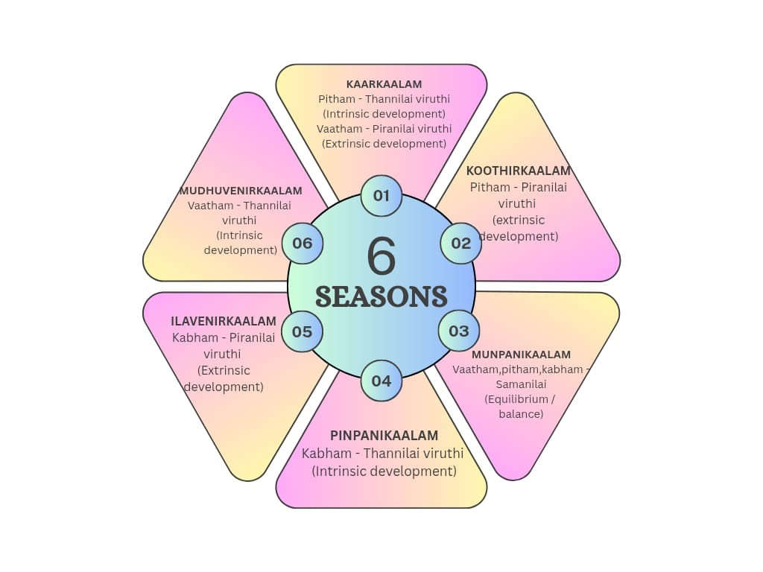

CLINICAL SIGNIFICANCE :
Siddha nosology provides a strong foundation for early diagnosis based on the assessment of humoral imbalance³. It emphasizes preventive strategies through appropriate dietary regulation and lifestyle modification⁸. The system supports an individualized treatment approach, considering the predominance of humors and the patient’s constitution. Siddha nosology also aids in prognostic assessment by evaluating the stage of disease progression and the extent of humoral involvement, thereby guiding effective clinical decision-making.¹⁵
DISCUSSION :
The Siddha classification of 4,448 diseases demonstrates an advanced and systematic understanding of human pathology. Unlike modern symptom-based disease classification systems, Siddha nosology emphasizes causative factors, systemic involvement, and preventive care.⁷This approach reflects the deep clinical insight of ancient Siddhars, who focused on understanding disease at its root rather than addressing symptoms alone. Integrating Siddha nosological concepts with modern disease taxonomy may enhance holistic patient management and improve outcomes through a more comprehensive diagnostic and therapeutic approach.¹⁵
CONCLUSION:
The Siddha system’s classification of 4,448 diseases represents a sophisticated and holistic framework encompassing physical, mental, and spiritual health.¹ Revisiting classical Siddha nosology and correlating it with contemporary medical science can strengthen integrative healthcare practices while preserving the rich traditional medical wisdom of Siddha medicine⁵. This integrative approach has the potential to contribute significantly to preventive healthcare and holistic disease management.¹⁵
REFERENCES :
1.Venkadarajan.S,Agaththiyar 2000 part 1,1st Ed,Thanjai, saraswati mahal,2005
2.Vinayagamoorthi .K,
Angathipatham
3.Shanmugavel.M,Noi naadal noi mudhal naadal part 1,4th Ed,india maruthuvam - homeopathy thurai,1987
4.Shanmugavel.M,Noi naadal noi mudhal naadal part 2,6th Ed,india maruthuvam - homeopathy thurai,2016
5.Arangarasan.S,4448 viyathikal,2006 6.Ramachandhiran.P, yugi vaithya sinthamani 800,3rd Ed,Thamarai noolagam,2018
7.Anbarasu.K,Yugi vaithiya sinthamani moolam uraiyum,1st Ed,thamarai noolagam,2018
8.Uthamarayan C.S.,siddhar aruvai maruthuvam,4th Ed, india maruthuvam - homeopathy thurai,2022
9.Thiyagarajan.R,Gunapadam thathu vaguppu,3rd Ed, india maruthuvam - homeopathy thurai,2019
10.Swarnamariyammal.I, Gunapadam jeeva vaguppu,6th Ed, india maruthuvam - homeopathy thurai,2021
11.Murugesa mudaliyar.K.S., Gunapadam mooligai vaguppu part-1,4th Ed, india maruthuvam - homeopathy thurai,2022
12.Murugesa mudaliyar.K.S., Gunapadam mooligai vaguppu part-2,4th Ed, india maruthuvam - homeopathy thurai,2022
13.Dhurairasan.K ,Noi illa neri,6th Ed, india maruthuvam - homeopathy thurai,2021
14. Kuppusamy muthaliyaar .K.N, Uthamarayan.C.S, siddha vaithya thirattu,8 th
Ed, india maruthuvam -homeopathy thurai,2021
15.Rakulini raveendran,Classification of 4448 diseases in siddha system of medicine- a review,2020

