Hospital Lockdown as a Control Strategy for the spread of Avian Influenza

Abstract
A mathematical model of avian influenza was developed to elucidate the transmission dynamics of the disease. The model assumes that the population is replenished through birth and utilizes existing data to validate its efficacy. The goal of this modeling exercise is to inform strategies for preventing, controlling, and eradicating avian influenza, ultimately improving public health policy and quality of life. Mathematical analysis reveals that the basic reproductive number R₀ is the critical parameter determining the global dynamics of the disease. If R₀ < 1, the disease-free equilibrium is locally stable, indicating that the disease will eventually die out. Conversely, if R₀ > 1, an endemic equilibrium exists, and the disease will persist at a stable level. Sensitivity analysis of the model parameters reveals their impact on the spread of avian influenza, providing valuable insights for disease control.
The model was solved using the Runge-Kutta scheme of order four, with a 30-year time horizon, and implemented in MATLAB. This study demonstrates the power of mathematical modeling in understanding the transmission dynamics of avian influenza, enabling informed decision-making and effective disease management.
Key words: Basic reproductive number, Sensitivity Analysis, Avian Influenza, Equilibrium point.

1.0 INTRODUCTION
Avian influenza, caused by an RNA virus with in the Orthomyxoviridae family [1], is a respiratory infection affecting birds and mammals. It is categorized into three main types (A, B and C) based on variances in two crucial internal proteins [9]. Of these types, avian virus A is the most perilous and epidemiologically significant. It holds ecological and evolutionary interest due to its presence across diverse bird and mammal species, often undergoing notable changes in immunological properties. According to [15], avian influenza A comprises three subtypes transmissible to birds and humans: AH5, AH9, and AH7. Transmission to humans occurs through airborne exposure to the virus or contact with contaminated surfaces. In humans, infection symptoms include coughing, fever, chills, and headache. Although the virus naturally circulates in birds, human infections stem from contact with infected poultry excrement. The transmission of avian flu to humans leads to severe consequences. In 1998, 16 confirmed human cases and three suspected cases were reported [7]. According to (WHO 2023), Indonesia saw 151 cases, resulting in 52 fatalities, while Vietnam recorded 119 cases, with 59 fatalities. In 2004, the avian virus was identified migratory birds in Hong Kong, with no evidence of local poultry, pet birds, or leisure birds being infected (Malcolm et al. 2006). On April 5, 2023, a 53-year-old man from northern Chile was reportedly infected, displaying no comorbidities or recent travel history. WHO reported a poultry farm employee in England contracting highly pathogenic avian influenza A(H5N1) viruses in mid-May. A second individual involved in slaughter operations at the farm also tested positive for the virus. Global concerns about avian flu’s rapid spread persist. Inadequate treatment of this disease can result in severe health complications and significant economic and societal burdens.
2.0 LITERATURE REVIEW
Mathematical models have emerged as valuable tools for understanding avian virus dynamics. In a related study, [18] incorporated spatial factors and phases into a model, while [12] proposed a differential equation model. [10] extended Iwami’s model, considering human-bird contact and isolating infected humans. Jung et al. 2009 presented another optimal avian influenza strategy, while Vaidya et al. 2012 explored avian influenza dynamics in wild birds. [17] introduced a model focusing on human suffering due to the virus.
Constantinescu et al., (2019) defines a new class of fractional differential operators alongside a family of random variables, which was further used to construct fractional integro-differential equations for ruin probabilities. These Authors used the ruin probability in collective renewal risk models with inter-arrival time distributions. Gamma-time risk models and fractional poison risk models are two specific cases investigated whose ruin probabilities have explicit solutions when claim size distributions exhibit rational Laplace transform. [16] Constructed two nonlinear dynamics of avian influenza bird-to-human transmission models with different growth laws of the avian population, one being logistic growth and the second with Allee effect, and analysis of the model dynamical behaviour were examined. A threshold value for the prevalence of avian influenza and investigated the local or global asymptotically stability of each equilibrium of the systems by linear analysis technique or combining Liapunov function method and LaSalle’s invariance principle, respectively. Furthermore, the authors gave necessary and sufficient conditions for the occurrence of periodic solutions in the avian influenza system with Allee effect of the avian population. Numerical simulations were also presented to validate the theoretical results.
[19] Formulated mathematical model of Avian Influenza for both human and bird population. They computed basic reproduction number 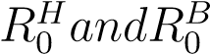 for both human
and bird population respectively and locally and globally asymptotically stability was obtained for disease-free equilibrium and unique endemic equilibrium point was globally asymptotically state in bird population when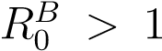. In an extensive numerical simulations and sensitivity analysis for various parameters of the model were also carried out. They concluded that Vaccination and Quarantined play a vital role for early recovery of the disease. Furthermore, quarantine the infectious population is in proportion to the recovery individuals. Recommendation suggested that suitable vaccine should be developed & appropriate interval of vaccination be chosen for recovery of the disease. [22] studied bird flu infection within a poultry farm with effect of spatial diffusion. Effect of threshold number that gives measure of infectious intensity was investigated, which depends on three factors; removal of infected bird, vaccination, and capacity of the farm. The analysis showed that transmission of bird flu within a poultry is expressible in terms of travelling wave solutions. It also shows a spatial significance of diffusivity. These mean, infection can be fully controlled with appropriate vaccination and proper removal of infected individuals. [15] discussed on global dynamics of Avian Influenza epidemic Models with psychological effect. The main consideration in the formulation was the psychological effect to Avian influenza in human population in which the avian population exhibits saturated effect. The results demonstrated that the saturation effect within avian population and the psychological effect in human population cannot change the stability of equilibrium but can affect the number of infected human if the disease is prevalent. Also, the numerical simulation supports the theoretical results and sensitivity analyses of the basic reproduction.
[2] Discussed the sensitivity analysis for avian influenza (bird flu) epidemic model with exposed class. [4] used fractional order in solving avian influenza epidemic model with quarantined vaccination. [11] examined the optimal control strategy for a continuous time mathematical model of avian influenza. They identified an effective strategy for diminishing the number for critically ill patients with avian flu and for treating carriers of the avian flu virus.

3.0 METHODS

3.1 Model Formulation
The model is a modification of the model proposed by Akpan and Ibrahim et al. (2022). They presumed that the human and bird population are divided into nine (9) compartments namely. Susceptible (S), Exposed (E), Infected human with avian strain (I_{a}), Infected human with mutant strain (I_{m}) Recovered human (R), Quarantined human (Q), Vaccinated Human (V), Susceptible bird (X), Infected birds (Y). The model was extended by adding the compartment (H). This compartment signifies individuals under hospital lockdown with ongoing health monitoring.

3.1.1 Basic Assumptions for Model
- Individuals are only recruited into susceptible population. The avian influenza virusis not contagious from an infective human to a susceptible human. It is only contagious from an infective avian to a susceptible human.
- It is assumed that an infected Avian cannot survive infection while an infected human can recover. The recovered human has permanent immunity.
- Susceptible individuals are vaccinated and vaccine efficacy expires after sometimes which will make vaccinated individual to become susceptible member again.
- Infected individuals are hospitalized and after undergoing health monitoring recovers for a period of time recovers.

3.1.2 Block Diagram of Model
Figure 2: The detailed description of epidemic model for Avian influenza transmission

3.2 3.3 Model Equation
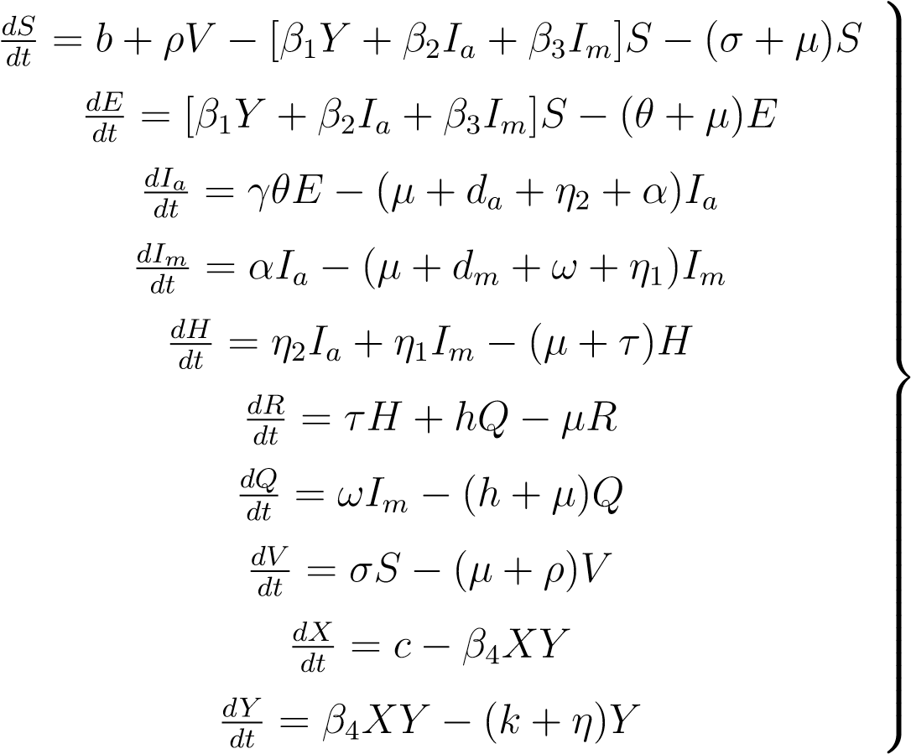 (1)

Table 3.1: Variable Description

Variable | Description
S | Susceptible Individual
E | Exposed Individual
$$I_{a}$$ | Infected individuals with Avian strain
$$I_{m}$$ | Dd  Infected individuals with mutant strain
R | Recovered Individual
V | Vaccinated Individual
Q | Quarantine Individual
H | Hospitalized Human
X | Susceptible Birds
Y | Infected Birds
PARAMETER | DESCRIPTION | VALUE | REFERENCES
b | Recruitment rate of human | 30 | Jabbari et al.
c | Bird inflow | 1000 | Akpan et al.
β1 | Rate at which bird to human avian influenza is contacted | 0.2 | Jabbari et al.
β2 | Rate at which human-human avian influenza is contacted | 0.4 | Jabbari et al.
β3 | Rate at which human-human mutant influenza is contacted | 0.0015 | Jabbari et al.
β4 | Rate at which bird contact avian influenza | 0.001 | Jabbari et al.
σ | Rate of transmission from susceptible to vaccinated human | 0.1 | Mishra et al.
µ | Natural death rate | 3.91 × 10⁻⁵ | Liu et al. 2
α | Mutant rate | 0.01 | Gumel 20
da | Induced death rate due to avian strain in human | 1 | Iwami et al.
dm | Induced death rate due to mutant strain to human | 0.06 | Jabbari et al.
k | Natural death rate for birds | 3.43 × 10⁻⁴ | Liu et al. 2
n | Induced death rate due to avian strain in birds | 5 | Iwami et al.
h | Rate of transmission from quarantined to recovered humans | 0.6 | Mishra et al.
θ | Disease progression rate of human from exposed to infections | 0.8 | Akpan et al.
γ | Proportion of human that are infected with avian strain | 0.3 | Akpan et al.
ω | Rate of transmission from infected individual with mutant strain to quarantine individual | 0.08 | Mishra et al.
τ | Rate at which hospitalized individual gets recovered | 0.03 | assumed
n1 | Rate at which infected individuals with mutant strain is been hospitalized | 0.08 | Hichan et al.
η | Rate at which infected individuals with avian strain is been hospitalized | 0.08 | Hichan et al.

Table 3.2: Parameter Description

3.3 Positivity and Boundaries of Solution

From this first equation in the model equation (1),

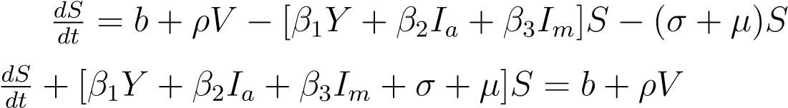
If = ^{R} [β₁Y + β₂I_{a} + β₃I_{m} + σ + µ]dt

Multiplying through by If we have,
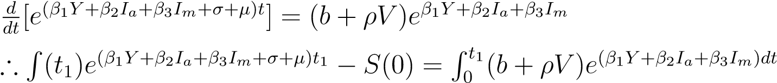
Hence,
We can show that this is true for all other state variables, for any given time t₁.
Disease-free equilibrium: In the absence of the disease,
E = I_{a} = I_{m} = H = Q = R = X = Y = 0
∴ From the model equation (1).
b + ρv − (σ + µ)S = 0 (1) σS − (µ + ρ)V = 0
By algebraic multiplication,
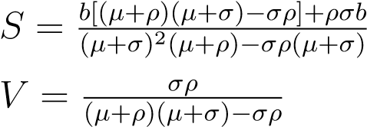
Hence, the disease free equilibrium is,
E₀ = [S⁰,0,0,0,0,0,0,V ⁰,0,0] with S and V given in terms of parameters above.

3.4 The Basic Reproductive Number
We will derive the basic reproduction number by using the next generation matrix approach.
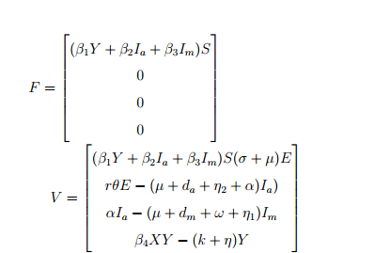
From the system,

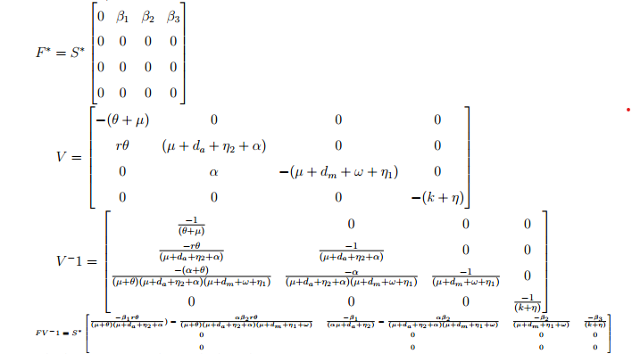
At DFE,

The largest eigen values, which is the R₀ is;
(3)

3.5 Local stability
The equilibrium (E₀) is locally asymptotically stable if R₀ < 1 and otherwise unstable. Proof:
The association Jacobian of the system is;
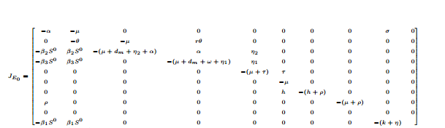

By expanding the characteristic equation

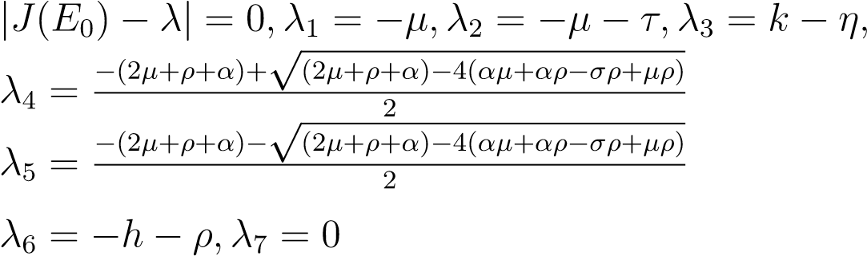
We have simple eigen values which is an indication for a stable system.
3.6 Endemic Equilibrium points
The Avian Influenza endemic equilibrium points are steady state solution where Avian influenza virus persists in the population. At endemic equilibrium $S≠E≠I_{a}≠I_{m}≠Q≠R≠V≠H≠X≠Y≠0$
$S$ = 0
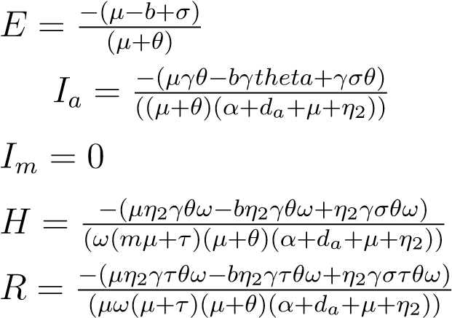
Q = V=0
$$X=\frac{k+n}{β_{4}}$$
$$Y=\frac{c}{k+n}$$

3.7 SENSITIVITY ANALYSIS
(2)
Where v = ((µ + σ)²(µ + ρ) − σρ(µ + σ))(αµ² + d_{a}µ² + d_{m}µ² + µ²η₁ + µ²η₂ + µ²θ + µ²ω + µ³ + αd_{m}µ + d_{a}d_{m}µ + αd_{m}θ + αµη₁ + d_{a}d_{m}θ + d_{a}µη₁ + d_{m}µη₂ + αµθ + αη₁θ + αµω + d_{a}µθ + d_{m}µθ+d_{a}η₁θ+d_{m}η₂θ+d_{a}µω+µη₁η₂ +αθω+d_{a}θω+µη₁θ+µη₂θ+η₁η₂θ+µη₂ω+µθω+η₂θω)

To understand how different parameters influence the spread of the disease, we carry out the sensitivity of each parameter that appears in the R₀ as follows using the technique used by Adagba, A. I, Akpan, C. E., and Mbah, M. A. (2024).

SENSITIVITY INDEX
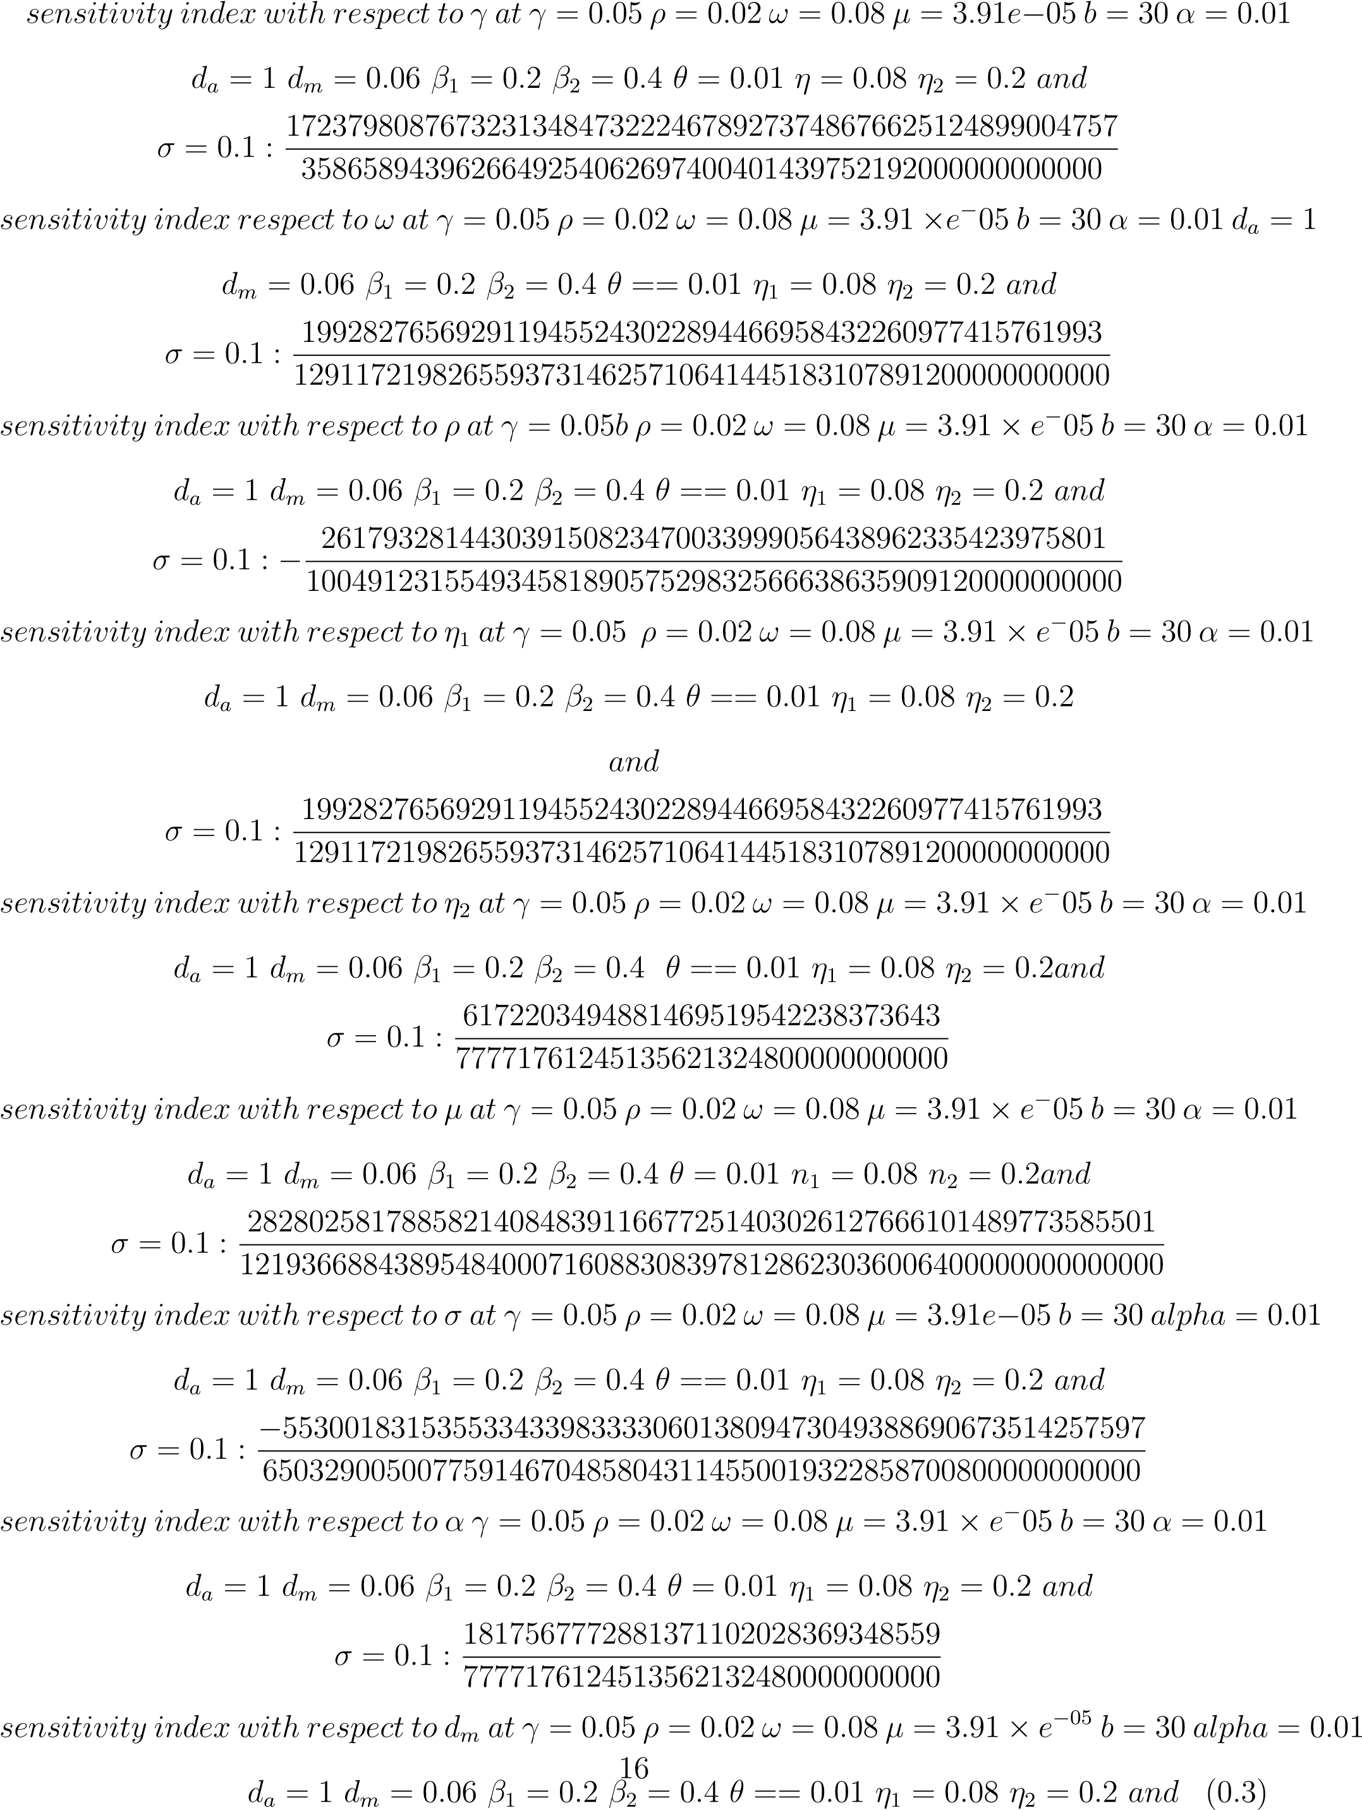
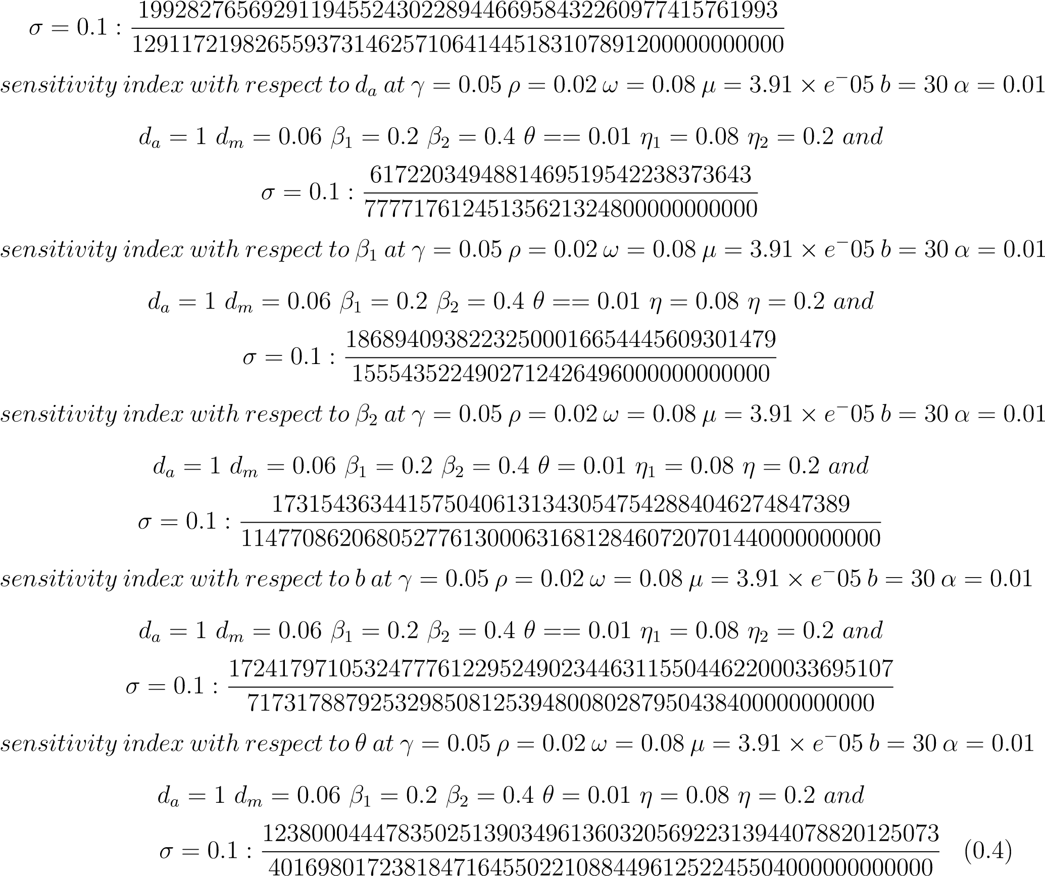

Table 4.3: Adopted data and Reference

PARAMETERS | VALUE | REFERENCE | SENSITIVITY SIGN
β₁ | 0.2 | Jabbari et al. 2016 | +
µ | 0.0000391 | Liu et al. 2017 | +
β₂ | 0.4 | Jabbari et al. 2016 | +
η₁ | 0.08 | Hichan et al. 2023 | +
η₂ | 0.2 | Assumed | +
Ρ |  | Mishra et al. 2016 | -
α | 0.0125 | Liu et al.2017 | +
σ | 0.1 | Mishra et al. 2016 | -
ω | 0.08 | Mishra et al. 2016 | +
b | 30 | Jabbari et al. 2016 | +
θ | 0.8 | Akpan et al. 2022 | +
d_{a} | 1 | Iwami et al. 2007 | +
d_{m} | 0.06 | Jabbari et al. 2016 | +
γ | 0.05 | Assumed | +

3.8 Numerical Simulation
Figure 4.3: Graph of Susceptible population
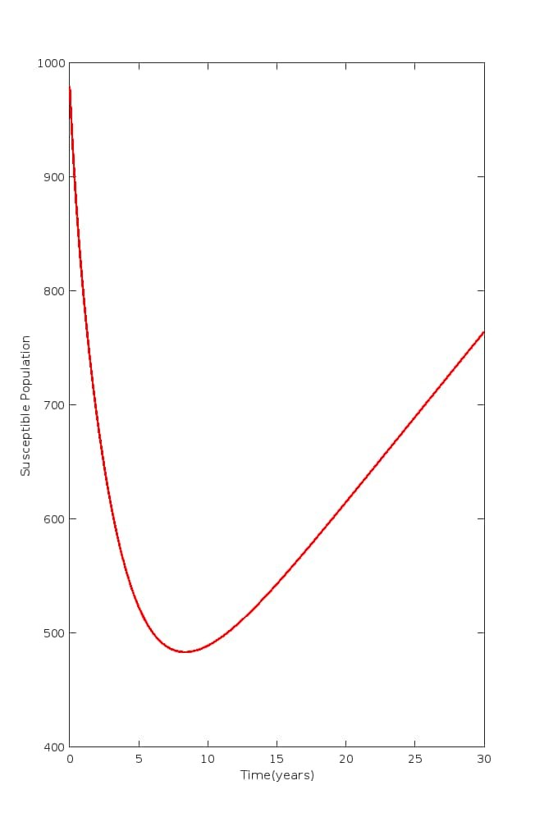

Figure 4.4: Graph of Y population
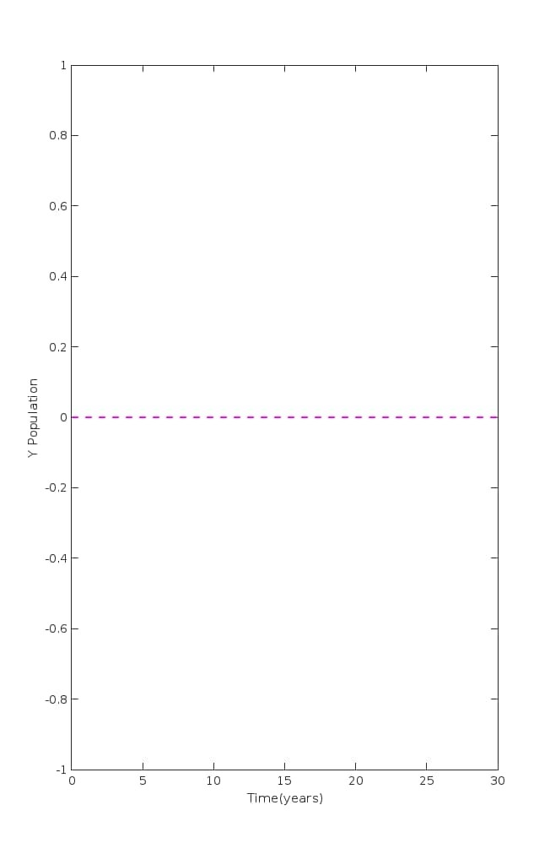

Figure 4.5: Graph of X population

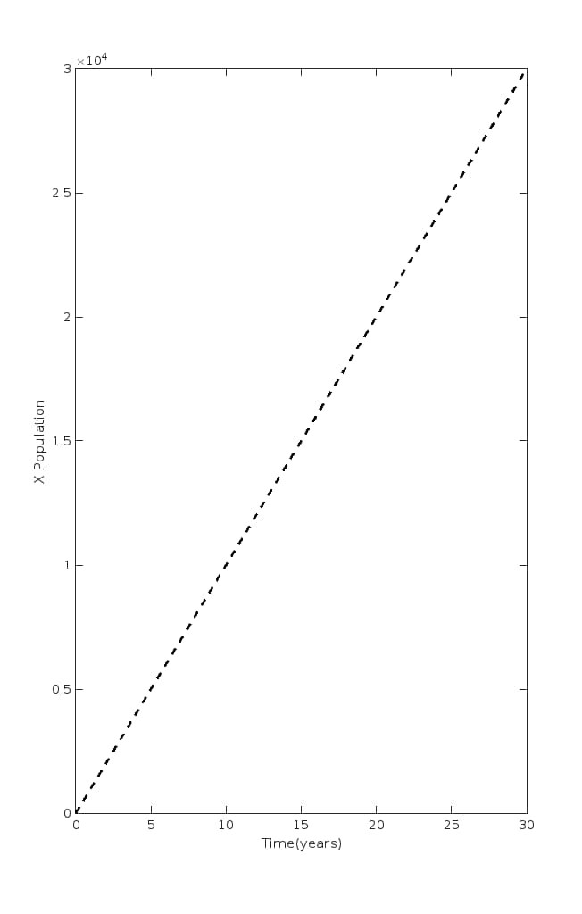

Figure 4.6: Graph of Vaccine population
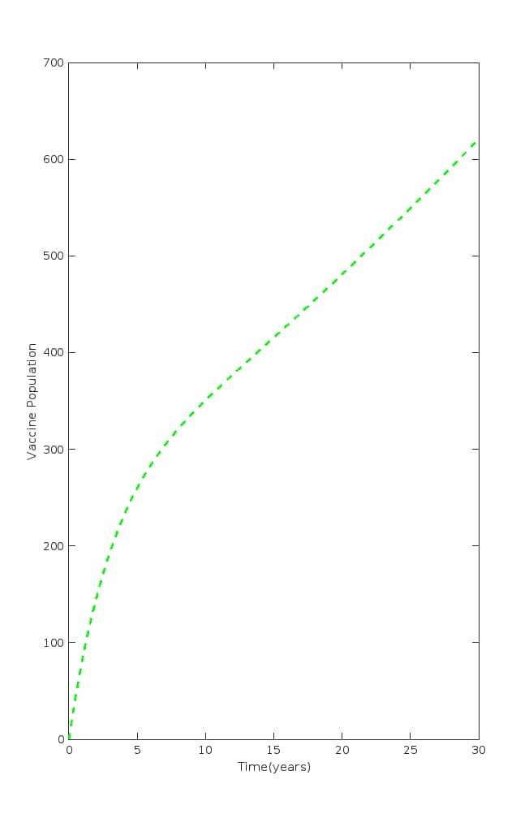

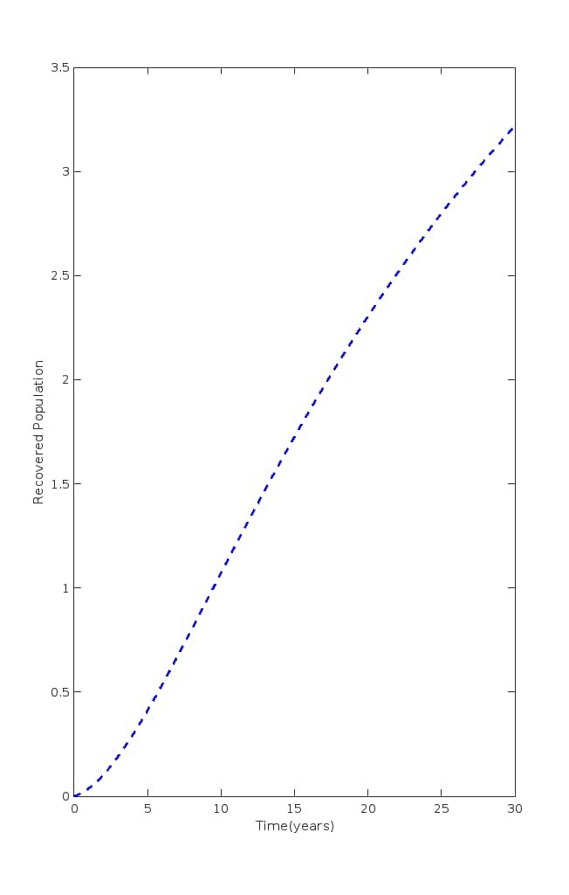
Figure 4.7: Graph of Recovered population

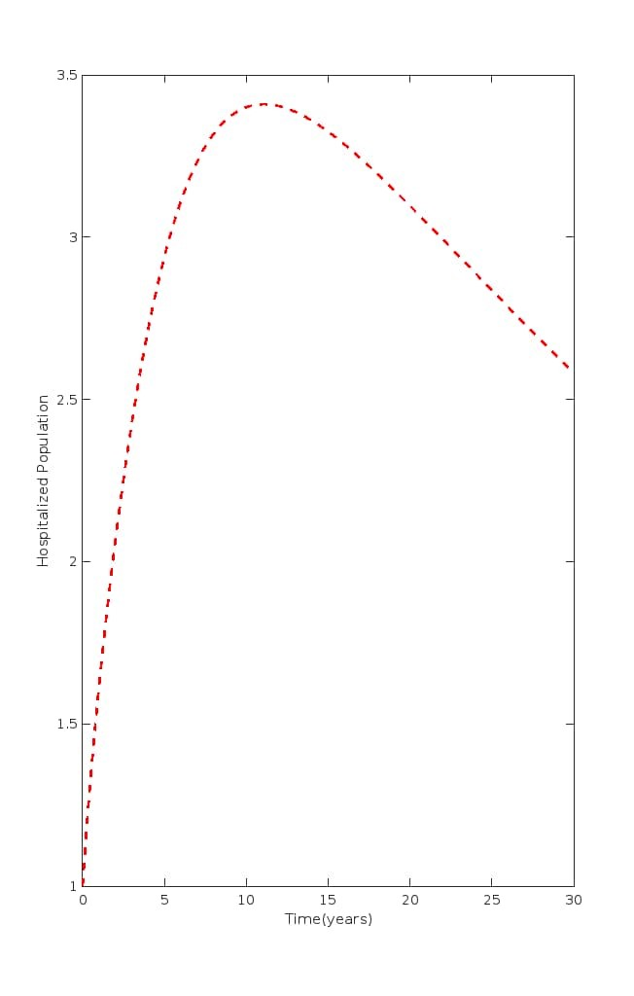
Figure 4.9: Graph of Quarantine population

Figure 4.12: Graph of $I_{a}$ population
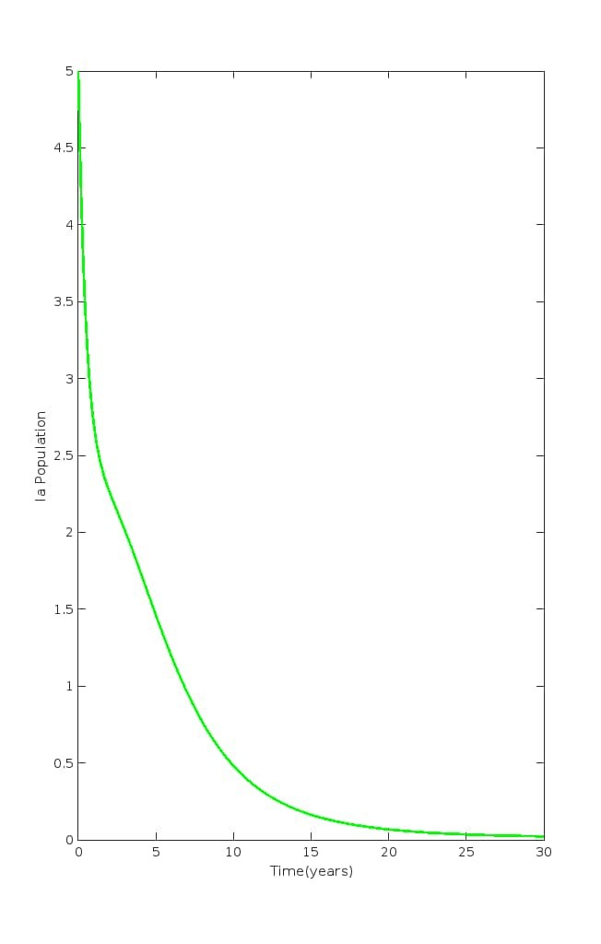

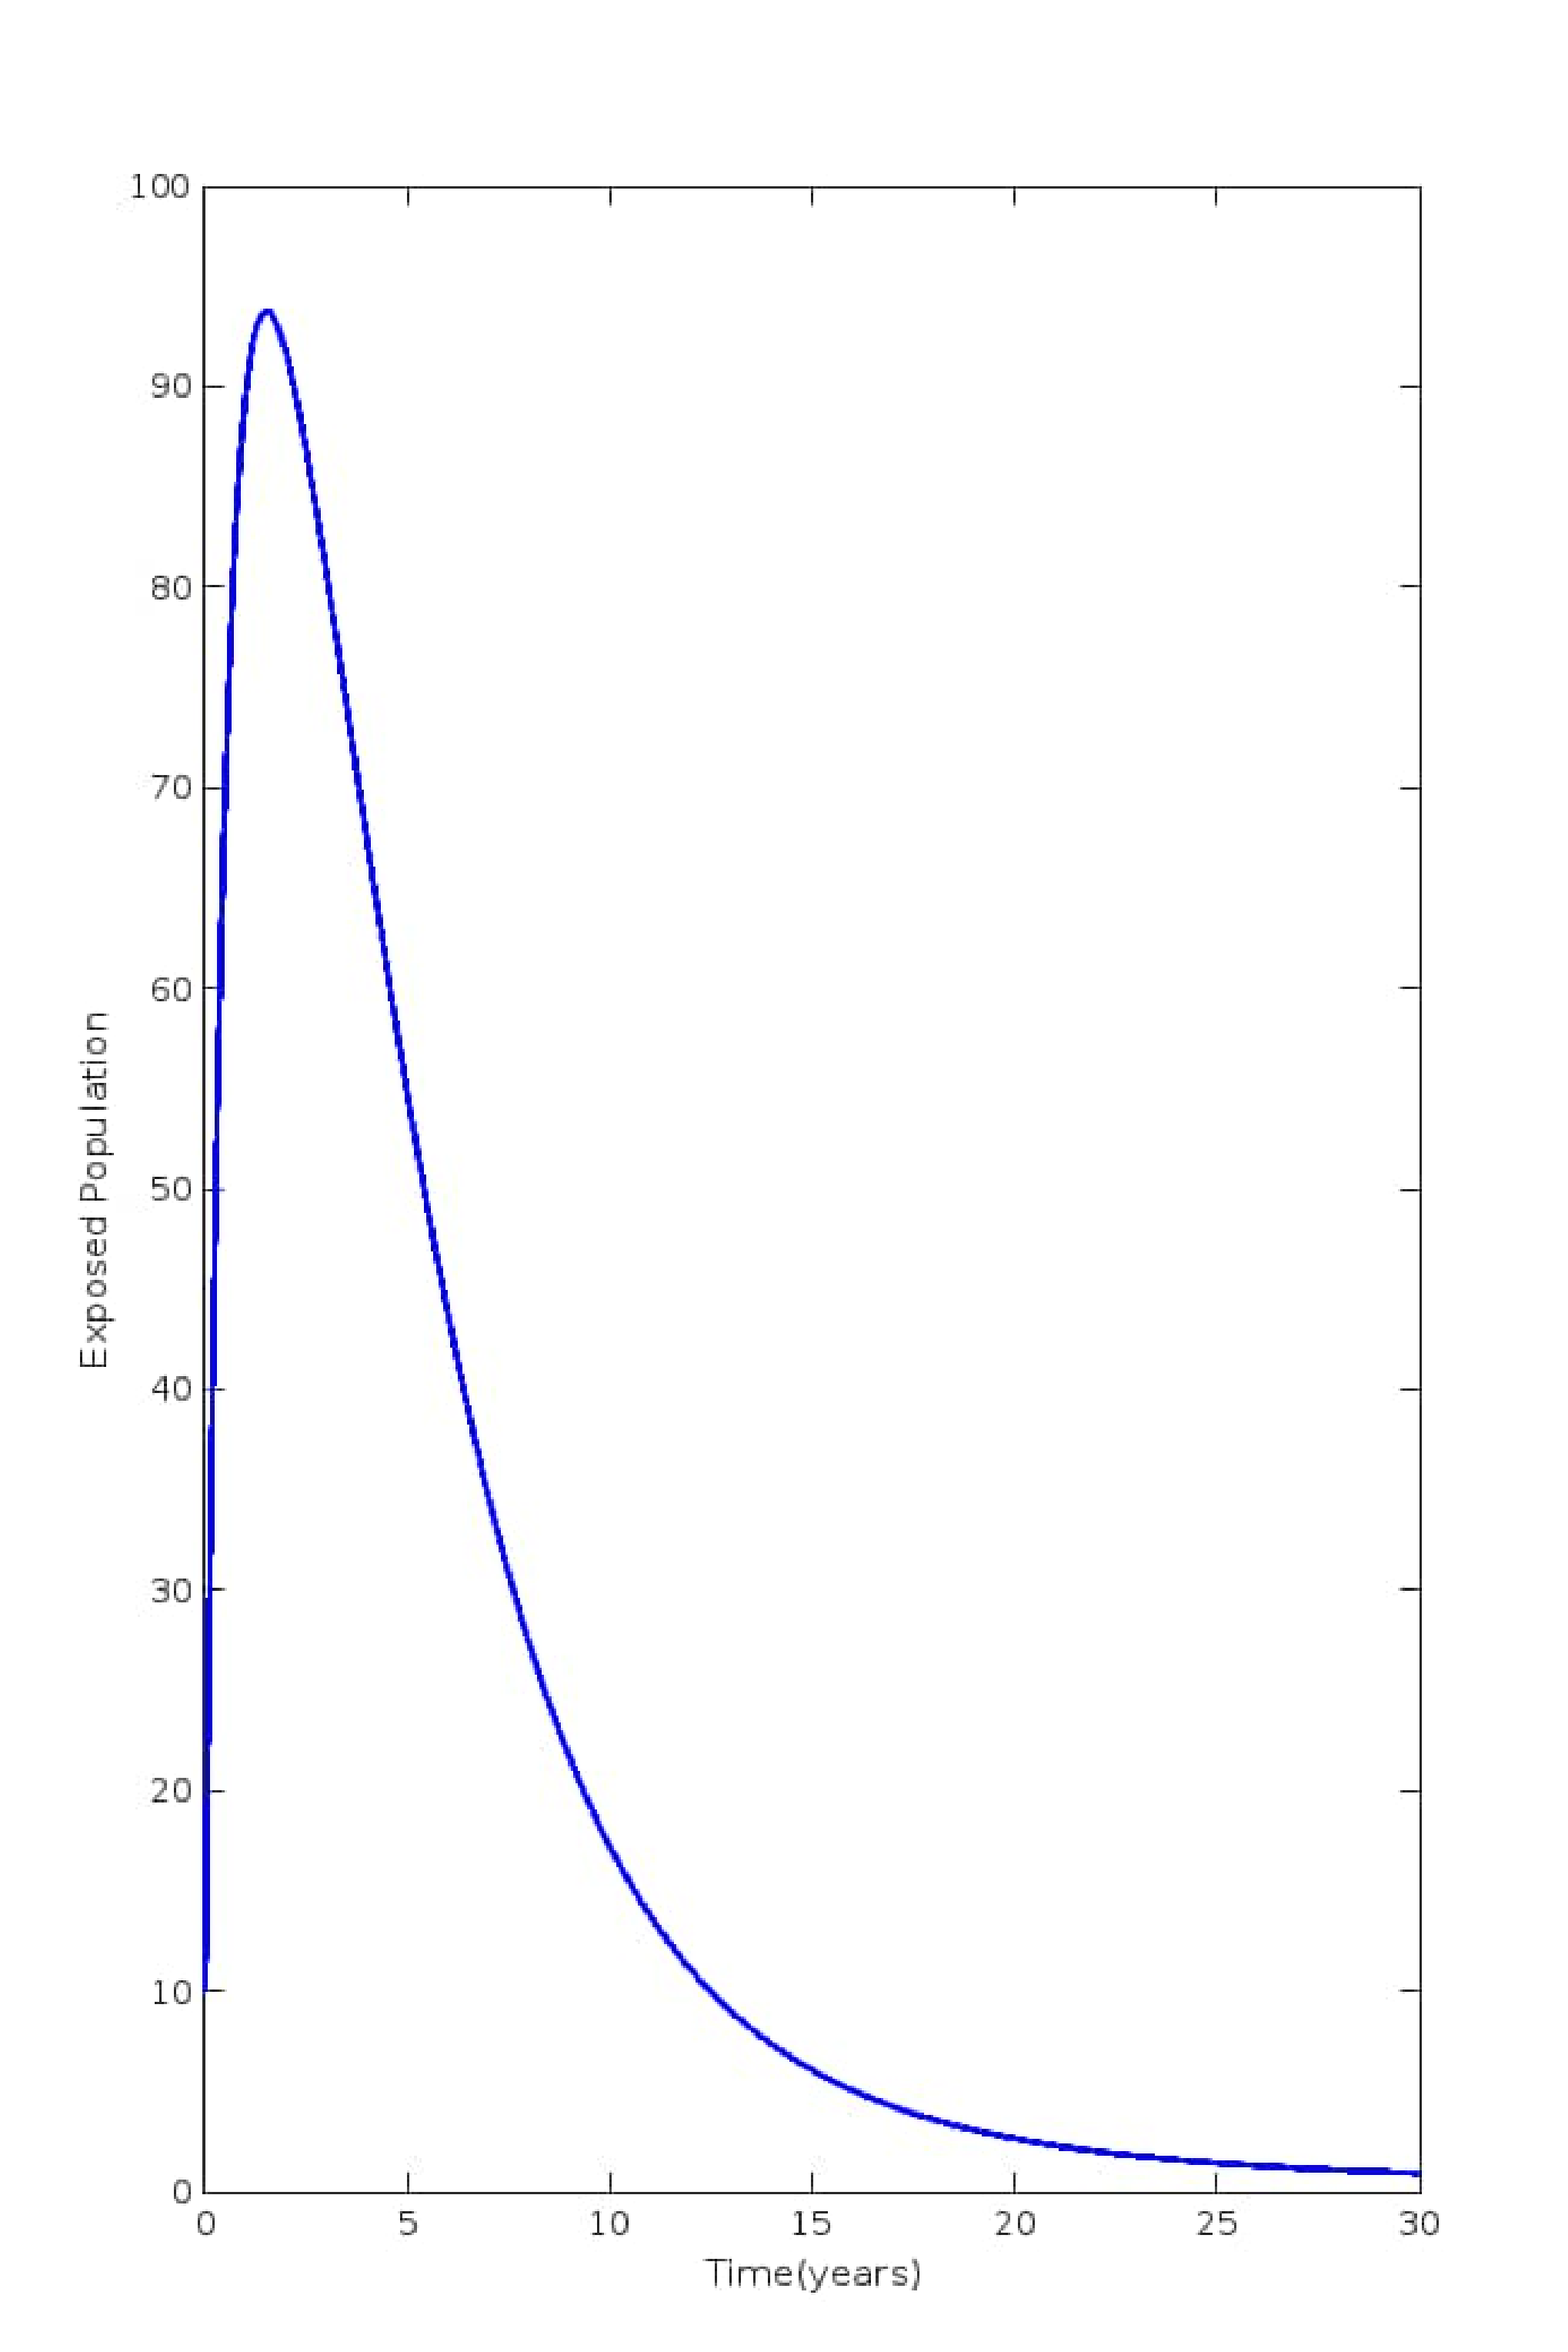
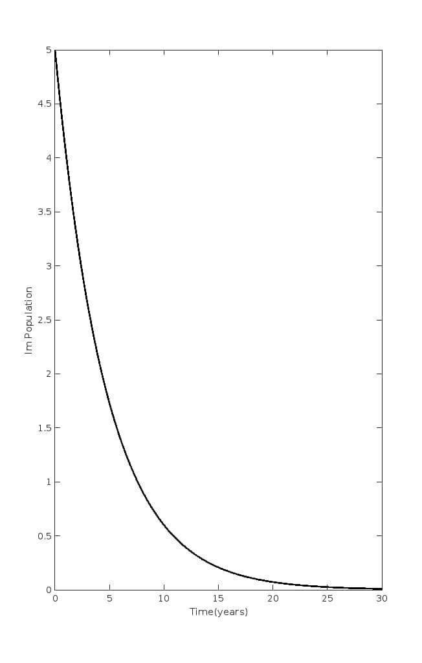
Figure 4.12: Graph of $I_{m}$ population

4.0 Results and Discussion
This study significantly enhances an existing typhoid fever model by incorporating the crucial aspect of hospitalized individuals under lockdown, accompanied by continuous health monitoring. This modification enables a more realistic representation of the dynamics of avian influenza spread. The results of this enhanced model reveal a crucial insight: the susceptible population initially decreases but eventually increases if adequate measures are not taken to control the spread of avian influenza (Fig 4.1). This highlights the urgent need for improved efforts to mitigate the prevalence of avian influenza, lest we risk a resurgence of the disease. Encouragingly, as vaccination rates increase, the recovered population grows significantly (Fig 4.5), while the number of hospitalized, quarantined, and exposed individuals decreases substantially (Figs 4.6, 4.7, and 4.10). This suggests that vaccination is a critical component in controlling the spread of avian influenza. Furthermore, the model demonstrates a notable decline in infected individuals with mutant avian strains I₍a) and I₍m) over time (Figs 4.8 and 4.9), indicating the effectiveness of the implemented measures in reducing the burden of the disease. These findings underscore the importance of a multi-faceted approach in combating avian influenza, including vaccination, hospitalization, quarantine, and continuous health monitoring. By acknowledging the complexity of this disease and leveraging the insights provided by this enhanced model, we can work towards a future where the threat of avian influenza is significantly diminished, and public health is safeguarded. Furthermore, our model analysis reveals that the disease-free equilibrium and endemic equilibrium are locally stable when the basic reproduction number R₀ is less than 1, but unstable otherwise, as determined by the Jacobian matrix approach. Sensitivity analysis identifies key parameters driving the epidemiology of avian influenza, with positive sensitivity indices indicating direct proportionality to R₀ and negative indices indicating inversely proportionality (Table 4.1). To combat the spread of the disease, concerted efforts are necessary. The government should provide adequate awareness programs and medical facilities to meet the demands of the epidemic. Moreover, avian influenza vaccination programs should be implemented from birth onwards to improve the population’s quality of life.
Our analysis has demonstrated how various parameter values impact the spread of avian influenza in the population. Specifically, increasing parameters with a positive sensitivity index will exacerbate the burden of avian influenza, while increasing parameters with a negative sensitivity index will significantly mitigate its impact. The basic reproductive number R₀ plays a crucial role in determining the dynamics of avian influenza, as an increase in R₀ directly leads to an increase in the disease’s burden, and vice versa. Notably, the incorporation of vaccination, hospitalization, and quarantine measures in our model has shown that the recovered population grows over time, as more individuals move into this category. This highlights the effectiveness of these interventions in controlling the spread of avian influenza. By understanding the impact of these parameters and implementing strategies to reduce the burden of avian influenza, we can work towards mitigating its challenges and protecting public health.
The model, combined with its sensitivity analysis, provides a comprehensive understanding of the dynamics of avian influenza and serves as a vital tool in combating its threat. To effectively mitigate the spread of the disease, it is crucial to prioritize avian influenza awareness and education, ensuring that the public is well-informed about its risks and consequences. Furthermore, maximum vaccination efforts should be implemented, ideally beginning at birth, to provide early protection against the disease. In conjunction with vaccination, social distancing measures should be emphasized to minimize contact rates and reduce the likelihood of transmission. In the event of a failed vaccination or infection, prompt hospitalization or quarantine is essential to prevent further spread and ensure proper treatment. The implementation of these measures in conjunction will significantly contribute to controlling the spread of avian influenza, improving the quality of life for individuals, and ultimately, eradicating the disease from the population. By acknowledging the importance of a multi-faceted approach, we can work towards a future where the threat
5.0 Conclusion
The implementation of these measures in conjunction will significantly contribute to controlling the spread of avian influenza, improving the quality of life for individuals, and ultimately, eradicating the disease from the population. By acknowledging the importance of a multi-faceted approach, we can work towards a future where the threat.
Conflict of Interest.
The authors declare no conflict of interest.

REFERENCES
[1] Agusto, F.B, Ogunye, O.R. Avian influenza optimal seasonal vaccination strategy, ANZIAM J. 51 (2010), 394-405. https://doi.org/10.1017/s1446181110000891.
[2] Akpan C. E, Ibrahim, M. O (2020). Sensitivity Analysis for Avian Influenza (Bird Flu) Epi demic Model with Exposed Class., Asian Journal of Mathematics and applications. Artic le ID ama 0563, 24 pages ISSN 2307-7743 http://scienceasia.
[3] Akpan C. E, Ibrahim, M. O (2021). Mathematical Modelling of the stability of Highly Pathogenic Avian Influenza with Saturated Contact rate, Journal of Mathematical Sciences and Computational Mathematics 2(2): 266-286
[4] Akpan C. E, Ibrahim, M. O (2022). The Use of Fractional order in Solving Avian Influenza
Epidemic Model with Quarantine and Vaccination. Curr Res Start Math, 1(1): 08-20
[5] Bree, N. & Sullivan, D. (2017). Bird flu. Healthline. Accessed on July 7, 2019 from https://www.healthli influenza
[6] Butler, T. (2011) Treatment of typhoid fever in the 21st century: promises and shortcomings. Clin. Microbiol. Infect. 17(7), 959-963.
[7] Centers for Disease Control and Prevention, Update: isolation of avian influenza A(H5N1) viruses from humans-Hong Kong, 1997-1998. MMWR Morb. Mortal. Wkly. Rep. 46
(1998), 1245-1247.
[8] Derrick, N. R. and Grossman, S. L. (1976) Differential equations with applications. Addison
Wesley Publishing Company.
[9] Earn, D.J.Dushoff, J. .Levin, S.A. Ecology and evolution of the flu,TrendsEcol.Evol.17(2002),334-
340. https://doi.org/10.1016/s0169-5347(02)02502-8.
[10] Gumel, A B. Global dynamics of a two-strain avian influenza model, Int. J. Computer Math.
86 (2009), 85-108. https://doi.org/10.1080/00207160701769625.
[11] Hicham, G., Mohammed, B., Abderraham, L & Mohammed B (2023). Mathematical Mod elling and Optimal Control Strategy for the influenza (H5N1)., Commun. Math Bio. Neurosci:, 2023:113 https://doi.org/10.28919/cmbn/8199Issn:2052-2541
[12] Iwami, S , Takeuchi, Y, & Liu, X. (2007) Avian-human influenza epidemic model, Math. Biosci. 207 , 1-25. https://doi.org/10.1016/j.mbs.2006.08.001.
[13] Jabbari, A., Kheiri, H., & Akbarfam, A.J. (2016). Dynamical analysis of the avian hu man influenza epidemic model using multistage analytical method. International Journal of Biomathematics, World Scientific Publishing Company 9(6), 1650090(19 pages) DOI: 10.1142/S179352451650090X
[14] Jung, E , Iwami, S & Takeuchi, Optimal control strategy for prevention of avian influenza pan demic, J. Theor. Biol. 260 (2009), 220-229. https://doi.org/10.1016/j.jtbi.2009.05.031.
[15] Liu, S, Pang L, & Ruan. Global dynamics of avian influenza epidemic models with psychological effect, Comput. Math. Methods Med (2015), 913726. https://doi.org/10.1155/2015/913726.
[16] Liu, S. Ruan, S., & Zhang, X., (2017). Nonlinear dynamics of avian influenza epidemic models. Mathematical Bio-sciences, 283, 118-135.
[17] Malcolm, R Bird flu may have entered Nigeria 3 times, Washington Post, July 5, 2006, Associated Press.http://www.washingtonpost.com/wpdyn/content/article/2006/07/05/AR20060705008
[18] Menach, L Vergu, E & Grais, R. F. Key strategies for reducing spread of avian influenza among commercial poultry holdings: lessons for transmission to humans, Proc. R. Soc. B. 273 (2006), 2467-2475. https://doi.org/10.1098/rspb.2006.3609.
[19] Mishra, B.K. & Sinha, N.D. (2016). Mathematical model on avian influenza with quarantine and vaccination. Journal of Immunol Tech. Infect Diseases Doi:10.4172/2329
[20] Nicholas, J. B. (2019). Avian influenza (Bird flu). Retrieved on July, 2019 from https://emedicine.medsca overview
[21] Porta, M. (2008). A dictionary of epidemiology-5th Edn. Oxford University Press.
[22] Putri, A.R., Watanabe, M., & Nova, T.D. (2017). Study on bird flu infection process within a poultry farm with effects of spatial diffusion. Universal Journal of Agricultural Research, 5(3), 190-196. DOI: 10.13189/ujar.2017.050302
[23] Somma, S. A., N. I Akinwande, M. Jiya & S. Abdulrahaman (2017). Stability Analysis of a Disease-Free Equilibrium (DFE) State of a Mathematical Model of Yellow Fever Incorporating Secondary Host. Pacific Journal of Science and Technology, 18(2), 110-119.
[24] Vahid, S.B. (2012). Stability analysis of positive systems with applications to epidemiological model. A dissertation for the degree of Doctor of Philosophy, National University of Ire land Maynooth.
[25] Vaidya, N.K. Wang, F.B & Zou, X. Avian influenza dynamics in wild birds with bird mobility and spatial heterogeneous environment, Discr. Contin. Dyn. Syst. Ser. B, 17 (2012), 2829-2848. https://doi.org/10.393 4/dcdsb.2012.17.2829
[26] WHO, Cumulative number of confirmed human cases for avian influenza A(H5N1) reported to WHO, 20032023, 5 January (2023), https://www.who.int/publications/m/item/cumulativenumber-of-confirmed-humancases-for-avian-influenza(h5n1)-reported-to-who-2003-2022-5jan-2023.

