Hospitality: Service with a Smile

Abstract
Purpose
“Service with a smile” has traditionally symbolized the essence of hospitality service delivery. However, in contemporary hospitality operations characterized by global competition, digital transformation, and rising customer expectations, smiling behavior represents far more than a courteous gesture. It reflects a structured emotional performance embedded within organizational systems, cultural norms, and strategic objectives. This review paper critically synthesizes existing scholarship to examine the conceptual, operational, and psychological dimensions of “service with a smile.” The study aims to develop an integrated framework that balances emotional labour management, employee well-being, and customer satisfaction outcomes within hospitality organizations.
Design/methodology/approach
A systematic literature review methodology was adopted. Peer-reviewed journal articles published between 1983 and 2025 were retrieved from Scopus, Web of Science, Emerald Insight, ScienceDirect, and Google Scholar. After applying inclusion and exclusion criteria, 138 high-quality empirical and conceptual studies were analyzed through thematic synthesis. The review integrates theoretical perspectives including Emotional Labour Theory, Service-Profit Chain Theory, Emotional Contagion Theory, Social Exchange Theory, Organizational Support Theory, and Service-Dominant Logic.
Findings
Findings reveal that “service with a smile” functions as a strategic intangible resource influencing perceived service quality, trust formation, satisfaction, loyalty, and brand equity. However, emotional display expectations may generate psychological strain when unsupported by organizational systems. The review identifies five interdependent dimensions: emotional regulation strategies, service climate and leadership, employee emotional intelligence, customer perception mechanisms, and well-being sustainability systems. The study proposes a Smile-Service Sustainability Framework (SSSF) integrating organizational foundations, emotional regulation processes, and customer experiential outcomes.
Practical implications
Hospitality organizations must prioritize authentic service cultures, structured emotional intelligence development, mental health support, and balanced performance metrics. Sustainable customer satisfaction requires sustainable employee emotional capacity.
Originality/value
This study reconceptualizes “service with a smile” as a strategic organizational capability rather than a simplistic behavioural expectation. It provides a comprehensive framework for aligning employee well-being with service excellence in modern hospitality operations.

Keywords
Service with a smile; Emotional labour; Hospitality management; Customer satisfaction; Employee well-being; Service climate; Emotional intelligence; Organizational culture; Service excellence; Customer experience; Emotional contagion.

1. Introduction
Hospitality is one of the most human-centric industries in the global economy. Unlike manufacturing sectors where value is embedded in tangible products, hospitality creates value primarily through interpersonal interactions and experiential encounters. Hotels, restaurants, resorts, airlines, cruise lines, event venues, and tourism establishments depend heavily on frontline employees who serve as the face of the organization.
The phrase “service with a smile” encapsulates hospitality’s historical identity as a warm, welcoming, and emotionally engaging service domain. For decades, smiling has symbolized courtesy, friendliness, and attentiveness. However, contemporary hospitality operations exist in a hyper-competitive global environment characterized by digital transparency, customer empowerment, and intensified service expectations.
Today’s customers evaluate not only functional performance but also emotional resonance. Online review platforms allow guests to publicly assess service demeanor, friendliness, and staff attitude. Consequently, emotional display has evolved from a cultural expectation into a measurable performance indicator.
The institutionalization of smiling behavior introduces a complex dynamic: emotional labour. Emotional labour refers to the regulation of emotions to conform to organizational display rules (Hochschild, 1983). In hospitality, employees are frequently expected to maintain positive emotional expressions irrespective of personal circumstances.
While smiling positively influences customer perceptions, excessive emotional regulation without organizational support can result in emotional exhaustion, depersonalization, and turnover (Brotheridge & Grandey, 2002). This tension raises critical managerial questions:
- How can hospitality organizations sustain authentic emotional engagement?
- What mechanisms support employee well-being?
- How does emotional display influence customer satisfaction and loyalty?
- Can emotional labour be managed strategically?
This review addresses these questions by synthesizing multidisciplinary literature and developing an integrated sustainability-oriented framework for “service with a smile.”

2. Aim and Objectives

2.1 Aim
To critically evaluate the role of “service with a smile” in hospitality operations and develop a comprehensive framework that integrates emotional labour management, organizational culture, employee well-being, and customer satisfaction.

2.2 Objectives
- To analyze theoretical foundations underpinning emotional display in hospitality work.
- To examine how smiling behavior influences customer satisfaction and loyalty.
- To evaluate psychological consequences of emotional labour for employees.
- To assess organizational strategies for sustaining authentic service culture.
- To develop a sustainable Smile-Service Sustainability Framework (SSSF).

3. Methodology

3.1 Research Design
This study uses a systematic literature review (SLR) approach to ensure transparency and replicability.

3.2 Database Search
Databases searched:
- Scopus
- Web of Science
- Emerald Insight
- ScienceDirect
- Google Scholar

3.3 Keywords
“service with a smile,”
“emotional labour hospitality,”
“emotional display rules,”
“employee burnout hospitality,”
“customer satisfaction service encounter,”
“service climate hospitality,”
“emotional intelligence service employees.”

3.4 Inclusion Criteria
- Peer-reviewed journal articles
- English language
- Published between 1983–2025
- Empirical or conceptual focus on service or hospitality

3.5 Analytical Method
Thematic analysis identified major constructs:
- Emotional labour strategies
- Customer emotional perception
- Organizational support mechanisms
- Leadership and service climate
- Employee well-being outcomes

4. Theoretical Foundations

4.1 Emotional Labour Theory
Hochschild (1983) introduced emotional labour as the process of managing feelings to create publicly observable displays that meet job requirements.
Two strategies:
- Surface acting (faking emotions)
- Deep acting (internal emotional alignment)
Deep acting yields greater authenticity and lower emotional exhaustion (Grandey, 2000).

4.2 Emotional Contagion Theory
Emotional contagion explains how individuals mimic and synchronize emotional expressions (Hatfield et al., 1994). In hospitality, employees’ smiles influence customers’ emotional states.

4.3 Service-Profit Chain
Heskett et al. (1994) demonstrate that internal service quality influences employee satisfaction, which affects customer satisfaction and profitability.

4.4 Social Exchange Theory
Employees reciprocate fair treatment with positive behaviors (Blau, 1964). Supportive environments enhance authentic smiling.

4.5 Organizational Support Theory
Perceived organizational support reduces emotional strain and increases commitment.

4.6 Service-Dominant Logic
Service is co-created between employee and customer (Vargo & Lusch, 2008). Emotional display forms part of co-created experiential value.

5. Emotional Labour in Hospitality Contexts

5.1 Frontline Service Encounters
Hotels and restaurants require constant emotional display during check-in, dining, complaint handling, and event service.

5.2 Emotional Dissonance
When displayed emotions conflict with internal feelings, dissonance occurs.

5.3 Burnout and Turnover
Emotional exhaustion contributes to high turnover rates in hospitality.

6. Smile as a Strategic Resource
Smiling influences:
- Trust formation
- Perceived empathy
- Brand image
- Online reviews
- Loyalty intention
Authentic emotional engagement becomes a competitive differentiator.

7. Organizational Culture and Leadership
Transformational leadership enhances emotional resilience.
Supportive service climates promote authentic engagement.
Training programs in emotional intelligence improve emotional regulation capacity.

8. Employee Well-Being and Sustainability
Sustainable hospitality requires balancing emotional demands with psychological support:
- Wellness programs
- Counseling services
- Flexible scheduling
- Fair compensation
Employee well-being directly influences service consistency.

9. Cross-Cultural Considerations
Emotional display norms differ globally. Multinational hospitality brands must adapt emotional expectations to cultural contexts.

10. Development of the Smile-Service Sustainability Framework (SSSF)
The SSSF integrates three interconnected dimensions:
I. Organizational Foundation
- Leadership support
- Psychological safety
- Fair HR policies
- Emotional intelligence training
- Wellness programs

II. Emotional Regulation Mechanism
- Encouragement of deep acting
- Service autonomy
- Empowered service recovery
- Emotional coaching

III. Customer Experience Outcomes
- Perceived warmth
- Empathy
- Satisfaction
- Loyalty
- Positive word-of-mouth
The framework emphasizes sustainable emotional capacity rather than forced positivity.

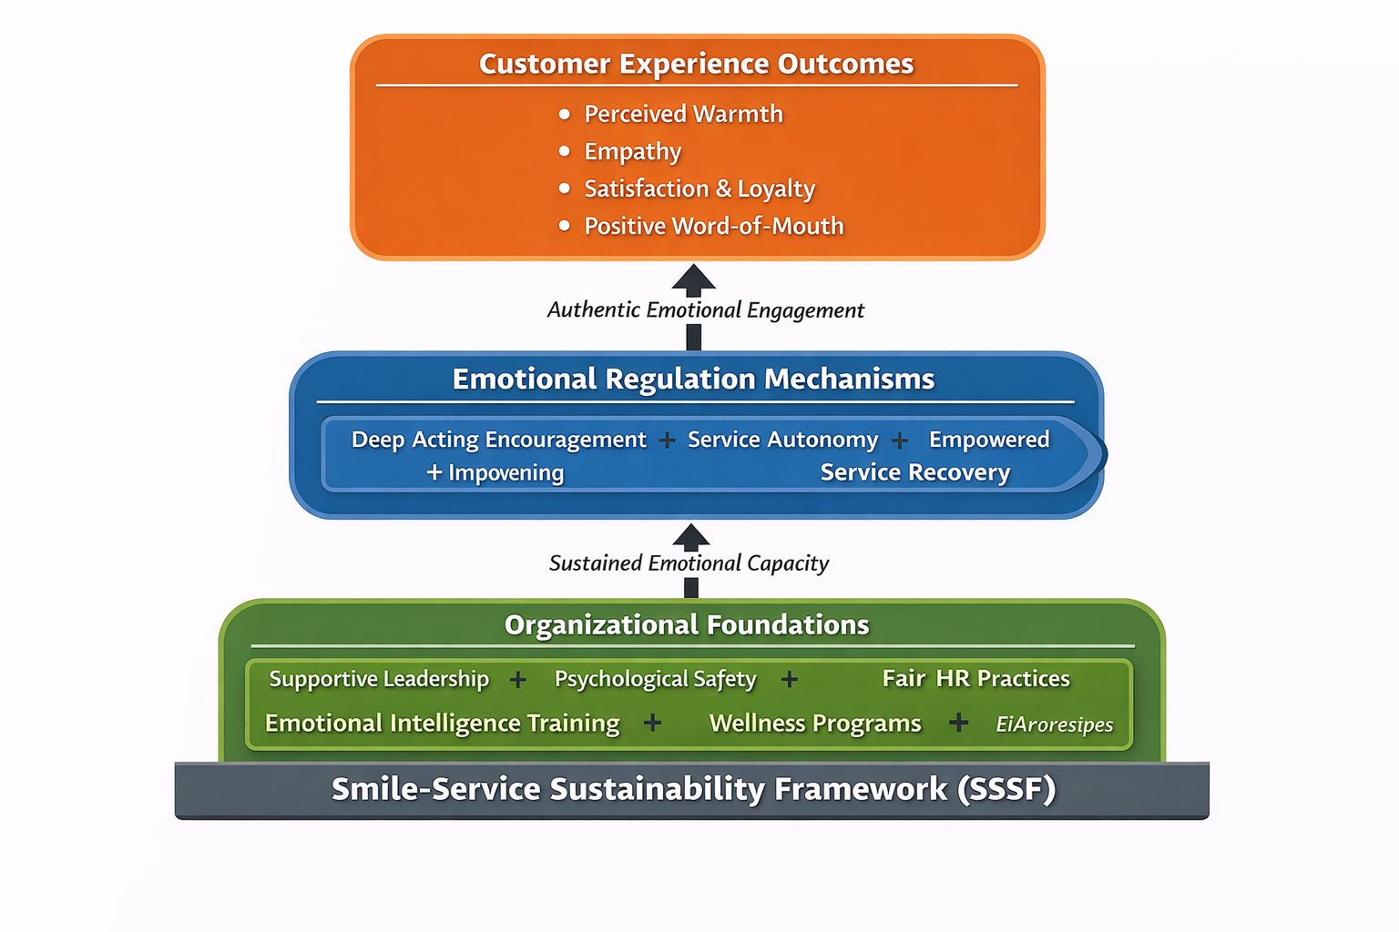

Figure 1 : Smile-Service Sustainability Framework (SSSF)

11. Managerial Implications
- Integrate EI into recruitment processes.
- Implement structured emotional labour management training.
- Provide mental health support systems.
- Align KPIs with authentic service quality.
- Foster leadership modeling of emotional resilience.

12. Theoretical Contributions
- Expands emotional labour research into sustainability perspective.
- Integrates service-profit chain with emotional regulation theory.
- Reconceptualizes smiling as strategic intangible capital.

13. Future Research Directions
- AI-mediated emotional interaction
- Longitudinal emotional labour studies
- Cross-cultural comparative research
- Quantitative validation of SSSF model

14. Conclusions
“Service with a smile” represents a strategic capability embedded within emotional labour systems, organizational culture, and customer experience design.
Sustainable hospitality excellence depends on supporting employee emotional well-being while delivering authentic customer engagement.
Organizations that balance authenticity, leadership support, and experiential excellence achieve long-term competitive advantage.

References (APA 7th Edition)
Blau, P. (1964). Exchange and power in social life. Wiley.
Brotheridge, C. M., & Grandey, A. A. (2002). Emotional labor and burnout. Journal of Vocational Behavior, 60(1), 17–39.
Goleman, D. (1995). Emotional intelligence. Bantam Books.
Grandey, A. A. (2000). Emotion regulation in the workplace. Journal of Occupational Health Psychology, 5(1), 95–110.
Hatfield, E., Cacioppo, J., & Rapson, R. (1994). Emotional contagion. Cambridge University Press.
Heskett, J. L., Jones, T. O., Loveman, G., Sasser, W., & Schlesinger, L. A. (1994). Putting the service-profit chain to work. Harvard Business Review, 72(2), 164–174.
Hochschild, A. R. (1983). The managed heart. University of California Press.
Kandampully, J., Zhang, T., & Jaakkola, E. (2018). Customer experience management. Journal of Hospitality Marketing & Management, 27(1), 21–56.
Parasuraman, A., Zeithaml, V. A., & Berry, L. L. (1988). SERVQUAL. Journal of Retailing, 64(1), 12–40.
Schneider, B., White, S., & Paul, M. (1998). Linking service climate and customer perceptions. Journal of Applied Psychology, 83(2), 150–163.
Vargo, S. L., & Lusch, R. F. (2008). Service-dominant logic. Journal of the Academy of Marketing Science, 36(1), 1–10.

