Brain Care Score, Tau-SUVr and Amyloid-Tau Biomarkers Across Menopausal Transitions in Gender-Specific Determinants of Dementia Risk
Abstract
Current dementia prevention strategies frequently rely on a generalized “one-size-fits-all” framework for risk assessment and clinical evaluation. However, it is evident that substantial biological, hormonal, and socio-behavioral differences between males and females influence both dementia risk and diagnostic accuracy. In this context, the effectiveness of the Brain Care Score (BCS), a 21-point modifiable lifestyle and health assessment tool is evaluated. By synthesizing data from large longitudinal cohort studies involving more than 250,000 participants, we highlight how incremental improvements in modifiable risk factors are associated with measurable reductions in the risk of dementia, stroke, and depression. Conventional diagnostic frameworks may underestimate early cognitive impairment in women. Studies indicate that women often demonstrate higher baseline memory performance and greater cognitive reserve, which can mask early disease manifestations during standard neuropsychological testing. This phenomenon may delay diagnosis despite the presence of underlying neuropathology. Integrating lifestyle-based risk metrics such as BCS with sex-specific biomarker interpretation, including patterns of Amyloid-beta deposition and Tau pathology provides a more accurate assessment of early disease trajectories. Together, these findings support a more integrated framework for dementia prevention that combines lifestyle-based risk scoring with biologically informed, sex-specific diagnostic approaches. Such a strategy aligns with the broader goals of precision medicine by acknowledging that dementia risk and progression are shaped not only by modifiable lifestyle factors but also by sex-dependent neurobiological mechanisms. Incorporating both dimensions into clinical and research paradigms may improve early detection, refine risk stratification, and ultimately guide more effective prevention strategies tailored to individual patient profiles.

Keywords: Dementia Prevention, Brain Care Score, Gender-Specific Medicine, Alzheimer’s Biomarkers, Menopause, Cognitive Resilience

Introduction
The global burden of dementia continues to rise rapidly, with millions of new cases emerging each year across both high-income and low- and middle-income countries. Among neurodegenerative disorders, Alzheimer’s disease and related dementias represent the most prevalent forms, accounting for approximately 60-70 % of all dementia cases worldwide [1]. Epidemiological studies consistently demonstrate that women bear a disproportionate share of dementia prevalence. Nearly two-thirds of individuals diagnosed with Alzheimer’s disease globally are women, suggesting the involvement of biological as well as sociocultural determinants [2]. Several factors contribute to this disparity. Women generally live longer than men, increasing exposure to age-related neurodegenerative processes. However, longevity alone does not fully explain the difference. Biological mechanisms including hormonal transitions during menopause, sex-specific genetic influences, and immune responses may influence vulnerability to neuropathology [3]. Simultaneously, sociocultural variables such as education level, healthcare access, and lifestyle behaviors interact with biological variables to shape dementia risk trajectories. Traditional dementia risk prediction and diagnostic models have largely relied on sex-neutral thresholds for cognitive testing and biomarker interpretation. While these models provide population-level guidance, they may fail to capture important sex-specific variations in disease onset and progression [4]. Consequently, women may remain undiagnosed or diagnosed later in the disease course despite harboring similar levels of underlying neuropathology. Within this context, the Brain Care Score has emerged as a promising population-level tool designed to quantify modifiable risk factors associated with brain health [5]. This research explores how BCS can be integrated with sex-specific diagnostic frameworks to improve both preventative interventions and early detection strategies.
Methodology
The Brain Care Score is a structured, evidence-based assessment developed to quantify modifiable lifestyle and health factors influencing long-term brain health. The score ranges from 0-21 points, with higher scores indicating healthier behaviors and lower risk profiles [6]. The BCS incorporates evidence from major dementia prevention studies, including the Lancet Commission on Dementia Prevention [7], which identified several modifiable risk factors responsible for a significant proportion of dementia cases worldwide. The assessment consists of 12 questions organized into three domains. Hypothetically, a subject gains +3 points if controls blood pressure, gains +1 point if sleeps 7 hours regularly and gains +1 point when increases social engagement.
Total improvement = +5 points
Risk Calculation: 0.90⁵ ≈ 0.59
This means about 41% lower risk of major brain outcomes over time. Figure 1 represents the Brain Care Score (range 0-21) showing progressive risk reduction with increasing score.
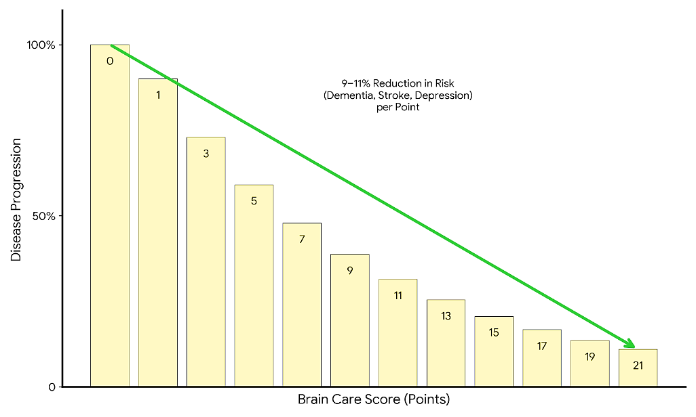
Figure 1. Brain Care Score (range 0-21). Progressive risk reduction with increasing score. Each one-point increase is associated with approximately 9-11% lower risk of major brain outcomes (dementia, stroke, and depression). The score is derived from 12 modifiable factors grouped into behavioral, psychosocial, and clinical domains.
Influencing Factors
Behavioral factors influencing neurological health include diet quality (fruit and vegetable intake), alcohol consumption patterns, smoking status, aerobic physical activity (≥150 minutes per week), and sleep duration & quality (>7 hours per night). Lifestyle interventions targeting these factors have been shown to reduce vascular and neurodegenerative disease risk [8]. Psychosocial health significantly influences cognitive resilience. This domain evaluates stress management, social relationships & engagement, and sense of purpose or meaning in life. Social isolation and chronic stress have been independently associated with increased dementia risk [9]. Clinical indicators of metabolic and cardiovascular health include blood pressure, glycated haemoglobin (HbA1c), cholesterol levels, and body mass index (BMI). These vascular risk factors strongly influence neurodegeneration through mechanisms involving inflammation, endothelial dysfunction, and impaired cerebral perfusion [10].
Results
Population-level analyses (N ≈ 200,000) indicate that the average Brain Care Score across large cohorts is approximately 15.8/21, suggesting moderate adherence to recommended brain-healthy behaviors. One key observation is the strong association between incremental improvements in BCS and reduced neurological risk. Data indicate that each one-point increase in BCS corresponds to approximately a 9-11 % reduction in the risk of dementia, stroke, and depression (figure 1.) [11]. These findings support the growing consensus that targeting modifiable lifestyle factors may substantially delay or reduce the incidence of neurodegenerative disease [12]. Traditional cognitive assessment models often fail to account for sex-specific cognitive differences. Studies demonstrate that women frequently exhibit higher baseline verbal memory performance compared with men, potentially masking early signs of cognitive decline [13]. Table 1 lists the relationship between modifiable lifestyle factors, sex-specific cognitive markers, and endocrine-driven biological risks.
Domain | Key Metrics | Impact on Neurodegeneration
BCS (Preventive) | Diet, Sleep, BP, Social | 1 point = ~10% risk reduction via reduced inflammation.
Cognitive (Diagnostic) | Verbal Memory | High baseline in women masks early atrophy; requires sex-specific thresholds.
Endocrine (Biological) | Estrogen, Menopausal Age | Early menopause triggers mitochondrial dysfunction and Tau spread.
Table 1. Determinants of Neurodegenerative Risk and Diagnostic Trajectories.
Research by Erin Sundermann and colleagues showed that women may maintain normal memory test scores despite having similar levels of amyloid pathology as men. This phenomenon reflects cognitive reserve, defined as the brain’s ability to maintain function despite underlying neuropathology. Figure 2 depicts the cognitive reserve masking effect in women. This shows why women are often diagnosed at a more advanced stage of disease.

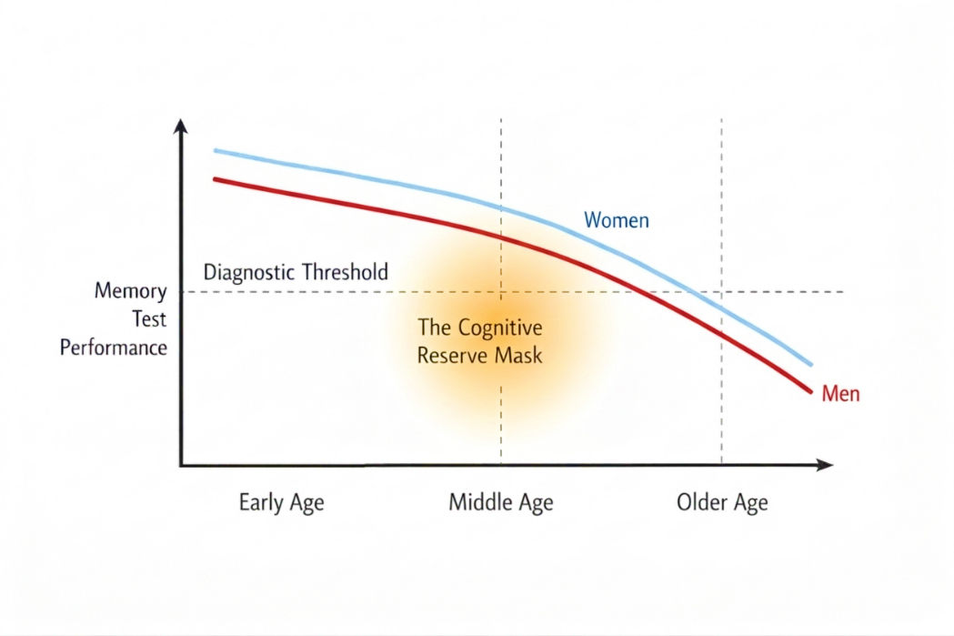
Figure 2. Cognitive reserve masking effect in women. Model showing the relationship between neuropathological burden (amyloid/tau) and memory performance in men and women. Women maintain higher cognitive test performance despite increasing pathology, delaying crossing of the diagnostic threshold. The shaded region represents the “cognitive reserve mask,” where significant pathology may be present despite normal cognitive scores.
While cognitive reserve may delay symptom onset, it can also contribute to delayed diagnosis. As a result, women may present with more advanced neuropathology at the time of diagnosis. Studies comparing sex-neutral diagnostic thresholds with sex-specific benchmarks demonstrate that amnestic Mild Cognitive Impairment (aMCI) is significantly underdiagnosed in women when traditional criteria are applied [14]. Hormonal transitions during menopause represent a major biological determinant of dementia risk in women. Declining Estrogen levels affect synaptic plasticity, mitochondrial function, and glucose metabolism in the brain [15]. Lisa Mosconi and colleagues (2025) demonstrated that menopausal timing and hormone therapy initiation influence Alzheimer’s disease biomarker trajectories, particularly interactions between amyloid accumulation and entorhinal cortex tau-SUVr [16]. Figure 3 illustrates the changes in tau deposition (entorhinal cortex Tau-SUVr) across pre-menopause, perimenopause, and post-menopause.
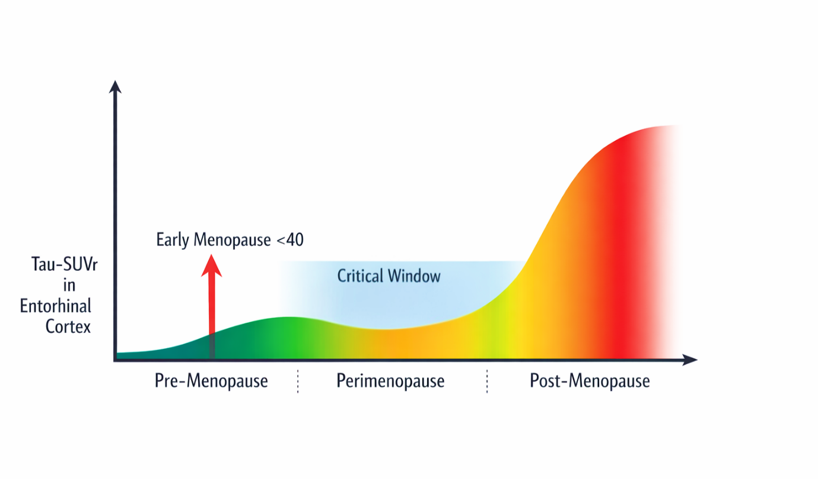
Figure 3. Hormonal window and tau accumulation across menopausal transition. Changes in tau deposition (entorhinal cortex Tau-SUVr) across pre-menopause, perimenopause, and post-menopause are depicted. Early menopause (<40 years) is presented as an accelerated inflection point for tau accumulation. The shaded region indicates the proposed “critical window”.
Specific Variables
Early menopause (before age 40) has been associated with increased tau accumulation and elevated Alzheimer’s disease risk [16]. Hormonal Imbalance after menopause is associated with higher tau pathology. These findings highlight the importance of incorporating reproductive history into dementia risk assessment frameworks.
Discussion
This paper proposes a dual-pathway framework describing how lifestyle and biological factors influence cognitive aging. Resistance mechanisms prevent or slow the development of neuropathology, including amyloid-beta plaque formation, tau neurofibrillary tangles, and TDP-43 protein aggregation. Lifestyle factors captured by the Brain Care Score, such as physical activity and cardiovascular health, may enhance resistance through anti-inflammatory and vascular protective mechanisms [5]. Resilience refers to the brain’s ability to maintain function despite pathology. Mechanisms include neural network efficiency, synaptic plasticity, and cognitive reserve. Female-specific factors; including X-chromosome gene expression, pregnancy history, and hormonal transitions may influence these resilience pathways [17]. Understanding how resistance and resilience interact may enable more personalized dementia prevention strategies. Recent advances in biomarker and mechanistic research further emphasize the importance of incorporating sex-specific considerations into dementia prevention and clinical research. Blood-based biomarkers; including amyloid-beta ratios, phosphorylated tau isoforms, and neurofilament light chain have emerged as minimally invasive tools for early detection of neurodegenerative pathology and may provide opportunities for more personalized diagnostic frameworks when interpreted in the context of biological differences between populations [18]. At the molecular level, experimental studies investigating tau pathology have demonstrated how subtle biological variations can substantially influence disease mechanisms. For instance, analyses of induced pluripotent stem cell-derived neurons and MAPT mutant mouse models have revealed a fetal tau bias, highlighting how developmental differences in tau isoform expression alter aggregation dynamics and vulnerability to pathology [19]. This distinction between fetal and adult tau biology illustrates how biological context can significantly influence neurodegenerative processes; by analogy, similar sex-based biological differences may contribute to divergent dementia trajectories between males and females. Consequently, future neuroscience clinical trials must account for such biological heterogeneity, as overlooking sex-specific differences in biomarker profiles, hormonal transitions, and disease progression has been identified as a key contributor to translational failures in neurodegenerative research [20]. Integrating gender-informed biomarker interpretation and stratified clinical trial design may therefore improve the reliability of therapeutic development and enhance the precision of dementia prevention strategies.
Conclusion
Reducing the global burden of dementia will require moving beyond generalized public health recommendations toward precision-based prevention strategies. The Brain Care Score provides a practical framework for identifying modifiable risk factors and guiding lifestyle interventions that promote brain health. However, its predictive value may be improved when combined with gender-specific diagnostic models; incorporating biomarker interpretation, hormonal history, and cognitive reserve metrics. Future research should focus on refining BCS algorithms to include female-specific risk modifiers such as reproductive health history, hormone therapy timing, and social connectivity patterns. Such refinements may enhance early detection and prevention strategies for neurodegenerative diseases.
List of abbreviations
BCS: Brain Care Score
Aβ: Amyloid-beta, Tau represents Tau protein
SUVr: Standardized Uptake Value Ratio
HR: Hazard Ratio
MCI: Minor cognitive Impairment
AD: Alzheimer's disease AD
PET: Positron Emission Tomography
MRI: Magnetic Resonance Imaging
HbA1c: Hemoglobin A1c
BMI: Body Mass Index

Ethics Statement
This article is a conceptual analysis based on previously published studies and does not involve human participants or animal experiments; therefore, ethical approval was not required.
Conflict of Interest
The authors declare that they have no known competing financial interests or personal relationships that could have appeared to influence the work reported in this paper.
Author Contributions
AK conceptualized the research theme, carried out literature review & data synthesis, validated the scientific statistics and wrote the entire manuscript. RM supervised data curation, and reviewed the manuscript for errors. SK interpreted pharmacological and biomarker-related evidence. UB contributed with methodological inputs, and proofread the manuscript. All authors read and approved the final version of the manuscript.
Acknowledgements
Aditi Kaushik acknowledges the institutional support provided by NIILM University, Kaithal; Atam Institute, OSGU, Hisar; and Ram Gopal College of Pharmacy, Gurugram, for facilitating the academic environment necessary for the completion of this work.

REFERENCES
- National Institutes of Health. (2025). 2025 NIH Alzheimer’s disease and related dementias research progress report: Advances and achievements. U.S. Department of Health and Human Services, National Institute on Aging. https://dictionary.cambridge.org/dictionary/english/report
- Moutinho, S. (2025). Women twice as likely to develop Alzheimer’s disease as men — but scientists do not know why. Nature Medicine, 31(3), 704-707. https://doi.org/10.1038/s41591-025-03564-3
- Mervosh, N., & Devi, G. (2025). Estrogen, menopause, and Alzheimer’s disease: Understanding the link to cognitive decline in women. Frontiers in Molecular Biosciences, 12, Article 1634302. https://doi.org/10.3389/fmolb.2025.1634302
- Sofonea, M. T., Cauchemez, S., & Boëlle, P. Y. (2022). Epidemic models: why and how to use them. Anaesthesia, critical care & pain medicine, 41(2), 101048. https://doi.org/10.1016/j.accpm.2022.101048
- Schiloski, K., Taylor, M., & Lachman, M. (2024). Use of a Brain Care Score to identify risk and Protective Factors for maintaining cognition and health in later life. Innovation in Aging, 8(Suppl 1), 947. https://doi.org/10.1093/geroni/igae098.3054
- Corliss, J. (2024, November 1). What's your Brain Care Score? Harvard Health Publishing. https://www.health.harvard.edu/heart-health/whats-your-brain-care-score
- Livingston, G., Huntley, J., Liu, K. Y., Costafreda, S. G., Selbæk, G., Alladi, S., Ames, D., Banerjee, S., Burns, A., Brayne, C., Fox, N. C., Ferri, C. P., Gitlin, L. N., Howard, R., Kales, H. C., Kivimäki, M., Larson, E. B., Nakasujja, N., Rockwood, K., Samus, Q., … Mukadam, N. (2024). Dementia prevention, intervention, and care: 2024 report of the Lancet standing Commission. Lancet (London, England), 404(10452), 572-628. https://doi.org/10.1016/S0140-6736(24)01296-0
- Granero, R., & Guillazo-Blanch, G. (2025). Nutrition and Dietary Patterns: Effects on Brain Function. Nutrients, 17(7), 1169. https://doi.org/10.3390/nu17071169
- Bartlett, L., Fair, H., Bindoff, A., & others. (2025). Loneliness and social isolation correlate with multiple modifiable risk factors for chronic diseases including dementia. Journal of Public Health (Berl.). Advance online publication. https://doi.org/10.1007/s10389-025-02412-5
- Yang, H.-M. (2025). Vascular Dementia: From Pathophysiology to Therapeutic Frontiers. Journal of Clinical Medicine, 14(18), 6611. https://doi.org/10.3390/jcm14186611
- MGH Communications. (2023, December 1). Brain Care Score reveals risk of dementia, stroke. The Harvard Gazette. https://news.harvard.edu/gazette/story/2023/12/brain-care-score-reveals-risk-of-dementia-stroke/
- Liu, X., Etxeberria, U., & Ruiz-Canela, M. (2023). Editorial: Nutrition and neurodegenerative diseases: insights and perspectives on prevention strategies. Frontiers in nutrition, 10, 1272338. https://doi.org/10.3389/fnut.2023.1272338
- Novozhilova, S., Fonov, V., Shafie, N., Klein, D., Villeneuve, S., & Collins, D. L. (2025). The role of verbal memory in masking Alzheimer’s disease symptoms in women [Preprint]. medRxiv. https://doi.org/10.1101/2025.11.07.25339777
- Sundermann, E. E., Maki, P. M., Rubin, L. H., Lipton, R. B., Landau, S., Biegon, A., & Alzheimer's Disease Neuroimaging Initiative (2016). Female advantage in verbal memory: Evidence of sex-specific cognitive reserve. Neurology, 87(18), 1916-1924. https://doi.org/10.1212/WNL.0000000000003288
- Zhao, W., Hou, Y., Song, X., Wang, L., Zhang, F., Zhang, H., Yu, H., & Zhou, Y. (2021). Estrogen Deficiency Induces Mitochondrial Damage Prior to Emergence of Cognitive Deficits in a Postmenopausal Mouse Model. Frontiers in aging neuroscience, 13, 713819. https://doi.org/10.3389/fnagi.2021.713819
- Mosconi, L., Nerattini, M., Williams, S., & Fink, M. (2025). New Horizons in Menopause, Menopausal Hormone Therapy, and Alzheimer's Disease: Current Insights and Future Directions. The Journal of clinical endocrinology and metabolism, 110(4), 911-921. https://doi.org/10.1210/clinem/dgaf026
- Lafta, M. S., Mwinyi, J., Affatato, O., Rukh, G., Dang, J., Andersson, G., & Schiöth, H. B. (2024). Exploring sex differences: Insights into gene expression, neuroanatomy, neurochemistry, cognition, and pathology. Frontiers in Neuroscience, 18, Article 1340108.
- Mandal, P. K., Maroon, J. C., Garg, A., Arora, N. K., Bansal, R., Kaushik, A., Samkaria, A., Kumaran, G., & Arora, Y. (2023). Blood biomarkers in Alzheimer’s disease. ACS Chemical Neuroscience, 14(22), 3975-3978. https://doi.org/10.1021/acschemneuro.3c00641
- Kaushik, A., Mor, R., Kaura, S., Kaushik, A., & Sharma, S. (2025). Fetal tau bias in iPSC-derived neurons, MAPT mutant mouse models and molecular mechanisms assessment for integrative analysis of tau pathology. International Journal of Research and Scientific Innovation, 12(11). https://doi.org/10.51244/IJRSI.2025.12110120
- Kaushik, A., Bhardwaj, U., & Kaura, S. (2026). Systemic failures in human neuroscience trials and how to fix them. International Journal of Research and Scientific Innovation, 13(1). https://doi.org/10.51244/IJRSI.2026.13010155

