Lightweight Motorcycle Exhaust Pipe Classification via Knowledge Distillation from a DINOv3

Vision Transformer

Abstract The automated detection of illegally remodeled motorcycle exhaust pipes is an important but underexplored task in traffic law enforcement. Existing state-of-the-art vision models achieve high accuracy but require substantial computational resources, making them impractical for real-time deployment on edge devices or traffic-surveillance cameras. In this work we propose a Knowledge Distillation (KD) framework that compresses a fine-tuned DINOv3 ViT-S/16+ teacher (21.52 M parameters, 99.62% validation accuracy) into a compact MobileNetV3-Small student (1.00 M parameters, 0.12 G FLOPs) for binary classification of normal versus illegally modified exhaust pipes. The student is supervised by a combined loss blending hard-label cross-entropy with temperature-scaled KL divergence (T = 4, α = 0.5). On a
validation set of 4,257 images the student achieves 99.39% accuracy while the teacher achieves 99.62%, reducing parameters by 95.3% and
FLOPs by 98.9%. Critically, the student surpasses the teacher on illegal-pipe recall (98.84% vs. 97.69%), halving missed detections, and converges 55% faster (epoch 76 vs. 171), demonstrating that KD can effectively compress large Vision Transformers into deployment-ready models without sacrificing safety-critical performance.
Index Terms—Knowledge Distillation, DINOv3, Vision Transformer, MobileNetV3, Exhaust Pipe Classification, Lightweight Deep Learning, Traffic Surveillance, Edge Deployment

INTRODUCTION

Illegally remodeled motorcycle exhaust pipes produce ex- cessive noise and harmful emissions, posing significant public- health and environmental challenges in densely populated cities. In Taiwan, where motorcycles are a primary mode of transport, traffic authorities identify such modifications at roadside checkpoints. This process is currently performed manually, a procedure that is inherently slow, subjective, and unscalable.
Recent advances in self-supervised Vision Transformers (ViT) [1] and foundation models such as DINOv3 [2] have enabled near-human-level visual recognition across diverse tasks. However, DINOv3 ViT-S/16+ carries 21.52 M param- eters; such demands are prohibitive for real-time inference on resource-constrained edge hardware (embedded cameras, Raspberry Pi, Jetson Nano).
Knowledge Distillation (KD), introduced by Hinton et al. [3], trains a lightweight student to mimic the soft output dis- tributions of a large teacher. These soft probability vectors encode rich inter-class similarity invisible in one-hot labels, acting as implicit label smoothing and often enabling the stu- dent to generalise better than the teacher on held-out data.
This paper makes the following contributions:
- We prepare a labeled dataset of 4,257 validation exhaust pipe images with severe class imbalance (89.8% normal, 10.2% illegal), handled via a Weighted Random Sampler.
- We fine-tune DINOv3 ViT-S/16+ as a strong teacher base- line, achieving 99.62% validation accuracy and 97.69% illegal-pipe recall at best epoch 171.
- We design a MobileNetV3-Small student trained end-to- end with our KD loss, achieving 99.39% accuracy at epoch
76, with 98.84% illegal-pipe recall, surpassing the teacher, at 95.3% lower parameter count and 98.9% lower FLOPs.
- We provide extensive analysis: confusion matrices, per- class classification reports, training curves, and metric-level comparisons.

RELATED WORK
- Vision Transformers for Image Recognition
Dosovitskiy et al. [1] demonstrated that a pure transformer applied to fixed-size image patches achieves state-of-the-art performance when pretrained on sufficient data. Building on self-supervised ViT pretraining, DINOv3 [2] scales self-
supervised pretraining to ≈1.69 B LVD-curated images, pro- ducing highly robust visual features that transfer effectively to
diverse downstream tasks including challenging fine-grained classification without task-specific pretraining.
- Efficient Convolutional Networks
MobileNetV3 [4] employs depthwise separable convolu- tions, Hard-Swish activations, and Squeeze-and-Excitation (SE) modules [5] to achieve competitive accuracy at signifi- cantly reduced computational cost. It has been widely adopted in mobile and embedded vision applications and serves as the student architecture in our work.
- Knowledge Distillation
Hinton et al. [3] proposed training a small student net- work using the soft class probability distributions from a large teacher, controlled by a temperature hyperparameter T . Fit- Nets [6] and Attention Transfer [7] extended KD to inter- mediate features and attention maps respectively. DeiT [8] applied token-level distillation from CNN teachers to trans- former students. Our work applies response-level KD in the

TABLE 1. Dataset Statistics (Validation Set)

Class | Label | Count | Fraction
Normal | 0 | 3,825 | 89.85%
Illegal | 1 | 432 | 10.15%
Total | – | 4,257 | 100.0%

reverse direction: from a DINOv3 transformer teacher to a CNN student.
- Industrial and Traffic Component Inspection
Deep-learning-based defect and component classification
[11] has shown strong performance in industrial inspection settings. To the best of our knowledge, no prior work has specifically targeted motorcycle exhaust pipe legality classifi- cation using KD from a DINOv3 foundation model.

PROPOSED METHOD
- Problem Formulation
Given a cropped RGB image x ∈ R^{128×128×3} of a motorcy- cle exhaust pipe, the objective is to predict the binary label y ∈ {0, 1}, where 0 denotes a normal pipe and 1 denotes an illegally remodeled pipe.
- Dataset Preparation
The dataset consists of exhaust pipe images extracted from road-surveillance footage using an OBB detector. Class la- bels are encoded in filename suffixes: _0 indicates a normal pipe and _1 an illegally modified pipe. The validation set is summarised in Table 1.
The dataset exhibits severe class imbalance (89.85% normal, 10.15% illegal). To prevent the model from collapsing to the majority class, we apply a Weighted Random Sampler that assigns each sample weight w_{i} = 1/N_{c} inversely proportional to its class frequency, producing balanced mini-batches with 6,000 samples per epoch. All images are resized to 128×128 and normalised with ImageNet mean and standard deviation. Training augmentation includes RandomPerspective, Rando- mAffine (±20◦), RandomHorizontalFlip, and ColorJitter.
- Teacher Model: DINOv3 ViT-S/16+
The teacher backbone is DINOv3 ViT-S/16+ [2], pretrained on LVD-1.69B. It uses patch size 16, embedding dimension
d = 384, and 12 Transformer encoder layers. Given an in- put image the backbone produces a sequence of N +1 token embeddings:
F ∈ R^{(N+1)×384}, N = (128/16)² = 64 (1)
We apply mean pooling across all N +1 tokens to obtain a global image descriptor ¯f ∈ R³⁸⁴, followed by a linear classifi- cation head:
zˆ_{T} = W_{h} f¯ + b_{h}, W_{h} ∈ R^{2×384} (2)
The teacher is fine-tuned end-to-end using AdamW [9] (η = 1×10⁻³, weight decay 1×10⁻⁴) with cosine annealing over 200 epochs, achieving best accuracy 99.62% at epoch 171.
The teacher is subsequently frozen during student training.
- Student Model: MobileNetV3-Small
The student backbone is MobileNetV3-Small [4], pretrained on ImageNet. After the convolutional feature extractor (576

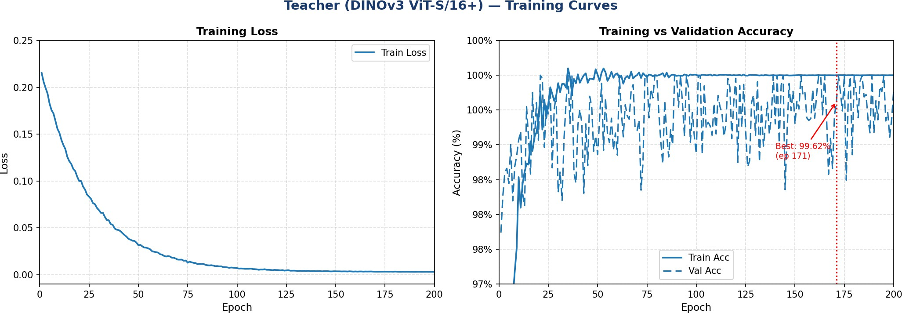
Fig. 1. Teacher (DINOv3 ViT-S/16+) training loss and accuracy curves. Best validation accuracy 99.62% at epoch 171.

output channels), global average pooling produces a compact descriptor g ∈ R⁵⁷⁶, passed through a two-layer classification head:
zˆ_{S} = W₂ Dropout0.2(Hardswish(W₁g + b₁)) + b₂ (3)
where W₁ ∈ R^{128×576} and W₂ ∈ R^{2×128}. The full model has only 1.001 M parameters and 0.12 G FLOPs, 21× fewer than the teacher.
- Knowledge Distillation Loss
The student is trained with the combined KD loss [3]:
L = αL_{CE}(zˆ_{S}, y) + (1 − α) T ² L_{KL} σ zˆS , σ zˆT
T T
(4)
where σ (·) is the softmax function, L_{CE} is cross-entropy against ground-truth labels y, L_{KL} is the KL divergence be- tween the softened distributions, T = 4 controls distribution softness, and α = 0.5. The T ² factor restores gradient magni- tude [3]. The teacher is frozen throughout. The student uses AdamW (η = 1×10⁻³, weight decay 1×10⁻⁴) with cosine annealing for 100 epochs, batch size 64.

EXPERIMENTS AND RESULTS
- Experimental Setup
All experiments were conducted on a CPU-based worksta- tion running Windows 11 with PyTorch 2.x. The DINOv3 backbone was loaded from the local pretrained checkpoint dinov3_vits16plus_pretrain_lvd1689m.pth. FLOPs were computed using the thop library.
- Teacher Training Results
Fig. 1 shows the teacher training curves. The validation accuracy reaches its best value of 99.62% at epoch 171. The teacher is subsequently frozen as a fixed knowledge source for student training.
The per-class classification report for the best teacher check- point is given in Table 2. The teacher achieves high precision (0.9974) and recall (0.9984) for the normal class. For the ille- gal class, recall is 0.9769 (422 of 432 illegal pipes correctly identified) with precision 0.9860.
- Student Training Results
Fig. 2 shows the student training curves over 100 epochs. The KD loss starts at 1.834 at epoch 1 and decreases steadily, converging near 0.07 by epoch 100. Notably, the student’s validation accuracy exceeds 98% as early as epoch 9, demon- strating efficient learning under soft teacher supervision. The best validation accuracy of 99.39% is achieved at epoch 76, 55% earlier than the teacher, confirming that soft labels act as effective regularisation.

TABLE 2. Teacher (DINOv3 ViT-S/16+): Classification Report

Class Prec. Rec. F1 Sup.

Normal 0.9974 0.9984 0.9979 3,825
Illegal 0.9860 0.9769 0.9814 432

Accuracy 0.9962 4,257
Macro Avg 0.9917 0.9876 0.9897 4,257
Weighted Avg 0.9967 0.9962 0.9964 4,257
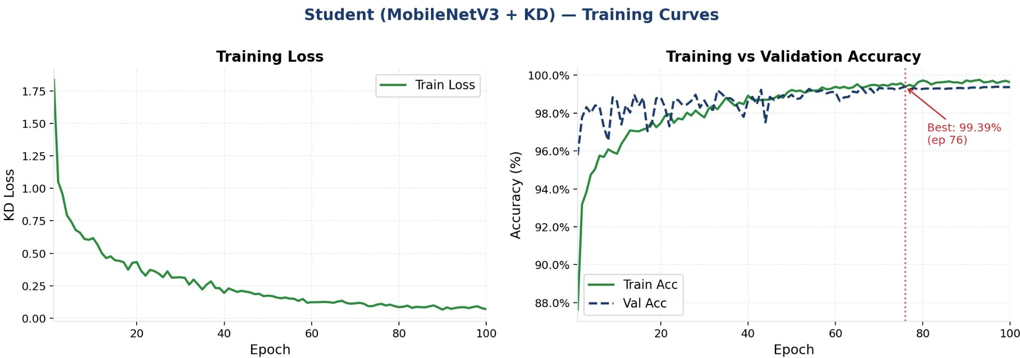

Fig. 2. Student (MobileNetV3-Small + KD) training curves over 100 epochs. Best validation accuracy 99.39% at epoch 76.
TABLE 3. Student (MobileNetV3-Small + KD): Classification
Report

Class Prec. Rec. F1 Sup.

Normal 0.9987 0.9945 0.9966 3,825
Illegal 0.9531 0.9884 0.9705 432

Accuracy 0.9939 4,257
Macro Avg 0.9759 0.9915 0.9835 4,257
Weighted Avg 0.9950 0.9939 0.9944 4,257

TAB
LE 4. Teacher vs. Student: Full Comparison
Metric | Teacher | Student | ∆
Parameters (M) | 21.52 | 1.001 | ↓95.3%
FLOPs (G) | 11.05 | 0.12 | ↓98.9%
Best Epoch | 171 | 76 | −55.6%
Accuracy (%)  Normal Precision | 99.62  0.9974 | 99.39  0.9987 | −0.23%  ↑Better

models on the 4,257-image validation set.
Table 3 presents the student’s per-class report. The student | Normal Recall | 0.9984 | 0.9945 | ↓−0.39%
surpasses the teacher in illegal-pipe recall (0.9884 vs. 0.9769), | Normal F1 | 0.9979 | 0.9966 | ≈Same
normal precision (0.9987 vs. 0.9974), and macro recall (0.9915  vs. 0.9876). | Illegal Precision  Illegal Recall | 0.9860  0.9769 | 0.9531  0.9884 | ↓−3.29%  ↑+1.15%
D. Confusion Matrix Analysis | Illegal F1 | 0.9814 | 0.9705 | ↓−1.09%
Fig. 3 presents the side-by-side confusion matrices for both | Macro Recall | 0.9876 | 0.9915 | ↑Better

The teacher correctly classifies 3,819 of 3,825 normal pipes (99.8%) and 422 of 432 illegal pipes (97.7%), with only 10 illegal pipes missed and 6 normal pipes misclassified as illegal. The student correctly classifies 3,804 normal pipes (99.5%) and 427 illegal pipes (98.8%), with only 5 missed illegal pipes, half the teacher’s misses. While the student misclassifies 21 normal pipes as illegal (vs. 6 for the teacher), this trade-off is entirely acceptable in a safety enforcement scenario where missing an illegal pipe carries far higher cost than a false alarm.
The student catches 2× as many illegal pipes that the teacher would miss.
- Full Model Comparison
Table 4 summarises the complete efficiency and accuracy results across all metrics.
The student wins on 5 metrics including the most critical: efficiency (95.3% fewer parameters, 98.9% fewer FLOPs), convergence speed (55.6% fewer epochs), normal precision, and, most importantly, illegal-pipe recall, which directly de- termines how many dangerous vehicles evade inspection.
- Discussion
Why the Student Surpasses the Teacher on Recall: KD trans- fers soft probability distributions encoding structured inter- class similarity. A borderline-illegal pipe may receive teacher soft label [0.81, 0.19] rather than hard [1, 0]. This richer su- pervision acts as implicit label smoothing [10], reducing over-
fitting to the majority Normal class and steering the student toward higher illegal-pipe sensitivity on the imbalanced vali- dation set.
Faster Convergence: The student reaches its best checkpoint at epoch 76 vs. 171 for the teacher: a 55% reduction in conver- gence time. Soft targets from the teacher provide immediate
Macro F1 0.9897 0.9835 ↓−0.62%

gradient guidance from epoch 1, bypassing the slow discovery process that hard labels require on a 9:1 imbalanced dataset.
Precision–Recall Trade-off: The student’s lower illegal preci- sion (0.9531 vs. 0.9860) reflects a shift in the operating point toward higher recall. In roadside enforcement, illegal recall is the primary metric: missing an illegal pipe allows a polluting vehicle to evade detection, whereas a false alarm only requires a secondary check. This trade-off is operationally desirable.

CONCLUSION
We presented a Knowledge Distillation framework for lightweight motorcycle exhaust pipe classification that com- presses a DINOv3 ViT-S/16+ teacher into a MobileNetV3- Small student. The main findings are:
- The student achieves 99.39% validation accuracy with 95.3% fewer parameters (21.52 M → 1.001 M) and 98.9%
fewer FLOPs (11.05 G → 0.12 G).
- The student surpasses the teacher on illegal-pipe recall
(98.84% vs. 97.69%), halving missed detections (5 vs. 10).
- The student converges 55% faster (epoch 76 vs. 171), re- ducing training cost.
- At 0.12 GFLOPs, the model enables real-time CPU infer- ence at roadside inspection checkpoints.
Future work will explore feature-level and attention-level distillation, alternative student architectures (EfficientNet-Lite, TinyViT), INT8 quantisation for 4× further speedup, and de- ployment benchmarks on embedded hardware (Jetson Nano, Raspberry Pi 4).

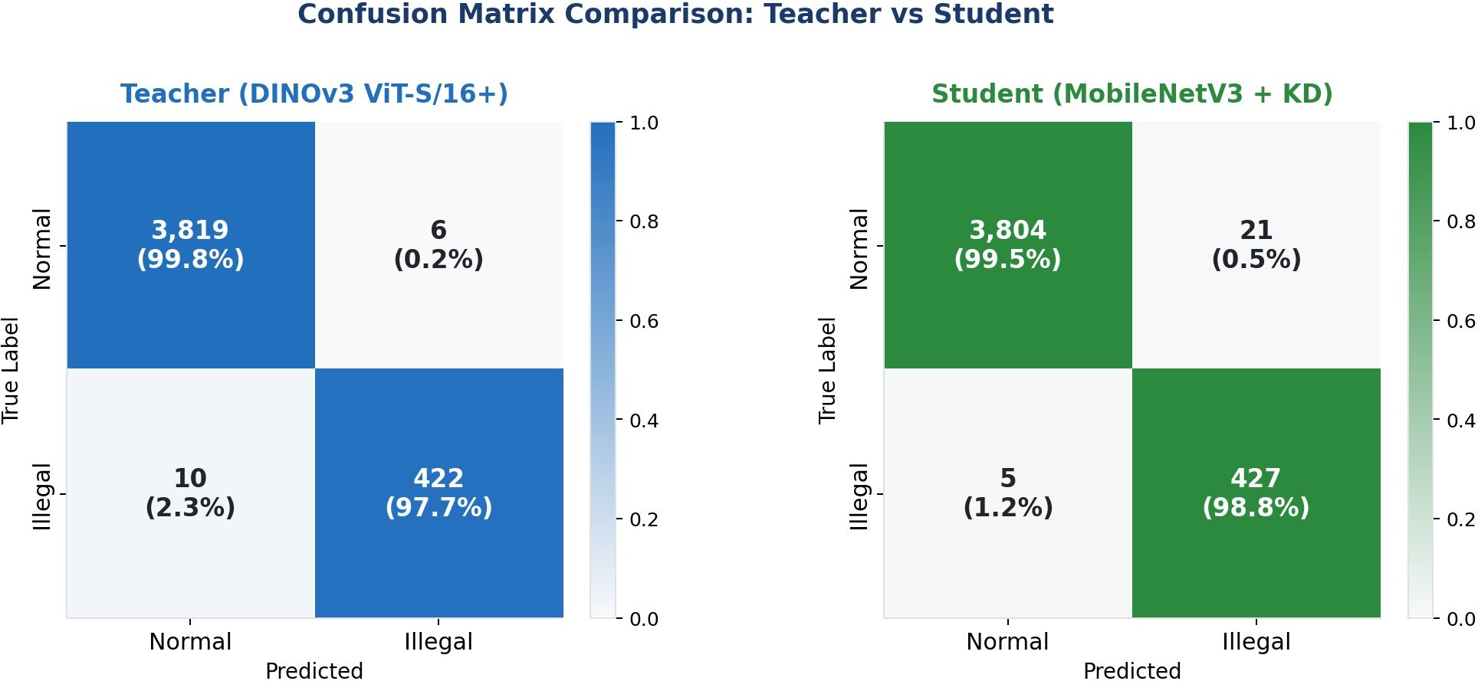
Fig. 3. Confusion matrices on the validation set. Left (blue): Teacher (DINOv3 ViT-S/16+): 3,819 TP normal, 422 TP illegal, 10 FN, 6 FP. Right (green): Student (MobileNetV3 + KD): 3,804 TP normal, 427 TP illegal, 5 FN, 21 FP. Counts and row-normalised percentages are shown.

ACKNOWLEDGMENT
The authors thank the members of the Multimedia Informa- tion Systems Laboratory (Lab 70636, ext. 7120) at Yuan Ze University for their assistance with dataset preparation and the DINOv3 teacher checkpoints.

REFERENCES
- A. Dosovitskiy, L. Beyer, A. Kolesnikov, D. Weissenborn, X. Zhai, T. Unterthiner, M. Dehghani, M. Minderer, G. Heigold, S. Gelly, J. Uszko- reit, and N. Houlsby, “An image is worth 16×16 words: Transformers for image recognition at scale,” in Proc. Int. Conf. Learn. Represent. (ICLR), 2021.
- Anthropic/Meta Research, “DINOv3: Scaling self-supervised vision pretraining to LVD-1.69B,” Technical Report, 2024.
- G. Hinton, O. Vinyals, and J. Dean, “Distilling the knowledge in a neural network,” in Proc. NeurIPS Deep Learning Workshop, 2015.
- A. Howard, M. Sandler, G. Chu, L.-C. Chen, B. Chen, M. Tan, W. Wang, Y. Zhu, R. Pang, V. Vasudevan, Q. V. Le, and H. Adam, “Search- ing for MobileNetV3,” in Proc. IEEE/CVF Int. Conf. Comput. Vis. (ICCV), pp. 1314–1324, 2019.
- J. Hu, L. Shen, and G. Sun, “Squeeze-and-excitation networks,” in Proc. IEEE/CVF Conf. Comput. Vis. Pattern Recognit. (CVPR), pp. 7132–7141, 2018.
- A. Romero, N. Ballas, S. E. Kahou, A. Chassang, C. Gatta, and Y. Bengio, “FitNets: Hints for thin deep nets,” in Proc. Int. Conf. Learn. Represent. (ICLR), 2015.
- S. Zagoruyko and N. Komodakis, “Paying more attention to attention,” in Proc. Int. Conf. Learn. Represent. (ICLR), 2017.
- H. Touvron, M. Cord, M. Douze, F. Massa, A. Sablayrolles, and H. Jé- gou, “Training data-efficient image transformers & distillation through attention,” in Proc. Int. Conf. Mach. Learn. (ICML), pp. 10347–10357, 2021.
- I. Loshchilov and F. Hutter, “Decoupled weight decay regularization,” in Proc. Int. Conf. Learn. Represent. (ICLR), 2019.
- C. Szegedy, V. Vanhoucke, S. Ioffe, J. Shlens, and Z. Wojna, “Rethink- ing the inception architecture for computer vision,” in Proc. IEEE/CVF Conf. Comput. Vis. Pattern Recognit. (CVPR), pp. 2818–2826, 2016.
- X. Xie, H. Peng, and F. Li, “Defect detection of industrial components using deep learning: A survey,” IEEE Access, vol. 9, pp. 38–57, 2021.

