HYDROGEOPHYSICAL ASSESSMENT OF AQUIFER VULNERABILITY IN AMAWBIA AND ITS ENVIRONS
Abstract
The rapid increase in the population of Amawbia have increased the demand for groundwater resources. This increase has necessitated the evaluation of aquifer protective capacity in order to protect it from contamination. The electrical resistivity measurement was used to assess the aquifer protective capacity of Amawbia. Vertical electrical sounding data were collected at four locations. The interpretation was done using Winresist software. The result revealed the lithology of the area comprises mainly of latrite, clayey sand, shale, dry sand and saturated sand. The longitudinal conductance was computed using the resistivity and thickness values obtained from the interpreted data to evaluate the protective capacity. The protective capacity values ranged between 0.0081 to 1.3486 mhos. The result revealed that most of the areas investigated are vulnerable to groundwater contamination.
Keywords: Groundwater, Electrical resistivity, vulnerability and Longitudinal conductance
1.Introduction
Amawbia is one of the fastest growing towns in South East, Nigeria with a population of about 200,000 people. The town has experienced a lot of development both human and infrastructure. It is estimated that by next ten years, the population will double. The increasing population growth has led to rise in groundwater demand since over 90% of the population depend on groundwater. However, the quality and sustainability of groundwater depends largely on the protective capacity. Aquifers that lack adequate protection will be vulnerable to contamination.
In recognition of the need for protecting groundwater resources from contamination, geophysicts have sought to develop methods for predicting areas that are vulnerable to contamination.
Electrical method is one of the methods developed and is a very suitable tools in exploration and has been widely applied in groundwater investigation (Obiajulu, 2021). The use of electrical resistivity method in investigating aquifer vulnerability is increasing becoming popular all over the world and it provides cost effective and an efficient means of collecting information about the subsurface of an area.
Researchers have used the method to investigate the aquifer vulnerability among them are Akana et al., (2016) that used it to assess aquifer vulnerability to pollution in Yenagoa, Bayelsa State, Nigeria. Atakpo (2013) applied the method to evaluate the vulnerability in Amukpe of Delta State, Nigeria. Oni et al., (2017) also the electrical method to evaluate groundwater vulnerability in Igbara Oke, Southwestern Nigeria.
The present study is aimed at using electrical resistivity method to evaluate aquifer vulnerability in Amawbia and its environs.
2. Description of the Study Area
The study area Amawbia is located in Awka South Local Government of Anambra State, Nigeria. The area lies 96 m above sea level. It is located along the old Enugu- Onitsha express road. The climate of the study area is tropical with its temperature around 28⁰c between April and October but rises to 33⁰c between November and March (Nimet, 2012; Obiajulu and Okpoko, 2014). The study area lies within the Anambra basin in the lower Benue trough tectonic unit and are mainly underlain by the Imo shale formation. Fig 1 is the topographic map of Awka South showing the study area.

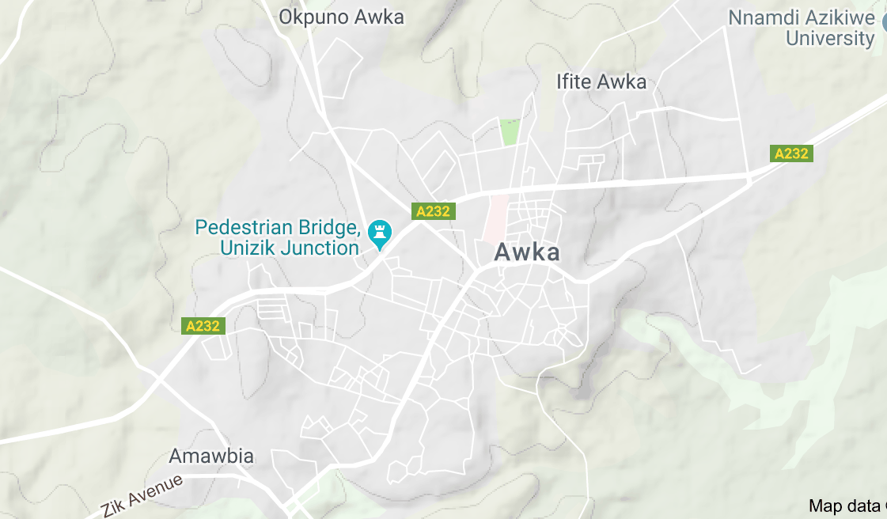
Fig 1: Topographic map of the study area

3. Materials and Method
3.1 Materials
The materials used for this research work include two current electrodes through which currents are passed, potential electrodes which were used to measure the voltage, Mc Ohm resistivity meter which was used to record apparent resistivity values. Others materials used are 12v battery used to power Mc Ohm resistivity meter, cables, hammers and measuring tapes etc.
3.2 Method
In the electrical resistivity method, an electric current is passed into the ground through current electrodes, the resulting potentials are measured at the surface using potential electrodes. Variations in the resistivity of materials beneath the ground affect how the electrical potential is distributed at the surface. The extent of this effect depends on the shape, size and resistivity of the underground materials. (Vingoe, 1972). For Schlumberger configuration, apparent resistivity according to Dobrin (1983) is given by:
$ρ_{a}= π \left[\frac{{\left(\frac{AB}{2}\right)}^{2}-{\left(\frac{MN}{2}\right)}^{2}}{MN}\right]\frac{V}{1}$ eqn (1)
Where $\frac{AB}{2}$ = half current electrode separation and $\frac{MN}{2}$ = half potential electrode separation.

4. Data Collection, Interpretation and Results
4.1 Data Collection and Interpretation
Electrical resistivity data were acquired at four different locations. The instrument used was Mc Ohm resistivity meter which was used to obtain resistivity values which was later multiplied by the geometric factor to obtain apparent resistivity. The interpretation was done using Winresist software in order to obtain resistivity, thickness and depth values of various layers. Fig 2 and Table 1 is a typical example of the interpreted VES data

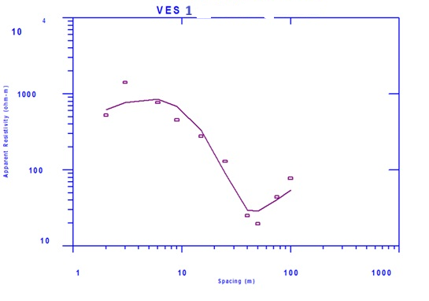

Fig 2: Sounding curve for VES 1

Table 1: Interpretation for VES 1

VES No. & Name | Layer | Res. (Ohm-m) | Thickness (m) | Depth (m) | Description
 | 1 | 744.83 | 2.52 | 2.52 | Top soil/laterite
VES 1 | 2 | 1726.81 | 8.17 | 10.69 | Dry sand
 | 3 | 892.35 | 26.05 | 36.74 | Saturated sand
 | 4 | 8.13 | 13.89 | 50.63 | Shale
 | 5 | 1591.62 | Base not reached |  | Dry sand

4.2 Mathematical Formulation
The resistivity and thickness values obtained from the interpretation of VES data were combined to produce longitudinal conductance Lc (Dar-Zarrouk parameters). Longitudinal conductance is defined as the ratio of layer thickness (h) to resistivity (ρ), L_{C} = h /𝞺 (Ω⁻¹). (Ekwe et al.,2006)
This parameter is very important in evaluating the properties of an aquifer in an area. Since the protective capacity of the overlying materials is directly proportional to longitudinal conductance. The total longitudinal conductance at each geoelectric sounding station was calculated using the formula
S=Σ ( $\frac{hi}{ρi}$ )= $\frac{h1}{ρ1}$ +$\frac{h2}{ρ2}$ +……+ $\frac{hn}{ρn}$ (Akana et al., 2016)
Where S is the total longitudinal conductance, h_{i} and 𝞺_{i} are the thickness and resistivity of the ith layer respectively. The resistivity and thickness values obtained from the interpretation of VES data were used to compute the longitudinal conductance L_{C.} Using Henriet (1976) classification table 2, the results of the longitudinal conductance were used to classify areas into good, moderate, weak and poor protective capacity while table 3 is the summary of the results obtained from VES.
Table 2 : Protective Capacity Rating (Henriet, 1976)
Sum of longitudinal conductance (mhos) | Overburden protective capacity classification
<0.1 | Poor
0.1-0.19 | Weak
0.2-0.69 | Moderate
0.70-4.9  5-10  >10 | Good  very Good  Excellent

Table 3: Calculated Values of VES Data and Aquifer Protective Capacities.

VES |  |  | Layers | Resistivity (Ohm-m) | Thickness (m) | Depth (m) | Lithology |  | Longitudinal Conductance (mho) | Protective Capacity | Classification
1 |  |  | 1 | 744.83 | 2.52 | 2.52 | Laterite |  | 0.0034 | 0.0081 |  | Poor
 |  |  | 2 | 1726.81 | 8.17 | 10.69 | Dry sand |  | 0.0047
 |  |  | 3 | 892.35 | 26.05 | 36.74 | S/ sand
 |  |  | 4 | 8.13 | 13.89 | 50.63 | Shale
 |  |  | 5 | 1591.62 |  |  | Dry sand
2 |  |  | 1 | 4765.19 | 2.12 | 2.12 | laterite |  | 0.0004
 |  |  | 2 | 245.97 | 4.04 | 6.16 | Clayey sand |  | 0.0164 | 0.0260
 |  |  | 3  4  5 | 1598.66  869.04  12.74 | 14.71  23.14 | 20.87  44.01 | D/ sand  S/s  Shale |  | 0.0092

3 |  |  | 1 | 1313.57 | 2.40 | 2.40 | Laterite |  | 0.0018 | 0.0517 | Poor
 |  |  | 2 | 101.08 | 1.57 | 3.97 | Shale |  | 0.0155
 |  |  | 3 | 468.04 | 12.28 | 16.25 | Clay |  | 0.0262
 |  |  | 4 | 3548.41 | 29.16 | 45.41 | Dry sand |  | 0.0082
 |  |  | 5  6 | 1528.17  15.95 | 27.18 | 72.59 | S/s  Shale
4 |  |  | 1 | 284.30 | 2.54 | 2.54 | Laterite |  | 0.0089 | 1.3486 | Good
 |  |  | 2 | 132.52 | 4.59 | 7.13 | Clayey  sand |  | 0.0346
 |  |  | 3 | 15.57 | 19.96 | 27.09 | Shale |  | 1.2820
 |  |  | 4 | 943.09 | 21.82 | 48.91 | Dry sand |  | 0.0231
 |  |  | 5  6 | 663.39  8065.97 | 22.11 | 71.02 | S/ sand  Dry sand
4.3 Discussion of Results
VES 1
There are five geoelectric sections in this location with the first layer having resistivity of 744.83 Ωm, thickness of 2.52 m and longitudinal conductance of 0.0034 mho and is interpreted as laterite. The second layer with resistivity of 1726.81 Ωm, thickness of 8.17 m and longitudinal conductance of 0.0047 mho is interpreted as dry sand. The third layer is interpreted as saturated sandstone (layer of interest) with resistivity of 892.35 Ωm and thickness of 26.05 m. The fourth layer has low resistivity of 8.13 Ωm, thickness of 13.89 m and is interpreted as shale. The last layer whose depth could not be reached is interpreted as dry sand with resistivity of 1591.62 Ωm. The aquifer protective capacity in this area is found to be poor with a value of 0.0081 mho.
VES 2
Five geoelectric layers were encountered in this location with the first layer interpreted as laterite having resistivity of 4765.19 Ωm, thickness of 2.12 m and longitudinal conductance of 0.0004 mho. The second layer has a resistivity of 245.97 Ωm, thickness of 4.04 m and longitudinal conductance of 0.0164 mho. Based on these parameters, it is interpreted as clayey sand. Beneath this layer lies the third which has resistivity of 1598.66 Ωm, thickness of 14.71 m and longitudinal conductance of 0.0092 mho. The fourth layer is the aquiferous layer of interest it has resistivity of 869.04 Ωm, thickness of 23.14 m and it’s interpreted as saturated sandstone. The last layer is interpreted as shale with low resistivity of 12.74 Ωm. Based on the computed total longitudinal conductance of 0.0260 mho, aquifer in this location has a poor protective capacity.
VES 3
This area has six geoelectric layers with the first layer having a resistivity of 1313.57 Ωm, thickness of 2.40 m and longitudinal conductance of 0.0018 and as expected is interpreted as laterite. The second layer is interpreted as shale with low resistivity value of 101.08 Ωm, longitudinal conductance of 0.0155 mho. The third layer has a thickness of 12.28 m, longitudinal conductance of 0.0262 mho and is interpreted as clay. The fourth layer has resistivity value of 3548.41 Ωm, thickness of 29.16 and longitudinal conductance of 0.0082 mho. The fifth layer is the layer of interest with resistivity of 1528.17 Ωm, depth and thickness of 72.59m and 27.18 m. The last layer whose depth could not be reached is interpreted as shale with a low resistivity of 15.95 Ωm. Based on the total computed longitudinal conductance of this area. The area is classified as poor with protective capacity value of 0.0517 mho.
VES 4
Six geoelectric sections were encountered in this area with the first layer having resistivity value of 284.30 Ωm, thickness of 2.54 m and longitudinal conductance of 0.0089 mho. The second with resistivity of 132.52 Ωm and longitudinal conductance of 0.0346 mho is interpreted as clayey sand. Beneath this layer lies the third layer with a very low resistivity of 15.57 Ωm, thickness of 19.96 m and longitudinal conductance of 1.2820 mho and is interpreted as shale. The fourth layer is interpreted as dry sand with resistivity of 943.09 Ωm and longitudinal conductance of 0.0231 mho. The layer that follows it is the layer of interest (aquifer), it has resistivity of 663.39 Ωm and thickness of 22.11 m. The last layer whose depth could not be found is interpreted as dry sand with resistivity of 8065.97 Ωm. The total computed longitudinal conductance of this area is 1.3486 and so the aquifer in this area has a good protective capacity.
5.0 Summary and Conclusion
The increase in the population of Amawbia, Awka South Local Government Area of Anambra State have increased the demand for groundwater resources with majority of the population depending on groundwater for domestic and agricultural use. This has necessitated the evaluation of aquifer protective capacity to safeguard groundwater from being contaminated. This research was carried out with the aim to assess the vulnerability of aquifer in the area using electrical resistivity method.
Four vertical electrical sounding (VES) were conducted using Mc Ohm resistivity meter. The acquired data were interpreted with Winresist software to determine the resistivity, thickness and depth of the various layers. The longitudinal conductance was computed using the interpreted parameters (resistivity and thickness) to evaluate the protective capacity. Using Henriet (1976) classification, the results of the protective capacity across the study area revealed that VES 1, 2 and 3 had poor protective capacity with longitudinal conductance ranging from 0.0081 to 0.0517 mhos while VES 4 showed good protective capacity. The results show that some areas of Amawbia are vulnerable to groundwater contamination.
This research has shown that electrical resistivity method is a cost effective and efficient way to investigate groundwater vulnerability assessment.

REFERENCES
Akana, T. S., George, G. C. and Oki, O. A. (2016). Aquifer vulnerability assessment in some towns of Yenagoa, South- South, Nigeria. Journal of Science and Technology 6 (1) 15-23.
Atakpo, E. A. (2013). Aquifer vulnerability investigation using geoelectric method in parts of Sapele local Government Area of Delta State, Nigeria. Nigeria journal of basic and applied science 21 (1) 11-19.
Dobrin, M. B (1983). Introduction to Geophysical prospecting. McGraw Int. Books Company. Tokyo. 70-10
Ekwe, A. C., Onu, N. N and Onuoha, K . M. (2006). Estimation of aquifer hydraulic characteristics from electrical sounding data. The case of middle Imo river basin aquifers, south eastern Nigeria. Journal of spatial hydrology 6(2) 121-132.
Henriet, J. P.(1976). Direct applications of Dar-Zarrouk parameters in groundwater surveys. Geophysical prospecting (24) 344-353.
NIMET. (2012). Nigerian Meterological Agency, Nigeria Climatic data, Abuja, Nigeria.
Obiajulu, O. (2021). Geophysical evaluations of engineering and hydrogeological properties of crustal materials of Awka, South Eastern, Nigeria. Unpublished Ph.D dissertation, Ebonyi State University, Abakaliki
Obiajulu, O. O and Okpoko, E. I. (2014). Geoelectric investigation of groundwater potentials of Ihiala and its environs, Anambra State, Nigeria. IOSR Journal of applied geology and geophysics 3 (6) 14 – 20.

Oni, T. E., Omosuyi, G. O. and Akinlalu, A. (2017). Groundwater vulnerability assessment using hydrogeologic and geoelectric layer susceptibility indexing at Igbara Oke, Southwestern Nigeria. NRIAG journal of Astronomy and geophysics 6 (2) 452-458
Vingoe, O. (1972). Electrical resistivity surveying. Geophysics memorandum 5/72 Atlas Copco ABEM AB, Bromma 20, Sweden.

