EFFECTS OF SOIL MOISTURE STRESS ON SEEDLINGS OF FOUR COCOA (THEOBROMA CACAO L.) VARIETIES AND SELECTED GENOTYPES IN GHANA

ABSTRACT
Soil moisture stress is a major constraint to cocoa production in West Africa, particularly under changing climatic conditions. This study evaluated the response of the seedlings of four cocoa varieties and selected genotypes to soil moisture stress under greenhouse conditions. The experiment was arranged in a Completely Randomized Design (CRD) with a factorial arrangement consisting of four varieties and the selected genotypes with four replications. Cocoa seedlings were subjected to varying soil moisture levels to simulate drought stress. Morphological and physiological parameters, including plant height, leaf area, chlorophyll content (NDVI), and root anatomical characteristics, were assessed. Results indicated that soil moisture stress significantly affected seedling growth and physiological performance (p < 0.05). Seedlings exposed to reduced moisture levels exhibited decreases in plant height, leaf area, and chlorophyll content compared to well-watered plants. However, certain genotypes maintained relatively higher NDVI values and improved root development under moisture stress, suggesting enhanced drought tolerance. These findings highlight the importance of identifying drought-tolerant cocoa genotypes for breeding programs to improve climate resilience in cocoa production systems in Ghana and across West Africa.

Keywords: Cocoa seedlings, drought tolerance, soil moisture stress, NDVI, cocoa genotypes, leaf relative water content.

INTRODUCTION
Agriculture plays a vital role in the socio-economic development of many countries, serving as a major source of employment and livelihood for the majority of the rural population. In Ghana, agriculture contributes significantly to national development through the cultivation of various crops across diverse climatic zones, ranging from the dry savanna to the moist forest regions. Crops such as grains, cocoa, oil palm, and cola nuts constitute an important component of the country's agricultural economy. Among these crops, cocoa (Theobroma cacao L.) remains the most prominent cash crop and a key contributor to Ghana’s export earnings. Cocoa (Theobroma cacao L.) is one of the most economically important crops in West Africa, contributing significantly to the livelihoods of millions of smallholder farmers and to national economies. Ghana is among the leading cocoa producers globally, with the crop serving as a major source of export revenue. Despite the significant economic and industrial importance of cocoa, its production faces numerous challenges that affect productivity and sustainability. One of the most critical challenges is climate change, which has contributed to irregular rainfall patterns and prolonged dry seasons. Water scarcity is a major factor affecting crop growth and productivity in many parts of the world and has profound effects on plant morphogenesis and physiological processes. The response of cocoa to drought and other environmental stress conditions varies considerably among different varieties and genotypes. Under drought conditions, water deficiency often leads to reduced growth, physiological disturbances, and alterations in plant metabolism (Das and Kar, 2018; Khalvandi et al., 2021; Yang et al., 2021; Zhou et al., 2021). Adequate water supply is therefore essential for optimal cocoa cultivation. In many cocoa-growing regions, seasonal weather changes frequently prolong the dry season, resulting in periodic drought conditions that adversely affect cocoa production.
Consequently, cocoa plants are generally considered to have limited tolerance to drought stress (Belsky and Siebert, 2003; Wood and Lass, 2001). Through extensive research activities, CRIG has developed improved cocoa varieties for distribution to farmers across the country. Researchers at CRIG have also undertaken efforts to screen and breed drought-tolerant cocoa hybrids, leading to the identification of several cocoa varieties with potential tolerance to drought conditions (Adu-Ampomah and Frimpong, 2002; Adu-Ampomah et al., 2001; Amponsah, 1973). Although extensive studies have been conducted on drought tolerance in other crops such as rice, maize, and cowpea, comparatively little research has focused on evaluating the drought tolerance of different cocoa varieties and genotypes.
Understanding the response of different cocoa varieties and genotypes to soil moisture stress is essential for the development of drought-tolerant cultivars. Plant responses to drought involve complex physiological and morphological adaptations, including reduced leaf area, altered root architecture, and changes in chlorophyll content. Indicators such as the normalized difference vegetation index (NDVI) and root anatomical traits can provide valuable insights into the mechanisms underlying drought tolerance.
Given the sensitivity of cocoa seedlings to environmental conditions, particularly water availability, drought stress can significantly hinder their growth and survival. Persistent drought conditions therefore pose a serious threat to cocoa productivity and the sustainability of the cocoa industry in Ghana. Identifying cocoa varieties or genotypes that can tolerate soil moisture stress is therefore essential for improving seedling survival during dry seasons and enhancing cocoa production. Therefore, this study aimed to evaluate the effects of soil moisture stress on selected cocoa varieties and genotypes by assessing key morphological, physiological, and anatomical traits in cocoa seedlings grown under controlled greenhouse conditions.

MATERIALS AND METHODS

Study location
The experiment was conducted in the greenhouse of the Department of Horticulture, College of Agriculture and Natural Resources, Kwame Nkrumah University of Science and Technology (KNUST), Kumasi, Ghana. The greenhouse environment allowed controlled evaluation of soil moisture stress effects on cocoa seedlings. Greenhouse benches with a height of 80 cm were used to support the experimental pots.

Experimental materials
Four cocoa varieties (Forastero, Trinitario, Criollo, and Hybrid) and four selected genotypes (PA150, PA7, C42, and C75) were used in the experiment. These cocoa seeds were obtained from selected cocoa farms in Bibiani-Anhwiaso-Bekwai municipal and the certified Seed Production Division (SPD) in Western North, respectively, and germinated under controlled conditions before transplanting into experimental pots.

Experimental design
The experiment was arranged in a Completely Randomized Design (CRD) with a 4 × 4 factorial arrangement consisting of four varieties and the selected genotypes. Each treatment was replicated three times. Seedlings were grown in pots filled with a standard soil mixture suitable for cocoa growth. Uniform seedlings were selected and maintained under greenhouse conditions prior to the imposition of moisture stress treatments.

Preparation of Plant Materials
Cocoa pods from each variety and genotype were first weighed collectively using a weighing balance, and the weights were recorded. The pods were then split open to release the seeds. Seeds from each pod were placed into sachets and weighed using an electronic balance. Seeds belonging to the same variety or genotype were collected together in a bucket, cleaned to remove excess pulp, and allowed to germinate. Approximately 650 kg of sandy loam soil was collected from a cocoa farm that had been under cocoa cultivation for over 20 years and transported to the Department of Horticulture, KNUST. Soil samples were collected from a depth of 25 cm using a pickaxe and shovel. The soil was air-dried and passed through a metallic sieve to remove stones, roots, and other debris. A representative soil sample was then analyzed at the Department of Soil Science, College of Agriculture and Natural Resources, KNUST, to determine its physicochemical properties. The prepared soil was transferred into plastic buckets (17 cm in height and 20 cm in diameter), which served as pots for the experiment. Each pot was filled with 5 kg of soil and provided with at least three drainage holes at the bottom to allow excess water to drain. All pots were saturated with water until water drained from the bottom, indicating full saturation. The pots were then allowed to drain overnight to reach field capacity, which corresponded to approximately 1200 ml of water. Germinated cocoa seeds were sown at a depth of 3 cm and spaced approximately 2 cm apart, with three seeds planted per pot to ensure the survival of at least one healthy seedling.
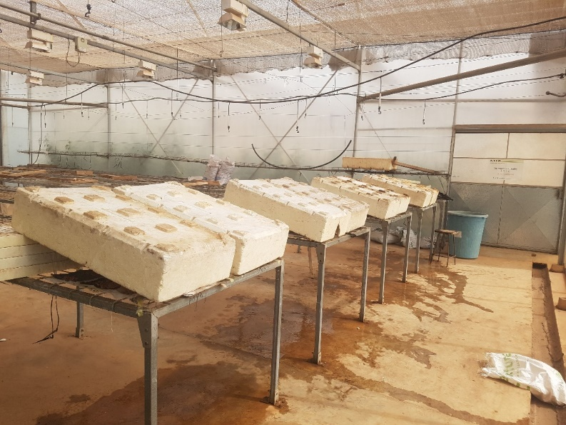

Plate 1. Styrofoam provides shade to prevent sunlight from reaching the seeds

Determination of Percentage Germination
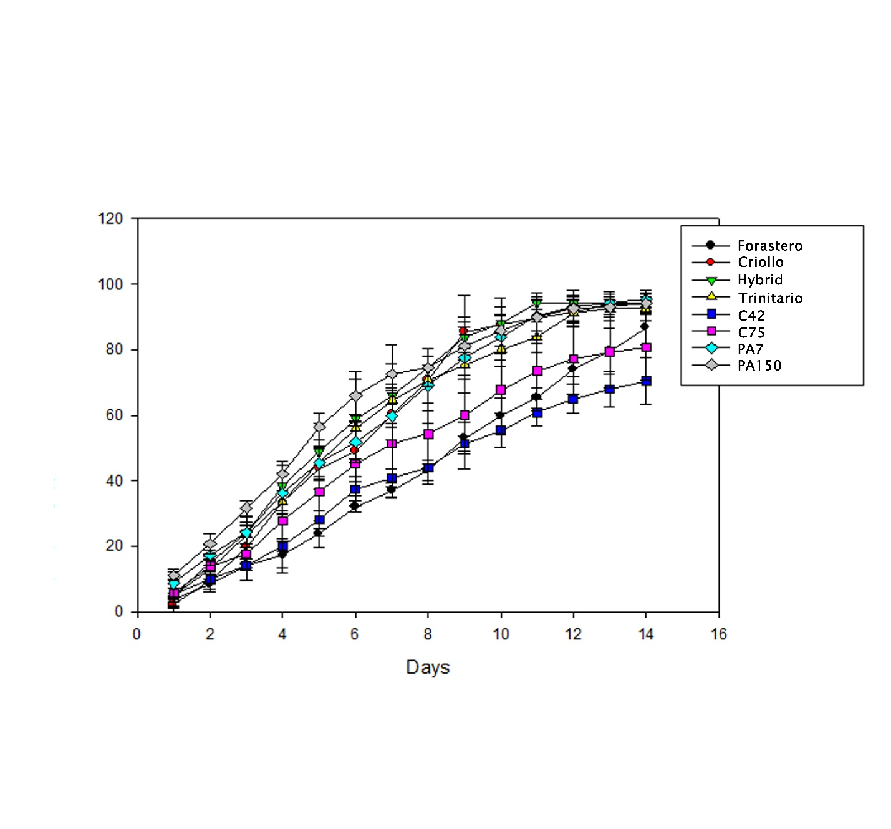
Eight styrofoam sheets (30 cm × 19 cm) were used to provide shade and prevent direct sunlight from reaching the seeds during tabletop germination. Plastic sacks of a similar size were placed beneath the styrofoam sheets to assist with water retention on the greenhouse benches. Three cloth pieces (7 cm × 7 cm), corresponding to the three replications, were placed on the plastic sacks and moistened with water. Seeds of each cocoa variety and genotype were counted and divided into three replicates. The seeds were placed on the moist cloth and watered daily for two weeks. Germination counts were recorded throughout this period to determine the percentage germination.

Figure 1. Percentage germination of cocoa seeds within 14 days

Soil Moisture Stress Treatments
Soil moisture stress treatments were applied by controlling irrigation levels to simulate varying moisture conditions. Soil moisture levels were monitored regularly with a soil moisture meter to ensure consistency across treatments.

Treatment | Description
T1 | Well-watered condition (100% field capacity)
T2 | Moderate moisture stress (75% field capacity)
T3 | High moisture-stressed (50% field capacity)
T3 | Severe moisture stress (0% field capacity)

The Complete Randomized Design resulted in 128 experimental units (pots). After sowing, the seedlings were watered at three-day intervals with 200 ml of water until they were fully established. Seedlings began to emerge within the first and second weeks after sowing. At three weeks after sowing (WAS), when the seedlings had reached the second leaf stage, they were thinned to two seedlings per pot to minimize competition for water and nutrients. Each pot was labeled according to the cocoa variety or genotype and the stress treatment applied.

Application of Soil Moisture Stress
Soil moisture stress treatments were applied nine weeks after sowing (9 WAS), when the seedlings were well established. The treatments were applied as follows: Control (C) watered to 100% field capacity once per week, Moderate Stress (MS): watered to 50% field capacity once per week, High Stress (HS): watered to 25% field capacity once per week, and Severe Stress (SS): no watering throughout the experimental period
Before the application of stress treatments, baseline measurements of plant height, stem thickness, number of leaves, leaf relative water content (LRWC), and soil relative water content (SRWC) were recorded. Visible symptoms of drought stress observed during the experiment included yellowing of leaves from the margins or lamina, necrosis of leaf tissues, death of tender leaves, leaf wilting, and leaf paling.

Data Collection
Morphological Parameters
Morphological parameters measured included plant height, stem thickness, leaf area, and number of leaves. Data were recorded at 9, 10, 11, 12, and 13 weeks after sowing. Plant height was measured from the soil surface to the tip of the shoot using a measuring tape. Stem thickness was measured using a vernier caliper, while the number of leaves was determined by direct counting. Leaf area was determined using the graph method. Fully expanded fourth leaves were collected, traced on graph paper, and their length and width measured using a ruler. Leaf area was calculated as:
Leaf Area = Leaf Length × Leaf Width

Physiological Parameters
Leaf relative water content was determined using fully expanded fourth leaves from the apex of each seedling. Leaf discs were obtained using a 2 cm cork borer and weighed immediately to obtain the fresh weight (FW). The discs were floated on distilled water at 25°C in darkness for four hours to obtain the turgid weight (TW). The discs were then oven-dried at 50°C for 24 hours to determine the dry weight (DW).
LRWC was calculated as:
LRWC (%) = [(FW − DW) / (TW − DW)] × 100

Soil samples were collected from each replicate at a depth of 5 cm using a 2 cm diameter sampling tube. The moist soil was weighed (M), oven-dried at 105°C overnight, cooled, and weighed again to obtain the dry weight (D).
SRWC (%) = [(M − D) / D] × 100

Chlorophyll content was estimated using a PlantPen NDVI 300 device. The device was calibrated using a white reference sample before measurements were taken. NDVI readings were taken directly from the physiologically expanded third leaf from the apex of each seedling without detaching the leaf.
Root Anatomical Analysis
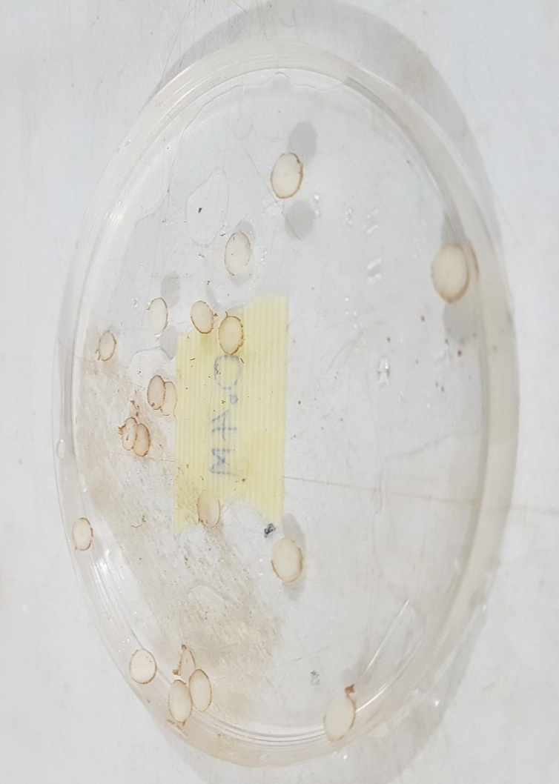
Roots were carefully removed from the soil and washed thoroughly to remove adhering soil particles. Thin root sections (2–5 cm from the root apex to the root-shoot junction) were collected and immersed briefly in distilled water. Root sections were hand-sectioned using a microtome knife and stained with iodine for 3–5 minutes. The sections were mounted on microscope slides with glycerine and examined under a light microscope at 100× magnification. Images were captured using an MU-series camera connected to the AmScope 3.7 software. Anatomical features measured included the pith, cortex, epidermis, and phloem tissues.

Plate 2. Transverse sections of the root put in distilled water

Data Analysis
The collected data were analyzed using analysis of variance (ANOVA) to determine the effects of soil moisture stress on the different cocoa varieties and genotypes. Means were separated using Tukey’s Honestly Significant Difference (HSD) test at a 5% probability level. Results were presented in tables and graphical formats.

RESULTS
Soil analysis before and after the experiment revealed significant alterations in soil chemistry due to moisture stress. Available phosphorus (P), organic carbon, and organic matter decreased under stress, with the lowest values observed under highly stressed conditions (P: 11.80 mg/kg; organic carbon: -1.284%; organic matter: 2.214%). This indicates reduced mineralization and nutrient availability, which can impair seedling development.
Table 1. Chemical Properties of soil before and after moisture stress of cocoa seedlings
Soil Property | Initial Content | Final Contents after Moisture Stress
Soil Property | Initial Content | Control | M. Stressed | H. Stressed | S. Stressed
pH | 6.293±0.172 | 6.323±0.091 | 6.323±0.074 | 6.503±0.021 | 6.633±0.015
Available P (mg/kg) | 21.937±1.146 | 21.170±0.175 | 12.283±0.146 | 11.803±0.031 | 13.210±0.105
Total N (%) | 0.114±0.001 | 0.118±0.002 | 0.113±0.001 | 0.107±0.002 | 0.115±0.001
Exchangeable K (cmol/kg) | 0.415±0.020 | 0.265±0.055 | 0.082±0.003 | 0.405±0.003 | 0.535±0.004
Exchangeable Ca (cmol/kg) | 4.520±0.087 | 8.607±0.031 | 6.100±0.100 | 8.120±0.072 | 7.433±0.012
Exchangeable Mg (cmol/kg) | 2.547±0.170 | 5.000±0.020 | 3.707±0.101 | 4.500±0.092 | 3.587±0.031
Exchangeable Na (cmol/kg) | 0.059±0.004 | 0.077±0.012 | 0.064±0.020 | 0.088±0.001 | 0.061±0.005
Organic Carbon (%) | 1.484±0.007 | -1.481±0.003 | -1.362±0.003 | -1.284±0.002 | -1.400±0.002
Organic Matter (%) | 2.558±0.012 | 2.554±0.005 | 2.349±0.005 | 2.214±0.004 | 2.414±0.004
Total Zn (mg/kg) | 22.967±2.919 | 62.473±1.550 | 67.147±5.906 | 60.680±2.841 | 79.893±3.091
Total Ni (mg/kg) | 0.733±0.037 | 0.790±0.037 | 0.634±0.034 | 0.700±0.036 | 0.699±0.015
Total Mn (mg/kg) | 7.270±0.419 | 148.600±4.629 | 102.033±1.504 | 163.167±4.389 | 94.247±0.442
Total As (mg/kg) | 0.881±0.029 | 0.864±0.036 | 0.738±0.022 | 0.676±0.023 | 0.638±0.056
Total Fe (mg/kg) | 273.167±45.608 | 2634.667±43.108 | 2404.667±16.442 | 5915.333±58.620 | 5424.000±1594.094
Total Cu (mg/kg) | 5.877±0.305 | 64.260±1.502 | 67.647±6.340 | 102.763±7.146 | 57.607±4.939
Total Pb (mg/kg) | 0.652±0.028 | 0.624±0.011 | 0.551±0.012 | 0.523±0.009 | 0.472±0.007
Total Cd (mg/kg) | 0.564±0.044 | 1.847±0.121 | 1.580±0.327 | 1.167±0.095 | 3.480±0.310
Total Hg (mg/kg) | 0.393±0.044 | 0.521±0.006 | 0.434±0.025 | 0.557±0.038 | 0.370±0.023

Morphological Responses to Moisture Stress

Visual Drought Symptoms
The seedlings used for the study exhibited varied symptoms of drought stress even within the same genotype/varieties. The visual symptoms indicative of drought symptoms in this study included: rapid yellowing of leaves starting from the leaf margin and/ or lamina, necrosis of leaf lamina, drooping and death of young tender leaves, wilting and paling starting from the leaf margin and lamina, similar to the observations made by Osei-Bonsu (2011).
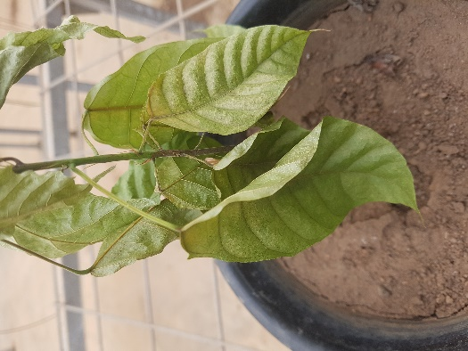
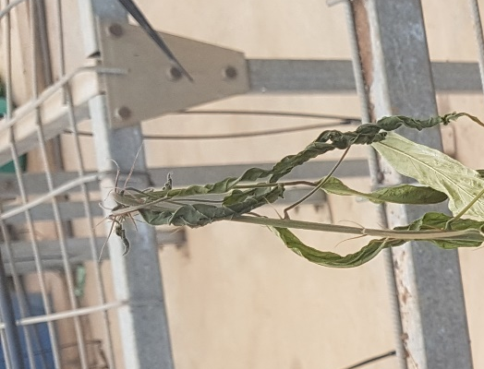

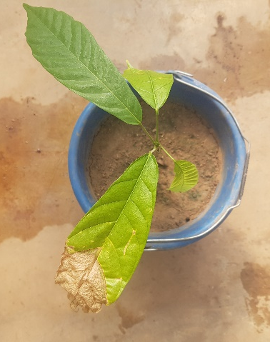

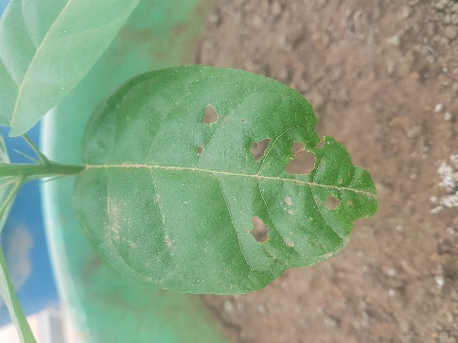
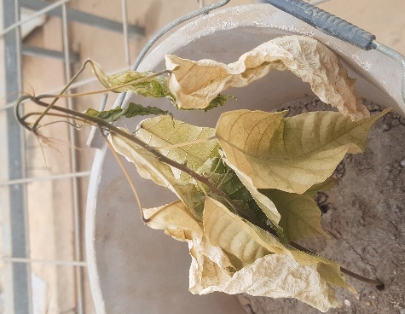

Plate 3. Various visual symptoms of drought stress observed in seedlings of the different genotypes and varieties of cocoa, indicative of drought symptoms (A) Perforation of mature green leaves (B) Necrosis on leaf apex (C) Browning of leaves (D) Paling starting from leaf margin and lamina (E) Shrinking of physiologically immature leaves

Effects of soil moisture stress on the number of leaves
PA150 consistently maintained the highest number of leaves across all treatments, peaking at 25.5 leaves under control conditions and showing the least reduction under stress. PA7 recorded the lowest leaf counts under moderate and severe stress (13.5 and 8.5, respectively), indicating poor morphological adaptability. Leaf number is a key determinant of photosynthetic capacity and seedling vigor. The resilience of PA150 suggests it allocates resources effectively to sustain growth under limited water.
Effects of soil moisture stress on stem thickness of cocoa seedlings
Stem thickness did not differ significantly across treatments for most genotypes, although Trinitario (4.35 mm) and Forastero (4.13 mm) showed robust stem development under control and moderate stress. PA7 again performed poorly (1.70 mm under severe stress). This suggests that while stem diameter is a relatively stable trait, it can still indicate stress susceptibility in sensitive genotypes.

Effect of Soil Moisture Stress on Plant Height
Soil moisture stress significantly affected plant height across the cocoa varieties and genotypes (p < 0.05). Height growth was suppressed under stress, with PA150 achieving the greatest height (39cm) under control, while PA7 stagnated at 11.25cm under severe stress. Criollo showed moderate height retention under severe stress (31 cm), indicating some level of tolerance.

Effect on Leaf Area and Leaf Development
Leaf area was significantly reduced under stress, with C42 showing the smallest leaf area (31.05 cm²) under severe stress, compared to PA150, which maintained the largest area (157.71 cm²) under control. Reduced leaf area under drought is a common avoidance mechanism to minimize transpirational water loss. However, genotypes like PA150 that maintain larger leaf area may sustain higher photosynthetic activity, offering a growth advantage if water is available.

Physiological Responses

Effect on Leaf Relative Water Content (LRWC)
LRWC declined progressively under stress across all entries. However, Criollo (83.71%) and C42 (63.30% under severe stress) maintained higher LRWC, indicating better water retention capacity. Low LRWC in PA7 (42.76%) correlates with its poor morphological performance. LRWC is a direct measure of plant water status and a reliable screening tool for drought tolerance. High LRWC under stress suggests efficient stomatal control or osmotic adjustment.

Effect on Soil Relative Water Content (SRWC)
SRWC varied widely, with C75 (6.04) and Trinitario (7.78 under high stress) showing high moisture retention. However, Forastero exhibited low SRWC (1.23) despite relatively high LRWC, suggesting that some genotypes may extract soil water more efficiently, maintaining leaf turgor even as soil dries.

Effect on Chlorophyll Content (NDVI)
Chlorophyll content decreased under stress, but Hybrid (67.02) and Trinitario (61.23) maintained higher NDVI values under control and high stress, respectively. PA7 (21.35) and C42 (24.15) showed sharp declines, indicating photosynthetic impairment. Chlorophyll retention under stress is critical for continued carbon assimilation. Genotypes that maintain green leaf area and chlorophyll content are better equipped to withstand and recover from drought.

Root Anatomical Adaptations
Root xylem architecture varied significantly under stress. PA150 exhibited larger, concentrated xylem vessels under stress, suggesting enhanced water transport capacity. PA7 and C75 showed xylem absence or reduction under severe stress, indicating structural vulnerability. Forastero and Trinitario maintained abundant, angular xylem tissues, supporting their relatively better performance. Xylem structure directly influences hydraulic conductivity. Genotypes with robust xylem networks are better able to sustain water flow under limited soil moisture, a key trait for drought tolerance.

DISCUSSION
The results highlight significant genotypic variability in response to soil moisture stress. PA150 and Forastero consistently outperformed other entries across morphological, physiological, and anatomical parameters. Their ability to maintain leaf production, plant height, leaf area, and chlorophyll content under stress suggests a combination of drought avoidance (e.g., efficient water use, stomatal regulation) and tolerance mechanisms (e.g., osmotic adjustment, xylem adaptation). In contrast, PA7 and C42 exhibited pronounced susceptibility, with sharp declines in all measured parameters. Their poor performance under even moderate stress raises concerns about their suitability for rain-fed systems in drought-prone areas. However, the observed changes in soil chemistry, particularly nutrient depletion and heavy metal accumulation, highlight the bidirectional impact of drought. Not only does moisture stress directly affect plant physiology, but it also degrades the soil environment, creating feedback loops that exacerbate stress. For instance, reduced phosphorus and organic matter limit root development and energy metabolism, while heavy metal accumulation may impose additional toxicity stress. These findings are consistent with reports that water stress reduces nutrient uptake by roots and transport to shoots due to decreased transpiration rates and impaired active transport.
Ghana's cocoa sector is vital to its economy, supporting millions of livelihoods. With climate change projected to increase the frequency and intensity of droughts in West Africa, identifying and deploying drought-tolerant cocoa genotypes is an urgent priority. The Cocoa Research Institute of Ghana (CRIG) has made efforts to screen and breed drought-tolerant cocoa hybrids, identifying several varieties with potential drought tolerance (Adu-Ampomah and Frimpong, 2002; Adu-Ampomah et al., 2001; Amponsah, 1973). PA150 and Forastero should be prioritized for inclusion in breeding pipelines. Their combined morphological, physiological, and anatomical strengths make them ideal candidates for further evaluation in multi-location trials. The Cocoa Research Institute of Ghana (CRIG) and seed production units should consider scaling up multiplication of PA150 for distribution to farmers in marginal areas (e.g., transition zones with erratic rainfall). Farmers must be educated on practices that maintain soil organic matter and moisture retention, such as mulching, cover cropping, and compost application. These practices can buffer against nutrient loss and heavy metal mobilization during dry periods. Integrating physiological markers like LRWC and NDVI into monitoring systems could help detect early signs of drought stress, enabling timely interventions (e.g., supplementary irrigation, shading). This study was conducted under controlled greenhouse conditions, which may not fully replicate field realities. Future research should validate these findings under on-farm conditions across different agroecological zones, investigate molecular mechanisms underlying drought tolerance in PA150 and Forastero (e.g., gene expression, proteomics), including the role of proline accumulation in osmotic adjustment (Hayat et al., 2012; Karamanos, 1995; Bae et al., 2009; Balasimha, 1988), assess long-term yield performance of selected genotypes under varying rainfall regimes, and explore the role of mycorrhizal associations and soil microbiomes in enhancing drought resilience.

CONCLUSION
This study demonstrates that cocoa genotypes exhibit pronounced variability in their response to soil moisture stress. PA150 and Forastero emerged as the most promising candidates for drought-prone environments, combining robust growth, physiological resilience, and adaptive root anatomy. In contrast, PA7 and C42 are highly susceptible and should be avoided in regions with limited water availability. The findings have direct implications for Ghana's cocoa sector, offering evidence-based guidance for breeding, seed selection, and farm management in the face of climate change. By integrating drought-tolerant genotypes into national programs and promoting soil health practices, Ghana can safeguard its cocoa industry and the livelihoods that depend on it.

REFERENCES

Adu-Ampomah, Y., Frimpong, E. B., and Mante, S.O. (2001). Breeding for easy establishment in degraded environment, p 73–74. In: Rep. Cocoa Res. Inst. Ghana, 1998/99. 203p. Cocoa Research Institute of Ghana (CRIG), Ghana.
Adu-Ampomah, Y., and Frimpong, E. B. (2002). Breeding for easy establishment in degraded environment, p 65–69. In: Rep. Cocoa Res. Inst. Ghana, 1999/2000. 217p. Cocoa Research Institute of Ghana (CRIG), Ghana.
Amponsah, J. D. (1973). Akumadan drought tolerance trial p 154–155. In: Rep. Cocoa Res. Inst. Ghana, 1971/72. 233p. Cocoa Research Institute of Ghana (CRIG), Ghana.
Belsky, J. M and Siebert, S. F. (2003). Cultivating cacao: implications of sun-grown cacao on local food security and environmental sustainability. Agric. Human Values 20:277-285.
Bae, H., Sicher, R. C., Kim, M. S., Kim, S.-H., Strem, M. D., Melnick, R. L. and Bailey, B. A. (2009). The beneficial endophyte Trichoderma hamatum isolate DIS 216d promotes growth and delays the onset of the drought response in Theobroma cacao. J. Exp. Bot. 60(11):3279-3295.
Balasimha, D. (1988). Water relations, growth and other indicators of plant water stress in cocoa under drought, p 215-217. In: Proc. 10th Int. Cocoa Res. Conf., Santo Domingo, Dominican Republic.
Cameron, K. D., Teece, M. A., Smart, L. B. (2006). Increased accumulation of cuticular wax and expression of lipid transfer protein in response to periodic drying events in leaves of tree tobacco. Plant Physiol 140:176–183
Cakmak, I. (2005). Role of potassium in alleviating the detrimental effects of abiotic stress in plants. Journal of Soil Science and Plant Nutrition, 168: 521-530.
Capell, T., Bassie, L., and Christou, P. (2004). “Modulation of the polyamine biosynthetic pathway in transgenics rica confers tolerance to drought stress”, Pnas., 101(26), 9909-9914.
COCOBOD. (2016). The history of cocoa and its production in Ghana. Retrieved May 13, 2016, from the Ghana Cocoa Board (COCOBOD) website on the World Wide Web: http://www.cocobod.gh/history.php.
Cornic, G., and Massacci, A. (1996). Leaf Photosynthesis Under Drought Stress. Photosynthesis and the Environment, 347–366. https://doi.org/10.1007/0-306-48135-9_14
Das, S., and Kar, R. K. (2018). Abscisic acid-mediated differential growth responses of root and shoot of Vigna radiata (L.) Wilczek seedlings under water stress. Plant Physiol. Biochem. 123, 213 – 221.
Fang, Y., & Xiong, L. (2015). General mechanisms of drought response and their application in drought resistance improvement in plants. Cellular and Molecular Life Sciences, 72(4), 673–689
Farooq, M., Wahid, A., Basra, N. K. D. F. S. M. A., Fujita, N. K. D., and Plant, S. M. A. B. (2009). Plant drought stress : effects, mechanisms and management To cite this version : HAL Id : hal-00886451. Review article. Agronomy For Sustainable Development, 29, 185–212. https://doi.org/10.1051/agro:2008021
Flexas, J., and Medrano, H. (2002). Drought-inhibition of photosynthesis in C3plants: Stomatal and non-stomatal limitations revisited. Annals of Botany, 89(2), 183–189. https://doi.org/10.1093/aob/mcf027
Foyer, C. H., Leiandais, M., and Kunert, K. J. (1994). Photooxidative stress in plants. Physiologia Plantarum, 92, 696–717. https://doi.org/10.1111/j.1399-3054.1994.tb03042.x
Fu, J., and Huang, B. (2001). Involvement of antioxidants and lipid peroxidation in the adaptation of two cool-season grasses to localized drought stress. Environmental and Experimental Botany, 45(2), 105–114. https://doi.org/10.1016/S0098-8472(00)00084-8
Hayat, S., Hayat, Q., Alyemeni, M. N., Wani, A. S., Pichtel, J., & Ahmad, A. (2012). Role of proline under changing environments: a review. Plant Signaling & Behavior, 7(11), 1456–66. http://doi.org/10.4161/psb.21949
Jefferies, R. A. (1993). “Responses of potato genotypes to drought. I. Expansion of individual leaves and osmotic adjustment”, Ann. Appl. Biol., 122, 93–104, doi: 10.1111/j.1744-7348.1993.tb04017.x.
João, P., Maroco, J. S. P., and M. M. C. (1997). Stomatal Responses to Leaf-to-Air Vapour Pressure Deficit in Sahelian Species. Australian Journal of Plant Physiology, 24, 381–387. https://doi.org/10.1071/PP96062
Karamanos, A. J. (1995). The involvement of proline and some metabolites in water stress and their importance as drought resistance indicators. Bulgarian Journal of Plant Physiology 21(2-3): 98-110
Khalvandi, M., Siosemardeh, A., Roohi, E., Keramati, S. (2021). Salicylic acid alleviated the effect of drought stress on photosynthetic characteristics and leaf protein pattern in winter wheat. Heliyon 7 (1), e05908.
Naveed, A. (2008). The potential of breeding okra (Abelmoschus esculentus L. Moench) for water stress tolerance. A PhD thesis, University of Agriculture, Faisalabad, Pakistan.
Nonami, H. (1998). Plant water relations and control of cell elongation at low water potentials. Journal of Plant Research, 111(3), 373–382. https://doi.org/10.1007/BF02507801
Obeng-Bio, E. (2010). Selection and ranking of local and exotic maize (Zea mays) genotypes to drought stress in Ghana. An MSc Dissertation, Kwame Nkrumah University of Science and Technology, Kumasi, Ghana.
Ogburn, R., Edwards, E. J. (2010). The ecological water-use strategies of succulent plants. Advances in Botanical Research 55:179–225
Okali, D.U.U., and Owusu, J.K. (1975). Growth analysis and photosynthetic rates of cocoa (Theobroma cacao L.) seedlings in relation to varying shade and nutrient regimes. Ghana J Agric Sci 8:51-67.
Okçu, G., Kaya, M. D., and Atak, M. (2005). Effects of Salt and Drought Stresses on Germination and Seedling Growth of Pea ( Pisum sativum L .). Turk. J. Agric. For., 29, 237–242.
Owusu, J. K. (1978). Light requirements of cocoa: a review, p 112-121. In: Proc. Int. Conf. Cocoa and Coconuts, Kuala Lumpur, Malaysia.
Pace, P. F., Cralle, H. T., El-halawany, S. H. M., Cothren, J. T., and Senseman, S. A. (1999a). Drought-induced Changes in Shoot and Root Growth of Young Cotton Plants. The Journal of Cotton Science, 3, 183–187.
Pace, P. F., Cralle, H. T., El-halawany, S. H. M., Cothren, J. T., and Senseman, S. A. (1999b). Drought-induced Changes in Shoot and Root Growth of Young Cotton Plants. Journal of Cotton Science, 3, 183–187.
Padi, F. K., Adu-Gyamfi, P., Akpertey, A., Arthur, A., and Ofori, A., (2013). Differential response of cocoa (Theobroma cacao) families to field establishment stress. Plant Breeding 132(2): 229-326. Doi: 10.1111/pbr.12039
Passioura, J. (1997) Drought and drought tolerance. Drought tolerance in higher plants: genetical, physiological and molecular biological analysis. Springer, Netherlands.
Taiz, L., and Zeiger, E. (2002). Plant Physiology. Annals of Botany (3rd Ed). Sinauer Associates Inc. Publishers, Massachusetts. https://doi.org/:10.1093/aob/mcg079
Taiz, L., and Zelger, E. (2006). Plant physiology (4th Edn), Sinauer Associates, Massachusetts, pp:69.
Tardieu, F. (2013) Plant response to environmental conditions: assessing potential production, water demand, and negative effects of water deficit. Front Physiol 4:17
Tezara, W., Mitchell, V. J., Driscoll, S. D., and Lawlor, D. W. (1999). Water stress inhibits plant photosynthesis by decreasing coupling factor and ATP. Nature, 401(6756), 914–917. https://doi.org/10.1038/44842
Tripathy, J. N., Zhang, J., Robin, S., Nguyen, T. T., and Nguyen, H. T. (2000). QTLs for cell-membrane stability mapped in rice (Oryza sativa L.) under drought stress. Theoretical and Applied Genetics, 100(8), 1197–1202. https://doi.org/10.1007/s001220051424
Tuinstra, M. R., Grote, E. M., Goldsbrough, P. B., and Ejeta, G. (1997). Genetic analysis of post-flowering drought tolerance and components of grain development in Sorghum bicolor (L.) Moench. Molecular Breeding, 3, 439–448. https://doi.org/10.1023/A:1009673126345
Turner, N. C. (1997). Futher Progress in Crop Water Relations. Advances in Agronomy, 58, 293–338.
Wood, G. A. R., and Lass, R. A. (2001). Cocoa (4th ed). p620. Oxford: Blackwell Science. Wiley.
Xiong, L., Wang, R.-G., Mao, G., and Koczan, J. M. (2006). Identification of Drought Tolerance Determinants by Genetic Analysis of Root Response to Drought Stress and Abscisic Acid. Plant Physiology, 142(3), 1065–1074. https://doi.org/10.1104/pp.106.084632
Yang, L., Zhang, L., Jiang, L., Zhang, Y. G., Fan, G. Z. (2021). Quercetin alleviates seed germination and growth inhibition in Apocynum venetum and Apocynum pictum under mannitol-induced osmotic stress. Plant Physiol. Biochem. 159, 268–276.
Zhou, H., Zhou, G., He, Q., Zhou, L., Ji, Y., Li, X. (2021). Capability of leaf water content and its threshold values in reflection of soil–plant water status in maize during prolonged drought. Ecol. Indicat. 124

