From Soil to Market: Enhancing Hill Farmer Incomes through Digital Platforms
Abstract: This study investigates the role of digital platforms in transforming agribusiness linkages and improving farmer incomes in the Himalayan hill districts of Uttarakhand, India. Implemented as part of the World Bank–supported Uttarakhand Decentralized Watershed Development Project Phase II (UDWDP-II), also known as GRAMYA-II, the initiative integrated mobile applications, e-commerce tools, and centralized data systems within a decentralized institutional framework comprising Farmer Interest Groups (FIGs), Farmer Federations (FFs), and Agribusiness Growth Centres (ABGCs). Using a mixed-methods approach that combined project documents, digital platform analytics, sales data, and stakeholder interviews, the study evaluated digital platform adoption, marketing performance, and institutional synergies. The Gramyashree platform functioned as both a digital marketplace and a management tool, facilitating direct producer–buyer engagement, real-time inventory tracking, yield forecasting, and coordinated marketing. Findings indicate that digital interventions improved market transparency, reduced transaction costs, and expanded access to urban and institutional buyers, particularly benefiting smallholders in remote areas. However, adoption varied due to connectivity limitations, uneven digital literacy, and product quality challenges. The study concludes that digital platforms can significantly enhance agribusiness outcomes in mountainous contexts when embedded within federated governance structures and supported by investments in capacity building, branding, quality assurance, and last mile logistics.
Keywords: Agribusiness Growth Centres; Digital platform; e-commerce; Farmer federations; Farmer Interest group; Smallholder farmers; Value chains.
JEL codes Q13, Q16

Introduction
The agricultural sector in developing countries is undergoing a structural transformation, increasingly driven by the integration of digital technologies. These innovations not only enhance productivity but also offer new pathways for market access, financial inclusion, and value chain integration. In geographically disadvantaged regions such as the Indian Himalayas, where market access remains constrained by terrain, poor infrastructure, and fragmented supply chains, digital platforms have emerged as viable solutions to bridge gaps between producers and markets.
India’s agriculture, employing nearly 54% of the population and contributing about 17–18% to national GDP, remains largely smallholder based (Department of Agriculture and Farmers Welfare, 2025). Despite this significance, farmers in hilly states like Uttarakhand face challenges in accessing organized markets. Traditional mandi systems involve multiple intermediaries, high transaction costs, and delayed price discovery, reducing farmers’ income share.
In this context, the Uttarakhand Decentralized Watershed Development Project Phase II (Gramya-II), implemented by the Watershed Management Directorate (WMD) with World Bank support (2014–2022), introduced interventions to enhance watershed management, climate-resilient agriculture, and market-driven agribusiness (Watershed Management Directorate, 2023). Central to this effort was the deployment of digital tools to improve value chains and create sustainable market linkages.
The project established the Gramya Shree brand and the Gramyashree digital platform (mobile app and e-commerce portal) to enable real-time listing of produce, connect farmers directly to buyers, and provide transparent information on price and availability. By reducing dependence on middle men and expanding digital reach, the platform empowered farmers to access broader markets, while offering buyers traceable, fresh, and often organic produce. Embedded within a larger ecosystem of FIGs, FFs, and ABGCs, the digital component amplified transparency and outreach key for inclusive agribusiness in hilly terrains.

Literature Review
Over the past two decades, digital innovation has transformed agribusiness from basic communication tools to integrated platforms using artificial intelligence (AI), Internet of Things (IoT) and blockchain. In the early 2000s, digital agriculture interventions mainly focused on agricultural advisories and price dissemination via SMS or radio. Glendenning and Ficarelli (2012) emphasized the localization of ICT content, laying the foundation for ICT4Ag innovations.
By the mid-2010s, ICT began playing a central role in market integration. Nakasone and Minten (2013) showed that digital tools reduced price dispersion and improved efficiency. Similarly, Shalendra, Sharma, and Gummagolmath (2019) found that e-tendering improved price discovery and transparency. Market Information Systems (MIS) such as Kenya’s KACE enabled real-time access to price data, thereby strengthening farmers’ bargaining power (Mukhebi et al. 2008).
Sermuksnyte-Alesiuniene and Melnikiene (2024) demonstrated how digitalization improved small farm sustainability, while studies by Ju and Lou (2024), Ningsih et al. (2024), and Chiwaridzo et al. (2024) confirmed the income-enhancing potential of e-commerce platforms for smallholders. These interventions also increased traceability and consumer trust.
Digital platforms economic benefits such as price realization, improved access, and reduced post-harvest losses are widely documented (Barton, 2003; Clasen and Mueller, 2006; Landreth, 2022). Integrated solutions like DigiFarm have enhanced access to inputs and credit (Sam and Grobbelaar, 2021). However, Hackfort (2021) cautioned that inequalities in access persist due to connectivity and cost barriers, while Saha, Prusty, and Nanda (2024) noted gendered gaps in digital participation.
Environmental and institutional implications have also been recognized. Blockchain and IoT-based traceability support low-emission, climate-smart systems (Deshmukh and Patil, 2022; Pavesi, Orsi, and Zanderighi, 2024). Nonetheless, few studies evaluate long-term institutional sustainability or interoperability in low-bandwidth contexts, suggesting that successful digital agriculture requires strong governance, robust infrastructure, and integration with existing local systems.

Methodology
This study adopts a mixed methods research design to assess the role of digital platforms in strengthening agribusiness linkages within the Gramya-II project, implemented in Uttarakhand, India. The methodology combines quantitative data analysis with qualitative insights, drawing on field-level observations, institutional records and stakeholders interviews
Study Area: The Gramya-II project was implemented between 2014 and 2022 across 527 Gram Panchayats (GPs) situated in 82 micro-watersheds of Uttarakhand (fig.1), characterized by rugged Himalayan terrain and limited market accessibility.
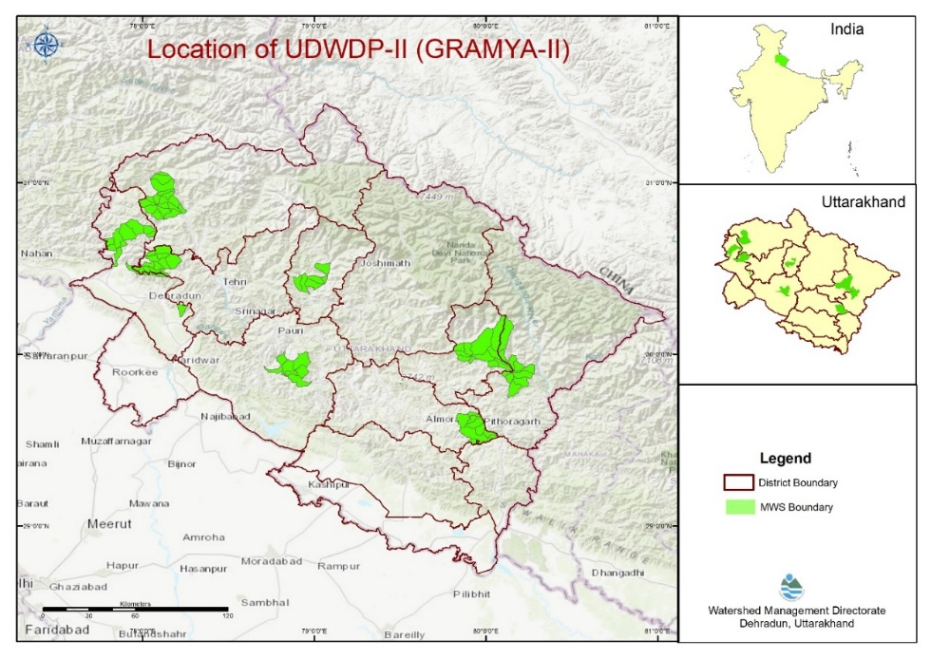
Fig. 1: Project location of UDWDP-II(GRAMYA-II)
The project aimed to enhance rural livelihoods through watershed management, climate-resilient agriculture, and digitally enabled agribusiness promotion. These interventions were particularly focused on remote and ecologically fragile hill regions where conventional market systems are often inaccessible or inefficient
Agribusiness Model and Digital Integration: The agribusiness strategy under Gramya-II was centered around the formation of Farmer Interest Groups (FIGs) voluntary associations of 5–15 farmers within a GP. These groups were consolidated into Farmer Federations (FFs) and supported through the establishment of Agribusiness Growth Centres (ABGCs). The ABGCs functioned as local hubs for aggregation, post-harvest management, value addition, and product marketing.
To enable digital integration, a digital platform (www.gramyashree.in) (fig-2) including mobile application “Gramyashree” was developed by the Project Management Unit (PMU), using the ODK platform (ODK Inc., n.d.). The customised app allowed farmers to enter crop production and sales data, receive advisories, and engage directly with registered vendors and buyers (fig 3). This information was synchronized with a centralized Project Management Information System (PMIS), which provided real-time inventory tracking, yield forecasting, and financial monitoring (Semwal, Vatsa and Rana, 2025). Additional data on seasonal availability was collected using Google Forms. Digital outreach was further expanded through active social media marketing on platforms such as Instagram and Facebook. These tools collectively created a digitally supported agribusiness value chain that linked smallholder production with consumer demand, both locally and in urban markets.
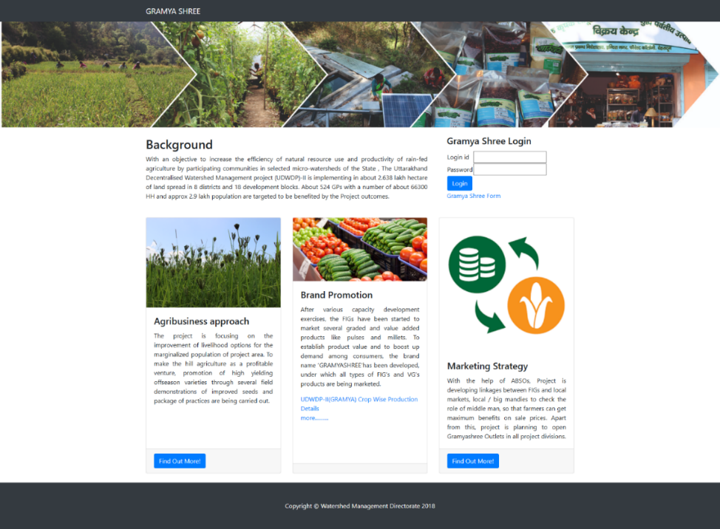
Fig. 2: Screenshot of Gramyashree digital platform)
Data Collection: Primary data sources included app based analytics from the Gramyashree platform, covering metrics such as vendor registration, crop-wise production, and transaction volumes. Additional data was obtained from PMIS dashboards, internal sales registers of ABGCs, and periodic reports generated at the district and state levels. Supplementary information was drawn from project evaluation documents and official Gramya-II completion reports. Where necessary, qualitative insights were gathered through interviews with federation members, digital facilitators, and field coordinators.
Analytical Framework: The analysis was organized across three dimensions-
Descriptive Statistics: Aggregated data was used to analysed the usage of digital tools, including the number of registered farmers and vendors, the volume of produce marketed through the app, and the distribution of sales across different marketing channels.
Comparative Assessment: Digital platform performance was evaluated by comparing sales volume and income generation across Gramyashree app users, physical Gramyashree outlets, and other sales channels.
Platform Evaluation: Qualitative feedback from farmers and consumers was analyzed to assess user satisfaction across online and offline marketing platforms. The review also examined the PMU’s initiatives to streamline and enhance sales channels, ensuring balanced promotion and accessibility of both digital and physical marketing pathways.

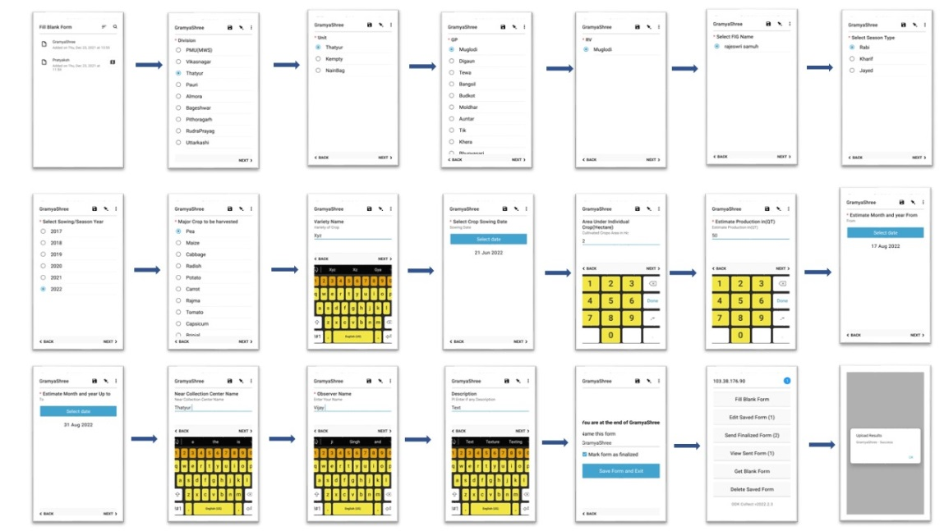
Fig.3: Step by Step data entry in Gramyashree App

Variables Considered: Key variables analyzed included--
- Volume of produce marketed via the digital platform versus traditional mandis
- Number of digital transactions per FIG or Federation
- Income realized from digital sales compared to offline counterparts
- Crop-wise price differentials linked to digital access
- Vendor and farmer engagement levels with the platform
Limitations: The effectiveness of digital adoption varied across districts due to differences in internet connectivity, digital literacy, and institutional support. While centralized sales outlets showed higher adoption rates, app-based participation was more prominent in areas with better digital infrastructure. Consequently, the findings are contextualized within the specific geographical and infrastructural conditions of Uttarakhand’s hill districts.

Results and Discussion
The GRAMYA-II project underscores the transformative potential of integrating digital tools within decentralized agribusiness models in hill geographies. The introduction of the Gramyashree digital platform, in combination with physical infrastructure through Agribusiness Growth Centres (ABGCs), demonstrated a replicable model for improving market access and income diversification among smallholder farmers in Uttarakhand.
The digital platform registered 7,729 farmers and 309 buyers/vendors, facilitating structured engagement through its mobile application and web interface. Over the project duration, digital sales totaled ₹20.88 million, with ₹107.47 million transacted through physical Gramyashree outlets and an additional ₹42.92 million through external markets (Table1). These figures highlight the importance of hybrid digital-physical market pathways.
Table1: Sales Performance by Channel (GRAMYA-II)
Sales Channel | Amount (₹ million) | % Contribution
Gramyashree Outlets | 107.47 | 62.78%
Other External Markets | 42.92 | 25.07%
Digital Sales (App-based) | 20.88 | 12.20%
Total Sales | 171.27 | 100%
Furthermore, analysis of the potential marketable surplus from project-supported crops. suggests an untapped value exceeding ₹8,128 million (Table 2), if full-scale digital integration and cluster-based market mobilization are achieved. These findings reinforce the scalability of the model and the economic potential of digitally integrated agribusiness in hill states.
Table2: Adoption and Participation Metrics
Metric | Value
Registered Farmers (App) | 7,729
Registered Vendors/Buyers (App) | 309
Functional Agribusiness Growth Centers (ABGCs) | 10
Functional Farmer Federations | 21
Potential Marketable Value (Full-scale) | ₹8,128 million
The Gramyashree app's operational design was particularly suited to low-bandwidth environments, ensuring its usability in remote terrain. It facilitated real-time product listing, vendor matching, and inventory tracking, which proved critical in synchronizing production with demand especially for perishable and value-added goods.
The Farmer Federations (FFs) and Agribusiness Growth Centres (ABGCs) played an essential intermediary role, linking digital tools with physical service delivery. The ABGCs offered packaging, grading, and primary processing facilities, while also serving as collection and distribution hubs for FIGs (Farmer Interest Groups). These centers ensured product quality and brand consistency under the single-brand “Gramyashree”, which gained visibility both in local and urban markets, as well as tourist routes.
The integration of the Project Management Information System (PMIS) enabled granular tracking of income, stock movement, seasonal forecasting, and federation level analytics (fig 4). Simultaneously, use of social media (e.g., Facebook, Instagram) expanded brand reach, while the centralized portal (gramyashree.in) enabled direct-to-consumer sales..
Compared to traditional mandi systems, which are prone to logistical inefficiencies and price volatility, the digital platform introduced transparency in price discovery and reduced farmers' dependency on intermediaries. Farmers could negotiate prices directly and retain a greater share of consumer-end value.
Importantly, GRAMYA-II illustrates that digital tools are not standalone solutions; their effectiveness is maximized when embedded within supportive institutional ecosystems such as federations, ABGCs, local governance bodies, and market-oriented clusters.
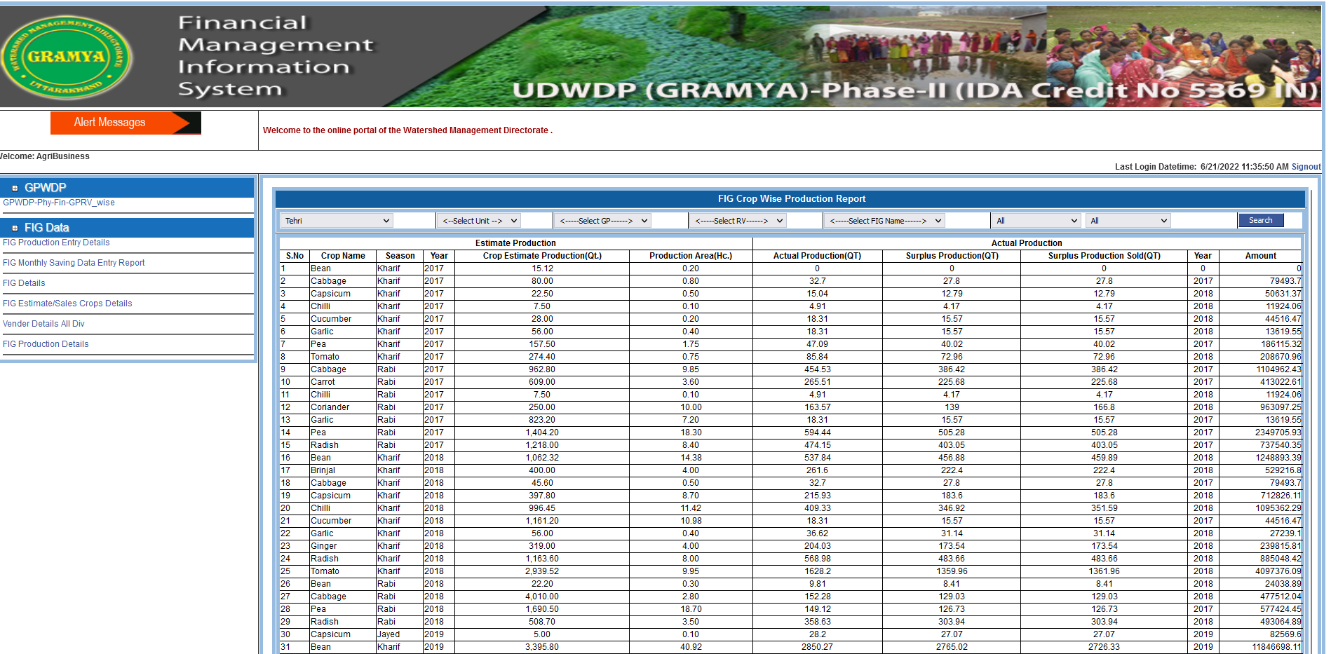
Fig. 4.: Aggregation of Agribusiness data in PMIS GRAMYA-II

Conclusion
The agribusiness strategy implemented under the GRAMYA-II project reflects a successful convergence of digital innovation, community-based aggregation, and decentralized value chain development in the context of Himalayan agriculture. By integrating the Gramyashree platform with a robust institutional framework comprising Farmer Interest Groups (FIGs), Federations, and Agribusiness Growth Centres farmers transitioned from isolated, subsistence-oriented production to a more organized and digitally enabled agribusiness ecosystem.
The platform significantly improved market access by connecting farmers directly to vendor networks and institutional buyers. Transparent digital transactions enhanced price realization, while value addition through processing and packaging at growth centres contributed to brand visibility and higher consumer trust. These advancements were further reinforced by the scalability of the model, made possible through federated structures and mobile-based connectivity, even in low-infrastructure environments.
The digital transformation promoted wider developmental outcomes in addition to transactional efficiency. These included a measurable rise in farmer incomes, a reduction in post-harvest losses, and an increase in formalized trade through federated systems. However, sustaining and scaling these gains requires strategic attention to several areas. Strengthening quality assurance systems will be essential for maintaining consistency across decentralized production clusters. Equally important is the implementation of unified branding strategies to ensure coherence and recognition across diverse product lines Building digital literacy among farmers and enhancing last-mile infrastructure will further improve adoption.
Despite these achievements, several challenges remain. The pace of digital adoption varies significantly across locations, often influenced by connectivity, literacy, and institutional capacity. Inconsistencies in product quality and the lack of standardized branding also pose limitations to market expansion. Addressing these gaps will be crucial for adapting and replicating it in other hill and rainfed contexts, where climate-resilient, digitally integrated agribusiness models are increasingly needed.

Acknowledgments
The authors would like to express their sincere gratitude to the Project Director of the Watershed Management Directorate, Uttarakhand, for his invaluable support and guidance throughout this research. The authors also acknowledge Watershed Management Directorate, Dehradun for providing the necessary facilities and resources to conduct this study.

Funding
This work was supported by the Watershed Management Directorate, Dehradun, Uttarakhand.

Competing interests
The Authors have declared that no competing interests exist.

Authors Contributions
Vikas Vatsa conceptualized the study, designed the research framework, and prepared the initial draft of the manuscript. Manoj Semwal and Vijaypal Singh Rana developed the digital platforms, managed data collection and analysis, and contributed to the interpretation of results. All authors reviewed, refined, and approved the final version of the manuscript.

References
Ashoka, P., N. K. Singh, N. H. Sunitha, D. R. K. Saikanth, O. Singh, G. Sreekumar, and B. V. Singh. (2023). Enhancing agricultural production with digital technologies: A review. International Journal of Environment and Climate Change 13 (9): 409–422. https://doi.org/10.9734/ijecc/2023/v13i92250
Barton, B. (2003). The internet’s impact on agricultural input distribution channels. Review of Agricultural Economics 25 (1): 14–21. https://doi.org/10.1111/1467-9353.00042
Chiwaridzo, O., R. Musiiwa, and T. Hlasi. (2024). Digitizing marketing in agriculture: Leveraging information communication technologies for success in Zimbabwe. https://doi.org/10.4018/979-8-3693-2011-2.ch007
Clasen, M., and R. A. E. Mueller (2006). Success factors of agribusiness digital marketplaces. Electronic Markets 16 (4): 349–360. https://doi.org/10.1080/10196780600999809.
Department of Agriculture and Farmers Welfare, Ministry of Agriculture and Farmers Welfare, Government of India. 2025. Annual report (2024–25). New Delhi, India. https://agriwelfare.gov.in/Documents/AR_Eng_2024_25.pdf
Deshmukh, S., and S. Patil. (2022). Applications and challenges of blockchain technology in agriculture sector: A review. Journal of Agricultural Extension Management 23 (1). https://epubs.icar.org.in/index.php/JAEM/article/view/159135
Glendenning, C. J., and P. P. Ficarelli. (2012). The relevance of content in ICT initiatives in Indian agriculture. IFPRI Discussion Paper No. 01180.
Hackfort, S. (2021). Patterns of inequalities in digital agriculture: A systematic literature review. Sustainability 13 (22): 12345. https://doi.org/10.3390/su132212345
Ju, D., and Y. Lou (2024). The impact of e-commerce on the sales of agricultural and sideline products. Frontiers in Business, Economics and Management 5 (10): 54097.
Landreth, G. L. (2022). Enhancing Africa’s agri-value chains through digital platforms. In Research anthology on digital transformation and the modernization of the agri-food sector, 1249–1271. IGI Global.
Mukhebi, A. W., J. Kundu, A. Okolla, M. Wambua, W. Ochieng, and G. Fwamba. (2008). Linking farmers to markets through modern information and communication technologies in Kenya. African Association of Agricultural Economists 2 (2): 20–22.
Ningsih, G., H. Rasyid, N. Ningsih, D. Pujotomo, and G. Suseno (2024). Agricultural marketing strategies in the digital era: Improving the competitiveness of local products. Journal of Social Science (JoSS) 3: 1756–1764. https://doi.org/10.57185/joss.v3i9.366
ODK Inc. n.d. ODK. https://getodk.org
Pavesi, R., L. Orsi, and L. Zanderighi. (2024). Seeds of change: A bibliometric study on sustainable technologies and business strategies in agriculture. Journal of Infrastructure, Policy and Development 8 (12): 9051. https://doi.org/10.24294/jipd.v8i12.9051
Saha, P., A. K. Prusty, and C. Nanda. (2024). Extension strategies for bridging the gender digital divide. Journal of Applied Biology & Biotechnology 12 (4): 76–80. https://doi.org/10.7324/JABB.2024.159452
Sam, A., and S. Grobbelaar (2021). Research trends, theories, and concepts on the utilization of digital platforms in agriculture: A scoping review. In Digital agriculture, 435–450. Springer. https://doi.org/10.1007/978-3-030-85447-8_30
Semwal, M., V. Vatsa, and V. S. Rana. (2025). Role of PMIS for monitoring and evaluation of externally aided development projects in developing countries. International Journal of Creative Research Thoughts 13 (8): 321–327. https://www.ijcrt.org/papers/IJCRT2508730.pdf
Sermuksnyte-Alesiuniene, K., and R. Melnikiene. (2024). The effects of digitalization on the sustainability of small farms. Sustainability 16: 4076. https://doi.org/10.3390/su16104076
Shalendra, P., P. Sharma, and K. C. Gummagolmath. (2019). Application of ICT for efficient and transparent price discovery: An analysis of e-tendering of agricultural commodities in Karnataka. Journal of Agricultural Extension Management 14 (2): 33–42.
Watershed Management Directorate (2023). Final impact assessment: Uttarakhand Decentralised Watershed Development Project (GRAMYA-II). Dehradun, India: Watershed Management Directorate. https://wmd.uk.gov.in/

