Comparative Analysis of Morphometric Characteristics and Length–Weight Relationship of Indigenous (Aplocheilus sp.) and Exotic (Gambusia sp.) Larvivorous Fish Species

Abstract
This research evaluates morphometric parameters, growth pattern and condition factor of two larvivorous fishes, Aplocheilus sp. and Gambusia sp. A total of 125 specimens were examined to determine morphometric relationships and length–weight dynamics. The statistical analysis revealed strong correlations between total length and several body measurements. Length–weight regression indicated negative allometric growth in both species. Condition factor analysis suggested relatively better physiological status in Gambusia females compared with other groups. The results provide useful baseline information for ecological studies and mosquito vector management programs.

Keywords
Larvivorous fish, Morphometry, Length–weight relationship, Condition factor, Mosquito control

1. Introduction
Biological control of mosquito larvae using fish has become an environmentally sustainable approach for reducing mosquito-borne diseases. Larvivorous fishes consume mosquito larvae at different developmental stages and help regulate vector populations in freshwater habitats. Indigenous species such as Aplocheilus sp. and exotic species like Gambusia sp. are widely recognized for their larval feeding efficiency.

2. Objectives
• To analyze morphometric characteristics of Aplocheilus sp. and Gambusia sp.
• To evaluate length–weight relationship.
• To determine growth pattern using regression analysis.
• To estimate condition factor.

3. Materials and Methods
Fish samples were collected from freshwater habitats in Tripura, India. Morphometric measurements were recorded using a digital vernier caliper. Statistical parameters including mean, standard deviation, and correlation coefficients were calculated. Length–weight relationship was determined using the equation W = aL^b.

4. Results
Morphometric analysis showed strong correlations among several body parameters.
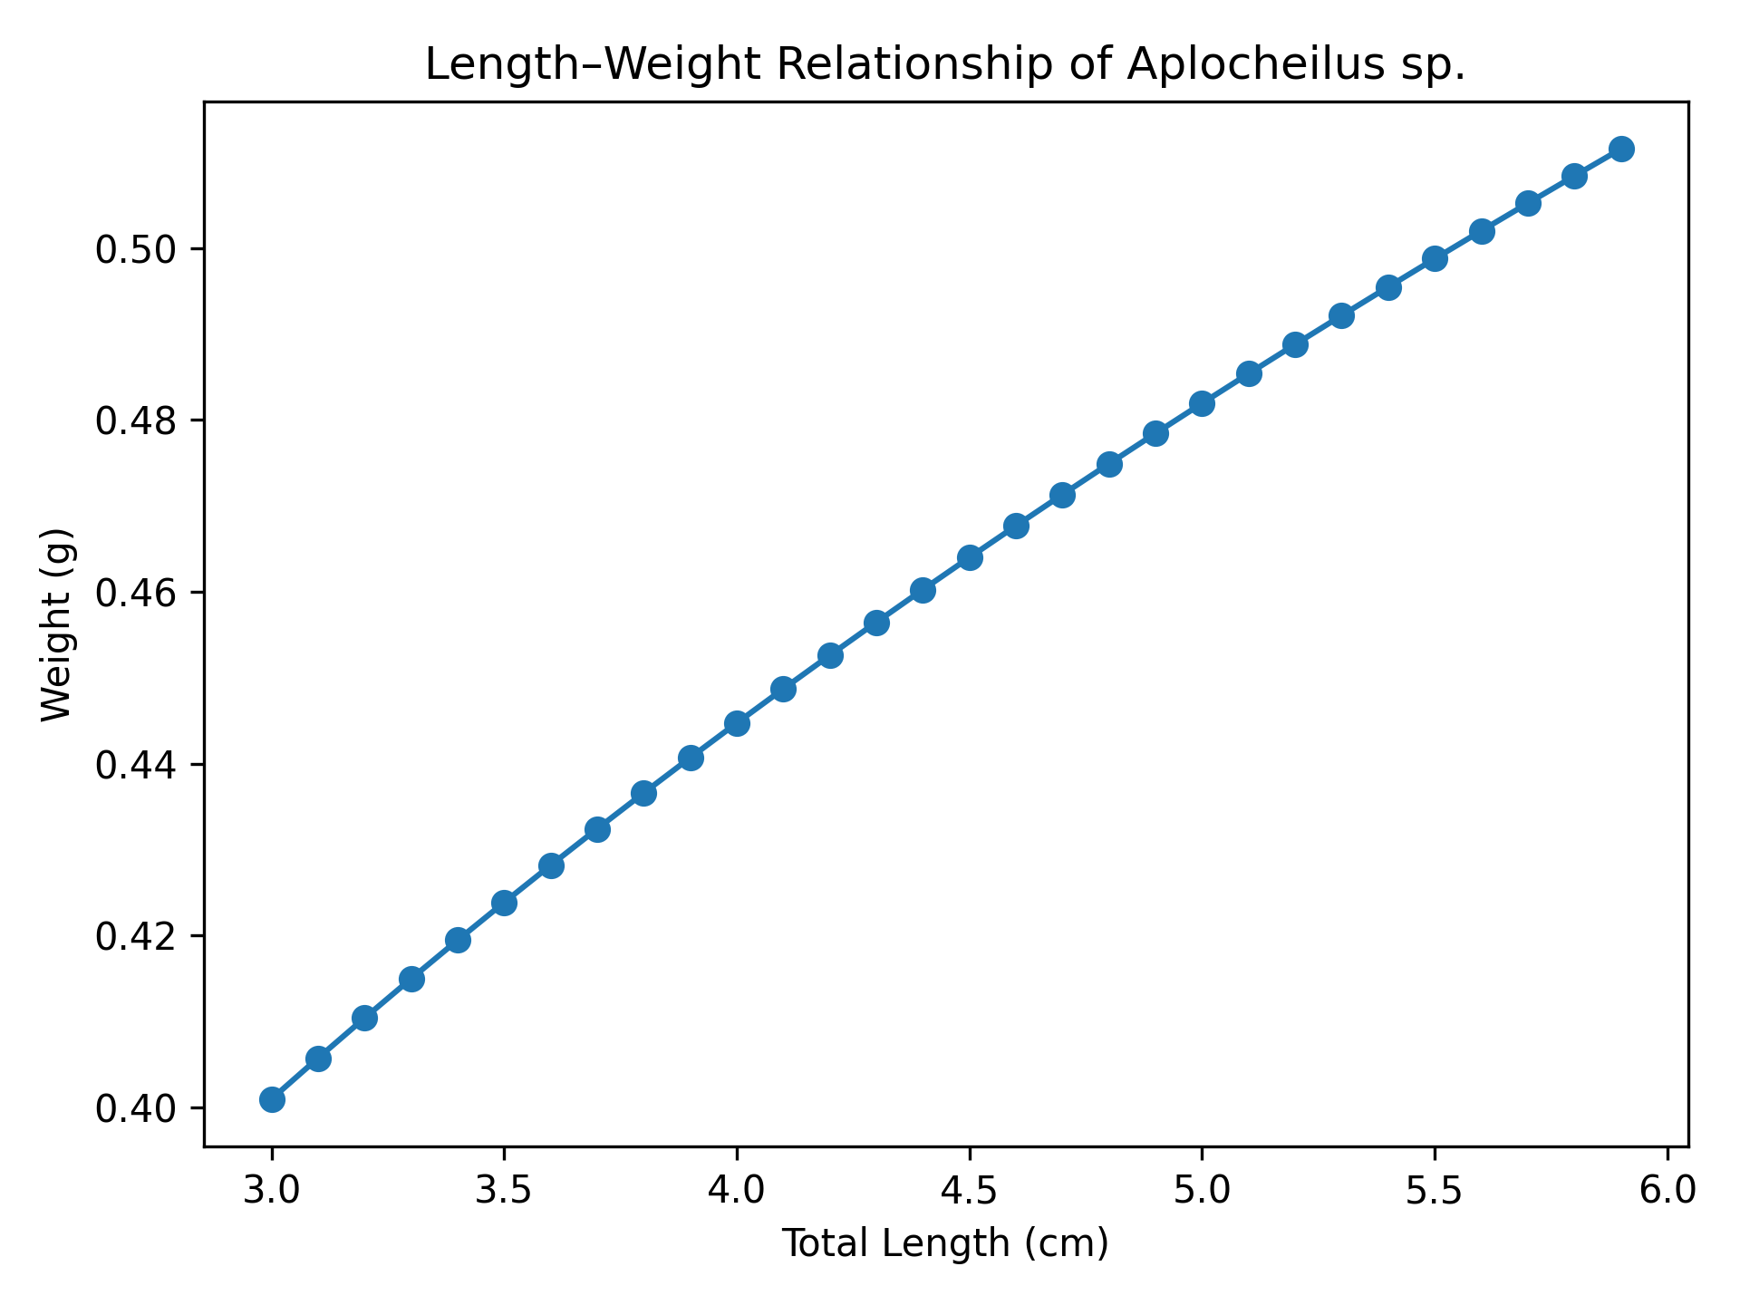
Figure 1. Length–Weight relationship of Aplocheilus sp.
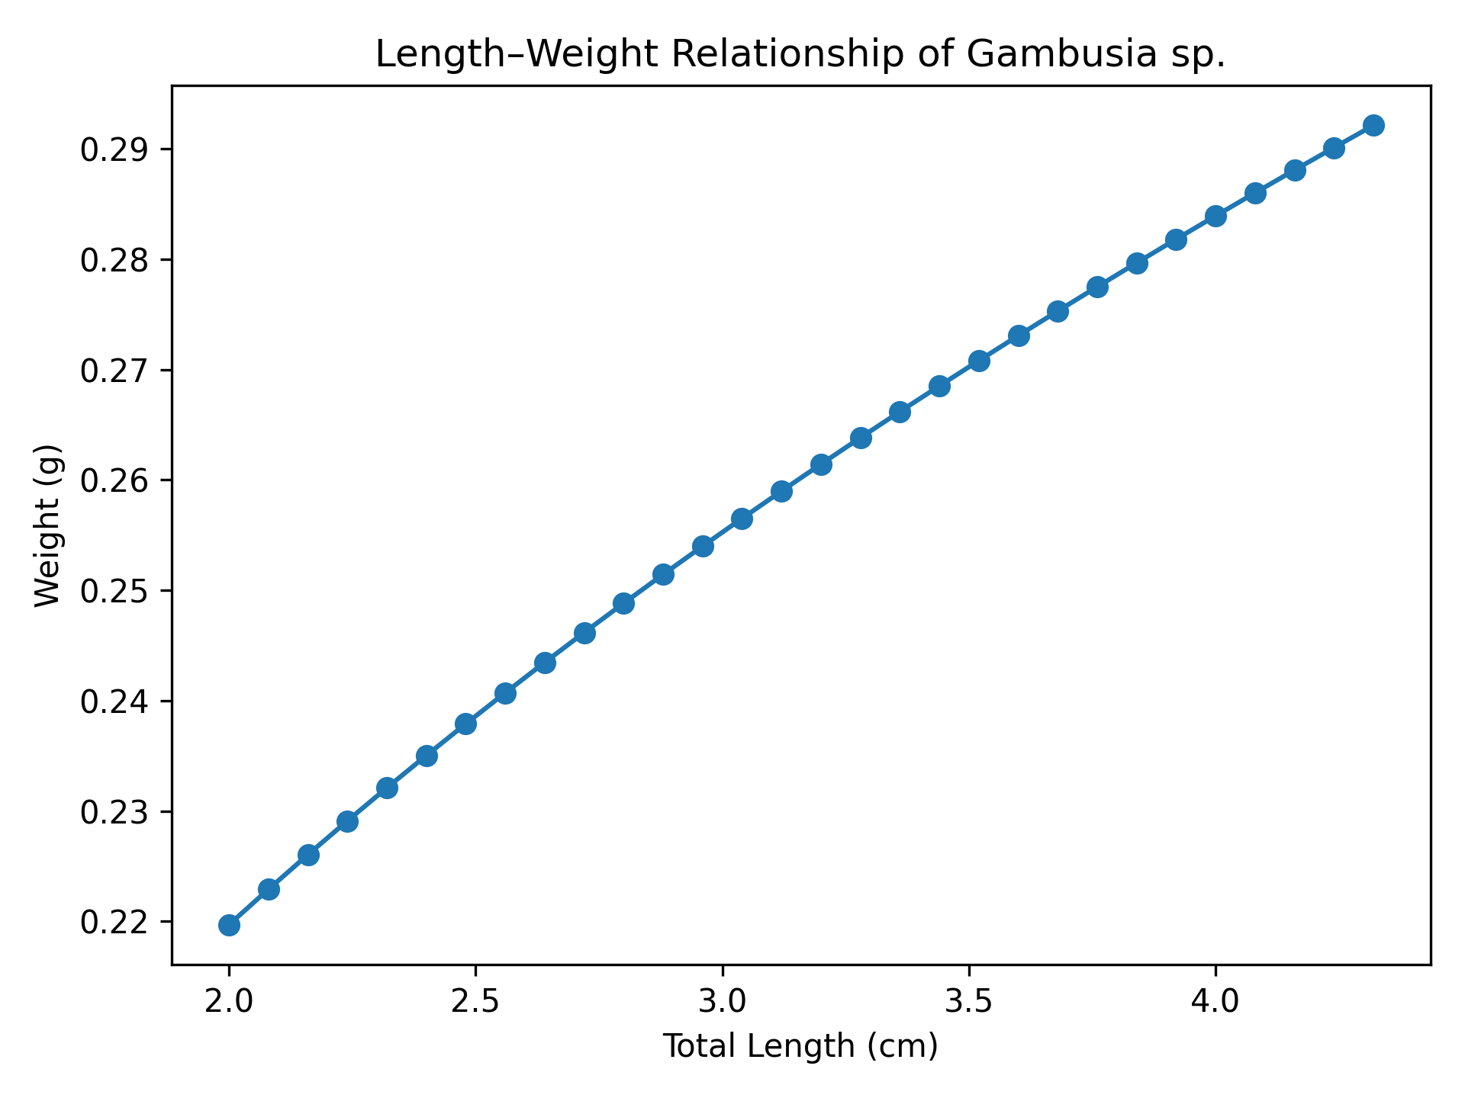
Figure 2. Length–Weight relationship of Gambusia sp.
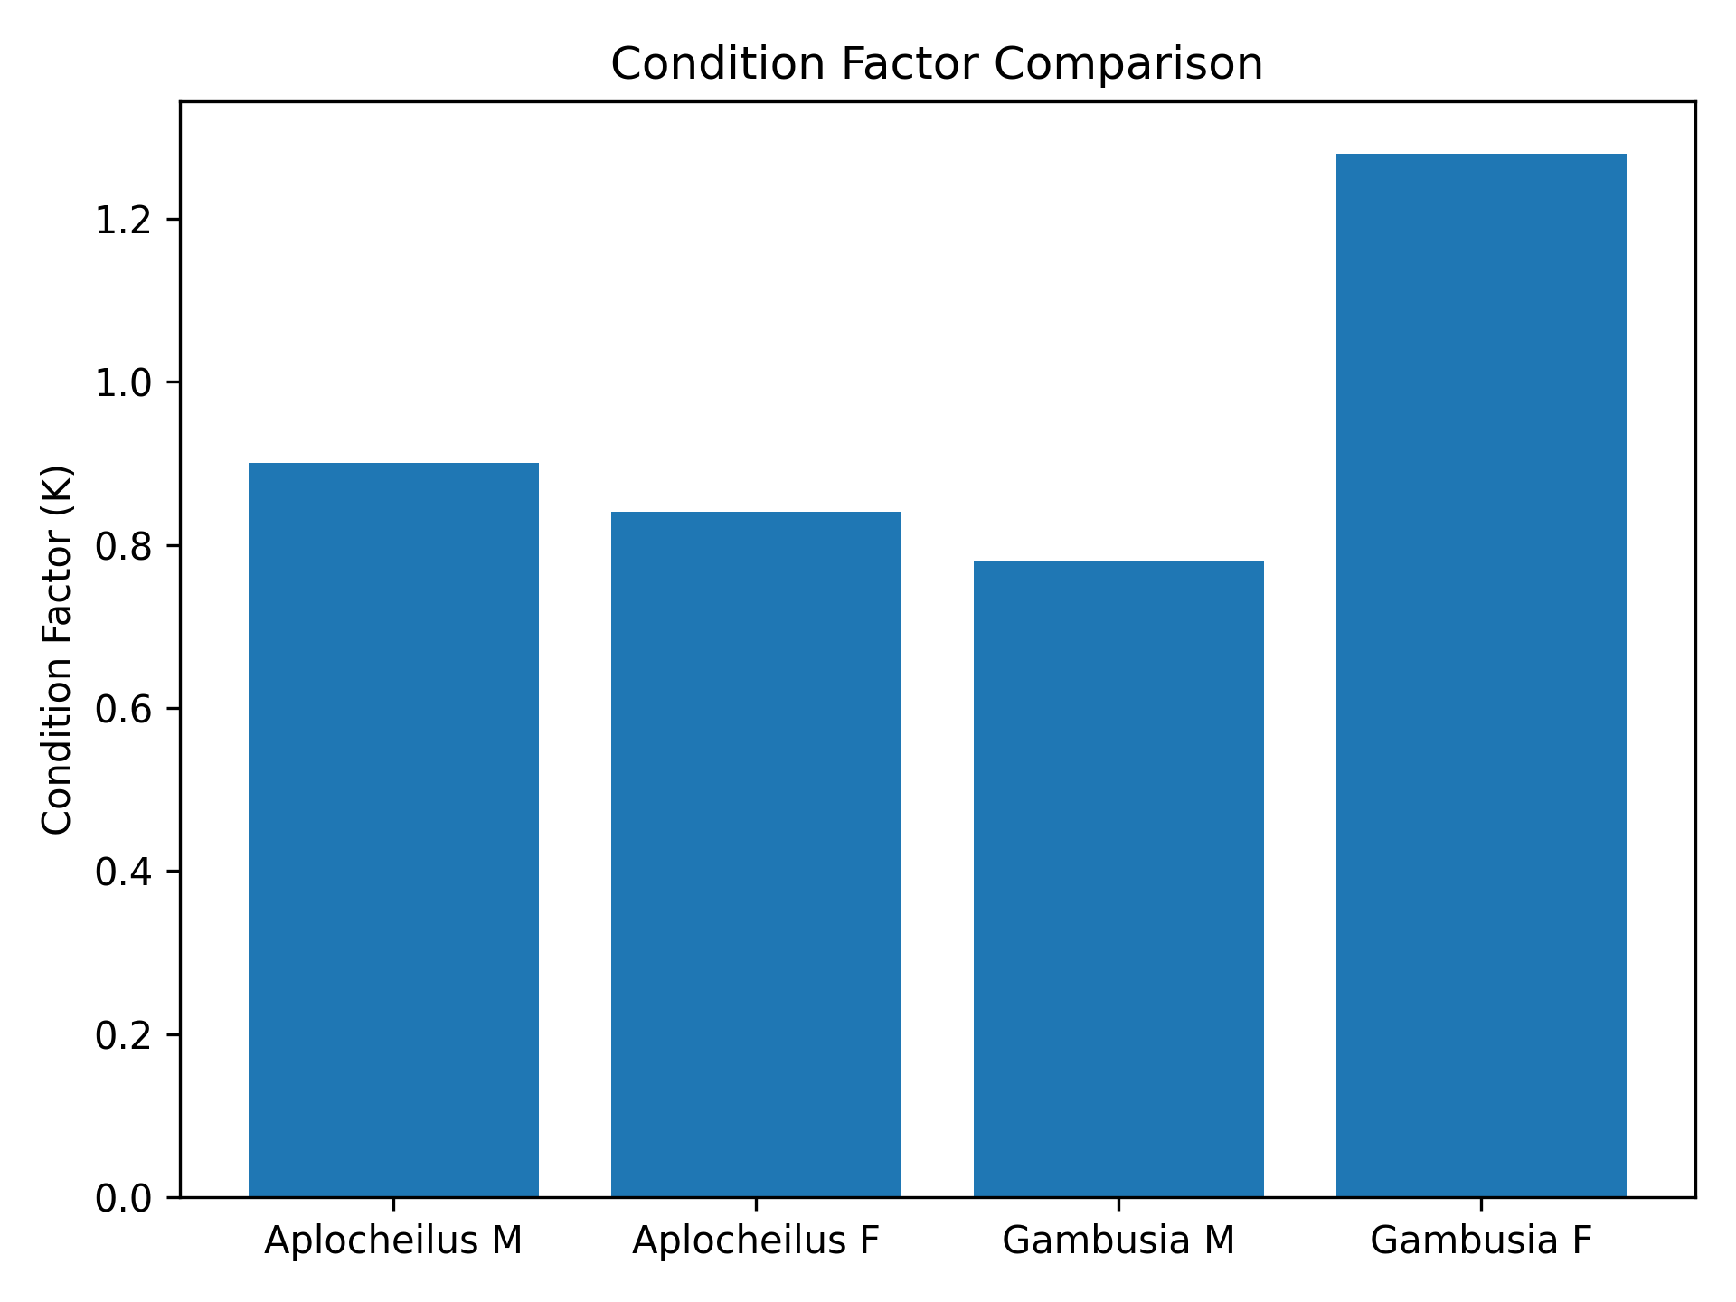
Figure 3. Condition factor comparison.
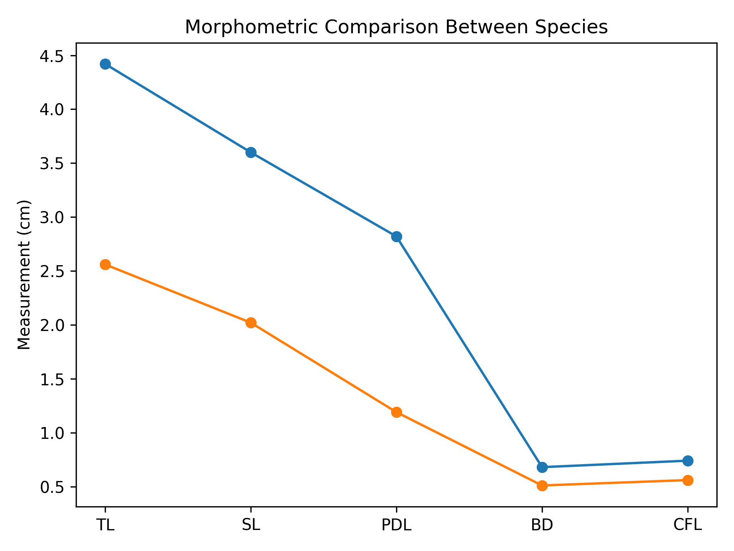
Figure 4. Morphometric comparison between species.
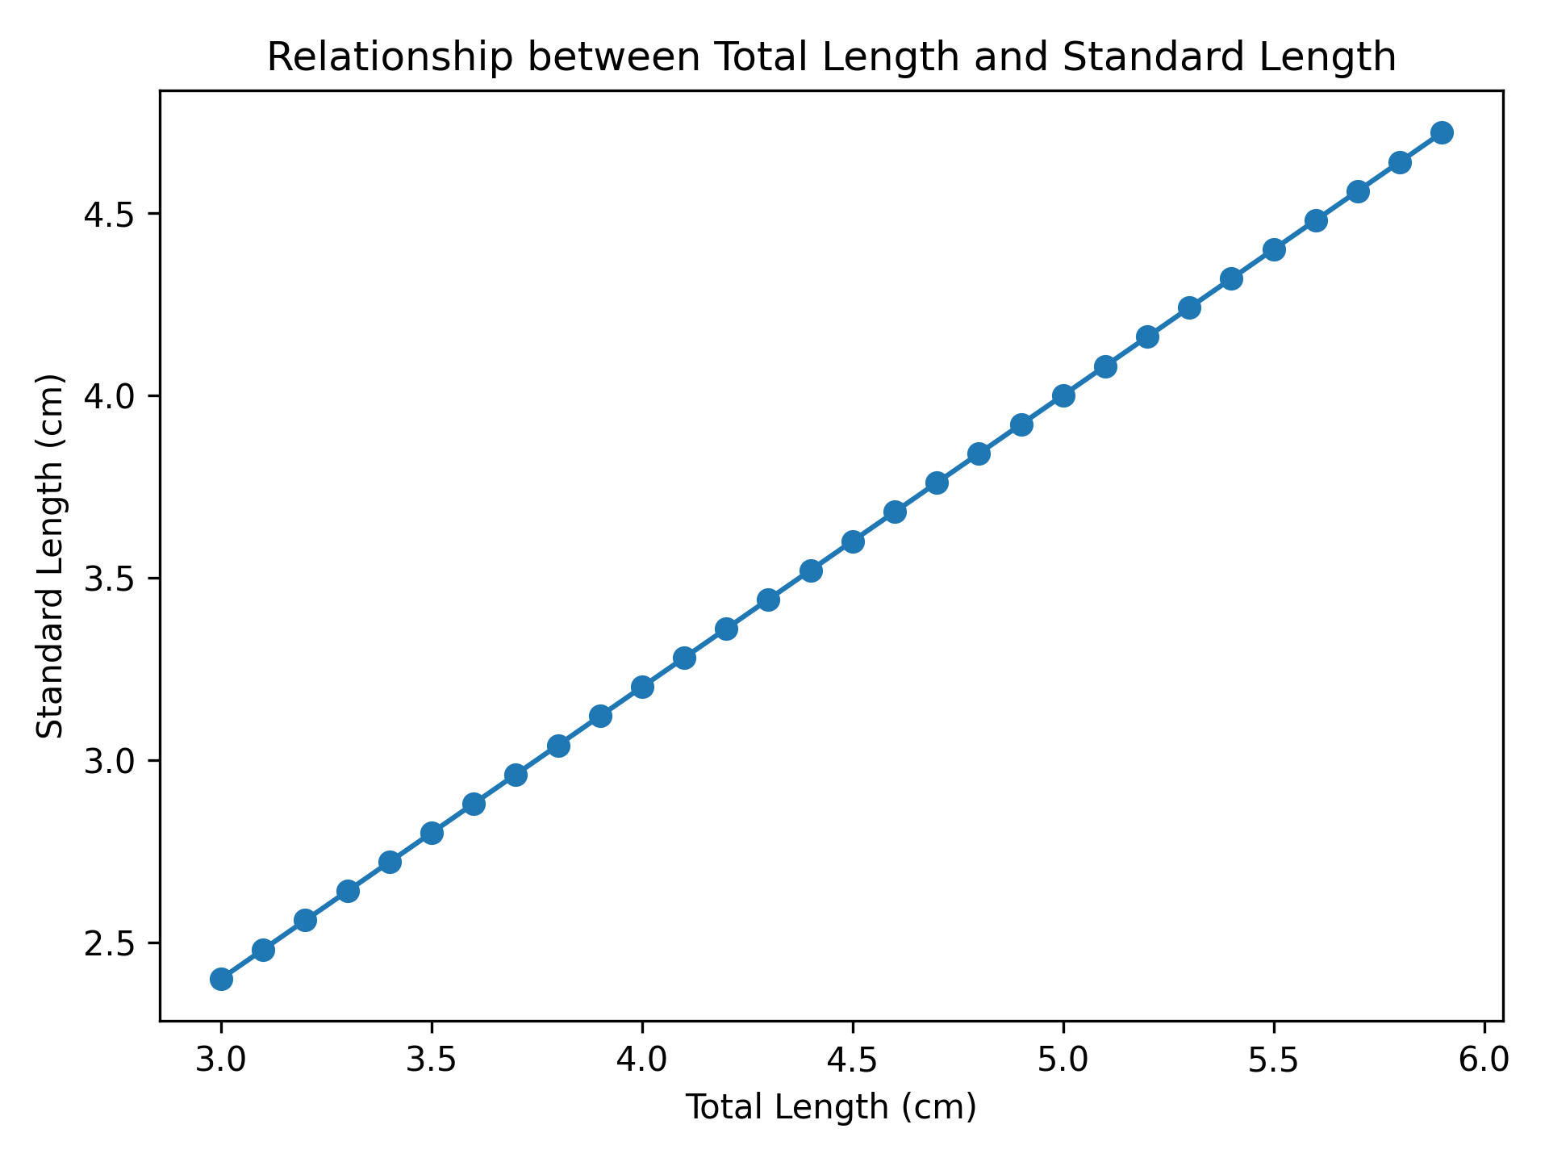
Figure 5. Relationship between total length and standard length.

5. Discussion

The present investigation provides a comparative evaluation of morphometric characteristics, length–weight relationships, and condition factors of two larvivorous fish species, namely the indigenous Aplocheilus sp. and the exotic Gambusia sp. Morphometric studies are widely used in fisheries biology to understand the structural variation, growth pattern, and ecological adaptation of fish populations. The results of the present study revealed significant correlations between several morphometric parameters and the total length of the fishes.

Among the studied characters, standard length, predorsal length, pelvic fin length, and body depth showed strong positive correlations with total length in both species. This indicates that these body structures grow proportionally as the fish increases in size. Such coordinated growth among body parts reflects a balanced morphological development that may be genetically regulated. Similar observations have been reported in various freshwater fish species where certain morphometric characters maintain consistent proportional relationships with body length.

However, some morphometric characters such as pre-pectoral length and pelvic fin length exhibited moderate correlations with total length. These variations may be influenced by environmental conditions rather than purely genetic factors. Environmental parameters such as water temperature, food availability, habitat structure, and population density can significantly affect morphological development in fishes. In natural aquatic systems, fishes often exhibit phenotypic plasticity, allowing them to adjust their morphology according to environmental conditions.

The comparative morphometric analysis also revealed differences between the two studied species. The indigenous Aplocheilus sp. displayed relatively larger body dimensions compared to Gambusia sp., indicating differences in growth rate and ecological adaptation. Aplocheilus species are generally adapted to freshwater habitats such as ponds, rice fields, and slow-moving streams where food resources may be relatively abundant. On the other hand, Gambusia species are known for their ability to survive under harsh environmental conditions including high temperature, salinity, and low oxygen levels. These ecological differences may contribute to the observed variation in morphometric characteristics.
The length–weight relationship (LWR) analysis revealed that both fish species exhibit negative allometric growth, as indicated by the exponent (b) values being less than 3. In fisheries science, the value of the growth exponent (b) is considered an important indicator of fish growth patterns. When the value of b equals 3, the fish exhibits isometric growth, meaning that length and weight increase proportionally. However, when the value of b is less than 3, the fish shows negative allometric growth, indicating that the fish increases more rapidly in length than in body mass.

The negative allometric growth observed in this study suggests that both Aplocheilus sp. and Gambusia sp. become relatively more elongated as they grow. Such growth patterns are commonly observed in small freshwater fishes, particularly in species that inhabit shallow water bodies and rely on rapid swimming to capture prey or avoid predators. Similar findings have been documented in earlier studies on larvivorous fishes and other freshwater species.

Several biological and environmental factors may influence the length–weight relationship of fishes. These include food availability, reproductive stage, age structure of the population, seasonal variations, and environmental conditions such as temperature and dissolved oxygen levels. In addition, differences between male and female fishes may also influence growth patterns due to variations in reproductive investment and metabolic activity.

The analysis of condition factor (K) provides valuable insights into the physiological health and overall well-being of fish populations. In the present study, the condition factor values varied between the studied species and sexes. Gambusia females exhibited the highest condition factor, indicating a relatively better physiological condition and higher body mass relative to length. This may be associated with reproductive activity, as female fishes often accumulate additional body mass during gonadal development.

In contrast, the condition factor values of Aplocheilus males and females were relatively similar, suggesting a more uniform growth pattern between sexes. The relatively stable condition factor in this species may indicate that the environmental conditions in their habitat are favourable for growth and survival. The condition factor is known to be influenced by various factors such as food availability, habitat quality, seasonal changes, and reproductive status.
Another interesting observation in this study is the ecological implication of using indigenous versus exotic larvivorous fishes for mosquito control. While Gambusia sp. is widely used as a biological control agent due to its high reproductive capacity and adaptability, it is also considered an invasive species in many aquatic ecosystems. Its aggressive feeding behavior and competition for food resources may negatively affect native fish populations.

On the other hand, indigenous species such as Aplocheilus sp. are better adapted to local ecological conditions and may have fewer negative impacts on native biodiversity. Therefore, the promotion and conservation of indigenous larvivorous fishes may represent a more sustainable strategy for biological mosquito control in freshwater ecosystems.

Overall, the present study highlights the importance of morphometric and growth analyses in understanding the biological characteristics and ecological roles of larvivorous fishes. These findings contribute valuable baseline information that may support future research in fish biology, ecological monitoring, and vector control programs.

6. Conclusion

The present study provides a comprehensive comparative assessment of morphometric characteristics, length–weight relationships, and condition factors of two larvivorous fish species, the indigenous Aplocheilus sp. and the exotic Gambusia sp. The analysis of morphometric parameters revealed significant correlations among various body measurements, particularly between total length and other structural characters such as standard length, pre dorsal length, and body depth. These relationships indicate coordinated morphological development and provide useful information for species identification and population studies.
The length–weight relationship analysis demonstrated that both species exhibit negative allometric growth patterns, indicating that the fishes increase more rapidly in length than in body weight as they grow. This type of growth pattern is commonly observed in small freshwater fishes and may be associated with their ecological adaptation to shallow water habitats and active feeding behavior.
The evaluation of condition factor revealed differences between species and sexes, with Gambusia females showing the highest condition factor values. This suggests that the physiological condition and energy reserves of female Gambusia may be relatively higher, possibly due to reproductive processes. In contrast, the condition factor values of Aplocheilus individuals were relatively stable between sexes, indicating balanced growth under the studied environmental conditions.
The findings of this research highlight the ecological significance of larvivorous fishes in aquatic ecosystems, particularly in relation to mosquito population control. Both Aplocheilus sp. and Gambusia sp. possess biological characteristics that make them effective predators of mosquito larvae. However, considering the potential ecological impacts of exotic species, greater emphasis should be placed on the conservation and utilization of indigenous larvivorous fishes.
From a broader perspective, the morphometric and growth data generated in this study provide valuable baseline information for fisheries biology, ecological monitoring, and vector management strategies. Such information can support the development of environmentally sustainable approaches to mosquito control while simultaneously contributing to the conservation of native fish biodiversity.
Future studies should focus on expanding the sample size, incorporating seasonal variations, and examining additional ecological factors such as water quality parameters and feeding ecology. Integrating molecular and genetic approaches with morphometric analyses may also provide deeper insights into population structure and evolutionary adaptation of larvivorous fish species.
In conclusion, the present study contributes to the scientific understanding of morphological variation, growth dynamics, and ecological importance of larvivorous fishes, and emphasizes their potential role in sustainable biological control programs for mosquito management.

References
Fulton TW (1904). The rate of growth of fishes.
Froese R (2006). Length–weight relationships in fishes.
Bagenal TB (1978). Methods for Assessment of Fish Production in Freshwaters.
Chandra G (2008). Mosquito control by larvivorous fish.

