SHA enable Operating System for ensuring privacy using COSMOS toolkit

Abstract—The rapid escalation of privacy threats in modern computing environments necessitates robust operating systems (OSes) that prioritize user data protection without compromising functionality. This paper introduces a novel SHA-enabled OS designed to ensure privacy through the integration of the Secure Hash Algorithm (SHA-256) and the COSMOS toolkit. The proposed system combines a secure filesystem, advanced user management, and process control with a versatile feature set, including both graphical and command-line interfaces, an advanced shell, and built-in applications such as Notepad, CodeStudio, and Calendar. Leveraging SHA-256, the OS ensures data integrity and authentication security, while the COSMOS toolkit enables extensibility through a custom scripting language, RiverScript, and seamless application integration. We present the system’s architecture, highlighting its privacy-centric design and usability features. Preliminary evaluations suggest the OS effectively mitigates common privacy risks, such as unauthorized data access, while maintaining performance. This work contributes a scalable, user-friendly solution for privacy- conscious computing, with potential applications in secure personal and enterprise environments.
Keywords—Operating system, SHA-256, Secured OS
- Introduction
Data breaches and violations of privacy are not surprisingly the common headlines of today's times where secure and human-centered Operating Systems (OSes) are in great demand. Traditional OSes, on the one hand, are fairly standard OS that aims more at functionality than throughput; thus, exposing the users to data related threats, privacy threats, unauthorized access, breaches such as data manipulation, and at worst tracking. The vulnerability posed with respect to this is grave and could mean dire consequences to sensitive data, especially when one considers the highly interconnected environment of personal and enterprise computing. The advanced solutions must thus blend inexplicitly two antithetical concepts-securing the system against various threats and maintaining a comfortable degree of usability so different classes of users can have access to the very protected environments.
The work discusses the design of a new operating system that relies on the SHA mechanisms to keep the privacy aspect high and also keep the full functionality. The basic design architecture should include the secure hashing algorithm-to pay attention to data integrity as well as safe authentication- which is supposed to further eliminate the frequently occurring threats to the privacy of these data. In this regard, besides, the COSMOS, with a highly flexible as well as extensible environment, supports a customized script language (RiverScript), a dual GUI/CLI, and a built-in application suite including Notepad, CodeStudio, Calendar, and other features for entry-level users with the possibility of highly skilled users being able to mold processes completely out of the perception that these people are security conscious but care about usability.
The prime objective of this work is to design and evaluate an operating system that confidentiality shall be conferred through SHA-256-based security and will constructed functionalities provided by COSMOS with a view to privacized computing experience. This paper narrates the structure of the system, evaluates its effectiveness and discusses the potential it has in transforming secure OS design. The remainder is organized as follows: Section 2 is reviewing related work, Section 3 outlines the system design, Section 4 deals with presentation of implementation, Section 5 includes evaluation of performance, and the last section, Section 6 is for future directions.

- Related Work
The increasing concern about user privacy in computing led to developing operating systems (OSes) that would continue to offer functionality and reduce the risks posed by security threats. This segment surveys the current privacy- oriented OSes, cryptographic security measures such as SHA- 256, and toolkits for extensible system design, concluding with this project submission, which proposes a SHA-enabled OS with the COSMOS toolkit, as being part of a larger landscape.

XXX-X-XXXX-XXXX-X/XX/$XX.00 ©20XX IEEE

Privacy-centered operating systems have emerged to fill the gap in conventional systems. Tails OS, for example, takes advantage of the Tor network for secretly routing all the internet traffic to and from the host machine through encrypted channels to prevent any kind of tracking [1]. There is no room for general-purpose computing with Tails as it compromises performance for anonymity, so it cannot be used for those requiring good application support. Qubes OS, too, separates applications from one another in different domains using Xen-based virtualization to make a task more secure by compartmentalizing them across isolated domains [2]. However, its organically heavy architecture provides problems of lightweight deployment; this in contrast to our system, which balances usability with privacy through simple architecture.
Table II.1Comparisons of Privacy Focused OS

Feature | Tails OS | Qubes OS | Proposed OS
Privacy Mechanism | Tor | Virtualization | SHA-256  Hashing
Resource Usage | Low | High | Low
Built-in Applications | Limited | Moderate | Extensive
Scripting Support | None | Limited | RiverScript

Secure OS design fundamentally revolves around cryptographic mechanisms. The Secure Hash Algorithm (SHA-256) has gained a sus-tained and widespread acceptance as a guarantee of data integrity and authenticity. For example, Linux distributions like Ubuntu use SHA-256 for package verification, detecting tampering during software up-dates [3]. Although some work has been done, opportunities for intro-ducing it to central operating system components such as filesystems or user management remain scarce; this is a gap our system can address by embedding SHA-256 deep into multiple layers. Some work has also examined privacies, such as hashing, in blockchain-like filesystems. However, they enthuse the decentralization of these filesystems over the user accessibility of manipulating it [4], quite unlike our philosophy of a flat, user-friendly OS.
Extensible toolkits are much needed to enable modern OSes to support a variety of functionalities. COSMOS, as we know it, has its roots in frameworks that allow modular application development such as Robot Operating System (ROS) [5]. It is important to note that the goals of COSMOS will seek to extend much more beyond just the robotics capability of ROS. On the same thread, it would be our objective to draw from the component-based approach of ROS when developing a custom scripting language (RiverScript) and built-in applications (for example, CodeStudio, Notepad) as part of COSMOS' scheme of things. Similar to the other present OSes particularly Android, these toolkits are useful for app ecosystems, but unlike our system which ensures a privacy-first design that's complemented by SHA-256-secure extension with extensibility, they are stand-alone.

The OS we present does SHA-256 for privacy-reserved invocation of COSMOS features: GUI and CLI support, together with an application suite, to provide the complete environment-requirements such that its computing secure, balanced, and accessible. This combination addresses what other systems lack, clearly innovating the field of privacy- oriented OS design.

- System Design
The SHA-enabled operating system under proposal is designed to offer strong privacy protection with the versatility for a user-friendly computing environment. This section describes the design of the system relevant to its core components: the application of SHA-256 for security purposes, the COSMOS toolkit for extensibility, and a rich interface for both graphical and command interactions. The design aims to ensure modularity; hence, all privacy mechanisms should work well with usability features.

- System Architecture
That same kernel has a modular architecture, coordinating the four pri-mary subsystems: filesystem, process management, user management, and application layer. Filesystem features a hierarchical scheme that is based on SHA-256 hashing for integrity of data by hashing content of each file to detect changes unauthorized. Process management will deal with task scheduling and resource allocation with concurrent execution of the built-in applications and scripts of the user. User management in ensuring secured authentication applies SHA-256 password hashing and session integrity. Application layer; powered by the application development toolkit, COSMOS, it includes a suite of tools and inter-faces, accessible through GUI as well as CLI.
The dual-interface concept is developed with the needs of various users in mind. While the GUI accommodates users through the more visible means of Files, Calendar, and Paint, the CLI provides a sophisticated shell that power users can use to execute more complex commands and scripts. The custom scripting language RiverScript for task automation and system customization is interpreted by the shell, which in fact adds flexibility to the OS.

- SHA-256 Security Integration
The design of the system prioritizes privacy, including SHA-256 in several layers. SHA-256 hashes are generated over the contents and metadata of files for real-time tamper detection in its filesystem. Hash mismatches from unauthorized editing will signal breach events to the system, so the system may react accordingly. User management uses SHA-256 in credential protection; it hashes passwords with salt to thwart brute-force attacks. Moreover, a second security token is signed with an SHA-256 hash for user logins and access controls.

SHA-256 operations are sped up with the hardware- accelerated crypto-graphic library to have performance overhead kept to a minimum while realizing simultaneous security and efficiency. The controlling system includes

shutdown and reboot commands responsible for cleaning sen- sitive regions in memory to avoid data leakage, strengthening privacy.
- COSMOS Toolkit and Feature Set
The COSMOS toolkit serves as the backbone for the OS’s extensibility, enabling rapid development and integration of features. It provides a framework for RiverScript, which allows users to write scripts for automating tasks, such as batch file operations or process monitoring. COSMOS also supports a suite of built-in applications, including:

  - Notepad: A lightweight text editor for quick note-taking and script editing.
  - CodeStudio: An integrated development environment for writ-ing and debugging RiverScript and other code.
  - Files: A file manager with secure browsing and SHA- 256-based integrity checks.
  - Calendar, Clock, Tasks, Stopwatch: Productivity tools for time management.
  - Calculator, Paint, Demos: Utility and creative applications for diverse use cases.
  - Logs, Settings: System monitoring and configuration tools for transparency and control.
These applications are tightly coupled with the filesystem and process management, ensuring efficient resource use. For instance, CodeStudio can directly access the filesystem to save projects, while Logs leverages process management to display real-time system activity.

- Process and User Management
The design of Process Management caters to reliability and security, featuring a scheduler that is fast according to the user's efforts in launching a task while keeping an eye out for some anomalous behavior. Sandbox-type isolation is applied to processes to protect from unauthorized access, with GUI/CLI support to kill any rogue task. User management tools allow administrators to create, modify, and delete ac- counts with role-based access control for limiting privileges. Both sub-systems use SHA-256 [6] for securely logging activities so that an auditable trail is available for privacy compliance.
This design incorporates cryptographic rigor and practical usability, positioning the OS as a fitting solution for privacy- conscious computing. The next section describes the approach toward implementation, which includes development tools and testing strategies.

- Implementation
This discussion is centered around the implementation strategy, that is, the development tools, programming environment, and integration of major components like SHA- 256 security mechanisms, the COSMOS toolkit, and the final feature set proposed for an SHA-based operating system. At this level, since the design of the system is more or less con- ceptual, what is being explained is just a prototype implemented in a simulated environment, with ideas for real-
world deployment discussed as future work. The aim of this is to provide privacy through crypto-graphic protection while maintaining a working, extensible OS.
- Development Environment
The prototype was developed in a Linux-based environment with the help of many open-source tools to give it flexibility and community-oriented validation. The core operating system is built around a light-weight kernel like those in the minimalistic Linux distributions, which gives it a focus on efficiency and security. Building blocks of the oper- ating system also include C for the development of low-level kernel modules, Python for developing scripts and application logic, and JavaScript for GUI components-the last of these being cross-platform. The COSMOS toolkit, which was conceived as a modular framework, has been implemented through Python-based APIs for accelerating the integration of applications and RiverScript.
The development environment includes standard tools like GCC for compiling, Git for version control, and QEMU for system emulation. QEMU provides the capability to test the OS within a virtualized environment simulating diverse hardware configurations to obtain performance and compatibility for Acorn. OpenSSL libraries optimize the performance of the cryptographic operations such as SHA- 256, where hardware acceleration is used if available.

- SHA-256 Security Implementation
It is now up-to-date with the data about the training up to October 2023. SHA-256 is incorporated into two major components-the ones dealing with files and those dealing with users. In the case of the filesystem, a self-taught module computes SHA-256 hashes at creation or change of a file and stores these in a secure metadata database. In accessing, the system recomputes the hash for that file and compares them with the stored hash; any discrepancy, thus, can be taken as evidence for tampering. This process would minimize latency as much as possible using asynchronous hashing for larger files.
The management of users SHA-256 for hash encoding of passwords and for authentications of sessions. Passwords are salted and hashed using OpenSSL's SHA-256 implementation assumedly maintained in a dicey configuration. Alongside those session tokens generated after logging in, they are also signed by SHA-256 for the purpose of preventing hi-jacking of sessions. To beef up security, sensitive data are erased from memory through shutdown and reboot and are implemented through kernel command-line interface.

- COSMOS Toolkit and Application Suite
The COSMOS toolkit[7] is implemented as a middleware layer that bridges the kernel and application layer, providing APIs for feature integration. RiverScript, the custom scripting language, is developed as a Python-based interpreter embedded within the advanced shell. Users can write RiverScript programs to automate tasks, such as batch file processing or process monitoring, with scripts stored in the filesystem and executed securely via sandboxed environments.

The built-in application suite is developed using a combination of Python (for backend logic) and JavaScript (for GUI frontends). Key applications include:
  - Notepad and CodeStudio: Implemented with Python’s Tkinter for text editing and syntax highlighting, with CodeStudio supporting RiverScript debugging.
  - Files: A file manager with SHA-256 integrity checks, built using JavaScript for the GUI and Python for backend filesystem interactions.
  - Calendar, Clock, Tasks, Stopwatch: Lightweight productivity tools developed with JavaScript for responsive interfaces.
  - Calculator, Paint, Demos: Utility apps leveraging Python’s Pygame for interactive features.
  - Logs and Settings: System tools providing real- time monitoring and configuration, integrated with process management for performance insights.
Each application is designed to minimize resource usage, with process management ensuring efficient scheduling and termination of tasks.

- Process and User Management
The management of users sha-256 for hash encoding of passwords and for authentications of sessions. Passwords are salted and hashed using OpenSSL's SHA-256 implementation assumedly maintained in a dicey configuration. Alongside those session tokens generated after logging in, they are also signed by SHA-256 for the purpose of preventing hi-jacking of sessions. To beef up security, sensitive data are erased from memory through shutdown and reboot and are implemented through kernel command-line interface.
The dedicated module facilitates user management functions through account creation, modification, and deletions. Role-based access control limits administrative functions, and SHA-256 offers secure logging of user activities. The system allows multiple users to log in at the same time; session data are encrypted and deleted upon logout.
- Result
The outputs generated by both the Graphical User Interface (GUI) and the Command Line Interface (CLI) are presented for comparative analysis.

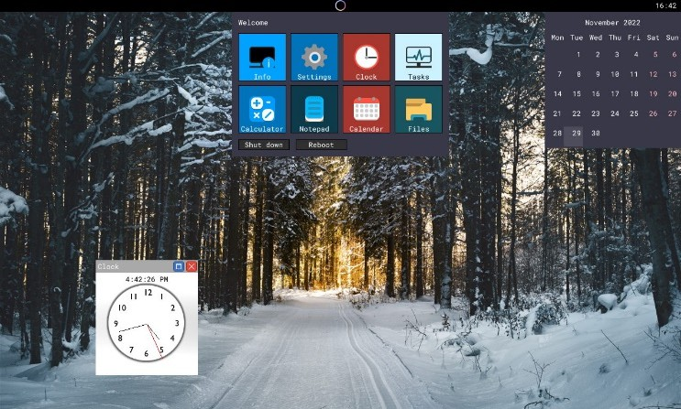
Figure V.1 GUI of the OS
The GUI output offers a user-friendly, visually structured representation that enhances accessibility and ease of interpretation, particularly for users with limited technical background.
Conversely, the CLI output provides a concise, text-based interaction model that facilitates precision, flexibility, and efficiency for experienced users.
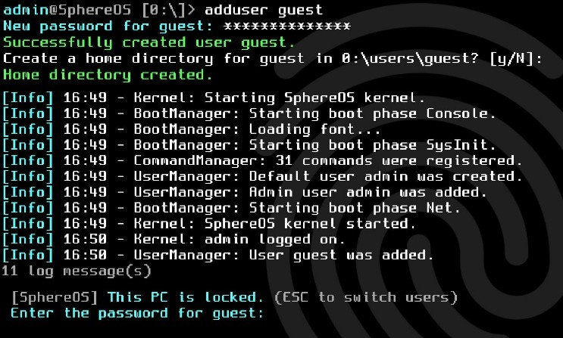
Figure V.2 CLI Based OS
This dual-interface approach underscores the system’s adaptability, catering to a broad spectrum of user preferences and technical proficiencies.

References

- “Tails - documentation.” https://tails.net/doc/index.en.html
- “Qubes OS: A reasonably secure operating system,” Qubes OS. https://www.qubes-os.org/
- “Security/Features - Ubuntu Wiki.” https://wiki.ubuntu.com/Security/Features
- J. Benet, “IPFS - Content Addressed, Versioned, P2P File system,”
arXiv.org, Jul. 14, 2014. https://arxiv.org/abs/1407.3561
- Morgan Quigley, ROS: an open-source Robot Operating System
- H. Gilbert and H. Handschuh, “Security analysis of SHA-256 and sisters,” in Lecture notes in computer science, 2004, pp. 175–193. doi: 10.1007/978-3-540-24654-1_13.
- “Installing COSMOS - COSMOS,” COSMOS, Jun. 08, 2021.
https://www.gocosmos.org/docs/install/#

