SMART IOT MONITORING IS AN AI-DRIVEN SECURITY AUTOMATION FRAMEWORK

Abstract— The fast expansion of Internet of Things (IoT) implementations in smart cities, health care, industrial automation, and critical infrastructure has become an important concern in terms of security risks and challenges to operations. The conventional IoT monitoring platforms typically do not support real-time analytics, smart threat identification, and scalable security controls, which is why they are not suitable in the conditions of large scale. This paper will overcome these shortcomings by proposing SMART IoT MONITORING, an AI-based security automation platform that will allow the secure, scalable, and real-time monitoring of IoT ecosystems with limited infrastructure overhead. Anomaly detection methods based on machine learning are used to detect abnormal behavior of devices and possible security threats without the need of large labeled datasets. The proposed framework has been shown to yield actionable insights and respond to incidents quickly through automated alerting and visualization mechanisms, which produce improved visibility of security and improve system reliability, as well as changing system operations, as opposed to traditional IoT monitoring systems. SMART IoT MONITORING is a scalable cost-effective and smart framework that can be used to implement modern IoT deployment.
Keywords— Internet of Things, IoT Security, Anomaly Detection, Serverless Computing, Cloud Monitoring, EC2, ECR, ECS, S3, IOT Core ,Lambda

- INTRODUCTION
Internet of Things (IoT) has become an enabler technology of intelligent and automated systems in areas including smart cities, smart healthcare, smart industrial automation, smart agriculture and smart critical infrastructure. The number of IoT gadgets in the market keeps producing real-time mass data, which can be used to monitor, control, and make decisions. But the growing size and diversity of IoT environments has brought with it major problems to do with security, scalability, and real-time monitoring. Most of the current IoT monitoring platforms prioritize connectivity of the devices and the basic visualization of the data, and have fewer features in terms of powerful security analytics and anomaly detection. These systems tend to be based on static threshold based rules and manual intervention that are not enough to identify advanced cyberattacks, device failures and zero-day attacks. Moreover, classical architectures cannot scale effectively with an increase in the number of devices being connected, causing an increase in the cost of operation and prolonged response time. Recent innovations in artificial intelligence (AI), machine learning (ML), and cloud computing have allowed creating smart and flexible monitoring solutions to the IoT systems. The AI-based anomaly detection algorithms have the ability to detect abnormal behavior on a device, in a network and sensor data, and allows detecting security threats and operational failures at earlier stages. In this regard, the paper proposes SMART IoT MONITORING, a novel AI-based automation system, which delivers real-time and scalable, as well as highly secure IoT ecosystem monitoring. The suggested framework incorporates the secure data ingestion, cloud-based real-time processing, machine learning-based anomaly detection, and automated alerting into one platform. The system security and resilience are enhanced with the use of end-to-end encryption, strong authentication and multi-layered monitoring strategies. In the current work, an IoT system on cloud to track livestock health is proposed through the AWS services and Python-based analytics. Sensor data collected from animals is transmitted securely to the cloud for real-time processing, visualization, and alert generation. This paper will provide a scalable system of cloud platform and automated checks and balances, where cloud functions are used to implement an IoT smart farming system that ensures a structured and efficient early disease detection and operational efficiency[1]. The suggested strategy will allow detecting threats in real-time, responding to them automatically, and enforcing policies without having a dedicated server. The outcomes are enhanced scalability, latency, and effectiveness of security event management of dynamic IoT deployments[2].The authors argue in favor of a serverless architecture of managing IoT devices, which pays attention to scalability and cost-efficiency. It is a system that manages events based on the cloud services into device registration, data ingestion, and lifecycle management. The experimental findings indicate better performance and lower operation overhead than the conventional server-based architecture[3].The paper illustrates an experimental hybrid machine learning based phishing detection system, which evaluates URL-based features. The suggested model that is lexical-based, host-based, and statistical attributes, but it is augmented with the use of ensemble learning offers high detection accuracy and low false positives. The paper will address the integration of serverless computing and federated learning into the cloud-to-edge continuum when it comes to applying IoT[4]. The proposed design permits distributed learning and preserves privacy and reduction of communication overheads of data. The pointing aspect of better scalability and flexibilities of heterogeneous IoT setups can be achieved through experimental analysis [5]

II.RELATED WORKS

The machine learning-based Android malware detection system suggested by the authors entails the integration of permissions, API calls, and behavioral characteristics. Co-existence feature method improves the accuracy of detection and decreases the false positives. The model is resistant to new forms of malware in the real world environment[6]. This paper presents a safe IoT system with microservice and serverless architecture. The framework is used to promote modular deployment, a stronger sense of security isolation, and scales process of IoT data. Through tests, there are enhanced reliability of systems, flexibility, and resistance to cyber threat[7].The current paper is a survey of serverless computing paradigms in both cloud and edge environments. It talks about architectural issues, performance issues, and future research opportunities in serverless IoT applications. The paper presents the contribution of serverless computing to scalability, low latency, and efficient use of resources[8].The researchers suggest a real-time anomaly detector in an IoT network based on the cloud. The machine learning algorithms are implemented on the streaming sensor data and abnormal behavior is detected. The findings show better detection and less response time to security incidents on IoT[9]. The present paper discusses the advantages of serverless computing in detail as a platform of the next-generation applications. It looks into the architectural patterns, performance trade-offs and new challenges. The paper mentions that serverless models are appropriate in scalable and event-driven programs like IoT surveillance and security auto-piloting [10].The plan integrates the safety of authentication with efficient scheduling to reduce a delay, energy consumption and unauthorized access. The experimental results provide the superiority of throughput and network lifespan in comparison with the current procedures [11].The article introduces ECC-based secure authentication protocol that is to be used on cloud servers and smart IoT devices. The proposed solution will ensure mutual authentication, integrity and resistant to frequent security attacks with the minimal computational cost. To detect malicious wireless access points, the paper proposes implicit spatio-temporal hybrid recommendation model, which is proved to be suitable in the conditions of limited resources in the IoT environment[12] The model is better at identifying threats in wireless networks by examining spatial and temporal patterns of behavior. The results of the experiments demonstrate better detection rates and resistance to changing attacker conditions[13].The proposed research presents a secure and new authentication system, which can be used to secure data centers in fog computing networks. The model focuses on the lightweight security operations but provides significant protection against unauthorized access and data breaches. Enhanced security with reduced latency and reduced computational cost are simulation findings that validate misdirected paths avoidance technique based on random waypoint mobility model in wireless sensor networks [14]. The strategy enhances the routing effectiveness by eliminating unreliable paths as well as limiting the loss of packets. Performance evaluation is more energy efficient, less routing overhead and network reliability is enhanced[15].

III.Proposed Approach

The recommended SMART IoT MONITORING framework follows a methodology of systematic approach and use of AI to provide secure data collection, real-time monitoring, anomaly detection based on AI, and automated response to incidents in the heterogeneous IoT settings. The methodology is also aimed to overcome the main issues of scalability, security, and reliability that emerge in large-scale implementation of the IoT when using many resource-constrained devices and high data rates. Data confidentiality, integrity and device authenticity is ensured by secure data acquisition in that authenticated and encrypted communication happens between the devices and the cloud infrastructure.
The real-time monitoring is supported with the help of the event-based processing model that analyses the received telemetry data constantly without causing any significant latency. Through artificial intelligence and machine learning methods, the framework conducts an ongoing analysis of the behavior of the IoT devices, enabling the early detection of abnormal behavior, system malfunctions, and possible cybercrimes.
The recommended methodology combines anomaly detection models to be found unsupervised and never use large sets of labeled data, which contributes to the flexibility of the system to the dynamic and changing environment in the IoT.
Anomalies are detected and automated mechanisms of responding to incidents are activated to generate alerts timely and reduce manual intervention. Moreover, serverless cloud services are highly scalable in nature which is fault tolerant and cost effective as well as infrastructure management overhead is also minimized significantly.
This architecture enables the system to dynamically change to meet different workloads, as well as the performance remains constant even when data ingestion is high, and therefore the proposed framework is appropriate in real-world, large-scale applications of the IoT security monitoring.

- Secure IoT Data Collection
Diverse telemetry data is always collected by IoT devices in the field (there are sensor readings, device health indicators, operational state, and communication metrics). This information gives important information about the behavior of a device and performance of the system .
The MQTT protocol over Transport Layer Security (TLS) enables the transmission of data between the IoT devices and the cloud infrastructure safely and allows to maintain the data confidentiality and integrity in the course of the communication.
To further enhance the security, device level authentication procedure is carried out with the help of unique identifiers and cryptographic credentials assigned to corresponding devices. All devices are supported and authenticated to ensure their validity and authorization through the ingestion process before the data is ingested.
This helps to avoid the infiltration of malicious data by unauthorized devices into the IoT network or assume the role of a legitimate node.
The proposed framework provides a high level of data ingestion reliability and ensures the protection of the IoT against hijacking data, spoofing, and unauthorized data access by controlling accessibility and the provision of secure communication channels.

- Real-Time Data Processing

The information that is received by the IoT is real-time processed, which is event-based and serverless. The processing of the data is triggered by the reception of the data and the processes of preprocessing, including data validation, noise filtering, normalization, and feature extraction, are sent to the cloud functions. This measure will ensure that no one will send dirty and unstructured information to the analytics layer that will improve the precision of detection and system reliability.

- Feature Engineering and Metric Generation

The processed telemetry data is processed to derive pertinent features such as temporal patterns, frequency of communication, sensor value deviation and trends in device behavior. Based on these features, monitoring metrics are transformed and fed to the engine of anomaly detection and to the monitoring dashboard so as to be analyzed in real-time

- AI-Based Anomaly Detection

A machine learning framework that is unsupervised is adopted in order to identify anomalies in IoT streams. Isolation Forest algorithm is employed in the detection of deviations of normal operation behavior without the need to have labeled datasets. The method can be useful in identifying any possible threat, malfunctions of devices, and unusual usage patterns in dynamic IoT deployment. The anomaly detection model is a continuous assessment model which scores the incoming data and the anomaly score is based on the deviation of the behavior. Those events that exceed the predefined limits of anomalies are indicated as possible security or operating incidents.

- Automated Alerting and Incident Response

In case of anomalies, the system sends out alerts and notifications automatically with the help of cloud messaging services. Alerts are ranked according to the level of severity, and administrators can react in time to the events of the greatest importance. This automation saves a lot of time in terms of response time and operational down time.

- Monitoring and Visualization

Interactive dashboards visualize all system metrics, anomaly reports, and all historical logs. These dashboards give real-time information about the health of devices, the performance of the system, and system security posture. Trend identification, auditing and compliance requirements are supported by historical data analysis

- Continuous Learning and Adaptation

The proposed framework supports continuous model evaluation and adaptation. As new data patterns emerge, anomaly detection models can be retrained to maintain detection accuracy. This adaptability ensures long-term effectiveness against evolving threats and changing IoT workloads.

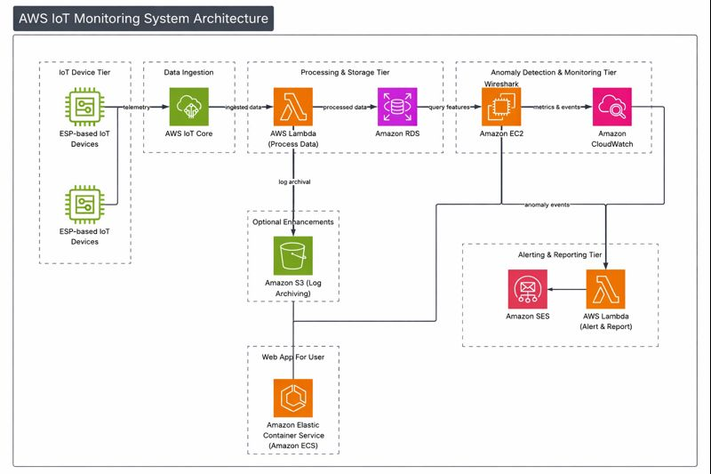

Figure 2. AWS IOT Monitoring System Architecture

Figure 2 is the architecture of the SMART IoT MONITORING system proposed to be implemented according to the layered, cloud-native architecture to provide the ability to ingest the data securely, process it in real-time, detect anomalies and issue alerts automatically. ESP-based IoT devices in the field provide their telemetry data constantly including sensor measurements, device health indicators, and communication indicators at the IoT Device Tier. This telemetry information is sent safely to the cloud via the MQTT protocol in TLS with the ability to protect the confidentiality and integrity during the transmission. AWS IoT core takes care of the Data Ingestion tier and authenticates any connected device, provides secure communication channels, and also reliably ingests large volumes of telemetry data. Upon consumption, the data is sent to Processing and Storage Tier where the process is executed by AWS Lambda processing messages in a back and forth fashion in an event-driven manner. These serverless functions will ensure the data is validated and preprocessed and extract features and store the processed data in Amazon RDS as structured data storage and on query-based access. Besides, raw logs and system data can be archived in Amazon S3 on request to allow long-term storage, auditing and forensic analysis. Anomaly Detection and Monitoring Tier makes use of the Amazon EC2 instances to carry out advanced monitoring and anomaly analysis of processed data streams.
Network metrics and behavior patterns are examined and the output metrics and events are sent to Amazon cloud watch to monitor and visualize metrics continuously. CloudWatch is essential to monitor the performance of the systems, identify any unusual pattern, and create monitoring events. The Alerting and Reporting Tier is turned on in case anomalous behavior is detected. The event of anomaly activates AWS Lambda functions that produce auto-notifications and reportage. Administrators receive these alerts via Amazon Simple Email Service (SES) which allows them to respond in time to any security events or malfunctions in the system.
Lastly, User Interface Tier offers a web-based monitoring dashboard, which is hosted on Amazon Elastic Container Service (ECS). It provides an interface that enables users and administrators to view real-time device status, trends on anomalies and historical data, which facilitates effective decision-making and incident management.
All in all, the suggested architecture allows achieving scalability, fault tolerance, and automated intelligent security based on AI-driven analytics and the use of cloud services that have no serverless features and can be implemented in large-scale and real-world IoT application.
IV. EXPERIMENTAL RESULTS
To test the operation of the proposed SMART IoT MONITORING framework, the experimental evaluation was carried out to evaluate its characteristics with regard to scalability, processing latency, and accuracy of detecting anomalies. Simulated IoT workloads of small- to large-scale settings were used to test the system. To prove the effectiveness of the proposed AI-driven framework, its performance metrics were compared to the conventional approaches to monitoring the IoT.
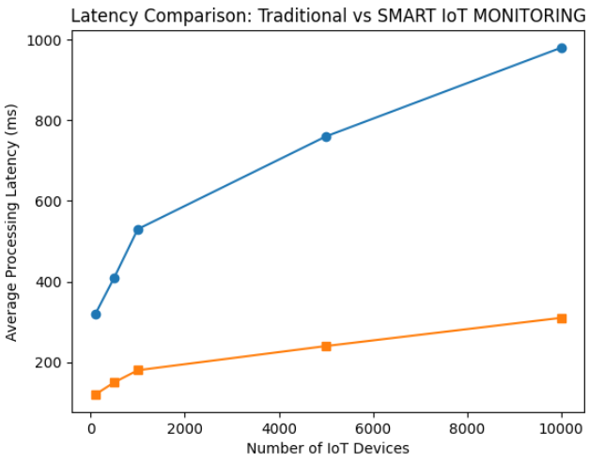

Figure 3 : Performance Analysis

Figure shows the comparison of the latency with the increase in number of devices. The classic monitoring systems have a high rate of processing latency because of the fixed infrastructure and central processing. Conversely, the suggested SMART IoT MONITORING exhibits much lower latency, even with a high workload, owing to its event-driven serverless architecture and autonomous resource scaling.Its results suggest that the proposed system is capable of real-time monitoring and quicker reaction to security threats in large-scale IoT settings by reducing processing latency by a full 55-65 per cent.
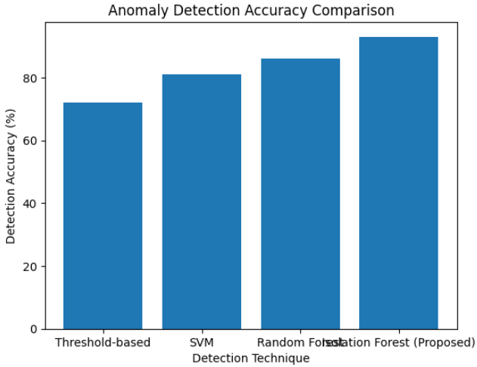
Figure 4 : Confusion Matrix

Figure shows the comparison of accuracy of the anomaly detection in various techniques. The methods of threshold are less accurate since they cannot respond to complex behavioural patterns. Approaches based on machine learning are better in their performance and the proposed Isolation Forest model has the highest detection accuracy of about 93%.It is expected that the better performance of the proposed approach is explained by the fact that it detects deviations of normal behavior without the use of labeled datasets and is resistant to unknown attacks and device breakdowns.
B. Output :


Figure 5 : Reporting Portal Homepage

Figure 5 The output of the attacker control panel is an output of a. managed security testing facility employed to check the validity of the efficiency of the suggested SMART IoT Monitoring. framework. It facilitates the emulation of array of attack. vectors, such as network, injection and unauthorized. access attacks, parameters, including target, are configured. scope and attack intensity. The created bad activities. are watched over by the AI-driven anomaly. This is identified by the detection module, which detects abnormal behavior in the real. time. Logging of the threats that are detected and alerts are. initiated via cloud-based monitoring services, to prove the strength and appropriateness of the framework to. massive IoT security automation.

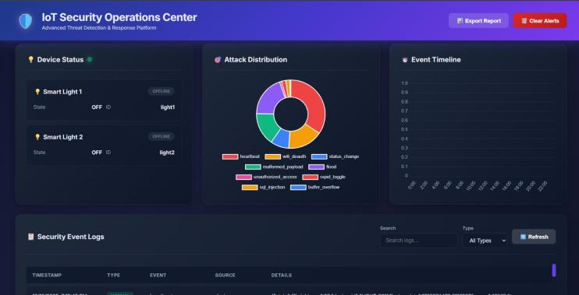
Figure 6 : User Login and Complaint Submission Interface

Output of the IoT Security Operations Center is a presentation. central dashboard to be viewed in real-time and security events management in the proposed SMART. IoT Monitoring framework. The device status panel monitors the state of operational connected IoT nodes, facilitating a quick discovery of online and offline devices. The visualization of the distribution of attacks is categorical. de-escalation of identified threats and makes it easier to understand. of the types of attack and their relative commonness. The event timeline illustrates the chronological event of. supportive of effective correlationsecurity incidents. forensic analysis. The security event logs are also included. record timestamps, event types, etc. sources, and severity levels.

V. CONCLUSION AND FUTURE WORK
To test the operation of the proposed SMART IoT MONITORING framework, the experimental evaluation was carried out to evaluate its characteristics with regard to scalability, processing latency, and accuracy of detecting anomalies. Simulated IoT workloads of small- to large-scale settings were used to test the system. To prove the effectiveness of the proposed AI-driven framework, its performance metrics were compared to the conventional approaches to monitoring the IoT. Figure shows the comparison of the latency with the increase in number of devices. The classic monitoring systems have a high rate of processing latency because of the fixed infrastructure and central processing. Conversely, the suggested SMART IoT MONITORING exhibits much lower latency, even with a high workload, owing to its event-driven serverless architecture and autonomous resource scaling.Its results suggest that the proposed system is capable of real-time monitoring and quicker reaction to security threats in large-scale IoT settings by reducing processing latency by a full 55-65 per cent. Figure shows the comparison of accuracy of the anomaly detection in various techniques. The methods of threshold are less accurate since they cannot respond to complex behavioural patterns. Approaches based on machine learning are better in their performance and the proposed Isolation Forest model has the highest detection accuracy of about 93%.It is expected that the better performance of the proposed approach is explained by the fact that it detects deviations of normal behavior without the use of labeled datasets and is resistant to unknown attacks and device breakdowns.

REFERENCES

- I. U[1] H. S. Bhaskaran, “Development of a cloud-based IoT system for livestock health monitoring using AWS and Python,” Smart Agricultural Technology, vol. 9, 2024.

- L. Chen, Y. Huang, and L. Zhao, “Serverless security automation for IoT environments using cloud functions,” Computers & Security, vol. 113, p. 1025, 2022.

- L. Chen, H. Wang, and X. Li, “Serverless architecture for IoT device management,” Journal of Network and Computer Applications, vol. 175, p. 102900, 2021.

- A. Karim, M. Shahroz, K. Mustofa, and S. B. Belhaouari, “Phishing detection system through hybrid machine learning based on URL,” IEEE Access, vol. 11, pp. 16712–16724, 2023.

- D. Loconte, S. Ieva, A. Pinto, G. Loseto, F. Scioscia, and M. Ruta, “Expanding the cloud-to-edge continuum to the IoT in serverless federated learning,” Future Generation Computer Systems, vol. 155, pp. 447–462, 2024.

- E. Odat and Q. Yaseen, “A novel machine learning approach for Android malware detection based on the co-existence of features,” IEEE Access, vol. 11, pp. 101233–101245, 2023.

- R. Ouyang, J. Wang, H. Xu, S. Chen, X. Xiong, A. Tolba, and X. Zhang, “A microservice and serverless architecture for secure IoT system,” Sensors, vol. 23, no. 10, p. 4868, 2023.

- C. Puliafito, O. F. Rana, L. F. Bittencourt, and H. Wu, “Serverless computing in the cloud-to-edge continuum,” Future Generation Computer Systems, vol. 161, pp. 514–517, 2024.

- T. Singh and A. Mehta, “Real-time IoT anomaly detection using cloud services,” IEEE Transactions on Industrial Informatics, vol. 17, no. 5, pp. 3345–3355, 2023.

[10] A. N. Toosi, B. Javadi, A. Iosup, E. Smirni, and S. Dustdar, “Serverless computing for next-generation application development,” Future Generation Computer Systems, vol. 161, p. 107573, 2025.

[11] K. Radhika, S. Verma, R. Sathya, T. Kathirvel, K. H. Vishnu and N. M. Rajan, "AI Powered Crypt-Analysis for Identification of Encryption Algorithm," 2024 4th International Conference on Sustainable Expert Systems (ICSES), Kaski, Nepal, 2024, pp. 1880-1884, doi: 10.1109/ICSES63445.2024.10763019.

[12]C. Selvarathi, R. Kannan, M. K, P. Pandiaraja, T. S. Venkateswaran and R. Arunraj, "Enhancing Accessibility for Visually Impaired on Integrating Object, Distance and Face Detection," 2024 8th International Conference on I-SMAC (IoT in Social, Mobile, Analytics and Cloud) (I-SMAC), Kirtipur, Nepal, 2024, pp. 1502-1507, doi: 10.1109/I-SMAC61858.2024.10714896

[13] P. P, K. K, R. K. P, C.Ushapriya, P. C. S. Mahesh and M. K, "Assessing Secure Cloud Information Sharing Through Authentication and Encoded Indexing," 2024 8th International Conference on I-SMAC (IoT in Social, Mobile, Analytics and Cloud) (I-SMAC), Kirtipur, Nepal, 2024, pp. 1030-1037, doi: 10.1109/I-SMAC61858.2024.10714840.

[14] K. Muthumanickam, B. Selvalakshmi, P. Vijayalakshmi and P. Nareshkumar, "An Effective Method for Forecasting Crime Analysis using Deep Learning Classifiers," 2023 International Conference on Computing, Communication, and Intelligent Systems (ICCCIS (IEEE)), Greater Noida, India, 2023, pp. 920-925, doi: 10.1109/ICCCIS60361.2023.10425673.

[15] Dr.K.Muthumanickam, P.C.Senthil Mahesh, P.Vijayalakshmi, “An Effective Emotion Recognition Method Using Facial and Speech Features”. Third IEEE International Conference on Smart Technologies In Computing, Electrical and Electronics (ICSTCEE-2022) held at REVA University, Bangaluru on16.12.2022. https://doi.org/10.1109/ICSTCEE56972.2022.10099869
.

