DELIGHTING CUSTOMERS: THE SECRETS OF

CASUAL DINING

ABSTRACT

Title : DELIGHTING CUSTOMERS: THE SECRETS
OF CASUAL DINING

Casual dining is more than just good food; it’s about the whole experience. This study set out to uncover what really matters to customers when they choose to dine in casual restaurants. Through firsthand feedback from regular diners in Dumaguete City, the research dug into the subtle details that often go unnoticed but make a big impact, like how fast the service is, how friendly the staff are, the feel of the place, and whether the experience feels worth the money spent.
Rather than just measuring basic satisfaction, the study focused on what makes people enjoy their visit and want to come back. It looked closely at how things like ambiance, food quality, and even small personal touches shape the overall experience. The goal was to figure out what turns a simple meal into something memorable.
The insights gathered from this study were used to build a practical guide, a framework, for restaurant owners and staff to better understand their customers and improve the way they deliver service. In the end, the study found that the real secret to success in casual dining isn’t just getting things right; it’s about creating moments that make people feel seen, valued, and glad they walked through the door.

Keywords: casual dining, customer experience, customer satisfaction, restaurant service, dining atmosphere, food
quality, service efficiency, loyalty, and restaurant management

CHAPTER 1

THE PROBLEM AND ITS SCOPE
INTRODUCTION

Rationale
In today’s fast-paced world, casual dining has become a go-to option for many people seeking a comfortable, affordable, and enjoyable meal. With growing competition in the restaurant industry, simply serving good food is no longer enough. Customers now look for experiences, those small but meaningful details that turn an ordinary meal into something memorable. This study was born from the need to understand what truly matters to customers in casual dining settings and how these insights can help local restaurants thrive.
By diving into real customer feedback and identifying the elements that lead to genuine satisfaction and repeat visits, this research offers practical value. It’s not just about statistics; it’s about listening to the people who keep these businesses alive. In the context of Dumaguete City, where local dining spots are on the rise, understanding what customers love (and what drives them away) can make all the difference.
The casual dining industry continues to grow as more people look for dining experiences that are affordable, relaxed, and enjoyable. In a setting where competition is high and customer preferences shift quickly, restaurants must go beyond offering basic service; they must understand and deliver what customers truly value. While many studies focus on food quality and pricing, this research aims to look deeper, uncovering the little things that make big impressions: the warmth of a smile, the speed of service, the cleanliness of the space, and the overall vibe of the restaurant.
This study explores the customer experience in selected casual dining restaurants in Dumaguete City. It draws from both theory and real-world customer insights to find out what makes diners come back, and what drives them away. The goal is not only to measure satisfaction but to uncover the "secrets" that turn everyday dining into something customers remember.
The researcher brings both academic and industry-based experience to this study. As an educator with a background in hospitality and tourism education, the researcher has spent years teaching subjects related to customer service, food and beverage operations, and business management. This academic foundation provides a strong understanding of theoretical frameworks related to consumer behavior and service quality.
In addition to a career in education, the researcher has also worked hands-on in the food service industry, including roles in restaurant supervision, front-of-house service, and hospitality events management. This industry exposure adds real-world depth to the research, allowing the study to bridge theory with practice. Firsthand experience dealing with customers, managing staff, and ensuring smooth dining operations gave the researcher a practical lens in identifying what matters most in the customer journey.
This combination of teaching competence and industry background ensures that the study is grounded in both knowledge and lived experience, making its findings relevant, realistic, and ready to be applied in the real world.
Theoretical Background
This study is anchored on the Experiential Marketing Theory by Bernd H. Schmitt (1999). This is also supported by the Queueing Theory by Agner Krarup Erlang (1909) and the Customer Satisfaction Theory by Philip Kotler (1967).
The Experiential Marketing Theory of Schmitt (1999) shifted the focus from just promoting product features to creating meaningful customer experiences. He emphasized that consumers aren’t purely logical; they also seek emotional, sensory, and memorable connections. The theory encourages brands to engage customers on multiple levels: through feelings, senses, actions, thoughts, and social identity. Instead of simply selling a product, the goal is to leave a lasting impression and build a deeper bond with the customer.
This theory describes five key types of customer experiences called Strategic Experiential Modules (SEMs): Sense, Feel, Think, Act, and Relate. The Sense module involves engaging the senses, like sight, sound, and taste, which is crucial in casual dining where ambiance and food presentation play a big role. Feel focuses on the emotions customers experience, such as comfort and joy. Think aims to engage customers intellectually through creative or thought-provoking elements. The Act module encourages physical or social interaction that fits the customer’s lifestyle. Finally, relate builds connections between customers and a wider community, strengthening loyalty and identity. These modules can work alone or together to create a rich, memorable dining experience.
This theory also offers a useful way to see how restaurants can do more than just serve food; they can truly delight and connect with customers on an emotional level. Creating experiences that engage the senses, spark positive feelings, and encourage social moments, casual dining spots can stand out in a crowded market. This theory highlights that customer satisfaction and loyalty don’t come just from the basics, but from the whole experience that leaves a meaningful, lasting impression.
The Queueing Theory by Agner Krarup Erlang (1909) is a mathematical approach that studies waiting lines or queues. Originally developed to understand telephone call congestion, it examines how systems handle demand by looking at factors like arrival rates, service speed, number of servers, and the order in which customers are served. This theory helps businesses manage resources better and reduce wait times, striking a balance between keeping customers happy and running operations smoothly.
This theory plays an important role because wait times directly affect how customers feel about their experience. Restaurants often deal with busy periods where long waits for seating, ordering, or food can hurt satisfaction. Using this theory, managers can anticipate these peak times and make smarter decisions, like scheduling more staff, rearranging seating, or speeding up service, to keep lines moving and guests happy.
This theory also offers a practical, data-driven way to improve service where some waiting is unavoidable but can be managed. In casual dining, where customers don’t like to wait long, crowded queues or slow service often cause frustration. Using this theory, restaurants can identify and fix bottlenecks, speed up service, and create a smoother dining experience. This theory helps businesses not only serve customers efficiently but also keep them happy with timely, hassle-free service.
The Customer Satisfaction Theory by Philip Kotler (1967) explains that satisfaction is determined by the comparison between customers’ expectations and the actual performance of a product or service. When performance meets expectations, customers feel satisfied; when it exceeds expectations, they experience a higher level of satisfaction, often described as delight. This theory provides a strong foundation in understanding how diners evaluate their experiences. Customers enter casual dining restaurants with expectations regarding food quality, service efficiency, ambiance, and price. Their level of satisfaction depends on how well these expectations are fulfilled during the dining experience.
The study highlights those delighting customers requires going beyond basic satisfaction. This theory implies that businesses must not only meet but exceed expectations to create memorable experiences. This can be achieved through attentive staff, prompt service, clean and inviting surroundings, and consistent food quality. When diners perceive that they receive greater value than expected, their emotional response shifts from simple satisfaction to delight. This emotional connection strengthens loyalty, increases repeat patronage, and encourages positive word-of-mouth recommendations.
Furthermore, this theory emphasizes the importance of managing expectations and continuously improving service performance. The study implies that casual dining establishments should actively seek customer feedback, personalize interactions, and address concerns immediately to maintain high satisfaction levels. By anticipating customer needs and delivering exceptional service, restaurants create positive perceptions that build long-term relationships. Thus, this theory in casual dining confirms that customer delight is a strategic outcome of exceeding expectations and consistently providing superior dining experiences.
Customer satisfaction is widely recognized as a key factor influencing customer loyalty and repeat patronage in service-oriented businesses, according to Richard L. Oliver (1997). He emphasized that satisfaction occurs when customers perceive that the service or product they receive meets or exceeds their expectations. When customers experience positive outcomes, they tend to develop favorable attitudes toward the establishment and are more likely to return and recommend it to others. This means that diners evaluate not only the quality of food but also the service, ambiance, and overall dining experience. When these elements are delivered effectively, customers feel valued and satisfied, which ultimately contributes to stronger customer loyalty and positive word-of-mouth for the restaurant.
Wait time is an important factor influencing customer satisfaction in service-oriented establishments, such as casual-dining restaurants, according to David Maister (1985). He found that customers’ perceptions of waiting can significantly affect their evaluation of the overall service experience. Waiting becomes less frustrating when customers feel that their time is valued and when the service process is organized and efficient. Long or poorly managed wait times for seating, ordering, or receiving food may lead to dissatisfaction, while prompt service and clear communication can enhance the dining experience. When restaurants effectively manage wait time, customers are more likely to feel satisfied and develop a positive impression of the establishment.
Speed of service is an important factor that influences customer satisfaction in the restaurant industry, according to James L. Heskett (1994). He highlighted that efficient and timely service delivery plays a significant role in shaping customers’ overall perceptions of service quality. When customers receive their orders promptly, and the service process flows smoothly, they are more likely to feel satisfied with their dining experience. Delays in food preparation or service may lead to frustration, while fast and well-organized service can enhance convenience and comfort for diners. Therefore, maintaining an efficient service pace helps restaurants meet customer expectations, improve satisfaction, and encourage repeat patronage.
Ordering systems play an important role in shaping customer satisfaction in restaurant operations, according to A. Parasuraman (1988). He emphasized that service quality is strongly influenced by the efficiency and reliability of service processes, including how orders are taken and delivered. An effective ordering system helps minimize errors, reduces waiting time, and ensures that customers receive their meals accurately and promptly. A clear and organized ordering process, whether through attentive staff, digital menus, or point-of-sale systems, can improve the overall dining experience. When customers feel that their orders are handled efficiently and correctly, it enhances their satisfaction and creates a more positive perception of the restaurant’s service quality.
Staff responsiveness plays a vital role in shaping customer satisfaction in restaurant settings, according to Valarie A. Zeithaml (2000). She emphasized that employees’ willingness and promptness in assisting customers significantly influence how customers evaluate service quality. When staff respond quickly to requests, provide clear information, and handle concerns efficiently, customers feel respected and valued. Responsive staff can enhance the overall dining experience by ensuring that orders are taken accurately, needs are addressed promptly, and issues are resolved without delay. This level of attentiveness helps create a positive impression, leading to higher customer satisfaction and encouraging repeat visits.
A study by Kim, Ng, & Kim (2009) delved into how customers' perceptions of service quality influence their satisfaction and future behavior in the restaurant industry. The study identified key factors such as food quality, atmosphere, value, cleanliness, and staff responsiveness as crucial elements that shape customers' dining experiences. Among these, they found that staff responsiveness and the speed of service were particularly significant in enhancing customer satisfaction. Their findings highlight the importance of attentive and prompt service in creating positive emotional responses, which in turn influence customers' loyalty and likelihood to recommend the restaurant to others. This underscores the role of both human and technological aspects in delivering high-quality service that meets and exceeds customer expectations.
In a study conducted by Del Mundo (2015), customer satisfaction in casual dining restaurants in Metro Manila was closely examined. The study revealed that long wait times and slow service were among the most common complaints from customers. To address these issues, the study recommended the implementation of more efficient queue management systems and comprehensive staff training programs to minimize service delays. The findings highlight the importance of operational efficiency and responsive service in enhancing the overall dining experience, aligning with global research that emphasizes these factors as key drivers of customer satisfaction in the casual dining industry.
The study by Kimes & Wirtz (2003) explored how the pace of service affects customer satisfaction in casual dining restaurants. They found that customers' perceptions of the service pace, whether they felt rushed or delayed, had a more significant impact on their satisfaction than the actual time spent dining. Diners who were informed about wait times and had their expectations managed effectively reported higher satisfaction levels, even if the actual wait was longer than anticipated. This highlighted the importance of clear communication and transparency in managing customer expectations, which can enhance the overall dining experience. Their findings indicate that restaurants should focus on managing perceived service pace to improve customer satisfaction and loyalty.
Choi and Lee (2014) identified key factors such as promptness, attentiveness, and effective communication as significant predictors of customer satisfaction. Additionally, the integration of technology in ordering systems, like digital kiosks and online ordering platforms, was found to contribute to faster service, reduced errors, and higher customer satisfaction. These findings highlight the importance of both human and technological elements in delivering quality service and enhancing the overall dining experience. Restaurants that focus on improving service quality through these means are more likely to achieve higher customer satisfaction and loyalty.
A study by Mattila (2001) explored how the speed of service affects customer satisfaction in restaurants. The study revealed that faster service generally leads to higher customer satisfaction, as diners appreciate prompt attention. However, the study also highlighted that there's a balance to be struck; if the speed of service compromises the quality of the food or the attentiveness of the staff, customer satisfaction can decline. This highlighted the importance of maintaining a balance between efficiency and quality to ensure a positive dining experience. The findings suggest that while customers value quick service, it should not come at the expense of the overall quality of the dining experience.
The study consistently highlights that wait times, service speed, technology integration in ordering systems, and staff responsiveness significantly influence customer satisfaction in casual dining. Efficiently managing customer expectations and streamlining operations are crucial for enhancing the dining experience. Leveraging both human and technological resources, establishments can improve service quality, foster customer loyalty, and achieve long-term success.
THE PROBLEM
Statement of the Problem
This study assessed the feedback of the customers in the casual dining services of selected restaurants in Dumaguete City, Philippines. The findings served as the basis for a proposed casual dining services framework.
Specifically, this study sought to answer the following questions:
1. What is the profile of the respondents in terms of:
1.1 age;
1.2 gender;
1.3 civil status;
1.4 educational attainment; and
1.5 occupation?
2. What is the level of contentment of the respondents in the casual dining services offered by restaurants in terms of:
2.1 wait time;
2.2 speed of service;
2.3 ordering system; and
2.4 staff responsiveness?

3. What are the problems encountered by the respondents when dining in the restaurants?
4. Is there a significant relationship between the profile of the respondents and the level of contentment of the respondents in the casual dining services offered by restaurants?
5. Based on the findings of the study, what casual dining services framework may be proposed?
Null Hypothesis
The following null hypotheses were tested:
At the 0.05 level of significance, the following hypothesis was tested:
Ho1. There is no significant relationship between the profile of the respondents and the level of contentment of the respondents in the casual dining services offered by restaurants.
Significance of the Study
This study is expected to offer valuable insights to the following groups:
Casual Dining Restaurant Owners and Managers. The study can help them enhance service quality, streamline operations, and foster customer loyalty.
Restaurant Staff (Servers, Kitchen Staff, and Other Employees). The study can help them improve their performance and customer interactions.
Customers. The study can help lead to improved dining experiences, as restaurants implement changes based on their feedback.
Restaurant Industry Analysts and Consultants. The study can help them provide data-driven recommendations, helping restaurants enhance operations and customer service strategies for improved business outcomes.
Food and Beverage Suppliers. The study can help them enhance operational efficiency in casual dining establishments by understanding their specific service needs. Adapting products and services accordingly helps streamline processes, particularly in order processing and menu offerings, leading to improved overall performance.
Hospitality and Culinary Educators. The study can help them integrate real-world insights into their teaching materials, enhancing students' understanding of key factors that drive customer satisfaction in the casual dining industry. This approach bridges theoretical knowledge with practical application, better preparing students for industry challenges.
Department of Tourism (DOT). The study can help them provide insights into customer satisfaction trends within the hospitality sector. This insight enables the DOT to develop policies and accreditation standards that enhance service quality in the restaurant industry, aligning with both local and international norms. Such measures contribute to the Philippines' competitiveness as a global tourist destination.
Technology Providers (e.g., POS, Ordering Systems). The study can help them enhance customer satisfaction by aligning their products with features that directly impact the dining experience.
Researchers. The study provides valuable insights that can assist researchers in the hospitality and tourism fields to refine existing theories, expand upon prior studies, and address gaps in the literature.
Future Researchers. The study may inspire new lines of inquiry and foster further development of theoretical concepts, tools, or applications in the field in addressing identified gaps and exploring emerging trends. Researchers can contribute to the advancement of knowledge and practices in the hospitality and tourism sectors.

RESEARCH METHODOLOGY
This chapter outlined the research methodology, detailing the study's design, setting, participants, data collection instruments, procedures, and statistical analysis methods. It provided a clear roadmap of how the research was conducted to ensure transparency and replicability.
Research Design
This study employed a descriptive-correlational research design to assess customer feedback on casual dining services in selected restaurants in Dumaguete City, Philippines. A survey questionnaire was utilized to collect data from customers, aiming to identify key factors influencing their dining experiences. The findings of this study informed the development of a proposed framework to enhance casual dining services, contributing to improved customer satisfaction and operational efficiency.
A researcher-developed checklist survey questionnaire was utilized to gather data for the study. The survey encompassed respondent profiles, their satisfaction levels with casual dining services, and the challenges encountered during their dining experiences. Fifty participants were selected to provide a comprehensive perspective.
To visually represent the study's framework, an Input-Process-Output (IPO) paradigm was constructed. This model illustrated the flow from input (respondent profiles and feedback) through the research process (data collection and analysis) to the output (findings and proposed framework), with feedback loops that informed continuous improvement.
INPUT PROCESS OUTPUT

- Profile of the respondents

- Level of contentment of the respondents in the casual dining services offered by restaurants

- Problems encountered by the respondents when dining in the restaurants

- Descriptive-correlational method of research

- Checklist Survey Questionnaire

- Data gathering, processing, analysis and interpretation

Proposed Casual Dining Services Framework

FEEDBACK

Figure 1
The Research Flow

Research Environment
This study was conducted in Dumaguete City, the capital of Negros Oriental province in the Negros Island region of the Philippines. Affectionately known as the "City of Gentle People," Dumaguete is a harmonious blend of urban development and small-town charm. With a population of approximately 134,000, the city is a vibrant hub for education, culture, and commerce. Its welcoming atmosphere, combined with a rich tapestry of local traditions and modern amenities, makes it an ideal setting for research in various fields, including education, business, tourism, and community development.
Dumaguete is home to several esteemed academic institutions, such as Silliman University, St. Paul University Dumaguete, Negros Oriental State University, and Foundation University. These institutions contribute to the city's dynamic intellectual environment, attracting students and professionals from across the country and abroad. The city's diverse population, consisting of students, educators, professionals, and entrepreneurs, fosters a collaborative and innovative community.
Beyond its academic prowess, Dumaguete boasts a thriving tourism industry. Visitors are drawn to its scenic attractions, including Rizal Boulevard, the historic Silliman University campus, and nearby natural wonders like Casaroro Falls and Apo Island. The city's commitment to sustainable tourism and its rich cultural heritage further enhances its appeal as a research locale.
Tourism plays a vital role in Dumaguete’s local economy. The city is a popular destination for both domestic and international travelers, offering a unique blend of natural attractions, cultural heritage, and accessible eco-adventures. Key tourist spots include Rizal Boulevard, a scenic seaside promenade; the historic Silliman University campus; and the majestic Casaroro Falls located in nearby Valencia. Dumaguete also serves as a gateway to renowned diving destinations such as Apo Island and the Dauin Marine Reserves, as well as nature sites like the Twin Lakes of Balinsasayao and Danao. Tourists are drawn to the city for its opportunities for diving, snorkeling, hiking, and cultural exploration. Accommodation options range from budget hostels to upscale resorts, and the city is easily accessible via Dumaguete-Sibulan Airport and a major seaport. Annual events like the Sandurot Festival showcase the city's cultural diversity and hospitality, further enhancing its appeal as a tourist destination. As tourism continues to grow, Dumaguete remains committed to improving infrastructure, maintaining safety, and promoting sustainable travel to preserve its natural beauty and cultural charm.
Here are five high-end casual dining restaurants in Dumaguete City, each offering a unique culinary experience:
Casual Dining Restaurant A. This is a popular dining destination in Dumaguete City, known for its vibrant ambiance, diverse menu, and Instagram-worthy interiors. With two branches, one along Rizal Boulevard in the city proper and another on E. Rovira Road in the residential area of Bantayan, the restaurant offers a unique fusion of global cuisines, including Filipino, American, European, Mexican, and Japanese dishes.
Casual Dining Restaurant B. Located along San Juan Street, this restaurant provides a youthful and vibrant dining atmosphere that appeals strongly to the younger crowd. With its modern interior and lively energy, the place transitions from a cozy daytime café into a bustling night spot. The menu features a mix of comfort food and specialty drinks, making it a favorite hangout for students and young professionals who enjoy both casual dining and a dynamic social setting.
Casual Dining Restaurant C. Situated along Rizal Boulevard, this restaurant offers a refined yet welcoming experience. Its elegant ambiance, complemented by a wine room and piano bar, creates an atmosphere suited for both casual meals and special gatherings. The menu combines international and Filipino flavors, highlighting dishes such as premium steaks and fresh seafood, all enjoyed with a scenic view of the Dumaguete coastline.
Casual Dining Restaurant D. This restaurant is a popular restaurant in Dumaguete City, known for its vibrant ambiance and a diverse menu that blends Mexican-inspired dishes with local flavors. With two branches in the city, one at Robinsons Place Dumaguete and another on Silliman Avenue, it offers a welcoming environment for both locals and visitors.
Casual Dining Restaurant E. This is a contemporary Filipino restaurant in Dumaguete City, celebrated for its modern take on traditional Filipino cuisine and its inviting ambiance. Located along the scenic Rizal Boulevard, the bistro offers a relaxed yet stylish dining experience, making it a popular choice among locals and visitors alike. This restaurant features a variety of Filipino dishes with a modern twist. While specific menu items are not detailed in the available sources, the restaurant is known for its flavorful offerings that showcase the rich culinary heritage of the Philippines.
Research Respondents
This study utilized purposive sampling to select fifty (50) customers from five (5) casual dining restaurants in Dumaguete City. Each restaurant contributed ten (10) respondents, representing 20% of the total sample per establishment.
Table 1 below illustrates the distribution of respondents across the selected restaurants:

Table 1
Distribution of Respondents

Identified Casual Dining Restaurant | Distribution Size
Identified Casual Dining Restaurant | F | %
Casual Dining Restaurant A | 10 | 20
Casual Dining Restaurant B | 10 | 20
Casual Dining Restaurant C | 10 | 20
Casual Dining Restaurant D | 10 | 20
Casual Dining Restaurant E | 10 | 20
Total | 50 | 100%

This purposive sampling approach was chosen to ensure that the selected respondents had relevant experiences and insights into the casual dining services offered by the chosen establishments.
Research Instrument
A researcher-developed survey was used to gather data from participants, structured into three clear sections for ease and clarity. First, it captured basic demographic information, age, gender, civil status, educational attainment, and occupation, using simple checklist questions to help respondents feel comfortable and prevent confusion. The second section asked participants to rate their satisfaction with various aspects of the dining experience using a four-point scale, from 4–Highly Contented (very satisfied and happy with one’s situation or experiences), 3–Moderately Contented (fairly satisfied, though there may be minor issues or areas for improvement), 2–Less Contented (somewhat dissatisfied, with noticeable concerns or unmet expectations), and 1–Not Contented (clearly unhappy or dissatisfied with the situation or outcome). This thoughtful design aimed to make the survey approachable, engaging, and effective at uncovering genuine insights into casual dining experiences. The third section focused on identifying any issues respondents encountered during their dining experience, using an easy-to-follow checklist.
Before launching the full study, the researcher performed a pilot test with 20 participants who were not part of the main sample. This small-scale trial helped ensure the questionnaire was clear, relevant, and free from confusing or biased items. Pilot testing this way aligns with best practices, as it enables the assessment of both validity (whether questions measure what they’re intended to) and reliability (the consistency of responses), helping to catch problems early and fine-tune the survey before its full rollout.
Research Procedures
This section presents the gathering of data and statistical tools to be used in the study.
Data Gathering
Before collecting data, the researcher personally delivered transmittal letters to restaurant managers in Dumaguete City to secure permission for the study. Throughout the study, participant privacy and anonymity were held in the highest regard; respondents were identified properly, and all data were handled confidentially, following best practices to protect sensitive information
To uphold ethical standards, the principle of “not harm” was carefully observed. This meant avoiding any physical, psychological, social, or economic harm to participants, in line with widely accepted research guidelines. Participants provided informed consent, were made aware of their rights (including the ability to withdraw), and were treated with respect at all times.
By following these protocols, from obtaining permissions and informed consent to safeguarding confidentiality and preventing harm, the study maintained the highest level of research integrity while ensuring all participants were respected and protected.
Treatment of Data
The following statistical tools were used in the study:
Frequency Count and percent were used to summarize, analyze, and interpret the profile of the respondents.
Weighted Mean and Ranking were used to summarize, analyze, and interpret the level of contentment of the respondents in the casual dining services offered by the restaurant and the problems encountered by the respondents when dining in the restaurant.
Chi-Square were used to determine the significance of the relationship between the profile of respondents and the level of contentment of the respondents in the casual dining services offered by the restaurant.
Analysis of Variance or the t-test was used to determine the significance of the differences between the level of contentment of the respondents in the casual dining services offered by the restaurant and the problems encountered by the respondents when dining in the restaurant.
Ethical Consideration
Before collecting any data, the researcher followed ethical guidelines outlined by Bryman & Bell (2007). To begin with, no one in the study was subjected to harm, and their dignity was always respected. Participants were given clear, written informed-consent forms and assured that their involvement was voluntary; they were free to stop at any time without penalty. Privacy and confidentiality were closely guarded: personal details were anonymized, stored securely, and only viewed by the researcher. No deception was used; the purpose and procedures of the study were fully disclosed, and all affiliations, funding sources, or potential conflicts of interest were shared openly. The researcher promised to remain objective, report findings honestly, and avoid bias in analysis or interpretation. In all communications and reporting, transparency and integrity were fundamental.

DEFINITION OF TERMS
The following terms and phrases are defined operationally to ensure clarity and a better understanding of their use within the context of this study:
Profile of the Respondents. This term refers to the demographic information of the respondents in terms of age, gender, civil status, educational attainment, and occupation.
The Level of Contentment of the Respondents with the Casual Dining Services Offered by Restaurants. This term refers to the wait time, speed of service, ordering system, and staff responsiveness.
Problems Encountered by the Respondents when Dining in the Restaurants. This term refers to the various difficulties or negative experiences faced by customers during their dining experience in casual dining restaurants. These may include issues related to food quality, service efficiency, staff behavior, cleanliness, ambiance, pricing, waiting time, and overall customer satisfaction, as identified through the survey responses.
Proposed Casual Dining Services Framework. This term refers to a structured plan or model developed based on the findings of the study, aimed at enhancing the quality of service in casual dining restaurants. It outlines recommended strategies, processes, and service improvements intended to address identified problems, increase customer contentment, and promote better dining experiences.

CHAPTER 2
PRESENTATION, ANALYSIS, AND INTERPRETATION OF DATA

In this chapter, we delve into the insights gathered from the survey conducted with customers at a casual dining restaurant in Dumaguete City, Philippines. The data collected offers a clear picture of the current state of restaurant operations, highlighting both strengths and areas for improvement. Through careful analysis, we identify common challenges faced by diners and explore the implications of these findings for enhancing the overall dining experience. To ensure a thorough and objective evaluation, the researcher employed a range of statistical tools, including frequency counts, weighted means, rankings, chi-square tests, and analysis of variance (ANOVA). These methods allowed us to draw meaningful conclusions that align with the study's objectives and provide actionable recommendations for restaurant management.
Profile of the Respondents
The profile of respondents provided valuable context by revealing key demographic and professional traits, including age, gender, civil status, educational attainment, and occupation, that helped ground their perspectives on casual dining experiences. The study could better interpret how different groups viewed service quality and operational challenges, ensuring that the findings reflected authentic customer voices across diverse population segments.
Table 2 shows the demographic profile of the 50 casual dining customers who participated in this study. It lists their age ranges, gender distribution, civil status, educational background, and occupations, providing a clear snapshot of who the respondents were. Presenting these key characteristics in a well-organized table makes it easy for readers to understand the sample’s composition at a glance and helps frame the study’s insights within the context of the people who provided the data.

Table 2
Profile of the Respondents

Respondents' Profile |  | Frequency | Percent
A. Age Group | 55 years old and above | 1 | 2%
A. Age Group | 45-54 years old | 6 | 12%
A. Age Group | 35-44 years old | 4 | 8%
A. Age Group | 25-34 years old | 26 | 52%
A. Age Group | 18-24 years old | 13 | 26%
B. Gender | Male | 23 | 46%
B. Gender | Female | 27 | 54%
C. Civil Status | Single | 31 | 62%
C. Civil Status | Married | 16 | 32%
C. Civil Status | Divorced/Annulled | 2 | 4%
C. Civil Status | Widowed | 1 | 2%
D. Educational Attainment | MA | 5 | 10%
D. Educational Attainment | Bachelor | 35 | 70%
D. Educational Attainment | Others | 10 | 20%
E. Occupation | Skills Trade/Technical | 5 | 10%
E. Occupation | Office/Administrative | 8 | 16%
E. Occupation | Professional/Academic | 6 | 12%
E. Occupation | Business/Corporate | 17 | 34%
E. Occupation | Others | 14 | 28%
 | Total | 50 | 100%

Age

As shown in Table 2, the majority of respondents fell into the 25–34 years age range, comprising 52% of the sample, followed by those aged 18–24 years at 26%, while participants aged 55 and above made up the smallest group at just 2%.
The fact that most respondents fell into the 25–34 age range, with 52%, implies that this group tends to dominate the casual dining scene. Adults in this age bracket are often balancing work, social lives, and family responsibilities, which makes dining out a convenient solution, like proximity, speed, and online ordering, when choosing where to eat. In short, casual dining fits seamlessly into their lifestyle, offering a good balance of quality, comfort, and convenience.
The second highest were aged 18–24-year-old age group, which made up 26% of our respondents, highlighting the significant presence of young adults in casual dining. This demographic often values affordability, convenience, and fresh food options, traits that casual dining establishments are well-positioned to offer. Catering to their preferences, such as offering flavorful yet budget-friendly menu choices and fast, seamless service, can directly influence their satisfaction. Engaging this group effectively with value-driven promotions, efficient ordering systems, and menu variety can help build loyalty among these frequent diners and strengthen a restaurant’s competitive edge.
The lowest rank was older adults (55+), who accounted for only 2% of the respondents, reflecting broader trends of changing dining preferences with age. This group prefers to cook dinner at home almost every night, and some still dine out occasionally, but they tend to favor fast food and home-cooked meals over casual dining experiences. This shift is often driven by health considerations, dietary restrictions, and a preference for the convenience and comfort of home meals. In addition, physical comfort plays a meaningful role. Studies show that older adults frequently experience difficulty with restaurant seating, and visitors aged 65 and above reported issues like pain and mobility challenges when rising from certain chairs. These seating difficulties and a preference for more relaxed environments help explain why those 55 and older are least represented in casual dining settings, suggesting that design and accessibility should be key considerations for eateries aiming to serve this demographic.
This means that the age distribution of respondents highlighted the importance of tailoring dining experiences to different generational preferences. Therefore, casual dining establishments should consider these generational preferences when designing their menus, services, and dining environments to cater effectively to their diverse clientele.
This finding is supported by the Experiential Marketing Theory by B. H. Schmitt (1999), which emphasizes that consumers seek memorable and engaging experiences that appeal to their senses, emotions, and personal values. This implies that restaurants should design menus, services, and dining environments that resonate with the specific preferences of different age groups, creating meaningful and enjoyable experiences that enhance satisfaction and foster customer loyalty.

Gender
The gender distribution in this study revealed that 54% of respondents were female, while 46% were male.
The finding that 54% of respondents were female reflects broader trends in dining preferences, where women often prioritize ambiance, customer service, and social dining experiences. Additionally, women are more health-conscious and attentive to menu options, often seeking establishments that offer healthier choices and cater to their dietary preferences. Therefore, casual dining restaurants aiming to attract female patrons should focus on creating inviting atmospheres, providing attentive service, and offering diverse, health-conscious menu options that cater to the preferences of this demographic.
The 46% male representation in this study, while slightly lower than the 54% female representation, still indicates a significant male presence in casual dining. The study also noted that men often prefer dining in groups or with family and friends, emphasizing the social aspect of eating out. However, despite these tendencies, men may be less inclined to dine out alone or in smaller groups compared to women, potentially due to social norms or personal preferences.
Therefore, casual dining restaurants aiming to attract female patrons should focus on creating inviting atmospheres, providing attentive service, and offering diverse, health-conscious menu options that cater to the preferences of this demographic.
The finding is supported by the Experiential Marketing Theory by Schmitt (1999), which emphasizes that customer experiences are shaped by engaging the senses, emotions, and personal values. By tailoring the dining environment and service to align with female customers’ expectations and lifestyle preferences, restaurants can create memorable experiences that enhance satisfaction and encourage repeat visits.
Civil Status
As shown in Table 2, 62% of respondents were single, followed by 32% who were married, and only 2% were widowed.
Singles made up 62%, no surprise, given the growing trend of solo dining. Younger adults, especially those aged 25–34, often dine out alone for convenience, social connection, or simply as a form of self-care. This behavior reflects their flexible lifestyles, desire for “me time,” and comfort-seeking preferences, making casual dining restaurants a natural fit for solo diners and explaining why singles represented the majority in this study.
Followed by married respondents comprised 32% of the sample, positioned between the single and widowed groups. This reflects a broader trend: married individuals, especially those with children, often dine out as a practical solution to busy schedules. This showed that families are eating out more frequently to save time, and many value convenience and variety when choosing restaurants. These diners appreciate options that are family-friendly, efficient, and offer good value, making them a crucial segment for restaurants to engage through thoughtful menu design, streamlined service, and promotions targeting family needs.
The lowest got only 2% of respondents were widowed, reflecting a broader pattern in which older widowed individuals are less likely to dine out. The study shows that widowhood often leads to changes in eating habits, eating alone more frequently, experiencing lower appetite, and turning to simpler, home-based meals rather than restaurant dining. These shifts in routine and social context mean that casual dining venues are typically less appealing or practical for them, which explains their minimal representation in this study.
These insights highlight the importance for casual dining establishments to tailor services, offering social, convenient experiences for singles, and accommodating family needs for married customers.
This study is supported by the Experiential Marketing Theory by Schmitt (1999), which emphasizes creating meaningful and memorable experiences that appeal to customers’ lifestyles, emotions, and social contexts. By designing dining environments and services that reflect the specific preferences of different life stages, restaurants can enhance customer satisfaction, foster loyalty, and encourage repeat patronage.
Educational Attainment
The majority of respondents, 70%, hold a bachelor's degree, indicating a well-educated customer base. This is followed by 20% with other forms of education, and 10% possessing a master's degree.
The highest percentage of individuals aged 25 and over who have attained at least a bachelor's degree has been gradually increasing. This trend reflects the country's ongoing efforts to enhance access to higher education and the increasing value Filipinos place on tertiary education. Therefore, a respondent group with 70% holding bachelor's degrees indicates a sample that is notably more educated, which may influence their expectations and preferences in various contexts, including dining experiences.
The second-highest group, accounting for 20% of respondents in the casual dining restaurant, reported having received other forms of education, such as vocational training, online courses, or informal learning. This indicates that non-traditional educational pathways are notably present in this industry segment, potentially reflecting the sector’s openness to diverse qualifications and practical experience over formal academic credentials.
Respondents with a master’s degree accounted for the lowest proportion at just 10%, indicating that advanced academic qualifications are relatively uncommon among individuals in the casual dining restaurant. This may indicate that higher education beyond a bachelor's degree is not a primary requirement or focus in this industry, where practical experience and operational skills are likely more valued.
The result highlighted that the educational profile of respondents in the casual dining restaurant reflects broader societal and industry trends. The high percentage of individuals holding a bachelor’s degree indicates a growing emphasis on formal education and its perceived value, even in service-oriented industries. The notable presence of respondents with alternative forms of education indicates a flexible and inclusive approach to qualifications within the sector, where practical skills are often prioritized. Meanwhile, the low proportion of master's degree holders may reflect the limited necessity for advanced academic credentials in operational roles. These findings highlight the dynamic relationship between educational attainment and industry demands, offering insights into how education shapes both workforce participation and consumer expectations in the casual dining context.
The findings is supported by the Customer Satisfaction Theory by Kotler (1967), which emphasizes that customers’ expectations and satisfaction are shaped by their knowledge, experiences, and perceptions. The educational background of customers can influence their expectations of service quality, menu offerings, and overall dining experience, highlighting the need for restaurants to balance professional standards with practical, customer-focused service.
Occupation
In terms of occupation, the highest proportion of respondents, 34%, are employed in business or corporate roles, followed by 28% classified under other occupations. The smallest group of 10%, at just the lowest proportion, consists of those working in skilled trades or technical fields.
The fact that 34% of respondents work in business or corporate roles indicates that a significant portion of the sample comes from professional environments, which may influence their preferences, behaviors, and expectations. This background often involves exposure to structured settings, higher levels of education, and different lifestyle patterns compared to other occupations, potentially shaping their outlook and decision-making processes in various contexts.
Following closely, 28% of respondents fall under various other occupations, reflecting a diverse range of professional backgrounds beyond the corporate sector. This variety means that the sample includes people with different skills, experiences, and perspectives, which can enrich the overall understanding of their attitudes and behaviors.
The smallest group, making up just 10% of respondents, is those working in skilled trades or technical fields. This means that fewer individuals from these hands-on professions were represented in the sample compared to other occupational categories.
This means that the occupational distribution of the sample highlights a strong representation of professionals in business and corporate roles, which likely shapes their preferences and decision-making. The notable diversity in other occupations adds valuable variety to the findings, while the smaller presence of skilled trades workers indicates these practical professions are less represented in this context. This mix is important for interpreting how background influences attitudes and behaviors across different groups.
The finding is supported by the Customer Satisfaction Theory by Kotler (1967), which posits that customers’ expectations and satisfaction are influenced by their background, experiences, and personal circumstances. In the casual dining context, the occupational profile of customers can affect their priorities—such as service efficiency, menu variety, and ambiance—emphasizing the need for restaurants to tailor their offerings to meet the preferences of different professional and demographic groups.
Level of Contentment of the Respondents in the Casual Dining Services Offered by Restaurants
The level of contentment of the respondents in the casual dining services offered by restaurants in terms of wait time, speed of service, ordering system, and staff responsiveness, measuring how satisfied customers are with the casual dining services provided by restaurants, gives valuable insight into their overall experience. This study examines respondents’ levels of contentment, shedding light on what they appreciate and where improvements can be made. These perspectives help restaurants enhance their offerings and create more memorable dining experiences.
Level of Contentment of the Respondents in the Casual Dining Services Offered by Restaurants in Terms of Wait Time
Table 3 highlights the respondents’ level of contentment with the wait time experienced in casual dining restaurants. The results indicate that wait time plays a crucial role in shaping customer satisfaction, with many respondents expressing moderate to high satisfaction when their orders are served promptly. This reflects the importance of efficient service in casual dining settings, where customers often expect quick turnaround without compromising quality. However, any noticeable delays were likely to lower satisfaction levels, emphasizing that even small increases in wait time can impact the overall dining experience. These findings highlighted the importance of restaurants optimizing their service processes to meet customer expectations and maintain a positive brand perception.

Table 3
Level of Contentment of the Respondents in the Casual Dining Services Offered by Restaurants in Terms of Wait Time

Indicators | Mean | Contentment Level
1. How contented were you with the estimated waiting time provided? | 3.56 | Highly Contented
2. How contented were you with the time you had to wait to be seated? | 3.62 | Highly Contented
3. How contented were you with the time you waited for your order to be taken? | 3.58 | Highly Contented
4. How contented were you with the management of the waiting area (e.g., comfort, organization)? | 3.62 | Highly Contented
5. How contented were you with the overall efficiency in minimizing waiting times? | 3.50 | Highly Contented
Aggregate Mean | 3.58 | Highly Contented

The results reveal that respondents are highly contented with the wait time in casual dining restaurants, as reflected by an aggregate mean of 3.58%. This means that most customers feel their orders are served quickly and that the service meets their expectations.
The highest-rated indicators were the respondents’ contentment with the time they had to wait to be seated and their satisfaction with the management of the waiting area, such as comfort and organization. Both received an average rating of 3.62%, which is interpreted as highly contented. This means that customers appreciate not only prompt seating but also a well-managed and comfortable waiting environment, both of which contribute positively to their overall dining experience.
The second-highest indicator was the respondents’ contentment with the time they waited for their order to be taken, which received an average rating of 3.58%, interpreted as highly contented. This means that customers generally felt attended to promptly, reinforcing the importance of quick and responsive service at the start of their dining experience. Being promptly acknowledged by staff appears to play a key role in shaping positive impressions in casual dining settings.
The lowest-rated indicator was the respondents’ contentment with the overall efficiency in minimizing waiting times, which received an average score of 3.50%. Although it is the lowest among the indicators, it is still interpreted as highly contented. This means that while respondents generally felt satisfied, there may still be some room for improvement in how efficiently the restaurant manages overall wait times, particularly during busier periods.
This implies that customers value both comfort and efficiency during their dining experience. They were especially pleased with how quickly they were seated and the overall comfort and organization of the waiting area, showing that first impressions matter. Customers also appreciated being promptly acknowledged and having their orders taken without long delays, highlighting the importance of attentive service early on. While overall satisfaction with wait times was still high, the slightly lower score in minimizing waiting across the entire dining experience suggests that there's still room to fine-tune operations, especially during peak hours. In short, making customers feel both welcomed and efficiently served goes a long way in shaping a positive dining experience.
The finding is supported by Experiential Marketing Theory by Schmitt (1999), which emphasizes that customers’ overall satisfaction is shaped not only by the core service but also by the experiences surrounding it. According to this theory, elements such as comfort, prompt acknowledgment, and efficient service enhance the sensory and relational aspects of the dining experience. Customers were especially pleased with how quickly they were seated, the organization and comfort of the waiting area, and the timely taking of their orders, showing that creating a welcoming and efficiently managed environment contributes significantly to a positive dining experience.
Level of Contentment of the Respondents in the Casual Dining Services Offered by Restaurants in Terms of Speed of Service
Table 4 takes a closer look at how satisfied customers are with the speed of service in casual dining restaurants. From the moment they’re greeted to the time their food arrives, speed plays a big role in shaping how people feel about their overall experience. This part of the study highlights whether guests felt the service was fast, efficient, and responsive, or if there were areas where delays affected their satisfaction. This helps restaurants pinpoint what they’re doing well and where they might need to pick up the pace to keep customers happy.
Table 4
Level of Contentment of the Respondents in the Casual Dining Services Offered by Restaurants in Terms of Speed of Service

Indicators | Mean | Contentment Level
1. How contented were you with the promptness in receiving your drinks? | 3.64 | Highly Contented
2. How contented were you with the time it took for your food to be served after ordering? | 3.60 | Highly Contented
3. How contented were you with the pacing of the meal service (e.g., appetizers, main course)? | 3.58 | Highly Contented
4. How contented were you with the efficiency of the staff in delivering your order to your table? | 3.68 | Highly Contented
5. How contented were you with the overall speed and efficiency of the service throughout your meal? | 3.72 | Highly Contented
Aggregate Mean | 3.64 | Highly Contented

Table 4 shows that respondents gave a weighted mean of 3.64% for the speed of service, which falls under the highly contented category. This means that most customers felt the service was quick and efficient, adding positively to their overall dining experience.
The top-ranking indicator was how contented you were with the overall speed and efficiency of the service throughout your meal, which received a score of 3.72%, which is considered highly contented. This means that customers were very happy with how consistently smooth and timely the service was from beginning to end. It shows that diners noticed and appreciated not just individual moments of fast service, but the overall flow and coordination throughout their meal, making their experience feel well-managed and enjoyable.
The second-highest indicator was How contented were you with the efficiency of the staff in delivering your order to your table, which received a score of 3.68%, also interpreted as highly contented. This means that customers were very pleased with how quickly and smoothly their food was brought to them. It reflects well on the staff’s coordination and attentiveness, showing that timely food delivery is a key part of what makes the dining experience feel organized, professional, and satisfying.
The lowest indicator was how contented you were with the pacing of the meal service (e.g., appetizers, main course), receiving a score of 3.58%, which is interpreted as highly contented. This means that customers were generally satisfied with the timing between courses. The flow of the meal, how quickly or slowly dishes were served, felt just right to most diners, contributing to a relaxed and well-paced dining experience without feeling rushed or delayed.
This implies that customers are highly satisfied with the overall speed and efficiency of service in casual dining, especially appreciating smooth coordination and timely food delivery. Although pacing between courses scored slightly lower, it still met customers’ expectations, showing that well-managed service timing plays an important role in creating a positive dining experience.
The finding is supported by Queueing Theory by A. K. Erlang (1985), which emphasizes that managing wait times and service flow directly impacts customer satisfaction. According to this theory, customers’ perceptions of service efficiency and satisfaction are influenced not only by actual waiting times but also by the predictability and smoothness of service delivery. Customers expressed high satisfaction with the overall speed and coordination of service, including timely food delivery, while the slightly lower score for pacing between courses suggests that fine-tuning timing during the dining experience can further enhance customer satisfaction.
Level of Contentment of the Respondents in the Casual Dining Services Offered by Restaurants in Terms of Ordering System
Table 5 presents how satisfied the respondents are with the ordering system used by restaurants in their casual dining services. It gives a clear picture of their overall experience and contentment with how orders are taken and processed in these dining establishments.

Table 5
Level of Contentment of the Respondents in the Casual Dining Services Offered by Restaurants in Terms of Ordering System

Indicators | Mean | Contentment Level
1. How contented were you with the ease and clarity of the menu presentation? | 3.66 | Highly Contented
2. How contented were you with the availability of staff to take your order promptly? | 3.58 | Highly Contented
3. How contented were you with the clarity of communication when placing your order? | 3.58 | Highly Contented
4. How contented were you with the options for order customization or special requests? | 3.72 | Highly Contented
5. How contented were you with the accuracy of your order upon arrival? | 3.74 | Highly Contented
Aggregate Mean | 3.66 | Highly Contented

Table 5 reveals that the respondents are highly contented with the casual dining services offered by restaurants in terms of the ordering system, as indicated by the aggregate mean score of 3.6%. This indicates that customers generally perceive the ordering process to be efficient, satisfactory, and user-friendly.
The highest-rated indicator shows that respondents were highly contented with the accuracy of their orders upon arrival, earning a mean score of 3.74%. This indicates that customers felt confident that what they ordered was exactly what they received, which played a key role in their overall positive dining experience.
Following closely, respondents also expressed high satisfaction with the options for order customization or special requests, which received a mean score of 3.72%. This indicates that customers appreciated the flexibility and willingness of restaurants to accommodate their individual preferences, enhancing their overall dining experience.
Lastly, the lowest-rated indicators, availability of staff to take orders promptly and clarity of communication when placing orders, both received a mean score of 3.58%, though still interpreted as highly contented. This indicates that while customers were generally satisfied, there is slightly less contentment in these areas, pointing to potential opportunities for improvement in staff responsiveness and clear communication during the ordering process.
This implies that while customers are generally happy with the ordering systems in casual dining restaurants, especially when it comes to order accuracy and customization options, there’s still room to grow. The slightly lower scores in staff availability and communication highlight areas where restaurants can improve. Better staff training and ensuring there are enough team members available to assist customers promptly and clearly, restaurants can further enhance the overall dining experience and maintain high levels of customer satisfaction.
The finding is supported by Customer Satisfaction Theory by P. Kotler (1967), which emphasizes that service quality, accuracy, and responsiveness directly influence customers’ overall satisfaction and loyalty. According to this theory, meeting or exceeding expectations in key service dimensions, such as order accuracy and customization, enhances satisfaction, while gaps in communication and staff availability can reduce perceived service quality. Customers were generally pleased with ordering systems, but the slightly lower scores in staff availability and communication suggest that improving these aspects through better training and adequate staffing can further elevate the dining experience and maintain high customer satisfaction.
Level of Contentment of the Respondents in the Casual Dining Services Offered by Restaurants in Terms of Staff Responsiveness
Table 6 presents how satisfied customers are with the staff's responsiveness in casual dining restaurants. This includes how quickly and attentively staff respond to customer needs, address concerns, and provide service throughout the dining experience of how diners feel in which helps highlight the importance of timely, courteous, and proactive service in shaping overall satisfaction.

Table 6
Level of Contentment of the Respondents in the Casual Dining Services Offered by Restaurants in Terms of Staff Responsiveness

Indicators | Mean | Contentment Level
1. How contented were you with the attentiveness of the staff to your needs during your meal? | 3.48 | Highly Contented
2. How contented were you with the politeness and courtesy of the staff interactions? | 3.56 | Highly Contented
3. How contented were you with the staff's willingness to address your questions or provide information? | 3.54 | Highly Contented
4. How contented were you with the staff's proactiveness in anticipating your needs (e.g., refills)? | 3.50 | Highly Contented
5. How contented were you with the speed and effectiveness of the staff in resolving any issues or concerns? | 3.50 | Highly Contented
Aggregate Mean | 3.52 | Highly Contented

Table 6 shows that respondents are highly contented with the staff's responsiveness in casual dining restaurants, as reflected by the aggregate mean score of 3.52%. This indicates that, overall, customers feel that restaurant staff are generally attentive and responsive to their needs, contributing positively to their dining experience, even though there may still be small areas for improvement.
The highest-rated indicator in this category shows that respondents were especially pleased with the politeness and courtesy of the staff, which received a mean score of 3.56% which is interpreted as highly contented. This indicates that customers truly value respectful and friendly interactions, and that courteous service plays a key role in making their dining experience more enjoyable and satisfying.
Following closely, respondents also expressed high satisfaction with the staff’s willingness to address questions or provide information, which received a mean score of 3.54% which is interpreted as highly contented. This indicates that customers appreciated the staff’s helpful attitude and their readiness to assist, which contributed to a more comfortable and informed dining experience.
The lowest-rated indicator was the attentiveness of the staff to customer needs during the meal, which received a mean score of 3.48%, though still interpreted as highly contented. This indicates that while customers were generally satisfied, there was slightly less consistency in how closely staff monitored and responded to their needs throughout the dining experience, highlighting a small but meaningful area for service improvement.
This implies that customers place great value on how they are treated by restaurant staff, particularly in terms of politeness, courtesy, and a willingness to assist. These qualities make a strong, positive impact on their overall dining experience. However, the slightly lower score for staff attentiveness during the meal shows there’s still room to grow. Restaurants may benefit from encouraging staff to be more observant and proactive throughout the customer’s visit, not just at the start. Small improvements in attentiveness can go a long way in making customers feel more valued and enhancing their overall satisfaction.
The finding is supported by Customer Satisfaction Theory by P. Kotler (1967), which highlights that interpersonal interactions and service quality are critical determinants of overall satisfaction. According to this theory, courteous, polite, and helpful behavior from staff enhances customers’ perceived value of the service, while lapses in attentiveness can negatively affect their overall experience. In this study, customers highly valued staff politeness and willingness to assist, but the slightly lower score for attentiveness during the meal suggests that encouraging staff to be more proactive and observant throughout the dining experience can further strengthen customer satisfaction.
Summary of the Level of Contentment of the Respondents in the Casual Dining Services Offered by Restaurants
Table 7 provides a summary of how satisfied customers are with various aspects of casual dining services offered by restaurants. It brings together the overall ratings across different service areas, like the ordering system, staff responsiveness, and other key factors, giving a clearer picture of how customers feel about their dining experience as a whole. This summary helps highlight both the strengths and the areas where restaurants can still improve to better meet customer expectations.

Table 7
Summary of the Level of Contentment of the Respondents in the Casual Dining Services Offered by Restaurants

Indicators | Mean | Contentment Level
1. Wait Time | 3.58 | Highly Contented
2. Speed of Service | 3.64 | Highly Contented
3. Ordering System | 3.66 | Highly Contented
4, Staff Responsiveness | 3.50 | Highly Contented
Overall Aggregate Mean | 3.61 | Highly Contented

Table 7 shows that, overall, respondents are highly contented with the casual dining services offered by restaurants, as reflected in the aggregate mean score of 3.61%. This indicates that customers generally have a positive dining experience, feeling satisfied with the quality of service they receive across different areas, from ordering to staff responsiveness. While there's always room for improvement, the results reflect a strong level of customer approval.
The fact that the ordering system received the highest rating with a mean score of 3.66%, interpreted as highly contented, shows that customers truly value a smooth and efficient ordering process. This indicates that restaurants are doing well in making it easy and convenient for customers to place their orders, whether through clear menus, accurate order handling, or flexible customization options. To build on this strength, restaurants should continue investing in technology, staff training, and systems that ensure speed, accuracy, and ease during ordering. A consistently reliable ordering experience not only improves satisfaction but also encourages repeat visits and positive word-of-mouth.
Followed by speed of service, with a high mean score of 3.64%, which is interpreted as highly contented, shows that customers appreciate getting their food and service promptly. This reflects positively on the restaurant's efficiency and ability to meet customer expectations without long waits. To keep this strength, restaurants should continue focusing on smooth kitchen operations, clear communication among staff, and streamlined service flow. Maintaining quick service not only improves the dining experience but also shows respect for customers’ time, something that can make a big difference in customer satisfaction and loyalty.
Although staff responsiveness received the lowest score among the four indicators, with a mean of 3.50%, it’s still interpreted as highly contented. This indicates that customers are generally happy with how staff respond to their needs, but there’s a slight gap compared to other areas like ordering and speed of service. To improve, restaurants could focus on training staff to be more attentive, proactive, and consistent throughout the dining experience. Even small gestures, like checking in during the meal or responding quickly to requests, can make customers feel more valued and cared for, turning a good experience into a great one.
This means that customers are highly satisfied with the ordering system and speed of service, reflecting efficient and well-managed operations. However, the slightly lower score for staff responsiveness indicates a need for improved attentiveness and proactive service to further enhance the overall dining experience.
The finding is supported by Customer Satisfaction Theory by P. Kotler (1967), which emphasizes that service efficiency, accuracy, and responsiveness significantly influence overall satisfaction. According to this theory, while efficient operations and timely service positively impact customers’ experiences, gaps in staff responsiveness can reduce perceived service quality. Customers were highly satisfied with the ordering system and speed of service, but the slightly lower score for staff attentiveness suggests that improving proactive and responsive service can further enhance the overall dining experience.
Problems Encountered by the Respondents when Dining in the Restaurants
This section delves into the problems or challenges those customers commonly encounter when dining in restaurants. While many may leave satisfied, it's equally important to understand the pain points that can affect their overall experience. By identifying these issues, from delays and miscommunications to limited menu options or inattentive service, restaurants can gain valuable insights into areas that need improvement, helping them create a more enjoyable and seamless dining experience for all guests.
Table 8 presents the problems encountered by respondents when dining in restaurants, offering insight into the common issues that may affect customer satisfaction. These challenges, whether related to service, food quality, wait times, or communication, allow restaurants to better understand areas that need attention and take steps to improve the overall dining experience.
Table 8
Problems Encountered by the Respondents when Dining in the Restaurants
Problems Encountered by the Respondents in Casual Dining | Counts | Rank Average
1. Excessive wait time before being seated. | 7 | 4
2. Slow service after being seated. | 4 | 7
3. Uncomfortable or inadequate waiting area. | 3 | 9.5
4. Insufficient staff during peak hours. | 14 | 2
5. Inaccurate order taking. | 3 | 9.5
6. Delays in food preparation. | 6 | 5
7. Lack of communication regarding wait times. | 4 | 7
8. Difficulty getting the attention of staff. | 18 | 1
9. Incorrect billing. | 1 | 14.5
10. Food served cold or at an incorrect temperature. | 2 | 11
11. Food quality not meeting expectations (taste, freshness, etc.). | 4 | 7
12. Menu items unavailable. | 10 | 3
13. The ordering system was difficult to use. | 1 | 14.5
14. Uncleanliness of the dining area (tables, floor, etc.). | 1 | 14.5
15. Uncomfortable ambiance (noise, temperature, etc.). | 1 | 14.5
16. The staff was unfriendly or unhelpful. | 1 | 14.5
17. Problems with payment processing. | 1 | 14.5
Total | 81

Table 8 shows the top five problems encountered by a total of 81 out of 100 respondents during their dining experience in restaurants. These responses highlight specific issues that may have affected their satisfaction, offering valuable insights into areas where restaurants can improve to better meet customer expectations and ensure a more enjoyable experience.
The first most commonly reported problem was difficulty getting the attention of staff, with 18 responses identifying this issue. This implies that while staff may be polite and helpful when approached, they might not always be readily available or attentive enough during the meal. This highlights the need to improve staff visibility and awareness on the floor, ensuring team members are consistently checking in with customers, especially during busy hours. Small changes like regular table visits or better staff coordination can make customers feel more attended to and valued.
The second most reported issue was insufficient staff during peak hours, cited by 14 responses. This indicates that during busy times, service may slow down or feel less personal due to staff being stretched too thin. This highlights the importance of proper staffing and scheduling, especially during high-traffic periods. Ensuring enough team members are available can help maintain service quality, reduce wait times, and prevent customer frustration, ultimately leading to a smoother and more satisfying dining experience.
The third most common problem reported was menu items being unavailable, with 10 responses mentioning this issue. This indicates that customers sometimes face disappointment when their preferred dishes aren’t offered, which can affect their overall satisfaction. This highlights the need to improve inventory management and menu planning to ensure popular items are consistently available. Clear communication about any unavailable dishes can also help manage customer expectations and maintain a positive dining experience.
The fourth most reported issue was excessive wait time before being seated, with 7 responses noting this problem. This indicates that customers sometimes experience delays right at the start of their visit, which can create frustration and set a negative tone for the rest of their dining experience. This highlights the importance of efficient seating management and reservation systems to minimize wait times, especially during busy periods. Improving this area can help customers feel welcomed and valued from the moment they arrive.
The fifth most common problem reported was delays in food preparation, with 6 responses mentioning this issue. This indicates that some customers experienced longer-than-expected wait times for their meals, which can impact their overall satisfaction. This highlights the need to improve kitchen efficiency and workflow to ensure timely food delivery. Addressing this can help enhance the dining experience by keeping customers happy and reducing frustration during their visit.
The findings reveal that customers commonly face issues like difficulty getting staff attention, insufficient staff during busy times, unavailable menu items, long waits to be seated, and delays in food preparation. These challenges highlight key areas where restaurants can improve, such as boosting staff presence and scheduling, better managing inventory, and streamlining seating and kitchen operations, to enhance overall customer satisfaction and dining experience.
The finding is supported by Queueing Theory by A. K. Erlang (1909) and Customer Satisfaction Theory by p. Kotler (1967), which emphasize that efficient service flow, resource availability, and timely delivery are critical to positive customer experiences. According to them, long waits, staff shortages, and service delays can negatively impact customers’ perceptions, while smooth operations and adequate staffing improve satisfaction. Customers frequently reported difficulties such as getting staff attention, unavailable menu items, long seating times, and delays in food preparation, suggesting that improvements in staff scheduling, inventory management, and operational efficiency can significantly enhance the overall dining experience.

Significant Relationship Between the Profile of the Respondents and the Level of Contentment of the Respondents in the Casual Dining Services Offered by Restaurants
This section examines whether there’s a significant relationship between the respondents’ profiles, such as age, gender, civil status, educational attainment, and occupation, and their level of contentment with the casual dining services offered by restaurants. These connections can help restaurants tailor their services better to meet the needs and preferences of different customer groups.
Table 9 illustrates the statistical analysis conducted to determine whether there is a significant relationship between the respondents' demographic profiles and their level of contentment with casual dining services. The results suggest that specific demographic factors significantly influence how customers perceive and evaluate their dining experiences.

Table 9
Significant Relationship Between the Profile of the Respondents and the Level of Contentment of the Respondents in the Casual Dining Services Offered by Restaurants

Variables | n | Chi-Square Value | df | p-Value | Decision | Significance
Age  - Wait Time  - Speed of Service  - Ordering System  - Staff Responsiveness | 50  50  50  50 | 4.741  4.929  11.217  5.322 | 8  8  8  8 | 0.785  0765  0.19  0.723 | Failed to Reject Ho  Failed to Reject Ho  Failed to Reject Ho  Failed to Reject Ho | Not Significant  Not Significant  Not Significant  Not Significant
Gender  - Wait Time  - Speed of Service  - Ordering System  - Staff Responsiveness | 50  50  50  50 | 2.765  1.791  5.028  4.581 | 2  2  2  2 | 0.251  0.408  0.051  0.101 | Failed to Reject Ho  Failed to Reject Ho  Reject Ho  Failed to Reject Ho | Not Significant  Not Significant  Statistically Significant  Not Significant
Civil Status  - Wait Time  - Speed of Service  - Ordering System  - Staff Responsiveness | 50  50  50  50 | 6.556  3.028  6.589  4.606 | 6  6  6  6 | 0.364  0.805  0.36  0.595 | Failed to Reject Ho  Failed to Reject Ho  Failed to Reject Ho  Failed to Reject Ho | Not Significant  Not Significant  Not Significant  Not Significant
Educational Attainment  - Wait Time  - Speed of Service  - Ordering System  - Staff Responsiveness | 50  50  50  50 | 1.48  3.724  1.271  3.154 | 4  4  4  4 | 0.839  0.445  0.856  0.532 | Failed to Reject Ho  Failed to Reject Ho  Failed to Reject Ho  Failed to Reject Ho | Not Significant  Not Significant  Not Significant  Not Significant
Occupation  - Wait Time  - Speed of Service  - Ordering System  - Staff Responsiveness | 50  50  50  50 | 7.838  10.502  8.577  4.158 | 8  8  8  8 | 0.449  0.232  0.379  0.843 | Failed to Reject Ho  Failed to Reject Ho  Failed to Reject Ho  Failed to Reject Ho | Not Significant  Not Significant  Not Significant  Not Significant

Table 9 presents the results of the Chi-square test conducted to examine the significant relationship between the respondents’ demographic profile and their level of contentment with casual dining services offered by restaurants. The demographic variables analyzed included age, civil status, educational attainment, occupation, and gender.
The findings revealed that there was no statistically significant relationship between most demographic variables, age, civil status, educational attainment, occupation, and gender, and the overall level of contentment among the respondents (p > 0.05). This indicates that the level of satisfaction experienced by customers in casual dining restaurants is generally consistent regardless of differences in these demographic factors. As such, the null hypotheses stating that there is no significant relationship between these variables and contentment were not rejected.
This implies that casual dining establishments may be providing a relatively uniform service experience that meets the general expectations of a diverse customer base. It also indicates that personal characteristics such as age do not largely affect how satisfied customers feel after dining.
However, an exception was noted in the area of the ordering system, where the variable gender showed a statistically significant relationship with the level of contentment (p < 0.05). This indicates that male and female respondents had differing levels of satisfaction with the way ordering is handled in casual dining restaurants. Therefore, the null hypothesis related to this specific variable was rejected. This result highlights that gender-based preferences or expectations may play a role in how customers experience the ordering process. One gender may prefer digital self-service options, while the other may favor traditional face-to-face interaction.
In conclusion, while the overall contentment with casual dining services appears unaffected by most demographic factors, gender-related preferences in ordering methods highlight the importance of offering diverse service options. Restaurant managers and service designers are encouraged to consider these differences when planning and implementing service strategies to enhance customer experience.
The finding is supported by Customer Satisfaction Theory by P. Kotler (1967), which emphasizes that individual preferences and expectations shape overall satisfaction. According to this theory, while general satisfaction may remain stable across demographic groups, variations such as gender-based preferences can influence how customers perceive and interact with services. Gender-related differences in ordering methods suggest that offering diverse service options can better meet varying customer needs, enabling restaurant managers to design strategies that enhance the overall dining experience.

CHAPTER 3
SUMMARY, FINDINGS, CONCLUSION, AND RECOMMENDATIONS

This chapter presents a summary of the study, highlights the key findings derived from the data analysis, and provides conclusions and recommendations based on the results.
Summary
This study assessed the feedback of the customers in the casual dining services of selected restaurants in Dumaguete City, Philippines. The findings served as the basis for a proposed casual dining services framework.
Specifically, this study sought to answer the following questions:
1. What is the profile of the respondents in terms of:
1.1 age;
1.2 gender;
1.3 civil status;
1.4 educational attainment; and
1.5 occupation?
2. What is the level of contentment of the respondents in the casual dining services offered by restaurants in terms of:
2.1 wait time;
2.2 speed of service;
2.3 ordering system; and
2.4 staff responsiveness?
3. What are the problems encountered by the respondents when dining in the restaurants?
4. Is there a significant relationship between the profile of the respondents and the level of contentment of the respondents in the casual dining services offered by restaurants?
5. Based on the findings of the study, what casual dining services framework may be proposed?
The study assessed customer feedback on casual dining services in selected restaurants in Dumaguete City, Philippines. The results revealed key areas of satisfaction and those in need of improvement, offering valuable insights into the dining preferences and expectations of customers. These findings served as the foundation for developing a proposed framework aimed at enhancing casual dining service delivery, ensuring better customer experiences, and increasing competitiveness for local restaurants.
Findings
This section presents the key findings of the study based on the data gathered from respondents. It highlights the level of contentment of the respondents in various aspects of casual dining services offered by selected restaurants in Dumaguete City, which served as the basis for developing a proposed service framework. The following findings of this study were drawn:
1. Most of the respondents were aged 25 to 34 years old, female, single, bachelor's degree holders, and were employed in business or corporate environments.
2. The level of contentment of the respondents in the casual dining services offered by restaurants in terms of wait time, speed of service, ordering system, and staff responsiveness was highly contented in all the indicators.
3. The top 5 highest ranks of the problems encountered by the respondents when dining in the restaurants were difficulty getting the attention of staff, insufficient staff during peak hours, menu items unavailable, excessive wait time before being seated, and delays in food preparation.
4. There is no significant relationship between the profile of the respondents in terms of wait time, speed of service, ordering system, and staff responsiveness.
Conclusions
In the world of casual dining, truly delighting customers goes beyond just serving good food; it’s about creating memorable experiences. The most successful restaurants understand that warm hospitality, attentive service, and a welcoming atmosphere are just as important as what’s on the plate. From the way staff greet guests to how quickly problems are resolved, every small interaction adds up to a bigger picture of customer satisfaction. By paying attention to details, listening to feedback, and constantly adapting to meet evolving expectations, casual dining spots can turn first-time visitors into loyal regulars. The secret lies in making people feel valued, comfortable, and cared for, like they’re more than just customers.
Recommendations
Given the foregoing conclusions, the following recommendations are given:
- The researcher recommends adopting the proposed action plan.
2. The researcher recommends that further studies be done on the following topics:
2.1 Explore the Role of Technology in Enhancing Casual Dining Experiences;
2.2 Study the Impact of Employee Emotional Intelligence on Customer Delight;
2.3 Analyze Cross-Cultural Differences in Dining Preferences and Satisfaction Drivers;
2.4 Investigate Sustainability and Ethical Practices as Emerging Delight Factors; and
2.5 Examine the Influence of Social Media Reviews and Influencers on Casual Dining Choices.

PROPOSED CASUAL DINING SERVICES FRAMEWORK

Rationale
Casual dining is meant to feel easy, friendly, and enjoyable, a place where people can relax, share a good meal, and feel taken care of. But even with great food, small gaps in service, long wait times, or a lack of personal touch can leave guests feeling disappointed. In a time when people value not just what they eat but how they’re treated, restaurants need to go beyond the basics.
This proposed framework was created to help casual dining spots bring more heart, consistency, and care into their service. It’s about helping teams work better together, making guests feel welcome, and creating experiences that keep people coming back, not just because the food is good, but because the whole experience feels right.
General Objective
To design a service framework that helps casual dining restaurants deliver more consistent, welcoming, and satisfying customer experiences by improving staff performance, streamlining operations, and putting customer needs at the heart of every service interaction.

CASUAL DINING SERVICES FRAMEWORK COMPONENTS

1 | Staff Training and Development  - Regular training sessions focused on customer service skills, menu knowledge, and emotional intelligence.  - Role-playing exercises to improve communication and problem-solving.  - Empower staff to make decisions that enhance guest satisfaction.
2 | Service Standardization & Quality Control  - Develop clear service protocols to ensure consistency across shifts and staff.  - Implement regular quality audits and customer feedback reviews.  - Use mystery shoppers or feedback apps to monitor service quality.
3 | Efficient Operations & Time Management  - Streamline seating, ordering, and food preparation processes to minimize wait times.  - Adopt technology tools (POS systems, table management apps) for faster service.  - Coordinate kitchen and floor staff to optimize workflow.

4 | Personalized Customer Engagement  - Train staff to greet guests warmly and engage with genuine interest.  - Encourage remembering repeat customers’ preferences.  - Use customer feedback to tailor offers and experiences.
5 | Cleanliness and Atmosphere Enhancement  - Establish routine cleaning schedules and maintenance checks.  - Create a comfortable, inviting ambiance through lighting, music, and decor.  - Monitor dining environment continuously during operating hours.
6 | Menu Knowledge & Recommendations  - Conduct regular briefings on menu updates, specials, and ingredients.  - Equip staff with key talking points to confidently suggest dishes.  - Encourage proactive upselling based on customer preferences.

Staff Training and Development plays a crucial role in shaping the overall dining experience. Well-trained staff not only ensure accuracy in orders and efficient service but also create a welcoming atmosphere through politeness, attentiveness, and proactive assistance. The findings indicate that while customers generally appreciate the service, gaps in staff responsiveness, availability, and attentiveness during meals reveal areas for improvement. Investing in regular training programs can enhance staff skills in communication, multitasking, and customer engagement, ensuring that employees are prepared to handle busy periods, address guest concerns promptly, and maintain consistent service quality. Continuous staff development strengthens customer satisfaction, fosters loyalty, and contributes to a seamless and enjoyable dining experience.
Service Standardization and Quality Control are essential for ensuring that every customer enjoys a consistent and satisfying dining experience. The findings show that while customers are generally pleased with service efficiency and order accuracy, inconsistencies, such as delays during busy periods or variations in staff attentiveness, can affect overall satisfaction. By establishing clear service standards, from greeting and seating guests to taking orders and delivering food, restaurants can minimize errors and create predictable, high-quality experiences. Coupled with quality control measures, such as regular monitoring of service flow, order accuracy checks, and staff performance assessments, standardization helps maintain reliability and professionalism. Consistent service not only meets customer expectations but also reinforces trust and loyalty, making diners feel confident in the restaurant’s ability to deliver a dependable and enjoyable experience.
Efficient Operations and Time Management are key factors in shaping a positive dining experience. The findings reveal that customers value prompt seating, timely order taking, and quick food delivery, all of which reflect well-managed operations. While overall satisfaction with service speed is high, slightly lower scores in pacing between courses suggest opportunities to fine-tune time management, especially during peak hours. Streamlining workflows in the kitchen, coordinating staff tasks effectively, and optimizing seating arrangements can help reduce delays and maintain smooth service flow. By prioritizing efficiency without compromising quality, restaurants can minimize customer wait times, enhance satisfaction, and ensure that each dining experience feels seamless, organized, and enjoyable.
Personalized Customer Engagement plays a vital role in creating memorable dining experiences and fostering customer loyalty. The findings show that customers highly appreciate staff who are polite, attentive, and willing to assist, as well as services that cater to their individual preferences, such as order customization. However, slightly lower scores in staff attentiveness during meals indicate opportunities to make interactions more proactive and personalized throughout the dining experience. By training staff to recognize and respond to individual needs, preferences, and special requests, restaurants can make customers feel valued and understood. Personalized engagement not only enhances satisfaction but also strengthens emotional connections, encouraging repeat visits and positive word-of-mouth.
Cleanliness and Atmosphere Enhancement are fundamental to creating a welcoming and enjoyable dining environment. The findings suggest that customers highly value a comfortable, organized, and hygienic setting, as it contributes to positive first impressions and overall satisfaction. A well-maintained dining area, including clean tables, restrooms, and waiting areas, signals professionalism and care, while a thoughtfully designed ambiance, through lighting, layout, and décor, enhances the sensory experience. Even small lapses in cleanliness or ambiance can negatively affect perceptions of service quality. By consistently maintaining high standards of hygiene and creating a pleasant atmosphere, restaurants can make guests feel comfortable, relaxed, and more likely to return, ultimately strengthening customer loyalty and satisfaction.
Menu Knowledge and Recommendations are key aspects of delivering a high-quality dining experience. The findings show that customers appreciate staff who are well-informed about menu items, ingredients, and preparation methods, as well as those who can provide helpful suggestions based on customer preferences. Knowledgeable staff not only assist in accurate ordering and customization but also create a sense of trust and confidence in the service. Slight gaps in staff guidance or recommendations may limit customers’ enjoyment or awareness of the full menu offerings. By training staff to be proficient in menu knowledge and proactive in suggesting dishes or specials, restaurants can enhance the dining experience, encourage upselling, and foster stronger customer satisfaction and loyalty.

REFERENCES

Books
Bernd H. Schmitt. (1999). Experiential marketing: How to get customers to sense,
feel, think, act, and relate to your company and brands. Free Press.

Bryman, A., & Bell, E. (2007). Business research methods (2nd ed.). Oxford
University Press.

David Maister. (1985). The psychology of waiting lines. Harvard Business School
Press.

Del Mundo, A. (2015). Service excellence in the hospitality industry. Ateneo de
Manila University Press.

Erlang, A. K. (1909). The theory of probabilities and telephone conversations.
Nielsen & Lydiche.

James L. Heskett. (1994). Service management: Operations, strategy, and
information technology (2nd ed.). Prentice Hall.

Kotler, P. (1967). Marketing management: Analysis, planning, and control.
Prentice-Hall.

Oliver, R. L. (1997). Satisfaction: A behavioral perspective on the consumer.
New York, NY: McGraw-Hill.

Schmitt, B. H. (1999). Experiential marketing: How to get customers to sense,
feel, think, act, and relate to your company and brands. The Free Press.

Periodicals/ Journals
A. Parasuraman, V. A. Zeithaml, & L. L. Berry. (1988). SERVQUAL: A multiple-
item scale for measuring consumer perceptions of service quality. Journal of Retailing, 64(1), 12–40.

Agner Krarup Erlang. (1909). The theory of probabilities and telephone traffic. Nyt
Tidsskrift for Matematik B, 20, 33–39.

Choi, Y., & Lee, S. (2014). The effects of service quality on customer satisfaction
and behavioral intentions in the restaurant industry. International Journal of Hospitality Management, 39, 50–60.

Del Mundo, R. S. (2015). Service quality and customer satisfaction in the
restaurant industry: A study of selected restaurants in Metro Manila. Asia
Pacific Journal of Multidisciplinary Research, 3(5), 1–9.

Kim, W. G., Ng, C. Y., & Kim, Y. S. (2009). Influence of institutional DINESERV
on customer satisfaction, return intention, and word-of-mouth. International Journal of Hospitality Management, 28(1), 10–17.

Kimes, S. E., & Wirtz, J. (2003). Perceived fairness of demand-based pricing for
restaurant services. Journal of Service Research, 5(3), 218–229.

Mattila, A. S. (2001). Emotional bonding and restaurant loyalty. Cornell Hotel and
Restaurant Administration Quarterly, 42(6), 73–79.

Parasuraman, A., Zeithaml, V. A., & Berry, L. L. (1988). SERVQUAL: A
multiple-item scale for measuring consumer perceptions of service quality. Journal of Retailing, 64(1), 12–40.

Valarie A. Zeithaml, A. Parasuraman, & L. L. Berry. (2000). Delivering quality
service: Balancing customer perceptions and expectations (1st ed.). Free
Press.

APPENDICES

Appendix A

TRANSMITTAL LETTER

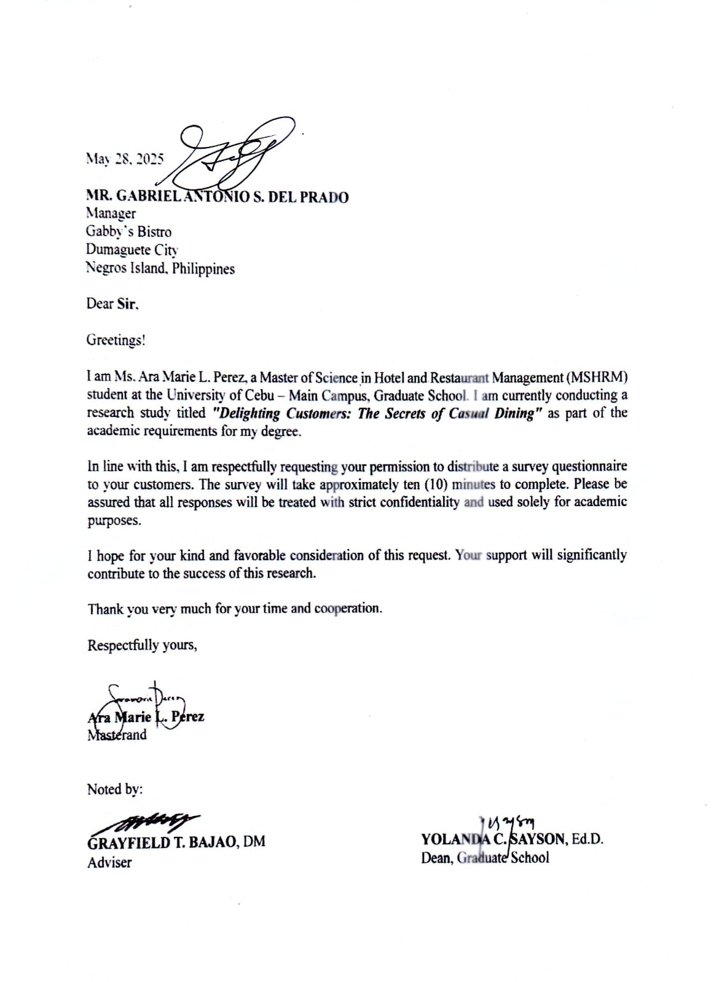

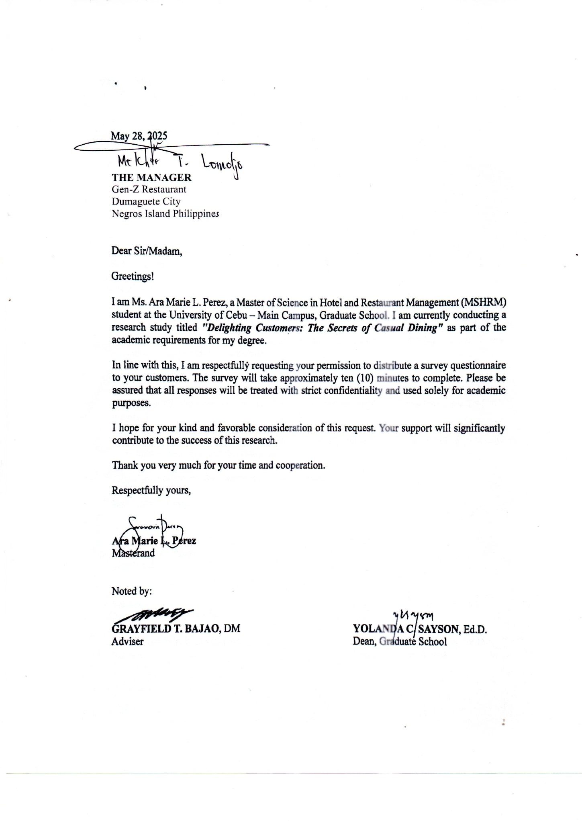
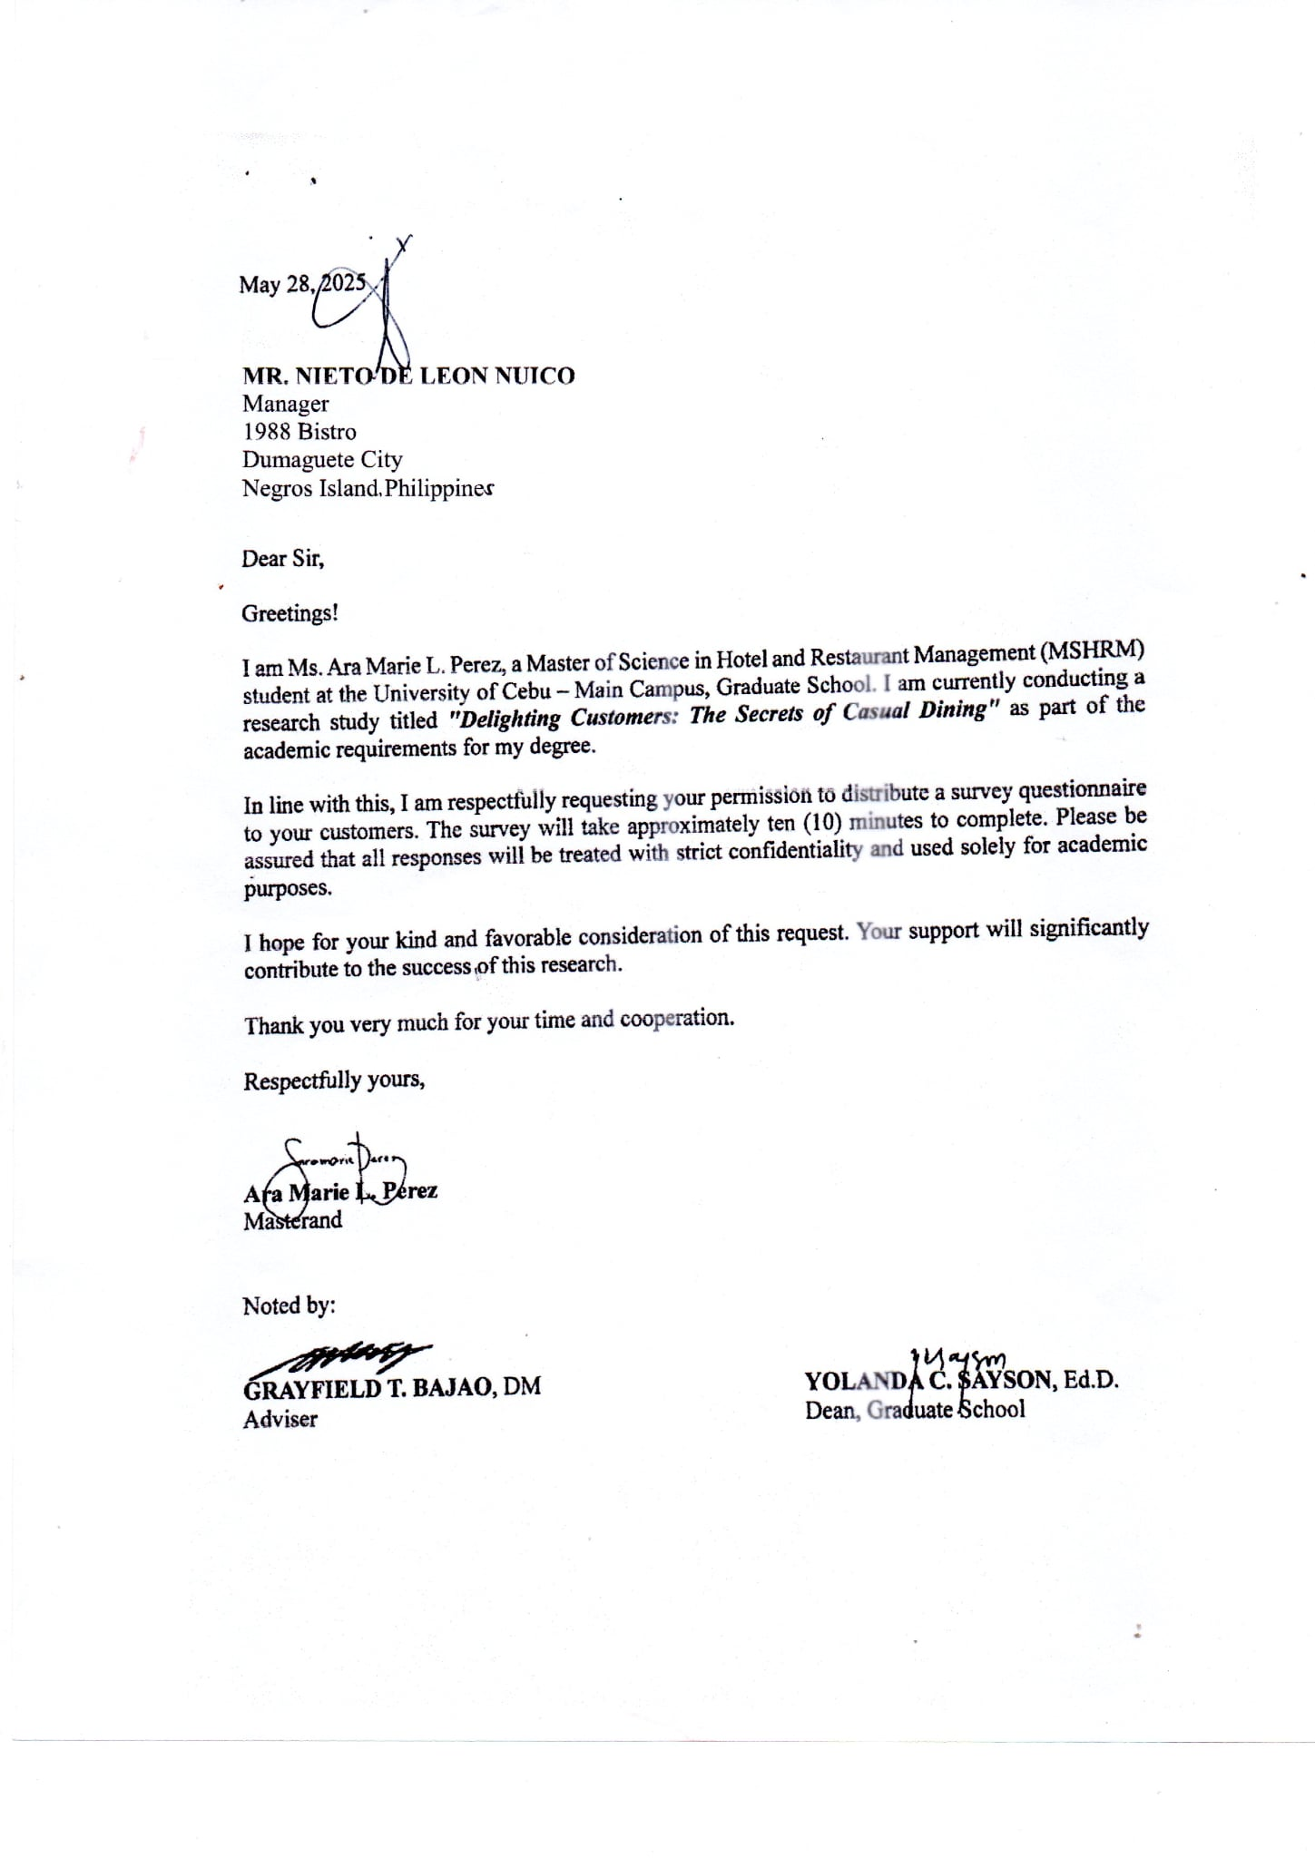

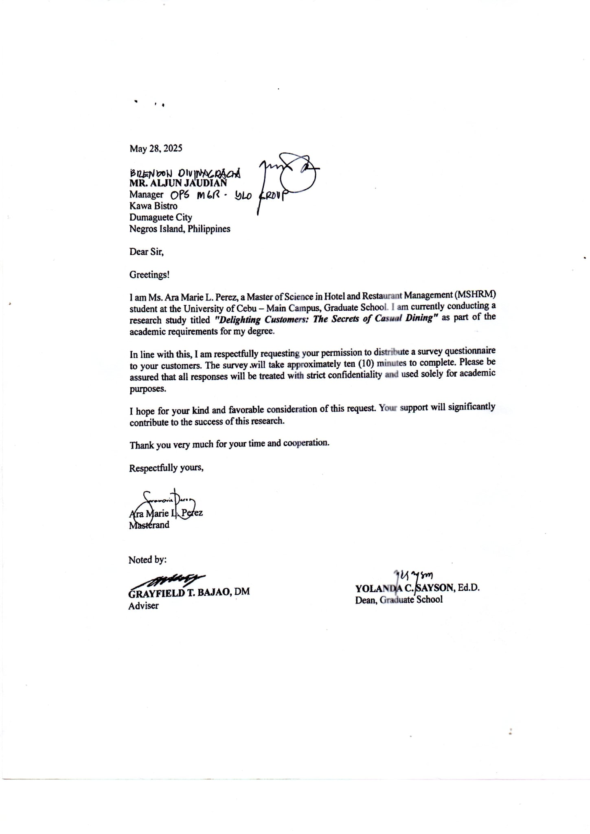
Appendix B
Research Survey Instrument

DELIGHTING CUSTOMERS: THE SECRETS OF
CASUAL DINING

Part I : Profile of the Respondents
INSTRUCTION: Kindly check (/) the following information in the space provided below, which corresponds to your description.

- Age ___ 55 years old and above
___ 45 – 54
___ 35 – 44
___ 25 – 34
___ 18 – 24

2. Gender ___ Male
___ Female
___ Prefer not to say

3. Civil Status ___ Single
___ Married
___ Divorced/Annulled
___ Widowed

4. Educational Attainment ___ Doctoral Degree Graduate
___ Master’s Degree Graduate
___ Bachelor’s Degree Graduate
___ Others, please specify __________

5. Nationality ___ American
___ Japanese
___ Korean
___ German
___ Filipino
___ Others, please specify __________

6. Occupation ___ Skills Trades/Technical
___ Office/Administrative
___ Professional/Academic
___ Business/Corporate
___ Others, please specify __________
Part II: Level of contentment of the respondents in the casual dining services offered by restaurants
INSTRUCTION: Kindly rate the following indicator of the level of contentment of the respondents in the casual dining services offered by restaurants by putting a check (√) mark in the box as indicated below, according to the rating scale and categorical responses provided.
Legend :
RATING | SCALE | DESCRIPTION
4 | Highly Contented (HC) | Very satisfied and happy with one’s situation or experiences
3 | Moderately Contented (MC) | Fairly satisfied, though there may be minor issues or areas for improvement
2 | Less Contented (LC) | Somewhat dissatisfied, with noticeable concerns or unmet expectations
1 | Not Contented (NC) | Clearly unhappy or dissatisfied with the situation or outcome

- WAIT TIME

INDICATOR | 4  (HC) | 3  (MC) | 2  (LC) | 1  (NC)
1. How contented were you with the estimated waiting time provided?
2. How contented were you with the time you had to wait to be seated?
3. How contented were you with the time you waited for your order to be taken?
4. How contented were you with the management of the waiting area (e.g., comfort, organization)?
5. How contented were you with the overall efficiency in minimizing waiting times?
6. Others, please specify

- SPEED OF SERVICE

INDICATOR | 4  (HC) | 3  (MC) | 2  (LC) | 1  (NC)
1. How contented were you with the promptness in receiving your drinks?
2. How contented were you with the time it took for your food to be served after ordering?
3. How contented were you with the pacing of the meal service (e.g., appetizers, main course)?
4. How contented were you with the efficiency of the staff in delivering your order to your table?
5. How contented were you with the overall speed and efficiency of the service throughout your meal?
6. Others, please specify

- ORDERING SYSTEM
INDICATOR | 4  (HC) | 3  (MC) | 2  (LC) | 1  (NC)
1. How contented were you with the ease and clarity of the menu presentation?
2. How contented were you with the availability of staff to take your order promptly?
3. How contented were you with the clarity of communication when placing your order?
4. How contented were you with the options for order customization or special requests?
5. How contented were you with the accuracy of your order upon arrival?
6. Others, please specify

- STAFF RESPONSIVENESS

INDICATOR | 4  (HC) | 3  (MC) | 2  (LC) | 1  (NC)
1. How contented were you with the attentiveness of the staff to your needs during your meal?
2. How contented were you with the politeness and courtesy of the staff interactions?
3. How contented were you with the staff's willingness to address your questions or provide information?
4. How contented were you with the staff's proactiveness in anticipating your needs (e.g., refills)?
5. How contented were you with the speed and effectiveness of the staff in resolving any issues or concerns?
6. Others, please specify

Part III. Problems encountered by the respondents when dining in the restaurants
INSTRUCTION: Kindly rate the following indicator on the problems encountered by the respondents when dining in the restaurants by putting a check (√) mark in the box provided before each item indicated below.
Possible Problems/Experiences Encountered | Check (/)
1. Excessive wait time before being seated.
2. Slow service after being seated.
3. Uncomfortable or inadequate waiting area.
4. Insufficient staff during peak hours.
5. Inaccurate order taking.
6. Delays in food preparation.
7. Lack of communication regarding wait times.
8. Difficulty getting the attention of staff.
9. Incorrect billing.
10. Food served cold or at an incorrect temperature.
11. Food quality not meeting expectations (taste, freshness, etc.).
12. Menu items unavailable.
13. The ordering system was difficult to use.
14. Uncleanliness of the dining area (tables, floor, etc.).
15. Uncomfortable ambiance (noise, temperature, etc.).
16. The staff was unfriendly or unhelpful.
17. Problems with payment processing.
18. Others, please specify

Thank you very much for your cooperation!

Appendix C
LOCATION MAP
DUMAGUETE CITY, PHILIPPINES


CASUAL DINING RESTAURANT A

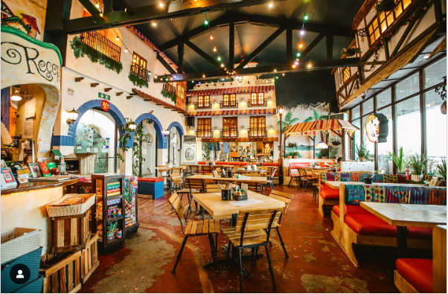

CASUAL DINING RESTAURANT B

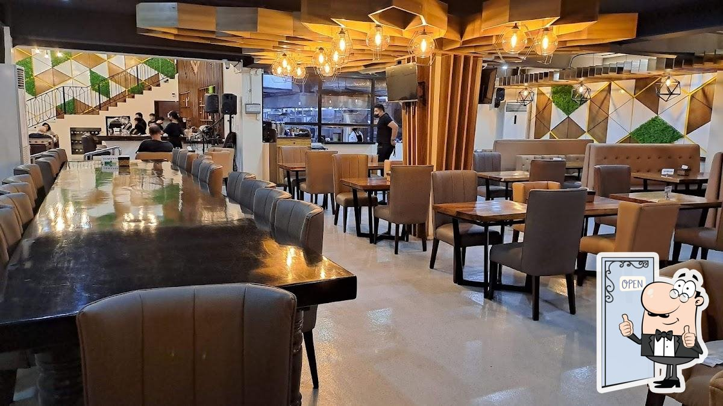

CASUAL DINING RESTAURANT C

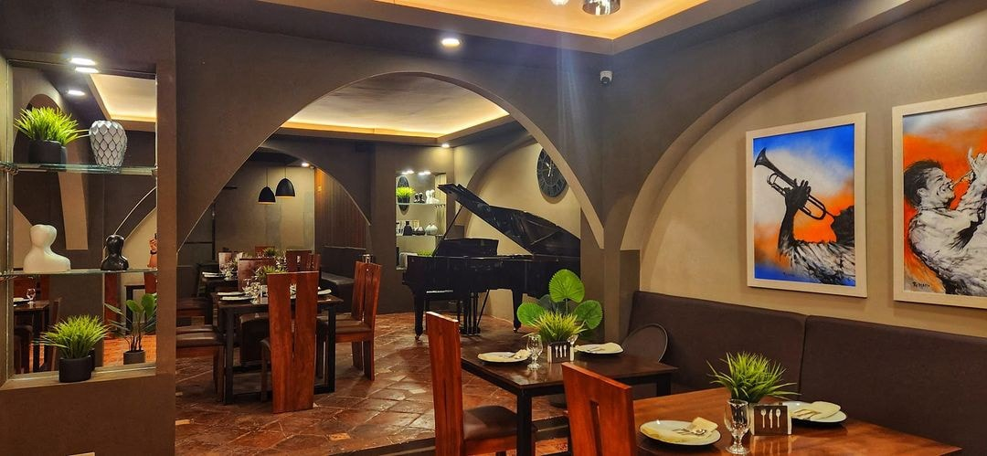

CASUAL DINING RESTAURANT D

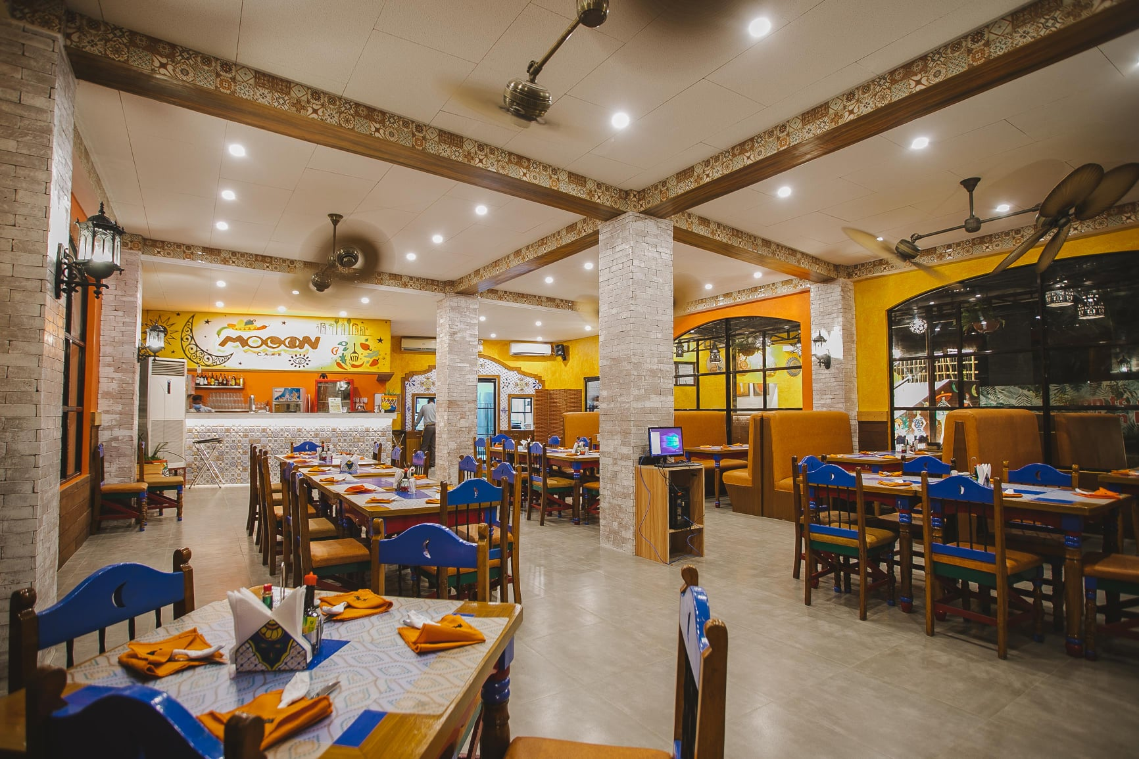

CASUAL DINING RESTAURANT E
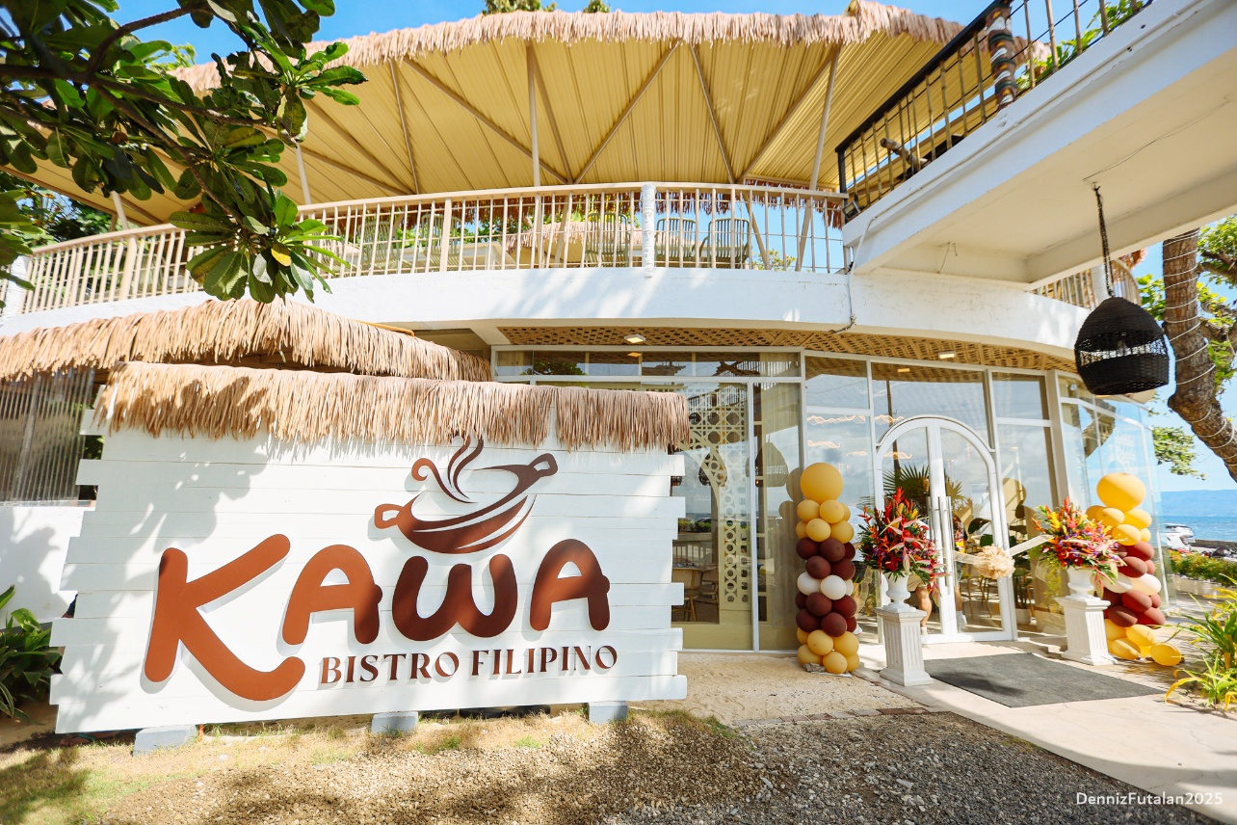

CURRICULUM VITAE

ARA MARIE L. PEREZ , LPT
https://orcid.org/0009-0000-7119-0700
aramarie801@gmail.com
Iniban, Ayungon Negros Oriental

Educational Background

Graduate School : Masters of Science in Hotel and Restaurant Management
University of Cebu – Main Campus
2024 (on-going)

Post Baccalaureate : Certificate in Professional Education
Saint Francis College – Guihulngan City
Graduated 2021

College : Bachelor of Science in Hospitality Management
Negros Oriental State Univeristy – Guihulngan Campus
Graduated March 2019

High School : Ayungon Science High School
Tampocon II, Ayungon Negros Oriental
Graduated March 2015

Elementary : Iniban, Elementary School
Iniban, Ayungon Negros Oriental
Graduated April 2011

Work Experiences

BSHM Part Time Instructor : Negros Oriental State University
Guihulngan City Campus
March 2023 to present

Customer Service Representative : Wonders Corporation
Dumaguete City
October 2021- December 2022

CPH 202 Enumerator : Philippine Statistics Authority
Dumaguete City
September 1-30, 2020

Cashier : Sans Rival Food Development Inc.
Dumaguete City
May 2019-December 2019

Trainings Attended

- Explore, Experience, Enjoy : The Fun starts here in Negros Oriental Naturally
- Council of Hotel and Restaurant Educators of the Philippines – Negros Island Chapter Convention and Skill Competition
- Beginners Stage 1 Japanese Language Course
- Nourishing Heart of a Teacher (PAFTE Webinar Series)
November 18, 2023
- Taking Care of the Teachers Eyes (PAFTE Webinar Series)
November 18, 2023
- Basic Computer Literacy (Edtech Teacher Training)
December 12, 2022 – December 21, 2022

