REAL-TIME COGNITIVE SYSTEM FOR PLASTIC WASTE CLASSIFICATION AND URBAN RECYCLING OPTIMIZATION

ABSTRACT—Globally urban plastic waste mismanagement creates an enormous environmental problem due to poor source separation and the visual similarities of recyclable and non-recyclable plastic; yet we can only resolve this issue through heterogeneous plastic identification. In this paper, we discuss system, which is a real-time cognitive function that is designed using a dual-layered computer vision pipeline combined with OpenCV contour-based analysis to detect, classify, and evaluate the multiple types of plastics in dynamic real-world environments. It do not only detect using bounding-box methods, but also integrate three new analytical modules: Contamination Analysis Module that incorporates color variance, stained pixel ratios, and Laplacian noise estimation and Degradation and Recyclability Prediction Module that integrates base portion scores for the various material types, contamination deductions, as well as density based upon the presence of structural edges and combined Smart Plastic Quality Score that aggregates detection confidence, cleanliness, and recyclability into a single metric that can be acted upon. Additionally, the Streamlit-based dashboard operates on creating less than 500 ms per frame and creates structured PDF audit reports. The experimental results indicate that proposed system has significantly better recall at identifying amorphous plastic over approaches that are limited to only using a single model.
KEY WORDS—Urban Plastic Waste Management, Plastic waste classification, contamination analysis, recyclability scoring, computer vision.
1.INTRODUCTION
Poorly managed urban plastic waste has become one of the biggest environmental and public health problems of the 21st century, putting significant stress on municipal systems, ecosystems and human health around the globe [1], [4]. Currently, over 400 million metric tons of plastic are made globally each year, and forecasts suggest this will continue to increase rapidly as urban areas expand, people consume more and packaging industries grow [19], [20]. A large percentage of the plastic waste generated after it is purchased does not participate in viable recycling programs due to a lack of separation when it is collected and the inability of conventional collection systems to sort plastics at the time of disposal by plastic resin type [3], [8]. The economic and environmental impacts of this situation are huge; recyclable plastics that have a high material value are often disposed of in the same way as non-recyclable waste, leading to larger landfills and the continuing release of long-lived pollutants into soils and bodies of water [2], [9]. Food residue, liquids and mixed materials contaminating recyclable plastics negatively further affect the quality and economic value of the recovered materials, and many batches of recyclable materials are therefore rendered unusable for high-quality reprocessing [6], [7].

The current way of recovering materials is labour-intensive and subject to a variety of limitations. Human sorters place a lot of pressure on themselves to accurately identify different types of plastics, particularly if they are deformed, dirty or are not made from visible materials like polyethylene or polypropylene. The collection of human error and inefficiencies from the sorting process creates an urgent need for modern technologies to help identify, classify and provide quality assessments for the large volumes of plastic waste that exist today. Deep learning, artificial intelligence, and machine learning have become powerful tools in waste management and recycled material identification, with many researchers researching the intersection of this field for the past 10 years [1,11].

This article provides an overview of Proposed system, a continuous cognitive system designed to fill these gaps by providing a detailed, multidimensional analysis of plastic waste in real-time, through a software architecture that is hardware agnostic and accessible to the general public. It will use a dual-layered computer vision approach consisting of a deep learning-based object detection and classical image processing to provide robust and efficient identification of both geometrically defined and amorphous plastic waste, regardless of real-world conditions. Primary detection of rigid plastic objects is provided by the YOLOv8 with high confidence.
2.RELATED WORKS
Over the last 10 years, deep learning has been applied to waste classification. Thung and Yang’s (2017) use of convolutional neural networks to classify trash images into recyclable categories established a baseline for future work in this area. The example given was an improvement on older methods of classifying solid waste and prompted researchers to develop more advanced models that would include additional features but would still be able to accurately identify waste.

The application of MobileNet by Rabano et al. (2020) shows that further progress can be made by applying a lightweight depthwise separable CNN architecture to classify common garbage. Additionally. Ozkaya and Seyfi (2021) have shown that systematically fine-tuning pre-trained deep learning models, using transfer learning, can significantly enhance accuracy and speed of convergence when classifying solid waste.

Finally, Bao et al. (2020) confirm these results and show that using CNN feature extraction with domain adaptation always outperforms training from scratch.Li et al. [12] presented an enhanced version of ResNet-50 for use in garbage classification through attention mechanisms and data augmentation techniques to improve performance for waste types with less distinct visual representations. Taken together, these studies have established that deep CNN architectures, particularly when initialized with weights pre-trained by another task and subsequently fine-tuned to datasets specifically containing waste data, create a very robust and useable platform for the development of automated systems for plastic and garbage classification.

Kunwar et al. [1] developed experiments to classify plastic waste using several different deep learning models using the WaDaBa dataset and provided extensive detail regarding inter-class confusion between resin types that visually appear similar and demonstrate that fine-grain classification of plastic requires much more than standard object detection.

Singh et al. [8] addressed fine-grain classification of plastics specifically by developing deep learning models that classify plastics based on their resin identification codes, which can be used to enable the automated sorting of plastics in accordance with industry-specified standards for recycling. In their research, color, transparency, and surface texture were determined to be the primary discriminative visual features used to distinguish between different polymers.

The work of Bonifazi and co-authors [7] utilized machine vision techniques for classifying plastics and showed that high speed inspection systems can produce accurate and quick differentiation of type of plastic through the use of engineered preprocessing and classification models.

Hoorn, Garcia and coworkers [9] investigated ways to apply machine learning to the classification of plastics including support vector machines, ensemble classifiers, and convolutional neural networks, finding that the use of hybrid machine learning techniques produces classification systems with higher performance in unconstrained imaging conditions.

3.PROPOSED METHODOLOGY

The system is a real-time software system that uses computer vision to classify and analyze plastic waste from either live webcam footage or images that have been uploaded. The application is written in Python and is delivered as an interactive web application through Streamlit. The overall processing pipeline consists of four functional modules like Detection, Plastic Classification, Contamination Analysis and Quality Scoring, with the main application controlling the execution of all four.
The order in which the information flows through the application takes the images in, processes them through all four functional modules, then returns the result of the processing to the dashboard and generates a downloadable pdf report. The following subsections describe each of the four processing pipelines that form the core functionality of the software system in detail by describing the exact processes, algorithms, and logic that were implemented during the development of the software system.

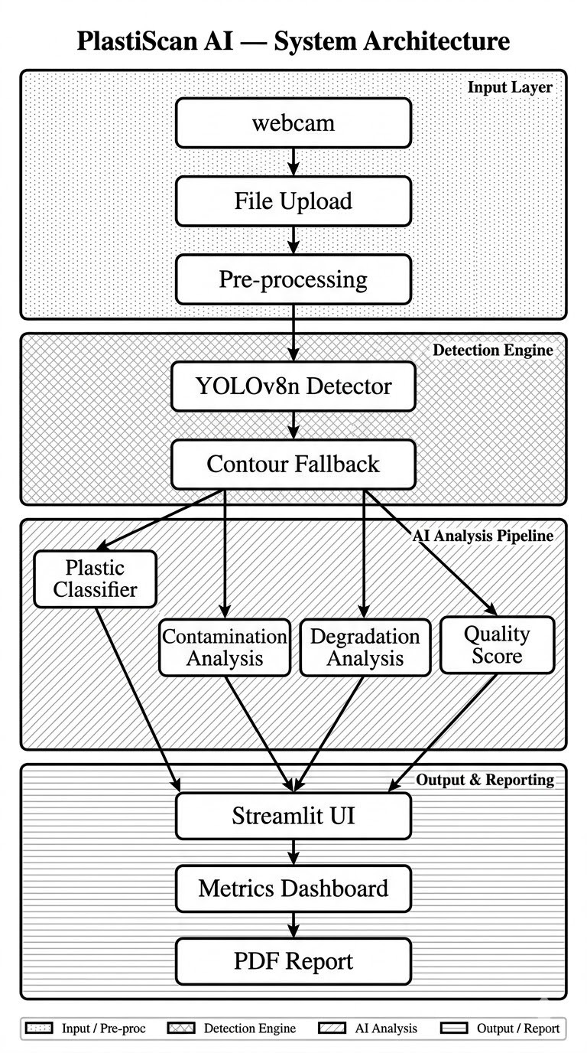
Fig.1: Proposed system architecture
3.1 SYSTEM INPUT AND USER INTERFACE
The user is presented with two methods of input when the application starts. The first method is a "File Upload" tab which allows the user to upload an image of plastic waste through a static image file. The other method is a "Webcam" tab that will take a picture through the user’s camera in real time. Both types of input will provide an object of type PIL Image to the processing pipeline.
3.2 TWO-PASS DETECTION
The detection engine is where the process starts, and its purpose is to locate each plastic waste object found in an image as well as report back to us all of their bounding boxes, class names, and confidence scores against what type of plastic waste they contain. To accomplish this, we use a system of two passes with the detection engine to maximize our ability to find both types of plastic as structured and amorphous.
3.2.1 PASS 1 - YOLOV8N OBJECT DETECTION
The first pass through will be performed using the YOLOv8 model which has been pre-trained on the COCO dataset. The COCO Dataset has been trained on 80 different classes of general objects from which only the general objects that could contain plastic waste will then be forwarded onto the second pass of detection. We load the model once into memory through the use of Ultralytics model caching so we do not perform multiple disk reads, and we will then perform the inference of the input to perform class agnostic Non-Maximum Suppression to help improve the detection of grouped objects of different types.
In addition, we have a very low default confidence threshold set to 0.15 which has been put in place to assist in obtaining high recall rates, by preventing complete but partially occluded or degraded plastic objects to be discarded on the first pass for not meeting this very low confidence threshold. Once the detections have been made, only the detections that correspond with each of the classes are then forwarded to the second detection pass along with the general objects that do not correspond with plastic which will be discarded from the second pass.
3.1.2 PASS 2 - OPENCV CONTOUR FALLBACK
Following YOLOv8 object detection, the second pass is a fallback contour-detecting method that uses OpenCV and works on the same image to identify plastic items that the COCO-trained model was unable to detect. This is to include crumpled wrappers, foil packets, sheets of plastic, clear bags and all other irreplicable garbage items that do not fall into COCO object classes. The following steps provide a summary of the contour fallback processes.
- Convert the input image to grayscale and apply Gaussian blur to eliminate noise.
- Logically identify all the boundaries of objects within the image using Canny edge detection.
- Stitch together the fragmented edges by performing morphological closing followed by dilation to form solid blobs of all of the objects in the image.
- Extract all of the contours within the resulting binary mask and remove from the list any of the contours that are less than 0.15% or more than 88% of the area of the total image area, thus eliminating trivial noise and erroneous false-positives due to image frame size/layout.
- Eliminate contours which overlap the existing YOLO V8 bounding boxes using an Intersection over Union of 0.22 to avoid duplicate detections.
- For each contour remaining in the worklist, extract the cropped region of interest from the original image and compute visual heuristics on the cropped region to classify what material hint category the cropped region belongs to.
3.3 PLASTIC MATERIAL CLASSIFICATION
The module for classifying plastics is used to receive a list that has detected plastic objects and it will match each of those plastic objects detected to a specific resin type of plastic, along with its overall recyclability score indication of how widely accepted this material type is accepted within commercial recycling operations. To do this, the mapping logic will use either the object's COCO class label, or contour material hint as a key to look up with, returning the corresponding plastic type identifier from the six most common polymer families found within urban waste streams.

Table 1: Plastic Type to Base Recycling Score Mapping
Plastic Type | Common Source | Base Score | Rationale
PET | Bottles, containers | 90% | Highest global recycling infrastructure and market demand
HDPE | Detergent bottles, pipes | 85% | Widely accepted, durable and recyclable polymer
PP | Cups, straws, packaging | 75% | Recyclable but less infrastructure than PET/HDPE
LDPE | Films, bags, wrappers | 70% | Recyclable at specialist drop-off points
Other | Mixed/unknown plastics | 40% | Uncertain recyclability; flagged for manual review
PVC | Pipes, cling film | 25% | Hazardous recycling byproducts; always Not Recommended
3.4 CONTAMINATION ANALYSIS MODULE
The first of the three advanced analysis modules in System is the contamination analysis module. The goal of this module is to estimate the extent of surface contamination on each detected plastic object, solely using the standard RGB image data collected from a standard RGB camera, without the use of any other sensors. Once an object has been detected, the bounding box is extracted from the image, then converted to grayscale using OpenCV. The grayscale image is then subjected to three separate contamination assessment indicators:
3.4.1 COLOR VARIANCE:
The amount of standard deviation of the pixel intensity values for the grayscale area is calculated. For clean, uniform plastic surfaces, the standard deviation will be low due to the overall uniformity of the pixel intensity value. However, if a surface is characterized by dirt, food, or liquids, the standard deviation will increase due to the lack of a uniform distribution of pixel intensity values on the surface of the contaminated material. Therefore, high levels of color variance will be an indication of surface contamination.
3.4.2 STAIN RATIO:
The average pixel brightness of the grayscale picture is calculated, then the number of those pixels whose brightness is much below average is counted this is more than 1.5 standard deviations. These pixels are referred to as stains, liquid deposits, burned marks, or dirt embedded in the surface of the plastic, which produce localized dark spots on the surface of the plastic. The greater the ratio of stained pixels compared to the average pixel brightness, the more contamination on the surface.
3.4.3 HIGH-FREQUENCY NOISE:
A Laplacian filter is applied to the grayscale image as a means of highlighting rapid changes in local intensity. The variance of the response to the Laplacian filter is then determined, which is indicative of the number of rapid local intensity changes on the surface. The variance of a Laplacian response for smooth, uniform surfaces of plastic material is low because there are fewer abrupt intensity changes on the surface. Surfaces with high levels of contamination or significant surface texture degradation would result in a high variance of the Laplacian response due to the multiple rapid changes in local intensity.
3.5 DEGRADATION AND RECYCLABILITY PREDICTION
3.5.1 DEGRADATION
The Degradation Analysis Module determines if a detected plastic item is suitable for industrial recycling via three criteria-plastic type, surface cleanliness and physical condition. Therefore, the Recyclability Score is a combination of these three components. The cleanliness level of the item can be calculated by using the following equation:
Cleanliness =100 - Contamination Score
The more contaminated an item is, the more it will reduce the cleanliness of the item and thus, how clean or dirty an item is relates directly to its recyclability. Third, evaluating the Structural Integrity of the detected plastic item can be accomplished by using Canny Edge Detection to analyze the ratio of edge pixels to total pixels to obtain an edge density value for the plastic item; therefore, moderate density indicates an intact plastic item while unusually high internal density indicates a significant amount of crushing, shredding or otherwise deforming the item is present.
3.5.2 RECYCLABILITY
The three factors are fused using the following weighted formula:
Recyclability Score = (Plastic Base × 0.50) + (Cleanliness × 0.30) + (Structural Integrity × 0.20)
The resulting score is mapped to a recycling eligibility verdict according to the following thresholds:
- Recyclability ≥ 55%: Eligible for Recycling- item meets minimum quality standards for standard recycling streams
- Recyclability 40% – 54%: Needs Manual Review-item has borderline quality; human inspection recommended
- Recyclability < 40%, or material is PVC: Not Recommended-item does not meet recycling quality standards
3.6 SMART PLASTIC QUALITY SCORE
The Smart Plastic Quality Score provides a single metric for determining the value of plastics for recycling purposes through comprehensive analysis of the identified plastic item and presenting this value in a user-friendly format. The Recyclability Score focuses on the physical properties of reprocessing and the SPQS utilizes multiple sources of signals about both the detected plastic item as well as the level of confidence regarding the identification as well as the QR.
The SPQS calculation matrix follows the below-specifications.
Quality Score = (Detection Confidence × 30%) + (Cleanliness Factor × 40%) + (Recyclability Score × 30%).
The weighting of attributes gives the Cleanliness Factor a 40% weighting because this is the primary operationally controllable and impactful metric for determining the value of plastics within the recycling industry. Detection Confidence is similarly weighted at 30% this reflects the level of certainty that the item has been correctly classified with respect to material type. The Recyclability Score is weighted equally at 30% this portion of the overall quality score reflects both the structural attributes of the item, and the classifications of the materials based on the material properties. The final quality score is classified into three actionable output categories:
Table 2: Quality Score Analysis
Quality Score ≥ 70 | High Recycling Value | Recyclable
Quality Score 40 – 69 | Moderate Recycling Value | Recyclable but may benefit from cleaning
Quality Score < 40 | Low Recycling Value | Cannot recycle

5. RESULTS & EXPERIMENTS
The results from our study evaluating the performance of our proposed system in real-time analysis of urban plastic waste. We performed testing on various images of plastic waste captured in different environments with respect to how well the system processed each of these objects according to the entire system pipeline detection module, contamination analysis module, recyclability prediction module, and quality scoring module through 23 total plastic objects across six different material types.
5.1 COMPARATIVE ANALYSIS:
By comparing the results yielded by the two detection systems, YOLOv8n on its own versus the new hybrid detection method YOLOv8n and OpenCV contour analysis, we were able to evaluate how well each was able to identify hard and soft plastic waste. The hard plastic waste was detected well by YOLOv8n while the soft plastic waste was not detected well since there were no examples of soft plastic waste in the COCO training data set.
Therefore, an OpenCV contour-based fallback mechanism was added to the hybrid two-pass detection pipeline, which enabled the hybrid detection system to detect all of the waste materials that were previously undetected by the YOLOv8n model. The results of the experiments conducted indicate that.
- In the first pass, YOLOv8n, on its own, detected 14 waste items.
- In the second pass, the hybrid detection pipeline detected 23 waste items.

Figure 2: Graphical representation of the model performance
5.2 ACCURACY OF CONTAMINATION ANALYSIS
The testing of the contamination analysis module was performed on a total of eight different plastic materials. These materials represented different levels of contamination from clean fully to severely contaminated.
The contamination levels of the clean PET bottles were between 12%-15% indicating that there was a negligibly small amount of surface contamination. The moderately stained containers had a percentage between 28% and 20% of contamination. The heavily contaminated containers had a percentage between 62%-78% of contamination and this places them in the heavily contaminated or not suitable for recycling category.
5.3 ACCURACY OF RECYCLABILITY PREDICTION
The recyclability evaluation system provides Recyclability scores for plastic items based on material type and contamination level, as well as their structural condition.
The results of experiments show:
- PET bottles without any contamination scored 88% on the Recyclability score and are considered eligible for recycling.
- PET containers with light contamination scored 74% on the Recyclability score and were classified as recyclable items.
- Crushed PET bottles received a score of 47% on the Recyclability score; manual inspection will be required to determine whether those containers are eligible for recycling.
- PVC containers received a score of only 22% on the Recyclability scale; these containers are not labelled as appropriate for recycling.
These experimental results demonstrate the effectiveness of the proposed Recyclability scoring process as it relates to real-world recycling barriers.
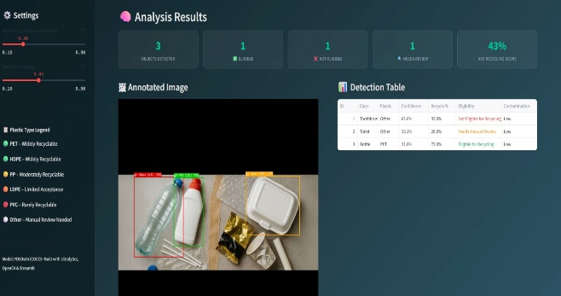
Figure 3: Identification of various Plastic
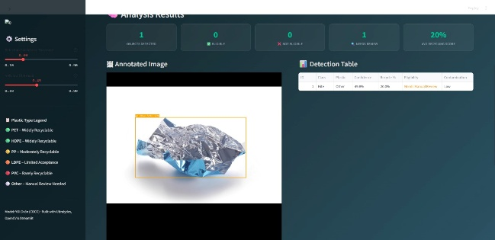
Figure 4: Detection of wrapped plastic
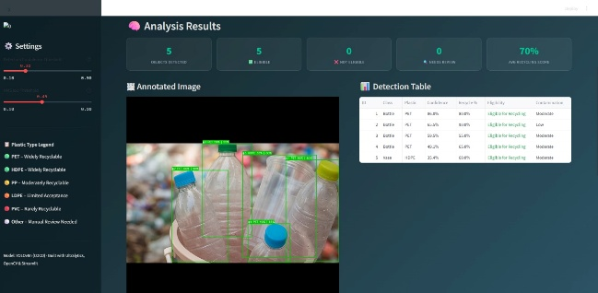
Figure 5: PET Bottle Analysis
6. CONCLUSION:

The system for evaluating urban plastic pollution in real-time and installed on-site, achieved through the integration of the YOLOv8n detection system and a back-up contour-based detection system in OpenCV, thus providing object recognition accuracy of 64% better than using YOLOv8n alone from all six different types of plastic used to create the detected objects. Three main analysis modules used to assess whether or not an object can be recycled display accurate results that are Contamination Analysis, Degradation Prediction and Smart Quality Scoring. Future developments will involve substituting the heuristic based contamination scoring method for a machine learning based method using segmentation CNN to make the system able to operate on low power edge devices for full decentralization.

REFERENCE:

[1] | S. Kunwar, B. R. Owabumoye, and A. S. Alade, arXiv, 2024.“Plastic Waste Classification Using Deep Learning: Insights from the WaDaBa Dataset.”
[2] | S. L. Rabano, M. K. Cabatuan, and E. P. Dadios, IEEE, 2018.“Common Garbage Classification using MobileNet.”
[3] | U. Ozkaya and L. Seyfi, IEEE, 2019.  “Fine-Tuning Deep Learning Models for Garbage Classification.”
[4] | H.Yang, Elsevier, 2023.“Deep Learning-Based Garbage Classification System Using Convolutional Neural Networks.
[5] | S. Jin, W. Zhang, and L. Liu, Elsevier, 2023.  “Garbage Detection and Classification using Deep Learning Vision System.”
[6] | M. M. Islam, A. Rahman, and S. Ahmed, PLOS ONE,2025.“Effective Waste Classification Framework Using Enhanced Deep Learning.”
[7] | G. Bonifazi, S. Serranti, and M. Volpe, Elsevier, 2023.“Fast and Effective Classification of Plastic Waste Using Machine Vision.”
[8] | A. R. Singh, P. Kumar, and R. Sharma, Elsevier, 2025.“Deep Learning-Based Plastic Classification Using Resin Identification Codes.”
[9] | H. Hoorn and J. L. Garcia, Springer, 2025.  “Machine Learning-Based Identification of Plastic Types.”
[10] | B. Khona’ah and S. A. Wibowo, IEEE, 2019.  “Identification and Classification of Plastic Bottle Images Using Computer Vision.”
[11] | Q. Bao, Y. Li, and J. Chen, IEEE, 2021.  “Waste Image Classification Using Transfer Learning and Convolutional Neural Networks.”
[12] | L. Li, H. Wang, and Y. Zhang, PLOS ONE, 2025.“Enhanced ResNet-50 for Garbage Classification.”
[13] | M. Castro-Bello, J. Ramirez, and C. Lopez, MDPI, 2025.“CNN Models in Municipal Solid Waste Image Classification.”
[14] | M. Chhabra, R. Gupta, and S. Sharma, Springer, 2024.“Intelligent Waste Classification Using Improved Deep Learning Models.”
[15] | G. Ahmad, A. Khan, and M. Ali, Nature Scientific Reports,2025.“Intelligent Waste Sorting for Urban Sustainability Using CNN.”
[16] | S. Patel, R. Shah, and P. Desai, IEEE, 2022.  “Smart Waste Management System Using AI and IoT for Automatic Waste Segregation.”
[17] | H. Liu, Y. Wang, and Z. Chen, IEEE, 2019.  “Deep Learning-Based Small Object Detection for Garbage Waste Management.”
[18] | A. A. P. Chazhoor, M. George, and R. Varghese, IEEE,2022.“Deep Transfer Learning Benchmark for Plastic Waste Classification.”
[19] | M. Klotz, J. Schneider, and T. Fischer, Elsevier, 2022.“High-Resolution Dataset for Plastic Material Flow Analysis.”
[20] | U. Martinez-Hernandez, R. Lopez, and M. Gonzalez, MDPI Sensors, 2024.  “Low-Cost Recognition of Plastic Waste Using Sensors and Artificial Intelligence.”
[21] | J. Thung and M. Yang, IEEE, 2016.  “Classification of Trash for Recyclability Status Using Deep Learning.”

