An Empirical Study on the Effect of Always-On Work Culture on the Physical and Emotional Well-Being of Private School Academicians in Tamil Nadu
Abstract
Despite increasing digital integration and post-pandemic normalization of online communication in Tamil Nadu’s private school sector, teachers’ mental and physical wellbeing remains under growing strain. With high smartphone penetration and rising parental and institutional expectations, teachers face persistent “always-on” work demands that blur professional and personal boundaries. Analysing responses from 394 private school teachers across multiple districts using descriptive statistics, Chi-square tests, correlation, and regression analysis, this study identifies a high prevalence of after-hours work communication and perceived pressure to remain constantly available. The findings reveal significant associations between always-on work demands and elevated levels of stress, sleep disturbance, physical fatigue, and emotional exhaustion (p < 0.05), while demographic variables show limited moderating influence. Workplace factors such as workload distribution, administrative support, and technological adaptability significantly shape wellbeing outcomes, either amplifying or buffering negative effects. The study underscores the need for institutional policies regulating digital communication norms and workload expectations to protect teacher wellbeing and ensure sustainable educational quality.
Keywords: always-on work culture, teacher wellbeing, digital work demands, private schools, Tamil Nadu, mental health, physical health
1.1 Introduction
The rapid digitalization of education has intensified work demands beyond formal working hours, creating an “always-on” work culture among teachers. Despite Tamil Nadu’s strong educational infrastructure, high digital access, and widespread adoption of online communication platforms, private school teachers increasingly experience blurred work–life boundaries. This study examines the prevalence of always-on work culture and analyses its impact on teachers’ mental and physical wellbeing, while assessing the role of workplace factors in shaping these outcomes within private schools in Tamil Nadu.
1.2 Educational Sector
India’s education sector has undergone rapid transformation with increased privatization and digital integration, particularly in school education. Private schools play a significant role in Tamil Nadu’s educational ecosystem, supported by widespread smartphone usage, online learning platforms, and digital communication tools. While technology has enhanced accessibility and administrative efficiency, it has also intensified work expectations for teachers through continuous connectivity, virtual classrooms, and instant parent–school communication. Despite structured academic calendars, informal after-hours work has become normalized, revealing systemic challenges related to workload regulation, boundary management, and teacher wellbeing within the private school sector.
1.3 Private Schools and Operational Models
Private schools in Tamil Nadu follow varied management and operational models focused on academic performance, parent satisfaction, and institutional reputation. Many schools adopt management-led systems supported by digital platforms for teaching, assessment, and parent communication, while others rely on traditional face-to-face interactions and manual processes. Although digital integration improves coordination and efficiency, it increases expectations of constant teacher availability. These models differ in workload distribution and accountability, often contributing to an “always-on” work culture that affects teacher wellbeing.
1.4 Statement of the Problem
The expansion of digital communication has intensified “always-on” work expectations among private school teachers in India, extending work demands beyond formal working hours. In Tamil Nadu, frequent after-hours messages, online academic tasks, and administrative monitoring blur work–life boundaries. Despite growing concern over teacher stress and burnout, empirical evidence on its mental and physical wellbeing impacts remains limited. This gap restricts informed policy and institutional interventions to safeguard teacher wellbeing.
1.5 Objectives of the Study
• To examine the relationship between always-on work demands and teachers’ mental wellbeing.
• To investigate the impact of always-on work culture on teachers’ physical wellbeing.

1.6 Scope of the Study
This study focuses on private school teachers in Tamil Nadu to examine the prevalence of “always-on” work culture and its impact on their mental and physical wellbeing. It covers teachers across different age groups, genders, experience levels, and school categories to ensure representative insights. The study considers digital work demands, after-hours communication, and workplace factors influencing wellbeing. It excludes government schools, student outcomes, and institutional performance to maintain focus on teachers’ experiences.
1.7 Significance of the Study
This study is significant as it provides empirical insights into how “always-on” work culture affects the mental and physical wellbeing of private school teachers in Tamil Nadu. It offers valuable evidence for school managements to design healthier work practices and digital communication norms. The findings can support policymakers and education authorities in framing guidelines to protect teacher wellbeing. Academically, the study contributes to the limited Indian literature on digital work pressure and occupational health in the education sector.
1.8 Conceptual Framework
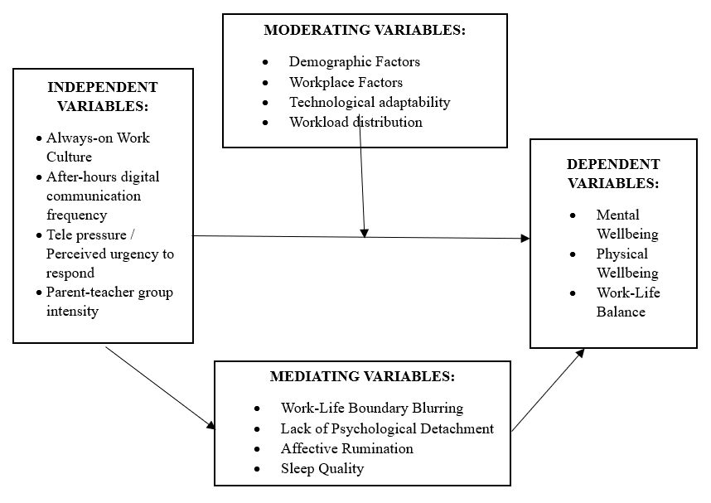
2. Review of Literature
2.1 Introduction
In this study, the review of literature focuses on the concept of the “always-on” work culture and its impact on teachers’ mental and physical wellbeing, with particular attention to the educational and school environment in India and abroad.
2.2 Review of literature
Akshaya Sekar, Geetha Anasuya Vithal, Nithyapriya Chinnaraju and Jeevithan Shanmugam (2024) in their work “A study on challenges and perceptions of schoolteachers towards online classes during COVID 19 pandemic”, examines the challenges faced by schoolteachers in Western Tamil Nadu. It highlights significant difficulties such as network issues, increased workload, and trouble engaging students virtually. A majority of teachers lacked prior experience in online teaching and expressed the need for technology training. The study found that the online teaching program was perceived as less effective compared to traditional classrooms, with notable impacts on student attention and academic performance. Despite these challenges, there was no significant association between teachers' age and the physical health issues caused by increased screen time. The findings stress the importance of training and infrastructural support to improve online teaching effectiveness and teacher wellbeing.
Jena and Mahanti (2014) conducted “An empirical study on technostress among Indian academicians”, identifying key factors such as techno-overload, techno-invasion, technocomplexity, techno-insecurity, and techno-uncertainty. Their research revealed that demographic variables including gender, age, and technological awareness significantly influence technostress levels, with male and older academicians experiencing higher stress, while increased technological awareness lowers it. The study emphasizes that frequent technology updates and demands lead to anxiety and reduced job satisfaction among educators.
S. Yoganand, I. K. Annie, John William Felix (2019) conducted a cross-sectional “A study on burnout syndrome among school teachers in Tamil Nadu” assessing burnout among government school teachers in Tamil Nadu. Using the Teachers Burnout Scale, they found the majority had low to below average burnout levels, with no significant differences by age or gender. Factors such as having a spouse who is also a teacher, chronic illnesses, and working in urban schools correlated with higher burnout. Physical activity like exercise and yoga was linked to lower burnout levels. Teachers in higher grade levels and those teaching social science experienced more burnout. The study emphasizes the need for burnout screening and health programs to support teacher wellbeing in addressing occupational stress.
2.3 Research Gap
Although there is considerable literature on workplace stress, job satisfaction, and work-life balance among teachers, there is a notable lack of focused research specifically examining the effects of an ‘always on’ work culture in private schools in Tamil Nadu. Most studies neglect the distinctive challenges introduced by persistent digital connectivity, such as immediate responsiveness to emails and school apps, which foster a sense of perpetual availability
3. Research Methodology
3.1. Introduction
This chapter presents the research design, sampling plan, data-collection procedures, pilot testing, reliability and validity assessment, and the statistical tools adopted for analysis.
3.2 Research Design
The descriptive element provides an overview of teachers’ demographic profiles, work patterns, and after-hours digital engagement, while the analytical element explores how these factors influence mental and physical wellbeing. Quantitative data are gathered through structured questionnaires, and qualitative insights are obtained from openended responses to capture personal experiences.
3.3 Sample Design
The study relies primarily on primary data collected directly from teachers employed in private schools across Tamil Nadu. The questionnaire has been developed based on validated scales from previous literature and customized to suit the education sector context.
3.3.1 Sampling Technique
A stratified quota sampling technique has been adopted for this study. The population is divided into distinct strata based on school location and school type to ensure fair representation. This technique allows the researcher to include diverse teacher profiles while maintaining balance and representativeness across regions.
3.3.2 Sample Area
The study area is Tamil Nadu, one of India’s leading states in terms of private school education. The units of analysis are private school teachers employed at the kindergarten, primary, secondary and higher secondary levels.
3.3.3 Population
The target population for this study comprises teachers working in private schools across Tamil Nadu. The population is estimated to include over 1.5 lakh private school teachers (as per UDISE+ 2022–23). Since obtaining responses from the entire population is not feasible, a representative sample will be drawn.
3.4 Validity, Pilot Study and Reliability
Experts and n=30 pilot established content/face validity with refinements, while Cronbach’s α>0.70 (overall 0 .798/30 items) confirmed internal consistency across constructs.
3.5 Statistical Tools
SPSS and Jamovi facilitates ANOVA for socio-economic trust differences and Pearson’s r for correlation.
4. Data Analysis & Interpretation
4.1 Correlation for examining the relationship between always-on work demands and teachers’ mental wellbeing
Correlations
 |  | Mental_wellbeing | after_hour_digital_communication_frequency
Mental_wellbeing | Pearson Correlation | 1 | .605**
Mental_wellbeing | N | 394 | 394
after_hour_digital_communication_frequency | Pearson Correlation | .605** | 1
after_hour_digital_communication_frequency | N | 394 | 394
**. Correlation is significant at the 0.01 level (2-tailed).
The correlation analysis reveals a strong and positive relationship between after-hours digital communication frequency and teachers’ mental wellbeing (r = 0.605, p < 0.01). This indicates that as the frequency of after-hours work-related digital communication increases, there is a corresponding increase in mental strain and psychological distress among private school teachers. The statistically significant result confirms that the “always-on” work culture plays a substantial role in influencing teachers’ mental wellbeing. The strength of the correlation suggests that persistent connectivity beyond official working hours significantly affects teachers’ emotional balance, stress levels, and overall mental health.
4.2 Regression for analysing the impact of always-on work culture on teachers’ physical wellbeing
Model | R | R Square | Adjusted R Square
1 | .384ª | .148 | .137

Model |  | Sum of Squares | df | F | Sig.
1 | Regression | 324.611 | 5 | 13.444 | .000^{b}
1 | Residual | 1873.726 | 388
1 | Total | 2198.338 | 393
a Dependent Variable: Physical_health
b Predictors: Constant
 |  | B | Beta | t | Sig.
1 | (Constant) | 14.259 |  | 31.149 | .000
1 | I receive communication from my immediate supervisor/HOD requiring an urgent response. | .262 | .115 | 2.114 | .035
1 | I actively work on lesson planning, grading, or administrative tasks. | .165 | .068 | 1.244 | .214
1 | My personal time is interrupted by work-related calls or communication from parents or students | -.134 | -.081 | -.910 | .363
1 | The need to monitor after-hours communication distracts me, making it difficult to prepare high-quality lessons. | .336 | .198 | 2.231 | .026
1 | I feel less effective or productive in my main teaching duties due to after-hours demands consuming my energy. | -.731 | -.447 | -4.346 | .000
Simple linear regression analysis showed that the “always-on” work culture significantly predicts the physical health of private school teachers (F = 13.444, p < 0.001). The model explained 14.8% of the variance in physical health (R² = 0.148), indicating a meaningful influence of after-hours work demands. After-hours communication from supervisors (β = 0.115, p = 0.035) and the need to monitor communication (β = 0.198, p = 0.026) had significant positive effects on physical health strain, while feeling less effective due to after-hours demands was the strongest predictor (β = −0.447, p < 0.001). Other after-hours activities were not significant predictors.
5. Findings, Suggestions & Conclusion
5.1 Objective 1: To examine the relationship between always-on work demands and teachers’ mental wellbeing
Finding:
The analysis shows a significant relationship between always-on work demands and teachers’ mental wellbeing. Continuous after-hours communication and blurred work–life boundaries are associated with increased stress, emotional exhaustion, and reduced psychological recovery. These findings confirm that always-on work culture acts as a persistent psychological stressor, weakening teachers’ mental resilience and increasing burnout risk.
Suggestion:
Educational institutions should implement structured digital boundary policies, including restricted after-hours communication windows, formal response-time protocols, and workload regulation frameworks to protect teachers’ psychological recovery time. Institutional mental wellbeing programs, such as stress management training, digital detox initiatives, and organizational support systems, should be integrated into school policies to mitigate the long-term psychological impact of always-on work expectations.
5.2 Objective 2: Investigate the impact of always-on work culture on teachers’ physical wellbeing
Finding:
The findings demonstrate that always-on work culture exerts a significant and measurable impact on teachers’ physical wellbeing. Continuous monitoring demands, energy depletion, and prolonged after-hours engagement contribute to physical fatigue, somatic stress symptoms, sleep disturbances, and reduced physiological recovery. The results confirm that digital work intensification not only affects psychological health but also produces tangible physical health deterioration, positioning always-on culture as a multidimensional occupational health risk.
Suggestion:
Institutions should introduce enforced digital disconnection policies, structured rest periods, ergonomic workload planning, and occupational health interventions. Preventive strategies must include workload redistribution, mandatory recovery time, and institutional monitoring of physical strain indicators to ensure sustainable teaching environments and long-term workforce health stability.
5.2 Conclusion
In conclusion, the study establishes that the always-on work culture significantly undermines both the mental and physical wellbeing of private school teachers. Persistent after-hours work demands, continuous connectivity, and blurred work–life boundaries contribute to psychological stress, emotional exhaustion, fatigue, and declining physical health. The findings highlight that wellbeing erosion is driven not by workload alone, but by the inability to disengage from work. Addressing always-on culture through institutional policies, boundary-setting mechanisms, and supportive workplace practices is essential for sustaining teacher health, productivity, and long-term educational effectiveness.
Bibliography
Athira, V. J. (2025). Impact of digitalization on work-life balance among female academics in higher-education institutions. Journal of Women and Work-Life Integration, 2(1), 44–59.
Chaudhry, S., & Chhajer, R. (2023). Enhancing psychological well-being of school teachers in India: Role of energy management, thriving, and stress. Indian Journal of Positive Psychology, 14(1), 91–102.
Esplana, J., & Callo, R. (2024). Workplace culture and environment towards teachers’ performance: The mediating role of professional commitment. Asian Journal of Education and Psychology, 6(1), 50–66.
Harish, K. A., & Jeyaprabha, P. (2024). Occupational stress and job satisfaction of teachers of government and private sectors. Journal of Educational Research and Practice, 14(1), 65–79.
Jena, R. K., & Mahanti, R. (2014). An empirical study on technostress among Indian academicians. Global Journal of Management and Business Research, 14(9), 18–27.
Hernandez, F. (2017). Impact of ICT on education: Challenges and perspectives. Educational Technology Review, 25(3), 99–110.
Klapproth, F., Federkeil, L., Heinschke, F., & Jungmann, T. (2020). Teachers’ experiences of stress and coping strategies during COVID-19-induced distance teaching. Teaching and Teacher Education, 92, 103118.
Myers-Briggs Company. (2019). The “Always-on” culture and its impact on workplace behaviour. Myers-Briggs Workplace Insights Report, 4(1), 1–25
Pradeepan, K. (2022). Work-life balance of teaching staff during the COVID-19 pandemic in Chennai. South Indian Journal of Business and Management Studies, 3(2), 112–121.
Sasikumar, N., & Jenifer, K. (2024). Occupational stress and cognitive load among private school teachers in Sivaganga district, Tamil Nadu. International Journal of Psychology and Education, 13(1), 85–98.

