Enhancing Concrete Performance Using Copper Slag

Alan Eric P

Abstract—In an effort to enhance concrete's performance and sustainability, this study analyzes the possibility of partially replacing traditional ingredients with copper slag, a by-product of the copper industry. The primary objective of the study is to determine the way adding copper slag in place of cement and/or fine aggregates affects the workability, durability, and mechanical qualities of concrete, including its resistance to sulfate attack, chloride ion penetration, and freeze-thaw cycles, as well as its compressive, tensile, and flexural strengths. The study also looks at the advantages of using copper slag for the environment, such as a smaller reliance on natural resources, better waste management, and maybe lower carbon emissions from the production of cement. Based on studies, copper slag can enhance the strength and durability of concrete when added in suitable amounts. It also provides a more cost-effective and environmentally conscious substitute for conventional concrete mixtures. The results indicate that by reusing industrial waste materials and reducing the environmental impact of concrete production, copper slag can significantly contribute to a circular economy while supporting environmentally friendly practices in the construction sector.

Keywords—Cement, Copper slag, Aggregates, Industrial waste

Introduction

Concrete is a fundamental construction material, widely used due to its high compressive strength, durability, and adaptability. However, the increasing demand for concrete has led to excessive exploitation of natural resources, particularly river sand and aggregates, raising environmental and economic concerns. To mitigate these issues, the construction industry is exploring sustainable alternatives by incorporating industrial byproducts into concrete production.

Copper slag, a byproduct of the copper smelting process, has gained attention as a potential alternative material for enhancing concrete performance. Rich in silica, iron, and alumina, copper slag possesses favorable physical and chemical properties that can improve concrete strength, workability, and durability. Previous studies have indicated that partial replacement of fine aggregates or cement with copper slag can enhance mechanical properties while reducing environmental impact.

This study aims to evaluate the effectiveness of copper slag in improving concrete performance, focusing on its influence on compressive strength, durability, and sustainability. By optimizing its utilization, copper slag can contribute to eco-friendly construction practices, reduce industrial waste, and promote resource conservation in the construction sector.

Motivation

The use of copper slag in concrete is motivated by its potential to enhance both performance and sustainability. As a byproduct of the copper smelting process, copper slag is often discarded as waste, leading to environmental concerns. Incorporating it into concrete helps reduce landfill disposal and supports sustainable construction practices by repurposing industrial byproducts. Additionally, copper slag improves the mechanical properties of concrete, including increased compressive, tensile, and flexural strength. Its dense and angular particles contribute to better durability, while its smooth texture enhances workability and flowability. Furthermore, replacing natural aggregates or cement with copper slag can lead to cost savings and a reduction in the environmental impact associated with traditional concrete materials.

EXISTING SYSTEM

The existing system for enhancing concrete performance with copper slag involves its use as a fine aggregate replacement, cementitious material, and durability enhancer. Copper slag is widely used to replace 40–50% of natural sand, improving workability, compressive strength, and durability, though excessive replacement may lead to increased density and reduced bonding due to its smooth surface. Additionally, its high silica, alumina, and iron oxide content makes it suitable for *partial cement replacement, especially when combined with pozzolanic materials like fly ash and GGBS, leading to improved long-term strength, reduced heat of hydration, and lower cement consumption. Moreover, copper slag enhances concrete durability by improving resistance to chloride penetration, sulfate attack, and abrasion, making it ideal for marine and industrial environments. The use of copper slag in concrete not only enhances performance but also supports sustainable waste management by repurposing industrial byproducts, reducing landfill disposal, and minimizing the depletion of natural sand and cement resources. This makes it a cost-effective and environmentally friendly solution for modern construction.

IV. PROPOSED SYSTEM

The utilization of copper slag as a partial replacement for fine aggregate in concrete has gained significant attention due to its potential to enhance mechanical properties and sustainability. Research has explored the mechanical and durability properties of copper slag concrete, highlighting improvements in compressive strength, abrasion resistance, and long-term performance. Additionally, studies on the effect of copper slag on workability and strength of high-performance concrete indicate that its use enhances flowability while maintaining structural integrity. 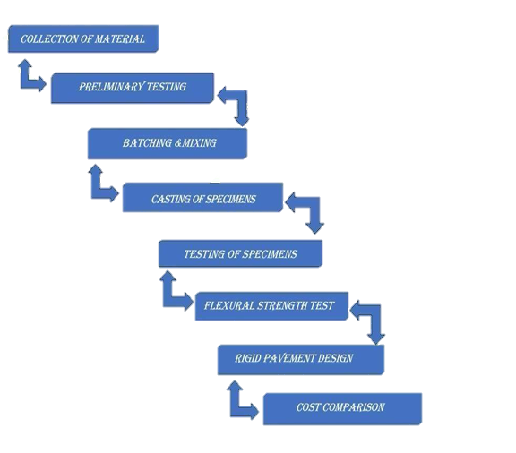
Fig 2. Flow diagram of proposed system

The sustainability aspects of using copper slag in concrete mixes are also crucial, as it promotes the reuse of industrial waste, reducing environmental impact. A comparative study on concrete with copper slag and conventional concrete helps evaluate the material's feasibility in construction. Furthermore, the influence of copper slag on the microstructure and strength development of concrete reveals its role in densifying the matrix and improving bond strength. To maximize its benefits, research focuses on optimizing copper slag percentage for maximum strength and durability in concrete. Long-term performance evaluations, such as experimental studies on the long-term performance of copper slag-based concrete, provide insights into its structural reliability. As an eco-friendly alternative, sustainable concrete using industrial waste like copper slag aligns with green construction initiatives. Additionally, research on the impact of copper slag on alkali-silica reaction in concrete mixes helps assess its effect on mitigating expansion-related durability issues. Overall, copper slag presents a promising solution for enhancing concrete properties while promoting sustainability.

V. EXPERIMENTAL RESEARCH

This research investigates the impact of copper slag as a partial replacement for fine aggregates in concrete, analyzing its effects on compressive strength, workability, and water absorption. The results demonstrate that compressive strength increases with copper slag replacement, reaching its peak at around 40% substitution before declining due to increased voids and changes in the hydration process. This indicates that a moderate amount of copper slag enhances concrete strength by improving particle packing and reducing microcracks, but excessive usage weakens the matrix. Workability, measured through slump values, shows a steady increase with higher copper slag content, attributed to the material’s smooth surface texture and reduced water absorption capacity, which facilitates better flowability. However, excessive workability at higher replacement levels could lead to segregation and bleeding issues, potentially affecting structural integrity. Water absorption follows an inverse trend, decreasing up to 40% replacement—indicating a denser and less permeable mix—before increasing again as higher copper slag content introduces additional porosity. A comparative analysis of these properties reveals that 40% replacement is the optimal balance point, offering maximum compressive strength, improved workability, and minimal water absorption, making it a viable alternative to traditional fine aggregates. Beyond this threshold, the decline in strength and increase in permeability suggest diminishing returns in durability, raising concerns about the long-term performance of high copper slag mixes. These findings highlight the potential of copper slag as an eco-friendly and cost-effective solution for sustainable construction, provided its application is carefully optimized. Future studies should explore long-term durability aspects, including resistance to chloride penetration, sulfate attack, and freeze-thaw cycles, to fully assess its viability for large-scale use in infrastructure projects.

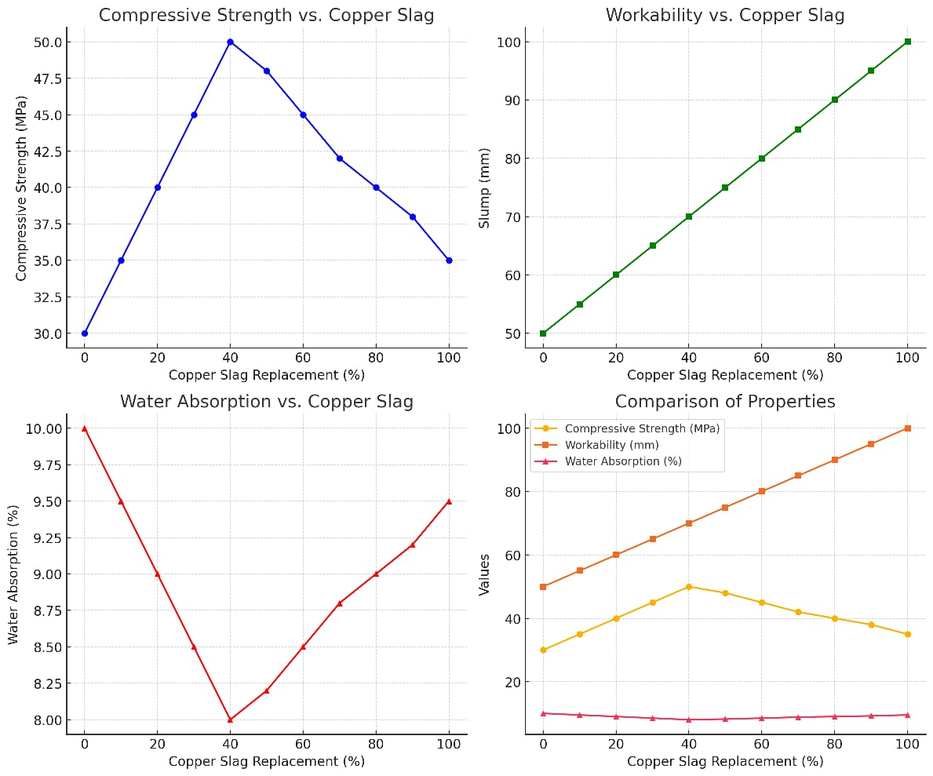
Table 1. Graph of Comparison

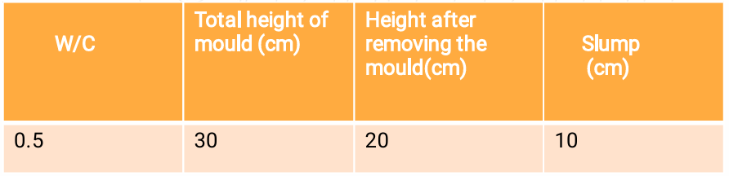

Table 2. Slump Cone Test

The data in Table 1 shows brief summary of SLUMP CONE TEST It can be used in site as well as in lab. This test is not applicable for very low and very high workability concrete. It consists of a mould that is in the form of frustum having top diameter of 10cm, bottom diameter of 20cm and height of 30cm. The concrete to be tested if fitted in the mould in four layers. The each is compacted 25 times with the help of tamping rod. After the mould is completely filled it is lifted immediately in the vertically upward direction which causes the concrete to subside.

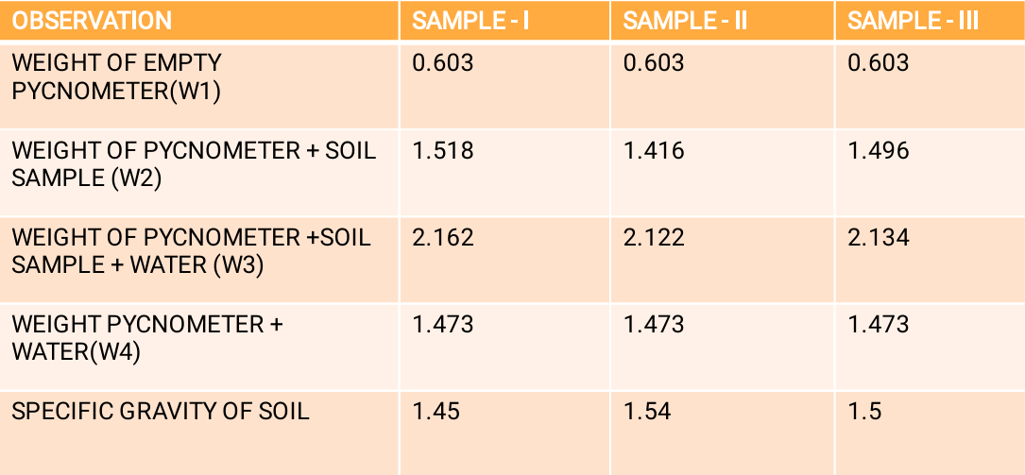

Table 3. Specific Gravity Test

The specific gravity of concrete is typically influenced by the density and types of materials used in its mix. Copper slag, a byproduct of copper extraction, is sometimes used as a partial replacement for sand in concrete production. It can influence the specific gravity of concrete depending on the proportion used and the physical properties of the slag itself. This change in specific gravity can affect the workability, strength, and durability of the concrete, but it's important to test the mix under specific conditions to ensure it meets the required performance standards.

- CONCLUSION AND FUTURE PROSPECTS

Workability results show that workability of concrete
decreases a bit with the increase in the quantity of Wood ash
and copper slag. The wood ash and copper slag are totally
mixable with other concrete aggregates. All the concrete
containing wood ash and Copper slag show good enough
workability to be easily compacted and finished. The Compressive strength results show that by replacing
cement with wood ash and Fine aggregates with copper slag,
there is increase in compressive strength but aggregates in
higher volume decreases strength. After 24 % wood ash and36% Copper slag volume addition and replacing Cement and fine aggregates in the same proportion, there is decrement of compressive strength. The optimum compressive strength is achieved at 24% replacement of the Cement by wood ash and 36% replacement of fine aggregates with Copper Slag and shows an increases over conventional concrete at 28 days. The optimum value of split tensile strength is at 24%
replacement of Cement by wood ash and 36% replacement
of the fine aggregates with Copper Slag. After that it keeps
decreasing. It shows an increase of at 28th day. The flexure strength also showed maximum strength when 24% of Cement is being replaced by wood ash and 36% of fine aggregates is being replaced with Copper Slag, and increased the strength up to at 28th day. Both help in increasing strength at low volume replacement. The optimum value of strength in compression, split tensile and flexure came at 24% replacement of the Portland cement by wood ash and 36% replacement of the taken fine aggregates with Copper Slag.

- REFERENCES

1 Gorai B, Jana RK, Premchand, Characteristics and utilisation of copper
slag—a review, Resources, Conservation and Recycling, 39(4), (2003), 299–
313, DOI 10.1016/S0921-3449(02)00171-4.
2 Nath P, Sarker P, Effect of fly ash on the durability properties of high
strength concrete, In: The twelfth Asia-Pacific Conference on Structural En-
gineering and Construction 2011, 2011, pp. 1149–1156.
3 Al-Jabri KS, Hisada M, Al-Oraimi SK, Al-Saidy AH, Copper slag as sand
replacement for high performance concrete, Cement and Concrete Compos-
ites, 31(7), (2009), 483–488, DOI 10.1016/j.cemconcomp.2009.04.007.
4 Wu W, Zhang W, Ma G, Optimum content of copper slag as a fine aggregate
in high strength concrete, Materials and Design, 31(6), (2010), 2878–2883,
DOI 10.1016/j.matdes.2009.12.037.
5 Alnuaimi AS, Effects of copper slag as a replacement for Fine aggregate on
the behavior and ultimate strength of reinforced concrete slender columns,
The Journal of Engineering Research (TJER), 9(2), (2012), 90–102.
6 Pundhir NKS, Kamaraj C, Nanda PK, Use copper slag as construction
material in bituminous pavements, Journal of Scientific and Industrial Re-
search, 64, (2005), 997–1002.
7 Brindha D, Nagan S, Durability Studies on Copper slag Admixed Concrete,
Asian Journal of Civil Engineering, 12(5), (2011), 563–578.
8 Alp I, Deveci H, Sungun H, Utilization of flotation wastes of copper slag as
raw material in cement production, Journal of Hazardous Materials, 159(2-
3), (2008), 390–395, DOI 10.1016/j.jhazmat.2008.02.056.
9 Mobasher B, Devagupta R, Arino AM, Effect of copper slag on the
hydration of blended cementitious mixtures, In: Chong K (ed.), Proceed-
ing, ASCE, Materials engineering conference ,material for new millennium,
1996, pp. 1677–86.
10 Arino AM, Mobasher B, Effect of ground copper slag on strength and
toughness of cementitious mixes, ACI Materials Journal, 96(1), (1999), 68–
73.
11 Pattanaik SC, Sabat AK, A study of NALCO Fly ash on compressive
strength for effective use in high volume mass concrete for a sustainable de-
velopment, In: International Conference on sustainable Technologies for con-
crete Constructions by India Chapter of American concrete Institute; Mum-
bai, 2010-09-03 and 2010
12 Atis CD, Heat evolution of high-volume fly ash concrete, Cement
and Concrete Research, 32(5), (2002), 751–756, DOI 10.1016/S0008-
8846(01)00755-4.
13 Sanjayan JG, Hydration temperatures in large high-strength concrete
columns incorporating slag, Cement and Concrete Research, 30(11), (2000),
1791–1799, DOI 10.1016/S0008-8846(00)00387-2.
14 Pazhani K, Jeyaraj R, Study on durability of high performance concrete
with industrial wastes, Applied Technologies and Innovations, 2(2), (2010),
19–28, DOI 10.15208/ati.2010.11.

