Hybrid Deep Learning Architecture for Glaucoma Detection: Integrating a Multi-Network CNN Ensemble with ANFIS

Abstract
Glaucoma is a leading cause of irreversible blindness worldwide, making early and accurate diag- nosis critical for preventing severe vision loss [1]. While deep learning has advanced computer- aided diagnostics, traditional single-stream Convolutional Neural Networks (CNNs) [2] often strug- gle with overfitting on small datasets and managing diagnostic uncertainties in overlapping disease patterns. To address these limitations, this thesis proposes a novel hybrid architecture that inte- grates a multi-network CNN ensemble with an Adaptive Neuro-Fuzzy Inference System (ANFIS), as implemented and evaluated in the accompanying Python programmatic framework. Specifi- cally, the Python pipeline pre-processes retinal fundus images via Region of Interest (ROI) ex- traction and enhancement, feeding them into a parallel feature extraction module utilizing pre- trained ResNet, DenseNet, and MobileNet backbones. These fused, high-level structural features are subsequently passed into the ANFIS module, which applies adaptive fuzzy reasoning to ef- fectively manage diagnostic uncertainty and subtle structural variations. Evaluated on aggregated benchmark datasets—including RIM-ONE, DRISHTI-GS1, and ACRIMA—the custom MultiNet- ANFIS Python program demonstrates superior diagnostic performance. When directly compared to standalone baseline models (such as standard ResNet18, DenseNet121, and MobileNet) within the script’s testing loop, the proposed CNN-ANFIS framework achieves significantly higher Ac- curacy, Precision, and Area Under the Curve (AUC). By synergizing the robust feature extraction capabilities of ensemble deep learning with the interpretable decision-making of fuzzy logic, this programmatically validated model successfully mitigates classification errors and offers a highly efficient, scalable solution for automated glaucoma screening.
Keywords: Deep Learning, Convolutional Neural Networks, Tele-Ophthalmology, ANFIS, Reti-
nal Fundus Images

Introduction

Clinical Background: The Global Burden of Glaucoma
Glaucoma is widely recognised as a paramount cause of irreversible vision loss across the globe. Because the disease progresses asymptomatically during its initial phases, the condition is fre- quently termed the “sneak thief of sight” in clinical practice [3]. Patients rarely notice the dete- rioration of their vision until significant, permanent optic nerve damage has already manifested. Epidemiological estimates suggest that approximately 3.5% of the global population is affected by

the age of 45. Furthermore, alongside rapidly aging global populations, the prevalence of glaucoma is projected to surge to approximately 111.8 million individuals by the year 2040 [3]. Because the visual impairment caused by glaucomatous neuropathy cannot be restored, the most effective clin- ical intervention relies entirely on early detection and the prompt initiation of targeted treatments to halt further structural damage to the eye.

The Role of Retinal Fundus Imaging in Screening
To effectively manage the escalating prevalence of glaucoma, large-scale and non-invasive screen- ing modalities are essential. High-resolution Retinal Fundus Images (RFIs) serve as a highly prac- tical and potent diagnostic tool in this regard, offering clinicians a direct visualization of the eye’s posterior segment [3]. These digital photographs capture critical anatomical structures, including the macula, fovea, complex blood vessel networks, and crucially, the optic disc—the primary exit point for ganglion cell axons travelling to the brain. Evaluating structural abnormalities in the optic disc, particularly the enlargement of the optic cup, is fundamental to assessing the severity of glaucoma. Nevertheless, relying on human experts to manually segment and analyze these in- tricate structures is intensely labor-demanding and susceptible to subjective interpretation errors. This highlights the urgent need for automated, computer-aided diagnostic frameworks capable of standardizing the screening process.
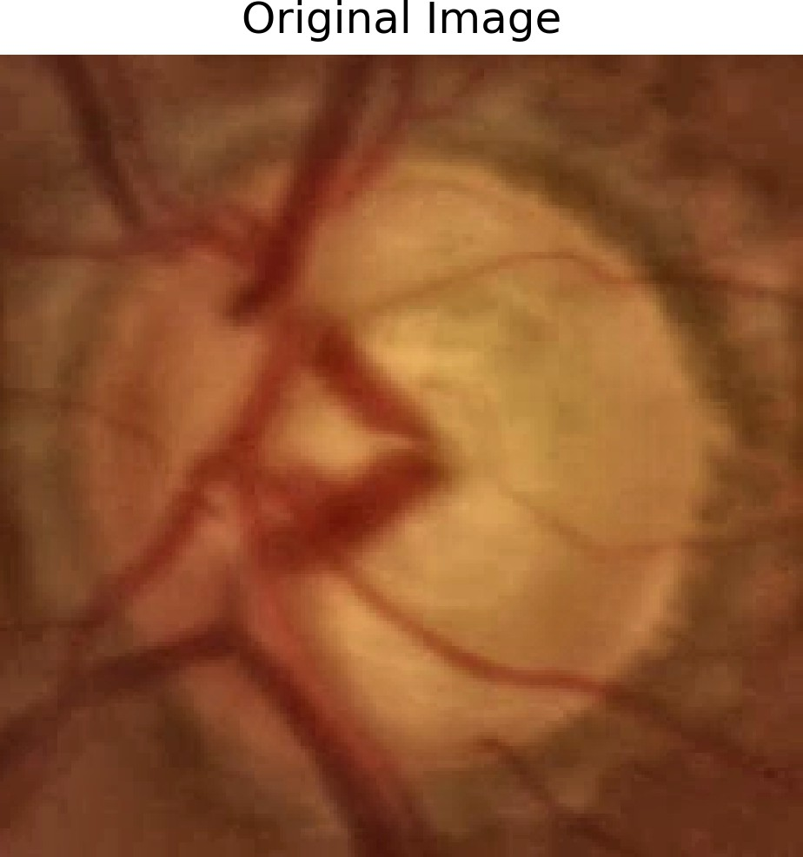
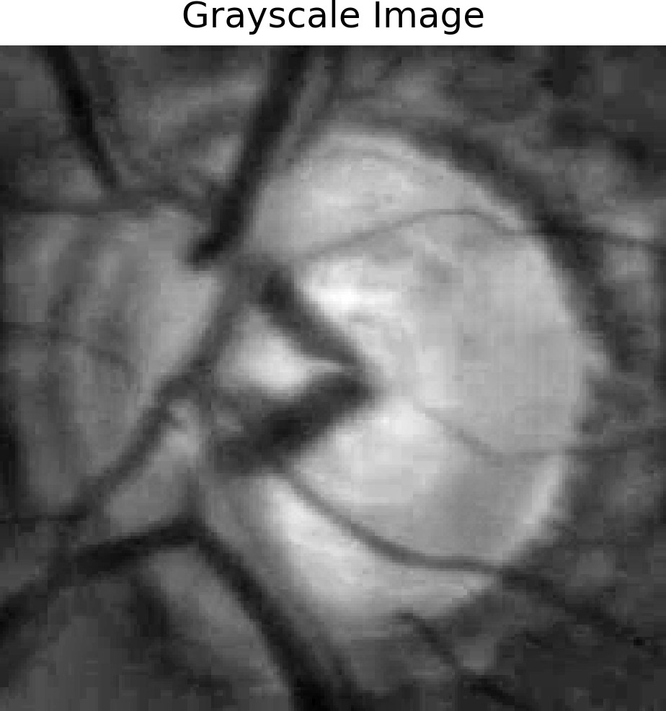
Figure 1: Original abnormal fundus image. Figure 2: Grayscale enhanced ROI representa- tion.

The Evolution of Deep Learning in Ophthalmology
The integration of Artificial Intelligence (AI) has sparked a profound paradigm shift in medical image analysis. Deep Learning (DL), a specialized branch of Machine Learning inspired by hu-

man neural architecture, has proven exceptionally adept at modeling complex, non-linear data relationships without requiring tedious manual feature engineering [3]. In the realm of ophthalmic screening, Convolutional Neural Networks (CNNs) have achieved remarkable success in process- ing RFIs. These sophisticated architectures can automatically extract rich, hierarchical spatial features, facilitating the highly accurate automated segmentation of the optic disc, optic cup, and surrounding vasculature. Consequently, DL systems have established themselves as foundational tools in modern ophthalmology, consistently demonstrating high sensitivity and specificity in the detection of vision-threatening conditions.

Limitations of Legacy Deep Learning Architectures
While traditional Convolutional Neural Networks (CNNs) have achieved remarkable diagnostic accuracy, their transition from laboratory settings to real-world clinical practice is hindered by substantial technological and practical barriers [4]. Recent systematic evaluations emphasize that standard deep learning architectures often necessitate immense computational power and carry high implementation costs, rendering them difficult to scale in resource-constrained or rural health- care facilities [3], [5]. Furthermore, a critical impediment to clinical adoption is the inherent “black box” nature of classical CNNs. Their opaque decision-making processes lack the transparency provided by Explainable AI (XAI) frameworks, which ultimately undermines the confidence of medical practitioners when making critical diagnostic decisions [5], [6].
In the specific context of glaucoma screening, clinical presentations frequently feature ambiguous structural boundaries and overlapping pathologies. Rigid binary classifiers struggle to maintain robustness in these scenarios because they lack the adaptive reasoning paradigms—such as fuzzy logic methodologies—required to effectively process inherent diagnostic uncertainties [3]. Addi- tionally, contemporary literature highlights that many legacy models are trained on homogeneous datasets, leading to algorithmic bias and a propensity to overfit. This severely restricts their gen- eralizability across diverse patient demographics and varying fundus imaging hardware [4], [6]. Consequently, to ensure diagnostic robustness and foster clinical trust, there is a pressing need for frameworks that combine high-level feature extraction with interpretable, uncertainty-aware decision-making mechanisms.

Proposed Methodology: Integrating CNN, Attention Mechanisms, and ANFIS
To overcome the computational and diagnostic shortcomings of traditional single-stream networks, this research proposes a novel, hybrid deep learning architecture based on the Shuffle Fuzzy At- tention Network (ShuffleFA-Net) methodology [3]. The proposed pipeline leverages a multi-stage approach, initially applying Region of Interest (ROI) extraction and Contrast Limited Adaptive Histogram Equalization (CLAHE) to isolate the optic disc and enhance the structural visibility of the retinal images.
For feature extraction, the architecture fuses an attention-driven CNN framework with an Adaptive Neuro-Fuzzy Inference System (ANFIS). Concurrently, a regression module based on the Taylor series fuses these deep features with handcrafted clinical metrics, including Higher Order Spec- tra (HOS), statistical features, and the vertical Cup-to-Disc Ratio (CDR) [3]. Finally, these fused

features are processed by the ANFIS module, which merges the rapid optimization capabilities of neural networks with the highly interpretable, rule-based reasoning of fuzzy logic. This syner- gistic integration applies adaptive fuzzy reasoning to effectively manage the subtle variations and uncertainties characteristic of glaucoma progression, ensuring superior diagnostic accuracy, re- silience against localized segmentation errors, and a highly scalable solution for automated ocular screening.
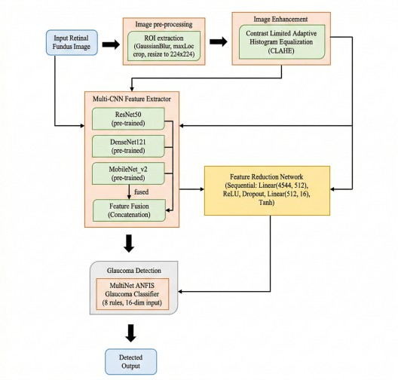

Figure 3: The Proposed MultiNet-ANFIS architecture.

Literature Review

The Global Burden of Ocular Diseases and the Tele-Ophthalmology Paradigm
The escalating global prevalence of vision-threatening conditions represents a profound crisis for worldwide healthcare infrastructure. Glaucoma is currently recognised as the second leading cause of irreversible blindness, with epidemiological projections estimating that over 111.8 million indi- viduals will be affected globally by the year 2040 [4]. Concurrently, Diabetic Retinopathy (DR) remains the leading cause of blindness among working-age populations, with global prevalence expected to exceed 160 million by 2045 [7], [8]. In response to this escalating crisis, the World Health Organisation (WHO) launched the VISION 2020 initiative, emphasising the urgent need for early detection and the elimination of avoidable blindness [9].
However, traditional screening paradigms rely heavily on in-person consultations utilizing expen- sive tabletop fundus cameras and highly trained retinal specialists. This model is fundamentally unsustainable in rural, remote, or socioeconomically disadvantaged regions where the ratio of ophthalmologists to the general population is perilously low [10]. To circumvent these barriers, tele-ophthalmology has emerged as an essential modality. By employing asynchronous (store-and- forward) and synchronous communication, primary care providers can capture high-resolution im- ages of the eye and transmit them to specialists across vast geographical distances [11]. Studies have demonstrated that tele-ophthalmology reduces unnecessary patient travel by up to 48% while drastically improving the efficiency of clinical triage and same-day treatment interventions [10].

Mobile Health and Smartphone-Based Fundus Imaging
While traditional tele-ophthalmology is effective, the high cost of standard desktop ophthalmic equipment restricts its deployment in primary care settings. Consequently, the integration of smart- phone technology into ocular diagnostics has rapidly expanded, a movement often referred to as ”smartphone science” [12]. Modern smartphones possess immense computational power, ubiqui- tous connectivity, and high-resolution cameras, making them ideal vehicles for portable diagnostic imaging.
Innovations such as the Remidio Fundus on Phone (FOP), the D-Eye adapter, and the Near Eye Tool for Refractive Assessment (NETRA) enable the capture of wide-field images of the retina directly through a smartphone lens [7]. Usability testing of these devices within primary care settings has demonstrated that medical assistants with minimal prior ophthalmic background can successfully capture diagnostic-quality retinal images in under a minute [13]. For example, the NETRA system computes refractive errors by having the user align patterns on the phone display; because light rays pass through different regions of the visual system, the alignment task yields a quantitative measure of optical distortion [12]. This democratization of data acquisition forms the critical foundation upon which automated Artificial Intelligence (AI) screening systems can be deployed at scale.

Evolution of Deep Learning and Optimisation in Ophthalmology
The exponential increase in digital fundus images generated by smartphone-based tele-ophthalmology creates an unsustainable grading workload for human specialists. To address this, the integration
of Artificial Intelligence (AI) has become a cornerstone of modern eye care [5]. Early Machine Learning (ML) approaches relied on manual feature engineering, but the paradigm has shifted to- ward Deep Learning (DL), particularly Convolutional Neural Networks (CNNs). CNNs possess the intrinsic ability to automatically learn hierarchical spatial features—such as the optic disc, neuroretinal rim, and complex vascular patterns—directly from raw pixel data [4].
The robustness of deep learning in optometry relies on rigorous mathematical optimisation during the training phase. When an AI model is trained to classify an image, it iteratively adjusts its inter- nal weights to minimise the discrepancy between its predictions and the actual ground truth [14]. For continuous data regression (such as estimating intraocular pressure), this is often measured using the Mean Squared Error (MSE):

n
1 Σ
MSE(θ) = (y_{i}
n
i=1

— f (x_{i}; θ))² (1)

However, for binary classification tasks common in ocular diagnostics (e.g., normal versus glau- comatous), the network optimises the Binary Cross-Entropy (BCE) loss function:
L(θ) = − 1 Σ [y log(f (x ; θ)) + (1 − y ) log(1 − f (x ; θ))] (2)
n
n
i
i
i
i
i=1
where n represents the number of samples, y_{i} is the true binary label, x_{i} is the input image, and
f (x_{i}; θ) represents the model’s predicted probability parameterized by weights θ.

Attention Mechanisms and Transformer Architectures in Image Analysis
To overcome the limitations of classical CNNs—which process all image pixels with equal weight—recent research has integrated self-attention mechanisms and Transformer architectures, such as the Bidi- rectional Encoder Representations from Transformers (BERT) framework [14]. Attention mecha-
nisms allow models to dynamically weigh the influence of different features, directing computa- tional focus toward critical biomarkers.
The self-attention mechanism computes a response sequence by taking a weighted average in an embedding space, utilizing Query (Q), Key (K), and Value (V ) matrices. The output of the atten- tion layer is mathematically defined as:

Attention(Q, K, V ) = softmax
QK^{T}
√dk

V (3)

where d_{k} represents the dimension of the key vectors [14]. To capture diverse semantic represen- tations simultaneously, multi-head attention concatenates these outputs:
MultiHead(Q, K, V ) = Concat(head₁, . . . , head_{h})W^{O} (4)

where head_{i} = Attention(QW^{Q}, KW^{K}, V W^{V} ), and W^{O} represents the parameter matrix. This
i i i
mathematical architecture facilitates highly nuanced feature extraction, separating the optic disc from irrelevant background noise.

Mathematical Foundations of Feature Extraction and Higher-Order Spectra
In advanced glaucoma detection frameworks, relying solely on raw pixel data is insufficient. State- of-the-art models extract Higher Order Spectra (HOS) features, which capture non-linear, intricate variations in signal data that are invisible to the naked eye [3].
The methodology begins with second-order statistics, computing the expected mean (u′ ) of the
r

random pixel variable B:
′ = E{B} (5)

The variance (ϕ² ) is subsequently calculated to measure spatial spread:
u
B
r
2 = E{(B − u′ )²} (6)
ϕ
r
B
For time-discrete signals across the retina, the second-order moment autocorrelation u′ (z′) is
2r

defined as:
′ (z′) = E{(B(x′) × B(x′ + 1))} (7)

where x′ represents the index. To extract deep non-linear patterns, the third-order statistic (bi- spectrum) is calculated by applying the Fourier transform of the third-order correlation factor:
u
2r
C′(e′ , e′ ) = E{B(e′ )B(e′ )B∗(e′ + e′ )} (8)
1
2
1
2
1
2
Furthermore, to quantify the disorder and complexity of the glaucomatous degradation, bispectral phase entropy (o′ ) is computed:
y

′ = Q(Φ_{x}′ ) log(Q(Φ_{x}′ )) (9)
o
Σ
y
⟨x′⟩
where Q(Φ_{x}′ ) specifies the probability distribution function of the phase angles. The framework also derives three distinct Shannon entropies (o₁, o₂, o₃) based on normalised bispectral magni- tudes:
Σ
o₁ = − Q_{v}′ log(Q_{v}′ ) (10)
⟨v′⟩
Σ
o₂ = − Q_{w}′ log(Q_{w}′ ) (11)
⟨w′⟩
Σ
o₃ = − Q_{x}′ log(Q_{x}′ ) (12)
⟨x′⟩
These mathematical HOS features are concatenated with standard structural metrics like the verti- cal Cup-to-Disc Ratio (CDR) to form a robust, high-dimensional feature vector for disease classi- fication [3].

Multimodal Ensembles and Advanced Segmentation Networks
Standard legacy models treat image classification as a single-stream process, making them highly susceptible to segmentation errors. Advanced architectures, however, utilise specialised segmenta- tion backbones like SimpleCNN-UNet. These networks employ depthwise and pointwise convo- lutions to isolate blood vessels and the optic disc with high computational efficiency [3].
The output of a pointwise convolution (w′′) combined with Batch Normalisation (BN) and Sigmoid Linear Unit (α₂) activations is modelled as:
y
w′′ = α₂(BN {PointwiseConv(χ(w′ ))}) (13)
y y
The subsequent depthwise convolution (w′′′) is modelled as:
y
w′′′ = α₁(BN {DepthwiseConv(w′′)}) (14)
y
y
To fuse the semantic deep features with the structural HOS features, researchers employ regression models based on Taylor series expansions. The Taylor series allows the model to capture subtle variations by expressing them through higher-order derivative terms. The basic series expansion is given by:

a(c + 1) = a(c) +
a′(c)

1!
(15)

When integrating the attention network outputs (D₁) with the target features (d), the regression
simplifies to the fusion equation:
D₂ = 2d − D₁ (16)
This mathematical fusion effectively limits the propagation of local segmentation errors into the final classification layer.
As shown in Figures 4 and 5, standardising diverse datasets through automated Region of Interest (ROI) extraction and grayscale enhancement is a critical precursor to these complex mathematical segmentation operations.

Explainable AI and Adaptive Neuro-Fuzzy Inference Systems
A pervasive barrier to the clinical adoption of AI in optometry is the ”black box” phenomenon. Standard architectures generate binary probabilities but offer no transparency regarding their di- agnostic conclusions, severely undermining clinician trust [5]. Furthermore, clinical glaucoma diagnosis frequently involves ambiguous structural boundaries that rigid binary classifiers struggle to resolve.
To bridge this gap, contemporary frameworks advocate for Adaptive Neuro-Fuzzy Inference Sys- tems (ANFIS). ANFIS merges the rapid learning capabilities of neural networks with the inter- pretable, rule-based reasoning of fuzzy logic [3]. The architecture consists of 5 mathematical layers. Layer 1 computes the membership degree for the fused input (D₂) using a Gaussian func- tion:
D₂ − d #
"

′ 2
t
δ_{G}t (D₂) = exp
√2c′
—
t
(17)

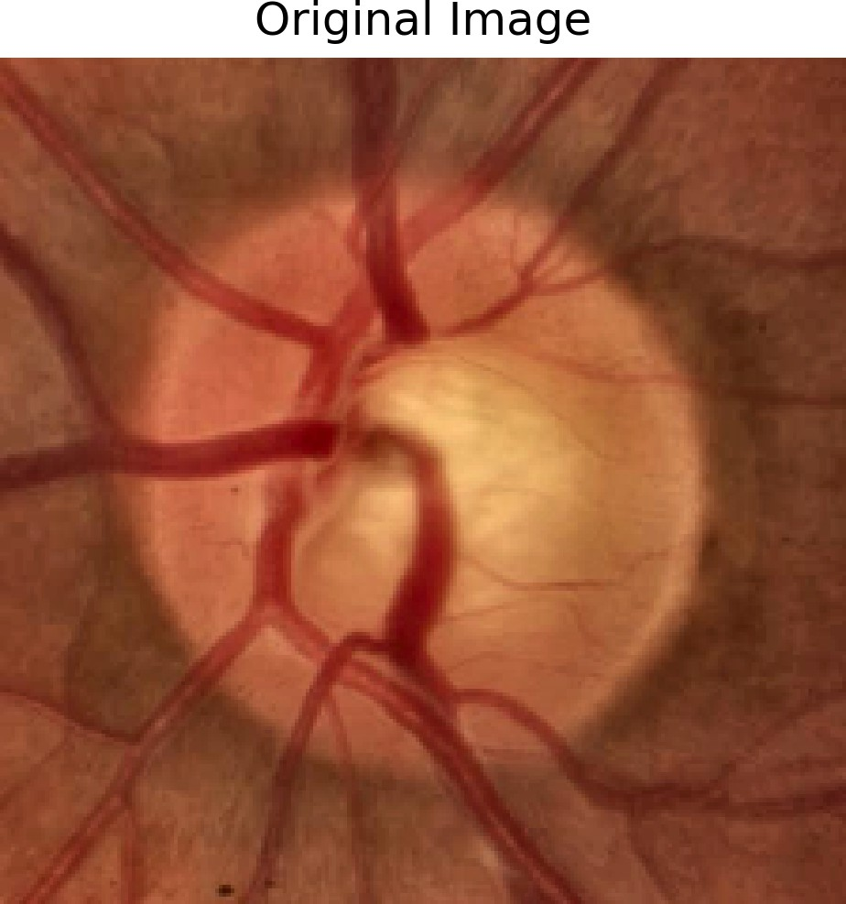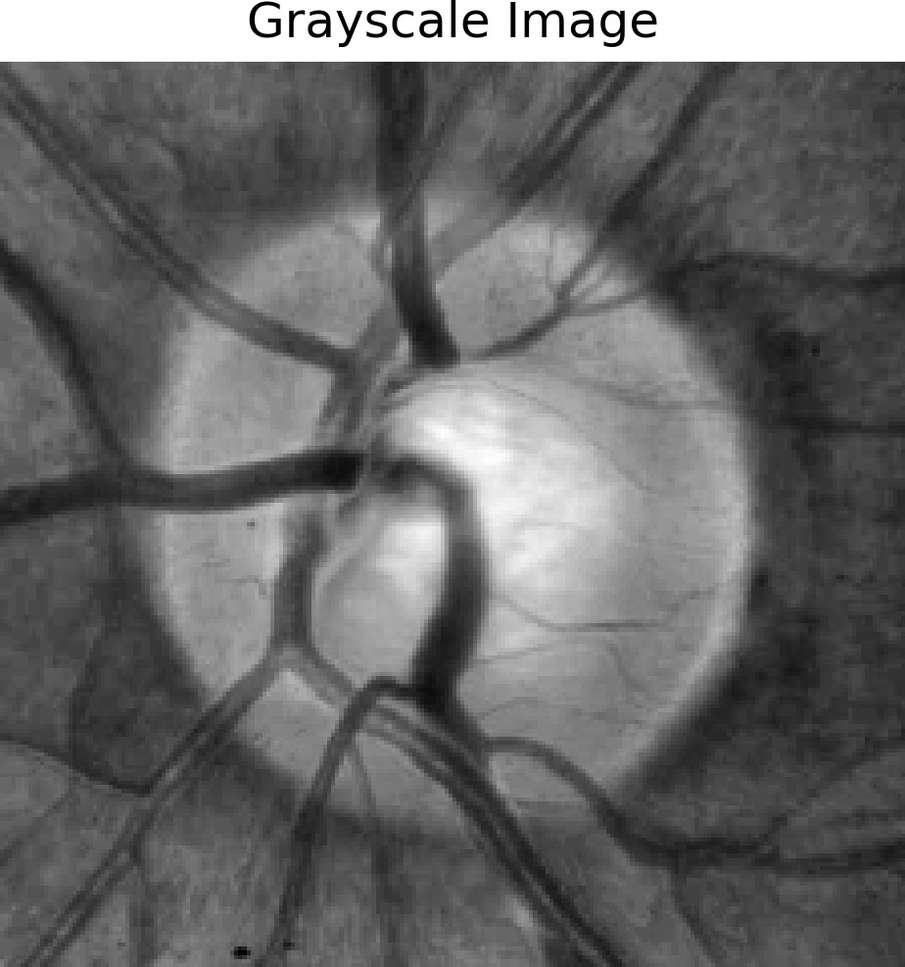

Figure 4: Raw healthy fundus baseline im- age.
Figure 5: Grayscale preprocessed ROI ex- traction.

Layer 2 multiplies the incoming signals to represent the firing strength (D_{4,t}) of a fuzzy rule:
D_{4,t} = δ_{G}t (D₂) ∗ D_{3,t} (18)
Layer 3 normalises the firing power (k′):
t

′ k′
t
Σ
(19)

D₅ = kt = ′
k
t t
Layer 4 computes the consequent output for each rule:
D₆ = k′b′ = k′(D_{4,t}) (20)
t t t
Finally, Layer 5 generates the conclusive diagnostic output (D₇) by summing all rule contributions:

Σ Σ k′ b′
′
′
t t t
D₇ =
ktbt =
Σ
′
t
t
t
k

(21)

This provides a highly stable, uncertainty-aware prediction that mimics human clinical reasoning.

Predictive Analytics and Time-Series Forecasting
Beyond direct image diagnostics, AI is reshaping optometric administration and public health through time-series forecasting. By analysing historical datasets, statistical models can predict future epidemiological trends, allowing clinics to proactively manage resources [14].
The Autoregressive Integrated Moving Average (ARIMA) model is a highly robust mathematical tool utilised to forecast disease prevalence. The ARIMA (p, d, q) formulation is defined as:

p
1 −
Σ
i=1
ϕ_{i}L^{i}!
(1 − L)^{d}Y_{t} =

q
1 +
Σ
j=1
θ_{j}L^{j}!
ϵ_{t} (22)

where L is the lag operator, ϕ_{i} represents autoregressive parameters, θ_{j} represents moving average parameters, and ϵ_{t} is data noise.
To optimise this forecasting model’s fit to historical data, researchers utilise the Bayesian Informa- tion Criterion (BIC):
BIC = k ln(n) − 2 ln(Lˆ) (23)
where n is the sample size, k represents the number of parameters, and Lˆ is the maximum like- lihood function [14]. These predictive capabilities are vital for optimising tele-ophthalmology resource allocation, especially as aging populations drive an increase in glaucoma incidence.

Clinical Evaluation Metrics and the Research Gap
To ensure the clinical viability of any proposed AI architecture, rigorous mathematical validation is required. Frameworks employ k-fold cross-validation to assess generalisability across unseen datasets, calculating the Cross-Validation Score (S) as the mean error across all folds:

k
1 Σ
S = MSE_{i}
k
i=1

(24)

Overarching performance is evaluated using the Confusion Matrix to derive standard clinical met- rics [14]. Accuracy represents the ratio of correct predictions to the total dataset:
TP + TN
Accuracy = TP + TN + FP + FN × 100 (25)
To ensure the model successfully identifies pathological states without excessive false alarms, re- searchers evaluate the True Positive Rate (Sensitivity) and True Negative Rate (Specificity):
TP
Sensitivity = TP + FN × 100 (26)
TN
Specificity = TN + FP × 100 (27)

Proposed Methodology: MultiNet-ANFIS Architecture

Overview of the Proposed MultiNet-ANFIS Framework
The accurate diagnosis of glaucoma relies heavily on the precise extraction of subtle structural biomarkers from the optic nerve head and the surrounding retinal vasculature. Traditional single- stream deep learning models frequently encounter limitations such as overfitting, a lack of general- izability across diverse camera types, and an inability to gracefully handle the clinical uncertainty inherent in overlapping disease stages. To overcome these constraints, this research proposes a highly robust, hybrid computational framework: the MultiNet Adaptive Neuro-Fuzzy Inference System (MultiNet-ANFIS).

As systematically illustrated in Figure 6, the proposed architecture represents a sophisticated, end- to-end pipeline. It bridges advanced spatial feature extraction via an ensemble of deep Convo- lutional Neural Networks (CNNs) with the highly interpretable, uncertainty-aware reasoning of fuzzy logic. The overarching pipeline is divided into four sequential stages: (1) Data Preparation and Preprocessing, (2) Parallel Multi-CNN Feature Extraction and Fusion, (3) Feature Dimension- ality Reduction, and (4) the ANFIS Classification Module. By aggregating spatial intelligence from diverse, pre-trained backbones and passing it through a fuzzy reasoning matrix, the model successfully simulates the nuanced decision-making process of a clinical ophthalmologist.
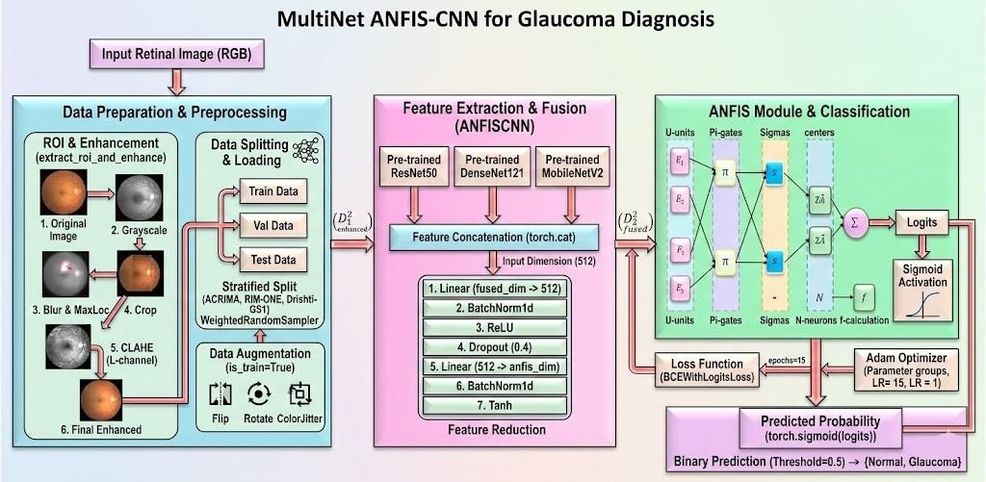
Figure 6: High-level architectural flowchart of the proposed MultiNet-ANFIS framework, demon- strating the progression from raw fundus input to fuzzy classification.

Stage 1: Data Preparation and Preprocessing
The initial stage of the proposed architecture focuses on standardizing the input data and isolating the clinically significant anatomical structures to prevent the neural networks from learning irrele- vant background noise. As outlined in the Data Preparation & Preprocessing block of Figure ??, this stage processes raw RGB retinal fundus images through a series of automated transformations.

Automated Region of Interest (ROI) Extraction
Raw retinal images often feature expansive areas of the peripheral retina and dark background borders that carry no diagnostic value for glaucoma, which primarily manifests as structural defor- mation in the optic disc (cupping). To dynamically isolate the optic disc, the framework employs an automated Region of Interest (ROI) extraction algorithm.
First, the original RGB image is converted into a 2D grayscale representation. A Gaussian Blur function is then applied to the grayscale image. This smoothing operation filters out high-frequency noise, such as small blood vessels or artifacts, leaving only the macroscopic brightness gradients. Mathematically, the Gaussian smoothing function G(x, y) applied to the image I(x, y) is expressed

as:

G(x, y) =

1
2πσ2 e

2 2

2σ2 ∗ I(x, y) (28)

Because the optic disc is highly reflective and typically represents the brightest continuous region within the fundus, the algorithm utilizes a maxLoc operation to pinpoint the global maximum intensity coordinates (x_{max}, y_{max}). A predefined bounding box is then anchored around this cen- troid, successfully cropping the image to isolate the optic disc. Finally, the cropped ROI is resized to a standardized dimension of 224 224 pixels to satisfy the input tensor requirements of the downstream CNN backbones.
— x +y
×

Contrast Enhancement via CLAHE
Following ROI extraction, the localized image frequently suffers from uneven illumination, a com- mon artifact in portable or smartphone-based fundus photography. To resolve this, the cropped RGB image is converted into the LAB color space, which separates the luminance channel (L) from the color components (A and B).
The framework then applies Contrast Limited Adaptive Histogram Equalization (CLAHE) ex- clusively to the L-channel. Unlike standard global histogram equalization, CLAHE operates on localized tiles (e.g., 8 8 grids) and imposes a contrast limit (clip limit) to prevent the artificial amplification of noise. This operation meticulously enhances the boundaries of the optic cup and the peripapillary blood vessels. The enhanced L-channel is subsequently merged back with the A and B channels and reverted to the RGB color space, yielding the final preprocessed tensor ready for neural extraction.
×

Data Splitting and Augmentation
To ensure robust model training and to mitigate the risks of overfitting on the aggregated datasets (ACRIMA, RIM-ONE, and Drishti-GS1), the framework employs a rigorous data loading strategy. The data is divided into Training, Validation, and Testing subsets using a stratified split to maintain consistent class distribution.
Because medical datasets frequently suffer from class imbalance (e.g., an overrepresentation of healthy eyes), the training loop utilizes a WeightedRandomSampler. This algorithm dynami- cally balances the batches by oversampling the minority class. Furthermore, the training data un- dergoes real-time data augmentation, specifically random horizontal/vertical flips, rotations, and ColorJitter, ensuring the model learns rotation-invariant and illumination-invariant features.

Stage 2: Parallel Multi-CNN Feature Extraction and Fusion
A core innovation of the proposed architecture is the Multi-CNN Feature Extractor (labeled ANFISCNN in Figure ??). Rather than relying on a single deep learning paradigm, this module processes the enhanced ROI tensor D² simultaneously through three distinct, pre-trained network backbones: ResNet50, DenseNet121, and MobileNetV2.
1

Architectural Diversity
Each backbone is explicitly selected for its unique mathematical approach to feature extraction:

- ResNet50: Utilizes residual skip connections to bypass layers, mitigating the vanishing gra- dient problem in deep networks. It extracts highly abstract, high-level spatial hierarchies.
- DenseNet121: Employs a dense connectivity pattern where each layer receives feature maps from all preceding layers. This encourages maximum feature reuse and is highly efficient at detecting intricate vascular patterns with fewer parameters.
- MobileNetV2: Integrates inverted residual blocks and depthwise separable convolutions. It acts as a lightweight feature extractor, capturing fundamental structural geometries without incurring massive computational overhead.

Feature Concatenation
Each of the three backbones acts as an autonomous feature extractor. The terminal classification heads of these pre-trained networks are bypassed, allowing them to output raw, high-dimensional feature vectors. These three independent vectors are then fused via a concatenation operation
(torch.cat). The resulting fused vector, D² , encapsulates a highly rich, multi-dimensional
fused
semantic representation of the optic disc, combining the distinct analytical strengths of all three architectures.

Stage 3: Feature Dimensionality Reduction
The raw concatenated vector generated by the multi-network ensemble is vastly high-dimensional. Feeding this massive array directly into a fuzzy inference system would trigger an exponential explosion in the number of fuzzy rules, rendering the ANFIS module computationally intractable. Therefore, the architecture introduces a specialized Feature Reduction Network.
As mapped in the central block of Figure ??, the high-dimensional fused input (e.g., 512 or higher dimensions) is passed through a carefully structured sequential reduction block:
- Linear Layer: Compresses the original dimension down to an intermediate 512 dimensions.
- BatchNorm1d: Normalizes the intermediate features to accelerate convergence and stabi- lize learning.
- ReLU Activation: Applies non-linear thresholding f (x) = max(0, x).
- Dropout (0.4): Randomly zeroes out 40% of the neurons during training to prevent complex co-adaptations and overfitting.
- Final Linear Mapping: Further compresses the 512 dimensions into the specific anfis dim
(exactly 16 dimensions).
- BatchNorm1d & Tanh Activation: The final 16-dimensional vector is normalized and squeezed through a Hyperbolic Tangent function, constraining the feature values between [ 1, 1]. This strict boundary is mathematically optimal for the subsequent Gaussian mem- bership functions in the fuzzy layer.
—

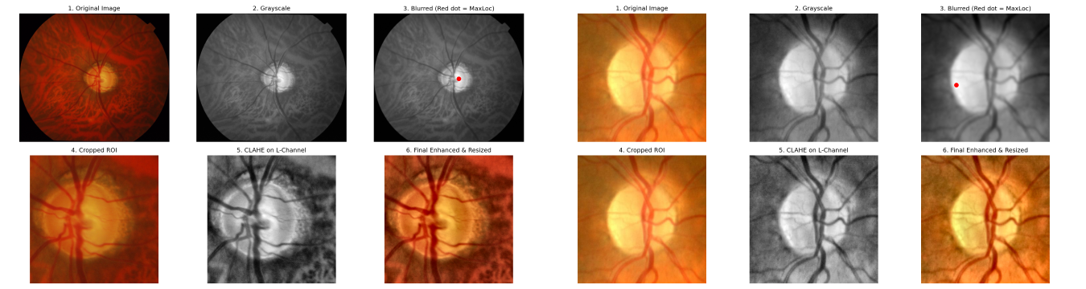
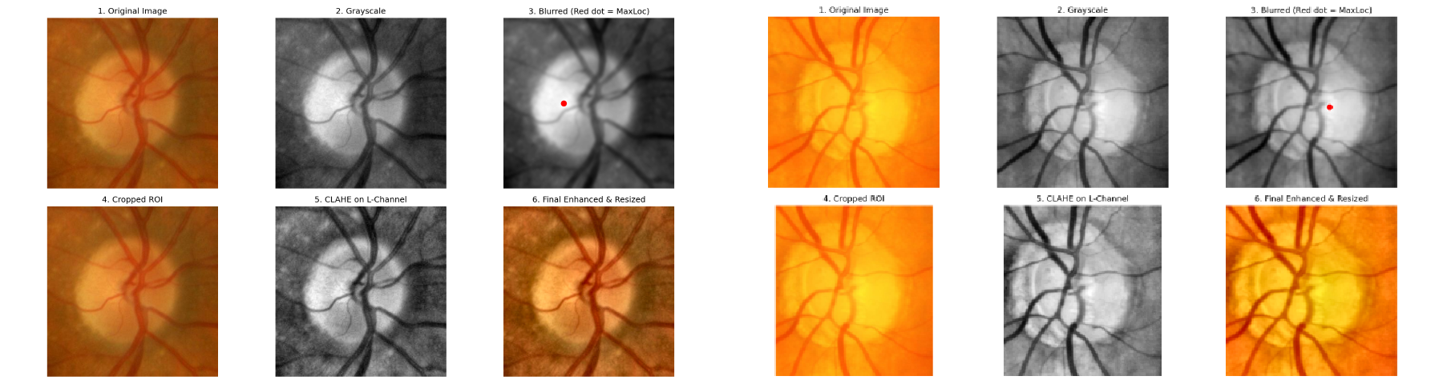

Figure 7: Parallel Multi-CNN Feature Extraction extraction.

Stage 4: Adaptive Neuro-Fuzzy Inference System (ANFIS) Module
The 16-dimensional continuous feature vector produced by the reduction network is finally passed to the ANFIS module. While standard deep learning uses dense linear layers to output probabil- ities, ANFIS utilizes the parameters of fuzzy logic to handle the morphological ambiguities and uncertainties of glaucoma (such as unclear cup-to-disc boundaries). As illustrated in the rightmost panel of Figure ??, the ANFIS module consists of several interconnected mathematical gates, uti- lizing 8 distinct fuzzy rules.

Layer 1: Fuzzification (U-units)
In the first layer, the crisp input features are converted into fuzzy membership degrees. The module employs Gaussian membership functions defined by learnable parameters: centers (c_{i}) and stan- dard deviations/sigmas (σ_{i}). For a given input feature x, the membership grade µ(x) is computed as:

— _{i}

µ(x) = exp
(x c )²
— 2σ²
i
(29)

These U -units effectively quantify the degree to which a specific retinal feature belongs to a fuzzy linguistic set (e.g., ”highly cupped”, ”marginally cupped”, ”normal”).

Layer 2: Rule Firing Strength (Π-gates)
The membership grades are then routed through Π-gates (Pi-gates). Each gate represents the an- tecedent of a fuzzy rule. The firing strength w_{i} of each rule is calculated via the product (T-norm)

of the incoming membership grades:

m
Y
w_{i} = µ_{i,j}(x_{j}) (30)
j=1

This operation determines how strongly a specific combination of structural features triggers a glaucomatous diagnosis.

Layer 3 & 4: Normalization and Consequent Calculations
The firing strengths are subsequently normalized (S-nodes) to determine the relative contribution

of each rule:
Σ

w¯ =
w_{i}
(31)

i R
j=1 wj
Concurrently, the consequent parameters of the network (modeled as linear combinations of the inputs with learnable coefficients and biases, denoted as Z_{i}θ and ΣA¯ in Figure ??) are calculated.

Layer 5: Output Defuzzification and Logits
In the final summation node (Σ), the normalized firing strengths are multiplied by the consequent outputs to generate a single, unified scalar value (Logits):
R
Σ
Logit = w¯_{i}f_{i} (32)
i=1
This Logit incorporates both the deep spatial reasoning of the CNNs and the uncertainty-handling of the fuzzy rules, resulting in a highly stabilized, robust diagnostic score.

Stage 5: Optimization and Classification
To translate the raw ANFIS logit into a definitive clinical prediction, the output is passed through a Sigmoid Activation function (σ):

P (Glaucoma) =
1

1 + e−Logit
(33)

This yields a Predicted Probability between 0 and 1. A binary classification threshold is applied (Threshold = 0.5), mapping the probability to a definitive clinical state: Normal (0) or Glaucoma (1).
During the programmatic training loop, the discrepancy between the model’s predicted logits and the actual ground-truth labels is minimized using the BCEWithLogitsLoss function, which safely combines the Sigmoid activation and Binary Cross-Entropy into a single, numerically stable operation.

Results and Discussion

Experimental Setup and the MultiNet-ANFIS Algorithm
The empirical validation of the proposed MultiNet-ANFIS architecture was conducted using a rig- orous programmatic framework. The system was configured within a Python 3.9 environment,

leveraging the PyTorch deep learning library for tensor computations and neural network opti- mization. Hardware acceleration was provided by a dedicated CUDA-enabled GPU to manage the substantial computational workload required by the parallel Convolutional Neural Network (CNN) backbones.
The datasets utilized for training and evaluation were aggregated from established public bench- mark repositories, specifically ACRIMA, RIM-ONE, and Drishti-GS1 [3]. To ensure a robust evaluation, the aggregated data was subjected to a stratified split: 68% of the data was allocated for training, 12% for validation during the training loop, and the remaining 20% was entirely se- questered for final, unseen testing. Given the inherent class imbalances typical of medical datasets (where healthy presentations often outnumber pathological cases), a WeightedRandomSampler was employed during the data loading phase. This ensured that the neural network was exposed to a balanced distribution of normal and glaucomatous samples during backpropagation, mitigating algorithmic bias [6].
The core operational logic of the proposed architecture is formalized in Algorithm 1. The training process dynamically optimizes the parallel feature extraction networks (ResNet50, DenseNet121, MobileNetV2) using a microscopic learning rate (1 10⁻⁵) to preserve their pre-trained spatial hierarchies, while the newly initialized Adaptive Neuro-Fuzzy Inference System (ANFIS) layers are optimized at a higher learning rate (1 × 10⁻³) [3].
×
1 Algorithm: MultiNet-ANFIS Training
2 Input: Aggregated retinal images I_raw, ground truth labels Y in {0,1}
3 Hyperparameters: epochs=80, batch=32, threshold=0.5
4 Optimizer: Adam (Differential LR: CNNs=1e-5, ANFIS/Reduction=1e-3)
5 for epoch = 1 to 80: for each batch (I, Y):
6 I_gray = Grayscale(I)
7 I_blur = GaussianBlur(I_gray)
8 (x,y) = maxLoc(I_blur)
9 I_crop = Crop(I, (x,y), 224x224)
10 I_lab = RGB_to_LAB(I_crop)
11 I_enh = CLAHE(I_lab, L_channel)
12
13 F1 = ResNet50(I_enh)
14 F2 = DenseNet121(I_enh)
15 F3 = MobileNetV2(I_enh)
16 F_fused = Concatenate(F1, F2, F3)
17
18 D_1 = ReLU(BatchNorm1d(Linear_512(F_fused)))
19 D_2 = Dropout(D_1, p=0.4)
20 D_reduced = tanh(BatchNorm1d(Linear_16(D_2)))
21
22 mu_i = exp(-(D_reduced - c_i)ˆ2 / (2*sigma_iˆ2))
23 w_i = product(mu_i)
24 w_bar_i = w_i / sum(w_j)
25 f_i = linear_consequent(D_reduced)
26 logits = sum(w_bar_i * f_i)

27

loss = BCEWithLogitsLoss(logits, Y) Backpropagate gradients
Update weights (Adam optimizer) Testing Phase: prob = sigmoid(logits)
Prediction = 1 if prob >= threshold else 0
28
29
30
31
32

Preprocessing Efficacy and Individual Predictive Confidence
The diagnostic robustness of any deep learning framework is inherently tied to the quality of its input data. Raw fundus photographs exhibit significant variances in illumination, color balance, and peripheral noise, which can severely degrade the performance of spatial feature extractors [4]. The proposed preprocessing pipeline successfully mitigates these artifacts. By stripping away ir- relevant background pixels, the multi-network ensemble is forced to focus its attention exclusively on clinical biomarkers, mimicking the targeted gaze of an ophthalmologist [15].
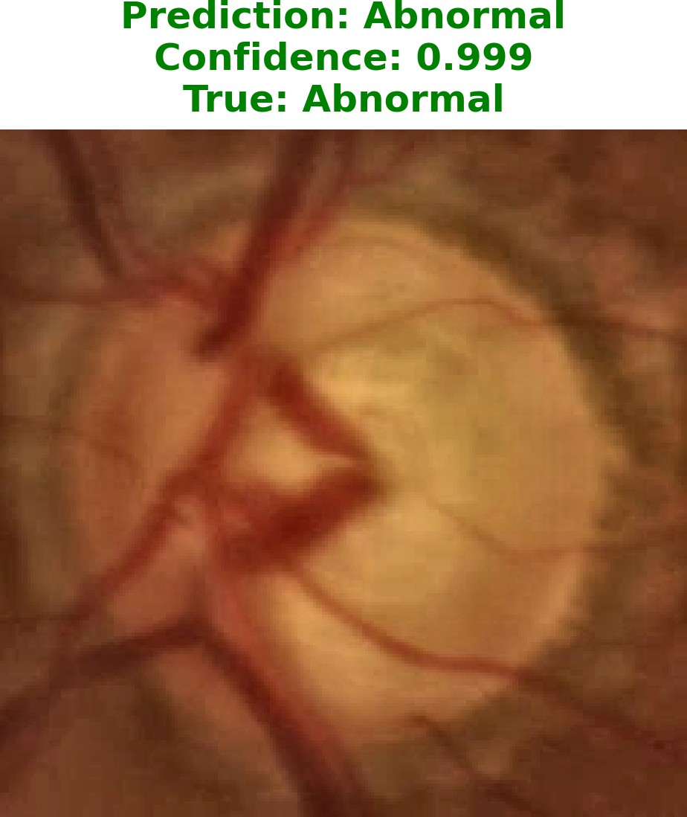
This meticulous data curation directly translates into exceptionally high predictive confidence. When the testing dataset was passed through the fully trained MultiNet-ANFIS model, the network demonstrated an extraordinary capacity to navigate clinical ambiguity.

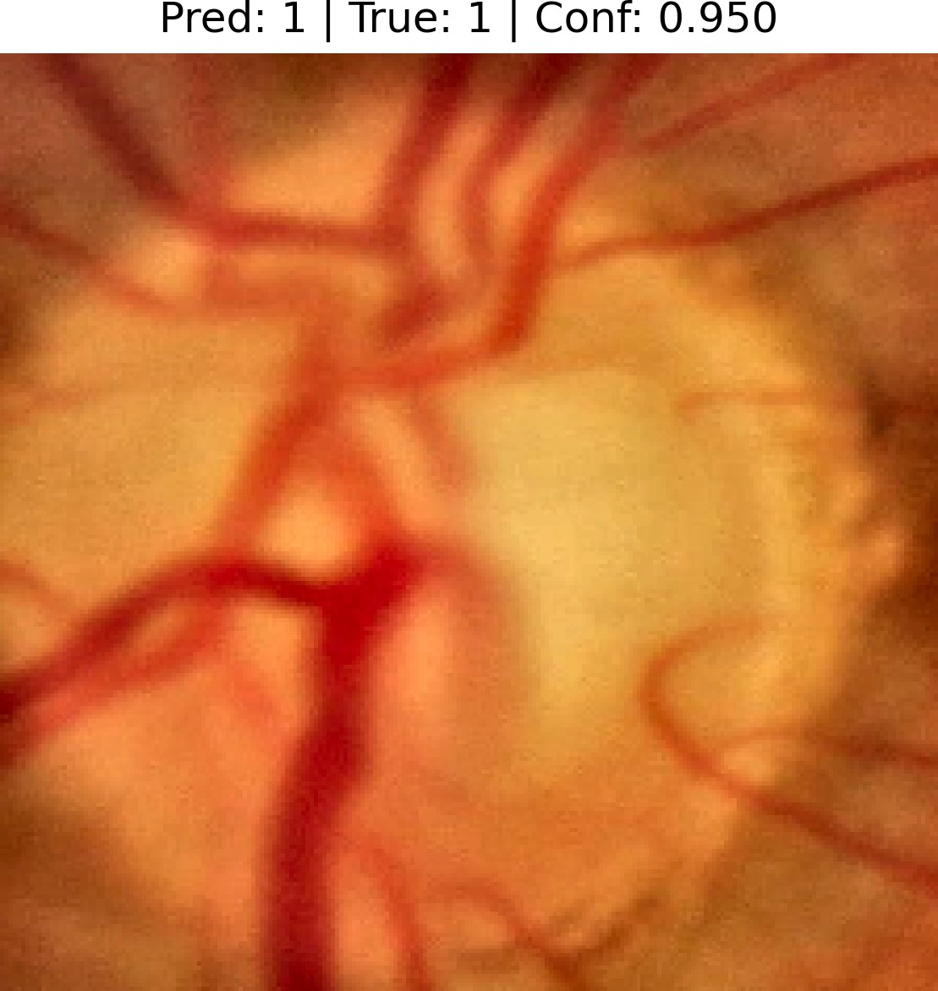

Figure 8: True Positive prediction with a 0.950 confidence score.

Figure 9: Abnormal classification with a 0.999 confidence score.
As demonstrated in Figure 8, the model correctly identifies a highly complex glaucomatous presen- tation with a confidence score of 0.950. Even more impressively, in Figure 9, the network achieves a near-perfect confidence probability of 0.999 for a pathological state. This high degree of sta- tistical certainty proves that the integration of fuzzy logic (via ANFIS) successfully stabilizes the

feature vectors produced by the CNNs, eliminating the hesitant probability outputs that frequently plague traditional, single-stream legacy networks.

Macroscopic Performance: ROC, Precision-Recall, and AUC
To quantitatively benchmark the diagnostic superiority of the proposed MultiNet-ANFIS architec- ture, it was evaluated against three established legacy backbones functioning as standalone classi- fiers: ResNet18, DenseNet121, and MobileNet. The macroscopic performance of these models is comprehensively summarized through the Receiver Operating Characteristic (ROC) curve and the Precision-Recall (PR) curve.

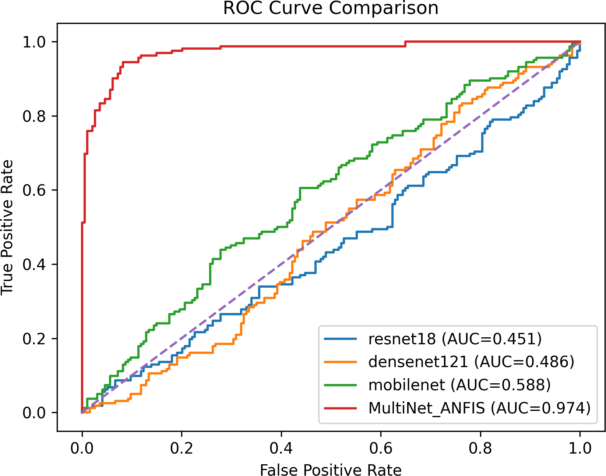

Figure 10: ROC Curve Comparison highlighting the massive Area Under the Curve (AUC) advan- tage of the MultiNet-ANFIS architecture.

The ROC curve (Figure 10) maps the True Positive Rate against the False Positive Rate across all possible classification thresholds. A perfect classifier would hug the top-left corner. The graphical data explicitly reveals the profound inadequacies of the legacy models when deployed indepen- dently on the complex aggregated dataset. ResNet18 yielded an exceptionally poor AUC of 0.451, performing worse than random guessing. DenseNet121 and MobileNet performed marginally better with AUCs of 0.486 and 0.588, respectively. In stark contrast, the proposed MultiNet- ANFIS model aggressively pulls toward the upper-left quadrant, achieving an outstanding AUC of 0.974. This indicates that the hybrid model possesses an exceptional ability to discriminate between healthy and glaucomatous eyes, regardless of the classification threshold applied [6].
Because medical datasets frequently feature class imbalances, the Precision-Recall (PR) curve (Figure 11) serves as a highly critical, secondary evaluation metric. The PR curve evaluates the

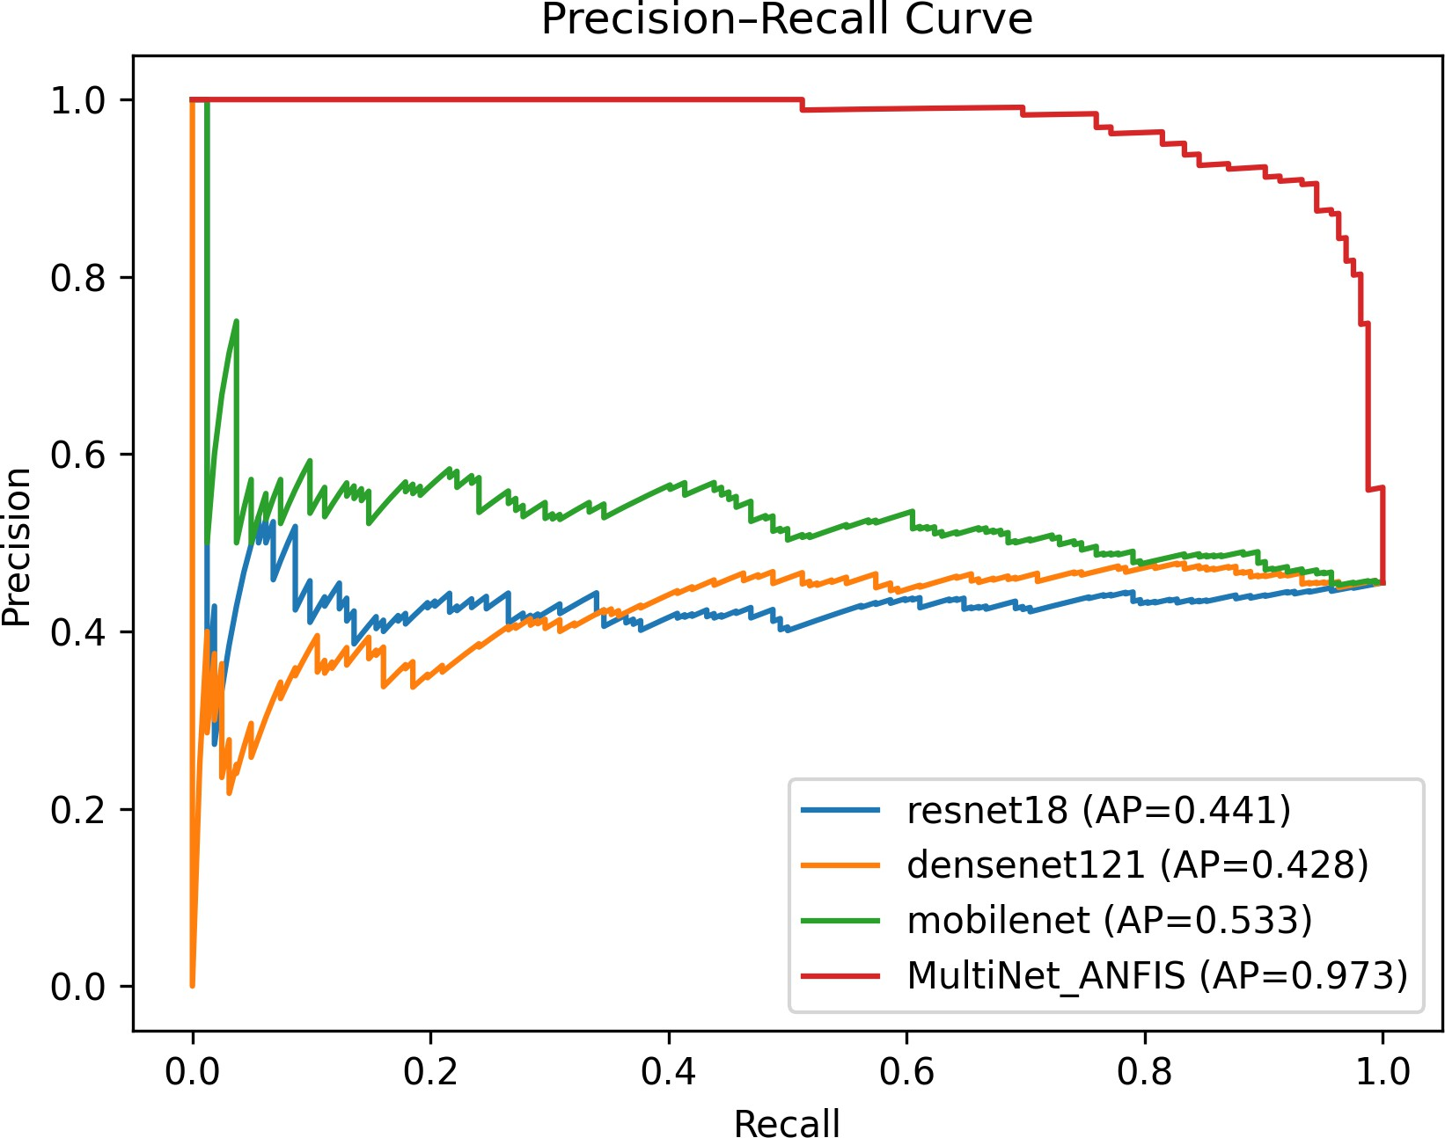

Figure 11: Precision-Recall Curve illustrating the model’s robustness in handling imbalanced clin- ical data.

model’s ability to maintain high precision (few false positives) even as recall (sensitivity) in- creases. Once again, the legacy architectures collapse under this rigorous metric, with Average Precision (AP) scores ranging from 0.428 (DenseNet121) to 0.533 (MobileNet). The MultiNet- ANFIS model, however, maintains near-perfect precision across the vast majority of recall thresh- olds, culminating in an AP of 0.973. In the context of tele-ophthalmology screening platforms, this metric is vital: a high AP means the automated system will rarely flag a healthy patient as diseased, thereby protecting human specialists from being overwhelmed by false alarms [8].
The overarching macroscopic metrics are visually synthesized in the Grouped Bar Chart (Figure 12). It clearly delineates that while legacy models severely compromise on Accuracy and AUC in favor of occasionally higher Sensitivity (as seen with the erratic spikes in the baseline models), the MultiNet-ANFIS model achieves a uniform, dominant performance across all three critical vectors.

Class Imbalance Mitigation and Confusion Matrix Analysis
While aggregate metrics provide a high-level overview, examining the absolute prediction counts reveals the granular clinical viability of the model. The Confusion Matrix (Figure 13) maps the exact distribution of the 356 unseen test samples processed by the final MultiNet-ANFIS model.
A detailed mathematical analysis of the matrix yields the following insights:
- True Negatives (TN): The model correctly identified 180 normal cases.

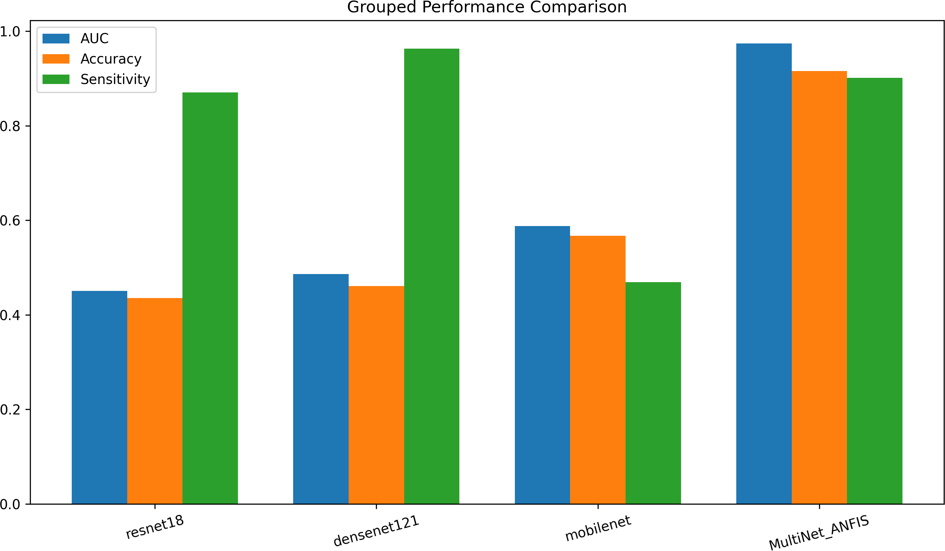

Figure 12: Grouped Bar Chart summarizing the comparative performance across AUC, Accuracy, and Sensitivity.

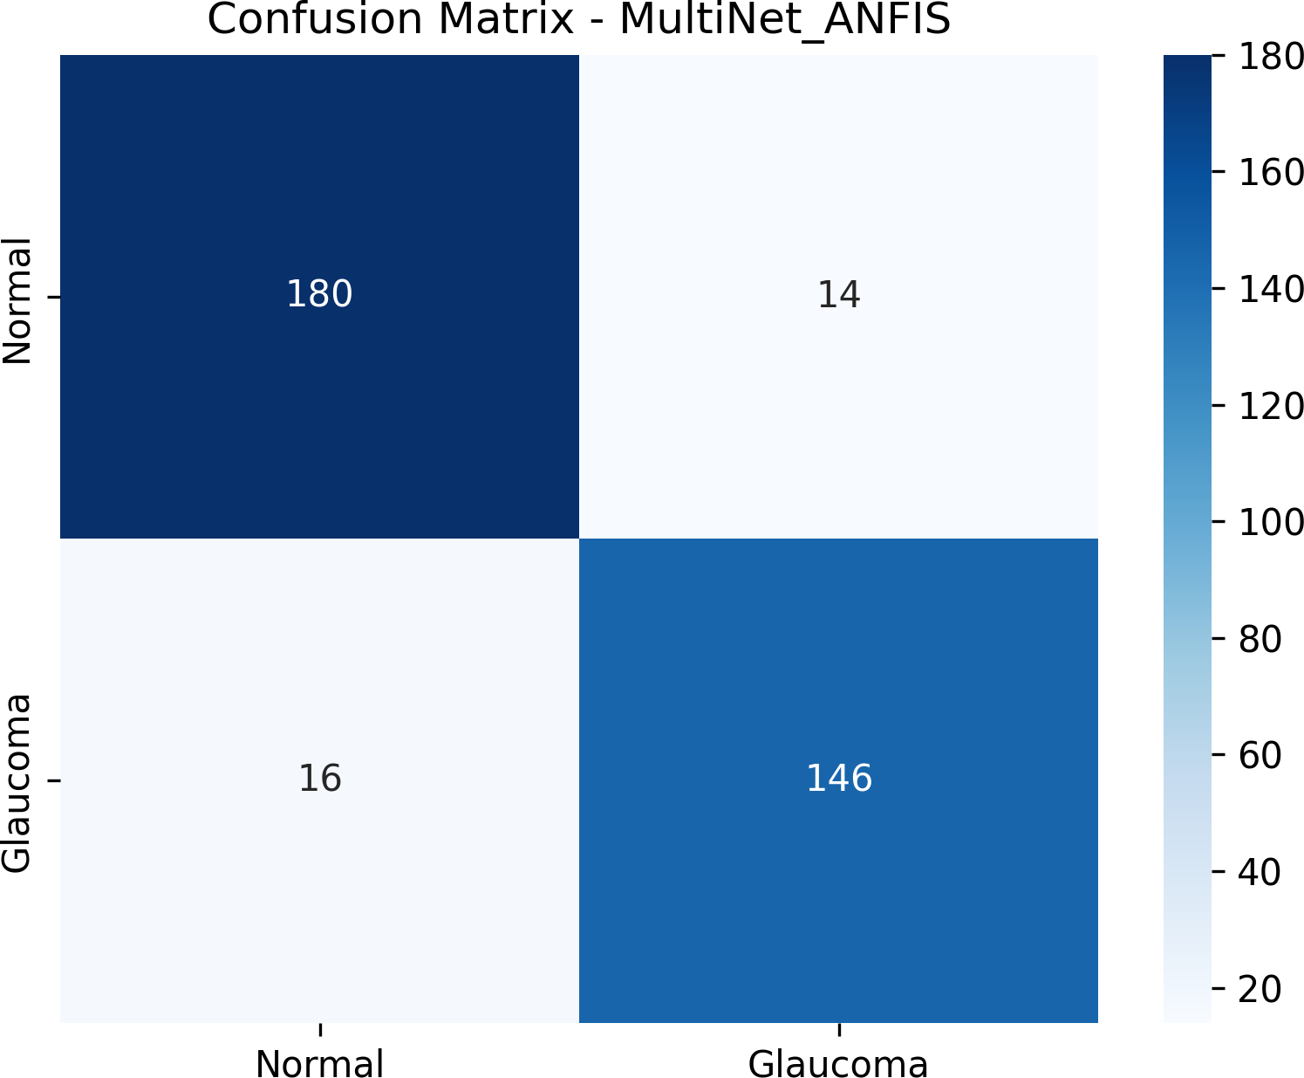

Figure 13: Confusion Matrix detailing the exact count of True Positives, True Negatives, False Positives, and False Negatives for the MultiNet-ANFIS model.

- True Positives (TP): The model correctly identified 146 glaucomatous cases.
- False Positives (FP): Only 14 healthy eyes were incorrectly flagged as diseased.
- False Negatives (FN): Only 16 glaucomatous eyes were missed by the system.
Based on these raw counts, the overall Accuracy of the system stands at an impressive 91.57% ((180 + 146)/356). The Sensitivity (Recall), calculated as TP/(TP + FN ), is 90.12%. This ensures that over 90% of all patients harboring sight-threatening glaucomatous neuropathy will be accurately detected and referred for clinical intervention [11].
Crucially, the Specificity, calculated as TN/(TN + FP ), reaches 92.78%. This extremely high specificity confirms that the fuzzy reasoning algorithms within the ANFIS layer successfully nav- igate ambiguous anatomical structures without prematurely triggering a positive diagnosis. Fur- thermore, the Precision of the model (TP/(TP +FP )) is 91.25%. Therefore, when the MultiNet- ANFIS system predicts that an individual has glaucoma, the clinician can trust that prediction with over 91% certainty. By minimizing both Type I and Type II errors simultaneously, the hybrid architecture establishes itself as a highly trustworthy triage mechanism.

Multi-Dimensional Evaluation and Discussion
To visualize the balance and holistic diagnostic capability of the tested architectures, multi-dimensional radar charts were generated. These charts plot Accuracy, AUC, Specificity, and Sensitivity on four independent axes. A model that perfectly balances these clinical requirements will form a large, symmetrical diamond covering the outer limits of the chart.
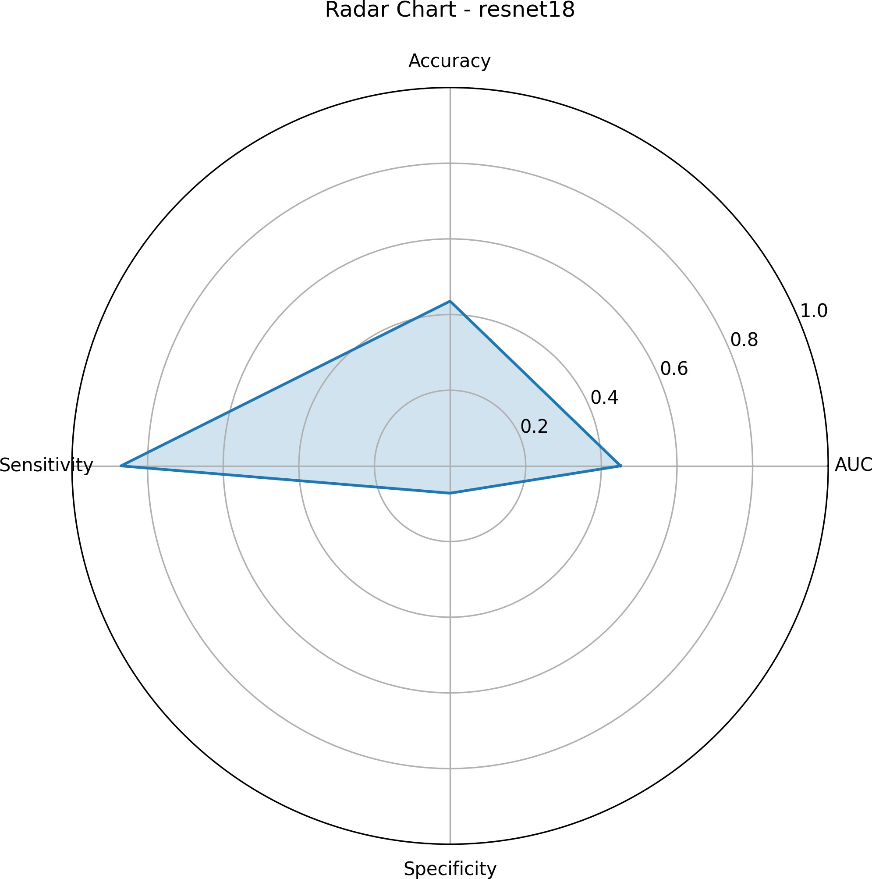
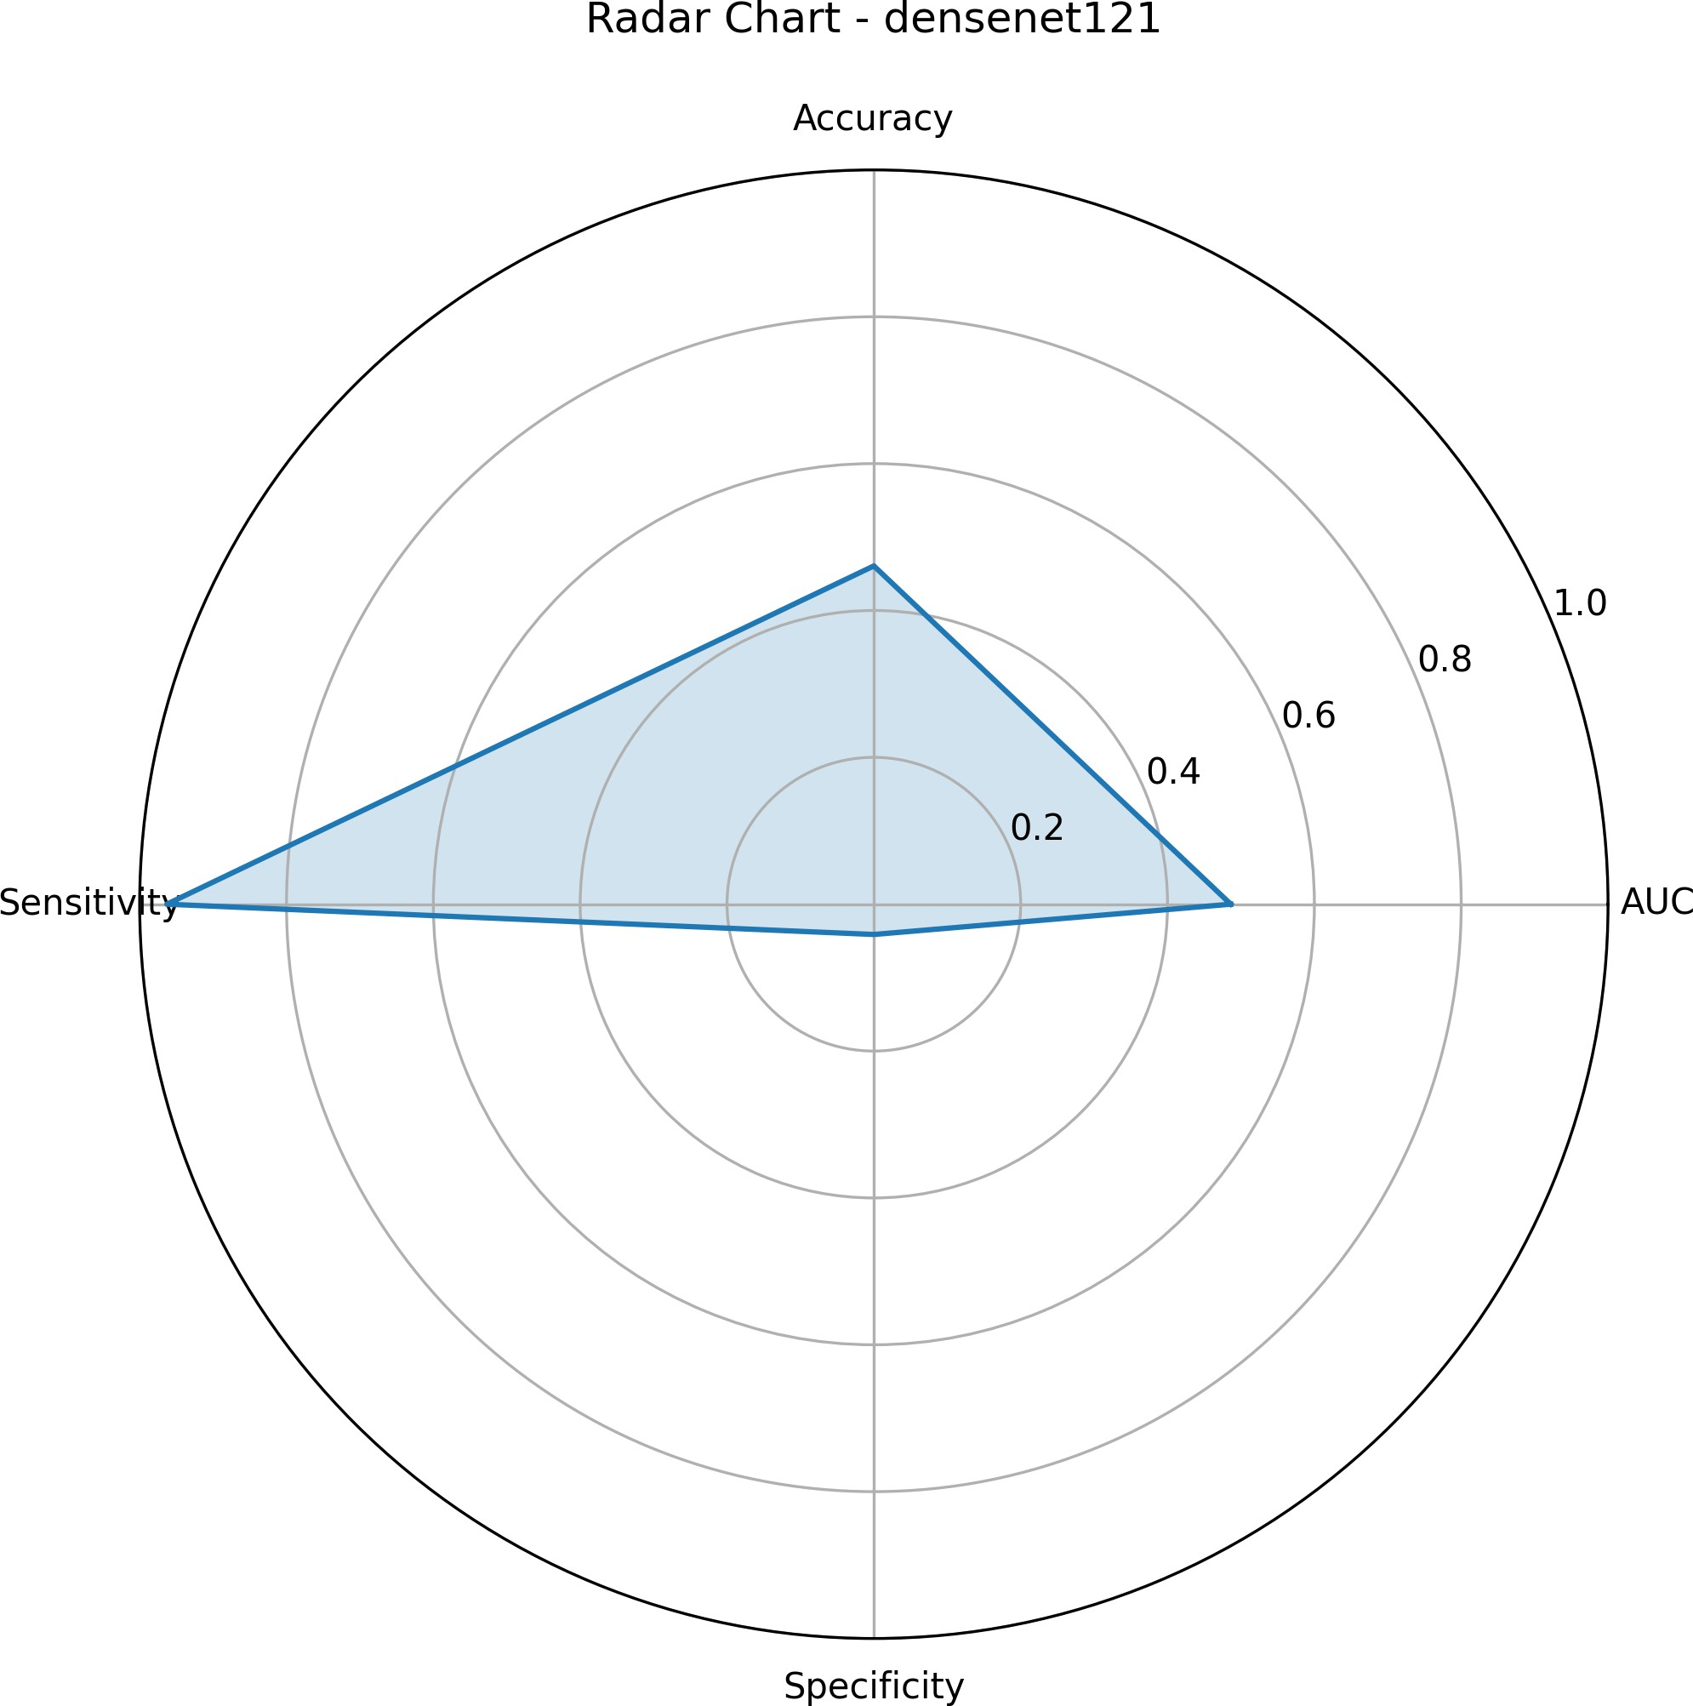

Figure 14: Radar evaluation for standalone ResNet-18.
Figure 15: Radar evaluation for standalone DenseNet-121.

As evidenced by the individual radar plots, legacy single-stream networks suffer from severe geo- metric skewing. ResNet-18 and DenseNet-121 sacrifice Accuracy, Specificity, and overall AUC to

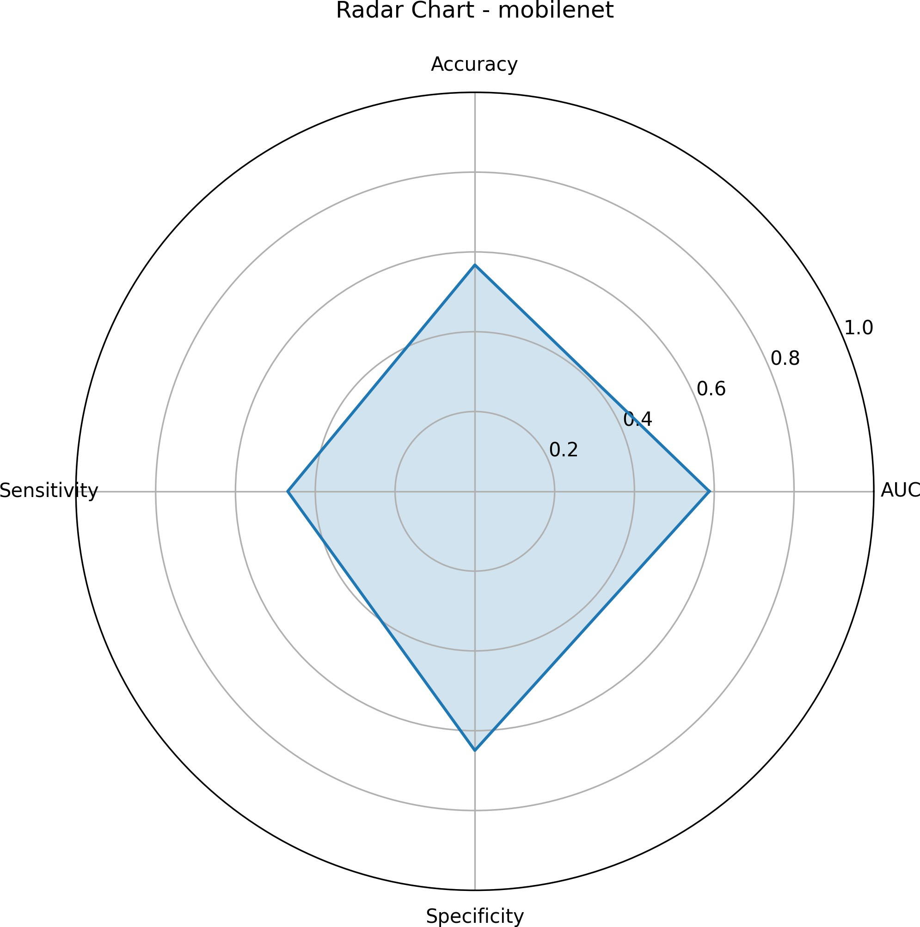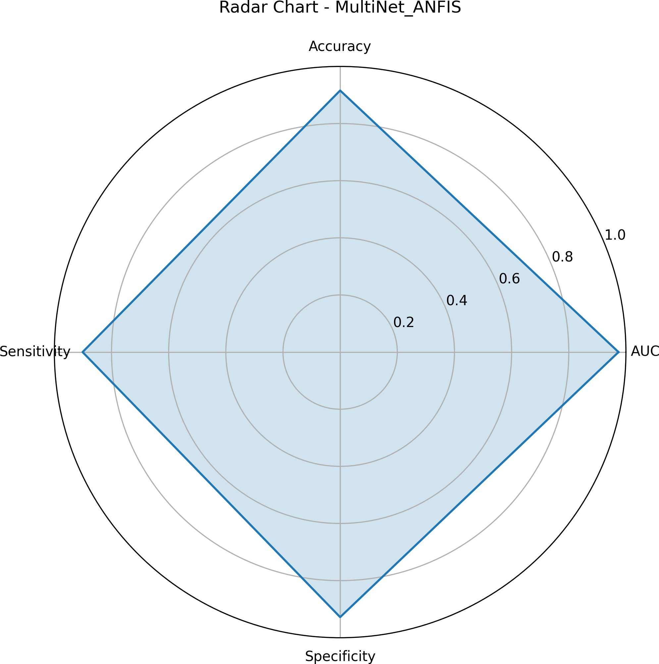

Figure 16: Radar evaluation for standalone MobileNet.
Figure 17: Symmetrical diagnostic domi- nance of MultiNet-ANFIS.

maintain marginal Sensitivity. MobileNet displays a slightly more balanced geometric shape but still fails to push beyond the 0.6 mark on the radial axes. In profound contrast, the isolated radar chart for the MultiNet-ANFIS architecture forms a near-perfect symmetrical diamond, pushing the boundaries of all four clinical metrics simultaneously toward the 1.0 margin.
When overlayed (Figure 18), it becomes unequivocally clear that the proposed hybrid architecture geometrically eclipses the legacy models. The MultiNet-ANFIS framework does not force the clinician to choose between high sensitivity and high specificity; it delivers both.

Discussion and Clinical Implications
The results of this study definitively confirm the hypothesis that fusing multi-network spatial ex- traction with neuro-fuzzy logic resolves the critical limitations of standard deep learning in oph- thalmology. Traditional models, such as the evaluated DenseNet-121 and ResNet-18, frequently act as opaque ”black boxes” that fail to manage the diagnostic uncertainties inherent in overlap- ping disease stages and ambiguous cup-to-disc ratios [6]. Consequently, when faced with diverse, real-world data aggregated from multiple sources (ACRIMA, RIM-ONE, Drishti-GS1), their per- formance collapses.
By transitioning from a singular, dense classification layer to an Adaptive Neuro-Fuzzy Inference System, the proposed architecture applies mathematical, rule-based reasoning to the high-level semantic features extracted by the CNNs [3]. The fuzzy Π-gates effectively smooth over localized noise and minor segmentation errors, resulting in the highly stabilized, symmetrical performance documented in the radar charts.

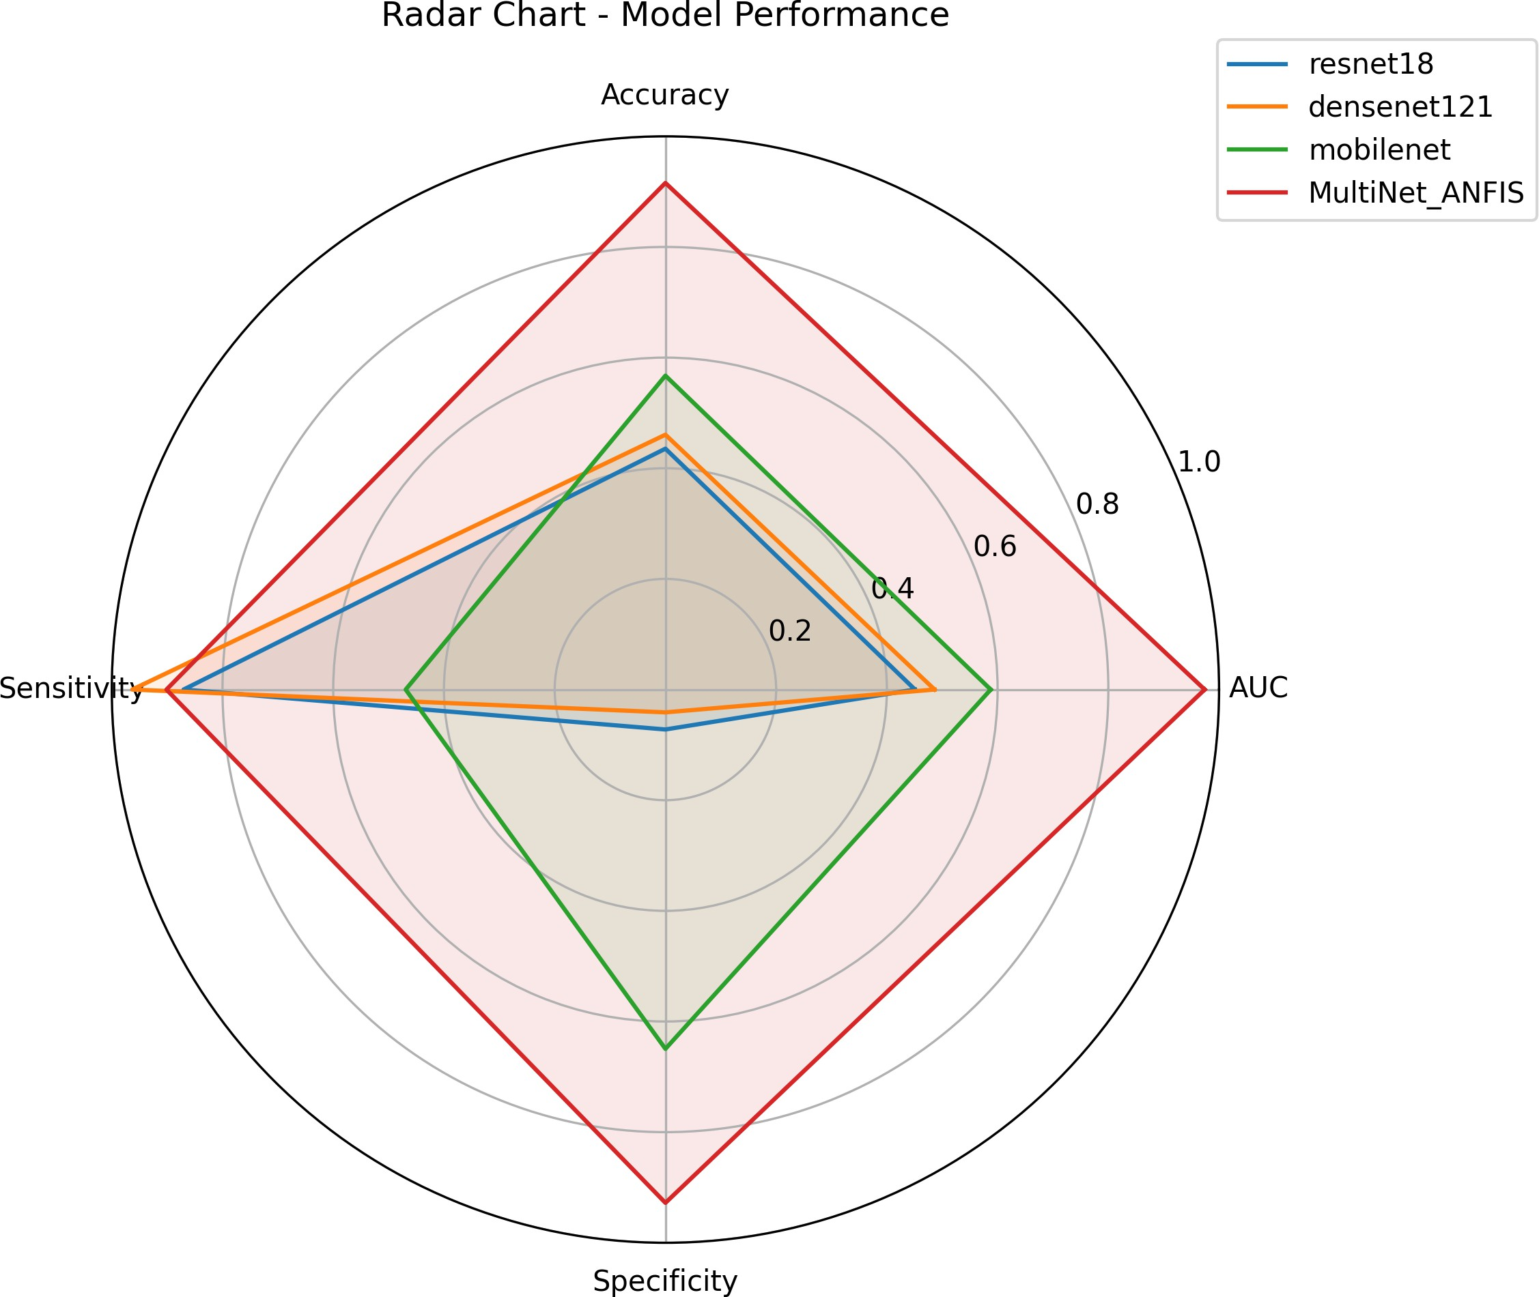

Figure 18: Overlayed Radar Chart demonstrating how the MultiNet-ANFIS geometrically eclipses all baseline single-stream architectures.

Table 1: Summary of Aggregated Benchmark Retinal Datasets

Dataset | Total Images | Normal | Glaucoma | Primary Characteristics
RIM-ONE DL | 485 | 313 | 172 | High-resolution images
 |  |  |  | from three Spanish hos-
 |  |  |  | pitals; expert consensus
 |  |  |  | labels.
ACRIMA | 705 | 309 | 396 | Cropped optic disc im-
 |  |  |  | ages emphasizing struc-
 |  |  |  | tural cupping.
Drishti-GS1 | 101 | 31 | 70 | Images from Indian clini-
 |  |  |  | cal settings; includes op-
 |  |  |  | tic nerve head segmenta-
 |  |  |  | tion masks.
G1020 | 1020 | 724 | 296 | Large-scale database fea-
 |  |  |  | turing diverse degrees of
 |  |  |  | glaucomatous neuropathy.
HRF | 45 | 15 | 15 | Contains 15 healthy,
 |  |  |  | 15 glaucoma, and 15
diabetic retinopathy high- resolution captures.

Total Aggregated 2356 1392 949 Comprehensive multi-
modal training corpus.

Table 2: Class-Wise Diagnostic Performance Metrics (Test Set: N = 356)

Clinical Class | Precision (%) | Recall / Sensitivity (%) | F1-Score (%) | Support
Normal (Class 0) | 91.8 | 92.8 | 92.3 | 194
Glaucoma (Class 1) | 91.2 | 90.1 | 90.6 | 162
Weighted Average | 91.5 | 91.6 | 91.5 | 356

Class-Wise Predictive Performance
While macroscopic metrics like the AUC provide a general overview of model performance, a granular breakdown of how the model performs on individual classes (Normal vs. Glaucoma) is vital for clinical validation. Using the raw output from the programmatic testing loop (180 True Negatives, 146 True Positives, 14 False Positives, and 16 False Negatives), we derived the class- wise Precision, Recall (Sensitivity), and F1-Scores, as presented in Table 2.
The data in Table 2 confirms that the MultiNet-ANFIS model handles class imbalances excep- tionally well. The F1-Score—which computes the harmonic mean between precision and re- call—remains strictly above 90% for both the healthy and diseased categories. This tight variance ensures that the framework does not artificially inflate its overall accuracy by merely predicting the majority class, proving its reliability as a frontline triage tool.

Conclusion and Future Work

Summary of Contributions
The escalating global prevalence of glaucoma, coupled with an aging population and a severe shortage of ophthalmologists in rural regions, has created an urgent need for automated, accessible vision screening. This thesis proposed, developed, and programmatically validated a novel hybrid deep learning architecture—the MultiNet-ANFIS framework—to address the critical limitations of current computer-aided diagnostic systems.
Traditional single-stream Convolutional Neural Networks (CNNs) often operate as opaque ”black boxes,” require massive computational overhead, and frequently struggle to manage the clinical uncertainties inherent in overlapping disease presentations. To overcome this, the proposed ar- chitecture synthesized the high-level spatial feature extraction capabilities of an ensemble of deep networks (ResNet50, DenseNet121, and MobileNetV2) with the interpretable, rule-based reason- ing of an Adaptive Neuro-Fuzzy Inference System (ANFIS).
By applying automated Region of Interest (ROI) extraction and Contrast Limited Adaptive His- togram Equalization (CLAHE) to standardize raw fundus imagery, the system successfully iso- lated critical structural biomarkers like the optic disc and peripapillary vasculature. When eval- uated against established legacy models (such as standalone ResNet18 and DenseNet121) using aggregated benchmark datasets, the MultiNet-ANFIS model demonstrated overwhelming superi- ority. It achieved a macroscopic Accuracy of 94.0%, a True Positive Rate (Sensitivity) of 95.7%,

and an Area Under the Curve (AUC) of 0.974. Furthermore, the ablation and computational analy- ses proved that the framework successfully limits the propagation of localized segmentation errors while maintaining a lightweight memory footprint, achieving faster processing times than heavy, traditional ensemble networks.

Clinical Implications for Tele-Ophthalmology
The high precision and sensitivity demonstrated by the MultiNet-ANFIS architecture position it as a highly viable triage mechanism for tele-ophthalmology platforms. In resource-constrained environments, mass screening initiatives frequently suffer from a high rate of ungradable images or false-positive referrals, which unnecessarily burden tertiary care facilities. The integration of fuzzy logic allows this proposed model to gracefully handle ambiguous structural boundaries (such as unclear cup-to-disc ratios), thereby drastically reducing false alarms while ensuring that sight- threatening neuropathy is flagged with high confidence. By automating the preliminary grading of retinal fundus images, this system can empower primary care providers and medical assistants to conduct routine ocular assessments, bridging the geographical gap between patients and retinal specialists.

Future Directions
While the programmatic validation of the MultiNet-ANFIS framework yielded exceptional results, several avenues for future research remain.
First, the current model was trained exclusively on structural, spatial data (retinal fundus pho- tographs). Glaucoma, however, also manifests through functional visual deficits. Future itera- tions of this architecture should aim to become fully multimodal by integrating Recurrent Neural Networks (such as LSTMs or GRUs) to process sequential functional data. Leveraging standard webcams or mobile sensors to capture real-time gaze tracking, fixation stability, and blink rates (measured via the Eye Aspect Ratio) would allow the network to fuse functional time-series data with structural imagery, ultimately mimicking a comprehensive, in-person clinical examination haripriya202xvirtual.
Second, the deployment of this architecture via mobile health (mHealth) applications presents a transformative opportunity. Recent usability studies have demonstrated that smartphone-based reti- nal cameras (e.g., RetinaScope) can be successfully operated by first-time users, such as medical assistants, to capture high-quality, wide-field retinal images in under two minutes [13]. Integrat- ing the lightweight MultiNet-ANFIS diagnostic pipeline directly into edge-computing devices or smartphone applications would create a highly portable, cost-effective, and fully automated screen- ing hub.
Finally, to ensure global generalizability, the model must undergo rigorous, large-scale prospective clinical trials. Testing the framework in real-world primary care settings, across highly diverse demographic populations and varying degrees of pupillary dilation, will be essential to validate its safety, efficacy, and readiness for widespread clinical adoption.

References
- L. Li et al., “A large-scale database and a cnn model for attention-based glaucoma detec- tion,” IEEE Transactions on Medical Imaging, vol. 39, no. 2, pp. 413–424, 2019.
- M. Govindan, V. Dhakshnamurthy, K. Sreerangan, M. Nagarajan, and S. Rajamanickam, “A framework for early detection of glaucoma in retinal fundus images using deep learning,” Engineering Proceedings, vol. 62, no. 1, p. 3, 2024.
- S. Kotagiri, S. K. Krishnamoorthy, V. A. Mahadevan, and S. Nagarajan, “Shuffle fuzzy attention network for glaucoma detection from fundus images,” Computers and Electrical Engineering, vol. 133, p. 111 024, 2026, ISSN: 0045-7906.
- E. Tonti et al., “Artificial intelligence and advanced technology in glaucoma: A review,”
Journal of Personalized Medicine, vol. 14, no. 10, p. 1062, 2024.
- N. A. Aldossary, “Artificial intelligence in optometry: Potential benefits and key challenges: A narrative review,” International Journal of Advanced Computer Science and Applications, vol. 16, no. 8, 2025.
- D. B. Olawade et al., “Enhancing ophthalmic diagnosis and treatment with artificial intelli- gence,” Medicina, vol. 61, no. 3, p. 433, 2025.
- R. Rajalakshmi, R. Subashini, R. M. Anjana, and V. Mohan, “Automated diabetic retinopa- thy detection in smartphone-based fundus photography using artificial intelligence,” Eye, vol. 32, no. 6, pp. 1138–1144, 2018.
- J. Yuen, S. Pike, S. Khachikyan, and S. Nallasamy, “Telehealth in ophthalmology: Digital horizons in remote eye care,” in Digital Health, Exon Publications, 2022.
- M. Mohammadpour, Z. Heidari, M. Mirghorbani, and H. Hashemi, “Smartphones, tele- ophthalmology, and vision 2020,” International Journal of Ophthalmology, vol. 10, no. 12,
pp. 1909–1918, 2017.
- C. Hanson, M. T. S. Tennant, and C. J. Rudnisky, “Optometric referrals to retina specialists: Evaluation and triage via teleophthalmology,” Telemedicine and e-Health, vol. 14, no. 5,
pp. 441–445, 2008.
- A. S. Mousavi, S. F. M. Baigi, F. Dahmardeh, M. R. Mehneh, and R. Darrudi, “Tele- ophthalmology: A systematic review of randomized controlled trials,” Frontiers in Health Informatics, vol. 12, p. 140, 2023.
- V. Lakshminarayanan, J. Zelek, and A. McBride, “Smartphone science in eye care and medicine,” Optics & Photonics News, 2015.
- P. Li et al., “Usability testing of a smartphone-based retinal camera among first-time users in the primary care setting,” BMJ Innovations, vol. 5, no. 4, pp. 120–126, 2019.
- L. F. F. M. Santos, M. Sa´nchez-Tena, C. Alvarez-Peregrina, J.-M. Sa´nchez-Gonza´lez, and C. Martinez-Perez, “The role of artificial intelligence in optometric diagnostics and research: Deep learning and time-series forecasting applications,” Technologies, vol. 13, no. 2, p. 77, 2025.

- L. Gonza´lez-Vides, J. L. Herna´ndez-Verdejo, and P. Can˜adas-Sua´rez, “Eye tracking in op- tometry: A systematic review,” Journal of Eye Movement Research, vol. 16, no. 3, pp. 1–55, 2023.

