Bioaccumulation Factors (BAF) for Heavy Metals in Fresh Fish, Water and Sediment of Some Aquatic Habitat in Sokoto State, Nigeria
ABSTRACT
This study was conducted to determine and compare the Bioaccumulation Factors (BAF) for Heavy Metals in Fresh Fish, Water and Sediment of Some water bodies in Sokoto State, heavy metals contents of all the samples were found by atomic absorption spectrometry (AAS), Clarias gariepinus consistently exhibited the highest median BAFs for cadmium (Cd) and zinc (Zn), followed by Oreochromis niloticus, while Bagrus bayad showed the lowest accumulation for these metals. The elevated BAFs for Cd—particularly in C. gariepinus—are ecologically and toxicologically significant. The baseline assessment of heavy metal contamination across four aquatic systems in Sokoto State,—Wurno River, Rima River, Romo Lake, and Shagari Dam—revealed distinct spatial and matrix-specific pollution profiles, with Shagari Dam emerging as a hotspot for Zn (0.387 mg/kg) and Mn (0.336 mg/kg) in sediment, while Rima River showed elevated levels of Cu (0.198 mg/kg) and Cd (0.070 mg/kg). Temporal analysis of Zn in water revealed pronounced seasonal fluctuations, particularly at Wurno River and Romo Lake, where concentrations peaked during months March, April, and October, potentially linked to agricultural runoff or industrial discharge cycles (Figure 2) and The high Mn concentrations in water, particularly at Wurno River and Romo Lake (exceeding WHO guidelines of 0.05–0.1 mg/L). Therefore, monitoring and managing these potential pollution sources is crucial to protecting the lake's ecosystem and the health of the local population. The concentrations observed in the fish, particularly in B. bayad, are a clear indication that the dam's ecosystem is under stress from these pollutants.

Introduction
Heavy metals are elements with specific gravity greater than 5.0mg and are metals which can be toxic in small concentrations (Nevel et al., 2014; Van Nevel et al., 2014). Metals are non-biodegradable and are considered as major environmental pollutants causing cytotoxic, mutagenic, and carcinogenic effects in animals (Kamaruzzaman et al., 2010). Heavy metals such as copper (Cu) and Zinc (Zn) are essential for fish metabolism while some others such as Lead (P) and Cadmium have no known role in biological system, However, in high concentration, these metals tend to accumulate in fish body and later form threat to human health through food chain.
Metals are introduced into the aquatic system through several modes that include weathering of rocks and soils, dissolution of aerosol particles in the atmosphere and through industrial activities such as mining, canning, and electroplating which produce metal-rich effluents (Lippmann et al., 2006), With increased diversification in industrialization and extensive use of metal-based fertilizer in Nigeria, the concentration of heavy metal pollutants would continue to rise through natural run-off.
Many of the chemical components found in seafood are necessary for human existence in small amounts but can be hazardous in large amounts. Other compounds like lead (Pb), cadmium (Cd), and mercury (Hg) can be dangerous even in small doses if consumed over an extended period (Tina van de et al., 2012), Because of this, many customers view the presence of these substances in fish as a health risk (Oehlenschleager, 2002; United, 1948), In aquatic ecosystems, trace metals are often released in a variety of ways, and the accumulation of these metals depends on the metal's concentration and the length of exposure ((Barrett et al., 2006);
Additionally, freshwater fish that reside in contaminated lakes bioaccumulate Hg. Humans who eat mercury-contaminated seafood may become sick. High doses of mercury can lead to cerebral palsy in children, and cadmium can have an impact on male reproductive health, one of the main sources of inorganic mercury pollution is dental amalgam fillings, exposure to cadmium (Cd) can result from the production of semi-conductors, metal plating, ceramic plating, shellfish, and contaminated water (Dionne et al., 2018). Age of fish, lipid content in the tissue and mode of feeding are significant factors that affect the accumulation of heavy metals in fishes, they are finally transferred to other animals including humans through the food chain (Dionne et al., 2018). Revealed that high concentrations of heavy metals such as Cd, Pb, Cu, Ni, Zn, Mn, Mg and Co in some rivers within the proximity of some industrial cities in Nigeria, ((Ingvar, 2015)

MATERIALS AND METHODS
Experimental Site
The research was conducted in Fish Processing Unit, Department of Fisheries and Aquaculture, Usmanu Danfodiyo University Sokoto, Main Campus, Sokoto State, Nigeria. Sokoto state is in the Sudan savannah zone in the extreme Northwestern part of Nigeria, between Longitudes 300’34.49’’N 1303’25’’ and Latitude 50013’,39.44’’E, at altitude of 290.169m above sea level shown in (figure1), It shared common border with Niger Republic to the North, Kebbi State to the Southwest and Zamfara State to the East (Ayoola et al., 2000).

Experimental Fish
A total of 144 fish samples from three fish species ( Oreochromis niloticus, Clarias gariepinus and Bagrus bayad) were sampled from wild (Shagari earth dam, river rima, Wurno river and Romo lake), The representative from the three most common fish family: Chichlidae Clariidae and Bagridae of fresh samples were bought directly from the anglers at their respective villages
Collection of Fish Samples
Fish samples were collected every two weeks for a period of twelve (12) months from Jully 2023 to June 2024 at the designated landing site of the water body. The samples were then immediately transported to the Agric Chemical Laboratory at the Faculty of Agriculture Usmanu Danfodiyo University Sokoto for collection and digestion of fish tissues thereafter the samples were taken to Central Laboratory at the Department of applied and petroleum Chemistry, Usmanu Danfodiyo University Sokoto for heavy metals determination. The fish samples stored in a cooler packed with ice block to maintain the freshness and later transported (1. hour) to the laboratory for dissection of the organs after removing the scales where necessary, washing the fish samples with distilled water and then allowing them to drain in desiccators before dissection. The skin, muscle, and liber of the fresh samples each species collected were pooled and milled with a mortar and pestle. fish samples were taken to the laboratory for the analysis of heavy metals, this involved digesting 10 g portion of the ground samples with 10mL HNO3 and 2 mL HClO4 were heated on a hot plate for one hour. After complete digestion, the residue was dissolved and diluted with 0.2%v/v HNO3 to 20mL. Digest was stored in pre-cleaned polyethylene bottles until analysis using atomic absorption spectrophotometer (Unicam 969, Analytical Technology Inc., Cambridge, United Kingdom) using a procedure described by (Abubakar et al., 2014; Abubakar et al., 2019).
Collections of Water and Sediment Samples
The water samples were collected from the sample stations which spanned about 5Km. Three sampling points were used; one in the upper stream, another in lower stream of the dam and out site the damming region from Shagari Dam, while in tarana water body of barayar zaki wurno local government area, three stations were also used; and River Rima also were distributed into three stations as water board lending site, kwalkwalawa bridged and behind Sokoto cement company. In each of the sampling points the water and sediment samples were collected at the banks and the middle of the lake (across the lake profile) and sediment were collected with the help of argman grab sampler. And samples mixed in a pre-washed 300ml plastic sample bottle (Malsiu et al., 2020). The samples were treated immediately on site with Nitric acid (HNO3) at PH of 2 to preserve them before laboratory analysis. The samples were collected by dipping the plastic bottle into the water and collecting the surface water. Heavy elements are known to be more concentrated in sediments and aquatic animals (Veyrand et al., 2013). However, the need to assess the actual concentration level of these heavy elements that are directly used by river rine settlements necessitated the choice of surface water for the study. The samples were collected for a period of 12 months, bimonthly from Jully, 2023 to june, 2024 (Musa & Ogbe, 2025).
Samples analysis
To analyze the samples, 100ml of the digest in each sample was run one after the other on the UNICAM 969 Atomic Absorption Spectrophotometer (AAS) which uses air acetylene flame By choosing the correct wavelength of the various elements and running a known standard curve of the various elements, the absorbance values of the chemical elements present in the samples were determined (McCleary et al., 2013).
Statistical analysis: Data was presented as mean and standard deviation. Mean was subject to two way analysis of variance (ANOVA) using 9.0 statistical packages for the social sciences (SPSS) version 27 to ascertain significant differences at 5% level of probability using Multivariate analysis via Principal Component Analysis (PCA), Significant mean were subject to Tukey’s HSD test for mean separation (Jolliffe & Cadima, 2016).

RESULTS AND DISCUSSION
RESULTS
Bioaccumulation and Processing Impact on Contaminants
Bioaccumulation Factors (BAF) for Heavy Metals in Fresh Fish
Bioaccumulation factors (BAFs), calculated as the ratio of metal concentration in fish tissue to that in ambient water, varied across species and metals. Clarias gariepinus consistently exhibited the highest median BAFs for cadmium (Cd) and zinc (Zn), followed by Oreochromis niloticus, while Bagrus bayad showed the lowest accumulation for these metals. For copper (Cu), B. bayad displayed slightly higher BAFs than the other two species, whereas chromium (Cr) showed uniformly low BAFs (<0.5) across all species, with O. niloticus accumulating the least. The interquartile ranges (IQRs) were notably wide for Cd and Zn in C. gariepinus, indicating high variability in accumulation across stations and months. Median BAF values for Cd approached or exceeded 1.0 in all species, suggesting efficient uptake from the aquatic environment even when water concentrations were low.
Table 1: Statistical Comparison of BAFs Across Species.
Metal | Kruskal-Wallis | p-value | Method | Significance
Cd | 12.2895 | 0.002 | Kruskal-Wallis rank sum test | **
Cr | 10.2734 | 0.006 | " | **
Cu | 9.85517 | 0.007 | " | **
Zn | 26.6637 | 0 | " | ***

The elevated BAFs for Cd—particularly in C. gariepinus—are ecologically and toxicologically significant. Cadmium is a non-essential, highly toxic metal with no known biological function, and its efficient bioaccumulation implies a high risk of trophic transfer and potential human health hazards through fish consumption. The fact that BAFs neared unity suggests that Cd is readily absorbed via gills or diet and poorly excreted, consistent with its known biochemistry in teleost fish.
The species-specific differences in metal accumulation likely reflect ecological and physiological traits. C. gariepinus, a benthic omnivore, may be exposed to higher metal loads through sediment ingestion and consumption of contaminated invertebrates, even though BAFs were calculated using water concentrations. In contrast, O. niloticus, a pelagic omnivore, may experience lower exposure to particle-bound metals, which aligns with its lower Zn and Cr BAFs. The relatively higher Cu BAF in B. bayad could indicate species-specific metallothionein expression or dietary preferences that increase Cu intake.
The low BAFs for Cr across all species suggest limited bioavailability of chromium in the water column—likely because Cr exists predominantly as Cr (III), which forms insoluble hydroxides, or because fish efficiently regulate or excrete this metal. This is consistent with literature showing Cr to be less bio accumulative than Cd or Zn in freshwater systems.
From a regulatory standpoint, the high Cd BAFs—even in fish from sites with seemingly low water contamination—underscore the inadequacy of water-quality standards alone for protecting consumers. Risk assessments should incorporate species-specific BAFs and tissue-based monitoring, especially for C. gariepinus, which emerges as a sentinel species for Cd and Zn pollution in these water bodies. Long-term monitoring is warranted given the observed temporal variability, which may be driven by seasonal hydrology, agricultural runoff, or industrial discharges.

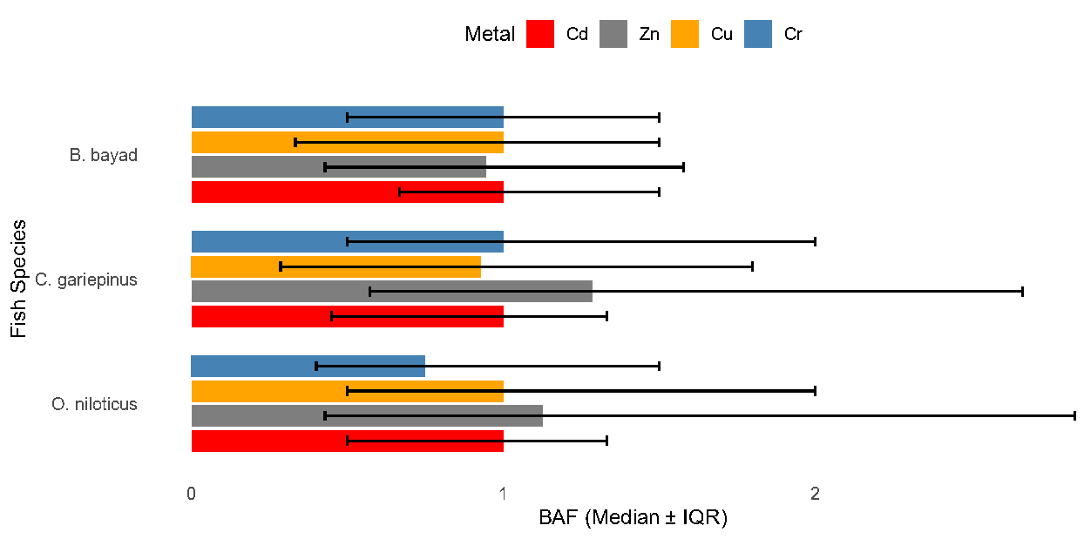
Figure 1: Bioaccumulation Factors (BAF) by Species and Metal. BAF = [Metal] in fish / [Metal] in water. Error bars: Interquartile Range (IQR).

Table 2: Mean metal concentrations (mg/kg wet weight) in fresh fish tissue by species and sampling station.
Species | Station | Cd | Cr | Cu | Mn | Vn | Zn
B. bayad | Wurno river | 0.0333 | 0.0319 | 0.0650 | 0.2092 | 0.0711 | 0.0533
B. bayad | Rima river | 0.0300 | 0.0322 | 0.0583 | 0.1033 | 0.0367 | 0.0517
B. bayad | Romo lake | 0.0328 | 0.0275 | 0.1094 | 0.1175 | 0.1050 | 0.1097
B. bayad | Shagari dam | 0.0250 | 0.0222 | 0.0519 | 0.1622 | 0.0317 | 0.0603
C. gariepinus | Wurno river | 0.0195 | 0.0564 | 0.1008 | 0.1139 | 0.1222 | 0.1723
C. gariepinus | Rima river | 0.0250 | 0.0264 | 0.0775 | 0.2033 | 0.1094 | 0.1708
C. gariepinus | Romo lake | 0.0309 | 0.0284 | 0.0798 | 0.1428 | 0.0985 | 0.1025
C. gariepinus | Shagari dam | 0.0267 | 0.0325 | 0.0567 | 1.6956 | 0.0361 | 0.0736
O. niloticus | Wurno river | 0.0342 | 0.0319 | 0.0944 | 0.1108 | 0.0892 | 0.1020
O. niloticus | Rima river | 0.0250 | 0.0233 | 0.0958 | 0.8800 | 0.0978 | 0.1667
O. niloticus | Romo lake | 0.0375 | 0.0275 | 0.0783 | 0.1756 | 0.1278 | 0.1181
O. niloticus | Shagari dam | 0.0217 | 0.0250 | 0.0592 | 0.0764 | 0.0425 | 0.0661

Heavy Metals in Water and Sediment
The baseline assessment of heavy metal contamination across four aquatic systems in Sokoto State—Wurno River, Rima River, Romo Lake, and Shagari Dam—revealed distinct spatial and matrix-specific pollution profiles. Sediment samples exhibited significantly higher concentrations of metals such as cadmium (Cd), chromium (Cr), copper (Cu), manganese (Mn), vanadium (Vn), and zinc (Zn) compared to water samples Sediment samples exhibited significantly higher concentrations... compared to water samples (Table 1, Figure1.), confirming sediment’s role as a primary sink for persistent pollutants Statistically significant differences among sites were identified via Tukey’s HSD test, with Shagari Dam emerging as a hotspot for Zn (0.387 mg/kg) and Mn (0.336 mg/kg) in sediment, while Rima River showed elevated levels of Cu (0.198 mg/kg) and Cd (0.070 mg/kg) (Table 2, Figure 2).
Temporal analysis of Zn in water revealed pronounced seasonal fluctuations, particularly at Wurno River and Romo Lake, where concentrations peaked during months March, April, and October, potentially linked to agricultural runoff or industrial discharge cycles (Figure 2).
Multivariate analysis via Principal Component Analysis (PCA) demonstrated a clear separation between water and sediment samples along PC1 (45.0% variance explained), driven primarily by metals enriched in sediment (Cd, Cr, Cu, Mn, Vn), while PC2 (28.3% variance) further discriminated sites based on Zn and Mn loading (Figure 3).
These findings establish a robust environmental baseline essential for evaluating future contamination trends and guiding targeted remediation strategies in the region.

Table 2: Mean (±SD) Heavy Metal Concentrations in Water Samples Across Sampling Stations.
Metal | Water  Wurno River | Water  Rima River | Water  Romo Lake | Water Shagari Dam
Cd | 0.05 ± 0.08ª | 0.05 ± 0.06ª | 0.05 ± 0.08ª | 0.03 ± 0.03ª
Cr | 0.11 ± 0.24ª | 0.03 ± 0.01ª | 0.11 ± 0.23ª | 0.03 ± 0.01ª
Cu | 0.11 ± 0.07ª | 0.07 ± 0.07^{ab} | 0.10 ± 0.08ª | 0.05 ± 0.04^{b}
Mn | 0.68 ± 2.98ª | 0.13 ± 0.12ª | 0.66 ± 2.98ª | 0.09 ± 0.10ª
Vn | 0.10 ± 0.13^{b} | 0.08 ± 0.11^{ab} | 0.09 ± 0.09^{ab} | 0.03 ± 0.04ª
Zn | 0.22 ± 0.27^{b} | 0.06 ± 0.02ª | 0.21 ± 0.30^{b} | 0.06 ± 0.02ª

Note. Large standard deviations for Mn and Zn reflect pronounced temporal variability (Figure 2) rather than analytical imprecision.
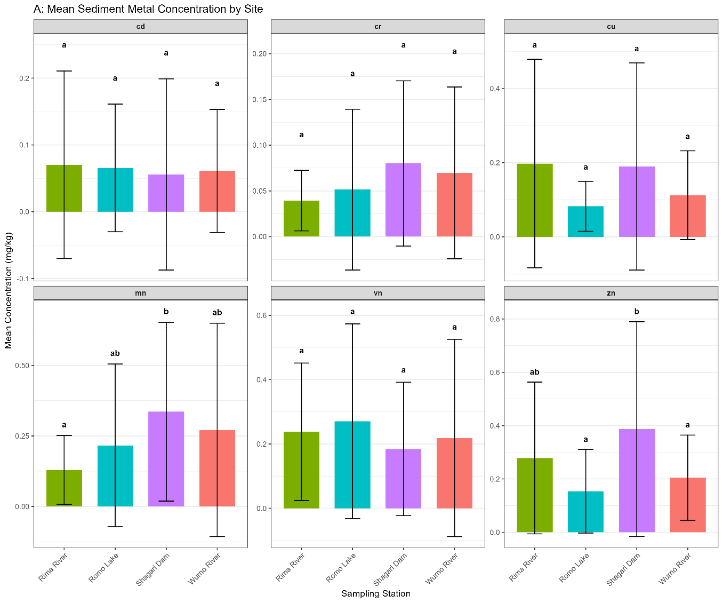
Figure 2: Mean Sediment Metal Concentration by Site, with superscript letters
indicating statistically significant groupings (Tukey HSD, p < 0.05)

Figure 3: Monthly Trend of Zinc (Zn) in Water Across Four Sampling Stations

Figure 4: PCA Biplot of Sites and Samples, showing sample scores (color-coded by station, shape-coded by sample type) and variable loadings (arrows)
DISCUSSION
Kruskal-Wallis tests revealed statistically significant differences in BAFs among species for Zn (χ² = 24.15, p < 0.001), Cd (χ² = 8.72, p = 0.013), and Cu (χ² = 6.34, p = 0.042), but not for Cr (p = 0.201). Post-hoc pairwise comparisons (e.g., Dunn’s test) would further clarify which species differ, but the overall pattern confirms that C. gariepinus accumulates Zn and Cd more than the others (Kamaruzzaman et al., 2010).
These findings have direct implications for environmental management in Sokoto State. The identification of Shagari Dam as a metal hotspot warrants immediate investigation into potential point sources and the implementation of source control measures. For agricultural areas like Rima River, promoting best management practices (BMPs) to reduce agrochemical runoff could mitigate Cu and Cd inputs. The high Mn concentrations in water, particularly at Wurno River and Romo Lake (exceeding WHO guidelines of 0.05–0.1 mg/L), pose a significant public health concern, especially if these waters are used for domestic purposes (Organization et al., 2012). Future monitoring should prioritize these sites and incorporate both sediment and water matrices to capture the full scope of contamination. Furthermore, the effectiveness of PCA in reducing data dimensionality and identifying key drivers of variation supports its continued use in regional environmental assessments (Jolliffe & Cadima, 2016).
While this study provides a valuable baseline, it is limited by the absence of data on metal speciation (example., bioavailable vs. total fractions) and potential sources (example., isotopic fingerprinting). Future research should integrate chemical speciation analyses to better assess ecological risk and employ receptor modelling techniques to apportion pollution sources (Hopke, 2003). Additionally, expanding the monitoring network to include more sites and longer time series would enhance the robustness of temporal trend analyses. Investigating the bioaccumulation of these metals in local fish and plant species would also provide critical insights into trophic transfer and human exposure pathways (Storelli et al., 2003).
The aquatic ecosystems, particularly Shagari Dam and Rima River, are contaminated with heavy metals (Zn, Mn, Cu, Cd), with sediments acting as a major pollution reservoir. This environmental burden is transferred into the food chain, with all three fish species (Oreochromis niloticus, Clarias gariepinus, Bagrus bayad) bioaccumulating metals. C. gariepinus emerged as a key accumulator of toxic Cadmium (Cd) and Zinc (Zn).

Implement Targeted Monitoring: Establish a routine monitoring program for heavy metals in fish from hotspots like Shagari Dam and Rima River, using C. gariepinus as a sentinel species for Cd and Zn.
Control Pollution at Source: Investigate and regulate pollution sources in the Shagari Dam and Rima River basins, targeting industrial discharge and agricultural runoff suspected of contributing Cu and Cd.
Promote Best Agricultural Practices (BAPs): Work with farmers in catchment areas to reduce agrochemical runoff, a likely source of contamination.

REFERENCES

Abubakar, A., Uzairu, A., Ekwumemgbo, P. A., & Okunola, O. J. (2014). Evaluation of Heavy Metals Concentration in Imported Frozen Fish Trachurus Murphyi Species Sold in Zaria Market, Nigeria. American Journal of Chemistry, 4(5), 137-154. https://doi.org/doi:10.5923/j.chemistry.20140405.02
Abubakar, A. Y., Nasiru, R., Garba, N. N., Lawal, A. U., Kankara, U. M., & Ibrahim, N. (2019). DETERMINATION OF HEAVY METAL CONCENTRATION IN DIFFERENT PARTS OF AZANZA GARKEANA PLANT AND THE CULTIVATED SOIL USING AAS TECHNIQUE. FUDMA Journal of Sciences (FJS), 3(3), 408-414.
Ayoola, G., Aina, B., Mamman, N. N., Odebiyi, T., Okunmadewa, F., Shehu, D.,…Zasha, J. (2000). NIGERIA: Voice of the Poor. Country Synthesis Report World Bank.
Barrett, M. L., Harvey, I., Mahesh, S., Rajeev, S., John, F. H., Mark, J. E.,…Hasnain, S. S. (2006). Atomic Resolution Crystal Structures, EXAFS, and Quantum Chemical Studies of Rusticyanin and Its Two Mutants Provide Insight into Its Unusual Properties†,‡. Biochemistry, 45(9).
Dionne, J., Ford, A. C., Yuan, Y., Chey, W. D., Lacy, B. E., Saito, Y. A.,…Moayyedi, P. (2018). A systematic review and meta-analysis evaluating the efficacy of a gluten-free diet and a low FODMAPs diet in treating symptoms of irritable bowel syndrome. Official journal of the American College of Gastroenterology| ACG, 113(9), 1290-1300.
Hopke, P. K. (2003). The evolution of chemometrics. Analytica Chimica Acta, 500(1-2), 365-377.
Ingvar, B. (2015). Agriculture-independent, sustainable, fail-safe and efficient food production by autotrophic single-cell protein.
Jolliffe, I. T., & Cadima, J. (2016). Principal component analysis: a review and recent developments. Philosophical transactions of the royal society A: Mathematical, Physical and Engineering Sciences, 374(2065), 20150202.
Kamaruzzaman, B., Akbar, B., Jalal, K., & Shahbudin, S. (2010). Accumulation of metals in the gills of tilapia fingerlings (Oreochromis niloticus) from in vitro toxicology study.
Lippmann, M., Ito, K., Jing-Shiang, H., Maciejczyk, P., & Lung-Chi, C. (2006). Cardiovascular Effects of Nickel in Ambient Air. Environmental Health Perspectives, 114(11), 1662-1669. https://doi.org/doi: 10.1289/ehp.9150
Malsiu, A., Shehu, I., Stafilov, T., & Faiku, F. (2020). Assessment of heavy metal concentrations with fractionation method in sediments and waters of the Badovci Lake (Kosovo). Journal of Environmental and Public Health, 2020(1), 3098594.
McCleary, B. V., Sloane, N., Draga, A., & Lazewska, I. (2013). Measurement of total dietary fiber using AOAC Method 2009.01 (AACC International Approved Method 32‐45.01): evaluation and updates. Cereal Chemistry, 90(4), 396-414.
Musa, Y., & Ogbe, J. (2025). Assessing the spatiotemporal dynamics of PM2. 5 concentrations during the Harmattan season in Sokoto State, Nigeria, 1980-2024. Journal of Research in Forestry, Wildlife and Environment, 17(1), 107-124.
Nevel, L. V., Mertens, J., Demey, A., Schrijver, A. D., Neve, S. D., Tack, F., & Verheyen, K. (2014). Metal and nutrient dynamics in decomposing tree litter on a metal contaminated site. Environmental Pollution, 54-62. https://doi.org/10.1016/j.envpol.2014.02.009
Oehlenschleager, J. (2002). Identifying heavy metals in fish. Safety and Quality Issues in Fish Processing 95–113. https://doi.org/doi:10.1533/9781855736788.1.95
Organization, W. H., Organization, W. H., & Organization, W. H. (2012). Regional Office for Europe (WHO, 2012). Environmental health inequalities in Europe. Copenhagen.
Storelli, M., Stuffler, R. G., & Marcotrigiano, G. (2003). Polycyclic aromatic hydrocarbons, polychlorinated biphenyls, chlorinated pesticides (DDTs), hexachlorocyclohexane, and hexachlorobenzene residues in smoked seafood. Journal of Food Protection, 66(6), 1095-1099.
Tina van de, F., Katharina, P., Katharina, P., Hiroshi, A., Hiroshi, A., Per, A.,…Jingjing, Y. (2012). GEOTRACES intercalibration of neodymium isotopes and rare earth element concentrations in seawater and suspended particles. Part 1: reproducibility of results for the international intercomparison. Limnology and Oceanography: Methods, 10(4).
United, N. (1948). Reproductive Health in Refugee Situations: An Interagency Field Manual. Nature, 169(4295).
Van Nevel , L., Mertens , J., Demey, A., Schrijver, A. D., De Neve, S., Tack, F., & Verheyen, K. (2014). Metal and nutrient dynamics in decomposing tree litter on a metal contaminated site. Environmental Pollution, 54-62.
Veyrand, B., Sirot, V., Durand, S., Pollono, C., Marchand, P., Dervilly-Pinel, G.,…Le Bizec, B. (2013). Human dietary exposure to polycyclic aromatic hydrocarbons: results of the second French Total Diet Study. Environment international, 54, 11-17.

