Deep Feature Learning Framework for Automated Oral Cancer Detection


Abstract- This article includes a deep learning-based system of automatic clinical tongue
detection of oral cancer on
16
The experiment employs a multi-class oral image dataset of both healthy tongue specimen and some pathologies including oral cancer, leukoplakia, oral lichen planus, thrush and hairy tongue. The proposed model was trained and tested using images taken on both afflicted and non-afflicted persons. DenseNet169 pre-trained network was used as the backbone architecture and fine-tuned with the help of transfer learning where extra fully connected layers were added to strengthen the discrimination of the classes. In order to minimize overfitting and enhance generalization, a large- scale image augmentation was used on the training. The efficacy of the introduced solution was proved by the fact that the suggested approach was compared with a traditional LeNet-based convolutional network. The experimental findings show that the model based on DenseNet has performed better with 08,
an accuracy of 94.
precision of
images.
8
3
94.16, and 94.70 an 70. On
recall of
and
F1-score of 94.
the
contrary, LeNet model delivered, much lower results, and the values of closer
accuracy, precision, recall, and F1-score are
12
64%. Even results put an emphasis on the advantage of proper selection of model architecture, strong data preprocessing, and methodical evaluation in medical image classification activities. Keywords:
to
the
Oral cancer detection, convolutional neural networks, medical image classification, DenseNet169, transfer learning, early diagnosis.
15
I. Introduction

An remains important health issues globally, and 100,000-200,000 new infections occur annually. Although medical interventions have improved, the survival rates are still below satisfactory, mainly because in most cases many patients are diagnosed at their advanced stages. Early diagnosis is important in enhancing the effectiveness of treatment and narrowing the death rates. The traditional methods of diagnosis are based on clinical judgment and physical examination that can result in discrepancies. Thus, oral health has increased the requirement of the automated and trusted diagnostic assistance systems.
oral cancer
one of the most

The law of recent developments in the field of deep learning has made an enormous impact on the sphere of medical image analysis as the approach allows recognizing the various patterns in an intricate visual image. Convolutional Neural Networks (CNNs) prove to be very effective when it comes to tasks regarding the detection of diseases using images. Among other CNN architectures, DenseNet has received interest on the basis of effective reuse of features, as well as, low demand on parameters. The latter qualities make it especially practical in medical practice where there are frequently constrained annotated data. Consequently, models based on DenseNet have become promising features to be used in the classification of oral diseases.

The data involved in expression in this paper is tongue images in healthy and various oral conditions such as oral cancer, leukoplakia, oral lichen planus, thrush, and hairy tongue. The pictures were gathered in the clinical settings and properly labeled with correct annotations by the
medical professionals. The model is also able to learn discriminatory characteristics of the different disease categories as oral conditions are added.

The suggested framework consists of the methodological steps of preprocessing data, training the model, validating it and assessing the model performance. Image virtualization methods, such as resizing, augmentation, etc., are performed to increase model generalization and avoid overfitting. Fine-tuning a pre-trained using transfer learning.

DenseNet model in order to customize it to oral pathology images. Standard measures that are measure
used to
model
performance include accuracy, precision, recall, and F1-
and use a confusion matrix. The effectiveness of modern deep learning models to identify oral cancer is also compared with LeNet architecture to determine its efficiency.
score
the
of

Related works

The past few years have seen fast development in non- invasive diagnostic technologies in various fields of usage, such as healthcare, agriculture, and biomedical analysis. The purpose of these methods is to lessen the discomfort of the patient and increase the accuracy and efficiency of the diagnosis. The further development of the machine learning has made non-invasive methods even stronger as complex patterns of data could be interpreted through the use of a machine. The analysis using visual materials has attracted special attention especially image-based analysis, which is capable of deriving clinically significant features out of visual data. Intelligent disease detection systems have been prepared by such developments. This has had a direct impact on the research on screening and diagnosis of oral cancer.

Various papers have discussed how spectroscopy and sensor methods can be utilized in medical assessment, non- invasively. Techniques like near-infrared spectroscopy and Raman scattering have proven useful in detection of biochemical alterations with disease conditions. Such methods are very sensitive and can be analyzed quickly without damaging the tissue. The success of these shows the significance of integrating signal processing and intelligent algorithms. They are, however, limited to scalability due to their reliance on specialized equipment. Consequently, deep learning methods based on the image have become an easier option.

Machine learning methods have found extensive use in predicting physiological parameters, which cannot be measured through invasive methods. Thermal images and sensor data have been suggested to researchers as predictive models of data categorised as glucose monitoring, respiratory disease identification, and metabolic analysis. The systems minimize the use of the

traditional invasive testing techniques and at the same time still achieve fair accuracy. Machine learning combined with cost-effective sensing technology has enhanced viability. These techniques indicate the wider possibilities of smart non-invasive diagnostics. These notions have impacted on the research of medical image classification.

In more recent work, deep learning architectures on oral disease classification on medical images have been studied. Different models like DenseNet and LeNet have been tried because of their success in attaining hierarchical visual representations through learning. In particular, denseNet has demonstrated better feature reuse and flow of gradients that are stable hence suitable with medical datasets. When comparing the deeper architectures to the traditional ones, it has been found that the former outperforms the latter. These results favour the implementation of contemporary deep learning models. The current study is based on this background in an attempt to improve early oral cancer, which is accurate through non-invasive imaging.

Existing System

As per the current performance of deep learning-based oral cancer detection methods, the methods have promising performances in the laboratory and research settings. It is based mostly on supervised learning that needs high amounts of labeled oral images to train effectively. The procedure of obtaining such datasets is characterized by large amounts of clinical binding, professional medical labeling, and years of data gathering. This process alone proves to be especially
6

14
computing and infrastructure requirements. Deep neural networks usually require a large hardware to be trained and so they are time- and resource-consuming as well as costly and energy-intensive. These requirements complicate implementation in small hospitals and in rural healthcare facilities. Moreover, the majority of the deep learning models are black-box systems that give limited information about the way decisions are made when classifying. This negative feedback affects transparency and lowers the clinician confidence and acceptance in critical diagnostic processes. Also in high sensitivity to model performance is the quality of data where noisy or ill annotated images can be detrimental to accuracy. Moreover, the current systems are not flexible and have to be retrained on a periodic basis to keep up with new disease patterns. All these challenges highlight that there is need to develop oral cancer detecting systems that are more interpretable, efficient, and scalable.

Proposed System

The presented system consists of a proposal of an automated deep learning-based system of early diagnosis of lung cancer based on medical imaging data. The systems are intended to process images of lungs that are acquired by imaging modalities like chest X-rays or computer tomography (CT) scans which is commonly used in clinical diagnosis. First, a pool of complete data comprising of healthy lung images, as well as images that depict the different stages of lung cancer, are gathered and systematized. Preprocessing of the data like image resizing, image normalization, and removing noise etc. are applied to make the input data uniform. In order to increase diversity of dataset and minimize overfitting,
data augmentation
methods scaling, variation in intensity included in training. An already trained convolutional neural network model, which is either DenseNet or EfficientNet, is trained on a transfer-learned model to extract features that are sensitive to lung-related visuals. Other fully connected layers are also attached in order to enhance the precision of classification as high-level spatial features are captured. The data is separated
such as rotation,
flipping and
are
into
so that validity performance could be considered. The model optimization is performed with an efficient choice of loss functions and adaptive optimization algorithms aimed at the reduction of classification errors.
Accuracy, precision, Recall, F1-score
training, validation and testing sets
the
of

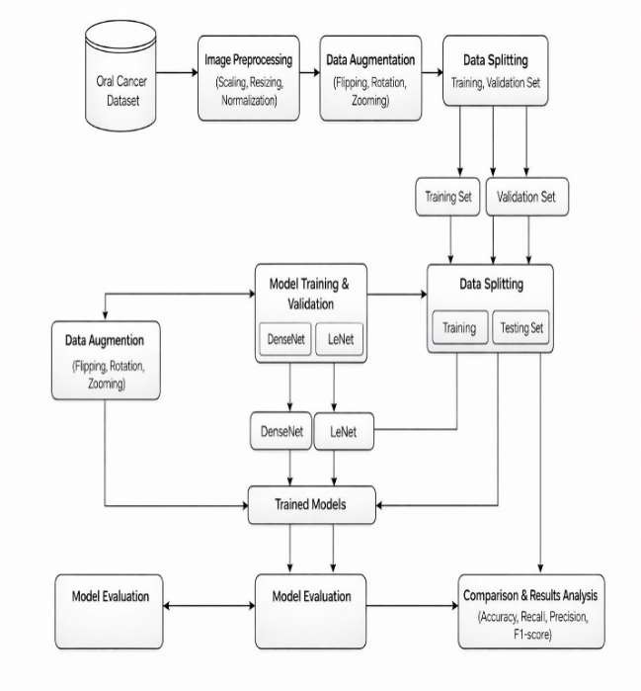
metrics used perform performance assessment. The system
and Confusion matrix analysis
the
to
the
9
are some of
suggested should provide a stable model lung to aid in
cost-effective,
and
scalable
to detect
cancer
early
3
diagnosis aid clinicians in making sound medical choices.
and

System Architecture

tedious with early-stage cancer imagery or in rare pathological differing. Inadequate diversity in datasets can result in biased learning that decreases the generalizability capacity of the model with another population. Because of this, a number of the current systems exhibit less reliability in when used in a real clinical scenario. The risk of wrong predictions is also high because of dataset imbalance. Such constraints hamper the usefulness of the existing solutions.
The Existing systems have a tremendous drawback in terms of

The system architecture shows the flow from image preprocessing and data augmentation to dataset splitting for training,
validation, and testing. Deep learning models are
10
trained evaluated, and final are compared to determine the best-performing model.
VI.Methodology
and
the
results
1

For proposed system, medical images related to lung conditions were collected from publicly available clinical datasets and validated sources. The dataset contains both normal lung images and images representing cancerous conditions, ensuring balanced class representation. All images were carefully reviewed and labeled to maintain data reliability. Prior to training, the images were standardized by resizing them to a fixed resolution to maintain consistency across inputs. Image normalization was applied to enhance feature clarity and improve learning efficiency. To increase dataset diversity and reduce model overfitting,
1. Data Collection and Preprocessing Module:
the
augmentation techniques such as
1
6
were employed. The processed images were then organized into structured directories, enabling efficient model
training and
evaluation.
Fig 2: Dataset for oral cancer detection
2. Model Development and Training Module
(DenseNet)
rotation, flipping, and scaling
1

:
This paper has constructed a deep learning model (DenseNet architecture) to classify oral cancer based on image data effectively. DenseNet169 was chosen because it is a dense network that has dense connections which facilitates the efficient flow of features, as well as minimizing redundancy in learned representations. The model was learnt by starting with weights that had been trained on the ImageNet data and subsequently fine-tuned using the oral cancer image data by transfer learning. Further fully connected layers were added to the network on top of to improve the discriminative power of the network with various classes of oral conditions. Categorical cross-entropy was utilized as loss-function during training, and accuracy was used as the key assessment measure. The methods of data augmentation were implemented in real time and enhanced the robustness and overfitting. A validation dataset was used to monitor model performance continuously and checkpointing mechanisms used to save the best model weights to be later evaluated and deployed.
Fig 3

:
Model Loss of DenseNet
3. Model Development and Training Module (LeNet)
To provide a comparative point of reference, a convolutional neural network with LeNet as the basis was created to assess the competence of more basic structures in oral cancer recognition. LeNet was selected because of its simple design and their significance in the initial research of deep learning studies. The model was also trained on the same preprocessed oral cancer image dataset to be fairly compared with the advanced architecture. The training parameters were cautiously set and performance of the model was observed during the course of learning. The results of the evaluation of the LeNet model were compared to the results of the DenseNet model to emphasize the discrepancy in the performance. This comparison gives an understanding of the weaknesses and strengths of shallow and deep neural network
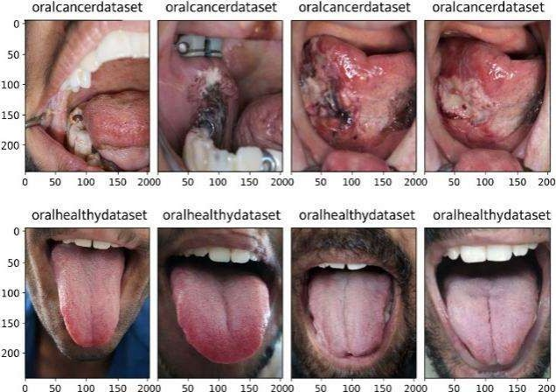
designs as far as medical image classification is concerned.
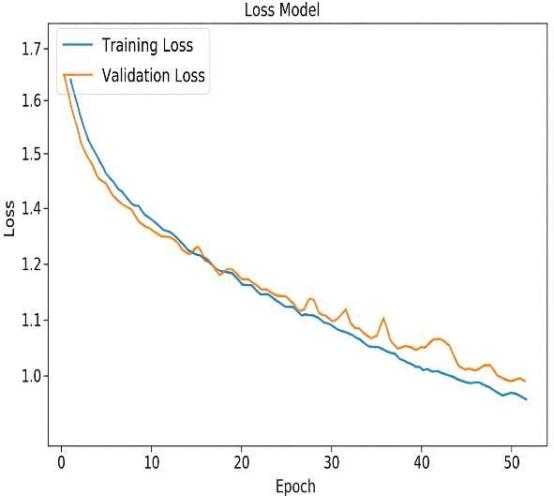

Fig 4
Model Loss of LeNet

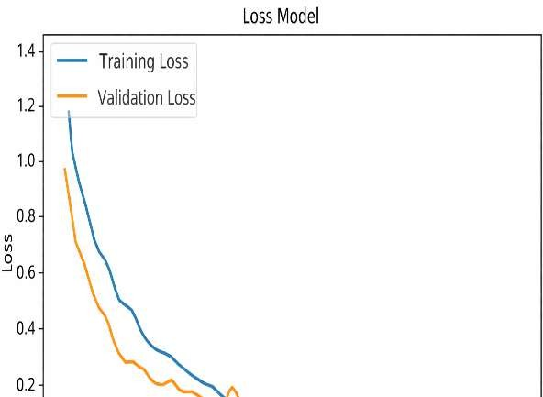

4 Submission ID trn:oid:::3618:127309494

Page 8 of 12 - Integrity Submission
1

4.
Integration and Deployment Module:
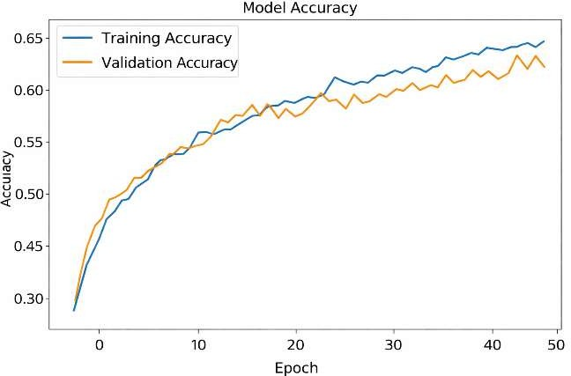
After training was complete, the models were prepared to be deployed into an application or system. To facilitate use and interoperability with preexisting systems, integration included packaging the models with all required dependencies and APIs. You may put the models on cloud platforms for scalability and accessibility, incorporate them into mobile apps, or provide them via online APIs. To effectively categorize photos or data points indicative of the existence of oral cancer, a deep learning model is first constructed and trained using datasets related to the disease. After the model is trained, it must be incorporated into an application or user interface that is easy to use,

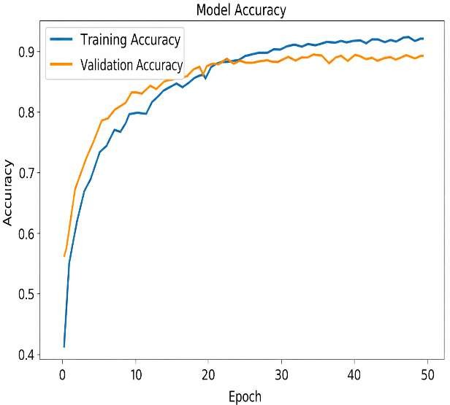

Fig 5 Model Accuracy of DenseNet

The effectiveness of the model proposed based on DenseNet and the baseline LeNet architecture was compared to evaluate the effectiveness of each of the two architectures in the detection of experiment
of oral cancer. The results
the
demonstrated
that there was
significant difference in the
a

1
which may include creating a web or mobile application.
4
4

VII.RESULT AND DISCUSSION
The conducted experiments prove that the suggested deep learning model is very effective as it helps to determine cancerous conditions of a medical picture. The trained DenseNet-based model performed well on classification with high accuracy levels i.e. it was able to distinguish between cancerous and non-cancerous samples. High validation accuracy is a factor that attests to the model in learning complex visual patterns that occur in medical imagery. The similarity in the results of the training and validation performance points to the strength of the proposed approach and indicates a low overfitting. Moreover, models like precision, recall, and the F1-score are evaluated variables proving the trustworthiness of the model to detect positive cases with a low error rate of misclassifying the cases. These findings underscore the appropriateness of deep convolutional neural networks in the automated detection of cancer and its ability to aid the clinical decision-making process as these systems can offer dependable and reliable diagnostic clues.
1
both models, LeNet network has significantly lower validation accuracy. This finding suggests that low-complexity convolutional structures might have difficulties in deriving complicated and discriminative features of oral cavity images. Conversely, the DenseNet architecture had a better learning ability as it was able to effectively capture more complex visual attributes that indicate cancerous traits. The high connectivity structure facilitates more effective reuse of features and flow of information between layers resulting to higher classification. These results indicate the relevance of using the next- generation deep learning models, which are both suitable in medical image analysis, especially in areas that demand high diagnostic accuracy.

Fig 6
Model Accuracy of LeNet
TABLE 1: Performance metrics
performance of
and the

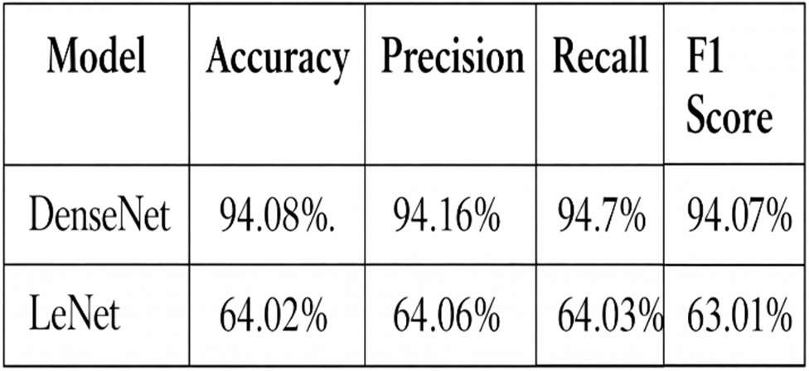

As the results given in the experiment show, the DenseNet- based deep learning model will show a better level of performance regarding the oral cancer classification than the LeNet architecture. DenseNet outperformed maxentius, as it yielded better scores in every measure of evaluation, such as which
accuracy, precision, recall, and F1-score,

accounted for differentiate between various conditions of oral cancer. This is enhanced performance due to the high level of connectivity pattern of the model, which facilitates feature reuse and enhancement of learning of complex visual patterns that occur in oral images. Conversely, the less complex LeNet model was also poor in predicting the complex features associated with a disease, and thus, it lacked high reliability in its classification. The findings highlight the significance of the use of the advanced deep learning architectures on the medical image analysis tasks that require a high degree of precision. Automated classification is especially important in the reduction of diagnostic uncertainty and aids in the early detection of the disease. The proposed DenseNet-based approach can help clinicians make informed decisions by enhancing the classification consistency. All in all, the results indicate that well-developed deep learning architectures have the potential to greatly increase diagnostic accuracy and lead to better healthcare results in oral cancer diagnosis.
its superior ability to
Fig 7 :
Confusion Matrix for actual and predicted values
of
DenseNet
1

Fig 8:
Confusion Matrix for actual and predicted values
of
LeNet
1

This study uses confusion matrices to visually examine the behavior of the proposed deep learning models during the classification of oral health conditions in different conditions. These matrices offer a step-by-step analysis of the results of the prediction by placing both the correct classifications and the various kinds of misclassifications of each of the classes. Analyzing the diagonal components, one can see that the model is accurate on identifying a considerable number of samples on greatest percentage in majority of the categories. The number of off-diagonal values is relatively low, which implies that there was a weak misunderstanding between the various classes of oral diseases. This implies that the model can discriminatively acquire features that can be used to distinguish similar clinical conditions. The confusion matrix analysis also assists in the interpretation of strengths and weaknesses of the model in class wise. These observations can be useful in determining the reliability of models beyond levels of total accuracy. Next to the fact that the proposed approach proves strong, there is a consistent performance, which shows the consistent results of the consistent performance across classes. The outcomes signify that the model can be used in practice in medicine. All in all, the confusion assessment analysis boosts the belief in the diagnostic ability of the system. This discussion demonstrates that deep models have the potential of aiding clinicians to identify the disease in an accurate and consistent way.
learning
11

VIII: Conclusion

This paper establishes that oral cancer detection through medical images using deep learning methods and especially with the DenseNet architecture are effective. Through
experimental analysis, it is evident that DenseNet model has been repeatedly superior to the LeNet architecture in all its critical performance indices, and attains a better classification performance. The findings lay stress on the significance of the choice of sophisticated neurological network designs that are well-adapted to challenging medical image processes. The proposed system also depicts practical feasibility, which implies its possibility to be realistically deployed to automated diagnostic environment. Clinicians can use these kinds of systems to aid them in the accuracy of diagnoses, as well as manual efforts. The future directions in work can be aimed at additional optimization of the model and the use of other deep learning approaches to improve the results in early detection of oral cancer and care of patients.

XI: FUTURE WORK
The future studies can be devoted to enhancing oral cancer detection through combining two or more types of data into the deep learning system. Besides the images of the oral cavity, patient related data like age, lifestyle habits, and clinical history could be incorporated to enable the model to make better predictions. Integration of imaging data with histopathological and molecular signal may also improve the

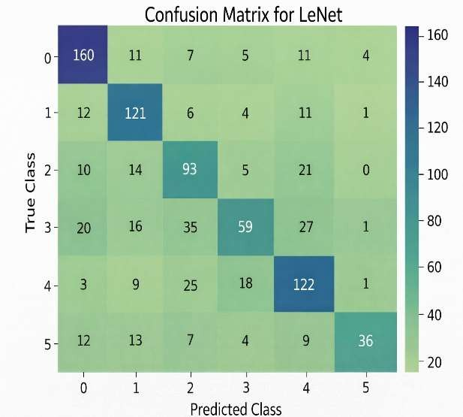
accuracy of the diagnosis. These multi-modal learning strategies can potentially be used to study a more extensive spectrum of the disease characteristics. This combination can result in stronger and clinically significant policies. Finally, it will be able to facilitate more individualized diagnostic results.
It is one more prospective path, which consists of improving the availability and variety of data by means of advanced augmentation methods. One of the ways to solve the problem of small annotated medical datasets is through the use of methods like synthetic image generation through generative models. Curriculum adaptation models could also be considered models
in order to enhance the performance of the
on other datasets that have been observed in various clinical practices. These methods are able to minimize overfitting and enhance generalization. This type of expansion of training data is particularly useful with rare or early-stage cancer cases. This method may substantially reinforce the reliability of the model.
Enhancements can be further done by delving into ensemble

and transfer learning methods. Making predictions using more than one deep learning architecture can enhance the stability of classification between models and decrease their own bias. Pre-trained fine-tuning models based on large-scale medical or cancer-related datasets can also increase the feature extraction ability.

X. References

- P. F. Ndlovu, L. S. Magwaza, S. Z. Tesfay, and R. R. Mphahlele, “Rapid and non-destructive techniques for identifying adulteration in powdered horticultural products: A comprehensive review,” Food Research International, vol. 157, pp. 111198, 2022.
- Y. Chen, Y. Wu, Y. Geng, X. Liu, L. Xiao, D. Xu, and
H. Ma, “Non-invasive evaluation of anti-inflammatory activity and molecular indicators of oral solutions using near-infrared spectroscopy,” Molecules, vol. 27, no. 9, p. 2955, 2022.
- M. M. Jadhav, A. O. Mulani, and M. Seth, “A painless, non-invasive machine learning approach for estimating blood glucose levels,” in IoT, Artificial Intelligence, and Smart Materials for Energy Applications, pp. 83–100, 2022.
- Y. Qu, R. X. Xu, H. Fan, and Y. Meng, “Low-cost thermal imaging combined with machine learning for non- invasive pneumonia diagnosis and monitoring,” Infrared Physics & Technology, vol. 123, p. 104201, 2022.
- S. X. Wang, D. L. Cortade, and A. S. de Olazarra, “Saliva-based non-invasive genotyping using magnetoresistive nanosensors and recombinase polymerase amplification,” Lab on a Chip, vol. 22, no. 11,
pp. 2131–2144, 2022.
- R. J. Price, V. R. Breza, K. M. Nowak, and M. R. Schwartz, “Recent developments in sonodynamic therapy for targeted, non-invasive cancer treatment,” Cancer Letters, vol. 532, p. 215592, 2022.
- J. Yu, K. Shan, X. Shang, J. Guo, G. Liu, Z. Mu, and
X. Liang, “Surface-enhanced Raman scattering for wearable and non-invasive medical diagnostics,” Frontiers in Chemistry, vol. 10, p. 1060322, 2022.
- H. Sharghi, M. Javid, M. M. Bordbar, H. Samadinia,
A. Sheini, J. Aboonajmi, and H. Bagheri, “A microfluidic colorimetric sensor array for non-invasive COVID-19 detection through urine analysis,” Microchimica Acta, vol. 189, no. 9, p. 315, 2022.
- F. Sabbagh, I. I. Muhamad, R. Niazmand, P. K. Dikshit, and B. S. Kim, “Advances in polymer-based non- invasive insulin delivery systems,” International Journal of Biological Macromolecules, vol. 203, pp. 222–243, 2022.
- C. Zambonin and A. Aresta, “Identification of cancer biomarkers from saliva and urine samples using MALDI- TOF/MS,” Molecules, vol. 27, no. 6, p. 1925, 2022.
- S. W. Chang, S. Abdul-Kareem, A. F. Merican, and
R. B. Zain, “Hybrid feature selection and machine learning techniques for oral cancer prognosis using clinicopathologic and genomic data,” BMC Bioinformatics, vol. 14, art. no. 170, May 2013.
- H. Rajaguru and S. Prabhakar, “Comparative analysis of oral cancer classification using Gaussian mixture models and multilayer perceptrons,” in Proceedings of the International Conference on Advances in Computing,
Communications and Informatics (ICACCI), 2017, pp. 212–219.

Page 12 of 12 - Integrity Submission Submission ID trn:oid:::3618:127309494
8

