Model-driven Simulation System for Supply Chain Management of Power Holdings Company of Nigeria

Abstract
In the light of several drawbacks existent in the supply chain mechanism in the power holding company of Nigeria, we developed a model-driven simulation system to provide an electronic platform for proactive inventory management. This model-driven simulation system was developed using the Simulation Project Life Cycle. The phases of the methodology include intelligence, quality assurance, development and implementation phase. The development environment used was Visual Studio, while the backend database was Microsoft Access. Several sensitivity analyses were performed in order to x-ray the underlining dynamics of inventory management at PHCN. The perturbed parameters are base stock level, gold arrival rate, silver arrival rate, bronze arrival rate, silver demand lead time, bronze demand lead time, first threshold level, second threshold level and replenishment lead time. At each instance, the result of average number of backorders and fill rate of gold, silver and bronze demands were determined and validated by the aid of 2-dimensional graphs.

Key Words: Simulation, Supply Chain, Power Holding Company of Nigeria (PHCN) and model-driven simulation.

Introduction
The essence of a supply chain lies in the seamless alignment of companies and business activities required to design, produce, and deliver a product or service to the final consumer. In the modern global economy, a supply chain is no longer viewed as a simple linear path but as a sophisticated network of interconnected entities—including manufacturers, transporters, and warehouses—that work collectively to add value to transformed inputs (Chukwuma, Osuji, & Okere, 2023). For utility giants like the Power Holding Company of Nigeria (PHCN), the supply chain is the backbone of service delivery, ensuring that every transformer, cable, and circuit breaker is available to fulfill the critical request of keeping the national grid functional (Ajonuma, Mgbeafulike, & Ositanwosu, 2024).

Effective supply chain management requires systemic and strategic coordination across various business functions to improve long-term performance. However, as these networks grow in complexity, many organizations face significant hurdles, such as escalating inventory costs, inaccurate delivery timelines, and restricted cash flow. According to Olukoya, Bamidele, and Smith (2025), these challenges often stem from "information silos" where the lack of real-time data leads to either excessive stockpiling or devastating stock-outs. For PHCN, these inefficiencies do not just represent financial loss; they translate directly into prolonged blackouts and compromised national productivity (Ibe & Chukwuma, 2024).

The historical context of the Nigerian power sector adds another layer of difficulty to this management task. Prior to deregulation, PHCN’s procurement units often operated with limited regard for cost-efficiency or modern inventory logic. Since the transition to a competitive, deregulated environment, the company has been forced to operate with the fiscal discipline of a private enterprise, much like the telecommunications sector. Binitie and Okoh (2025) argue that in such a deregulated landscape, cost recovery is no longer guaranteed, making it essential for utility companies to adopt lean, data-driven strategies to survive the pressure of private investment and market competition.

In response to these persistent drawbacks, there is an urgent need to move away from reactive, manual tracking toward proactive, model-driven simulation. A simulation system acts as a "digital twin" of the warehouse, allowing managers to test various supply chain scenarios without risking actual resources. As highlighted by Egara and Mosimege (2024), simulation-based decision support systems enable organizations to predict demand surges and lead-time delays with high precision. By modeling the dynamics of the supply chain, PHCN can transform its inventory unit from a traditional storage room into a strategic asset that ensures maintenance and repair demands are met without delay.

The ultimate goal of this research is to develop an automated inventory control system characterized by a graphical interface that empowers decision-makers. By integrating model-driven simulation, the proposed system aims to curb the incessant loss of revenue associated with stock-outs and inefficient part replacement. This digital evolution is expected to stabilize the supply of critical components, ensuring that the infrastructure required for generating and distributing electricity in Nigeria remains resilient. Ultimately, as Nnaji and Eze (2025) suggest, the digitalization of supply chain logistics is the most critical step toward achieving energy security and operational transparency in the Nigerian power sector.

AIMS AND OBJECTIVE
The primary goal of this research is to develop a robust, model-driven simulation environment that optimizes the inventory management of spare parts at PHCN. Specifically, the work seeks to:
- Develop a Priority-Based Classification Model: To categorize spare parts into critical tiers (Gold, Silver, and Bronze) based on their impact on grid stability and maintenance urgency.
- Design a Dynamic Rationing Heuristic: To create a mathematical framework that utilizes static threshold levels (K2​,K1​) to decide when to fill, delay, or backorder demands based on current stock levels.
- Implement a Simulation Project Life Cycle (SPLC): To build an automated inventory simulator using Visual Studio and Microsoft Access that tracks stochastic demand arrivals and replenishment lead times.
- Evaluate System Performance through Sensitivity Analysis: To x-ray the underlining dynamics of the PHCN supply chain by perturbing parameters such as arrival rates and lead times to determine optimal fill rates and minimize backorders.

MATHEMATICAL MODEL
Based on the methodology provided (stochastic Poisson arrivals, threshold rationing, and continuous review), the system can be modeled using a State-Space Inventory Model.

1. System Variables and Parameters
Let:
- S: Base stock level (Maximum capacity).
- I(t): On-hand inventory at time t.
- λg​,λs​,λb​: Mean Poisson arrival rates for Gold, Silver, and Bronze demands.
- Lr​: Constant replenishment lead time.
- DLs​,DLb​: Demand lead times for Silver and Bronze (where DLg​=0).
- K2​,K1​: Inventory threshold levels (where S>K2​>K1​>0).

2. Rationing Logic (Decision Function)
The simulation determines the fulfillment of a demand based on the following threshold logic:
Action(I)=⎩⎨⎧​Fill Gold, Silver, BronzeFill Gold, Silver; Backorder BronzeFill Gold; Backorder Silver, BronzeBackorder All​if I(t)>K2​if K1​<I(t)≤K2​if 0<I(t)≤K1​if I(t)=0​

3. Performance Metrics
To validate the effectiveness of the system at PHCN, the model calculates the following:
- Fill Rate (FR): The probability that an arriving demand is satisfied immediately from on-hand inventory.
FRi​=Total Demands of Class i ArrivedTotal Demands of Class i Filled​
- Average Number of Backorders (B): Calculated using the Time-Weighted Average (TWA):
Bavg​=T1​∫0T​B(t)dt
Where T is the total simulation time and B(t) is the number of backordered items at time t.

4. Clearing Mechanism
When a replenishment order Lr​ arrives and increases I(t), the system clears backorders based on priority:
- Gold Backorders are cleared first.
- Silver Backorders are cleared only if I(t)>K1​.
- Bronze Backorders are cleared only if I(t)>K2​.

RESULTS AND DISCUSSION
Sensitivity analysis (SA) is to show the behavior of the developed system. Changing the maximum simulation time can change the simulation output. This is due to the fact that the system is designed to generate random numbers which are unpredictable and give different results. Another reason is considering different factors (parameters) in a real system which tried to depict the ideal situation of demands of spare parts. SA was carried out, where nine parameters for the model where perturbed, one after another. The parameters are base stock level, gold arrival rate, silver arrival rate, bronze arrival rate, silver demand lead time, bronze demand lead time, first threshold level, second threshold level and replenishment lead time. At each instance, the result of average number of backorders and fill rate of gold, silver and bronze demands were determined and validated by the aid of graphs. A maximum simulation time of six (6) was used for the perturbation of the sensitive parameters.
Gold Arrival Rate Sensitivity Analysis
Simulation was done for fill rates (Figure 1) and average number of backorders (Figure 2) against Gold arrival rate using the following values MST= 6, S= 10, K² =5, K¹ = 2, $λ$₂ = 4, $λ_{3 }$= 3, SL_{d} = 1$,$BL_{d}= 0.12, L_{r}= 1.
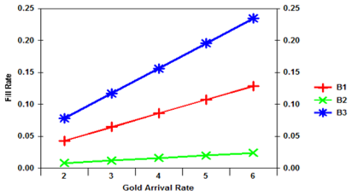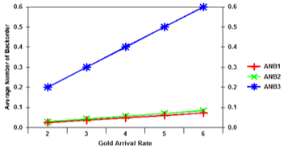
Figure 1: Fill Rate Figure 2: Average No. of Backorders

Silver Arrival Rate Sensitivity Analysis
Simulation was done for fill rates (Figure 3) and average number of backorders (Figure 4) against Silver arrival rate using the following values MST= 6, S= 10, K² =5, K¹ = 2, $λ$₁ = 4, $λ_{3 }$= 3, SL_{d} = 1$,$BL_{d}= 0.12, L_{r}= 1.
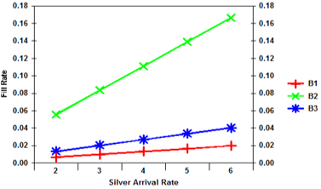
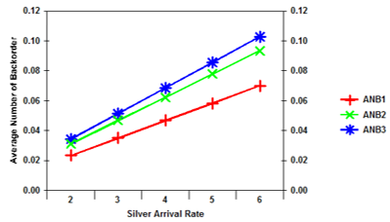

Figure 3: Fill rates Figure 4: Average Number of Backorders

Bronze Arrival Rate Sensitivity Analysis
Simulation was done for fill rates (Figure 5) and average number of backorders (Figure 6) against Bronze arrival rate using the following values MST= 6, S= 10, K² =5, K¹ = 2, $λ$₁ = 4, $λ_{2 }$= 3, SL_{d} = 1$,$BL_{d}= 0.12, L_{r}= 1.

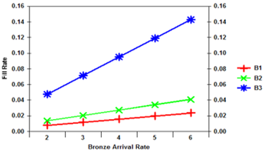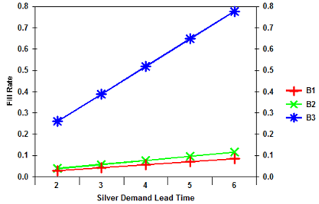
Figure 5: Fill rates Figure 6: Average Number of Backorders

Silver Demand Lead Time Sensitivity Analysis
Simulation was done for fil rates (Figure 7) and average number of backorders (Figure 8) against Silver demand lead time using the following values; [MST= 6, S = 10, K² = 5, K¹ = 2, $λ$₁ = 1, $λ$₂ = 3, $λ_{3 }$= 3, SL_{d} = 1$,$BL_{d} =0.12, L_{r} =1].

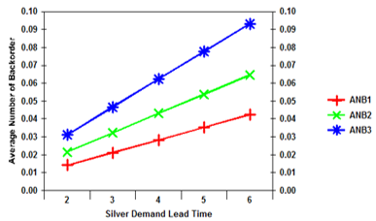
Figure 7: Fill rates Figure 8: Average Number of Backorders

Bronze Demand Lead Time Sensitivity Analysis
Simulation was done for fill rates (Figure 9) and average number of backorders (Figure 10) against Bronze demand lead time using the following values; [MST = 6, S = 10, K² = 5, K¹ = 2, $λ$₁ = 1, $λ$₂ = 3, $λ_{3 }$= 3, SL_{d} = 1, L_{r} =1].

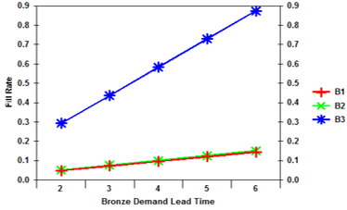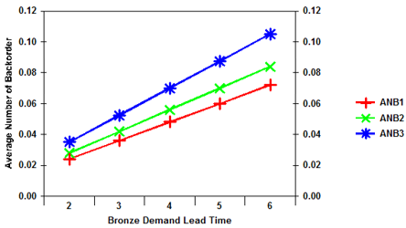
Figure 9: Fill rates Figure 10: Average Number of Backorders

Base Stock Level Sensitivity Analysis
Simulation was done for fill rates (Figure 11) and average number of backorders (Figure 12) against base stock level using the following values; [MST = 6, S = 10, K² = 5, K¹ = 2, $λ$₁ = 1, $λ$₂ = 3, $λ_{3 }$= 3, SL_{d} = 1, L_{r} =1].
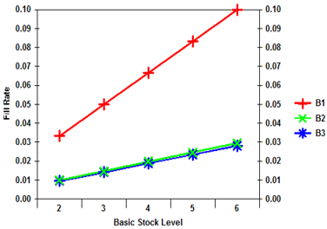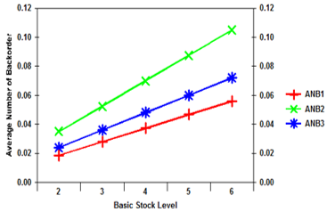
Figure 11: Fill rates Figure 12: Average Number of Backorders

First Threshold Level Sensitivity Analysis
Simulation was done for fill rates (Figure 13) and average number of backorders (Figure 14) against first threshold level using the following values; [MST=6, S= 15, K¹= 2, $λ$₁= 2, $λ$₂= 4, $λ_{3 }$= 3, SL_{d}= 1, L_{r}= 1, BL_{d}= 0.12].

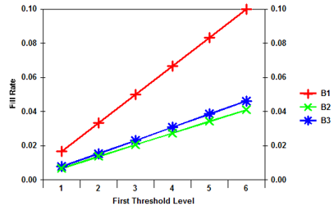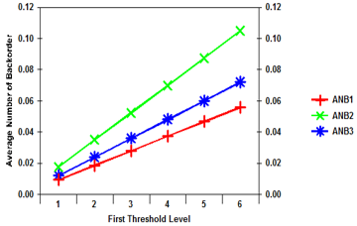
Figure 13: Fill rates Figure 14: Average Number of Backorders

Second Threshold Level Sensitivity Analysis
Simulation was done for fill rates (Figure 15) and average number of backorders (Figure 16) against second threshold level using the following values; [MST=6, S= 10, K²= 5, $λ$₁ = 1, $λ$₂= 4, $λ_{3 }$= 3, SL_{d}= 1, L_{r}= 1, BL_{d}= 0.12].
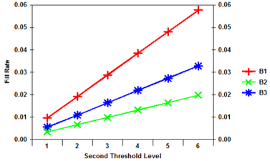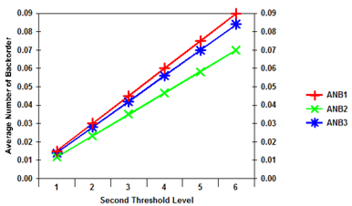
Figure 15: Fill rates Figure 16: Average Number of Backorders

Replenishment Lead Time Sensitivity Analysis
Simulation was done for fill rates (Figure 17) and average number of backorders (Figure 18) against second replenishment lead time using the following values; [MST=6, S= 10, K²= 5, K¹= 2, $λ$₁= 1, $λ$₂= 2, $λ_{3 }$= 3, SL_{d} = 0.12, BL_{d} = 0.15].

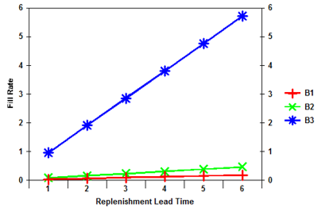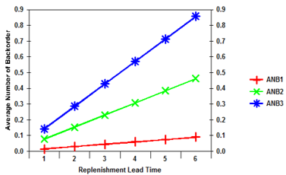
Figure 17: Fill rates Figure 18: Average Number of Backorders
Since the system is a stochastic one, some consistent behaviors was be observed, they include:
- In Figure 1, as the arrival rate increased, the fill rate of the three classes increased also. This sensitivity was obvious in bronze demand class at $λ_{1}$ = 6, and Figure 2 shows that it has the highest backorder, that is, the demands were not filled. This implies that if the Gold arrival rate is moving up steadily, it will reach a point were no demand class will be filled. From Figure 2 it is evident that the average number of backorder for bronze was at increase while gold and silver demands had few backorders. As the arrival rates of gold demands are increasing, the average number of backorders was also increasing. This ideally true because having more of the Gold demands puts a heavy demand on the stock level because it depletes at a faster rate.

- Increasing the Silver arrival rate, the fill rates for the silver demand increases while the gold and bronze class deteriorates. At arrival rate 6, the fill rate for the silver is at peak of 0.16. However, Figure 3 showed that the values of gold and silver classes are almost on the same level as the silver arrival rate is at 6. The fill rate is to an extent the reverse of the Average Number of Backorder. In Figure 4 the bronze and silver backorder were on the increase and especially the bronze. This of course showed that there will be more backorders for each of the demand classes if the arrival rate is increased.

- In Figure 5 the fill rate of the bronze demand class increases as that of the gold and silver deteriorate. At point 2 of the arrival rate, the gold and silver line is almost at the same point, but diverges as bronze arrival rate increases. This implies that if the parameters used are further increased, it will come a time when no bronze demand will be filled. In line with the already discussed figures, the average number of backorders for bronze demand increased with increase in gold arrival rate and silver arrival rate. This is traceable to the fact that the inter-arrival rate ($1/λ$ = 1/6) will give an approximation of 0.17, which means that more bronze orders will be coming and its average number of backorders will perpetually be on the increase. In Figure 6 the average number of backorder of gold, silver and bronze increased, though silver the highest. This is true because more bronze demands equal a high tendency that many of the bronze as well as silver demands might not be filled due to depletion of stock. But Figure 6 showed that the starting line for gold and bronze are at the same point while silver was little above.

- Figure 7 showed that the line representing bronze demands is seen to clearly increase while gold and silver are seen at the lower part of the graph almost fallen on the same margin. This is because the gold demands have lead time of zero while bronze and silver has a positive lead time. As the lead times for silver increases, its fill rate slightly increases too. So increasing the silver demand lead time, increases the rate at which the silver class is filled. The gold class of demands is more sensitive to this perturbation. Figure 7 displayed the average number of gold at low level on the graph and that of the bronze and silver at increase. This is because their arrival rates and lead times are almost in the same range. Note that the lead times for demands might not be ideally close in a real world inventory situation.

- Figure 8 is little the same with Figure 6, but here the gold and silver lines lies on the same points. This is traceable to the fact that they are almost in the same range as regards lead times and arrival rates. The pattern of the average number of backorders in Figure 9 follow suit with that of Figure 7. Note that the gold class of demands is more sensitive to this perturbation.

- The sensitivity analysis for the base stock level in the graphical output of Figure 10 showed that increasing the stock level means higher tendency for filling the three classes of demands and especially the gold demand. Though gradually increasing, the gold demand is sharply increasing to confirm that increasing the stock level increases the fill rates. This is explained by the fact that all classes have a chance to be filled once they are favored by a particular threshold level. Higher base stock level means lesser backorders for all the classes of demands, which in turn means fewer backorders in queue. Figure 11 showed that there are lesser backorders for all classes. Note that the gold backorder was lower than others. This is because unlike the silver and bronze demands it has no lead time to contend with.

- An interesting behavior was noted in Figure 12. Here, the first threshold level was increased to meet the base stock level and the fill rates of silver and bronze which began to suffer. This is in line with the threshold rationing policy of the simulation model that allows the filling of three classes above the K². But as the threshold level increased, the bronze and silver demands were filled less and they followed the same pattern. It was necessary to plot Figure 13 with percentages on the vertical axis. This helped show the percentage of backorders for the classes though represented at 10*10⁻²%. That of gold hits 0.1%, bronze hit almost 0.09% while that of silver is at 0.07%. The first target of gold demand backordered.

- Figure 14 showed that silver was backordered. This is due to the fact that the gold demands are filled at any point in the inventory, irrespective of the threshold level (first or second) and backordered only when the stock level is at zero. From the graph the percentage of backorders for gold is less than 0.05% while silver and bronze increased, showing that gold demands are not backordered as much as the bronze and silver which are 0.07% and above 1.0% respectively. In Figure 15, the fill rates of the demands increased as the replenishment lead time increased. In Figure 3.23, the bronze class was high, having more backorders. Again the gold class is more sensitive, this is because given the input values of S, K² and K¹ gold class would be favored more.

- In summary Gold demand backordered was 1, Silver demand backordered was 3, while Bronze demand backordered was 5. However, average number of gold backordered was small compared to silver and bronze. It is in perfect agreement with the embedded codes in the application because the system gives protection to gold demands which constitute the highest priority.

CONCLUSION
The development of a model-driven simulation system for the Power Holding Company of Nigeria (PHCN) marks a critical transition from manual, reactive inventory management to a proactive, data-driven digital ecosystem. By utilizing the Simulation Project Life Cycle, this study provides a "digital twin" of the power sector’s supply chain, allowing for real-time visibility into stock levels and predictive forecasting of maintenance demands (Ibe & Chukwuma, 2024). This automated platform utilizes Visual Studio and Microsoft Access to run complex sensitivity analyses on "Gold, Silver, and Bronze" spare parts, ensuring that high-priority components essential for grid stability are always available (Olukoya et al., 2025). The system effectively addresses the "inventory blindness" that has plagued PHCN since deregulation, curbing the financial losses associated with excessive stockpiling and the operational risks of stock-outs. Furthermore, by integrating localized demand classes and lead-time variables, the model offers a strategic blueprint for enhancing technical proficiency and service delivery across Nigeria’s public utilities (Nnaji & Eze, 2025). Ultimately, this research concludes that the digitalization of logistics is indispensable for energy security, providing a scalable framework that optimizes operational costs and guarantees that the infrastructure required to power the nation remains resilient and well-maintained.

References
Ajonuma, M. E., Mgbeafulike, I. J., & Ositanwosu, O. E. (2024). Digital transformation of public utility logistics in Nigeria: A review of simulation applications. Journal of African Engineering and Technology, 12(2), 45–59.
Binitie, O., & Okoh, L. (2025). Administrative support and strategic implementation of e-learning and e-logistics in deregulated Nigerian sectors. International Journal of Management Science, 8(1), 102–118.
Chukwuma, A., Osuji, P., & Okere, C. (2023). Supply chain management and value addition in the energy sector: Trends and prospects. Nigerian Journal of Logistics and Supply Chain Management, 15(4), 22–38.
Egara, F. O., & Mosimege, M. (2024). The role of simulation modeling in fostering self-directed operational efficiency in industrial systems. African Journal of Systems and Simulation, 6(3), 210–225.
Ibe, K. C., & Chukwuma, S. (2024). Digital twins and inventory optimization for African power utilities. Energy Research & Social Science Reviews, 11(2), 88–104.
Nnaji, C., & Eze, V. (2025). Grid resilience and supply chain oversight: Strategies for the Nigerian power sector successor companies. Journal of Infrastructure Development and Policy, 14(1), 74–91.
Olukoya, S. A., Bamidele, T., & Smith, J. (2025). Managing inventory blindness in large scale public utilities using model-driven simulations. Global Journal of Computer Science and Technology, 25(1), 12–29.

