THEMATIC MAPPING OF LANDSLIDE SUSCEPTIBILITY
OF KAYAPA NUEVA VIZCAYA

ABSTRACT

To properly manage the landslide threat and minimize property damage and fatalities, a landslide susceptibility map must be created. The municipality of Kayapa has seen landslides, just like many other hilly areas, which have caused lives, injuries, and property damage. Therefore, the purpose of this work was to use a Geographic Information System-based spatial multicriteria approach to create map of landslide susceptibility. For the current assessment, seven parameters were chosen, that include elevation, land cover, rainfall, slope, road distance, and river distance. Four susceptibility classes low, moderate, high and very high—were identified on the landslide susceptibility map that resulted from the integration of Analytical Hierarchy Process and Geographic Information System methodologies. The thematic maps provide a more detailed representation of the places that are susceptible. The data indicates that 7288.12 hectares are classified as low susceptible, 14138.65 hectares as moderate susceptible, 16525.27 hectares as highly susceptible, and 11618.47 hectares as very highly susceptible to landslides. The study also reveals that the Slope is the most influential factor affecting landslide vulnerability. Additionally, the field survey and geotagging validation provide positive findings, meaning that the verified spots match the susceptibility levels on the landslide susceptibility map. The visualization of landslide susceptibility is a useful tool for disaster preparedness since it allows local government agencies to put specific policies in place to reduce the danger of landslides, particularly in high-risk areas.

Keywords: landslide, map, parameters, susceptibility classes

INTRODUCTION

Landslide is a natural process that refers to the downslope motion of soil and rock materials under the influence of gravity (Kehew, 1988). Triggered by different factors including heavy or prolonged rainfall, earthquakes, volcanic eruptions, disturbance by human activities, or any combination of these factors (United States Geological Survey). Notably, landslides are most prevalent in regions with elevated or mountainous terrain which causes a significant injury, loss of human life, and extensive damages to properties and infrastructure.

According to the Mines and Geosciences Bureau (MGB), the Philippines rank as the fourth most exposed to landslide risk, after Indonesia, India and China. The combination of mountainous and hilly regions that experiences earthquakes as well as intense rainfall brought on by monsoons and/or typhoons, makes the terrain naturally susceptible to landslides as highlighted by the United Nations International Strategy for Disaster Reduction (UNISDR).

The Philippines has experienced several devastating landslides, the tragic event in Guinsaugon in St. Bernard, Southern Leyte on February 11, 2006, triggered by heavy rainfall from a tropical storm buried the entire village, claiming around 1,126 lives. Another catastrophic event occurred in Andap, New Bataan, Compostella Valley in November 2012, the heavy rains brought by Typhoon Pablo caused a massive debris flow that resulted in 128 fatalities and 450 individuals were reported missing. These cases illustrate the recurring threat of landslides in the Philippines, often amplified by the country's geographical characteristics and meteorological conditions. The northern part of Luzon like Nueva Vizcaya province is no exception. The province has experienced numerous landslides, resulting casualties, property damages and economic losses (Bishop et.al., 2007).

In Kayapa town in Nueva Vizcaya, a landslide buried a family of four in Barangay Banaw. In a statement, said the erosion took the lives of a 36-year-old father and his children: a 9-year-old boy, a two-year-old girl, and an eight-month-old baby. Landslides pose a significant threat in Kayapa, Nueva Vizcaya, with their potential loss of life, property damage, and environmental degradation. Hence, to mitigate these risks and enhance disaster preparedness, many researchers had utilized Geographic Information System (GIS) to generate landslide susceptibility map (Wright, 1997). However, despite advancements in landslide susceptibility mapping, a notable research gap exists in localized studies. Landslide susceptibility can change over time due to various factors. such as weather, construction activities and natural processes.

Therefore, this gap necessitates further and ongoing research of a landslide susceptibility to mitigate the evolving risks in the area. This research, titled “Thematic Mapping of Landslide Susceptibility of Kayapa Nueva Vizcaya” was conducted to reevaluate landslide prone areas within the municipality of Kayapa Nueva Vizcaya.

METHODOLOGY

INPUT | PROCESS | OUTPUT
- Raster file (Slope, Precipitation, Digital Elevation Model)  - Shapefile or Vector file (Soil type, Landcover, Road networks, River networks) | - Generate thematic maps using GIS  - Relative Weight Assignment using AHP  - Validation | - Tabulated Total Area in hectares of susceptibility classes  - Thematic maps (Slope, Elevation, Precipitation, Soil type, Landcover, Distance from road, and Distance from river)  - Landslide susceptibility map

Figure 1. Conceptual framework of the study

Figure 1 shows the Conceptual Framework of the Study. The Input-Process-Output (I-P-O) is used to illustrate the scope of this study. The seven parameters that include slope, precipitation, elevation, soil type, landcover, distance from roads and rivers were considered in this study to determine the most influential factor of landslide susceptibility in terms of area in hectares per class categorized as low, moderate, high, and very high susceptibility, to generate thematic maps and landslide susceptibility map.

Geographic Information System (GIS) particularly the ArcGIS 10.8 (Developed by Esri) is the primary tool used for data processing, analysis, geospatial modelling and to create thematic maps. Individual maps for slope, elevation, precipitation, soil type, land cover, distance from river and distance from road are the thematic maps generated using that ArcGIS 10.8.

In this study, researcher applied the Analytical Hierarchy Process (AHP) as a suitable statistical tool to facilitate the decision-making and weighting process for accurately reflecting the influence of each causative factors in developing landslide susceptibility map through the application of Geographic Information System (GIS). The AHP developed by mathematician and operations researcher Thomas L. Saaty (1980) is a powerful multi-criteria decision analysis (MCDA) technique that enables the incorporation of multiple criteria in decision-making processes. Table 1 shows the Saaty’s proposed numerical scale. In the context of this study, where various factors such as slope, aspect, landcover, soil type, elevation, rainfall and distance from roads and rivers contribute to landslide susceptibility, the AHP were aid in prioritizing and weighting these factors according to their significance.

A pairwise comparison of all components of the variables that contribute to landslides is conducted to create a scale of the relative significance of each element; the outcomes are presented as a numerical rating on a rating scale. Pairwise comparisons in matrix form, when combined, will provide a priority scale for the key variables contributing to landslides. The weight analysis evaluation of utilizing the Analytical Hierarchy Process (AHP) was used, as presented in Table 1.

 | 1 | 2 | 3 | 4 | 5 | 6 | 7 | Weights (%)
Slope (1) | 1 | 2 | 3 | 4 | 5 | 5 | 6 | 35
Rainfall (2) | .5 | 1 | 2 | 3 | 4 | 4 | 5 | 23.563
Soil (3) | .333 | .5 | 1 | 2 | 3 | 3 | 4 | 15.377
Landcover (4) | .25 | .333 | .5 | 1 | 2 | 2 | 3 | 9.749
Elevation (5) | .2 | .25 | .333 | .5 | 1 | 2 | 3 | 7.205
Distance to Road (6) | .2 | .25 | .333 | .5 | .5 | 1 | 2 | 5.443
Distance to River (7) | .167 | .2 | .25 | .333 | .333 | .5 | 1 | 3.663
Table 1. Pairwise comparison matrix, normalized factor weights and consistency ratio
of the data layers (Rahim et.al., 2018)

CR (Consistency ratio) = 0.027, <0.1 acceptable

RESULTS

- Total area in hectares for each susceptibility class to landslide based on the seven parameters
Slope | Class | Area (Hectares) | Area (Percentage)
<18° | Low | 1865.91 | 3.77
18°-30° | Moderate | 6523.90 | 13.17
30°-50° | High | 16412.24 | 33.13
>50° | Very High | 24744.19 | 49.94
Table 2. Area coverage for each susceptibility class based on the Slope

Table 3. Area coverage for each susceptibility class based on the Precipitation
Rainfall | Class | Area (Hectares) | Area (Percentage)
200.00-221.80 | Low | 34585.66 | 66.77
221.80 -238.67 | Moderate | 7858.08 | 15.85
238.67-260.12 | High | 5592.61 | 11.28
260.12-289.99 | Very High | 1531.17 | 3.09

Soil Type | Class | Area (has) | Area (%)
Annam clay loam | Low | 4127.69 | 8.33
Sevilla clay | Moderate | 8626.66 | 17.41
Guimbalaon clay loam, Guimbalaoan Annam Complex | High | 18700.48 | 37.73
Mountain Soil, Sibul clay, Guimbalaon clay loam Eroded phase | Very high | 18072.64 | 36.54
Table 4. Area coverage for each susceptibility class based in Soil Type

Landcover Type | Class | Area (has) | Area (%)
Open /Close Forest | Low | 17402.07 | 35.13
Brush/Shrubs | Moderate | 8166.57 | 16.48
Annual/Perennial Crops | High | 4947.41 | 9.99
Open/Barren, Built Up,Grassland, Inland Water | Very high | 9032.68 | 18.23
Table 5. Area category for each susceptibility class based on the Land Cover

Table 6. Area coverage for each susceptibility class based on the Elevation
Elevation (m) | Class | Area (has) | Area (%)
<500 | Low | 614.95 | 1.24
500-1000 | Moderate | 12145.68 | 24.51
1000-1500 | High | 25166.29 | 50.78
>1500 | Very high | 11629.62 | 23.47

Table 7. Area coverage for each susceptibility class based on the Distance from Road
Distance from road | Class | Area (has) | Area (%)
<100 | Very high | 1474.34 | 2.97
100-200 | High | 2754.09 | 5.56
200-300 | Moderate | 1841.43 | 3.72
>300 | Low | 43490.76 | 87.75

Table 8. Area coverage for each susceptibility class based on the Distance from River
Distance from river (m) | Class | Area (Hectares) | Area (Percentage)
<100 | Very high | 31179.04 | 62.92
100-200 | High | 6631.29 | 13.38
200-300 | Moderate | 7812.79 | 15.76
>300 | Low | 3932.48 | 7.94

Causative factors | Rating | Susceptibility Class | Weights (%)
Slope  <8°  8°-18°  18°-30°  >30° | 1  2  3  4 | Very low  Low  Moderate  High | 35.00
Rainfall  170.00-174.54  174.54-178.66  178.66-182.58  182.58-187.60 | 1  2  3  4 | Very low  Low  Moderate  High | 23.563
Soil  Riverwash  Guimbalaon Clay Loam  San Manuel Sandy Loam  Unknown  Quingua Silt Loam  Annam Clay Loam  Mountain Soils | 1  1  1  1  2  3  4 | Very low  Very low  Very low  Very low  Low  Moderate  High | 15.377
Landcover  Closed/ OpenForest  Brush/Shrubs  Annual/Parennial crop  Open /Barren  Built-up  Inland water/Fishpond  Grassland | 1  2  3  4  4  4  4 | Very low  Low  Moderate  High  High  High  High | 9.749
Elevation (m)  <250  250-500  500-1000  >1000 | 1  2  3  4 | Very low  High  Moderate  High | 7.205
Distance to Road (m)  <100  100-200  200-300  >300 | 1  2  3  4 | Very low  Low  Moderate  High | 5.433
Distance to River (m)  <100  100-200  200-300  >300 | 1  2  3  4 | Very low  Low  Moderate  High | 3.663
Table 9. Synoptic table presenting the causative factors, their rating, susceptibility class and the
weight assigned to each factor through AHP (Rahim et.al., 2018)

2. Thematic maps of the seven parameters
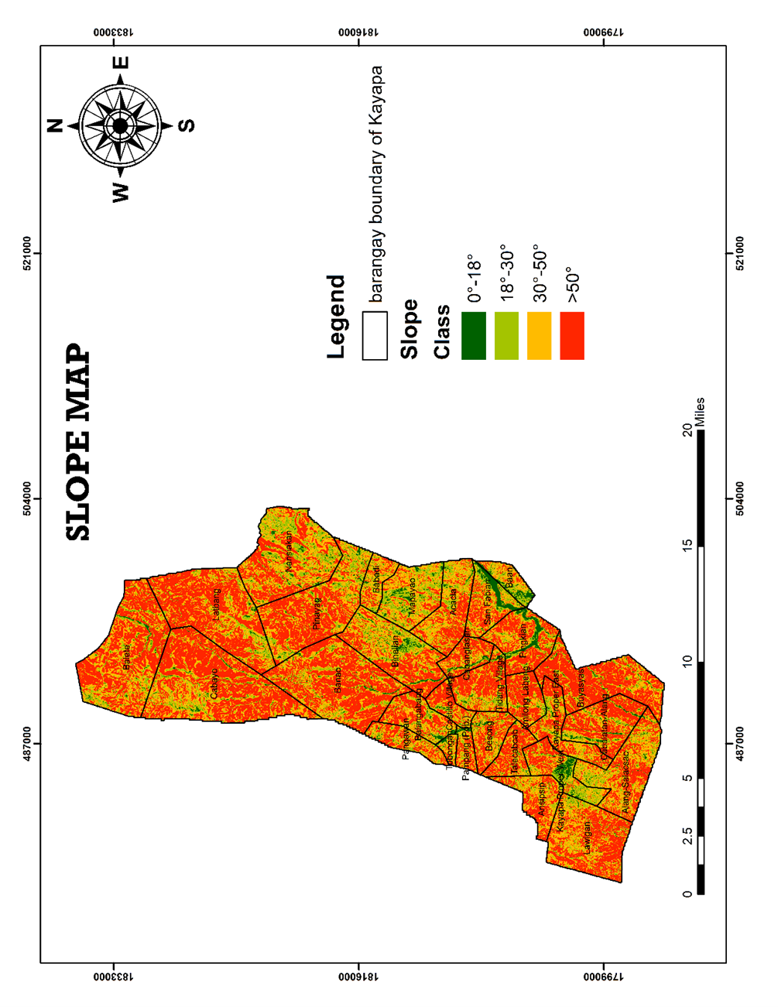
Figure 2. Slope Map of Kayapa Nueva Vizcaya

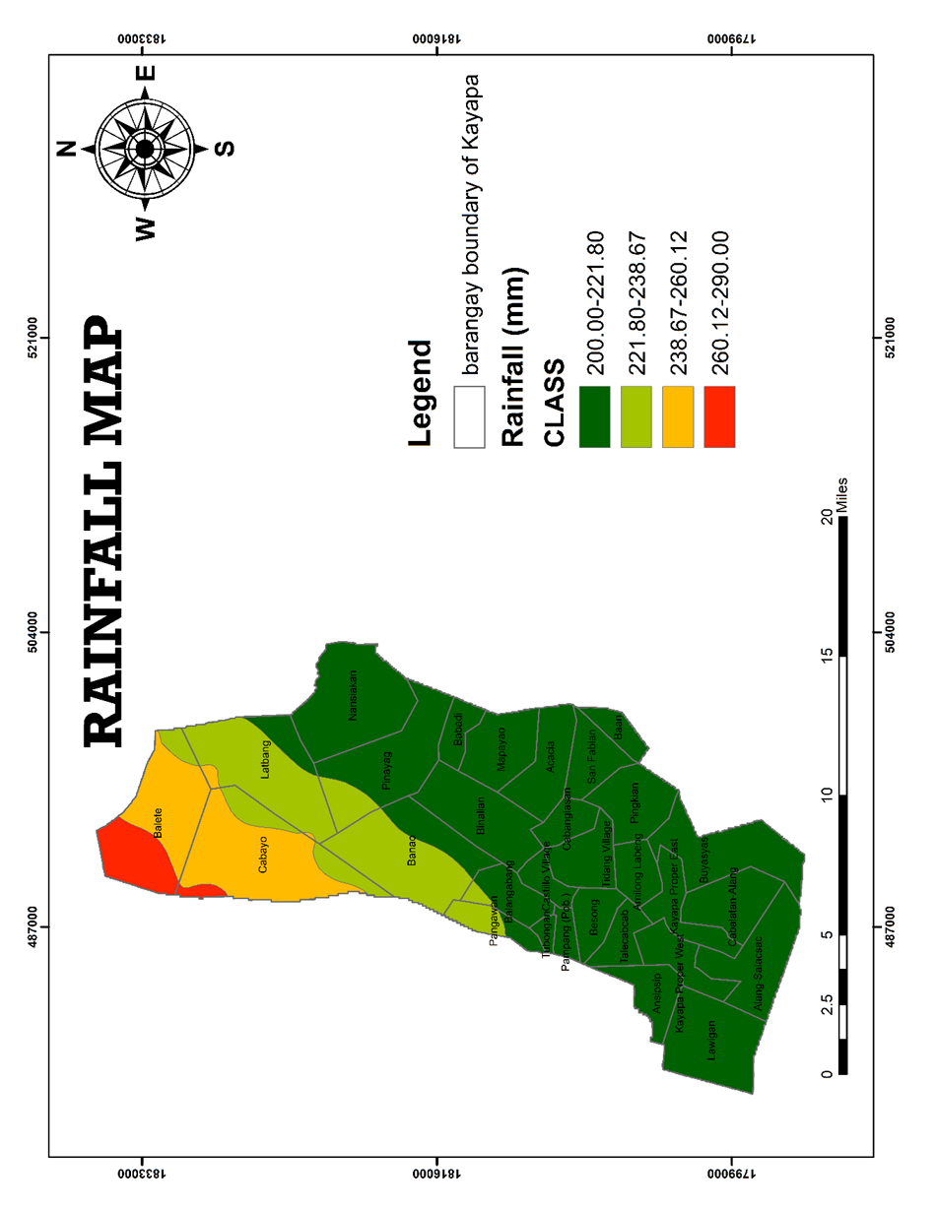
Figure 3. Rainfall Map of Kayapa Nueva Vizcay
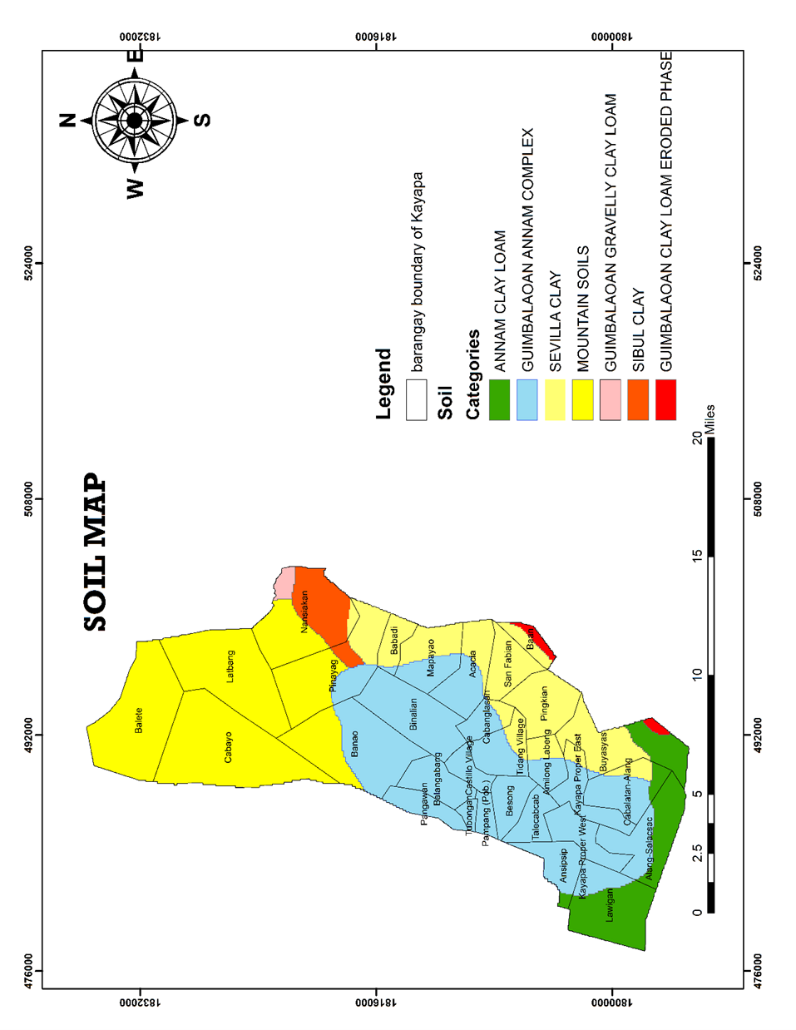
Figure 4. Soil Map of Kayapa Nueva Vizcaya

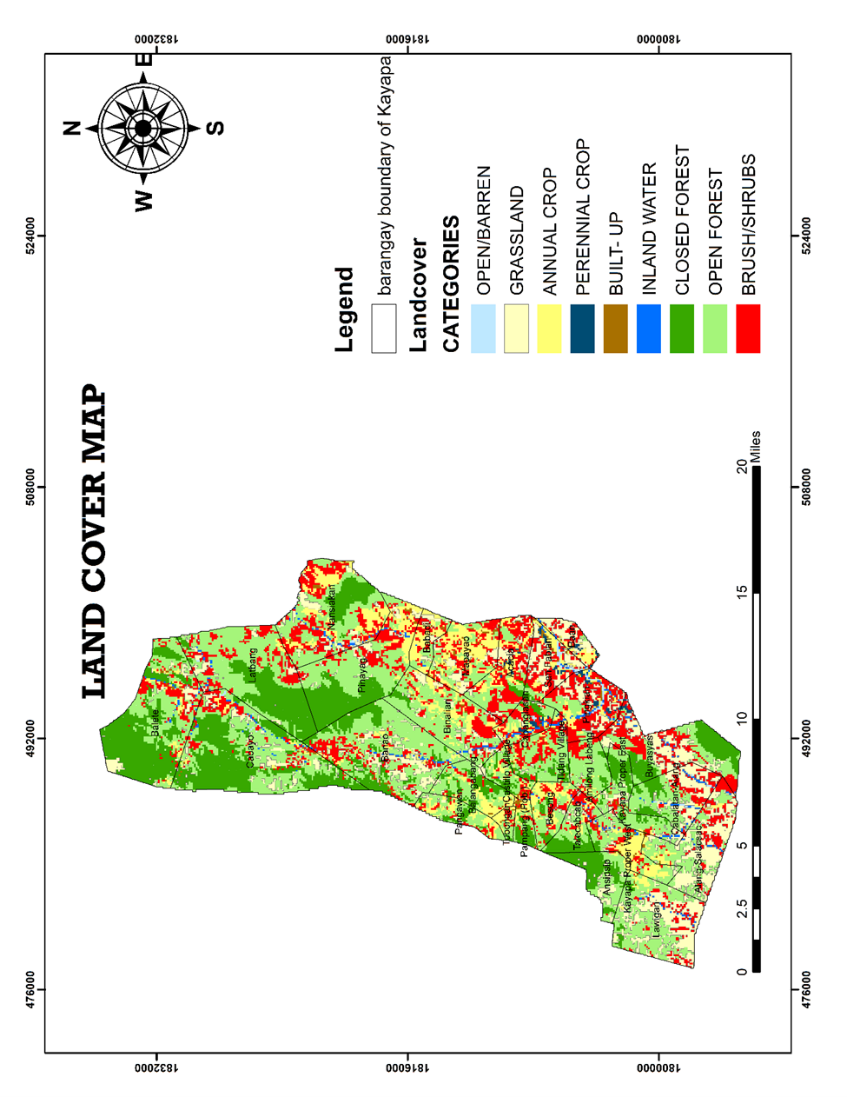
Figure 5. Land Cover Map of Kayapa Nueva Vizcaya

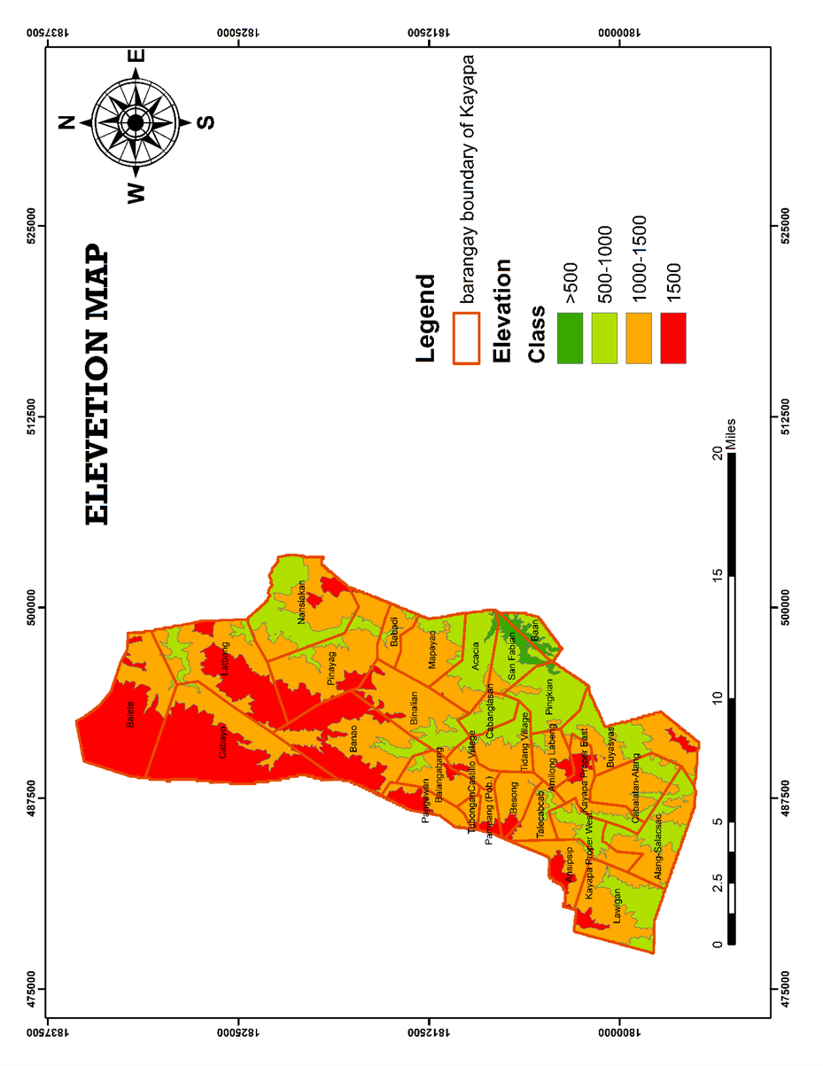
Figure 6. Elevation Map of Kayapa Nueva Vizcaya

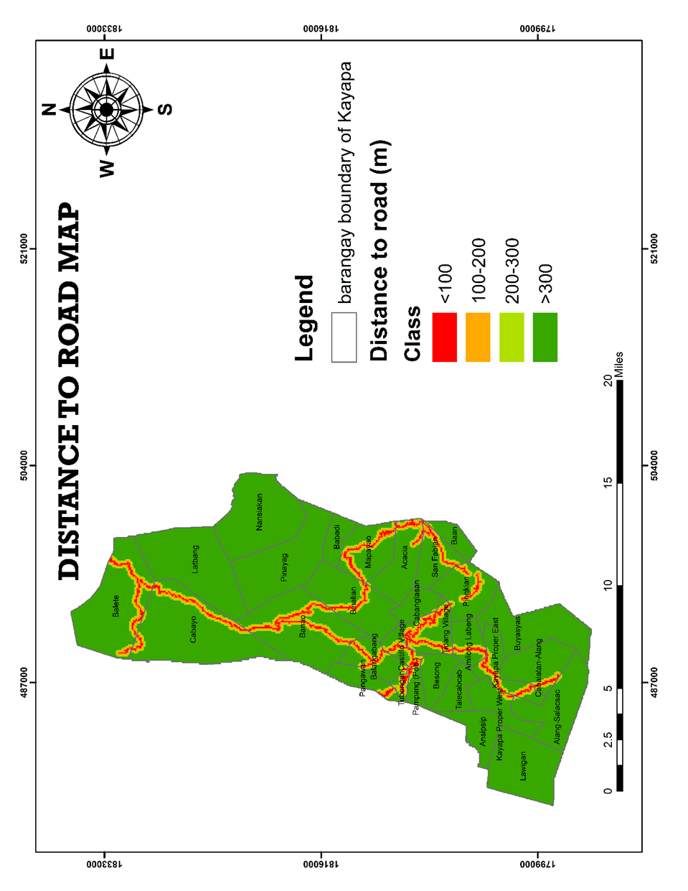
Figure 7. Distance to Road Map of Kayapa Nueva Vizcaya

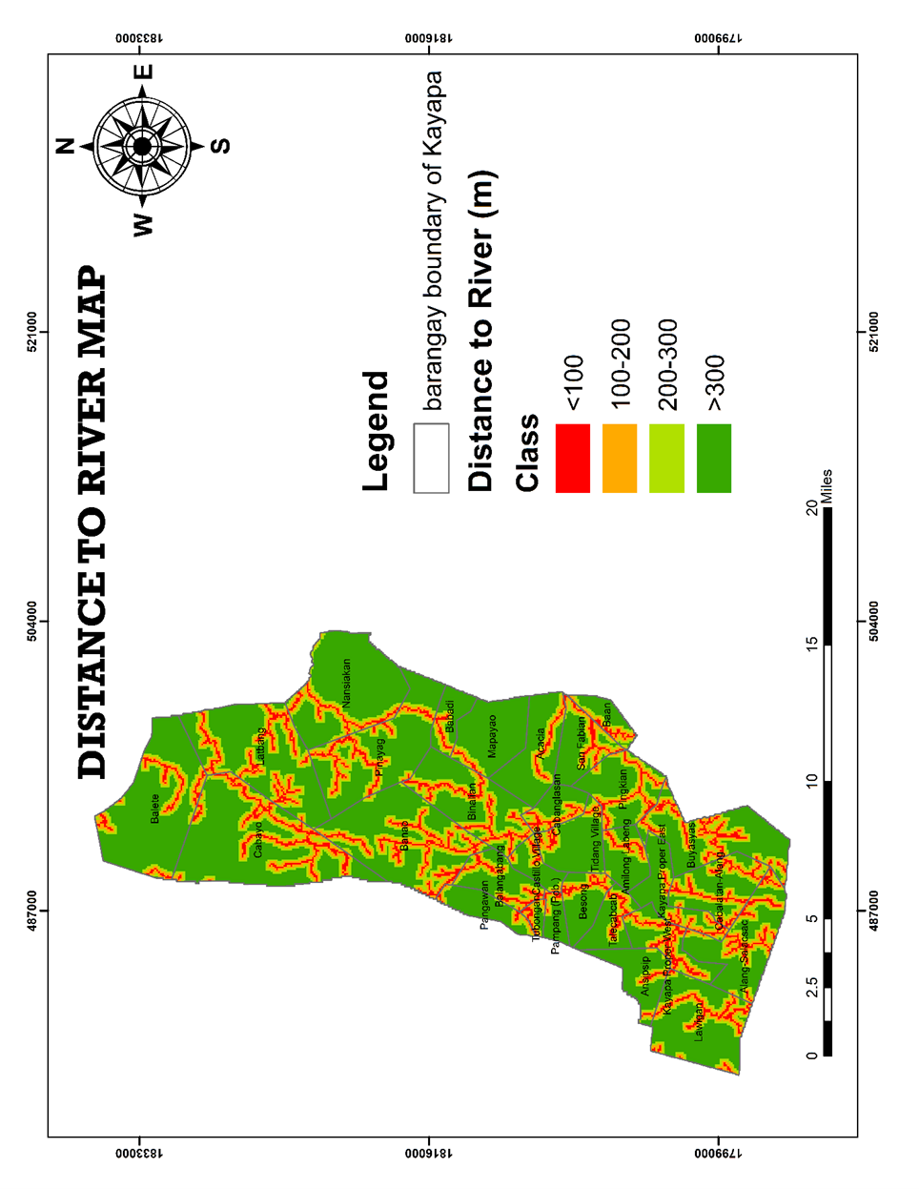
Figure 8. Distance to River Map of Kayapa Nueva Vizcaya

3. Visualization of Landslide Susceptibility of Kayapa Nueva Vizcaya

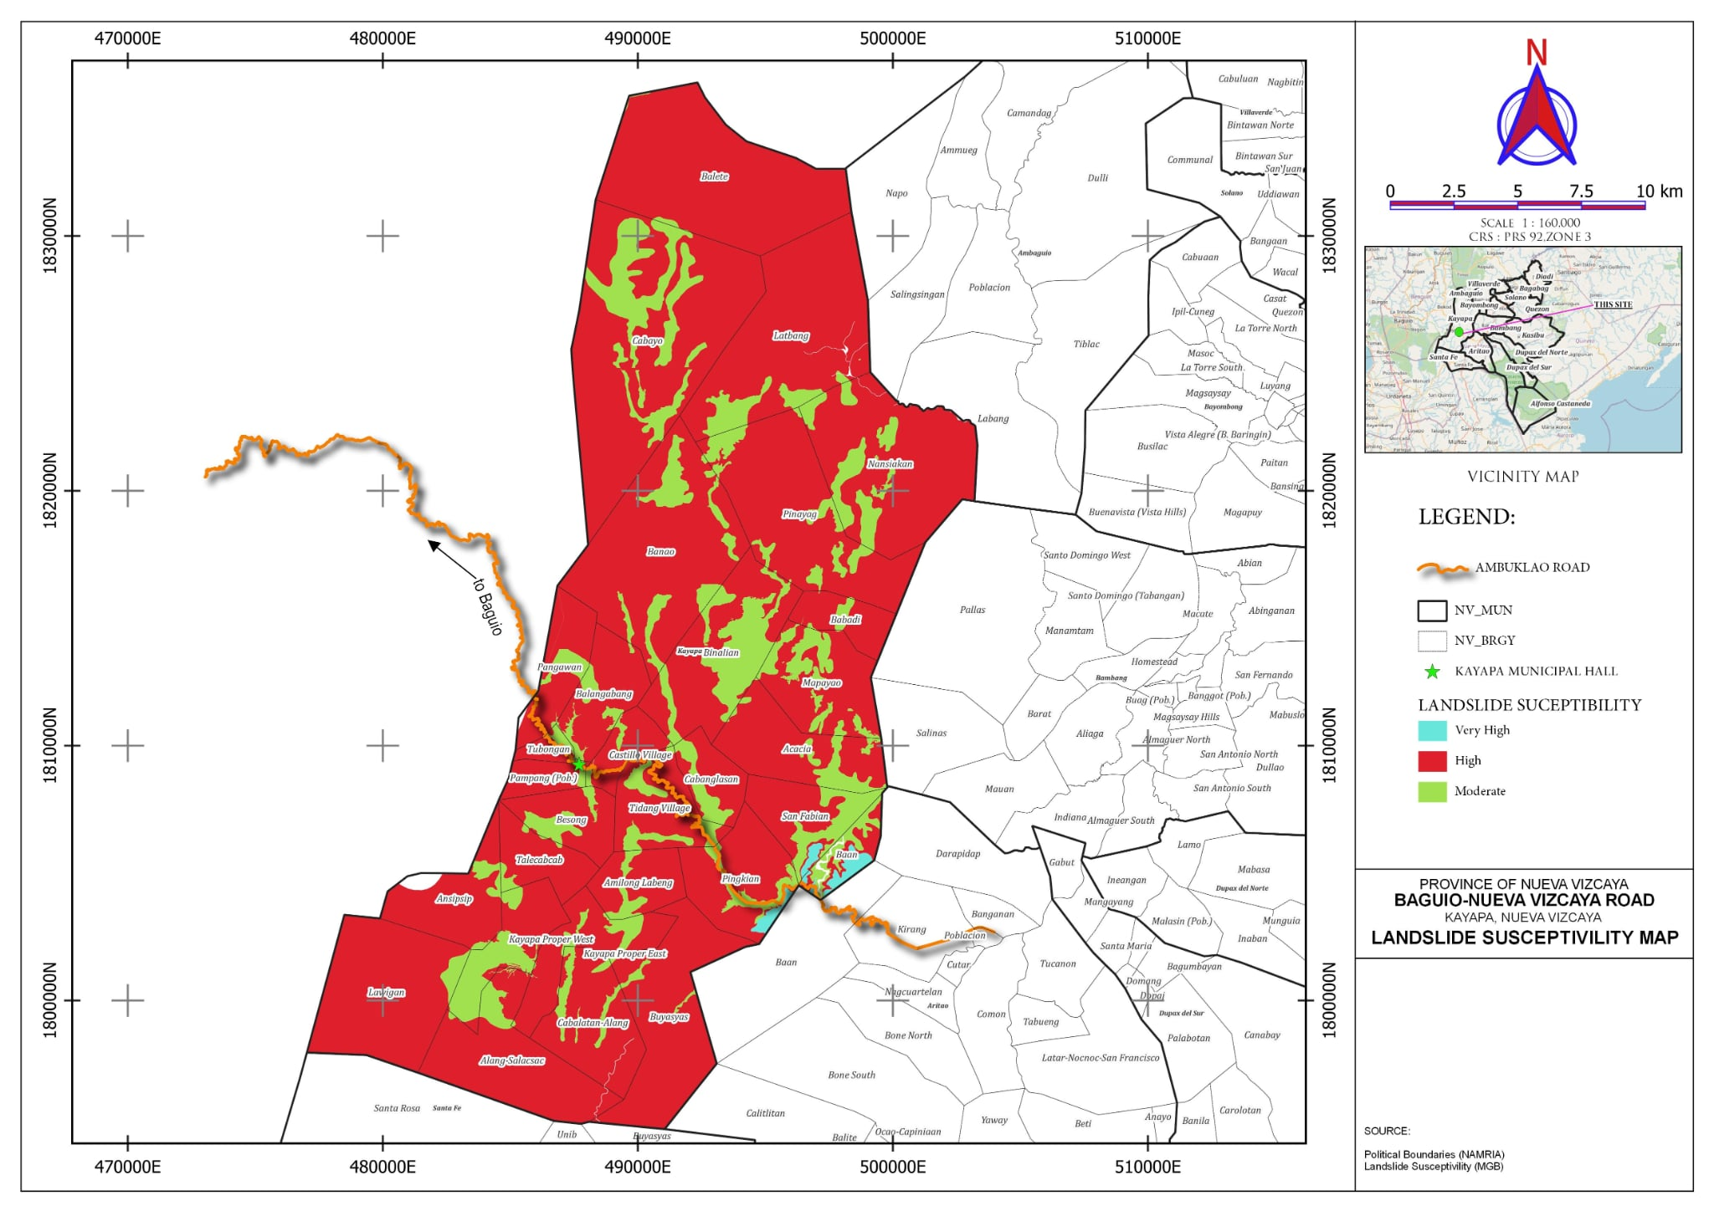
Figure 9. Landslide Susceptibility Map of Kayapa Nueva Vizcaya
4. Validations to support the landslide susceptibility map

Points | Validation Rating
1 | Low
2 | High
3 | Low
4 | High
5 | High
6 | High
7 | High
8 | High
9 | High
10 | High
11 | Moderate
12 | High
13 | High
14 | High
15 | Moderate
16 | Low
17 | High
18 | High
Table 10. Field Survey for validation of points

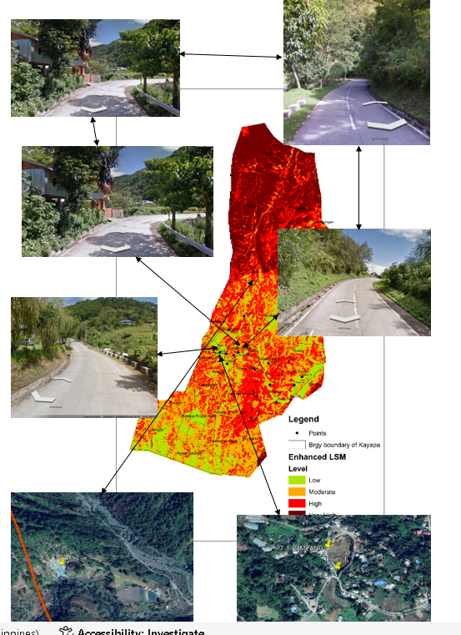

Figure 10. Overlaying of Points Validated in Enhance LSM of Kayapa Nueva Vizcaya

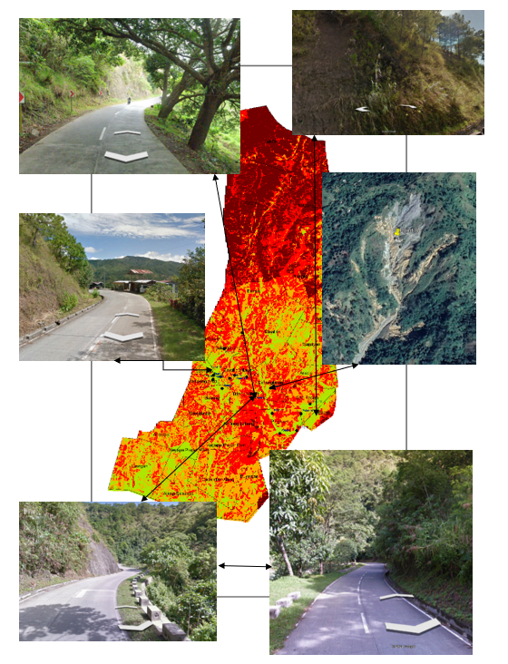
Figure 11. Overlaying of Points Validated in Enhance LSM of Kayapa Nueva Vizcaya

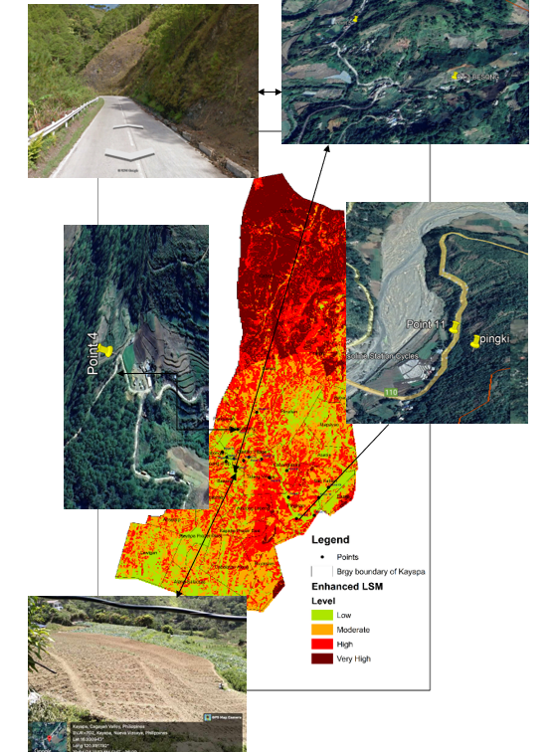
Figure 12. Overlaying of Points Validated in Land SM of Kayapa Nueva Vizcaya

DISCUSSION

Slope angle emerged as the most influential factor among other causative factors, with a relative weight of 35%. Table 2 and Figure 2 illustrates that slopes above 50 degrees and 30 to 50 degrees are classifies as having a very high and high level of susceptibility to landslides and have the largest area, covering 24744.19 hectares (49.94%) and 16,412.24 hectares (33.13%).

Table 3 shows the distribution of rainfall with its corresponding classes and emerged as the second most influential factor among other causative factors, with a relative weight of 23.56%. Based on Figure 3, the study revealed that most of the total area under study were received 200- 221 average rainfall per year.

Soils and landslides are closely related, especially for shallow landslides that occur in soil or weathered bedrock (Temme 2021). Table 4 and Figure 4 depict that mountain soil, sibul clay, guimbalaon clay loam eroded phase, guimbalaon clay loam, and guimbalaom annam complex is categorized as very high and highly susceptible to landslides, having a vast area of 11,412.26 hectares (53.77%) and 18700.48 hectraes (37.73%) of the total area of Kayapa.
Land cover influences landslide susceptibility by affecting soil stability and water infiltration. As shown in Table 5, open/barren, built-up, grassland, inland water, annual/perennial crops are considered to be very highly and high susceptible to landslides but have the smallest are, encompassing 9,036.68 hectares (35.13%) and 4,947.71 hectares (9.99%) of the total area of Kayapa.
Elevation is a parameter frequently used in landslide susceptibility analysis and is regarded as a vital factor for susceptibility mapping (Anthuwaynee et al., 2022). As shown in Table 6, a very high and high level of susceptibility is attributed to elevations exceeding 1000 meter and 1000 to 1500 meters above datum, but they have the largest area, covering 11,629.62 hectares (23.47%) and 25,166.29 hectares (50.78%) of the total area of Kayapa.

Proximity to roads can influence landslide susceptibility due to disturbances and slope destabilization during construction. As shown in Table 7 and Figure 7, places within 0 to 100 meters from the roads are considered to have a very high susceptibility to landslides and consist of only 1,474.34 hectares (2.97%) of the total area of Kayapa.

Distance from rives emerged as the last influential factor, with a relative weight of 3.66%. Table 8 revealed that areas within 0 to 100 meters from rivers are classified as having a high susceptibility to landslides, covering only 2447.06 hectares (11.53%) of the total area. Moreover, areas falling within 100 to 200 meters and 200 to 300 meters are classifies ad having low to moderate levels of susceptibility to landslides, with the smallest portion encompassing 1643.89 hectares (7.75%) and 1784.71 hectares (8.41%).

To validate the results, the researchers employed geotagging on areas identified to exhibit disparities or differences in susceptibility class between the existing landslide susceptibility map and the updated version. Thereafter, a field survey was carried out to further assess the accuracy and the reliability of the latter, using GPS Camera to capture numerous georeferenced photographs. Furthermore, photos online from reliable sources that illustrate landslide cases in the area were geotagged. This method was identified to yield positive result.
The verified locations are shown in Figures 10 to 12, together with the associated geotagged photos. The points 1 in Pampang (points 2 and 4), Balangabang (points 6, 7, 8, and 9), Pingkian, and (points 9) Cabanglasan were identified as being extremely vulnerable to landslides in the current landslide susceptibility map. Validation revealed that the spots are located 500 to 1000 meters above the datum and have slopes between 18 and 30 degrees, which indicates that they are not very susceptible to landslides. Moreover, the average annual rainfall in these regions is somewhat low. While there are some sections with quite steep slopes, most of the land is not.
Furthermore, points 10 and 13 and points 11 and 16, San Fabian, are situated in Tidang Village. These locations were identified as having a high landslide susceptibility in both the updated susceptibility map and the current one. It has been evaluated and proven by field studies that certain places are in fact extremely sensitive. The geotagged photographs taken with the GPS camera show that these regions have high elevations and steep slopes and received more precipitation in this area.
Moreover, the geotagged images of landslide cases at points 12, 13, 14, 15, 16, and 18 were obtained from reputable online sources, and locals were contacted to verify their positions. After comparing the results with these points were categorized as very sensitive on the susceptibility map because of their high altitudes and steep slopes. In overall results of the validation, based from table 10 as presented, the study area is highly susceptible to landslide.

CONCLUSION

The result demonstrated a strong relationship between the contributing variables in the municipality of Kayapa particularly along the road the vulnerability to landslides. The data shows a definite increase is susceptibility levels with increasing slope steepness. A total of 24,744.19 hectares (49.94%) is categorized as extremely prone to landslides, especially those with slopes higher than 50 degrees. Rainfall is also crucial factor, with areas experiencing intense or prolonged rainfall being more susceptible to landslides. landsides are most likely to affect areas above 1500 meters above the datum, which total 11629.62 hectares (3.09%). Additionally, the distance to highways and rivers had an impact on susceptibility; regions that were closer to these features—that is, less than 100 meters away—showed a greater chance to landslides.

ACKNOWLEDGEMENTS

With sincere gratitude and great appreciation to my BSGE fourth year students, Ms. J.B. Bello; Mr. CJ. G. Fontanilla; Mr. E. B. De Guzman; and Mr. J. S. Ferrer, for their dedications and efforts in data gathering particularly in the field survey for validation of points and for thematic mapping.

REFERENCES

1. Aafaf EJ., et al. (2019). GIS-multicriteria evaluation using AHP for landslide susceptibility mapping in Oum Er Rbia high basin (Morocco).https://geoenvironmental-disasters.springeropen.com/articles/10.1186/s40677-019-0119-7.
2. Addis A. (2023). GIS-Based Landslide Susceptibility Mapping Using Frequency Ratio and
ShannonEntropyModelsinDejenDistrict,NorthwesternEthiopia.https://www.hindawi.com/journals/je/2023/1062388/.
3. Ali S. (2020). Landslide Susceptibility Mapping by Using GIS Along the China Pakistan Economic Corridor (Karakoram Highway), Pakistan. https://nhess.copernicus.org/preprints/nhess-2018-39/nhess-2018-39-manuscript-version3.pdf.
4.Alsubal et al., (2009). A review on mechanism of rainwater in triggering landslide. https://iopscience.iop.org/article/10.1088/1757-899X/513/1/012009.
5. Althuwaynee O. F., Pradhan B., Lee S. (2022). A novel integrated model for assessing
landslide susceptibility mapping using CHAID and AHP pair-wise comparison. InternationalJournalofRemoteSensing.https://www.researchgate.net/publication/295860919_A_novel_integrated_model_for_assessing_landslide_susceptibility_mapping_using_CHAID_and_AHP_pair-wise_comparison
6. Arca & Lorenzo, (2018). Landslide hazard mapping using limit equilibrium method with GIS application of roadway traversing mountain slopes: The case of Kitaotao Bukidnon, Philippines https://scholar.google.com.ph/scholar?start=0&q=study+on+enhanced+landslide+mapping+using+gis+philippines&hl=en&as_sdt=0,5&as_vis=1#d=gs_qabs&t=1705823710710&u=%23p%3DLScOtlgluc8J
7. Arizapa JL., Combalicer EA., Tiburan CL. (2015). Landslide Susceptibility Mapping of Pansanjan-Lumban Watershed using GIS and Analytical Hierarchy Process. https://ovcre.uplb.edu.ph/journals-uplb/index.php/EDJ/article/view/216.
8. Chen et al., (2019). The influence of land use and land cover change on landslide susceptibility: a case study in Zhushan Town, Xuan'en County (Hubei, China) https://nhess.copernicus.org/articles/19/2207/2019/
9. Eco, R. N., Aquino, D. T., Lagmay, A. M. F., Alejandrino, I., Bonus, A. A., Escape, C. M.,
... & Timbas, N. L. (2015). Landslide and debris flow susceptibility mapping of Leyte Province, Philippines using remote sensing, numerical modelling, and GIS. Journal of the Philippine Geoscience and Remote Sensing Society, 1(1), 53-71.https://www.researchgate.net/profile/NicolaLouiseTimbas/publication/333930175_Journal_of_the_Philippine_Geoscience_and_Remote_Sensing_Society_Date_25/links/5d0cf58792851cf4403ebdd4/Journal-of-the-Philippine-Geoscience-and-Remote-Sensing-Society-Date-25.pdf
10. Hong et al., (2018). Improving the accuracy of landslide susceptibility model using a novel region-partitioningapproach.pp.753-772.
11. Guo et al., (2022). Landslide susceptibility mapping in the Loess Plateau of northwest China using three data-driven techniques. A case study from middle yellow Yellow Rivercatchment.https://www.frontiersin.org/articles/10.3389/feart.2022.1033085/full#B17
12. Hadmoko DS et al., (2017). Spatio-Temporal Distribution of Landslides in Java and the Triggering Factors. Forum Geogra, Vol 31 (1) July 2017: 1-15. ISSN: 0852-0682. DOI: 10.23917/forgeo. v31i1.3790.
13. Javier et al., (2019). Frequency Ratio Landslide Susceptibility Estimation in a Tropical Mountain Region. The International Archives of the Photogrammetry Remote SensingandSpatialInformationSciences.https://www.researchgate.net/publication/335452933_FREQUENCY_RATIO_LANDSLIDE_SUSCEPTIBILITY_ESTIMATION_IN_A_TROPICAL_MOUNTAIN_REGION
14. Jones et al., (2023). Multi-event assessment of typhoon-triggered landslide susceptibility in the Philippines https://nhess.copernicus.org/articles/23/1095/2023/
15.Knapen et al., (2006). Landslides in a densely populated county at the footslopes of Mount Elgon(Uganda):Characteristicsandcausalfactors.https://www.sciencedirect.com/science/article/abs/pii/S0169555X05002060
16. Lindelöf and Åberg (2014). Landslide survey, Mamuyod, The Philippines - DiVA portal https://www.diva-portal.org/smash/get/diva2:743578/FULLTEXT01.pdf
17. Meten et al., (2015). Effect of Landslide Factor Combination on the Prediction Accuracy of Landslide Susceptibility Maps in the Blue Nile Gorge of Central Ethiopia. https://geoenvironmental-disasters.springeropen.com/articles/10.1186/s40677-015-0016-7.
18. Nseka et al., (2021). Implications of Soil Properties on Landslide Occurrence in Kigezi Highlands of South Western Uganda. https://www.intechopen.com/chapters/78594
19. Opiso, E.M., Puno, G.R., Alburo, J.L.P. et al., (2016). Landslide susceptibility mapping using GIS and FR method along the Cagayan de Oro-Bukidnon-Davao City route corridor,Philippines. KSCEJCivEng 20,2506–2512.
20.PAGASA (Philippine Atmospheric, Geophysical and Astronomical Services Administration),(2022)ClimateChangeinthePhilippines,https://www.pagasa.dost.gov.ph/information/climate-change-in-the-philippines.
21. Palmisano, F., Vitone, C., & Cotecchia, F. (2018). Assessment of landslide damage to buildings at theurban scale. Journal of Performance of Constructed Facilities, 32(4),04018055.https://ascelibrary.org/doi/abs/10.1061/(ASCE)CF.1943-5509.0001201
22.Petley, D. (2012). Global patterns of loss of life from landslides. Geology, 40(10), 927-930. https://pubs.geoscienceworld.org/gsa/geology/article-abstract/40/10/927/130722
23.Pioquinto., et al. (2010). Landslide hazard assessment and mitigation measures in Philippinegeothermalfieldhttps://www.academia.edu/25794287/Landslide_hazard_assessment_and_mitigation_measures_in_Philippine_geothermal_fields
24. Rabby YW, Ishtiaque A, Rahman MS., (2020). Evaluating the Effects of Digital Elevation Models in Landslide Susceptibility Mapping in Rangamati District, Bangladesh. https://www.mdpi.com/2072-4292/12/17/2718.
25. Rahim et al., (2018). GIS Based Landslide Susceptibility Mapping with Application of Analytical Hierarchy Process in District Ghizer, Gilgit Baltistan Pakistan https://www.scirp.org/journal/paperinformation.aspx?paperid=82358
26. Ram Mohan, V., Jeyaseelan, A., Raj, T. N., Narmatha, T., & Jayaprakash, M. (2011). Landslide susceptibility mapping using frequency ratio method and GIS in south eastern part of Nilgiri District, Tamilnadu, India. International Journal of GeomaticsandGeosciences, 1(4),951-961.
27.Roodposhti et al., (2023). PROMETHEE II and fuzzy AHP: an enhanced GIS-based landslidesusceptibilitymapping.https://www.researchgate.net/publication/257632800_PROMETHEE_II_and_fuzzy_AHP_an_enhanced_GIS-based_landslide_susceptibility_mapping
28. Sui et al., (2022). Study on the Risk Assessment Method of Rainfall Landslide. https://www.mdpi.com/2073-4441/14/22/3678.7
29.Sultana & Tan (2021). Landslide mitigation strategies in southeast Bangladesh: : Lessons learnedfromtheinstitutionalresponseshttps://www.sciencedirect.com/science/article/abs/pii/S2212420921003630?fbclid=IwAR0TcBm9hUcLHrxu9Fgfl4qnW-koJ1n4qT0pL57gyuNeE9mevOgUs1Hs4Kw
30.Temme, (2021). Relations Between Soil Development and Landslides https://agupubs.onlinelibrary.wiley.com/doi/10.1002/9781119563952.ch9
31.Tubog et al., (2023). Landslide susceptibility modeling derived from remote sensing, multi-criteria decision analysis, and GIS techniques. A case study in the Southeast Bohol Province, Philippines.https://www.researchgate.net/publication/368554421_Landslide_susceptibility_modeling_derived_from_remote_sensing_multicriteria_decision_analysis_and_GIS_techniques_A_case_study_in_the_Southeast_Bohol_Province_Philippines.
32. Vojteková J. & Vojtek M., (2020). Assessment of Landslide Susceptibility at a Local Spatial Scale Applying the Multi-Criteria Analysis and GIS: A Case Study from Slovakia. https://www.tandfonline.com/doi/full/10.1080/19475705.2020.1713233.
33. Vranken, L., Vantilt, G., Van Den Eeckhaut, M., Vandekerckhove, L., & Poesen, J. (2015). Landslide risk assessment in a densely populated hilly area. Landslides, 12, 787-798. https://link.springer.com/article/10.1007/s10346-014-0506-9

