A PREDICTIVE PATIENT HEALTH FRAMEWORK FOR DISEASE IDENTIFICATION AND SPATIAL CARE ACCESSIBILITY

Abstract—Accessibility to healthcare and early detection of illness is one of the largest challenges faced by society today. This research presents a comprehensive solution named an intelligent health prediction and medical recommendation tool for patients seeking medical assistance that utilizes machine learning techniques to analyze patient-reported symptoms and provide predictions of possible diseases. The intelligent health prediction and medical recommendation tool is built upon a random forest classifier that analyzes individual symptom patterns and uses this information to provide the user with a list of their five most likely diseases and the associated probability scores. The tool also provides the user with home care guidance specific to their disease, as well as recommendations for doctor information, including doctor specialization, city of practice, and doctor contact number, when the user needs further assistance beyond home care. The tool also contains multi-language capabilities so that patients can access the tool in English, Tamil and Hindi enhancing accessibility. The developed system integrates data collected based on patient-reported symptoms and the resulting predictions of possible diseases, home care recommendations, and an easy-to-use web interface developed using Streamlit that patients can access to obtain their medical prediction and corresponding guidance on their own time. The experiments revealed that a random forest classifier had an accuracy rate of more than 92%, while logistic regression had an accuracy rate of about 80-85%. Hence, the system enhances how users access healthcare services as it enables users to gauge their potential diseases and provides good counsel on how to seek medical care for their conditions.

Keywords— Machine Learning, Disease Prediction, Random Forest Classifier, Healthcare Decision Support, Symptom Analysis, Hospital Recommendation System, Personalized Healthcare.

INTRODUCTION
Machine learning and artificial intelligence are changing the face of the healthcare industry with the inclusion of smart tools for diagnosis. The early detection of diseases is important to prevent any complication for the patient. However, many individuals are not getting the right medical advice at the right time due to their living location, level of understanding of health information, and the medical resources available at the local level.

The conventional healthcare system demands a patient’s physical presence at a healthcare facility for medical diagnosis. This often results in delayed medical attention for the patient, thereby increasing healthcare expenditure. In this regard, intelligent healthcare systems can be implemented for disease prediction using
machine learning algorithms for assisting patients in recognizing potential diseases based on their symptoms.

The research aims at developing a predictive patient health model using machine learning algorithms for predicting potential diseases from patient symptom data. A Random Forest classifier can be employed for predicting diseases by analyzing symptom-disease relationships.

LITERATURE REVIEW
Machine learning has emerged as an essential component in the prediction of diseases and decision-making in the context of the healthcare industry. A number of researchers have proposed different models to evaluate the symptoms and history of the patients to determine the possibilities of the diseases.

Machine learning has been employed in the prediction of infectious diseases by the researchers Fathima and Manimegalai, as they proposed the application of SVM to construct the system that can forecast the prediction of the spread of the dengue disease; the results show that the application of the machine learning approach can effectively determine the trends related to the diseases [1]. A recent example is the study proposed by Tarmizi et al., as the researchers proposed the application of the system that can detect the dengue outbreak using different feature selection methods to improve the prediction of the diseases [2].

Research has also been carried out in predicting liver diseases by applying data mining techniques. Rajeswari and Reena worked on analyzing liver diseases to find key prediction attributes [3]. Vijayarani and Dhayanand compared the results of Support Vector Machine and Naive Bayes algorithms in predicting liver diseases and found that accurate results could be achieved by applying these algorithms on proper data sets [5].

Machine learning algorithms have also been applied in predicting diabetes. Sarwar and Sharma developed a consultation system for type-2 diabetes by applying the Naive Bayes algorithm [6]. Iyer et al. also worked on different classification techniques for diagnosing diabetes and highlighted the importance of machine learning in clinical decision support systems [7].

In the field of heart disease prediction, Vembandasamy et al. applied the Naive Bayes classifier for predicting heart disorders using patient medical data [9]. Pan et al. also investigated various ensemble machine learning techniques for accurate prediction of heart diseases [11].

Surveys have also been carried out to show the increased use of machine learning in various healthcare applications. Garg and Mago presented the potential of machine learning in medical research and healthcare analytics [12]. Shehab et al. also reviewed various machine learning techniques applied in medical applications and concluded that intelligent prediction systems are useful in improving healthcare decision-making [13].

Even though there are various systems developed for disease prediction using machine learning techniques, none of these systems are providing extra features such as hospital recommendations and language support. The proposed system is trying to overcome these limitations by incorporating extra features in the system.

PROPOSED METHODOLOGY
The proposed system can predict diseases based on symptoms faced by users and provide healthcare recommendations accordingly. The framework for this proposed system includes several modules: data collection, data preprocessing, model training, disease prediction, and hospital recommendations. The overall workflow for this proposed system is demonstrated in the system architecture diagram.

A. Data Collection

The initial step in the system, as presented, is the creation of a dataset that reflects information on a variety of diseases and the symptoms associated with them. This data is essentially the primary source for the training of the machine learning model.The data, in the form of CSV, is easily compatible with most popular machine learning libraries and programming tools.The data itself includes a variety of common indicators, such as fever, cough, headache, fatigue, nausea, sore throat, muscle ache, and chills, which are essentially used to identify and distinguish between different kinds of diseases.The rows in the data represent a specific disease, and the columns identify the presence or absence of specific symptoms for the disease.The data, in its organized form, is a fundamental step towards training a machine learning model to learn and understand the relationship between symptoms and diseases.
B. Data Preprocessing

Datapreprocessing includes all steps that are necessary for cleaning up your dataset before you begin creating your machine learning models. In this stage, we try to identify and correct inconsistencies to ensure that your data remains as correct as possible. In order to achieve our goal, we employ a number of data cleaning methods that remove outliers or any additional irrelevant information that may affect the accuracy of our model. For instance, if we are working with binary data where a symptom present is denoted by a 1 and a symptom absent is denoted by a 0, this helps the algorithms read our data better for a more precise prediction.

C. Feature Selection

Feature selection is a major contributing factor in identifying the actual symptoms that are important for prediction. By choosing only the best features, we are removing additional information from the data. The system is able to run more efficiently by reducing the dimension. The actual accuracy of the system is also improved by focusing only on the most important symptom information. In other words, it is able to forecast results more accurately without additional complexity.

D. Machine Learning Model Training

After preprocessing and feature selection, we proceed to train the machine learning model. We train the classifier by examining the relationship between symptoms and diseases that symptoms indicate. This report looks at how Gen Z (those born in 1997-2012), are starting to change the world of retail and fashion through their increasing buying power and environmental issues. Being the first digital native generation, they have become the largest consumer group in the United States, with projected annual purchases of $143 billion in 2030.The analysis includes an examination of the forces behind Gen Z's decision-making process for today and the future regarding their sustainability-driven behavior patterns of purchasing apparel and their desire for brands that are socially responsible and demonstrate transparency.In particular, this report highlights the value-action gap the difference between Gen Z's positive sustainability attitudes, and their inability to convert those to action experiencing a combination of financial constraints and current fast fashion trends that influence their buying decisions.

E. Symptom Input Module

The system allows users to input the selected symptoms they are experiencing. This can be achieved by presenting the user with a list of the selected symptoms to choose from. This will make it easier for the user to input the condition that he/she is experiencing.

F. Disease Prediction Module

Once the user selects the symptoms, the supervised machine learning model will take over to predict the illness. It will check the data, crunch the numbers, and get the results. It determines how likely a person is to have a certain disease based on the selected symptoms, followed by the determination of the disease the person is likely to have.

G. Hospital Recommendation Module

It provides users with suggestions for hospitals and doctors based on their chosen location. Once a condition is diagnosed, this part provides suggestions for hospitals along with doctor information like their names and contact details. This makes it easier for users to reach hospitals more efficiently.

H. Home Care Suggestion

The system provides users with basic assistance / guidance in utilizing the elements of sequence as part of their self-management strategy. Basic options may consist of suggestions for rest, hydration, simple diets and tempra. Basic home care suggestions assist users in managing their mild illness without requiring them to access hospital emergency rooms. This home care feature of the proposed system can prevent users from making unnecessary trips to the emergency room for minor illnesses. Users will still be encouraged to speak with a health care provider for the management of their severe illness.

I. Multilingual Interface
This new model will have a multilingual user interface that novice or advanced users can use easily. The Users will be able to get predictive case outcomes as well as case-related health information in the language of their choice (English Tamil or Hindi).
Key Features:
- Users can use English, Tamil and Hindi (Multilingual Interface System)
- Users can understand predictive findings and recommendations in their own language.
- The system information can be used by all users and is easy to access.
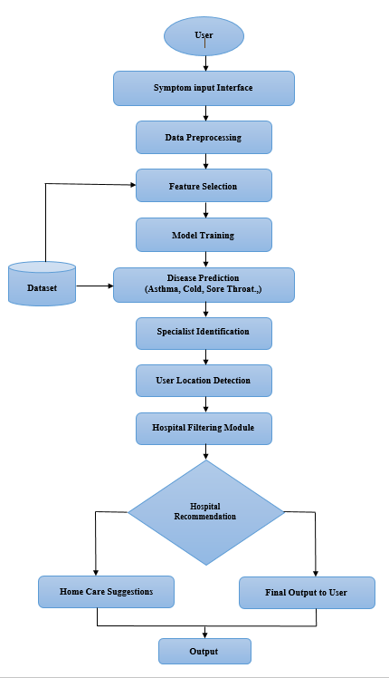
Figure. 1. Proposed system architecture

EXPERIMENTAL SETUP AND RESULTS
A. Development Environment

A disease prediction system was developed using Python, incorporating machine learning libraries for handling the data and training the models. The system was designed with a user-friendly interface, which allows users to enter their symptoms to obtain disease prediction results. The researchers developed a plan for the experimental setup, which was intended to determine the effectiveness of various machine learning techniques for disease prediction using the symptoms entered by the users.

B. Dataset Description

A dataset was used for the research, which maps a variety of symptoms with different diseases. The dataset is a CSV file containing a list of symptoms, including fever, cough, headache,fatigue, nausea, sore throat, muscle ache, and chills, corresponding to a disease condition with its related symptoms.

C. Data Preprocessing

Data preprocessing was conducted before training the model, as is the case with any machine learning model. The dataset was cleaned, and missing values were handled before transforming the symptoms into a binary format. The binary format represents the presence of a disease's symptoms with a 1, while the absence of the disease's symptoms is indicated with a 0. This format makes the dataset easy for machine learning models to work with.

D. Model Training and Evaluation

The dataset was divided into a training set and a test set to assess how well these machine learning algorithms perform. Various classification algorithms were implemented, such as Naïve Bayes, Decision Tree, K-Nearest Neighbor (KNN), and Support Vector Machine (SVM). Accuracy, precision, recall, and F1-score were used as metrics for evaluating these algorithms.

E. Performance Comparison of Algorithms

The study evaluated how well the machine learning algorithms performed by determining their accuracy, precision, recall, and F1 score. Of all the algorithms tested in the study, the Support Vector Machine performed the best in terms of accuracy at 94.1%, followed by the K-Nearest Neighbors algorithm at 92.3%, the Decision Tree algorithm at 91.5%, and the Naive Bayes algorithm at 89.2%. Overall, the study concluded that SVM performed better than the other algorithms in predicting diseases from symptoms.
Algorithm | Accuracy  (%) | Precision | Recall | F1-Score
Naive Bayes | 89.2 | 0.88 | 0.87 | 0.87
Decision Tree | 91.5 | 0.90 | 0.91 | 0.90
KNN | 92.3 | 0.91 | 0.92 | 0.91
SVM | 94.1 | 0.93 | 0.94 | 0.93

Table.1. Performance comparision of algorithms

F. Graphical Representation of Results
A glance at the accuracy chart would reveal that SVM is in the top rank, providing the highest accuracy in prediction. It is clear that SVM is doing exceptionally well in predicting diseases based on the provided symptom data.

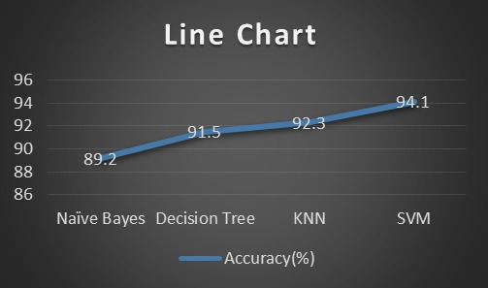
Figure 2. Algorithm Accuracy Line Chart
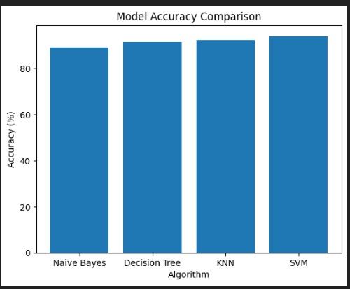

Figure 3. Algorithm Performance Bar Chart

G. System Output Interface

The system provides an interface where users can easily select a list of provided symptoms and input them for prediction of diseases. After processing, the machine learning model would output the probable disease.

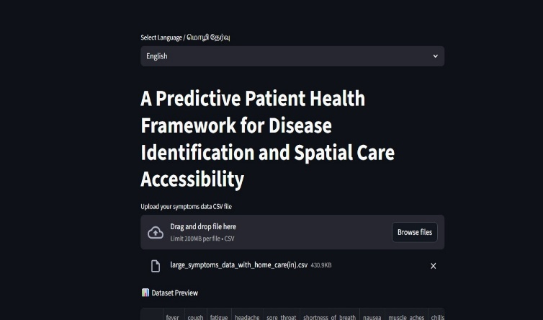
Figure 4. Disease Prediction System Interface
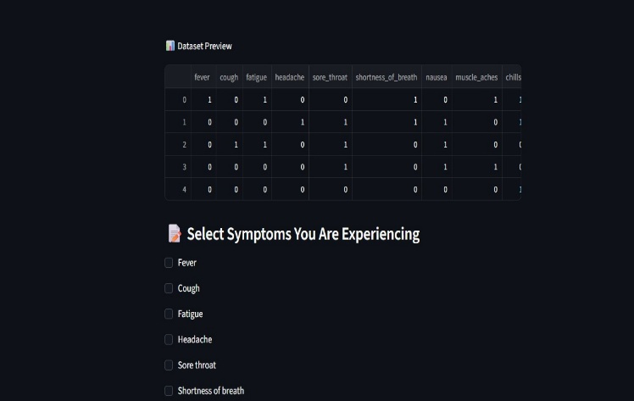
Figure 5. Symptom Selection User Interface
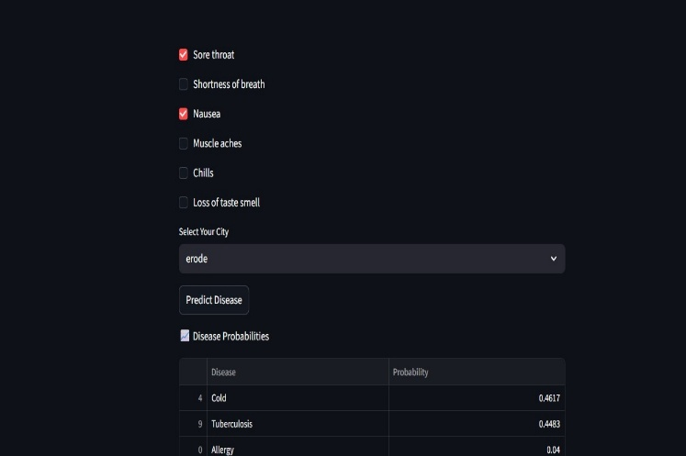
Figure 6. Disease Prediction Output Interface
H. Hospital Recommendation and Multilingual Interface

The system is not only limited to predicting diseases but also helps users locate nearby hospitals and doctors based on their specified location. In addition, it provides home care tips for minor illnesses. To cater to users in specific regions, the system is designed to be used in multiple languages, allowing users to interface in English, Tamil or Hindi.

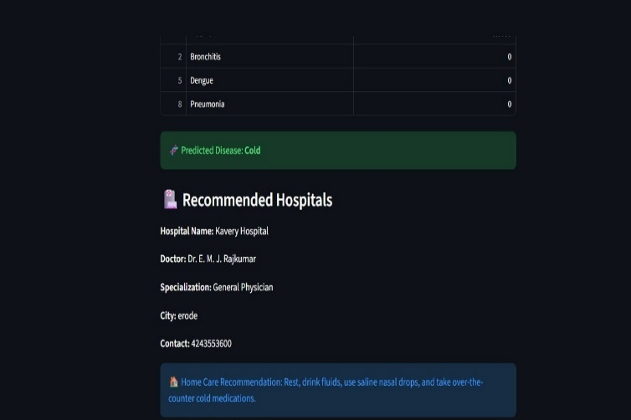
Figure 7. Hospital Recommendation System Output
The Figure 7 shows the result of the proposed disease prediction system. Based on the symptoms provided by the user, the system suggests the disease as Cold. This is shown to the user. Along with this information, the system provides hospital suggestions. Information provided includes the hospital's name, the doctor's name and specialty, the city, and how to contact them. Further, the system provides simple home care tips to the users. This helps the users to understand their health condition and seek proper medical facilities.

Figure 8. Tamil Language System Interface

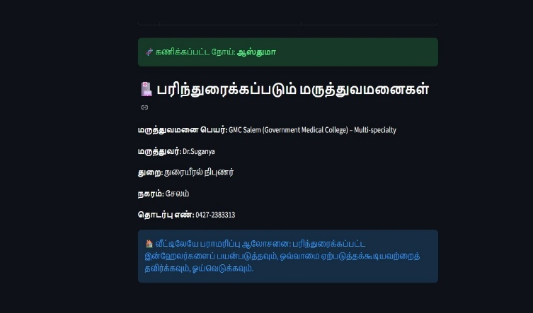
Figure 9. Tamil Hospital Recommendation Output
The above figure shows the multilingual interface of the proposed system using the Tamil language. It shows the suggested disease to the user and provides information on the suggested hospitals and doctors along with their phone numbers. It also provides some home care tips to the users in the Tamil language so that they can understand the information provided. This allows the users to interact with the system in their native language.
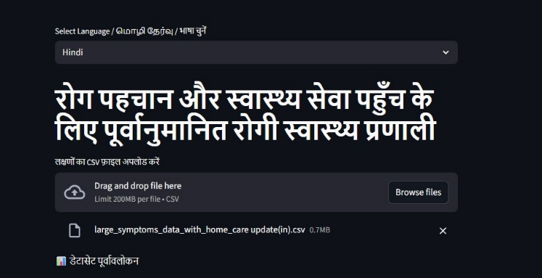
Figure 10. Hindi Language System Interface
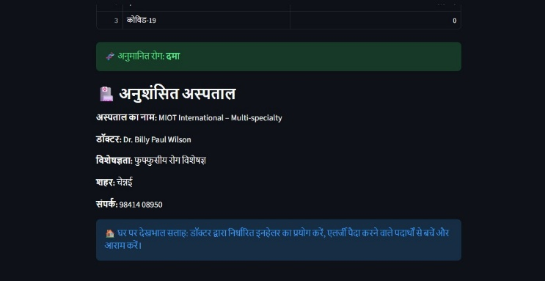
Figure 11. Hospital Recommendation Output in Hindi
CONCLUSION
The paper presents a machine learning-based disease prediction system that can predict possible diseases based on the symptoms provided by the user. The system utilizes various classification algorithms like Naive Bayes, Decision Tree, K-Nearest Neighbor (KNN), and Support Vector Machine (SVM) to process the inputted symptoms and determine the possible disease. The results of the experiment showed that the SVM algorithm has the highest accuracy of 94.1%. The system not only helps users predict possible diseases but also helps users find hospitals and home care services. The system supports both English and Tamil languages. The system is beneficial for people who want to know some basic health information about themselves. The system helps people detect their possible diseases at an early stage.

REFERENCES

[1] A. S. Fathima and D. Manimegalai, “SVM classification models for predicting arbovirus dengue trends,” Journal of Advanced Engineering and Technology Studies, vol. 2, no. 521, pp. 521–527, 2024.

[2] N. D. A. Tarmizi et al., “Dengue outbreak detection system development using feature selection methods in Malaysia,” NextGen Information Technology Journal, vol. 4, no. 1, pp. 96–107, 2023.

[3] P. Rajeswari and G. S. Reena, “Analysis of liver disease using data mining techniques,” World Journal of Computer Science Research, vol. 10, no. 12, pp. 48–52, 2022.

[4] A. Gulia et al., “Advanced computation methods for classifying liver patients,” Global Journal of Computer Science and IT, vol. 5, no. 12, pp. 5110–5115, 2022.

[5] S. Vijayarani and S. Dhayanand, “Predicting liver disease using SVM and Naive Bayes techniques,” Journal of Innovative Science and Engineering Research, vol. 4, no. 15, pp. 816–820, 2023.

[6] A. Sarwar and V. Sharma, “Smart type-2 diabetes consultation with Naive Bayes approaches,” International Journal of Computer Applications, vol. 3, no. 12, pp. 14–16, 2025.

[7] A. Iyer, S. Jeyalatha, and R. Sumbaly, “Classification based approaches of diabetes diagnosis,” Journal of Data Mining and Knowledge Processing, vol. 5, no. 7, pp. 1–14, 2022.

[8] T. Tan et al., “Hybrid evolutionary methods for feature selection in data mining applications,” Expert Systems and Applications, 2023.

[9] V. Vembandasamy et al., “Predicting heart disorders using Naive Bayes classifier,” Innovative Science and Technology, vol. 2, pp. 441–444, 2024.

[10] A. Otoom et al., “Effective methodologies for diagnosis and monitoring of heart disease,” Software Engineering Applications, vol. 9, pp. 143–156, 2025.

[11] C. Pan et al., “Effect of categorical and numerical variables in ensemble machine learning models to predict heart disease,” Biomedical Signal Processing and Control, vol. 76, 2022.

[12] A. Garg and V. Mago, “The potential of machine learning in advancing research in medicine,” Computer Science Review, vol. 40, 2021.

[13] M. Shehab et al., “Current machine learning methods in medical applications: A survey,” Computers in Biology and Medicine, vol. 145, 2022.

[14] M. Bansal et al., “A comparative study of KNN, genetic algorithm, SVM, decision tree and LSTM algorithms,” Decision Analytics Journal, vol. 3, 2022.

[15] M. M. Ahsan and Z. Siddique, “A systematic review of machine learning methods to diagnose heart disease,” Artificial Intelligence in Medicine, vol. 128, 2022.

