Dockers Pin height in semi-sweet variety may be the game changer for cost reduction

Abstract:-
Every ingredient we are adding in the recipe of semi-sweet Hard Dough variety biscuit has some output, which effect on the yield.
One of the most popularly used ingredients in Biscuit Industry is Ammonium Bicarbonate. Without this ingredient semi sweet Hard Dough biscuit production is difficult, but it has no output as it is 100% evaporating at the time of Baking and no contribution on yield.
How much we can reduce the use of this ingredient; we can reduce the cost of the product.

Keywords :- Dockers pin, dockers hole and its importance, reduction of leavening agent, Semi-sweet Hard dough Biscuit.

Dockers pin height may reduce the consumption of Leavening Agent.
Introduction: -
Semi sweet hard dough biscuit means it is simple hard dough biscuit without any fermentation process. In this process leavening agent like ammonium bicarbonate, sodium bicarbonate…. are basically used for getting proper stack height of the biscuit with proper bite. Ammonium bicarbonate is the only ingredients which has no contribution on yield and its quantity is not fixed in any recipe of semisweet hard dough variety biscuit, to get proper stack height some time we are using excess ammonium bicarbonate, as it has no contribution on yield so it is just increasing the cost of production.
Dockers hole on semi sweet hard dough variety plays a major roll to eliminating moisture, proper baking, avoid blister and uneven surface finished.

Roll of dockers hole in semi-sweet hard dough biscuits
Each and every dockers hole act as an edge of the biscuits, when biscuits passing through the baking oven, heat flow will continue through the dockers hole and product baked properly.
When Biscuits passes through the baking oven, leavening agents releases CO₂ which lift the biscuits and releases the gases from dockers hole, if dockers hole is not there then upper layer of the biscuits will lift like a ballon and it will be burnt and blisters will appear on the top surface of the biscuits.
Present scenario: -
If we go through any semi-sweet hard dough variety biscuit cutting die, we will find some dockers pin is there and brand name or Organization name is there. Hight of the dockers pin is always larger in size than that off Organization name or brand name impression, it is due to top to bottom dockers hole in biscuit. As dockers pin immersed the biscuit fully so effectiveness of leavening agent reduces as gases released from top and the bottom side of the biscuit for that reason to get desire thickness of the biscuit more leavening agent is required.
Critical observation: -
If we check semi-sweet Hard dough biscuit very critically, blister never find on the Brand Name or Organization Name impression section, It is indicating that for this particular variety full immersion of dockers pin is not required for preventing blister on Biscuit, If upper layer of the biscuit punch through dockers pin, then gases can be released easily.
New Development and its benefit: -
Dockers pin height reduced to Brand Name or organization name character height of a cutting die cup. So that dockers pin punch the upper layer of the biscuit but not the total Biscuit. Thickness of the raw biscuit for semi-sweet hard dough variety is about 1.4 to 1.7mm and thickness of the baked biscuit is about 5mm to 6mm. so if dockers pin punch up to 60 to 70% of the thickness then gases generated from the leavening agent can be released properly, and from the rest part where dockers pin is not there will help to lift the inner layer of the biscuit, as a result biscuit will get desired stack heigh . As the bottom layer of the biscuit not punch through dockers pin so gasses generated from leavening agent can’t release from bottom. Bottom layer is very thin and at the time baking, biscuit runs through weir band, there is no issue of heat transfer from weir band to the bottom layer of the biscuit and the baking quality should be perfect.

Benefits: -
In this new development as dockers pin only punch the upper layer of the biscuit not the total biscuit, in that case gases generated from leavening agent to lift the biscuit will released from only upper layer. As gas released will be within controlled condition, so the effect of the gas to lift the biscuit will be more, as a result we will get more stack height. To get desired stack height consumption of leavening agent will be reduced and we get desired thickness of the biscuit with minimum uses of Ammonium bi carbonate which has no contribution on yield. So cost of production automatically reduces with the reduction of consumption of Ammonium bicarbonate.
How to satisfy other roll of dockers pin.
- For semi sweet Hard dough variety dockers hole release the gas and prevent blister formation on the biscuit surface.
- If we reduce dockers pin length, it will also punch the top surface of the biscuit and gases also released and blister formation on the top surface not happened.
- Dockers hole forms multiple edge in a Biscuits and help to transfer hit as a result baking quality improved.
- If we reduce dockers pin length, it will also punch the biscuit 70 % of its thickness, gasses will be released and thin layer of the bottom will baked properly as it directly touch with the oven band and heat transfer will be perfect and no issue on baking.
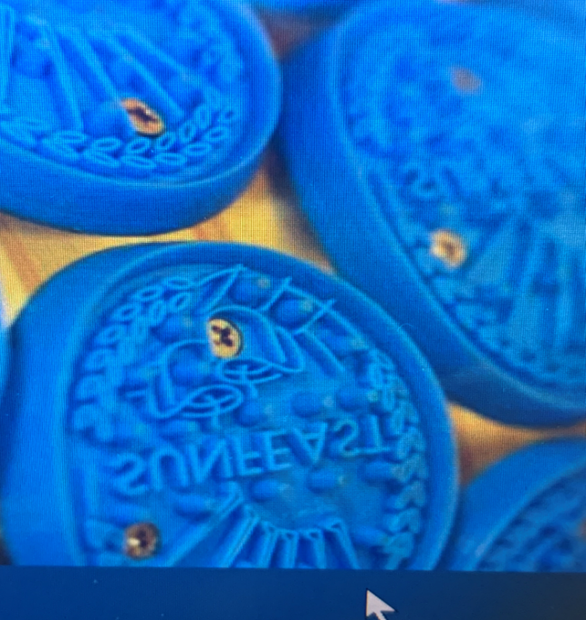
Dockers pin
We want to reduce the height of the dockers pin, by which it will just punch the upper layer of biscuit.

Case study:-
Trial has been taken in a plant for semi sweet hard dough variety biscuit, details result are given below.
For a particular recipe it is found that, to get standard thick ness of the biscuit 12 kg ammonium bicarbonate is used.
SL No | No of Biscuit | Stack length (mm) | Weight (gm)
1 | 20 | 114 | 88.6
2 | 20 | 114 | 88.5
3 | 20 | 113 | 88.5
4 | 20 | 114 | 88.5
5 | 20 | 115 | 88.6
Trial has been taken after reduction of Dockers pin length and found very good result in stack height in a same condition with same batch using 12 kg ammonium bicarbonate, result given below
SL. No | No of Biscuit | Stack length (mm) | Weight (gm)
1 | 20 | 122 | 88.6
2 | 20 | 124 | 88.4
3 | 20 | 124 | 88.4
4 | 20 | 122 | 88.4
5 | 20 | 124 | 88.6
This is a sample data, this trial has been continued for two month and every time same result is observed ie , with a same biscuit weight stack length of 20 biscuit increased by 6 to 8mm. At the same time to ensure perfect baking, moisture of the biscuit have been checked and no deviation found with the Biscuit made with large size dockers pin, result given below.
SL. No | Moisture % of the Biscuit with small dockers pin size (punch only upper layer) | Moisture % of the Biscuit with existing size dockers pin size (punch through out the biscuit)
1 | 1.68 | 1.72
2 | 1.72 | 1.68
3 | 1.75 | 1.80
4 | 1.67 | 1.70
5 | 1.69 | 1.65
In both the cases moisture % found within standard 1.6% to 1.8%
To get more confidence with this trial, one arrangement has done, In a single cutter 50% of the cup change by small dockers pin cup and run the cutter. In this trial 50% biscuit with full punch and 50% biscuit with only upper layer punch. In case of stack height, distinct difference has been observed but moisture found almost same for both the biscuit. result given below.

SL. No | Stack height of 20 biscuit with large dockers pin (mm) | Moisture% of the biscuit with large Dockers pin | Stack height of 20 Biscuit with small dockers pin(mm) | Moisture % of Biscuit with small dockers pin
1 | 112 | 1.72 | 122 | 1.72
2 | 113 | 1.68 | 120 | 1.75
3 | 112 | 1.76 | 122 | 1.76
4 | 114 | 1.75 | 124 | 1.76
5 | 113 | 1.70 | 120 | 1.68
6 | 112 | 1.68 | 124 | 1.78
7 | 114 | 1.80 | 124 | 1.81
8 | 114 | 1.75 | 120 | 1.65
9 | 113 | 1.68 | 124 | 1.70

From the above study it is clear that more stack height is observed with small dockers pin and moisture % is within standard of 1.6 to 1.8% in both the cases.
All the above study has been done with regular running batch, now trial has been taken after reduction 40% Ammonium bicarbonate, ie in regular cutter we are using 12 kg Ammonium bicarbonate as a leavening agent for a particular recipe. Now batch has been prepared with 7.2 kg Ammonium bicarbonate in a particular recipe without changing other ingredients. Result given below

SL .No | Weight of 20 Biscuit (gm) | Stack height of 20 biscuit with upper layer punching(mm) | Moisture % of Biscuit | Remarks
1 | 88.4 | 112 | 1.58 | Stack height within standard
2 | 89.2 | 114 | 1.65 | Moisture within standard
3 | 88.6 | 113 | 1.62
4 | 87.8 | 112 | 1.66 | Standard Stack height is 112 to114 mm of 20 biscuits
5 | 88.2 | 112 | 1.59
6 | 88.1 | 112 | 1.62
7 | 88.3 | 114 | 1.65
8 | 89.2 | 114 | 1.65
9 | 88.7 | 114 | 1.58
10 | 87.9 | 113 | 1.72
11 | 88.2 | 113 | 1.67
In this particular recipe and from the above trial data it is found that after reduction of 40% ammonium bicarbonate from regular batch size stack height and biscuit moisture within standard for small dockers pin and only upper layer punch biscuit and physically no blister found on upper surface of the biscuit.
One more trial also conducted after reduction of 50% ammonium bicarbonate ie 6 kg ammonium bicarbonate used for this particular batch. Result given below.

SL. No | Weight of 20 Biscuit (gm) | Stack height of 20 Biscuit (mm) | Moisture %
1 | 87.7 | 112 | 1.61
2 | 88.2 | 112 | 1.62
3 | 88.3 | 111 | 1.62
4 | 87.8 | 112 | 1.59
5 | 87.8 | 112 | 1.63
6 | 87.6 | 111 | 1.64
7 | 88.2 | 110 | 1.58
8 | 88.4 | 112 | 1.62
9 | 87.9 | 113 | 1.67
10 | 88.4 | 111 | 1.63
11 | 87.8 | 110 | 1.58
12 | 88.6 | 112 | 1.57
13 | 88.1 | 110 | 1.65
From the above study it is found that after reduction of 50% ammonium bicarbonate we can achieve desired stack height (For this particular variety standard stack height is 112 – 114 mm for 20 biscuit of weight 88 gm).
Conclusion: - From the above trial and result it can be concluded that after reduction the height of dockers pin ie if dockers pin only punch the upper layer of the semi-sweet biscuit then stack height of the biscuit increases, and to maintain the standard stack height quantity leavening agent (like ammonium bicarbonate which has no contribution on yield as it is 100% evaporated during baking) decreases. As per trial result almost 40% of Ammonium bicarbonate decrease which will directly reduce the cost of the product.
References: -
- Modelling heat and mass transfer during the continuous baking of biscuits Journal of Food Engineering (2002)
- Influence of the drying conditions on the drying constants and moisture diffusivity during the thin-layer drying of figs

Journal of Food Engineering (2004)

3. Sheeting, gauging and cutting in biscuit manufacture
Manley’s Technology of Biscuits, Crackers and Cookies (Fourth edition)2011
D. Manley H. Clark

