FinVoice: Voice-First Multimodal AI with RAG Memory and Blockchain Settlement for Smart Finance Automation

Abstract—Users are simultaneously utilizing different apps for carrying out banking transactions, expenses, making group settlements, as well as doing their shopping. These various apps make users experience cognitive overload. Such a conflicting user experience in financial activities is common today. However, users are not able to handle complex multi-step activities such as contextual purchases, persistent spending memory, as well as group settlements. Although there have been developments in using voice interfaces for queries, these are not accessible to the users due to poor user experience as well as technical complexities that act as barriers in the application of blockchain- based settlement as well as credit innovations. Moreover, there are inaccuracies associated with group settlements. Such hindrances are imposing restrictions on the application ofdigital finance tools as well as the provision of automatic financial assistance.
Hence, to overcome these challenges, the Finvoice consortium proposes the ”voice-first platform for the future of finance” that incorporates ”blockchain-native primitives for settling funds,” ”permanent memory through RAG and multi-modal AI that encompasses voice, text, and images,” and ”semantic + graph knowledge stack to capture context and user preferences,” ”multi- party expense split and settlement through smart contracts and a settlement token on a low-cost L2,” and ”compile pricing and commerce data from vendors to conduct optimal purchases.” Finvoice commits to developing smooth and automated financial experiences that are ”easy for consumers to understand” and ”expandable for the ecosystem through secure auth, storage, and real-time interfaces.”
Index Terms—Voice-first finance, multimodal AI, RAG-based memory, blockchain settlement, smart contracts, automated ex- pense splitting.

- Introduction
The last ten years have witnessed a huge digital revolution in the financial services industry, and it has significantly changed the way people interact and handle their finances. Finance has become more accessible but at the same time
more fragmented in the shift away from physical banking and towards mobile devices and technologies. Confusion and frustration come about as people are increasingly forced to use multiple systems and tools to manage their finances, including budgeting tools, investments, savings, and payments, all of which require multiple sign-on operations. Although the usage of these technological tools in the financial services industry has yet to be explored, the popularity of voice- activated tools and the apparent shift away from typing and typing-based interfaces suggest that the interface needs to be more conversational.

Starting from command and response systems to even more advanced systems of conversations that can even understand context, voice commerce has taken leaps in its development. However, with all this development and creation in the field of voice commerce, only a handful of systems have been able to implement voice commerce and financial management in the form of blockchain technology. The use of blockchain technology, which has led to the development of concepts like ‘Digital Payments’ and ‘Finance,’ is making a tremendous impact in the field of finance. However, the possibilities that can be generated in the field of daily expenses using ‘Blockchain Technology’ remain unexplored. The creation of even more advanced multimodal systems of AI that can understand context based on voice, text, images, etc., has provided fresh opportunities for the development of even more comprehensive and ‘smart’ financial systems. This can be seen in the form of ‘Retrieval-Augmented Generation (RAG).’

Digital fragmentation, on the other hand, it just makes it more messy. You end up using one app here, another app there, and also signing in and out everywhere. Your financial

information is still isolated in different boxes, and therefore, forget about any clever information and/or automaton. Of course, paying up a bill or settling up with friends? Still a mess, lots of complicated math involved, and slow repayment. Most of them also won’t be able to present the general pic- ture by correlating your spending habits, social activities, and likes to enable you to understand how this money is attached to you. This is not just frustrating; it is also influencing how you use your money. Research is continually demonstrating that overly elaborate systems just add to the stress and stress of how one handles their cash. If it is difficult to track just how you are spending your cash or trends in spending, you jeopardize your control over it altogether. Unpaid groups may
even affect relationships.
All of this scattered information means you don’t get to experience the much-better ways of spending money, intel- ligent ways of budgeting, or new and cool technology like decentralized finance or AI that could actually personalize your experience. Of course, there are a ton of financial tools out there, but none of them actually allow you to integrate everything seamlessly. You can use a series of tools like Mint and You Need a Budget to help you track everything, but you still have to enter most of this information manually and sync slowly. You can use voice assistants like Alexa and Siri for simple purchases, but they don’t actually do anything complicated for you. You can use payment splitting tools like Venmo and Splitwise to actually split your bill with friends without any issues, but you still have to chase people down to confirm payment with them. You can use new blockchain and AI-based tools that are recently emerging, but they are still either too complicated for you to use or don’t actually integrate well with other financial tools you are trying to use.

Even with all the advancements in technology like AI, Blockchain, and Voice technology, no one has been able to marry all these together to build a smart system. The tools that exist today are like islands unto themselves; they don’t allow you to seamlessly move between different modalities, they don’t see the whole picture, and they cannot simply settle transactions on their own. That creates a void where something actually intelligent can be built to listen to what you’re saying, marry financial worlds together in their understanding of it all, and make it all seamless.
That’s where FinVoice comes in. FinVoice is a single solution that combines voice communications, financial in- sights from AI technology, and transactional powers from blockchain technology. FinVoice is built on the sharp RAG 2.0 technology, which ensures it gets it right with users, ensuring they always understand the context. You talk, and it listens. The platform enables users to complete transactions with just voice communications. FinVoice settles through SETL tokens, which are fast and cheap, and it pulls from all kinds of places to be sure you see everything clearly.
FinVoice is moving fintech forward, for example, through contextual RAG intelligence, a credit scoring system based on
staking, and gamified incentives for positive financial behavior. It’s transforming personal finance through a revolution that combines AI, blockchain, and voice for a smarter, easier, and far more automated way of managing money. What’s next is an exploration of how it’s made, what differentiates it, where it sits, and what it might do for digital finance in the coming years.
- RELATED WORKS
However, it has been clearly proved by various recent studies that there is a significant shift in focusing more on a particular application of artificial intelligence, i.e., as a tool related to voice-based UI designs and intelligent automation of finance-related applications, e-commerce sites, or service- based applications [1], [6], [7]. Various studies have been conducted on focusing more on the application related to a voice-driven payment system and related commerce applica- tions, indicating how the ease, efficiency, and accessibility of such payment and commerce-related applications have been maintained through technologies such as speech recognition or related machine learning approaches[1], [6]. Additionally, applications related to a voice-based platform like Hello UPI describe how this particular platform has huge potential for catering more towards visually challenged users or first-time users[1]. Conversing has surprisingly contributed towards the progression of digital transactions[10].
Another big avenue of the currently existing literature deals with the use of biometric authentication for purposes of security and trust in digital systems[5]. The studies concerning voice biometrics have highlighted the necessity of the use of voice features with the aim of minimizing the rates of fraud[5]. The studies on multimodal authentication have also highlighted the necessity of the use of facial features with the aim of security and identification of users, which makes the system implementation highly applicable for purposes of security and convenience[10], as highlighted by the studies.
However, there are a number of studies that also address the issue of application in creating a sense of improvement concerning the satisfaction of users and the quality of decision making [2], [3], [4]. Indeed, it is clear that restaurant ordering and food delivery services that employ the use of artificial intelligence place more emphasis on sentiment analysis to ensure that recommendations on food for consumption are made appropriately[2], [4]. On the other hand, shopping and budgeting apps aim to ensure that users are able to make better decisions by performing various comparisons[3]. The application is based on the satisfaction of the end product user.
Application of finances in mobile phones has also been a topic of interest among researchers in the context of the overall impact of financial literacy, as well as inclusion in the overall field of finance[8], [9]. According to researchers, the overall utilization of smart phone financing will have a significant

effect on the overall practice of individual budgets, saving, as well as borrowing, particularly in the context of the overall economy of developing countries. Thus such applications provide an important role in the empowerment of the users.
Hence, in recap, existing research evidence altogether con- firms that the incorporation of AI voice technologies, biometric security technologies, and intelligent personalization technolo- gies shifts the nature of digital service ecosystems[1], [5], [7]. For example, these help to enhance access, security, and experience in financial, commercial, and service sectors. In turn, voice interaction facilitates a reduction in efforts, the incorporation of hands-free operation, and catering to visually impaired and rural populations. The intelligent systems help to render accurate responses for supporting user needs according to preference[7].
The literature seems to support this belief that the continued progression observed within the development of AI-based voice interaction technologies would continue to ensure that digital interaction is seamless, secure, and inclusive within various application areas[6], [7]. There are several research studies that have indicated that continued progression, as observed within voice recognition technologies, along with biometric verification technology, and through the application of machine learning principles, would continue to ensure that the problems, which were previously observed within voice interaction technologies and which were inherent within their inaccuracy, security, and seamless interaction, would continue to be addressed[5], [6]. It is also considered that the continued progression of voice technologies would greatly contribute to ensuring the design of smarter financial models, as well as personalized commerce and services[7].
- Methodology
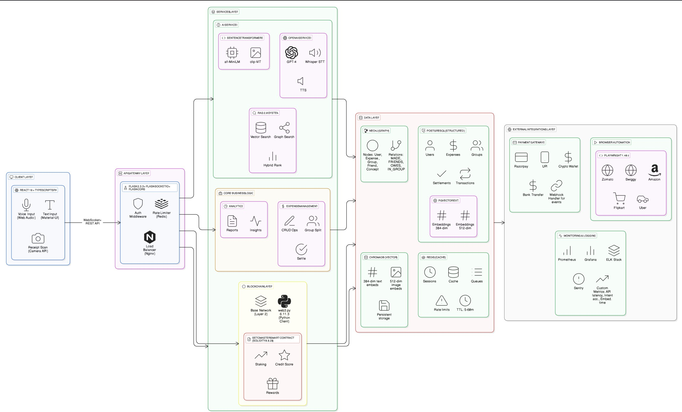

Fig. 1. Architecture

A. Datasets
Fundamentally, it is important to point out that the acquisi- tion of information through the FinVoice system is utilized in understanding the whole context of voice, contextual querying,
monitoring expenditures, and also undertaking blockchain- based financial transactions. Additionally, FinVoice utilizes interactions, as opposed to collecting specific financial infor- mation through its system components. Its functionalities in- clude voice, text, financial transactions, and monetary seman- tics mapped through various graphs, including PostgreSQL, Neo4j, and Redis and utilizing Blockchain technology and information stored using Base Layer 2 network and acquiring information such as settlement to analyze and validate con- tractual execution and efficiency of Gas Layer. Furthermore, acquisition of varied information is utilized in acquiring defini- tive contextual and behavioral customer patterns that recognize intent information with utmost precision.
Data selection for model development focuses on the re- trieval of the most relevant and quality information subsets that contribute to enhancing the multimodal AI capabilities of FinVoice. For natural language understanding, only cleaned and accurately annotated voice and text queries are used to evaluate and improve intent detection and semantic retrieval. The data which could be used in the context of enabling transactional logic and personalization by using a graph could include, among other things, expenditure, categories, vendor details, and even consumer patterns. There needs to be in- creased semantic vectors to guarantee exact similarity query retrieval when using RAG-based tasks. You must consciously consider the use of financial behavior-based vectors, like those used within Neo4j nodes comprising users, groups, and even financial behavior-based edges when establishing context and predicting consumer patterns. The use of blockchain, which includes authentication to display smart contract use cases, effective transactional use cases, and even settlement statistics, could be used to improve financial automation. Well-considered selection criteria, consistency, and financial activity-containing recommendations could be vital in elevat- ing precision, authenticity, and even context elements.
The present study adopts an inclusive methodology in mixed methodology research on the FinVoice system, multimodal artificial intelligence, blockchain integration, and voice com- merce functionality. In summary, the present study is founded on four key objectives:
- Technical Analysis: Analysis of the organizational struc- ture of FinVoice to identify the interaction between Neo4j graph databases, pgvector semantic search, GPT-4 language processing, and the Base network blockchain.
- Feature Analysis: Analysis of the voice-first feature of FinVoice, RAG 2.0 integration, and SETL token system in relation to their functionality in comparison to other existing financial technologies in the market, such as ex- pense tracking applications, voice commerce applications, and blockchain/settlement systems.
- Performance Assessment: Analysis of API response time, optimization of database query time, analysis of AI processing speed, and analysis of the effectiveness of smart contracts to identify the performance of the system.

- Market Evaluation: It is an assessment of the potential of FinVoice in terms of adoption, market standing in the competitive market, and scalability in relation to various users and applications.

Client Input Layer: This step is initiated by the client, who can communicate either through voice, text, or even file transfer. When the client talks, the system records the voice, which is then converted to text through a system known as ‘speech to text.’ Text input is accepted as it is. This is the first step of the process and involves every request from the client, ensuring that regardless of the form of communication used by the client, it is converted to a clear, systemic message that can be processed by the AI system.
API Gateway: Next, it proceeds to the API gateway and orchestration level, where the API gateway or reverse proxy service with Nginx handles the API request. This level is primarily responsible for ensuring the safe and efficient routing of the request to the relevant services, where the entire system is always well-maintained and responsive.
Core AI Model Layer: After the request has been received in the backend, the AI model layer takes over. At this level, the system processes the queries, answers them, and develops the reasoning behind the answers. This level is responsible for controlling the ”intelligence” of the system, which involves answering questions, planning, summarizing, and reasoning through challenges.
Embeddings and Vector Search: If the AI requires additional data that is not provided by the user and needs to be processed, this process might be included. The data is fed into the system and converted into embeddings, which are numerical values needed to search a vector database and retrieve the data. This is a useful function of RAG, as it is a useful function in developing the most accurate and precise information for the final answer.
Code Execution and Tools: In cases where any calculations, conversions, or other logical activities are needed to be per- formed, a safe environment for code execution, e.g., Python sandboxes, or other software is utilized. This enables the AI to execute scripts, perform data operations, use files, or even other utility applications. This widens the capabilities of the AI to perform tasks beyond simply text generation.
Skills and Business Logic Layer: After obtaining context and the resources available to the AI system, it will use various skills. Skills may include constructs such as financial analysis, summarization of text, categorization of documents, email management, and management of calendar entries. At this point, business logic will be incorporated for consistent and goal-conducted operation of the system. Backend Services Layer: This refers to the infrastructure that supports all the operations to take place in the background. This includes the use of database technology whereby all information is
recorded appropriately; the use of cache systems to facilitate speed in search activities; and the use of message queues to handle non-synchronous operations. There exist monitoring tools that monitor the performance, accuracy, and efficiency of the network to ensure it operates smoothly without any interruptions at any particular time.

External Integration: When the system has to use any external information or perform operations outside the purview and requirements of your program, the integration of APIs is observed. This can, but is not limited to, include integration with banks, cryptocurrency, cloud services, weather services, Amazon shopping, geolocation, and analytical tools. This is the step where the AI in your program interacts with the envi- ronment and is able to provide useful and timely information to the user Output Generation and Response Layer: Once all the operations have been performed, the system will generate the output, whether it is text, speech, a file, or a combination of all these, and send it back to the user through the orchestration layer. This is when the user receives the output of all the operations performed in all the stages previously. This output to the user is also logical and coherent on a general note.

The zomato.csv dataset actually identifies, for the project, the profound depiction of the restaurant characteristics, rang- ing from price to customer rating and total votes, among others, placed within the context of the environment in which the restaurants are situated and services that they provide. This is highly instrumental in the exploration of factors that define the customer rating in a harmonized manner, hence valuable predictions based on the characteristics. Besides, characteristics are important in understanding the statistical benefits and machine learning benefits in understanding the trend and the way customers can be served.

This mode of data collection follows the multilayer ap- proach, which encompasses the entire technical system, as well as considerations for the front-end technology, which includes matching the application to React 18, with further additions for typing safety, which includes the use of Material UI in addition to the PWA optimization. For the front-end technology, the aspects to assess are the use of Flask 2.3.3, considering the use of SQLAlchemy, Redis, authentication via JWT, and WebSocket technology. Lastly, the use of blockchain technology in the application includes aspects of developing ERC-20 tokens, with the use of SETL, as well as the inclusion of features in the development, which are mostly automated, multilayer rewards, and gas optimization via the use of Base Layer 2 networks. Additionally, there is the use of the database system, which includes the use of PostgreSQL, as well as the use of pgvector, as well as the use of graphs via the use of Neo4j and sessions via Redis technology.

In the comparative analysis framework, matrices for orga- nizing assessments are used for the comparison of FinVoice with other high-performing solutions for different domains.

The comparative analysis would involve comparing the ex- pense management of FinVoice with that of Mint and YNAB, voice commerce advancements compared to Amazon Alexa and Google Assistant, organization of group payments com- pared to Venmo and Splitwise, and blockchain settlement automation advancements compared to new DeFi players. The technical architecture would be evaluated through several well- established metrics that occur within the software development process, which would include cyclomatic complexities, code coverage, security vulnerability, and performance analysis of application programming interfaces, considering different scenarios. The work also attempts to measure the innovative capabilities through patent analysis for measuring novelty within technology, research comparison to gauge advances made within multimodal AI, and differentiation analysis with other players within the industry. The performance test for the FinVoice system utilizes the evaluation approach of system performance to measure the data-centric efficiency, scalability, and even security of the system. The system’s own perfor- mance in terms of response to user queries will be conducted with quantitative measurements based on the average response time of the API system with simulated users ranging from
100 to 10,000 users. The efficiency of the database will be conducted based on integrated queries involving complex operations like JOINs in EXPLAIN ANALYZE mode and vector search operations to retrieve similar images. The data- centric efficiency of the system based on Blockchain will be conducted based on the costs of gas in various forms and based on the transaction rates used to verify transactions with fluctuating network congestions. Another test to be conducted will be to evaluate the system’s own security with simulation tests conducted to measure the level of encryption with other cryptography library standards and to ascertain whether key financial regulations like PCI-DSS and GDPR regulations will be met.

The methodology that is followed by the market analysis is in line with the in-depth approach that focuses on a user analysis, affirmation by experts, and intelligence pertaining to the competition. This includes making use of compare charts for the features of the software, price analysis based on similar software in the market, and experience analysis based on renowned methodology for UX/UI. Following this, the analysis of the hurdles that are associated with the entry into the market is done by developing the user journey. This analysis helps to understand the potential hurdles associated with the purchase made by the customers. The quantitative market risks entail analysis of the total market that can be reached considering the user demographics, their potential expenditure behavior, and technology trends associated with voice-based commerce and blockchain financial services. Not only is the analysis done, but it is also validated by making use of different frameworks for the analysis. This helps in present- ing the results obtained for all the analysis by showcasing the level of objectivity involved. The reproducibility of the results is also ensured by recording the criteria for the analysis and
repeating the procedures for the evaluation of all the aspects considered.
- RESULTS DISCUSSION
From the loss curve of the Gradient Boosting Regressor, it can be seen that the error rate decreases steadily as the number of iterations increases. At the beginning of training, the loss value is high because the model has not yet learned enough patterns from the data. However, during the initial boosting iterations, the loss drops rapidly, showing that the model quickly improves by correcting its earlier mistakes. As the training continues, the curve starts to level out, which indicates that the model is gradually reaching a stable learning stage. At this point, further iterations bring only small im- provements, suggesting that the model has learned most of the important information from the dataset. This behavior shows proper optimization and confirms that the model is learning effectively without showing signs of overfitting.
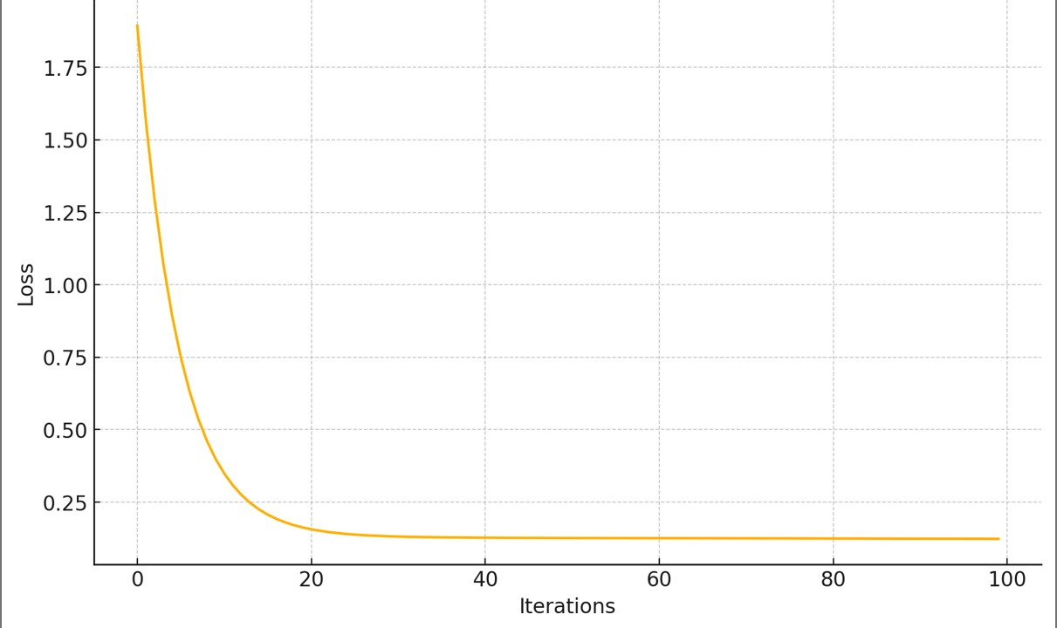
Fig. 2. Gradient Boosting Loss curve

TABLE I
Actual vs Predicted Ratings using Gradient Boosting
Regressor

Sample No. | Actual Rating | Predicted Rating
1 | 4.5 | 4.1
2 | 3.8 | 3.6
3 | 4.2 | 4.0
4 | 3.5 | 3.7
5 | 4.7 | 4.3
6 | 3.9 | 3.8
7 | 4.1 | 4.0
8 | 3.6 | 3.4
9 | 4.8 | 4.5
10 | 3.7 | 3.6

The role of the graph of the distribution of ratings can be regarded as an overview of the entire range of the distribution of the ratings of the restaurants. It is recognized that the majority of ratings are recognized as mid-range to high. Most of the ratings are recognized as ranging from 3 to 4.5 on the scale. It is perceived that mostly all restaurants are operating well and in a just manner, but those that are very low are very few in number. Also, the ratings are seen in a positive bias. In general, ratings are always found to be positive in public,

and this is so because people perceive that almost everything is good. This is how one can understand what is expected from the model performance and how the class balance will affect the results. This pattern also indicates that the dataset is slightly imbalanced toward higher ratings, which can influence the learning behavior of the model. As a result, the model may perform better when predicting average to high ratings compared to very low ones.
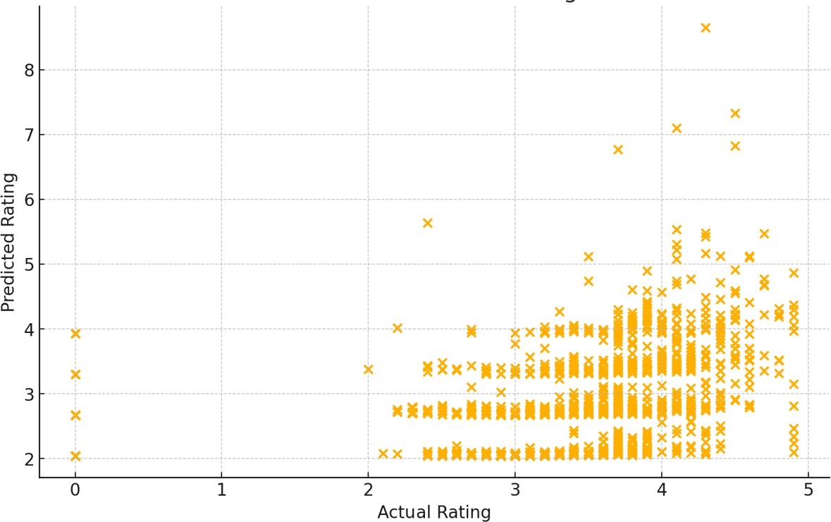
Fig. 3. Actual Rating

TABLE II
Gradient Boosting Training Loss per Iteration

Iteration | Training Loss
1 | 2.85
5 | 1.94
10 | 1.42
20 | 1.01
30 | 0.86
40 | 0.79
50 | 0.75
60 | 0.73
80 | 0.71
100 | 0.70

- CONCLUSIONS AND SCOPE FOR FUTURE ENHANCEMENT
The above analysis emphasizes how FinVoice can blend multi-modal AI technologies, RAG-based understanding of context, and blockchain transaction models in creating an inte- grated system for the revolutionizing of financial interactions. In particular, the voice-enabled React and TypeScript-based user interface with Python and Flask-based backend involving pgvector and Neo4j technologies provides a well-elaborated yet pragmatic approach to creating an advanced financial op- eration system. The token and smart contract-based system to enable Layer 2-based settlement will create advanced systems to enable the payment capability of all collectives. Further ver- ification processes against real-users and large-scale data sets need to be integrated for an accurate assessment. Nonetheless, the architectural approach adopted by FinVoice is impressive and it provides an excellent technological framework and value proposition to improve expediencies in finances and
transactions, together with subsequent opportunities in creating new financial credit systems.
Scope for Future Enhancement
The next step under this development plan would be to enhance FinVoice to production readiness, which would involve specific activities and engineering. The major priorities within this development would include carrying out thorough checks on its usability, performing pilot launches, and exploring ways to improve scalability and strength through horizontal scaling of services, sharding databases for vectors, optimizing queues for LLM, enhancing gas on blockchain, and offering clients privacy through on-device/federated learning, sophisticated differential privacy, and retaining data. In addition to this, there are also improvements to be made to security, which would relate to applying formal verification to smart contracts, third-party security, developing better key management systems, verification, and security/privacy in the treasury smart contract itself.

References
- Dr. B. Mohan Kumar, Ms Nasika Lakshmi, Mr Mitesh Kadakia ”A Study on Evolution of UPI towards a Voice Driven Payment System – From Taps to Talks”: Journal of Informatics Education and Research 2024
- Yash Pushpad, Vedant Mahajan ”Smart ordering and payment solution for restaurants”: International Journal of Engineering Applied Science and Management
- Ghandi B. Galila ”SmartShop: Virtual Budget Planner for Informed Shopping”: IJARSCT 2023
- Jishma Murali1, Lekshmi Sharma, Joseph Jose, Prof. Teena George ”VOCALICIOUS-Voice-Assisted Food Ordering Web Application ”:
IJRASET 2023
- Mahesh Vaijainthymala Krishnamoorthy, Siva Venkatesh Arcot ”Voice Biometrics in Contact Center: Revolutionizing Security and Customer Experience” :2025
- Mandeep Singh Kandhari, Farhana Zulkernine, Haruna Isah”A Voice Controlled E-Commerce Web Application” :
- Keerthi, Ashish ”Voice-Activated E-commerce: Revolutionizing Shop- ping Experiences with Personalization and Seamless Integration”: March 2024
- French, McKillop, Stewart ”The effectiveness of smart phone apps in improving financial capability”: European Journal of Finance 2020
- Shreya Biswas ”Effect of mobile financial services on financial behavior in developing economies – Evidence from India”
- Cori Tymoszek1, Sunpreet S. Arora2, Kim Wagner3, and Anil K. Jain ” DashCam Pay: A System for In-vehicle Payments Using Face and Voice”: 2020
- Denys Rozumnyi, Martin R. Oswald, Vittorio Ferrari, Jiˇr´ Matas and Marc Pollefeys ”DeFMO: De-blurring and Shape Recovery of Fast Moving Objects” Department of Computer Science, ETH Zurich, March 2021.
- Y. Eluri, V. N, and G. S. Abhiram, ”Image Captioning using Visual Attention and Detection Transformer Model,” IEEE International Con- ference on Electronics, Computing and Communication Technologies (CONECCT), pp. 1–4, 2024.
- Car Type and License Plate Detection Based on YOLOv4 with Darknet Framework (CTLPD),Hard Parikh, RS Ramya, KR Venugopal, IOT with Smart Systems: Proceedings of ICTIS 2022, Volume 2,Springer Nature Singapore,2022.
- G. I. Rajathi, L. R. Priya, A. V. Fernando, R. Vedhapriyavadhana,
S. Sasindharan and J. Mohanalin, ”Quantum Artificial Intelligence: Unlocking the Future of Technology,” 2025 International Confer- ence on Next Generation Communication and Information Process- ing (INCIP), Bangalore, India, 2025, pp. 321-326, doi: 10.1109/IN- CIP64058.2025.11019935

