Geospatial Assessments of Wetlands Soils for Rice Production in Shendam and Langtang South of Plateau State, Nigeria
Abstract
Wetlands are among the most productive ecosystems on Earth, providing essential ecological services such as water purification, flood control, biodiversity conservation, and carbon sequestration. However, increasing anthropogenic activities, urban expansion, and agricultural encroachment have led to rapid degradation of wetland environments. This study investigates the spatial extent, ecological condition, and anthropogenic impacts on selected wetland areas using geospatial techniques to enhance sustainable management and conservation of wetland. Satellite imagery and ancillary data were utilized to analyze land use and land cover changes over a defined period. Field surveys and GPS mapping were conducted to validate remote sensing data. Geospatial tools such as ArcGIS were employed for image classification, change detection, and spatial analysis. Data were analyzed using both descriptive statistics and GIS-based quantitative techniques to assess wetland degradation patterns. The study Results revealed that there is an extend of over 421.219 Km² of wetlands in the study area, a large proportion of which are currently being cultivated for rice production either during the rainy season or, to a lesser extent, all year round, over 70% of the land is currently being used for rice farming within the area and there is still much room for improvement especially in mechanization and cultivation of improved varieties. Over 700 Km² of clay soils within the area can be beneficiated through several forms of intervention to make them more suitable for farming, most especially, of rice. Also, there Significant reduction in wetland coverage over the study period due to agricultural expansion, urban development, and deforestation. The rate of conversion from natural wetland to build up and cultivated land was found to be accelerating, with corresponding decline in vegetation and hydrological integrity. The study found that unsustainable land use practices and poor management policies are the main drivers of wetland degradation. These changes threaten ecosystem services and biodiversity within the region. Wetland ecosystems are under increasing pressure from human-induced activities. Effective monitoring through remote sensing and GIS provides reliable data for conservation and sustainable utilization. The study recommends stricter environmental regulations, community awareness programs, and integration of geospatial technologies in wetland management strategies. Periodic monitoring should be institutionalized to prevent further degradation and promote ecological restoration of original wetland areas.
Keywords: Wetland Soil, Rice production, Geospatial, Assessment, Shendam, Langtang South, Plateau State and Nigeria

1.0 Introduction
Wetlands are areas where water saturates the soil, either permanently or seasonally. These can be found in a variety of geographic settings, ranging from floodplains and riverbanks to coastal areas and swamps around many regions in the world. Wetlands are distinguished by their hydrology, vegetation adaptation to wet conditions, and soil types like waterlogged areas often with low oxygen. Wetlands played an important role in human development and nature nutrient store for rice cultivation. Wetland soils are often rich in organic material due to limited oxygen availability. Wetlands are found all over the world and play a crucial role in maintaining ecological balance; there distribution is wide, including tropical Wetlands. Wetlands help in maintaining the necessary water levels for rice paddies, which are typically flooded during cultivation. The natural ability of wetlands to store and regulate water ensures that rice fields receive the required water supply, especially during dry seasons or in areas where water availability can fluctuate. Wetlands contribute to the nutrient cycling process, particularly the availability of essential nutrients like nitrogen and phosphorus. These nutrients enrich the soil in rice-growing regions, boosting rice yields by improving soil fertility and quality of rice production. The presence of wetland ecosystems helps in the formation of fertile soils, which are beneficial for rice farming and the accumulation of organic matter and the process of silt deposition in wetlands enhance soil structure and fertility, which can improve rice yields over time. Wetlands play a crucial role in global rice production, as they provide several key environmental and agricultural benefits. They help maintain a stable water supply throughout the growing season, ensuring consistent irrigation. Rice is a water-intensive crop, and wetlands offer an efficient way to manage water needs, particularly in areas that rely on rainfall or river systems for irrigation. The organic matter in wetlands contributes to soil fertility by providing essential nutrients. The decaying plant material and sediments in wetlands enhance the soil structure and nutrient content, which is beneficial for rice growth.
Despite their importance, wetlands face numerous threats and challenges worldwide through human activities. Wetlands across the globe, including in Africa and Nigeria, face several significant challenges. These challenges arise from both natural and human-induced factors, leading to the degradation of wetland ecosystems and their functions.
Climate change dynamic leads to rising temperatures, altered rainfall patterns, which disrupt wetland ecosystems. Africa is particularly vulnerable to the effects of climate change; with some areas experiencing prolonged droughts and others facing increased flooding. These changes affect the hydrology of wetlands, leading to either water scarcity or excess water, both of which threaten wetland ecosystems. In Nigeria, wetland cultivation is now being emphasized especially for rice production Tobore et al (2021). In the study area, Plains and river valleys are the two major landforms that dominate the landscape of the area. The area is drained by two major rivers, namely, Shemankar, and Dep with many tributaries. The combination of the plains and river valleys provides good drainage for the studied area. Application of technological advances such as geographic information system (GIS) and remotely sensed (RS) data made possible to study the changes in wetland in less time, at low cost, and with better accuracy. It can inform decisions on the suitability of wetland areas for rice cultivation, management, and sustainable practices to ensure optimal rice production without compromising wetland ecosystems. It is against this background that this study seeks to employ geospatial technology to assess the potential of wetlands for improved rice production.
Rice cultivation in North Central Nigeria has been carried out in valleys and flood plain areas, with little or no attention to wetlands for a long time. However, due to rapid population growth and high demand for rice in Nigeria, much pressure has been put on these wetlands to increase rice production which has led to their degradation. The continued use of upland fields for farming has also resulted in loss of soil fertility due to erosion and overuse. The growing demand for food especially rice, across the nation has necessitated an urgent need to harness and maximize wetlands potential for rice cultivation. Despite the significant potential for rice production in the wetlands of Shendam and Langtang South, Plateau State, Nigeria, there is a lack of comprehensive data on the spatial distribution and suitability of these wetland areas for sustainable rice cultivation. Traditional methods of assessing wetlands are time-consuming and may not capture the full extent of land characteristics crucial for optimal rice production. The integration of geospatial technology, such as Geographic Information System (GIS) and remote sensing, offers a modern and efficient approach to assessing wetland areas, but its potential to improve the identification and management of suitable rice production zones in these regions has not been fully explored. This study seeks to employ the application of geospatial technologies in assessing the wetland soils of Shendam and Langtang South, aiming to provide accurate, timely, and actionable data to enhance rice farming practices and improved sustainable agricultural development in the region.
The study aims to examine the spatial distribution of wetland ecosystems in order to improve rice agriculture and increase food security. The aim of the study will be achieved through the following objectives as; to carry out an environmental characterization of wetlands, delineate suitable wetland areas for rice cultivation, produce a spatial distribution map of wetlands in the area and provide conservation and management measures for improved rice cultivation.
2.0 Study Area
2.1 Geographical Location and Spatial Characteristics
Shendam and Langtang South Local Government Areas, situated in Plateau State's North-Central region, represent dynamic administrative territories that embody Nigeria's rich geographical, demographic, and cultural heritage. These areas present a unique opportunity to understand rural development patterns and socio-economic dynamics in Nigeria's middle belt region. Shendam lies between 8°52'N to 9°5'N and 9°22'E to 9°35'E, while Langtang South is positioned between 8°35'N to 8°51'N and 9°45'E to 9°58'E (Nigerian Geographic Information Service, 2023). This strategic positioning creates a complex network of interactions with neighboring territories, including Mikang LGA to the north, Taraba State to the south, Qua'an Pan LGA to the east, and Nasarawa State to the west as seen in figure 1. The geographical configuration has historically influenced trade routes, cultural exchanges, and settlement patterns throughout the region.
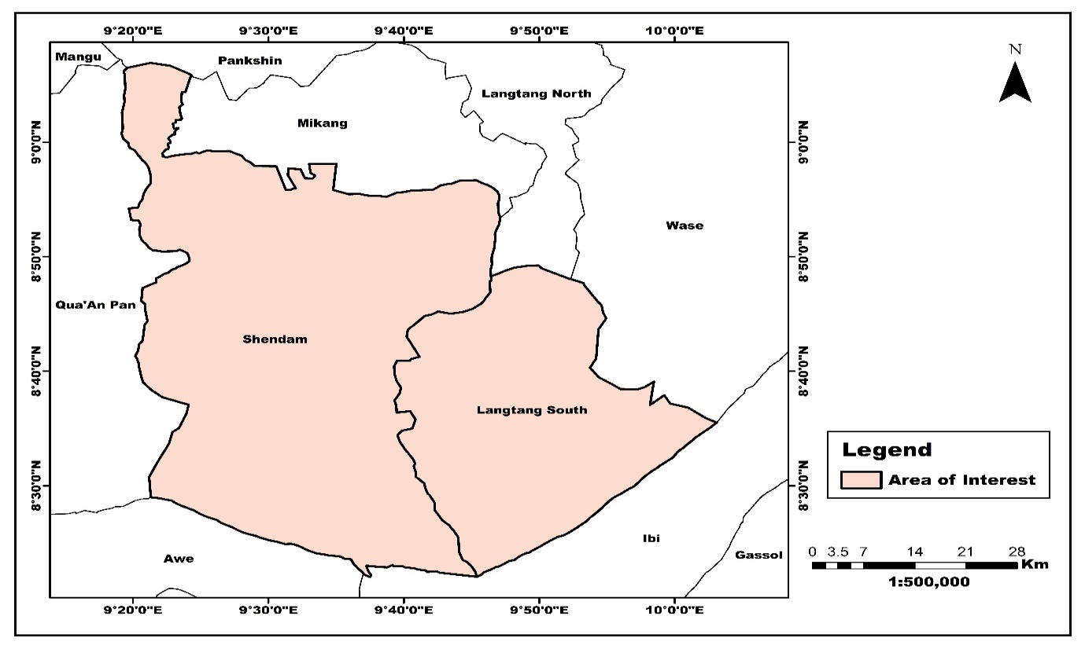
Figure 1: The study area.
2.2 Topography
The topographical landscape presents a fascinating transition from elevated plateaus in Langtang South to the expansive plains of Shendam. Elevation ranges from 95 meters to 564 meters above sea level, creating diverse microclimates and ecological zones that significantly influence agricultural practices and human settlement patterns. The terrain features natural drainage systems characterized by gradual slopes that facilitate water movement and soil development. These topographical variations have created distinct agricultural zones, with the highlands supporting cereal cultivation and the lowlands favoring root crops and rice production (Geological Survey of Nigeria, 2023).
2.3 Geology
The geological framework of the region reveals a complex history dating back to the Precambrian era. The area is predominantly composed of basement complex rocks, including granite, gneiss, and metamorphic formations that have undergone various degrees of weathering and transformation. These geological formations have significant implications for soil development, groundwater availability, and mineral resources.
2.4 Hydrology
The hydrological system demonstrates remarkable complexity, characterized by a network of perennial and seasonal water bodies. Major rivers including the Wase and Shemankar, along with their tributaries such as Pil-Gani, Bapkwai, and Zamko, form the backbone of the region's surface water resources. These water bodies exhibit significant seasonal variations in flow rates, with peak discharge occurring during the rainy season between July and September.
2.5 Climate and Environmental Characteristics
The region experiences a tropical climate with distinct wet and dry seasons, characteristic of the Guinea Savannah zone. According to the Nigerian Meteorological Agency (2023), annual rainfall averages between 1,100mm and 1,400mm, with significant spatial and temporal variations. The wet season spans April to October, with peak rainfall occurring in August, while the dry season extends from November to March. Figure 4 shows the annual rainfall distribution across the Shendam and Langtang South.
Temperature patterns show considerable seasonal variation, ranging from 15°C during the Harmattan period to 35°C in the hot season. Mean monthly temperatures are highest in March-April (25°C-35°C) and lowest in December-January (15°C-28°C). The region experiences approximately 2,500 hours of sunshine annually, supporting robust agricultural production (Nigerian Meteorological Agency, 2023).
Relative humidity fluctuates significantly throughout the year, with values ranging from 30% during the dry season to 85% during the rainy season. These humidity variations, combined with temperature and rainfall patterns, create distinct growing seasons that influence agricultural practices and crop selection (Nigerian Meteorological Agency, 2023).
2.6 Vegetation and Agricultural Systems
The study area falls within the Guinea Savannah vegetation zone, characterized by scattered trees, tall grasses, and gallery forests along waterways. Common indigenous tree species include Parkia biglobosa (Locust bean), Vitellaria paradox (Shea butter), and Tamarindus indica (Tamarind), which contribute significantly to local livelihoods and ecological sustainability (Federal Ministry of Environment, 2023).
Agricultural practices in the region demonstrate remarkable adaptation to local environmental conditions. Shendam, with its fertile floodplains, has emerged as a major producer of yam, rice, and cassava. The area's agricultural success is particularly evident in its commercial yam production, which has established Shendam as one of Plateau State's primary yam-producing regions. Langtang South, characterized by its higher elevation, focuses more on cereal cultivation, including sorghum, millet, and maize (Plateau State Ministry of Agriculture, 2024).
3.0 Methodology

3.1 Materials

The materials required for the geospatial assessment of wetland soils for rice production include satellite imagery and field equipment essential for data collection and analysis. Landsat 8 or 9 and Sentinel-2 imagery is used for land cover classification and wetland mapping, while soil data on texture and nutrient content was obtained through laboratory analysis. Field equipment such as a GPS receiver aid in ground truthing and location mapping, while a soil auger or core sampler was used to collect soil samples at various depths. Soil sample bags and labels was used to ensure proper storage and identification, Additionally, a digital camera is been used for field documentation and capturing aerial imagery of the study area.
3.2 Methods
3.2.1 Field Study
The field work entails a comprehensive reconnaissance survey followed by systematic field exercises to identify and document wetland ecosystems within the designated study area. Field teams conducted targeted investigations at strategically selected locations, meticulously recording essential wetland characteristics including vegetative composition, hydrological patterns, and anthropogenic modifications. Each wetland site was precisely geolocated using GPS technology to ensure spatial accuracy. All field observations and corresponding coordinate data were initially documented in Microsoft Excel and subsequently exported as CSV (Comma-delimited Values) format to ensure optimal compatibility with the ArcGIS 10.8 processing environment. The geospatial point data was then imported into the ArcGIS interface utilizing standardized protocols and converted to shapefile format, establishing a robust foundation for subsequent spatial analysis operations. This conversion facilitated the integration of field-collected data with other spatial datasets, enabling comprehensive wetland analysis and characterization.
3.2.2 Data Acquisition and Preprocessing
Procurement of Sentinel-2 satellite imagery with 10-meter spatial resolution. Selection criteria included minimal cloud coverage (less than 10%), seasonal appropriateness for wetland identification (preferably during peak hydration periods), and temporal relevance to field observations. Following acquisition, preprocessing procedures were implemented within ArcGIS 10.8 to prepare the imagery for analysis. The preprocessing workflow consisted of three primary operations: mosaicking, reprojection, and subsetting. Multiple Sentinel-2 scenes were mosaicked using the Mosaic to New Raster tool in ArcGIS, ensuring consistent radiometric values across scene boundaries by applying histogram matching techniques. The mosaicked imagery was then reprojected to the appropriate local coordinate system using the Project Raster tool, maintaining spatial integrity and enabling accurate distance and area measurements in subsequent analyses. Finally, the study area was extracted from the larger mosaic using the Extract by Mask tool, delineating boundaries based on watershed limits and administrative boundaries.
3.2.3 Maximum Likelihood Classification
Utilizing the preprocessed Sentinel-2 imagery, supervised classification was performed through the Maximum Likelihood Classification tool within ArcGIS 10.8's Image Classification toolbar. Training samples were created by digitizing polygons around areas of known wetland types informed by field observations. The Create Signatures tool generated spectral signatures for each wetland category and additional land cover classes. The Maximum Likelihood Classification algorithm was applied to the multiband imagery, assigning each pixel to the most probable class based on probability density functions. Classification parameters included a probability threshold of 0.95 and option to create a confidence raster. Post-classification processing involved applying a majority filter to reduce salt-and-pepper effects and eliminate isolated pixels using the Generalization tools. The classified raster dataset was then converted to polygons using the Raster to Polygon tool, with the simplify polygons option enabled to generate clean boundaries.
3.2.4 Digital Extraction of Wetlands
High-resolution aerial satellite imagery acquired from Google Earth served as the primary base data for precise wetland digitization. This process was methodically executed using the previously collected and plotted field location coordinates as reference points to ensure spatial accuracy. The digitization procedure involved careful delineation of wetland boundaries, accounting for hydrological indicators and vegetation patterns visible in the imagery. The resulting wetland polygons were extracted as standardized shapefiles, preserving all spatial attributes and topological relationships. These extracted vector datasets were subsequently integrated into the classification accuracy assessment framework to validate the spatial precision of the wetland delineation. This rigorous validation process quantified the positional correspondence between remotely-sensed features and ground-truth observations, thereby establishing the definitive locations and comprehensive spatial extent of the wetland ecosystems throughout the study area.
3.2.5 Soil Texture
Texture indicates the relative content of particles of various sizes, such as sand, silt and clay in the soil. Texture influences the ease with which soil can be worked, the amount of water and air it holds, and the rate at which water can enter and move through soil. One of the most important and widely used tools for classifying soil texture based on the proportions of sand, silt, and clay --particles is the USDA Soil Textural Triangle. The texture triangle developed by the U.S. Department of Agriculture (USDA) has traditionally been a basic tool in soil classification. We used visual representation of the possible soil type combinations based on soil particle size (Figure 5) to give names to various combinations of clay, sand, and silt to obtained soil types in the study.
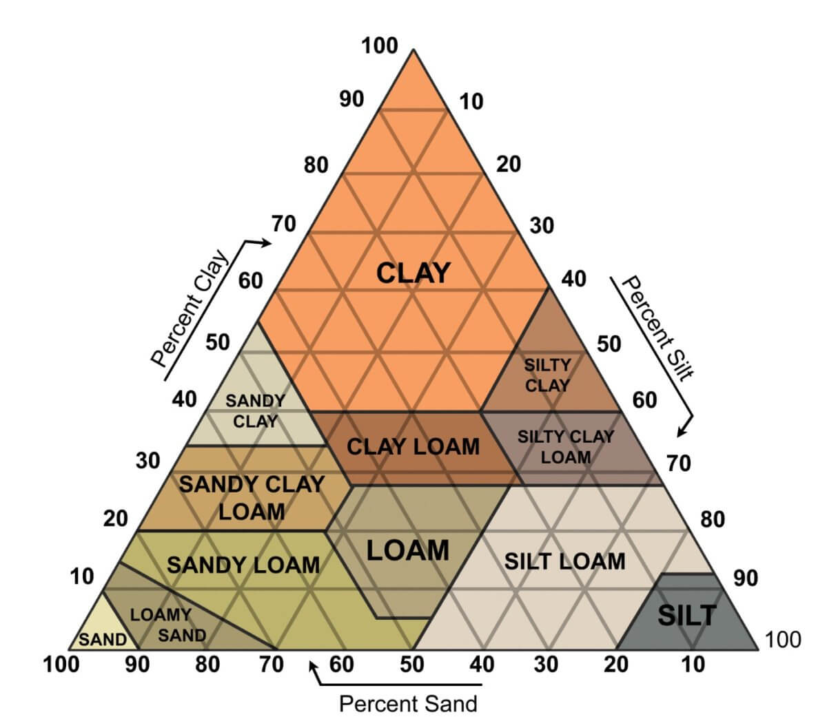
Figure 2: The USDA Soil Texture Triangle Chart. (After USDA, 2017)
3.2.6 Comparative Analysis and Interpretation
The final phase involved comprehensive interpretation of the wetland analysis results within the broader landscape context. The relationship between wetland distribution and environmental factors was explored through multivariate statistical analysis using the Spatial Statistics tools. The final products included detailed wetland maps, classification statistics, accuracy reports, and interpretative analyses, all managed within an ArcGIS geodatabase for consistent data management and future reference.
3.2.7 Generation of Statistical Data
To generate statistics from the data, extra fields were initially added to the attribute table, where area in square kilometers was calculated. This was accomplished by multiplying the spatial resolution of the resampled images (10 by 10 meters) by the number of pixels to obtain the area in meters squared and then dividing by 1000000 (1 Km by 1 Km). This was done in ArcGIS and then exported to Excel in dBase format. In Excel, the total and percentage areas were calculated and tabulated, ready for interpretation and inclusion in the report.

Download of Sentinel 2 (10m) Image
Reconnaissance & Pre-Field work/Planning
Image Preprocessing (Mosaic, reprojection & Subset)
Field Exercise
Maximum Likelihood Classification
Digital Extraction of Wetlands
Plotting of Field Points (Coordinates)
Accuracy Assessment
Comparisons and Interpretation
Climatic Data

Combining Classified and Digitized Wetlands

Soil Texture Classification
Soil Texture Classification

Figure 3: Flow Chart
4.0 Result and Discussion
4.1 Spatial Distribution of Wetlands
Figure 4 depicts the spatial distribution of the area's wetlands. This occupied 421.219 Km² of the whole area (Table 1). Wetlands were found to be more abundant in the northwestern portion of the Shendam, which extends to Shemankar, Lakushi, and Kuka. The spatial extent of these wetlands is also visible in Magama and Sabon Gida, Langtang South. This is because the region is dominated by plains and valleys. The wetland in the area covered 421.219 Km² of the total area (Figure 4 and Table 1). The spatial distribution is greater in Shendam than in Langtang South due to terrain and lithological units, resulting in soil textural variation with more sandy loam and sandy clay documented in these areas. There were a large number of small wetland fragments distributed in the study area as shown in Figure 4.
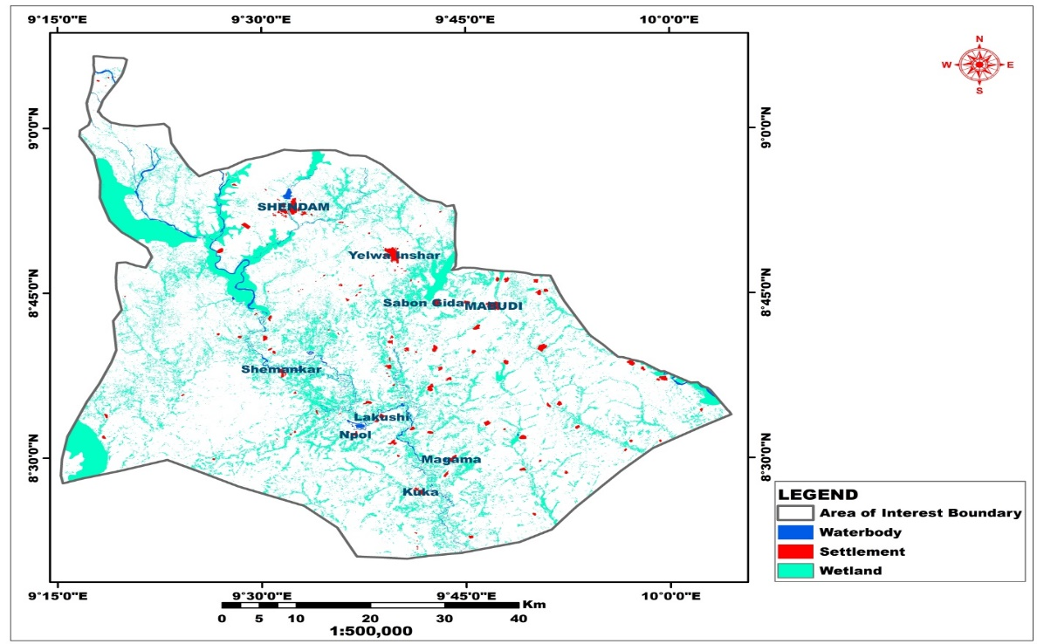
Figure 4: Wetlands in the Study Area

Table 1: Area (Km² and Hectares) of Wetland Coverage
Class Name Area (km²) Hectares
Wetland 421.219 42,122
4.2 Wetlands Overlay on the Satellite Imagery
Figure 5 depicts the wetlands superimposed on high resolution satellite data (Quickbird at 1 meter resolution). The environment is dominated by plains and river valleys. The average elevation ranges from 148 to 222 meters above mean sea level. The area is drained by three large rivers: Shemankar, Ogunpa, and many tributaries. The combination of plains and river valleys ensures adequate drainage for the study region. This satellite data demonstrated an improved understanding and mapping of wetlands in rice farming areas.
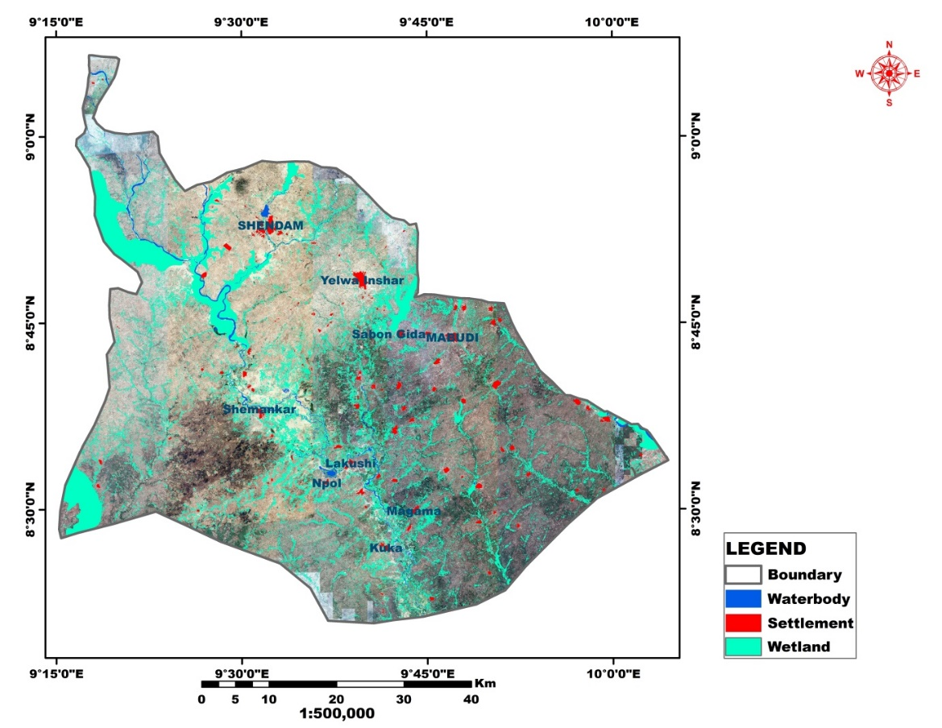
Figure 5: Wetlands superimposed on the Satellite Image
4.3 Soil Texture
The studied region is primarily sandy loam, with a spatial coverage of 988.589 Km² accounting for 26.65% of the study area. While sandy clay loam and clay soil occupied 868.403 and 718.88 Km², representing 23.4% and 19.37% of the research region, respectively (Figure 6 and Table 2). Clay loam occupied 356.62 Km². These soils were derived from the sedimentary formations of the middle Benue trough and are ideal for growing crops like rice, cassava, yam, and cocoyam. However, wetland soils are noticeable in areas with clay and clay loam because of the rock forming minerals such as feldspars and mica. This study improved the understanding of wetland soil assessment for improved rice production.
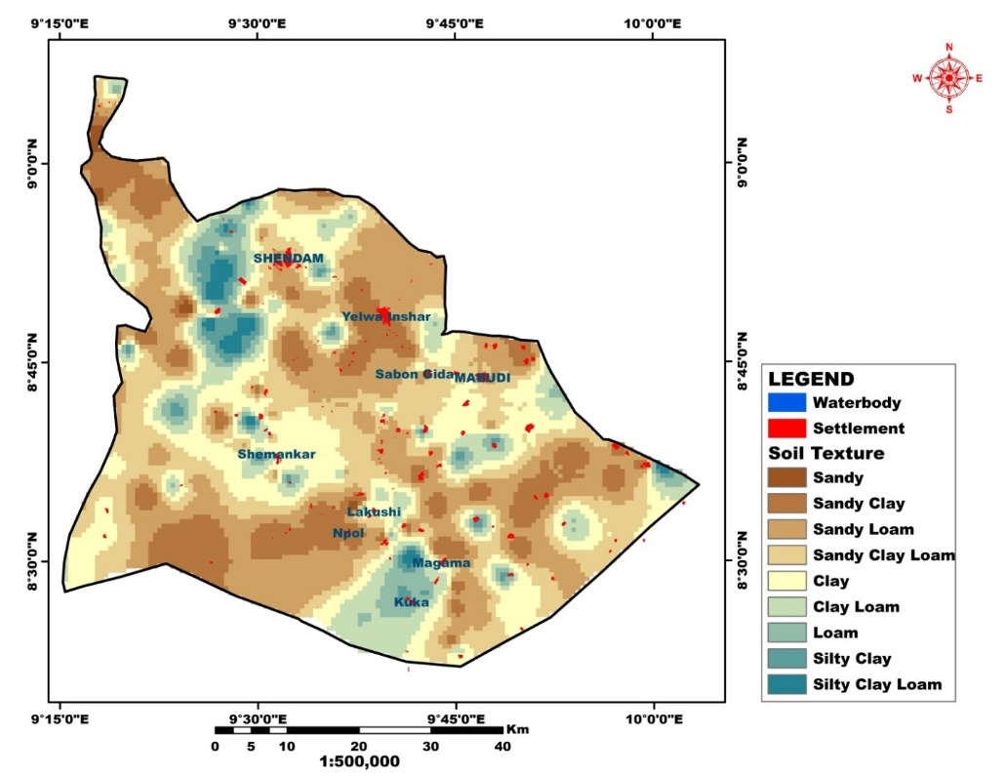
Figure 6: Soil Texture of the Study Area

Table 2: Area (Km²) Coverage and Percentage of each Soil Class
Class Name Area (Km²) Percentage (%)
Sandy Clay Loam 868.403 23.4
Sandy Loam 356.620 26.5
Clay 718.887 19.37
Clay Loam 356.620 9.61
Sandy Clay 484.713 13.06
Loam 164.921 4.45
Silty clay loam 40.245 1.09
Silty clay 75.299 2.03

5.0 Findings
Wetlands have played a significant role in human development and are regarded as one of the world's most valuable natural resources. Geospatial approaches have been increasingly important and widely used to quantify the spatial extent and changes in wetlands and soil texture variations. However, they face numerous challenges from anthropogenic activities. Although they are usually hubs of agricultural, ecological and hydrological importance. Their relevance, especially in paddy rice cultivation, cannot be over stated. They are disseminated widely around the study area, evidenced by the amount of paddy rice already being produced in Figure 4 and Table 1 of the study area and are, generally, associated with the stream channels passing through or bordering the local governments. It was observed that there were a large number of small wetland fragments distributed in the area. Some wetlands are found in places where abandoned stream channels have formed ox-bow lakes or ponds or within the flood plain of larger streams (Figure 5). The wetlands that are located in the study area present variety of opportunity for increasing, in particular, rice production. Though a large proportion of the wetlands in this area are already being used for rice cultivation, there is still a sizeable number of wetlands yet to be cultivated for varying reasons. If and when these lands are added to the already plentiful amount of land that are cultivated for rice production in the area, this area could become a more important hub of rice production and an addition to the value chain in Nigeria and even extending into other parts of West Africa and, indeed, the African continent as a whole.
The soils in this area are generally good for cultivation of several types of crops, rice, yam and groundnuts inclusive. Sandy loam, sandy clay loam clay loam and loam together cover 64.11% (2378.53 Km²) and, thus, make up the dominant soil grouping within the study area with sandy loam (26.65%, 988.59 Km²) covering the highest area and sandy clay loam (23.4%, 868.4 Km²) coming in a close second. These fertile soils, for the most part, contain good proportion of loam and thus, ease the process of farming. They often require less effort for tilling and other land preparation processes. This textural quality can also, in part, be attributed to textures inherited from sedimentary rocks of the Benue trough that underlay parts of the study area (especially in the southernmost edges) and inclusions from transported sediments along the numerous waterways within the area. This soil can be observed in most of the southern half of Shendam through to Ajikamai, Npol and Lakushi. Clay soils cover 19.37% (718 Km²) of the study area, lending credence to the observations made during field reconnaissance and visits that clay soils play a huge part in both the evolution and possible expansion of wetlands in the area. These clay soils can be noticed in areas around Shemankar and in a narrow stretch from around Mabudi down towards Kuka and back north towards Lakushi, terminating around Shendam and Yelwa Inshar (Figure 4 and 5). This was, particularly, noted at an abandoned earthen-brick making site near Kuka. Noticeable in some clays are desiccations and polygonal cracks wetlands interspersed in some portion of Kuka, Sabon Gida, and Lakushi areas. These cracked wetlands" refers to a wetland that is undergoing drought and soil cracking as a result of a seasonal water supply, which is frequently indicative of rising temperatures and altered precipitation patterns caused by climate change can exacerbate such conditions and lead to wetland cracking. Sometimes, it could be due to unsustainable water management strategies, such as excessive water extraction for irrigation agriculture and other human-induced economic activities can deplete wetlands and cause cracking. The streams in the area exhibited dendritic networks pattern which enhanced the movement of plant and animal detritus to wetland soils. As a result, these soils could contain high levels of organic matter, nitrogen, and phosphorus, which can be nutrient-dense and beneficial to rice growth. The wetland in Magama (Langtang South) is considered a wasteland due to the growth of water hyacinth, and it is unsuitable for rice cultivation. However, other crops grow in the wetland's buffer zone flood plain. The same clay was also observed in several other locations where deep and significant cracks were observed in several seasonal wetlands towards the southern end of both Langtang South and Shendam local government areas.
The clay was gray in color, indicating possible marine origins from the orogeny that formed the Benue trough, Anambra and Bida basins and several other sedimentary units within Nigeria. Thus, this layer of clay would have been deposited during marine transgressions that accompanied the rifting that occurred during the orogeny. This is in agreement with the research conducted by (Williams 2021) who asserted that marine environments are indeed rich in both organic matter and nitrogen, which are crucial for marine life and ecosystem function. Also, organic matter in the marine environment refers to the carbon-based compounds derived from the remains and waste products of marine organisms (like plants, animals, and microorganisms).
This grey clay is of particular importance because it underlays most of the study area and outcrops in several locations and lends its distinctive texture and colour to other mixture of soils encountered in the area, indicating its influence. There is a possibility of interventions in areas where this clay prevents farming due to its composition and characteristics. These interventions could be textural, where soils of coarser grain size are carefully added to the clay, or chemical, where desalination is done and organic materials introduced. This will, in turn, allow for areas where these soils prevent farming to be made available, especially, for rice farming. Thus, up to 700 Km² new farmlands may be introduced, boosting rice production within the area at a geometric rate.
There are also desiccations and polygonal cracked wetlands interspersed in some portions of Kuka, Sabon Gida, and Lakushi areas. These “cracked wetlands” refers to a wetland that is undergoing drought and soil cracking as a result of a lack of water, which is frequently indicative of rising temperatures and altered precipitation patterns caused by climate change. Climate change can exacerbate such conditions and lead to wetland cracking. Sometimes, it could be due to unsustainable water management strategies, such as excessive water extraction for irrigation agriculture and other human-induced economic activities that can deplete wetlands and cause cracking. The streams in the area exhibited dendritic network pattern which enhanced the movement of plant and animal detritus to wetland soils. As a result, these soils could contain high levels of organic matter, nitrogen, and phosphorus, which can be nutrient-dense and beneficial to rice growth. The wetland in Magama (Langtang South) is considered a wasteland due to the growth of water hyacinth, and it is unsuitable for rice cultivation. However, other crops grow in the wetland's buffer zone and flood plain.
5.1 Conservation and Management of Wetlands for Sustainable Rice Cultivation
Wetland management typically refers to operations that can be carried out on, in, and around wetlands, both natural and man-made, in order to protect, restore, manipulate, or provide for their functions and values. The wetlands in the area are primarily used for rice farming. Strategies for effectively conserving and managing wetlands include protection, restoration, sustainable usage, and public awareness. Actions such as constructing buffer zones, managing invasive species, and implementing integrated water resource management are also good management strategies. Wetlands in the area can be protected and preserved by enacting and implementing rules that prevent development and contamination. This policy must also provide for the sustainable use of wetlands and proposes two strategies to achieve this goal: wetlands can be used in such a way that traditional benefits are not lost, and any decision to use wetlands must take into account the needs of all other users in the community. Wetland management strategies include conservation, water supply, environmental impact assessment, research and inventory, and public awareness development.
In addition to conservation, habitat restoration is crucial for restoring ecosystems that have been damaged by human activities such as deforestation, pollution, and urbanization. Restoration operations may include reforestation, wetland restoration, and the eradication of invasive species that endanger native plants and animals. Creating buffer zones around wetlands to shield them from the detrimental effects of other land usage. Wetlands can also be used and managed sustainably by applying integrated water resource management systems that take into account both human and environmental demands. Wetland ecosystems should be monitored on a regular basis to assess their changes and the success of management measures, as well as creating public knowledge about the importance of wetlands and responsible management. Supporting and sharing research and development products to better understanding of wetlands and develop appropriate management solutions for improved rice production in the Southern Plateau.
The present production of rice in Langtang south and Shendam local government areas is quite reasonable, with extensive farms at places like Lakushi and around several lengthy stream channels extending towards Shendam town. But, the potential output in this area could be significantly greater with a few practical measures. Improvements could be made in mechanization, which would allow for larger tracts of land to be cultivated, and with more ease, while other forms of farm inputs like improved seed varieties, fertilizers (both organic and inorganic) as well as pesticides and herbicides need to be made available. For these measures to be effective, smallholder farmers and smaller cooperatives should be enjoined to merge their holdings into larger cooperatives to best maximize used of land and other factors of production. In addition to these, better use of the water resources available to ensure year-round cropping could be encouraged. This would entail sourcing water pumps, subscribing to some engineering solutions such as building channels or drilling wells and engaging in advanced irrigation techniques like drip irrigation to further make production more robust. As mentioned earlier, the improvement of the large quantities of clay soils abundant within the area will have a huge multiplier effect by making them useful for agricultural purposes.
5.3 Summary
- There is an extent of over 400 Km² of wetlands in the study area, a large proportion of which are currently being cultivated for rice production either during the rainy season or, to a lesser extent, all year round.
- Though over 70% of the land is currently being used for rice farming within the area, there is still much room for improvement especially in mechanization and cultivation of improved varieties.
- Over 700 Km² of clay soils within the area can be beneficiated through several forms of intervention to make them more suitable for farming, most especially, of rice.
- Water scarcity in parts of the area, evidenced by areas with marked desiccation cracks and water crisis within the population, severely limits the potential yield of the area.
- Various stream channels, ponds and other waterbodies could be utilized better for irrigation purposes to enhance yield during the dry season.
- Results revealed that the wetland soils were characterized by predominantly clay soil.
- These soils in the area were derived from the sedimentary formations of the middle Benue trough and are ideal for growing crops like rice, cassava, yam, and cocoyam.
- Dark grey soil indicative of marine environment can also, with some improvements, boost rice cultivation.

6.0 Conclusion
Wetland soils in the area offer high potential for rice production in the area. However, achieving this potential sustainably requires integrating geospatial tools and conservation practices. The study area is a viable hub for intensive intervention which will increase yield and make the area a focal point in the rice production value chain and, hence, help in tackling issues surrounding food security both within the region and in the world at large. The study has shown Geospatial technique is an indispensable tool for mapping wetlands to improved sustainable rice production if managed based on evidence and best practices.
7.0 Recommendation
It is worthy of note that rice is the most widely consumed staple in Nigeria, cutting across ethnic, religious and geographic boundaries. It has been established from this study that the area is a viable hub, particularly, for the production of rice and it is recommended that it should be a key platform for the establishment of a rice value chain initiative focused on food security, hunger reduction and prevention of nutritional maladies such as malnutrition.
References
Abubakar, M., & Adeoye, P. A. (2018). GIS-based land suitability analysis for rice production in Kogi State, Nigeria. Journal of Geographic Information System, 10(2), 145–160.

Adeyemi, L. (2022). Wetland degradation and agricultural expansion. DeGruyter Journal of Environmental Policy, 14(1), 55–72.

Ajayi, O., & Ibitoye, A. (2020). Multi-criteria GIS analysis for rice suitability in Ogun wetlands. Nigerian Journal of Remote Sensing, 12(3), 22–35.

Ajibode, A., Bello, M., & Salami, A. (2022). Land suitability assessment and soil fertility mapping in Ajibode wetland. Environmental Earth Sciences, 81(5), 148–159.

Anurag, S., Hema, T., Das T., Ashutosh M., &Yogesh, P. (2023): Wetland Conservation and Management

Ayanlade A, Proske U (2016) Assessing wetland degradation and loss of ecosystem services in the Niger Delta. Nigeria Marine Freshwater Res 67(6):828–836. https:// doi. org/ 10. 1071/ MF150 66

Balasubramanian, V., Sie, M., Hijmans, R., & Otsuka, K. (2007). Increasing rice production in Sub-Saharan Africa: Challenges and opportunities. Advances in Agronomy, 94, 55–133.

Chidumeje NPO, Lalit K, Subhashni T (2015) The Niger Delta wetland ecosystem: what threatens it and why should we protect it? Afr J Environ Sci Technol 9(5):451–463. https:// doi. org/ 10. 5897/ AJEST 2014. 1841

Cohen MJ, (2018): Dunne EJ, Bruland GL. Spatial variability of soil properties in cypress domes surrounded by different land uses wetlands. 2008;28(2):411–22. doi: 10.1672/06182.1.

Davidson, N. C. (2014). How much wetland has the world lost? Marine and Freshwater Research, 65(10), 934–941.
Environews Nigeria. (2023). Nigeria's Ramsar-listed wetlands and implications for agriculture. https://environewsnigeria.com
FAO. (2020). Rice and wetlands in Africa: Environmental management strategies. Rome: FAO.

Federal Ministry of Environment. (2023). Vegetation Survey of North Central Nigeria.

Fei SX, Shan CUIH, Hua GUOZ (2011) Remote sensing of mangrove wetlands identiﬁcation. Procedia Environ Sci 10:2287–2293. https:// doi. org/ 10. 1016/j. proenv. 2011. 09. 357

Frolking, S., Qiu, J., Boles, S., Xiao, X., Liu, J., Zhuang, Y., & Li, C. (2010). Combining remote sensing and ground census data to develop new maps of rice agriculture. *Global Biogeochemical Cycles*, 16(4).

Géant, R., Boucher, Y., & Ngoma, J. (2023). Monitoring wetland transformation with remote sensing. *MDPI Sensors*, 23(4), 2156.

Global Forest Watch. (2024). Shendam LGA forest cover data. https://globalforestwatch.org

Guo M, Li J, Sheng C, Xu J, Wu L (2017) A review of wetland remote sensing. Sensors (Switzerland) 17(4):1–36. https:// doi. org/ 10. 3390/ s1704 077

Hassan T, Majid M, Davidson SA, Medugu N (2014) The role of wetlands in mitigating the eﬀect of climate change in Nigeria. Handbook of Climate Change Adaptation. https:// doi. org/ 10. 1007/ 978-3- 642- 40455-9_ 109-2
Hu S, Niu Z, Chen Y (2017) Global wetland datasets: a review. Wetlands 37(5):807–817. https:// doi. org/ 10. 1007/ s13157- 017- 0927-

Ibrahim, H., Umar, M., & Bala, G. (2020). Wetland LULC change detection using Landsat imagery. Journal of Sustainable Environment, 9(3), 33–46.
IER. (2023). Improving wetland soil fertility with integrated organic systems. Institute for Environmental Research Reports, 5(1), 12–19.

Junk WJ, An S, Finlayson CM, Gopal B, Květ J, Mitchell SA et al (2013) Current state of knowledge regarding the world’s wetlands and their future under global climate change: a synthesis. Aquat Sci 75(1):151–167. https:// doi. org/ 10. 1007/ s00027- 012- 0278

Kaplan G, Avdan U, Avdan Z. (2007): Estimation of wetland biomass using sentinel-2 images. IcocceCapadokia. Nevsehir, Turkey: Digital Proceeding of ICOCEE.

Mahdianpari M, Salehi B, Mohammadimanesh F, Homayouni S, Gill E (2018) The ﬁrst wetland inventory map of new-foundland at a spatial resolution of 10 m using sentinel-1 and sentinel-2 data on the google earth engine cloud com-puting platform. Remote Sens 11:43. https:// doi. org/ 10. 3390/ rs110 10043

McFeeters, S. K. (1996). The use of normalized difference water index (NDWI) in the delineation of open water features. International Journal of Remote Sensing, 17(7), 1425–1432.

McKinney ML. (2009): Urbanization, biodiversity, and conservation. Bioscience. 2002;2:883–9.
Ramsar (2009): Wetlands: a global disappearing act; 2009. Available from: https://goo.gl/GCBTT9 (accessed on November 21, 2016).
Murray-Hudson M, Wolski P, Ringrose S (2006) Scenarios of the impact of local and upstream changes in climate and water use on hydro-ecology in the Okavango Delta. Bot-swana Journal of Hydrological Science 331(1–2):73–84. https:// doi. org/ 10. 1016/j. jhydr ol. 2006. 04. 041

Murray-Hudson M, Wolski P, Cassidy L, Brown MT, Thito K, Kashe K, Mosimanyana E (2015) Remote sensing-derived hydroperiod as a predictor of ﬂoodplain vegetation com-position. Wetlands Ecol Manage 23(4):603–616. https:// doi. org/ 10. 1007/ s11273- 014- 9340-

National Commission for Museums and Monuments. (2023). Cultural Heritage Documentation.

National Population Commission. (2025). Population Projections and Demographics.

Nigerian Geographic Information Service. (2023). Topographical Surveys of Plateau State.

Nigerian Meteorological Agency. (2023). Climate Data Analysis for North Central Nigeria.

Nomadseason. (2024). Weather and climate in Southern Plateau. https://nomadseason.com

Obaje, N. G. (2009). Geology and Mineral Resources of Nigeria. Berlin: Springer.

Olalekan, E. I. (2014) Wetland resources of Nigeria: case study of the Hadejia-Nguru wetlands. Poult Fish Wildl Sci. https:// doi. org/ 10. 4172/ 2375- 446X. 10001 23

Onweremadu, E. U., Peter, K. D. (2016): Pedogenesis of soils of two tropical microclimates in Owerri Area. South East Niger International Journal of Soil Science.11(1):14–8.

Plateau State Government. (2024). Administrative Records and Development Plans.

Plateau State Ministry of Agriculture. (2024). Agricultural Production Survey.

Plateau State Ministry of Works. (2024). Infrastructure Development Report.

Plateau State Ministry of Commerce and Industry. (2023). Market Systems Analysis.
Ramsar Secretariat. (2020). The Ramsar Convention on Wetlands: Wise use handbook. Gland, Switzerland.

Rodenburg, J., Zwart, S. J., & Ceesay, M. (2014). Sustainable rice production in African inland valleys: How to make better use of untapped resources. Agricultural Systems, 127, 28–36.

Singh, B. N., Fagade S, Ukwungwu, M. N., Williams C., Jagtap, S. S., Oladimeji O., et al. (2007): Rice growing environments and biophysical constraints in different agroecological zones of Nigeria. Meteorological Journal.; 2(1):35–44.

Tobore, S., Bello, A., & Ufuoma, A. (2021). GIS-based land suitability analysis for wetland rice cultivation in Nigeria. DeGruyter Agricultural Science, 10(2), 90–110.

Weatherspark. (2024). Climate in Southern Plateau. https://weatherspark.com

WUR. (2020). Inland valley characterization for rice development in West Africa. Wageningen University & Research. https://research.wur.nl

Zhang, Y., Wang, H., & Liu, J. (2021). Global patterns of rice production and wetland sustainability. MDPI Land, 10(3), 316.

