SPACE-BASED DRIVEN APPROACH TO HYDROLOGICAL ANALYSIS OF PROSPECTIVE WATERSHEDS AND DAMS FOR SUSTAINABLE IRRIGATION IN NIGER STATE NIGERIA

ABSTRACT
The study focuses on the hydrological analysis of prospective watersheds using a space-based driven approach for enhanced and sustainable irrigation agriculture. The methodology integrates climatic and hydrological data to produce a comprehensive and data-rich framework for water management within a geohydrological unit for agricultural planning and environmental protection. The approaches employed statistical computation of land resources using Sentinel 2 in Google Earth Engine, as well as spatial analysis of hydrological systems utilizing digital elevation model data for stream network analysis. A multi-criteria decision analysis was used to identify potential reservoir sites, taking into account topography, stream order, catchment area, and slope. The study clearly delineated twenty-two (22) prospective watersheds as geo-hydrological units, categorizing them based on size, terrain, drainage patterns, and land use. These watersheds ranged from 675.77 km² to 12,358.8 km². The circularity ratios of the watersheds demonstrate that most of them are quite elongated, with over 55% of watersheds in the state having circularity ranging from 0.4 to 0.5, indicating irregular shape, moderate runoff, and high permeability. This suggests structural controls, presumably due to remnant tectonic features in the underlying crystalline rocks. The results showed that a variety of factors, including topography, land use, soil type, geology, and climate, influence the hydrological features of watersheds in the state. The streams in the area feature a dendritic network that flows primarily NE-SW, parallel to the Nigerian regional lineament, demonstrating structural control and acting as conduits for groundwater recharge. The tectonic pressures that formed the failed triple-arm rifting system, which resulted in the Niger and Benue river valleys and sedimentary basins, have had a significant structural influence in these places. The state has a significant agricultural land area of 25361.27km² which accounts for more than 80% of its entire area. While water bodies cover 460.51 km², this implies a sufficient supply of water for significant irrigation in the area. The prospective water reservoirs have the potential to irrigate more than 22000 km² of agricultural land in the State. The Shiroro and Zungeru dams can irrigate 2642.41 km² of agricultural land in their basins, assuring food security. Also, the Kainji and Jebba dams have the capacity to irrigate around 7000 and 4,000 km² of agricultural area, respectively. As a result, participatory techniques, integrated planning, and adaptive management for sustainable resource will be used to manage these prospective watersheds in order to achieve efficient and long-term impact. This study recommends effective multisectoral collaboration with the overarching goal of increasing the quality of these resources in a sustainable manner, aiming to balance ecological, economic, and social needs through integrated land and water resource management for sustainability for food security and improve SDG 2 and 6.
Keywords: hydrological, watershed, dam, irrigation, agriculture, sustainability, management.

- INTRODUCTION

Watersheds and dams are integral to the effectiveness and sustainability of irrigation systems. Their function in supplying sustainable and reliable water, preserving soil health, and promoting effective water management is critical for agricultural productivity. Nigeria is rich in prospective watersheds and dams, which are underutilized (Shanono et al., 2024). Identifying these potential watersheds is necessary before applying planning interventions for agricultural growth (Puskar et al 2016). These watersheds and dams also benefit ecosystems by ensuring consistent water management, increasing food security, and promoting sustainable irrigation agriculture. However, the lack of data on watersheds and dams has far-reaching worldwide implications for irrigation agriculture and food security, particularly in developing countries. Furthermore, fundamental land and water resource management principles, such as watershed development, catchment and sub-catchment development, should be prioritized to ensure Nigeria's environmental and agricultural sustainability. Geospatial approaches based on remote sensing and geographic information systems are crucial for evaluating, characterizing, and managing these watersheds for optimal exploitation in order to achieve sustainable irrigated agriculture. This methodology integrates climatic, hydrological, and socioeconomic data to produce a comprehensive, geographically accurate, and data-rich framework for water management, agricultural planning, and environmental protection. From a geospatial perspective, analyzing a watershed's hydrological properties is important for successful water collection and management for food production. Niger state has abundant land and water resources, as well as a huge number of potential watersheds, also known as geo-hydrological units, suitable for irrigation agriculture (Adeniyi et al. 2023). These watersheds vary in size, shape, and structure, from small local areas to vast river basins that cover entire regions. Several factors influence the watershed's hydrological characteristics, including land use, soil type, geology, topography, and climate. Niger State has distinct hydrological characteristics that distinguish them from other states. They are the most effective and productive hydrological hubs, providing water to the majority of Nigeria's river basins. This river system forms a wide network of streams, floodplains, and wetlands that affect the state's ecosystem, communities, and economy. Niger State is defined by two large river systems: the Niger, which forms its southern boundary, and the Kaduna, which runs through its eastern half. These rivers and their tributaries form huge floodplains that serve agricultural, fishery, and transportation purposes (Niger State Ministry of Water Resources, 2023). The Niger River, Africa's third-longest river, runs through the state for around 630 kilometers, forming a natural border with Kebbi State and the massive Kainji Lake, which covers over 1,300 square kilometers. The Kaduna River, a prominent tributary of the Niger, travels through the state's eastern districts for about 210 kilometers before meeting the Niger near Pategi. These stream networks, which traverse the entire state, empty into the River Niger, which is drained by the Niger-Benue River system and flows beyond Lokoja to the Niger Delta, where it empties into the Atlantic. The river Niger joins the river Benue in Lokoja in the state of Kogi, forming a "Y"-shaped split that divides Nigeria into three parts. With numerous stream distributions across the two states, it is evident that there are enormous water resource potentials that may be used to irrigate vast agricultural lands and ensure food security if properly harnessed. (Panjala et al 2023). As a result, identifying prospective watersheds is required before implementing geospatial-based planning interventions for agricultural development to facilitate the attainment of SDG 2 and 6.
2.0 STUDY AREA
Niger State, located in Nigeria's north-central region, is one of the largest states in terms of land area. The state covers roughly 76,363 square kilometers and is located between latitudes 8°20'N and 11°30'N and longitudes 3°30'E and 7°20'E. It accounts for approximately 8.3% of Nigeria's total land area (National Bureau of Statistics [NBS], 2023). As shown in Figure 1, the state shares borders with Zamfara and Kebbi States to the north, Kaduna and the Federal Capital Territory to the east, Kogi and Kwara States to the south, and the Republic of Benin to the west, making it a strategic gateway between northern and southern Nigeria (Niger State Government [NSG], 2023).
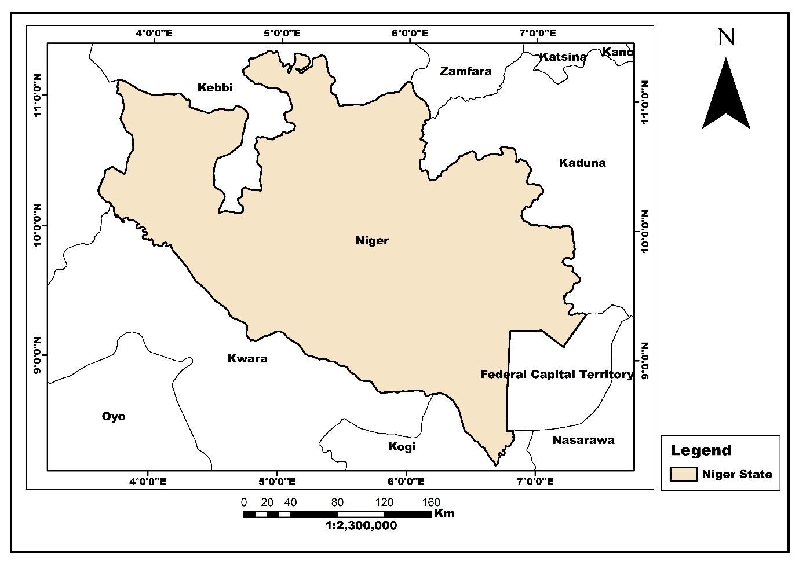
Figure 1: The Study Area (Niger State)
2.1 Rainfall Distribution and Patterns
Niger State experiences significant spatial variation in precipitation. Figure 2 revealed that the southeastern region receives the highest rainfall amounts, reaching up to 39.4 cm, while the northern and northwestern portions record lower precipitation levels of approximately 25.2 cm. This north-south rainfall gradient reflects Niger State's position in Nigeria's Middle Belt region, where the humid southern climate transitions into the drier Sahelian conditions of the north.
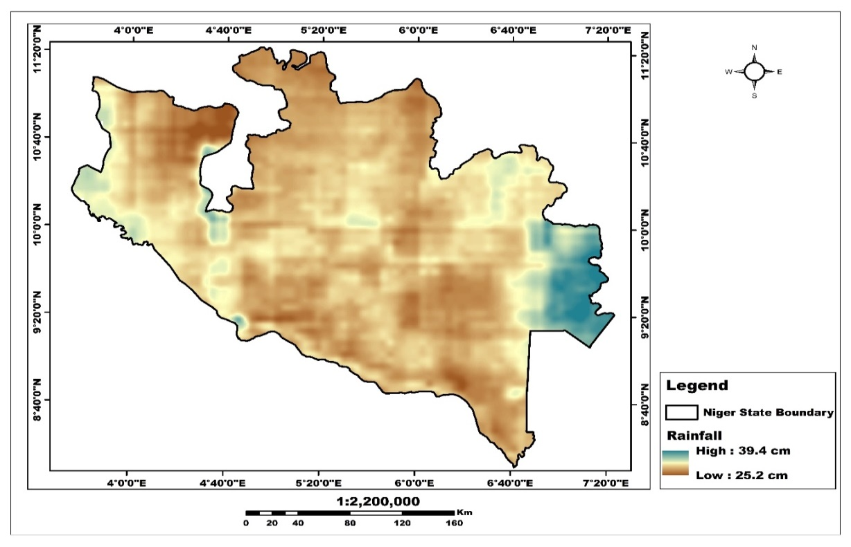
Figure 2: Distribution of Annual Rainfall in Niger State.
Annual rainfall ranges from 1,100mm in the northern parts to 1,600mm in the southern regions (Nigerian Meteorological Agency, 2023), with precipitation concentrated between April and October. Peak rainfall typically occurs in August and September, when monthly totals can exceed 250mm in the wettest areas (NIMET, 2023). The state's southern districts benefit from their proximity to moisture-laden air masses from the Atlantic Ocean, resulting in longer rainy seasons and higher annual precipitation.
2.2 Relative Humidity
The relative humidity across Niger State ranges from 37.0% in the driest areas to 94.7% in the most humid zones (Figure 3). The highest humidity levels are concentrated along river valleys and in the southeastern region, where they create distinct microclimates favorable for specific vegetation types and agricultural practices (Figure 3). Humidity fluctuations follow the seasonal precipitation cycle, with peak levels occurring during the rainy season (June to September) when atmospheric moisture content remains consistently high. During this period, morning humidity commonly exceeds 80% across most of the state. Conversely, the Harmattan season brings extremely dry conditions, with humidity levels frequently dropping below 40% (NIMET, 2023), causing increased evapotranspiration, water stress for plants, and respiratory discomfort among residents.
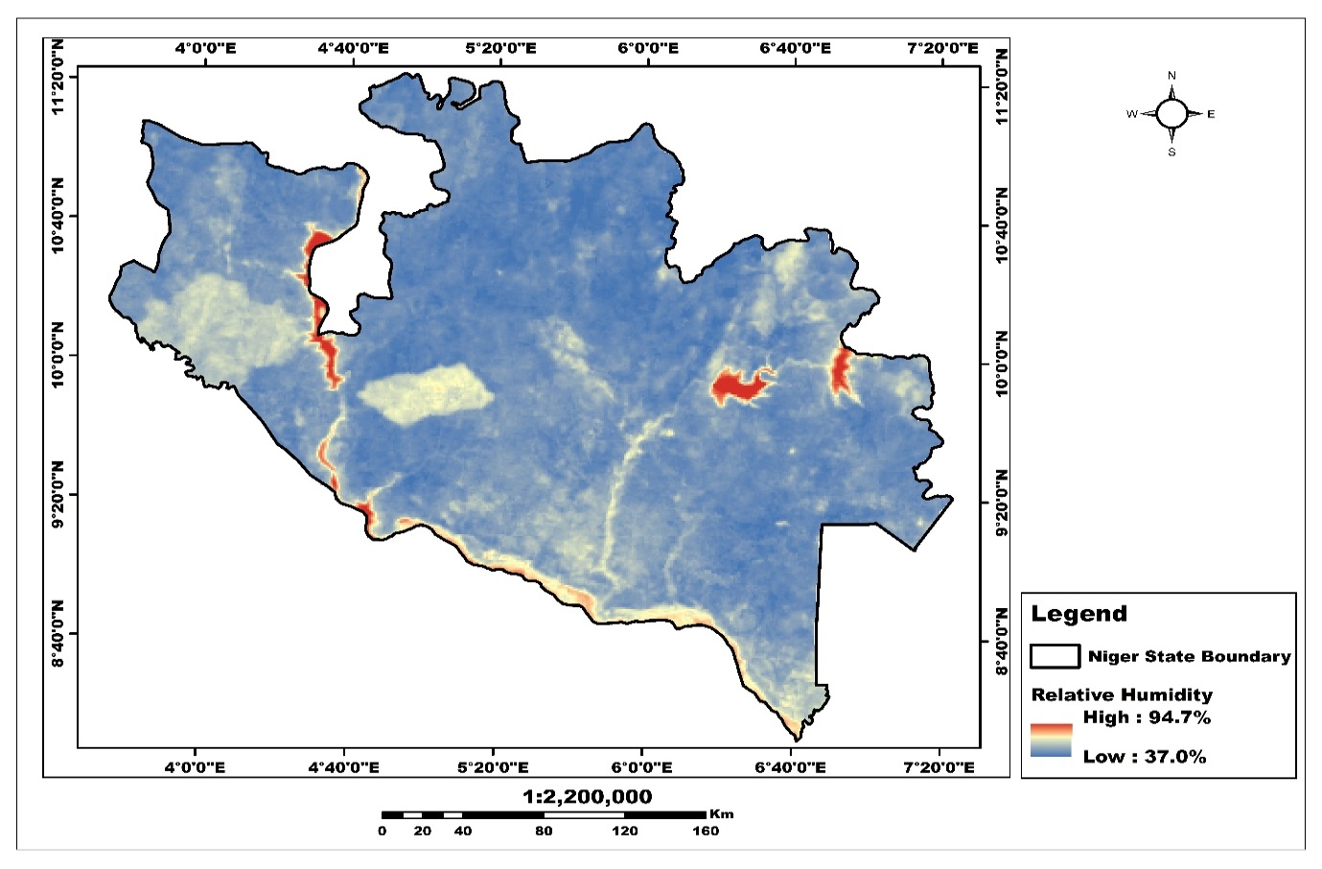
Figure 3: Relative humidity of Niger State.
2.3 Temperature Variation
Figure 4 shows the temperature distribution across Niger State ranging from 24.0°C in the cooler pockets to 37.2°C in the hottest zones. The temperature pattern exhibits an interesting inverse relationship with elevation, where the few elevated areas (particularly in the central region) display slightly cooler temperatures than surrounding lowlands. Average temperatures fluctuate between 22°C and 36°C throughout the year (NIMET, 2023), with marked seasonal variations. The hottest period spans from March to May, immediately preceding the onset of the rainy season, when maximum temperatures regularly exceed 35°C and occasionally approach 40°C in the northern districts. The relatively cooler period occurs during the Harmattan season (November to February), when nighttime temperatures can drop to 15°C, creating a significant diurnal temperature range that impacts both agricultural activities and human comfort.
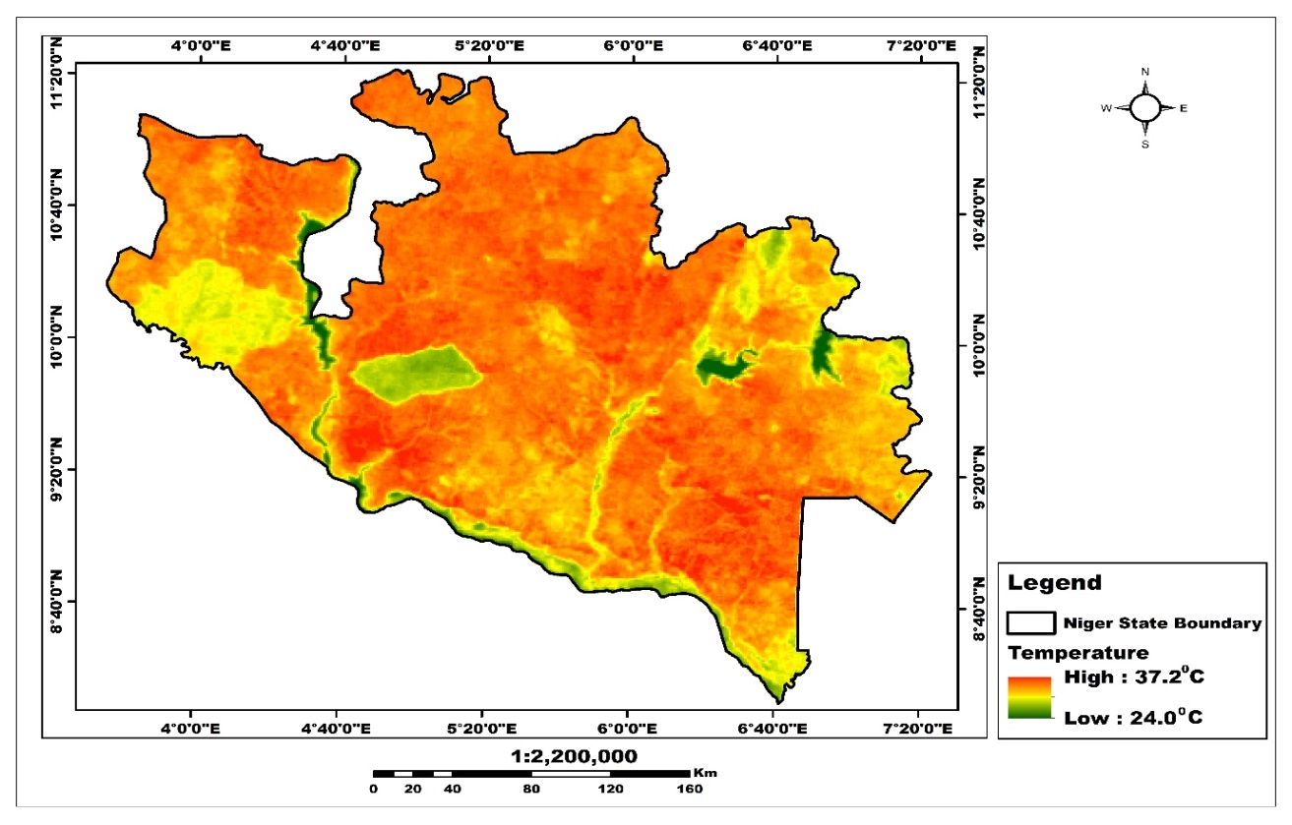
Figure 4: Distribution of Annual temperature in Niger State.
2.4 Geological Setting
Niger State is underlain by the Basement Complex rocks of the Nigerian Basement Complex, with some areas overlain by sedimentary formations of the Bida Basin in the northeast and the Sokoto Basin in the northwest (Nigerian Geological Survey Agency [NGSA], 2021). The Basement Complex, comprising mainly Precambrian igneous and metamorphic rocks, covers approximately 65% of the state's area and is characterized by granites, gneisses, migmatites, and schists dating back to the Pan-African orogeny). The Bida Basin, a northwest-trending depression filled with Cretaceous to Tertiary sediments, contains significant deposits of sandstones, siltstones, claystones, and ironstones, while the smaller portion of the Sokoto Basin present in Niger State features limestone and shale formations (Federal Ministry of Mines and Steel Development, 2022). The state's topography features expansive plains, occasional hills, and inselbergs, with elevations ranging from 150 meters in the Kaduna River valley to over 650 meters in the highlands near Kagara (NGSA, 2021). This varied topography influences local drainage patterns, agricultural potential, and settlement distribution across the state. Significant mineral deposits include tantalite, gold, talc, iron ore, and feldspar, contributing to the state's economic potential (Ministry of Solid Minerals Development, 2022). The soils of Niger State vary considerably, reflecting the diversity in parent materials, topography, and climate (Niger State Ministry of Agriculture, 2023). These soils exhibit varying degrees of fertility, with the most productive agricultural lands found in the floodplains of the major rivers and their tributaries (Niger State Environmental Protection Agency, 2022).

2.5 Topography
Niger State presents a diverse topography transitioning dramatically across its expanse, from undulating northern plains and plateaus to more rugged southern terrain (Figure 5). The southwestern border features the Niger River carving a fertile valley with lush floodplains contrasting against drier savannah regions, while the central portions showcase rolling hills with isolated inselbergs and dramatic rock formations, particularly around Zuma Rock. This elevation gradient generates diverse ecosystems ranging from lowland forests and wetlands near major rivers to savannah woodlands at middle elevations and sparser vegetation in the higher northeastern regions, ultimately influencing both the state's distinctive ecological zones patterns and agricultural practices.
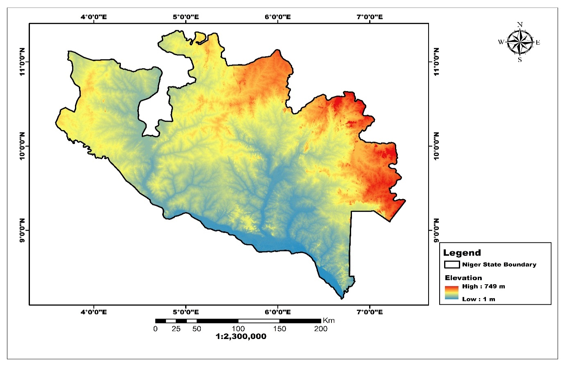
Figure 5: Elevation of Niger State
2.6 Hydrological Characteristics
Niger State is defined by two major river systems: the Niger River, which forms its southern boundary, and the Kaduna River, which traverses the eastern portion of the state. These rivers and their tributaries create extensive floodplains that support agricultural activities and provide opportunities for fishing and transportation (Niger State Ministry of Water Resources, 2023). The Niger River, Africa's third-longest river, flows through the state for approximately 630 kilometers, creating a natural boundary with Kebbi State and forming the expansive Kainji Lake, which covers about 1,300 square kilometers within Niger State (Niger State Ministry of Water Resources, 2023). The Kaduna River, a major tributary of the Niger, traverses about 210 kilometers through the eastern districts of the state before joining the Niger River near Pategi. Other significant water bodies include the Gbako, Gurara, and Chanchaga Rivers, which collectively form a dense drainage network across the state (Niger State Hydrological Services Agency, 2022). The Kainji and Shiroro hydroelectric dams, situated on the Niger and Kaduna Rivers respectively (Niger State Ministry of Environment, 2022).
3.0 METHODOLOGY
3.1 Data Acquisition
This research commenced with comprehensive data acquisition for Niger State as well as Kogi State of Nigeria. High-resolution satellite imagery, digital elevation models, and existing geospatial datasets such as annual temperature, rainfall and humidity data were collected from multiple sources, mainly USGS Earth Explorer, Copernicus and Google Earth Engine. These datasets were subsequently processed using the ArcGIS 10.8 software. Different scenes of the satellite imagery were mosaicked into one composite to extract the whole extent of the area of interest (Niger State). After that, band combination was carried out to achieve the “false colour composite” with which to carry out the classification task. All spatial data were standardized to UTM projection (Zone 32N) and resampled to a uniform 30-meter resolution to facilitate seamless integration. A structured geodatabase was established to maintain data integrity throughout the analytical process, with appropriate metadata documentation for each layer. This initial preparation stage was crucial for ensuring spatial and temporal consistency across the diverse datasets, particularly when dealing with information from varied sources and collection periods. Figure 6 display the work flow for the data pre-processing, hydrological and watershed analysis.
3.2 Climatic Data Analysis
The climate variable mapping phase focused on visualizing three critical parameters: relative humidity, rainfall distribution, and temperature patterns. For the relative humidity analysis, satellite-derived atmospheric moisture data was processed and interpolated using Inverse Distance Weight (IDW) method to generate a continuous surface across the study area. The resulting map revealed significant spatial variation, with humidity values ranging from 37.0% in the central regions to 94.7% along specific western boundaries and waterways. These findings highlighted the considerable microclimatic variations, influenced by topography, vegetation cover, and proximity to water bodies. The rainfall distribution map was created by processing precipitation data from multiple meteorological stations on Google Earth Engine, which was then interpolated and validated against historical records. This analysis exposed notable precipitation gradients across the states, with distinct wet and dry zones that corresponded to topographic features and regional climatic patterns. Temperature variation across the State was mapped using thermal infrared bands from satellite imagery, revealing thermal hotspots and cooler zones that correlated with both natural features and anthropogenic influences.
3.3 Land use Land Cover Analysis
Land cover classification was performed using supervised maximum likelihood classification technique on multi-spectral satellite imagery. Training samples were carefully selected for each land cover category based on field data and high-resolution reference imagery. The classification process identified eight distinct land use/land cover (LULC) classes: forest, shrubland, grassland, agricultural land, built-up areas, water bodies, wetlands, and rock outcrops. This detailed categorization allowed for comprehensive landscape characterization essential for understanding hydrological processes and watershed dynamics. Post-classification refinement included majority filtering and contextual correction to reduce salt-and-pepper effects. Accuracy assessment was conducted using a confusion matrix against independent validation points, achieving an overall accuracy of 87% with Kappa coefficient of 0.83. The final LULC map clearly illustrated the dominance of agricultural land across Niger State while vegetation dominated Kogi State.

3.4 Hydrological Analysis
The watershed delineation methodology employed a systematic approach based on hydrological modeling principles. First, a hierologically corrected digital elevation model was prepared by filling sinks and removing imperfections. This process was computationally intensive but essential for creating a continuous flow surface that accurately represented the terrain. Flow direction and flow accumulation analyses were subsequently performed to identify natural drainage patterns and stream networks. The watershed characteristics analysis examined the relationship between drainage patterns and potential water resource management opportunities. Drainage density calculations revealed areas of high surface runoff potential, visualized through a multi-tiered intensity classification. These calculations considered the total stream length per unit area within each sub-watershed, providing quantitative metrics for comparative analysis. Watersheds were classified based on multiple criteria including slope, soil permeability, and stream density, with darker red areas indicating higher flood risk or erosion potential. Potential reservoir sites were identified through a multi-criteria decision analysis that considered topographic suitability, stream order, catchment area, and proximity to settlements. Each site was evaluated using a weighted scoring system that prioritized locations with optimal combinations of these factors. These locations represented strategic points for potential water harvesting structures based on their hydrological characteristics and estimated storage capacity. The hydrological analyses were carried out are presented in the flow chart below (Figure 6).
Downloading image
Aster Image 1:1m

Mosaic Image
Reproject
Resample
Preprocessing
Filter (Fill Sinks)
Flow Direction
Flow Accumulation
Stream order
Conditional Raster
Stream to Feature
Hydrological Analysis
Locate Pour Points
Create Pour Points
Delineate Basins
Delineate Watersheds
Watershed Morphometric
Watershed Analysis

Figure 6: Flow Chart of Methodology
4.0 RESULTS AND DISCUSSION
4.1 Watersheds and Natural Resources in the Study Area
The study identified twenty-two (22) geohydrological units known as watersheds, which are dispersed throughout the area's land resources ranging from 675.77Km² to 12,358.8Km² (Table 2 and 3). Identifying appropriate watersheds is a prerequisite for implementing planning interventions for sustainable agricultural development. Figures 7 shows the spatial extent of existing dams and the distribution of stream networks among watersheds in the area's land resources. Table 1 shows that agricultural land covered 25361.27 km², accounting for more than 80% of the total area. While water bodies cover 460.51 km², this indicates the availability of water for irrigation agriculture in the area. The existing dams are situated in Kainji, Jebba, and Shiroro, with the Zungeru dam placed west of Shiroro. Table 1 shows that a wetland of 100.29 km² can support rice production. Rock outcrops play a significant role in the evolution of several hydrological variables in the studied area. This is not unique to Niger state, but is common throughout Nigeria's north central area, where the crystalline basement rock outcrops and their underlying structural features have always played an important role in the formation of hydrological systems.
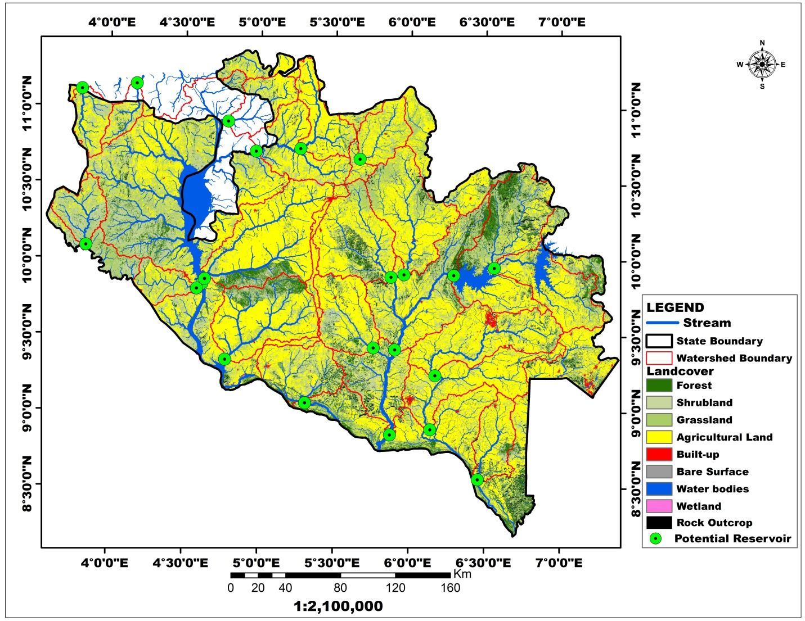
Figure 7: Spatial Distribution of Natural Resources in Niger State

Table 1: Natural Resources of Niger State
S/N | LANDCOVER | AREA (Km²)
1 | Forest | 5176.08
2 | Shrubland | 9505.86
3 | Grassland | 8056.98
4 | Agricultural Land | 25361.27
5 | Built-up | 482.68
6 | Bare Surface | 137.74
7 | Water bodies | 460.51
8 | Wetland | 100.29
4.2 Watersheds and Potential Water Reservoirs
The geo-hydrological units in which water flows downslope, passes through a common exit via a network of streams, and is distributed to rivers and reservoirs. Figures 8 and 9 show the spatial distribution of pour places (potential dams) and twenty-two (22) watersheds (geo-hydrological units) that were identified as prospective water reservoirs in the research region. The streams exhibited a dendritic network that ran largely from NE to SW, indicating a flow orientation similar to that of Nigerian regional lineaments, implying that the flow pattern was structurally controlled. Understanding these parameters can provide valuable insights into the behavior and characteristics of water flow within a watershed. The watershed area and volume of water that drains from it are directly proportional to the size and flow of the major stream or water body. Land use and soil types, geology, geography, and climate are other features that characterize each watershed in Niger state.
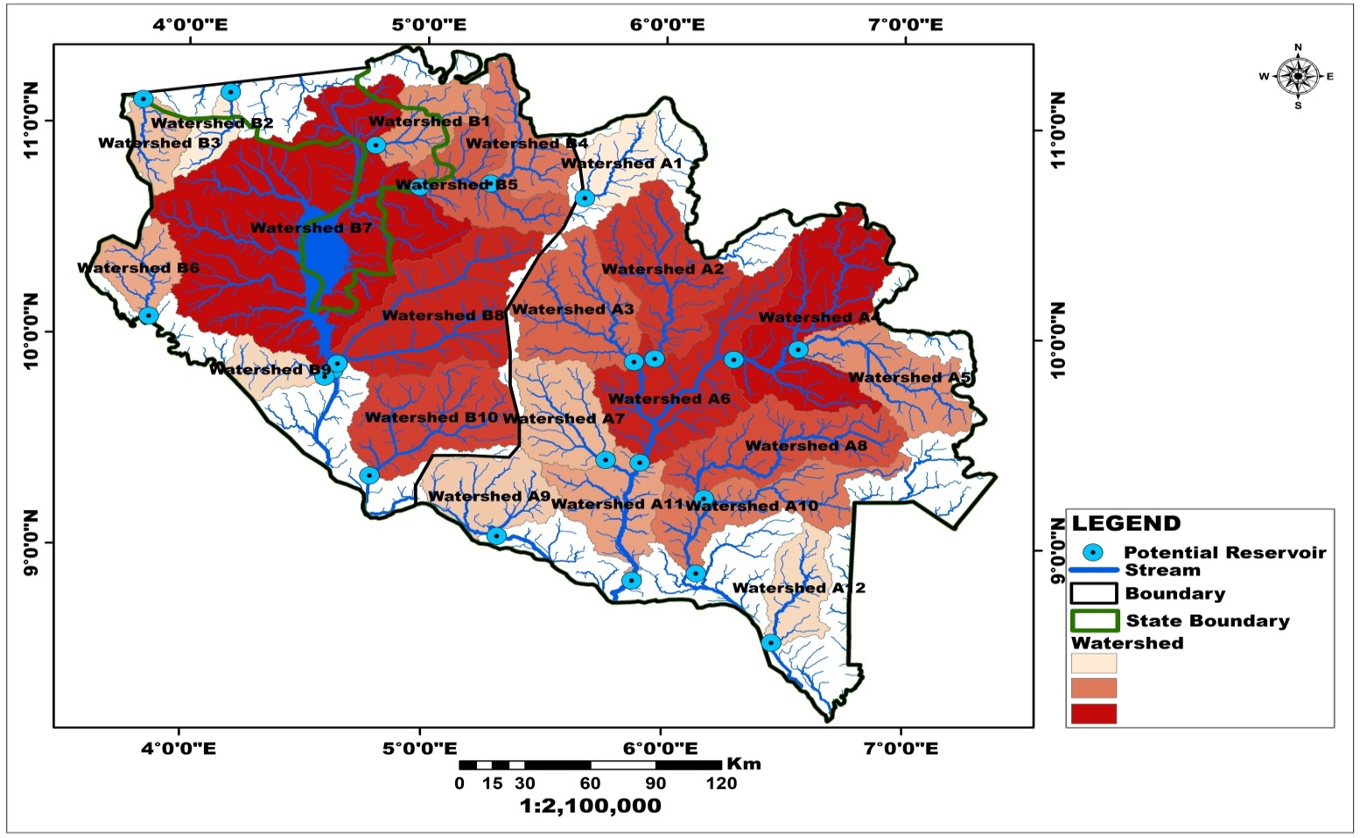
Figure 8: Delineated Watersheds for Irrigation Agriculture in Niger State
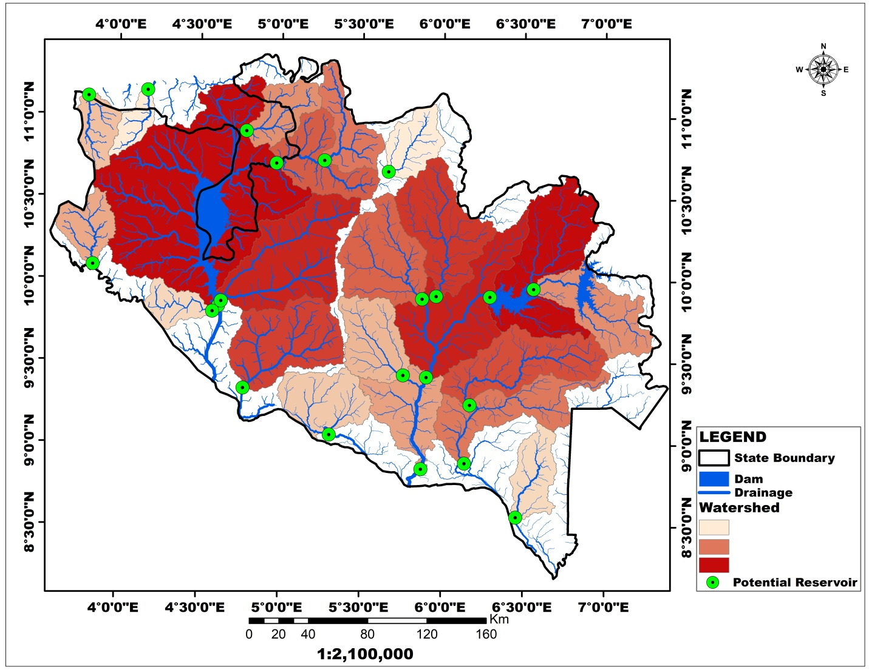
Figure 9: Potential Water Reservoirs for Irrigation Agriculture in Niger State
4.3 Watersheds and Potential Water Reservoirs in the Western part Niger State
Figure 10 displays a geohydrological unit in Niger State's western region where water flow downhill, through a network of streams, and into rivers and reservoirs. Figure 11 depicts the area's natural resources, with agricultural land accounting for more than 80% of the total area. This region has ten (10) potential water reservoirs for irrigation, with geo-hydrologic unit code watershed B7 (Kainji watershed) occupying the largest area at 12358.88 Km² (1,235,800 Hectares), as shown in Figure 12 and Table 2. The Kainji Dam extends to the southern section of Kebbi State. While geo-hydrologic unit code B2 is the smallest, with a geographical size of 675.77 km² (67,577 hectares), it is designated as a macro-watershed. The shape of the watershed influences the rate of run-off and infiltration within the basin. Table 2 shows a circulatory ratio of 0.556481 and 1.553264 for watersheds B8 (slightly above the range of 0.5 and 1.0. This has an impact on flow rates, sediment transport potential, water travel time, and floods duration within specific watersheds. Such elements regulate the rate at which water gathers within reservoirs, the rate of sedimentation in reservoirs, and reservoirs' potential for use as a flood control medium. This indicates structural controls, possibly from remnant tectonic structures in the underlying crystalline rocks.

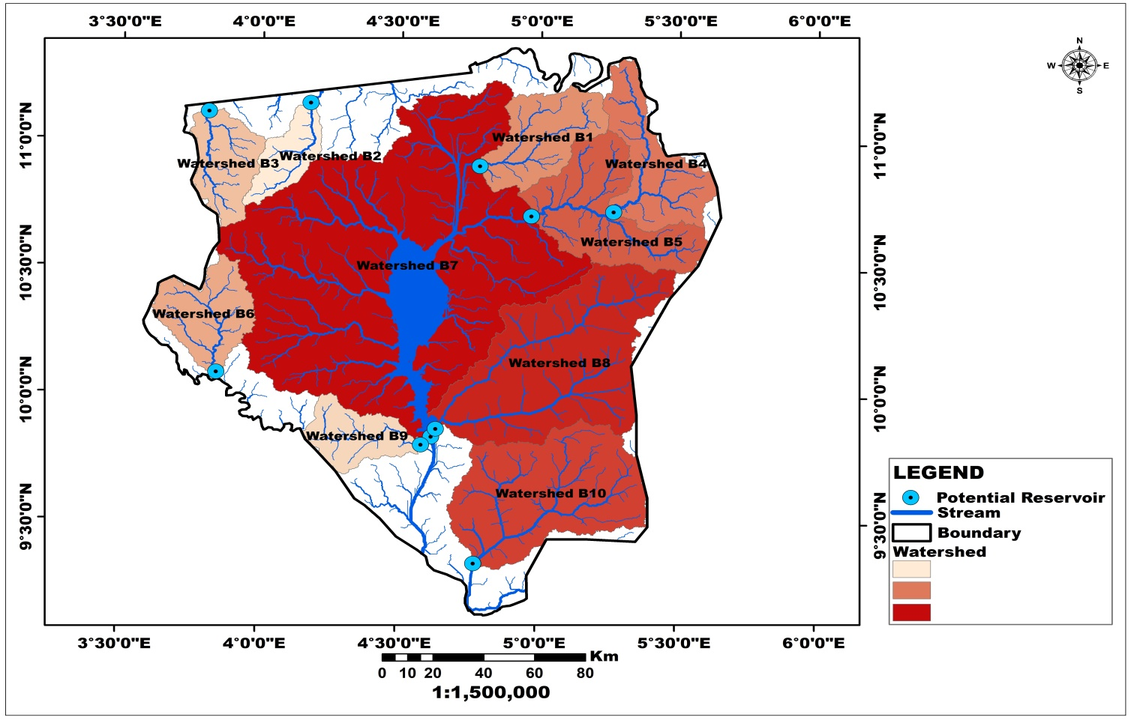
Figure 10: Kainji Dam and Potential Water Reservoirs in the Western part of Niger State
Table 2: Statistics of the watersheds
S/N | Shape_Length | Area (Km²) | Geohydrological Units | Circularity Ratio
1 | 207992.68 | 1385.92 | Watershed B1 | 0.174182
2 | 151689.27 | 675.77 | Watershed B2 | 0.084931
3 | 180605.78 | 991.83 | Watershed B3 | 0.124653
4 | 281073.90 | 1553.23 | Watershed B4 | 0.19521
5 | 317270.90 | 2183.99 | Watershed B5 | 0.274484
6 | 207117.28 | 1220.77 | Watershed B6 | 0.153426
7 | 717063.22 | 12358.88 | Watershed B7 | 1.553264
8 | 410609.76 | 4427.76 | Watershed B8 | 0.556481
9 | 159971.40 | 876.48 | Watershed B9 | 0.110156
10 | 321508.92 | 3356.71 | Watershed B10 | 0.421871
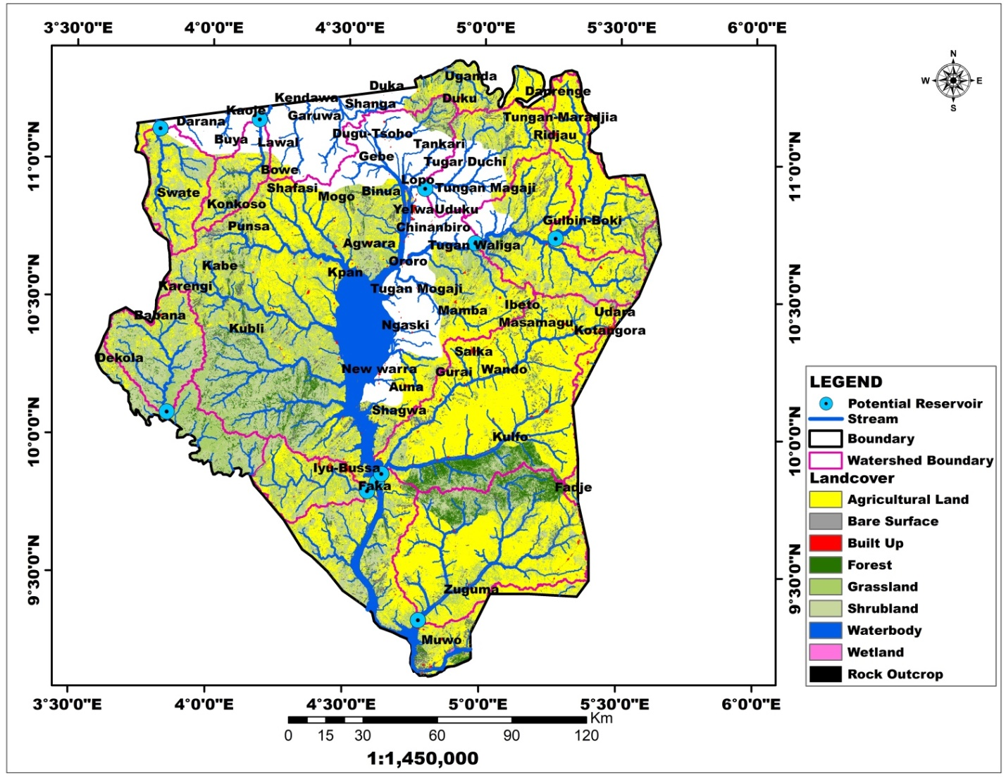
Figure 11: Kainji Dam and its Tributaries, Western Part of Niger State
4.4 Watersheds and Potential Water Reservoirs in the Eastern part Niger State
Figures 12 and 13 represent a geo-hydrological unit in Niger State's western region, where water flows downhill, through a network of streams, and into rivers and reservoirs. Figure 14 depicts the area's natural resources, with agricultural land accounting for more than 80% of the total area. This region has twelve (12) potential water reservoirs for irrigation and labeled A1 to A12 (Figure 14 and Table 3). The size variation of a watershed is specified on many scales, known as its geo-hydrological unit codes (Figures 10 and 12 and Table 3 and 4), which are delimited and designated as A1 to A12 and B1 to B10 based on the hydrological characteristics most relevant to its unique area. Other elements that distinguish each watershed in the area include land use, soil type, geology, geography, and climate. The streams in the area have a dendritic network that flows predominantly NE-SW, which corresponds to the Nigerian regional lineament, indicating structural control and serving as conduits for recharging groundwater. The surface topography (slope of land and stream channel) within the watershed has a significant impact on streamflow. The watershed with geo-hydrological unit A6 has the highest expansion of 4037.42 km², while Watershed-A 12 has the smallest with a geographical extent of 1414.42 km². The variation in the shape of these watersheds is attributed to the surface topography, lands cover types, climate, geology and soil types, and these also influence the rate of surface run-off and infiltration within each basin. Within this smaller area, the link between the watershed characteristics and the structures of the underlying rock formations is even more obvious. Two (2) of the twelve (12) watersheds identified had circularity ratios slightly above 0.5, while two (2) were between 0.4 and 0.5, and seven were less than 0.4 (Table 3).
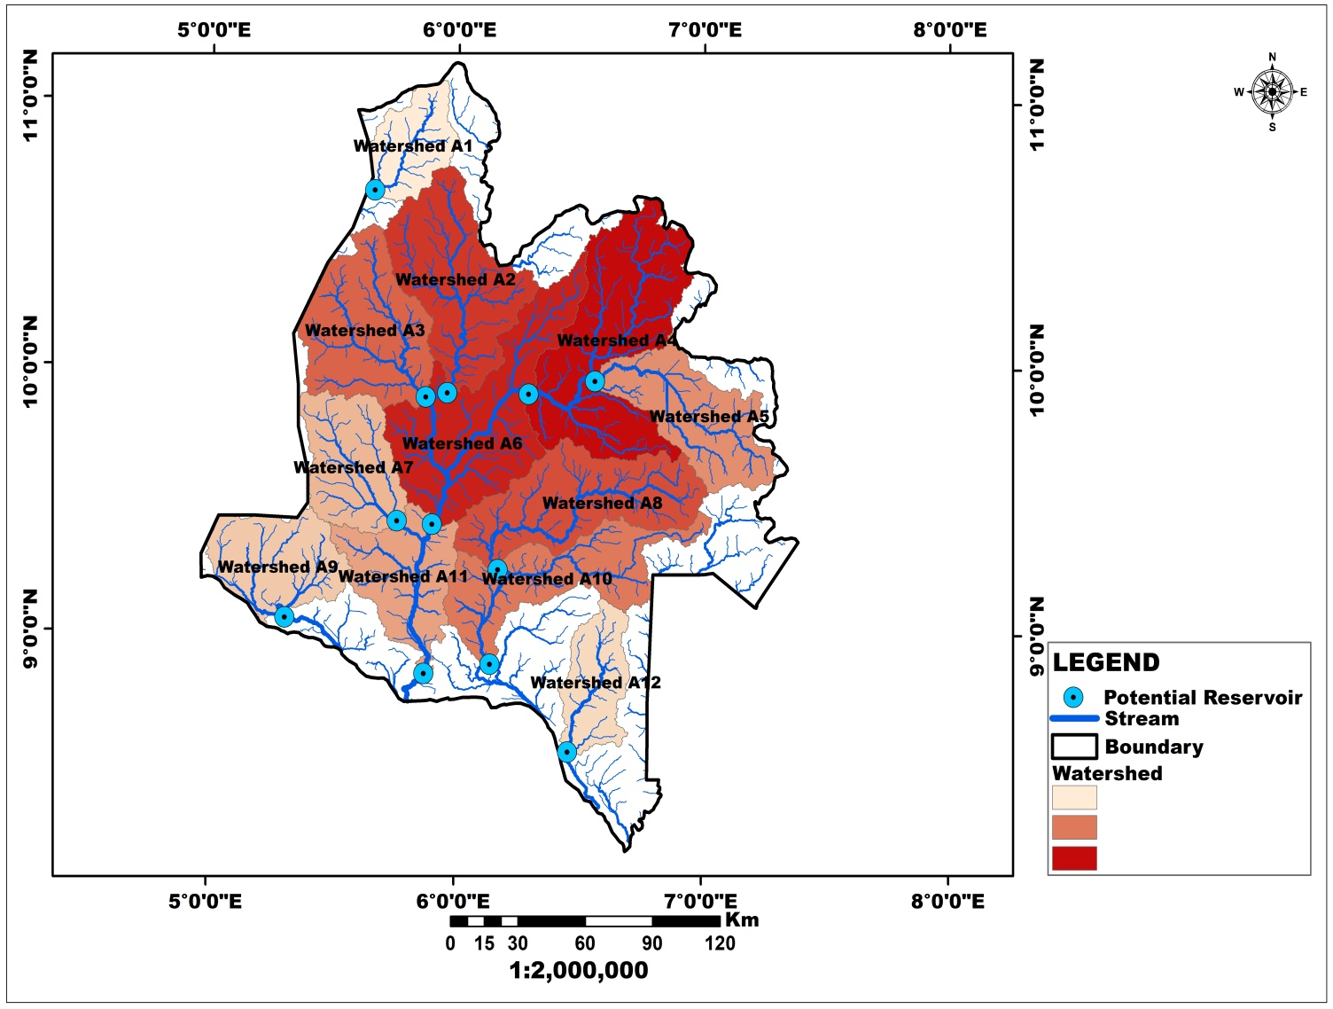
Figure 12: Potential Water Reservoirs in the Eastern part of Niger State
Table 3: Statistics of the Watersheds
S/No | Length | Area (Km²) | Geohydrological Unit | Circularity Ratio
1 | 187342.92 | 1307.51 | Watershed A1 | 0.164328
2 | 350460.71 | 3294.51 | Watershed A2 | 0.414054
3 | 307437.26 | 3062.49 | Watershed A3 | 0.384894
4 | 498980.91 | 4335.73 | Watershed A4 | 0.544915
5 | 318658.33 | 2455.58 | Watershed A5 | 0.308617
6 | 488610.36 | 4037.42 | Watershed A6 | 0.507423
7 | 248325.00 | 2096.77 | Watershed A7 | 0.263522
8 | 383412.31 | 3292.47 | Watershed A8 | 0.413798
9 | 247383.82 | 2046.55 | Watershed A9 | 0.25721
10 | 460562.72 | 2721.18 | Watershed A10 | 0.341998
11 | 314448.28 | 2131.45 | Watershed A11 | 0.267881
12 | 223740.10 | 1414.42 | Watershed A12 | 0.177764

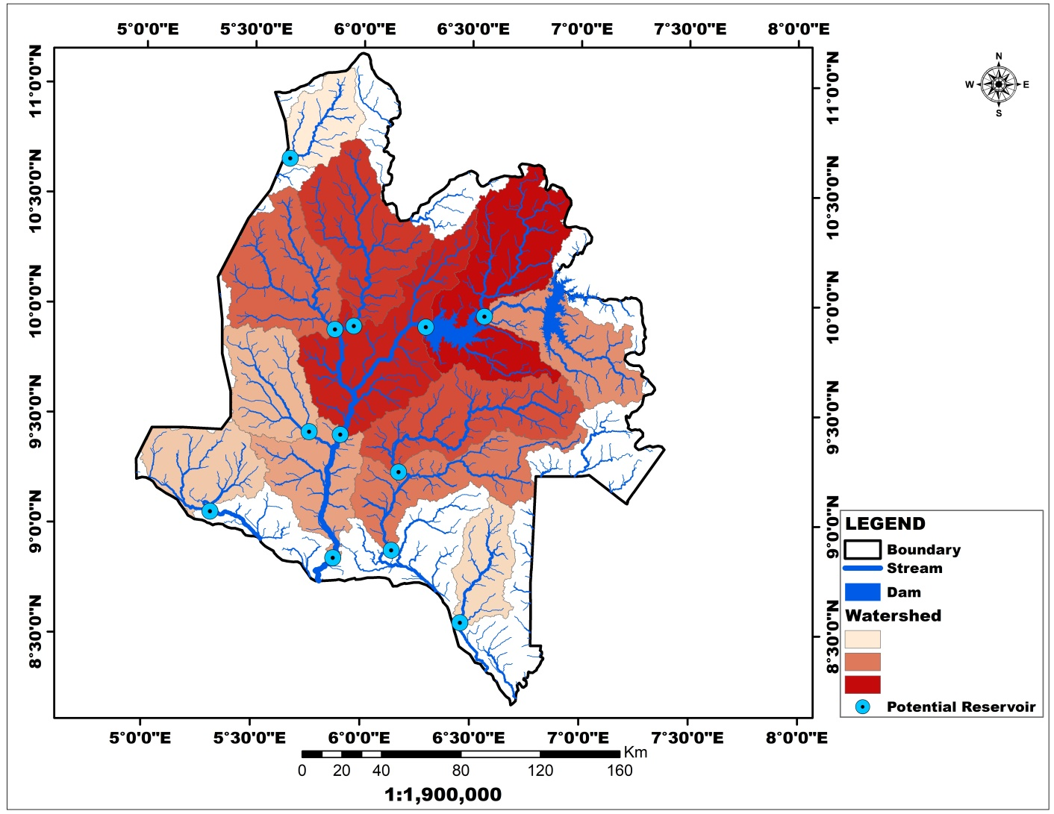
Figure 13: Dams and Potential Water Reservoirs in the Eastern Part Niger State
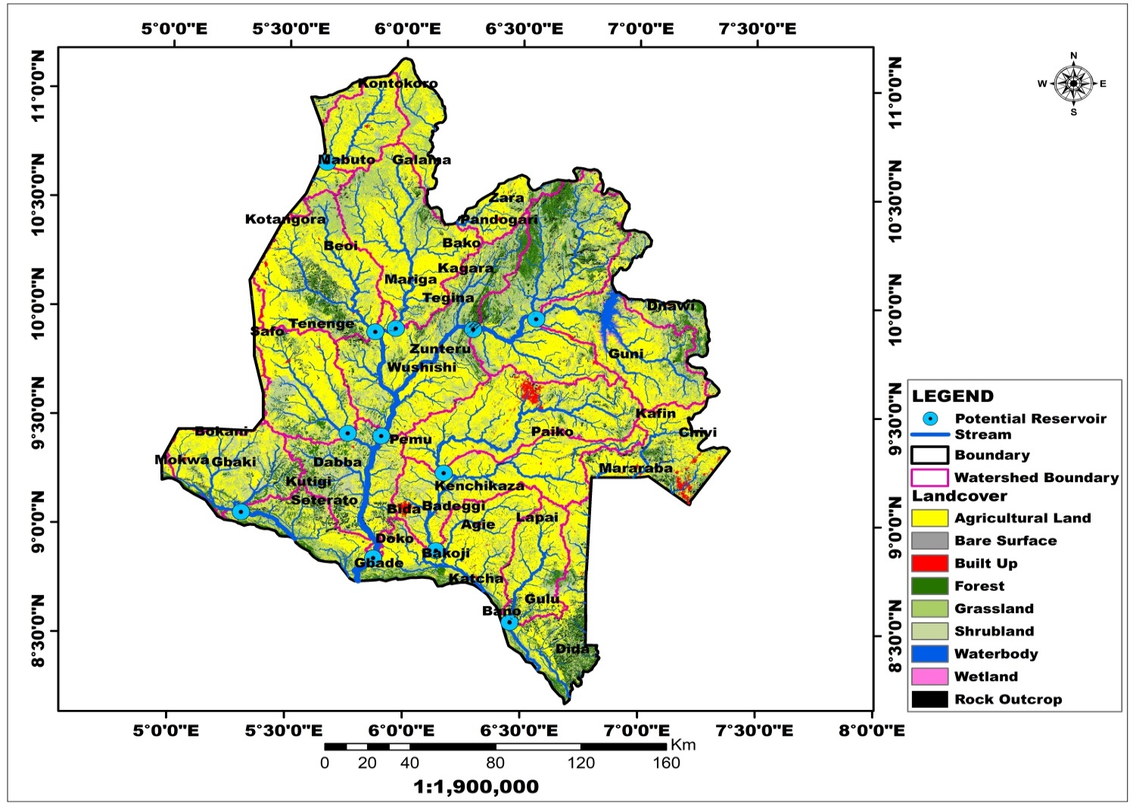
Figure 14: Distribution of Natural Resources in the Eastern Part of Niger State
4.5 Hydrological Characteristics of Shiroro and Zungeru (New Dam) Watershed
The Shiroro and Zungeru dam watersheds (Figure 15) shows six main components including the catchment area which includes all the area within the ridgeline, the continuous ridgeline which is the boundary of the watershed, the stream network which drains and collects water for the watershed from the primary water body and tributaries, the outlet or pour point. Majority of the rivers flow NE-SW with few taking SE-NW orientation. The volume of water that drains from it relates directly to the size and flow of the primary stream or water body. The hydrological characteristics of the watershed are control by land uses, soil types, geology, topography, and climate. These also have influence on groundwater recharge which feeds some of the influent streams that drains to the pour point in the area. The Shiroro Dam in Nigeria features a rock-filled concrete-faced dam that is 115 meters high and 700 meters long, with a reservoir holding capacity of 7 billion cubic meters of water, covering a 34 Km² area.
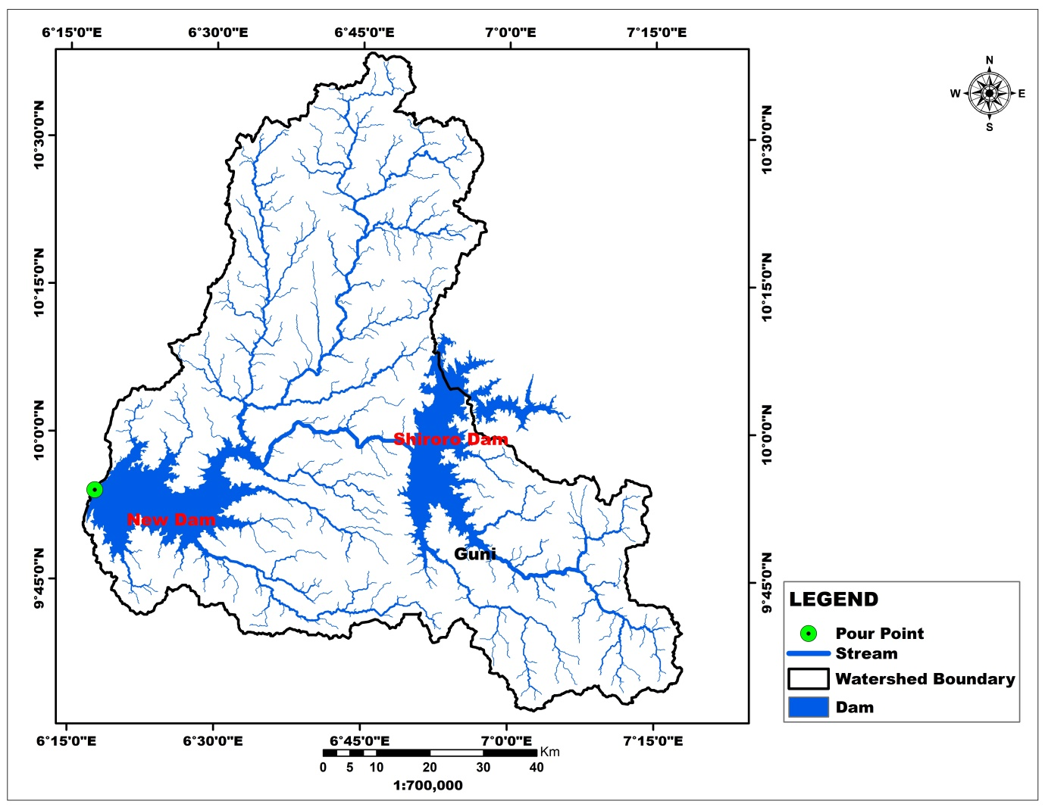
Figure 15: Catchment of Shiroro and Zungeru Dams in Niger State

4.6 Spatial Distribution of Natural Resources in Shiroro and Zungeru Dam Watershed
Figure 16 and Table 4 indicate the distribution of land resources and their area coverage, with agricultural land occupying 2642.41 km² (264,241 hectares). A 42.48 km² wetland can sustain rice farming. The Shiroro and Zungeru dams and some perennial rivers have the ability to irrigate 2642.41Km² of cultivated land in the basin.
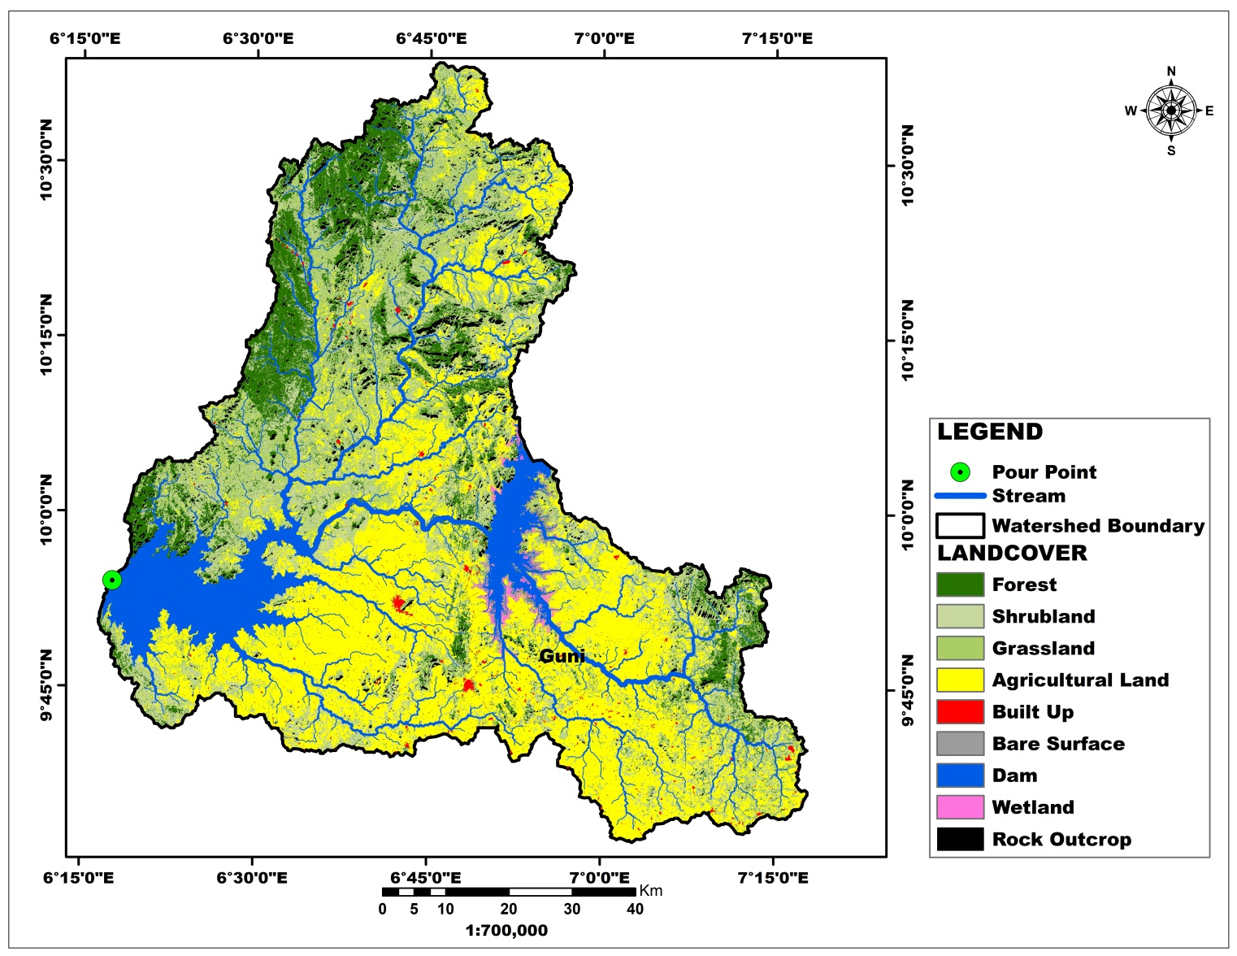
Figure 16: Spatial Distribution of Natural Resources in Shiroro and New Dam Watershed
Table 4: Distribution of Natural Resources (SqKm)
S/N | LANDCOVER | AREA (Km²)
1 | Forest | 969.45
2 | Shrubland | 1432.16
3 | Grassland | 1230.52
4 | Agricultural Land | 2642.41
5 | Built-up | 31.18
6 | Bare Surface | 44.56
8 | Water bodies | 171.10
9 | Wetland | 42.48

The surface topography within the watershed has a significant impact on stream flow. Steep sections of a watershed drain fast to the stream and eventually to the pour point or outlet (assuming there is no dam), but water drains considerably slower and more evenly in flat terrain (Figure 5). Soil properties and fracture system in the area influence stream flow. The vegetation in the area (Figure 7) varies according to soil types formed by the weathering of various rock outcrops. As a result, in terms of groundwater potential, this vegetation reduces surface runoff, increasing infiltration into the area's groundwater system. In the same vein, the leaves of trees and forests retained water droplets, which traveled down to recharge the groundwater system, resulting in the formation of a water mound. Based on the stream orders, the streams in the research area can be classed as; influent and effluent streams, intermittent and perennial streams, and ephemeral streams. Since the streams network are structurally controlled, it is highly likely that both surface and groundwater hydrological systems have similar characteristics and orientation, and both are influenced by geology and surface topography in crystalline terrain. This implies that in some regions within each geo-hydrological unit, the groundwater table is located beneath the bed of some streams, and seepage from the stream feeds the groundwater, resulting in the formation of a water mound; such streams are referred to as influent streams. Irrigation channels serve as influent streams. Some streams, particularly first and second order streams, totally dry up during a rainless period and are referred to as ephemeral streams. Similarly, it was discovered that where the groundwater table is higher than the water surface elevation in the stream within the research region, the groundwater feeds the stream; these streams are known as effluent streams.
4.6 Watersheds Management Plan for Sustainable Irrigation Agriculture
Watershed management is a comprehensive approach to managing land and water resources in a specific geographic area within a watershed (geo-hydrological unit). The sustainable use and protection of natural resources within a watershed, aiming to balance ecological, economic, and social needs through land and water resource management includes the entire management of all aspects of the watershed, including land, water, vegetation, and socioeconomic variables. The goal is to promote the preservation, rehabilitation, and appropriate utilization of natural resources while also meeting the needs and ambitions of local communities. With twenty-two (22) macro watersheds identified, watershed management in this context takes a holistic approach that includes soil and water conservation, plantation, agronomical practices, livestock management, renewable energy, and institutional development to achieve long-term and environmentally friendly outcomes. The management in the area will adhere to certain ideas for efficient and long-term impact, such as participatory approaches, integrated planning, watershed management as a geo-hydrological unit, adaptive management, and sustainable resource use. The identification and potential use of these watersheds has far-reaching consequences in all of these regions. Those that drain directly into the Benue River, in particular, can assist to alleviate or reduce the perennial flooding that occurs along its banks and expands westward to the confluence and southward to the delta. Damming these tributaries allows for more control over the volume of flow in the Benue and Niger States, providing some relief, especially when water from the Lagdo dam is discharged. Best practice integrated watershed management usually includes a participatory planning approach at both landscape and micro scales, with management plans utilizing high quality scientific data from both field and geospatial sources. The watershed planning in the area should be carried out using analytical approaches and through development of a modern knowledge base (including collation of existing data from in situ and earth observation and biophysical surveys). Because of the hydrological characteristics of the watersheds in the area, it will require extensive multisectoral approach (including World Bank collaboration with Niger State ACReSAL, Federal Ministry of Water Resources, Nigerian Hydrological Services Agency, Integrated Water Resources Management Agency, Federal Ministry of Environment, and Government of Niger State) and participatory stakeholder consultations will be fundamental. Youdeowei et al (2019) asserted that watershed management requires a careful balance between economic and environmental goals, as well as a thorough analysis of all biophysical interactions within the watershed system.
4.7 Comparative Analysis of This Study with Similar Research Studies
A comparison of a comparable study conducted by Hyungjin Shin et al. (2024) on hydrological analysis of watersheds based on the water usage system, utilizing the catchment hydrological analysis tool model. The findings identified 27 watersheds as agricultural reservoirs. Similarly, Balasubramani (2024) assessed watershed resources for sustainable agricultural development in regions of India using geospatial technologies. The study used well-known empirical and quantitative methods to define the watershed and determine the geographical pattern of prospective watershed resource usage in agriculture. Ebenezer et al. (2024) revealed significant differences in travel distances to water sources, underlining the significance of improved water infrastructure such as dams, watersheds, and river access sites. Furthermore, Jankaro et al. (2023) conducted a similar study using GIS-based irrigation suitability evaluation of the Lapai-Agaie Irrigation Scheme in Niger State, and discovered that 59.0% of the area is extremely suitable for irrigation, 32.0% is moderately acceptable for surface irrigation, and 9.0% is marginally appropriate.
SUMMARY OF FINDINGS
- The study identified twenty two (22) potential water reservoirs in Niger State, with sizes ranging from 675.77Km² to 12,358.8Km².
- Geohydrological units with a circularity ratio greater than 0.5 indicate irregular shape, strong run-off, and moderate permeability.
- Over 55% of watersheds in Niger State have circularity of between 0.4 to 0.5 indicative of irregular shape, moderate run-off and high permeability.
- The streams in the area have a dendritic network that flows predominantly NE-SW, which corresponds to the Nigerian regional lineament, indicating structural control and serving as conduits for recharging groundwater.
- The major structural influence within these areas can be attributed to the tectonic tensions that created the failed triple-arm rifting system of which the Niger and Benue river valleys and sedimentary basins are results.
- Niger State has a large agricultural land area of 25361.27 Km² (2.5 million hectares), which can be used for irrigation due to abundant water resources.
- The prospective water reservoirs have the ability to irrigate more than 22000Km² of agricultural area in Niger State.
- The Shiroro and Zungeru dams can irrigate 2642.41 km² of agricultural area in the basin, ensuring food security.
- The Kainji and its surrounding has 10 potential macro watersheds can irrigate about 7000Km² of agricultural land.
- The Jebba dam has the potential to irrigate about 4,000 km² of agricultural land.
Conclusion
The advent of space based technology with its most advanced and innovative developments have revolutionized watershed analysis by providing spatial data to characterize and model watershed characteristics. Hence, as deduced from this research, it can be concluded that the appropriate and sustainable use of these watersheds will help invigorate agricultural activity, increasing the State's production of agro-allied products, increases agri-businesses and, ultimately, favorably enhancing food security.
Recommendation
This study recommends effective collaboration with investors to deploy cutting edge watershed management systems and irrigation infrastructure to support farming clusters in participating communities. As such Nigeria’s food security status will be significantly enhanced and the era of import dependency on staple foods will start to fade. Furthermore, this can reduce rural-urban migration by providing economic opportunities within local communities. It will also mitigate farmer-herder conflicts by reducing pressure on grazing lands and promoting structured land use planning.
REFERENCES
Adeniyi, G.A., Habeeb, G., Abraham, B.O., & Oseni, O. (2023): Modelling the Impacts of Selected Watershed Management Strategies on Sediment Reduction Upstream of Shiroro Dam, Nigeria in Jounal of Engineering Studies and Research 28(4):7-17.
Balasubramani, K. (2024): Assessment of watershed resources for sustainable agricultural development: a case of developing an operational methodology under indian conditions through geospatial technologies.
Ebenezer, N. K., Boateng, G. A., Simon, M., Ishmael, M., Fiifi, A.J., Christine, F., & Benjamin, K. N., (2024): Spatial and multivariate assessment of access to water for sustainable agriculture intensification in semi-arid Ghana.
Hyungjin, S., Hyeokjin, L., & Jaenam, L. (2024): Hydrological Analysis of Agricultural Reservoir Watersheds Based on Water Utilization System Using the Catchment Hydrology Cycle Analysis Tool Model
Jankaro, L. S., Odofin, A. J., Lawal, B. A. & Onuigbo, I. C. (2023): GIS-Based Irrigation Suitability Evaluation of Lapai-Agaie Irrigation Scheme, Niger State, Nigeria.
Ministry of Solid Minerals Development. (2022): Mineral Resources Inventory of Nigeria: North Central Zone. Federal Government of Nigeria.
Nigerian Geological Survey Agency [NGSA]. (2021): Geological Map and Mineral Resources Inventory of Niger State. Federal Ministry of Mines and Steel Development.
Nigerian Meteorological Agency [NIMET]. (2023): Climate Review of Niger State 2018-2022. Federal Government of Nigeria.
Niger State Bureau of Statistics [NSBS]. (2023): Niger State Statistical Yearbook 2022. Niger State Government.
Niger State Ministry of Environment. (2022): Environmental Impact Assessment of the Hydroelectric Projects in Niger State. Niger State Government.
Niger State Ministry of Water Resources. (2023): Hydrological Assessment of Major Water Bodies in Niger State. Niger State Government.
Panjala P., Gumma, M. K., Ajeigbe, H.A., Hakeem, A.A., (2022): Identifying Suitable Watersheds across Nigeria Using Biophysical Parameters and Machine Learning Algorithms for Agri–Planning in International Journal of Geo-Information.
Pushkar Inamdar, T. P. S.1, Ketki, & M., Vidya, K. (2016): Assessment of Irrigation and Agriculture Potential of the Krishna River Basin using Geospatial Techniques.
Shanono N.J., Nasidi N.M., Abdullahi A.H & Umar S.I. (2024): Dams Utilization Analysis and Potentials to Enhance Irrigated Agriculture in Kano State, Nigeria.
Youdeowei P. O., Nwankwoala, H. O. & Desai D. D. (2019). Dam Structures and Types in Nigeria: Sustainability and Effectiveness. Water Conservation and Management 3(1) 20-26

