Optimization of Nanosilica-Enhanced Geopolymer-Based Fire Retardant Coating (GFC) derived from Sugarcane Bagasse Ash and Kauswagan Red Clay for Steel Application
ABSTRACT
Developing a sustainable and environmentally friendly fire-retardant coating has become a critical focus on reducing reliance on non-renewable raw materials in the production of conventional coatings, specifically for steel structure applications. While steel offers flexibility in design and high strength-to-weight ratio, it loses mechanical integrity at elevated temperatures, which may result in structural collapse. This study focuses on optimizing a nanosilica-enhanced geopolymer fire-retardant coating (GFC) derived from sugarcane bagasse ash (SCBA) and Kauswagan Red Clay (KRC) using response surface methodology (RSM). The effects of Si/Al ratio, nanosilica wt%, and geopolymer-binder-coating-to-alkyd paint (GBC/AP) ratio on the fire-resistance properties were evaluated. Experimental results that the increase in Si/Al ratio, nanosilica wt%, and GBC/AP ratio significantly improved the thermal performance. The optimized GFC formulation (Si/Al ratio = 4.728 ±0.001, nanosilica wt % = 0.583 ±0.001, GBC/AP = 0.497 ±0.001) took 326 s to reach 300 °C (TT300), which outperforms the AP without the GBC (TT300 = 82 s). Adhesion test results showed that the incorporation of GBC does not compromise the adhesion of the coating. Thermogravimetric analysis (TGA) further supported that the best sample has higher residual weight and better thermal stability. Scanning Electron Microscopy (SEM) analysis revealed that lower Si/Al ratios led to severe cracking while excessive Si/Al ratio resulted to more unreacted particles. Higher nanosilica and lower GBC/AP ratio enhance the homogeneity of the coating. Results highlight the potential of GFC as an eco-friendly alternative to conventional coatings for steel protection.
Keywords: sugarcane bagasse ash, kauswagan red clay, nanosilica; response surface methodology, geopolymer, coating, paint
INTRODUCTION
Rapid technological progress has significantly contributed to the advancement of more efficient construction methods, especially within structural applications. In the construction industry, steel has been widely used mainly due to its relatively optimal cost, great flexibility in design, and high strength-to-weight ratio, which allows construction to save a significant amount of time and money without compromising the structure's durability. Common applications of steel are in the construction of infrastructures and high-rise steel structures. However, one disadvantage of steel is that during fire incidents in which it is exposed to extreme temperatures and heat, the structural steel begins to soften when the temperature reaches 425 °C and the steel starts to lose its strength and stiffness when the temperature reaches between 600 °C and 650 °C, which may cause the structure to collapse that could result in damages to properties, injuries, or even death [1]. The Bureau of Fire and Protection (BFP) reported an average of 15,713 fire incidents, 855 fire-related injuries, 253 fire-related deaths, and P4.599 billion pesos worth of asset losses in the Philippines for the year 2013-2018. Additionally, it was emphasized that the Philippines ranked 3rd for the highest fire and fire-related incidents in Asia for the year 2018 [2].
To address this issue, a range of strategies has been developed, among which passive fire protection (PFP) methods are prominent. PFP systems function by limiting fire propagation through the implementation of physical barriers designed to compartmentalize and contain the spread of flames and heat. An example of passive fire protection methods is intumescent coatings. Intumescent coatings react to heat by swelling in a controlled manner up to a hundred times its original thickness. This process generates a carbonaceous char composed of numerous microbubbles, which form an effective insulating layer. This barrier mitigates thermal and mass transport by limiting the transfer of heat and volatiles between the condensed and vapor phases, thereby protecting the underlying substrate [3]. Most intumescent coatings are based on a conventional system comprising three primary components: an acid source (typically ammonium polyphosphate, APP), a carbon source (pentaerythritol, PER), and a blowing agent (melamine, MEL), all integrated within an organic polymer binder. The APP-PER-MEL system is widely utilized due to its effective intumescence and char-forming capabilities. The performance characteristics of intumescent coatings are largely influenced by the specific formulation and ratios of these components [4]. To further improve the fire resistance performance of coatings, researchers explored the use of additives. Yan et al. incorporated nanosilica as an additive to the conventional key components to synthesize a silica-modified cyclic polyphosphate (SPEA) coating. Results show that the addition of nanosilica has a significant improvement in the thermal properties and performance of the intumescent coating. It reduces weight loss, flame speed rating, heat and smoke release, and creates a more stable intumescent char layer during combustion [5]. Wang et al. investigated the combined effect of nanosilica and intumescent flame retardant on polypropylene composites. It was found that the addition of nanosilica, for as low as 1 wt %, enhances the fire-resistant properties of the polypropylene composites [6].
Although intumescent coatings possess good fire ratings and a high-quality finish, they also have their disadvantages. A disadvantage of intumescent coatings is their dependence on environmental conditions, which may cause unnecessary reaction between the APP and MEL. Additionally, intumescent coatings have poor corrosion resistance when applied outdoors due to the presence of water-sensitive ingredients in the formulation [7]. Moreover, another disadvantage is their reliance on non-renewable raw materials as the carbon source, such as pentaerythritol [8]. This led to the development of a greener and more sustainable way of synthesizing coatings, which is geopolymers. The advantage of geopolymers is they can retain their structure without significant decomposition even when subjected to temperatures relative to refractory applications due to their excellent fire resistance properties, durability, and mechanical strength [9], [10], [11], [12], [13].
Geopolymers are synthesized by polymerization of aluminosilicate-rich minerals such as fly ash, metakaolin, mine tailings, slag, and red mud in an alkaline environment. However, using different raw materials results in varying physical and chemical properties of geopolymers [14], [15]. This led to a rise in interest in exploring different raw materials and several factors to ensure the effectiveness of geopolymers in fire-resistant coating applications. Temuujin et al. investigated the Si/Al ratios (1, 2, and 2.5) on the developed metakaolin-based geopolymer coating as a thermal barrier coating for application on stainless and mild steel substrates. It was observed that a Si/Al ratio of 2.5 provided the highest adhesive strength, exceeding 3.5 MPa, whereas ratios of 1 and 2 showed poor adhesion to the metal substrate. Furthermore, when exposed to 800 °C, the geopolymer coating with a Si/Al ratio of 2.5 expanded by 6%, while those with ratios of 1 and 2 experienced a 4% shrinkage [16]. A study by Mustafa Al Bakri et al. formulated geopolymer-based protective coatings by mixing fly ash with an alkaline activator (AA) solution for applications on high-temperature fire-resistant panels. The influence of varying Na₂SiO₃/NaOH ratios and fly ash-to-alkaline activator (AA) ratios was examined. The highest compressive strength, 73.86 MPa, was achieved with a Na₂SiO₃/NaOH ratio of 2.0 and a fly ash-to-AA ratio of 2.5 [17]. A recent study by Abdullah et al. developed a geopolymer-based coating using rice husk ash (RHA) as the source of aluminosilicate material mixed with alkyd paint (AP) for refractory coating application. The impact of varying aluminosilicate and AP ratios on the thermal performance of the coating was evaluated. The optimal formulation for the geopolymer coating was found to be 50 wt% RHA-based geopolymer fire retardant combined with 82.628 wt% paint [18]. It was evident that geopolymers using different industrial and agricultural wastes as sources of aluminosilicate showed an excellent fire-resistant performance. However, research on sugarcane bagasse ash (SCBA) and Kauswagan red clay (KRC) as sources of aluminosilicate for the synthesis of geopolymer coating remained unexplored.
Sugarcane bagasse ash (SCBA) and clay-based materials can provide complementary advantages when used together as aluminosilicate precursors in geopolymer synthesis. SCBA is typically rich in amorphous silica (SiO₂), which contributes to improved thermal stability and promotes the formation of a more extensive silicate network during geopolymerization. However, SCBA generally contains relatively lower amounts of alumina (Al₂O₃), which may limit the formation of a balanced aluminosilicate framework when used alone. In contrast, red clays such as Kauswagan Red Clay (KRC) contain significantly higher alumina content that can enhance the formation of a stronger geopolymer network through increased Si–O–Al linkages within the matrix. By combining SCBA and KRC, a more balanced Si/Al ratio can be achieved, which is a critical parameter influencing the mechanical strength, thermal stability, and microstructural integrity of geopolymer materials [14], [16]. The silica-rich SCBA contributes to the formation of thermally stable silicate structures, while the alumina-rich KRC promotes cross-linking within the geopolymer framework, resulting in a denser and more stable matrix. This complementary interaction is expected to improve structural stability and enhance the fire-resistant performance of the developed coating compared to formulations utilizing a single precursor source.
Sugarcane bagasse ash is produced through the high-temperature combustion of sugarcane bagasse (SCB), a by-product of sugar manufacturing. Sugarcane is among the most extensively cultivated crops globally, particularly in Asia and Southeast Asia. In the Philippines, sugarcane is currently grown in eight regions. Western Visayas is considered the largest producer of sugarcane, with 1.44 million metric tons, which is 55% of the country’s production. Northern Mindanao ranks second and contributes 14.9% of the national production [19]. On average, the Philippines produced 23 million tons of sugarcane from 1990-2017 [20]. Following the extraction of sugar, 29% of the sugarcane becomes SCB, a substantial fibrous waste material. Sugar mills and bio-ethanol distilleries then valorize the waste SCB by burning it to generate energy for plant-related operations. However, 30-50% of the generated bagasse remains unused and poses a problem as it requires space for proper disposal. Excess bagasse often accumulates in open areas, leading to "bagasse storms" where loose fibers are carried by the wind, posing environmental and health hazards. Additionally, the seasonal nature of sugar mill operations contributes to the buildup of unused SCB, raising growing environmental concerns over the disposal of these unutilized agricultural residues [21], [22]. Rising concerns over sugarcane bagasse (SCB) have prompted researchers to explore methods for maximizing its use while creating eco-friendly materials. One proposed solution is the combustion of SCB to produce sugarcane bagasse ash (SCBA). This process yields about 2–3% of the original SCB's mass as SCBA, which is rich in aluminosilicates and can serve as a valuable raw material for geopolymer production [23].
On the other hand, clays are naturally occurring soils formed through the long-term weathering of rocks and minerals. They are abundant in aluminosilicates, making them essential for geopolymer synthesis. Thanks to their chemical makeup, clays are considered valuable precursor materials for producing geopolymer binders and coatings. However, in their natural state, most clays have low reactivity, which limits their direct use in geopolymerization. To improve their reactivity, thermal activation is applied to remove structural water from the clay [24]. Researchers have explored various types of clays as precursor sources for geopolymer synthesis, including natural clay, metakaolin, and red clay. Natural clays are widely available but often require processing to improve their reactivity. Metakaolin, derived from thermally activated kaolinite, is among the most effective geopolymer precursors due to its high purity and reactivity. Red clay, which contains significant amounts of iron oxide (Fe₂O₃), has also been investigated, although its role in geopolymerization is still being studied due to potential effects on structural and thermal properties [25], [26], [27].
Despite extensive research on various clay-based precursors, KRC has remained largely unexplored for geopolymer coating applications. This fine-grained soil is locally abundant and readily available in the municipality of Kauswagan, Lanao del Norte, Philippines, yet it remains an untapped resource [28]. Its potential as a geopolymer precursor is of particular interest due to its availability and chemical composition, which could make it a cost-effective and sustainable alternative to conventional geopolymer materials. Exploring the potential of KRC for geopolymer coatings could offer a new strategy for improving fire resistance, mechanical strength, and environmental sustainability. This investigation may also yield valuable insights into the effective use of locally available resources for advanced material applications.
In this study, sugarcane bagasse ash (SCBA) and Kauswagan Red Clay (KRC) are explored as alternative aluminosilicate precursors for the development of a geopolymer-based fire-retardant coating for steel applications. By utilizing these locally available waste materials, the research aims to contribute to the advancement of sustainable, cost-effective, and environmentally friendly fire protection solutions. To optimize the coating’s formulation, response surface methodology (RSM), specifically the Box-Behnken design model, is employed to investigate the effects of key parameters, including the Si/Al ratio, nanosilica wt %, and geopolymer-binder-coating-to-alkyd paint (GBC/AP) ratio. The developed geopolymer fire retardant coating (GFC) is then applied to steel substrates and subjected to mechanical and thermal performance evaluations, including adhesion tests, fire resistance tests, and thermogravimetric analysis (TGA). The surface morphology of the coating is characterized using scanning electron microscopy (SEM). Through this approach, the study aims to establish the feasibility of SCBA and KRC as viable geopolymer precursors while addressing the challenges associated with waste valorization and fire safety in industrial and structural applications. The findings are expected to contribute to the ongoing development of eco-efficient fireproofing technologies, paving the way for sustainable advancements in construction and materials engineering.
METHODOLOGY
The Box–Behnken design with five center points was used to optimize and evaluate the effects of the Si/Al ratio, nanosilica wt percentage (wt%), and geopolymer-binder-coating-to-alkyd paint (GBC/AP) ratio on the fire performance of the developed coating system. The design was employed as the response surface methodology (RSM) to investigate the interactions among these three formulation variables and their influence on the time required for the backside of the coated steel sheet to reach 300°C (TT300). The Box–Behnken Design was selected because it is one of the most commonly used experimental designs in RSM [29] and has demonstrated greater efficiency in response outcomes compared to the Central Composite Design and Full Factorial Design [30].
Three experimental factors were investigated in the experiment, the Si/Al ratio, nanosilica weight percentage (wt%), and geopolymer-binder-coating-to-alkyd paint (GBC/AP) ratio which were designated as A, B, and C, respectively. The selected ranges of the formulation parameters were determined based on previous studies on geopolymer coatings and preliminary laboratory trials conducted prior to the experimental design. The Si/Al ratio range of 3–5 was selected because previous studies have shown that geopolymer systems within this range generally exhibit improved mechanical strength, thermal stability, and adhesion when used for high-temperature applications [16]. Ratios lower than this range tend to produce more rigid structures prone to cracking, while excessively high ratios may lead to incomplete dissolution of aluminosilicate precursors and reduced structural homogeneity. The nanosilica content range of 0.3–0.6 wt% was selected based on studies demonstrating that small additions of nanosilica can significantly enhance the compactness of the geopolymer matrix and improve the formation of a stable char layer during fire exposure, while excessive nanosilica may lead to particle agglomeration and reduced dispersion within the coating system [5], [6]. The selected GBC/AP ratio range (0.3–0.5) was determined through preliminary mixing trials to ensure sufficient geopolymer incorporation while maintaining the workability, coating uniformity, and adhesion of the paint-based system.
The three levels and ranges of these factors are shown in Table 1. The main response in the experiment is the time taken for the backside of the steel sheet to reach 300°C (TT300). Design Expert software version 13 (Stat-Ease Inc., Minneapolis, MN, USA) was utilized to create the design matrix and serve as the statistical tool for data analysis. Analysis of variance (ANOVA) was conducted to assess the significance and interactions of the main factors, with a confidence level set at 95% and an alpha value of 0.05. Regression models were applied to examine the effects of different factors on fire performance, and contour plots were generated for clearer visualization. Additionally, the fire performance of the steel sheet coated with pure AP was evaluated as the positive control.
The sugarcane bagasse (SCB) used in this study was sourced from Crystal Sugar Milling Company in Maramag, Bukidnon, Philippines. It was initially washed with running water to remove surface impurities and then oven-dried at 105°C for 24 hours. Following this, the dried SCB underwent a chemical pretreatment process involving soaking in 0.1 M HCl to eliminate residual minerals, metal ions, and other impurities. The pretreated SCB was then thoroughly rinsed with running water until the pH was neutralized, ensuring the removal of excess acid [31], [32]. After washing, the pretreated SCB was oven-dried at 105°C for 24 hours. The dried, pretreated SCB was subsequently subjected to controlled combustion in a furnace at 700°C for 3 hours [33]

Table 1. Factors and levels for the mixed design.
Factor | Symbol | Levels
Factor | Symbol | -1 | 0 | 1
Si/Al ratio | A | 3 | 4 | 5
nanosilica wt% | B | 0.3 | 0.45 | 0.6
GBC/AP ratio | C | 0.3 | 0.4 | 0.5
Kauswagan Red Clay (KRC) was sourced from the municipality of Kauswagan, Lanao del Norte, Philippines. The raw KRC was washed with running water to remove surface contaminants and then oven-dried at 105°C for 24 hours. The dried KRC was then pulverized using a mortar grinder to achieve a fine and uniform particle size. The ground KRC was then subjected to calcination at 750 °C for 2 hours to enhance its reactivity[24], [34].
Both SCBA and KRC were further pulverized using a mortar grinder and sieved through a 250-mesh sieve to achieve a uniform particle size, ensuring better dispersion and increased surface area for enhanced reactivity [35]. Subsequently, X-ray Fluorescence (XRF) analysis (Rigaku NEX CG II) was performed to determine their elemental composition, as presented in Table 2. The chemicals used in this study were HCl, NaOH, and Na₂SiO₃. These were sourced from the Sustainable Resource Engineering Research for Construction Technologies Center (SuRER CT) at Mindanao State University – Iligan Institute of Technology. The AP used in the experiment was Davies Gloss-It Quick Dry Enamel Paint DV-300 White.
Table 2. X-ray Fluorescence (XRF) Analysis of SCBA and KRC.
Element | % Composition
Element | SCBA | KRC
SiO₂ | 75.05 | 44.42
Al₂O₃ | 6.25 | 36.11
Fe₂O₃ | 3.10 | 16.27
CaO | 5.61 | 0.19
MgO | 2.99 | 0.10
Others | 1.23 | 1.60
LOI | 4.31 | 0.93
LOI = Loss on ignition, Others = K₂O, Na₂O, TiO₂, P₂O₅
The synthesis of the geopolymer-based fire-retardant coating (GFC) involved two main steps: (1) the preparation of the Alkaline Activator (AA) solution and (2) the synthesis of the GFC. The flowchart of the synthesis is shown in Figure 1. The AA solution was prepared by directly adding Na2SiO3 into 8 M NaOH solution at a 5.5 ratio, the solution was prepared 24 hours prior to the production of the GFC. This facilitates the formation of reactive silicate species, improves its reactivity, and ensures a consistent geopolymerization process [11], [18]. The geopolymer binder coating was prepared by first blending the dry raw materials—SCBA, KRC, and nanosilica—using a mechanical stirrer for 5 minutes. The alkaline activator (AA) solution was then added to the mixture, maintaining a constant Na₂O/Al₂O₃ ratio of 0.8. Water was introduced at a fixed water-to-geopolymer binder coating ratio of 0.30. The entire mixture was then mechanically stirred for an additional 15 minutes to ensure uniform consistency.
The prepared GBC was then mixed with the AP and mixed thoroughly for 15 minutes producing the homogeneous GFC. The developed GFC was applied on stainless steel sheets with dimensions of 100 mm x 150 mm x 0.4 mm and with a coating thickness of 0.8 ± 0.1 mm. The stainless-steel sheets were cleaned using sandpaper and washed with acetone before application to ensure the removal of grease and oil on the surface. The coated metal sheets were then cured for 14 days at room temperature [18], [36]. A sample of the developed GFC applied on a steel sheet is shown in Figure 2.

Figure 1. The flow chart of the synthesis of GFC.
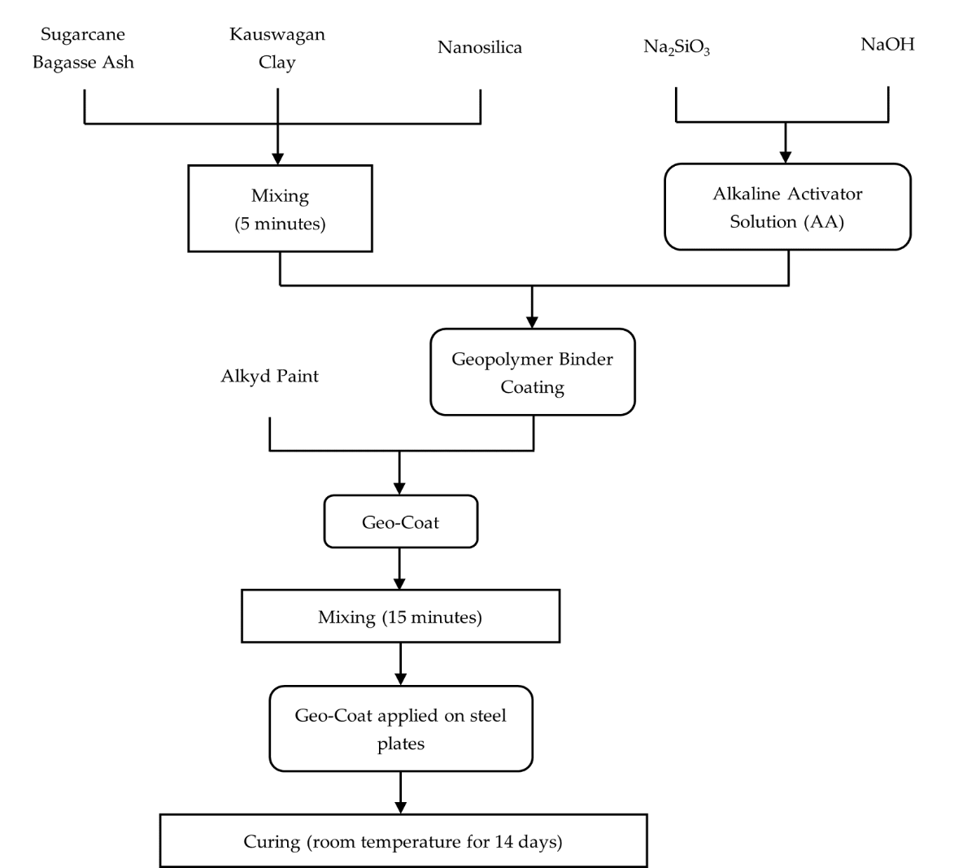
Figure 1. The flow chart of the synthesis of GFC.
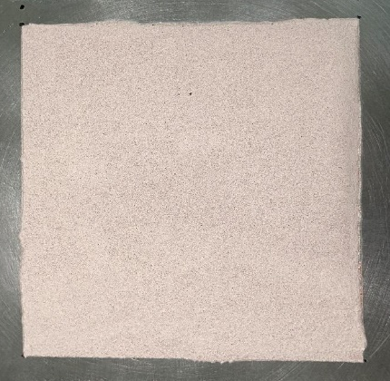
The fire resistance test setup was adapted from the methods reported by Abdullah et al. (2021) and Basri et al. (2021) [18], [36], both of which follow established standard fire testing procedures. The adapted configuration enabled the generation of comparative thermal performance data necessary for material optimization at the laboratory scale. Accordingly, the test setup was considered suitable for preliminary evaluation during the developmental stage prior to conducting full-scale fire tests.
A blow torch was set up at a distance of 7 cm from the painted surface and directly fired at the center of the steel plate. A thermocouple is attached at the back side of the coated steel plate where no coating was applied and the temperature against time data was gathered using a data acquisition device. The test continued until a backside temperature of 300 °C was reached. A bare mild steel plate and a steel plate coated with AP only were used as the control samples. The fire resistance setup is shown in Figures 3a and 3b.
Figure 3. The fire resistance test (a) setup (b) during testing.
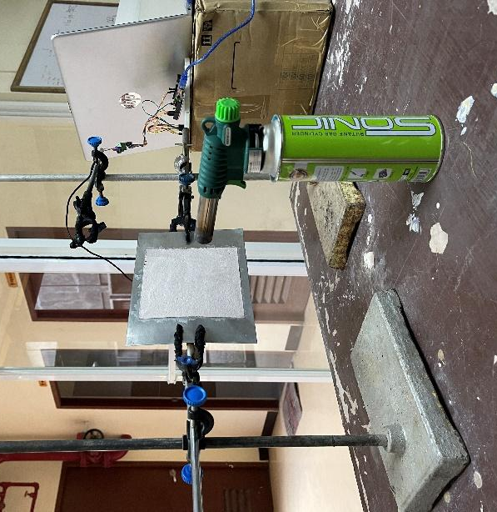  (a) | 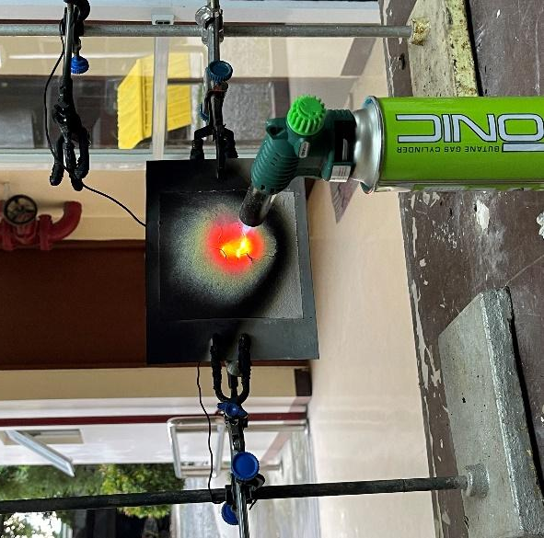  (b)
The adhesion test is a critical evaluation for the GFC, ensuring its durability, performance, and long-term stability when applied to metal surfaces. Strong adhesion is essential to prevent peeling, flaking, or delamination, which could compromise the coating’s fire-retardant and protective properties over time.
To assess adhesion strength, the ASTM D3359-17 standard test was performed. In this test, the coated steel surface was incised using a blade to create a crosshatch pattern. A strip of paper tape was then firmly applied over the incised area, pressed down to ensure contact, and quickly pulled off. The extent of coating detachment was then compared against the ASTM classification standards to determine adhesion quality. The ASTM D3359-17 rating system is shown in Table 3. According to the ASTM standard, a coating is considered to have acceptable adhesion if the detached area is less than 50% of the incised pattern (1B to 5B).
Thermogravimetric Analysis (TGA) was employed to assess the thermal decomposition and stability of the GFC, particularly for high-temperature applications, by tracking the sample's weight loss as a function of temperature. The analysis was conducted using a TGA 4000 (PerkinElmer Inc., U.K.). For the test, 5–10 grams of the sample were placed in alumina crucibles and loaded into the TGA chamber. The samples were then heated from 30 °C to 900 °C at a controlled rate of 20 °C/min under a nitrogen atmosphere, maintained at a constant flow rate of 20 mL/min [27]. The use of nitrogen prevents unwanted oxidation, ensuring that the observed weight loss is due to thermal degradation alone rather than combustion.
The surface morphology of the GFC samples before and after the fire resistance test was examined using Scanning Electron Microscopy (JEOL JSM-IT200) at magnifications of x1000 and x8000. The pre-test SEM analysis helps assess the initial surface structure and uniformity of the GFC. Meanwhile, the post-test analysis provides insights into thermal degradation effects, crack formation, and structural integrity after exposure to high temperatures.
Table 3. Classification for adhesion test.
Classification | Definition | % Area Removed
5B | The edges of the cuts are completely smooth, and none of the squares in the lattice is detached. | 0%
4B | Small flakes of the coating detach at the intersection. | <5%
3B | Small flakes detach along the edges and intersections of cuts. | 5-15%
2B | The coating flakes along the edges and parts of the squares. | 15-35%
1B | Large sections of the coating detach along the cuts. | 35-65%
0B | Severe flaking and detachment occur. | >65%
RESULTS AND DISCUSSION
The complete design matrix with two replications and their respective response value for TT300 is shown in Table 4. The uncoated steel sheet reached 300 °C in 58 s, while the control sample, which contained no geopolymer additive, took 82 s.
The experimental data were analyzed using Design-Expert software, and a two-factor interaction (2-FI) model was found to best fit the data. The significance of the overall model and its individual terms was evaluated through a sequential F-test, Lack-of-Fit test, and ANOVA.
Table 5 summarizes the statistical analysis for TT300, revealing that factors A, B, and C are highly significant, with p-values less than 0.0001. Additionally, interaction terms AB, AC, and BC were found to be significant, having p-values below 0.0500. The Lack of Fit F-value of 1.00 and its 45.02% probability of occurrence due to noise (p-value) indicate that the lack of fit is non-significant, which is desirable. This suggests that the model closely fits the experimental data, with minimal unexplained variability.
Table 4. Design matrix and response value for the time taken to reach the backside temperature of 300 °C
Sample | Coded Factors |  |  | TT300 | Sample | Coded Factors |  |  | TT300
Sample | A | B | C | TT300 | Sample | A | B | C | TT300
S1 | 3.00 | 0.45 | 0.3 | 95 | S18 | 3.00 | 0.45 | 0.3 | 92
S2 | 4.00 | 0.45 | 0.4 | 178 | S19 | 4.00 | 0.45 | 0.4 | 201
S3 | 4.00 | 0.3 | 0.5 | 177 | S20 | 4.00 | 0.3 | 0.5 | 113
S3 | 5.00 | 0.45 | 0.3 | 165 | S21 | 5.00 | 0.45 | 0.3 | 178
S5 | 4.00 | 0.6 | 0.3 | 125 | S22 | 4.00 | 0.6 | 0.3 | 146
S6 | 3.00 | 0.6 | 0.4 | 105 | S23 | 3.00 | 0.6 | 0.4 | 111
S7 | 5.00 | 0.6 | 0.4 | 309 | S24 | 5.00 | 0.6 | 0.4 | 291
S8 | 4.00 | 0.45 | 0.4 | 126 | S25 | 4.00 | 0.45 | 0.4 | 157
S9 | 5.00 | 0.45 | 0.5 | 337 | S26 | 5.00 | 0.45 | 0.5 | 293
S10 | 5.00 | 0.3 | 0.4 | 176 | S27 | 5.00 | 0.3 | 0.4 | 213
S11 | 4.00 | 0.45 | 0.4 | 153 | S28 | 4.00 | 0.45 | 0.4 | 163
S12 | 3.00 | 0.45 | 0.5 | 129 | S29 | 3.00 | 0.45 | 0.5 | 107
S13 | 4.00 | 0.45 | 0.4 | 186 | S30 | 4.00 | 0.45 | 0.4 | 138
S14 | 4.00 | 0.3 | 0.3 | 107 | S31 | 4.00 | 0.3 | 0.3 | 128
S15 | 4.00 | 0.45 | 0.4 | 167 | S32 | 4.00 | 0.45 | 0.4 | 131
S16 | 3.00 | 0.3 | 0.4 | 102 | S33 | 3.00 | 0.3 | 0.4 | 127
S17 | 4.00 | 0.6 | 0.5 | 260 | S34 | 4.00 | 0.6 | 0.5 | 251
TT300 = Time taken to reach backside temperature of 300 °C (in seconds).

Table 5. ANOVA for TT300.
Source | Sum of Squares | DoF | Mean Square | F-value | p-value | Remarks
Model | 1.31E+05 | 6 | 21835.02 | 39.78 | < 0.0001 | Highly Significant
A-Si/Al | 78260.06 | 1 | 78260.06 | 142.59 | < 0.0001 | Highly Significant
B-Nanosilica | 11556.25 | 1 | 11556.25 | 21.06 | < 0.0001 | Highly Significant
C-GBC/AP | 24885.06 | 1 | 24885.06 | 45.34 | < 0.0001 | Significant
AB | 4950.13 | 1 | 4950.13 | 9.02 | 0.0057 | Significant
AC | 7080.5 | 1 | 7080.5 | 12.9 | 0.0013 | Significant
BC | 4278.13 | 1 | 4278.13 | 7.8 | 0.0095 | Significant
Lack of Fit | 3297.35 | 6 | 549.56 | 1 | 0.4502 | Not Significant
Furthermore, the predicted R² of 0.8409 and the adjusted R² of 0.8758 indicate that the selected factors account for 84.09% of the total response variation. The small difference between the predicted and adjusted R² suggests minimal overfitting and ensures reasonable accuracy on new data findings. The model also has an Adequate Precision ratio of 20.579, which is well above the threshold of 4, confirming a strong signal-to-noise ratio. This high value signifies that the model is statistically reliable and can be effectively used for predicting responses, optimizing process parameters, and navigating the design space with confidence.
The effects of the factors on the fire resistance performance (TT300) of the geopolymer-based is quantitatively described by the regression model presented in equation (1). It can be observed that all factors were found to positively affect TT300. That is, an increase in A, B, or C results in an increase of TT300. Moreover, this model can be used to predict the value of the response.
Y_{TT300} = 169.47 + 69.94A + 26.88B + 39.44C +24.87AB + 29.75AC + 23.13BC | (1)
Aside from equation (1), Figures 4-6 illustrate the interaction between the factors and the time taken to reach the backside temperature of 300 °C (TT300). Figures 4a and 4b, show that the increase in both Si/Al ratio (A) and nanosilica wt% (B) increases the time taken to reach 300 °C above 250 s. Figures 5a and 5b, indicate that the increase in both Si/Al ratio (A) and GBC/AP ratio (C) increases the time taken to reach 300 °C above 300 s. Finally, in Figures 6a and 6b, it can be observed that the increase in both nanosilica wt% (B) and GBC/AP ratio (C) increase the time taken to reach 300 °C above 240 s.
The improved thermal performance at higher Si/Al ratios is attributed to the increased presence of amorphous silica, which enhances the thermal stability of the geopolymer matrix. Amorphous silica contributes to the formation of a more rigid and thermally resistant geopolymer network, reducing thermal degradation and enhancing fire resistance [36], [37], [38], [39]. This improvement is also associated with the increased formation of thermally stable Si–O–Si bonds.These bonds are stronger and more thermally stable than Si–O–Al bonds due to their higher bond dissociation energy [40], [41].
Higher Si/Al ratios promote the formation of an expanded intumescent char layer that acts as an insulating barrier, limiting heat transfer to the substrate [42]. On the other hand, lower Si/Al ratios increase the likelihood of cracking within the geopolymer matrix [43]. This behavior is associated with increased shrinkage of the geopolymer matrix during high-temperature exposure [44], [45] As a result, the coating with a higher Si/Al ratio demonstrates superior fire resistance, making it a more effective thermal protective barrier [16]. This improved expansion behavior is essential for maintaining the protective properties of the coating over prolonged exposure to heat.
Moreover, the incorporation of the GBC into the AP has significantly enhanced its thermal performance. This improvement can be attributed to the presence of a GBC, which increases the coating’s resistance to combustion and effectively delays heat penetration. As a result, the underlying substrate remains protected for a longer duration, reducing its direct exposure to the fire source. Additionally, a higher GBC/AP ratio results in greater thermal stability and lower weight loss. This is because a lower proportion of paint in the mixture reduces the presence of volatile components, which are more prone to thermal degradation. As a result, the coating maintains its structural integrity more effectively under high temperatures, enhancing its fire-retardant properties [46].
Furthermore, the improved fire resistance performance observed can also be attributed to the denser and more compact structure of the GFC with the addition of nanosilica. This results in a stronger char layer formed upon exposure to high temperatures. This protective char acts as an insulating barrier, significantly reducing heat transfer between the fire and the underlying substrate. [3], [47], [48].
The parameters were optimized to maximize the time taken to reach 300 °C by setting the minimum and maximum values for TT300 to 92 s and 337 s, respectively. In range was chosen as the constraint for factors Si/Al ratio, nanosilica wt%, and GBC/AP. While maximizing the response, TT300. The value of parameters required to achieve the optimum thermal performance of the geopolymer coating is shown in Figure 7. The values of the optimum parameters are Si/Al ratio of 4.728 ±0.001, nanosilica wt% of 0.583 ±0.001, and GBC/AP ratio of 0.497 ±0.001, which is predicted to obtain a value for TT300 of 340 s. The optimization yielded a desirability value of 1.000, confirming that all parameters met the criteria for achieving maximum thermal performance.
The optimized parameters were validated by calculating the percent error between the predicted value and the experimental value. The validation requires an acceptable error value of below 15.00% [18], [49]. To verify the reproducibility of the regression model and RSM model, three replicates of the optimized GFC were subjected to validation. Table 6 shows the result of the experimental validation of the optimized parameters for the fire resistance test. Compared to the predicted value of 340 s, an average percent error of 6.67% of the experimental value was obtained, which falls within the acceptable range of below 15.00%. Thus, it can be concluded that the developed regression and RSM models effectively optimized the response values
Figure 4. Effect of Si/Al ratio and nanosilica wt% on TT300 in the fire resistance test (a) contour plot (b) 3D surface.
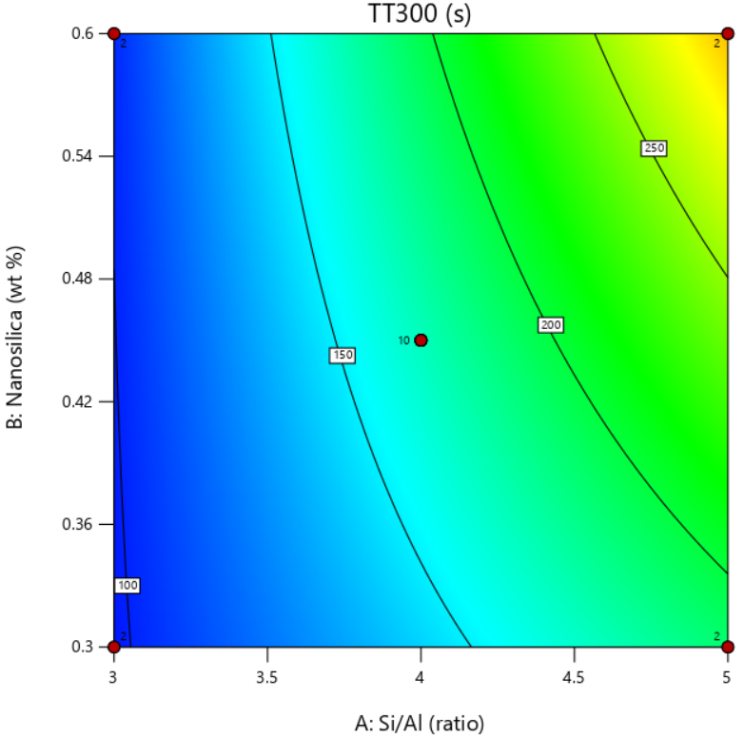  (a) | 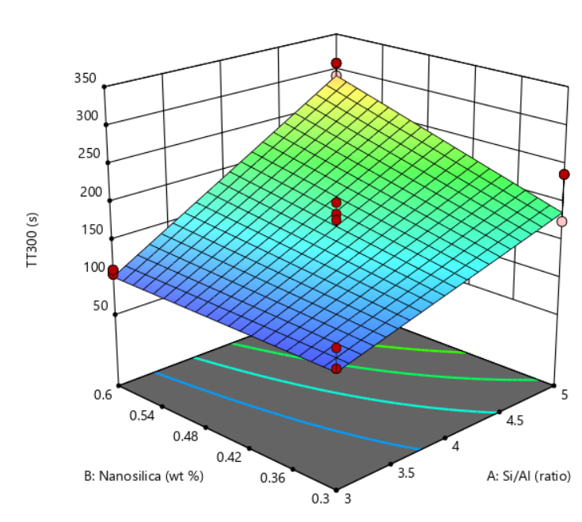  (b)
Figure 5. Effect of Si/Al ratio and GBC/AP ratio on TT300 in the fire resistance test (a) contour plot (b) 3D surface.
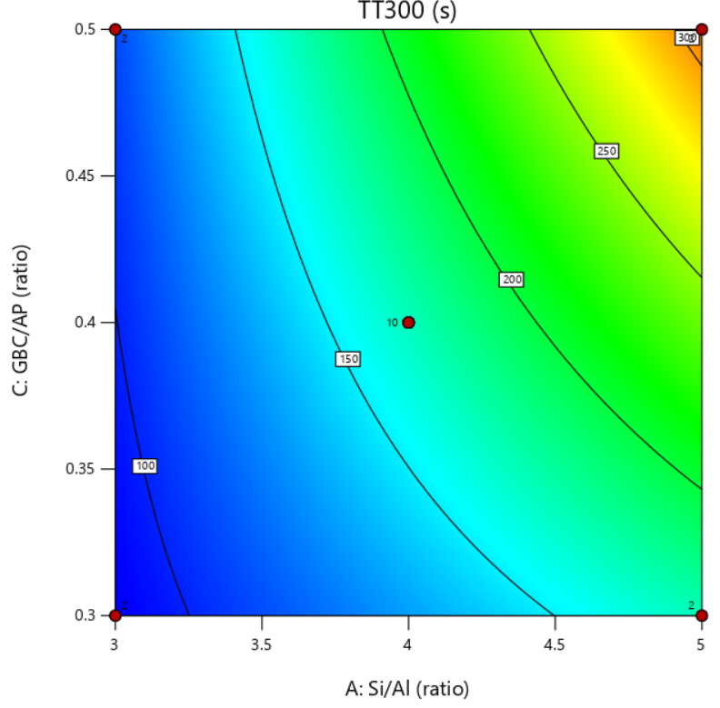  (a) | 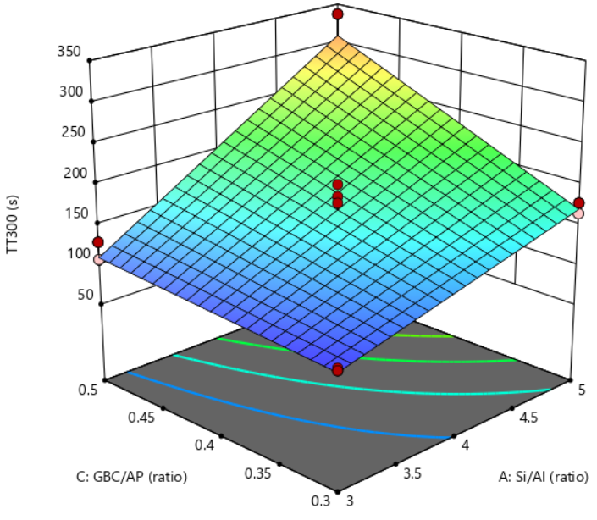  (b)
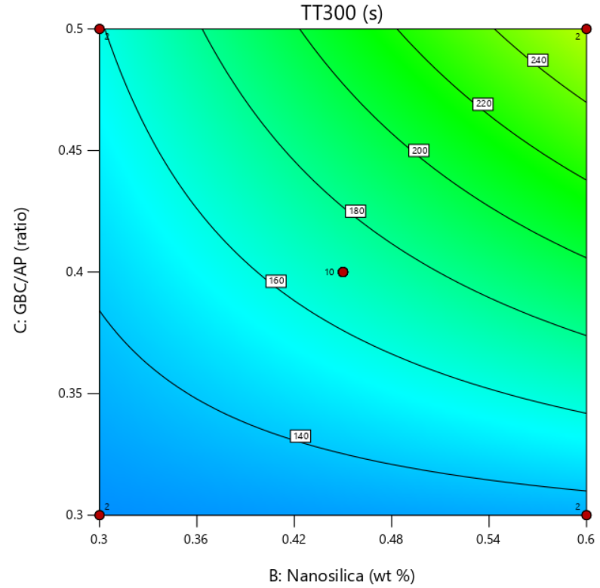  (a) | 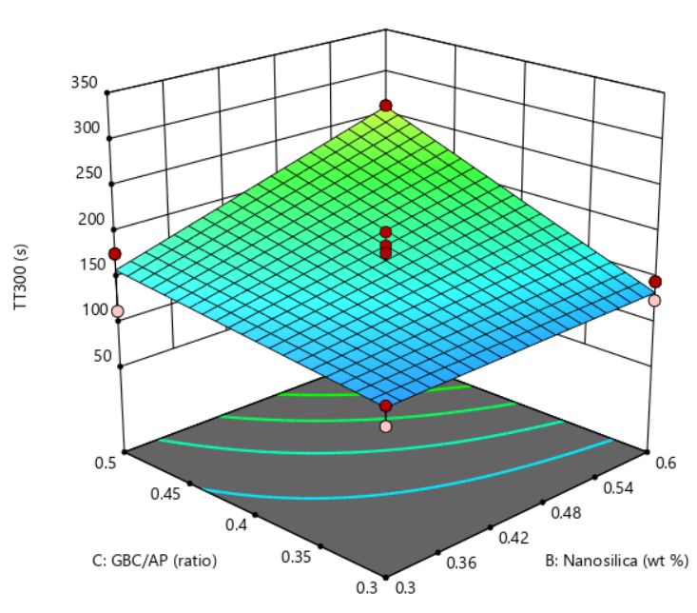  (b)
Figure 6. Effect of nanosilica wt% and GBC/AP ratio on TT300 in the fire resistance test (a) contour plot (b) 3D surface.

Figure 7. Optimum parameters for optimum thermal performance.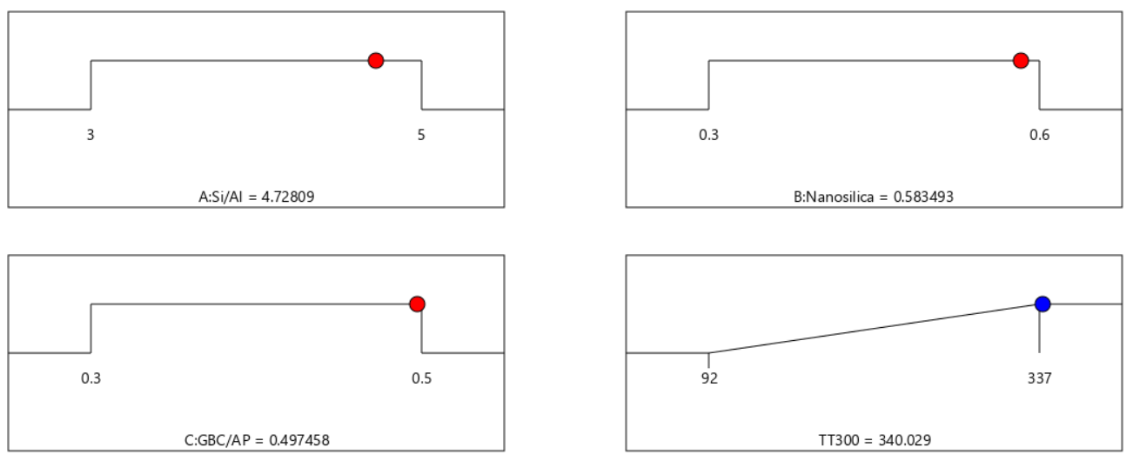
Table 6. Experimental validation of the optimized parameters for fire resistance test.
TT300 (s)
 |  | Predicted Value | Experimental Value | Error (%)
SV1 |  | 340 | 310 | 8.82
SV2 |  | 340 | 353 | 3.82
SV3 |  | 340 | 315 | 7.35
Average | 326 |  |  | 6.67
SV = Sample Validation; A = 4.728 ±0.001, B =0.583 ±0.001, C = 0.497 ±0.001
It can be observed that the experimental value took 326 s to reach a backside temperature of 300 °C, while the control sample took 82 s. This indicates that the incorporation of GBC into the paint effectively enhances its fire resistance performance. Figures 8a and 8b show the surface structure of the control sample and the optimized geopolymer after the fire resistance test. It can be observed that a hole was formed at the center of the control sample, while, in the optimized GFC sample, the center remained intact. This finding confirms that the addition of the GBC to the AP improves the compactness and density of the char layer, thereby enhancing its protective performance [3], [46], [47], [48].
Figure 8. (a) Control sample and (b) optimized GFC sample after fire resistance test.
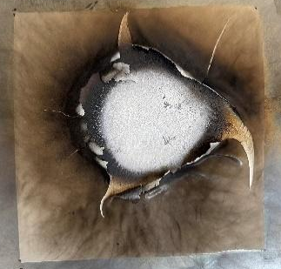  (a) | 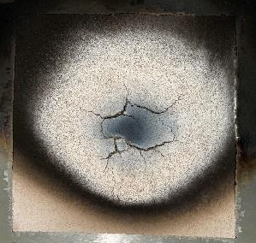  (b)

The adhesion strength of the coating on the substrate is critical to provide better fire protection. Table 7 summarizes the results of the cross-cut test for the GBC as an additive to AP. Results showed that all samples have a rating of 5B, which is the highest rating that can be obtained by ASTM standards, in which no squares were detached from the substrate, and the edges of the cuts were smooth. A sample of the adhesion test results of the GFC is shown in Figure 9.

Table 7. Classification for adhesion test.
Run | Classification | Run | Classification
S1 | 5B | S10 | 5B
S2 | 5B | S11 | 5B
S3 | 5B | S12 | 5B
S4 | 5B | S13 | 5B
S5 | 5B | S14 | 5B
S6 | 5B | S15 | 5B
S7 | 5B | S16 | 5B
S8 | 5B | S17 | 5B
S9 | 5B

Figure 9. Geopolymer coating adhesion test.
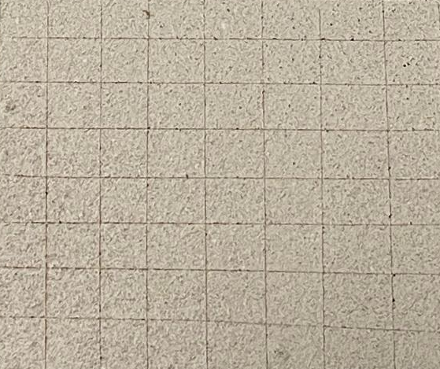
The thermal decomposition and stability of the GFC were analyzed. For this analysis, the best-performing and least-performing samples were selected to provide a comparative evaluation of their thermal resistance. Examining both extremes allows for a better understanding of the key factors influencing thermal stability, highlighting the effectiveness of the formulation with the highest performance while identifying the weaknesses of the least stable sample. The results of the thermal degradation analysis are presented in Figure 10.
Figure 10. TG and DTG for (a) Sample 1; (b) Sample 9
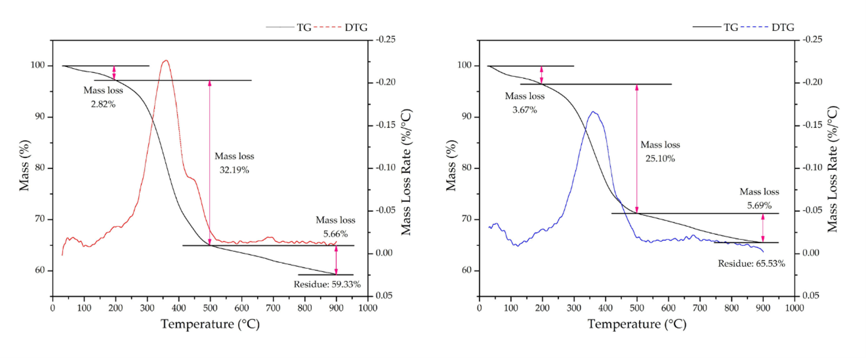
In the initial phase of the investigation (30–200°C), Sample 1 exhibited a weight loss of 2.82%, while Sample 9 showed a higher weight loss of 3.67%. This can be attributed to the evaporation of free water, hydrogen-bonded water, and water bonded to silicate molecules formed during the geopolymerization process [18], [50]. Additionally, further weight loss can be attributed to the softening stage of solvent vaporization [51].
The small weight loss observed in Sample 1 can be correlated with its lower Si/Al ratio, which results in a denser, more rigid structure that retains moisture more effectively and delays decomposition. This can be attributed to the minimal water content evaporated when exposed to fire, thus generating less pressure in the pores and thermal expansion. Since thermal expansion plays a crucial role in enhancing the insulating properties of fire-resistant coatings, this reduced expansion prevents the formation of an effective protective barrier. Consequently, the diminished thermal expansion compromises its fire resistance by allowing greater heat transfer to the underlying substrate.
In contrast, a higher weight loss was observed for Sample 9. This behavior is associated with endothermic dehydration, which promotes faster intumescence during heat exposure. This result further supports the improved thermal insulation associated with higher Si/Al ratios [18].
The subsequent stage of the TGA curve (200-500°C), where a weight loss of 32.19% and 25.10% was observed for Sample 1 and Sample 9, respectively, can be attributed to the oxidative degradation of AP [52]. This is depicted as the greater amount of weight loss in Sample 1, which can be attributed to the lower GBC/AP ratio. A lower GBC/AP ratio indicates a higher amount of AP used in the mixture. This results in an increase in oxidative degradation upon exposure to fire, resulting in higher weight loss. In contrast, Sample 9 with the higher Si/Al ratio allows the formation of a more stable char layer during thermal expansion caused by the evaporation of water and the oxidative degradation of the AP. This stability is due to the 2D linear structure of the geopolymer paste [46], [52], [53]. This characteristic allows for the expansion of the coating during the formation of the intumescent layer, which aids in protecting the substrate from the heat source and increasing the time taken to reach 300°C.
The third and final stage of the TGA curve (500-900°C) is attributed to the loss of bound water in the geopolymer matrix. During this phase, the rate of water loss was examined, in which values of 0.01418 (%/°C) for Sample 1 and 0.01429 (%/°C) for Sample 9 were observed. No significant difference in the rate of water loss between the two samples, since the amount of water was held constant across all samples. This region also signifies where the material achieved thermal stability [18].
Furthermore, the residual weight of the coating was examined at the end of the experiment, revealing values of 59.33% and 65.53% for Samples 1 and 9, respectively. The lower residual weight for Sample 1 can be attributed to the higher amount of AP that underwent oxidative degradation, and the opposite is true for Sample 9. This lower residual weight indicates that Sample 1 is less stable during thermal degradation. In contrast, the higher residual weight of Sample 9 demonstrates superior thermal performance, implying that it can better withstand high-temperature conditions and has better thermal stability.
The GFC samples exhibiting the poorest (Sample 1), best (Sample 9), and optimized fire resistance performance were selected for further material characterization and microstructural analysis using scanning electron microscopy (SEM) at magnifications of x1000 and x8000. The SEM observations were interpreted based on observable microstructural features such as crack formation, particle distribution, and pore structure within the coating matrix. Figure 11 shows the SEM micrographs of the GFC samples before the fire resistance test. The SEM micrographs of Sample 1 show a relatively uniform matrix with fewer visible unreacted aluminosilicate particles. This observation is consistent with the lower Si/Al ratio, which may promote greater dissolution of precursor materials during geopolymerization. Additionally, it can also be attributed to the lower GBC/AP ratio, which indicates that the GBC was more effectively mixed with the AP, resulting in a more uniform surface. However, despite the smoother texture, visible cracks were present as shown in Figures 11a and 11b. This can be attributed to its lower Si/Al ratio, which makes the coating more rigid. This behavior is attributed to the lower Si/Al ratio, which results in a more rigid matrix with reduced resistance to thermal cracking. These cracks facilitate heat transfer to the substrate, thereby reducing fire resistance [11].
In contrast, Sample 9 exhibited a surface containing a greater number of visible particles and microstructural heterogeneities, as shown in Figures 11c and 11d. These features may be associated with incomplete dissolution of aluminosilicate precursors at higher Si/Al and GBC/AP ratios, resulting in the presence of residual particles within the coating matrix. That is, the aluminosilicate precursors used were not fully dissolved in the AA solution prior to mixing with the AP. Despite the presence of these residual particles, the coating exhibited improved fire resistance, likely due to the formation of a more stable geopolymer network and char layer during thermal exposure [18].
Figures 11e and 11f show that the optimized GFC sample exhibited a more homogeneous microstructure with fewer visible unreacted particles and reduced microcrack formation. Aside from a high Si/Al ratio and low GBC/AP ratio. This improvement in homogeneity and structural integrity can also be attributed to the addition of nanosilica, which acts as a filler material, occupying voids within the geopolymer matrix and enhancing overall compactness. The denser microstructure of the optimized coating promotes the formation of a stronger char layer, thereby delaying heat penetration to the substrate [47], [48].
After the samples were directly exposed to fire during the fire resistance test, the upper surface of the coating was analyzed to characterize its surface morphology. Figure 12 shows the SEM micrographs of the residue of the poorest (Sample 1), best (Sample 9), and optimized GFC samples after the fire resistance test at magnifications of 1000x and 8000x. The porosity of the GFC samples plays an important role in the formation of the char layer of the coating, which significantly influences the fire resistance performance of the coating. A porous structure reduces heat transfer between the fire source and the underlying substrate [54]. The presence of pores can be attributed to the rapid evaporation of water and the decomposition of volatile compounds within the coating during heat exposure [18], [55]. During the evaporation process of the free water in the coating, it escapes, creating a porous layer that acts as a pathway for the gas to escape. Furthermore, the evaporation of water molecules induces swelling of the coating, thereby enhancing its intumescent properties [56].
In Sample 1, shown in Figure 12a, SEM images clearly show the presence of wide cracks and large fissures within the char layer. The observed cracks in these samples are attributed to their lower Si/Al ratios. Lower Si/Al ratios produce a more rigid and less elastic coating structure. Reduced elasticity limits the coating’s ability to expand during thermal exposure, causing stress-induced fractures to widen as the material swells due to the escaping water vapor and volatile compounds [11]. Additionally, a lower Si/Al ratio results in shrinkage of the geopolymer matrix upon exposure to high-temperature as previously stated [44], [45]. Furthermore, this can also be attributed to its low GBC/AP ratio. A higher GBC/AP ratio means higher AP content, resulting in a higher number of volatile compounds decomposing [18], [43]. The presence of these cracks facilitates heat penetration, thereby reducing their fire resistance.
In contrast, Sample 9, shown in Figures 12c and 12d, exhibited a char layer containing smaller and less extensive cracks compared to Sample 1. This can be attributed to its higher Si/Al ratio and GBC/AP ratio. A high Si/Al ratio increases the elasticity of the coating and, at the same time, produces a more compact gel structure. This is attributed to the excellent dimensional stability of a higher Si/Al ratio when exposed to high temperatures. Thus, allowing the formation of a stronger intumescent char layer [57]. The increased GBC/AP ratio reduces the amount of AP in the formulation, thereby lowering the concentration of volatile compounds that decompose upon exposure to fire. These result in a more thermally stable coating with improved fire resistance.
Similarly, the optimized GFC, shown in Figures 12e and 12f, exhibited a more continuous char layer with fewer visible cracks and pores, indicating improved structural stability after thermal exposure. This enhanced homogeneity is due to the optimized balance of Si/Al and GBC/AP ratios, along with the incorporation of nanosilica. The presence of nanosilica enhances the structural integrity of the coating by promoting a more uniform expansion during heat exposure as it fills the voids in the coating matrix. Additionally, it ultimately strengthens the char layer by making it denser and more compact, thus improving its ability to withstand high temperatures, limiting direct heat penetration, and ensuring prolonged protection of the underlying substrate in high-temperature conditions [47], [48]. The combination of these factors demonstrates how the optimized formulation effectively enhances the protective capability of the GFC under extreme conditions.
Figure 11. SEM micrographs of the (a,b) poorest (Sample 1), (c,d) best (Sample 9), and (e,f) optimized GFC samples before fire resistance test at 1000x (left, 10 µm) and 8000x (right, 2 µm) magnifications.
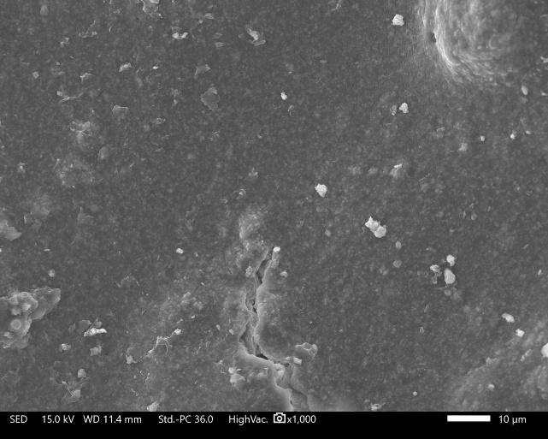  crack | 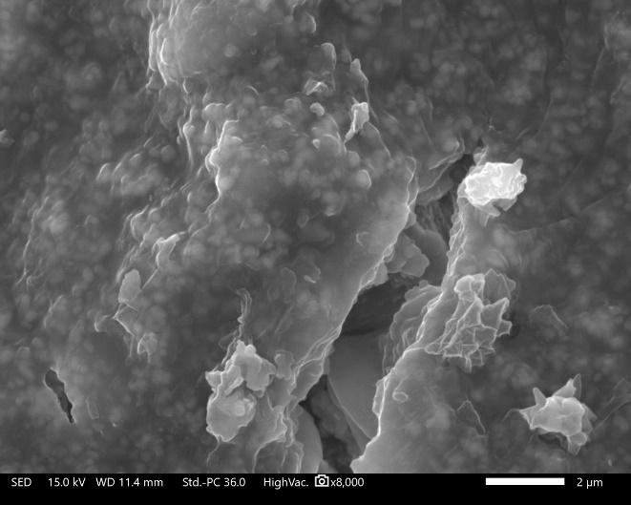  crack  Geopolymer matrix
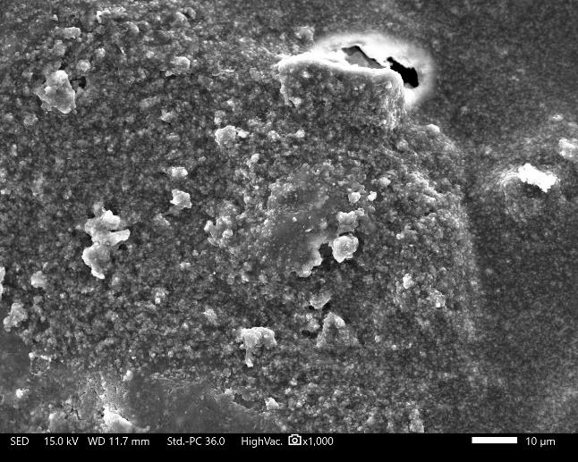  unreacted SCBA | 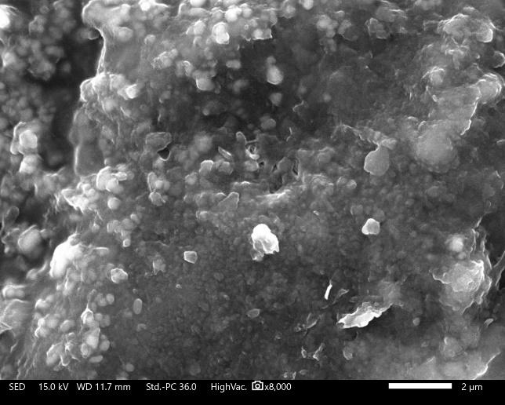  unreacted SCBA
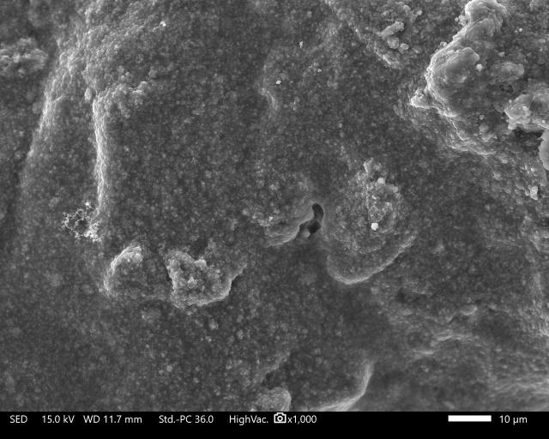 | 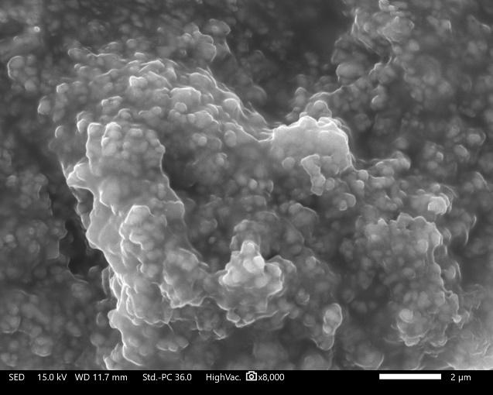  Geopolymer matrix

Figure 12. SEM micrographs of the residue of the (a,b) poorest (Sample 1), (c,d) best (Sample 9), and (e,f) optimized GFC samples after fire resistance test at 1000x (left, 10 µm) and 8000x (right, 2 µm) magnifications.
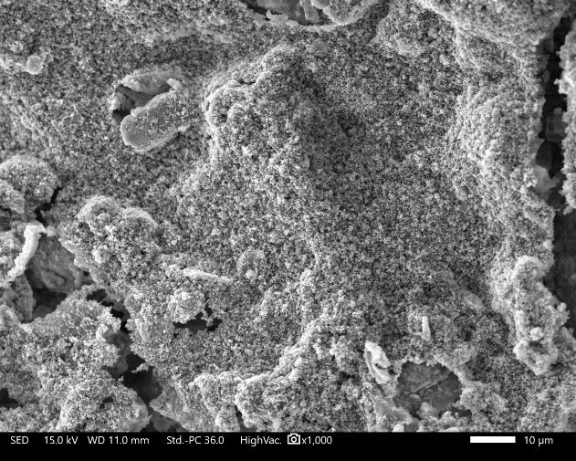  cracks | 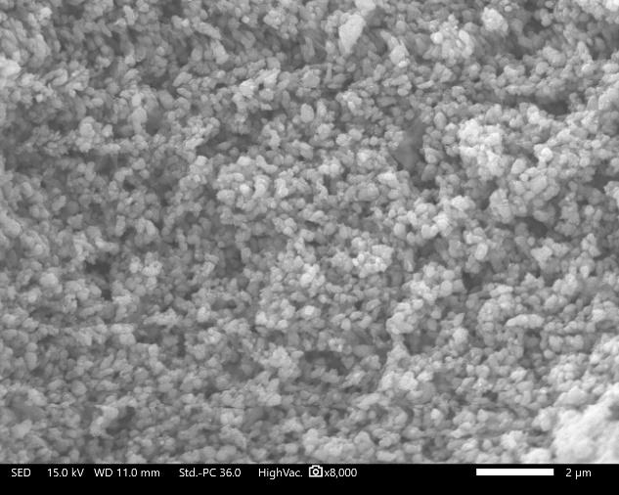  Geopolymer matrix
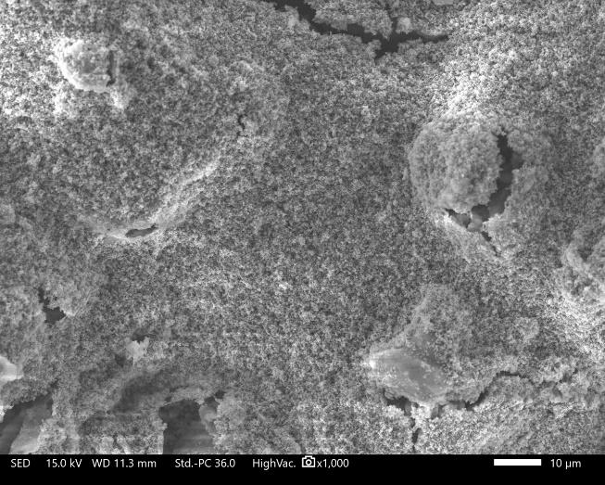  crack  Unreacted SCBA | 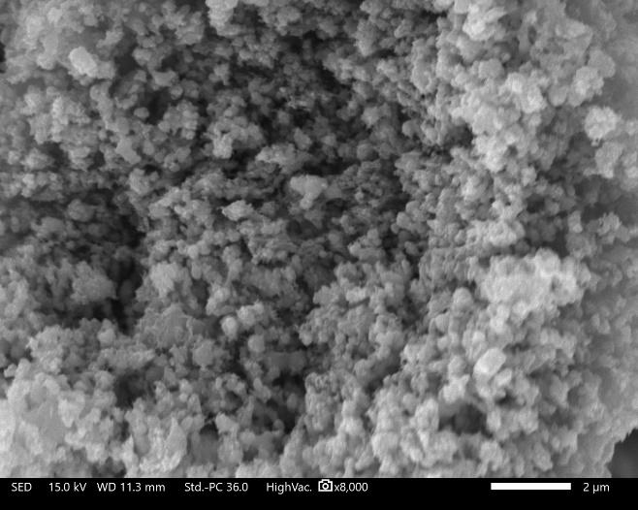  Geopolymer matrix
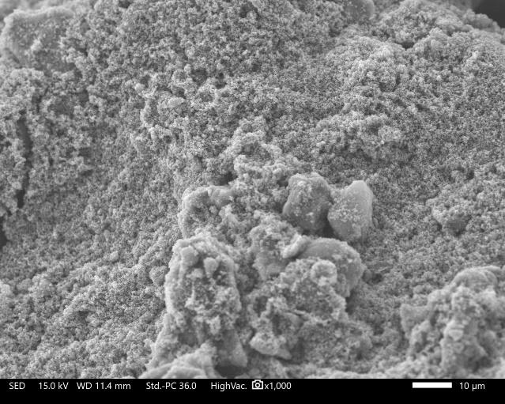 | 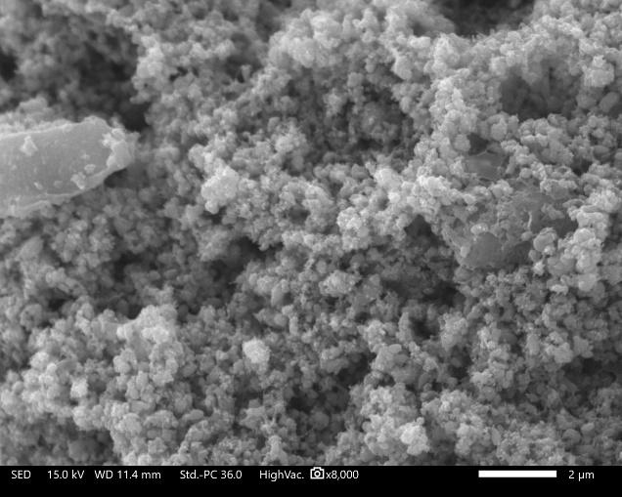  Geopolymer matrix
CONCLUSION
A nanosilica-enhanced geopolymer fire-retardant coating (GFC) derived from sugarcane bagasse ash (SCBA) and Kauswagan Red Clay (KRC) was successfully optimized using response surface methodology (RSM). The experimental results demonstrated that the Si/Al ratio, nanosilica wt%, and geopolymer-binder-coating-to-alkyd paint (GBC/AP) ratio all had a significant impact on the time taken to reach a backside temperature of 300 °C (TT300). Their effects can be summarized by the RSM model as in Equation 1.
Among the tested samples, Sample 1 exhibited the poorest fire resistance, reaching TT300 in 92 s, whereas Sample 9 demonstrated the best performance, achieving TT300 in 337 s. The improvement in fire resistance was attributed to the increased Si/Al ratio, nanosilica wt%, and GBC/AP ratio, which contributed to enhanced thermal stability and fire protection. Adhesion test results further showed that the incorporation of GBC into AP does not have a negative effect on the adhesion of the coating and showed the best rating (5B). Thermogravimetric analysis (TGA) supported these findings, with Sample 1 having a residual weight of 59.33% while Sample 9 had a residual weight of 65.53%. This shows that sample 9 has superior thermal stability after thermal degradation. Microstructural analysis via scanning electron microscopy (SEM) revealed that lower Si/Al ratios, nanosilica wt%, and GBC/AP ratios led to more severe cracking, which compromised the coating’s structural integrity and facilitated heat penetration, reducing fire resistance. However, an excessively high Si/Al ratio resulted in the presence of unreacted particles on the surface, creating a rougher and less homogeneous morphology. These findings suggest that an optimal balance among formulation parameters is crucial to achieving a dense, crack-free, and thermally stable coating.
The optimal coating composition was determined to be a Si/Al ratio of 4.728 ±0.001, nanosilica wt% of 0.583 ±0.001, and a GBC/AP ratio of 0.497±0.001, with a predicted TT300 of 340 s. The experimental validation showed an error margin of 6.67% between the predicted and actual values, confirming the accuracy and reliability of the RSM model for optimization. Furthermore, the incorporation of GBC into AP significantly enhanced fire resistance. The control sample, AP without GBC, reached TT300 in 82 s, whereas the optimized GFC formulation achieved TT300 in 326 s, demonstrating a substantial improvement in fire protection. The enhanced performance was attributed to the formation of a stable and compact char layer brought by the incorporation of GBC into AP, which acted as an effective thermal barrier, reducing heat transfer to the underlying substrate.
Overall, these findings emphasize the potential of GFC as a sustainable and efficient fire-retardant material for protective applications, offering a practical alternative to conventional fireproofing solutions.
REFERENCES
- ‘Spray Applied Fireproofing Contractors for Structural Steel’. Accessed: Jul. 28, 2024. [Online]. Available: https://clmfireproofing.com/structural-steel-fire-protection/
- ‘Fire Incidents and BFP Performance’, Accessed: Jul. 28, 2024. [Online]. Available: https://www.ctif.org/
- R. G. Puri and A. S. Khanna, ‘Effect of cenospheres on the char formation and fire protective performance of water-based intumescent coatings on structural steel’, Prog Org Coat, vol. 92, pp. 8–15, Mar. 2016, doi: 10.1016/J.PORGCOAT.2015.11.016.
- A. Andersson, S. Landmark, and F. H. J. Maurer, ‘Evaluation and characterization of ammoniumpolyphosphate-pentaerythritol-based systems for intumescent coatings’, J Appl Polym Sci, vol. 104, no. 2, pp. 748–753, Apr. 2007, doi: 10.1002/APP.25588.
- L. Yan, Z. Xu, and X. Wang, ‘Influence of nano-silica on the flame retardancy and smoke suppression properties of transparent intumescent fire-retardant coatings’, Prog Org Coat, vol. 112, pp. 319–329, Nov. 2017, doi: 10.1016/J.PORGCOAT.2017.07.017.
- Y. Wang et al., ‘Synergistic Effect of Nano-Silica and Intumescent Flame Retardant on the Fire Reaction Properties of Polypropylene Composites’, Materials 2023, Vol. 16, Page 4759, vol. 16, no. 13, p. 4759, Jun. 2023, doi: 10.3390/MA16134759.
- L. H. Daus, B. Schartel, V. Wachtendorf, R. Mangelsdorf, and M. Korzen, ‘A chain is no stronger than its weakest link: Weathering resistance of water-based intumescent coatings for steel applications’, https://doi.org/10.1177/0734904120961064, vol. 39, no. 1, pp. 72–102, Nov. 2020, doi: 10.1177/0734904120961064.
- S. C. de Sá et al., ‘Environmentally friendly intumescent coatings formulated with vegetable compounds’, Prog Org Coat, vol. 113, pp. 47–59, Dec. 2017, doi: 10.1016/J.PORGCOAT.2017.08.007.
- C. Jiang, A. Wang, X. Bao, T. Ni, and J. Ling, ‘A review on geopolymer in potential coating application: Materials, preparation and basic properties’, Journal of Building Engineering, vol. 32, p. 101734, Nov. 2020, doi: 10.1016/J.JOBE.2020.101734.
- M. B. Watolla, G. J. G. Gluth, P. Sturm, W. D. A. Rickard, S. Krüger, and B. Schartel, ‘Intumescent Geopolymer-Bound Coatings for Fire Protection of Steel’, Journal of Ceramic Science and Technology, vol. 8, no. 3, pp. 351–364, 2017, doi: 10.4416/JCST2017-00035.
- M. S. Mohd Basri, F. Mustapha, N. Mazlan, and M. R. Ishak, ‘Fire Retardant Performance of Rice Husk Ash-Based Geopolymer Coated Mild Steel - A Factorial Design and Microstructure Analysis’, Materials Science Forum, vol. 841, pp. 48–54, 2016, doi: 10.4028/WWW.SCIENTIFIC.NET/MSF.841.48.
- K. Srinivasan and A. Sivakumar, ‘Geopolymer Binders: A Need for Future Concrete Construction’, Int Sch Res Notices, vol. 2013, no. 1, p. 509185, Jan. 2013, doi: 10.1155/2013/509185.
- K. Neupane, D. Chalmers, and P. Kidd, ‘High-Strength Geopolymer Concrete- Properties, Advantages and Challenges’, Advances in Materials 2018, Volume 7, Page 15, vol. 7, no. 2, pp. 15–25, Jun. 2018, doi: 10.11648/J.AM.20180702.11.
- Z. Zhou, C. Zeng, H. Wei, and Y. Ding, ‘Preparation and property study of geopolymer composite fireproof coating with PVA fiber and manganese slag’, Cleaner Materials, vol. 15, p. 100289, Mar. 2025, doi: 10.1016/J.CLEMA.2024.100289.
- H. Zain, M. M. A. B. Abdullah, K. Hussin, N. Ariffin, and R. Bayuaji, ‘Review on Various Types of Geopolymer Materials with the Environmental Impact Assessment’, MATEC Web of Conferences, vol. 97, p. 01021, Feb. 2017, doi: 10.1051/MATECCONF/20179701021.
- J. Temuujin, A. Minjigmaa, W. Rickard, M. Lee, I. Williams, and A. van Riessen, ‘Preparation of metakaolin based geopolymer coatings on metal substrates as thermal barriers’, Appl Clay Sci, vol. 46, no. 3, pp. 265–270, Nov. 2009, doi: 10.1016/J.CLAY.2009.08.015.
- A. M. Mustafa Al Bakri, H. Kamarudin, I. Khairul Nizar, M. Bnhussain, Y. Zarina, and A. R. Rafiza, ‘Correlation between Na2SiO3/NaOH Ratio and Fly Ash/Alkaline Activator Ratio to the Strength of Geopolymer’, Adv Mat Res, vol. 341–342, pp. 189–193, 2012, doi: 10.4028/WWW.SCIENTIFIC.NET/AMR.341-342.189.
- M. N. Abdullah, M. Mustapha, N. Sallih, A. Ahmad, F. Mustapha, and A. Dahliyanti, ‘Study and Use of Rice Husk Ash as a Source of Aluminosilicate in Refractory Coating’, Materials 2021, Vol. 14, Page 3440, vol. 14, no. 13, p. 3440, Jun. 2021, doi: 10.3390/MA14133440.
- ‘Initiatives and Implications of Philippine Sugar Liberalization | FFTC Agricultural Policy Platform (FFTC-AP)’. Accessed: Jul. 28, 2024. [Online]. Available: https://ap.fftc.org.tw/article/1841
- S. E. L. Gudia et al., ‘Sugarcane bagasse ash as a partial replacement for cement in paste and mortar formulation – A case in the Philippines’, Journal of Building Engineering, vol. 76, p. 107221, Oct. 2023, doi: 10.1016/J.JOBE.2023.107221.
- A. W. Go, A. T. Conag, R. M. B. Igdon, A. S. Toledo, and J. S. Malila, ‘Potentials of agricultural and agro-industrial crop residues for the displacement of fossil fuels: A Philippine context’, Energy Strategy Reviews, vol. 23, pp. 100–113, Jan. 2019, doi: 10.1016/J.ESR.2018.12.010.
- O. A. Caparino and N. Ambassador Hotel Busan, ‘2018 International Forum on Sustainable Application of Waste-to-Energy in Asia Region STATUS OF AGRICULTURAL WASTE AND UTILIZATION IN THE PHILIPPINES’, Accessed: Feb. 17, 2025. [Online]. Available: www.philmech.gov.ph
- ‘IOP Conference Series: Earth and Environmental Science A review of sugarcane bagasse ash: Characteristics, properties and sustainable applications in concrete’, doi: 10.1088/1755-1315/1409/1/012002.
- C. Ferone et al., ‘Thermally treated clay sediments as geopolymer source material’, Appl Clay Sci, vol. 107, pp. 195–204, Apr. 2015, doi: 10.1016/J.CLAY.2015.01.027.
- S. Prasanphan, S. Onutai, and N. Nawaukkaratharnant, ‘Influence of partial replacement of calcined red clay by gypsum-bonded casting investment waste on geopolymerization reaction of red clay-based geopolymer’, Heliyon, vol. 10, no. 2, p. e24448, Jan. 2024, doi: 10.1016/J.HELIYON.2024.E24448.
- M. A. Gómez-Casero, F. J. Moral-Moral, L. Pérez-Villarejo, P. J. Sánchez-Soto, and D. Eliche-Quesada, ‘Synthesis of clay geopolymers using olive pomace fly ash as an alternative activator. Influence of the additional commercial alkaline activator used’, Journal of Materials Research and Technology, vol. 12, pp. 1762–1776, May 2021, doi: 10.1016/J.JMRT.2021.03.102.
- Z. Jwaida, A. Dulaimi, N. Mashaan, and M. A. Othuman Mydin, ‘Geopolymers: The Green Alternative to Traditional Materials for Engineering Applications’, Infrastructures 2023, Vol. 8, Page 98, vol. 8, no. 6, p. 98, May 2023, doi: 10.3390/INFRASTRUCTURES8060098.
- J. M. Tiongson and M. A. Q. Adajar, ‘Compaction characteristics of a fine-grained soil potential for landfill liner application’, International Journal of GEOMATE, vol. 19, no. 71, pp. 211–218, Jul. 2020, doi: 10.21660/2020.71.37070.
- X. Peng, G. Yang, Y. Shi, Y. Zhou, M. Zhang, and S. Li, ‘Box–Behnken design based statistical modeling for the extraction and physicochemical properties of pectin from sunflower heads and the comparison with commercial low-methoxyl pectin’, Scientific Reports 2020 10:1, vol. 10, no. 1, pp. 1–10, Feb. 2020, doi: 10.1038/s41598-020-60339-1.
- N. Ferreira et al., ‘Application of response surface methodology and box–behnken design for the optimization of mercury removal by Ulva sp.’, J Hazard Mater, vol. 445, p. 130405, Mar. 2023, doi: 10.1016/J.JHAZMAT.2022.130405.
- S. Norsuraya, H. Fazlena, and R. Norhasyimi, ‘Sugarcane Bagasse as a Renewable Source of Silica to Synthesize Santa Barbara Amorphous-15 (SBA-15)’, Procedia Eng, vol. 148, pp. 839–846, Jan. 2016, doi: 10.1016/J.PROENG.2016.06.627.
- R. Embong, N. Shafiq, A. Kusbiantoro, and M. F. Nuruddin, ‘Effectiveness of low-concentration acid and solar drying as pre-treatment features for producing pozzolanic sugarcane bagasse ash’, J Clean Prod, vol. 112, pp. 953–962, Jan. 2016, doi: 10.1016/J.JCLEPRO.2015.09.066.
- I. Marzuki, E. Bachtiar, A. M. SETIAWAN, and SRIGUSTY, ‘Potency Of Sugarcane Bagasse Ash Partial Substitution Of Cement In Concrete’, Mar. 2019, doi: 10.31219/OSF.IO/FS9UM.
- K. J. D. MacKenzie, D. R. M. Brew, R. A. Fletcher, and R. Vagana, ‘Formation of aluminosilicate geopolymers from 1:1 layer-lattice minerals pre-treated by various methods: A comparative study’, J Mater Sci, vol. 42, no. 12, pp. 4667–4674, Jun. 2007, doi: 10.1007/S10853-006-0173-X/METRICS.
- N. Yaseen, ‘Exploring the potential of sugarcane bagasse ash as a sustainable supplementary cementitious material: Experimental investigation and statistical analysis’, Results Chem, vol. 10, p. 101723, Aug. 2024, doi: 10.1016/J.RECHEM.2024.101723.
- M. S. M. Basri et al., ‘Rice husk ash/silicone rubber-based binary blended geopolymer coating composite: Fire retardant, moisture absorption, optimize composition, and microstructural analysis’, Polymers (Basel), vol. 13, no. 6, Mar. 2021, doi: 10.3390/polym13060985.
- H. C. Yong, L. Y. Ming, M. M. Al Bakri Abdullah, and K. Hussin, ‘Fire Resistant Properties of Geopolymers: A Review’, Key Eng Mater, vol. 660, pp. 39–43, 2015, doi: 10.4028/WWW.SCIENTIFIC.NET/KEM.660.39.
- M. M. A. B. Abdullah et al., ‘Clay-Based Materials in Geopolymer Technology’, Cement Based Materials, Oct. 2018, doi: 10.5772/INTECHOPEN.74438.
- J. K. H. Wong, S. T. Kok, and S. Y. Wong, ‘Fibers, Geopolymers, Nano and Alkali-Activated Materials for Deep Soil Mix Binders’, Civil Engineering Journal, vol. 6, no. 4, pp. 830–847, Apr. 2020, doi: 10.28991/CEJ-2020-03091511.
- P. He et al., ‘Effects of Si/Al ratio on the structure and properties of metakaolin based geopolymer’, Ceram Int, vol. 42, no. 13, pp. 14416–14422, Oct. 2016, doi: 10.1016/J.CERAMINT.2016.06.033.
- H. Wang, H. Wu, Z. Xing, R. Wang, S. Dai, and A. Molar Ratios, ‘The Effect of Various Si/Al, Na/Al Molar Ratios and Free Water on Micromorphology and Macro-Strength of Metakaolin-Based Geopolymer’, Materials, vol. 14, no. 14, p. 3845, 2021, doi: 10.3390/MA14143845.
- Q. Yang, C. A. Davy, J. Sarazin, S. Bourbigot, and G. Fontaine, ‘Effect of the Al/Si ratio on intumescent Na-based geopolymer’, Fire Saf J, vol. 148, p. 104220, Sep. 2024, doi: 10.1016/J.FIRESAF.2024.104220.
- M. Lahoti, K. K. Wong, E. H. Yang, and K. H. Tan, ‘Effects of Si/Al molar ratio on strength endurance and volume stability of metakaolin geopolymers subject to elevated temperature’, Ceram Int, vol. 44, no. 5, pp. 5726–5734, Apr. 2018, doi: 10.1016/J.CERAMINT.2017.12.226.
- S. Xiang, M. Guo, Y. Zhou, and Z. Huang, ‘Tailoring thermal performance of geopolymer via metakaolin/fly ash ratio and activator variation’, Journal of Building Engineering, p. 111856, Jan. 2025, doi: 10.1016/J.JOBE.2025.111856.
- R. He, N. Dai, and Z. Wang, ‘Thermal and Mechanical Properties of Geopolymers Exposed to High Temperature: A Literature Review’, Advances in Civil Engineering, vol. 2020, no. 1, p. 7532703, Jan. 2020, doi: 10.1155/2020/7532703.
- S. Guzii, I. Bazhelka, N. Svitlychna, and V. Lashchivskiy, ‘Protection of Wood from Burning with Paints on Alkaline Aluminosilicates-Based’, Materials Science Forum, vol. 1006, pp. 19–24, 2020, doi: 10.4028/WWW.SCIENTIFIC.NET/MSF.1006.19.
- D. Adak, M. Sarkar, and S. Mandal, ‘Effect of nano-silica on strength and durability of fly ash based geopolymer mortar’, Constr Build Mater, vol. 70, pp. 453–459, Nov. 2014, doi: 10.1016/J.CONBUILDMAT.2014.07.093.
- P. S. Deb, P. K. Sarker, and S. Barbhuiya, ‘Effects of nano-silica on the strength development of geopolymer cured at room temperature’, Constr Build Mater, vol. 101, pp. 675–683, Dec. 2015, doi: 10.1016/J.CONBUILDMAT.2015.10.044.
- Sivaraosa, K. R. Milkeya, A. R. Samsudina, A. Dubeyb, and P. Kiddc, ‘Comparison between Taguchi Method and Response Surface Methodology ( RSM ) in Modelling CO 2 Laser Machining’, 2014.
- D. L. Y. Kong, J. G. Sanjayan, and K. Sagoe-Crentsil, ‘Comparative performance of geopolymers made with metakaolin and fly ash after exposure to elevated temperatures’, Cem Concr Res, vol. 37, no. 12, pp. 1583–1589, Dec. 2007, doi: 10.1016/J.CEMCONRES.2007.08.021.
- W. C. Puspitasari, F. Ahmad, S. Ullah, P. Hussain, P. S. M. Megat-Yusoff, and P. J. Masset, ‘The study of adhesion between steel substrate, primer, and char of intumescent fire retardant coating’, Prog Org Coat, vol. 127, pp. 181–193, Feb. 2019, doi: 10.1016/J.PORGCOAT.2018.11.015.
- R. Ploeger, D. Scalarone, and O. Chiantore, ‘Thermal analytical study of the oxidative stability of artists’ alkyd paints’, Polym Degrad Stab, vol. 94, no. 11, pp. 2036–2041, Nov. 2009, doi: 10.1016/J.POLYMDEGRADSTAB.2009.07.018.
- D. D. Burduhos Nergis, M. M. A. B. Abdullah, P. Vizureanu, and M. F. Mohd Tahir, ‘Geopolymers and Their Uses: Review’, IOP Conf Ser Mater Sci Eng, vol. 374, no. 1, p. 012019, Jun. 2018, doi: 10.1088/1757-899X/374/1/012019.
- H. Wang, H. Wu, Z. Xing, R. Wang, and S. Dai, ‘The Effect of Various Si/Al, Na/Al Molar Ratios and Free Water on Micromorphology and Macro-Strength of Metakaolin-Based Geopolymer’, Materials 2021, Vol. 14, Page 3845, vol. 14, no. 14, p. 3845, Jul. 2021, doi: 10.3390/MA14143845.
- Y. Luna-Galiano, A. Cornejo, C. Leiva, L. F. Vilches, and C. Fernández-Pereira, ‘Properties of fly ash and metakaolín based geopolymer panels under fire resistance tests’, Materiales de Construcción, vol. 65, no. 319, pp. e059–e059, Sep. 2015, doi: 10.3989/MC.2015.06114.
- M. M. Al Bakri Abdullah, L. Jamaludin, H. Kamarudin, M. Binhussain, C. M. Ruzaidi Ghazali, and M. I. Ahmad, ‘Study on Fly Ash Based Geopolymer for Coating Applications’, Adv Mat Res, vol. 686, pp. 227–233, 2013, doi: 10.4028/WWW.SCIENTIFIC.NET/AMR.686.227.
- S. Luhar, D. Nicolaides, and I. Luhar, ‘Fire Resistance Behaviour of Geopolymer Concrete: An Overview’, Buildings 2021, Vol. 11, Page 82, vol. 11, no. 3, p. 82, Feb. 2021, doi: 10.3390/BUILDINGS110300

