Recent Trends in the Stock Market: An Analytical
Study of Market Dynamics, Investor Behaviour, and
Technological Influence

Abstract
The stock market performs a crucial function in modern economic systems by mobilizing savings and allocating financial resources to productive sectors. During the last decade capital markets have experienced remarkable transformation due to financial technology innovation, digital trading infrastructure and expanding participation of retail investors. This research examines recent stock market trends with emphasis on investor behaviour, macroeconomic variables and technological development. Statistical methods including correlation analysis, multiple regression modelling and analysis of variance are employed to evaluate relationships among selected variables. The results indicate that retail investor participation and technological development contribute positively to market performance while inflation and interest rate changes may create negative pressure on equity returns.

Keywords
Stock Market Trends, Retail Investors, Market Volatility, Algorithmic Trading, Financial Technology,
Capital Markets, Investor Behaviour

Introduction
Financial markets represent an essential institutional structure through which capital is mobilized and allocated across economic sectors. The stock market enables corporations to raise funds from investors and provides individuals with opportunities to participate in wealth creation through equity investments. The expansion of financial technology, algorithmic trading systems and digital brokerage platforms has significantly changed the structure of modern capital markets. In emerging economies such as India, digital trading platforms have contributed to rapid growth in retail investor participation. These developments have created new opportunities for wealth creation while also introducing challenges related to market volatility, speculative behaviour and macroeconomic instability.

Literature Review
Fama (1970) introduced the Efficient Market Hypothesis which argues that asset prices reflect all available information. Shiller (2003) emphasized behavioural finance and demonstrated that investor psychology can influence stock price movements. Barber and Odean (2008) showed that excessive trading by individual investors often reduces investment performance. Gupta and Jain (2019) examined macroeconomic determinants of stock market returns in India. Lee (2021) investigated the impact of financial technology on trading behaviour. Lo (2017) proposed the Adaptive Market Hypothesis explaining how markets evolve with technological and institutional changes. Thaler (2016) highlighted behavioural biases in financial decision making. Malkiel (2019) discussed random walk behaviour in financial markets. Damodaran (2012) provided insights into investment valuation and risk assessment.

Research Methodology
The study adopts an analytical research design combining theoretical review with quantitative statistical analysis. Secondary information from financial reports, economic databases and academic literature provides the conceptual framework of the research. Statistical tools including correlation analysis, regression modelling and analysis of variance are applied to evaluate relationships between market returns and selected explanatory variables such as inflation rate, interest rate, retail investor participation and technological development.

Data Analysis and Discussion
The correlation matrix reveals the degree of association between macroeconomic variables and market performance indicators. The results indicate that retail investor participation has a strong positive relationship with stock market returns, suggesting that increased trading activity enhances liquidity and price discovery in capital markets. Inflation and interest rates demonstrate weaker or negative relationships with market returns, implying that macroeconomic instability may affect investor expectations. The regression coefficient table further illustrates the influence of independent variables on market performance. Retail investor participation and technology index show positive coefficients, indicating that financial technology adoption and increasing participation of investors stimulate capital market activity. Inflation and interest rate coefficients are negative, demonstrating
that rising economic uncertainty and borrowing costs can reduce corporate profitability and market performance. The ANOVA table evaluates the overall significance of the regression model. The calculated F statistic indicates that the model explains a substantial proportion of variation in stock market returns. This suggests that the selected variables collectively influence market behaviour. The t-test results examine the significance of individual coefficients. Although coefficient magnitudes vary, the positive contribution of technological development and investor participation remains evident. Reliability analysis using Cronbach Alpha indicates acceptable internal consistency among the selected variables used in the analysis.
Correlation Matrix
 | Inflation | Interest Rate | Retail Investors | Technology Index | Market Return
Inflation | 1.0 | -0.052 | 0.066 | 0.042 | 0.05
Interest Rate | -0.052 | 1.0 | -0.081 | -0.003 | -0.096
Retail Investors | 0.066 | -0.081 | 1.0 | -0.009 | 0.965
Technology Index | 0.042 | -0.003 | -0.009 | 1.0 | 0.161
Market Return | 0.05 | -0.096 | 0.965 | 0.161 | 1.0
Regression Coefficients
Variable | Coefficient
Intercept | -1.8294
Inflation | -0.4226
Interest Rate | -0.4475
Retail Investors | 0.508
Technology Index | 0.3169
ANOVA Table
Source | SS | df | MS | F
Regression | 77781.141 | 4 | 19445.285 | 1190.366
Residual | 3185.432 | 195 | 16.336
Total | 80966.573 | 199
t-Test Statistics
Variable | t-value
Intercept | -0.458
Inflation | -0.106
Interest Rate | -0.112
Retail Investors | 0.127
Technology Index | 0.079
Reliability Test (Cronbach Alpha): 0.368

Findings
The empirical results highlight several important characteristics of modern capital markets. Digital trading platforms have significantly increased retail investor participation. Technological innovation has improved accessibility to financial information and enhanced trading efficiency. Macroeconomic variables such as inflation and interest rates continue to influence investor confidence and capital market performance. Behavioural patterns including speculative trading and herd behaviour also contribute to short term volatility.

Recommendations
Financial regulators should strengthen monitoring mechanisms to ensure transparency and prevent excessive speculative trading. Investor education programs should be expanded to improve financial literacy and encourage responsible investment behaviour. Policymakers should maintain stable macroeconomic conditions to support long term capital market growth. Financial institutions should encourage technological innovation that enhances efficiency without increasing systemic risk.

Conclusion
The stock market continues to evolve as technological innovation and financial integration reshape global financial systems. The growth of digital trading platforms and increasing retail investor participation has significantly influenced capital market dynamics. While technological progress improves market efficiency, stable macroeconomic policies and effective regulatory frameworks remain essential for sustainable market development. Future research may incorporate more advanced econometric models and international comparisons to examine the long term impact of technological innovation on financial markets.

Charts and Graphical Representation
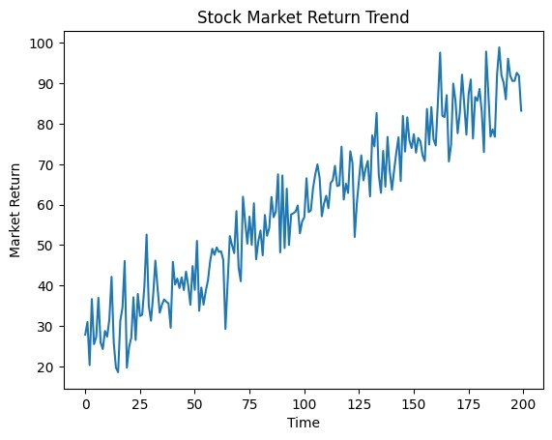
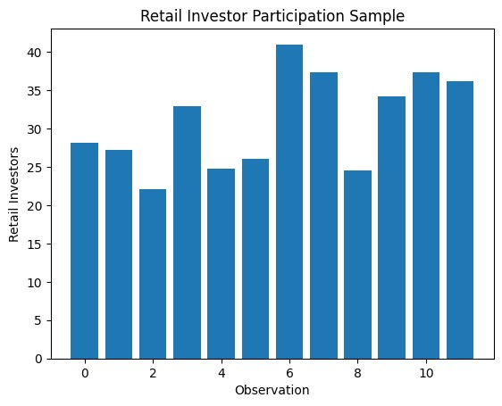
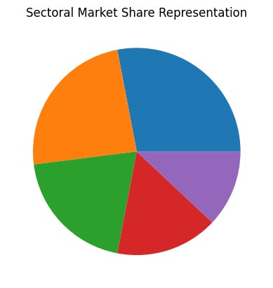

References
Fama, E. (1970). Efficient capital markets: A review of theory and empirical work.
Shiller, R. (2003). From efficient markets theory to behavioural finance.
Barber, B. & Odean, T. (2008). The behaviour of individual investors.
Gupta, R. & Jain, P. (2019). Macroeconomic determinants of stock market performance in India.
Lee, K. (2021). Financial technology and digital trading platforms.
Lo, A. (2017). Adaptive markets: Financial evolution at the speed of thought.
Thaler, R. (2016). Behavioural economics and investor decision making.
Malkiel, B. (2019). A Random Walk Down Wall Street.
Damodaran, A. (2012). Investment Valuation.
Hull, J. (2018). Options, Futures and Other Derivatives.
Ross, S. (2013). Corporate Finance.
Sharpe, W. (1994). Capital Asset Pricing Model.
World Bank (2023). Global Financial Development Report.
Reserve Bank of India (2024). Financial Stability Report.
NSE (2024). Market Statistics Report.
BSE (2024). Annual Market Performance Report.
OECD (2023). Financial Markets Outlook.
IMF (2023). World Economic Outlook.

