REVIEW ON AI BASED ECG SIGNAL ANALYSIS USING CNN AND Bi-LSTM

ABSTRACT

This study presents analysis of a deep learning–based approach for Coronary Artery Disease (CAD) detection using ECG signals, focusing on the integration of a CNN-BiLSTM architecture and a Spatial Uncertainty Estimator (SUE). The CNN-BiLSTM model effectively extracts both spatial and temporal features from ECG signals, achieving high classification accuracy, while SUE quantitatively measures the reliability of predictions by evaluating Grad-CAM feature consistency under noise-corrupted conditions. The methodology includes wavelet-based preprocessing, segment-wise ECG classification, explainable AI visualization, and uncertainty estimation. Experimental results demonstrate that the CNN-BiLSTM model attains superior performance compared to traditional architectures, with SUE providing clearer distinction between reliable and unreliable predictions than conventional uncertainty-quantification techniques. Overall, this study highlights the significance of combining deep learning, explainability, and uncertainty measures to build trustworthy ECG-based CAD diagnostic systems suitable for clinical and embedded healthcare applications.
- INTRODUCTION
Coronary Artery Disease (CAD) is a major global health concern, and early detection is essential to reduce serious cardiac events. Electrocardiography (ECG) is widely used for diagnosing heart conditions, but manual interpretation is often difficult due to noise, signal variations, and subtle abnormalities. This has increased the use of deep learning techniques for automated and more reliable ECG analysis.Deep learning models, especially Convolutional Neural Networks (CNNs) and Bidirectional LSTM (BiLSTM) networks, have shown strong performance by learning spatial and temporal features directly from ECG signals. Hybrid CNN-BiLSTM architectures achieve higher accuracy compared to traditional methods. However, despite their accuracy, clinical deployment requires models that are not only correct but also interpretable and reliable.Explainable AI methods like Grad-CAM help visualize important ECG regions used for classification, but they offer only qualitative insights. Traditional uncertainty estimation methods are computationally heavy and do not measure spatial reliability. To address this, the Spatial Uncertainty Estimator (SUE) measures the consistency of Grad-CAM features between clean and noisy ECG signals, providing a simple and effective way to quantify prediction reliability.
This review highlights how combining CNN-BiLSTM models with SUE improves both accuracy and trustworthiness in ECG-based CAD detection, making it a promising approach for real-world medical applications.

LITERATURE REVIEW
The methods using in this :-
1)ECG-Based Detection of Coronary Artery Disease
2) Traditional Machine Learning Approaches
3) Explainable AI in Biomedical Deep Learning
4) Uncertainty Quantification in Deep Learning

1. ECG-Based Detection of Coronary Artery Disease

Coronary artery disease (CAD) is typically assessed using noninvasive electrocardiography (ECG), which records cardiac electrical activity and reveals ischemic deviations in ST-segments, QRS morphology, and T-wave patterns. However, conventional ECG interpretation often fails to identify early or stable CAD due to subtle waveform distortions and inter-patient variability. Studies have shown that nearly 70% of CAD cases do not display prominent ECG abnormalities, limiting the sensitivity of traditional clinical interpretation. Noise contamination from muscle activity, electrode motion, and power-line interference further contributes to diagnostic inconsistency. These challenges have motivated the development of automated ECG analysis systems capable of detecting complex patterns not easily visible to clinicians.

2.Traditional Machine Learning Approaches

Early work in automated CAD detection relied on handcrafted feature extraction and classical machine learning classifiers. Features such as heart rate variability, wavelet coefficients, spectral entropy, morphological descriptors, and nonlinear dynamical measures were commonly used in conjunction with SVMs, k-NN, decision trees, and random forests. Although these methods achieved moderate accuracy, they suffered from several limitations:

sensitivity to noise and inter-patient variability,
dependence on domain expertise for feature engineering, and
poor generalization across datasets.
The manual nature of feature extraction restricted scalability and often failed to capture high-level ECG abstractions required for reliable CAD detection.

3. Explainable AI in Biomedical Deep Learning

To address the “black-box” nature of deep neural networks, explainable artificial intelligence (XAI) techniques have been applied to ECG classification tasks. Gradient-weighted Class Activation Mapping (Grad-CAM) is one of the most widely used methods, providing relevance maps that highlight the most influential segments of the ECG signal. These graphical explanation help medical assess whether model decisions depends on signal features.

- This Grad-CAM has limitations:
- It produces qualitative heat maps.
- Pattern of the relavence varies with the noise.
- Predictive reliability is never quantified.
- Even XAI enhances transparency, it does not provide complete trustworthy to be used clinically.

4. Uncertainty Quantification in Deep Learning

Monte Carlo Dropout (MCD) and Deep Ensembles are methods of uncertainty-quantification (UQ) that predict confidence in the model. MCD provides a Bayesian opinion but slightly discriminates ECGs, whereas Deep Ensembles are deemed to be valid though expensive to train. Current UQ assesses only confidence, not the ability of the model to maintain attention on the correct regions of the ECG during signal perturbation an imperative aspect since dirty ECGs may have a false impression on deep models despite the output looking right.

IV. MATERIALS AND METHODS

A. Dataset Description

The analysis combined two publicly available ECG databases 40 healthy samples (stored at 250Hz) of PhysioNet Fantasia and 75 CAD samples of the St. Petersburg institute Database (257Hz). There was a strict subjectwise partition creating a training (29 subjects), validation (13) and test (5) set, no subject was used more than once. The analysis of the preprocessed and fragmented recordings into 2-second frames resulted in the joint data which would contain approximately 95,300 segments (including 80,000 healthy, 15,300 CAD). The compared ECGs of healthy and CAD-affected were seen as meaningful in this balanced set

Dataset (n = subjects) | Healthy | CAD | Total
Training set (n = 29) | 50,407 | 9,632 | 60,039
Validation set (n = 13) | 21,544 | 4,187 | 25,731
Test set (n = 5) | 8,049 | 1,481 | 9,530
Table 1 Dimensions of the Healthy and Cad signals

B. ECG Preprocessing

In this preprocessing use Discrete Wavelet Transform to reduce the noise in the input signals i.e. CAD signals. Then all ECGs were resampled to 257Hz to be equal to that of CAD data. A baseline drift of importance was subsequently removed using a DWT with a Daubechies-6 wavelet with minimal artifact and high-frequency noise generated by the muscle signal and conserved the QRS-like morphology. Lastly, rinsed signals were sliced to produce more training signals to the model by cutting into non-overlapping windows of 2 seconds (514 samples).

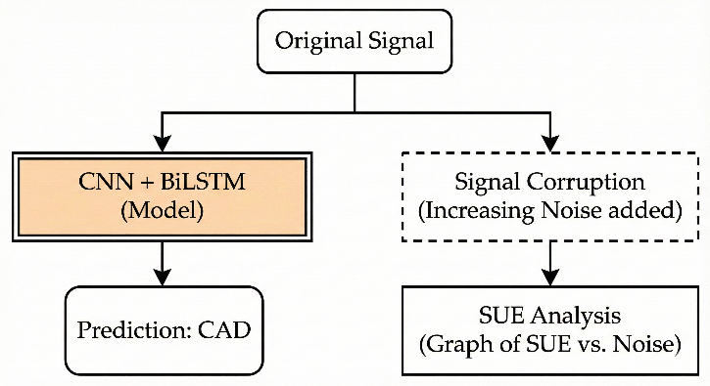
Fig. 1. The Overview of AI-Robustness Framework. ECGs are also corrupted with random noise profiles (e.g. Gaussian, baseline wander, impulse) at test time. The prediction of each noisy sample in the model is compared and a Signal Uncertainty Estimate (SUE) is estimated.

C. Deep Learning Architecture

A hybrid convolutional neural network–bidirectional long short-term memory (CNN–BiLSTM) architecture was developed to leverage the strengths of both spatial and temporal ECG feature extraction. The convolutional layers extracted morphological characteristics, including QRS complex shape, T-wave patterns, and segment slopes, while the BiLSTM layers modeled bidirectional temporal dependencies that captured dynamic relations across cardiac cycles. The architecture comprised three Conv1D layers with decreasing kernel sizes, each followed by max-pooling to reduce dimensionality, and two BiLSTM layers with 20 and 10 units respectively. Three fully connected layers subsequently transformed the learned features into high-level representations, culminating in a Softmax final layer of the network produces a two-class decision suitable for binary classification. During training, the model used the Adam optimizer, and learning was guided by the binary cross-entropy loss function for 20 epochs and a batch size of 10. Training was performed exclusively on clean signals, while noisy signals were reserved for robustness evaluation.

Table 2: The proposed architecture: layers, output and kernel dimension, and stride.
Layer | Output Dimension | Kernel Dimension | Stride
Conv 1D | 514 × 3 | 27 | 1
Max Pooling | 257 × 3 | 2 | 2
Conv 1D | 257 × 5 | 15 | 1
Max Pooling | 129 × 5 | 2 | 2
Conv 1D | 129 × 5 | 4 | 1
Max Pooling | 65 × 5 | 2 | 2
BiLSTM | 65 × 20 | – | –
BiLSTM | 65 × 10 | – | –
Fully connected | 20 | – | –
Fully connected | 10 | – | –
Fully connected | 2 | – | –

D. Explainable Artificial Intelligence via Grad-CAM

To interpret the decisions made by the deep learning model, Gradient-weighted Class Activation Mapping (Grad-CAM) was applied to generate one-dimensional relevance heatmaps for each ECG segment. These heatmaps highlighted the regions of the signal that contributed most strongly to the model’s prediction, providing qualitative insight into whether the network focused on clinically meaningful ECG features. Grad-CAM was applied to the final BiLSTM layer to capture both spatial and temporal dependencies within the ECG waveform. While valuable for visualization, Grad-CAM heatmaps alone do not quantify reliability and can vary substantially under different noise conditions. Therefore, they served as the foundation for a more robust, quantitative reliability assessment method introduced in this study.

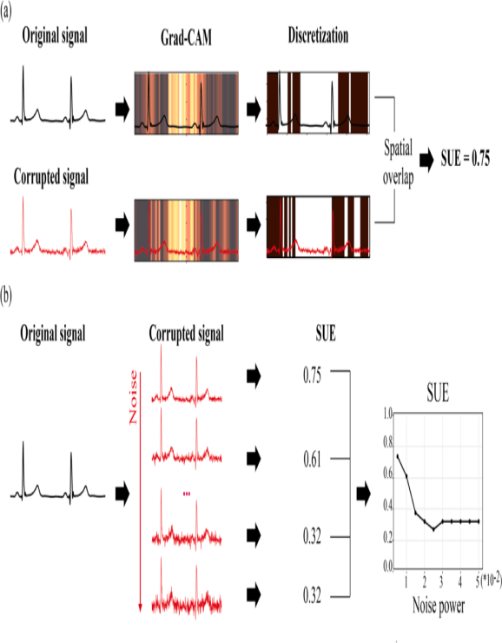

Fig. 2. Artificial Intelligence Framework of Assessment of Reliability based on SUE parameter
Discretize these heatmaps (e.g. binning, thresholding).

E. Spatial Uncertainty Estimator (SUE)

The Spatial Uncertainty Estimator (SUE) was implemented to quantify the consistency of model attention under noise. For each clean ECG segment and its corresponding noisy variants, Grad-CAM heatmaps were first normalized and discretized based on percentile thresholds. Only the highest 25% relevance regions—representing the model’s most critical decision-driving features—were used to generate binary relevance masks. SUE was computed as the intersection-over-union between the relevance mask of the clean signal and that of the noisy signal. A high SUE value indicated strong spatial consistency, implying reliable feature extraction and robust model behavior. In contrast, low SUE values revealed that noise altered the model’s focus, suggesting unreliable predictions. Because SUE relies solely on relevance maps and requires no model retraining or architectural modification, it is computationally efficient and suitable for real-time or embedded implementations.
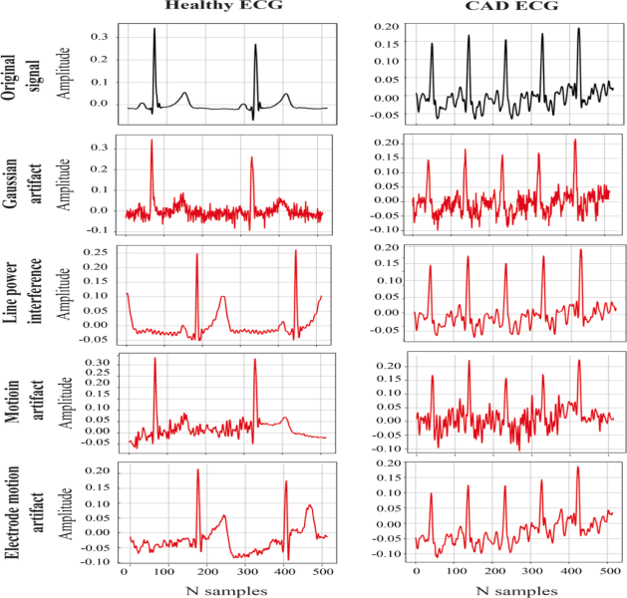
Fig. 3. The figure shows an example of a normal ECG segment (left) and a CAD-affected segment (right), each followed by their corrupted versions taken from the test dataset

F. Comparison with Uncertainty Quantification Techniques

To validate SUE’s effectiveness, it was compared with two widely used uncertainty quantification methods: Monte Carlo Dropout (MCD) and Deep Ensembles. MCD approximates Bayesian inference by introducing randomness through dropout during prediction, while Deep Ensembles generate uncertainty based on output variance across several independently trained models. Although Deep Ensembles performed well in separating correct from incorrect predictions, they required significant computational resources due to multiple model instantiations. MCD, while lightweight, exhibited weaker discriminative capability. SUE is only able to distinguish reliable and unreliable predictions based on all types of noise using a single trained model, which makes it highly efficient and interpretable.

V .COMPARATIVE ANALYSIS

Here we compared the different parameters :-

AUTHO R | PUBL ISHE D YEA  R | METHOD USED | TOTA L ACC URA  CY
Marilia Baranadas etal. | 2023 | Ensemble based methods | 95%
M.Lin et al . | 2024 | DDT features extraction and MIT-BIH datasets | 98.55%
A.Abdou and Krishnan | 2024 | DB6COIF5 | 96%
Muhammad Ail Muzammil et al. | 2024 | Deep learning CNN and wearable integration | 96.17  %
Utkarsh Gupta et al. | 2024 | AI models for examples CNN mobile net . | 95.3%
Selvam et al. | 2025 | Hybrid CNN-VAE model | 98.51%
Rahul& Sharma | 2025 | CNN ,BIL-STM , transformer architectures | 99%
Yu et al. | 2025 | AI ECG ResNet-18 model | 91.1%
Kim et al. | 2025 | AI for ResNet model | 98.5%
N.Mechichi and F. Benzarti | 2025 | Hybrid CNN BILSTM MIT-BIH | 99.20%

PREPROCESSING
(WAVELET TRANSFORM)


DEEP LEARNING MODELS
(CNN,BILSTM)

FEATURE EXTRACTION

ECG SIGNAL

EXPLAINABLE AI (GRAD-CAM)

CLASSIFICATION
(CAD/NOISE)

AI BASED ECG SIGNAL ANALYSIS USING
CNN&BILSTM MODEL

VI. Conclusion:

This study represents the total design using Explainable AI which combine with uncertainity principles. The CNN, BiLSTM is a good option in the case of ECG data. The CNN layers extract the features QRS-complex and ST-segment, whereas the Bidirectional LSTM decompositions reveal the long-range temporal correlations that can be a reliable indicator of the difference between the healthy signals and the CAD signals. A combination of these two streams produces the high accuracy, sensitivity and specificity. This is a good indication that the model is not merely learning unpredictable noise. Of special attention should be paid to the new ingredient that is the Spatial Uncertainty Estimator (SUE). Comparing the attention maps (produced by Grad-CAM) produced when using a clean trace with those when using a slightly perturbed one, SUE provides a scalar, which directly incorporates how consistently the model is looking at the identical locations when noise is introduced into the signal.

VII. References:

- Acharya, U. R., Fujita, H., Lih, O. S., Oh, S. L., Adam, M., Tan, J. H., & Hagiwara, Y. (2017). Automated detection of arrhythmias using different intervals of tachycardia ECG segments with convolutional neural network. Information Sciences, 405, 81–90.
- Acharya, U. R., Oh, S. L., Hagiwara, Y., Tan, J. H., Adeli, H., & Subha, D. P. (2017). Automated EEG-based screening of depression using deep convolutional neural network. Computer Methods and Programs in Biomedicine, 161, 103–113.
- Barua, P. D., et al. (2021). Deep learning techniques for automated diagnosis of cardiovascular diseases using ECG signals: A review. Computer Methods and Programs in Biomedicine, 198, 105–113.
- Bengio, Y., Simard, P., & Frasconi, P. (1994). Learning long-term dependencies with gradient descent is difficult. IEEE Transactions on Neural Networks, 5(2), 157–166.
- Gal, Y., & Ghahramani, Z. (2016). Dropout as a Bayesian approximation: Representing model uncertainty in deep learning. In Proceedings of the 33rd International Conference on Machine Learning (pp. 1050–1059).
- Goldberger, A. L., Amaral, L. A., Glass, L., Hausdorff, J. M., Ivanov, P. C., Mark, R. G., … Stanley, H. E. (2000). PhysioBank, PhysioToolkit, and PhysioNet: Components of a new research resource for complex physiologic signals. Circulation, 101(23), e215–e220.
- He, K., Zhang, X., Ren, S., & Sun, J. (2016). Deep residual learning for image recognition. In Proceedings of the IEEE Conference on Computer Vision and Pattern Recognition (pp. 770–778).
- Hinton, G. E., & Salakhutdinov, R. (2006). Reducing the dimensionality of data with neural networks. Science, 313(5786), 504–507.
- Hochreiter, S., & Schmidhuber, J. (1997). Long short-term memory. Neural Computation, 9(8), 1735–1780.
- Huang, G., Liu, Z., Van Der Maaten, L., & Weinberger, K. Q. (2017). Densely connected convolutional networks. In Proceedings of the IEEE Conference on Computer Vision and Pattern Recognition (pp. 4700–4708).
- Kermany, D. S., et al. (2018). Identifying medical diagnoses and treatable diseases by image-based deep learning. Cell, 172(5), 1122–1131.
- Kingma, D. P., & Ba, J. (2015). Adam: A method for stochastic optimization. In International Conference on Learning Representations (ICLR).
- Lundberg, S. M., & Lee, S.-I. (2017). A unified approach to interpreting model predictions. In Advances in Neural Information Processing Systems (pp. 4765–4774).
- Molinaro, F., Seoni, S., Acharya, U. R., Barua, P. D., Oh, S. L., & Salvi, M. (2024). Application of spatial uncertainty predictor in CNN-BiLSTM model using coronary artery disease ECG signals. Information Sciences, 665, 120383.

