Study on the Influence of Cinnamon Powder on the Corrosion Resistance of 21K Gold Alloy in Artificial Saliva in the Presence of Cinnamon Powder

ABSTRACT
Corrosion resistance is a critical factor influencing the long-term performance and biocompatibility of dental and biomedical alloys. This study explores the corrosion behaviour of 21K gold alloy and other metallic materials in artificial saliva both in the presence and absence of cinnamon powder. Cinnamon, a common natural flavouring agent used in food and oral care products contains bioactive compounds that may alter the electrochemical environment of the oral cavity. Corrosion testing was performed using potentiodynamic polarisation and electrochemical impedance spectroscopy (EIS) to evaluate the electrochemical stability of the materials. The results indicated that the presence of cinnamon powder enhances the corrosion resistance of 21K gold alloy. These findings suggest that the dietary or therapeutic use of cinnamon powder could influence the durability and performance of metallic dental and orthodontic devices.

Keywords: Corrosion, Artificial Saliva, Cinnamon Powder, 21K Gold Alloy, Polarisation study, and AC impedance spectra.

INTRODUCTION
Once implanted, metals and alloys are exposed to various body fluids and may undergo corrosion in this biological environment. The corrosion resistance of different alloys in bodily fluids has been extensively studied by numerous researchers. For example, B.I. Johansson et al. investigated the corrosion behaviour of dental copper, nickel, and gold alloys in artificial saliva and saline solutions over four weeks. Their study revealed that copper and beryllium-containing nickel alloys exhibited significant surface degradation whereas high-gold alloys demonstrated superior stability.
D. Brune et al. investigated the corrosion behaviour of gold alloys and titanium in artificial saliva, focusing on the release of metal ions during extended immersion. Their findings provide valuable baseline data on the behaviour of gold and its alloys in artificial saliva. Tzu-Hsin Lee et al. highlighted the impact of fluoride as a recurring factor in corrosion studies, noting that the presence of fluoride in artificial saliva significantly reduces the corrosion resistance of Ni-Ti and other dental alloys. Additionally, Aggryppyne Keyne Oberta Sembiring et al. studied the use of cinnamon bark extract as a natural corrosion inhibitor for iron. Their results showed that compounds from cinnamon bark can form complexes with Fe(III) at the metal surface, thereby reducing corrosion rates.
Orthodontic wires, such as SS 18/8, Ni–Cr, Ni–Ti. Doctors commonly use SS316 and 22 K gold to correct the alignment of teeth. These wires are exposed to corrosion in a saliva environment. In addition, they are affected by corrosive agents present in food, beverages, candies, and orally administered tablets.
The present study investigates the effect of cinnamon powder on the corrosion resistance of 21K gold in artificial saliva using electrochemical techniques, including polarisation and AC impedance spectroscopy.

EXPERIMENTAL METHODS

Preparation of the metal specimens
A thin wire of 21K gold alloy was used as the test material in this work. 21K gold alloy consists of 21 parts of pure gold, and the remaining two parts are copper and zinc. The added metals make the texture of 21K gold harder and thereby more durable for making jewellery.
The 21K gold alloy was compressed using a Teflon rod. The samples were polished to a mirror finish and used for electrochemical studies. The metal specimens encapsulated in a Teflon rod were immersed in artificial saliva ( ISO standard ISO 3160-2) whose composition was as follows: 0.4g/l of KCl, 0.4g/l of NaCl, 0.906g/l of CaCl₂.2H₂O, 0.690g/l of NaH₂PO₄.2H₂O, 0.005g/l Na₂S.9H₂O and 1g/l of urea (Fusayama Meyer artificial saliva, with the pH of the artificial saliva being approximately 6.9.
Preparation of Cinnamon powder:
About 0.5 g of cinnamon powder was accurately weighed and powdered.
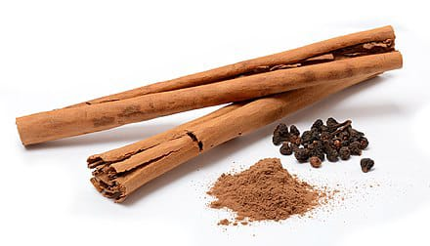
Fig 1 cinnamon powder

Composition
Cinnamon contains a range of resinous compounds, including cinnamaldehyde, cinnamate, cinnamic acid, and other essential oils.
Benefits of cinnamon powder
Manages Blood Sugar and Diabetes: Cinnamon improves insulin sensitivity and helps lower blood glucose levels, which is particularly beneficial for individuals with Type 2 diabetes. Heart Health Support: It helps reduce "bad" LDL cholesterol, triglycerides, and blood pressure, while maintaining "good" HDL cholesterol. High Antioxidant Content: It contains potent antioxidants that protect the body against oxidative stress and free radical damage. Anti-inflammatory Properties: Its active compounds help fight inflammation, which can alleviate conditions like joint pain and muscle aches. Weight Management: Cinnamon can help curb cravings, reduce hunger, and speed up metabolism. Improves Digestion: Known to reduce symptoms of gas, bloating and indigestion. Cognitive Function: Studies suggest it may help protect brain health and reduce the risk of neurodegenerative diseases.

ELECTROCHEMICAL STUDY
In the present study, the corrosion resistance of 21K gold alloy immersed in artificial saliva was evaluated in the absence and presence of cinnamon powder using polarization studies and AC impedance spectroscopy. Polarization measurements were conducted using a CHI Electrochemical Workstation (model 604E).

Polarization study
Polarization studies were conducted using a three-electrode cell setup (Figure 2), with a saturated calomel electrode (SCE) as the reference electrode, platinum as the counter electrode and a 21K gold alloy as the working electrode. From these studies, key corrosion parameters were obtained, including the corrosion potential (Ecorr), corrosion current density (Icorr), anodic (ba) and cathodic (bc) Tafel slopes, and linear polarization resistance (LPR) values.

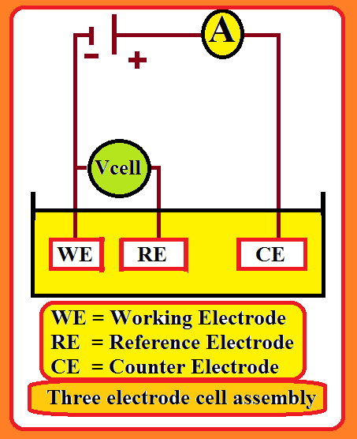
Figure 2. Three-electrode cell assembly

AC impedance spectra
In the present study the same instrument and setup used for the polarization measurements were employed to record the AC impedance spectra. A stabilization period of 5-10 min was allowed for the system to reach a steady-state open circuit potential. The real (Z′) and imaginary (Z″) components of the cell impedance were measured in ohms over a range of frequencies. Impedance spectra were recorded with the following parameters: initial potential E(v) = 0, high frequency = 1×10⁵ Hz, low frequency = 1 Hz, amplitude = 0.005 V, and a quiet time of 2s. From the Nyquist plots, the transfer resistance (Rₜ) and double-layer capacitance (Cdl) were determined, while Bode plots were used to obtain the impedance.

RESULTS AND DISCUSSION
The present investigation aimed to evaluate the corrosion resistance of orthodontic wire made from 21 K alloy in artificial saliva both in the absence and presence of cinnamon powder, using electrochemical techniques such as polarization studies and AC impedance spectroscopy .

Polarization study
The influence of cinnamon powder on the corrosion resistance of the 21K gold alloy in artificial saliva (AS) was investigated using a polarization study. The Polarization curves of the 21K gold alloy in the AS solution in the absence and presence of cinnamon powder, are shown in Figure 3. The corrosion parameters are listed in Table 1. The corrosion parameters are compared in Figure 4-5.
Table 1: Corrosion Parameters of 21K gold alloy immersed in artificial saliva in the absence and presence of cinnamon powder obtained by polarization study.
Metal | System | E_{corr}  _{mV vs SCE} | b_{c}  _{mV/decade} | b_{a}  _{mV/decade} | LPR  Ohm cm² | I_{corr}  _{A/0.00785 cm}²
21K gold alloy | Artificial saliva | -0.227 | 3.140 | 1.786 | 435713 | 2.026x${10}^{-7}$
21K gold alloy | Artificial saliva + Cinnamon powder | -0.206 | 5.325 | 4.618 | 437277 | 1.023 X10⁻⁸
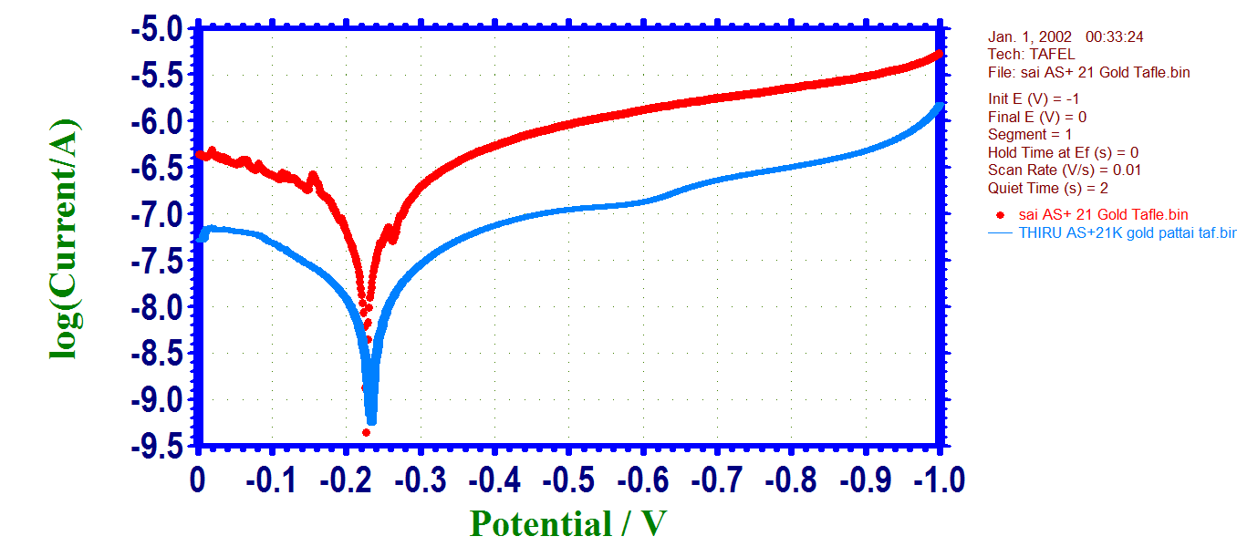
a

b

Figure 3. Polarization curves of 21K Gold alloy immersed in various test solution
- AS b) AS+cinnamon powder

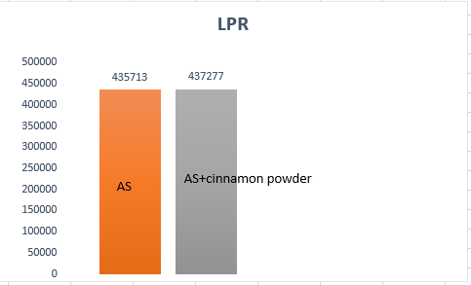
Figure 4. Comparison of LPR values of 21K gold alloy immersed in artificial saliva (AS) in the presence and absence of cinnamon powder

Figure 5. Comparison of Icorr values of 21K Gold alloy immersed in artificial saliva (AS) in the presence
and absence of cinnamon powder.
Correlation of corrosion parameters obtained by Polarization Study is shown in Scheme A.
CORROSION
RESISTANCE INCREASES
LPR
INCREASES
CORROSION CURRENT
DECREASES
POLARISATION STUDY
Scheme A. Correlation among corrosion parameters in polarization study.
Based on these concepts, it can be observed from Table 1 that in the presence of cinnamon powder, the corrosion resistance of the 21K gold alloy in AS increases. This is revealed by the fact that, in the presence of cinnamon powder the LPR value of the 21 K gold alloy increases (Figure 3) and the corrosion current decreases (Figure 3).

Implication
The corrosion resistance of the 21K gold alloy in artificial saliva increased in the presence of cinnamon powder. Hence, it was concluded that individuals fitted with orthodontic wires made of 21K gold alloy in artificial saliva need not hesitate to take cinnamon powder orally.
AC Impedance spectra
The AC impedance spectra (Nyquist plot) of 21K gold immersed in artificial saliva are shown in Figure 6, and the AC impedance spectra (3D Interaction) of 21K gold immersed in artificial saliva (AS) + cinnamon powder are shown in Figure 7. The AC impedance spectra (Bode plot) of 21K gold immersed in artificial saliva are shown in Figure 8, and the AC impedance spectra (Bode plot) of 21K gold immersed in artificial saliva (AS) + Cinnamon powder are shown in Figure 9. The corrosion parameters are compared in Figures 10 and 11, respectively. The corrosion parameters, such as the charge transfer resistance (R_{t}) and double layer capacitance (C_{dl}) values, are listed in Table 2.

Table 2: Corrosion parameters of 21K gold alloy immersed in artificial saliva (AS) in the absence and presence of Cinnamon powder obtained from AC impedance spectra.
Metal | System | Nyquist plot |  | Bode plot impedance log(Z/ohm)
Metal | System | R_{t}  ohm cm² | C_{dl}  _{F/cm}² | Bode plot impedance log(Z/ohm)
21K Gold alloy | Artificial saliva | 21356 | 2.406X10⁻¹⁰ | 5.340
21K Gold alloy | Artificial saliva + Cinnamon powder | 160472 | 3.203X10⁻¹¹ | 5.220

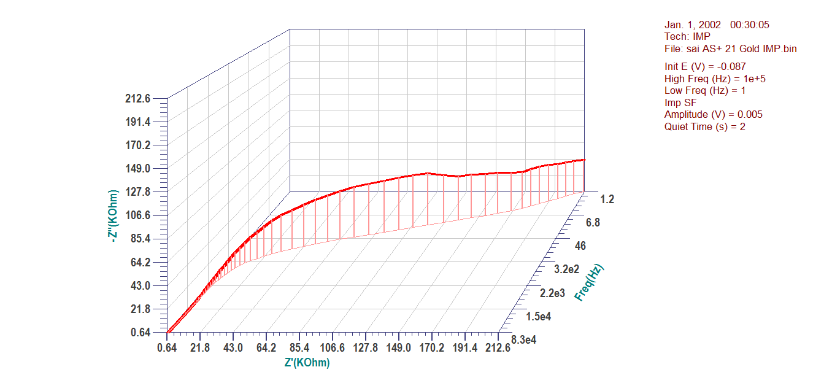
Figure 6: AC impedance spectra of 21K gold alloy immersed in artificial saliva.
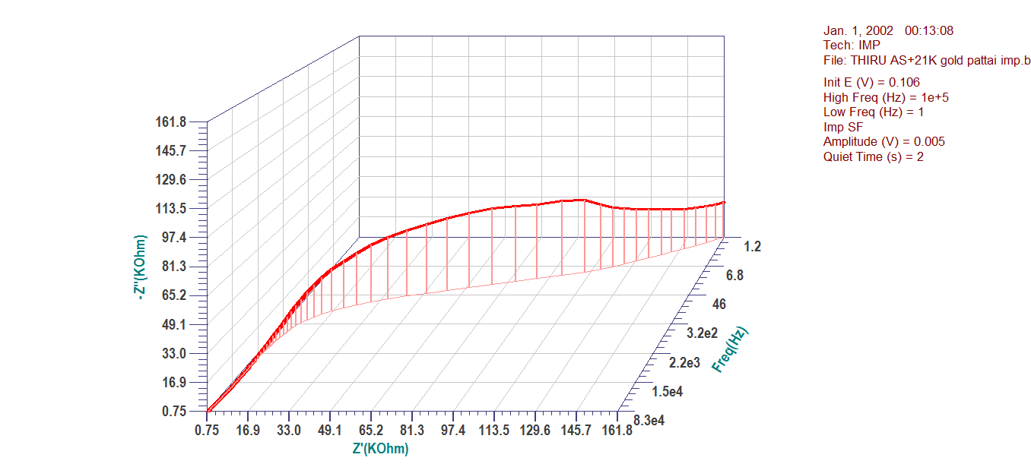
Figure 7: AC impedance spectra (3D Interaction) of 21K gold alloy immersed in artificial saliva (AS)+ Cinnamon powder

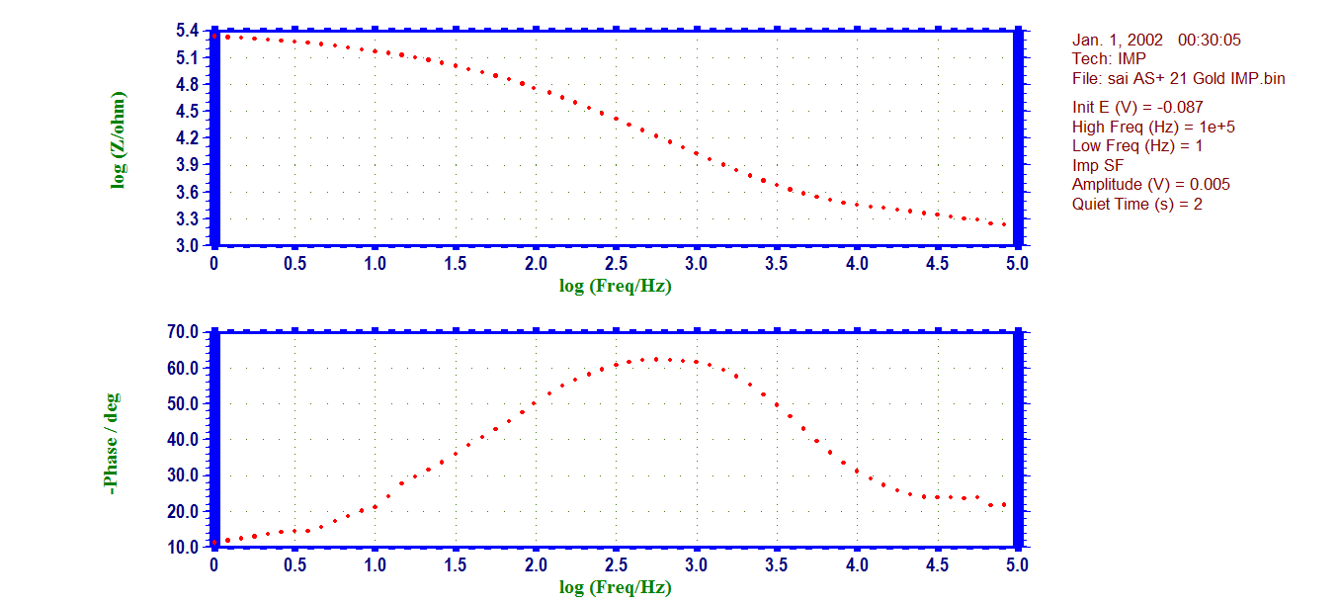
Fig 8. The AC impedance spectra (Bode plot) of 21K gold alloy immersed in artificial saliva
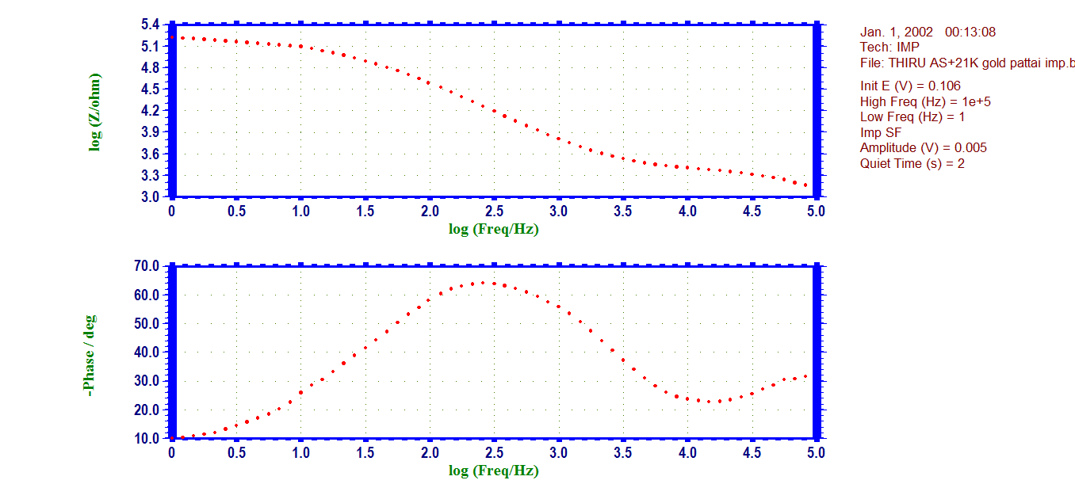
Fig 9 AC impedance spectra (Bode plot) of 21K gold alloy immersed in artificial saliva (AS)+ Cinnamon powder

AS
AS+Cinnamon powder
Figure 9. Comparison of Rt values of 21K gold alloy immersed in various test solutions

AS
AS+cinnamon powder
Figure 10. Comparison of C_{dl} values of 21K gold alloy immersed in various test Solutions.
As shown in Table 2, in the presence of cinnamon powder, the corrosion resistance of the 21K gold alloy in artificial saliva increased. This is revealed by the fact that in the presence of cinnamon powder, the R_{t} value increased and the C_{dl} value decreased.
AC impedance spectra (Bode plot) of 21K gold alloy immersed in artificial saliva (AS)+ Cinnamon powder in Figure 8.
The Rt value was 21356. The double-layer capacitance (C_{dl}) was 2.413 × 10⁻¹¹. These observations indicate that the protective film formed on 21K gold alloy was more stable. It can withstand the attack of aggressive ions present in the AS.
The Rt value was 160472. The double-layer capacitance (C_{dl}) was 3.1781X10⁻¹¹. These observations indicate that the corrosion resistance of 21 Karat gold in AS increased in the presence of cinnamon powder. The film formed on the metal surface prevented electron loss from the metal. The presence of the film caused the charge transfer resistance to increase and decreased the double-layer capacitance value.

Implication
Patients who use 21K gold alloy orthodontic wires can consume cinnamon powder, as the corrosion resistance of 21K gold alloy metal increases in the presence of cinnamon powder.

SUMMARY AND CONCLUSIONS
The corrosion resistance of 21K gold alloy in artificial saliva (AS), in the absence and presence of cinnamon powder, was investigated using polarisation studies and AC impedance spectra. The corrosion resistance of the 21 K gold alloy in artificial saliva increased in the presence of cinnamon powder. This was revealed by an increase in the LPR value, an increase in the Rt value, a decrease in the corrosion current, and a decrease in the double-layer capacitance value. Hence, it was concluded that people fitted with orthodontic wires made of 21K gold alloy in artificial saliva need not hesitate to take cinnamon powder orally. (Table 3).
Table 3. Summary of the study
Corrosion parameters | Artificial Saliva (AS) | AS+ cinnamon powder (increases/decreases)
LPR | 435713 | 437277 (increases)
Rt | 21356 | 160472 (increases)
Corrosion Current | 2.026 x 10⁻⁷ | 1.023 x 10⁻⁸(decreases)
Double-layer Capacitance | 2.406×10⁻¹⁰ | 3.203×10⁻¹¹(decreases)

REFERENCES
- Aggryppyne Keyne Oberta Sembiring, Anak Agung Bawa Putra, Oka Ratnayani,(2023) Journal Ilmu Pendidikan, Indonesia, “Utilization of cinnamon bark extract as a natural inhibitor for the control of corrosion rate in iron metal,” 11(3).
- Al-Nami.S.Y, Fouda.A.E-A.S,(2020) “Corrosion inhibition effect and adsorption activities of methanolic myrrh extract for Cu in 2M HNO₃,” International Journal of Electrochemical Science, 15(2), 1187-1205 .
- Anandan.A, Rajendran.S, Sathiyabama.J, Sathiyaraj.D and Abdulhameed Al-Hashem, (2018), Der Pharma Chemica, 10, 2.
- Belghiti.M.E, Ouadi.Y.E, Echihi.S, Bentiss.F, Dafali.A,(2020), “Anticorrosive properties of two 3,5 disubstituted-4-amino-1,2,4-triazole derivatives on copper in hydrochloric acid environment: Ac impedance, thermodynamic and computational investigations, Surfaces and Interfaces, 21,100692.
- Brune.D, Evie.D, Melsom.S,”(1982), “Corrosion of gold alloys and titanium in artificial saliva, European Journal of Oral Sciences, 90(2), 168-171.
- Chenglong.L, Paul Chu.K, Guoqiang.L,(2007), “Effects of Ti/TiN Multilayer on Corrosion Resistance of Nickel-Titanium Orthodontic Brackets in Artificial Saliva, Corrosion Science, 49, 2007, 3783–3796 .
- Christy Catherine Mary.A, Jeyasundari.J, Nezaire Banu.V.R, Senthil Kumaran.S, Peter Pascal Regis.A.(2020) Corrosion behavior of orthodontic wires in artificial saliva with the presence of beverage (Book Chapter), Nanotechnology in the Beverage Industry: Fundamentals and Applications, 471-504, .

- Dorothy.R, Sasilatha.T, Rajendran.S.(2021), “Corrosion resistance of mild steel (Hull plate) in seawater in the presence of a coating of an oil extract of plant materials, International Journal of Corrosion and Scale Inhibition,” 10(2), 676-699.
- Elzohry.A.M, Khorshed.L.A, Attia.A, Adly.M.A, Mohamed.L.Z,(2021), “Chemical, Electrochemical and Corrosive Wear Behavior of Nickel-plated Steel and Brass-plated Steel Based Coins from Egypt in Artificial Sweat, International Journal of Electrochemical Science, 16, 1-16.
- Huang.S, Song.X, Pan.C, Cao.G, Wang.Z,(2020), “Atmospheric corrosion behaviour of benzotriazole treated Cu-based coins in synthetic sweat, International Journal of Electrochemical Science,15,7693- 7708.
- Jeslina.V.D.A.M, Kirubavathy.S.J, Al-Hashem.A, Joany.R.M, Lacnjevac.C, (2021), “ Inhibition of corrosion of mild steel by an alcoholic extract of a seaweed, Sargassum Muticum, Materials Protection, 62(4), 304-315.
- Jessima.S.J.H.M, Berisha.A, Srikandan.S.S, Subhashini.S,(2020), “Preparation, characterization, and evaluation of corrosion inhibition efficiency of sodium lauryl sulfate-modified chitosan for mild steel in the acid pickling process, Journal of Molecular Liquids, 320, 114382,.
- Johansson.B.I, Lemons.J.E, Hao.S.Q(1989), Corrosion of dental copper, nickel, and gold alloys in artificial saliva and saline solutions, Science Direct, 5, 324-328.
- John Mary.S and Rajendran.S 2012, Corrosion behaviour of metals in artificial blood plasma in the presence of glucose, Zaštita Materijala, 53(2), 109 – 113.
- Joycee.S.C, Raja.A.S, Amalraj.A.S, Rajendran.S (2021), Inhibition of corrosion of mild steel pipeline carrying simulated oil well water by Allium sativum (Garlic) extract, International Journal of Corrosion and Scale Inhibition,10(3),943-960 .
- Larissa N Miotto, Laiza Maria Grassi Fais, Ana Lúcia Roselino Ribeiro,Luís Geraldo Vaz(2016), Surface properties of Ti-35Nb-7Zr-5Ta, Journal of Prosthetic Dentistry 116(1) .
- Mary.S.J, Delinta.D, Ajila.A, Muthukumaran.S.K, Rajendran.S(2021). Electrochemical behavior of various implantation biomaterials in the presence of various simulated body fluids–an overview, Materials Protection, 62(3), 213-219 .
- Nagalakshmi.R, Rajendran.S, Sathiyabama.J, Pandiarajan.M, and Lydia Christy.J2013, Corrosion behaviour of metals in artificial urine in the presence of Sodium Chloride, Eur. Chem. Bull., 2(4), 150-153.
- Naser.S.A, Hameed.A.A, Hussein.M.A (2020), Corrosion behavior of some jewelries in artificial sweat, AIP Conference Proceedings, 2213,020030.
- Prabha.A.S, Kavitha.K, Shrine.H.B, Rajendran.S(2020), Inhibition of corrosion of mild steel in simulated oil well water by an aqueous extract of Andrographis paniculata, Indian Journal of Chemical Technology, 27(6), 452-460.
- Rachael Ajmera, MS, RD (2025), “Medically reviewed by Cynthia Cobb, DNP, APRN, WHNP-BC, FAANP.
- Saranya.R and Rajendran,S (2018), Influence of D-Glucose on Corrosion Resistance of SS316L in the presence of Artificial Saliva, Rasayan J. Chem., 11(1), 103-110
- Senanayake UM, Lee TH, Wills RBH(1978), Volatile constituents of cinnamon (Cinnamomum zeylanicum) oils. Journal of Agricultural and Food Chemistry, 26(4):822–824.
- Shanthy.P, Thangakani.J.A, Karthika.S, Rajendran.S, Jeyasundari.J (2021), Corrosion inhibition by an aqueous extract of Ervatamia divaricata, International Journal of Corrosion and Scale Inhibition, 10(1), 331-348.
- Tzu-Hsin Lee, Ta-Ko Huang, Shu-Yuan Lin, Li-Kai Chen, Ming-Yung Chou, Her-Hsiung Huang(2010), Corrosion Resistance of Different Nickel-Titanium Archwires in Acidic Fluoride-containing Artificial Saliva, the angle orthodontist, 547-553.
- Wang.X, Herting.G, Wei.Z, Odnevall Wallinder.I, Hedberg.Y (2019), Bioaccessibility of Nickel and Cobalt in powders and massive forms of stainless steel, nickel- or cobalt-based alloys, and nickel and cobalt metals in artificial sweat, Regulatory Toxicology and Pharmacology,106,15-26.

