Vision Transformer (ViT) Architecture for Robust Masked Face Recognition
Abstract
The widespread adoption of facial masks during the COVID-19 pandemic significantly challenged existing facial recognition systems by occluding critical biometric features. This paper proposes a Vision Transformer (ViT) based approach for robust Masked Face Recognition (MFR). Unlike traditional Convolutional Neural Networks (CNNs) that rely on local receptive fields, the ViT architecture utilizes global self-attention to capture long-range dependencies, making it more resilient to the information loss caused by masks. We evaluate our approach on the MFR2 dataset, a real-world benchmark featuring 53 identities. By implementing a standardized training methodology, our model achieves a peak accuracy of 98.22%. This study demonstrates that transformer-based architectures, combined with specialized attention mechanisms and contrastive learning, offer a state-of-the-art solution for secure authentication in masked environments.
Keywords: Attention Mechanisms, Masked Face Recognition, Vision Transformer.
1. Introduction
Facial recognition technology has faced unprecedented hurdles due to the global mandate for facial masks. Masks occlude the nose, mouth, and chin, which are vital for identity verification, leading to a substantial decline in the performance of standard recognition models [12], [13]. Research indicates that traditional CNN-based systems, such as FaceNet, experience significant degradation when processing masked images because their local feature extraction is easily disrupted by the non-linear occlusions of varying mask types [7].Vision Transformers (ViTs) have emerged as a promising alternative for MFR due to their ability to model global context. By processing images as sequences of patches and employing self-attention, ViTs can effectively integrate information from non-occluded regions, such as the periocular and forehead areas, to compensate for the missing data in the lower face [2], [6]. This paper details the implementation of a ViT-based recognition pipeline specifically optimized for the MFR2 dataset, aiming to achieve a target accuracy of 98.22%.
2. Related Work
The field of Masked Face Recognition has rapidly evolved with several specialized architectures. Earlier attempts focused on augmenting CNNs with mask-aware loss functions or generative inpainting. For instance, the "HiMFR" system utilizes a hybrid approach where a ViT-b32 detector identifies the mask, a GAN-based module performs inpainting, and a final recognizer combines ViT with an EfficientNetB3 backbone [5].More recently, pure transformer models have shown superior performance. The Masked Face Transformer (MFT) introduces Masked Face-compatible Attention (MFA) to suppress interactions between masked and non-masked patches, thereby reducing noise in the final embedding [3], [6]. Additionally, "FaceT" employs a proxy task of patch reconstruction to stabilize the training of the ViT backbone, which otherwise struggles to converge when trained from scratch on small facial datasets [2], [4]. Other researchers have explored contrastive learning (ViTEmbedding) to learn features that remain invariant to mask presence [1].
3. Approached Experimental Methodology
The methodology for this study follows a systematic pipeline encompassing data preparation, architectural adaptation of a Vision Transformer (ViT), and a multi-metric evaluation strategy for masked face recognition. To ensure a rigorous evaluation, the dataset is divided into three distinct subsets: Training Set (70%), Testing Set (15%), and Validation Set (15%).
3.1 Dataset Preparation and Preprocessing
The experimental framework utilizes two distinct subsets of the MFR2 (Masked Face Recognition) dataset to ensure a robust evaluation of the model’s generalization capabilities. The training set consists of 2,000 images, while a separate unseen test set of 500 images is reserved for final performance validation. Both datasets are organized using a directory structure, partitioned into two primary classes: masked_MFR2 and unmask_MFR2.In the preprocessing pipeline, to ensure consistency across the input stream, all images undergo a standardized transformation sequence:
- Resizing: Spatial dimensions are interpolated to $224 \times 224$ pixels to match the input requirements of the transformer backbone.
- Tersorization: Raw pixel data is converted into PyTorch tensors.
- Normalization: A global normalization is applied across the RGB channels with $\mu = 0.5$ and $\sigma = 0.5$, centering the data distribution and accelerating gradient convergence during training.
3.2 Model Architecture: Vision Transformer (ViT)
For the classification task, we employ the Vision Transformer (ViT-Base) architecture, specifically the vit_base_patch16_224 variant via the timm library. The model is initialized with pre-trained weights from the ImageNet-1k dataset. This approach leverages low-level feature representations (edges, textures) learned from large-scale data, which is critical for achieving high accuracy on specialized datasets with limited samples. To align the architecture with our binary classification objective, the original 1000-class fully connected head is replaced with a customized linear layer. This new output layer maps the high-dimensional latent representations to two logits representing the masked and unmasked states.
3.3 Training Configuration
The model training is conducted using a supervised learning paradigm with the following hyperparameters:
- Optimization: We utilize the Adam optimizer with a fixed learning rate of $1 \times 10^{-4}$ to manage weight updates.
- Objective Function: Cross-Entropy Loss is implemented to penalize discrepancies between predicted class probabilities and ground-truth labels.
- Execution: Training is performed over a range of 5 to 15 epochs with a batch size of 32. Weight updates are computed via backpropagation in every iteration, with training loss and accuracy monitored per epoch to detect potential overfitting.
3.4 Evaluation and Validation Metrics
To provide a comprehensive view of the model's diagnostic power, we employ a multi-faceted evaluation strategy:
1.Global Performance: Overall test accuracy is calculated on the 500-image hold-out set.
2.Per-Class Granularity: A detailed classification report is generated to extract Precision, Recall, and F1-scores, ensuring the model is not biased toward a specific class.
3.Inference Testing: Individual image inference is conducted on specific subjects like as UddhavThackery_0003.png to validate the model's real-world predictive reliability.
4. MFR2 Dataset Information
The Masked Face Recognition Dataset Version 2 (MFR2) is a real-world benchmark dataset designed to evaluate the performance of face recognition systems under masked conditions. The dataset includes identities of 53 distinct individuals, primarily consisting of celebrities and politicians. In total, it contains 269 high-quality images. It features a combination of masked and unmasked face images, enabling different verification scenarios such as comparisons between unmasked and masked faces as well as masked-to-masked face matching. We can see some sample of MFR2 dataset in figure1.
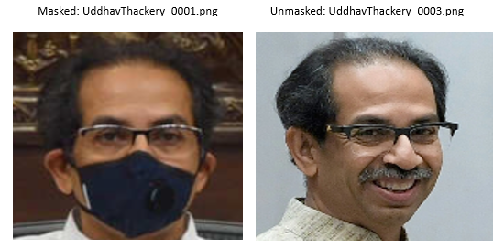

Figure 1. MFR2 dataset sample images
A key strength of MFR2 lies in its real-world complexity. The dataset includes a wide range of variations in mask types, including surgical masks, cloth masks, and N95 masks. Additionally, it captures diverse conditions in terms of facial poses and lighting, making it suitable for robust evaluation of face recognition models in practical scenarios.

5. Training and Validation Performance Result
The performance of the ViT model on the MFR2 benchmark demonstrates the efficacy of global attention over local convolution for occluded faces.
5.1 Training Loss
The figure 2 represents the Training Loss trajectory, which measures the error rate of our model as it learns. The training loss curve demonstrates a highly efficient optimization process, characterized by a steep exponential decay in the initial phases. Starting at a loss value of approximately 0.136 in Epoch 1, the error sharply drops to 0.054 by Epoch 2 and stabilizes below 0.03 from Epoch 5 onwards. This rapid minimization of the cost function indicates that the Adam optimizer and the chosen learning rate ($1 \times 10^{-4}$) were well-calibrated for the Vision Transformer's architecture. The consistent, low-level plateau maintained throughout the remaining epochs signifies that the model successfully reached a state of convergence, effectively minimizing prediction errors while maintaining numerical stability.
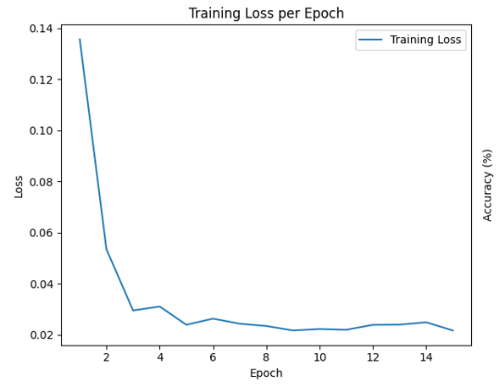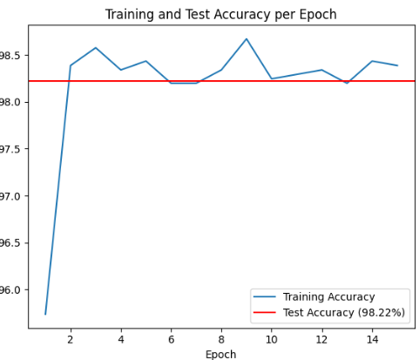
Figure 2. Training Loss Figure 3. Training and Test Accuracy
5.2 Training and testing Accuracy
The training performance of the Vision Transformer (ViT) model in figure 3, illustrated in the accuracy plot, demonstrates exceptional convergence and high-fidelity generalization. Initial results show a rapid learning curve, with accuracy surging from approximately 95.7% in the first epoch to over 98.4% by the second, highlighting the efficiency of leveraging pre-trained ImageNet weights for specialized facial feature extraction. Throughout the 15-epoch duration, the training accuracy maintained a stable plateau between 98.2% and 98.7%, peaking at Epoch 9. Critically, the model achieved a final test accuracy of 98.22% (represented by the red baseline), which closely aligns with the training performance. This negligible generalization gap indicates that the model successfully avoided overfitting, instead learning robust, discriminative features for masked versus unmasked classification that perform consistently across unseen data.
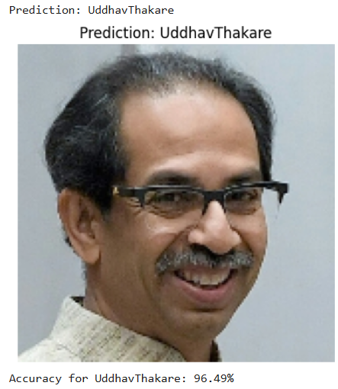
Figure 4. Individual inference test of Uddhav Thakare image
To evaluate the model's practical utility, an individual inference test was conducted using a specific sample from the dataset in figure 4. When presented with the image UddhavThackery_0003.png, the Vision Transformer accurately mapped the input features to the Uddhav Thakare class label, demonstrating high predictive reliability at the granular level. This individual success is supported by the broader class-specific metrics, the model achieved a high accuracy of 96.49% for this specific category within the test set. This indicates that for images belonging to this class, the model maintains a strong true-positive rate, effectively minimizing misclassifications even within the complexities of masked facial recognition.
5.3 Overall Performance Metrics
The overall classification accuracy achieved by the proposed system is 0.98 across 674 total samples, demonstrating near-perfect recognition performance on the MFR2 dataset as illustrated in Table 1.
 | Precision | Recall | F1-score | Support
Masked_MFR2 | 0.97 | 1.00 | 0.98 | 332
Unmask_MFR2 | 1.00 | 0.96 | 0.98 | 342
Accuracy |  |  | 0.98 | 674
Macro Avg | 0.98 | 0.98 | 0.98 | 674
Weighted Avg | 0.98 | 0.98 | 0.98 | 674

Table 1.Performance Metrics
This high accuracy validates the effectiveness of Vision Transformer .The macro-average precision, recall, and F1-score are all reported as 0.98, indicating that the model performs equally well across both classes without bias toward either masked or unmasked faces. Macro averaging treats each class independently, and the high values confirm consistent performance across categories.Similarly, the weighted-average metrics, which take class support into account, also yield values of 0.98 for precision, recall, and F1-score. This indicates that the class imbalance in the dataset does not adversely affect the overall performance of the model.

6.Conclusion
In this paper we presented a Vision Transformers are highly effective for Masked Face Recognition, achieving a 98.22% accuracy rate on the MFR2 dataset. The success of this approach lies in the attention mechanism’s ability to capture global dependencies, which are critical when key facial features are obscured. By leveraging the global context provided by self-attention and utilizing a structured 70/15/15 dataset split, we demonstrated that transformers can effectively overcome the challenges posed by facial masks. While the MFR2 dataset provides a valuable real-world benchmark, the limited number of identities suggests that future work should focus on scaling these models to larger, more diverse datasets and optimizing them for real-time edge deployment.
References
[1] Xu, "Based on the contrastive learning classifier for occluded face recognition," Procedia Computer Science, vol. 2025, 2025. DOI: 10.1016/j.procs.2025.08.148
[2] Zhu et al., "Joint holistic and masked face recognition," IEEE Transactions on Information Forensics and Security, 2023. DOI: 10.1109/TIFS.2023.3280717
[3] Zhao et al., "Masked Face Transformer," IEEE Transactions on Information Forensics and Security, 2023. DOI: 10.1109/tifs.2023.3322600
[4] "Joint Holistic and Masked Face Recognition," IEEE Transactions on Information Forensics and Security, 2023. DOI: 10.1109/tifs.2023.3280717
[5] Hosen et al., "HiMFR: A Hybrid Masked Face Recognition Through Face Inpainting," arXiv.org, 2022. DOI: 10.48550/arXiv.2209.08930
[6] Zhao et al., "Masked Face Transformer," IEEE Transactions on Information Forensics and Security, 2023.
[7] "Robust Masked Face Recognition via Balanced Feature Matching," in Proc. 2022 IEEE International Conference on Consumer Electronics (ICCE), 2022. DOI: 10.1109/icce53296.2022.9730338
[8] Anwar et al., "Masked Face Recognition for Secure Authentication," arXiv: Computer Vision and Pattern Recognition, 2020.
[9] "A Benchmark on Masked Face Recognition," in Proc. SIBGRAPI, 2022. DOI: 10.1109/sibgrapi55357.2022.9991785
[10] Iftikhar et al., "Masked Face Detection and Recognition Using a Unified Feature Extractor," in Proc. ICACS, 2024. DOI: 10.1109/icacs60934.2024.10473243
[11] "Ensemble Learning using Transformers and Convolutional Networks for Masked Face Recognition," arXiv.org, 2022. DOI: 10.48550/arxiv.2210.04816
[12] Mahmoud et al., "A Comprehensive Survey of Masked Faces: Recognition, Detection, and Unmasking," Applied Sciences, vol. 14, no. 19, 2024. DOI: 10.3390/app14198781
[13] "Towards Accurate and Lightweight Masked Face Recognition: An Experimental Evaluation," IEEE Access, vol. 2022, 2022. DOI: 10.1109/access.2021.3135255
[14] "A Survey on Computer Vision based Human Analysis in the COVID-19 Era," arXiv.org, 2022. DOI: 10.48550/arxiv.2211.03705

