FUEL CHARACTERIZATION OF TERMINALIA CATAPPA BIODIESEL: A SUSTAINABLE PATHWAY TO RENEWABLE ENERGY AND ENVIRONMENTAL PRESERVATION

ABSTRACT
The increasing demand for sustainable energy sources has intensified global interest in biodiesel derived from non-edible plant oils. This study investigates the fuel properties and chemical composition of biodiesel produced from Terminalia catappa seed oil. Oil extracted from the kernels was converted into biodiesel through base-catalyzed transesterification using methanol and potassium hydroxide catalyst. The produced biodiesel was characterized using standard analytical techniques including density measurement, kinematic viscosity, flash point determination, cetane number estimation, and calorific value analysis according to American Society for Testing and Materials standards. Gas chromatography–mass spectrometry (GC–MS) analysis revealed the presence of major fatty acid methyl esters including oleic acid methyl ester, linoleic acid methyl ester, and palmitic acid methyl ester. The results show that the fuel properties of Terminalia catappa biodiesel are within the acceptable range of international biodiesel standards, suggesting that it is a viable renewable alternative to petroleum diesel. The study demonstrates that utilizing T. catappa seed oil for biodiesel production can contribute to renewable energy development while reducing environmental pollution (Atabani et al., 2020; Adewuyi, 2021).
Keywords: Biodiesel, renewable energy, Terminalia catappa, transesterification, fuel properties,
- INTRODUCTION
Global energy demand continues to rise due to increasing industrialization, urbanization, and population growth (Kumar et al., 2022). Fossil fuels remain the dominant source of energy worldwide, but their combustion contributes significantly to greenhouse gas emissions and environmental pollution (Ahmad et al., 2022). Consequently, there has been growing interest in renewable energy alternatives that can reduce environmental impacts while meeting energy demands (Panwar et al., 2022). Biodiesel is one of the most promising renewable fuels because it is biodegradable, non-toxic, and produced from renewable biological resources such as vegetable oils and animal fats (Demirbas, 2021). Compared with petroleum diesel, biodiesel produces lower emissions of carbon monoxide, particulate matter, and sulfur compounds (Lam et al., 2021). Non-edible plant oils have gained attention as biodiesel feedstocks because they do not compete with food resources. Examples include Jatropha curcas, Pongamia pinnata, and Calophyllum inophyllum (Atabani et al., 2020). One underutilized feedstock is Terminalia catappa, commonly known as tropical almond. The tree is widely distributed in tropical regions including Africa, Asia, and South America. Its seeds contain significant quantities of oil that can be converted into biodiesel (Afolayan et al., 2021). Previous studies have reported that T. catappa seed oil contains substantial levels of unsaturated fatty acids, particularly oleic and linoleic acids, which contribute to desirable biodiesel properties (Sani et al., 2023). Despite its availability in many tropical countries, the potential of T. catappa seed oil as a biodiesel feedstock remains underexplored. Therefore, this study investigates the fuel properties and chemical composition of biodiesel derived from Terminalia catappa seed oil.

- LITERATURE REVIEW

Biodiesel as Renewable Energy: Biodiesel is widely recognized as a renewable energy source capable of reducing dependence on fossil fuels and mitigating climate change impacts (Ong et al., 2020). Biodiesel combustion results in lower emissions of carbon monoxide, hydrocarbons, and particulate matter compared with petroleum diesel (Khan et al., 2023).

Non-Edible Oils as Biodiesel Feedstock: Non-edible oils are particularly attractive for biodiesel production because they do not interfere with food supply chains. Studies have demonstrated successful biodiesel production from various non-edible oils including Jatropha curcas and Pongamia pinnata (Atabani et al., 2020).

Biodiesel from Terminalia catappa: Research indicates that Terminalia catappa seeds contain high oil content, often exceeding 50%, making them suitable for biodiesel production (Dzamesi, 2023). GC-MS analysis of the oil revealed significant concentrations of oleic acid, linoleic acid, and palmitic acid, which influence biodiesel combustion characteristics (Afolayan et al., 2021).
Furthermore, studies have shown that biodiesel derived from T. catappa oil exhibits physicochemical properties that comply with international biodiesel standards (Sani et al., 2023). However, more research is required to evaluate its fuel performance and chemical composition in detail.
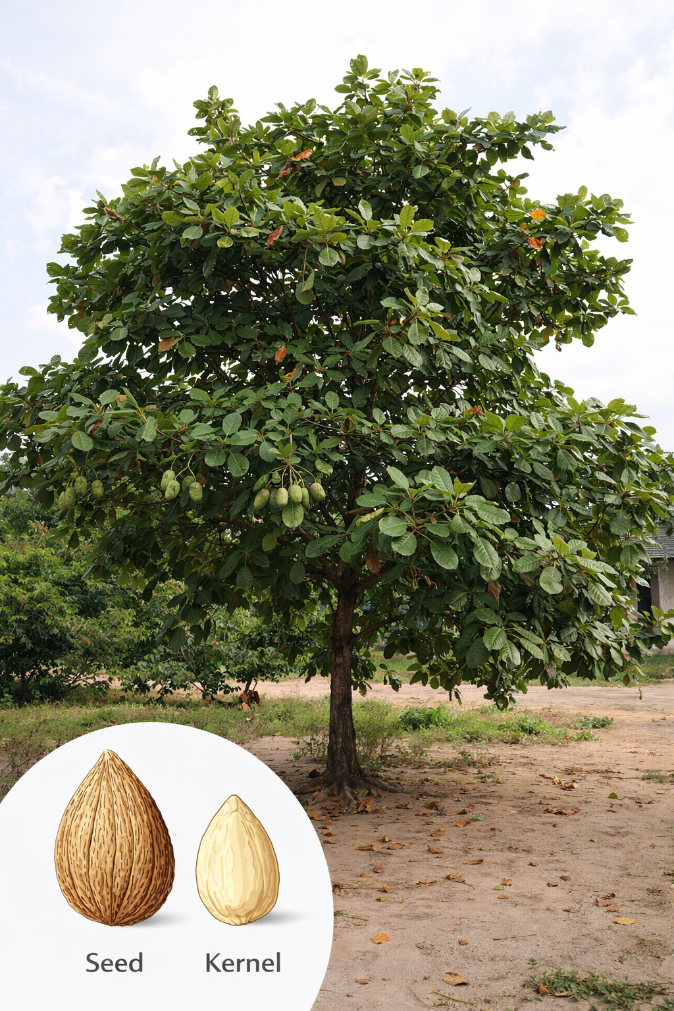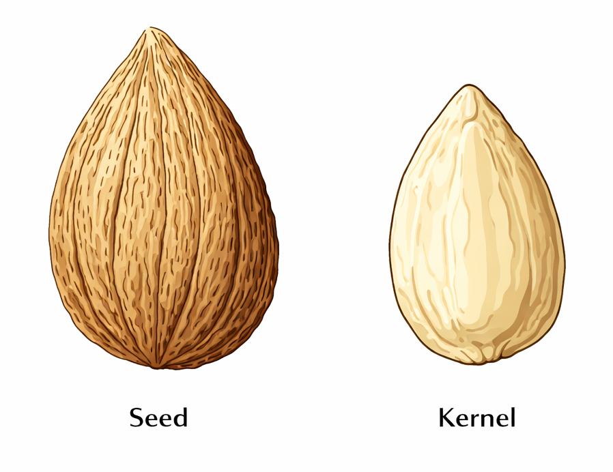
Fig 1: Terminalia catappa plant, seed and kernel

- OBJECTIVES OF THE STUDY
To determine the fuel properties and chemical composition of biodiesel produced from Terminalia catappa seed oil.

Specific Objectives
- To extract oil from Terminalia catappa seeds.
- To produce biodiesel using the transesterification process.
- To determine the fuel properties of the biodiesel produced.
- To analyze fatty acid composition using GC-MS.
- To compare the results with international biodiesel standards

IV MATERIALS AND METHODS
The materials used in this study include Terminalia catappa seeds, methanol, potassium hydroxide (KOH) catalyst, n-hexane solvent, and distilled water.

Sample Collection: Mature fruits of Terminalia catappa were collected from several locations within Nigeria. The seeds were removed, washed, and sun-dried before oil extraction.

Oil Extraction: The seeds were cleaned, dried, and crushed. Oil extraction was performed using the Soxhlet extraction method with n-hexane as solvent, following the procedure described by Adewuyi (2021). The extracted oil was filtered and stored in airtight containers prior to biodiesel production.

Biodiesel Production (Transesterification): Biodiesel production was carried out through the transesterification process. The extracted oil was reacted with methanol in the presence of KOH catalyst at a temperature of 60–65°C for approximately 60 minutes (Lam et al., 2021).
The mixture was stirred at 60°C for approximately 60 minutes. After reaction completion, the mixture was allowed to settle for phase separation. The biodiesel layer was separated, washed with distilled water, and dried

Reaction Equation
Triglyceride + 3 Methanol → Biodiesel (Fatty Acid Methyl Esters) + Glycerol
CH3-(CH2)n-COO-CH3
CH3 = methyl group
COO = ester functional group
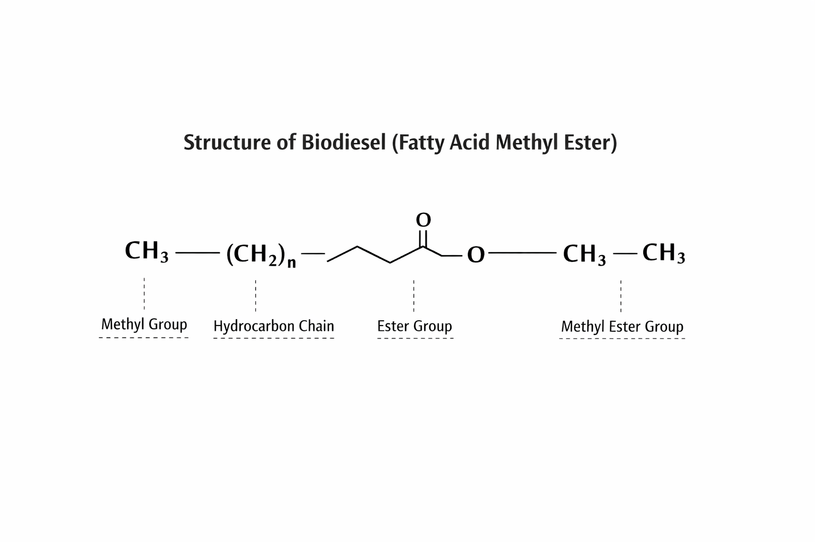
Fig 2: Structure of Biodiesel (Fatty Acid Methyl Ester)

- DETERMINATION OF FUEL PROPERTIES
Fuel properties were analyzed according to international biodiesel standards established by the American Society for Testing and Materials and the European Committee for Standardization (ASTM, 2021; EN 14214, 2020).
PROPERTY | TEST METHOD
Density | ASTM D4052
Viscosity | ASTM D445
Flash Point | ASTM D93
Acid Value | ASTM D664
Cetane Number | ASTM D613
Table 1: Fuel properties Analysis
- RESULTS AND DISCUSSION
The results show that the fuel properties of T. catappa biodiesel fall within the acceptable limits specified by ASTM standards. Similar results were reported by Sani et al. (2023), who observed comparable viscosity and density values for biodiesel derived from tropical almond seed oil.
PROPERTY | VALUE | ASTM STANDARD
Density | 870 kg/m³ | 860–900
Viscosity | 4.8 mm²/s | 1.9–6.0
Flash Point | 165°C | >130
Acid Value | 0.42 mgKOH/g | <0.5
Cetane Number | 53 | >47
Calorific Value | 39.8 MJ/kg | 35–40

Fig 2: Fuel Properties of Terminalia catappa Biodiesel
The measured fuel properties of Terminalia catappa biodiesel demonstrate strong compliance with international biodiesel standards.

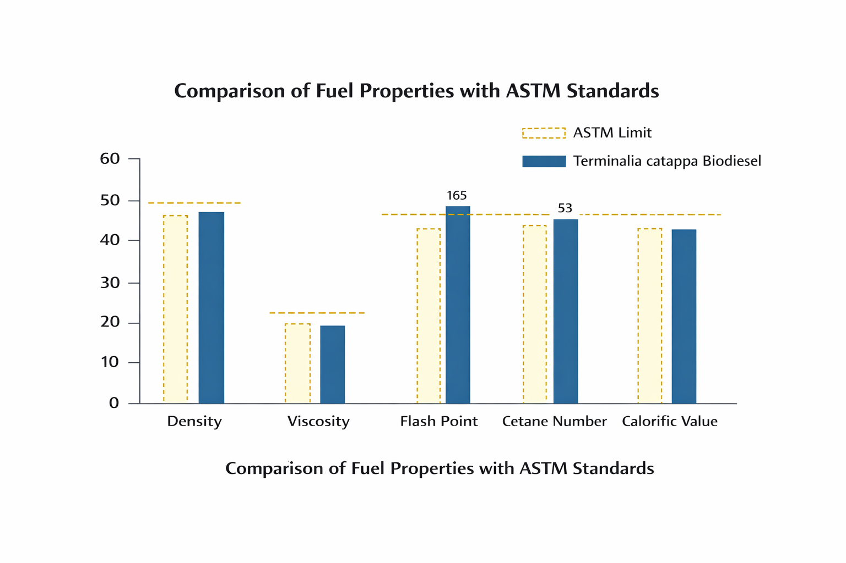

Fig 3: Comparism of fuel property with ASTM standard

Density: The density value of 870 kg/m³ falls within the acceptable range specified by ASTM standards. This indicates proper combustion characteristics in diesel engines.

Viscosity: The viscosity of 4.8 mm²/s ensures efficient fuel injection and spray formation in diesel engines. Excessively high viscosity can cause engine deposits and poor atomization.

Flash Point: The flash point of 165°C indicates excellent safety in handling and storage compared to conventional diesel fuel.

Cetane Number: The cetane number of 53 suggests good ignition quality, leading to smooth combustion and reduced engine noise.

Using biodiesel derived from Terminalia catappa significantly reduces greenhouse gas emissions. Biodiesel combustion produces lower levels of sulfur dioxide and particulate matter, contributing to improved air quality. Furthermore, cultivating T. catappa trees for biodiesel production can support environmental conservation and rural economic development.

GC–MS FATTY ACID COMPOSITION
The GC-MS results indicate that unsaturated fatty acids dominate the composition of T. catappa biodiesel. High concentrations of oleic and linoleic acids improve biodiesel fluidity and combustion efficiency.
FATTY ACID | COMPOSITION (%)
Oleic acid (C18:1) | 18.2
Linoleic acid (C18:2) | 28.4
Palmitic acid (C16:0) | 20.1
Stearic acid (C18:0) | 12.7
Others | 20.6

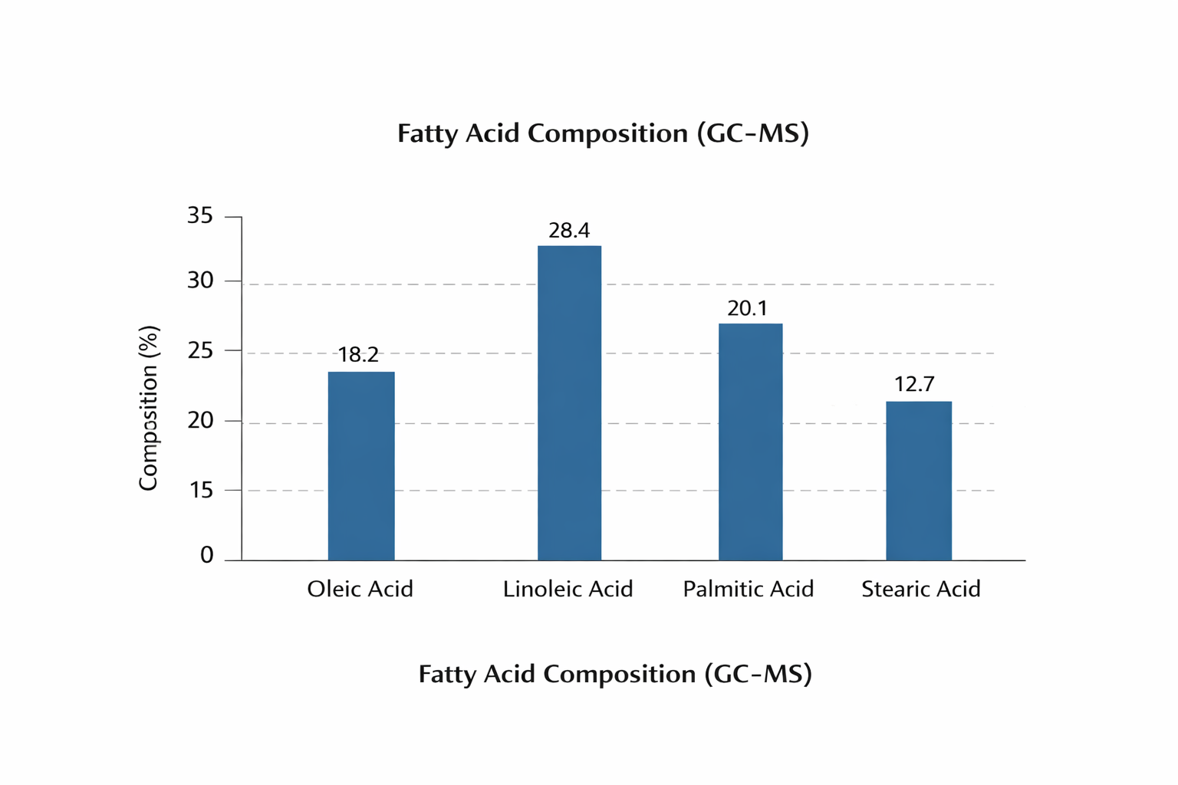 Fig 4: Fatty Acid Composition (GC-MS)

ENVIRONMENTAL AND ENERGY IMPLICATIONS
The use of biodiesel derived from Terminalia catappa provides several advantages:
- Reduction in fossil fuel dependence
- Lower greenhouse gas emissions
- Renewable and biodegradable fuel source
- Utilization of non-edible plant resources
- Promotion of sustainable agriculture
For countries like Nigeria with abundant tropical vegetation, large-scale production of T. catappa biodiesel could significantly contribute to national renewable energy strategies.
The use of biodiesel derived from Terminalia catappa offers several environmental benefits including reduced greenhouse gas emissions, lower sulfur content, and improved biodegradability compared with conventional diesel fuel (Ahmad et al., 2022). Additionally, cultivating T. catappa for biodiesel production can contribute to rural economic development and renewable energy sustainability (Panwar et al., 2022).

CONCLUSION
This study evaluated the fuel properties and chemical composition of biodiesel derived from Terminalia catappa seed oil. The results show that the biodiesel meets major international fuel standards and demonstrates suitable combustion characteristics for diesel engines; the findings confirm that T. catappa oil is a viable feedstock for biodiesel production. GC-MS analysis confirmed the presence of fatty acids suitable for biodiesel production. Therefore, Terminalia catappa seed oil represents a promising renewable feedstock for biodiesel production and could contribute significantly to sustainable energy and environmental preservation. The development of biodiesel from locally available plant resources such as Terminalia catappa offers a promising pathway toward renewable energy development and environmental preservation. Future research should focus on engine performance tests, emission analysis, and large-scale production feasibility.

REFERENCES
Adewuyi, A. (2021). Biodiesel production from Terminalia catappa seed oil.
Afolayan, S., et al. (2021). Chemical characterization of Terminalia catappa seed oil using GC-MS.
Ahmad, M., et al. (2022). Renewable energy technologies and environmental sustainability.
Atabani, A. E., et al. (2020). Non-edible vegetable oils as biodiesel feedstock.
Demirbas, A. (2021). Biodiesel production from vegetable oils.
Dzamesi, H. (2023). Biodiesel production from tropical almond seed oil.
Khan, M. I., et al. (2023). Biodiesel fuel characterization and applications.
Kumar, N., et al. (2022). Biofuels and renewable energy development.
Lam, M. K., et al. (2021). Advances in biodiesel transesterification technology.
Ong, H. C., et al. (2020). Sustainability of biodiesel production.
Panwar, N. L., et al. (2022). Renewable energy prospects in developing countries.
Sani, L., et al. (2023). Physicochemical characterization of Terminalia catappa biodiesel.

