Design and Performance Analysis of Rectangular Microstrip Patch Antenna for 5G Signal Reception using Python and Feko

Abstract--The growing demand for high-speed, short-range wireless communication in 5G networks calls for compact and efficient antenna solutions. This study presents the design, simulation, and performance evaluation of a rectangular microstrip patch antenna optimised to resonate at 46.2 GHz. The antenna was designed using numerical calculations in Python and modelled with FEKO simulation software, employing RT Duroid as the substrate material with a dielectric constant of 2.2 and a substrate thickness of 0.4 mm. The calculated patch dimensions were 1.9268 mm in length and 2.5579 mm in width. The following parameters were analysed; return loss, gain, VSWR, radiation patterns, and directivity. The simulation results showed a return loss of -23.59 dB, a VSWR of 1.156, a gain of 10 dB, and a directivity of 9.5 dB, confirming excellent impedance matching, high radiation efficiency, and strong directional performance. These are within standard benchmarks and also compared favourably with existing literature. The findings demonstrate that the proposed antenna is a practical and high-performing solution for next-generation 5G wireless communication systems.

Keywords—Antenna, Microstrip Patch, Wireless Communications, Feko, Python

INTRODUCTION
A
NTENNAS are essential components of modern wireless communication systems, serving as the primary medium for the transmitting and receiving of electromagnetic waves through space. Functioning as transducers, they facilitate the conversion of electrical signals travelling through transmission lines into radiated electromagnetic energy during transmission, and inversely, they capture incident electromagnetic waves and transform them back into electrical signals during reception. Through this bidirectional energy conversion, antennas form the essential interface between guided and free-space wave propagation, making them indispensable in applications ranging from radio and television broadcasting to satellite, radar, and mobile communication systems [1].
The fast growth of wireless systems and the growing need for new wireless applications mean that broadband antennas need to function across a broad bound of frequencies. It is quite hard to make a small, efficient, wideband antenna for current wireless applications [2]. Due to their modest profile, microstrip patch antennas are utilized in wireless communication systems, they’re often flexible, cheap to make, and easy to connect to feed networks [3]. Traditional microstrip patch antennas, on the other hand, have an extremely narrow bandwidth, usually only 5% of the centre frequency. This restriction makes it hard for antenna designers to come up with broadband solutions [4], [5]. There exist several well-known ways to improve antenna’s bandwidth which includes using a thicker substrate, a minimal dielectric substrate, different impedance match and feeding strategies, multiple resonators, and slot antenna designs [6], [7]. But usually, bandwidth and antenna size have opposite effects, so making one better usually means making the other worse. Recently, a number of ways to increase bandwidth have come to light. For instance, An impedance bandwidth of more than 20% has been achieved by creating a single-layer rectangular patch antenna [8]. Reducing the pins or walls on the uneven arms of U-shaped, U-slot, or L-probe fed patch antennas have made it possible to achieve wide-band and dual-band impedance bandwidths having modest dimensions [9]. Microstrip patch antennas are becoming increasingly useful in modern wireless communication systems. There exist many different classes of antennas, each with its own features and uses. Some examples are folding dipoles, slot antennas, patch antennas, and parabolic reflectors. Antennas are important for practically every part of wireless communication. They make possible the many uses of modern technology that we see today [10]. In today's world, wireless communication and radio frequency (RF) technologies are tremendously important for both ordinary life and numerous industries. Recently, other wireless communication technologies have come out, like wireless broadband, wireless local area networks, and wireless interconnectivity for microwave access [11]. The microstrip patch antenna possess a small bandwidth, a disordered radiation pattern, and weak gain, but it meets the needs of RF communication systems [12]. Scientists and academics have been working on this challenge because there are so many different wireless uses. Microstrip patch antennas, an advanced electrical technology potentially manufacturable on printed circuit boards [11], have been extensively researched [13]. These antennas are very important for modern wireless communication systems [14]. The term "antenna" comes from the Latin term "antennae." The IEEE says that an antenna is "a part of a system that sends or receives signals that radiate or receive electromagnetic waves." Using typical microstrip fabrication methods, it's easy to design microstrip antennas. To make a small microstrip patch antenna, you need a substrate that has a higher dielectric constant, but this makes it less efficient. As technology moves quickly forward, especially with fifth generation (5G) applications, the necessity for services like medical care and remote control of factories has grown. 5G makes society safer and more secure, and it also helps the economy flourish. The fourth industrial revolution has caused a huge increase in worldwide demand that only 5G apps can meet. The 5G wireless communication infrastructure is now a necessary component of our life because most electronics use it every day. 4G isn't good enough for the whole world because it has problems including slower speeds, unreliable connections, and less ability to stream. 5G, on the other hand, has far reduced transmission delays, more bandwidth, stable connections, and faster speeds than 4G. Both businesses and consumers will utilise 5G networks a lot, especially through wireless devices. Microstrip patch antennas are great for 5G applications because they have better bandwidth, work more efficiently, having a high gain while using minimal power. [15], [16]. High gain is important in antenna technology to make sure that the most energy is used.

LITERATURE REVIEW
Microstrip antenna (also known as a patch antenna) is a low-profile radiator commonly used in modern wireless communications, such as mobile phones, Wi-Fi routers, and satellite systems. Its popularity stems from its ease of fabrication using printed circuit board (PCB) technology and its ability to conform to non-planar surfaces [17]. Microstrip, also known as printed patch antennas, are widely used in modern wireless systems due to advances in printed circuit technology. Their primary function is to transmit and receive electromagnetic waves in the microwave frequency range, making them essential components in wireless communication systems. The effectiveness and operating characteristics of a microstrip antenna are strongly influenced by the shape [6], and dimensions of the printed patch, as well as the electrical properties of the substrate material on which the antenna is fabricated. Microstrip antennas have demonstrated excellent radiation performance in many applications due to their numerous advantages over conventional microwave antennas [18], As a result, they are widely applied across a broad frequency spectrum, typically ranging from about 100 MHz to 100 GHz.

METHODOLOGY

RT Duroid (Substrate)
RT Duroid was selected as the dielectric substrate due to its poor dielectric constant (2.2) and very poor loss tangent (0.0004), which help reduce dielectric losses and support wideband, high-frequency operation. It is perfect for demanding microwave and millimetre-wave applications because of its high mechanical strength, low moisture absorption, and thermal stability.

Copper (Conductive Patch and Ground Plane)
Copper was adopted as the primary material for the patch and ground plane due to its high electrical conductivity (≈ 5.8 × 10⁷ S/m), which ensures minimal conductor loss and efficient radiation.

Antenna Design
The design of the rectangular patch microstrip antenna operating at frequency 46.3GHz using RT Duroid [$ε_{r}$=2.2, substrate thickness = 0.4mm] is outlined below:

- The width of the patch is given by:
$W_{p}=\frac{C_{0}}{2f\sqrt{\frac{ε_{r}+1}{2}}}=$ 2.5779 mm
- The extended Length of the patch is given by $L_{ext}=\frac{C_{0}}{2f\sqrt{ε_{reff}}}$
The true length of the patch is calculated by eliminating the fringing effect using the following equation.
$∆L=0.412\frac{(\frac{w}{h}+0.264)(ε_{reff}+0.3)}{(ε_{reff}-0.258)(\frac{w}{h}+0.813)}$ $L=L_{ext}-2∆L$

RESULTS
This section outlines the results acquired from the design and simulation of the proposed microstrip patch antenna and provides a detailed discussion of its performance based on key parameters. The findings are analyzed to evaluate the effectiveness of the design in meeting the targeted specifications, including gain, return loss, bandwidth, and radiation pattern. Comparative insights are also discussed to highlight the influence of design choices and optimization steps on the antenna’s overall performance.

Radiation Pattern

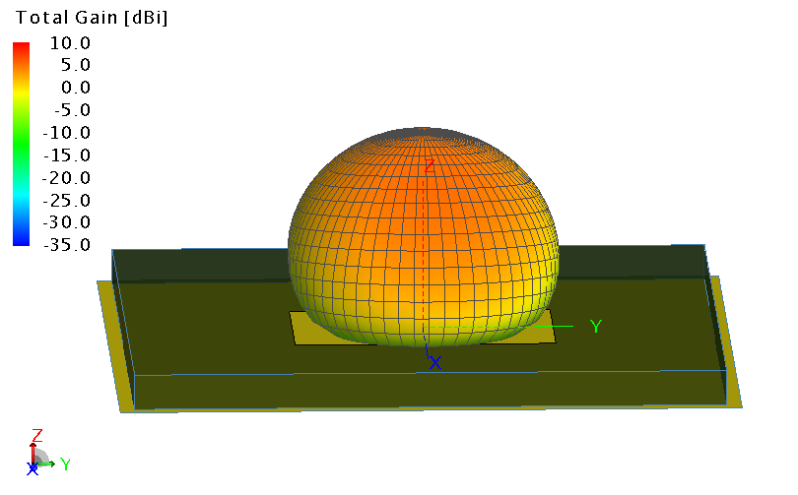
Figure 1: 3D Radiation Pattern

Figure 1 illustrates the 3D radiation pattern of the designed MPA. The pattern shows a predominantly hemispherical shape, indicating an omnidirectional radiation characteristic in the upper hemisphere. The gain is highest along the broadside direction (z-axis), where the colour transitions to orange and red shades, signifying regions of maximum radiation intensity. Gain levels in dB are shown by the colour bar on the left, which goes from -35 dB (deep blue) to +10 dB (bright red). According to this pattern, the antenna efficiently radiates energy upward, making it perfect for wide-area coverage applications like point-to-multipoint communication systems and radar. The symmetry and smooth gradient of the radiation confirm acceptable performance in terms of directional gain and uniform radiation across the main lobe.

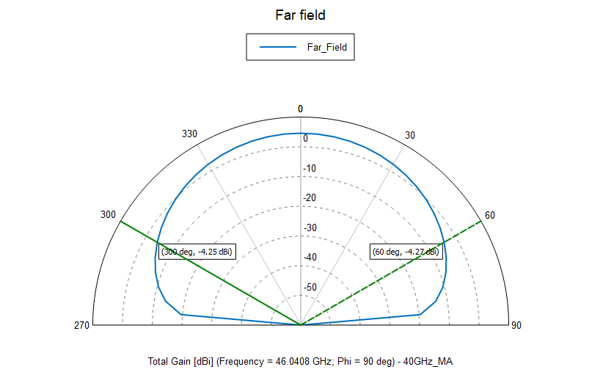
Figure 2: 2D Radiation Pattern

Figure 2 presents the 2D radiation pattern of the MPA at the resonant frequency. The plot demonstrates the angular distribution of the radiated power in a specific plane, typically the E-plane or H-plane. The pattern shows lobes at 60° and 300°, each with a gain of approximately 4.25 dB, indicating the radiation's highest direction. The symmetrical nature of the plot reflects the antenna’s good directional properties and stable beam orientation. Such radiation behaviour is desirable in wireless communications (especially 5G and radar), where targeted directional gain improves link quality and system performance [17].

Return Loss

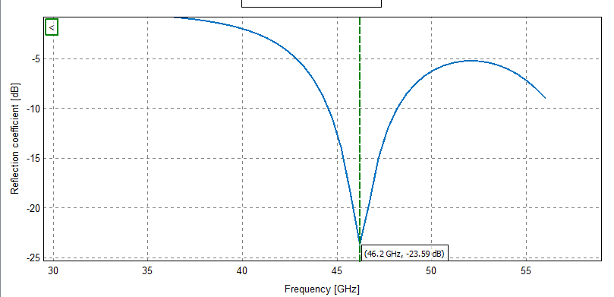
Figure 3: Return Loss

Figure 4.3 shows the antenna's return loss over a range of frequencies of 30 GHz to 55 GHz. A notable dip is observed at 46.2 GHz, where the return loss reaches -23.59 dB. This indicates excellent impedance matching at the resonant frequency, as values below -10 dB typically represent effective radiation with minimal signal reflection. The sharp and deep notch around the resonant point verifies that the antenna is adjusted properly for operation at this frequency. Such a performance is essential for systems that use high-frequency transmission like automotive radar and millimetre-wave 5G networks, where efficient power transfer is essential [19].

Voltage Standing Wave Ratio (VSWR)

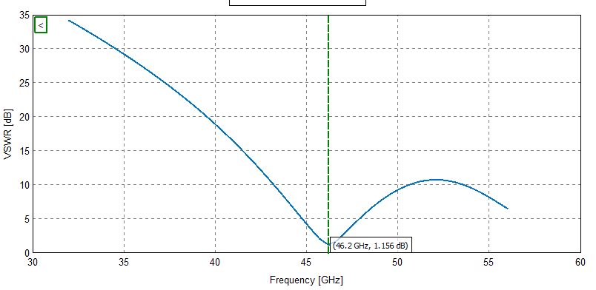
Figure 4: Voltage Standing Wave Ratio

Figure 4.4 shows that the VSWR curve reaches a minimum value of approximately 1.156 at 46.2 GHz, indicating a well-matched impedance at that frequency. This suggests efficient power transfer between the transmission line and the load.

Table 1: Antenna dimension obtained from design
Parameter | Value
Patch Length | 1.9268 mm
Patch Width | 2.5779 mm

Table 2: Measured vs. standard values of microstrip antenna parameters
Parameters | Researchers’ values | Standard values
Gain | 10 dB | 6–9 dB (typical), >8 dB (good)
Directivity | 9 dB | 6–10 dB
VSWR | 1.156 | ≤ 2.0 (preferably < 1.5)
Return Loss | -23.59 dB | ≤ -10 dB (preferably < -15 dB)

Table 3: Comparison of this study’s antenna performance with recent research works
Parameters | This work | [20] | [21] | [22]
Gain | 10 dB | 7.38 dB | 6.61 dB | 8.19 dB
Directivity | 9.5 dB | 8.09 dB | 6.99 dB | -
VSWR | 1.156 | 1.05 | 1.05 | 1.18
Return Loss | 23.59dB | −20.00dB | −31.19dB | −21.40dB

CONCLUSION
The design and simulation of a high frequency microstrip patch antenna presented in this study has been successful, with results showing high efficiency, minimal losses, and suitability for modern communication needs. By leveraging RT Duroid as a substrate, precise dimensioning, and the advanced capabilities of FEKO simulation software, the antenna was able to achieve performance characteristics that meet or exceed industry benchmarks.
The study demonstrated that a gain of 10 dB, return loss of −23.59 dB, and VSWR of 1.156 can be achieved at a frequency of 46.2 GHz, which confirms that the antenna is well-matched, radiates efficiently, and operates with minimal power reflection. These characteristics are particularly critical for millimetre-wave communication systems, where signal attenuation and impedance mismatch are common challenges.
The results from this work were benchmarked against standard values and those reported by other researchers. The comparison showed that the designed antenna performs better in several key parameters, establishing its viability and as such competitive candidate for practical deployment.
To sum up, this research offers a solid design that satisfies the demanding specifications of 5G wireless networks and advances the continuous creation of small, effective, and highly effective antenna systems. It also acts as a benchmark for upcoming research on antenna miniaturisation, performance improvement, and practical implementation.

References
- Mzeh, H. K., Salabi, L., Jafer, M. T., & Sikalu, T. C. (2022). “Fundamentals and Applications of Antenna Theory and Design Methodology.” National Journal of Antennas and Propagation, 4(2), 34-40.
- Tariqul Islam M., M.N. Shakib, N. Misran., and B. Yatim (2008). Analysis of L-Probe Fed Slotted Microstrip Patch Antenna, in Eleventh IEEE International Conference on Communication Systems (IEEE ICCS 2008), Guangzhou, China, November 19-21, pp. 380-383.
- He W., Jin R., and Geng J. (2008). E-Shape patch with wideband and circular polarization for millimeter-wave communication. IEEE Trans. Antennas Propag., vol. 56, no. 3, pp. 893-895.B. Smith, “An approach to graphs of linear forms (Unpublished work style),” unpublished.
- Lau K. L., Luk K. M., and Lee K. L. (2006). Design of a circularly-polarized vertical patch antenna. IEEE Trans. Antennas Propag., vol. 54, no. 4, pp. 1332-1335.J.
- Zhang Y. P. and Wang J. J. (2006). Theory and analysis of differentially driven microstrip antennas. IEEE Trans. Antennas Propag., vol. 54, no. 4, pp. 1092-1099
- Pozar D. M. and Schaubert D. H.. (1995) Microstrip antennas, the analysis and design of Microstrip antennas and arrays, New York: IEEE press
- Sun D. M. B., Song I. S., Choa S. H., I. S. Koh, Y. S. Lee, and J. G. Yook (2006). Package-Level integrated antennas based on LTCC technology. IEEE Trans. Antennas Propag., vol. 54, no. 8, pp. 2190-2197
- Yang F., Zhang X., Rahmat-Samii Y. (2001). Wide-band E-shaped patch antennas for wireless communication. IEEE Trans. Antennas Propag., vol. 49, pp. 1094-1100.
- Mak C. L., Luk K. M., Lee K. F., and Chow Y. L.. (2000). Experimental study of a microstrip patch antenna with an L-shaped probe, IEEE Trans. Antennas Propag., vol. AP-48, pp. 777–783.
- Khraisat Y. S. H. (2012). Design of 4 elements rectangular microstrip patch antenna with high gain for 2.4 GHz applications. Modern Applied Science, vol. 6, no. 1, p. 68, doi: 10.5539/mas.v6n1p68.
- Babu, C. V. S., Dasari, R., sagar, N. S., Sandeep, B., & prasad, C. B. (2024). Optimization of printed dipole antenna performance for wireless communication systems. International Research Journal of Engineering and Technology (IRJET), 11(4).
- Bajpai R. K., Paulus R., Singh A., and Aneesh M. (2018). Review: dual band microstrip antennas for wireless applications,’’ International Journal of Advances in Applied Sciences (IJAAS), vol. 7, no. 2, pp. 143-151, doi: 10.11591/ijaas.v7.i2.pp143-151.
- Kaur A. and Parkash D. (2017). Design of dual-band microstrip patch antenna with chair shape slot for wireless application. International Journal of Engineering Research & Technology, vol. 6, no. 4, pp. 728-731, doi: 10.17577/ijertv6is040570.
- Junnarkar, P. V., & Mengade, R. D. (2015). Communication with triangular microstrip patch antenna array. IJARIIE-ISSN(O)-2395-4396
- Attaran, M. (2021). The impact of 5G on the evolution of intelligent automation and industry digitization. Journal of Ambient Intelligence and Humanized Computing, pp. 1-17, doi:10.1007/s12652-020-02521-x.
- Ershadi S., Keshtkar A., Abdelrahman A. H., and Xin H. (2017). Wideband high gain antenna subarray for 5G applications. Progress in Electromagnetics Research C, vol. 78, pp. 33–46, doi: 10.2528/pierc17061301.
- Balanis, C. A. (2016). Antenna theory analysis and design. John Wiley & Sons.
- Bahl, J. J., & Bhartia, P. (1980). Microstrip antennas. Artech House.
- Pozar, D. M. (2012). Microwave engineering. John Wiley & Sons. Retrieved from https://www.scirp.org/reference/referencespapers?referenceid=1970397
- Ali, N. Q., Mohammed, A. J., ALRikabi, H. T. S., Aliwy, A. K., & Khazaal, H. F. (2024). Development and implementation of a 5.8 GHz microstrip patch antenna for autonomous vehicles and IoT in 5G systems. Journal of Applied Research and Technology, 22(6), 816–822.
- Barışer, B., Umakoğlu, İ., Namdar, M., & Başgümüş, A. (2024). Microstrip patch antenna design for 5G and beyond wireless communication systems. Journal of Scientific Reports-A, 058, 83–98. Reported gains ~6.61 dB; directivity ~6.99 dB; return loss −31.19 dB; VSWR ~1.05
- Zakariyya, S. O., Sadiq, B. O., Alao, R. A., Adesina, J. A., & Obi, E. (2024). Design of an improved microstrip antenna at 28 GHz. Preprint (CST simulations). Gain 8.19 dB; return loss −21.4 dB; VSWR 1.18

Ayuba E.J. was an undergraduate student with the Department of Physics, Federal University Wukari. He is now a graduate student with the Department of Physics, University of Uyo. (e-mail: emmanuelayuba41@gmail.com). Adeniran A.O. PhD. is a senior lecturer with the Department of Physics, University of Uyo (e-mail: adeniranadebayo@uniuyo.edu.ng).

