Patterns and Predictors of Cyber Delinquency among Minors in the Internet Era

Abstract
This research article delves deep in analysis of emerging patterns of internet related offenses committed by minors along with multi-dimensional aspects of internet society which has created a cyber-world. Our global world is continuously transforming with the everyday use of internet technologies which are playing significant role in transforming the human society. This change is multifaceted, driven by the advent of ‘Information and Communication Technologies (ICT) that was widely being used since 20th century and have rapidly advanced in the present era. ICT involves the digital transmission of data between various devices worldwide. “Information technology is the "the science and activity of moving data digitally. (Gutmann, 2001)” Emerging society is an "information society." (Castells & Gustavo, 2005) Internet technology and social media are the most prominent and revolutionary innovations, bringing remarkable changes to modern society creating cyber-cultures. In context of Indian society which is facing numerous modern challenges and issues and is evolving into a "risk society," as it transitions "from etiquettes to netiquettes, from school bullying to cyberbullying, from theft to cyber-fraud, multiple new aspects of deviance and crimes are evolving" The internet and social media have created a cyber-world through social networking, forming a network society where data is sensitive and precious
Internet and social media are now inalienable part of human lives, having both positive and negative impact on minors especially. Internet is the fastest and cheapest means through which data can be transmitted in real time at any place on globe but on the other hand, they also expose users especially minors to risks being a cyber-delinquent but also a victim of cyber-crimes. Since the evolution of human society crime has always been an integral part of human society, but with the expansion of the internet and social media, its patterns and methods are continuously evolving. Delinquency is now becoming cyber-delinquency with the involvement of internet technology. This study is based on qualitative analysis of Patterns and Predictors of Cyber Delinquencies committed by minors and how effects society it when committed by minors. This study relies on primary data being sourced from various stake-holders of judiciary, academia and member of civil society, students and victim of cyber-crimes while secondary data is sourced from NCRB and government records and official academic data from journals and books.

Keywords- Cyber-World, Cyber-Delinquency, Internet, Information Society, Cyber-crimes

Introduction
Information and communication technologies (ICT) that began in the 20th century and have rapidly advanced in the 21st century, alongside a global industrial revolution. ICT involves the digital transfer of information between various devices worldwide. Information technology is "the science and activity of moving data digitally. (Gutmann, 2001)” This emerging society is an "information society" or "knowledge society.( Castells & Gustavo,2005) " ICT is often used interchangeably with Information Technology (IT), though it specifically refers to the use of computer-based technology and the Internet to provide information and communication services to a broad audience. The terms IT and ICT are often used interchangeably in the context of modern technology infrastructure. “Information and Communication Technologies (ICTs) encompass all those technologies that enable the handling of data and facilitate different forms of communication between human beings and electronic systems.” (Hamelink, 1997) Information and Communication Technology (ICT) is synonymous with IT and sometimes used in preference to Information Technology (IT).In recent years, human society has gone through dynamic advancements in science and technology and innovations such as computers, mobile phones and the Internet have revolutionized human life. While technology cannot govern society, it plays a crucial role in shaping its direction. Society, in turn, moulds technology to meet its needs, values and interests. From etiquettes to netiquettes and from school bullying to cyberbullying, society faces new challenges and issues, evolving into what we call a "risk society." Internet and social media applications have created a virtual world through online networking, leading to the development of a cyber-world or cyber society. This technology is breaking down national boundaries and creating a cyberspace where users can engage in various activities and behaviours. Anonymity and remote access are some of the significant yet vulnerable features of internet and cyber-world. Social media’s role in shaping behaviour, particularly in adolescents is a serious concern”, as internet is becoming a new platform of socialization and learning, it develops stubbornness and arrogance among children, as here on social media children/youth can use fake identity which makes them anonymous(Gupta, 2020). Covid-19 pandemic made education on smartphones/laptops. “The shift to online education has affected students' stress levels and simultaneously created a difficult situation for parents to make their children away from internet” (Patel & Desai, 2022). Internet addiction also raised the concern of “overuse of online gaming which is creating aggressive tendencies among children.” (Sen & Joshi, 2019)
This cyber world has its own netiquettes and own behavioural patterns forming, ‘cyber-culture’ Internet era has revolutionized our lifestyles and communication methods. However, it has also introduced new challenges, particularly in the field of cyber security. Cyber-crimes have emerged as a major global concern and India is no exception. The National Crime Records Bureau (NCRB) collects and publishes data on various crimes, including cyber-crimes, in its annual “Crime in India” report. The 2024 report reveals a troubling rise in cyber-crimes across the nation. This study analyses the data provided by the NCRB, exploring the trends, types of cyber-crimes and their multi-faceted aspects. The primary data source is the NCRB’s annual report, which provides comprehensive statistics on cyber-crimes in India. The data is systematically grouped to identify patterns and categorize different types of cyber-crimes. Further, in order to understand the recent trends, the temporal trends are analysed to understand the increase or decrease in specific cyber-crimes over the years. Themes and patterns are identified through a detailed examination of the data, providing insights into the nature and characteristics of cyber-crimes in India.
Research Design
This study adopts a qualitative, exploratory research design to understand the emerging patterns and predictors of cyber delinquency among minors in the internet era. Given the sensitivity and hidden nature of online deviant behaviour by children, the research relies on snowball sampling, which allows access to respondents independently who are otherwise difficult to identify through conventional sampling. This approach helps trace individuals connected through professional, social, or institutional networks who possess relevant insights into juvenile cyber behaviour. To capture a holistic and nuanced understanding, the data were collected from respondents belonging to a diverse group viz. judiciary and law enforcement agencies, academicians, practising cyber-experts, technology professionals and individuals with experience in child protection systems under the framework of juvenile laws. Their perspectives are essential for interpreting how cyber delinquency is understood, managed and addressed within institutional and societal settings. A total of 97 respondents voluntarily participated by filling out structured questionnaire forms. Their responses provide rich, experience-based viewpoints on issues such as the rise of digital exposure among children, gaps in parental or institutional supervision and the challenges of applying existing juvenile justice provisions to virtual offences. Apart from respondent’s data, this work also relies on academic works, government data which is pertinent to our research question. This research adopts a qualitative thematic approach, allowing meaningful patterns, concern and perceptions to emerge from the narrative data. Through careful reading, coding and clustering of responses, the study draws connections between technological landscapes, behavioural tendencies of minors and the adequacy of current legal frameworks. This design ensures that the findings are grounded in lived experiences rather than abstract assumptions, offering a comprehensive understanding of the socio-legal dimensions of cyber delinquency. Overall, the research design enables a multidimensional exploration of an evolving issue that demands collective insight and policy attention.
Cyber Culture: A Global Trend
Culture is the sum total of both materialistic and non-materialistic aspects of human life. As to Herskovits, "culture is the man-made part of the environment”. The Internet has become an integral part of our lives, influencing us directly or indirectly. This cyber culture is being fostered and expanded by internet technology and social media platforms. Social Media has transformed from print to digital communication with the advent of the Internet. As the Internet's reach has expanded, so has cyber culture is expanding across the globe. Social media applications are key contributors to this cyber culture and the internet world. India, with its vast market for the internet and smartphones, has a large population that utilizes the internet in various ways. Norbert Wiener first used 'Cyber' as a prefix in 'Cybernetics' in 1948. Cyber culture can be understood as, "a collection of cultures and cultural products enabled by the Internet, along with the narratives about these cultures and products." Cyber culture as "a collection of cultures and cultural products that exist on and/or are made possible by the Internet, along with the stories told about these cultures and cultural products. (Silver, 2017)" According to the Merriam-Webster Dictionary, cyber culture refers to "a set of shared attitudes, practices and goals associated with the world of computers and the Internet.” "Cyber-culture is a blend of technology and culture through the concept of the cyborg, a fusion of machine and living organism. She argues that cyber culture challenges traditional views of feminism, identity and politics by blurring the lines between human and animal, natural and artificial and physical and non-physical.” (Haraway, 2010) "Cyber culture as the emerging global culture shaped by the convergence of computing, telecommunications and media technologies.”(Rheingold, 2000) Cyber culture also involves the use of the Internet and multimedia tools to create art, literature, music and more. It is linked to the electronic production of new ideas and behaviour patterns related to technological innovations. In essence, it encompasses the social expectations, etiquettes, practices, behaviours and languages used by people active on the World Wide Web or any digital platform powered by the Internet. Cyber culture has evolved from the relationship between internet technology, social media and digital interactions. As the Internet's reach has expanded, so have the boundaries of cyber culture, encompassing all of human society, directly or indirectly. This cyber culture is becoming an integral part of human lives, creating virtual groups or societies whose members may come from different sections of society, regardless of time and place. The Internet and social media have created a virtual world where people associate with different communities based on their tastes, choices and needs. This expanding cyber society is becoming a global cyber-world. Social media and the internet serve not only as communication mediums but also as platforms for entertainment, advertising and, unfortunately, deviant behaviours.
Everyone in this modern digital world has a significant connection to the cyber world, either directly or indirectly, constructed through the use of the Internet. Nowadays, Internet, smartphones and media applications are integral to human life. The presence and dominance of internet in the 21st century cannot be ignored. However, this internet culture often misleads children and youth, whose minds are not fully developed to understand its darker aspects. This cyber culture is making our children and youth addicted to the Internet and smartphones. Unguided and unrestricted use of internet can lead to addiction and when needs are not met, it can result in deviance. As per report from ‘statista’, there were one billion smartphone users in India earlier which was 659 million in 2022. Smartphones along with social media, specifically Instagram and YouTube are playing significant roles in enhancing the spread of culture by connecting people across the world digitally. This connection not includes transmit of good and healthy data nut also contains, explicit, wrong and many times porn and adult content too. Use of smartphones and social media are not only confined to urban or metro cities but from youth to children, teen to old age groups, etc. Over 90% of rural children in the 14-18 years' age group have a smartphone in their home (as compared to 73% in 2017) and are on social media, according to the Annual Status of Education Report (ASER) 2023 released in Jan 2024.

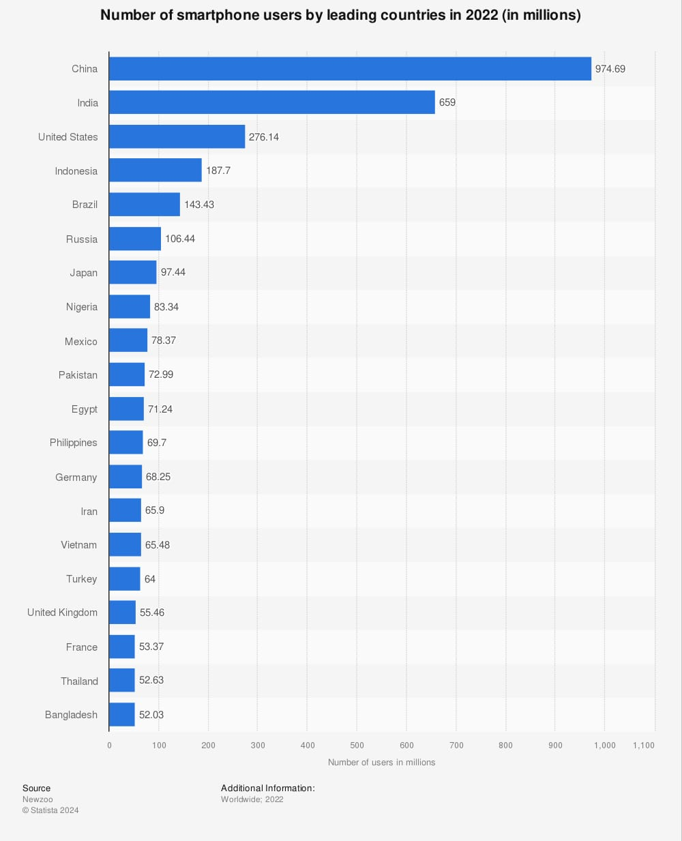
The internet world, often referred to as the ‘e-world’, encompasses all aspects and elements of the internet. Virtual world, or e-world/cyber world, also has its unique behavioural patterns and cultural practices, such as surfing and netiquettes. In any society or culture, individuals may engage in unacceptable behaviours or crimes to achieve certain goals or fulfil their desires. Similarly, in the cyber-world/cyberspace, the nature of deviant behaviour and crime also varies.
Patterns of Cyber Delinquency in India
Crime is an inseparable aspect of human society, affecting individuals regardless of age, education, or socioeconomic status. When minors commit crimes, the impact can be particularly detrimental, affecting entire generations. The term "cyber" refers to internet-enabled devices and tools, while "crime" denotes unlawful acts or behaviours that violate the law. Crimes committed using digital, internet, or computer platforms are classified as cyber-crimes. In cyber-crimes, it is not necessary for both the perpetrator and the victim to be online simultaneously. Further, when children (who has not completed 18 years of age) commits an offence or violates legal laws, then it is referred as delinquency. ‘Computer-related crime or “cyber-crime” or “e-crime” or “digital technology crime” is a long-established phenomenon, but the growth of global connectivity is inseparably tied to the development of contemporary cyber world. Any criminal activity that involves a computer either as an instrument, target or a means for perpetuating further crimes comes within the purview of cybercrime. A generalized definition of cyber-crime, be, “unlawful acts wherein the computer and internet is either a tool or target or both.” (Chawki, 2015)
In various settings such as schools, playgrounds and among peers, children often engage in bullying, which can be physical or verbal. Cyber-bullying involves using internet or cyber devices to harass or bully individuals or groups with the intent to cause social, psychological, or even physical harm. This can manifest in several ways, including abusive texts and emails, vulgar messages, morphed images or videos, online snubbing, public humiliation and malicious online gossip and chats. Cyberbullying can escalate into cyber-delinquency, causing significant harm to both the perpetrator and the victim. If not addressed, a cyber-bully may evolve into a cyber-delinquent. Cyber-bullying and cyber-stalking are initial steps that can lead to more severe cyber-criminal activities. Inadequate parenting, social coherence and family oversight can result in children (under 18 years of age) becoming cyber-delinquents or juvenile delinquents. The term "juvenile" is commonly used for minors who commit crimes, while "delinquency" refers to the criminal or bad behaviour exhibited by them. Cyber-bullying and cyber-stalking are among the most visible and common cyber-crimes, with school children, teenagers and women being the primary victims. If cyber-bullies or cyber-stalkers are not restrained or punished, they may progress to other cyber offenses. Juvenile cyber-crime is a harsh reality in India, often beginning with cyber-stalking or bullying. The exploitation, oppression and suppression of women remain significant issues globally and in the context of cyber-crime, women and girls are particularly vulnerable to victimization by cyber criminals. According to the National Crime Records Bureau (NCRB) of India, there were 50,035 cases of cyber-crimes in year 2020, while 52,974 cases in year 2021 and 65893 cases of cyber-crimes in year 2022 in India.
Cyber delinquency encompasses two main components: "cyber," which pertains to computers and the internet and "delinquency," which involves offenses or legally unacceptable actions committed by juveniles. The term "juvenile" originates from the Latin word "Juvenis," meaning young, while "delinquency" comes from the Latin word "delinquentia", signifying fault or crime. “A juvenile can be defined as a child who has not attained a certain age at which he can be held liable for his criminal acts like an adult person. There is a difference between the term Juvenile and Minor. Although in general, we use both the terms interchangeably but ‘juvenile’ and ‘minor’ in legal terms are used in different context. The term juvenile is used with reference to a young criminal offender and the term minor relates to legal capacity or majority of a person. Thus, Juvenile is a child who is alleged to have committed certain acts or omissions which are in violation of any law and are declared to be an offence. (Kohli & Mittal, 2015)” Further, “a boy or a girl is not a juvenile delinquent just because he commits a delinquent act. If so all boys and all, or practically all, girls would be delinquent. A delinquent is one who has been treated as such by society. He must be considered by the people in the community to be a delinquent. In other words, he must have an official record. (Burgess, 1952)” Juvenile delinquents are then those children who have official records as delinquent. They have completed one or more stages of the process by which a child becomes delinquent. They have been arrested by the police. Juvenile delinquency is a gateway to adult crime, as a significant percentage of criminal careers begin in childhood, causing serious problems globally.
Children are precious assets for any nation, it is really a matter of concern to address the juvenile delinquency. Parliament of India enacted the" Juvenile Justice Act,” 1986 which brought the uniform system throughout the country. Section 2(a) of the Act defined the term ‘juvenile’ as a “boy who has not attained the age of 16 years and a girl who has not attained the age of 18 years”. (Juvenile Justice Act, 1986, Govt. of India). Later on, the Govt. of India enacted the Juvenile Justice (Care and Protection) Act, 2000, “Juvenile” or “child” means a person who has not completed eighteenth year of age; “juvenile in conflict with law” means a juvenile who is alleged to have committed an offence” (Juvenile Justice Act, 2000, Govt. of India). The Juvenile Justice Act (JJ Act) was later amended in year 2015was finally published by the Government of India. “THE JUVENILE JUSTICE (CARE AND PROTECTION OF CHILDREN) ACT, 2015, NO. 2 OF 2016”. In case of a heinous offence (heinous offences includes the offences for which the minimum punishment under the Indian Penal Code or any other law for the time being in force is imprisonment for seven years or more) alleged to have been committed by a child, who has completed or is above the age of sixteen years, the Board shall conduct a preliminary assessment with regard to his mental physical capacity to commit such offence, ability to understand the consequences of the offence and the circumstances in which he allegedly committed the offence.” A juvenile can be defined as a child (child means a person who has not completed eighteen years of age; as per JJ act 2015, Govt. of India) who has not attained a certain age at which he can be held liable for his criminal acts like an adult person. There is a difference between the term Juvenile and Minor. Though in common language we use both the terms interchangeably but ‘juvenile’ and ‘minor’ in legal terms are used in different context. The term juvenile is used with reference to a young criminal offender and the term minor relates to legal capacity or majority of a person. Thus, Juvenile is a child who is alleged to have committed certain acts or omissions which are in violation of any law and are declared to be an offence. In India, anyone below or under 18years of age is treated as Juvenile, (“juvenile” means a child below the age of eighteen years , as per JJ Act 2015, Govt. of India) however, in case of heinous(heinous offences” includes the offences for which the minimum punishment under the Indian Penal Code or any other law for the time being in force is imprisonment for seven years or more; as per JJ Act 2015, Govt. of India) offences anyone who has completed 16 years of age will not be treated as a child/juvenile( subject to assessment of his/her mental social and physical capacity, as per JJ Act 2015, Govt. of India) Further, to make this act more efficient, ‘Juvenile Justice (Care and Protection of Children) Amendment Act, 2021' stands on the 2015 law by making child protection systems more efficient, accountable, transparent and sensitive to the needs of children. One of the key changes is a clearer definition of “serious offences,” which now covers crimes that carry a minimum of three years’ punishment and up to seven years. This helps close earlier gaps where certain offences did not fit neatly into existing categories. This Amendment also places greater responsibility on the District Magistrate, giving them the authority to issue adoption orders and oversee the functioning of Child Care Institutions. This shift aims to reduce delays, ensure better monitoring and create a more responsive administrative structure.
No one is a ‘born criminal’, their environment, socialization and challenging times shape individuals into such roles. Socio-economic and cultural conditions, both within the home and in the broader society, play a significant role in shaping a person's life and identity. The common factors associated with juvenile crimes include poverty, drug abuse, anti-social peer groups, abusive guardians, single-parent households, nuclear families, family violence, child sexual abuse and the influence of media. In India, poverty and the impact of media, especially social media, are particularly influential in driving adolescents towards criminal activities. Poverty is a major factor that compels juveniles to engage in criminal acts. Additionally, the role of social networking today has a more negative than positive impact on young minds. Delinquency has become a global social concern, present in all human societies. When minors use the internet or internet-enabled devices to commit unlawful acts, it is referred to as cyber delinquency. The dynamics of juvenile delinquency are intriguing to study analytically, as they help develop data and records about the changing patterns of behaviour and misbehaviour among children. These changes are influenced by the evolving social, economic, political and cultural patterns in human groups due to rapid industrialization, urbanization and widespread use of the internet and technology worldwide. There are significant variations in the socio-cultural, economic and psychological bases of juvenile delinquency across different societies. In third world countries, the situation differs from that in developed nations due to multiple reasons, including legal issues and socio-economic and cultural factors. In India, the absence of laws regarding the legal age for internet use is a major factor contributing to the misuse of the internet and social media. To understand the society’s perception, stake holders of judiciary and law enforcement, academicians, cyber-experts and professionals etc. were also questioned to know the issues, concerns and perceptions of cyber-culture, juvenile delinquency in the society with the frame-work of Juvenile laws. For the same, 97 respondents replied through questionnaire forms.

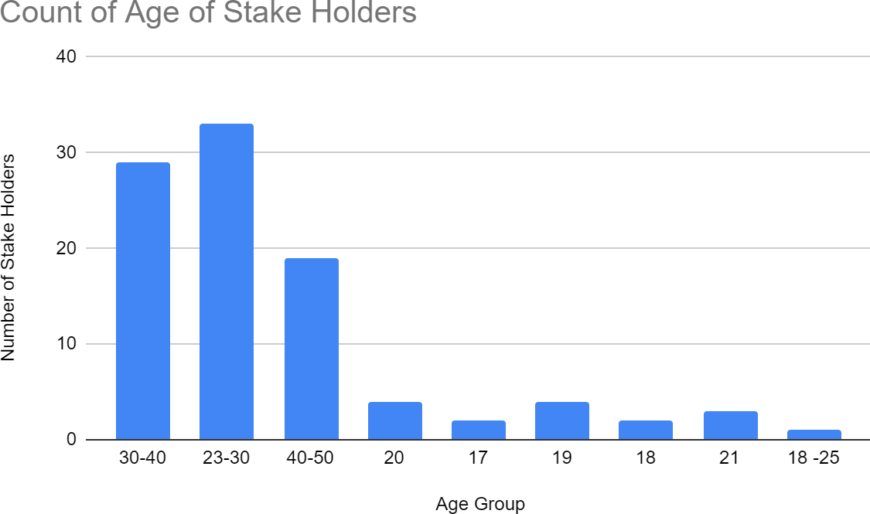

Fig. 1
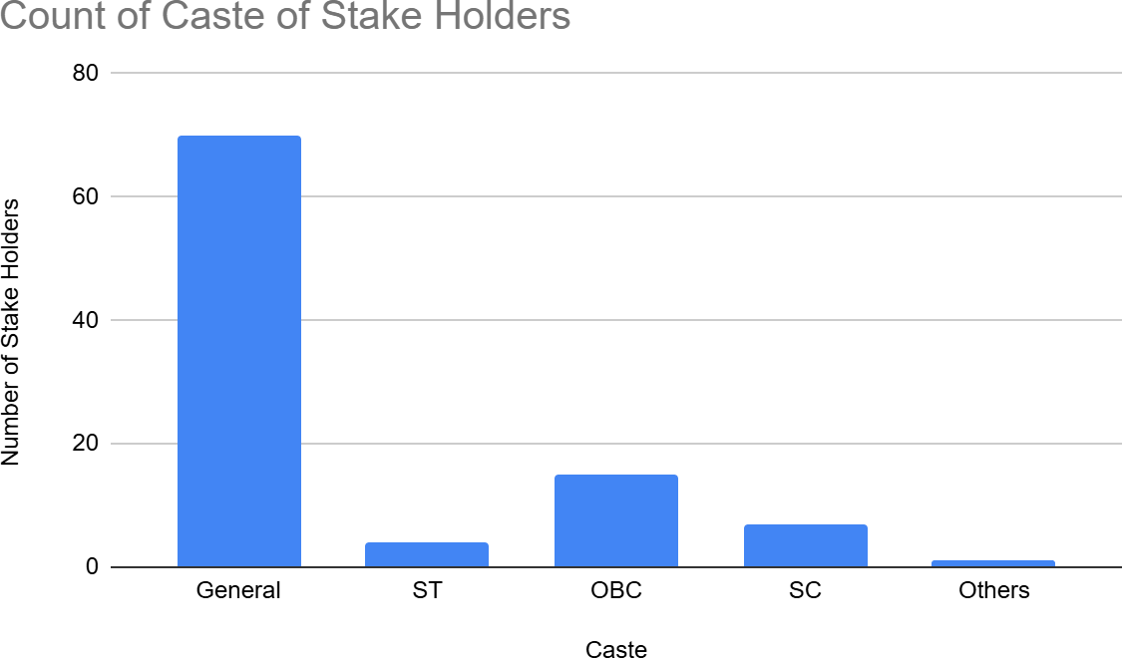
The above graph shows the age group of stake holders

Fig. 2
The above graph shows the caste category of stake holders
Out of 97, respondents, 70(72.2%) of stake holders belongs to general category while 15(15.5%) belongs to OBC category and 7(7.2%) were from SC category.

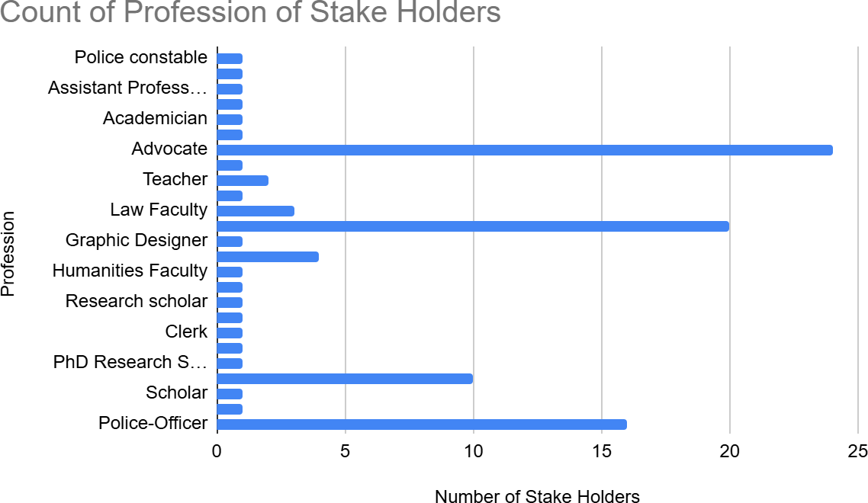

Fig. 3
The above graph is showing the profession of stake holders

Out of 97 respondents, 24(24.7%) were advocates, further 20(20.6%) were law students and 16(16.5%) were police officers, further it also includes professors, cyber professionals and one former magistrate of Juvenile Court and one magistrate.
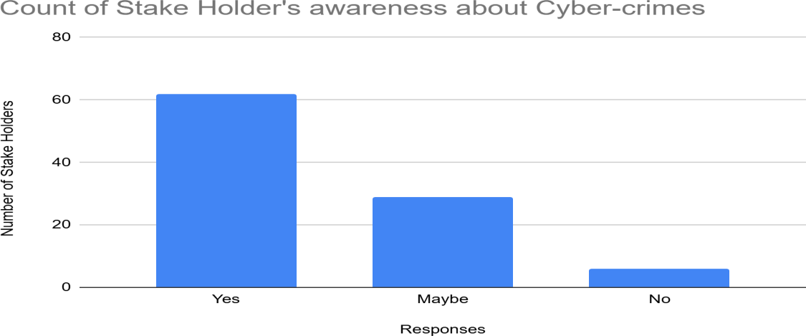
Fig. 4
The above graph represents the stake holder’s awareness about cyber-crimes
Out of 97 stake holders, 62(63.9%) respondents said that they are fully aware about cyber- crimes while 29(29.9%) respondents said that they are not fully aware about cyber-crimes.

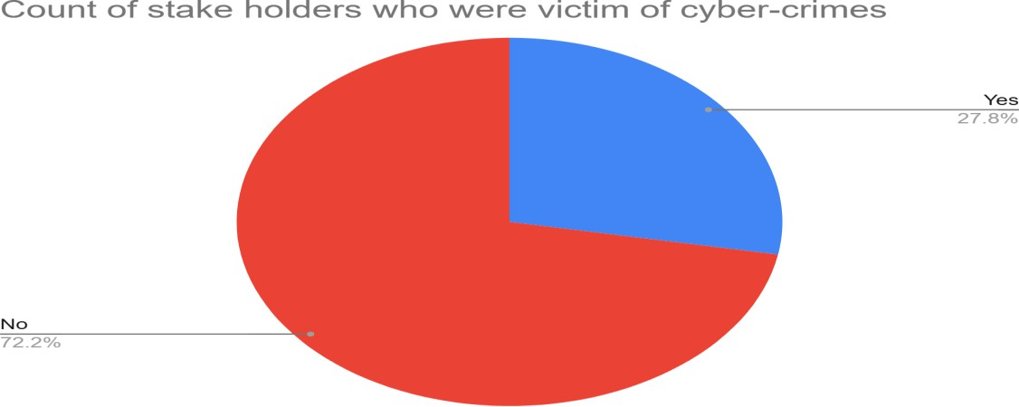

Fig. 5
The above representation shows the percentage of stake holders who were ever be the victim of cyber crimes
Out of 97 stakeholders, 27 (27.8%) respondents said that they were victims of cyber-crimes.

.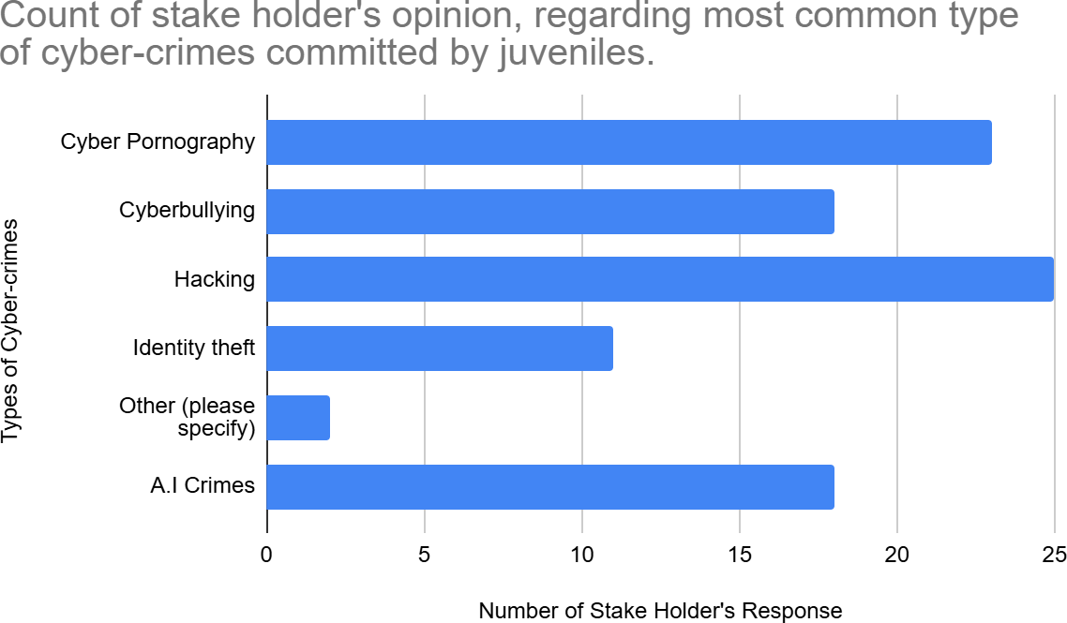

Fig. 6
The above graph represents the types of cyber-crimes committed by juveniles

Among 97 stake holders, 25(25.8%) respondents opined that juvenile mostly engaged in hacking of social media accounts, then 23(23.7%) respondents opined that mostly juveniles engaged in cyber-pornography and 18(18.6%) stake holders said that mostly juveniles engaged in cyber-bullying.

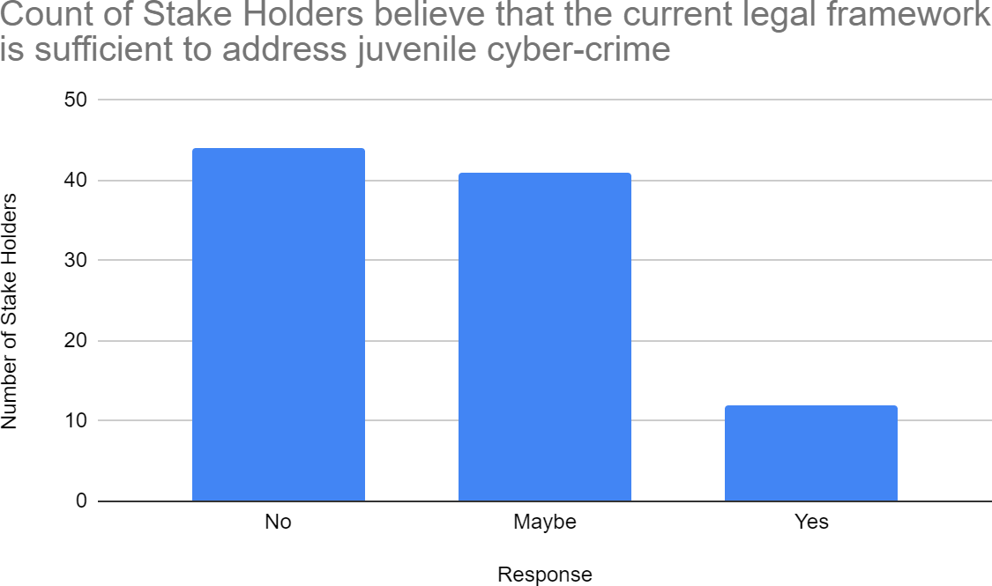
Fig. 7
The above graph is showing stake holders response regarding their opinion for current legal system for juveniles committing cyber-crimes

Out of 97 stake holders, 44(45.4%) stake holders opined that current legal framework is not enough sufficient to tackle the juvenile cyber delinquency while 41(42.3%) respondents were not sure as they said sometimes system acts in effective manner but many times it doesn’t.

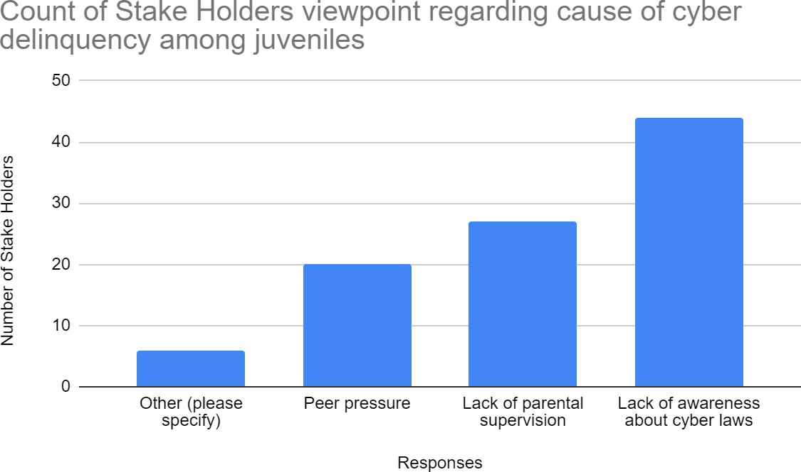
Fig. 8
The above graph shows the response of stake holders regarding cause of Juvenile cyber delinquency

Out of 97 stake holders,44(45.4%) respondents believes that due to lack of awareness about cyber laws is one of the main causes behind juvenile cyber delinquency, however, 27(27.8%) respondents believes that due to lack of parental supervision it is happening.
However, 20(20.6%) said due to peer pressure of performance and in order to prove themselves that they are better and more active sometimes juveniles commit these offences.

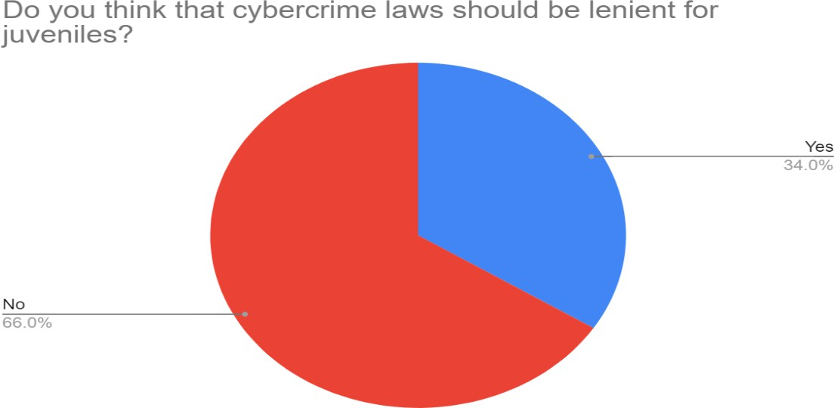

Fig. 9
The above chart shows the stake holders viewpoint regarding leniency in cyber-crime laws for juveniles.

Out of 97 respondents,64(66%) stake holders believes that cyber-crime laws for juveniles shouldn’t be lenient for juveniles, as it may lead to more offences.
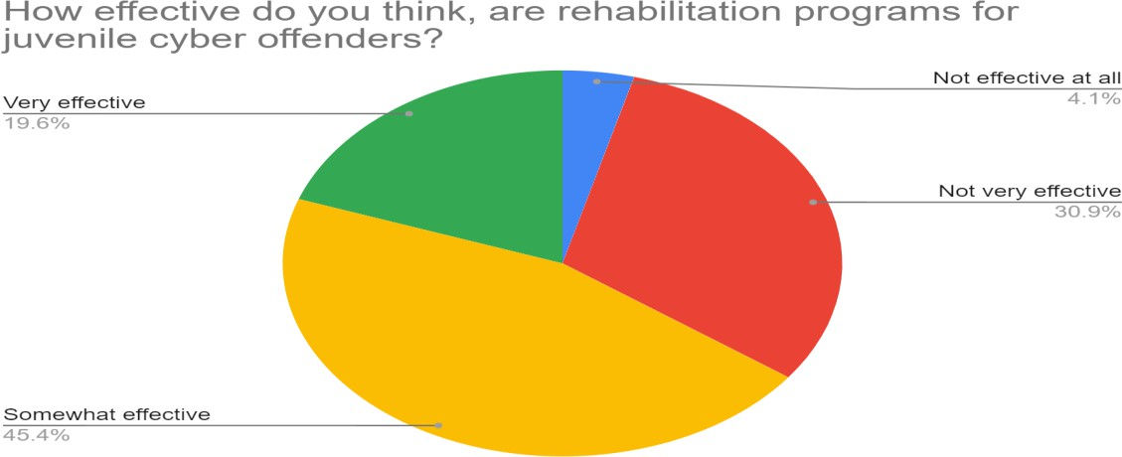

Fig. 10
The above graph shows the stake holders viewpoint regarding rehabilitation programs for Juveniles

Out of 97 stake holders, 44(45.4%) respondents believes that rehabilitation programs for juveniles are effective and can bring change up to a small level, while 30(30.9%) respondents believes that they are not effective at any level.
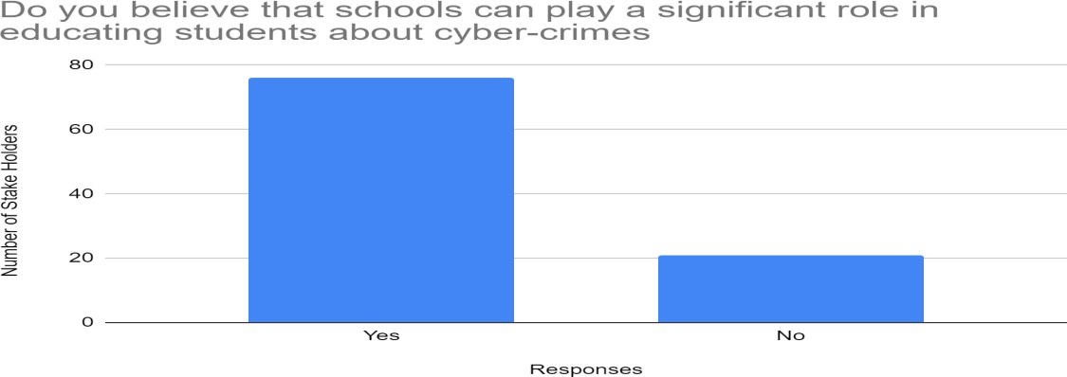

Fig. 11
The above graph shows the stake holders viewpoint regarding role of schools in educating children about cyber-crimes and cyber laws

Out of 97 respondents,76(78.4%) respondents believes that schools can play a vital role in educating children about cyber laws and can play a crucial role in restraining the delinquency among children.
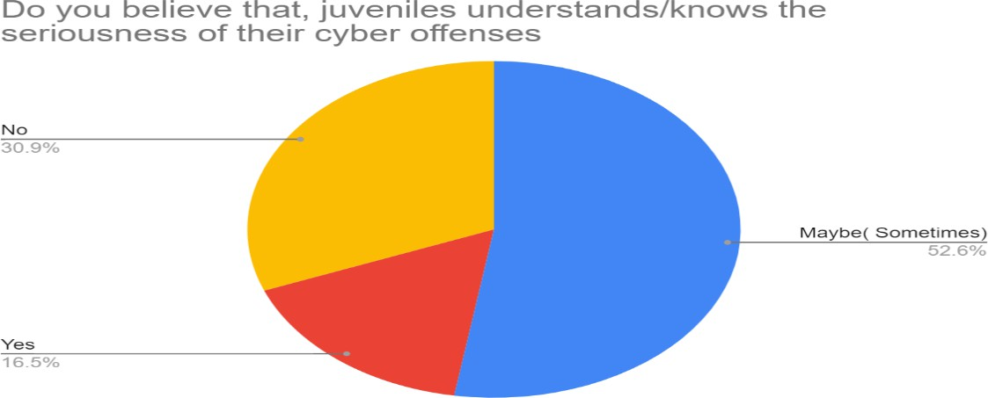

Fig. 12
The above graph shows the stake holders response regarding awareness among juveniles for the offences they are committing

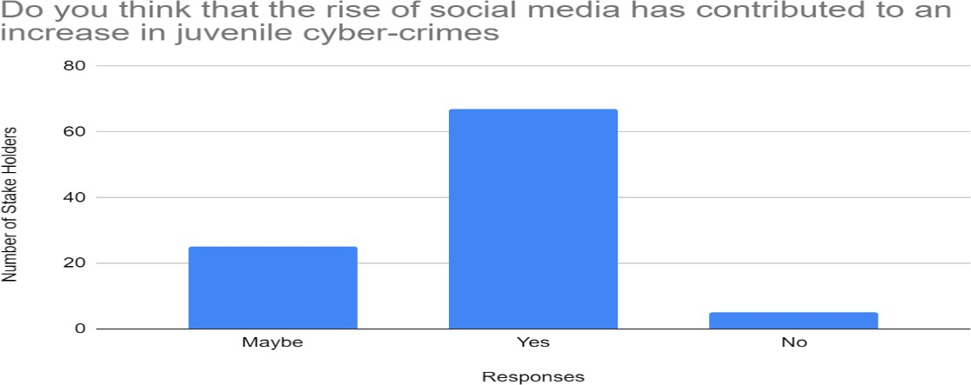
Out of 97 stake holders, 30(30.9%) respondents believes that juveniles were not aware about seriousness and impact of delinquency which they are committing, however 51 (52.6%) stake holders opined that sometimes they are aware about the delinquency and its impact which they are committing but they were not aware fully.

Fig. 13
The above graph shows the opinion of stake holders regarding role of social media in increase in juvenile cyber-crimes.

Out of 97 stake holders, 67(69.1%) respondents opined that due to rise in number of social media applications there is increase in cyber-crimes committed by juveniles, however, 25(25.8%) said that it may be or sometimes it causes rises in cyber-crimes committed by juveniles.

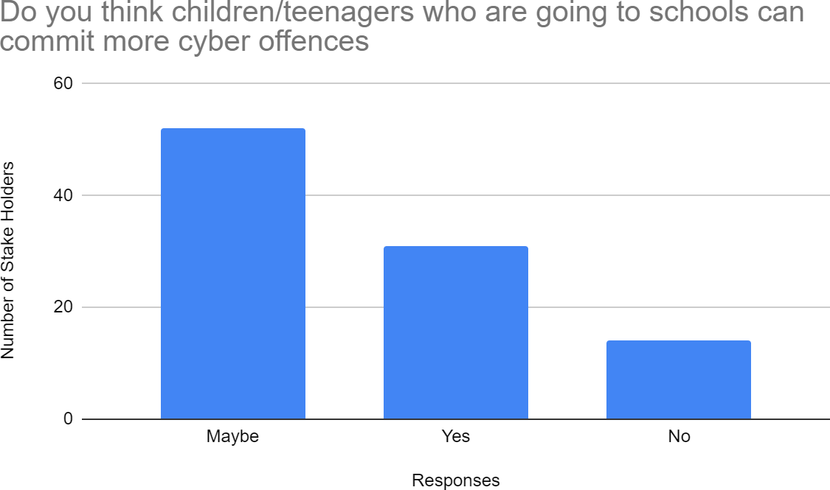
Fig. 14
The above graph shows the stake holders view point regarding cyber offences committed by school going children

Out of 97 stake holders, 31(32%) respondents opined that school going children commits more offences, while 52(53.6%) stake holders opined that may be sometimes school going children commits more offences than other children.

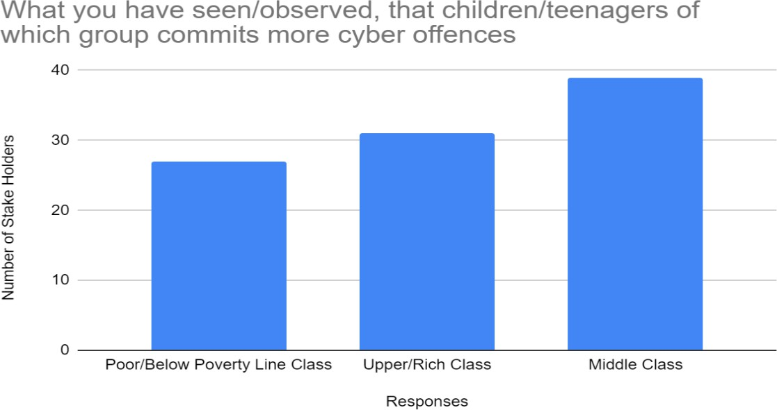

Fig. 15
The above graph shows the responses from stake holders regarding financial group of juveniles who commits cyber offences
Out of 97 stake holders, 39(40.2%) respondents opined that mostly middle-class children commit more cyber offences, however, 31(32%) respondents believes that children belonging to rich class or upper income group commits more cyber offences whereas 27(27.8%) respondents opined that mostly poor class children commit cyber offences. Strong surveillance and strict internet security protocols must be there in order to curtail the cyber-offences and to provide a clean and safe environment to our children and youth. Cyber-security is an urgent need of hour, as in nation like India, where internet is not only a source of communication, but also used for knowledge sharing, data transmission, data storage, entertainment and also a platform for generating income via multiple businesses. Since, Covid-19 human activities are changed significantly especially in education and corporate sectors. Nowadays smartphones and internet are becoming an integral part of school and university education, where many children are highly prone to be a victim as well as culprit of cyber offences. Data from NCRB shared in Rajya Sabha on dated 24-11-2024 shows a significant high rise in cyber-crimes in India.
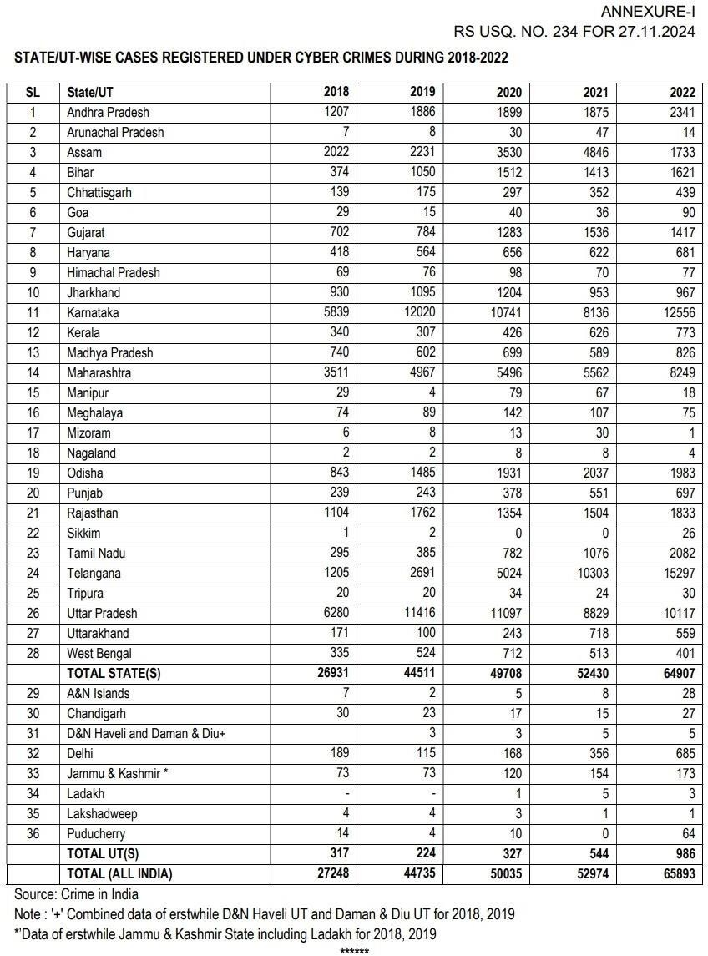

Conclusion and Suggestions
This analytical study underscores how deeply the internet has become embedded in the daily routines of minors, influencing the ways they learn, communicate and behave with the world. Yet this digital integration also brings a parallel rise in behaviours associated with cyber-delinquency. A major pattern emerging from the analysis is the persistent disconnect between legislative intent and practical implementation with public awareness. Although statutory frameworks such as the Juvenile Justice (Care and Protection of Children) Amendment Act, 2021 aim to safeguard children online, their effectiveness is weakened by limited enforcement capacity and the rapid evolution of digital risks. Children and adolescents increasingly rely on digital platforms for learning, entertainment and social interaction, yet their exposure to unregulated online spaces raises concerns about what they consume, how they interpret it and the behavioural patterns emerging from such engagement. In a rapidly transforming nation like India, where digital access is expanding faster than social awareness and institutional readiness, these concerns become even more pronounced. The proliferation of adult and illicit harmful material, including deep-fakes, reflects a technological pace that outstrips existing regulatory and protective mechanisms.
The findings also highlight that minors often become involved in harmful online activities unintentionally. Algorithm-driven content, unsolicited downloads and exposure to explicit material blur the distinction between deliberate digital misconduct and accidental encounters. Study indicates that a steady rise in cyberbullying, stalking, phishing and exposure to explicit content, all of which adversely influence young users. The social tendency to overlook minor online misbehaviours at their early stages allows them to escalate, eventually contributing to more serious forms of cyber delinquency. Socio-economic and environmental conditions further shape these vulnerabilities: excessive screen time, unregulated social media engagement, addictive gaming contexts and disrupted sleep cycles contribute to emotional strain and social withdrawal, which, in turn, heighten susceptibility to risky online behaviours. These risks are compounded by limited parental digital literacy and weak supervision practices.
Institutional limitations are another significant concern. Inadequate forensic technologies, understaffed cyber-crime units and the complexity of cross-border digital offences hamper timely detection and intervention. The study recommends strengthening child-focused cyber legislation, improving operational capacities within enforcement agencies and promoting collaboration between digital platforms and regulatory bodies. Indian society needs a strong cyber surveillance and cybersecurity mechanism to protect the digital environment. Integrating digital literacy into school curricula, conducting regular awareness programmes for parents and ensuring accessible mental-health support for minors are essential steps. . Legal and institutional frameworks must adopt proactive and child-centred approaches, while community-based monitoring and awareness campaigns can strengthen collective responsibility. Ensuring a safer digital ecosystem requires coordinated efforts across families, educational institutions and policy bodies to guide minors toward responsible and ethical online behaviour. Together, these measures can help cultivate a safer, more resilient digital environment for children.

References
- Burgess, W.E 1952, ‘The Economic Factor in Juvenile Delinquency’, Journal of Criminal Law and Criminology, vol. 43, (issue.1) p.29.
- Castells, Manuel (ed) & Cardoso, Gustavo 2005, ‘The Network Society: From Knowledge to Policy’, Washington, DC: Johns Hopkins Center for Transatlantic Relations, p. 4.
- Chawki, Mohamed, Darwish, Ashraf, Ayoub Khan, Mohammad & Tyagi, Sapna 2015, ‘Cybercrime, Digital Forensics and Jurisdiction’, Springer, Switzerland, vol.593, p. 3.
- Gupta, S. (2020). Social media exposure and self-esteem in Indian teenagers. Cyberpsychology Journal, 45(1), 101-115
- Gutmann Michael, Spring 2001, ‘Information Technology and Society’, Swiss Federal Institute of Technology Zurich, p.1 (accessed at 4:40 PM IST, 25th January 2026, https://www.zurich.ibm.com/pdf/news/Gutmann.pdf)
- Hamelink, C. J 1997, ‘New information and communication technologies, social development and cultural change’, URISD Discussion Paper; No. 86, p.3.
- Haraway, D. (2010). A Cyborg Manifesto [1985]. Cultural theory: An Anthology, 454
- Kohli, Rajni & Mittal, Kunjana 2015, ‘Juvenile Delinquency in India’ Research Gate. (accessed at 8:20 PM IST, 20th February 2026, https://courseware.cutm.ac.in/wpcontent/uploads/2022/01/juveniledeliquency.pdf)
- NCRB,2022, ‘Crime in India 2021 Statistics’, National Crime Records Bureau, Ministry of Home Affairs, India, vol.1, 5A.1.
- Patel, V., & Desai, M. (2022). E-learning and cognitive stress among Indian students. Educational Psychology Review, 50(3), 230-245
- Sen, B., & Joshi, A. (2019). Video gaming and aggression among Indian adolescents. Behavioral Studies, 27(3), 85-110
- Silver, D. (2004). Internet/cyberculture/digital culture/new media/fill-in-the-blank studies. New media & society, 6(1), 55-64

