A Comparative analysis for Multi-dimensional Fake Influencer Detection using AI

ABSTRACT
This paper will suggest a systematic and interpretable machine learning model to identify fake influencers on Instagram with respect to engagement-based behavioural features. A leakage-safe labelling plan, which incorporates the ratio between the likes and the followers will guarantee that the classification will be balanced and fair without feature leakage. Supervised models such as the Logistic Regression, Random Forest and Gradient Boosting are done together with DBSCAN to detect anomalies through unsupervised methods. In addition to predictive accuracy, the framework also incorporates SHAP (Shapley Additive Explanations) to give the feature attribution analysis as a transparent and mathematically justified one. Contrary to previous black-box models, our system also describes clearly both the global feature influence, as well as the local decision behaviour. SHAP visualizations confirm the nonlinear modelling dominance of Gradient Boosting and show that it is representation of engagement (not follower magnitude specified) that predicts authenticity. The hybrid decision layer involving supervised classification, density-based anomaly detection and explainable AI increase trust, interpretability, and deployment reliability of influencer fraud detection systems.
Keywords: Fake Influencer Detection, Social Media, Analytics, Gradient Boosting, Random Forest, Logistic Regression, DBSCAN, and Density-based Clustering, Engagement ratio, Outlier Detection, Machine Learning Classification
INTRODUCTION
Influencer marketing has been one of the key focuses of the online marketing campaigns where the concept of authenticity is believed to directly influence the brand trust and interaction with the customers. Research indicates that the credibility of an influencer can be quite influential in the construction of brand authenticity and buying behaviour and in the advent of AI-driven virtual influencers, we have new dimensions of engagement measurement. Nonetheless, with the increasing follower numbers manipulation and artificial boost of engagement numbers, the domain of false or artificially-hyped influencer accounts has grown. Previously developed researches include fake social network account detection using a machine learning model and ensemble-based methods and reviews and have demonstrated effectiveness of supervised-model, and feature engineering methods for profile identification. Even with these advancements, majority of such studies are prone to labelled data or behaviour traces of a specific platform that can test the generalization of the situation of influencer-based evaluations. This implies that such a complex computational framework is required in the determination of the authenticity of influencers, whose engagement pointers, quantified and comparative modelling approaches guarantee authenticity.
Explainability is one of the most crucial concerns of fraud detection systems since automated classification decisions have a direct effect on marketing investments and brand partnerships. Lack of interpretability in a black-box prediction can lead to decreased trust by stakeholders particularly in claiming accounts of high profile as fraudulent. Transparency is not a choice but a must in such a high stakes decision environment like in influencer marketing. Explainable AI models like SHAP have global and local interpretability and allow auditors to follow the path of each engagement aspect to authenticity prediction. This makes sure that the outputs of models are not arbitrary but they are backed by quantifiable evidence. The use of interpretability in influencer fraud detection allows strengthening accountability, minimizing deployment risk, and matching the framework with the ethical aspects of AI. Thus, the given research is based not just on predictive performance, but the mechanisms of explainability are also considered to provoke model transparency and excellent readiness of adoption.
The latest works on fraud detection reveal that ensemble models like the Random Forest and Gradient Boosting are effective in identifying nonlinear behavioural patterns and offer more stable predictions. Ensemble-based methods to the detection task have also been applied in the framework of social media, and have provided very good results in terms of classification in the event that the features that depend on the are well-engineered. Moreover, cost-sensitive learning and multidimensional analytics models can also enhance the robustness in the classification tasks in the real-world limitations. Based on the findings above, the influencer authenticity can be transformed into a supervised classification task by engaging the assistance of the signals based on the engagement. With the aid of stratified validation and cross validation analysis and overfitting diagnosis, supervised models may be compared rigorously on the basis of accuracy and performance metrics at a macro-level. Such systematic examination will guarantee transparency and reliability as well as identify the most discriminative indices of engagement in the authenticity evaluation.
In addition to the supervised methods, unsupervised methods of detecting anomalies have corresponding benefits as well since even though they do not synthesize labels of what is dangerous or suspicious, they find suspicious accounts. This is particularly true with density-based clustering schemes that are applicable in finding irregularities and noise in engagement distributions. Disagreements with centroid-based clustering algorithms: Compared to centroid-based clustering algorithms, density-based models can automatically detect outliers and they can support arbitrary shapes of clusters. Through inclusion of preprocessing steps, such as the log and feature scaling approaches, one can optimize the clustering performance and also measure performance through the assistance of silhouette and adjusted Rand. The integration of the monitored classification and the density-based possibilities of finding the anomalies in such a way purports a full-scale adaptability to the influencer authenticity examination. This mixed method assists to enhance trust assessment in online campaigns and aligns with the rest of the research by applying machine learning to identify fraud.
LITERATURE REVIEW
Influencer Marketing and the Authenticity of a Brand
Influencer marketing has emerged as one of the powerful tools of online marketing that delivers a strong impact on the perception of brands and the degree to which consumers trust them. The credibility of influencers is directly reflected in authenticity of the brand and purchase behaviour in the online campaign in research. Along with the development of AI-controlled virtual influencers, certain new factors such as the participation of artificial agents and the use of algorithms to customize the delivery of the content come into the fragment of authenticity evaluation. Nevertheless, the commercialization of the development of social media have turned the figure of a counterfeit following as well as the inflated engagement measurements into an even more widespread occurrence. This shift comes with a challenge that marketers have to face on the way of differentiating actual influence and enforced popularity on the basis of those quantifiable engagement models of analysis rather than on the subjective models of brand perception.
Machine Learning Algorithms to Detect a Space-Time Trend of a Proposed Spam Profile
Incorporating supervised machine learning models into detecting the fake development of social networks has been extensively studied. The initial strategies relied on the behaviour traits and patterns of activity when in the recent method approaches techniques founded on ensemble learning were exploited to have an enhanced predictive accuracy. Surveys of the fake profile detection methods prove the methods based on feature engineering and classification frameworks are rather effective in the fake online identity detection. The ensemble-based models particularly those that have decision trees, can be characterized by the strength against noisy and non-linear distributions of data. Through these studies, we may come to the conclusion that systematic preprocessing, feature extraction and validation methodologies are the significant factors in the creation of an efficient and expanded fake profile detection model.
Fraud Detection Models and Ensemble Learning Models
Random Forest and Gradient Boosting are also Ensemble Learning Models that are popular in the field of fraud detection research where the model is used to describe complex nonlinear relationship. Ensemble based fake profile detection has demonstrated outstanding results in classification and enhanced stability of the generalization in the context of social media analysis. An added benefit to reliability of detection also comes by use of cost sensitive learning strategies and optimized feature selection methods. These innovations are based upon the requirement of structured validation and cross validation variance examination and interpretability on the user part when implementing ML systems. The ensemble techniques are thus an excellent trade-off between predictive ability and model transparency.
Systems of Multi-Dimensional Detection and Adaptation
New studies have paid attention to multi-dimensional analytics systems which integrate both engagement metrics and behavioural characteristics and structural measures in attempts to enhance the detection of malicious profiles. These frameworks recommend full preprocessing in addition to adjust initiative project forms to counteract of fraud structures. Relative fields in combination with adaptive drift detection processes has resulted into increased better fraud observation systems in a dynamic data environment. The study creates a sense of requirement of scalable and adaptable detection architectures that will be able to address the distributional shift in the social media engagement data. Multi-dimensional signal incorporation it does is the enhancement of the strength of a model and allows a more valid process of authenticating the signals.
Density-Based Clustering: Clustering Detection
In addition to the classification of supervision, the use of unsupervised forms of learning has been shown referring to the art of unsupervised learning employing unlabelled data. Clustering algorithms based on density are well applicable to detection of irregularities in engagement and extreme cases in skewed data of social media. Density-based clustering methods unlike the centroid based clustering methods can automatically compute cluster structures and can also isolate noise points. This kind of approach assists in complementing the supervised classifiers in that it points out the suspicious accounts that would not be within the engagement patterns of involvement. Combining the density-based clustering with ensemble classification models is an end-to-end framework of the detection system that enhances the authenticity validation and to facilitate the scalable systems of influencer fraud detection.
PROPOSED METHODOLOGY
Figure 1. Model Architecture
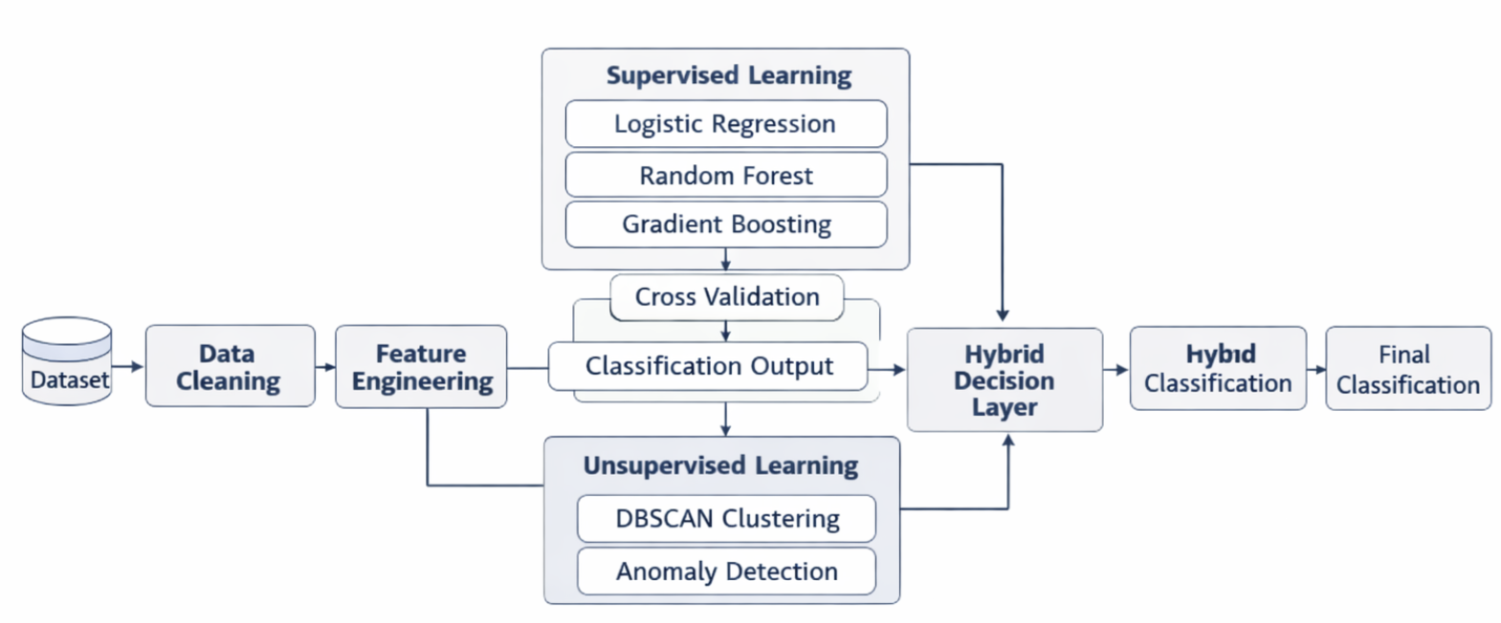
Acquiring and Preprocessing Data
The suggested methodology begins with the organized data collection of a processed set of influencers with numerical characteristics of engagements. The selected features are followers, total posts, average likes and new post average likes. Textual shorthand values like m and k are transformed to absolute numeric values so as to make computations. The fields which are concerned with the interest of the engagement have the percentage symbols stripped and turned into the floating-point format. Lacking values are matched with row equations abolition of vital attributes and set in place with zero values in reasonable circumstances. It is the preprocessing stage during which the process becomes numerically stable and the inconsistencies in the formatting is removed as well as preparation of the process is also done to fit in the unsupervised and supervised pipelines of learning without producing any leakages and possibly bias.
Engagement Ratio Used to Construct the Label
A leakage safe labelling mechanism is suggested to offer a supervised classification solution that gets rid of any ground truth dependency. The like to follower ratio is computed by dividing the average likes by the total number of followers to the account. A median in this ratio distribution is considered as a threshold and involves awarding balanced binary labels. The accounts that feature ratios equal or higher to the median will be considered a genuine account and be below the median considered a potentially fake account. This method offers a balance in classes and is not used to take fields that record the rate of engagement with a threat of leakage. The acquired labels can be used to evaluate the performance of the classification on a constant basis and provide transparency in the methods.
Distributed System Training and Supervised learning
The learner to be used is the Logistic Regression classifier, Random Forest, and Gradient Boosting. A stratified train-test split of 75:25 was utilized, thus, there is equal representation of classes. In measuring stability and generalization ability, fivefold stratified cross-validation is done on the training set. Hyperparameters will be configured to prevent overfitting such as maximum tree depth, number of estimators, subsampling ratio, minimum leaf size etc. Evaluation of performance will be done based on accuracy, precision, recall, macro-F1 score and confusion matrix analysis. Overfitting diagnostic is done by comparing cross-validation mean accuracy, with the test accuracy which assures that the deployment of the models to predict the authenticity of the influencers is reliable.
Selecting Density-based Unsupervised Clustering
A density-based clustering strategy is added as a supplement to the part that is supervised and classifies, DBSCAN. Because the distribution of the engagement features is highly skewed, the log transformation will be applied to compress the magnitude of variance. Standard scaling is undertaken to make the range of features to be of normal range. The Measure of Manhattan distance is selected to ensure the measure is not that sensitive to the extremity values. Mathematical analysis of epsilon and sample parameters has yielded the optimal epsilon and minimum sample parameters. The nearest centroid in the cluster is assigned noise points which have been identified by DBSCAN as the purpose of analyzing the alignment. The clusters are analyzed based on their quality measurements, which are silhouette score and an adjusted Rand index to determine how similar the derived labels were to the agreement to engagement.
SHAP-based Interpretability and Feature Importance
SHAP (SHapley Additive exPlanations) handles model interpretability suggesting both global and local feature attribution based on cooperative game theory. Although the scores of the feature importance are inherently calculated by Random Forest and Gradient Boosting, they do not adequately address the nonlinear interactions on their own. Thus, SHAP is used to calculate the values of mean absolute contributions in all predictions, which creates a clear hierarchy of the influence of engagement features. The SHAP model describes the changes in model output by each feature of a genuine or a fake classification. The strategy confirms the leakage safe labeling strategy by showing that the predictive decision is made mainly by engagement-based indicators, not by the raw popularity indicators. Besides, SHAP local explanations enable auditing of single accounts, which provides a break-down of features by contribution. This will prevent the system being a black-box classifier but rather a transparent decision support framework applicable in a real-life context in influencer frauds.
Decision Strategy and Evaluation Hybrid
The last phase represents a combination of density-based anomaly detection and supervised classification in order to come up with a hybrid binding authenticity assessment system. High confidence prediction of influencer classification is by the use of supervised models; however, DBSCAN is utilized to discover anomalous or suspicious engagement structures that fall outside and this cannot be predicted based on parametric limits. The strengths of cross validation stability, test accuracy, macro F1 score, silhouette coefficient and adjusted Rand Index are used as a comparative evaluation. The potentially abnormal accounts are detected with the help of noise detection rates. This combination strategy enhances strength as it introduces predictive accuracy and sensitivity to anomalies that increases the degree of authenticity verification and scaling fraud detection to the digital marketing systems.
Algorithm Description
- Step: Load the processed dataset of influencers which includes the fields followers, posts, average likes, new post average likes, and engagement-related fields.
- Step: Transform the shorthand words of numerical expressions like m (millions), and k (thousands), to absolute numerical expressions. Purge all percentage properties off of the engagement attributes and transform them into single-precision floating points.
- Step: Choose the key characteristics: followers, posts, average likes and new post average likes. Treat non-performing entries with row filtering critical entries and impute values of zero used accordingly.
- Step: Calculate the engagement ratio of each account by calculating it through the following formula: likes/ratio = average likes divided by followers.
- Step: Find out the median of the distribution of the engagement ratios. Assign binary labels as: indicator = 1 (Genuine) in case likes-ratio, median otherwise = 0 (Fake).
- Step: Split the dataset (75 25): stratified sampling randomized into training and testing to maintain the ratio of classes in these datasets.
- Step: Practitioners on the training data using supervised classifier: Logistic Regression, Random Forest and Gradient Boosting and cross-validate the models with 5-fold stratified validation.
- Step: Compare monitored models on the test data with the help of accuracy, precision, recall, macro F1-score, and confusion matrix. Compare the cross validation mean accuracy and test accuracy in order to find overfitting.
- Step: Logarithmic transformation of the data and feature scaling of the data. DBSCAN clustering should be performed based on optimized epsilon, minimum samples and Manhattan distance. Calculate silhouette score and adjusted Rand index and will allocate the noise points to the closest clusters.
- Step: Combine the outcomes of supervised classification and those of the density-based anomaly detection to form the final decision on the authenticity of the influencer based on the results of the classification and outlier detection.

RESULTS AND DISCUSSION
Cross Validation Analysis of Performance

The supervised models were analyzed using 5-fold stratified cross-validation to utilize the stability and the uniformity of generalization. Gradient Boosting has the highest mean accuracy, and variance is small (means that it is very robust across the folds). The random Forest was found to be competitive in terms of performance with a minor increase in variance. A stable linear baseline that used a fairly lower accuracy was Logistic Regression. This is because the standard deviation of the Gradient Boosting is minimal, which makes the behaviours of performance variation across data partitions negligible, hence the learning behaviour of the Gradient Boosting only seems to be consistent. The analogy had provided the depth control in the ensemble and regularization importance in enhancing the predictive stability and avoiding possible overfitting in the process of influencer authenticity detection via engagement.
Table 1. Cross Validation accuracy comparison

Model | Mean Accuracy | Std Div | Min | Max
Gradient Boosting | 0.9200 | 0.0163 | 0.9000 | 0.9400
Random Forest | 0.8800 | 0.0650 | 0.8200 | 0.9400
Logistic Regression | 0.8400 | 0.0410 | 0.8000 | 0.9000

Test set Classification results

Results in the held-out test set show ensemble techniques to be the superior choice compared to linear methods of classification; Gradient Boosting achieved the best test accuracy of approximately 90%, followed by 86% by Random Forest and 82% by the Logistic Regression. The fact that Gradient Boosting promises to have a good generalization ability because the gap between means of cross validation and test accuracy is amazing. The confusion matrix analysis is also demonstrating even distribution in the detection of fake and genuine accounts. The outcomes to this can exemplify the fact that nonlinear ensemble learners can study the engagement-based behavioural variation as compared to the linear decision boundaries in an effective manner.

Table 2. Test Set Performance Comparison

Model | Accuracy | Precision | Recall | Macro F1
Gradient Boosting | 0.9000 | 0.90091 | 0.8929 | 0.9008
Random Forest | 0.8600 | 0.8636 | 0.8571 | 0.8603
Logistic Regression | 0.8333 | 0.8261 | 0.8400 | 0.8330

Overfitting Diagnostic Evaluation

Overfitting was analysed by taking a cross validation with Mean Accuracy and Test Accuracy. The very slight difference such that gradient Boosting had an in spite of 0.02 - indicative of a good level of generalization. The difference was hardly greater with Random Forest, which is within an acceptable range. The Logistic Regression had a stable but relatively poor performance. The analysis establishes that these parameters of regularization as restricted tree depth and minimum sample size of leaves did not allow the memorization of the models. Ensemble models explored good training stability devoid of analysis dependability which makes them adaptable in detection of influencer verisimilitude tasks.

Significance of Interpretation of Features

Although the traditional evaluation metrics would be highly predictive, interpretability analysis would offer more insight on model behaviour validation. The SHAP Feature Importance chart in Fig. 2 illustrates apparent empirical scores of engagement attributes ranking them. The findings validate the fact that Average Likes is the most dominating predictor and it plays a bigger role in comparison to raw follower count. This observation supports the theoretical premise that the quality of engagement, and not superficial popularity, is what is behind the classification of authenticity. The nonlinear form of the structure energetically embraced by Gradient Boosting can enable significant interaction modelling of the follower and engagement measures. SHAP values in contrast to traditional feature importance constructed on the basis of impurity reduction reflect the mean marginal value of each feature within all predictions. This enhances methodological transparency and evidences the leakage safe labelling strategic approach by empirically establishing that fraud detection results are controlled by engagement-based signals.

Figure 2. Global Feature Importance Ranking based on mean absolute SHAP values
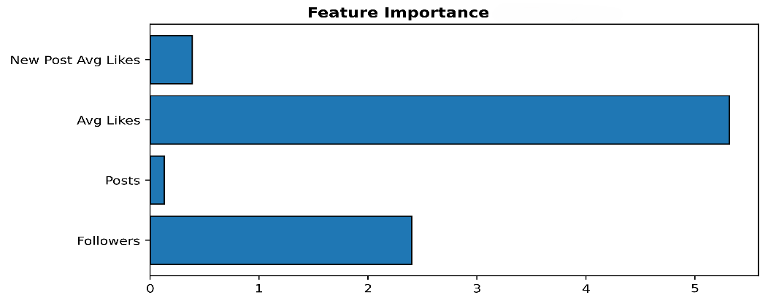

The SHAP Feature Importance plot quantifies the global contribution of each engagement variable toward model predictions. Average Likes clearly dominates the decision-making process, contributing more than twice the weight of raw follower counts. This confirms that engagement quality, rather than superficial popularity metrics, drives authenticity classification.
Performance of Density Based Clustering

It is shown that SHAP Force Plot analysis of a high-profile anomalous account is localizable. The visualization is an example of a mathematical tug-of-war with contributing features as shown in Fig. 3. High number follower has a positive impact on the actual classification (red), although it is substituted by incredibly low mean likes and poor engagement indicators (blue), which finally leads to the fraud labelling. This regional rationale proves the fact that the classifier does not make any determination only by magnitude-predicted popularity but standardizes proportional quality of engagement. The Force Plot makes feature-level visibility of individual predictions so that the auditors and marketers can know why a specific account was categorized as fake. This enhances reliance, facilitates transparent implementation, and makes such significant decisions as explained by comprehensible data instead of mysterious probability scores.

Figure 3. Individual Account Audit showing the feature-level contribution to a specific fraud prediction

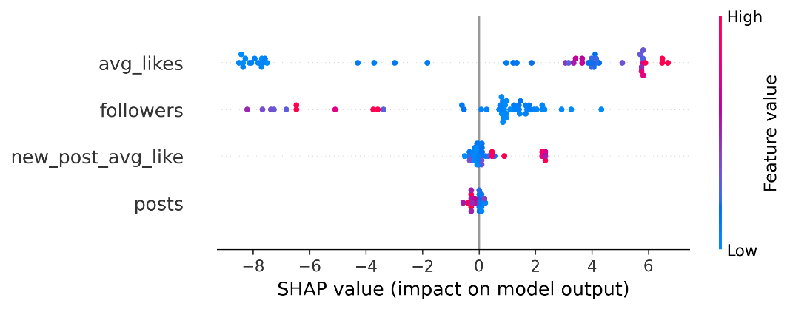

The visualization of the local explanation of a given influencer classification is done through the Force Plot. Though follower count is a positive factor towards the actual classification, it is totally negated by the extremely low engagement rates of the metrics that propel the prediction toward fraud. This confirms the fact that the model looks at proportional quality of engagement and not exclusively at the size of follower.

Comparative Model Ranking

Test accuracy, macro F1-score and stability were done by a Comparative ranking. The best with max. predictive accuracy and minimum variance was Gradient Boosting. The second with high interpretability advantages was the random Forest. DBSCAN was ranked number three yet with some demonstrated unique capabilities in anomaly detection. The comparison establishes that supervised models are more accurate in classification when compared to unsupervised clustering and that density-based models provide an improvement in outlier detection.

General Performance Discussion

In addition to the measures of numerical accuracy, SHAP summary analysis can show how the model classifies authenticity at a global scale. The Beeswarm Plot as depicted in Fig. 4, the directional effect of engagement features on all accounts can be traced. The horizontal dispersion illustrates an obvious level of authenticity in which low levels of engagement (blue points) keep the SHAP values in the negative state, causing fake classification irrespective of the size of the followers. On the other hand, increased average likes recommends forecasts to accurate classification. The nonlinear spreading validates the fact that Gradient Boosting is able to carry along interaction effects that cannot even be reflected in linear models. This is the reason why ensemble learning performs better than the Logistic Regression. It means that the Beeswarm visualization thus fits the gap between predictive performance and interpretability in a successful sense which allows the application of empirical evidence in justifying the claim that the model signals the difference between the accounts because of dynamics of proportional engagement and not on the basis of absolute scale.

Figure 4. SHAP Dependence Plot demonstrating the ‘Anti-Gravity’ effect of engagement vs. follower scaling

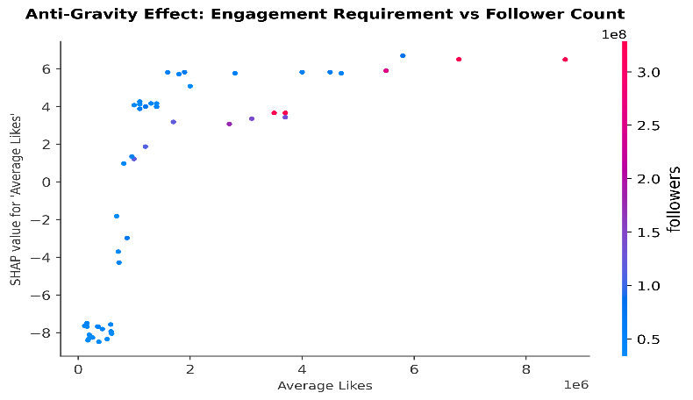

The Dependence Plot illustrates the non-linearity of the scaling between number of followers and the level of engagement needed. The higher the magnitude of the followers, the higher the engagement threshold of one who must be still considered authentic increases out of disproportion. This is the reason why Gradient Boosting is preferred to linear classifiers like the Logistic Regression.

CONCLUSION & FUTURE ENHANCEMENTS

The paper suggested an explicable and transparent machine learning model to find fake influencers based on engagement metrics of behaviour. Leakage-safe labelling strategy made classification balanced without providing predictive bias. Gradient Boosting was the best predictive accuracy model and proved to be highly generalized among the supervised models. DBSCAN was a complement of classification revealing abnormal structures of engagement. Notably, SHAP explainability integration made this system more transparent as it was no longer a black-box predictor but an analytical system. The global SHAP analysis revealed that mean likes are dominant over authenticity prediction, and the individual-level was available in local Force Plot audits. The SHAP Dependence Plot also indicated that the scaling between the number of followers and engagement, which was necessary, did not exhibit any linearity, which is the reason why Gradient Boosting was chosen in favour of linear baselines. Influencer fraud detection systems are likely to be more reliable, trustworthy, and ready to deploy due to the integration of both predictive and explainable AI, which can enable the proposed framework.

This can be applied to the real world in future, through future work since ground truth data, which has been verified by external entities instead of engagement-based labels are used. Increasing feature space to include the time trends, sentiment analysis, network connectivity measurement to enhance the prediction ability. More profound depth learning structure integration can also enhance the challenge of nonlinear correlation (pattern recognition) on large data set. The possible imbalance in classes in the deployment environment can be counteracted by cost-sensitive methods of learning. The capability of real time detection of drift would increase the capability to support varying types of manipulation. Also, through explainable AI, it may bring increased transparency and trust in the stakeholders, in particular. Lastly, somebody needs to climber the framework with distributed processing systems that might require making it compatible with effectively analyzing large influencer ecosystems to support the deployment of meaningful systems to the industry level.

REFERENCES

- Al Lawati, H.M., Zainal, A., Al-Rimy, B.A.S., Al-Azawi, M., Kassim, M.N., Almalki, S.A. and Alghamdi, T.A. (2025). An integrated preprocessing and drift detection approach with adaptive windowing for fraud detection in payment systems. IEEE Access.
- Alrasheedi, M.A. (2025). Enhancing fraud detection in credit card transactions: A comparative study of machine learning models. Computational Economics, pp. 1–27.
- Chen, Y., Zhao, C., Xu, Y., Nie, C. and Zhang, Y. (2025). Year-over-year developments in financial fraud detection via deep learning: A systematic literature review. arXiv preprint, arXiv:2502.00201.
- Goyal, B., Gill, N.S., Gulia, P., Alduaiji, N. and Shukla, P.K. (2025). Instagram fake profile detection using an ensemble learning method. Scientific Reports, 15(1), 26464.
- Kadam, O. and Surse, N. (2025). Detection of fake social network account. International Journal, 6(4).
- Sambari, S.K. and Kumar, A. (2025). Measuring the influence of AI-driven virtual influencers on brand value and customer engagement: Introducing novel variables for next-gen impact assessment. Preprint/Unpublished manuscript.
- Shikha, D. and HOD, R.J. (2025). A review on fake profile detection methods using machine learning approaches. International Journal of Advanced Research and Multidisciplinary Trends (IJARMT), 2(2), 306–316.
- Terumalasetti, S. and Reeja, S.R. (2024). Enhancing social media user’s trust: A comprehensive framework for detecting malicious profiles using multi-dimensional analytics. IEEE Access, 13, 7071–7093.
- Tiwari, H., Sharma, N., Premananthan, G., Usha, S. and Abdullajonovich, K.B. (2025). The impact of influencer marketing on brand authenticity in digital campaigns. Proceedings of the 2025 International Conference on Innovations and Emerging Technologies in AI & Communication Systems (IETACS), pp. 1117–1122.
- Zardi, H. and Alreshoodi, R. (2026). Cost-sensitive fake profile detection in online social networks using random forest feature selection and LightGBM. Engineering, Technology & Applied Science Research, 16(1), 30906–30912.

