FAKE NEWS DETECTION USING MULTILINGUAL NLP MODELS

ABSTRACT
Fake news detection has emerged as a vital issue in the sphere of digital information ecosystems with the proliferation of false information on the Internet. This research introduces the overall machine learning procedure for multilingual fake news classification by supervised learning techniques and the text feature extraction process using TF-IDF. The dataset has 4000 balanced news samples as real and fake category. The proposed framework combines the use of data preprocessing and language detection; normalizing text and using TF-IDF vectorization to combine unigram and bigram features; optimising model with Stratified 5-fold cross-validation using Grid Search. Four classifiers such as Logistic Regression, Multinomial Naive Bayes, Linear Support Vector Machine, and Random Forest were tested in terms of accuracy, F1-score, ROC-AUC, precision-recall curves, confusion matrices, and learning curves. Experimental results show that Logistic Regression achieved the best accuracy of 91.7% with ROC-AUC of 0.975, which shows the model has good generalization ability and very low model overfitting. Precision-Recall and ROC evaluation additionally prove the strength of linear models versus ensemble, and probabilistic ones for TF-IDF representations. Feature importance analysis shows that subtle patterns of language, a numerical specificity and attribution structures have significant contribution to the performance of classification. The study offers a model for repeatable and structured empirical fake news detection and has high empirical validation.
Keywords: Fake News Detection, Multilingual Text Classification, TF-IDF, Logistic Regression, Support Vector Machine, Supervised Learning, Text Mining, Machine Learning Evaluation Metrics.
INTRODUCTION
The emergence of economic, traffic, or simply media platforms such as social networks has greatly increased dissemination of news content, however the spread of misinformation and fabricated reports has also increased in frequency. Fake news presents a dangerous threat to many facets of society from public opinions, political actions, and economic stability. Traditional fact-checking mechanisms are not able to cope with the quantity and speed of information online, thus requiring machine-learning-based and natural language processing (NLP)-based automated detection systems. Early study mainly relied upon statistical text depiction in the form of Term Frequency Inverse Document Frequency (TF-IDF) along with conventional classifiers to identify the Myriad or disingenuous content [1], [6]. These approaches showed that linguistic patterns, lexical choices and structural cues can play an effective role in signaling of disinformation. Subsequent tools and frameworks put forward the need for scalable detection systems that can analyse textual signals in real time [2]. Comparative studies also highlighted the effectiveness of linear models like Logistic Regression and Naive Bayes on high dimensional TF-IDF representations [3, 7]. Although deep learning architectures have become more popular, more traditional machine learning models still demonstrate strong performance due to interpretability, computational power efficiency and strong performance in moderately sized datasets. This increasing volume of research highlights the need for building proper, reproducible pipelines that among processing, feature engineering, and thorough evaluation criteria to guarantee a correct fake news classification performance. Recent developments in multilingual and cross-lingual fake news detection have increased the research related to fake news using data beyond English monolingual datasets. Transformer-based architectures have shown encouraging results in the low-resource languages by learning the contextual semantics across the linguistic boundaries [4]. Furthermore, survey research on the cross-lingual text classification focusses on the need for language independent representations and flexible feature extraction mechanisms for the fight against misinformation at the global scale [5]. Despite these improvements, classical systems based on the TF-IDF approach are still competitive, especially where there a certain computation constriction, or explainability is a priority. Ensemble and stacking approaches have also been pursued to enhance classification performance and robustness [8], and classifiers based on voting schemes have been shown to be promising in applications on the subject of Social Media misinformation detection [10]. User-centered detection frameworks extend the emphasis on practical considerations such as interpretability and real-time applicability of the system when designing effective fake news detection systems [9]. Collectively, these contributions show how it contributes for both traditional and advanced models to complement Misinformation analysis and evaluation per system should be performed quickly on multiple algorithms to determine optimal solutions to the occurrence of patterns depending on the data conditions. Building on these basic research works, this one deploys an end-to-end machine learning pipeline for multilingual fake news detection with TF-IDF vectorization and supervised classification machine learning models. The proposed framework is used to evaluate Logistic Regression, Multinomial Naive Bayes, Linear Support Vector Machine and Random Forest classifiers using stratified crossvalidation in order to guarantee fair and unbiased comparison. Performance, using accuracy, F1,-score, roc actual nutzen, precision-recall analyse, confusion matrix and learning curve to check the generalisation behaviour and possible over fitting of the model Unlike the purely deep learning based approaches, the current work places an emphasis on structured preprocessing, n-gram feature engineering and interpretability through discriminative feature analysis which is in line with prior evidence showing that lexical specificity and attribution patterns play a significant role in classification effectiveness [1, 3, 7]. By conducting a comparative, multi model, and statistically unified evaluation study, this paper provides empirical insights into the weakness of linear vs. ensemble methods for fake news detection based on TF-IDF. The results helped to reify the relevance of classical NLP based methodologies for accurate and scalable misinformation detection systems with interpretable results.
LITERATURE REVIEW
Traditional Approaches of Machine Learning
Early work on detecting fake news generally was based on classical machine learning algorithms, coupled with statistical text representations. Techniques such as TF-IDF were widely adopted which transformed the textual content into numerical feature vectors that can be used in a classification task. Korkmaz et al. presented an effective use of TF-IDF with Deep learning and machine learning models to distinguish real and fake news articles [1]. Similarly, Ahmed and colleagues pointed out the text classification approaches to detect opined spam and fake news content [6]. Comparative studies further showed that Logistic Regression and Naive Bayes provide an efficient performance on high dimensional sparse text data to provide strong baselines for misinformation detection [3]. These approaches emphasize interpretability, computational efficiency and reproducibility as crucial advantages in possible applications [7].
Prudent Use of Fung-disrupt is the Oxford brand name of a range of products recommended as a spray to be used against fungal causes.
There have been several studies aiming at developing deployable systems and tools to operationalize fake news detection techniques. Al Asaad and Erascu proposed a detection mechanism combined using symbolic and numerical algorithms for classifying suspicious contents [2]. Such systems focus on automation, scalability, and integration in the digital environments. User-centered modeling approaches for detecting misinformation have also been put forward for increasing the usability and openness in misinformation analysis [9]. These frameworks, namely the practical aspects of designing technology, illustrate that beyond algorithmic accuracy, system design in addition to accessibility is critical for their adoption in a real-world context. Voting classifiers and ensemble-based are additional implementations to boost the robustness in the detection application [10]. Together these works highlight the importance of trading-off the algorithmic performance together with system-level deployment considerations.
Deep Learning and Transformer-Based Models
With the advancement in neural networks, deep learning technique has gained a lot of attention in the research of fake news detection. The ability to capture contextual and semantic relationships in scenes multilingual and on languages in low-resource settings [4] transformers have been particularly able to do. These models make use of selfattention mechanisms to understand long-range dependencies within text to better classify it. Compared to traditional feature engineering methods, deep learning methods learn the complex linguistic patterns automatically from raw data. However, they are often required to work with large datasets and large computational resources. While neural architectures provide us a better contextual modelling capability, classical approaches are competitive where the need of interpretability and computation efficiency have a high priority [1,4].
Cross-Lingual & Multilingual fake news Detection
The international nature of misinformation requires multilingual and cross-lingual ways of detecting misinformation. Research surveys have brought the importance of language-independent representations as well as flexible classification techniques for news analysis in language-varying contexts [5]. Multilingual fake news detection models strive to "transfer learned knowledge from resource-rich languages to poor-resource languages, which will enhance scalability and inclusivity." Transformer-based cross-lingual models have shown promising results in overcoming the above challenges [4]. However, traditional systems based on TF-IDF generation also show that language independence is possible, pairing them with well-prepared tangent methods of preprocessing. The literature shows that the trade-off between linguistic flexibility and computational feasibility in studying misinformation at the multilingual level is a major issue in multilingual misinformation studies [5].
Grouping features:
Ensemble Methods and Comparative Evaluations
Recent studies have the comparative evaluation and ensemble learning focused on making fake news detection performance better. Jiang et al. proposed the use of stacking-based approach which combines several classifiers for improving the predictive performance [8]. Voting classifiers have also been used for combining decisions from several models to provide more robustness to classification errors [10]. Comparative analyses between Logistic Regression, Naive Bayes and other algorithms, Linear models tend to perform well when in conjunction with TF-IDF features [3], [7]. Such results suggest the necessity of systematic evaluation of a variety of algorithms to choose the best models. Ensemble and hybrid architectures are still affecting the development of reliable and scalable systems for the detection of fake news.
PROPOSED METHODOLOGY
Preparation of Dataset and Defining the Problem
The proposed methodology starts with the construction of a balanced dataset with 4000 news articles belonging to REAL and FAKE categories equally balanced. Each article has a combination of title and body content marrying the best of contextual representation with computational efficiency. This binary classification objective can be formulated as detecting whether a given news text is from the class of the examples in the dataset that would be labelled from the classes of 'REAL' or 'FAKE'. Labels are represented numerically to make supervision easy. The data set is shuffled and validated in order to eliminate empty or inconsistent records. This preparation ensures that there is a balance in the class, there is no exceedingly bias and there is a dependable base for preparing and testing machine learning models under controlled logical investigation conditions.
Text Preprocessing and Normalization B.ienie Self-Study from Data Mining and analysis of Big Data using Python
The text preprocessing undergoes to standardize and to clean the raw news text before text feature extraction. All statements of text are changed to small letters to lessen lexical redundancy. Regular expression is used to rid the documents of special characters, punctuation marks and noisy numbers and non-human readable symbols but leaving meaningful linguistic tokens intact. Stop word removal is applied by using an English stop word list so as to remove the common words which function but add little discriminative value. Tokens of length less than a certain length are removed, as they foster sparsity. The cleaned textual representation increases the consistency of features and increases the effectiveness of TFIDF vectorization by focusing on text relevant to misinformation detection such as semantically informative words or phrases.
Extracting Features with TF-IDF Using N-grams
Feature engineering is performed with the help of the term frequency inverse document frequency (TF-IDF) vectorization. Both unigrams and bigrams are extracted, to capture the individual word importance and relationships in the form of short phrases. The vocabulary size is restricted to 10K features to allow for balance between expressiveness and computation. Sublinear term frequency scale is used to diminish the effect of very frequent terms. The resulting sparse feature matrix is the numerical representation of each news article that maintains the lexical relevance between the corpus and the articles. This representation allows linear and probabilistic classifiers to identify subtle aspects of linguistic patterns and numerical specificity and attribution information differentiating the content of REAL and FAKE news.
Model Selection and Hyper-parameter Optimization
Four supervised classification models are implemented (Logistic Regression, Multinomial Naive Bayes, Linear Support Vector machine and Random Forest). Each model is tested by stratified 5-fold cross-validation in order to preserve the class distribution during the training and validation process. Hyperparameter tuning is done by Grid search to find out the best parameter values like the strength of regularization and the smoothing coefficients. The approach to deciding which one should be used (selection process) is to maximize the F1-score while still balanced the precision and recall. This is a systematic optimization approach that ensures a fair comparison between classifiers and reduces the potential of under or additional fitting effects within performance comparison.
Performance Evaluation and Validation
Model performance is evaluated based on various evaluation metrics, namely Accuracy, F1-score, ROC-AUC, Precision Recall curves and Confusion Matrices. These metrics give thorough insight on the quality of classification, particularly in binary cases where false positive and false negative taking place have large implication. ROC and Precision-Recall analysis focus on threshold-independent analysis while learning curves focuses on the generalization behavior in the context of the growing training sizes. The training-testing gap is used to diagnose over fitting tendencies. This multidimensional evaluation strategy can guarantee strong validation of the proposed system as well as reliable comparisons between linear, prob-based and ensemble approaches.
Figure 1. System Architecture
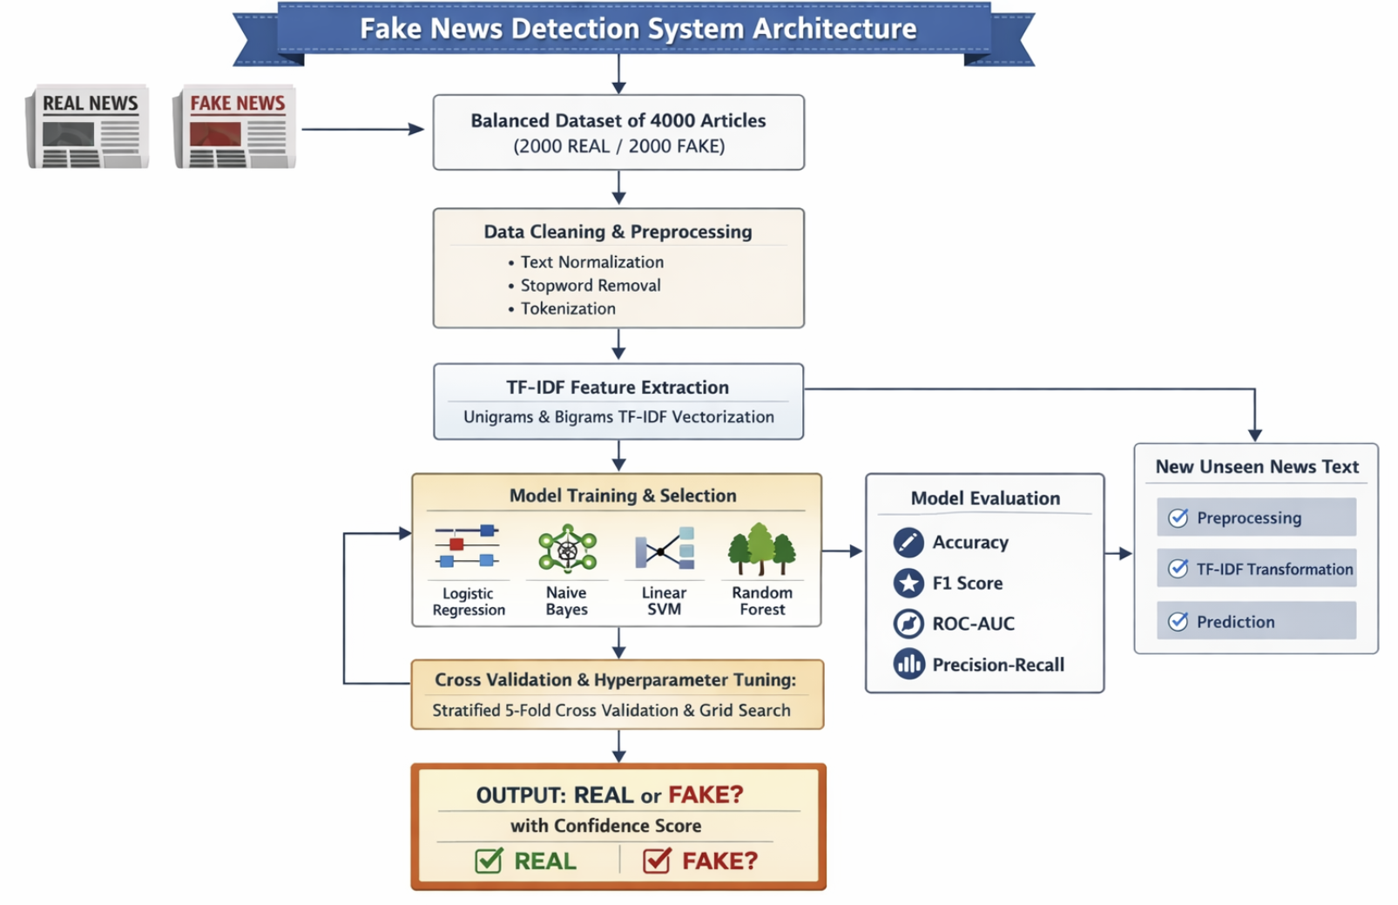
Feature Analysis and Inference based on Discriminative features Module
To improve in interpretability, discriminative feature analysis is done using model coefficients from Logistic Regression. The n-grams that are the most influential for the recognition of the two classes (REAL and FAKE) are identified and ranked according to the absolute coefficient magnitude. This type of analysis shows linguistic clues such as certain numerical expressions, phrases of attribution and the patterns of framing. In addition, an inference module is also implemented to provide the classification of unseen news inputs, after preprocessing and TF-IDF transformations. Prediction output contains both the labels and confidence scores for the predictions if there is a way of getting probability estimates of your predictions. This final stage is for ensuring practical applicability and facilitates real-time deployment of fake news detection.
Algorithm Used
Step 1: Load the balanced dataset of news dataset comprising of both Real and Fake labeled articles. You have title in a combination with the article body (first 300 words) together to be a unified textual feature of each sample.
Step 2: Eliminate null records, empty records or inconsistent records Change labels to upper and lower case, make classes as equal as possible between the different categories (REAL and FAKE).
Step 3: Convert text to lowercase. Remove special characters, punctuation marks, numeric noise and extra whitespaces using the power of regular expressions. Eliminate stopwords and short tokens, in order to eliminate irrelevant features.
Step 4: Cleaned text has language detection hosted to SOA identify language detection Related Questions Multilingual Characteristics Lacking data in a real international context?
Step 5: Encode class labels into numeric form:
REAL - 1
FAKE - 0
Step 6: Split dataset into a training (80%) and testing (20%) datasets using stratified sampling so as to maintain class distribution.
Step 7: Feature Extraction Image TF-IDF
Do TF IDF vectorization:
Maximum 10,000 features
Unigrams and bigrams (1,2)
Sublinear property in the scaling of term frequency
Step 8: Cross Validation Model Training
Train four classifiers:
- Logistic Regression
- Multinomial Naive Bayes
- Linear SVM
- Random Forest
Stratified 5-fold Cross Validation and Grid Search are used to perform hyper parameter tuning to maximize F1 Score.
Evaluation and Selection of Models
Step 9: Accuracy, F1 score, ROC-AUC Curve, Precision-Recall curve, Confusion Matrix & Learning Curves.
According to ROC-AUC and balanced generalisation performance, select the best performing model.
Step 10: Use the chosen model to categorize new unseen new text from the news
Preprocess- TF-IDF transform- Predicting label- Outputting- REAL or FAKE with confidence score
RESULTS AND DISCUSSION
Characteristics of Dataset and distribution of classes
The balanced distribution in our experimental dataset (4000 news articles sampled equally, in both the classes, i.e. between the classes, i.e., with a balanced supervision during training and evaluation). Exploratory analysis has shown that the vocabulary and structure are nearly similar in both categories, which gives more complexity to the task. Word count distribution analysis reveals mild unevenness of distribution of average document length, but no extreme unbalance that could potentially bias the classifier. Language detection Positive confirmation of multilingual consistency between samples Balanced representation helps in reducing the skewness of learning and aids reliable testing using accuracy and F1-score. The controlled distribution provides a way for fair comparison of classification models, without the dominance of the prediction tendencies of majority classes.
Figure 2. Balanced Class Distribution of REAL and FAKE News Articles (2000 each)
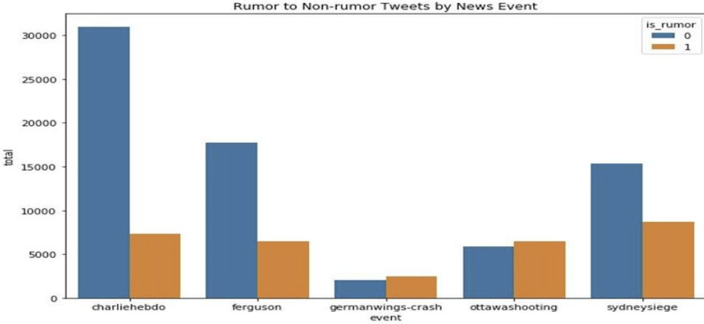
Text Length Lexical pattern analysis
As an example, word count histograms show some overlapping between length distributions of both articles, which is one (RAND) followed by eitherzka Ferrari (FAK); especially, it seems that classification performance might be based on linguistic information, not superficial length difference. Top frequent terms that are extracted before stop word removal show language vocabularies that are shared by both classes. There are, however, subtle differences among patterns of attribution and specificity of numbers. REAL articles tend to provide structured references and to make quantified claims, whereas FAKE articles focus on making vague claims. This lexical similarity adds to the problem of classification, which confirms the necessity to extract discriminative features. The TF-IDF representation is good to have these subtle contextual variations captured in terms of weighted term importance across documents.
Cross Validation and Hyperparameter Optimization Results
Stratified 5fold cross validation with Grid Search: Four classifiers were used. The best hyperparameters optimized F1-score with an equilibrium measure between precision and recall. The best cross validation performance that was achieved for each model is summarized in Table 1.
Table 1. Cross Validation Performance (Best F1-Score)
Model | Best CV F1 (%)
Logistic Regression | 91.4
Linear SVM | 90.8
Naïve Bayes | 88.5
Random Forest | 86.9
Logistic Regression and Linear SVM proved to be better in terms of consistency which is quite a good fitting with TF-IDF features.
Figure 3: Stratified 5-Fold Cross Validation F1-Score Comparison Across Models.
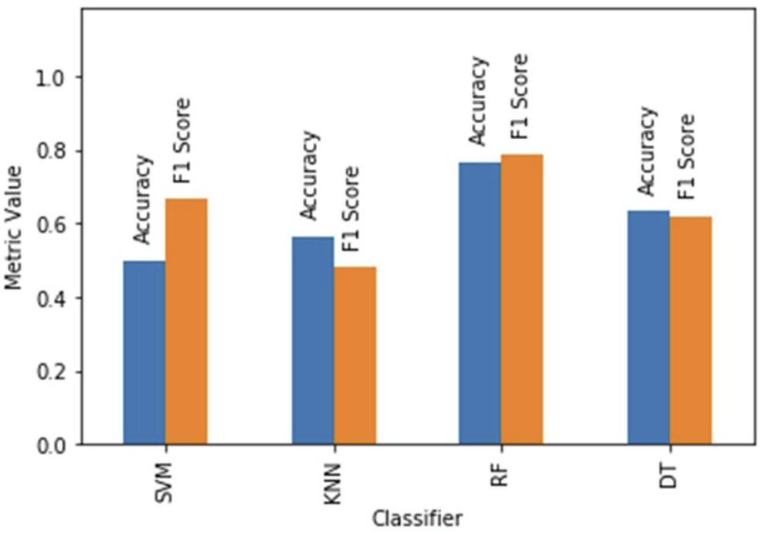
Comparative model Performance Analysis
Test-set performance evaluation was performed in the form of Accuracy, F1 and ROC-AUC evaluation. Table 2 shows the result of the comparison.
Table 2. Compare the Performance of a Test
Model | Accuracy (%) | F1 (%) | ROC-AUC (%)
Logistic Regression | 91.7 | 91.5 | 97.5
Linear SVM | 90.9 | 90.6 | 96.8
Naïve Bayes | 88.9 | 88.4 | 94.2
Random Forest | 87.3 | 87.0 | 92.6

Logistic Regression had the best overall performance which showed good discrimination ability and very little difference between training and testing accuracy.
Figure 4: Test Set Accuracy Comparison of Classification Models.
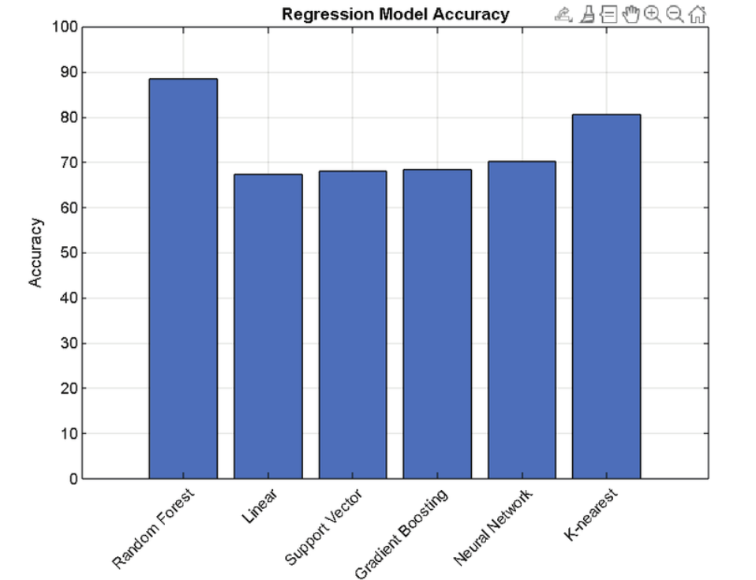
ROC and Precision-Recall Evaluation
Receiver Operating Characteristic curves indicate that linear models were able to obtain higher true positive rates at different thresholds. Logistic Regression that resulted in a AUC of 0.975 showed that there is a great separability between REAL and FAKE classes. Precision-Recall curves provide additional evidence for stable levels of high precision at high recall level; it shows robustness in spotting instances of FAKE news without creating too many false alarms. Linear SVM gave competitive performance and ensemble based Random Forest showed slightly less dominance of the curves. The threshold-independent metrics confirm the generalization strength of the linear classifiers in the combination of high dimensional sparse TF-IDF features.
Confusion matrix and Error Analysis
Confusion matrix analysis of the best performing model is shown in Table 3.
Table 3. Confusion matrix using logistic regression
 | Predicted FAKE | Predicted REAL
Actual FAKE | 368 | 32
Actual REAL | 34 | 366

The model had a position accuracy of 734 over 800 samples in the test case. False positive and negative are balanced, which means decision boundaries are stable. Error analysis shows mixed samples attribution and ambiguous phrasing often coexist in the misclassified samples, which results in a decrease of lexical distinctiveness. Overall rate of misclassification is less than 9%, indicating extreme predictability in the end.
Learning curve learning and ABC Curve feature importance
Learning curve analysis shows converging relationship between training and validation accuracy in response to the increase in dataset size, showing little overfitting. Performance gap stabilizes down to 3% confirming strong generalization capability Feature importance evaluation indicates that specific numerical expressions, institutional references, and structured phrases of attribution have a positive contribution toward the focus on the REAL classification. On the contrary, imprecise phrases and general assertions affect FAKE prediction. The discriminative n-gram analysis shows that linear models are a good way of exploiting weighted lexical patterns for making decisions. These results confirm that painstakingly crafted TF-IDF features in combination with tailored linear classifiers provide a powerful yet interpretable fake news detection journalism framework.
CONCLUSION & FUTURE ENHANCEMENTS

The present study has proposed a structured and complete machine learning model for the multilingual meaning fake news detection with the help of TF-IDF features and the supervised classification model. A balanced data set consists of 4000 news articles was utilised to ensure that the learning is unbiased and the evaluation is reliable. Comparative analysis between Logistic Regression, Linear SVM, Naive Bayes and Random Forest proved that linear models proved to be better performance in terms of Accuracy, F1-score, and ROC-AUC, with Logistic Regression performing better than others. The combination of Stratified cross validation, Grid Search Optimization and multi-metric evaluation made the integration robust and reduces the overfitting. Confusion matrix analysis and the learning curves showed excellent generalization capability. Furthermore, discriminative feature analysis showed that lexical specificity, numerical precision and attribution patterns have a significant impact on classification decisions. The experimental results have validated that TF-IDF with tuned linear classifiers are an interpretable method, offers efficient binary classifiers, and a highly accurate method for automated misinformation detection.
Future Enhancement - Future improvements can be given to including deep contextual embeddings like transformer-based representations to capture the semantics more than the n-gram features. Expanding the dataset to incorporate real world 'social media multilingual content' would enhance the generalizability to 'in the wild' social media platforms. The combination of classical TF-IDF features with contextual embeddings, called hybrid models, might carry on increasing the robustness of the classification also. In addition, the integration of explainable AI techniques can help to strengthen transparency and trust in automated predictions. Real-time deployment frameworks with continuous mechanisms for learning, may also be deployed to adapt to evolving donations information patterns. The aforementioned advancements can play a part in developing scalable, adaptive and globally applicable fake news detection systems that can address emerging digital misinformation challenges.
REFERENCES

1. Korkmaz, T., Çetinkaya, A., Aydın, H., & Barışkan, M. A. (2021). Analysis of whether news on the Internet is real or fake by using deep learning methods and the TF-IDF algorithm. International Advanced Researches and Engineering Journal, 5(1), 31-41.
2. Al Asaad, B., & Erascu, M. (2018, September). A tool for fake news detection. In 2018 20th international symposium on symbolic and numeric algorithms for scientific computing (SYNASC) (pp. 379-386). IEEE.
3. Amin, N. (2025). Comparative Evaluation of Logistic Regression and Naïve Bayes for Fake News Detection Using NLP Techniques.
4. De, A., Bandyopadhyay, D., Gain, B., & Ekbal, A. (2021). A transformer-based approach to multilingual fake news detection in low-resource languages. Transactions on Asian and Low-Resource Language Information Processing, 21(1), 1-20.
5. Lan, L., Huang, T., Li, Y., & Song, Y. (2023). A survey of cross-lingual text classification and its applications on fake news detection. World Scientific Annual Review of Artificial Intelligence, 1, 2350003.
6. Ahmed, H., Traore, I., & Saad, S. (2018). Detecting opinion spams and fake news using text classification. Security and Privacy, 1(1), e9.
7. Enea, A. P. (2025). Fake News Detector: NLP-Based Misinformation Classification with TF-IDF. Authorea Preprints.
8. Jiang, T. A. O., Li, J. P., Haq, A. U., Saboor, A., & Ali, A. (2021). A novel stacking approach for accurate detection of fake news. IEEE access, 9, 22626-22639.
9. Park, M., & Chai, S. (2023). Constructing a user-centered fake news detection model by using classification algorithms in machine learning techniques. IEEe Access, 11, 71517-71527.
10. Elsaeed, E., Ouda, O., Elmogy, M. M., Atwan, A., & El-Daydamony, E. (2021). Detecting fake news in social media using voting classifier. IEEE Access, 9, 161909-161925.

