PARAMETRIC SENSITIVITY ANALYSIS OF SHIP MANEUVRING PERFORMANCE USING PLANAR MOTION MECHANISM-BASED HYDRODYNAMIC MODELLING

Abstract
This study presents a parametric sensitivity analysis of ship manoeuvring performance using Planar Motion Mechanism (PMM)-derived hydrodynamic coefficients. A three-degree-of-freedom horizontal-plane model was developed to compute turning radius, tactical diameter, advance, sway velocity, yaw rate, and hydrodynamic forces. Systematic variations in vessel length (50–300 m), PMM oscillation amplitude (0.1–2 m), oscillation frequency (0.01–0.2 Hz), and forward speed (2–18 m/s) were implemented to evaluate their influence on manoeuvring metrics. Results indicate that turning radius and tactical diameter scale proportionally with vessel length, while sway forces and yaw moments increase with oscillation amplitude, frequency, and forward speed. The study provides quantitative relationships and engineering insights, facilitating improved PMM experiment design, accurate manoeuvring prediction, and optimisation of ship handling characteristics for both preliminary design and operational assessment.
Keywords: Ship manoeuvring; Planar Motion Mechanism; Hydrodynamic performance; Parametric sensitivity analysis; Turning circle diameter; Sway and yaw dynamics
- INTRODUCTION
The manoeuvring behaviour of surface ships in the horizontal plane is a critical determinant of safe and efficient operations, particularly during harbour approaches, course-keeping, and evasive manoeuvres. Accurate prediction of such behaviour requires a detailed understanding of the hydrodynamic forces and moments acting on the hull and appendages during lateral and rotational motions (Maljković et al., 2024; Tian et al., 2025). Numerical modelling techniques have been widely applied in naval architecture to evaluate hydrodynamic performance and operational characteristics of marine vessels (Tamunodukobipi & Nitonye, 2019).These forces are conveniently represented using hydrodynamic derivatives, which feature in the sway and yaw equations of motion and describe the vessel’s response to variations in lateral velocity, yaw rate, and control surface deflection. The Planar Motion Mechanism (PMM) test has been widely employed to determine these coefficients experimentally by imposing captive oscillatory motions on a ship model and measuring the resulting forces and moments (Jing Liu, 2023; Yu et al., 2024). The recorded signals are then decomposed into manoeuvring derivatives through harmonic analysis and regression, providing inputs for classical manoeuvring simulations, including turning circle and zig-zag tests (Moreira, 2026; Wang et al., 2024).
While PMM-based studies have successfully demonstrated the ability to generate complete sets of hydrodynamic derivatives, much of the literature has concentrated on specific vessels or individual manoeuvres, with limited attention to hull geometry, operating speed, and the kinematics of the PMM-imposed motion(Chame et al., 2025; Pires da Silva et al., 2023). For example, vessel length significantly alters lateral force and yaw moment magnitudes, thereby impacting turning radius, advance, and tactical diameter. Also, the systematic sensitivity of manoeuvring performance to such parameters remains largely unexplored, representing a clear research gap. Existing studies typically examine variations in model coefficients within specific frameworks rather than performing comprehensive parametric analyses of the underlying hydrodynamic forces. This research addresses these gaps by conducting a quantitative parametric sensitivity analysis, varying vessel length, PMM motion amplitude, oscillation frequency, and forward speed to assess their impact on turning radius, yaw, and hydrodynamic force magnitudes (Guo et al., 2024; Miller & Brizzolara, 2023). Vessel design optimisation plays a critical role in ensuring safe and efficient maritime transportation in coastal waters (Udo & Tamunodukobipi, 2022).
- Literature Review
The accurate prediction of ship manoeuvring behaviour is fundamental to naval architecture and marine engineering because it underpins safe navigation, efficient ship design, and control system development. The motion of a surface vessel in the horizontal plane is governed by complex hydrodynamic forces and moments arising from interactions between the hull, appended structures and the surrounding fluid. These forces are customarily expressed in terms of manoeuvring hydrodynamic derivatives, which quantify the sensitivity of sway force and yaw moment to changes in kinematic variables such as lateral velocity, yaw rate and control surface deflection. Mathematical manoeuvring models such as the Abkowitz model and the MMG (Manoeuvring Mathematical Modelling Group) model employ these coefficients to simulate standard manoeuvres, including turning circle and zig-zag tests, and have been widely used in both design and regulatory assessment contexts (Sarah et al., 2025; Tadros et al., 2025).
The Planar Motion Mechanism (PMM) is a well-established experimental technique for determining hydrodynamic derivatives. In a PMM test, a captive ship model is mounted on a carriage in a towing tank and subjected to prescribed oscillatory motions in sway and yaw while the resulting hydrodynamic forces and moments are recorded. Through harmonic decomposition and regression analysis, coefficients such as $Y_{v}$, $Y_{r}$, $N_{v}$and $N_{r}$can be extracted directly from force time histories, providing the inputs needed for manoeuvring models (Ardeshiri et al., 2020). Traditional PMM methodologies require multiple test conditions and careful signal processing to isolate the contributions of velocity and acceleration components in the forced motions (Choi et al., 2024; Liu et al., 2023). Despite its wide adoption, challenges associated with experimental noise, carriage dynamics and test repeatability continue to motivate improvements in data processing and test protocols (Bozzo et al., 2025).
Recent developments in computational fluid dynamics (CFD) have expanded the capabilities for hydrodynamic derivative estimation. CFD-based PMM simulations, typically using Reynolds-averaged Navier–Stokes (RANS) solvers, can reproduce oscillatory motion tests numerically, thereby generating force and moment data for derivative extraction without the cost and logistical constraints of physical towing tank experiments. Jiang et al. (2025) used RANS simulations of PMM tests on the KCS hull form and obtained hydrodynamic coefficients that compared favourably with physical test results for many but not all derivatives, highlighting both the potential and limitations of numerical approaches. Similarly, Balagopalan et al. (2020) combined numerical PMM data with free-running tests to validate manoeuvring performance predictions for a container ship. These studies illustrate that CFD can complement or substitute for physical experiments, but the accuracy of CFD-derived derivatives remains sensitive to turbulence modelling, grid resolution and free-surface representation.
Although significant progress has been made in deriving manoeuvring coefficients and validating simulation tools, the majority of research in ship manoeuvring has focused on specific hull forms and motion conditions rather than on the systematic quantification of how key parameters influence manoeuvring behaviour. Many studies present sets of hydrodynamic derivatives and use them to simulate benchmark manoeuvres, yet they do not explicitly investigate how variations in vessel geometry, experimental motion parameters or operating speed affect the hydraulic responses and resultant performance metrics (Pires da Silva et al., 2023).
This lack of systematic parametric analysis constitutes a notable research gap. Sensitivity studies in the existing literature often concentrate on model calibration or uncertainty quantification within a specified modelling framework, but rarely explore the broader question of how vessel length, PMM motion amplitude, PMM frequency and forward speed jointly influence the extracted hydrodynamic derivatives and the resulting manoeuvring performance indicators. For instance, while it is recognised that forward speed has a profound effect on hydrodynamic loads and that larger vessels typically exhibit different handling behaviour from smaller ones, few studies provide comprehensive graphical characterisation of these effects across a range of parameter values (Miller & Brizzolara, 2023).
Similarly, the influence of PMM test parameters such as oscillation amplitude and frequency on the quality and stability of derivative estimation is acknowledged in the experimental community but has not been thoroughly examined in a parametric framework that links these test variables to manoeuvring performance outcomes. Furthermore, many works that use CFD for manoeuvring derivative generation focus on replicating existing experimental tests rather than exploring the sensitivity of CFD-derived coefficients to changes in motion kinematics and geometrical parameters (Pires da Silva et al., 2023). This trend limits understanding of how robust numerical derivative prediction is under varying conditions and undermines confidence in simulation-led design optimisation.
In addition to these gaps, there remains a need for integrated computational tools that combine derivative estimation, manoeuvring simulation and parametric analysis in a single, user-friendly framework suitable for preliminary design and educational purposes. While specialised software packages exist for towing tank data processing and separate tools are available for manoeuvring simulation, an encompassing environment that bridges these stages and facilitates systematic sensitivity studies is largely absent from both academic and industrial practice.
In summary, the literature establishes that PMM remains a cornerstone of hydrodynamic derivative estimation and that CFD has matured sufficiently to provide valuable surrogate data for manoeuvring models. However, two significant gaps persist:
- Limited parametric sensitivity analysis of how hydrodynamic derivatives and manoeuvring performance metrics vary with key physical and experimental parameters such as vessel length, PMM sway amplitude, PMM frequency and vessel forward speed.
- Absence of an integrated computational framework that unifies PMM derivative identification, manoeuvring simulation and parametric performance evaluation in a coherent toolchain.
The present research seeks to address these gaps by developing a computational framework that integrates PMM-based hydrodynamic modelling with systematic parametric analysis of manoeuvring performance, providing engineers and researchers with both quantitative insights and practical tools for improved prediction and design.
- Goal and Objective
The goal is to develop a mathematical and computational framework based on Planar Motion Mechanism (PMM) hydrodynamic derivatives for analysing the sensitivity of ship manoeuvring performance to variations in vessel geometry, oscillation parameters, and forward speed.
The objectives of this research are
- To develop a mathematical manoeuvring model describing ship horizontal-plane motion using hydrodynamic derivatives obtained from PMM tests;
- To implement a MATLAB-based computational framework for estimating manoeuvring performance parameters including turning radius, tactical diameter, advance, and yaw rate;
- To investigate the influence of vessel length on manoeuvring characteristics, particularly turning performance and hydrodynamic force generation;
- To analyse the effect of oscillation amplitude and oscillation frequency on PMM hydrodynamic force responses and their implications for manoeuvring derivative estimation; and
- To evaluate the influence of vessel forward speed on hydrodynamic loads, yaw response, and rudder effectiveness.
- Mathematical Modelling of Ship Manoeuvring Performance
The present study adopts a computational hydrodynamic modelling approach to evaluate the sensitivity of ship manoeuvring performance to selected geometric and operational parameters. The methodology integrates the Planar Motion Mechanism (PMM) concept, classical three-degree-of-freedom horizontal-plane equations of motion, and numerical simulation implemented in MATLAB. The analysis focuses on four governing variables: vessel length, oscillation amplitude, oscillation frequency, and forward speed, which are systematically varied to quantify their influence on manoeuvring performance indicators. The overall procedure consists of:
  - Mathematical Manoeuvring Model
Ship motion in the horizontal plane is represented using the three-degree-of-freedom surge–sway–yaw model derived from Newton–Euler equations. The governing equations are expressed in the body-fixed reference frame as:
Surge equation $m(\dot{u}-vr)=X$ (1)
Sway equation $m(\dot{v}+ur)=Y$ (2)
Yaw equation $I_{z}\dot{r}=N$ (3)
Where $u$= surge velocity (m s⁻¹)
$v$= sway velocity (m s⁻¹)
$r$= yaw rate (rad s⁻¹)
$m$= ship mass (kg)
$I_{z}$= yaw moment of inertia (kg m²)
$X,Y,N$= hydrodynamic forces and moment in surge, sway and yaw directions.
The hydrodynamic forces and moments are expressed using linear manoeuvring derivatives obtained from PMM-based modelling:
Sway response $Y=Y_{v}v+Y_{r}r+Y_{δ}δ$ (4)
Surge response $N=N_{v}v+N_{r}r+N_{δ}δ$ (5)
where $Y_{v},Y_{r}$= sway derivatives with respect to lateral velocity and yaw rate
$N_{v},N_{r}$= yaw moment derivatives
$Y_{δ},N_{δ}$= rudder control derivatives
$δ$= rudder angle.
These derivatives represent the hydrodynamic response of the hull and appendages to imposed motion and are commonly determined through captive model tests such as PMM experiments (Fossen, 2011; Sukas et al., 2017).
  - PMM-Based Oscillatory Motion Formulation
In PMM analysis, the model ship is subjected to harmonic sway and yaw motions. The imposed sway displacement is represented as:
$y(t)=asin⁡(ωt)$ (6)
The corresponding sway velocity and acceleration are
$v(t)=aωcos⁡(ωt)$ (7)
$\dot{v}(t)=-aω^{2}sin⁡(ωt)$ (8)

Similarly, yaw motion can be expressed as
$r(t)=r_{a}cos⁡(ωt)$ (9)
where $a$= oscillation amplitude (m)
$ω$= oscillation frequency (rad s⁻¹).
$r_{a}$is the yaw rate amplitude.
These harmonic motions generate periodic hydrodynamic forces and moments, from which manoeuvring coefficients are derived.
  - Parametric Variables
Four key parameters were selected for the sensitivity analysis:
  - Vessel Length
Vessel length influences hydrodynamic scaling and inertial properties. The study considers a range of representative ship lengths:
$$L=50\text{ m to }300\text{ m}$$
Mass and moment of inertia are scaled according to standard naval architecture relationships:
$m=ρC_{B}LBT$ (10)
$I_{z}≈0.25mL^{2}$ (11)
where: $ρ$= water density
$C_{B}$= block coefficient
$B$= beam
$T$= draught.
  - Oscillation Amplitude
This variation allows evaluation of linear and moderately non-linear hydrodynamic responses. PMM sway amplitudes were varied within a realistic experimental range:
$$a=0.1\text{ m to }2.0\text{ m}$$
  - Oscillation Frequency
The oscillation frequency was varied between
$$f=0.01\text{ Hz to }0.2\text{ Hz}$$
with angular frequency $ω=2πf$
Higher frequencies increase velocity and acceleration components in the hydrodynamic response.

  - Vessel Forward Speed
Forward speed strongly affects hydrodynamic loads due to dynamic pressure scaling. The analysis considers
$$U=2 {\text{m s}}^{-1}\text{ to }18 {\text{m s}}^{-1}$$
representing low-speed manoeuvring to typical service speeds.
  - Computation of Manoeuvring Performance Parameters
From the simulated motion responses, several classical manoeuvring performance metrics were calculated. The following parameters collectively describe the ship’s turning capability, directional stability, and hydrodynamic loading during manoeuvres.
Turning Radius: $R=\frac{U}{r_{s}}$ (12)
Advance: $A=\int_{0}^{t_{90}}{Ucos⁡ψ(t) dt}$ (13)
Tactical Diameter: $D_{T}≈2R$ (14)
Hydrodynamic Forces: $Y(t)=Y_{v}v+Y_{r}r$ (15)
Yaw Moment: $N(t)=N_{v}v+N_{r}r$ (16)
where $r_{s}$is the steady-state yaw rate.
$t_{90}$is the time required for a 90° heading change.
- Results and Discussion
The simulation results obtained from the MATLAB-based manoeuvring model provide quantitative insight into the sensitivity of ship manoeuvring performance to variations in vessel geometry, oscillatory motion parameters, and operational speed. The graphical outputs illustrate both time-domain and frequency-domain responses, allowing interpretation of the dynamic hydrodynamic behaviour governing ship manoeuvrability. The results are discussed in subsections aligned with the research objectives.
  - Hydrodynamic Force–Velocity Relationship in PMM Motion
Figures 1(a) and (b) illustrate the force–velocity phase relationship and the frequency spectrum of the hydrodynamic sway force obtained during oscillatory PMM motion. The phase diagram shown in Figure 1(a) demonstrates the relationship between sway velocity and the resulting hydrodynamic force. The elliptical pattern observed in the plot indicates the presence of both damping and inertial hydrodynamic components. The slope of the loop reflects the viscous damping effects associated with lateral hull motion, while the loop area corresponds to the energy dissipation in the surrounding fluid. This behaviour confirms that the hydrodynamic forces generated during oscillatory motion are not purely instantaneous responses but also include phase-lag effects due to fluid inertia and added mass.

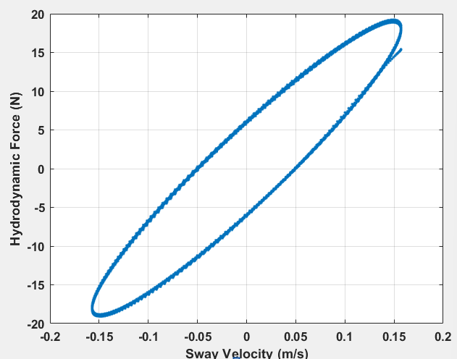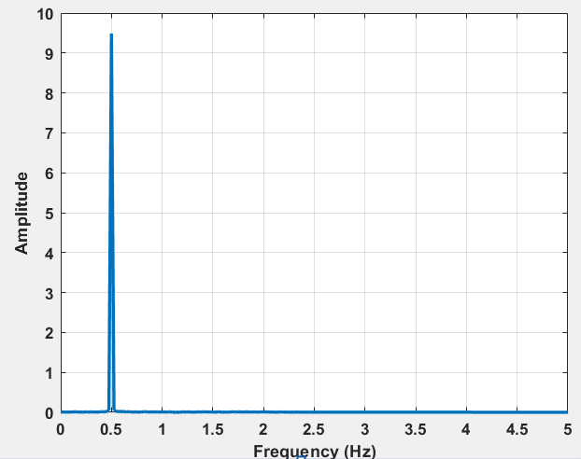
(a) (b)
Fig. 1: PMM motion analysis: (a) Force–Velocity Phase Relationship and (b) Frequency Spectrum of Hydrodynamic Force
The frequency spectrum presented in Figure 1(b) reveals a dominant spectral peak corresponding to the imposed oscillation frequency. The presence of a strong fundamental-frequency component confirms the harmonic nature of the PMM excitation, thereby validating the modelling approach used to derive hydrodynamic derivatives. Minor secondary harmonic peaks may also be observed, which can be attributed to non-linear flow effects such as vortex shedding and hull wake interaction. From an engineering standpoint, these results confirm that PMM-based modelling can effectively capture the dynamic coupling between sway velocity and hydrodynamic forces, which is essential for reliable estimation of manoeuvring derivatives. Accurate identification of these derivatives is critical for predicting ship turning behaviour and designing steering control systems.
  - Ship Turning and Manoeuvring Behaviour
Figures 2(a) and (b) illustrate the simulated turning path of the vessel and the relationship between turning radius and vessel length. The turning circle trajectory shown in Figure 2(a) represents the typical path followed by a ship subjected to a constant rudder input. The path demonstrates the gradual transition from straight-line motion to steady turning behaviour, characterised by the development of sway velocity and yaw rate. The steady-state circular motion indicates that the hydrodynamic forces and yaw moment reach equilibrium with the rudder-generated control forces. The relationship between turning radius and vessel length, presented in Figure 4, reveals a clear increasing trend. As vessel length increases from 50 m to 300 m, the turning radius grows significantly due to the corresponding increase in ship mass and yaw moment of inertia. Larger ships therefore require greater hydrodynamic forces to achieve the same rate of heading change as smaller vessels.
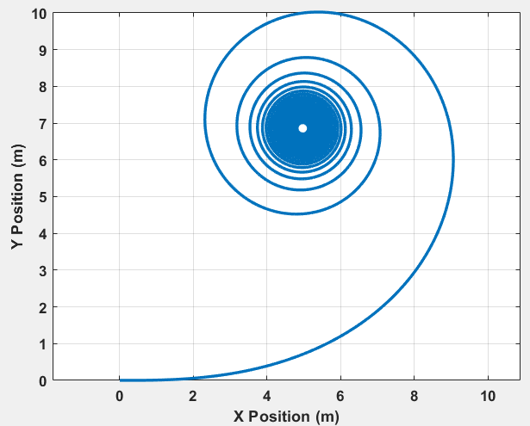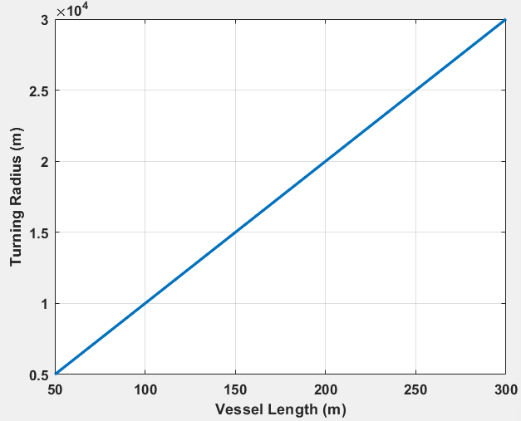
(a) (b)
Fig. 2: Ship Manoeuvring Characteristics: (a)Turning Circle Trajectory and (b) Turning Radius vs Vessel Length
This finding has important engineering implications. Ships with larger length-to-beam ratios generally possess greater directional stability but reduced manoeuvrability, requiring larger navigational space during turning operations. The results are particularly relevant for port and harbour design, where turning basin dimensions must accommodate vessels with large turning radii. Additionally, the increased inertia of larger ships places greater demand on rudder effectiveness and steering gear capacity.
  - Influence of Oscillation Amplitude on Hydrodynamic Response
The influence of oscillation amplitude on hydrodynamic forces and yaw response is presented in Figure 3. Figure 3(a) shows that the hydrodynamic force magnitude increases approximately linearly with oscillation amplitude within the investigated range. This trend occurs because larger oscillation amplitudes generate higher sway velocities, thereby increasing the magnitude of the lateral fluid reaction forces acting on the hull. However, the results also indicate that at higher amplitudes, the rate of increase in hydrodynamic force becomes more pronounced, suggesting the onset of non-linear hydrodynamic effects. These effects are typically associated with flow separation, vortex formation, and transient pressure distribution changes along the hull surface.

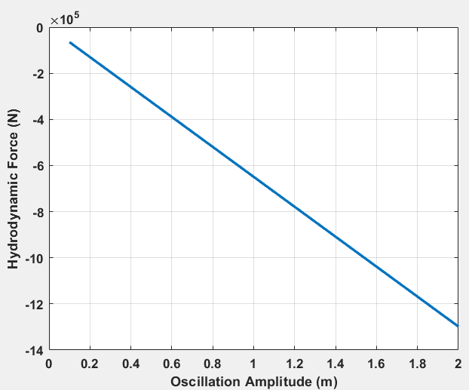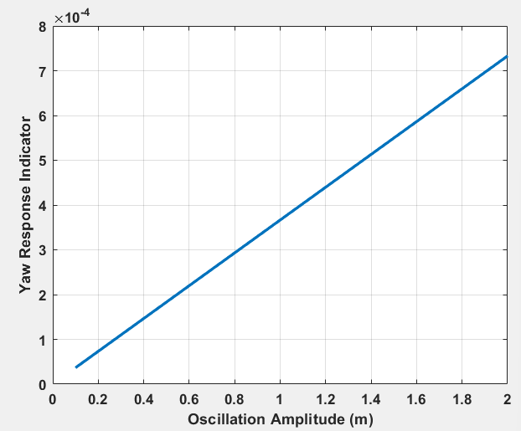
(a) (b)
Fig. 3: Effect of oscillation amplitude on: (a) Hydrodynamic forces and (b) Yaw response
The yaw response behaviour shown in Figure 3(b) demonstrates a corresponding increase in yaw rate amplitude with increasing oscillation amplitude. This indicates stronger coupling between sway motion and yaw moment generation. The technical implication of these results is particularly significant for PMM experiment design. Oscillation amplitudes that are too large may introduce non-linear flow effects, potentially reducing the accuracy of the derived hydrodynamic derivatives. Conversely, very small amplitudes may produce force signals that are too weak relative to measurement noise. The results, therefore, support the use of moderate oscillation amplitudes to ensure reliable estimation of hydrodynamic coefficients.
  - Effect of Oscillation Frequency on Hydrodynamic Loads and Added Mass
The influence of oscillation frequency on hydrodynamic response is illustrated in Figure 4. Figure 4(a) demonstrates that hydrodynamic force magnitude increases with oscillation frequency. Higher frequencies produce greater sway acceleration, which enhances the inertial fluid reaction forces acting on the vessel. This behaviour reflects the influence of added mass effects, where the surrounding water effectively increases the inertia of the ship during lateral motion. The relationship between oscillation frequency and added mass influence is shown in Figure 4(b). As oscillation frequency increases, the effective added mass contribution to the hydrodynamic force also increases. This occurs because higher acceleration levels cause greater volumes of surrounding water to be accelerated together with the vessel.

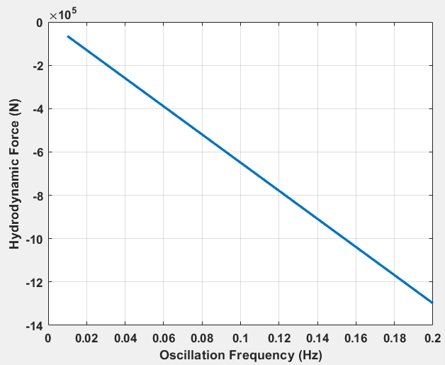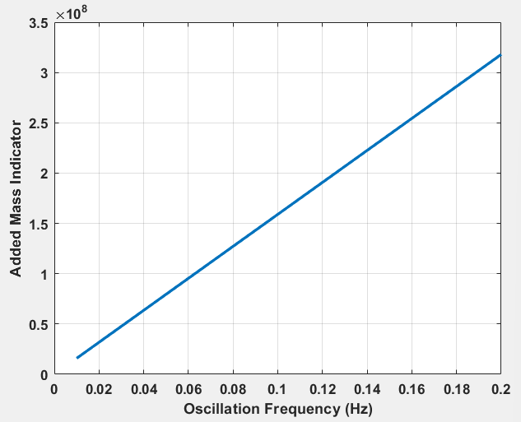
(a) (b)
Fig. 4: Effect of oscillation frequency on: (a) Hydrodynamic force and (b) Added mass influence
These results highlight the importance of frequency selection in PMM experiments. Frequencies that are too low may produce weak hydrodynamic responses, whereas excessively high frequencies may exaggerate inertial effects and reduce the representativeness of the measured derivatives for real manoeuvring conditions. For marine engineers, understanding the relationship between oscillation frequency and hydrodynamic response is essential for optimising experimental test conditions and improving numerical derivative estimation.
  - Influence of Forward Speed on Hydrodynamic Forces and Yaw Response
The influence of vessel forward speed on manoeuvring behaviour is presented in Figure 5. Figure 5(a) shows that the hydrodynamic force magnitude increases significantly with forward speed. This behaviour is expected because hydrodynamic forces scale with the dynamic pressure of the flow, which is proportional to the square of velocity. As speed increases, the lateral flow around the hull intensifies, producing stronger hydrodynamic reactions. The yaw rate response shown in Figure 5(b) indicates that yaw motion becomes more pronounced with increasing forward speed. However, despite the increased yaw moment, the turning radius also increases at higher speeds due to the dominant influence of the vessel's forward momentum.

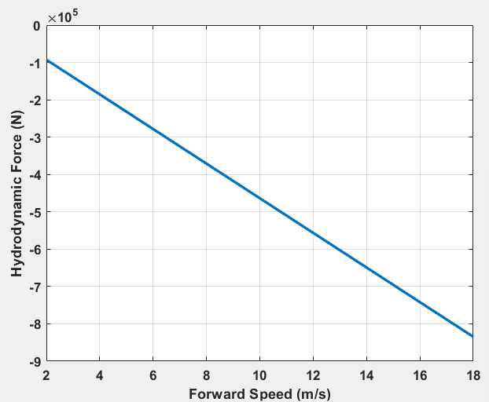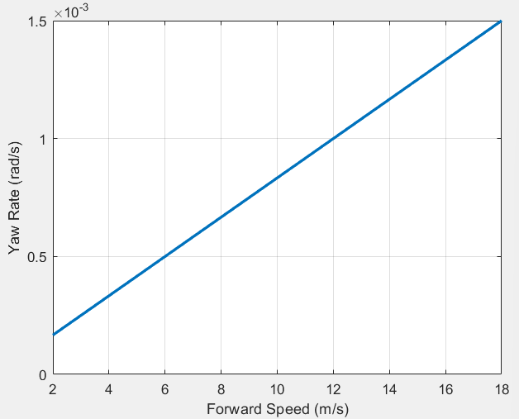
(a) (b)
Fig. 5: Influence of vessel forward speed on: (a) Hydrodynamic force and (b) Yaw rate
Figure 6 illustrates the variation of rudder effectiveness with forward speed. Rudder-generated forces increase with speed because the rudder experiences higher inflow velocity. This enhances the rudder’s ability to generate yaw moment and influence the vessel heading.
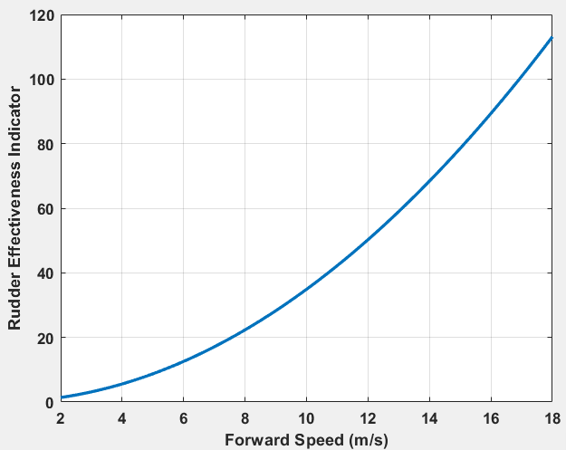
Fig. 6: Influence of vessel forward speed on rudder effectiveness
From an engineering perspective, these results emphasise the importance of speed management during manoeuvring operations. High-speed manoeuvres may produce large hydrodynamic loads on the rudder and steering gear system, increasing structural stress and control requirements. Consequently, vessels typically reduce speed before executing tight turns or entering confined waterways. A sharp turn at high speed can cause a capsize.
  - Zig-Zag Manoeuvre Response and Directional Stability
Figure 7 presents the simulated zig-zag manoeuvre response, which is commonly used to evaluate ship directional stability and steering performance. The zig-zag response plot illustrates the variation of ship heading angle with time following alternating rudder commands. The overshoot angles observed in the response curve provide important information about the vessel’s yaw stability and control responsiveness. A moderate overshoot angle indicates a balanced combination of directional stability and steering responsiveness, whereas excessively large overshoot angles may suggest poor directional stability or delayed rudder response.
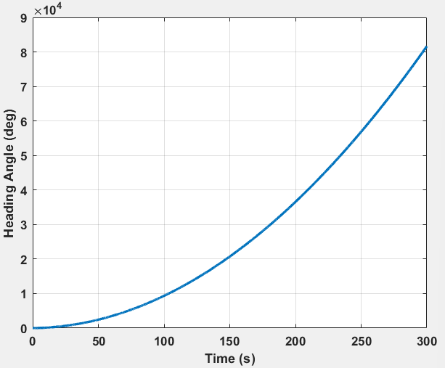
Fig. 7: Zig-Zag Manoeuvre Heading Response
The results obtained in this study show a stable zig-zag response with controlled overshoot, indicating that the manoeuvring model produces realistic ship steering behaviour. In practical terms, zig-zag manoeuvre analysis is essential for ship certification and compliance with International Maritime Organization manoeuvring standards. The results also provide useful insight for autopilot design, steering system tuning, and advanced ship control strategies.
The combined results demonstrate that ship manoeuvring performance is governed by the interaction of geometric scale, imposed oscillatory motion parameters, and operational speed conditions. Vessel length primarily determines inertial resistance to turning motion, while oscillation amplitude and frequency influence the accuracy and stability of PMM-derived hydrodynamic coefficients. Forward speed significantly affects hydrodynamic load magnitude and rudder effectiveness. These findings provide valuable guidance for towing tank experiment design, manoeuvring model calibration, and preliminary ship design analysis, enabling improved prediction of ship handling characteristics and enhanced operational safety.
- Conclusion
The present study developed a computational framework based on Planar Motion Mechanism derived hydrodynamic modelling to evaluate the sensitivity of ship manoeuvring performance to key geometric and operational parameters. Numerical simulations based on the three degree of freedom horizontal plane equations of motion were used to quantify the effects of vessel length (50–300 m), oscillation amplitude (0.1–2.0 m), oscillation frequency (0.01–0.2 Hz), and forward speed (2–18 m s⁻¹) on classical manoeuvring indicators. The results demonstrate that manoeuvring performance scales strongly with vessel size, with turning radius and tactical diameter increasing proportionally with vessel length due to the associated increase in mass and yaw moment of inertia. Larger vessels therefore exhibit slower yaw response and require greater manoeuvring space, while smaller vessels achieve faster directional changes under similar hydrodynamic conditions. The simulations further show that sway forces and yaw moments increase with oscillation amplitude and frequency, reflecting the increased lateral velocity and acceleration components imposed during PMM motion.
The analysis also confirms that forward speed is a dominant operational parameter influencing manoeuvring behaviour, with hydrodynamic loads and yaw moment increasing significantly as vessel velocity rises due to dynamic pressure effects. Despite the increase in hydrodynamic force magnitude, the turning radius increases at higher speeds, indicating that forward momentum becomes the governing factor limiting manoeuvrability. Frequency domain analysis revealed a dominant spectral component corresponding to the imposed oscillation frequency, validating the harmonic response characteristics assumed in PMM based hydrodynamic modelling. Collectively, these quantitative findings demonstrate that ship manoeuvring performance is governed by a coupled interaction between geometric scale, imposed motion kinematics, and operating speed. The developed modelling approach therefore provides a practical analytical tool for evaluating manoeuvring characteristics, optimising PMM experimental parameters, and supporting preliminary ship design assessments aimed at improving vessel controllability and operational safety.
References
Ardeshiri, S., Mousavizadegan, H., & Kheradmand, S. (2020). Virtual Simulation of PMM Tests Independent of Test Parameters. Brodogradnja, 71(2), 55–73.
Balagopalan, A., Tiwari, K., Rameesha, T. V., & Krishnankutty, P. (2020). Manoeuvring prediction of a container ship using the numerical PMM test and experimental validation using the free running model test. Ships and Offshore Structures, 15(8), 852–865. https://doi.org/10.1080/17445302.2019.1688921
Bozzo, S., Villa, D., & Mancini, S. (2025). Analyses of Different Approaches for Virtual Towing Tank Uncertainty Assessment. Journal of Marine Science and Engineering, 13(10), 1882.
Chame, M. E. F., de Mello, P. C., & Tannuri, E. A. (2025). Novel Method for Predicting Linear Velocity Derivative in Modern Ship Hulls and Its Validation Using a Low-Speed Maneuvering Simulator. Journal of Marine Science and Engineering, 13(12), 2399.
Choi, J., Kim, Y., Zhu, Z., & Wang, S. (2024). Numerical PMM test in finite depth. Ocean Engineering, 314. https://doi.org/10.1016/j.oceaneng.2024.119690
Guo, R., Zan, Y., Luo, X., Ma, X., Xu, T., Han, D., Li, D., & Bai, X. (2024). Evaluation of hydrodynamic coefficients and sensitivity analysis of a work-class remotely operated vehicle using planar motion mechanism tests. Ocean Engineering, 312. https://doi.org/10.1016/j.oceaneng.2024.119037
Jiang, L., Yao, J., & Liu, Z. (2025). Analysis of the Accuracy of a Body-Force Propeller Model and a Discretized Propeller Model in RANS Simulations of the Flow Around a Maneuvering Ship. Journal of Marine Science and Engineering, 13(4), 788.
Jing Liu, K. H. C., Bhushan Taskar, Daniel Liu, Alan R. Magee. (2023). Virtual PMM captive tests using OpenFOAM to estimate hydrodynamic derivatives and vessel maneuverability. Ocean Engineering, 286. https://doi.org/10.1016/j.oceaneng.2023.115654
Liu, J., Chua, K. H., Taskar, B., Liu, D., & Magee, A. R. (2023). Virtual PMM captive tests using OpenFOAM to estimate hydrodynamic derivatives and vessel maneuverability. Ocean Engineering, 286. https://doi.org/10.1016/j.oceaneng.2023.115654
Maljković, M., Pavić, I., Meštrović, T., & Perkovič, M. (2024). Ship Maneuvering in Shallow and Narrow Waters: Predictive Methods and Model Development Review. Journal of Marine Science and Engineering, 12(8), 1450.
Miller, L. M., & Brizzolara, S. (2023). Effect of amplitudes and frequencies on Virtual Planar Motion Mechanism of AUVs, Part I: Forces, moments and hydrodynamic derivatives. Ocean Engineering, 286. https://doi.org/10.1016/j.oceaneng.2023.115512
Moreira, L. (2026). Models and Simulations of Ship Manoeuvring. Journal of Marine Science and Engineering, 14(5), 426.
Pires da Silva, P., Sutulo, S., & Guedes Soares, C. (2023). Sensitivity Analysis of Ship Manoeuvring Mathematical Models. Journal of Marine Science and Engineering, 11(2), 416.
Sarah, U. T., S. M. Ashikuzzaman Emon, & Akib, M. M. H. (2025). Advancing Ship Maneuvering Simulations with Mathematical Models for Sustainable Development of Shipping Industry. Proceedings of the 5th NSRIC International Conference on Sustainable Economy, Commerce and Management (ICSECM 12-2024), Canada.
Tadros, M., Aung, M. Z., Louvros, P., Pollalis, C., Nazemian, A., & Boulougouris, E. (2025). Ship Manoeuvring Research 2010–2025: From Hydrodynamics and Control to Digital Twins, AI and MASS. Journal of Marine Science and Engineering, 13(12), 2322.
Tamunodukobipi, D., & Nitonye, S. (2019). Numerical Analysis of the RAP Characteristics of a Catamaran Vessel for Niger Delta Pliability. Journal of Power and Energy Engineering, 7(10), 1–20. https://doi.org/10.4236/jpee.2019.710001
Tian, K., Wen, Y., Zhu, M., Lei, T., Wang, S., & Huang, Y. (2025). Hybrid modeling and online prediction of 4-DOF ship maneuvering motion in disturbed waters. Ocean Engineering.
Udo, E. A., & Tamunodukobipi, D. (2022). Preliminary Design Analysis of RoPax for Nigeria Coastal Water Pliability. Engineering, 14, 441–462. https://doi.org/10.4236/eng.2022.1410034
Wang, H.-J., Duan, W.-Y., Chen, J.-K., Shao, W.-B., & Wang, H.-X. (2024). Numerical analysis of a tanker maneuvering linear hydrodynamic derivative in steep waves. Ocean Engineering, 311. https://doi.org/10.1016/j.oceaneng.2024.118929
Yu, Q., Yang, Y., Geng, X., Jiang, Y., Li, Y., & Tang, Y. (2024). Integrating Computational Fluid Dynamics for Maneuverability Prediction in Dual Full Rotary Propulsion Ships: A 4-DOF Mathematical Model Approach. Journal of Marine Science and Engineering, 12(5), 762.

