PRODUCTION OF XYLANASE BY THE WHITE-ROT FUNGUS GANODERMA LUCIDUM IN SUBMERGED FERMENTATION USING WILDLY GROWING NON-FOOD PLANT BIOMASS AS SUBSTRATE
ABSTRACT
Xylanases are important hydrolytic enzymes responsible for the degradation of xylan, the major hemicellulosic component of lignocellulosic biomass. These enzymes play an essential role in various industrial processes, including pulp and paper bleaching, food processing, textile manufacturing, animal feed formulation, and biofuel production. However, the high cost of enzyme production has limited their widespread industrial application. One promising approach to reduce production costs is the utilization of inexpensive lignocellulosic biomass as a fermentation substrate. The present investigation focuses on the production of extracellular xylanase by the white-rot fungus Ganoderma lucidum using hydrolysates derived from widely growing non-food plant biomass. Six terrestrial and aquatic weeds—Commelina benghalensis, Cynodon dactylon, Eichhornia crassipes, Parthenium hysterophorus, Pistia stratiotes, and Setaria viridis—were evaluated as potential substrates for xylanase production under submerged fermentation conditions. Plant biomass samples were subjected to autohydrolysis to release hemicellulose-rich soluble compounds that could serve as carbon sources for fungal growth and enzyme production. Fermentation experiments were conducted at 25 ± 2 °C and pH 5.5 under static conditions for 7–14 days. Among the substrates tested, hydrolysate derived from Setaria viridis resulted in the highest xylanase production, followed by Cynodon dactylon and Parthenium hysterophorus. Moderate enzyme activity was observed with aquatic plant substrates such as Eichhornia crassipes and Pistia stratiotes, whereas Commelina benghalensis supported minimal enzyme production. The results demonstrate that non-food plant biomass can serve as an economical and sustainable substrate for xylanase production. Utilization of such biomass not only reduces production costs but also contributes to effective management of invasive plant species and lignocellulosic waste. This study highlights the potential of Ganoderma lucidum as a promising organism for cost-effective industrial enzyme production.
Keywords: Xylanase, Ganoderma lucidum, plant biomass hydrolysate, lignocellulose, submerged fermentation, white-rot fungi
1. INTRODUCTION
Lignocellulosic biomass represents the most abundant renewable organic resource available on Earth. It is primarily composed of cellulose, hemicellulose, and lignin, which together form the structural framework of plant cell walls. Among these components, hemicellulose accounts for approximately 20–35 % of plant biomass and consists mainly of complex heteropolymers such as xylan, arabinoxylan, and glucomannan. Efficient degradation of hemicellulose is essential for the conversion of lignocellulosic materials into valuable products.
Xylanases (EC 3.2.1.x) are glycoside hydrolases that catalyze the hydrolysis of β-1,4-xylosidic linkages in xylan, leading to the release of xylo-oligosaccharides and xylose. These enzymes play a crucial role in the bioconversion of plant biomass and have attracted considerable attention due to their broad industrial applications. In the pulp and paper industry, xylanases are widely used in environmentally friendly biobleaching processes that reduce chlorine consumption. In the food industry, they improve dough handling properties and bread quality. Additionally, xylanases are used in animal feed, textile processing, fruit juice clarification, and bioethanol production.
Microorganisms represent the primary source of industrial enzymes due to their rapid growth rates and ability to produce large quantities of extracellular enzymes. Various bacteria, actinomycetes, and filamentous fungi are known to produce xylanases. Among these microorganisms, filamentous fungi are considered the most efficient producers due to their high secretion capacity and ability to grow on complex lignocellulosic substrates.
White-rot fungi are particularly important in the degradation of lignocellulosic materials because they possess a powerful ligninolytic enzyme system capable of degrading lignin and hemicellulose. Ganoderma lucidum, a basidiomycete white-rot fungus, is widely recognized for its medicinal properties and has been extensively studied in pharmaceutical and nutraceutical research. However, it also exhibits strong lignocellulolytic capabilities and produces several extracellular enzymes, including cellulases, lignin peroxidases, laccases, and xylanases. One of the major challenges in industrial enzyme production is the high cost associated with fermentation media, particularly carbon sources such as purified xylan. To address this issue, researchers have explored the use of inexpensive agricultural residues and lignocellulosic wastes as alternative substrates for enzyme production.
Wildly growing non-food plant species, such as aquatic weeds and terrestrial grasses, represent an abundant and underutilized source of lignocellulosic biomass. Many of these plants grow rapidly and often cause ecological problems by invading agricultural land or water bodies. Converting these biomass resources into value-added products such as industrial enzymes offers a sustainable solution for waste management and resource utilization.
In the present study, wildly growing non-food plant biomass was evaluated as a potential substrate for xylanase production using Ganoderma lucidum. Plant biomass hydrolysates were prepared through autohydrolysis to release hemicellulose-rich soluble compounds that could act as enzyme inducers. The objectives of this study were to evaluate the efficiency of different plant biomass hydrolysates as carbon sources for xylanase production, to investigate the potential of Ganoderma lucidum for enzyme production under submerged fermentation conditions, and to identify cost-effective lignocellulosic substrates suitable for industrial enzyme production.
2. MATERIALS AND METHODS
2.1 Microorganism and Culture Maintenance
The fungal strain used in this study was the white-rot fungus Ganoderma lucidum. The culture was maintained on Potato Dextrose Agar (PDA) slants and incubated at 25 ± 2°C. Subculturing was performed periodically to maintain culture viability.
2.2 Collection of Plant Biomass
Six wildly growing non-food plant species were selected as potential substrates for xylanase production. These plants were collected from agricultural fields, water bodies, and roadside vegetation in Warangal, Telangana, India. The selected plant species included: Commelina benghalensis (Benghal day flower), Cynodon dactylon (Bermuda grass), Parthenium hysterophorus (Congress grass), Setaria viridis (Green foxtail millet), Eichhornia crassipes (Water hyacinth), and Pistia stratiotes (Water lettuce),
2.3 Preparation of Plant Biomass
The collected plant materials were washed thoroughly with tap water to remove soil and impurities. The biomass was then air-dried and subsequently oven-dried at 60 °C until constant weight was obtained. Dried plant material was ground into fine powder using a mechanical grinder and stored in airtight containers for further use.
2.4 Preparation of Plant Biomass Hydrolysate
Autohydrolysis was employed to release soluble hemicellulose components from plant biomass. Plant biomass powder was mixed with distilled water and subjected to heat treatment under controlled conditions. This process facilitated the breakdown of hemicellulose polymers into soluble sugars and oligosaccharides. The resulting slurry was filtered to obtain a clear hydrolysate containing hemicellulose-derived compounds. The hydrolysate served as the primary carbon source in the fermentation medium.
2.5 Submerged Fermentation
Submerged fermentation experiments were carried out in 250 ml Erlenmeyer flasks containing production medium supplemented with plant biomass hydrolysate. Fermentation conditions were maintained at a temperature of 25 ± 2 °C, pH of 5.5, Incubation period of 7–14 days at static culture. Fungal inoculum was prepared from actively growing mycelial cultures and introduced into the fermentation medium.
2.6 Enzyme Extraction
At the end of the incubation period, the fermentation broth was filtered through Whatman No.1 filter paper to remove fungal biomass. The clear filtrate obtained represented the crude extracellular enzyme extract used for xylanase activity determination.
2.7 Xylanase Activity Assay
Xylanase activity was determined using the dinitrosalicylic acid (DNS) method for the estimation of reducing sugars released from xylan substrate. The reaction mixture consisted of crude enzyme extract and xylan solution prepared in an appropriate buffer. After incubation at a suitable temperature, the DNS reagent was added to terminate the reaction and develop color. Absorbance was measured spectrophotometrically at 540 nm. One unit of xylanase activity was defined as the amount of enzyme required to release 1 µmol of reducing sugar per minute under assay conditions.

3. RESULTS
The results demonstrated that different plant biomass substrates supported varying levels of xylanase production by Ganoderma lucidum. Among the substrates tested, hydrolysate derived from Setaria viridis showed the highest enzyme production. This was followed by Cynodon dactylon and Parthenium hysterophorus. Aquatic weeds such as Eichhornia crassipes and Pistia stratiotes supported moderate enzyme activity. In contrast, Commelina benghalensis resulted in minimal xylanase production (Table 1). These variations in enzyme production may be attributed to differences in hemicellulose composition and the availability of xylan-rich components in the plant biomass.
Figure 1: Isolation and Maintenance of Ganoderma lucidum
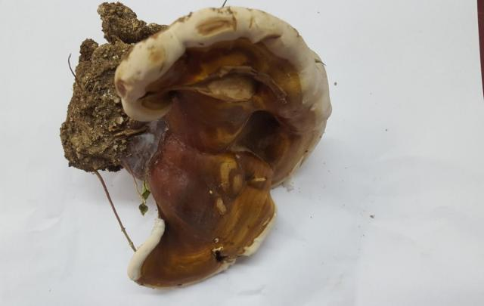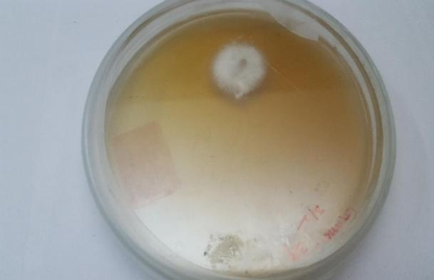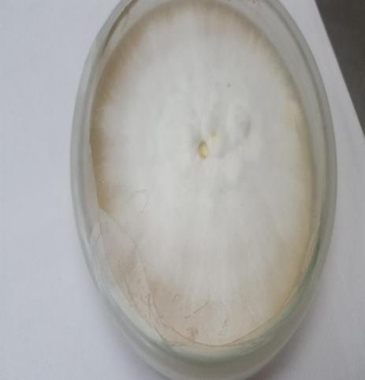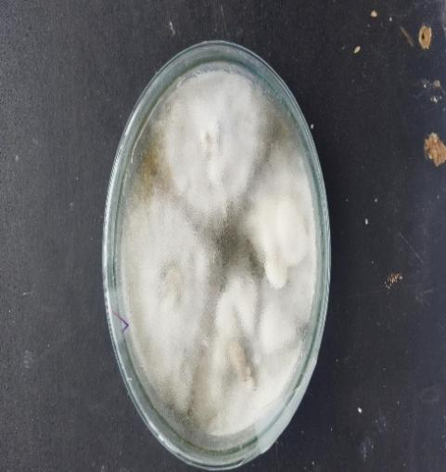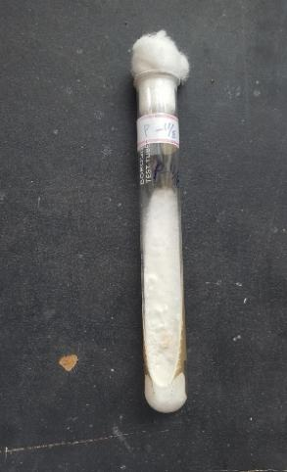

Figure 2: Submerged fermentation of Ganoderma lucidum for xylanase production using non-food plant biomass as substrate
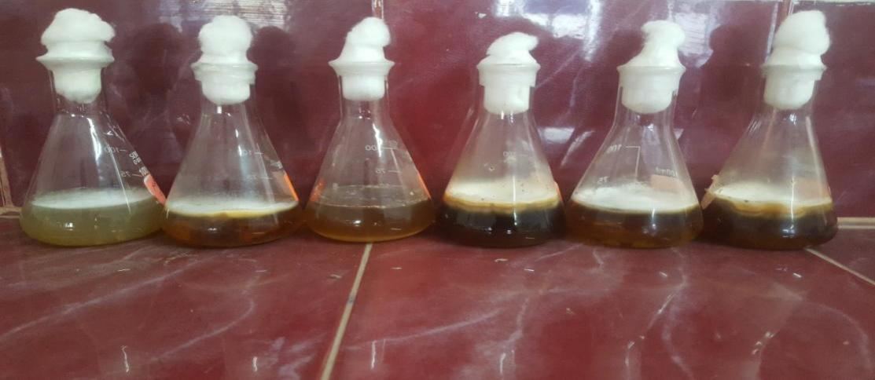
Figure 3: Wildly growing non-food terrestrial and aquatic plants
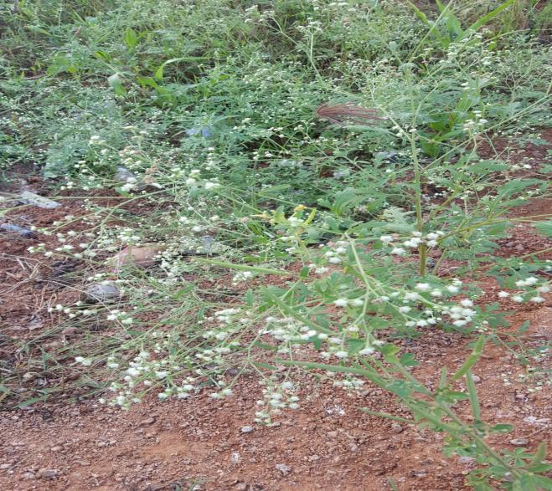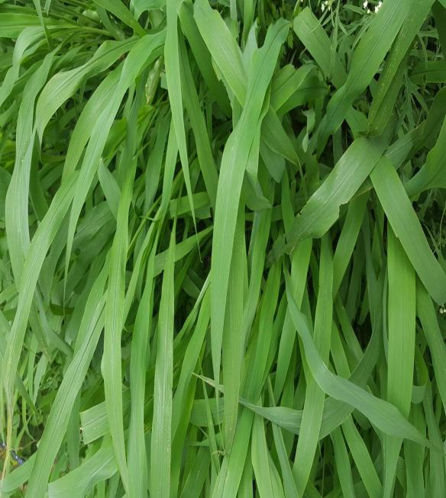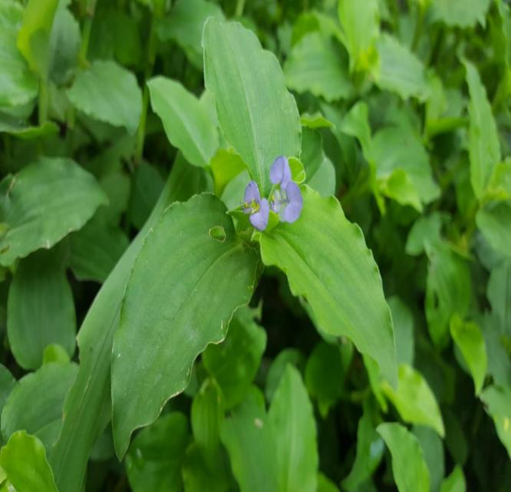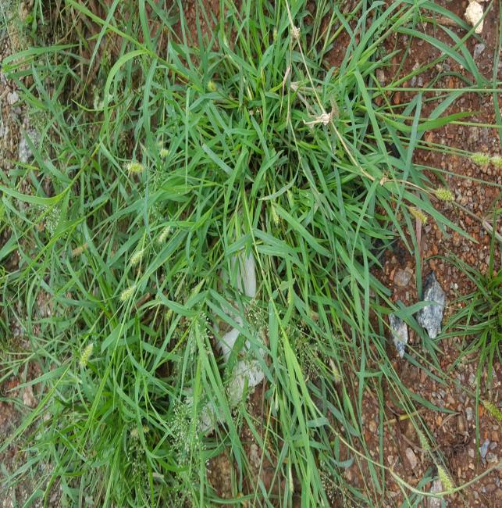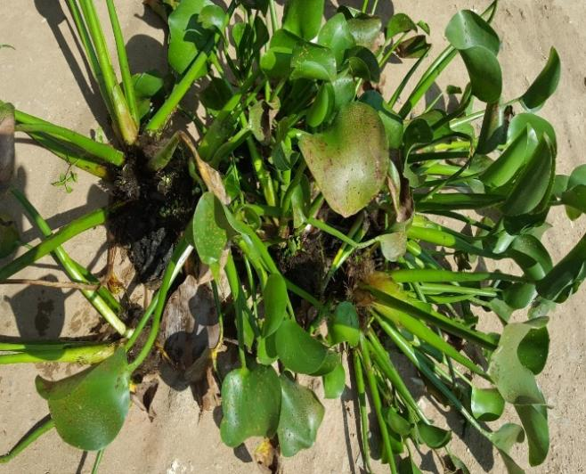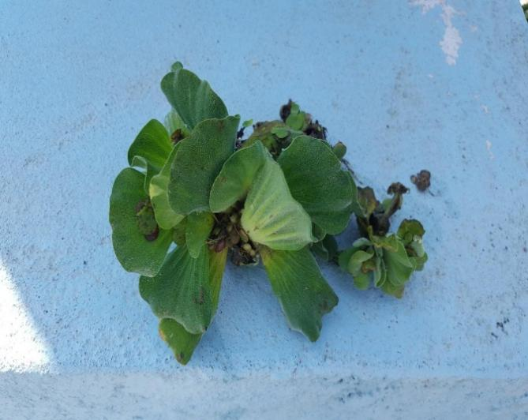

Table 1: Xylanase activity of Ganoderma lucidum by using non-food plant biomass autohydrolysis liquor in submerged fermentation
S. No. | Substrate | Xylanase activity (U/ml)
1 | Pure xylan | 19.5
2 | Setaria viridis | 14.5
3 | Cynodon dactylon | 12.7
4 | Parthenium hysterophorus | 11.8
5 | Eichhornia crassipes | 9.8
6 | Pistia stratiotes | 9.0
7 | Commelina benghalensis | 5.2

4. DISCUSSION
The utilization of lignocellulosic biomass as a fermentation substrate has gained considerable attention due to its potential to reduce enzyme production costs. In the present study, wildly growing non-food plant biomass was successfully used as a substrate for xylanase production by Ganoderma lucidum.
The high enzyme production observed with Setaria viridis may be attributed to its relatively high hemicellulose content, which acts as an effective inducer for xylanase synthesis. Previous studies have also reported that lignocellulosic residues rich in xylan can significantly enhance xylanase production by filamentous fungi.
The moderate enzyme production observed with aquatic weeds such as Eichhornia crassipes and Pistia stratiotes suggests that these plants contain adequate hemicellulosic components capable of supporting fungal enzyme production. Since these aquatic weeds often cause environmental problems by clogging water bodies, their utilization in biotechnology could provide both ecological and economic benefits.
The low enzyme production observed with Commelina benghalensis may be due to lower availability of hemicellulose or the presence of inhibitory compounds that interfere with fungal metabolism.
Overall, the results indicate that plant biomass hydrolysates can effectively serve as low-cost substrates for enzyme production. This strategy not only reduces fermentation costs but also contributes to the sustainable utilization of lignocellulosic waste.
5. CONCLUSION
The present study demonstrated that wildly growing non-food plant biomass can be effectively utilized as substrates for xylanase production by Ganoderma lucidum under submerged fermentation conditions. Among the tested substrates, Setaria viridis showed the highest potential for enzyme induction, followed by Cynodon dactylon and Parthenium hysterophorus. Aquatic weeds such as Eichhornia crassipes and Pistia stratiotes supported moderate enzyme production, while Commelina benghalensis showed minimal activity.
These findings suggest that non-food plant biomass can serve as a cost-effective alternative to expensive substrates for industrial enzyme production. Further studies involving optimization of fermentation parameters and large-scale production are recommended to enhance enzyme yield.
REFERENCES
Beg, Q. K., Kapoor, M., Mahajan, L., & Hoondal, G. S. (2001). Microbial xylanases and their industrial applications. Applied Microbiology and Biotechnology, 56, 326–338.
Collins, T., Gerday, C., & Feller, G. (2005). Xylanases: Structure and function. FEMS Microbiology Reviews, 29, 3–23.
Pandey, A., Soccol, C. R., Nigam, P., & Soccol, V. T. (2000). Biotechnological potential of agro-industrial residues. Bioresource Technology, 74, 69–80.
Polizeli, M. L., et al. (2005). Xylanases from fungi: Properties and industrial applications. Applied Microbiology and Biotechnology, 67, 577–591.
Sun, Y., & Cheng, J. (2002). Hydrolysis of lignocellulosic materials for ethanol production. Bioresource Technology, 83, 1–11.

