ANALYSIS OF WAVE ENERGY AS RENEWABLE ENERGY SOURCE ON SHALLOW WATER

Case Study Msasani Bay

ABSTRACT
This study takes a closer look at how effective a wave energy converter (WEC) is at producing renewable energy through simulation methods, specifically focusing on Msasani Bay along the Tanzanian coast., recently the electrical market in Tanzania increased due to different demand example the presence of SGR (standard gauge railway) and industrial use. the study focusses on developing country perhaps existing research are more focusing on developed country also msasani have it uniqueness in climate which differ to the existing literature review. The study aims to analyze wave characteristics like height, period, and direction, measure wave energy flux, set up input boundary conditions for a numerical wave model, and simulate the energy output and efficiency of a chosen WEC system. Data were collected from Tanzania meteorological authority (TMA) and been stimulated using Simulink modeling and been analyzed using spectral analysis used to characterize wave parameter which include wave heigh wave period and wave direction The result means that each meter of wave crest in Msasani Bay can deliver approximately 11.19 kilowatts of power under monthly average conditions. This is considered a moderate energy level, suitable for small-scale wave energy conversion technologies such as oscillating water columns or point absorber This research adds to the expanding field of marine renewable energy studies in East Africa and provides a cost-effective modeling framework for assessing wave energy projects in areas with limited data. It also suggests the need for site-specific field validation and long-term monitoring to support the future development and implementation of wave energy technologies in Tanzania.

TABLE OF CONTENT

CERTIFICATION ii
DECLARATION AND COPYRIGHT iii
ACKNOWLEDGEMENTS iv
DEDICATION v
ABSTRACT vi
LIST OF ABBEREVIATION x
NOMENCLATURE xi
LIST OF FIGURES xii
LIST OF TABLES xiii
CHAPTER ONE 1
INTRODUCTION 1
  - Introduction 1
  - Background of Statement 1
  - Statement of the Problem 3
  - Research Objective 4
    - General Objectives 4
    - Specific Objectives 4
  - Research Questions 4
  - Significance of Research 5
  - Scope of Research 5
CHAPTER TWO 7
LITERATURE REVIEW 7
  - Chapter Overview 7
  - Definition of Key Term 7
    - Wave Energy 7
    - Wave Converters 7
    - Shallow Water 10
    - Wave Power Density 10
    - Wave Height 10
    - Wave Period 10
    - Sea Waves 10
    - Swell Waves 11
    - Monsoon-Driven Waves 11
2.2.11 wave formation 11
2.2.13 Generation and Propagation of Ocean Waves 14
  - Theoretical Literature Review 16
    - Wave Energy Theory 16
    - Shallow Water Wave Transformation Theory 17
    - Theories Applicability to Study 17
    - Power Take-Off System in Wave Converters 18
  - Empirical Literature Review 19
    - Global Review 19
    - Africa Review 19
    - Tanzania Review 20
  - Research Gap 20
  - Conceptual Frame Work 21
    - Relation Between Variables 21
    - Boundary Condition 22
CHAPTER THREE 23
RESEARCH METHODOLOGY 23
  - chapter Overview 23
  - Research Approach 23
  - Research Design 23
  - Study Area 24
  - Data Collection 24
    - Secondary Data Collection 25
  - Data Analysis 25
    - Wave Energy Potential and hydrodynamic performance 25
  - Validation 26
  - Chapter Overview 27
  - Site Profile and Environmental Characteristics 27
    - Geographical Information of Msasani 27
    - Wave Climates and Pattern 28
    - Bathymetric and Tidal Information 28
  - Costal And Marine Condition 29
    - The Geomorphology of the Coast 29
    - Oceanic Environments 29
    - Sediment Conditions and Water Quality 30
    - Coastal Use and Human Activity 30
  - Discussion Based On Specific Objectives 30
    - Evaluate Wave Characteristics 30
    - To Quantify the Wave Energy Flux (Power Density) In Msasani Bay 34
    - Input Boundary Condition for the Numerical Wave Model Using Shallow Water Data 37
  - Implementation in Simulink 44
    - Simulation Parameters 45
  - Results Based on Each Specific Objective 45
    - Wave Characteristics 45
    - wave energy density (power flux) 46
CHAPTER FIVE 47
CONCLUSION AND RECOMMENDATION 47
  - Introduction 47
  - Conclusion 47
  - Recommendation 48
REFERENCE 49
APPENDEX 51

LIST OF ABBEREVIATION

CRSES  DMI | Center for renewable and sustainable energy studies  Dar es salaam maritime institute
KW/M | Kilowatts per meter
Kv | Kilovolts
LCOE | Level zed cost of energy
Mw | Megawatts
NOAA | National oceanic and atmospherically administration
OWC | Oscillating water column
PTO | Power takes off
SGR | Standard gauge railway
SWAN | Simulating wave near shore
SWL | Safe working load
TMA | Tanzania meteorological authority
TWH | Terawatts hour
PTO | Power takes off
WEC | Wave energy converter
WIOMSA | Western Indian Ocean marine science association
ZECO | Zanzibar electricity corporation

NOMENCLATURE
Constants
g = 9.81 m s−2 αPM = 0.0081
αP = 0.0074
σa = 0.07
σb = 0.09
ρ = 1025 kg m−3

Standard symbols
Wave amplitude [ m]
Wave amplitude of the wave component [ m]
Cw Wave steepness constant [ ]
C Wave propagation speed [ m/s ]
Cb Bottom friction coefficient [ ]
Cg Group speed [ m/s ]
Cg0 Group speed at deep water [ m/s ]
Cgs Group speed at deep water [ m/s ]
Cx Propagation velocity in x-space [ m/s ]
Cy Propagation velocity in y-space [ m/s ]
Cθ Propagation velocity in θ-space [ ]
Cσ Propagation velocity in σ-space [ ]
Cds Turnable coefficient for wave energy dissipation [ ]
Cp Phase speed [ m/s ]

LIST OF FIGURES
Figure 1.1 wave power global approximately in Kilowatts per meter (kW/m) 3
figure 2. 1 OWC device 8
figure 2. 2 point absorber converter 9
figure 2. 3 Wave refraction induced by bottom topography close to the shore 12
figure 2. 4 wave diffraction induced by breakwater 13
figure 2. 5 The classification of wave breaking types into categories and they all depend on wave steepness 14
figure 2. 6 Ocean wave generation induced by wind action (Pinet, 2020 14
figure 2. 7 Periodic oscillation of the water surface, adapted from Bosboom and Stive .15 figure 2. 8. The figure shows various types of ocean waves which are classified according to their periods and frequency 16
Figure 2. 9 conceptual frame work 21
Figure 3. 1 Topography of msasani bay 24
Figure 4. 1 The graph of wave height (m) and wave period 31
Figure 4. 2 The histography representing wave height (m) 33
Figure 4. 3 The line graph presenting the wave period (s) 34
Table 4. 6 Wave height and wave period used in modeling 38
Figure 4.5 The graph of simulated extracted power over a time for a wave energy converter under shallow water 39
Figure 4.6 The graph Cumulative energy extraction over time by the wave cinveter WECs in shallow water 40
Figure 4.7 The graph of velocity response of the wave energy converter (WECs)floats under shallow water 41
Figure 4.8 Wave energy input and extracted power overtime by wave energy converter42 Figure 4.9 The graph of displacement respond of the wave energy converter over a time under shallow water 43
Figure 4.10 The Graph of acceleration respond of the wave energy conveter floats over time under wave excitation 44

LIST OF TABLES
Table 2.1: different types of PTO technologies 18
Table 4.1 Table Showing Evaluated Data 31
Table 4. 2 The Summary of sample data 32
Table 4. 3 Wave height (m) of selected data at msasani bay 32
Table 4. 4 Wave period of selected data at msasani nay 33
Table 4. 5 Showing different hydrodynamic performance of each converter 36
Table 4. 6 Wave height and wave period used in modeling 38

Introduction

CHAPTER ONE INTRODUCTION

This chapter focuses on the historical background of the study, statement of the problem, objectives and research questions, significance of the study, scope of the study, limitation of the study and definition of key terms

Background of Statement
Ocean wave energy stands out as one of the most promising and sustainable renewables Energy resources available today. According to the World Energy Council, the global potential for wave energy that can be harnessed from the oceans is estimated at a staggering 2 TWh per year. This makes wave energy a significant player in the renewable sector, capable of generating substantial amounts of energy for society. With growing concerns about global warming and air pollution, numerous studies have been undertaken to explore better ways to generate electricity that can replace fossil fuel-based energy production, ultimately aiming to reduce greenhouse gas emissions (Liberti, 2015).
Ocean energy encompasses various forms of renewable resources that can be tapped for electricity generation. These include thermal gradients, salinity gradients, ocean currents, tides, and, of course, wave energy. This study specifically focuses on wave energy, which is most abundant between 30° and 60° latitude in both hemispheres, particularly along the western coasts of Scotland, Portugal, Chile, New Zealand, Australia, and South Africa. This abundance is largely due to the prevailing wind patterns and the long distances over which storms can develop (Bekker, 2019)
Wave energy is increasingly recognized as a viable renewable energy source, especially for coastal regions that experience consistent wave activity. Africa, with its extensive coastline, holds tremendous potential for harnessing wave energy. However, research and development in this area have lagged behind other parts of the world (Aderinto, 2018)
Countries like South Africa and Morocco are beginning to explore wave energy as a clean alternative to fossil fuels. Yet, challenges such as high initial investments,

technological complexities, and environmental impacts continue to hinder full-scale development (Mpholo, 2020)
Along the stunning coast of Tanzania, places like Msasani Bay offer a fantastic chance to explore how well wave energy converters (WEC) work, thanks to the consistent wave patterns from the Indian Ocean. Previous studies on ocean energy in East Africa have pointed out the region's incredible potential, while also stressing the importance of localized feasibility studies (Omar, 2024)
According to reports from Global Information Systems (GIS), Tanzania boasts powerful offshore wave power that could generate up to 17 GWh, along with an estimated tidal stream power of 133 kW/m. unfortunately, this potential remains largely untapped.
Shockingly, around 60% (or two-thirds) of Tanzanians still don‘t have reliable access to electricity. In recent months, power rationing has become even more severe, with outages lasting over 12 hours as the national grid struggles with significant shortages due to overloads and aging infrastructure. The situation in 2023 is notably worse than it was five years ago, significantly impacting Tanzania‘s economic production and growth. The World Bank estimates that power outages cost businesses in Tanzania about 15% of their annual sales, translating to millions of dollars lost for the national economy ). ((GEPC), 2022)
The energy crisis is hitting Zanzibar hard, a semi-autonomous region and popular tourist destination that depends heavily on mainland Tanzania for its electricity. Both Unguja and Pemba rely entirely on power sourced from TANESCO, connected by undersea cables with capacities of 100 MW and 25 MW, respectively. Unfortunately, Zanzibar doesn‘t have its own power generation facilities, so it gets its electricity through a 132kV undersea cable. This cable often faces reliability and maintenance issues, which can leave the entire island in the dark. To help counter this risk, the Zanzibar Electricity Company (ZECO) has set up 25MW of grid-connected high- speed backup diesel generators. Many hotels, offices, industries, and private consumers also have their own emergency diesel generators to cope during outages. However, these come with high maintenance costs and emit harmful fumes, posing a threat to the environment. Exploring offshore wind and tidal energy could be a game- changer for Zanzibar, allowing it to reduce its dependence on TANESCO, especially

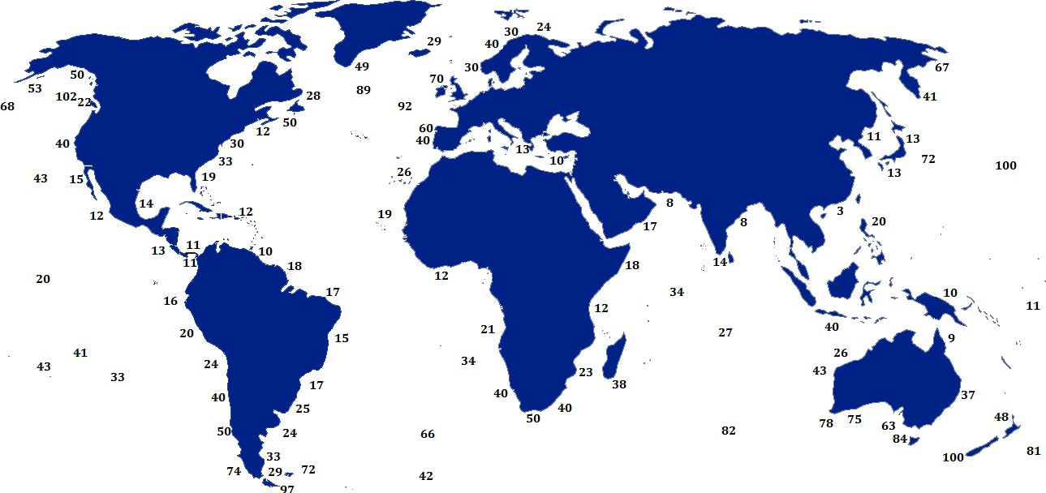
since the national grid has been struggling with ongoing power shortages. ((GEPC), 2022)

Figure 1.1 wave power global approximately in Kilowatts per meter (kW/m) (Parry et al., 2016).

Statement of the Problem
The global imperative to transition toward sustainable energy source is accelerating due to climate change concern and finite nature of fossil fuel. Wave energy, on the other hand is a promising and largely untapped resource, especially for coastal nations. However, its potential remains mostly unexplored in Tanzania, which is situated along the east coast near Dar es Salaam. It's clear that Tanzania needs alternative energy sources to support its existing energy demands. For instance, the Standard Gauge Railway (SGR) plays a crucial role in economic activities, and any energy shortfall could lead to economic downturns
While significant research and development effort have focuses on wave energy extraction in developed countries the potential of wave energy in developing country particularly in coastal areas with high demand remain less comprehensively understood and characterized
The lack of local data on wave dynamics, energy conversion efficiency, and economic viability hinders the adoption of wave energy as a sustainable alternative to fossil fuels in Tanzania. Previous studies have primarily focused on regions

outside of Africa, making it challenging to assess their performance under the specific conditions found along Tanzanian coasts (falcao, 2010).
Inaccurate resources analyze may lead to limits the design WECs specifically adopted on such climated condition. The study aims to analyze wave characteristics like height, period, and direction, measure wave energy flux, set up input boundary conditions for a numerical wave model, and simulate the energy output and efficiency of a chosen WEC system
Wave energy is an exciting opportunity for renewable energy generation, especially in coastal areas like Tanzania. However, the widespread use of wave energy converters (WECs) is still quite limited. One major reason for this is the uncertainty surrounding how efficiently these WECs operate under the specific wave conditions and environmental constraints of Msasani Bay. To truly harness the potential of wave energy, we need a thorough assessment of WEC efficiency in this context. (Omar, 2024)

Research Objective
The objective of the proposed research consists of general objectives and specific Objectives.

General Objectives
The study aims to analyze wave energy as renewable energy source on shallow water at msasani bay

Specific Objectives
      - To evaluate wave characteristics (height, period, direction) in msasani bay.
      - To quantify the wave energy flux (power density) in msasani bay.
      - To Obtain the input boundary conditions for the numerical wave model using shallow wave data.

Research Questions
- What are the wave characteristics (height, period and direction) in msasani bay?
- What are wave energy flux available in msasani bay?

- What Are Input boundary condition required for numerical wave model using Shallow Wave Data?

Significance of Research
This study aims to assess the potential of wave energy in shallow water settings, using Msasani Bay as a focal point. It will provide essential insights for the development of renewable energy in Tanzania. The research will enhance our understanding of the availability of wave energy resources, the feasibility of the technology, The results will be invaluable for policymakers as they craft comprehensive renewable energy strategies, helping to lessen reliance on fossil fuels and boost energy security.
Moreover, this research will serve energy investors, technology developers, and international development organizations by offering localized data on wave energy potential in tropical shallow waters. It will also add to the global knowledge pool regarding shallow water wave energy systems, providing insights that could benefit other coastal developing nations grappling with energy issues.
Additionally, the study will align with Tanzania's commitment to sustainable development goals, especially like Affordable and Clean Energy by delivering evidence-based recommendations for renewable energy initiatives. It will also play a role in building capacity for renewable energy research and development within Tanzanian academic and research institutions.

Scope of Research
This study aims to explore wave energy as a renewable resource in shallow water settings, specifically focusing on Msasani Bay in Tanzania. We will dive into wave resource assessment, evaluate the technology available, analyze environmental impacts. Msasani Bay is a prime example of a shallow water environment along the Tanzanian coast, offering valuable insights that could apply to other similar coastal regions.We will investigate the characteristics of wave energy through field measurements, numerical modeling, and data analysis that captures both seasonal and annual variations. The research will also evaluate the technical feasibility of different wave energy conversion technologies that are suitable for shallow water,

taking into account factors like wave climate, water depth, and local environmental conditions.
Moreover, we will assess the environmental impacts of developing wave energy, including how it affects marine ecosystems, coastal dynamics, and the local communities. The economic side will also be analyzed, looking at capital costs, operational expenses, and potential revenue streams from wave energy projects.
Our geographical focus will be on Msasani Bay and its nearby coastal environment, while we‘ll also consider the current wave energy potential and future development scenarios. The study will specifically target shallow water environments (depths of 2 to 15 meters) and will not extend to deep-water wave energy systems.

Chapter Overview.

CHAPTER TWO LITERATURE REVIEW

This chapter provides a comprehensive overview of wave energy, including definition of key terms, theoretical literature review, empirical literature review, conceptual framework, and research gap. It analyses feasibility of wave energy as source of energy in shallow water at msasani bay and identifies gaps in existing literature to enhance adequate investments on wave energy

Definition of Key Term

Wave Energy
This is type of renewable source of energy derived by movement of the ocean's surface waves. Waves are produced when wind moves across the sea's surface, transferring energy to the water. These waves have both potential energy, which comes from the wave's height variations, and kinetic energy, which comes from the water's motion. By capturing this energy using devices known as Wave Energy Converters (WECs), it is possible to convert it into usable electricity.
Because of its high energy density, predictability, and minimal environmental impact, wave energy is regarded as a promising clean energy source. For coastal areas with regular wave activity, it can be extremely beneficial. (Holthuijsen, 2015)

Wave Converters
A wave energy converter (WEC) is a nifty device that harnesses the power of ocean waves, transforming that energy into usable electricity through various methods like mechanical, pneumatic, or hydraulic processes (copping, 2025)

Oscillating Water Column:
Oscillating water column (OWC) devices are typically built or installed right along the shoreline, and they‘re pretty easy to maintain. However, they don‘t capture as much energy as their nearshore and offshore counterparts. This is mainly because, as waves approach the shore, the interaction with the seabed diminishes the wave energy, resulting in less power being generated for the grid. (s.b, 2024)

These devices feature a wave capture chamber equipped with an open-air turbine. When waves come in, they enter the chamber from below, pushing air through the turbine, as illustrated in figure 2.1 The moving air spins the turbine generator, producing power. OWCs utilize a Wells turbine, which is unique because it can rotate in one direction no matter which way the air flows. The only moving part in this setup is the Wells turbine, named after its inventor, Professor Wells (Smith, 2019) OWC energy conversion systems are among the most widely used in wave energy technology (Joubert, 2016). According to Jamasb et al. (2016), a significant number of OWCs have been constructed around the globe. Here are a few notable examples: The Wavegen LIMPET, a 500-kW plant featuring two 250 kW counter-rotating Wells turbines, is located on the island of Islay off Scotland‘s west coast. The Japanese OWC device known as Kaimai, developed by Yoshio Masuda, who is often referred to as the father of wave energy technologies (Guedes Soares et al., 2015). The European OWC Pilot Plant, Pico OWC, which can be found on the island of Pico.

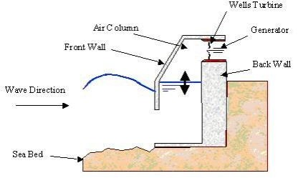

figure 2. 1 OWC device (konispoliastas, 2024)

The Land Installed Marine Powered Energy Transformer, or LIMPET for short, was the very first commercial-scale wave energy device to connect to the grid right from the shoreline. This groundbreaking technology made its debut on the beautiful Hebridean island of Islay, located off Scotland's southwestern coast, and it officially started operating in November 2000 (copping, 2025)

Point Absorber
A point absorber is essentially a floating device, and its size like the diameter of a buoy is quite small compared to the wavelength of the waves it interacts with. This compactness is what sets it apart. Thanks to this design, point absorbers can effectively capture energy from waves coming from any direction, making them omnidirectional.
The core idea is to take advantage of the movement between two parts of the device or between the device and a stationary point. As the waves cause this motion, it gets transformed into electricity through a system known as Power Take-Off (PTO) (rathaur, 2024)
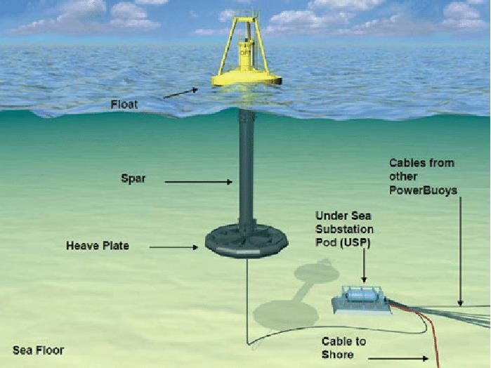

figure 2. 2 point absorber converter
Source: Jingjing (2023)

Attenuators:
Attenuators are an important type of Wave Energy Converters (WECs). Unlike point absorbers, which are small compared to the wavelength and can capture energy from all directions, attenuators have unique features that shape how they function.
An attenuator is a long, segmented floating device that usually aligns parallel to the incoming waves. Its length is typically equal to or even longer than the wavelength of the waves it aims to harness. These devices work by "surfing" the waves, flexing and bending as the wave crests and troughs move along their length

Shallow Water
shallow water environment in the context of wave energy, refers to coastal areas where the water is less than half the wavelength of incoming waves. These spots usually have depths ranging from 2 to 15 meters, especially in near-shore locations (Liberti, 2015)

Wave Power Density
Wave power density measures how much wave energy is available per unit of wave crest length, typically expressed in kilowatts per meter (kW/m). This figure gives us a good idea of the energy potential that can be harnessed (onea, 2019)

Wave Height
wave height is defined as the average height of the tallest one-third of waves recorded over a period. This measurement is crucial for assessing wave energy and designing systems to capture it (s.b, 2024).

Wave Period
The wave period refers to the time it takes for successive wave crests to pass a fixed point. This interval is important because it affects the energy content of the waves and helps shape the design requirements for wave energy converters (s.b, 2024)

Sea Waves
This is type of wave Formed by local winds blowing over the ocean surface (Whose Wave period: 3 to 10 seconds. And it‘s Wave height: 0.5 to 3 m (more in monsoon seasons). Directionality: Determined by prevailing winds (NE monsoon vs. SE trade

winds). Its Best-suited wave energy converter is Point Absorbers (e.g., buoy-type WECs) buoy which are Efficient at capturing energy from short-period waves
It Challenges Intermittency due to wind variability with Lower energy density compared to swell waves (Bekker, 2019)

Swell Waves
This is type of wave formed by distant storms and travel thousands of kilometers, it‘s Wave period 10 to 20 seconds. With Wave height: 1to 4 m (more consistent than wind waves). Typically aligned with Indian Ocean swells (southwesterly in Tanzania) It‘s is Best-suited wave energy converter WECs for Oscillating Water Columns (OWCs) Effective for long-period waves. And Attenuators (e.g., Pelamis WEC) Align well with directional swells. (Li, 2025)

Monsoon-Driven Waves
This type of wave is seasonal wave having north east (NE) Monsoon (Dec to Mar): having Increased winds with higher waves (2 to 4 m). whereas SE Monsoon (Jun to Sep) with Milder waves (1 to 2.5 m), Wave steepness: Higher in NE monsoon, with higher structural loads Hybrid Systems (e.g., point absorber and OWC integrated) for coping with variability. Overtopping Devices (e.g., Wave Dragon) Appropriate for monsoon waves with high energy. (Kamphuis, 2010)

Breaking Waves (Surf Zone Waves)
This is type of Occur in shallow waters its depth is 1/2 wavelength with High turbulence and energy dissipation which suitable Shoreline WECs (e.g., TAPCHANTapered Channel Device (Holthuijsen, 2015)

wave formation
      - Wave Refraction
The waves are affected by the bottom topography as they approach the shallow water region. This will cause the orbital motion of the waves to change. The waves will bend and change direction at an angle. This is called wave refraction that
is analogous to the refraction of light waves. This process is described by Snell‘s law,

with the refraction coefficient given as

Kr =
cos 𝛼
√
0
2.1

cos 𝛼

where α is the angle between the wave crest and the shoreline and αo is the deep water
angle. The angles can be found by applying Snell‘s law expressed as

𝑠𝑖𝑛 𝛼

𝑠𝑖𝑛 𝛼0
= 𝐶𝑃
𝐶𝑃0
2.2

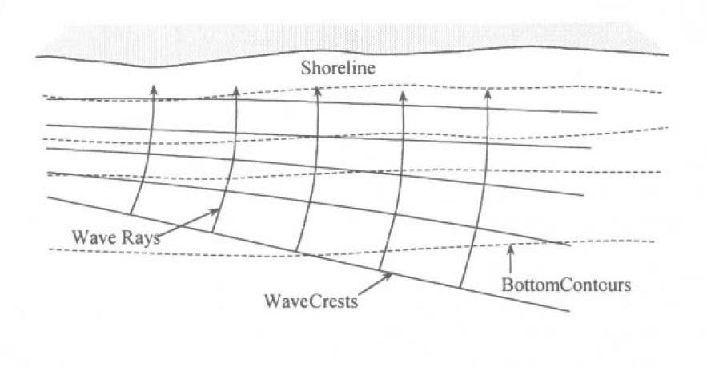
where Cp and Cpo are the phase speeds at shallow water and deep-water regions, respectively (Kamphuis, 2010) figure below show as how refraction occur in wave

figure 2. 3 Wave refraction induced by bottom topography close to the shore
(halsne, 2025)

Wave Reflection
Ocean waves are either partially or totally reflected by man-made structures such as breakwaters or natural objects such as sea walls and cliffs. Waves bounce back from these objects and can cause interference with other approaching
waves which may result in standing waves (Reeve et al., 2015).

Wave Diffraction
The wave diffraction phenomenon is the process of obstruction of the wave propagation induced by obstacles such as offshore island, headlands, rocks, reefs, and breakwaters. During this process, the wave energy spreads sideways when the waves are in contact with one of the obstacles and the rest of the waves will be reflected towards the sea (Bosboom and Stive, 2017).
Figure below shows Diffraction which also analogous to the physical phenomena in sound and light wave motion
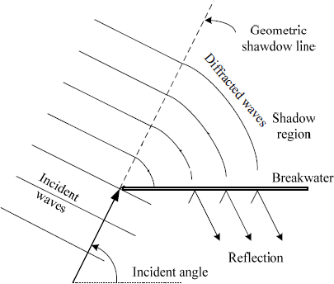

figure 2. 4 wave diffraction induced by breakwater
(Rasmeemasmuang and Weesakul, 2009)

2.2.11.14 Wave Breaking
Wave breaking occurs when the front face of the waves becomes steeper which will lead into the slow motion of the wave crest. During this process, the orbital motion of the waves will change because of the seabed. This will cause the lower part of the wave to decrease its speed and eventually the wave crest will be unstable and the wave will start to break According to Bosboom and Stive (2017) and Davidson- Arnott (2016),
the wave breaking condition in deep water is limited by the wave steepness ratio

𝐻 = 𝐻0
𝐿0
(2.3)

and occurs when the wave crest interior angle is 120⁰𝐶There are three categories considered as the basic types for wave breaking and these
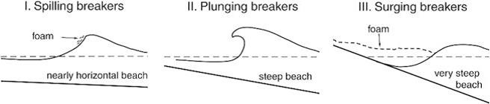

figure 2. 5 The classification of wave breaking types into categories and they all depend on wave steepness
(Pecher and Kofoed, 2017)

2.2.13 Generation and Propagation of Ocean Waves
Waves are generated by wind action on the water surface, as illustrated in Figure The wind blows across the ocean surface and the waves are generated. Waves are fluctuations of the water level that are accompanied by local currents and pressure fluctuations (Kamphuis, 2010).
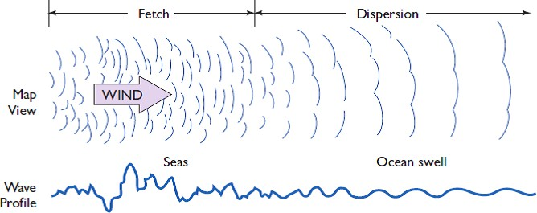

figure 2. 6 Ocean wave generation induced by wind action (Pinet, 2020).
These waves appear as a periodic oscillation of the water surface above and below

the still water level (SWL). They are characterized by the following parameters: the
vertical distance, H, of the wave that is the distance between the crest and trough, and it is twice the amplitude a, the horizontal distance between successive wave crests is the wavelength, L, the period T is the time interval between successive crests passing a particular location. The frequency f is the inverse of the wave period. The waves propagate with the speed C which is the distance travelled by a wave per unit time and is sometimes referred to as the phase speed.

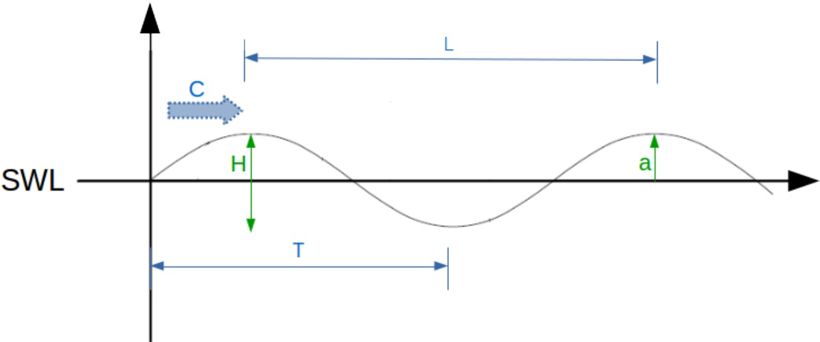

figure 2. 7 Periodic oscillation of the water surface, adapted from Bosboom and Stive (2017).
The height of the waves depends on the distance which the wind blows over the ocean surface (known as the fetch), the duration of how long the wind blows and the speed of the wind over the ocean surface (Davidson-Arnott, 2020). The greater the wind speed, the longer it blows and the longer the fetch, the bigger the waves. Figure
2.5 shows different types of waves that are found in the ocean as a function of wave period. It also shows the relative amount of energy that the ocean contains at each frequency (or period) and shows that wind-generated waves are the most energetic ocean waves.

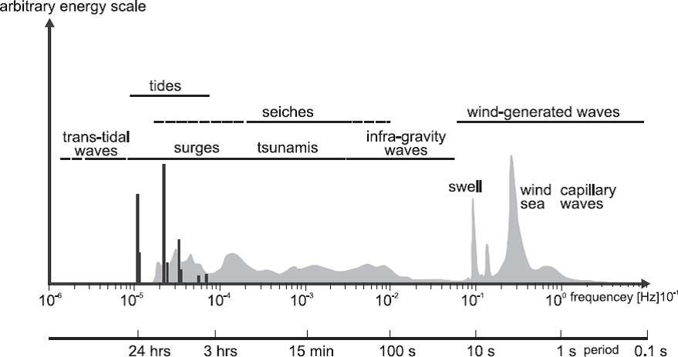

figure 2. 8. The figure shows various types of ocean waves which are classified according to their periods and frequency (Holthuijsen, 2015).
Ocean waves can vary in size, from small ripples to bigger waves. These waves propagate the energy supplied by the wind to the nearshore. According to Holthausen (2010) and Benassi (2006), wind-generated waves are divided into short and long waves which are classified in terms of periods as shown in Figure. The short waves have periods less than 20 s and long waves have periods ranging from 20 to 30 s (Benassi, 2006

Theoretical Literature Review

Wave Energy Theory
wave energy theory is all about fluid mechanics and the dynamics of ocean waves. It lays the groundwork for grasping how we generate, propagate, and convert wave energy. The linear wave theory, first introduced by Airy in 1845 and later expanded by Stokes in 1847, tells us that ocean waves carry energy that‘s proportional to the square of their height and directly related to their period. This relationship is crucial for assessing wave energy and designing converters (dean, 1991).

The theoretical framework also includes wave energy flux, which explains how wave energy moves through water. In deep water, we can express wave energy flux with

the equation P = 𝜌𝑔2𝐻2𝑇
32𝜋
(2.4)

Here, P stands for wave power per unit width, ρ is the density of water, g is the acceleration due to gravity, H is the significant wave height, and T is the wave period (johannes, 2020). This fundamental relationship will help us evaluate wave energy potential in shallower waters, where we need to consider how waves transform.

Shallow Water Wave Transformation Theory
Shallow water wave transformation theory describes how wave properties change when waves travel from deep water to the coast. It builds on Lamb's 1932 work and was expanded upon by Mei et al. in 2018. Grasp the behavior of wave energy in shallow places like Msasani Bay requires a grasp of this theory. It discusses wave shoaling, refraction, diffraction, and breaking, all of which have a major effect on the availability of wave energy and converter performance. (2019, Bekker)
When waves enter shallow water, they go through particular mathematical changes that account for the energy conservation laws and the depth-dependent speed of waves. Shoaling effects, which concentrate wave energy close to the shore, cause waves to initially increase in height while their wavelength shortens as they approach shallower locations. This theoretical insight will guide us in designing and optimizing wave energy converters.

Theories Applicability to Study
Since they establish the foundation for comprehending the wave energy potential in Msasani Bay, the wave energy theory and shallow water transformation theory are essential to our investigation. These theoretical frameworks will be used to explore the properties of wave energy resources, predict system performance, and optimize converter design for shallow water situations. Additionally, this study will use these theories to assess the efficacy of several wave energy conversion systems under the particular environmental conditions of Msasani Bay. Our examination of the interaction between waves and structures, the effectiveness of energy harvesting, and

the development of systems for deployment in shallow waters will all be guided by the theoretical framework (Aderinto, 2018).
merging wave energy theory with shallow water transformation principles, we can thoroughly assess the wave energy potential while taking into account the distinct features of near-shore environments. This solid theoretical base will aid in crafting suitable wave energy solutions tailored to the coastal conditions of Tanzania and will help push forward the development of shallow water wave energy technology.

Power Take-Off System in Wave Converters
The Power Take-Off (PTO) system is the core energy conversion mechanism in a WEC device. It transforms mechanical energy captured the waves into electrical power that can be integrated onboard or fed into the grid. The efficiency and effectiveness of the PTO significantly influence the overall performance of any wave energy conversion system. The PTO is responsible for absorbing wave induced motion and converting it into useful work via pneumatic, hydraulic or direct drive mechanisms (Falcao, 2010).
There are several PTO technologies used in wave energy systems, and are suitable for different WEC systems.

Table 2.1: different types of PTO technologies

PTO Type | Description | Typical Applications
Hydraulic PTO | Uses fluid under pressure to drive a hydraulic motor and generator | Point absorber, oscillating bodies
Pneumatic PTO | In OWC devices, wave motion compresses air to drive an air turbine | OWC chambers
Direct Drive PTO | Uses linear or rotary electrical generators without intermediate systems | Modern floating WECs
Mechanical PTO | Uses cams, gears or linkages  to transmit motion to an | Small scale devices

 | electrical generator
Piezoelectric | Uses material deformation to generate electricity | Micro-scale WECs
Source: Babarit (2017)

Empirical Literature Review

Global Review
Around the world, numerous studies have been carried out to assess the characteristics of wave energy and how effective wave energy converters (WECs) are. As noted by (review of wave energy extraction, 2007), the efficiency of these converters is heavily influenced by factors like wave height, wave period, and wave direction, all of which can change depending on the sea conditions and the geographical area. In their research, Yu and Li (2013) utilized the WEC-Sim model to simulate how point absorber wave energy converters perform, finding that their efficiency ranged from 40% to 60% when the devices were finely tuned to the local wave environment. Likewise, (Iglesias and Carballo 2019) employed the SWAN (Simulating WAves Nearshore) model to evaluate the wave power potential along the Spanish coastline. Their results underscored the reliability of simulation models, especially when they are fed accurate boundary conditions, revealing seasonal power densities that fluctuated between 20 and 40 kW/m. (falcao, 2010)

Africa Review
In Africa, research on wave energy is definitely on the rise, but it still lags behind global trends. That said, there‘s a lot of potential, especially along the coastlines of East and West Africa. For instance, Obudho, Gathua, and Odido (2015) carried out a wave energy resource assessment along the Kenyan coast, utilizing satellite-derived wave data and numerical modeling. Their findings revealed that this region boasts a steady wave energy potential of about 3 to 5 kW/m, which is perfect for small to medium-scale marine energy systems. Odido (2019) pointed out that many African countries, due to limitations in infrastructure and funding, often depend on simulation and remote sensing data instead of direct field measurements for their marine energy research. Moreover, Dada and Alibaba (2013) examined wave

conditions along Nigeria's coastline using offshore data and highlighted the potential for power generation, even with the fluctuations in seasonal wave energy flux. These studies underscore that while Africa may be under-resourced in marine technology, it can still tap into satellite and numerical modeling data to explore wave energy opportunities in a cost-effective manner.

Tanzania Review
In Tanzania, there's not a lot of specific research on wave energy, but some foundational environmental studies lay the groundwork for simulations. For instance, Mtolera and Zwolinski (2015) carried out a baseline environmental assessment of Msasani Bay, concentrating on hydrology and water quality. Although their work didn‘t focus on wave energy directly, they did gather important data on tide levels, water depth, and the shape of the bay key elements for grasping how waves behave in shallow waters. Similarly, (Mgaya and Kalanga he 2016) looked into marine pollution and oceanographic processes along Tanzania‘s coast. Their results offer useful insights that can help define the boundaries for numerical models and shed light on how waves transform in coastal areas. While there haven't been any direct studies on wave energy conversion efficiency in Tanzania, researchers can still leverage satellite-based wave data from sources like NOAA and Copernicus, along with tools like WEC-Sim and SWAN, to carry out virtual assessments. This is especially beneficial for Msasani Bay, where on-site equipment and ongoing wave monitoring are quite limited.

Research Gap
Integration of wave energy converter on shallow water particularly in east African continent remain under explore while global advanced has been made in WECs technologies most studies focus on developed country and not in developing country. The analysis will fill the gap by modeling WEC efficiency in the shallow water circumstances of Msasani Bay, assessing wave energy characteristics, and quantifying power density using simulation tools such as MATLAB/Simulink. It will deliver the empirical simulation-based
Furthermore, although research by Kofoed et al. (2016) and Astariz and Iglesias (2016) shows that shallow water wave energy systems are technically feasible, their

studies concentrate on industrialized nations with well-established marine renewable energy sectors. The research currently in publication mainly ignores the obstacles and possibilities for wave energy growth in underdeveloped nations, especially in sub-Saharan Africa.

Conceptual Frame Work
independent variable Dependent variable
Simulation
Wave energy
Boundary condition for mode
- Wave depth
- bathymetry
Wave energy flux (power density)
Wave characteristics
- Height
- Period
- Direction
Figure 2. 9 conceptual frame work
Source (researcher ,2025)

Relation Between Variables
      - wave characteristics
Wave height, wave period, and wave direction are the independent variables in this study, which aims to assess the wave characteristics (height, period, and direction) in Msasani Bay. The shape and movement of waves throughout time and space are determined by these factors. The overall wave profile or classification, which fluctuates in response to changes in those wave parameters, is the dependent variable in this instance. Wave energy and directional spread therefore alterwhen wave height or period rises, impacting the description or modeling of the wave environment. when wave height or period rises, impacting the description or modeling of the wave environment. And directional spread therefore

Wave Energy Flux
Together with factors like water density and gravitational acceleration, the wave height and wave period still function as independent variables. The dependent variable, the wave energy flux expressed in watts per meter (W/m), is directly impacted by these inputs. Wave energy equations show a direct positive link between the independent variables and the power output, with higher waves and longer wave periods transferring more energy through the wave.

Boundary Condition
objective is to use shallow wave data to create input boundary conditions for the numerical wave model; the independent variables include nearshore wave characteristics, seabed bathymetry, and shallow water depth. As waves travel from deeper to shallower waters, several environmental factors affect how the energy of the waves is changed. The set of boundary conditions needed to be entered into the simulation model is the dependent variable in this case. The accuracy of the simulation could be impacted by poor or unrealistic model boundaries caused by inaccurate or incomplete independent variables.

chapter Overview

CHAPTER THREE RESEARCH METHODOLOGY

This chapter describe how the research was conducted and it will involve Research approach, Research design, Area of the study, pilot study, sample size and sample technique, data collection methods, data analysis, validity and reliability of finding, and Ethical consideration

Research Approach
According to Creswell (2015) research approach described as plans procedures for research that spans the steps from broad assumption to detailed methods of data collection, analysis and interpretation. This study employed a quantitative approach.
Data will be sourced from historical oceanographic data, and secondary datasets, including meteorological records and bathymetric charts. Analytical tools such as simulation software (e.g., Simulink). This quantitative methods approach ensures that the study is both data-driven and context-aware, making it well-suited to assess the viability of wave energy as a renewable energy option for shallow water regions like Msasani Bay.

Research Design
This study adopts a simulation based quantitative research design aimed at assessing the efficiency of wave energy converter (WEC) in generating renewable energy at msasani bay .this research is structure to evaluate wave characteristic estimate wave energy flux define boundary condition for numerical models and analyses the performance of a (WEC)Under simulating condition Due to the scarcity of field data in the area, the study does not use physical measurements; instead, it makes use of modeling programs like MATLAB/Simulink as well as secondary wave data from documentary sources . These tools make it possible to model energy flux, wave dynamics, and converter performance using realistic environmental input.

Study Area
Area of study takes place at Msasani Bay, a sheltered coastal environment, located in Dar-Es-Salaam, Tanzania, which borders the Indian Ocean (approximate coordinates; 6.75°S, 39.25°E). Msasani Bay is an interesting coastal environment due its shallowness (10 to 30 meters nearshore), moderate wave conditions (wave heights of between 0.5 and 2 meters with periods of 6 to 10 seconds) and a tropical climate with monsoon seasons. Being so sheltered means that the wave energy flux (approximate estimates of 2 to 10 kW/m) is relatively low and/or moderate making it a good location to understand WEC efficiencies in one representing low to moderate energy coastal environments. It is also a location of importance to the local fishing and tourism industries and the fact that it is a populated area raises concerns for the environmental and social implications. The bay experiences a range of wave conditions influenced by seasonal changes and local weather patterns, making it a representative location for evaluating WEC performance in tropical marine environments
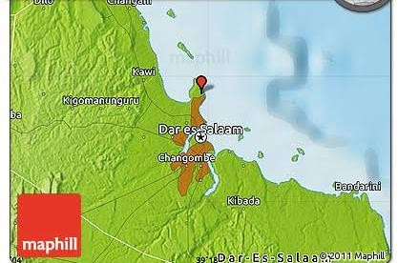
Figure 3. 1 Topography of msasani bay

(maphill201)

Data Collection
The study uses, secondary data sources. According to Rao (2001), secondary data referred to information that have been collected by other researcher or institution

through methods such as documentary review. In this research, secondary data was obtained from TMA Tanzania meteorological authority

Secondary Data Collection
      - Documentary Review
A researcher reviewed and used wave data such as significant wave heights and wave periods as secondary data sources from numerical wave models. Numerical wave models are global or regional oceanographic models that simulate wave conditions based on wind, pressure and historical sea state. Wave characteristics data such as wave heights and wave periods were collected using secondary retrieval from Tanzania meterological authority (TMA) which provides validated and timely information suitable for marine coastal engineering and marine energy assessment.

Data Analysis
    - Wave Energy Potential and hydrodynamic performance
The Wave Power Equation calculates a wave's power. The energy flow through a vertical surface perpendicular to the direction of propagation is known as wave power. Thus, Wm-2 might be used to express it. This is not the typical application, though, and it is better to measure wave power in Wm-1. (Islam and others, 2021). Finding the mathematical energy of a vertical column of water and multiplying it by the wave's speed is required to compute the energy flow. The total of a water column's kinetic and potential energy is its mechanical energy. Both the kinetic energy density and the potential energy density are equal.
𝐸𝑚 = 𝐸𝑘(𝑡) + 𝐸𝑝(𝑡)
(3.1)

Where:
(𝑡) = 𝐸𝑝(𝑡) = 𝐸𝑚/2 = (𝜌𝑔𝐻²)/16
𝐸𝑚 = (𝜌𝑔𝐻²)/8

ρ_{w} = Density of seawater (1,025kg/m3) E_{k} = Kinetic energy of wave column

E_{p} = Potential energy of water column g = Gravitation due to gravity
H = Wave height
E_{m} = Mechanical energy of water of water column
When the depth of the water is infinite, the group speed, v_{g} (i.e., speed of energy propagation) is written as follows:
_{(𝑇)} = 𝑔𝑇/4𝜋

𝑃_{𝑤}
= 𝜌𝑔2𝐻2𝑇
32𝜋
(3.2)

The equation to calculate the power generated by WEC technology supplied to vessel is studied from a book ‗Marine Renewable Energy Handbook‘ edited by Bernard, Multon. Power absorbed by a WEC will be analyzed as follows:
It is the simple equation of ideal wave power avoiding complexity. This equation is valid for unidirectional and unform sinusoidal waves
𝑃_{𝑎𝑏𝑠} = 𝑃_{𝑤} × 𝐵 × 𝜂 (3.2)
Where,
P_{abs} =Wave power absorbed by the WEC
P_{w} = Wave power per meter length wavefront
η = Hydrodynamic performance of wave converters

Validation
Validation in this study is achieved by using multiple data sources and methods to cross-verify results. This includes comparing in-situ wave data measurements and marine records to ensure the accuracy of wave energy estimates. Also, cross- referencing technical performance of WECs from manufacturers with published academic studies.

CHAPTER FOUR
RESULT, DISCUSSION AND FINDING

Chapter Overview
This chapter provides the methodology and results of a study that used Tanzania's Msasani Bay as a case study to evaluate the effectiveness of a wave energy converter (WEC) in producing renewable electricity. The study assesses important factors such wave height, period, direction, and energy flux using a simulation-based methodology backed by secondary wave data. The study models the relationship between ocean wave characteristics and WEC performance using programs like MATLAB/Simulink and WEC-Sim. To ascertain the system's power production and energy conversion efficiency, data inputs were processed and examined. After the results are displayed as simulation graphs, data tables, and charts, a thorough explanation that emphasizes Msasani Bay's wave energy potential and identifies important

Site Profile and Environmental Characteristics

Geographical Information of Msasani
Msasani Bay is located along the eastern coastline of Dar es Salaam, the largest city and commercial capital of Tanzania. It lies within the Indian Ocean basin and forms part of Tanzania‘s extensive marine ecosystem. Geographically, the bay is situated between latitude 6.7° South and longitude 39.3° East, making it part of the western Indian Ocean region (WIOMSA)
The surrounding area is semi-urban and includes residential neighborhoods, fishing communities, and tourist beaches. These human activities interact with the bay‘s natural dynamics, making Msasani Bay not only environmentally significant but also socio-economically important. The combination of consistent wave exposure, shallow depth, and proximity to populated areas makes Msasani Bay a strategic location for conducting renewable energy studies, particularly in evaluating the feasibility of harvesting wave energy in shallow water conditions (Francis, J. (2024)

Wave Climates and Pattern
The long-term trends and features of wave activity in the area are referred to as Msasani Bay's wave climate. This covers variables like frequency over time, wave height, wave period, and wave direction. Assessing the potential for wave energy harvesting requires an understanding of the wave climate, particularly in shallow water settings like Msasani Bay Both monsoonal wind systems and open ocean swell have an impact on Msasani Bay, which is situated along the western Indian Ocean. Depending on the season, the average significant wave height in the bay ranges from
0.5 to 1.5 meters, indicating generally moderate wave activity. Usually, the wave period ranges from 6 to 10 seconds.
The two main seasonal wind regimes are as follows:
- From November to March, the Northeast Monsoon (Kaskazi) brings calmer seas and smaller waves.
- Stronger winds and more waves are produced during the Southeast Monsoon (Kusi), which lasts from May to September. The wave energy potential is at its highest during this time.
The majority of waves in the bay come from the southeast, which is in line with the southwest Indian Ocean's predominant wind patterns. But the bay's enclosure and the Msasani Peninsula have an impact on local wave transformation, such as diffraction and refraction, which can change the distribution of wave energy. (Mahongo 2018)

Bathymetric and Tidal Information
Bathymetric refers to the underwater depth and topography of ocean floor. Wave behavior, energy potential, and the choice of suitable wave energy conversion technologies are all significantly influenced by bathymetry, which is the underwater depth and topography of ocean floors. With depths normally ranging from 0.5 meters close to the shore to roughly 15 meters at the bay's outer edge, the bathymetric profile of Msasani Bay is defined by gradually sloping shallow waters that pass into deeper ocean waters. (WIOMSA 2014) Fine sand, silt, and sporadic rocky substrates make up the bay's seafloor, which affects the processes of sediment transport and wave energy dissipation. The energy available for conversation is impacted by the

incoming waves slowing down, shoaling, and occasionally breaking before they reach the shore due to the shallow and gently sloping seabed.
These circumstances may present difficulties from the standpoint of wave energy, including: decreased wave energy density as a result of bottom interaction and friction.
increased effects of wave transformation, such as breaking and refraction
Msasani Bay has semi-diurnal tides, which means that there are two high tides and two low tides roughly every 24 hours. Although moderate, the bay's average tidal range of 0.9 to 1.4 meters still affects the operational efficiency and effective depth of wave energy devices. Wave height and energy concentration fluctuate during different tidal phases as a result of tidal variations' effects on wave interaction with the seabed. When evaluating the site and designing the system for wave energy harvesting in the area, this dynamic behavior needs to be taken into consideration. (Shanghaied 2024)

Costal And Marine Condition
Wave dynamics, sediment transport, and the viability of wave energy development are all influenced by the combination of natural ecosystems and man-made landscapes that make up Msasani Bay's coastal and marine environment. Comprehending these circumstances is essential for assessing the sustainability and environmental appropriateness of putting wave energy systems in the bay

The Geomorphology of the Coast
Mangrove fringes, rocky outcrops, and sandy beaches define the coastline around Msasani Bay. Wave shoaling and breaking occur gradually because the beach profile is usually low-lying and gently sloping. Further offshore, coral reefs act as a natural barrier, absorbing wave energy before it enters the inner bay.

Oceanic Environments
Diverse marine ecosystems are supported by Msasani Bay, including: Beds of seagrass Mangrove forests, especially those found near protected areas Reefs of coral These ecosystems serve as natural barriers against wave action and are significant from an ecological standpoint. However, because installations must not

disturb delicate habitats, they also present environmental challenges for energy projects.

Sediment Conditions and Water Quality
Runoff, coastal erosion, and sediment resuspension are the primary causes of the bay's moderate turbidity. Sediments and organic matter input are increased by seasonal rainfall, particularly from adjacent urban catchments. The stability and anchoring of wave energy devices depend on sediment dynamics.

Coastal Use and Human Activity
Msasani Bay is close to fishing villages, recreational beaches, and urban areas. Planning energy infrastructure must take into account activities that put stress on the coastal environment, such as artisanal fishing, boating, and tourism. Additionally, local wave reflection and sediment transport may be impacted by current coastal developments like jetties and seawalls.

Discussion Based On Specific Objectives

Evaluate Wave Characteristics
Research related to the evaluation of wave height and wave period features was carried out in Msasani Bay using simulation data which is available for this location. These two parameters are very important while analyzing the potential of any waters including Msasani bay for harnessing waves energy as well as understanding the hydrodynamic behavior of the region.
Wave parameter data for msasani bay were obtain from historical Tanzania metalogical authority covering 9 months in which average of 9 months from October 2024 to July 2025

Table 4.1 Table Showing Evaluated Data

Wave height (m) | Wave period (s) | Wave power | Converter output (Kw) | Direction
1.61 | 7.64 | 09.72 | 4.37 | ESE
2.25 | 8.46 | 21.01 | 9.45 | ESE
2.01 | 7.00 | 13.87 | 6.24 | ESE
1.86 | 7.79 | 13.22 | 5.95 | ESE
1.37 | 7.98 | 07.35 | 3.31 | ESE
1.37 | 6.62 | 06.10 | 2.74 | ESE
1.26 | 8.02 | 06.25 | 2.81 | ESE
2.15 | 6.93 | 15.72 | 7.07 | ESE
1.86 | 6.66 | 11.30 | 5.07 | ESE
Source (field data, 2025)

9
8
7
6
5
4
3
2
1
0
1
2
3
4
5
6
7
8
9

Figure 4. 1 The graph of wave height (m) and wave period (t)
Source (Researcher ,2025)

Table 4. 2 The Summary of sample data

Parameter | Minimum | Maximum | Mean | Standard deviation
Wave  height (Hs) |  | 2.225 | 1.75 | 0.286
Wave period (T) | 6.62 | 8.46 | 7.46 | 0.532
Direction | 45°NE | 225°(SW) | - | -
Source (Researcher ,2025)

Wave Height
The wave height data recorded range from 1.26meter to 2.25 meter. the average wave height was calculated to be approximately 1.75meters. this indicates moderate wave climate which are suitable for small scale wave energy conversion system. the highest wave height (2.25) suggested period of intensives wave activity possibility due to season wind pattern or local storm

Table 4. 3 Wave height (m) of selected data at msasani bay

Wave height
1.61
2.25
2.01
1.86
1.37
1.37
1.26
2.15
1.86

1.61
2.25
2.01
1.86
1.37
1.37
1.26
2.15
1.86

Figure 4. 2 The histography representing wave height (m) Source Field data (2025)

1 2 3 4 5 6 7 8 9

Wave Period
Wave period in msasani bay ranged from 6.62 second to 8.46 secondary with an average period of approximately 7.46seconds. longer period above 7.5 is typically suggest higher energy content in the waves which is favorable for energy extraction the variation in wave period indicates a dynamics coastal environment influenced by both local and regional weather pattern.
Table 4. 4 Wave period of selected data at msasani nay

Wave period (s)
7.64
8.46
7.00
7.79
7.98
6.62
8.02
6.93
6.66
Source: field data (2025)

9
8
7
6
5
4
3
2
1
0 |  |  | 2 |  | 4 |  | 6 |  | 8 | 10
Figure 4. 3 The line graph presenting the wave period (s) Source field data (2025)
0

To Quantify the Wave Energy Flux (Power Density) In Msasani Bay
The rate at which wave energy travels through a unit length of the wave crest is known as the wave energy flux, or power density P. It is a crucial determinant of the amount of usable energy that ocean waves can provide. For deep water conditions, the standard formula is:

(4.1)

Where by
P= 𝞀𝑔2 𝐻²T
32π

P = Wave power per meter of crest (kW/m)
H = Significant wave height (m) – usually estimated as average wave height T = Wave period (s)
ρ = Water density (~1025 kg/m³) g=Acceleration due to gravity (9.81 m/s²)

from my wave data average wave height is 1.75m and average 7.65s
from
P= 𝞀𝑔2 𝐻²T
32π

P = 0.49𝐻²T P=0.49(1.75 ×1.75) ×7.65 P=11.19Kw/m
Now
𝑃_{𝑎𝑏𝑠} = 𝑃_{𝑤} × 𝐵 × 𝜂 (4.2)
= 11.19 × approximated buoy with size of 5m (width), × 0.09kW
= 11.19 × 5 × 0.09
𝑃_{𝑎𝑏𝑠} =5.0355Kw
So, the power which can be absorbed by a heaving buoy WEC is estimated equals 5.0355kW. The power take-off (PTO) efficiency of wave energy converter is 80% (PTO = 0.8). If this power is converted into electricity, the amount of power integrated
P = (5.0355 × 0.8) Kw
Power = 4.0284 kW Considering numbers of WECs to be implemented
If 10 small size point absorber heaving buoys would be employed the total power is;
𝑃_{𝑇𝑜𝑡𝑎𝑙} = (4.0284 × 10) 𝑘𝑊
𝑃_{𝑇𝑜𝑡𝑎𝑙} = 40.28 𝑘𝑊
With comparison consider the table below

Table 4. 5 Showing different hydrodynamic performance of each converter

Category  Reference  dimension | Sub-category Average  hydrodynamic  performance |  |  | Min |  | Max | Typical  size
Oscillating  Water Column |  |  | 33% | 20% | 45% | 30m | Width
Overtopping  System |  |  | 13% | 4% | 23% | 300m | Width
 |  | Small heaving  Buoy | 9% | 3% | 14% | 5m | Width
 |  | Large heaving  buoy | 29% | 19% | 42% | 20m | Width
System driven by the waves |  | Bottom fixed Oscillating  Flaps system | 41% | 25% | 65% | 20m | Width
 |  | Floating  oscillating flaps system | 20% | 14% | 36% | 25m | Width
 |  | Floating system combining surge/  heave/ pitch | 17% | 6% | 27% | 30m | Width

Heave/ yaw
6%
5%
7%
150m

Length
Source: Multon (2015)

This result means that each meter of wave crest in Msasani Bay can deliver approximately 11.19 kilowatts of power under average conditions. This is considered a moderate energy level, suitable for small-scale wave energy conversion technologies such as oscillating water columns or point absorber

Input Boundary Condition for the Numerical Wave Model Using Shallow Water Data
It was crucial to establish boundary conditions based on observed or modelled wave data in order to faithfully replicate wave behavior in Msasani Bay. The numerical wave model's input parameters, such as wave height, wave period, wave direction, and bathymetry, were determined using shallow water measurements close to the bay. These parameters were input into software Simulink the data was cleaned formed on MATLAB When it comes to numerical wave modeling, these boundary conditions are crucial for kicking off and managing wave movement within the model's area. They include: Wave height (H) Wave period (T) Wave frequency (f or ω) Water depth (h)Wave type (like sinusoidal or irregular) was the primary source of energy output
These parameters play a vital role in solving the shallow water wave equations and help us simulate how waves propagate and interact with a wave energy converter (WEC) system.

Table 4. 6 Wave height and wave period used in modeling

Wave height (m) | Wave period (s)
1.61 | 7.64
2.25 | 8.46
2.01 | 7.00
1.86 | 7.79
1.37 | 7.98
1.37 | 6.62
1.26 | 8.02
2.15 | 6.93
1.86 | 6.66
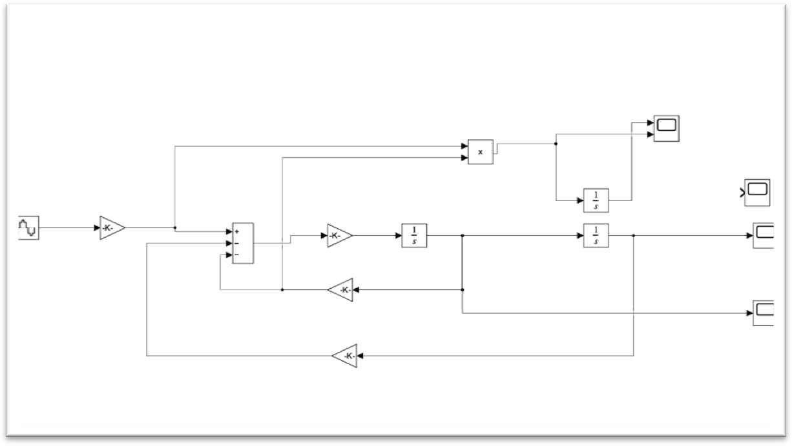
Source field data (2025)

Figure 4. 4 block configuration of wave energy converter modelling in Simulink Source field data (2025)

The boundary conditions were implemented in Simulink as given above shows the wave energy converter system. the modal has well defined input boundary condition implementing via a sinusoidal wave generator. the diagram includes key element such as wave forces and inputs
The wave signal (displacement of water surface) was represented by a Sine Wave block. Where by Amplitude: Computed from wave height (A = H/2) Frequency: Computed according to wave period (ω = 2π/T) Gain block was used to adjust the amplitude to the specified value of wave height.
This provided the Mass-Spring-Damper system (WEC) with an external forcing function to simulate response.
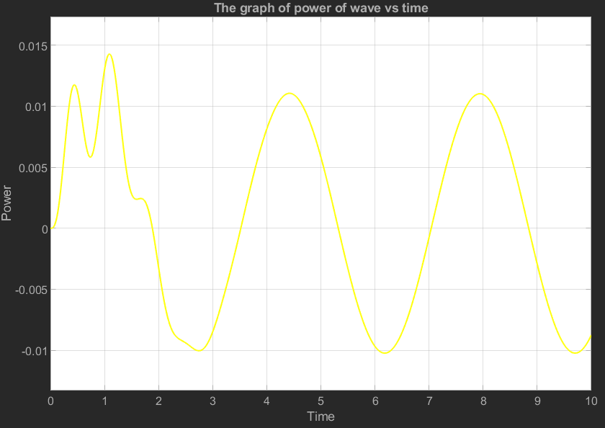

Figure 4.5 The graph of simulated extracted power over a time for a wave energy converter under shallow water
Source: Simulink simulation results (2025)
Figure 4.5 The graph of power of wave vs time, illustrate the instantaneous power extracted by WECs system as function of time. The input boundary condition causes

the floats to oscillate and modal predicative control. The fluctuation of the power output reflects the dynamics nature of the wave input.
The simulation results demonstrate the effective of implemented MPC in regulating the control force to minimize energy extraction The power output of the wave varies greatly, especially in the first phase, reaching a peak of about 0.015 W within the first second. After this initial change, the power stabilizes into a more consistent oscillating pattern, ranging from about 0.01 W to 0.012 W for the rest of the 10second duration. The observed pattern confirms the system ability to adapts the input boundary
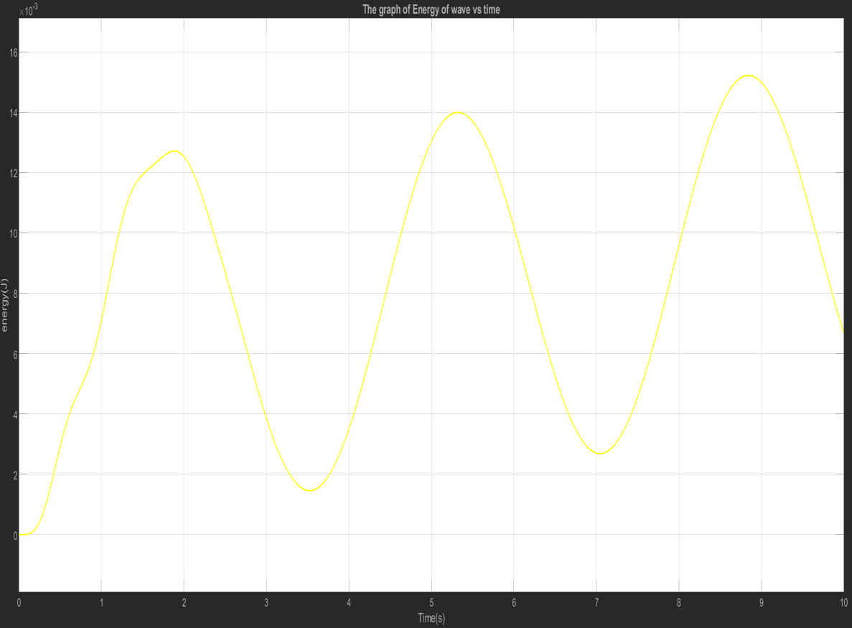

Figure 4.6 The graph Cumulative energy extraction over time by the wave cinveter WECs in shallow water
Source: Simulink simulation results (2025)
Figure 4.6 shows cumulative energy extracted by the wave energy converter as a function of time it derives by integrating the instantaneous power output over the simulation duration the curve exhibits steadily increasing trend indicating that the WEC continuous harvests energy from incoming wave input

The smooth upward coming trend of the energy curve confirms the proper functioning of control system and efficiency of WEC under applied input condition. also this graph help in assessing the performance of the system over a time
Description:
X-axis: Time (s)
Y-axis: Energy (Joules,
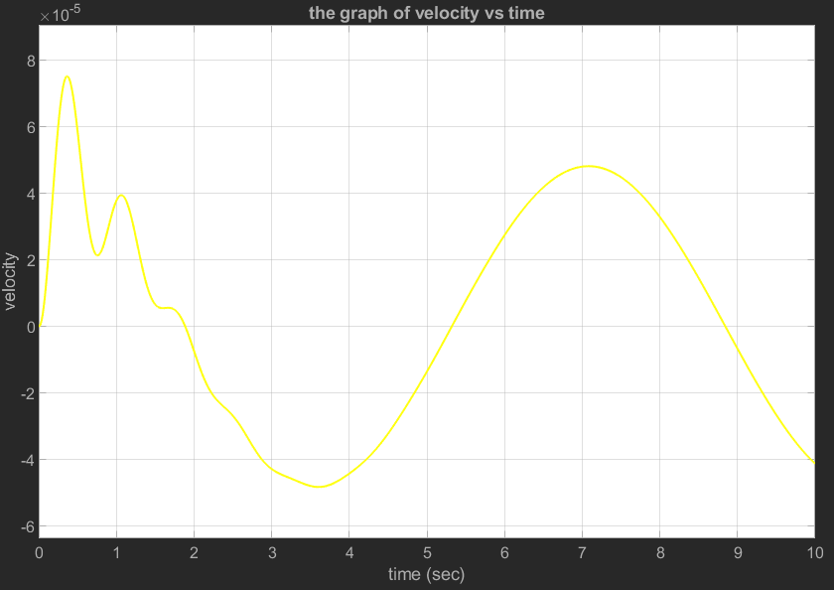
Line Color: Yellow (showing how wave energy changes over time Time Range: 0 to 10 seconds

Figure 4.7 The graph of velocity response of the wave energy converter (WECs) floats under shallow water
Source: Simulink simulation results (2025)
the graph of velocity vs time velocity plotted on the y-axis (in units of 10⁻⁵) against time in seconds (sec) on the x-axis. The velocity starts close to zero, quickly surges to a peak of around 7.5×10⁻⁵ in less than a second, then oscillates with a diminishing amplitude before rising again to a peak of about 4.5×10⁻⁵ around 7.5 seconds,

ultimately tapering off as we approach the end of the 10-second interval a well- shaped velocity curve is a crucial because the extracted power is the products of this velocity and control force. thus, this graph not only validates the system respond but also direct influence energy performance
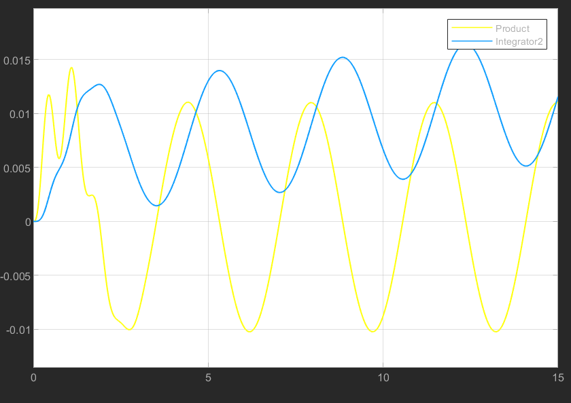

Figure 4.8 Wave energy input and extracted power overtime by wave energy converter
Source: Simulink simulation results (2025)
The graph above shows energy and power where by wave energy is been presented using blue color and wave power using yellow color whereas power increase at interval of10sec the energy also increases. in extraction of power energy is need to be converted into electrical energy.
By comparing those two graphs it is evident how variation in wave direct influence the fluctuation in power output peak in power energy input correspond increase power generation demonstrating the WECs ability to harness energy during period of

higher wave activity. the power output decreases according This analytical confirm that the accuracy of input boundary condition is critical for realistic simulation of WECs performance

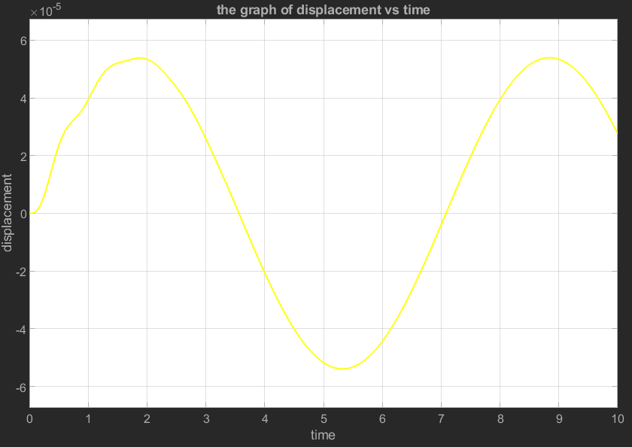

Figure 4.9 The graph of displacement respond of the wave energy converter over a time under shallow water
Source: Simulink simulation results (2025)
Figure above the graph of displacement vs time, which displays displacement on the y-axis (in units of 10⁻⁵) against time on the x-axis. The displacement follows a smooth, oscillating pattern, reminiscent of a sine or cosine wave. It reaches a maximum displacement of about 5.5×10⁻⁵ around 1.5 seconds and again at approximately 8.5 seconds, while hitting a minimum displacement of about 5.5×10⁻⁵ at around 5 seconds. Monitoring displacement over a time provides valuable insight into dynamic behavior and operation limits of the WECs under realistic sea condition

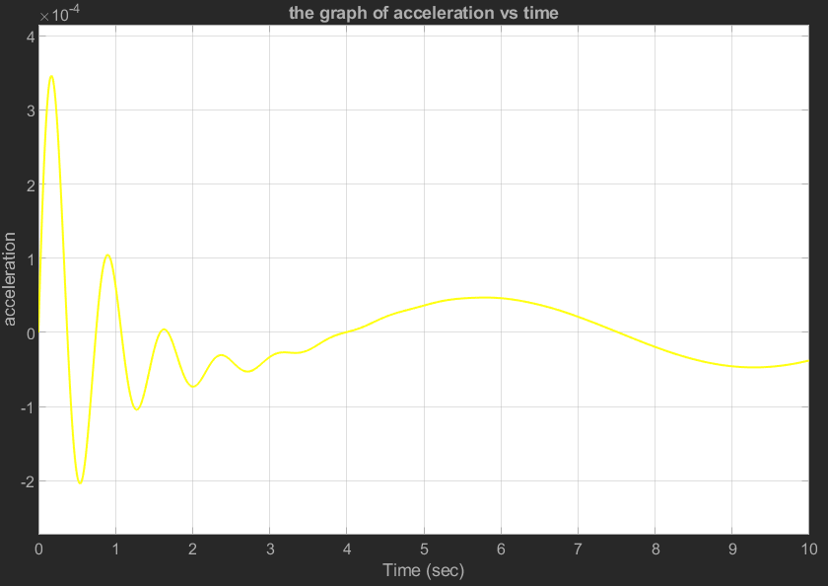

Figure 4.10 The Graph of acceleration respond of the wave energy conveter floats over time under wave excitation
Source: Simulink simulation results (2025)
The graph of acceleration vs time, illustrates acceleration on the y-axis (in units of 10⁻⁴) against time in seconds (sec) on the x-axis. Here, we see notable initial oscillations with a large amplitude, peaking at around 3.5×10⁻⁴ and dropping to about
−2×10⁻⁴ within the first second. These oscillations significantly dampen over time, with acceleration trending towards zero or a slightly negative value by the 10-second mark.This graph confirms that WECs is dynamics stable under the simulated wave environment and that control system does not induces unsafe oscillation

Implementation in Simulink
To model and stimulates the performance of wave energy converter for maximum power extraction under shallow water condition a dynamic system was constructed in MATLAB Simulink the modal integrates the mechanical respond of WECs float with a control strategy design to optimized energy capture from incoming wave force

Assuring realistic input parameters strengthens simulation fidelity to the actual wave energy conversion system operation. Boundary conditions determine the points at which the wave energy enters the domain, which impacts:
Changes in shallow water waves, Motion of the buoy Electricity production In shallow water, boundary effects are more important due to: Wave refraction, Wave shoaling and Friction with the bottom
    - Simulation Parameters Wave frequency = 0.6Hz Amplitude =0.5
Mass of float =1000kg Damping coefficient =500Ns/
Simulation time was from 0-10 seconds
Finally, the stimulation successfully demonstrates the respond to incoming wave. the graphs generated shows how power, displacement, velocity acceleration and energy evolved over a time. the result indicates that implementation control strategy enables effective energy extraction

Results Based on Each Specific Objective

Wave Characteristics
To evaluate the wave characteristics simulated wave data were analysis over a defined observational period in shallow water condition. Main parameter were wave height and wave period which influence the dynamic response and energy conversion performance

Wave Height
Minimum heigh was 1.26m and maximum height was 2.225 whose standard deviation was 0.286. this shows that the wave environment includes both moderated and high wave energy. the relatively small standard deviation suggests that most wave height store close to average typical for shallow water

Wave period
Minimum period was 6.62sec and 8.46sec with standard deviation of 0.532 sec. this indicates long period swell which is suitable for harvesting. the narrow spread in period value shows relatively uniform wave cycle which allow easier synchronization of WECs floats to maximum energy
Above results demonstrates that stimulates environment accuracy reflects shallow water wave condition with stead and predictable pattern of wave height and period. such condition is ideal for analyzing the performance and tuning of control strategies in wave energy converters

wave energy density (power flux)
The theoretical power density calculated was 11.19kw/ shows energy flux available in each meter crest. while power observed by WEC was 5.0355kw this shows that the system captures only 45% of the available wave power the recommended type of converter be absorbed type converter. result demonstrate that the WEC was able to converter a significant portion of the incoming wave energy into useful mechanical power

CHAPTER FIVE CONCLUSION AND RECOMMENDATION

Introduction
Using Msasani Bay as the case study location, this study examined wave energy as a renewable energy source. The primary objective was to assess the wave properties, namely wave height, period, and direction, and utilize them as input conditions for a numerical wave model in shallow water. In order to precisely model the marine environment and calculate the energy potential present in the bay, the wave data— whether gathered or estimated was crucial.
A mass-spring-damper model was created using MATLAB and Simulink to model how a wave energy converter (WEC) would behave in shallow water wave conditions. Realistic ocean wave motion was represented by the sinusoidal wave input based on the measured characteristics. The simulation yielded valuable information about the displacement and velocity of the float, as well as the instantaneous and cumulative power output

Conclusion
The results of this study show that, with the right energy converter system calibration to local wave conditions, wave energy can be reliably extracted from shallow coastal environments like Msasani Bay. According to the simulation's findings, wave height and period are crucial variables that have a direct impact on the energy conversion system's effectiveness and performance. The wave energy converter can efficiently react to wave forces and transform mechanical motion into useful energy by precisely simulating these inputs. To further optimize the positioning and alignment of wave energy devices, the directional analysis also showed that some wave directions occur more frequently and with higher intensity. Even in relatively shallow water, where wave energy is generally lower than Consistent and usable energy levels can still be captured in deep-sea settings. Thus, this project lends credence to the idea that wave energy can be incorporated into Tanzania's sustainable energy solutions, particularly in coastal communities

Recommendation
A number of suggestions are offered to improve future research and real-world application in light of the analysis and findings of this study. First, in-situ measurements in Msasani Bay using underwater pressure sensors or wave buoys are advised. This will increase the simulations' accuracy by supplying location-specific and real time wave data. Second, to improve the model's robustness and better represent real sea conditions, future models ought to take irregular and random wave patterns into account.
A physical prototype of the wave energy converter should also be created and tested in both natural and controlled environments. This will assist in verifying the numerical model and identifying practical construction and operation issues. Additionally, site-specific WEC parameter optimization such as buoy size, stiffness, and damping is crucial to enhance energy output.
More funding for Tanzania's research and development of marine renewable energy is required from a policy standpoint. Government support, alongside private sector partnerships, could drive innovation in this field. Lastly, integrating wave energy systems with other renewable sources like solar and wind could create hybrid energy solutions for
(Bahaj, 2011)

REFERENCE

(GEPC), G. a. (2022). The looming energy transition will potentially have significant economic impacts on fossil rich countries in Africa and potential new producers such as Tanzania and Uganda. Strategic policy and practical steps must be taken to ensure countries are prepare.
Abanades Tercero, J. (2017). Beach morphodynamics in the lee of a wave farm: synergies with. University of Plymouth.
Aderinto. (2018). Ocean Wave Energy Converters: Status and Challenges. texas usa.
Bahaj, A. (2011). Generating electricity from the ocean. In Renewable and Sustainable Energy.
Bekker, N. M. (2019). Renewable energy integration impacts within the context of generator type, penetration level and grid characteristics.
Brooke, J. (2013). Wave energy conversion.
copping, D. a. (2025). perspectives on progress . ocean energy.
Davidson-Arnott, R. (. (2010). Introduction to coastal processes and geomorphology.
Cambridge: Cambridge press .
dean, r. g. (1991). water wave mechanics for engineer and scientistis . world scientist publshing company .
falcao. (2010). wave energy utiliztaion . In review of technologies . reneawable and sustanable energy review .
Folley, M. W. (Renewable Energy,). The oscillating wave surge converter. halsne. (2025). development and analysis of ray capture .
Holthuijsen, L. (2015). coastal wave modelling .
j, f. (2007). review of wave energy extraction. marine structure . johannes, f. (2020). wave power absorption by parrallel row of interacting
oscillating.
Kamphuis, J. (2010). . Introduction to coastal engineering and management, vol. 30.
World.
konispoliastas. (2024). floating oscillating water column .

Li, Y. (2025). Construction of New Surface Wave Solutions of the Modified KdV Equation. Open Journal of Applied Sciences.
Liberti, L. (2015). Renewable Energy. Wave energy resource assessment in the Mediterranean, the Italian perspective.
Mpholo, M. (2020). Determination of the lifeline electricity tariff for Lesotho.
lesotho .
Omar, M. A. (2024). Maximizing Wave Energy Harvesting Efficiency using NAHRIM 3D Wave Breakwater Oscillating Water Columns. Journal of Advanced Research in FluidMechanics and Thermal Sciences .
onea, e. r. (2019). a review of the technologies for wave energy extraction . clean energy .
Phillips, O. (1998). The equilibrium range in the spectrum of wind-generated waves.
. Journal.
Rasmeemasmuang, T. a. (2009). One-line model using the combination of polar. In
Proceedings Of Coastal Dynamics (pp. pp. 1–14.). rathaur. (2024). numerical study of buoy shape .
s.b, m. (2024). assesing the variability of extreme weather event and its influence on marine accident along dar es salaam costs . america jornal of climate change
.

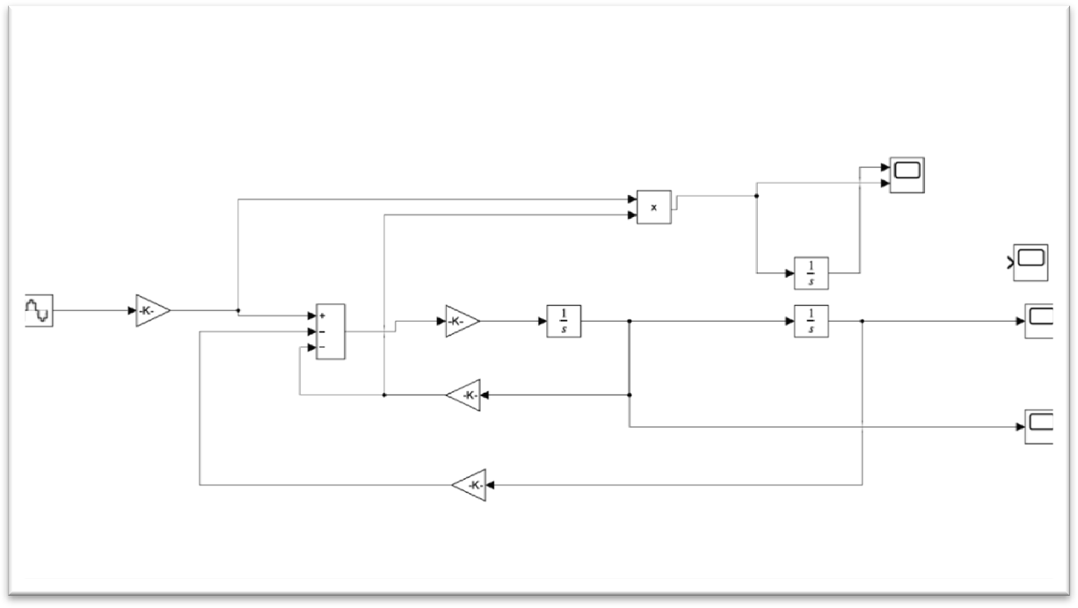
APPENDEX

