Enhancing Traceability and Efficiency in Livestock Management through Mobile Technology
Abstract— This paper presents the design and implementation of a mobile application, LivestockPro, aimed at transforming livestock management in Kilimanjaro, Tanzania. The system addresses traditional inefficiencies in record-keeping and monitoring, employing GPS, REST APIs, and a user-friendly Android interface. Using a mixed-methods approach for requirements gathering and incremental Agile development, LivestockPro enables real-time tracking, health updates, and administrative access across user roles. Pilot testing demonstrated improved traceability, reduced fraud, and enhanced livestock security. The project contributes to digital transformation and sustainable livestock development in Tanzania.
Keywords— Livestock management, mobile application, GPS tracking, REST API, digital agriculture

INTRODUCTION
The agricultural sector is undergoing a transformative shift globally, with digital innovations playing a crucial role in redefining how resources are managed, productivity is measured, and data are utilized for decision-making. As developing economies adopt these changes, mobile technology emerges as a particularly accessible and scalable tool for modernizing rural farming practices. Among the key areas ripe for digital transformation is livestock management, a traditionally labour-intensive and error-prone domain that demands greater precision, traceability, and real-time monitoring. In this context, the integration of mobile-based solutions offers a promising avenue for improving livestock tracking, disease control, and administrative oversight.

Background
Livestock farming plays a crucial role in the economies of many African countries, including Tanzania, where it significantly contributes to the livelihoods of rural communities. According to the Ministry of Livestock and Fisheries (2022), livestock contributes approximately 7.4% to Tanzania’s Gross Domestic Product (GDP) and supports over 30% of the population through employment and income generation. Despite its economic importance, the sector faces numerous challenges, particularly in traditional livestock management practices. [1].
In rural areas like Kilimanjaro, livestock management is often done manually, with farmers relying on paper-based record-keeping or verbal agreements. This leads to inaccuracies, data loss, and inefficient tracking of livestock movements highlight that fraudulent activities such as cattle theft, illegal sales, and ownership disputes are prevalent due to the lack of a secure and centralized system[2]. Furthermore, poor livestock monitoring contributes to challenges in disease control and market access, ultimately affecting productivity and profitability.
The rapid advancement of digital technology presents an opportunity to revolutionize livestock management. Mobile applications and digital platforms have been successfully implemented in various agricultural sectors to enhance efficiency and transparency emphasize that digital solutions, such as mobile-based livestock tracking systems, improve record-keeping, enhance traceability, and reduce fraud in livestock transactions.[3] Countries like Kenya and Rwanda have already adopted similar technologies, such as the Kenya Livestock Identification and Traceability System (KLITS)[4], which has significantly reduced cases of cattle theft and improved market access for farmers.
Inspired by these advancements, this project aims to develop a Digital Livestock Management System (LivestockPro) tailored to the unique needs of farmers in Kilimanjaro, Tanzania. The system address inefficiencies by providing a mobile application that facilitates livestock registration, monitoring, and record-keeping in a secure and centralized manner. This innovation was expected to enhance productivity, reduce fraud, and safeguard livestock assets, contributing to the sustainable growth of the livestock sector in Tanzania[5].
By leveraging modern technologies such as GPS tracking, cloud-based data storage, and mobile accessibility, LivestockPro aimed to empower farmers with real-time information about their livestock, allowing them to make informed decisions and improve overall management practices. Ultimately, this project will play a significant role in transforming livestock farming in Kilimanjaro, fostering economic growth and improving the livelihoods of rural communities[3].

Project Framework
The project framework for developing the Digital Livestock Management System (LivestockPro) incorporated the principles and best practices outlined in REST API Development, as discussed in this work. REST (Representational State Transfer) is a widely adopted architectural style for developing web services that allow communication between client and server using stateless, scalable, and lightweight protocols, primarily HTTP. REST APIs provides a seamless means for different systems to interact with the LivestockPro system, ensuring that farmers, veterinary officers, and other stakeholders can efficiently manage and track livestock information.
Priyanka Gowda emphasizes several best practices for REST API development that align with the objectives of LivestockPro [6], such as clear endpoint definitions, resource-oriented architecture, and proper use of HTTP methods (GET, POST, PUT, DELETE). These principles guided the development of the system's backend, enabling easy access to livestock data and management tools by mobile apps or web interfaces.
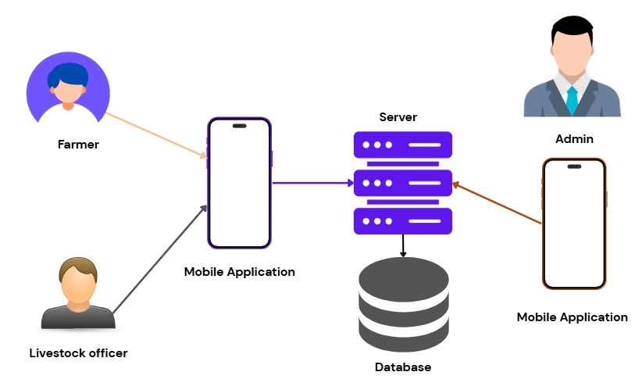
Fig 1. Project framework
For instance, resource-oriented architecture refers to the idea of structuring the API around resources like livestock registration, tracking, health monitoring, and market transactions. Each resource was assigned a unique URL endpoint, making it easy for users to retrieve or manipulate data using simple HTTP requests. By organizing the system around clearly defined resources, the API allows scalability as new features are added to the system over time.
[7] also suggests implementing pagination and filtering mechanisms to manage large data sets. Given the possibility of handling large amounts of livestock data in Kilimanjaro, these features will be essential for ensuring that users can easily search, sort, and filter livestock records without causing system delays. Additionally, the use of status codes (e.g., 200 OK, 404 Not Found, 500 Internal Server Error) will provide users with clear feedback on the success or failure of their requests.
Security best practices, as outlined by [8], will also play a key role in ensuring that LivestockPro is secure and trustworthy for users. The system implemented authentication mechanisms like OAuth 2.0 for secure access to data, ensuring that only authorized users can access sensitive livestock records or financial data.
In conclusion, by following the best practices and guidelines for REST API development proposed by [7], the LivestockPro system was developed to meet the needs of farmers and officers in Kilimanjaro, providing them with a robust, secure, and scalable tool for efficient livestock management.

LITERATURE REVIEW
The literature review aims to provide a comprehensive understanding of the existing knowledge and research related to the challenges in traditional livestock management, including reliance on manual record-keeping, poor tracking of livestock health and production, and limited access to real-time information[3]. This section will explore relevant studies, frameworks, and best practices that inform the development of a mobile-based Digital Livestock Management System (DLMS)[3]. By reviewing current systems and identifying gaps in livestock record-keeping, monitoring, and stakeholder communication, this chapter provides a strong foundation for the design and implementation of a digital solution tailored to the needs of farmers and livestock officers[2].

Theoretical Review
Theme 1: Livestock Management Systems
Livestock Management Systems (LMS) are essential in supporting data-driven decision-making in animal health, production, and breeding. According to, LMS refers to software tools that assist in tracking livestock records, vaccinations, births, sales, and feed. These systems enhance transparency, minimize data loss, and enhance traceability. Similarly, [9]emphasized that LMS enhances productivity and disease control through structured record-keeping. The studies demonstrate that digital LMS can significantly boost livestock productivity by replacing outdated manual systems.
Theme 2: Technology Acceptance Model (TAM)
The Technology Acceptance Model remains a valuable framework for understanding the adoption of digital solutions among users. TAM posits that two main factors—Perceived Usefulness (PU) and Perceived Ease of Use (PEOU)—influence user acceptance of new technology. Applying TAM to the Digital Livestock Management context, farmers and livestock officers are more likely to use the app if they believe it will simplify record-keeping and livestock tracking, and if the interface is user-friendly. [10] highlighted that TAM can effectively predict farmer adoption of agricultural technologies.
Theme 3: User Experience Design
User experience (UX) is central to the successful deployment of mobile applications. Studies emphasized that intuitive design, clear navigation, and relevant features enhance the usability and appeal of digital agricultural tools. In the livestock domain, a well-designed app can reduce the learning curve for farmers, many of whom may have limited digital literacy. These studies underline the need for contextual design, factoring in local languages, offline capabilities, and simplified user interfaces tailored to rural users [11].
Theme 4: Mobile Applications in Agriculture
The use of mobile applications in agriculture has revolutionized how farmers manage crops and livestock. Mobile apps improve access to farming information, market data, and livestock health alerts. In the livestock sector, these apps facilitate better communication between farmers and veterinary officers, real-time data entry, and access to analytics on animal performance. The studies noted that mobile apps reduce dependency on physical records and enable timely decision-making, which is critical in managing animal health and productivity.
Theme 5: Digital Transformation in Agriculture
Digital transformation involves integrating technology into all areas of farming operations to improve efficiency and data management. Defined it as the shift from traditional farming practices to tech-based approaches. In the livestock sector, this involves digital records, sensors for health monitoring, and integrated platforms for veterinary support. Stressed that successful digital transformation requires training, stakeholder involvement, and infrastructure development. These findings support the need for a mobile DLMS that aligns with broader agricultural digitization efforts.

Empirical Review
Empirical studies have examined the effects of digital systems on livestock management, focusing on user adoption, productivity improvement, and data reliability. The following themes emerge:
Theme 1: User Adoption and Satisfaction
Research found that livestock management apps with simple interfaces and local language support experienced higher adoption among rural farmers. Similarly, [12] observed that mobile apps offering personalized data and reminders for vaccinations enhanced satisfaction and trust among users. This reinforces the importance of designing apps that cater to the specific needs and contexts of the end-users.
Theme 2: Productivity and Decision-Making
A study of productivity and decision making showed that digital livestock tools improved record accuracy and enabled early disease detection, leading to a 25% increase in milk production on smallholder farms. Likewise, research indicated that apps allowing easy tracking of animal weight, health, and breeding cycles resulted in better decision-making and increased farm profitability.
Theme 3: Data Accuracy and Real-Time Monitoring
Empirical studies, highlighted the importance of digital data collection in livestock management. Their research found that apps enabling real-time data updates reduced errors and improved the traceability of livestock movements. Biometric tagging and GPS integration were identified as key enablers of data accuracy and security in digital livestock platforms.

Unaddressed issues
This section identifies key gaps in the reviewed literature that require further research to ensure the successful development of a Digital Livestock Management System tailored to local needs.
- Gap in Manual-to-Digital Transition: While studies highlight the benefits of digital livestock systems, there is little insight into the actual process of transitioning from manual paper-based records to digital systems. Research is needed to explore practical challenges in digitizing rural livestock data and strategies to support this shift.
- Gap in Rural Accessibility: Current literature does not sufficiently address how DLMS can improve access for farmers in remote areas with limited internet access. Investigating how the system can work offline, support local languages, and run on low-end smartphones is essential to bridge the urban-rural digital divide.
- Gap in Behavioural Change: There is limited focus on the psychological and behavioural factors influencing farmers’ acceptance of digital systems. Research is needed on change management approaches and community sensitization to increase adoption.
- Gap in Contextual UX Design: While user experience is recognized as important, few studies delve into how cultural norms, education levels, and technology exposure affect app design in East African rural areas. Tailored UI/UX research could improve usability and engagement.
- Gap in Stakeholder Communication and Engagement: The literature lacks exploration of how DLMS can improve communication between farmers, veterinary officers, and administrators. Understanding how the app can streamline communication and reporting among stakeholders is critical for system success.

METHODOLOGY

Study Area
The study was conducted in the Kilimanjaro region, specifically within livestock farming communities affiliated with the Moshi Cooperative University (MoCU) and its surrounding areas. These communities provided an ideal setting for the development and testing of the Digital Livestock Management System (LivestockPro). The area is characterized by both smallholder and large-scale livestock farmers, offering a rich variety of livestock management practices and challenges. The presence of agricultural and livestock extension officers, combined with access to academic resources and student researchers at MoCU, made this region a strategic and practical site for implementing and evaluating the usability of a mobile application.
By situating the project within this environment, it was possible to gather real-time insights from active livestock farmers, veterinary officers, and government agricultural officials. The area also offered diverse terrain and connectivity conditions—ranging from urban to rural settings—which helped to test the app’s usability under varying infrastructure conditions. The Kilimanjaro region’s agricultural economy, supported heavily by livestock, provided a relevant and practical setting for innovation in livestock data management.

Project Design and Approach

Project Design
The research employed a mixed-methods design, integrating both quantitative and qualitative approaches. This method was selected to offer a holistic understanding of the livestock management practices and digital challenges faced by farmers and officers. The quantitative component focused on structured data collection through digital surveys targeting livestock farmers and extension officers. These surveys gathered numerical data on livestock types, population counts, disease occurrences, and user technology preferences.
The qualitative component captured in-depth insights through interviews and field observations. Key informants included ward-level livestock officers, district agricultural officials, and selected farmers. These qualitative findings helped reveal farmers’ attitudes towards digital tools, existing record-keeping practices, and perceptions of the proposed system.[13].

Project Approach
Online surveys (via Google Forms) were distributed to farmers and officers to collect quantitative data. Structured interviews were carried out in person for qualitative data collection. The quantitative data was analyzed using statistical methods (descriptive and inferential), including frequency distributions and cross-tabulations to identify usage patterns and trends. Thematic analysis was used for qualitative data to extract recurring themes and concerns.
The software development approach followed the Agile methodology, allowing for iterative development based on user feedback gathered during the pilot phase. Early prototypes were shared with users, and revisions were made based on real-world input to improve usability and functionality.

Target Population
The target population consisted of two main groups:
Livestock Farmers – These included both small- and medium-scale livestock owners responsible for cattle, goats, sheep, and poultry. They were the primary users of LivestockPro, using it to register animals, record health events, access veterinary services, and manage livestock data.
Livestock Officers (Ward, District, Regional, and Veterinary Doctors) – These administrative users were responsible for overseeing livestock health and registration. They used the system to access reports, monitor livestock health trends, verify field data, and provide expert recommendations.[14]
The app was designed to support both operational users (farmers) and administrative users (officers), with features tailored to each user group’s roles and responsibilities.

Sampling

Sampling Frame
All registered and active livestock farmers affiliated with selected wards in the Kilimanjaro region. Lists were obtained from ward livestock offices and cooperative groups.
All active livestock and veterinary officers at the ward, district, and regional levels, who were officially registered under the Ministry of Agriculture and Livestock Development.
This dual-category sampling frame ensured both user perspectives and administrative insights were captured, essential for a system that spans grassroots to policy-level application.

Sample Size Determination
To determine the required sample size for the quantitative component of this study, the standard formula for sample size estimation in proportion studies is:
$$n=\frac{Z^{2}*p(1-p)}{E^{2}}$$
Where:
- n = required sample size
- Z = Z-score corresponding to the desired confidence level (e.g., 1.96 for 95% confidence)
- p = estimated population proportion (commonly set at 0.5 to maximize sample size)
- E = desired margin of error (e.g., 0.1 for ±10%)
Substituting the values:
- Z=1.96
- p=0.5
- E=0.1
n = 96.04
Therefore, the minimum recommended sample size was approximately 96 respondents. To ensure balanced representation, this study targeted 70 livestock farmers and 10 livestock officers, reflecting the distribution and accessibility of participants within the project scope, with some allowance for non-response or incomplete data.
For the qualitative component, the sample size was guided by the principle of data saturation the point at which no new insights emerge from additional data. A total of 4 in-depth interviews were conducted with experienced veterinary officers and farmers. This number was deemed sufficient to capture diverse perspectives and validate themes uncovered through quantitative findings.

Sampling Techniques
The project employed stratified sampling to ensure proper representation of both user groups:
Stratum 1: Livestock Farmers – A simple random sampling was applied within wards to select participants from the list of registered farmers. This ensured that farmers from different livestock types and sizes were represented.
Stratum 2: Officers and Veterinarians – Purposive sampling was used to select officers based on their roles and willingness to participate in interviews.
This stratified technique helped capture the broad spectrum of use cases and ensured balanced input from both system beneficiaries and implementers.

Data Collection
Data collection has been meticulously orchestrated, encompassing a dual-pronged strategy of interviews and questionnaires. These strategies have been adeptly executed within the confines of the Moshi District Council office and extend beyond its premises to engage Livestock Farmers from diverse settings. This multifaceted approach has been employed to comprehensively glean insights and perspectives from carefully selected farmers, thereby facilitating a panoramic comprehension of the livestock management system and the envisaged mobile app.

Questionnaires
Surveys and questionnaires were used as quantitative data collection tools to gather structured and measurable information from a large sample of livestock farmers. These methods are effective in obtaining standardized responses that can be analysed statistically to identify patterns, trends, and correlations within livestock management practices. By using structured questionnaires, the study ensured consistency in data collection, making it easier to compare responses across different geographical areas and farming scales.
One of the main objectives of the surveys will be to collect data on current livestock management practices and challenges. Questions will focus on how farmers currently record livestock ownership, monitor animal health, and track breeding history. This helps to determine whether manual, semi-digital, or fully digital methods are being used and identify gaps in existing practices.
Another important area is the rate of adoption of existing digital tools[15]. Some farmers may already be using ear tags, RFID chips, or mobile applications, while others still rely on traditional branding methods. Understanding adoption levels and barriers such as cost, digital literacy, and internet access helps in designing a system that is accessible and scalable. The survey also explored the frequency of livestock theft or loss. Farmers were asked to provide estimates of how many animals they lose annually, the suspected causes, and the effectiveness of current theft prevention strategies. This highlight the economic impact of livestock theft and inform the security features of LivestockPro.
Additionally, the economic impact of inefficiencies in livestock tracking was assessed. Poor record-keeping and lack of tracking systems often lead to revenue losses, disputes over ownership, and challenges in disease control. Quantitative data on these issues helps in making data-driven recommendations to improve livestock management.

Interviews
Interviews are a crucial qualitative data collection technique that will be utilized to gather first-hand insights from key stakeholders, including ward livestock officers and farmers. These interviews helped in understanding the challenges, needs, and expectations regarding livestock management in Kilimanjaro. A combination of structured and semi-structured interviews were conducted to ensure both consistent responses and flexibility in exploring deeper insights.
One major area of focus in the interviews was record-keeping challenges and inefficiencies. Many livestock officers still rely on manual documentation methods, such as paper records, which are prone to errors, loss, and tampering[16]. Farmers may also struggle with maintaining accurate livestock records, leading to challenges in tracking ownership, vaccinations, and sales history. Understanding these issues helped in designing a digital record-keeping system that enhances accuracy and security.
Another critical area was livestock theft and fraud cases, which pose significant economic risks to farmers[16]. Interviews explored the common methods used by cattle rustlers, the effectiveness of local security measures, and the role of livestock branding, tagging, or digital identification in reducing theft. Insights from farmers and local authorities will guide the integration of advanced tracking mechanisms into the LivestockPro system.
Additionally, existing livestock tracking mechanisms and their effectiveness were assessed. Some farmers may already be using ear tags, branding, or mobile-based solutions, while others rely on traditional herding methods. Interviews helped to determine the strengths and weaknesses of these methods and how they can be improved through GPS tracking and biometric identification.
Interviews also explored adoption barriers to digital solutions in rural settings, such as low digital literacy, lack of access to smartphones, poor internet connectivity, and resistance to change. By understanding these barriers, the project developed user-friendly interfaces and offline functionalities to ensure accessibility for all farmers.

Data Analysis
The analysis of both qualitative and quantitative data collected during the project was carried out using robust and context-appropriate methodologies to generate actionable insights:

Thematic Analysis of Qualitative Data
Data collected from open-ended questionnaire responses and interviews with livestock officers and farmers were analysed using thematic analysis. Responses were coded and grouped into categories such as "recordkeeping challenges", "preferred mobile features", "veterinary access", and "training needs". Recurring themes such as "limited digital literacy" and "desire for real-time updates" emerged, offering deep insights into users’ experiences and expectations[17]. These themes were instrumental in shaping the features and interface of the proposed mobile application.

Descriptive Statistics Analysis of Quantitative Data
Structured responses from the survey were analysed using descriptive statistics to identify patterns, trends, and central tendencies. Key metrics such as mean satisfaction score, standard deviation of smartphone usage frequency, and median years of experience with digital tools were calculated. Bar charts and frequency tables were used to visualize the distribution of responses, aiding in identifying dominant user needs and system shortcomings.

Integrated Insights for System Development
The combination of qualitative and quantitative analyses created a comprehensive understanding of the livestock management landscape. While the thematic analysis provided nuanced insights into user expectations and pain points, the descriptive statistics quantified these insights across a broader population. Together, these findings informed the functional requirements, design considerations, and user experience components of the Digital Livestock Management System.

RESULTS
After gathering data and analyzing user needs, the proposed Digital Livestock Management System (LivestockPro) was designed, developed, and tested. This section presents the results of the design and implementation processes.

Functional Requirements
Functional requirements define the core services and behaviors the system must exhibit to fulfil user expectations.
Table 1. Functional Requirements for LivestockPro

Non-Functional Requirements
These requirements define system quality, performance, and usability aspects.
Table 2. Non-Functional Requirements for LivestockPro.

System Modelling
System modelling helped in visualizing and validating the system's structure and user interactions. Unified Modelling Language (UML) diagrams were used for this purpose.

Use Case Diagram
The use case diagram illustrates how different users interact with the system based on their roles (e.g., Admin, Livestock Officer, Farmer). It highlights key functionalities such as livestock registration, health updates, and report generation (Raghunath et al., 2024).
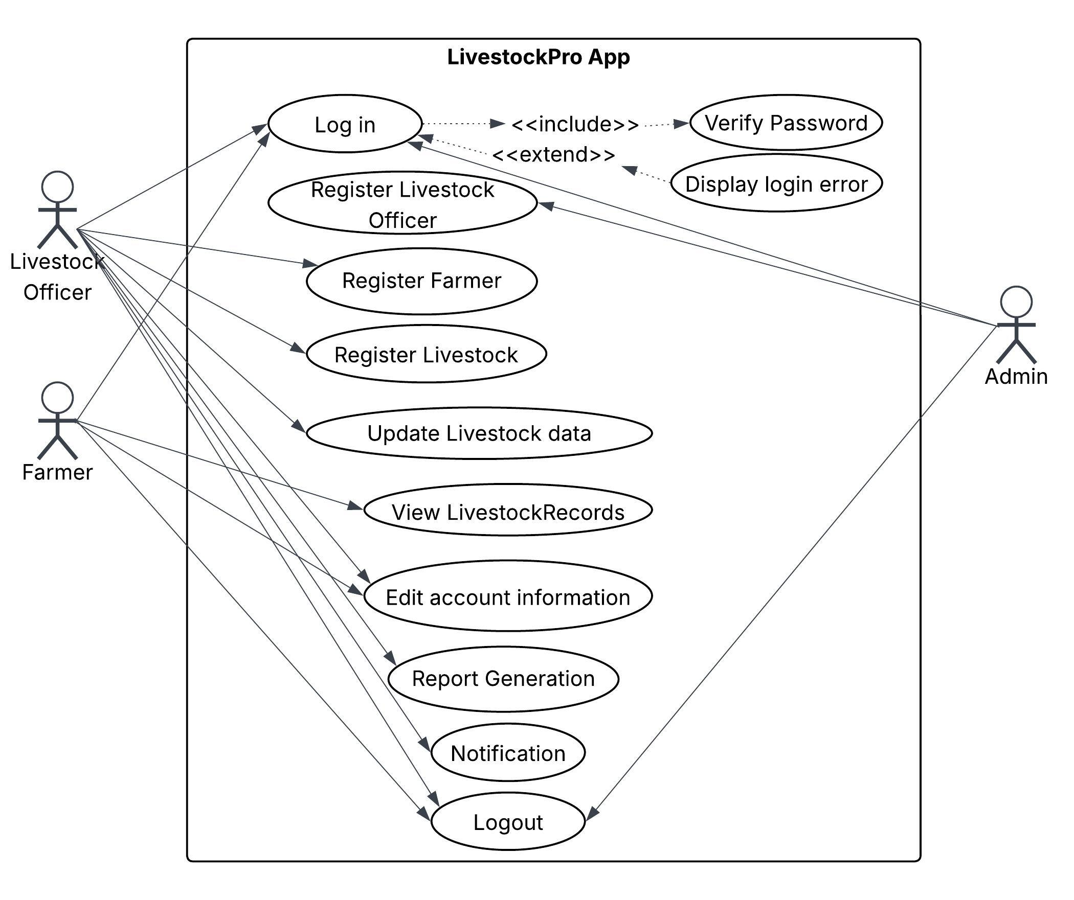
Fig 2. Use Case Diagram for LivestockPro

Database Design
A relational database schema was designed using MySQL to manage livestock records, users, roles, and health history. The design supported relational integrity, scalability, and fast data retrieval[18].

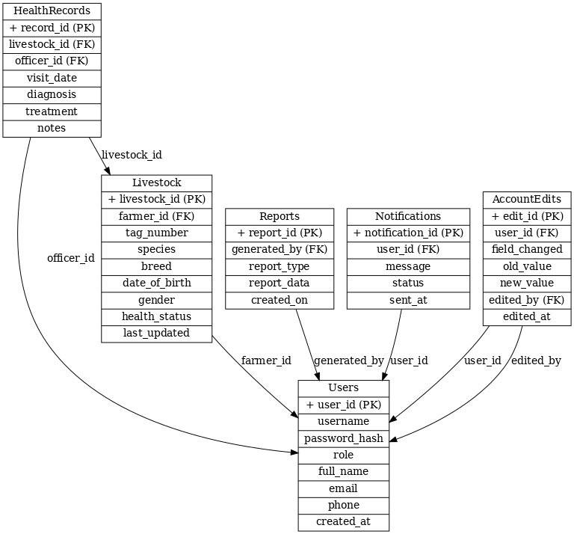
Fig 3. Database Schema for LivestockPro

Development Model
LivestockPro was developed using the Iterative and Incremental Development Model, which allowed for:
- Frequent feedback from stakeholders.
- Modular development of key system features.
- Progressive enhancement of system functionalities.
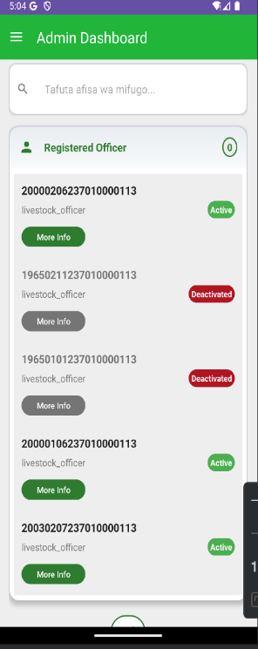
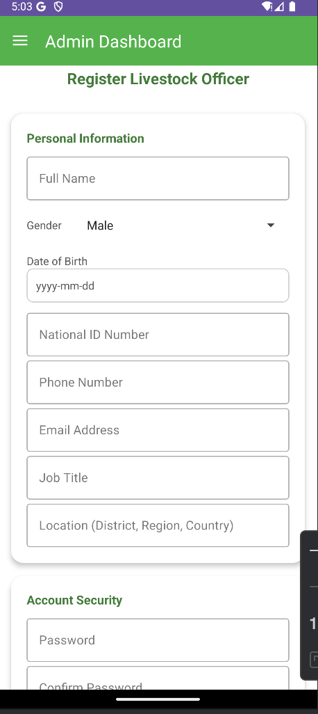
Fig 4. Admin side features
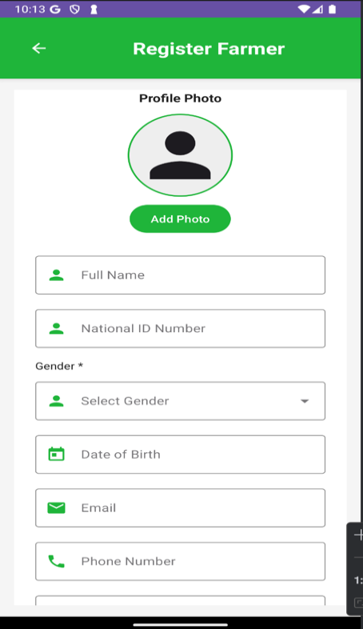
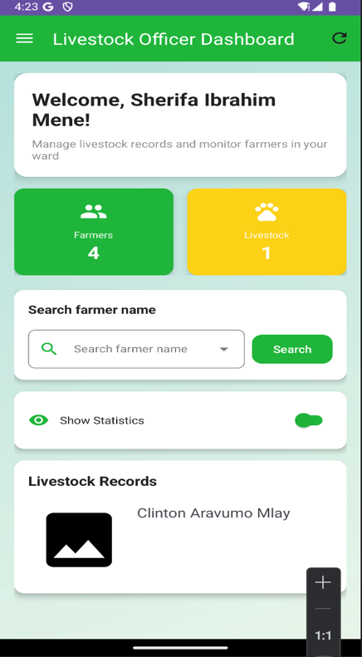
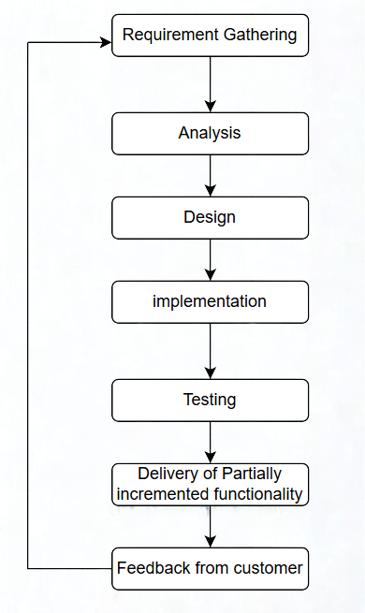
Fig 5. Livestock officer Side Features
Fig 6. Phases of Incremental Development

System Features
The system was built with three main user interfaces: Admin side, Client Side (Farmer) and Livestock officer.
- Admin side features
The Admin Interface of the LivestockPro system is designed to provide centralized control and oversight. Admins have access to a comprehensive dashboard that displays essential system metrics and controls. From this interface, they can add new livestock officers and manage existing ones, ensuring effective personnel coordination. Additionally, the admin can initiate and manage requests for veterinary visits on behalf of farmers or officers, enhancing service delivery and response efficiency.

- Livestock officer Side Features
The Livestock Officer Interface equips officers with tools to manage and monitor livestock-related data.
It features a dashboard that displays vital livestock statistics, allowing officers to track trends and performance. Officers can access detailed records of both farmers and their livestock, which supports accurate monitoring and informed decision-making. Moreover, the system enables officers to generate and view detailed reports, aiding in documentation, evaluation, and follow-up activities in the field.

- Farmer Side Features
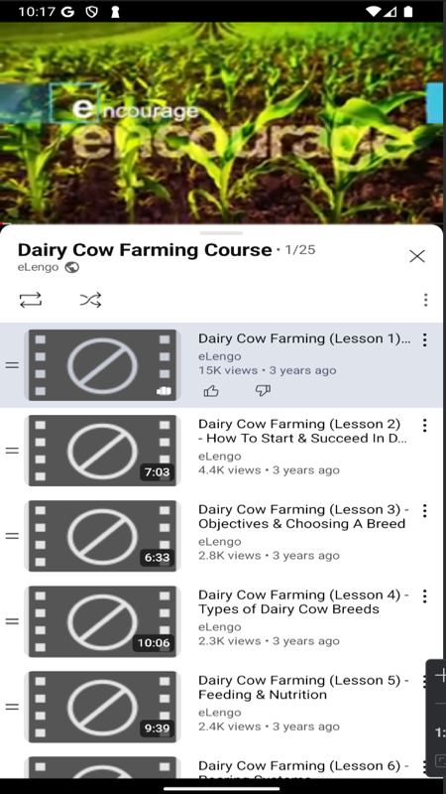
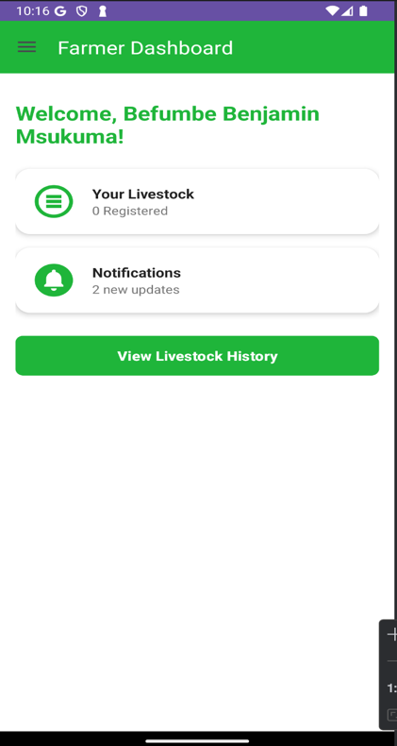
The Farmer Interface offers a user-friendly experience tailored to farmers managing their livestock. It includes a personalized dashboard that gives an overview of their livestock status and key updates. Farmers can easily add or edit livestock information, allowing them to maintain accurate and up-to-date records. The interface also supports viewing of important notifications, keeping farmers informed about system updates, vet visit schedules, or other relevant alerts.
Fig 7. Farmer Side Features

System Verification and Validation
System verification ensured that the software was built correctly as per the design documents. Validation confirmed that the software met user requirements and performed the intended tasks.[15].
Verification was done through unit testing, integration testing, and interface testing.
Validation included user acceptance testing (UAT) by farmers, veterinary doctors, and officers from various levels.[17].
Results:
- Farmers were able to successfully register and manage their livestock.
- Veterinary doctors could add treatment records and generate reports.
- Officers could view real-time livestock distribution and summaries.
- No critical bugs or security issues were found during testing.

DISCUSSION
The Digital Livestock Management System (LivestockPro) successfully addressed the diverse needs of stakeholders in the livestock sector by offering a centralized platform for data entry, retrieval, and reporting. It enhanced the visibility and traceability of livestock health and movement, while improving communication between farmers and veterinary officers. District and regional officers benefited from data-driven decision-making supported by visual dashboards. The use of an iterative development model enabled flexibility and regular feedback, ensuring the final system aligned with user expectations. Overall, LivestockPro significantly improved operational efficiency, transparency, and evidence-based livestock management, while also demonstrating strong market potential and readiness for national expansion [19].

CONCLUSION
The development of the LivestockPro application directly addresses the limitations of traditional manual livestock record-keeping systems. Built through rigorous research and iterative development, the application tackles key challenges such as poor traceability, inefficiency, and fraud. Stakeholder feedback emphasized the need for digital tools that are accessible, secure, and user-friendly for managing livestock data. LivestockPro responds to these needs by offering integrated modules for livestock registration, health record tracking, account management, and automated report generation. On a broader scale, the project contributes meaningfully to the digital transformation of Tanzania’s agricultural sector. It showcases how mobile technology can empower livestock officers and farmers to manage resources more efficiently, promote animal welfare, and mitigate fraudulent practices [3]. Furthermore, LivestockPro illustrates the practical integration of theoretical models such as the Technology Acceptance Model (TAM) and human-centered design, ensuring the system is usable, sustainable, and scalable within rural agricultural contexts.

REFERENCES
[1] Livestock Data for Decisions & Digital Agri Hub, “Digital Revolution in Livestock Development: eConversation February 2025,” 2025, [Online]. Available: https://livestockdata.org/news/digital-revolution-livestock-development-insights-february-2025-econversation
[2] Wikipedia, “Digital Agriculture,” 2025, [Online]. Available: https://en.wikipedia.org/wiki/Digital_agriculture
[3] Wikipedia, “Precision Livestock Farming,” 2025, [Online]. Available: https://en.wikipedia.org/wiki/Precision_livestock_farming
[4] Bullvine, “The Digital Dairy Revolution: How IoT and Analytics Are Transforming Farms in 2025,” 2025, [Online]. Available: https://www.thebullvine.com/news/the-digital-dairy-revolution-how-iot-and-analytics-are-transforming-farms-in-2025/
[5] Stellar Enterprises SK, “Digital Livestock Farming Market Overview 2025: Key Players and Strategies,” 2025, [Online]. Available: https://www.linkedin.com/posts/stellar-enterprises-digital-livestock-2025
[6] P. Gowda and P. G. Ashwath Narayana Gowda, “Best Practices in REST API Design for Enhanced Scalability and Security,” J. Artif. Intell. Mach. Learn. Data Sci., vol. 2, pp. 827–830, Feb. 2024, doi: 10.51219/JAIMLD/priyanka-gowda/202.
[7] M. Hosseinzadeh et al., “Data cleansing mechanisms and approaches for big data analytics: a systematic study,” J. Ambient Intell. Humaniz. Comput., vol. 14, pp. 1–13, Nov. 2021, doi: 10.1007/s12652-021-03590-2.
[8] BarreraDavid, BellmanChristopher, and V. OorschotPaul, “Security Best Practices: A Critical Analysis Using IoT as a Case Study,” ACM Trans. Priv. Secur., Mar. 2023, doi: 10.1145/3563392.
[9] Data Insights Market, “Digital Livestock Market Outlook and Strategic Insights 2025,” 2025, [Online]. Available: https://www.datainsightsmarket.com/reports/digital-livestock-275756
[10] “Kimani L. & Wangari M., 2021 - Google Scholar.” Accessed: Jun. 11, 2025. [Online]. Available: https://scholar.google.com/scholar?q=Kimani+L.+%26+Wangari+M.,+2021&hl=en&as_sdt=0&as_vis=1&oi=scholart
[11] Y. Salamzadeh, N. Damij, S. Issa, and R. Khan, “Digital Readiness,” 2024. doi: 10.1016/B978-0-443-13701-3.00436-9.
[12] Z. A. Mekonnen, K. A. Gelaye, M. Were, and B. Tilahun, “Effect of Mobile Phone Text Message Reminders on the Completion and Timely Receipt of Routine Childhood Vaccinations: Superiority Randomized Controlled Trial in Northwest Ethiopia,” JMIR MHealth UHealth, vol. 9, no. 6, p. e27603, Jun. 2021, doi: 10.2196/27603.
[13] A. Rohan, M. S. Rafaq, Md. J. Hasan, F. Asghar, A. K. Bashir, and T. Dottorini, “Application of Deep Learning for Livestock Behaviour Recognition: A Systematic Literature Review,” 2023, [Online]. Available: https://arxiv.org/abs/2310.13483
[14] A. Raghunath et al., “eKichabi v2: Designing and Scaling a Dual‑Platform Agricultural Technology in Rural Tanzania,” 2024. doi: 10.1145/3613904.3642099.
[15] J. D. Shulkin, A. Vibhatasilpin, and V. Adhana, “Pervasive Sensing for Livestock Health and Activity Monitoring: Current Methods and Techniques,” 2025, [Online]. Available: https://arxiv.org/abs/2503.15674
[16] AgDaily, “Smart Farming Tools: How Technology Saves Livestock Health in 2025,” 2025, [Online]. Available: https://www.agdaily.com/sponsored/smart-farming-tools-technology-saves-livestock-health-2025/
[17] A. Selakov, “Role of Artificial Intelligence and Digital Technologies in Livestock Farming,” Feed Addit., 2025, [Online]. Available: https://www.feedandadditive.com/role-of-artificial-intelligence-and-digital-technologies-in-livestock-farming/
[18] M. Habib, M. A. Kabir, and L. Zheng, “LEISA: A Scalable Microservice‑based System for Efficient Livestock Data Sharing,” 2025, [Online]. Available: https://arxiv.org/abs/2501.14781
[19] Bullvine, “The Digital Dairy Revolution: How IoT and Analytics Are Transforming Farms in 2025,” 2025, [Online]. Available: https://www.thebullvine.com/news/the-digital-dairy-revolution-how-iot-and-analytics-are-transforming-farms-in-2025/

