Beta-fractional dynamics of time-fractional ion-acoustic models: Soliton propagation, bifurcation, stability and chaos

Abstract: This study presents a comprehensive investigation of beta-fractional and bifractional dynamics in time-fractional ion-acoustic wave models arising in plasma physics. By incorporating the beta fractional derivative into classical ion-acoustic frameworks, the proposed models effectively capture intrinsic memory, nonlocality, and hereditary effects that are not adequately described by integer-order formulations. The governing nonlinear evolution equations, including a (2+1)-dimensional extended time-fractional Zakharov-Kuznetsov model, are reduced to ordinary differential equations through an appropriate traveling wave transformation. Exact analytical solutions are then constructed using the recently developed double (${σ^{'}}/σ,1/σ$)-expansion method. A rich spectrum of new closed-form soliton solutions is obtained, including hyperbolic, trigonometric, and rational structures representing kink, bell-shaped, periodic, singular, asymptotic, and anti-asymptotic wave profiles. To further elucidate the underlying nonlinear dynamics, a detailed bifurcation and phase-plane analysis is performed, revealing stable soliton propagation, sensitivity to parametric variations, and transitions to chaotic behavior. The stability characteristics and chaotic dynamics are shown to be strongly governed by the fractional-order parameters, which act as effective control mechanisms in plasma wave evolution. The influence of time-fractional and bifractional effects on wave amplitude, velocity, and robustness is examined in detail, demonstrating enhanced modeling flexibility and deeper physical insight. Overall, the results highlight the significance of beta-fractional operators in nonlinear wave theory and provide valuable contributions to the understanding of ion-acoustic phenomena in fractional plasma models.
Keywords: Beta fractional derivative; Ion-acoustic models; Stability analysis; Sensitivity analysis; Exact soliton solutions; Fractional-order chaos.
1. Introduction
Ion-acoustic waves constitute one of the most important nonlinear collective modes in plasma physics, where ion inertia is balanced by electron pressure. These low-frequency electrostatic waves are commonly observed in laboratory experiments, space plasmas, and astrophysical environments and they play a central role in the formation of nonlinear structures such as solitons, kinks, and periodic wave trains.¹⁻³ Classical ion-acoustic wave dynamics are typically described by nonlinear evolution equations including the Korteweg-de Vries equation, the Zakharov-Kuznetsov equation, and their higher-dimensional generalizations.^{4,5} Although these models successfully explain dispersive and nonlinear effects under ideal assumptions, they are often inadequate for describing memory-dependent and nonlocal behaviors present in realistic plasma systems.⁶⁻⁹
To overcome these limitations, fractional calculus has been widely adopted as an effective mathematical framework for modeling systems with hereditary properties and anomalous transport. In plasma physics, the incorporation of time-fractional derivatives into ion-acoustic models has led to generalized forms of the ZK equation, allowing the inclusion of long-range temporal correlations and non-Markovian effects.¹⁰⁻¹⁴ Among the various fractional operators, the beta fractional derivative has gained increasing attention due to its non-singular kernel, local formulation, and compatibility with classical initial and boundary conditions, while retaining essential fractional characteristics.
Existing studies on time-fractional ion-acoustic models have primarily focused on constructing exact analytical solutions using different expansion and transformation techniques. However, most of these investigations are restricted to single fractional-order formulations and provide limited insight into how fractional parameters influence wave sensitivity, stability, and robustness.¹⁵⁻¹⁸ Furthermore, bifractional modeling-where two independent fractional orders are introduced to represent multiple memory scales-remains largely unexplored in ion-acoustic plasma dynamics, despite its strong physical relevance.
A variety of numerical and analytical methods have been used to analyze fractional-order ion-acoustic models, including the tanh-function method,¹⁹ the exp-function method,^{20,21} the sub-equation approach,²² the extended fractional sub-equation method,²³ the ${{(G}^{'}}/G)$-expansion method,^{24,25} the modified exp$(-ϕ\left(ξ\right))$-expansion function method,²⁶ the sine-Gordon expansion method,²⁷ the trial equation technique,^{28,29} the $\left({G^{'}}/G,1/G\right)$-expansion approach,³⁰⁻³² the reductive perturbation technique,^{33,34} the reduced perturbation method,³⁵ the optimal homotopy asymptotic method,³⁶ the fractional Adams-Bashforth-Moulton scheme,³⁷ and the q-homotopy analysis transform method,³⁸ etc.
Rashid et al.³⁹ applied the Aboodh Adomian decomposition method to attain approximate analytical solutions for the time-fractional Zakharov-Kuznetsov model, successfully demonstrating its effectiveness in handling nonlinear plasma equations. However, their study did not include any comparative analysis with other analytical approaches, such as the double $\left({σ^{'}}/σ,1/σ\right)$-expansion approach. Moreover, they did not assess the temporal evolution or stability of the solutions derived in their work. Gao and Wang⁴⁰ derived travelling wave solutions of the generalized Zakharov-Kuznetsov equation with variable coefficients using the unified approach, the modified Kudryashov method, and an enhanced 𝐹-expansion technique. By using these methods, they attained a variety of exact rational and polynomial solutions, including rational, trigonometric and hyperbolic forms with several free parameters. New wave structures were also produced via the modified Kudryashov approach, and for specific parameter values, the relevant physical properties were visually depicted. Lu⁴¹ solved the time-fractional ZK equation using an iterative Elzaki transform method and obtained a convergent semi-analytical series solution. This method demonstrated computing efficiency, but it did not give quantitative error comparisons with benchmark numerical approaches or evaluate spectrum accuracy. Applying the group analysis in the framework of the Riemann-Liouville fractional derivative, Liu et al.⁴² thoroughly investigated the time-fractional extended (2+1)-dimensional Zakharov-Kuznetsov equation in quantum magneto-plasmas. They successfully accomplished three key tasks: identifying the symmetry properties of the model, constructing an optimal system of one-dimensional subgroups and obtaining both stable and unstable solutions of the reduced equations through one-parameter group transformations. They also derived new conservation laws by applying a fractional conservation theorem, which clarifies the conservation structure of nonlinear plasma systems exhibiting fractional symmetry.
In view of these gaps, the present work examines the sensitivity, bifractional effects, and stability characteristics of ion-acoustic waves governed by a (2+1)-dimensional time-fractional Zakharov-Kuznetsov equation formulated via the beta fractional derivative. By applying a suitable traveling wave transformation, the governing fractional model is reduced to an ordinary differential equation, and a broad class of new closed-form exact solutions is derived using the double ${{(σ}^{'}}/σ,1/σ)$-expansion method. The role of fractional-order parameters in controlling soliton structures, wave propagation, and stability behavior is analyzed in detail.
The findings reveal that fractional and bifractional orders act as effective tuning parameters for nonlinear ion-acoustic dynamics, significantly influencing solution profiles and robustness. This study provides a unified analytical and qualitative framework that advances the understanding of fractional plasma models and demonstrates the effectiveness of beta-fractional and bifractional formulations in nonlinear wave theory.
The novelty of this work lies in the systematic integration of beta-fractional and bifractional time derivatives into ion-acoustic wave models, providing a unified framework that captures multiple memory scales and nonlocal plasma effects beyond classical and single-fractional formulations. Unlike existing studies that primarily focus on obtaining exact solutions, this work combines exact analytical soliton construction with qualitative nonlinear dynamical analysis, including bifurcation, phase-plane behavior, stability, and chaos. The use of the double ${{(σ}^{'}}/σ,1/σ)$-expansion method leads to a broad family of new closed-form solutions that have not been reported for beta-fractional ion-acoustic and extended Zakharov-Kuznetsov models. Moreover, the study demonstrates that the fractional-order parameters act as effective control variables, governing soliton amplitude, velocity, stability, and transition to chaos. This dual analytical-dynamical perspective significantly advances the physical interpretation of fractional plasma models and establishes the beta-fractional operator as a powerful tool in nonlinear wave theory.
The structure of this article proceeds as follows: Section 2 establishes the mathematical foundations of fractional derivatives in ion-acoustic modeling. Section 3 examines analytical and numerical solution techniques. Section 4 focuses on sensitivity and bifractional analyses, chaotic analysis, and stability and modulation instability. Finally, Section 5 concludes with future research directions.
2. Methodology
The ${{(σ}^{'}}/σ,1/σ)$-expansion technique is a simple and effective mathematical approach for constructing exact analytical soliton solutions to NLEEs of both classical and fractional order. In this method, a second-order nonlinear equation is utilized, and its general solution plays a pivotal role in formulating the series solution of the studied NLEEs. The equation is given below:
$σ^{''}\left(λ\right)+κ ϕ(λ)=s$, (2.1)
here $κ$ and $s$ are individual constants. The relationship can be seen as follows:
$ϱ={σ'}/σ$ and $ω=1/σ$. (2.2)
By differentiating equation (2.2) with respect to $λ$, the outcome acquired is as follows:
$ϱ^{'}(λ) =sω(λ)-κ-ϱ^{2}(λ)$, $ω^{'}(λ)=-ϱ\left(λ\right)ω(λ)$. (2.3)
Based on the value of $κ$, equation (2.1) possess three distinct general solutions.
Category 1 ($κ<0$): When $κ$ allocates a negative value, the general solution of Eq. (2.1) will contain hyperbolic functions in the subsequent form:
$σ\left(λ\right)= d_{1}\sinh\left(\sqrt{-κ} λ\right)+ d_{2}\cosh\left(\sqrt{-κ} λ\right)+ \frac{s}{κ}$, (2.4)
conjointly
${ω(λ)}^{2}=-\frac{κ(ϱ^{2}\left(λ\right)-2sω\left(λ\right)+κ)}{κ^{2}c+s^{2}}$, (2.5)
where $c=d_{1}^{2}-d_{2}^{2}$ and $d_{1}$, $d_{2}$ are free parameters.
Category 2 ($κ>0$): If $k$ takes a positive value, the general solution of Eq. (2.1) can be expressed in terms of trigonometric functions as follows:
$σ\left(λ\right)= d_{1}\sin\left(\sqrt{κ} λ\right)+ d_{2}\cos\left(\sqrt{κ} λ\right)+ \frac{s}{κ}$, (2.6)
along with
${ω(λ)}^{2}=\frac{κ(ϱ^{2}\left(λ\right)-2sω\left(λ\right)+κ)}{κ^{2}c-s^{2}}$, (2.7)
where $c=d_{1}^{2}+d_{2}^{2}$ and $d_{1}$, $d_{2}$ are free constants.
Category 3 $(κ=0)$: the generic solution of Eq. (2.1) assumes the following rational function form when $κ$ is equal to zero:
$σ\left(λ\right)=\frac{s}{2}λ^{2}+ d_{1}λ+ d_{2}$, (2.8)
in conjunction with ${ω(λ)}^{2}=\frac{(ϱ^{2}\left(λ\right)-2sω\left(λ\right))}{(d_{1}^{2}-2sd_{2})}$, (2.9)
real constants are $d_{1}$, $d_{2}$ .
A general formulation involving the fractional-order derivative can be expressed as follows.
$M\left(ω,D_{t}^{θ}ω,D_{x}^{θ}ω,D_{tt}^{2θ}ω,D_{xx}^{2θ}ω,D_{ttt}^{3θ} ω,D_{xxx }^{3θ}ω,⋯.\right)=0, 0<θ≤1$, (2.10)
Both $ω$ and its fractional derivatives are included in $M$. The double ${{(σ}^{'}}/σ,1/σ)$-expansion method for two-variable equations will be explained.⁴⁴
The wave transformation is
$ω\left(x,t\right)=V(λ)$, $λ={(x+\frac{1}{г(θ)})}^{θ}-\frac{p}{μ}{(t+\frac{1}{г(θ)})}^{θ}$. (2.11)
Here, the wave number is $μ$, wave variable $λ$, wave velocity $p$ and $θ$ is a fractional order derivative. Substituting the transformation given by equation (2.11) into equation (2.10), the following nonlinear equation is obtained.
$F\left(V,V^{'},V^{''},V^{'''},⋯.\right)=0$, (2.12)
The derivative polynomial associated with $V$ is denoted by $F$.
Using this technique, the polynomial solution of Eq. (2.12), in terms of the variables $ϱ$ and $ω$, can be written as:
$V\left(λ\right)=\sum_{i=0}^{N}{e_{i}ϱ^{i}}+\sum_{i=1}^{N}{f_{i}ϱ^{i-1}ω}$ , $ϱ={σ'}/σ$, $ω=1/σ$, (2.13)
here $e_{i}(i=0,1,⋯,N)$ and $f_{i}(i=1,⋯,N)$ are free parameters in this expression.
Equating the highest-order derivative and nonlinear terms in Eq. (2.13) yields the integer $N$.
A new equation involving $ϱ$, $ω$ and their derivatives is obtained by substituting the trial solution given in Eq. (2.13) into Eq. (2.12). In the new equation can be eliminated by utilizing the fixed values of $ϱ^{'}$, $ω^{'}$, and $ω^{2}$ and the higher-order terms of $ω$ and its derivatives. Equating the coefficients of $ϱ^{i}ω^{j}(i=0,1,⋯,N, j=0,1…N)$ to zero on both sides, a set of algebraic equations has been attained. Finally, solving this system of algebraic equations, multiple sets of solutions have been found. These solution sets are subsequently used in the trial equation (2.13), after generating the corresponding analytical travelling-wave solutions.
3. Solution analysis
The time-fractional extended (2+1)-dimensional Zakharov-Kuznetsov equation describes ion-acoustic models and serves as an essential tool for analyzing nonlinear wave phenomena in plasmas and other ionized media.
This equation can be expressed as:
$D_{t}^{θ}ω+e\left({ωω}_{x}\right)+f\left(ω_{xxx}+ω_{yyy}\right)+g\left(ω_{xyy}+ω_{xxy}\right)=0$,$0<θ≤1$ (3.1)
In two spatial dimensions, the coefficients $e$, $f$ and $g$ are constants associated with nonlinear interaction and dispersion. Ion-acoustic wave potential denotes $ω(x,y,t)$.The term $D_{t}^{θ}$ represents the time-fractional derivative, capturing the non-local behavior of ion-acoustic waves and providing a more accurate description of wave propagation in complex plasma environments. In ion-acoustic models, it accounts for the time-dependent behavior of these waves and introduces a non-integer order temporal evolution that better describes anomalous diffusion or dissipation in the plasma. The parameter $θ$ (with $0<θ≤1$) controls the degree of this fractional temporal evolution. The nonlinear term ${ωω}_{x}$ involves its spatial derivative and the product of the wave function $ω$.This term models the interaction between the wave function and its gradient, which can lead to wave steepening and the formation of solitons in the ion acoustic waves. The term $f\left(ω_{xxx}+ω_{yyy}\right)$ includes third-order spatial derivatives of the function, where $ω_{xxx}$ and $ω_{yyy}$ are the third derivatives of $ω$ with respect to $x$ and $y$ respectively. They allow for the formation of smooth wave structures and balance the nonlinearity and describe dispersive properties of ion-acoustic waves.$g\left(ω_{xyy}+ω_{xxy}\right)$ is a mixed derivative term. The mixed derivatives $ω_{xyy}$ and $ω_{xxy}$ describe the coupling between the spatial dimensions $x$ and $y$. These terms account for the cross-dispersive interactions in the wave dynamics. Physically, it models the multi-dimensional effects of ion-acoustic waves in plasma, where interactions occur in more than one spatial direction simultaneously.
The wave transformation is:
$λ=x+y-\frac{μ}{θ}{(t+\frac{1}{Γθ})}^{θ}$, (3.2)
where $ω\left(x,y,t\right)=V(λ)$, (3.3)
where $0<θ≤1$ and $ν$ denotes a constant.
The equation (3.1) has been reconstructed as follows by using the wave transformations (3.2) and (3.3).
$\left(2f+2g\right)V^{''}-μV+\frac{e}{2}V^{2}=0$. (3.4)
According to the balancing procedure between $V^{''}$ and $V^{2}$, we attained $N=2$. In equation (3.4), the trial solution is as follows:
$V\left(λ\right)=e_{0}+e_{1}ϱ\left(λ\right)+e_{2}ϱ^{2}\left(λ\right)+f_{1}ω\left(λ\right)+f_{2}ϱ\left(λ\right)ω(λ)$ . (3.5)
Here $e_{0}$, $e_{1}$, $e_{2}$, $f_{1}$ and $f_{2}$ are free parameters.
Case 1: When $(κ<0)$: Solution (3.5) is placed in equation (3.4) and following to the procedure describe in methodology section, a coupled of solution have been achieved for the parameters.
Set 1: $e_{0}=-\frac{4(f+g)κ}{e}$, $e_{1}=0$, $e_{2}=-\frac{8(f+g)}{e}$, $f_{1}=\frac{8s(f+g)}{e}$, $f_{2}=\frac{8(f+g)\sqrt{-κ(κ^{2}c+s^{2})}}{eκ}$, $μ=2κ(f+g)$.
Substitution of the above solution set1 in equation (3.5) provides,
$V\left(λ\right)=-\frac{4(f+g)κ}{e}+ \frac{8κ\left(f+g\right){\left\{d_{1}\cosh\left(\sqrt{-κ}λ\right)+d_{2}\sinh\left(\sqrt{-κ}λ\right)\right\}}^{2}}{e{\left\{d_{1}\sinh\left(\sqrt{-κ}λ\right)+d_{2}\cosh\left(\sqrt{-κ}λ\right)+\frac{s}{κ}\right\}}^{2}}$
$+ \frac{8s\left(f+g\right)}{e\left\{d_{1}\sinh\left(\sqrt{-κ}λ\right)+d_{2}\cosh\left(\sqrt{-κ}λ\right)+\frac{s}{κ}\right\}}$
$+ \frac{8\left(f+g\right)\sqrt{(κ^{2}c+s^{2})}\{d_{1}\cosh\left(\sqrt{-κ}λ\right)+d_{2}\sinh\left(\sqrt{-κ}λ\right)\}}{e{\{d_{1}\sinh\left(\sqrt{-κ}λ\right)+d_{2}\cosh\left(\sqrt{-κ}λ\right)+\frac{s}{κ}\}}^{2}}$ . (3.6)
where, $λ=x+y-\frac{μ}{θ}{(t+\frac{1}{Γθ})}^{θ}$, $μ=2κ(f+g)$.
In space-time coordinates, the travelling wave solution of equation (3.1) is
$ω\left(x,y,t\right)=-\frac{4(f+g)κ}{e}+\frac{8κ\left(f+g\right){\left\{d_{1}\cosh\left(\sqrt{-κ}λ\right)+d_{2}\sinh\left(\sqrt{-κ}λ\right)\right\}}^{2}}{e{\left\{d_{1}\sinh\left(\sqrt{-κ}λ\right)+d_{2}\cosh\left(\sqrt{-κ}λ\right)+\frac{s}{κ}\right\}}^{2}}$
$+\frac{8s\left(f+g\right)}{e\left\{d_{1}\sinh\left(\sqrt{-κ}λ\right)+d_{2}\cosh\left(\sqrt{-κ}λ\right)+\frac{s}{κ}\right\}}$
$+\frac{8\left(f+g\right)\sqrt{(κ^{2}c+s^{2})}\{d_{1}\cosh\left(\sqrt{-κ}λ\right)+d_{2}\sinh\left(\sqrt{-κ}λ\right)\}}{e{\{d_{1}\sinh\left(\sqrt{-κ}λ\right)+d_{2}\cosh\left(\sqrt{-κ}λ\right)+\frac{s}{κ}\}}^{2}}$. (3.7)
In the specific case when $d_{2}=0$, $d_{1}≠0$ and $s=0$, in equation (3.7) the wave solution is as follows:
$ω\left(x,y,t\right)=-\frac{4(f+g)κ}{e}-\frac{8κ\left(f+g\right)}{e}\coth^{2}\left(\sqrt{-κ}λ\right)$
$+\frac{8κ\left(f+g\right)\sqrt{c}}{{ed}_{1}}coth\left(\sqrt{-κ}λ\right)cosech\left(\sqrt{-κ}λ\right)$. (3.8)
Set 2: $e_{0}=-\frac{4(f+g)κ}{e}$, $e_{1}=0$, $e_{2}=-\frac{8κ(f+g)}{e}$, $f_{1}=\frac{8s(f+g)}{e}$, $f_{2}=-\frac{8(f+g)\sqrt{-κ(κ^{2}c+s^{2})}}{eκ}$, $μ=2κ(f+g)$.
The solution for the solitonic structure is obtained from (3.5) by exploiting the assessed parameters arranged in set2 as follows:
$V\left(λ\right)=-\frac{4(f+g)κ}{e}+ \frac{8κ\left(f+g\right){\left\{d_{1}\cosh\left(\sqrt{-κ}λ\right)+d_{2}\sinh\left(\sqrt{-κ}λ\right)\right\}}^{2}}{e{\left\{d_{1}\sinh\left(\sqrt{-κ}λ\right)+d_{2}\cosh\left(\sqrt{-κ}λ\right)+\frac{s}{κ}\right\}}^{2}}$
$+ \frac{8s\left(f+g\right)}{e\left\{d_{1}\sinh\left(\sqrt{-κ}λ\right)+d_{2}\cosh\left(\sqrt{-κ}λ\right)+\frac{s}{κ}\right\}}$
$- \frac{8\left(f+g\right)\sqrt{(κ^{2}c+s^{2})}\{d_{1}\cosh\left(\sqrt{-κ}λ\right)+d_{2}\sinh\left(\sqrt{-κ}λ\right)\}}{e{\{d_{1}\sinh\left(\sqrt{-κ}λ\right)+d_{2}\cosh\left(\sqrt{-κ}λ\right)+\frac{s}{κ}\}}^{2}}$. (3.9)
where $λ=x+y-\frac{μ}{θ}{(t+\frac{1}{Γθ})}^{θ}$, $μ=2κ(f+g)$.
Consequently, the closed-form wave solution of equation (3.1) in space-time coordinates is
$ω\left(x,y,t\right)=-\frac{4(f+g)κ}{e}+ \frac{8κ\left(f+g\right){\left\{d_{1}\cosh\left(\sqrt{-κ}λ\right)+d_{2}\sinh\left(\sqrt{-κ}λ\right)\right\}}^{2}}{e{\left\{d_{1}\sinh\left(\sqrt{-κ}λ\right)+d_{2}\cosh\left(\sqrt{-κ}λ\right)+\frac{s}{κ}\right\}}^{2}}$
$+ \frac{8s\left(f+g\right)}{e\left\{d_{1}\sinh\left(\sqrt{-κ}λ\right)+d_{2}\cosh\left(\sqrt{-κ}λ\right)+\frac{s}{κ}\right\}}$
$-\frac{8\left(f+g\right)\sqrt{(κ^{2}c+s^{2})}\{d_{1}\cosh\left(\sqrt{-κ}λ\right)+d_{2}\sinh\left(\sqrt{-κ}λ\right)\}}{e{\{d_{1}\sinh\left(\sqrt{-κ}λ\right)+d_{2}\cosh\left(\sqrt{-κ}λ\right)+\frac{s}{κ}\}}^{2}}$. (3.10)
For the specific case $d_{1}=0$, $d_{2}≠0$ and $s=0$, equation (3.7) yields the following wave solution.
$ω\left(x,y,t\right)=-\frac{4(f+g)κ}{e}+ \frac{12κ\left(f+g\right)}{e} \tanh^{2} \left(\sqrt{–κ}λ\right)$
$-\frac{8κ\left(f+g\right)\sqrt{c}}{{ed}_{2}}tanh\left(\sqrt{-κ}λ\right)sech\left(\sqrt{-κ}λ\right)$. (3.11)
Case 2:$(κ>0)$: Two sets of parameter values are found in this instance. The first set of solutions is described as follows:
Set1: $e_{0}=-\frac{4κ(f+g)}{e}$, $e_{1}=0$, $e_{2}=\frac{8κ(f+g)}{e}$, $f_{1}=\frac{8s(f+g)}{e}$, $f_{2}=\frac{8(f+g)\sqrt{κ(κ^{2}c-s^{2})}}{κe}$, $μ=2κ(f+g)$.
Inserting the parameters estimated in set 1 into solution (3.5), the resulting outcome is as follows:
$V\left(λ\right)=-\frac{4κ\left(f+g\right)}{e}+\frac{8κ\left(f+g\right){\left\{d_{1}\cos\left(λ\sqrt{κ}\right)-d_{2}\sin\left(λ\sqrt{κ}\right)\right\}}^{2}}{e{\left\{d_{1}\sin\left(λ\sqrt{κ}\right)+d_{2}\cos\left(λ\sqrt{κ}\right)+\frac{s}{κ}\right\}}^{2}}$
$+ \frac{8s(f+g)}{e\{d_{1}\sin\left(λ\sqrt{κ}\right)+d_{2}\cos\left(λ\sqrt{κ}\right)+\frac{s}{κ}\}}+ \frac{8\left(f+g\right)\sqrt{(κ^{2}c-s^{2})}\{d_{1}\cos\left(λ\sqrt{κ}\right)-d_{2}\sin\left(λ\sqrt{κ}\right)\}}{e{\{d_{1}\sin\left(λ\sqrt{κ}\right)+d_{2}\cos\left(λ\sqrt{κ}\right)+\frac{s}{κ}\}}^{2}}$. (3.12)
Where $λ=x+y-\frac{μ}{θ}{(t+\frac{1}{Γθ})}^{θ}$, $μ=2κ(f+g)$.
The travelling wave solution in space-time coordinates of equation (3.1) is given below.
$ω\left(x,y,t\right)=-\frac{4κ\left(f+g\right)}{e}+\frac{8κ\left(f+g\right){\left\{d_{1}\cos\left(λ\sqrt{κ}\right)-d_{2}\sin\left(λ\sqrt{κ}\right)\right\}}^{2}}{e{\left\{d_{1}\sin\left(λ\sqrt{κ}\right)+d_{2}\cos\left(λ\sqrt{κ}\right)+\frac{s}{κ}\right\}}^{2}}$
$+ \frac{8s(f+g)}{e\{d_{1}\sin\left(λ\sqrt{κ}\right)+d_{2}\cos\left(λ\sqrt{κ}\right)+\frac{s}{κ}\}}+ \frac{8\left(f+g\right)\sqrt{(κ^{2}c-s^{2})}\{d_{1}\cos\left(λ\sqrt{κ}\right)-d_{2}\sin\left(λ\sqrt{κ}\right)\}}{e{\{d_{1}\sin\left(λ\sqrt{κ}\right)+d_{2}\cos\left(λ\sqrt{κ}\right)+\frac{s}{κ}\}}^{2}}$. (3.13)
In this particular case, by $d_{2}=0$, $d_{1}≠0$, and $s=0$ in (3.13), the wave solution is obtained as follows.
$ω\left(x,y,t\right)=-\frac{8κ\left(f+g\right)}{e}+\frac{8κ\left(f+g\right)}{e}\cot^{2}\left(λ\sqrt{κ}\right)$
$+\frac{8κ\left(f+g\right)}{{ed}_{1}} cot\left(λ\sqrt{κ}\right)cosec\left(λ\sqrt{κ}\right)$. (3.14)
Set 2: $e_{0}=-\frac{8κ(f+g)}{e}$, $e_{1}=0$, $e_{2}=-\frac{8κ(f+g)}{e}$, $f_{1}=\frac{8s(f+g)}{e}$, $f_{2}=-\frac{8(f+g)\sqrt{κ(κ^{2}c-s^{2})}}{κe}$, $μ=2κ(f+g)$.
By inserting the estimations gathered above into equation (3.5)
$V\left(λ\right)=-\frac{8κ(f+g)}{e}-\frac{8κ\left(f+g\right){\left\{d_{1}\cos\left(λ\sqrt{κ}\right)-d_{2}\sin\left(λ\sqrt{κ}\right)\right\}}^{2}}{{e\left\{d_{1}\sin\left(λ\sqrt{κ}\right)+d_{2}\cos\left(λ\sqrt{κ}\right)+\frac{s}{κ}\right\}}^{2}}$
$+ \frac{8s(f+g)}{e\{d_{1}\sin\left(λ\sqrt{κ}\right)+d_{2}\cos\left(λ\sqrt{κ}\right)+\frac{s}{κ}\}}- \frac{12\left(f+g\right)\sqrt{(κ^{2}c-s^{2})}\{d_{1}cos⁡(λ\sqrt{κ})-d_{2}sin⁡(λ\sqrt{κ})\}}{e{\{d_{1}\sin\left(λ\sqrt{κ}\right)+d_{2}\cos\left(λ\sqrt{κ}\right)+\frac{s}{κ}\}}^{2}}$. (3.15)
where$λ=x+y-\frac{μ}{θ}{(t+\frac{1}{Γθ})}^{θ}$ , $μ=2κ(f+g)$.
The traveling wave solution of equation (3.1) in space-time coordinates is as follows:
$ω\left(x,y,t\right)=-\frac{8κ(f+g)}{e}-\frac{8κ\left(f+g\right){\left\{d_{1}\cos\left(λ\sqrt{κ}\right)-d_{2}\sin\left(λ\sqrt{κ}\right)\right\}}^{2}}{{e\left\{d_{1}\sin\left(λ\sqrt{κ}\right)+d_{2}\cos\left(λ\sqrt{κ}\right)+\frac{s}{κ}\right\}}^{2}}$
$+ \frac{8s(f+g)}{e\{d_{1}\sin\left(λ\sqrt{κ}\right)+d_{2}\cos\left(λ\sqrt{κ}\right)+\frac{s}{κ}\}} -\frac{8\left(f+g\right)\sqrt{(κ^{2}c-s^{2})}\{d_{1}cos⁡(λ\sqrt{κ})-d_{2}sin⁡(λ\sqrt{κ})\}}{e{\{d_{1}\sin\left(λ\sqrt{κ}\right)+d_{2}\cos\left(λ\sqrt{κ}\right)+\frac{s}{κ}\}}^{2}}$. ( 3.16)
Moreover, by setting $d_{1}=0$, $d_{2}≠0$, and $s=0$, in (3.16), the wave solution becomes
$ω\left(x,y,t\right)=-\frac{8κ(f+g)}{e}-\frac{8κ\left(f+g\right)}{e}\tan^{2}\left(λ\sqrt{κ}\right)$
$+ \frac{8κ\left(f+g\right)}{{ed}_{1}}tan\left(λ\sqrt{κ}\right)sec\left(λ\sqrt{κ}\right)$. (3.17)
Case 3: When $(κ=0)$, one set of solution has been attained in this regard this has been brought out below:
$e_{0}=\frac{\sqrt{60}}{6}s$, $e_{1}=0$, $e_{2}=\frac{s}{2κ}$, $f_{1}=-\frac{s^{2}}{2κ}$, $f_{2}=0$, $μ= \frac{\sqrt{60}}{3}\{κ(f+g)\}$.
By substituting these values in (3.5), we obtain
$V\left(λ\right)=\frac{\sqrt{60}}{6}s+\frac{s}{2κ}{(\frac{sκ+d_{1}}{\frac{s}{2}λ^{2}+d_{1}λ+d_{2}})}^{2}-\frac{s^{2}}{2κ(\frac{s}{2}{ζλ}^{2}+d_{1}λ+d_{2})}$. (3.18)
where $λ=x+y-\frac{μ}{θ}{(t+\frac{1}{Γθ})}^{θ}$, $μ=\frac{\sqrt{60}}{3}κ(f+g)$.
Below is the travelling wave solution in space-time coordinates for equation (3.1).
$ω\left(x,y,t\right)=\frac{\sqrt{60}}{6}s+\frac{s}{2κ}{(\frac{sκ+d_{1}}{\frac{s}{2}λ^{2}+d_{1}λ+d_{2}})}^{2}-\frac{s^{2}}{2κ(\frac{s}{2}{ζλ}^{2}+d_{1}λ+d_{2})}$. (3.19)
Specifically, by setting $d_{2}=0$ and $d_{1}≠0$ in equation (3.19), the wave solution is obtained as follows.
$ω\left(x,y,t\right)=\frac{\sqrt{60}}{6}s+\frac{s}{2κ}{(\frac{sλ+d_{1}}{\frac{s}{2}λ^{2}+d_{1}λ})}^{2}-\frac{s^{2}}{2κ(\frac{s}{2}λ^{2}+d_{1}λ)}$. (3.20)
Similarly, for $d_{1}=0$ and $d_{2}≠0$, solution (3.19) becomes
$ω\left(x,y,t\right)=\frac{\sqrt{60}}{6}s+\frac{s}{2κ}{(\frac{sλ}{\frac{s}{2}λ^{2}+d_{2}})}^{2}-\frac{s^{2}}{2κ(\frac{s}{2}λ^{2}+d_{2})}$. (3.21)
4. Analysis based on physical applications and structural outlines
In this section, we have presented a comprehensive analysis of the obtained soliton solutions along with their graphical illustrations. Two-dimensional and three-dimensional plots are generated by selecting suitable parameter values from the derived exact traveling wave solutions.
The characteristics of the kink soliton are described by the solution (3.7) using the following parameter values:$c=0.875$,$e=1.245$, $f=3.26833$, $g=3.80289$, $s=2.14239$, $y=0.5$, $d_{1}=3$, $d_{2}=4$, $μ=1.626$, $κ=-1.22026$ and varying fractional order values $θ=0.3,0 .5,0 .9$ and integer order value $θ=1$ within $0≤x≤10$,$0≤t≤10$ and shown in Fig.1.
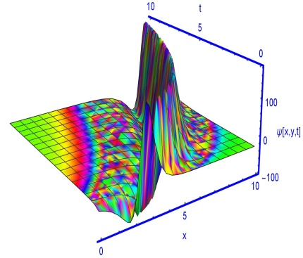  3D plot for $θ=0.3$ | 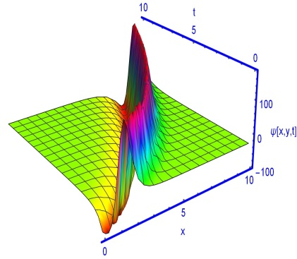  3D plot for $θ=0.5$ |  | 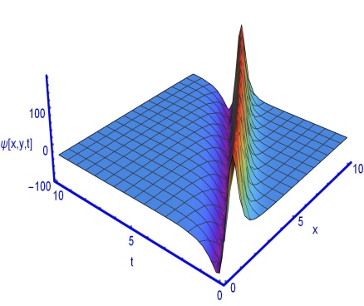  3D plot for $θ=0.9$
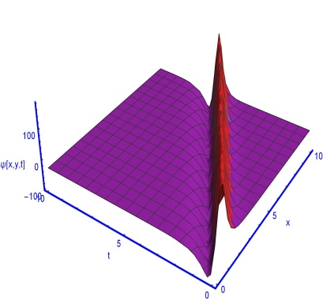
3D plot for $θ=1$

Fig. 1. Kink soliton. 3D plot and 2D plot for different values of $θ=0.3, 0 .5, 0 9, 1 and t=0.$
Fig. 1: The shape of a soliton can be understood based on time and space using a three-dimensional plot. From the observation, it can be seen that the higher the value of $σ$, the sharper and more localized the soliton becomes. The energy of the wave is then concentrated in a narrow region, which indicates that the spread of the soliton is very limited and it interacts less with the environment. On the other hand, if the value of $σ$ is low, the soliton is more spread out. This wide shape indicates the presence of memory effects, i.e. the system retains its previous states for a longer time, which causes the waves to spread. In addition to the three-dimensional analysis, the matter becomes clearer when observing a two-dimensional plot taken at a specific time (e.g.$t=1$): a higher $σ$ results in a steeper wave front, and a lower $σ$ value results in a lower slope. This confirms that there is a direct relationship between σ and the steepness of the wave. Thus, by increasing the value of $σ$, the expansion of the soliton decreases and it takes on a more compact and robust shape-higher $σ=$ dense soliton, lower $σ$ = diffuse soliton.
On the other hand, kink solitons are a special type of topological soliton, which forms a bridge between two different states and essentially indicates a phase transition. This property has made them very important in modern optical communications. Because kink solitons can switch between two different states, they are used to make optical logic gates-they act like electronic transistors, but with the help of light. They can switch from one state to another depending on the intensity of the signal, so they act as a switch and help route data. Moreover, kink solitons undergo phase changes, making them ideal for phase encoding; this allows two states of data (such as $0$ and $1$) to be clearly separated and noise to be greatly reduced.
Fig. 2 illustrates the bell-shaped soliton structures corresponding to solution (3.13) for different fractional orders, namely $θ=0.004,0 .5,0 .7$, along with the classical integer case $θ=1$. The simulations are carried out by fixing the parameter values as and $c=1.5$,$e=1.700155$, $f=2.18473$, $g=1.50534$, $s=1.16$, $y=0.59429$, $d_{1}=0.69716$, $d_{2}=0.421529$, $μ=1.52089$, $κ=1$. The graphical profiles are plotted within the spatial interval $0≤x≤10$ and the temporal range $0≤t≤10$.
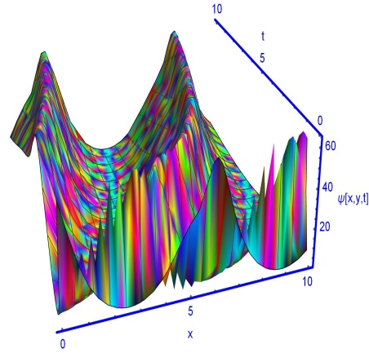  3D plot for $θ=0.004$ | 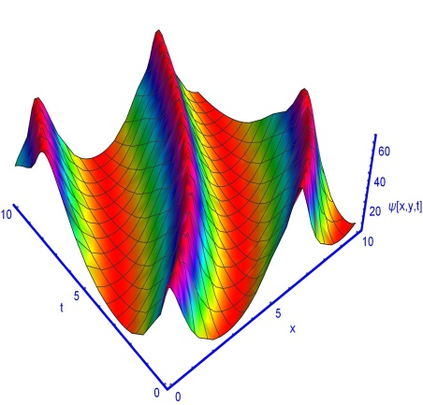  3D plot for $θ=0.5$ |  | 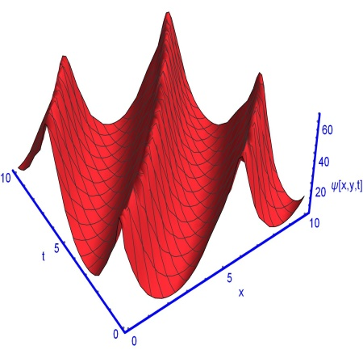  3D plot for $θ=0.7$
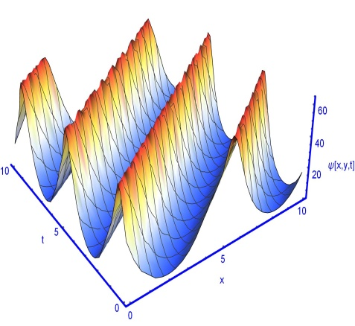
3D plot for $θ=1$
Fig. 2. Bell-shaped soliton. 3D plot and 2D plot for different values of $θ=0.004, 0 .5, 0 .7, 1 and t=0.$
Fig. 2: The graphical results reveal the formation of smooth, bell-shaped solitary wave structures with finite amplitude and rapid spatial decay, confirming the existence of stable localized soliton solutions. Each curve maintains a similar qualitative structure, indicating that the fundamental waveform is preserved despite parameter variation. However, noticeable quantitative differences are observed in peak amplitude, width, and propagation characteristics.
Specifically, as the fractional-order parameter increases, the crest of the soliton becomes sharper and slightly shifts in position, suggesting enhanced localization and reduced dispersion effects. Conversely, for smaller fractional values, the wave profile appears comparatively broader with reduced peak amplitude, indicating stronger memory effects and nonlocal behavior inherent in fractional-order systems. This behavior highlights the significant role of fractional derivatives in controlling wave modulation and energy concentration.
Another important observation is the symmetry of the wave structures around the central axis, which implies that the obtained solution represents a symmetric solitary wave propagating without distortion. The preservation of waveform shape across different parameter values confirms the robustness and stability of the analytical solution. Such stability is a hallmark feature of soliton dynamics in nonlinear evolution equations.
Physically, these results demonstrate that the fractional-order parameter acts as a tunable mechanism influencing dispersion–nonlinearity balance. In plasma physics, optical fiber systems, or ion-acoustic models, this implies that memory-dependent effects can regulate wave steepness, amplitude, and localization. Therefore, the fractional framework provides a more flexible and realistic description of nonlinear wave propagation compared to the classical integer-order case.
Overall, the obtained results validate the effectiveness of the employed analytical method in generating physically meaningful solutions. The graphical analysis confirms that the model successfully captures essential nonlinear wave phenomena, including amplitude modulation, localization control, and stable soliton propagation under fractional dynamics.
For the parameter $c=1.055$,$e=1.483$, $f=1.323$, $g=1.153$, $s=1.088$, $y=1.78$, $d_{1}=3.27$, $d_{2}=3.27$, $μ=1.206$, $κ=-2.5293$, solution (3.10) yields a combining bright and dark soliton. Figures 3(a)–3(e) illustrate its evolution over the domain $0≤x≤10$ and $0≤t≤10$ for fractional orders $θ=0.11,0 .13,0 .15, 0.3$ and classical integer order $θ=1$, respectively. Figure 3(f) presents the corresponding two-dimensional profile at $t=2$.

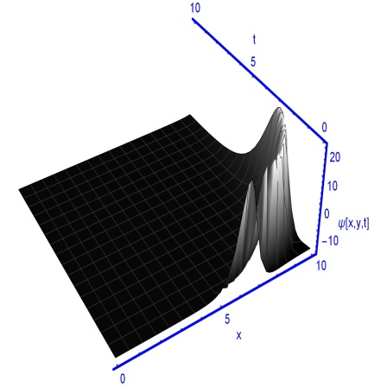  3D plot for $θ=0.11$ | 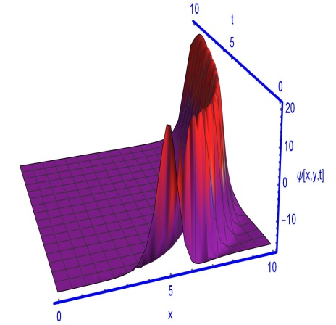  3D plot for $θ=0.13$ | 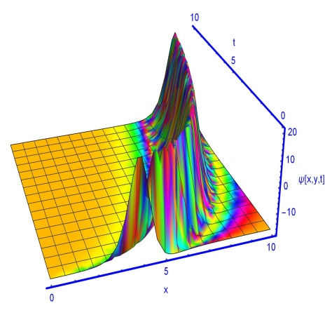  3D plot for $θ=0.15$
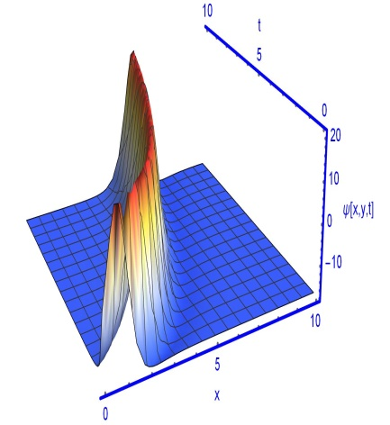  3D plot for $θ=0.3$ | 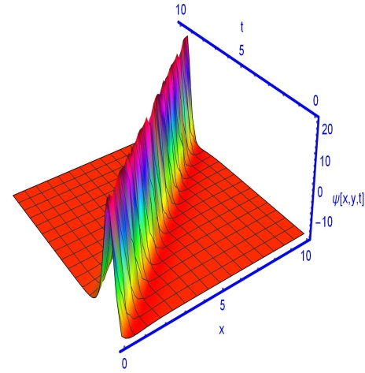  3D plot for $θ=1$
Fig. 3. Combining bright and dark soliton. 3D plot and 2D plot for different values of $θ=0.11,0 .13,0 .15, 0.3, 1 and t=0.$
Fig. 3: From the graphical representation, it is observed that each curve maintains a highly localized high-amplitude peak, followed by a rapid decay toward a negative or near-constant background level. This behavior indicates the presence of strong nonlinear effects dominating the dispersive contribution in specific spatial regions. The sharp rise and fall of the wave profiles confirm the existence of compressive solitary structures, while the undershoot (negative dip) following the crest suggests dispersive oscillatory adjustment of the medium. A significant horizontal shift among the curves is also evident, implying variation in wave speed or phase constant due to parameter modification. Such translational displacement is consistent with the traveling wave transformation employed in the analytical formulation. Furthermore, the amplitude magnitude remains nearly preserved across different cases, indicating structural stability of the solution despite parameter variation. However, the localization width and background asymptote vary slightly, reflecting sensitivity to the governing fractional or nonlinear coefficients. Such configurations indicate the presence of mixed solitary wave patterns, combining bright and dark features within a single waveform structure. This suggests that the model supports hybrid wave structures combining soliton-like peaks with monotonic transition states. Such hybrid solutions are physically relevant in plasma environments and nonlinear optical media where abrupt energy localization and state transitions coexist. The absence of discontinuities or singularities in the plotted solutions confirms their physical admissibility and mathematical consistency. The smooth yet steep gradients indicate strong nonlinear coupling balanced by fractional dispersive effects, reinforcing the effectiveness of the analytical method used to derive the solutions. The graphical analysis confirms the presence of localized, compressive, and transition-type wave structures governed by the model parameters. The results highlight the rich dynamical behavior of the system and demonstrate that parameter variation significantly influences wave localization, amplitude distribution, and propagation characteristics, making the model applicable to complex nonlinear physical phenomena.
Soliton propagation analysis is performed to investigate how fractional-order parameters influence the amplitude, width, and velocity of ion-acoustic solitary waves. The derived exact solutions demonstrate that the propagation speed and localization of solitons are strongly controlled by the fractional order $θ$. As $θ$ decreases from unity, soliton profiles become broader and their peak amplitudes are reduced, indicating enhanced memory and nonlocal effects in the plasma medium. This confirms that fractional parameters act as effective tuning controls for nonlinear ion-acoustic wave propagation.
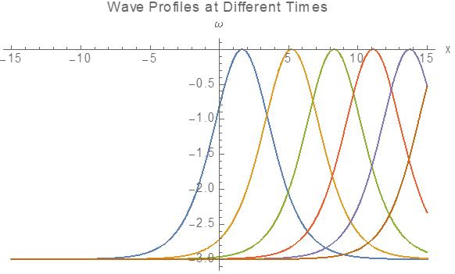
Fig. 4 depicts the temporal evolution of the obtained traveling wave solution, illustrating wave profiles at different time instances.
It is clearly observed that the waveform maintains its localized bell-shaped structure while translating along the positive $x$-direction. The amplitude and width of the pulse remain invariant over time, confirming that the solution preserves its fundamental characteristics during propagation. The overlapping nature of the profiles, differing only by a spatial shift, indicates that the wave travels with a constant velocity without experiencing dispersion-induced spreading or nonlinear steepening. This behavior verifies the existence of an exact balance between nonlinear and dispersive effects in the governing nonlinear evolution equation. Such a balance is the defining property of soliton dynamics. Furthermore, the rapid decay of the wave amplitude away from its central peak demonstrates strong spatial localization, implying that the energy of the system remains confined within a narrow region of the medium. The absence of amplitude attenuation or waveform distortion over time suggests dynamical stability of the derived solution. From a physical perspective, this type of propagation is characteristic of stable solitary structures observed in plasma physics, nonlinear optical fibers, and other nonlinear dispersive media. In particular, for fractional-order models, the preservation of the waveform indicates that the fractional parameter does not destroy the nonlinear-dispersive equilibrium but instead supports stable soliton transmission. Overall, the graphical analysis confirms that the obtained solution represents a robust traveling soliton exhibiting stable, shape-preserving propagation with constant velocity.
Bifurcation analysis
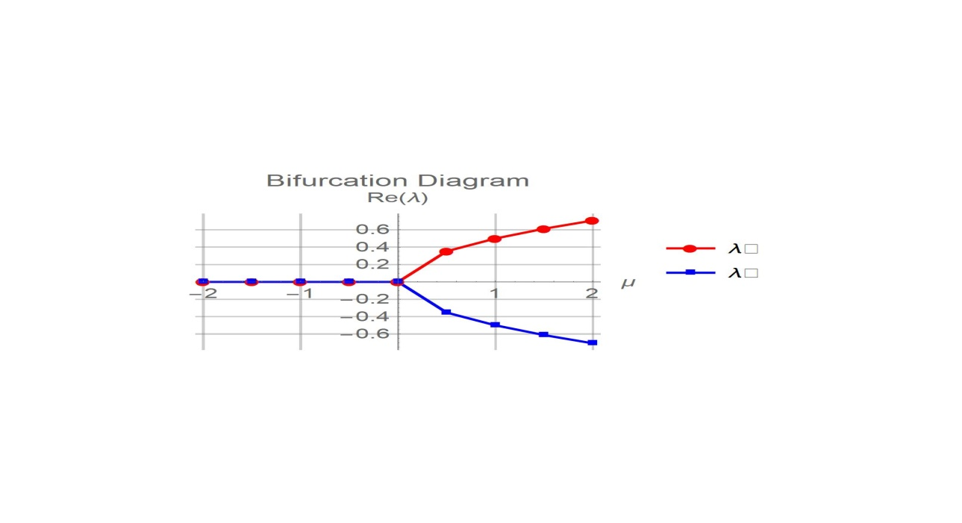
Fig. 5. shows the bifurcation diagram of the real part of the eigenvalue, $R_{e}(λ)$, versus the control parameter $μ$.
For $μ<0$, $R_{e}(λ)$ remains near zero, indicating that the equilibrium state is stable and perturbations do not grow. At the critical point $μ=0$, a stability transition occurs.
For $μ>0$, the eigenvalue branch splits symmetrically into two curves-one positive and one negative-forming a pitchfork-type bifurcation. The positive branch $(R_{e}(λ)>0)$ represents instability with exponential growth of disturbances, while the negative branch $(R_{e}(λ)<0)$ corresponds to decaying modes. Overall, the figure confirms a supercritical pitchfork bifurcation at $μ=0$, marking the transition from a stable homogeneous state to symmetry-broken states.

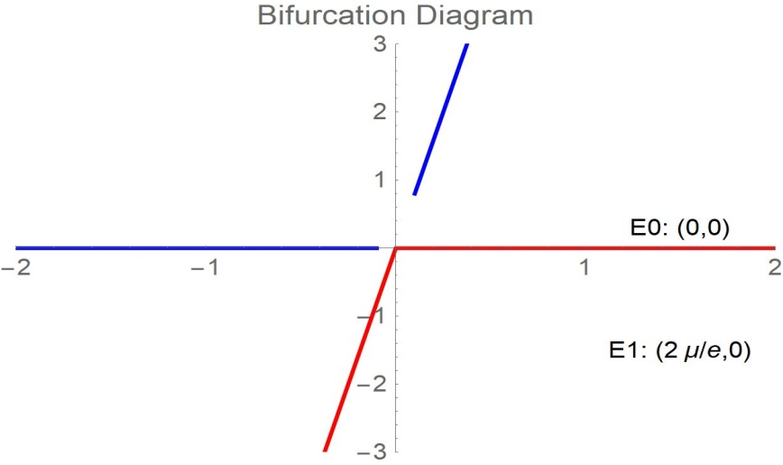

Fig. 6. shows a bifurcation diagram illustrating how the equilibrium states change with the control parameter $μ$.
For $μ<0$, the system remains at the trivial equilibrium $E_{0}=(0,0)$, indicating a stable homogeneous state. At the critical point $μ=0$, a stability transition occurs.
For $μ>0$, a new equilibrium branch $E_{1}=\left({2μ}/e,0\right)$ emerges, while the trivial solution changes its stability. This branching behavior indicates a pitchfork-type bifurcation, where the system shifts from a single stable state to multiple equilibrium states.
Overall, the diagram confirms that $μ=0$ is the critical bifurcation point, marking the transition from a stable state to symmetry-broken solutions.

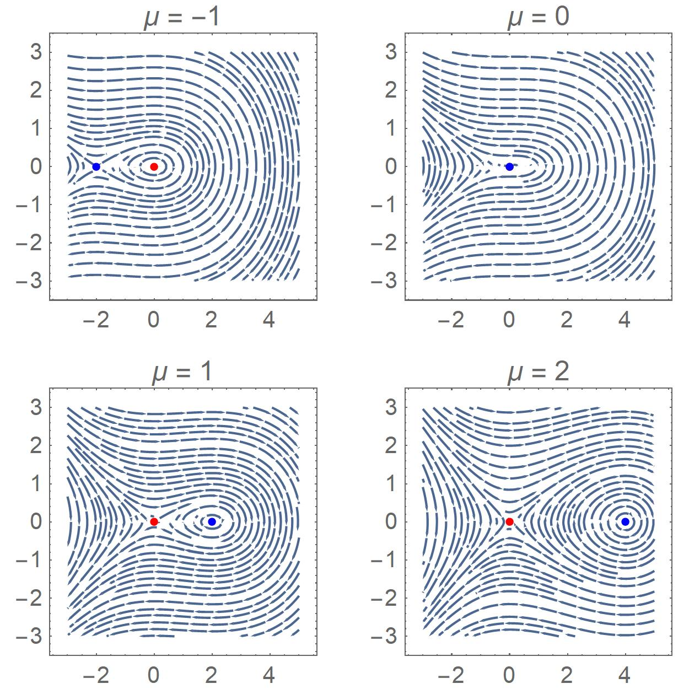

Fig. 7. presents phase portraits of the dynamical system for different values of the control parameter$μ=-1, 0, 1, 2$, illustrating the bifurcation behavior.
For $μ=-1$, the trajectories circulate around a central equilibrium point, indicating a stable enter configuration. At $μ=0$, the system reaches a critical transition state where the stability of the equilibrium changes, marking the bifurcation point. For $μ=1$, a new equilibrium point appears, and the flow structure reorganizes, showing the emergence of additional steady states.
At $μ=2$, the separation between equilibria becomes more pronounced, confirming the development of symmetry-broken states. Overall, the sequence demonstrates a pitchfork-type bifurcation as $μ$ crosses zero, where the system transitions from a single equilibrium to multiple equilibria with altered stability.

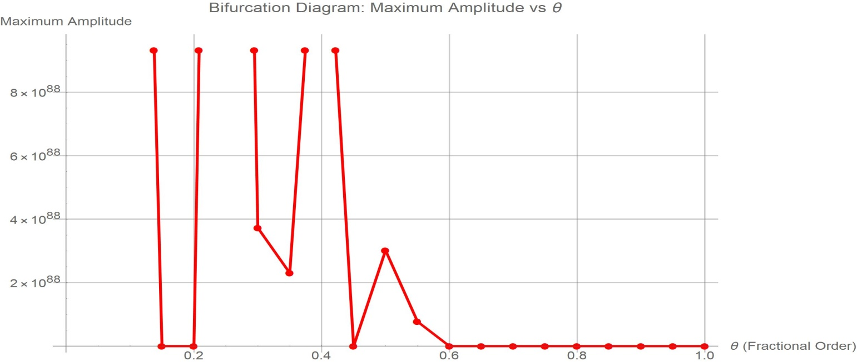
Fig. 8. presents the bifurcation diagram of the maximum wave amplitude versus the fractional-order parameter $θ$.
For lower values of $θ$ (approximately$0.1≤θ≤4$), the amplitude exhibits large fluctuations and abrupt jumps, indicating instability and strong sensitivity to parameter variation. These sharp transitions suggest the presence of bifurcation points where the system switches between different dynamical states.
As $θ$ increases beyond about 0.5, the maximum amplitude rapidly decreases and eventually stabilizes near zero. This indicates that the system transitions from a highly unstable or chaotic regime to a stable equilibrium state.
Overall, the diagram confirms that the fractional-order parameter $θ$ plays a crucial role in controlling stability, with a critical threshold separating unstable high-amplitude dynamics from stable low-amplitude behavior.

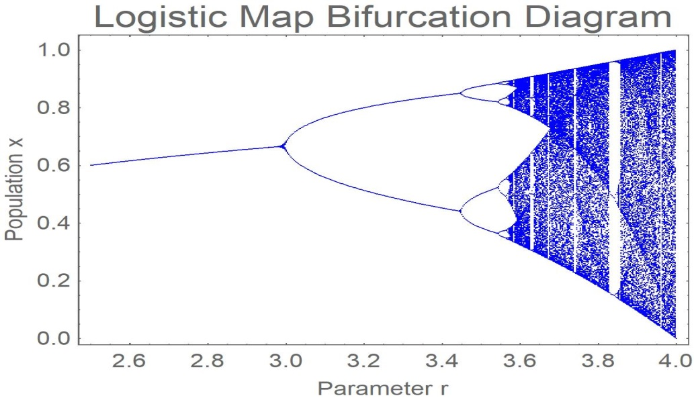
Fig. 9. shows the bifurcation diagram of the logistic map, illustrating how the long-term population $x$ changes as the control parameter $r$ increases.
For smaller values of $r$ (around 2.5-3.0), the system converges to a single stable steady state, indicating stable population dynamics. As $r$ increases beyond $r≈3$, the system undergoes a period-doubling bifurcation, where the single steady state splits into two oscillating values.
With further increase in $r$ successive period-doubling occurs $(2→4→8→…)$, leading to a cascade toward chaos. For $r≥3.57$, the diagram becomes densely populated, indicating chaotic behavior where the population varies irregularly and becomes highly sensitive to initial conditions. Overall, the figure demonstrates the classic route to chaos through period-doubling bifurcations.
Chaotic analysis
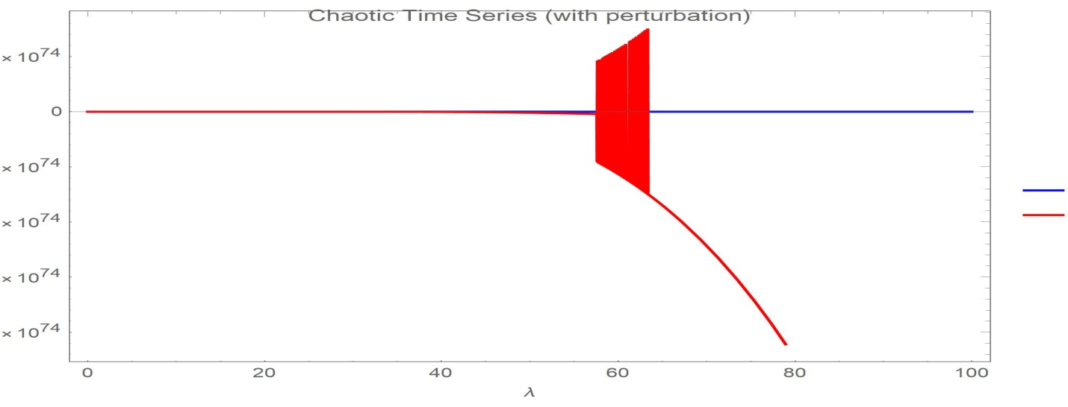
Fig. 10. illustrates the chaotic time series of the ion-acoustic wave under perturbation
For smaller values of the travel coordinate $λ$, the solution remains nearly constant, indicating that the system stays close to its equilibrium state. However, around $λ≈55-65$, irregular and rapidly fluctuating oscillations appear, forming a dense region in the plot. This sudden transition from steady behaviour to highly irregular motion is a clear signature of chaos, showing strong sensitivity to perturbation. After this chaotic burst, the amplitude diverges sharply, indicating instability and the breakdown of regular wave propagation. Overall, the figure confirms that the fractional system can exhibit chaotic dynamics when subjected to perturbations, particularly near critical parameter regimes.
Stability analysis
We consider the (2+1)-dimensional time-fractional extended Zakharov-Kuznetsov equation with beta-fractional derivative:
$D_{t}^{θ}ω+e\left({ωω}_{x}\right)+f\left(ω_{xxx}+ω_{yyy}\right)+g\left(ω_{xyy}+ω_{xxy}\right)=0$ , $0<θ≤1$
which models ion-acoustic waves in plasmas. Using the travelling wave transformation

$λ=x+y-\frac{μ}{θ}{(t+\frac{1}{Γθ})}^{θ}$, $ω\left(x,y,t\right)=V(λ)$
the equation reduces to the ordinary differential equation

$\left(2f+2g\right)V^{''}-μV+\frac{e}{2}V^{2}=0$ (A)
All subsequent analysis is based on this reduced ODE. The fractional order $θ$ does not appear explicitly in (A); it only affects the relation between $λ$ and the physical coordinates. Therefore, the stability and bifurcation properties derived from (A) are universal for all $θ$, while the physical wave profiles depend on $θ$ through the argument $λ$.
Constant solutions $V=V_{0}$ satisfy $-μV_{0}+\frac{e}{2}V_{0}^{2}=0$, hence $V_{0}=0$ or $V_{0}=\frac{2μ}{e}$. Linearising (A) around $V_{0}$ by setting $V=V_{0}+ ν$ gives $\left(2f+2g\right)ν^{''}-μν+eV_{0}ν=0$.
For $V_{0}=0$: $ν^{''}-\frac{μ}{2\left(f+g\right)}ν=0$.
If $\frac{μ}{\left(f+g\right)}>0$: exponential growth or decay (unstable if positive real part).
If $\frac{μ}{\left(f+g\right)}<0$: oscillatory (stable).
For $V_{0}=\frac{2μ}{e} : \left(2f+2g\right)ν^{''}+νμ=0$
$ν^{''}+\frac{μ}{2\left(f+g\right)}ν=0$ .
If $\frac{μ}{\left(f+g\right)}>0:$ oscillatory (stable).
If $\frac{μ}{\left(f+g\right)}<0$: exponential (unstable).
Thus the stability of constant state is determined by the sign of $\frac{μ}{\left(f+g\right)}$. Physically, $μ$ is related to the wave speed and $(f+g)$ represents dispersion; stability requires $μ$ and $(f+g)$ to have the same sign for the nontrivial constant state.

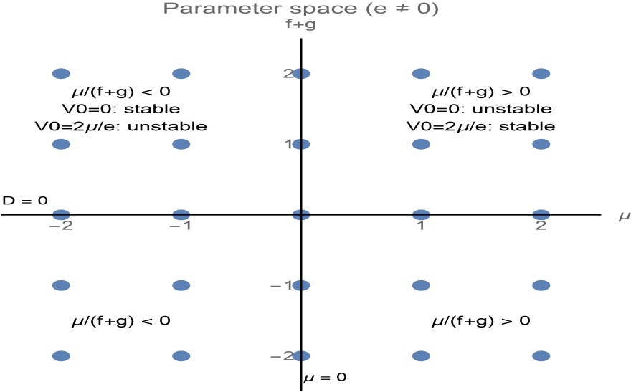

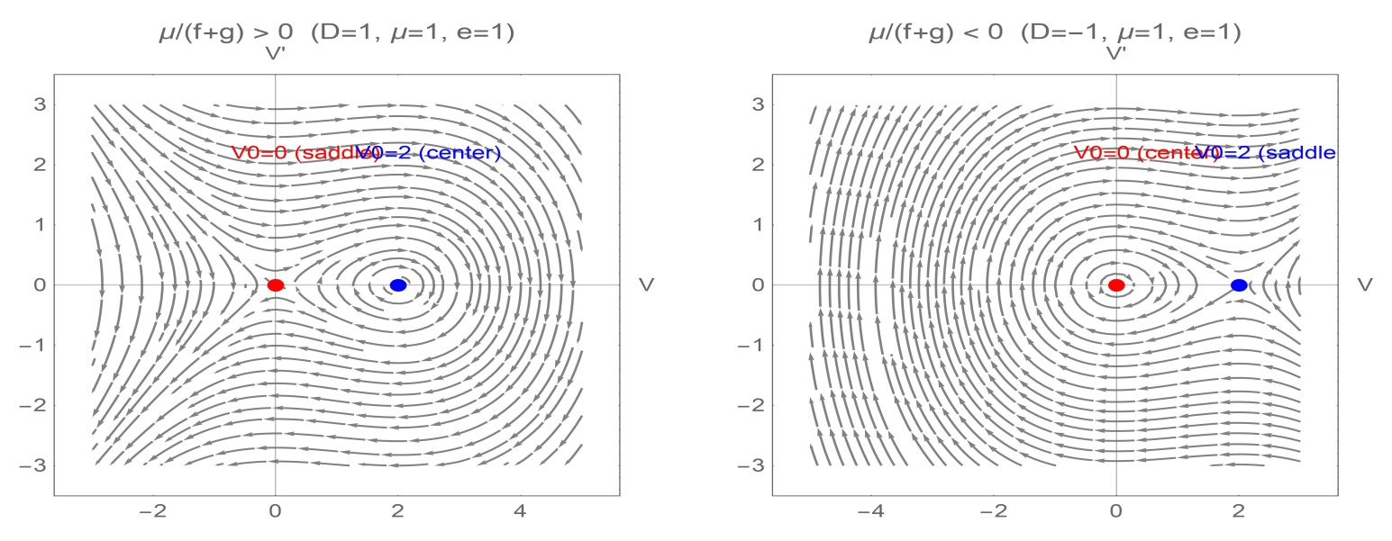
Fig. 11. the stability analysis depicted in the figure is illustrated by the following composited graphic
The stability of the two constant states and the sign of $\frac{μ}{\left(f+g\right)}$ are displayed in a parameter space diagram. Two-phase portraits utilizing $e=1$ and $μ=1$ with $f+g=1$ and $g+f=-1$ for the instances $\frac{μ}{\left(f+g\right)}>0$ and $\frac{μ}{\left(f+g\right)}<0$ respectively. The parameter space $\left(μ, f+g\right)$ is mapped in the top panel. The sign of $\frac{μ}{\left(f+g\right)}$ and the related stability of the two constant solutions, $V_{0}=0$ and $V_{0}=\frac{2μ}{e}$, are displayed in the four quadrants. Both $f+g=0$ and $μ=0$ are degenerate situations; when $f+g=0$, the ODE order changes, and when $μ=0$, the constant solution $V_{0}=\frac{2μ}{e}$ corresponds with zero. Phase portraits for two particular parameter selections are displayed in the bottom panel: Left $\frac{μ}{\left(f+g\right)}>0$ (in this case $μ=1$, $f+g=1):$ $V_{0}=2$ is a center stable, whereas $V_{0}=0$ is a saddle unstable. Right $\frac{μ}{\left(f+g\right)}<0$, where $μ=1$, $f+g=-1$ and $V_{0}=2$ is an unstable saddle, while $V_{0}=0$ is a stable center. The fractional order $θ$ does not appear explicitly in these stability results; it only influences the physical wave profiles through the transformation $λ=x+y-\frac{μ}{θ}{(t+\frac{1}{Γθ})}^{θ}$. Thus the bifurcation analysis is universal for all $θ∈(0,1]$.
5. Conclusion
This study has presented a comprehensive analysis of the beta-fractional dynamics of time-fractional ion-acoustic models, emphasizing soliton propagation, bifurcation behavior, stability characteristics, and the emergence of chaotic dynamics. By employing the beta-fractional derivative, the proposed framework effectively incorporates memory and nonlocal effects that are absent in classical integer-order formulations, thereby offering a more realistic description of ion-acoustic wave evolution in complex plasma environments.
Exact traveling-wave solutions were successfully derived and categorized into physically meaningful structures, including solitary, periodic, and singular solitons. The influence of the fractional-order parameter was shown to play a decisive role in controlling wave amplitude, width, and propagation speed, demonstrating the sensitivity of ion-acoustic dynamics to fractional memory effects. Furthermore, bifurcation and phase-space analyses revealed critical transitions between stable, unstable, and chaotic regimes, highlighting the ability of the beta-fractional model to capture nonlinear instabilities and chaos that are inaccessible through classical approaches.
Overall, the results confirm that the beta-fractional formulation provides a unified and robust mathematical framework for investigating nonlinear plasma waves. The findings not only enhance the theoretical understanding of ion-acoustic phenomena but also offer valuable insights for applications in laboratory plasmas, space plasma dynamics, and astrophysical systems. This work establishes a solid foundation for future studies on higher-dimensional, multi-fractional, and magnetized plasma models.
References
1. Zubair A, Raza N, Mirzazadeh M, Liu W, Zhou Q. Analytic study on optical solitons in parity-time symmetric mixed linear and nonlinear modulation lattices with non-Kerr nonlinearities. Optik. 2018; 173:249-262.
2. Raza N, Aslam MR, Rezazadeh H. Analytical study of resonant optical solitons with variable coefficients in Kerr and non-Kerr law media.Opt Quant Electron. 2019; 51, 59.
3. Hosseini K, Osman MS, Mirzazadeh M, Rabie F. Investigation of different wave structures to the generalized third-order nonlinear Schrödinger equation. Optik. 2020; 206, 164259.
4. Israwi S. Higher order dissipative-dispersive system and application. J Partial Diff Eqs. 2020; 33: 1-16.
5. Bakar MA, Owyed S, Faridi WA, El-Rahman MA, Aallah M.The first integral of the dissipative nonlinear Schrödinger equation with Nucci’s direct method and explicit wave profile formation. Fractal Fract. 2023; 7 (1): 38.
6. Almatrafi MB, Alharbi A. New soliton wave solutions to a nonlinear equation arising in plasma physics. CMES. 2023; 137,1.
7. Zuo DW, Gao YT, Xue L, Feng YJ. Lax pair, rogue-wave and soliton solutions for a variable coefficient generalized nonlinear Schrödinger equation in an optical fiber, fluid or plasma. Opt Quant Electron. 2016; 48, 76.
8. Biswas A. Multiple-scale analysis for solitons due to Langmuir waves in plasmas. Int J Comput Math. 2010; 87(12): 2831-2836.
9. Alazman IA, ALkahtani BST, Mishra MN. Dynamic of bifurcation, chaotic structure and multi soliton of fractional nonlinear Schrödinger equation arise in plasma physics. Scientific Reports. 2024; 14, 25781.
10. Das N, Ray SS. Dispersive optical soliton solutions of the (2+1)-dimensional cascaded system governing by coupled nonlinear Schrödinger equation with Kerr law nonlinearity in plasma. Opt Quant Electron. 2023; 55, 328.
11. Hoang Vt, Widjaja J, Qiang YL, Liu MK, Alexgender TJ, Runge AFJ, Sterke CM. Nonlinear wave propagation governed by a fractional derivative. Nature Communications. 2025; 16, 5469.
12. Akram G, Sadaf M, Zainab I, Abbas M, Akgul A. A comparative study if time fractional nonlinear Drinfeld-Sokolov-Wilson system via modified auxiliary equation method. Fractal Fract. 2023; 7, 665.
13. Wang Kj, Liu JH. Diverse optical solitons to the nonlinear Schrödinger equation via two novel techniques. Eur Phys J Plus. 2023; 138; 1-9.
14. Podlubny I. Fractional differential equations: An introduction to fractional derivatives, fractional differential equations, to methods of their solution and some of their applications. Elsevier: Amsterdam, the Netherlands. 1998.
15. Yildirim Y, Biswas A, Khan S, Guggilla P, Alzahrani AK, Belic MR. Optical solitons in fiber Bragg gratings with dispersive reflectivity by sine-Gordon equation approach. Optik. 2021; 237, 166684.
16. Triki H, Zhou Q, Biswas A, Liu W, Yildirim Y, Alshehri HM, Belic MR. Chirped optical solitons having polynomial law of nonlinear refractive index with self-steepening and nonlinear dispersion. Phys Lett A. 2021; 417, 127698.
17. Wu GC. A fractional variational iteration method for solving fractional nonlinear differential equations. Comput Math Appl. 2011; 61: 2186-2190.
18. Tariq H, Akram G, Sadaf M, Iftikhar M, Guran L. Computational study for fiber bragg grating with dispersive reflectivity using fractional derivative. Fractal Fract. 2023; 7, 625.
19. Goswami A, Singh J, Kumar D, Gupta S, Sushila. An efficient analytical technique for fractional differential equations occurring in ion acoustic waves in plasma. J Ocean Engg Sci. 2019; 4(2): 85-99.
20. He JH, Wu XH. Exp-function method for nonlinear wave equations. Chaos, Solitons Fractals. 2006; 30: 700-708.
21. Yaslan HC, Girgin A. Exp-function method for the conformable space-time fractional STO, ZKBBM and coupled Boussinesq equations. Arab J Basic Appl Sci. 2019; 26(1): 163-170.
22. Aminikhah H, Sheikhani AH, Rezazadeh H. Sub-equation method for the fractional regularized long-wave equations with conformable fractional derivatives. Scientia Iranica, Transactions B: Mech Engg. 2016; 23: 1048-1054.
23. Abdou MA, Owyed S, Ray SS, Chu YM, Inc M, Ouahid L. Fractal ion acoustic waves of the space-time fractional three dimensional KP equation. Adv Math Phys. 2020; 7: article ID 8323148.
24. Ali AHA, Soliman AA, Abdou MA, Emara MH. Exact travelling wave solution of fractional space-time Zakharov-Kuznetsov equation. Indian J Sci Tech. 2019; 12(3), 127285.
25. Zheng B. ${{(G}^{'}}/G)$-expansion method for solving fractional partial differential equations in the theory of mathematical physics. Commu Theore Phys. 2012; 58: 623-630.
26. Abdou MA. On the fractional order space-time nonlinear equations arising in plasma physics. Indian J phys. 2019; 93(40: 537-541.
27. Zayed EME, Abdelaziz MAM, Abualnaja KM. Optical solitons of the space-time fractional Schrödinger-Hirota equation by the sine-Gordon expansion method. Res Phys. 2020; 16, 102876.
28. Rehman SU, Ahmed N, Zhou Q. Analytical soliton solutions for the fractional-order ion-acoustic wave equations via the trial equation method. Chin J Phys. 2022; 77: 1271-1282.
29. Seadawy AR, ALI A. New exact solutions for nonlinear ion-acoustic wave equations in plasma physics via the trial equation method. Alexandria Engg J. 2020; 59(1): 135-144.
30. Akbar MA, Asaduzzaman, Gepreel KA. Soliton solutions and wave dynamics of complex fractional models in nonlinear optics. Res Engg. 2025; 26, 105590.
31. Zayed EME, Al-Nowehy AG, Abdelaziz MAM. New optical soliton solutions of fractional-order nonlinear evolution equations via the double$\left({G^{'}}/G,1/G\right)$-expansion method. Optik. 2021; 241, 166929.
32. Asaduzzaman, Akbar MA. Dynamics of optical solitons of nonlinear fractional models: a comprehensive analysis of space-time fractional equations. Opt Quant Electron. 2024; 56, 783.
33. Alsatami KA. Exploring nonlinear fractional (2+1)-dimensional KP-Burgers models: derivation and ion acoustic solitary wave solution. Int J Anal Appl. 2024; 22, 147.
34. Akbari-Moghanjughi M, Mohammadnejada M. Formation of ion acoustic rogue waves in warm dense matter. Eur Phys.2021; 75, 307.
35. Chen L, Liu Q. Time-space fractional model for complex cylindrical ino-acoustic waves in ultrarelativistic plasmas. Complexity. 2020; Article Id 9075823.
36. Zada L, Nawaz R, Jamshed W, Ibrahim RW, Tag El Din ESM, Raizah Z, Amjad A. New optimum solutions of nonlinear fractional acoustic wave equations via optimal homotopy asymptotic method-2 (OHAM-2). Scientific Reports. 2022; 12, 18838.
37. Sohail A, Arshad S, Ehsan Z. Numerical analysis of plasma KdV equation: time-fractional approach. Int J Appl Comput Math. 2017; DOI 10.1007/s40819-017-0420-7.
38. Prakash A, Veram V. Numerical solution of nonlinear fractional Zakharov–Kuznetsov equation arising in ion-acoustic waves. Pramana-J Phys. 2019; 93, 66.
39. Rashid S, Kubra KT, Guirao JLG. Construction of an approximate analytical solution for multi-dimensional fractional Zakharov-Kuznetsov equation via Aboodh Adomian Decomposition method. Symmetry. 2021; 13, 1542.
40. Gao B, Wang Y. Traveling wave solutions for the (2+1)-dimensional generalized Zakharov-Kuznetsov equation with variable coefficients. Opt Quant Electron. 2021; 53, 58.
41. Lu D. The iterative Elzaki transform method for fractional Zakharov-Kuznetsov equations. Res Phys. 2021. 24, 104053.
42. Liu JG, Yang XJ, Feng YY, Cui P. On group analysis of the time fractional extended (2+1)-dimensional Zakharov-Kuznetsov equation in quantum magneto-plasmas. 2020; 178; 407-421.

