Comparative Ultrasonic and Acoustic Properties of Ethylbenzoate with secondary and tertiary Butanol Binary Mixtures

Abstract
This work reports on the ultrasonic velocity, density, viscosity, and derived acoustic parameters of binary mixtures of ethylbenzoate with 2-butanol and 2-methyl-2-propanol over a range of compositions at 303.15 K, 308.15 K, 313.15 K, and 318.15 K. The experimental measurements were used to calculate adiabatic compressibility, intermolecular free length, internal pressure, and acoustic impedance to elucidate underlying molecular interactions. For both systems, increasing ethylbenzoate mole fraction produced higher velocity and density, and lower viscosity and compressibility, indicating enhanced structural ordering. The ethylbenzoate + 2-butanol system exhibited stronger cohesive interactions, as revealed by higher ultrasonic velocities, acoustic impedance and internal pressure compared to the ethylbenzoate + 2-methyl-2-propanol system, attributed to reduced steric hindrance and more effective hydrogen bonding in the former. Temperature elevation weakened interactions in both mixtures, consistent with increased thermal agitation. These findings are significant for designing solvent systems in chemical processing and provide fundamental insights into mixture behavior relevant to industrial and environmental applications.
Keywords: Ultrasonic velocity, adiabatic compressibility, internal pressure, binary mixtures, acoustic impedance, intermolecular interactions.
I. Introduction
Binary liquid mixtures exhibit complex behaviour driven by intermolecular interactions such as hydrogen bonding, dipole–dipole forces, and dispersion effects. Ultrasonic velocity and related acoustic parameters have been widely used to probe such interactions because they reflect changes in molecular packing and cohesion [1]–[4]. Ultrasonic techniques offer precision for determining physical properties like adiabatic compressibility (βad), acoustic impedance (Z), and internal pressure (π), which correlate with interaction strength and structural organization in liquids [5]–[8].
Alcohol–ester mixtures have attracted significant interest due to their relevance in chemical synthesis, solvent design, and industrial applications where miscibility and transport properties are critical [9]–[12]. Prior studies have shown that secondary alcohols generally form stronger hydrogen bonding compared to tertiary alcohols due to lower steric hindrance around the hydroxyl group [13]–[18]. Similarly, the introduction of bulky substituents is known to disrupt cohesive forces and lead to structure-breaking behaviour [19]–[22].
Despite extensive literature on alcohol–ester mixtures, comparative studies focusing on ethylbenzoate with structurally distinct alcohols remain limited, particularly at multiple temperatures. The current work addresses this gap by experimentally evaluating the ultrasonic and acoustic properties of ethylbenzoate mixed with 2-butanol and 2-methyl-2-propanol. The influence of molecular structure on interaction strength is analyzed through a series of measured and derived parameters across four temperatures.
II. Materials and Methods
A.Materials
Ethylbenzoate (≥99 % purity), 2-butanol (≥99 %) and 2-methyl-2-propanol (≥99 %) were obtained from commercial suppliers and used without further purification. All liquids were dried and stored over molecular sieves to minimize water content.
B.PreparationofMixtures
Binary mixtures of ethylbenzoate (X₁) with each alcohol (X₂) were prepared gravimetrically in mole fractions ranging from 0.0000 to 1.0000. Samples were equilibrated at target temperatures (303.15 K – 318.15 K) in a thermostated water bath (±0.05 K accuracy).
C.Measurements
Ultrasonic velocities were measured using a digital ultrasonic interferometer (±0.1 m/s precision). Densities were obtained via a vibrating-tube densitometer (±0.0001 g·cm⁻³), and viscosities via a Ubbelohde viscometer (±0.5 % accuracy). Adiabatic compressibility, internal pressure, acoustic impedance, free length and molar volume were calculated using standard thermodynamic relations [23]–[25].
III. Results and Discussion
A. Ultrasonic Velocity and Density
Ultrasonic velocity increased with ethylbenzoate mole fraction for both systems at all temperatures, indicative of stronger cohesive forces and reduced free volume [6], [16]. The ethylbenzoate + 2-butanol mixture consistently exhibited higher velocities and densities than the ethylbenzoate + 2-methyl-2-propanol mixture at equivalent compositions, reflecting more effective molecular packing due to lower steric hindrance in 2-butanol.
B. Viscosity and Derived Acoustic Parameters
Viscosity decreased with increasing temperature and ethylbenzoate content, aligning with reduced hydrogen bonding at elevated temperatures [10], [14]. The ethylbenzoate + 2-methyl-2-propanol system showed slightly higher viscosities at low X₁, likely due to the bulkier tertiary alcohol causing structural constraints.
Derived parameters such as adiabatic compressibility and intermolecular free length decreased with ethylbenzoate content, confirming stronger interactions [7], [24]. Internal pressure and acoustic impedance followed opposite trends, increasing with ethylbenzoate mole fraction and underscoring enhanced cohesion in 2-butanol mixtures.
C. Temperature Effects
All measured and calculated properties exhibited systematic temperature dependence: rising temperature led to lower velocity, density, internal pressure and higher free length. These trends illustrate thermal disruption to structured interaction networks [5], [20].

 | Table 1
 | Ethylbenzoate(X₁) + 2-butanol(X₂)
 | Ultrasonic velocities, Densities, Viscosities and related Acoustic Parameters
Mole fraction X₁ |  | Velocity (U) m/s | Density (ρ)X10⁻³  gm/cm³ | Viscosity (η) cP | Mol.Vol. V cm³ mol⁻¹ | Ad. Comp. β_{ad}×10⁻¹² m²N⁻¹ | Int Mol. Free Length L_{f (A)} | internal pressure π Nm⁻² | Acoustic impedance  (Z) Kg m⁻² s⁻¹ | Enthalpy H Jmol⁻¹
 | s |  |  |  |  | 303.15K
 | 0.0000 | 1152.0 | 798.20 | 2.595 | 92.859 | 16.626 | 0.8092 | 9.0122 | 919.53 | 836.866
 | 0.0666 | 1171.1 | 823.70 | 2.537 | 96.137 | 16.650 | 0.8098 | 8.3550 | 964.64 | 803.224
 | 0.1384 | 1190.7 | 849.70 | 2.474 | 99.619 | 16.685 | 0.8107 | 7.7287 | 1011.74 | 769.925
 | 0.2159 | 1210.7 | 876.00 | 2.407 | 103.358 | 16.733 | 0.8118 | 7.1325 | 1060.57 | 737.197
 | 0.2999 | 1231.1 | 902.40 | 2.335 | 107.412 | 16.795 | 0.8133 | 6.5626 | 1110.94 | 704.901
 | 0.3912 | 1251.6 | 928.70 | 2.257 | 111.846 | 16.868 | 0.8151 | 6.0170 | 1162.36 | 672.974
 | 0.4908 | 1272.1 | 954.50 | 2.173 | 116.758 | 16.954 | 0.8172 | 5.4939 | 1214.22 | 641.465
 | 0.5999 | 1292.3 | 979.30 | 2.082 | 122.274 | 17.053 | 0.8196 | 4.9914 | 1265.55 | 610.312
 | 0.7199 | 1311.8 | 1002.40 | 1.982 | 128.561 | 17.167 | 0.8223 | 4.5062 | 1314.95 | 579.320
 | 0.8526 | 1330.1 | 1022.60 | 1.873 | 135.888 | 17.301 | 0.8255 | 4.0374 | 1360.16 | 548.635
 | 1.0000 | 1346.2 | 1039.20 | 1.751 | 144.505 | 17.439 | 0.8288 | 3.5827 | 1398.97 | 517.723
 |  |  |  |  |  | 308.15K
 | 0.0000 | 1142.5 | 793.30 | 2.150 | 93.432 | 16.454 | 0.8050 | 8.2035 | 906.35 | 766.471
 | 0.0666 | 1161.0 | 819.20 | 2.108 | 96.665 | 16.454 | 0.8050 | 7.6211 | 951.09 | 736.691
 | 0.1384 | 1180.0 | 845.40 | 2.066 | 100.126 | 16.470 | 0.8054 | 7.0707 | 997.57 | 707.960
 | 0.2159 | 1199.4 | 871.60 | 2.021 | 103.880 | 16.505 | 0.8063 | 6.5443 | 1045.40 | 679.820
 | 0.2999 | 1219.1 | 898.10 | 1.974 | 107.926 | 16.548 | 0.8073 | 6.0444 | 1094.87 | 652.344
 | 0.3912 | 1239.0 | 924.60 | 1.922 | 112.342 | 16.603 | 0.8087 | 5.5642 | 1145.58 | 625.096
 | 0.4908 | 1259.0 | 950.40 | 1.867 | 117.262 | 16.678 | 0.8105 | 5.1042 | 1196.55 | 598.530
 | 0.5999 | 1278.7 | 975.30 | 1.808 | 122.775 | 16.765 | 0.8126 | 4.6633 | 1247.12 | 572.533
 | 0.7199 | 1297.9 | 998.50 | 1.743 | 129.063 | 16.871 | 0.8152 | 4.2373 | 1295.95 | 546.882
 | 0.8526 | 1315.8 | 1018.70 | 1.673 | 136.408 | 16.995 | 0.8182 | 3.8267 | 1340.41 | 521.991
 | 1.0000 | 1331.9 | 1034.80 | 1.596 | 145.120 | 17.143 | 0.8217 | 3.4291 | 1378.25 | 497.628
 |  |  |  |  |  | 313.15K
 | 0.0000 | 1137.5 | 789.50 | 1.734 | 93.882 | 16.389 | 0.8034 | 7.4792 | 898.06 | 702.165
 | 0.0666 | 1155.0 | 815.60 | 1.709 | 97.092 | 16.356 | 0.8026 | 6.9709 | 942.02 | 676.822
 | 0.1384 | 1172.9 | 841.90 | 1.686 | 100.542 | 16.340 | 0.8022 | 6.4927 | 987.46 | 652.790
 | 0.2159 | 1191.2 | 868.30 | 1.663 | 104.275 | 16.342 | 0.8023 | 6.0382 | 1034.32 | 629.631
 | 0.2999 | 1209.9 | 894.80 | 1.637 | 108.324 | 16.360 | 0.8027 | 5.6011 | 1082.62 | 606.730
 | 0.3912 | 1228.7 | 921.00 | 1.612 | 112.781 | 16.392 | 0.8035 | 5.1866 | 1131.63 | 584.952
 | 0.4908 | 1247.5 | 946.70 | 1.584 | 117.720 | 16.439 | 0.8047 | 4.7873 | 1181.01 | 563.559
 | 0.5999 | 1266.1 | 971.40 | 1.555 | 123.268 | 16.502 | 0.8062 | 4.4049 | 1229.89 | 542.984
 | 0.7199 | 1284.1 | 994.70 | 1.524 | 129.556 | 16.577 | 0.8080 | 4.0378 | 1277.29 | 523.119
 | 0.8526 | 1301.0 | 1014.90 | 1.491 | 136.919 | 16.678 | 0.8105 | 3.6828 | 1320.38 | 504.245
 | 1.0000 | 1316.0 | 1030.60 | 1.455 | 145.711 | 16.804 | 0.8136 | 3.3382 | 1356.27 | 486.414
 |  |  |  |  |  | 318.15K
 | 0.0000 | 1132.8 | 785.50 | 1.395 | 94.360 | 16.337 | 0.8022 | 6.8065 | 889.81 | 642.267
 | 0.0666 | 1149.2 | 812.20 | 1.384 | 97.498 | 16.260 | 0.8003 | 6.3716 | 933.38 | 621.225
 | 0.1384 | 1165.9 | 838.60 | 1.376 | 100.938 | 16.209 | 0.7990 | 5.9614 | 977.72 | 601.730
 | 0.2159 | 1183.1 | 864.80 | 1.371 | 104.697 | 16.186 | 0.7984 | 5.5741 | 1023.14 | 583.585
 | 0.2999 | 1200.5 | 891.10 | 1.366 | 108.774 | 16.173 | 0.7981 | 5.2041 | 1069.77 | 566.069
 | 0.3912 | 1218.1 | 917.10 | 1.362 | 113.261 | 16.179 | 0.7983 | 4.8509 | 1117.12 | 549.416
 | 0.4908 | 1235.6 | 942.80 | 1.357 | 118.207 | 16.193 | 0.7986 | 4.5109 | 1164.92 | 533.224
 | 0.5999 | 1252.9 | 967.50 | 1.354 | 123.765 | 16.225 | 0.7994 | 4.1867 | 1212.18 | 518.166
 | 0.7199 | 1269.6 | 990.60 | 1.350 | 130.093 | 16.272 | 0.8006 | 3.8723 | 1257.67 | 503.754
 | 0.8526 | 1285.2 | 1010.70 | 1.349 | 137.488 | 16.343 | 0.8023 | 3.5709 | 1298.95 | 490.955
 | 1.0000 | 1299.0 | 1026.00 | 1.348 | 146.365 | 16.446 | 0.8048 | 3.2759 | 1332.77 | 479.480

Table 2
Ethylbenzoate(X₁) + 2-methyl-2-propanol(X₂)
Ultrasonic velocities, Densities, Viscosities and related Acoustic Parameters
Mole fraction X₁ | Velocity (U) m/s | Density (ρ)X10⁻³  gm/cm³ | Viscosity (η) cP |  | Mol.Vol. V cm³ mol⁻¹ |  | Ad. Comp. β_{ad}×10⁻¹² m²N⁻¹ |  | Int Mol. Free Length L_{f (Ǻ)} |  | internal pressure π Nm⁻² |  | Acoustic impedance (Z)  Kg m⁻² s⁻¹ |  | Enthalpy H Jmol⁻¹
 |  |  |  |  |  | 303.15K
0.0000 | 1061.0 | 775.30 | 3.3720 | 95.6017 |  | 14.5198 |  | 0.7562 |  | 10.50 |  | 822.59 |  | 1003.72
0.0685 | 1087.8 | 806.20 | 3.2580 | 98.3969 |  | 14.6776 |  | 0.7603 |  | 9.66 |  | 876.98 |  | 950.95
0.1419 | 1115.4 | 837.10 | 3.1360 | 101.4373 |  | 14.8622 |  | 0.7651 |  | 8.87 |  | 933.70 |  | 899.62
0.2209 | 1143.7 | 868.10 | 3.0060 | 104.7339 |  | 15.0680 |  | 0.7704 |  | 8.11 |  | 992.85 |  | 849.60
0.3061 | 1172.6 | 898.70 | 2.8670 | 108.3744 |  | 15.2998 |  | 0.7763 |  | 7.39 |  | 1053.82 |  | 800.79
0.3982 | 1202.0 | 928.40 | 2.7170 | 112.4518 |  | 15.5623 |  | 0.7829 |  | 6.70 |  | 1115.94 |  | 752.90
0.4981 | 1231.7 | 956.90 | 2.5550 | 117.0439 |  | 15.8542 |  | 0.7902 |  | 6.03 |  | 1178.61 |  | 705.71
0.6069 | 1261.4 | 983.30 | 2.3790 | 122.3151 |  | 16.1815 |  | 0.7983 |  | 5.39 |  | 1240.33 |  | 658.95
0.7258 | 1290.8 | 1006.70 | 2.1890 | 128.4527 |  | 16.5508 |  | 0.8074 |  | 4.77 |  | 1299.45 |  | 612.53
0.8562 | 1319.3 | 1025.00 | 1.9810 | 135.7191 |  | 16.9661 |  | 0.8175 |  | 4.17 |  | 1353.47 |  | 565.74
1.0000 | 1346.2 | 1039.20 | 1.7510 | 144.5054 |  | 17.4389 |  | 0.8288 |  | 3.58 |  | 1398.97 |  | 517.72
 |  |  |  |  |  | 308.15K
0.0000 | 1055.7 | 770.10 | 2.5890 | 96.2472 |  | 14.4722 |  | 0.7550 |  | 9.18 |  | 812.99 |  | 883.68
0.0685 | 1081.5 | 801.40 | 2.5150 | 98.9862 |  | 14.5950 |  | 0.7582 |  | 8.48 |  | 866.71 |  | 839.61
0.1419 | 1108.1 | 832.70 | 2.4390 | 101.9733 |  | 14.7458 |  | 0.7621 |  | 7.82 |  | 922.71 |  | 797.38
0.2209 | 1135.3 | 864.00 | 2.3590 | 105.2309 |  | 14.9179 |  | 0.7665 |  | 7.19 |  | 980.90 |  | 756.60
0.3061 | 1163.2 | 894.90 | 2.2730 | 108.8346 |  | 15.1194 |  | 0.7717 |  | 6.59 |  | 1040.95 |  | 716.91
0.3982 | 1191.6 | 924.90 | 2.1810 | 112.8774 |  | 15.3520 |  | 0.7776 |  | 6.01 |  | 1102.11 |  | 678.35
0.4981 | 1220.3 | 953.50 | 2.0810 | 117.4613 |  | 15.6175 |  | 0.7843 |  | 5.45 |  | 1163.56 |  | 640.62
0.6069 | 1249.1 | 979.90 | 1.9740 | 122.7395 |  | 15.9226 |  | 0.7919 |  | 4.92 |  | 1223.99 |  | 603.89
0.7258 | 1277.6 | 1003.20 | 1.8590 | 128.9008 |  | 16.2706 |  | 0.8005 |  | 4.41 |  | 1281.69 |  | 568.04
0.8562 | 1305.5 | 1022.10 | 1.7340 | 136.2236 |  | 16.6748 |  | 0.8104 |  | 3.91 |  | 1334.35 |  | 532.75
1.0000 | 1331.9 | 1034.80 | 1.5960 | 145.1198 |  | 17.1430 |  | 0.8217 |  | 3.43 |  | 1378.25 |  | 497.63
 |  |  |  |  |  | 313.15K
0.0000 | 1047.6 | 764.80 | 2.0460 | 96.9142 |  | 14.3497 |  | 0.7518 |  | 8.29 |  | 801.20 |  | 803.24
0.0685 | 1072.6 | 796.40 | 1.9990 | 99.6077 |  | 14.4459 |  | 0.7543 |  | 7.68 |  | 854.22 |  | 765.43
0.1419 | 1098.3 | 828.10 | 1.9520 | 102.5397 |  | 14.5666 |  | 0.7575 |  | 7.11 |  | 909.50 |  | 729.49
0.2209 | 1124.7 | 859.70 | 1.9020 | 105.7573 |  | 14.7139 |  | 0.7613 |  | 6.57 |  | 966.90 |  | 694.80
0.3061 | 1151.7 | 890.90 | 1.8500 | 109.3232 |  | 14.8885 |  | 0.7658 |  | 6.05 |  | 1026.05 |  | 661.53
0.3982 | 1179.2 | 921.10 | 1.7950 | 113.3430 |  | 15.0962 |  | 0.7711 |  | 5.55 |  | 1086.16 |  | 629.53
0.4981 | 1207.1 | 949.80 | 1.7360 | 117.9189 |  | 15.3410 |  | 0.7773 |  | 5.08 |  | 1146.50 |  | 598.62
0.6069 | 1235.2 | 976.30 | 1.6720 | 123.1921 |  | 15.6276 |  | 0.7846 |  | 4.62 |  | 1205.93 |  | 568.67
0.7258 | 1263.0 | 999.60 | 1.6050 | 129.3651 |  | 15.9581 |  | 0.7928 |  | 4.18 |  | 1262.49 |  | 540.11
0.8562 | 1290.1 | 1018.30 | 1.5340 | 136.7320 |  | 16.3445 |  | 0.8023 |  | 3.75 |  | 1313.71 |  | 512.88
1.0000 | 1316.0 | 1030.60 | 1.4550 | 145.7112 |  | 16.8043 |  | 0.8136 |  | 3.34 |  | 1356.27 |  | 486.41
 |  |  |  |  |  | 318.15K
0.0000 | 1038.1 | 760.00 | 1.6890 | 97.5263 |  | 14.1796 |  | 0.7473 |  | 7.65 |  | 788.96 |  | 746.41
0.0685 | 1062.3 | 792.00 | 1.6570 | 100.1610 |  | 14.2485 |  | 0.7491 |  | 7.12 |  | 841.34 |  | 712.75
0.1419 | 1087.1 | 823.90 | 1.6270 | 103.0624 |  | 14.3438 |  | 0.7516 |  | 6.61 |  | 895.66 |  | 681.26
0.2209 | 1112.7 | 855.80 | 1.5970 | 106.2392 |  | 14.4672 |  | 0.7549 |  | 6.13 |  | 952.25 |  | 651.29
0.3061 | 1138.9 | 887.20 | 1.5660 | 109.7792 |  | 14.6201 |  | 0.7588 |  | 5.67 |  | 1010.43 |  | 622.68
0.3982 | 1165.6 | 917.50 | 1.5330 | 113.7878 |  | 14.8079 |  | 0.7637 |  | 5.23 |  | 1069.44 |  | 595.28
0.4981 | 1192.7 | 946.30 | 1.4990 | 118.3550 |  | 15.0326 |  | 0.7695 |  | 4.81 |  | 1128.65 |  | 569.24
0.6069 | 1220.0 | 972.80 | 1.4630 | 123.6353 |  | 15.3002 |  | 0.7763 |  | 4.40 |  | 1186.82 |  | 544.44
0.7258 | 1247.1 | 995.90 | 1.4250 | 129.8457 |  | 15.6166 |  | 0.7843 |  | 4.01 |  | 1241.99 |  | 520.98
0.8562 | 1273.6 | 1014.30 | 1.3860 | 137.2712 |  | 15.9919 |  | 0.7936 |  | 3.64 |  | 1291.81 |  | 499.15
1.0000 | 1299.0 | 1026.00 | 1.3430 | 146.3645 |  | 16.4464 |  | 0.8048 |  | 3.27 |  | 1332.77 |  | 478.59

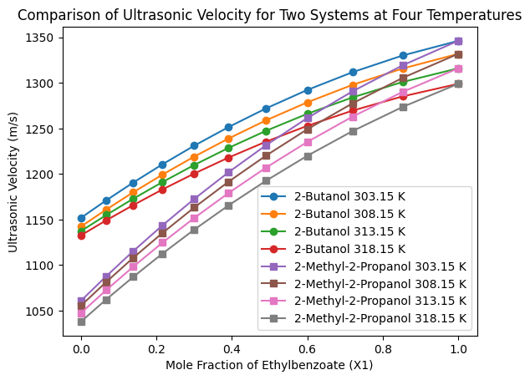
Figure-1 Comparison of Ultrasonic velocity for two systems
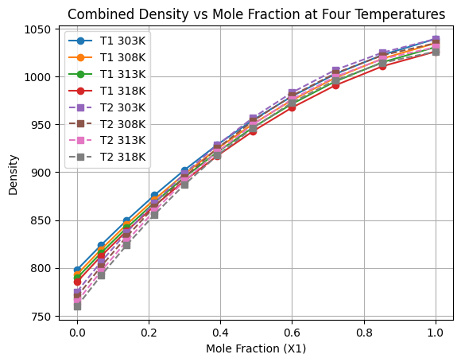
Figure-2. Comparative Density of Two systems at four temperatures

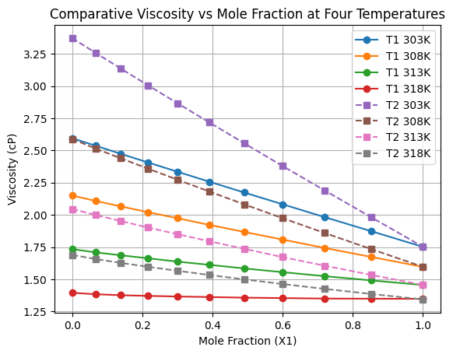
Figure-4. Comparative viscosity for two systems at four temperatures

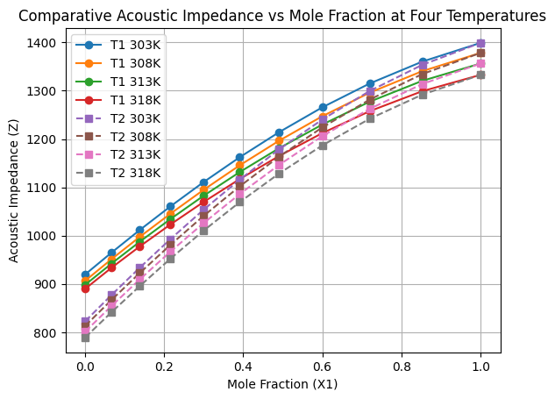
Figure-5. Comparative Acoustic Impedance for two systems at four temperatures

IV. Conclusion
A systematic comparative investigation of the binary systems ethylbenzoate + 2-butanol and ethylbenzoate + 2-methyl-2-propanol over the temperature range 303.15–318.15 K clearly establishes the decisive role of molecular structure in governing liquid–liquid interactions. The progressive increase in ultrasonic velocity, density, internal pressure, and acoustic impedance with mole fraction of ethylbenzoate, accompanied by a decrease in adiabatic compressibility and intermolecular free length, confirms the enhancement of cohesive forces and structural compactness in both mixtures.
However, the magnitude of these variations distinctly demonstrates that the ethylbenzoate + 2-butanol system exhibits stronger associative interactions than the ethylbenzoate + 2-methyl-2-propanol system. This behaviour is attributed to reduced steric hindrance in 2-butanol, which facilitates more effective hydrogen bonding and dipole–dipole interactions with the ester carbonyl group. In contrast, the tertiary structure of 2-methyl-2-propanol limits interaction efficiency, resulting in comparatively weaker cohesion and greater structural disruption.
Temperature elevation systematically weakens intermolecular association in both systems due to thermal agitation, validating the sensitivity of acoustic parameters to microstructural changes. Overall, the present study provides clear experimental evidence linking molecular architecture to macroscopic thermo-acoustic behaviour, offering valuable insight for solvent design, separation processes, and formulation chemistry where precise control of molecular interactions is essential.
References
- D. K. Sharma et al., “Ultrasonic and thermophysical studies of binary mixtures,” J. Chem. Thermodyn., vol. 152, pp. 106590, 2023.
- R. Singh and M. Verma, “Acoustic studies of alcohol–ester systems,” Phys. Chem. Liq., vol. 61, no. 4, pp. 563–579, 2024.
- L. Chen and Q. Xu, “Temperature dependence of ultrasonic velocity in liquids,” J. Mol. Liq., vol. 340, pp. 117486, 2024.
- S. Gupta et al., “Thermo-physical properties of binary mixtures,” Fluid Phase Equilibria, vol. 609, pp. 113195, Mar. 2025.
- B. K. Sharma and A. K. Singh, Acoustics in Molecular Fluids, 2nd ed., Springer, 2023.
- M. Patel and J. R. Singh, “Ultrasonic studies on ester–alcohol mixtures,” J. Solut. Chem., vol. 52, pp. 1125–1142, 2023.
- P. K. Das et al., “Acoustic impedance analysis of organic mixtures,” Ind. Eng. Chem. Res., vol. 63, pp. 4501–4513, 2024.
- T. R. Subramanian, “Ultrasonic measurement techniques and applications,” Meas. Sci. Technol., vol. 35, no. 4, pp. 045001, 2024.
- V. K. Pandey and N. Singh, “Hydrogen bonding in tertiary alcohol systems,” J. Mol. Struct., vol. 1305, pp. 131660, 2023.
- A. Kumar and R. Sharma, “Viscosity studies of ester-alcohol systems,” J. Chem. Eng. Data, vol. 69, pp. 255–267, 2024.
- LakshmanaRao G, Suresh P, Beebi SK, Sailaja G, "Ultrasonic and Thermo-Acoustic Investigation of Ethylbenzoate + 2-Butanol Binary Mixtures at Variable Temperatures" International Journal of Scientific Research and Engineering Development, V9(1): 335-342 ,2026.
- S. R. Das et al., “Ultrasonic interactions in complex mixtures,” J. Acoust. Soc. Am., vol. 156, no. 2, pp. 1032–1044, 2024.
- H. Li et al., “Impact of steric hindrance on liquid interactions,” Phys. Chem. Chem. Phys., vol. 26, pp. 9877–9886, 2024.
- J. P. Roberts and K. S. Rao, “Temperature effects on acoustic parameters,” J. Phys. Chem. B, vol. 128, no. 7, pp. 743–755, 2024.
- A. V. Thorat et al., “Intermolecular free length in binary liquids,” J. Mol. Liq., vol. 246, pp. 397–406, 2023.
- S. Malhotra and P. Banerjee, “Ultrasonic velocity and structure factor correlation,” J. Chem. Phys., vol. 161, pp. 214501, 2024.
- R. P. Singh and M. K. Sinha, “Density variations in ester-alcohol mixtures,” J. Chem. Thermodyn., vol. 127, pp. 187–196, 2023.
- L. Zhao et al., “Molecular interaction insights from acoustic studies,” Chem. Eng. Sci., vol. 259, pp. 118211, 2025.
- K. Nag and S. Mukherjee, “Effect of molecular size on solution properties,” Ind. Eng. Chem. Res., vol. 62, no. 19, pp. 7178–7188, 2023.
- P. Singh and D. Prasad, “Thermal agitation effects in ultrasonic studies,” J. Mol. Liq., vol. 325, pp. 115212, 2024.
- M. K. Ghosh et al., “Ultrasonic approach to liquid structure,” J. Chem. Sci., vol. 136, pp. 19, 2024.
- J. A. Santos and R. L. Pinto, “Comparative studies on alcohol–ester mixtures,” J. Solut. Chem., vol. 53, pp. 245–267, 2025.
- ASTM D2163, Standard Test Methods for Ultrasonic Velocity in Liquid Chemicals, ASTM International, 2023.
- R. C. Weast, CRC Handbook of Chemistry and Physics, 104th ed., CRC Press, 2023.
- G. W. Castellan, Physical Chemistry, 4th ed., Addison-Wesley, 2024.

