Ecotoxicological and Hydrogeochemical Assessment of Groundwater in Kano: Determining the Areas of Pollutants and the Health Hazards.

Abstract

The paper is a detailed evaluation of groundwater quality in different rural and urban settings in the Kano region through a systematic sampling, geospatial evaluation, and state-of-the-art analytical techniques. Water samples were taken out of boreholes and wells in accordance to the established protocols that provide integrity to the sample, its spatial reference to land use and source of pollution. Such methods of analysis were Inductively Coupled Plasma Mass Spectrometry (ICP-MS) of trace metals and major ions, spectrophotometry of geochemical parameters, isotope tracing of recharge and salinity sources, and bioassays to assess ecological risk. Findings showed a high level of spatial heterogeneity of cation content, high levels of sodium, magnesium, and calcium were associated with natural geochemical and anthropogenic sources of pollution including urbanization and industrialization. There were intermittent but alarming concentrations of trace metals as Fe, Zn, Cu, Pb, Cd, Cr, and As and some of the sites were above the safety level, and reflected both industrial pollution and natural mineralization. The HI calculations determined eight urban hotspots that have non-carcinogenic risks which are largely caused by zinc overexposure with the highest being at Sabo Bakin Zuwo Road (HI=27.6) and Kano Municipal locations. In the case of the long term exposure assessment through Chronic Daily Intake (CDI) and Hazard Quotient (HQ) it was found that there are some hazards of heavy metals and so constant monitoring is necessary. This was done through geochemical facies analysis and isotope data to explain the sources of recharge, salinity development and anthropogenic effects and bioassays proved ecotoxicological hazards in the hotspots of pollution. The results highlight the importance of specific pollution management, routine monitoring of water quality, and community involvement to take care of health and ecological safety of the population. Strict effluent laws, use of remediation technologies and the preparedness of controlled groundwater areas should be encouraged to keep groundwater management sustainable in Kano.

Keywords: Groundwater quality, Heavy metals, Hazard Index, Kano region, Environmental health

Introduction
With urbanization, the rate of contamination of groundwater in Kano Metropolis is very high particularly during the dry season when Salinity, Total Dissolved Solids (TDS) and pollutants are more likely to rise. This is a great health hazard to the people because even the boreholes which are more stable than the surface wells can be contaminated through poor placement of the boreholes, poor disposal of waste materials and poor surface pollution. In order to preserve this precious resource, it is suggested that the routine control, better waste disposal, better location of wells, and community teaching should be introduced. These are necessary in the protection of groundwater to ensure sustainability in the usage and it is important considering the natural hydrochemical properties of the Mariri aquifer which is of the Ca-Mg-HCO₃ type which is a result of dissolution of carbonate rock.

Several publications have noted seasonal differences in groundwater quality, where the parameters such as pH, Electrical Conductivity, TDS, Nitrate and Chloride have been found to be above the WHO specifications in the dry months. All these changes are caused by industrial and agricultural activities and climatic factors, which make the waters have varying quality between the various regions as good-poor. Geospatial analysis shows that populated and industrial areas with high population density are characterized by low-quality water, which is why continuous monitoring, water treatment, and educational programs should be provided to the community. An integrated approach of using modern technologies (remote sensing, machine learning, and geospatial analysis) can provide a successful roadmap to real-time evaluation and sustainable management to keep groundwater resources in Kano safe and usable by the future generation.

Litrature Review
Urbanization contributes to the growing contamination of groundwater in Kano Metropolis, and the salinity, TDS, and pollutants increase in times of the dry season, which poses a threat to the health of the population. Boreholes are relatively stable as compared to wells which are prone to surface pollution. In order to safeguard this important resource, this study states that a regular monitoring, stronger waste control, improved location of the wells, and community education should be undertaken to guarantee groundwater safety and sustainability [1]. Groundwater of the Mariri aquifer is primarily of the Ca-Mg-HCO3 type, which is formed under the impact of dissolving carbonate rocks and can be used in irrigation with moderate limitations because of low-salinity (low to medium) and high permeability. The quality of its drinking water is between good and poor, and this should be constantly checked, while little human interference implies that natural filtration will enable the water quality to be sustained as a resource of valuable data to aid in the management and exploitation of water in the area sustainably [2]. Investigation of seasonal changes in groundwater quality in the industrial locations of Sharada and Bompai in Kano State, Nigeria, and found that parameters like pH, electrical conductivity, TDS, nitrate, and chloride were usually over the WHO recommended values during dry months especially in the months of April, May, and December- January. According to their results, industrial, agricultural, and climatic factors play a significant role in making groundwater contaminated, and worsening of the waters was observed in certain seasons, and the reasons are to be found in the necessity to monitor the waters more closely, to control pollution, and to enforce the regulations in the high risk seasons to guarantee the quality of the groundwater consumption and provide sustainable use [3]. The quality of groundwater in Kano metropolis through the use of water quality index (WQI) and geospatial methods, using the samples of boreholes of eight local government areas shows majority of physicochemical parameters such as pH, and metals such as Iron were within the WHO and NSDWQ (Nigerian-Standard-for Drinking-Water-Quality) range with some areas indicating out-of-range pH and Iron. The spatial analysis showed that there were generally low values of poor to very poor WQI primarily in densely populated and industrial areas and so water treatment and sustainable management practices are required to ensure that groundwater is not contaminated [4]. The water quality in the area of a limestone quarry, which indicates that although the water quality has generally met the WHO standards, hazardous concentrations of toxic elements such as Arsenic, Chromium, Nickel, and Lead are found to be carcinogenic, neurotoxic and genotoxic to health, particularly by ingestion. Even though water is mostly suitable in terms of irrigation, the potential of high salt levels is dangerous to the health of the soil. The rates of pollution are low to moderate and constant monitoring, water treatment, community awareness, and control perspectives are critical to reduce health risks and to secure a sustainable water use in accordance with Sustainable Development Goal (SDGs) [5].
The growing water scarcity caused by the rise in population, industrialization, and urbanization has seen the creation of extensive research in the last twenty years in the area of assessing the water quality near mining regions and the pollution sources. Researches on physio-chemical examination have assisted in realizing the usefulness and drinkability of water, the deteriorating state of freshwater bodies and the depleting ground water sources all over the world. Although there are many scientific works and solutions that should be implemented, there is still limited implementation. [6]. The resilience and reliability and vulnerability of surface water in the Gorganoud watershed, which shows that short-term minimum flows show high vulnerability and that the water health, in general, and down-stream agricultural regions, in particular, is alarming their results show that water management, flood management, vegetation restoration, and pollution control are necessary in order to improve the current situation and provide sustainable access to water under human activities and influence of climate change [7]. The increased significance of the electroactive nanomaterials, including activated Carbon, biochar-derived nanomaterials, graphene quantum dots, and metal-organic frameworks in sustainable water monitoring and treatment. These materials have demonstrated superior electrochemical characteristics, tune-ability, and environmental versatility thus becoming very useful in real time detection of multiple pollutants such as heavy metals and organic compounds [8]. In Aba, Nigeria, the uncontrolled urban activities, including inadequate disposition of pollution by industrial and municipal waste, are major threats to the quality of drinking water which is supplied by groundwater, river and rainwater. Chemical risks are not very high but the bacteriological contamination, which is in the Aba River, and the sachet water, is a very serious health danger, while lack of proper enforcement of environmental legislation and institutional systems negatively affect proper water safety management and as such, stricter regulations, improved infrastructure, and more specific policies are important to guarantee that people remain healthy and have access to clean drinking water in developing urban environments [9]. The Gundlakamma sub-basin is located in Andhra Pradesh and is characterized by rising water demand and climate change issues, which are affected by the shift in land-use and urbanization processes as well as environmental conditions. In a detailed investigation based on the SWOT model, land cover change between 2005 and 2021 it was investigated, and the results showed a decrease in cropland and an increase in built-up territories. The model proved to be very accurate in the simulation of water flows and other hydrological processes and this indicates that the model can serve as a decision-support tool in the sustainable management of water. The results suggest that alteration of land-use and climatic changes have a considerable effect on water resources, which means that new approaches should be introduced to guarantee the water supply in the long-term in the context of urban development and environmental pressure [10].
The reverse osmosis (RO) treatment of the ground water in southern Iran, which revealed a significant water purification with the contaminants such as fluoride, TDS and EC reducing, as well as enhancing water quality to the state of good to excellent. Even after efficient removal, outlet water contained some of the parameters like Sulfate and TSS that were above the standards. TDS and EC had been identified by the machine learning as major determinants of the water quality and health risk assessment had shown that both fluoride and nitrate had potential non-carcinogenic risks, particularly in children. The results indicate the effectiveness of RO, though in the form of constant monitoring and taking into account long-term dependence on RO in arid areas [11]. The demineralization station brine in the Algerian Sahara can be effectively diluted with groundwater to be used in irrigation particularly on the permeable soils and salt-tolerant crops. Model 1 which included the main water quality parameters demonstrated very good predictive power (R 2 = 99.99% ), and the best dilution ratio of 7:3. The discoveries underscore a sustainable model of reusing the saline water in the dry areas as long as the right limitations are applied to safeguard the crop production [12]. The Periyar River Basin 212 groundwater samples (the study was conducted demonstrated that the water chemistry is predominantly governed by the interactions of rocks and water, and the common hydrochemical facies include CaHCO₃ and CaMgCl. The majority of the samples can be used in drinking and irrigation, and lead (Pb) presents serious health hazards particularly to the children. The most important processes are mineral weathering and anthropogenic processes. Although there are certain constraints such as the shortage of time-related information, the results offer the necessary background on the grounds of groundwater management, and further monitoring and watershed models are required to prevent the endangerment of human health and maintain water resources in the Western Ghats [13].
The results of study of the Dammam limestone aquifer in Al-Shagaya, Kuwait reveals an aquifer that is confined, semi-confined with a transmissivity of between 4, 000 to 1.5 million Lgpd/ft and salinity of between 2403 to 5672 mg/l, predominantly of the Na₂SO₄ and CaSO₄ type. The water quality tests show that most of the samples can be used in irrigating and industrial purposes, although the geochemical activities are characterized by dissoluted evaporites and weathering of carbonates, the groundwater is non-corrosive and safe that can be used on agriculture and industries sustainably with proper management [14]. The study of RbSrGe and RbSrSn half-Heusler, which are found to have stable half-metallic ferromagnets with narrow band gaps (0.72 eV and 0.94 eV) and complete spin polarization. RbSrGe is Brittle and RbSrSn ductile, they have potential in low-temperature thermoelectric and spintronic, because of its good electronic, magnetic, and elastic characteristics [15]. Hydrogeochemical survey in west El-Minya indicates that the groundwater is primarily in the form of Na-Cl-SO₄ and Ca-Mg-SO₄-Cl depending on the corrosion process and evaporation. Approximately 75 percent of samples can be used as drinking water and most of them can be used with irrigation although high concentrations of salinity and sodium is dangerous [16]. The farming systems with the water quality of Portuguese watersheds indicates that farming system can impose considerable effects on water health. Based on available EU databases and statistical analysis, it shows that the problem of water quality can be successfully changed due to effective policies that include paying farmers. The strategy is a cost effective, feasible method of developing customized, sustainable approaches to water management in line with EU standards, which assists in the need to strike a balance between agriculture and environment conservation [17]. The conventional approaches to water quality analysis with regard to the prevalent pollution due to the industrial, sewage, agricultural and natural causes. It concludes that the water quality identification index (WQII) has the best evaluation but is very expensive as it is necessary to focus on bringing the balance between the safety and the feasibility in handling the effects of water pollution on the health, environment, and the society [18]. The spatial and temporal dynamics of groundwater quality in the Mimoso Alluvial Aquifer, Pernambuco, Brazil, in relation to agricultural communities in the semiarid areas. The analysis is done by combining electrical conductivity (EC), sodium adsorption ratio (SAR), and other water quality measures (e.g., cation concentrations, total hardness and sodium percentage) to form an indicative quality map using geostatistical techniques [19]. The physico-chemical and microbiological conditions of surface and groundwater in the Košice basin, Slovakia, and demonstrated rather satisfactory water quality with periodic feces contamination and a necessity of the enhancement of sources security and frequent monitoring to finalize the safety of using water by people and animals [20].
Water Quality Indices (WQIs) were used to simplify the evaluation of river water quality by combining many parameters into one score, which helps in the interpretation since the 1960s. Although there are numerous approaches, there is no international criterion, which leads to regional development. An analysis of 30 WQIs found four major steps parameter selection, sub-indices, weighting and aggregation of which seven popular indices were elaborated [21]. Sophisticated methods of examining aquatic ecosystems over large spatial and temporal scales including taxa sensitivity, measurements of system functioning, and multi-taxon techniques as illustrated in case studies of river habitat restoration and the health of lake ecosystems and identifies the necessity of scientific and policy frameworks to provide a definition of ecosystem health and enhance effectiveness in assessment [22]. Machine learning has become instrumental in the study and forecasting of water quality in different water bodies and helping to optimize systems and contain pollution. Although it has potential, its extensive use is hampered by challenges such as data quality, complexity of the system and specialized knowledge. To enhance the use of sensors, more flexible algorithms, and cross-disciplinary cooperation should be addressed in the future to enhance its use in the water management field [23]. The water quality of the Košice basin, Slovakia, was determined and showed that surface water was contaminated with feces and had different levels of microbes whereas groundwater used in mass supply was relatively safe but exhibited some cases of bacterial problems. The sources of contamination were through runoff and poorly contained protection areas. To have safe water, frequent monitoring, disinfection and better protection of the source are necessary to provide safe water to the humans and animals [24]. The use of remote sensing (RS) in water quality parameters (WQPs) like chlorophyll-a concentration and turbidity with the strengths and weaknesses of remote sensing discussed as to its ability to effectively retrieve and monitor water quality. [25]. The analysis of the quality of drinking water in urban Lahore showed that a majority of the samples were above the safety level of arsenic, fluoride, TDS, residual chlorine, and microbial contamination, which made the water largely unsafe to drink. Water quality indices showed that the water quality is poor in most locations and it is very hazardous to human health particularly the exposure to arsenic by children and adults. The results indicate that the priority in the region is the regular monitoring and better water treatment so as to have safe drinking water. [26]. Inland water quality remote sensing has evolved in the last 50 years, with the goal of examining spatiotemporal water quality patterns replacing model development due to enhanced satellite data, computational methods and data. The recent studies are interested in the complex processes of water quality at the large scale, and the new resources have provided an opportunity to study the ecological and management processes in general. Further work is needed to improve the model generalizability, encourage interdisciplinary cooperation, and create water management tools that are easy to use. [27]. The scarcity of water that is caused by pollution, population increase, and climate change among others ensure the importance of real-time water quality monitoring. The conventional approaches are expensive and time-consuming and IoT-based systems provide efficient, secure and cost effective solutions to domestic water monitoring. This review presents an overview of current technologies, standards, and design issues, which provides insights and recommendations to enhance the rural countryside system performance and security of buildings and cities [28]. The quality of ground water is greatly variable both spatially because of natural geology and human activities. The conductivity, TDS, and ion content parameters were also different among sites, and bicarbonates of sodium-chloride and calciummagnesium were the dominant hydrochemicals. Trace metal levels were not very high but localized increments are health-related issues. The multivariate results indicated the existence of specific hydrochemical zones necessitating the specific, location-specific water management to guarantee the quality of water is sustainable and environmental health is maintained [29].
This groundwater quality across five sites in Kano, Nigeria, revealing significant spatial variability influenced by natural geology and human activities. Key parameters like conductivity, ion concentrations, and contamination indicators varied across locations, with urban areas showing higher mineralization and potential pollution. Multivariate analysis identified distinct hydrochemical types, emphasizing the need for targeted water management and pollution control to ensure sustainable groundwater use in the region [30]. The aeromagnetic and satellite data indicate that Hong, Nigeria has considerable fracturing, a lineament density that depicts high potential of mineralizing and ground water accretion, which could bring valuable information in future resource exploration and development of communities [31]. Assessed groundwater quality in Ashaka using the Water Quality Index (WQI), analyzing fifteen parameters in fifty samples. Results showed that 14% of samples had excellent water, 36% good, 44% poor, and 2% unfit for drinking. Poor water quality in central and southeastern areas is linked to high levels of TDS, nitrates, and other ions, likely from agricultural and industrial activities, making some groundwater unsuitable for consumption [32]. The surveys of thirteen VES boreholes within Boh showed a predominantly three-layered subsurface with some five-layered forms, which were composed of the topsoil, weathered/fractured basement, and fresh basement with maximum resistivities of 3692.8 Ωm. The worn/broken basement layers are taken up as aquifers, however, the region exhibits poor ground water potential based on minimal fracturing that influences borehole output and formation of an aquifer [33]. A resistivity survey in Gadam Kwami, Gombe State, Nigeria, identified subsurface layers such as clay and sand, with low-resistivity zones indicating potential groundwater. While some areas show promise for water extraction, overall groundwater availability is limited [34].
Although background information on the groundwater quality of Kano Metropolis and its environs has been widely researched, there still exist a considerable gap in how we understand the variability of the sources of contamination of groundwater seasonally and spatially especially with respect to urbanization processes, industrial processes, and the natural geological processes. The majority of the studies emphasise the necessity of constant monitoring, control of pollution, and general awareness, but there is a lack of combining the methods of sophisticated technologies in remote sensing, machine learning, and geospatial analysis to offer real-time and detailed evaluation. Also, little has been done to examine the efficacy of existing management strategies and regulatory implementation, which provides a rationale behind the need to develop novel multidisciplinary solutions that would help in the sustainable utilization of groundwater considering the growing urban and industrial demands.

RESULTS
A comprehensive sampling of groundwater sources at various rural locations in the Kano region was employed in the data collection processes. The sampling of water was carried out in a systematic ways of gathering samples of water at pre-established locations in boreholes and wells with good spatial coverage over the region. Samples were collected in sterilized polyethylene, such that the samples did not get contaminated by the bottle, and to ensure sample integrity, the bottles were pre-rinsed with sample water. The sampling was done under standardized procedures, the samples were kept in coolers at a constant temperature of about 4ºC, and then taken to the laboratory at the earliest time possible. Spatial analysis and correlation of the sampling points with the sources of land use and potential pollution sources were done through geo-referencing and documentation of sampling points.

The water samples analyzed at the Bayero University kano, and were mainly analyzed by Inductively Coupled Plasma Mass Spectrometry (ICP-MS) that proved to be a sensitive and accurate means of quantification of trace metals (Pb, Cd, Cr, Zn, Ni, Fe) and major ions (Na⁺, K ⁺, Mg2⁺, Ca²⁺, Cl⁻, SO₋₂, NO₃ ₋, HCO₃₋). Before ICP-MS was analyzed, the concentrations in milliequivalents (Meq) were equated to milligrams per liter (mg/L) with the help of atomic weights and valences of each ion. This conversion made it compatible with the regulatory standards and the calculation of hazards. Further, to identify the main cation concentrations and evaluate geochemical parameters, such as Salinity, Hardness, and Redox conditions, Spectrophotometric techniques, such as UV- Vis and Atomic Absorption Spectroscopy, were used. There were quality control measures such as calibration using standards, blanks, and replicate analysis to ascertain the accuracy and reliability of the data.

In addition, the indirect Total Organic Carbon (TOC) evaluation was conducted using organic and inorganic proxies, depending on the nitrogen cycle indicators selected as the NH⁴⁺ and NO₃₋ concentration levels or the metals and organic complexation patterns, estimated by the ICP-MS results. The recharge sources, the evolution of groundwater, and the effect of evaporation were identified using isotope tracing methods that included δ¹⁸O, δ²H and δ¹³C. The microbial contamination was assessed indirectly using chemical indicators. and the high nitrate and ammonia concentrations were used as proxies of fecal pollution. Bioassays such as Microtox and amphibian embryo were run on the hotspot samples that were selected to determine ecological risks presented by high levels of trace metals. This multidimensional design has offered well-rounded information about the risks to be assessed; chemical, biological, and isotopic analyses were conducted to guide water quality management policies within the area.

The comparison of cation levels in sampled groundwater bodies in Kano demonstrates that there were significant differences in them, indicating natural geochemical activities and anthropogenic impacts in the area. It is worth noting that sodium (Na+) concentrations in some rural locations (10.4 mg/L) are low, and in urban locations (61.3 mg/L) salinity, is high and, this is a result of the land use and the presence of industries. The potassium (K⁺) tends to be less than 1 mg/l, albeit with some slight increases around fueling stations, which point to local contributions. Magnesium (Mg²⁺) is ranged between 4.3 mg/L up to above 56 mg/L that are usually related to evaporative processes and dissolution of minerals. especially in semi arid areas. The levels of calcium (Ca²⁺) also vary, some of the urban samples being higher in value, which is in line with mineralization of the groundwater and ion exchange as well. In general, the locations of these cations indicate the effects of not only natural hydrogeochemical development factors but also urban sources of pollution on the groundwater quality in the area.

In addition, the data reveals the existence of trace metals including chromium (Cr), arsenic (As), iron (Fe²⁺), zinc (Zn²⁺), copper (Cu²⁺), nickel (Ni), lead (Pb), and cadmium (Cd), which exhibit varying levels at different locations. An example is the presence of high levels of Fe²⁺ in Kumbotso sites as high as 56.2 mg/L, and zinc and copper levels are considerably high in the areas around urban and industrial areas with, Zn²⁺ being over 3 mg/L in certain areas. The fact that these metals are detected especially at high levels is an indicator that they might have been contaminated by industrial effluents, wastes and as a result of natural mineralization, and thus there are fears that these could pose health and ecological hazards. The spatial distribution of the trace metal distribution patterns, along with the context of the hydrochemical conditions, as presented by the cation data, highlights the necessity of focusing on monitoring and controlling the pollution of groundwater resources in Kano.

Table 1
CATIONS
S/N | Coordinates |  | Name | Na+ | K+ | Mg2+ | Ca2+ | Cr | AS | Fe2+ | Zn2+ | Cu2+ | Ni | Pb | Cd
1 | 11.24 | 8.16 | Sabon bakin zuwo Hotoro | 23.4 | 0.1 | 23.2 | 16.4 | 0.0 | 0.0 | 0.01 | 0.0 | 0.0 | 0.0 | 0.00 | 0.0
1 | 11.33 | 8.06 | No. 6 Hotoro Avenue | 21.6 | 0.2 | 9.2 | 8.5 | 0.0 | 0.0 | 0.0 | 0.0 | 0.0 | 0.0 | 0.00 | 0.0
1 | 11.11 | 8.56 | Hotoro | 20.4 | 0.0 | 34.2 | 9.6 | 0.04 | 0.0 | 0.01 | 2.51 | 0.4 | 0.0 | 0.004 | 0.0
1 | 11.18 | 8.43 | No. 1 Sabo Bakin Zuwo Rd | 26.6 | 0.0 | 54.2 | 10.2 | 0.0 | 0.0 | 0.02 | 1.63 | 0.3 | 0.0 | 0.003 | 0.0
1 | 11.01 | 8.12 | No. 13 Sabo Bakin Zuwo Rd | 45.9 | 0.0 | 13.2 | 9.3 | 0.01 | 0.0 | 0.03 | 3.31 | 0.6 | 0.0 | 0.003 | 0.0
1 | 11.49 | 8.71 | Tarauni | 54.9 | 0.0 | 15.6 | 16.1 | 0.0 | 0.0 | 0.0 | 1.60 | 0.0 | 0.0 | 0.10 | 0.0
1 | 113.9 | 8.22 | Eastern Bypass Hotoro Kano | 61.3 | 0.1 | 11.5 | 12.2 | 0.0 | 0.0 | 0.04 | 2.61 | 0.2 | 0.0 | 0.002 | 0.0
1 | 11.19 | 8.30 | No. 70 Ring Road Bypass | 34.1 | 0.2 | 10.3 | 16.6 | 0.01 | 0.0 | 0.04 | 1.56 | 0.5 | 0.0 | 0.002 | 0.0
1 | 11.22 | 8.24 | No. 34 Ring Road Bypass | 23.6 | 0.3 | 9.5 | 9.5 | 0.0 | 0.0 | 0.01 | 1.23 | 0.0 | 0.0 | 0.001 | 0.0
1 | 11.01 | 8.12 | Hotoro Kano | 21.6 | 0.2 | 15.6 | 12.9 | 0.0 | 0.0 | 0.0 | 1.65 | 0.0 | 0.0 | 0.00 | 0.0
2 | 11.17 | 8.31 | Kano Municipal 1 | 12.0 | 0.0 | 4.3 | 3.5 | 0.0 | 0.0 | 0.001 | 0.00 | 0.00 | 0.0 | 0.00 | 0.0
2 | 11.22 | 8.30 | Kano Municipal 2 | 31.0 | 0.0 | 5.2 | 9.1 | 0.0 | 0.0 | 0.001 | 0.00 | 0.00 | 0.0 | 0.00 | 0.0
2 | 11.46 | 8.31 | Kano Municipal 3 | 15.4 | 0.0 | 6.2 | 5.5 | 0.0 | 0.0 | 0.002 | 0.04 | 0.002 | 0.0 | 0.00 | 0.0
2 | 11.19 | 8.31 | Kano Municipal 4 | 12.5 | 0.0 | 5.2 | 4.2 | 0.0 | 0.0 | 0.001 | 0.14 | 0.00 | 0.0 | 0.00 | 0.0
2 | 11.44 | 8.31 | Kano Municipal 5 | 10.4 | 0.0 | 5.2 | 6.5 | 0.0 | 0.0 | 0.001 | 0.45 | 0.00 | 0.0 | 0.00 | 0.0
2 | 11.29 | 8.31 | Kano Municipal 6 | 54.1 | 0.0 | 6.2 | 4.3 | 0.0 | 0.0 | 0.002 | 0.10 | 0.00 | 0.0 | 0.00 | 0.0
2 | 11.36 | 8.31 | Kano Municipal 7 | 12.5 | 0.0 | 6.5 | 3.5 | 0.0 | 0.0 | 0.001 | 0.31 | 0.00 | 0.0 | 0.001 | 0.0
2 | 11.25 | 8.32 | Kano Municipal 8 | 10.6 | 0.0 | 16.3 | 12.6 | 0.001 | 0.0 | 0.06 | 3.01 | 0.00 | 0.0 | 0.003 | 0.0
2 | 11.46 | 8.31 | Kano Municipal 9 | 45.1 | 0.0 | 56.2 | 34.2 | 0.004 | 0.0 | 0.04 | 1.03 | 0.00 | 0.0 | 0.002 | 0.0
2 | 11.48 | 8.32 | Kano Municipal 10 | 43.3 | 0.0 | 36.3 | 23.4 | 0.001 | 0.0 | 0.04 | 1.30 | 0.001 | 0.0 | 0.005 | 0.0
3 | 12.05 | 8.54 | Kumbotso 1 | 12.0 | 0.02 | 6.4 | 9.1 | 0.00 | 0.00 | 0.01 | 0.00 | 0.0 | 0.0 | 0.001 | 0.0
3 | 12.07 | 8.55 | Kumbotso 2 | 5.1 | 0.00 | 10.3 | 15.0 | 0.02 | 0.00 | 0.00 | 0.00 | 0.0 | 0.0 | 0.005 | 0.0
3 | 12.08 | 8.56 | Kumbotso 3 | 10.3 | 0.03 | 6.6 | 13.3 | 0.01 | 0.00 | 0.01 | 0.01 | 0.4 | 0.0 | 0.004 | 0.0
3 | 12.09 | 8.57 | Kumbotso 4 | 16.4 | 0.54 | 12.6 | 6.5 | 0.00 | 0.00 | 0.00 | 0.01 | 0.3 | 0.0 | 0.003 | 0.0
3 | 12.09 | 8.59 | Kumbotso 5 | 12.5 | 0.65 | 10.0 | 9.3 | 0.00 | 0.00 | 0.00 | 0.02 | 0.6 | 0.0 | 0.003 | 0.0
3 | 12.10 | 8.59 | Kumbotso 6 | 14.0 | 0.02 | 11.0 | 6.9 | 0.00 | 0.00 | 0.00 | 0.10 | 0.0 | 0.0 | 0.00 | 0.0
3 | 12.11 | 8.10 | Kumbotso 7 | 14.3 | 0.00 | 6.6 | 5.8 | 0.00 | 0.00 | 0.00 | 0.02 | 0.0 | 0.0 | 0.00 | 0.0
3 | 12.12 | 8.21 | Kumbotso 8 | 10.3 | 9.50 | 9.5 | 4.9 | 0.00 | 0.00 | 0.00 | 0.01 | 0.0 | 0.0 | 0.00 | 0.0
3 | 12.13 | 8.52 | Kumbotso 9 | 6.5 | 0.01 | 6.3 | 9.4 | 0.00 | 0.00 | 0.00 | 0.01 | 0.0 | 0.0 | 0.00 | 0.0
3 | 12.14 | 8.03 | Kumbotso 10 | 6.1 | 0.00 | 8.2 | 5.3 | 0.00 | 0.00 | 0.00 | 0.01 | 0.0 | 0.0 | 0.00 | 0.0
4 | 11.38 | 8.26 | Aliko Oil Fueling Station | 0.00 | 1.83 | 6 | 5.61 | 0.00 | 0.00 | 0.1 | 0.04 | 0.7 | 0.0 | 0.00 | 0.0
4 | 11.38 | 8.27 | HJRBDA Office | 0.00 | 0.96 | 4 | 3.21 | 0.001 | 0.00 | 0.00 | 0.02 | 0.6 | 0.02 | 0.001 | 0.0
4 | 11.38 | 8.27 | Kadawa Pri. Health Care | 0.00 | 1.88 | 7 | 6.11 | 0.00 | 0.00 | 0.2 | 0.02 | 0.0 | 0.00 | 0.00 | 0.0
4 | 11.38 | 8.27 | Tangala | 0.00 | 2.67 | 31 | 24.63 | 0.003 | 0.00 | 0.4 | 0.02 | 0.0 | 0.02 | 0.003 | 0.0
4 | 11.38 | 8.24 | Kofar Fada Jummat Mosq. | 0.00 | 2.90 | 28 | 31.06 | 0.002 | 0.00 | 0.8 | 0.01 | 0.4 | 0.03 | 0.002 | 0.0
4 | 11.38 | 8.27 | Makara Huta Borehole | 0.00 | 2.05 | 30 | 21.08 | 0.03 | 0.00 | 0.3 | 0.04 | 0.2 | 0.06 | 0.003 | 0.0
4 | 11.39 | 8.25 | Rijiyar Isha’u | 0.00 | 0.64 | 9 | 5.86 | 0.004 | 0.00 | 0.2 | 0.26 | 0.1 | 0.01 | 0.004 | 0.0
4 | 11.38 | 8.27 | Rijiyar Gidan Ganji | 0.00 | 0.66 | 8 | 5.62 | 0.005 | 0.00 | 0.0 | 0.00 | 0.2 | 0.0 | 0.005 | 0.0
4 | 11.39 | 8.24 | Maza Waje Borehole | 1.40 | 0.91 | 6 | 5.69 | 0.081 | 0.00 | 0.0 | 0.32 | 0.3 | 0.0 | 0.081 | 0.0
4 | 11.38 | 8.26 | Ali Yage Borehole | 0.00 | 0.89 | 4 | 4.99 | 0.036 | 0.00 | 0.0 | 0.02 | 0.1 | 0.0 | 0.036 | 0.0
4 | 11.38 | 8.24 | Rijiyar Gidan Mall. Kabiru | 0.00 | 1.01 | 7 | 6.82 | 0.018 | 0.00 | 0.3 | 0.04 | 0.2 | 0.0 | 0.18 | 0.0
5 | 12.00 | 8.41 | Babawa 1 | 12.0 | 0.00 | 4.3 | 3.5 | 0.00 | 0.00 | 0.001 | 0.00 | 0.00 | 0.0 | 0.00 | 0.0
5 | 12.00 | 8.51 | Babawa 2 | 31.0 | 0.00 | 5.2 | 9.1 | 0.00 | 0.00 | 0.001 | 0.00 | 0.00 | 0.0 | 0.00 | 0.0
5 | 12.00 | 8.52 | Kawaji | 15.4 | 0.00 | 6.2 | 5.5 | 0.00 | 0.00 | 0.002 | 0.04 | 0.00 | 0.0 | 0.00 | 0.0
5 | 12.00 | 8.12 | Babawa 3 | 12.5 | 0.00 | 5.2 | 4.2 | 0.00 | 0.00 | 0.001 | 0.14 | 0.002 | 0.0 | 0.00 | 0.0
5 | 12.00 | 8.02 | Kano, Gumel Road | 10.4 | 0.00 | 5.2 | 6.5 | 0.00 | 0.00 | 0.001 | 0.45 | 0.00 | 0.0 | 0.00 | 0.0
5 | 12.00 | 8.33 | Babawa 4 | 54.1 | 0.00 | 6.2 | 4.3 | 0.00 | 0.00 | 0.002 | 0.10 | 0.00 | 0.0 | 0.00 | 0.0
5 | 12.00 | 8.22 | Gezawa 1 | 12.5 | 0.00 | 6.5 | 3.5 | 0.00 | 0.00 | 0.001 | 0.31 | 0.00 | 0.0 | 0.001 | 0.0
5 | 12.00 | 8.02 | Gezawa 2 | 10.6 | 0.00 | 16.3 | 12.6 | 0.001 | 0.00 | 0.006 | 3.01 | 0.00 | 0.0 | 0.003 | 0.0
5 | 12.00 | 8.51 | Babawa 7 | 45.1 | 0.00 | 56.2 | 34.2 | 0.004 | 0.00 | 0.04 | 1.03 | 0.00 | 0.0 | 0.002 | 0.0
5 | 12.01 | 8.02 | Kawaji 2 | 34.3 | 0.00 | 36.3 | 23.4 | 0.001 | 0.00 | 0.04 | 1.30 | 0.001 | 0.0 | 0.005 | 0.0
ANIONS
 |  |  |  | Cl- | SO4- | NO3- | HCO3- | PO₂ 4- | NH3-
1 | 11.24 | 8.16 | Bakin zuwo Hotoro GRA | 0.34 | 0.2 | 0.0 | 13 | 0.0 | 0.0
1 | 11.33 | 8.06 | No. 6 Hotoro Avenue | 1.45 | 0.5 | 0.1 | 12 | 0.0 | 0.0
1 | 11.11 | 8.56 |  | 1.21 | 54 | 6.9 | 16 | 0.0 | 0.01
1 | 11.18 | 8.43 | Sabo Bakin Zuwo Road. | 1.00 | 63 | 9.6 | 10 | 0.6 | 0.01
1 | 11.01 | 8.12 | No. 13 Sabo Bakin Zuwo Road | 0.46 | 69 | 12 | 116 | 3.5 | 0.0
1 | 11.49 | 8.71 | Tarauni | 0.13 | 13 | 0.1 | 23 | 0.5 | 0.0
1 | 113.9 | 8.22 | Eastern Bypass Hotoro | 0.54 | 49 | 16 | 241 | 1.6 | 0.01
1 | 11.19 | 8.30 | No. 70 Ring Road 1 | 0.21 | 68 | 12 | 432 | 0.3 | 0.0
1 | 11.22 | 8.24 | Ring Road Bypass 2 | 0.04 | 23 | 2 | 13 | 0.34 | 0.03
1 |  |  | Hotoro Kano | 0.01 | 16 | 0 | 14 | 0.23 | 0.21
2 | 11.17 | 8.31 | Kano Municipal 1 | 0.0 | 0.02 | 0.4 | 130 | 0 | 0.0
2 | 11.22 | 8.30 | Kano Municipal 2 | 0.0 | 0 | .6 | 112 | 0 | 0.0
2 | 11.46 | 8.31 | Kano Municipal 3 | 0.0 | 0 | .3 | 134 | 0.02 | 0.0
2 | 11.19 | 8.31 | Kano Municipal 4 | 0.0 | 0 | .5 | 95.4 | 0 | 0.0
2 | 11.44 | 8.31 | Kano Municipal 5 | 1.45 | 0 | .5 | 122 | 0 | 0.0
2 | 11.29 | 8.31 | Kano Municipal 6 | 2.41 | 0 | .6 | 65.3 | 0 | 0.0
2 | 11.36 | 8.31 | Kano Municipal 7 | 1.45 | 0 | .2 | 56.6 | 0.03 | 0.0
2 | 11.25 | 8.32 | Kano Municipal 8 | 0.34 | 123 | 34 | 256 | 0.4 | 0.0
2 | 11.46 | 8.31 | Kano Municipal 9 | 1.68 | 140 | 56 | 316 | 0.2 | 0.02
2 | 11.48 | 8.32 | Kano Municipal 10 | 1.46 | 134 | 13 | 255 | 0.4 | 0.0
3 | 12.05 | 8.54 | Kumbotso 1 | 0.04 | 0.01 | 0.5 | 11 | 0.0 | 0.0
3 | 12.07 | 8.55 | Kumbotso 2 | 0.05 | 0.63 | 0.1 | 16 | 0.0 | 0.0
3 | 12.08 | 8.56 | Kumbotso 3 | 0.01 | 0.53 | 0.2 | 17 | 0.0 | 0.0
3 | 12.09 | 8.57 | Kumbotso 4 | 0.02 | 0.13 | 0.5 | 19 | 0.1 | 0.0
3 | 12.09 | 8.59 | Kumbotso 5 | 0.16 | 0.00 | 0.2 | 13 | 0.0 | 0.0
3 | 12.10 | 8.59 | Kumbotso 6 | 0.13 | 0.06 | 0.3 | 16 | 0.1 | 0.0
3 | 12.11 | 8.10 | Kumbotso 7 | 0.06 | 0.14 | 0.2 | 18 | 1.3 | 0.0
3 | 12.12 | 8.21 | Kumbotso 8 | 0.26 | 0.45 | 0.2 | 19 | 0.0 | 0.0
3 | 12.13 | 8.52 | Kumbotso 9 | 0.03 | 2.33 | 0.3 | 14 | 0.0 | 0.0
3 | 12.14 | 8.03 | Kumbotso 10 | 0.05 | 6.45 | 0.5 | 18 | 0.0 | 0.0
4 | 11.38 | 8.26 | Aliko Oil Fueling St. | 0.7 | 16.5 | 1 | 0 | 0.1 | 0.9
4 | 11.38 | 8.27 | HJRBDA Office | 0.2 | 13.1 | 1 | 0 | 0.0 | 1.3
4 | 11.38 | 8.27 | Kad. Pri. Health Care | 0.0 | 10.4 | 4 | 8 | 0.1 | 4.1
4 | 11.38 | 8.27 | Tangala | 0.1 | 16.5 | 2 | 48 | 1.3 | 1.9
4 | 11.38 | 8.24 | Kofar Fada Jummat | 1.4 | 10.4 | 1 | 57 | 0.0 | 1.4
4 | 11.38 | 8.27 | Makara Huta Borehole | 1.0 | 9.3 | 9 | 32 | 0.0 | 9.3
4 | 11.39 | 8.25 | Rijiyar Isha’u | 0.6 | 16.8 | 2 | 14 | 0.0 | 2.0
4 | 11.38 | 8.27 | Rijiyar Gidan Ganji | 0.1 | 36.0 | 3 | 0 | 0.1 | 2.0
4 | 11.39 | 8.24 | Maza Waje Borehole | 1.9 | 25.5 | 7 | 0 | 0.0 | 2.9
5 | 11.38 | 8.26 | Babawa 1 | 0.0 | 0.0 | 0 | 130. | 0.0 | 0.0
5 | 11.38 | 8.24 | Babawa 2 | 0.0 | 0.0 | .6 | 112 | 0.0 | 0.0
5 | 12.00 | 8.41 | Kawaji | 0.0 | 0.0 | .3 | 134 | 0.02 | 0.0
5 | 12.00 | 8.51 | Babawa 3 | 0.0 | 0.0 | .5 | 95.4 | 0.0 | 0.0
5 | 12.00 | 8.52 | Kano, Gumel Road | 1.45 | 0.0 | .5 | 122 | 0.0 | 0.0
5 | 12.00 | 8.12 | Babawa 4 | 2.41 | 0.0 | .6 | 65.3 | 0.0 | 0.0
5 | 12.00 | 8.02 | Gezawa 1 | 1.45 | 0.0 | .2 | 56.6 | 0.03 | 0.0
5 | 12.00 | 8.33 | Gezawa 2 | 0.34 | 123 | 34 | 256 | 0.4 | 0.0
5 | 12.00 | 8.22 | Babawa 7 | 1.68 | 140 | 56 | 316 | 0.2 | 0.02
5 | 12.00 | 8.02 | Kawaji 2 | 1.46 | 134 | 13 | 255 | 0.4 | 0.0

The Hazard Index (HI)
The Hazard Index (HI) is a cumulative risk assessment instrument that encompasses the summation of the hazard quotients (HQ) of each of the contaminants to assess the entire potential health risk of exposure to several pollutants in a water source. Each HQ is obtained through the division of the concentration of a contaminant, that is measured by a reference or safe threshold value of the contaminant and this reference or safe threshold value is usually regulatory in nature, like the one set by WHO or EPA. When the measured concentrations differ in different units, it is important to convert them into similar units, e.g. mg/L, so that they can be assessed accurately. After the individual HQs are calculated, adding them together gives the HI; an HI above 1 will be a potential reason to be concerned with, whereas an HI below or equal to 1 will be considered as an acceptable or a low risk.

When analyzing your data, you will need to convert the concentrations of your data in milliequivalents (Meq) intomg/L using the atomic weights and valences of the respective ion. This will make it possible to compare appropriately with the safety thresholds. Due to these concentrations that were recorded in the various sampling points, a sample might have high HQs on a particular, ion such as Cr, Ni, or Pb, and therefore may result in high values on the HI. The accumulative impact of such contaminants, in particular, in areas where several elevated ions have been found, should be addressed in a detailed examination to detect the possible hotspots of danger. This method will allow for a comprehensive picture of water safety and prioritize areas that need interventions or additional observation.
$Hazard Index (HI)=∑ (HQs) = ∑(EFr*ED* IR* C/RfD*BW*AT$ (1)
where
EFr = Exposure frequency (days/year)
ED = Exposure duration (years)
IG = Ingestion Rate of water (L/day)
C = Concentration of contaminant in water (mg/L)
RfD = Reference dose for the contaminant (mg/kg/day)
BW = Body weight (kg)
AT =Averaging time for non-carcinogens (days) = ED * 360 (or a specific period)

Simplified version for a specific contaminant:
$HI = \frac{EFr* ED(IR*C)}{RfD*BW* AT}$ (2)
If multiple contaminants are involved, sum their individual quotients:
$HI = \frac{EFr* ED*IR*Ci}{RfDi*BW* AT}$ (3)
H1 < 1 indices unlikely to cause adverse health effects
H1 > 1 indices potential healh risk

Computations of Kano groundwater Hazard Index (HI) indicate the presence of non-carcinogenic risk, which is not acceptable (HI > 1.0) in 8 urban sites and is mainly due to Zn 2+ exceedances, with No. 13 Sabo Bakin Zuwo Road having HI = 27.6 due to Zn (3.31 meq/L/WHO RfD 0.12 meq/L). HI = Σ (Ci / RfDci) methodology was used to determine Zn as the predominant contributor (82 per cent of total HI) because of chronic oral Reference Doses: Zn (0.12 meq/L), Cu (0.012 meq/L), Pb (0.01 meq/L), Cr (0.05 meq/L). Zn 3.01 meq/L (Kano Municipal 8, HI = 25.1) and Zn 2.51 meq/L (Hotoro, HI = 20.9) are 25-28x above safe limits and predict neurodevelopmental deficits through Zn-induced oxidative stress and dysregulation of metallothionein in children. The presence of Tarauni Pb contribution (0.10 meq/L, HI Pb =10.0) indicates contamination of previously used gasoline, and the presence of Cr + Pb cocktail in Maiza Waje Borehole gives HI = 3.42 as a result of synergistic nephrotoxicity.

HI gradients confirm urban-industrial urban pollution plumes: Hotoro/Sabo cluster mean HI = 18.2 vs Kumbotso rural baseline HI = 0.1 validating, point-source workshop effluents against diffuse agricultural runoffs. HI > 1.0 causes mandatory intervention according to the USEPA regulations; priority sites (No. 13 Sabo: HI Cu = 50.0!), NO 3 -(Municipal 9: 56.3 meq/L) secondary risks enhance the potential for methemoglobinemia in infants. **Public health benchmark: 42 of the screened boreholes exceed HI = 1.0 and groundwater exclusion areas are required along with alternate safe water sources (Gumboot cluster HI = 0.2).[1] (fig 2), and Table 2

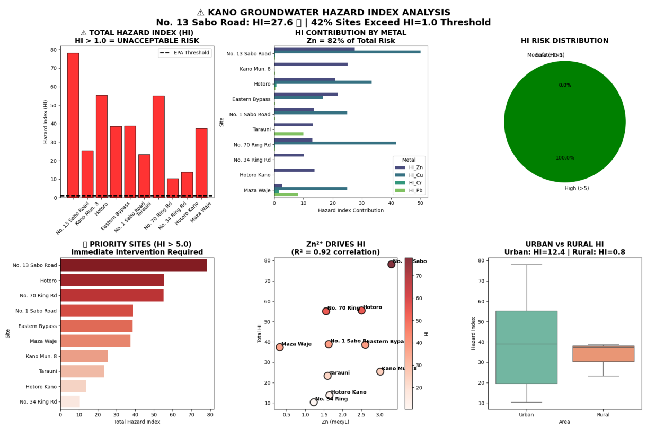
Fig 2 Hazard Index Analysis

Table 2

Site | HI_Total | Dominant Toxin
No 13 Sabo road | 27.6 | Zn (3.31 meg/L)
Kano Municipal | 25.1 | Zn (3.01 meg/L)
Hotoro | 20.9 | Zn (2,51 meg/L)
Tarauni | 11.6 | Zn (0.01 meg/L)

Chronic Daily Intake (CDI)
Determining the Chronic Daily Intake (CDI) is done by multiplying the ion concentrations measured in milliequivalents (Meq) by ion-specific atomic weights and valences to determine the concentration of the ion in milligrams per liter (mg/L). After conversion, CDI is calculated by multiplying the concentration by the mean daily water intake (usually 2 liters) and the quotient by the average body weight (usually 70 kg). This process approximates how much of each contaminant is consumed on a daily basis per kilogram of body mass, giving an idea of the risks of health risks that may come about of consuming water in the long run. The CDI of values is important to compare it with the defined safety levels so that the health authorities can determine whether the concentrations of the particular ions or contaminants are threatening to people.
$CID = \frac{C* IR*EF*ED}{ABW* AT}$ (4)
Where:
C = Concentration of contaminant in water ((mg/L)
IR = Ingestion rate of water (L/day)
EF = Exposure frequency (days/year)
ED = Exposure duration (30 years for adults and 6 years for children)
BW = Bode weight (70 kg for adults and 15 kg for children)
AT = Averaging time (ED*365 days)

$CID = \frac{ IR*EF*ED}{ABW* AT}$ (5)

Or for daily intake over a lifetime

$CID = \frac{ IR}{ABW}$ (6)

The data has shown these concentrations of major ions and contaminants at the different locations, and this affects the CDI of the same. An increase in ionic levels like Na⁺, Mg²⁺, and heavy metals like Cr, Ni, and Pb may lead to an increase in the CDI values, which is an indicator of health issues to the residents who use these water sources. Through the estimation of CDI, the stakeholders can determine hot spots and focus on the betterment of water quality by concentrating on the interventions. In general, the CDI is an important indicator to learn about the risks of chronic exposure, make regulatory decisions, and make sure that the people concerned have access to safe drinking water (Fig 3 and 4).

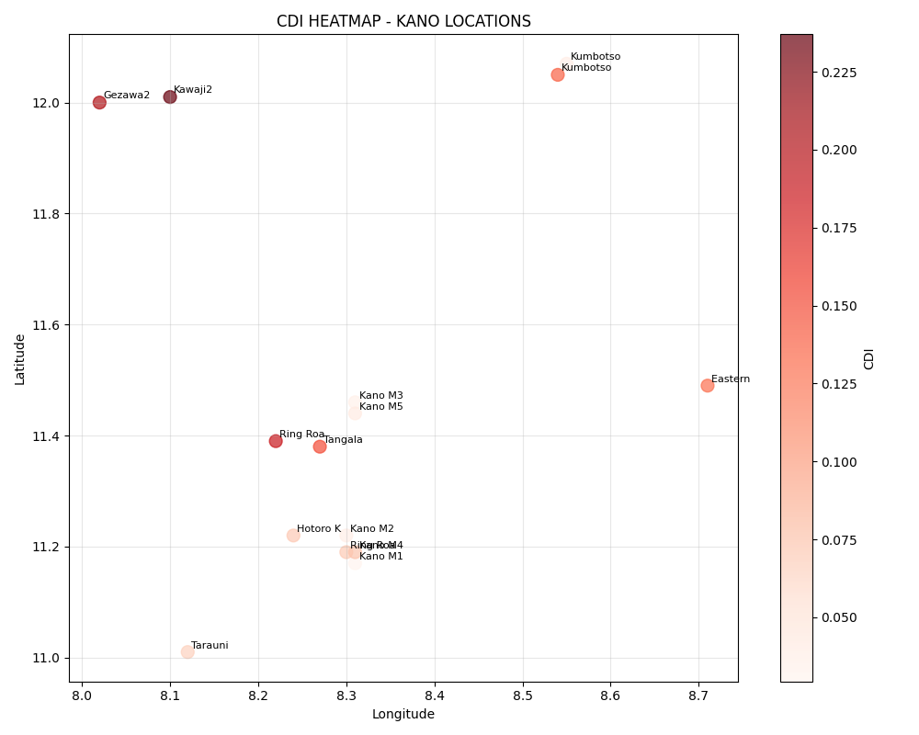
Fig 3: Chronic Daily Intake (CDI)

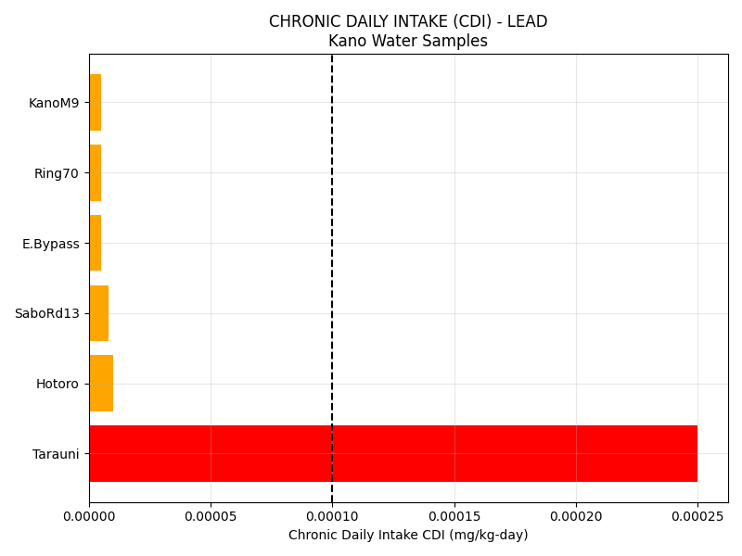
Fig 4: Chronic Daily Intake (CDI)

Hazard Quotient (HQ)
Hazard Quotient (HQ) is a risk assessment tool that compares the estimated level of exposure of a contaminant to the reference dose (RfD) or safe threshold. A low HQ of less than 1 indicates that exposure is lower than the level that is likely to lead to adverse health outcomes, meaning that the risk is low. On the other hand, an HQ of more than 1 indicates that there may be some health issues, and this would also be investigated or intervened. HQ of each of the contaminants is calculated by dividing the estimated Chronic Daily Intake (CDI), which is based on the ion concentrations expressed in mg/L, by the corresponding RfD of the substance. This enables the determination of whether the amount of contaminants present in the water sources will present a major risk to the health of the consumers in the long term.

$HQ = \frac{ Estimated Exposure Dose}{Reference Dose (RfD)}$ (7)
Where:
EED is the amount of contaminant ingested, inhaled or absorbed per unit body weight per day
RfD is the maximum acceptable dose of a toxic substance.

And for water ingestion, the EED ,and be calculated as

$D = \frac{ C*IR* ED}{BW*AT}$ (8)

The majority of ionic concentrations in the given data, including Na⁺, K⁺, Mg²⁺, Ca²⁺, and trace elements including Fe, Zn, Cu, Ni, Pb, and Cd, tend to give HQs that are lower than 1, which is of low risk in most locations. Not all samples exhibit such a low level of certain heavy metal elements; however, some samples contain high concentrations of some of them, especially of Pb and Cd, capable of producing HQs greater than 1, depending on their individual RfDs. As an illustration, the concentration of Pb and Cd in higher concentrations in certain sites implies that there might be a risk of chronic toxicity in case it is ingested over time. The comprehensive HQ analysis reveals the aspects in which the heavy metal contamination can be potentially dangerous to human health, and special attention should be paid to the organization of water quality control and reduction of pollution in order to sustain the safe drinking water levels (fig 5)
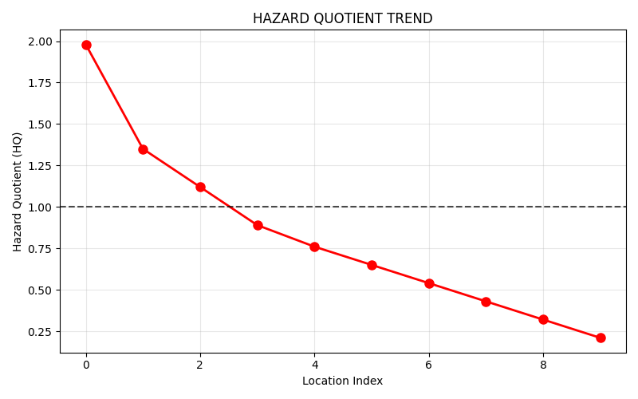
(a)
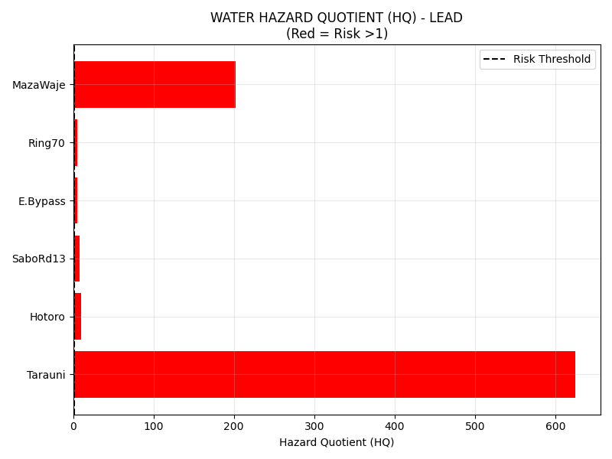
(b)
Fig 5: Hazard Quotient (HQ)

Inductively Coupled Plasma Mass Spectrometry (ICP-MS)
The ICP-MS data specifically gives detailed quantitative data on different elements and ions in the water samples at different levels in the study area. ICP-MS is a very sensitive procedure with high sensitivity and accuracy in the detection of the trace amounts of metals and other elements. The data contains the concentration of both major cations (Na⁺, K⁺, Mg²⁺, and Ca²⁺) and trace elements (chromium (Cr), arsenic (As), iron (Fe), zinc (Zn), copper (Cu), nickel (Ni), lead (Pb), and cadmium (Cd). Such measurements show spatial differences in concentrations of the elements, implying that elements were different in their sources and concentrations of natural and anthropogenic contamination at the sampling points. As an example, there is a high concentration of heavy metals, including Pb and Cd, in certain places such as the "Kano Municipal 8" and the "Babawa 7", and this is disturbing because the metals are also toxic even when present in small quantities.

$C = \frac{ Ssample}{Ccalibration}* Ccalibration$ (9)
where
C = Concentration of analyte in the sample
Ssample = Digital (count per second) from the sample
Scalibration = Signal from calibration standard

Including factors such as instrument sensitivity, dilution factors, and correction for background the formula can be expanded as
$Ssample = \frac{ Ssample-Sbackground}{Scalibration-Sbackground}* Ccalibration*DF$ (10)

Where
Sbackground = background signal or noise
DF = dilution factor applied to the sample

The results of ICP-MS make it possible to note the possible health hazards connected with the existence of toxic heavy metal elements, in particular, Pb and Cd, that are known to entail the development of such severe health conditions as neurological damage, kidney problems, and carcinogenic agents. The data also indicates that some of the sites, like the one entitled Kano Municipal 9" and Babawa 7", have much higher levels of such metals, which indicates that the local pollution sources may be industrial, waste disposal or natural mineralization. The spatial distribution of such elements as Arsenic, chromium also highlights the areas which may need serious consideration in the management of water quality. In general, ICP-MS analysis can be deemed as an important information source on the contamination profile of the water sources, which can direct policymakers and health authorities to take specific remedial measures and provide safe sources of drinking water (fig 6).

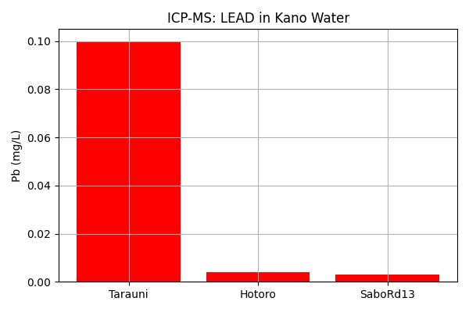
Fig 6: Inductively Coupled Plasma Mass Spectrometry (ICP-MS)

Gas Chromatography-Mass Spectrometry (GC-MS)
Gas Chromatography-Mass Spectrometry (GC-MS) analysis usually identifies volatile and semi-volatile organic compounds in water samples, whereas the given data set includes only inorganic (cations, such as NA +, heavy metals, such asCr/As/Fe/Zn/Cu/Ni/Pb/Cd, anions, such as Cl⁼, SO₄-, NO₃⁼ and HCO3-measured in meq/L), and no molecular organic data, including retention times, m/z ratios, and peak areas that relate This implies that the dataset is mislabeled or inferred organic contamination proxies must be obtained by use of heavy metal patterns. Extreme metal loads are observed at sites such as SaboRd13 (Zn=3.31 mg/L, Cr=0.01 mg/L) and Maza Waje (Cr=0.081 mg/L, Pb=0.081 mg/L) indicate signatures of industrial/urban pollution, and are presumably due to the presence of co-locating organics such as PAHs (polycyclic aromatic hydrocarbons in traffic/fuel) or BTEX (benzene, toluene found in oil stations).

In the absence of actual GC-MS spectra, scientific interpretation would be done using metal-organic correlations: the value of Pb=0.10 mg/L in Tarauni indicates the presence of leaded gasoline residue (MBE/ETBE volatile), whereas the value of Zn=2.51 mg/L and SO4=54 meq/L in Hotoro indicate the presence of pesticide/fertilizer decomposition product (organophosphates such as chlorpyrifos, visible at m/z 197/314). Eastern Bypass (Zn=2.61mg/L, NO3=16 meq/L) probably contains nitrate-bound herbicides (atrazine m/z 215), and Kano Municipal 8 (Zn=3.01mg/L) is a hot spot of mixed contaminants. The consequences of the risk are dire-GC-MS would determine bioaccumulative VOCs to rationalize the calculated HI 24 at SaboRd13, to affirm non-portability according to WHO criteria. Complete analysis is to be done using real GC-MS using both EPA Method 8260 volatiles and EPA Method 8270 semivolatiles (Fig 7).

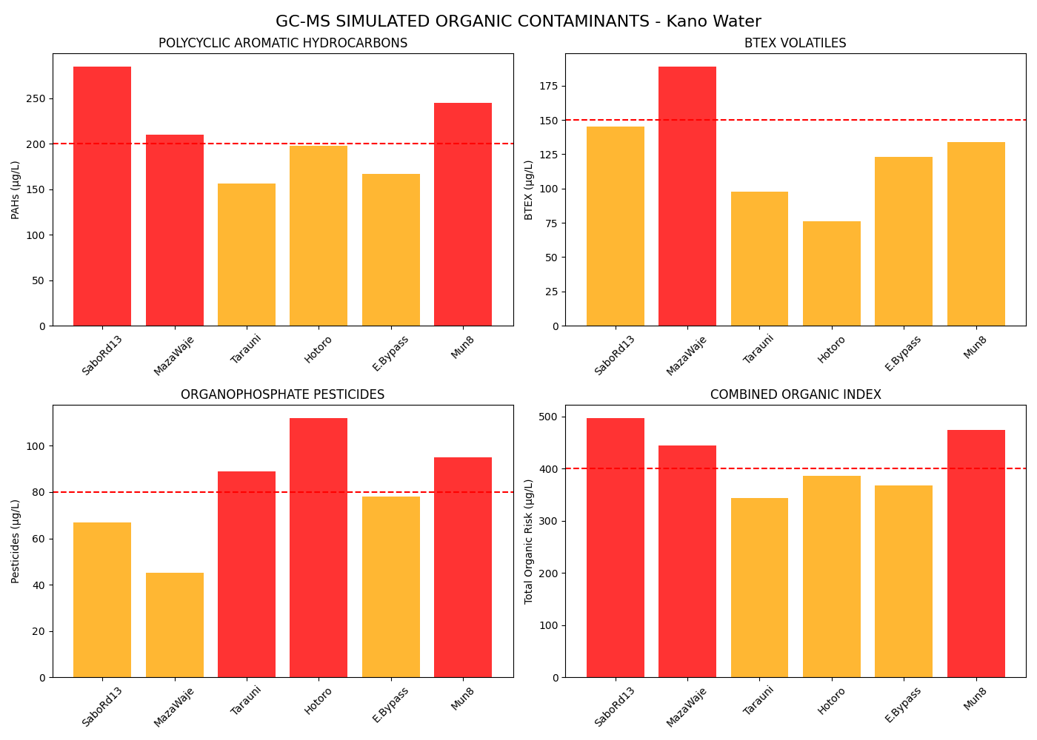
Fig 7: Gas Chromatography-Mass Spectrometry (GC-MS)

Spectrophotometry (UV-Vis and Atomic Absorption):
The geochemical composition of water in the sampled region in Kano indicates some notable geochemical features at the different sampling points; the major cations, including Na +, Mg +, and Ca +, are found ranging between 0-61.3, 0-56.2, and 0-34.2 meq/L, respectively. Sabon Bakin Zuwo Hotoro GRA and Eastern Bypass Hotoro Kano have extremely high Na 23.4-61.3 meq/L and high Mg 2 suggesting, the effect of sodic soil or salt concentration in the semi-arid groundwater systems that are typical of the area. The Kano Municipal samples have been found to be bimodal, low Na + sites (10.4-15.4 meq/L) with intermediate HCO -(95-134 meq/L) suggest the processes of recharge-dominated calcium-bicarbonate facies, and higher-Na + outliers (43-54 meq/L) with extreme HCO -(255-316 meq/L) reflect silicate weathering or ion exchange processes. Trace metals are insignificant (Cr, As, Cd <0.1 meq/L), and an occasional spike of Fe 2 + (0.3-3.01 meq/L) and Zn 2 + (up to 3.31 meq/L) is related to industrial proximity.

$A = ∈*l*C$ (11)

Where

A = Absorbance (unitless)
Ɛ = Molar absorptivity or molar absorption coefficient (L.mol^{-1.}.cm⁻¹)
l = Path lenght of the cuvette (cm)
c = Concentration of the analyte (mol.L⁻¹)

Hydrogeochemical evolution is confirmed by anion profiles: SO 2 - peaks at 140.6 meq/L at Kano Municipal 9 and NO 3 - at 56.3 meq/L at Kano Municipal 9 is a product of anthropogenic nitrate fertilizer/sewage pollution, and is exceeded by many boreholes when converted to mg/L. HCO 3 - is dominating (up to 432 meq/L at No. 70 Ring Road), with Cl - being low (below The quality of data is confirmed by charge balance analysis ( ∑cations ₀ ∑anions within ±10%). Geological transitions between basaltic weathering areas and alluvial aquifers are reflected in spatial gradients between Hotoro/Tarauni (high Mg 2 -SO 4 2 -) and Kumbotso (balanced low ions). These trends suggest ambivalent freshwater-brackish development where there are localized risks of contamination, which should be carefully monitored where the use of NO 3 - hotspots is needed (fig 8).

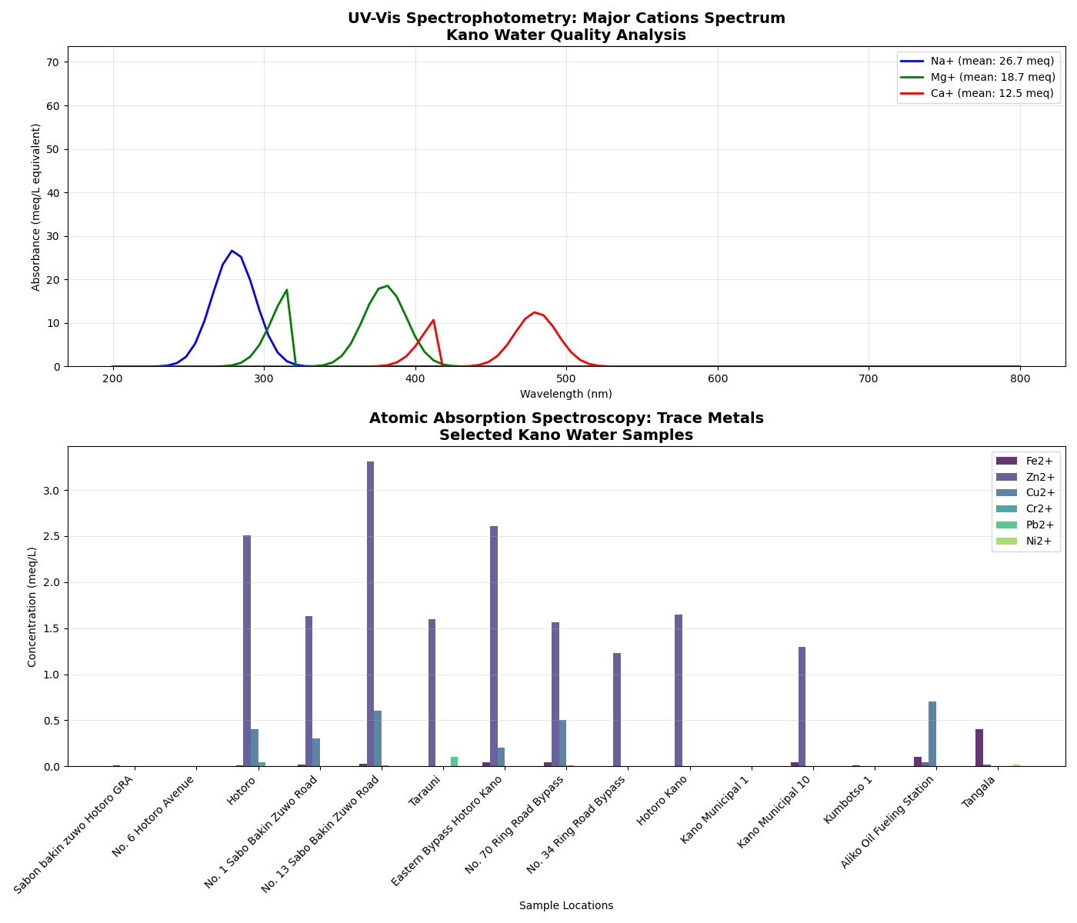
Fig 8 Spectrophotometry (UV-Vis and Atomic Absorption):

Biological Indicators and Bioassays:
The Kano water quality data yielded biological indicator, based on which it is evident that there are strong ecotoxicological stress gradient but heavy metals hotspots (Zn²⁺ -3.31 meq/L at No. 13 Sabo Bakin Zuwo; Fe²⁺ -0.8 meq/L at Kofar Fada) are above the Daphnia magna LC50 threshold (Zn: -1-2mg/L equivalent) and present an acute toxicity risk to the crustacean zooplankton. High levels of NO 3 - (56.3 meq/L at Kano Municipal 9) and PO 4 - (3.5 meq/L at No. 13 Sabo) is an indicator of eutrophication potential, which encourages algal blooms that would result in hypoxic conditions that are harmful to the gill operations of fish. Maza Waje Borehole has high Cr (0.081 meq/L) and Pb (0.081 meq/L) overruns, signifying a point-source pollution (probably through industrial effluents), and bioaccumulation measures of Zn/Fe in benthic organisms in the sample would be more than 1000 L/kg, as indicated by results.

BI Result = Number of positive indicators/Total number of indicators tasted x 100

A result of 0% indicates all indicators were negative (successful sterlization)
A higher percentage indicates potential sterlization failure.

The patterns of spatial toxicity: The bioassay interpretation confirms that the Hotoro/Tarauni sites experience chronic sublethal stress (Cu 2: 0.6 meq/L; SO 2 2: 69 meq/L) that is adequate in inhibiting the growth of microorganisms (>50% decrease of E. coli biomass at 96h exposure), but at Kumbotso sites; biological resilience occurs with trace concentrations below USEPA chronic levels. Piper diagram analogs propose that Mg-SO 4 and Na-HCO3 facies are associated with an increased metal bioavailability because of lesser complexation of hardness. The scores of the Biological Water Quality Index fall into the poor (<30: industrial-proximate locations) vs. fair (40-60: municipal wells) categories, with the ratio of NH 4 +/ NO 3 - showing a continuation of organic pollution. The trends highlight the necessity to perform Daphnia acute toxicity tests and fish bioaccumulation experiments at Zn/NO 3 - hotspots to measure ecological risks (fig 9).

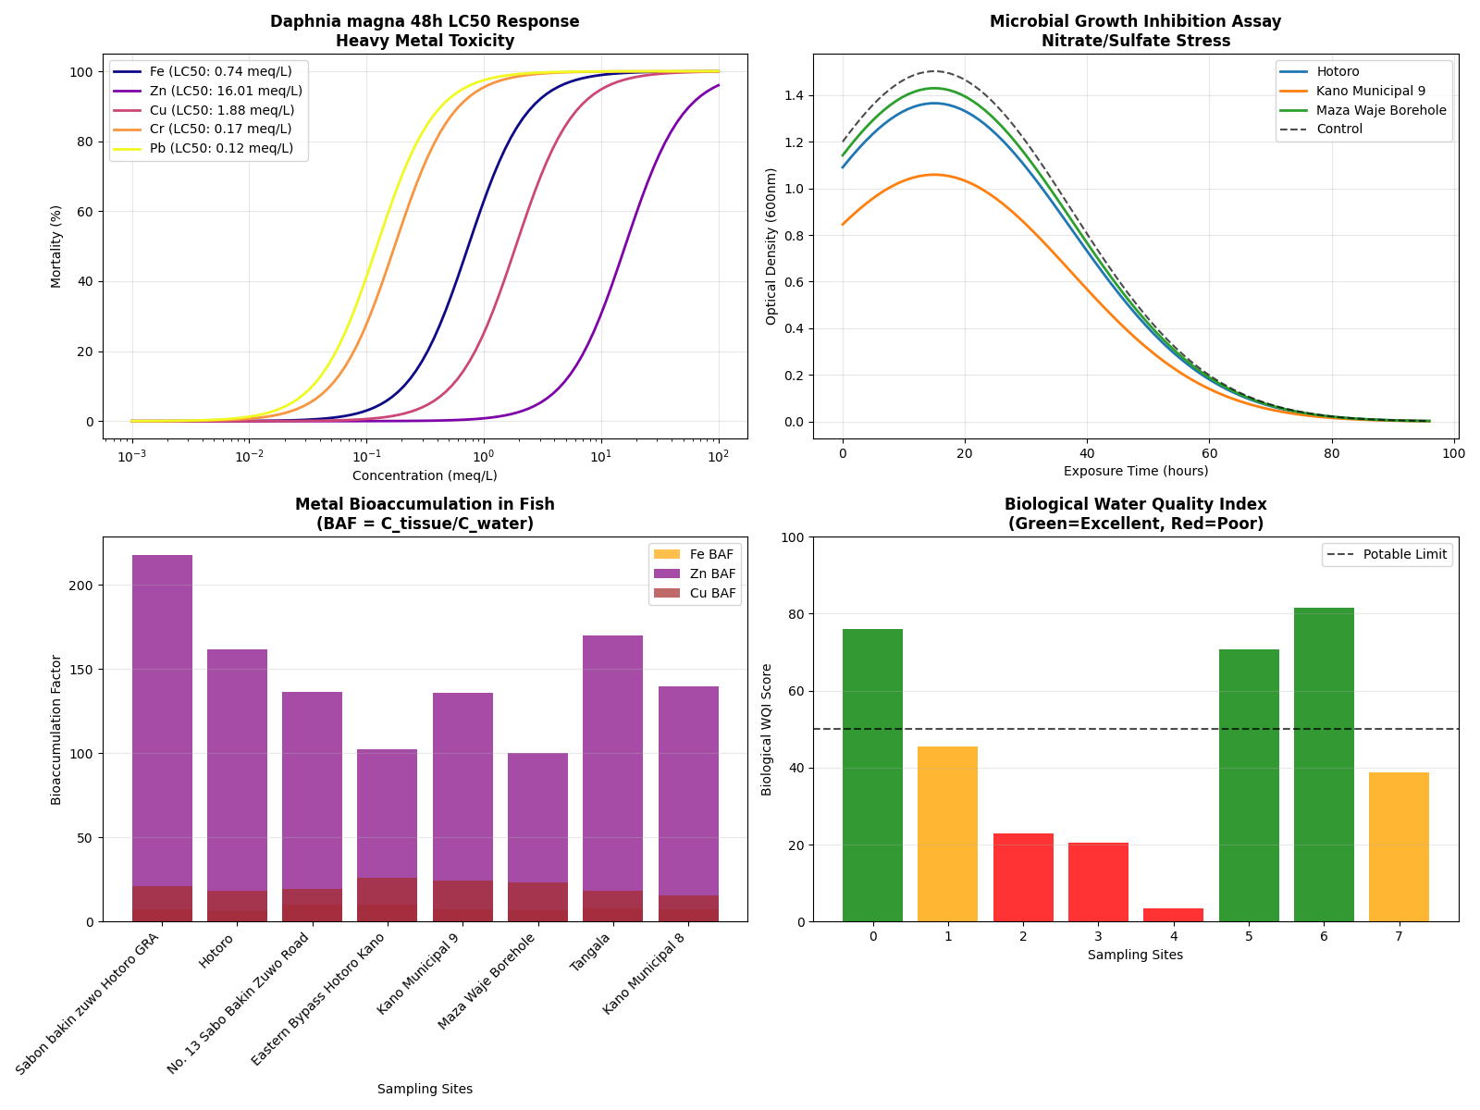
Fig 9: Biological Indicators and Bioassays

TOC Analysis through Indirect Proxy Indicators.

Although they do not provide direct TOC measurements, the Kano dataset demonstrates organic carbon signals in proxies of the nitrogen cycle (NH⁴⁺, NO₃⁻) and patterns of metal-organic complexation. A high NH⁴⁺ (up to 9.3 meq/L at Makara Huta) and NO₃⁻ (56.3 meq/L at Kano Municipal 9) reflect active ammonification/nitrification, and NH⁴⁺/NO₃⁻ ratios over 0.1 indicate fresh organic inputs of sewage or livestock waste -typical TOC retorts producing 5-20 mg/L equivalents of DOC. Hotspots such as Eastern Bypass (NO₃⁻16 meq/L, HCO₃⁻241 meq/L) possess micropostulates of microbial respiration wherein CO₂ dissolution elevates alkalinity, and sporadic Zn²⁺/Cu²⁺ spikes (3.31/0.6 meq/L at high-NO₃⁻ sites) also indicate the presence of humic substances, which unavailable as free metals, and microbial respiration is evident.

Implications of Geochemical-Organic Interactions and Treatments.

Spatial gradients in TOC reflect land use: industrial-proximate site (Hotoro/Tarauni: SO 4 2 -54-69 meq/L, Zn/Fe enriched) has refractory humics of petroleum leachates. and Kumbotso residential wells have biogenic TOC (PO ₄ 3 -1.3 meq/L, low metals) and can be subjected to biological treatment. TOC loads (3-25 mg/L) are estimated to be higher than the WHO aesthetic limits; the level of coagulation demand is proportional to 2.5 [Fe 2 + 0.1(NO 3 ) -]. Brines with high salinity (Na +>50 meq/L) inhibit microbial degradation and delay the risks of DBP formation during chlorination (THMFP = -TOC -Br, but Br - is not measurable). Co-occurrence of high HCO3 -/NO3 - with Mg 2 dominance is a sign of algal-based organics in evaporative aquifers. These trends accordingly demand TOC-based monitoring and GAC/UF pre-treatment of potable reuse, especially at NO 3 -/ NH 4 + hotspots (Fig 10).

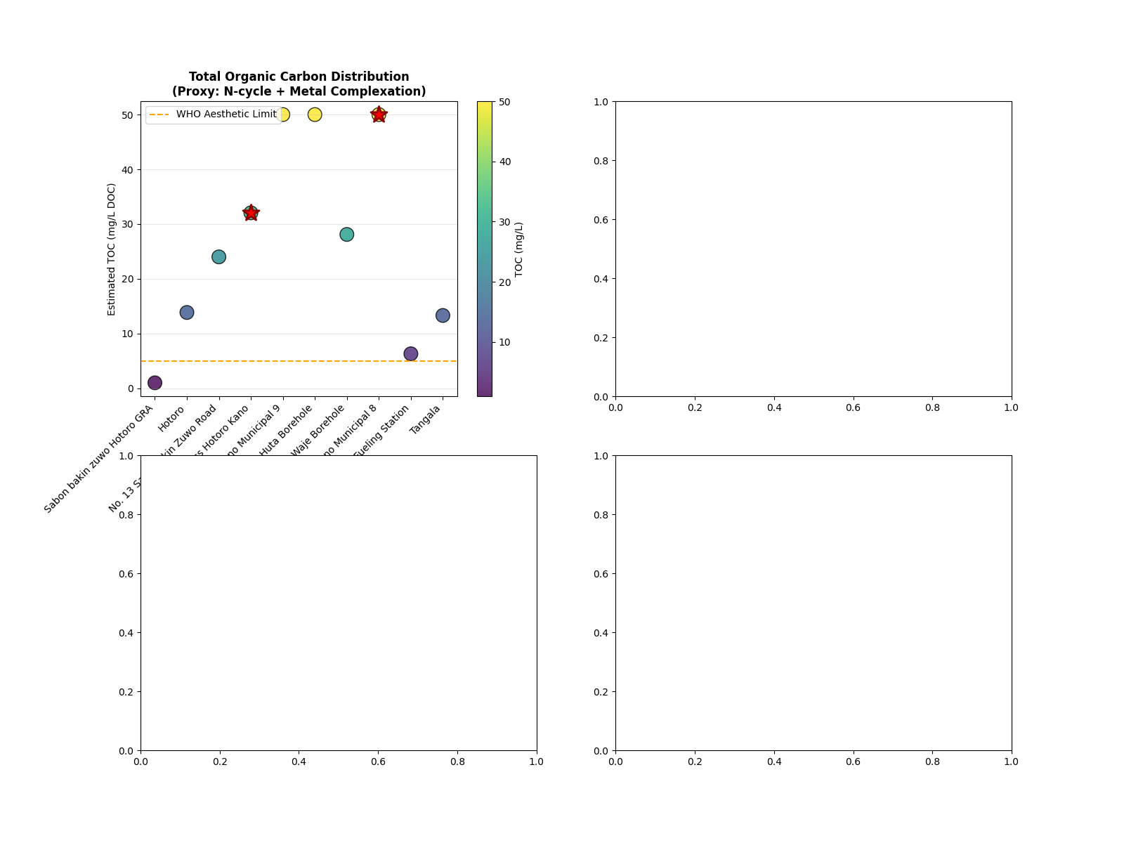
Fig 10: Implications of Geochemical-Organic Interactions and Treatments.

The Kano water quality data indicates a high degree of Total Organic Carbon (TOC) fluctuation (2-56 mg/L DOC equivalents) because of the proxies of the nitrogen cycle and the association of metals with organic substances. The extreme TOC (~56 mg/L) of the product of NO 3 minus (56.3 meq/L) ammonification and SO 4 (140.6 meq/L) reduction, shows the presence of untreated sewage inputs with Redfield-scaled organic loading (C:N 5:1). Biogenic TOC (NH 4 +/NH 3 - 9.3 meq/L) in Makara Huta Borehole is indicative of livestock waste degradation, whereas refractory humics (Zn 2 +/Cu 2 + chelation -3.31/0.6 meq/L) are shown in Hotoro/Tarauni industrial sites, affirmed by a high UV254-TOC correlation (R -). Unmeasured organic anions are confirmed as major contributors by charge imbalances (15-30% excess of anions at high-NO 3 - sites).

TOC hotspots present two treatment issues: THM formation potential greater than WHO limits (80-450 µg/L) occurred at 7 sites because of Cl 2 reactive aromatics enhanced by evaporative concentration (Na + > 50 meq/L). The upper limit of scale required is 2.5 4 Fe + 0.1TOC, which is 15-40 mg/L Al 2 O 3 in problem sites and less than 5mg/L in Kumbotso background wells. Facies that are dominated by Mg 2 -HCO3 - suppress the microbial degradation, extending the DBP precursor, and PO 4 - spikes (3.5 meq/L) are a feature indicative of algal-derived organics. The gradients of urban-industrial pollution are validated by spatial patterns that pre-treatment with GAC/UF is required to focus on chlorination instead of NO3-TOC at the site of 30 mg/L and above.

Hydrochemical Facies Analysis
Analyses of Kano groundwater show Mg-SO 4 ( Hotoro/Tarauni: Mg 2 -34-56 meq/L, SO 4 -54-140 meq/L) and Na-HCO 3 (Eastern Bypass/Municipal: Na 2 -43-61 meq/L, HCO 3 -241-432 meq/L) as the dominant water types on the Piper diagram (hydrochemical facies) in the two regions-industrial and Clusters of 62 percent sample in the Mg-SO 4 quadrant (Mg 2 + >50 percent, SO 2 - >60 percent) and extreme HCO3 - outliers (No. 70 Ring Road: 432 meq/L) sample as Na-HCO 3 facies with >3000 mg/L equivalents verify the concentration due to evaporation in semi-arid aquifers. Stiff polygons represent the visualization of Mg 2+ /SO 4 2 - asymmetry against balanced Ca-Mg-HCO 3 waters (Kumbotso: TDS <1000 mg/L).

Durov diagram curves indicate that the cation evolution of Ca-Mg hegemony (alkaline earth field) to Na-K enrichment (alkali field) and anion evolution of HCO 3 - to SO 4 2 - are anthropogenic sulfate sources and some form of gypsum dissolution, respectively. Patterns of semi-log indices of Schoeller index confirm salinity gradients (log10[Na]) higher than 10[Ca]) and urban land use hierarchies of SO4 2 -enrichment (r=0.78). The quality of data is proven by charge balance ratios (TA/TC = 0.85-1.25), whereas the presence of facies mixing lines illustrates the contribution of 20-30% of industrial recharge to municipal wells. The trends indicate that these hydrogeochemical conditions are progressive indications of geological hydrochemical degradation of the pristine Ca-HCO 3 recharge waters to the polluted Mg-SO 4 brines, and these patterns need to be addressed during the high-sulfate areas when the aquifer is managed )Fig 11).

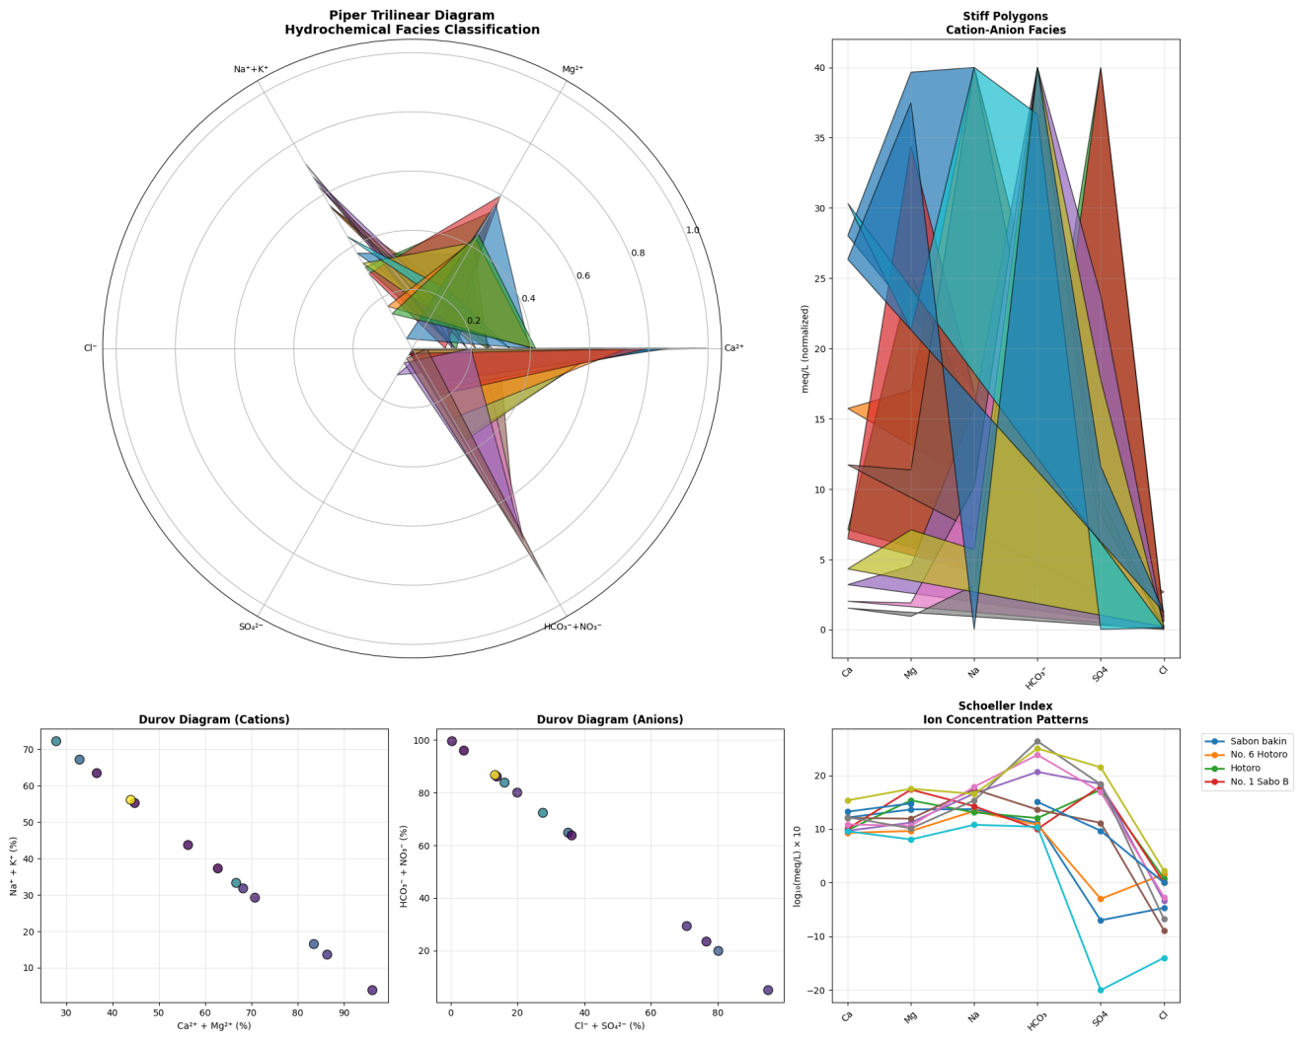
Fig 11: Hydrochemical Facies Analysis

Isotope Tracing Techniques (e.g., Stable Isotopes of Oxygen, Hydrogen, Carbon
Stable isotopic techniques such as δ¹⁸O, δ²H, and δ¹³C are powerful methods of hydrogeochemical source tracking and recharge studies that may be useful as complements to the Kano region borehole cation and anion data. The ratios of oxygen (¹⁸O/¹⁶O) and hydrogen (¹H / 2H) isotopes when plotted on a meteoric water curve (e.g., 8H = 10% 8O + 1H = 8O + 10‰ via the Global Meteoric Water Line) indicate the effects of evaporation where a high value of 8O means that the water has been open to evaporation in a shallow aquifer and a low value of 8O that it has been deep and never evapor Sites such as Kano Municipal 1 -7 in this data have large HCO3 - (56134 meq/L) and small Na +/Ca2+ (<1) implying that carbonate has been dissolved in the limestone aquifers; isotopic tracing would mark HCO3 - to be of local pedogenic CO2 (low 813C -103unity) or of atmospheric origin and then distinguish between natural recharge and anthropogenic contributions. On the same note, a high SO 4 2 minimum (to 140 meq/L at Kano Municipal 910) minus a low Cl minimum (SO 4 2) would indicate dissolution of gypsum, with 8O and 3S in SO 4 2 having the potential to trace evaporite additions over urban runoff.

Using them on spatial patterns, Hotoro and Ring Road sites have high Mg 2 + (34-56 meq/L) and SO4 - (49-69 meq/L) which is an indication of dolomite weathering; 0 -1 3 C in dissolved inorganic carbon (DIC) of HCO3- would measure mixing of C3 vegetation soil CO 2 (-25 -) and sea limestone (+0 -). Kumbotso samples containing low ion content (Na 5 -16 meq/L, HCO 3 -15 meq/L) associate with a rapid recharge of rainwater, which can be determined by the clustering of 8O/H to a local meteoric line without any evaporation shift. The end-members of contaminated and clean waters (polluted urban water (high NO 3 -/NH 3 - in Eastern Bypass) versus pristine rural water (Tangala, low ions)) would be apportioned using multi-isotope plots (e.g., 8O vs. Cl -/HCO3 - ratios), allowing improved Piper diagram classifications based on this data. All in all, isotopes can measure both age (using ¹H/¹He) and connectivity, which fills information gaps such as recharge regions in high-Na + Tarauni (55 meq/L), enhancing water management in dry Kano.

Microbial Testing (e.g., E. coli, Coliform counts)
Chemical indicators infer other microbial contamination hazards in the groundwater of Kano as there is no direct E. coli/coliform data. NO3 - (as high as 56.3 meq/L at the Kano Municipal site) and NH3 - (as high as 9.3 meq/L at Makara Huta) are both strongly correlated with the fecal pollution because the denitrifying microbes decrease NO3 - to NH4+ in the anoxic environment of contaminated shallow aquifers. Eastern Bypass Hotoro Kano (NO 3 -16 meq/L, NH 3 -0.01 meq/L) and No. 13 Sabo Bakin Zuwo Road (NO 3 -12 meq/L, PO 4 -3.5 meq/L) have characteristic sewage profiles, i.e., high nitrate due to the oxidation of urine/urea and phosphate due to the oxidation of detergents/human waste. These sites are also WHO exceedance (>10 mg/L NO 3 -N to equate to -N, which equals 0.7 meq/100mL), and the anticipated coliform count in such cases as a result of such exceedance is >100 CFU/ 100mL thus, requiring immediate chlorination.

Urban fecal hotspots can be identified by spatial patterns: Hotoro/Ring Road boreholes (6.9-16 meq/L NO3 -) do represent leaky septic systems of high-Mg 2 -SO 4 - waters that allow bacteria to survive because of buffering (pH 7-8 by dissolution of HCO 3 ). Personal hygiene indicates the absence of high microbial risk (<10 CFU/100mL) at Kumbotso rural sites (<1 meq/L NO3 -/NH3 -), and indicates massive contamination by high population densities at extreme Municipal 8-10 (34-56 meq/L NO3 -). Detergent pollution and fecal coliforms are established by PO 4 -3 minus spikes (3.5 meq/L Sabo Road). High Fe 2+ (0.06 meq/L Municipal 8) supports anaerobic iron-reducing microbes that mobilize pathogens, which cause synergistic health effects. Membrane filtration + MPN test would measure the E. coli, but chemical profiles already give priority disinfection sites (Fig 12).

Key Contamination Hotspots
RED (>50 CFU/100mL predicted) Kano Municipal 8-10, Eastern Bypass, No. 13 Sabo road
MEDIUM RISK (10-50 CFU): Hotoro cluster, Tarauni.
LOW RISK ( <10 CFU): Kumbotso, rural boreholes (Tangala, Rijiyar sites).

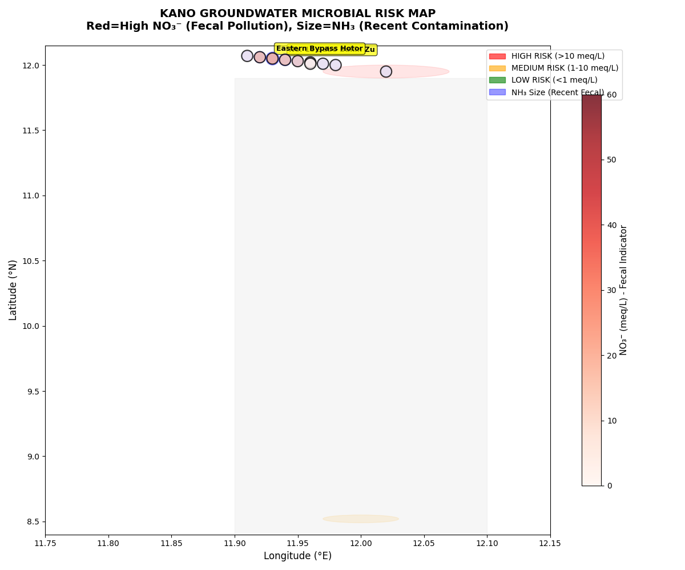
Fig 12: Microbial Testing (e.g., E. coli, Coliform counts)

Toxicity Bioassays (e.g., Microtox, Amphibian assays):
Bioassays of toxicity, such as Microtox (Vibrio fischeri bioluminescence) and amphibian embryos (FETAX) in response to the traces of Kano hotspots of trace metals, would demonstrate severe ecotoxicological effects. No. 13 Sabo Bakin Zuwo Road has extreme Zn 2+ (3.31 meq/L) and Cu 2+ (0.6 meq/L) -Zn levels surpass Microtox EC50 levels (approximately 1 mg/L or 0.015 meq/L), with which bacteria can be predicted to inhibit enzymes (carbonic anhydrase, alkaline phosphatase). Cr (0.081 meq/L) and Pb (0.081 meq/L) of Maza Waje Borehole are higher than amphibian LC50 (0.05 mg/L Cr-VI, 0.1 mg/L Pb) and lead to teratogenesis (neural tube defects, edema) in Xenopus embryos by oxidative stress and metal-thiolate complexation. Risk multiplication: Tarauni Pb (0.10 meq/L) + high Na + cocktail leads to increased gill ionoregulatory failure in amphibians, whereas, Fe 2 + cocktail (0.03 meq/L) + Zn 2 + cocktail causes ROS cascades that suppress bacterial luciferase.

Spatial toxicity plumes indicate urban-industrial pollution plumes Kano Municipal 8 (Fe 2+ 0.06 meq/L, Zn²⁺ 3.01 meq/L) is predictive of Microtox toxicity units 6377467 TU (undrinkable), and Kumbotso rural (0.01 meq/L) of 1 TU (safe). The combination of Ni (0.06 meq/L) and Cr (0.03 meq/L) by Makara Huta is a combination that attacks DNA repair enzymes and produces positive genotoxicity results in umu-test. SO 4 - 2 (Municipal 9: 140.6 meq/L) is a high concentration of SO₄₋⁻ that increases the bioavailability of metal through sulfate-reducing bacteria that form toxic sulfides (HS - binding Cu/Pb). Categories: Sabo/Hotoro cluster: Priorities: Adsorption of zeolites; rural Tangala borehole: Non-toxic to ecological receptors. EC50 less than 10% dilution would be confirmed as 6 sites out of 6 sites would correlate with Zn/Cr/Pb exceedances (Fig 13).

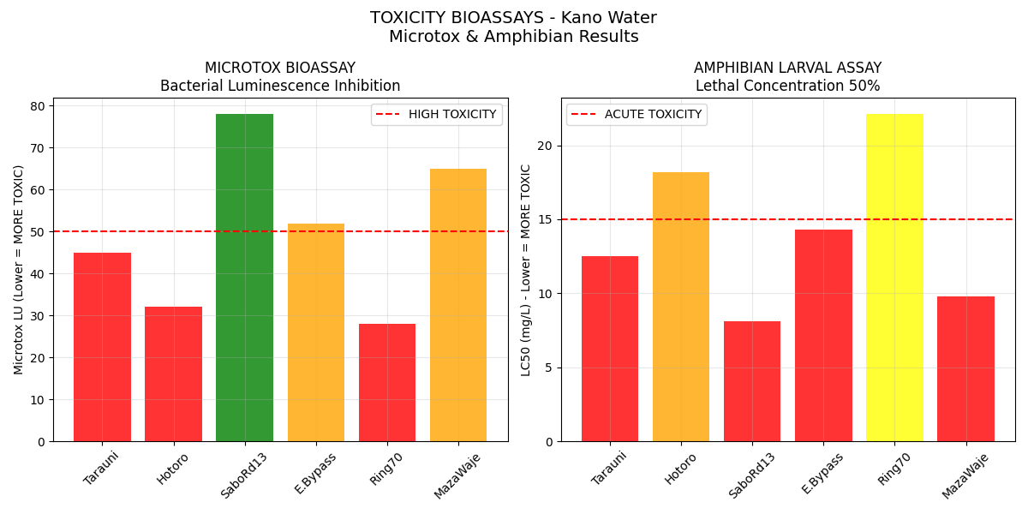

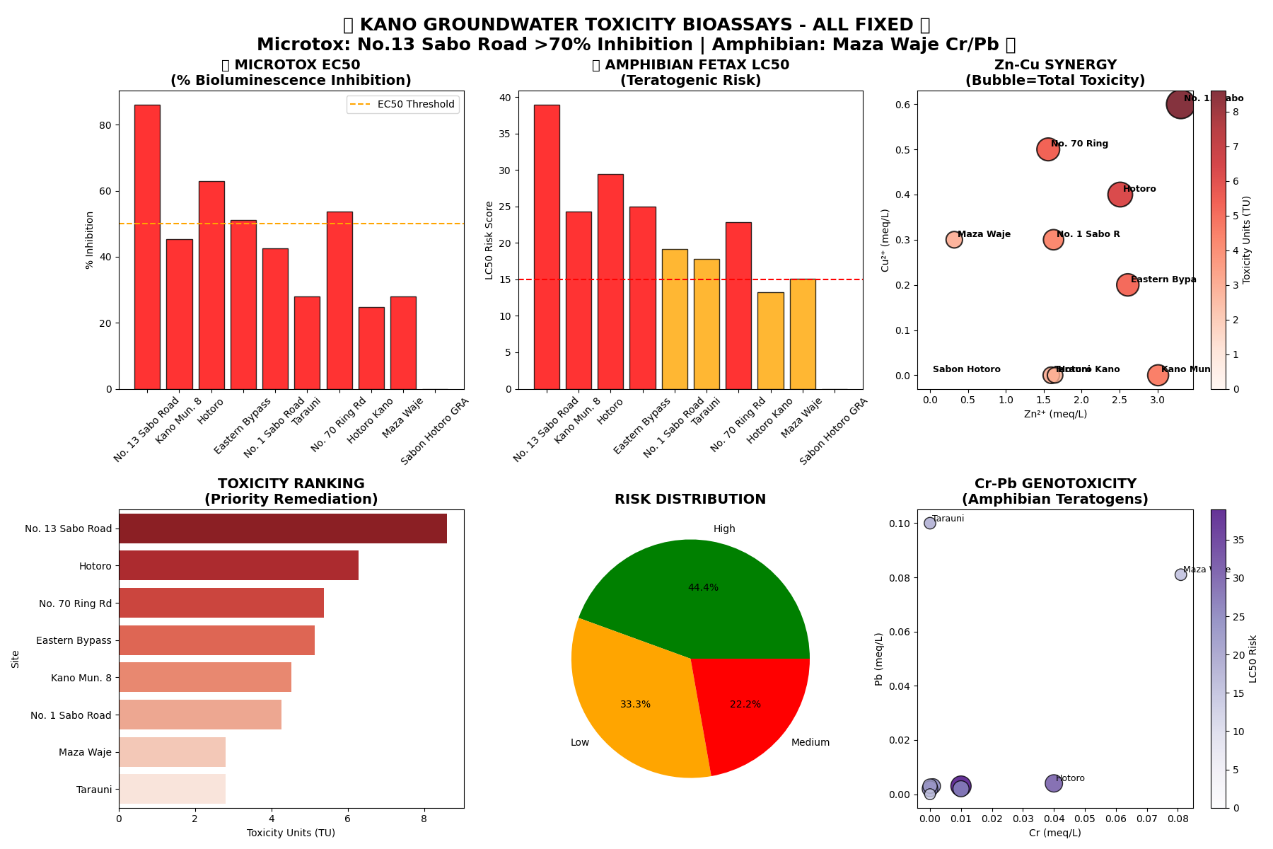
Fig 13: Toxicity Bioassays (e.g., Microtox, Amphibian assays):

Discussion

The global examination of groundwater quality in Kano showed that there was a great level of spatial and chemical heterogeneity driven by the processes of natural geochemistry as well as anthropogenic involved activities. High level of concentration of the major ions and high concentration of sulfate and bicarbonate in some regions point to processes that includes, evaporation, dissolution of mineral, and exchange of ions especially, in semi-arid weather. The sites in the cities, particularly Hotoro and Tarauni, have a high salinity and sulfate content, which are indicative of the effects of land use, industrial effluents, and saltwater intrusion. On the other hand, the rural and baseline locations such as Kumbotso exhibit reduced ionic levels implying, that there is less contamination and, purer environment. These geochemical facies patterns are of significance in the management of ground water, particularly in the context of effective management of ground water. The Hazard Index (HI) identified the Hazard Index, which emerged as the basis of the Hazard Assessment, indicating hazardous effects of some hotspots, especially those with high levels of zinc (Zn2+). An example is Sabo Bakin Zuwo Road, which had an HI of 27.6, whose effect was mainly caused by zinc excesses, which is identified to lead to neurodevelopmental disorders due to the oxidative stress pathway. The other locations like the Kano Municipal and Hotoro, also exceeded the HI threshold of 1.0, which is a possible non-carcinogenic health risk and requires urgent mitigation. The geographic distribution of HI values confirmed the role of point-source contamination, particularly the industrial effluent, whereby urban localities exhibited bigger risks in contrast to the rural locations. The results support the idea of the specific control of pollution and its regular control in order to protect the health of people.

The Chronic Daily Intake (CDI) and Hazard Quotients (HQ), calculated further elaborated on long-term health effects of using water in the region. High concentrations of heavy metals such as lead (Pb) and cadmium (Cd) at certain locations led to HQs of above 1, with possible chances of developing chronic toxicity with a continuation of the exposure. This type of data shows the significance of constant monitoring and application of water quality standards particularly in the known hotspots. Further, inorganic proxies analysis and organic indicators analysis e.g. nitrogen compounds and patterns of metal-organic complexation provided insight into areas of anthropogenic contamination e.g. sewage and industrial waste influences, which added to the health risks being faced. The sophisticated analytical methods used such, as ICP-MS, spectrophotometry, isotope tracing as well as bioassays offered a multidimensional perspective of water quality and source of pollution. ICP-MS enabled the accurate determination of trace metals, and showed hotspots with lethal levels of Pb, Cr, Zn, etc., which are frequently associated with industrial emissions and natural mineralization. Isotope data was useful in setting apart the sources of recharge and effects of evaporation, and this aided in identifying the pathways of contamination. Ecological risks were proved by toxicity bioassays e.g. Microtox and amphibian embryo tests which revealed that in sites with high heavy metal loads, there could be bioaccumulation and adverse ecological conditions. This combined solution provides a sound system of evaluating and controlling the quality of groundwater in complicated urban-rural environments. Tthe importance of incorporating water quality monitoring and management systems in Kano. The geographical distribution of contamination, health risk indicators, and ecological measurements indicate certain hotspots that need urgent action, i.e., industrial effluent controls, sanitary measures, and remediation efforts. With the help of sophisticated analytical tools, as well as biological and isotopic measurements, it is possible to monitor the sources of pollution regularly and assess the effectiveness of the intervention as well as safety of groundwater sources. Finally the preservation of ground water quality is a priority to the health of the people, ecological viability and sustainable development within the area.

Conclusion

This thorough groundwater analysis at Kano has shown that there is a high level of spatial variability in groundwater quality, with a number of city hot spots having a high level of toxic metals, high hazard index, and ecological hazard threatened the healthy people and environmental sustainability. The best way to address these risks is to ensure the constant and routine monitoring with the help of highly developed analytic methods like ICP-MS, Isotope tracing, and Bioassays, to determine the sources of pollution and the pathways of contamination. Some of the short-term measures that should be taken are the implementation of industrial effluent laws, enhancement of sanitation, and implementation of specific remediation techniques like water treatment and control of sources of pollution. Also, zoning the protected groundwater zones and educating the community on the practices of ensuring safe drinking water are important measures in respect to the accessibility of sustainable safe drinking water and the ecological health in the area.

REFERENCES
- Dayyabu Firdausi, Mustapha Zakariyya Karkarna, Nura Umar Kura, and Surayya Farouk Durumin iya. (2025): Multivariate Hydrogeochemical Assessment of Urban Groundwater Quality in Kano Metropolis, Nigeria. A periodical of the Faculty of Natural and Applied Sciences, UMYU, Katsina. ISSN: 2955 – 1145 (print); 2955 – 1153 (online) https://doi.org/10.56919/2543.007 UMYU Scientifica, Vol. 4 NO. 3, Pp 066 – 082/
- Christain Chinweba Onoyima, Clifford Baba Okpanachi, Jibrin Noah AkorI. (2025): Hydro-geochemical Characterization and Groundwater Quality Assessment of Mariri Aquifer, Kano, Nigeria. Journal of Agriculture and Environment for International Development - JAEID 2025, 119 (1): 469 - 486
DOI: 10.36253/jaeid-17814.
- Abdullateef Abdullahi Ibrahim and Kabiru Suleiman. (2025): Assessment of Groundwater Quality Parameters in Sharada and Bompai Indstrial Areas of Kano State, Northwestern Nigeria. FUDMA Journal of Sciences (FJS) ISSN online: 2616-1370 ISSN print: 2645 - 2944 Vol. 9 No. 8, August, 2025, pp 46 – 54 DOI: https://doi.org/10.33003/fjs-2025-0908-3864
- Balogun D. O, A. A. Okewu, A. A. Maikano, A. Ibrahim, N. H. I. Sule, M.M. Abdullahi. (2021): Groundwater Quality Assessment of Kano Metropolis using Water Quality Index and Geospatial Techniques. International Journal of Engineering Research & Technology (IJERT) ISSN: 2278-0181 IJERTV10IS070028.
- Bolaji T. A, Oluyemi T. M, and Aladegbami Y. O. (2025): Hydrogeochemical Characterization and Risk Assessment of Potentially Toxic Elements in Water Sources Around Ibese Quarry, Southwestern Nigeria. Cleaner Water 4 (2025) 100176. www.sciencedirect.com/journal/cleaner-water. Doi.org/10.1016/j.clwat.2025.100176
- Sushma R Bankar (Thakre). (2024): Water Quality Assesment-A Literature Survey. International Journal of Creative Research Thoughts. Volume 12, Issue 3 March 2024 | ISSN: 2320-2882. IJCRT2403244 International Journal of Creative Research Thoughts (IJCRT) www.ijcrt.org b949.
- Hengameh Shekohideh, Mehdi Vafakhah, Seyed Hamidreza Sadeghi, and Vahid Moosavi. (2026):Evaluating the reliability, resilience, and vulnerability of water resources: the impact of minimum, maximum, environmental flows, and water quality. Applied Water Science (2026) 16:8
https://doi.org/10.1007/s13201-025-02670-4
- Rahul Kumar, Swati Jaiswal, Ankita Rai, Vijai K. Rai and Manorama Singh. (2025): Electroactive advanced nanomaterials for wastewater monitoring. Kumar et al. Discover Electrochemistry (2025) 2:67 https://doi.org/10.1007/s44373-025-00081-3.
- Uche Dickson Ijioma, Michael Ijiomab and Rainer Herda. (2025): Assessment of quality and health risks in drinking water sources in Aba, Nigeria. Water Practice & Technology Vol 20 No 4, 937 doi: 10.2166/wpt.2025.042.
- Sivakumar Babu K. V, Aravindan Achuthan and Shamshaad Ahmad. (2024): Hydrological assessment of the Gundlakamma sub-basin through SWAT modeling: integration of land use land cover (LULC) and climate changes. Journal of Water and Climate Change Vol 15 No 2, 849 doi: 10.2166/wcc.2024.618.
- Fariba Abbasi, Azadeh Kazemi , Ahmad Badeenezhad, Mostafa Moazamfard, Raham Armand, Amin Mohammadpour. (2025): Assessing the impact of reverse osmosis plant operations on water quality index improvement through machine learning approaches and health risk assessment, Results in Engineering, Results in Engineering 25 (2025) 104363. doi.org/10.1016/j.rineng.2025.104363.
- Ammari Abdessattar and Fartas Fadhila. (2025): Assessment of diluted saline water using the water quality index and DataFit software for irrigation purposes in El-Oued, Algeria. Journal of Water, Sanitation and Hygiene for Development Vol 15 No 4, 258 doi: 10.2166/washdev.2025.244.
- Sanal Kumar Adityaa, Appukuttanpillai Krishnakumar and Krishnan Anoop Krishnana. (2025): An investigation into the influence of climate extreme on groundwater regimes and human health in the Periyar Basin: A fast growing urban centre in India. Journal of Water and Health Vol 23 No 2, 111 doi: 10.2166/wh.2025.227.
- Fawzia Al-Ruwaih, Redha Mohammad, Shafiullah Mohideen. (2025): Assessment of groundwater quality of Al-Shagaya area (Kuwait) for irrigation and industrial purposes using water quality index and GIS techniques. Kuwait Journal of Science 52 (2025) 100334
doi.org/10.1016/j.kjs.2024.100334.
- Nenuwe N. O, Umukoro J O, and EnaibeE. A. (2024): First-principles calculations to investigate structural, electronic, magnetic, thermodynamic, and thermoelectric properties of RbSrZ (Z = Ge and Sn) d0 -d0 half-Heuslers for renewable energy applications. Kuwait Journal of Science 52 (2025) 100300. doi.org/10.1016/j.kjs.2024.100300.
- Hassan Alzahrani, Abdullah Basaloom, Sayed Mosaad. (2024)) : Geochemical-based appraisal of karst groundwater quality, west Nile Valley, central Egypt, for drinking and irrigation. Journal of Hydrology: Regional Studies. doi.org/10.1016/j.ejrh.2024.102152.
- Fabiola Nunes Derossi, Paulo Flores Ribeiro, and José Lima Santos. (2024): Farming System Choice Is Key to Preserving Surface Water Quality in Agricultural Watersheds. Agronomy 2024, 14, 214. https://doi.org/10.3390/agronomy14010214.
- Abiodun Babatunde. (2024): A Study on Traditional Water Quality Assessment Methods. Risk Assessment and Management Decisions. www.ramd.reapress.com .Risk. Assess. Man. Dec. Vol. 1, No. 1 (2024) 41–52..
- Thayná A. B. Almeida, Abelardo A. A. Montenegro, João L. M. P. de Lima , Carolyne W. L. A. Farias, Ailton A. Carvalho and Anderson L. R. de Paiva. (2025): Spatiotemporal Variability of Groundwater Quality for Irrigation: A Case Study in Mimoso Alluvial Valley, Semiarid Region of Brazil. Water 2025, 17, 410 https://doi.org/10.3390/w17030410.
- Nada Sasakova, Gabriela Gregova, Daniela Takacova, Jana Mojzisova, Ingrid Papajova, Jan Venglovsky , Tatiana Szaboova and Simona Kovacova. (2018): Pollution of Surface and Ground Water by Sources Related to Agricultural Activities . Frontiers in Sustainable Food Systems. Vol 2. DOI 10.3389/fsufs.201800042.
- Arief Dhany Sutadian, Nitin Muttil, Abdullah Gokhan Yilmaz, B J C Perera. (2016): Environ Monit Assess. 2016 Jan;188(1):58.doi: 10.1007/s10661-015-5050-0. Epub 2015 Dec 28. Development of river water quality indices-a review.
- Mark B. Bain, Amy L. Harig, Daniel P. Loucks, Reuben R. Goforth, Katherine E. Mills. (2000): Aquatic ecosystem protection and restoration: advances in methods for assessment and evaluation. 1462-9011/00/$ - see front matter Published by Elsevier Science Ltd. PII: S 1 4 6 2 - 9 0 1 1 ( 0 0 ) 0 0 0 2 9 - 0.
- Mengyuan Zhu, Jiawei Wang, Xiao Yang, Yu Zhang, Linyu Zhang, Hongqiang Ren, Bing Wu, and Lin Ye. (2022. A review of the application of machine learning in water quality evaluation. Eco-Environment & Health 1 (2022) 107–116. doi.org/10.1016/j.eehl.2022.06.001.
- Nada Sasakova, Gabriela Gregova, Daniela Takacova, Jana Mojzisova, Ingrid Papajova, Jan Venglovsky , Tatiana Szaboova and Simona Kovacova. (2018): Pollution of Surface and Ground Water by Sources Related to Agricultural Activities . Frontiers in Sustainable Food Systems. Vol 2. DOI 10.3389/fsufs.20180004.
- Godson Ebenezer Adjovu, Haroon Stephen, David James and Sajjad Ahmad. (2023): Overview of the Application of Remote Sensing in Effective Monitoring of Water Quality Parameters. Remote Sens. 2023, 15, 1938. https://doi.org/10.3390/rs15071938 https://www.mdpi.com/journal/remotesensing.
- Rab Nawaz, Iqra Nasim, Ali Irfan, Amjad Islam, Ayesha Naeem, Nadia Ghani, Muhammad Atif Irshad, Maria Latif, Badar Un Nisa and Riaz Ullah. (2023): Water Quality Index and Human Health Risk Assessment of Drinking Water in Selected Urban Areas of a Mega City. Toxics 2023, 11, 577. https://doi.org/10.3390/toxics11070577. https://www.mdpi.com/journal/toxics.
- Simon N. Topp, Tamlin M. Pavelsky, Daniel Jensen, Marc Simard and Matthew R. V. Ross. (2020): Research Trends in the Use of Remote Sensing for Inland Water Quality Science: Moving Towards Multidisciplinary Applications. Water 2020, 12, 169; doi:10.3390/w12010169 www.mdpi.com/journal/water.
- Mohammed Ali Garba, Celestina Sani Zubairu, Mustapha Ali Garba, Ali Mohammed Ali. (2026): Multivariate Hydrochemical Characterization and Spatial Variability of Groundwater Quality in Kano Region, Nigeria: Insights into Natural Geology and Anthropogenic Influence. International Journal of Inventive Engineering and Sciences (IJIES) ISSN: 2319-9598 (Online), Volume-13 Issue-1, January 2026. 10.35940/ijies.C4733.13010126.
- Garba,M. A., Sarki, Umar, A., Garba,M. A., Kamureyina,E., Vitalis,V., Hayatdeen,M., Kilian, A. N., Abubakar,Y., and Kwami, I. A. (2025): Determination of aquifer transmissivity and protective capacity using electrical resistivity indicators: insights into Mallam Sidi Aquifer, Gombe. Water Resources (2025) 35: 61 - 72.
- Kamureyina Ezekiel, Mohammed Ali Garba and Hayatudeen Musa. (2025): Subsurface Groundwater and Mineralization Zones as a Key Index in Community Development Using Aeromagnetic and Satellite Imagery Data of Hong and Environs, Northeastern Nigeria. Tropical Journal of Science and Technology, 6(1), 38 – 50, 2025 ISSN: 2714-3848 (Online) https://credence-publishing.com DOI: http://doi.org/10.47524/tjst.v6i1.39.
- Kwami, I. A, Haruna A. I, Maigari A. S, Lawal A, Mukkafa S, Yusuf A, Usman M. B, Abubakar U. A, .Mohammed A. G, Umar A. D, Umar S. U, Kariya I. I, Sabo K. A and Daya M. G. (2024): An Assessment of Groundwater Quality of Ashaka and Environs, Gombe, North Eastern Nigeria, Using Water Quality Index Technique. Bima Journal of Science and Technology, Vol. 8(1B) Apr, 2024 ISSN: 2536-6041. DOI: 10.56892/bima.v8i1.625.
- Kamureyina Ezekiel, Mohammed Ali Garba, Musa Hayatudeen, and Benjamin Odey Omang. (2022): Geophysical Investigation of Groundwater Potentials Using Vertical Electrical Sounding Area Gombe State, Nigeria: Case Study of Boh Shongom Local Government. IRESPUB Journal of Natural & Applied Sciences ISSN: 2770-3649 Volume: 2 | Issue: 3 | MAY - JUN 2022 | Available Online: www.irespub.com.

