SmartCam: A Low-Cost Module for Security Applications

ABSTRACT
SmartCam functions as a cost-effective lightweight security system which utilizes Wi-Fi connectivity and ESP32-CAM technology. SmartCam uses Python with OpenCV and a YOLO-based deep learning model to execute face recognition and object detection from live video streams which exceed the capabilities of traditional CCTV cameras. The system identifies people as either known or unknown while it identifies dangerous items which include knives. The system transmits live video through a local Wi-Fi network to a Python-based Flask server which handles video processing tasks.
The mobile application receives processed video together with alert status and captured images which developers created using MIT App Inventor. The application enables users to monitor events in real time while it sends alert notifications with audible alerts and saves images automatically when it detects threats and allows users to control flash intensity together with camera movement through servo-based systems. The study presents the complete system design together with its operational methods and evaluation results which demonstrate that SmartCam serves as an effective low-cost security system that can be expanded to new locations.
Keywords: Face Recognition, ESP32-CAM, IoT Security, Real-Time Monitoring, OpenCV, Flask Server, Local Wi-Fi Streaming, Mobile Application, Embedded Vision, Smart Home Surveillance.
INTRODUCTION
Ensuring real-time monitoring and intelligent recognition in residential and small-scale security environments is often limited by the high cost and computational requirements of traditional surveillance systems. SmartCam addresses this challenge by integrating the ESP32-CAM module with Python-based processing to deliver a compact, cost-effective smart surveillance solution.
The system captures live video, streams it to a Python server via Wi-Fi, and performs face recognition using machine learning models. The processed output authorized or unauthorized is then relayed to a mobile application built using MIT App Inventor. This allows users to monitor activity, view recognition results, and control the ESP32-CAM flash remotely. SmartCam’s modular architecture offers flexibility, making it suitable for home monitoring, small offices, and IoT-based security setups. The SmartCam system includes real-time sharp object detection and servo-based camera pan control together with its face recognition capabilities to enhance its ability to monitor and detect potential threats. A complete mobile application integration enables users to monitor live feeds receive alert notifications capture images and control the camera system remotely thereby providing interactive features to users.
LITERATURE SURVEY
Recent advancements in low-cost embedded vision systems have encouraged the adoption of ESP32-CAM-based face detection and recognition solutions across security, healthcare, and automation domains. Several studies have explored different system architectures, performance capabilities, and application-specific implementations using the ESP32-CAM and supporting technologies.
Khadafi et al. [1] developed an IoT-enabled guest face detection system using ESP32-CAM, where facial data is matched with stored employee records hosted on GitHub. Notifications are delivered to users through Telegram, demonstrating a lightweight, low-cost approach for digital visitor management. However, the system lacks deeper performance evaluation, particularly in terms of scalability and recognition accuracy under varied environmental conditions.
Harun and Zainal [2] enhanced residential security by integrating ESP32-CAM with a smart door-lock mechanism controlled via Telegram. Their design includes live image capture, user verification, and remote lock operation through Wi-Fi. Although practical and cost-effective, the work does not rigorously analyze recognition speed, operational reliability, or security vulnerabilities of cloud communication.
Muhammad et al. [3] improved door-security systems by combining ESP32-CAM with the Haar Cascade Classifier and a fingerprint sensor. The system achieved a recognition accuracy of 96.6% at short distances and under controlled lighting, illustrating the feasibility of hybrid authentication. The long response time (21.5 seconds) and sensitivity to lighting variations highlight limitations for real-time deployment.
A comprehensive benchmark study by Nowroz et al. [4] evaluated the ESP32-CAM module’s performance across resolutions and voltage conditions. The study fixed the FPS reporting bug and measured frame rate, thermal stability, and data throughput over six hours of continuous testing. Results show reliable operation at low resolutions but significant performance degradation at higher resolutions, making it less suitable for high-quality real-time video analytics.
Kadhim et al. [5] presented an assistive face-recognition system for Alzheimer’s patients using ESP32-CAM and Raspberry Pi. By providing real-time identification and audio feedback, the system achieved extremely high recognition accuracy (99.48%). However, the requirement for dual processing units increases system cost and complexity.
Krishnan [6] explored the use of biometric facial recognition with deep learning (DeepFace CNN) for residential security. The system supports cloud-based training and multi-angle image capture but suffers from limited experimental scope, being tested on only two users, which restricts generalizability.
Jadhav et al. [7] designed a Python-OpenCV based automated attendance system capable of recording real-time student attendance. The use of encryption and secure authentication enhances privacy, but the system heavily depends on consistent lighting and a controlled environment for reliable face detection.
Das and Halder [8] implemented a real-time ESP32-CAM based monitoring system for face recognition, reporting accuracy up to 98.86% under varied environmental conditions. The study demonstrates strong performance and real-world applicability; however, challenges remain in handling extreme lighting or rapid motion.
Jahnavi et al. [9] proposed a Python-based face recognition attendance system paired with ESP32, enabling real-time data logging and monitoring through a spreadsheet. The system is efficient but still sensitive to environmental changes and requires constant network availability.
Overall, the literature shows that ESP32-CAM is a viable and economical platform for face-based security and monitoring systems. However, common limitations persist across studies, including low processing power, heavy dependence on lighting, restricted frame rates at high resolutions, and reliance on external processing units or network connectivity. These constraints motivate the need for improved system designs such as hybrid processing, optimized data flow, enhanced mobile app integration, and additional actuation (e.g., pan-tilt mechanisms) to achieve more robust and scalable real-time smart security solutions.
METHODOLOGY
The proposed SmartCam system follows a multi-stage workflow that integrates hardware acquisition, wireless transmission, computer-vision processing, backend communication, and user-side interaction. The process begins with the ESP32-CAM module, which captures live video frames using the OV2640 sensor and streams them over the local network through Wi-Fi. Custom firmware developed in the Arduino IDE configures the camera parameters, initializes Wi-Fi, manages the MJPEG streaming interface, and controls the onboard LED flash. The video stream is received by a Python-based processing system, which extracts frames in real time and performs face detection and recognition using OpenCV and pre-trained facial encodings.

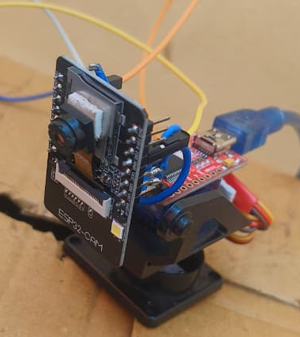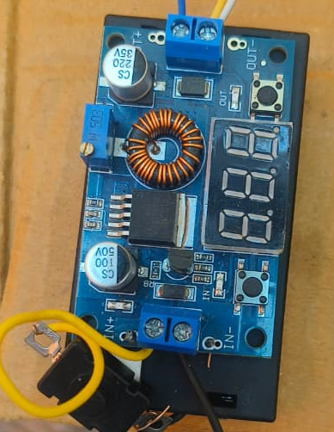
Fig.1 Camera Module
The recognized output is classified as either recognized or unrecognized. It is then sent to a Flask server that acts as the communication backbone of the system. Flask maintains dedicated routes for transmitting the processed stream, sharing recognition status, and receiving control requests such as flash toggling. A mobile application developed using MIT App Inventor interacts with the Flask API to display the processed video, show live recognition results, and allow the user to control the ESP32-CAM flash remotely. Through this integrated workflow, the system achieves real-time monitoring and interactive control over a local Wi-Fi network, ensuring seamless coordination between the imaging hardware, software algorithms, backend server, and user interface. The Python processing pipeline uses a YOLO-based object detection model to detect knives which improves system intelligence. The system creates an alert event when it detects either an unrecognized face or a sharp object. The system captures images automatically while it transmits alert data to the mobile application using Flask REST APIs.
A servo motor connects to the ESP32-CAM system which allows users to control horizontal pan movements. The servo motor receives PWM signals from the ESP32-CAM while an external 5V power supply maintains stable operation. Users can change the pan angle by using the mobile application slider control which allows them to make adjustments.
SYSTEM WORKFLOW
The SmartCam system starts its operations when the ESP32-CAM system records continuous video streams which it sends to a nearby Wi-Fi network. The Python processing server receives the video stream which it uses to execute face detection and face recognition along with sharp object detection through OpenCV and a YOLO model.
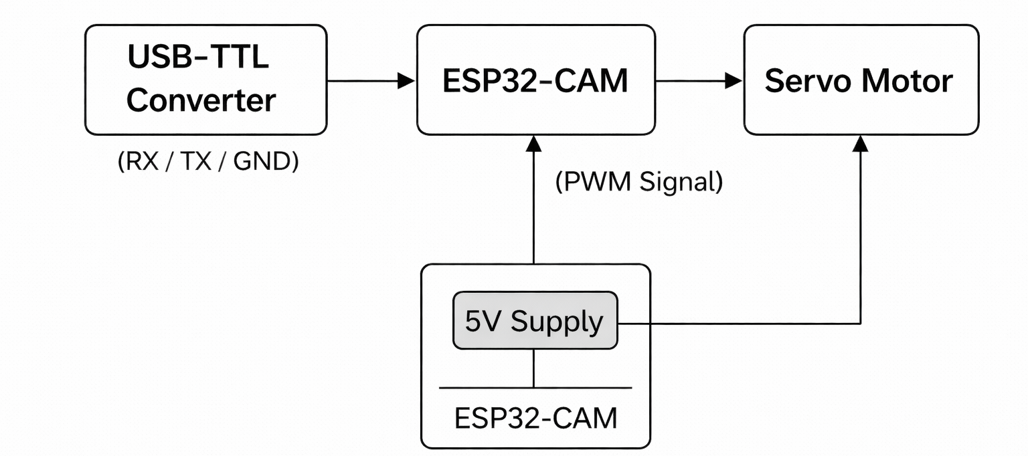
Fig.2 Block Diagram of the Camera Module

The system maintains its regular monitoring operations when it identifies a familiar face. The system creates an alert together with an automatic image capture of the environment when it identifies an unfamiliar face plus a sharp object. The mobile application receives alert information through a Flask REST API which functions as a backend interface.
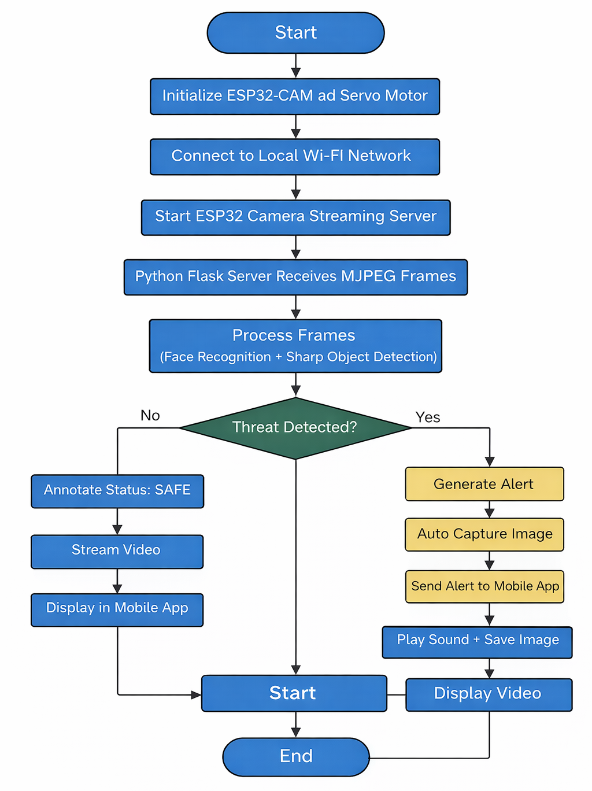
Fig.3 Work Flow of the System

The mobile application built with MIT App Inventor shows real-time video stream processing results together with detection results and system alerts. The user receives visual notifications and alert sounds and can also control the camera flash intensity and servo-based pan movement through the application interface.
SOFTWARE IMPLEMENTATION
The software implementation of the SmartCam system integrates multiple technologies Arduino IDE, Python, OpenCV, Flask, and MIT App Inventor to enable real-time face recognition and system control. The ESP32-CAM is programmed using the Arduino IDE, where firmware is uploaded to configure Wi-Fi connectivity, HTTP video streaming, and LED flash control. Once initialized, the module continuously streams video frames over the local network. On the processing side, Python acts as the core computation engine, receiving the video stream from the ESP32-CAM and performing face detection and recognition using OpenCV. The recognition algorithm compares facial features with a pre-trained dataset to classify individuals as recognized or unrecognized. A Flask server is implemented to bridge communication between the ESP32-CAM, Python processing script, and the mobile application. It exposes HTTP routes for video streaming, recognition results, and flashlight control, ensuring seamless data transfer among modules. The mobile application, developed using MIT App Inventor, serves as the user interface, displaying processed recognition status and enabling remote flashlight toggling. Together, the software components operate synchronously to provide a functional, low-cost security monitoring system capable of real-time recognition over Wi-Fi.
The mobile application uses continuous HTTP polling to establish alert handling between the mobile application and the Flask server. The server activates mobile device notifications and alert sounds when it detects a threat through its alert data response. The client side enforces timing constraints to prevent multiple alerts from occurring.
The ESP32-CAM provides a dedicated HTTP endpoint which enables users to control servo motors. The mobile application sends angle values through its slider interface which enables users to control the camera pan movement with both smoothness and accuracy. This method increases the area visible to observers while improving their ability to understand what is happening in their surroundings.
RESULTS
The SmartCam system demonstrates advanced capabilities through its ability to conduct face recognition and sharp object detection in real-time within local Wi-Fi networks. The system identifies known individuals while it creates alerts for both unrecognized faces and sharp objects.
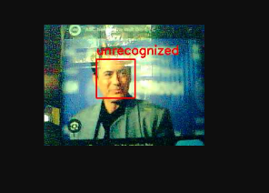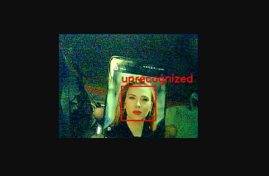
Fig.4 Unrecognized
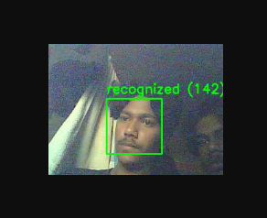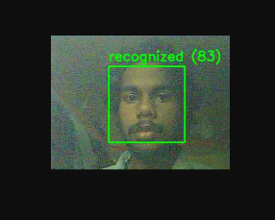
Fig.5 Recognized
The system responds to threat detection through its automatic processes which include image capture and mobile application alert data transmission and alert sound playback. The mobile device successfully stores captured images for future examination. The camera system achieves improved monitoring capabilities through its use of servo-based pan control which allows operators to change the camera's viewing area.
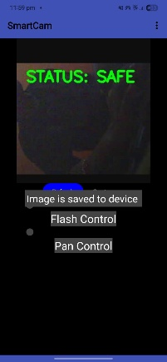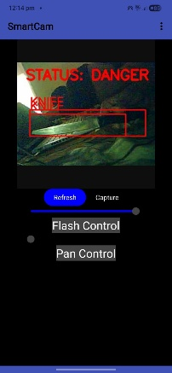
Fig.6 App Interface
The experimental results show that the system achieves stable video streaming and consistent detection performance together with the ESP32-CAM and Python backend and Flask server and mobile application working together without problems.
CONCLUSION
The SmartCam system shows an effective affordable method for smart surveillance through its combination of ESP32-CAM hardware and Python computer vision together with mobile application control. The system distinguishes between known and unknown people while it simultaneously tracks dangerous objects through its real-time security monitoring system.
The system uses automatic alert generation together with image capture and mobile notifications and flash control and servo-based pan functionality to enhance both usability and system responsiveness. The system achieves dependable real-time performance because it transfers its computing responsibilities to a Python backend which frees the system from hardware constraints. The results confirm SmartCam’s suitability for residential and small-scale security applications.
FUTURE SCOPE
The SmartCam system can be significantly enhanced to create a more intelligent, flexible, and user-centric security platform. A key improvement is the integration of a servo-based pan mechanism, which will enable the camera to rotate and cover a wider field of view, automatically track detected faces, and enhance surveillance accuracy. The mobile application can be further developed to include real-time notification alerts, advanced flash control, and seamless streaming of processed video, making the system more convenient and responsive for everyday use. Another major upgrade is transitioning from a local Wi-Fi-only environment to a global server or cloud-enabled architecture, allowing users to access their SmartCam feed from anywhere in the world with secure authentication. Additional expansions such as multi-face recognition, automatic dataset updating, optimized lightweight ML models for faster edge processing, and integration with home automation devices like smart locks and alarms can elevate the system into a fully scalable smart-security ecosystem. Future enhancements may include cloud-based alert delivery, encrypted communication, autonomous servo-based face tracking, and integration with smart locks or alarm systems.
REFERENCE
[1] Khadafi, M., Pardede, A. M. H., & Sembiring, H. (2024). Design of a Guest Face Detection Tool Using ESP32-CAM Based on Internet of Things (IoT). Journal of Artificial Intelligence and Engineering Applications (JAIEA), 4(1), 124-130.
[2] Harun, N. B., & Zainal, M. S. B. (2023). Development of Face Recognition Smart Door Lock System Using ESP32-CAM and Telegram Application As Media Control and Monitoring. Progress in Engineering Application and Technology, 4(2), 035-048.
[3] Muhammad, N., Ariyanto, E., & Yudo, Y. A. S. (2023). Improved face detection accuracy using Haar cascade classifier method and ESP32-CAM for IoT-based home door security. JIPI (Jurnal Ilmiah Penelitian dan Pembelajaran Informatika), 8(1), 154-161.
[4] Nowroz, S. T., Saleh, N. M., Shakur, S., Banerjee, S., & Amsaad, F. (2025). A Benchmark Reference for ESP32-CAM Module. arXiv preprint arXiv:2505.24081.
[5] Kadhim, T. A., Hariri, W., Smaoui Zghal, N., & Ben Aissa, D. (2023). A face recognition application for Alzheimer’s patients using ESP32-CAM and Raspberry Pi. Journal of Real-Time Image Processing, 20(5), 100.
[6] Krishnan, A. (2025). Using Biometric Recognition in Residential Security.
[7] Jadhav, A., Jadhav, A., Ladhe, T., & Yeolekar, K. (2017). Automated attendance system using face recognition. International Research Journal of Engineering and Technology (IRJET), 4(1), 1467-1471.
[8] Das, B., & Halder, K. K. (2024, March). Face Recognition Using ESP32-Cam for Real-Time Tracking and Monitoring. In 2024 International Conference on Advances in Computing, Communication, Electrical, and Smart Systems (iCACCESS) (pp. 01-06). IEEE.
[9] Jahnavi, G., Juber, K. A., Reddy, P. S. K., Reddy, P. M. K., Surendra, S., & Surendra, M. (2024). FACE RECOGNITION BASED ATTENDANCE SYSTEM USING PYTHON WITH ESP32. Journal of Nonlinear Analysis and Optimization, 15(1).

