Participatory Evaluation and Demonstration of Calibrated Phosphorous Recommendations for Bread Wheat (Triticum species) under limed conditions in Jimma Geneti District, Western Oromia

ABSTRACT

Ethiopia is the primary wheat producer in Sub-Saharan Africa (SSA) owing to the suitable agro ecological conditions. Despite wheat’s economic potential for food security, the actual yield under smallholder farmers’ conditions is low due to various production constraints. Thus, the objectives of this study was to demonstrate soil test crop response based recommended results of P-Critical(20ppm) and P-requirement factor(4.76) and to create awareness about the importance of STCRPR as compared to farmers’ practices in Jimma Geneti District, Western Oromia.Two treatments were used, T1(Contro), T2(STCRPR), T3(F/Practices). Treatments were aid out with simple adjacent plots side by side by using improved bread wheat Galan variety and replicated over eight farmers’ fields in the district. The plot size was 10m x 10m (100m²) for each treatment. The highest mean grain yield (3713.75 kg/ha) was obtained from soil test crop response based fertilizer recommendation while the lowest mean grain yield (2803.75kg/ha) was recorded from the farmers practices/Blanket recommendations/. Finally, cost benefit analysis also indicated that phosphorus critical and requirement factor were economically feasible having cost benefit of (93,090 Et.Birr) and 65,410) for STCRPR and farmers practices respectively. Therefore, Pc and Pf were demonstrated and recommended for farmers of Jimma Geneti District to produce and obtain optimum yield from bread wheat while further scaling up will be expected to popularize the technology to farmers of the study areas and similar agro ecologies.

Key Words: Bread wheat; P-Critical; P-requirement factor; PED; Yield

INTRODUCTION
Bread wheat (Triticum aestivum L.), with an annual global production of 772.6 million tons, is a staple food for more than 35% of the world’s population (Statista, 2021). Globally, China, India and Russia are the largest wheat producers, while South Africa and Ethiopia are the largest wheat producers in sub-Saharan Africa (SSA) (USDA, 2019). Ethiopia’s annual production is about 5.8 million tons with mean productivity of 3 tons per hectare (tha⁻¹) (CSA 2021), which is relatively lower than the attainable yield of the crop, reaching up to 5 tha⁻¹ (Zegeye et al. 2020). Wheat accounts for about 17% of total grain production in Ethiopia making it the third most important cereal crop after teff [Eragrostis tef (Zucc.) Trotter] and maize (Zea mays L.) (CSA, 2021). The most suitable altitude range for wheat production is between 1900 and 2700 meters above sea level (Hunde et al. 2000). Globally, the demand for wheat has increased sharply due to human population pressure, urbanization and lifestyle changes (Minot et al. 2015). The total per capita consumption of wheat in SSA has increased by 0.35 kg/person/year b/n 2000-2009 (Sununtnasuk 2013). In Ethiopia, about 29.6 kg/ person/year wheat was consumed in 2004/5 and is expected to increase in the future (Berhane et al. 2011). The increased demand for wheat has presented an opportunity for greater production in Ethiopia. The demand for wheat has surpassed its production, and the country had to import an additional 1.5 million tons of wheat to meet the domestic consumption needs (FAOSTAT 2018). In SSA, including Ethiopia, wheat production and productivity are affected by complex and interactive effects of biotic and a biotic factors and socio-economic challenges, notably in the smallholder farming systems. Crop productivity and production remained low and variable in the 90s for the most part but there have been clear signs of change over the past decade. Low soil fertility is one among the major factors limiting crop production and productivity in Western Oromia, Ethiopia (Wakene et al., 2005)
Inorganic fertilizers are relied upon to improve crop yields and maintain soil fertility; insufficient use of fertilizers resulting in severe nutrient depletion of soils (Christina, 2002). It is widely believed that economic optimum fertilizer application can only be achieved by developing appropriate fertilizer recommendation. Currently however, there are negligibly site-specific fertilizer recommendations for different soil-crop climatic conditions and none in Jimma Geneti district of Western Oromia. As in all other areas of the country, site specific fertilizer recommendation for wheat in the District is very important since its application is not based on soil test based results. In Jima Geneti district soil test crop response based phosphorus fertilizer recommendation was completed and verified in the last consecutive four years. This year(2024) its PED(participatory Evaluation and Demonstration) was also terminated for further scale up of the result for increasing the production and productivity of this important commodity in the district and similar agro ecologies of the study areas. Therefore, fertilizer application schedules should be based on the requirement of crop response to applied nutrients at different soil fertility levels (Wassie et al., 2011). The aim of this paper is to evaluate and demonstrate soil test crop response fertilizer recommend results in Jimma Geneti district.
Objective(s)

- To evaluate and demonstrate soil test crop response based recommended results of P-Critical and P-requirement factor in Jimma Geneti District, Western Oromia.
- To create awareness about the importance of STCRPR as compared to farmers practices in the study area.
MATERIALS AND METHODS
Description of the study area
The experiment was conducted on farm in Jimma Geneti district, western oromia. It is located approximately 290 km to west of Addis Ababa along the main road from North West direction of Bako to Shambu. The soil type of the district is dominantly red soil. Majorly the economy of the area is dominated by crop production and livestock raring agricultural production system. The area is majorly dominated by crops types like wheat, tef, maize, faba bean, field pea, and rarely barley existence).

Description of the study area

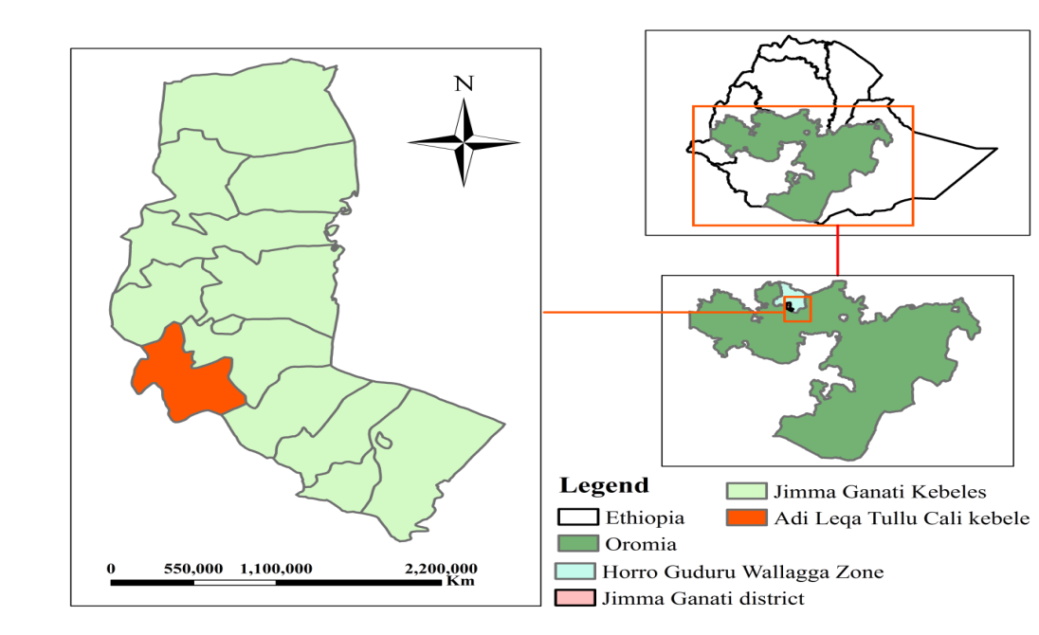

Fig.1: Location map of the study area.

Experimental Design and Procedure

Bread wheat (Galan variety) was used as test crop.
Treatments

Trt1=Blanket recom./Farmers Prac/(1:1 ratio of Urea and P respectively)
Trt2= STCRPR (Pc=20ppm and Pf= 4.76), 92kg/ha N
Treatments were arranged in none deigned plots. Plot size of the trial 10mx10m=100m² for both treatments. The treatments were replicated over eight (8) farmers/sites/. Collected data was analyzed by simple descriptive statistics used for treatment comparison. The spacing b/n rows 0.2m uniformly drilling along the furrow with seed rate of 150 kg/ha and over all other management activities were kept constant as per its recommendations.

Data Collected

Biomass yield (kg/ha), grain yield (kg/ha) and farmers and other stakeholders perception were collected, analyzed and interpreted.
Evaluation of the practices
The trial was evaluated by farmers, DA’s, Expertise, researchers and M&E committee of the center.
Mini-field day was organized about 66 participants were participated and evaluated on the mini field day (Table: 1).

Table: 1. Mini field day organized and number of participants

Stakeholders | Participants
Stakeholders | Male | Female | Total
Woreda Experts | 4 | 2 | 6
DAs and Supervisors | 3 | 1 | 4
Farmers | 42 | 3 | 45
Researchers | 10 | 1 | 11
Total | 59 | 7 | 66

Photo taken during evaluation

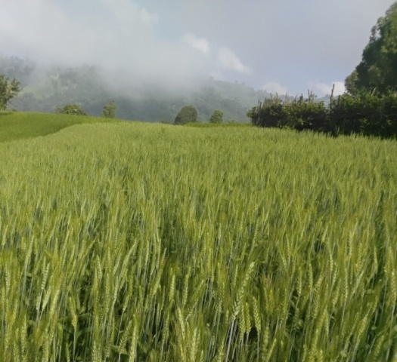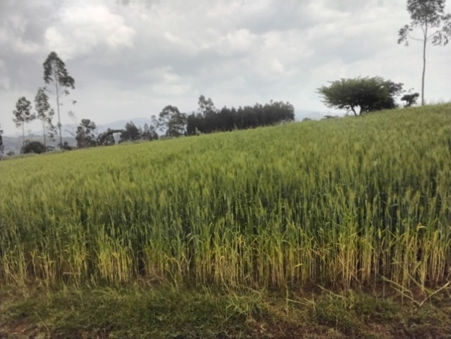
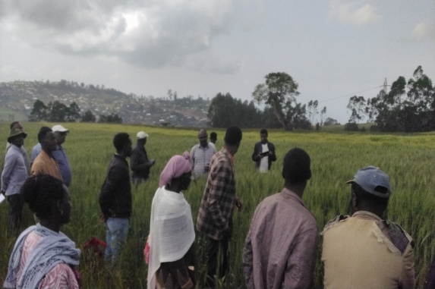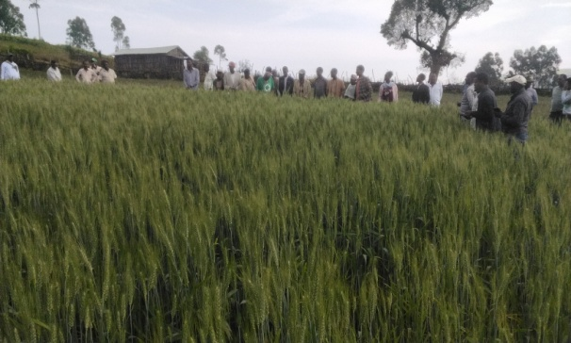

Participatory Evaluation and Selection

Farmers ranked wheat under STCRBPR against bread wheat under blanket recommendation by 10 different criteria. Accordingly; Pair-wise ranking matrix was employed to evaluate, rank and select among the two practices demonstrated against the criteria set by farmers’ and weight attached for each of the criteria for evaluation and selection. Pair-wise ranking of farmers selection criteria were conducted through comparing and contrasting each of the criteria that were set by farmers themselves and adjusted by relevant researchers and rank them in order of importance. The criteria that farmers used in identifying the suitable practices depend on the existing constraints and opportunities farmers faced in their location. Therefore, 1= Disease tolerant, 2= Lodging tolerant 3= Early maturity, 4=Spike length, 5= Number of seed/spike, 6= Grain color, 7=Grain size, 8= Stay greenness; 9= high yielder and 10= Crop stand; were farmers criteria identified for evaluation, ranking and selection. The farmers’ preference result was summarized and presented in below (table 2).
Table 2: Pair-wise farmers’ preference ranking for wheat under different practices in the district.
Pair-wise farmers’ preference ranking for bread wheat under different practices was conducted.
Selection | 1 | 2 | 3 | 4 | 5 | 6 | 7 | 8 | 9 | 10 | Frequency | Rank
Criteria
1 |  | 1 | 1 | 1 | 1 | 1 | 1 | 1 | 9 | 1 | 8 | 2nd
2 |  |  | 2 | 2 | 5 | 2 | 2 | 2 | 9 | 2 | 6 | 4th
3 |  |  |  | 4 | 5 | 6 | 7 | 8 | 9 | 10 | 0 | 7th
4 |  |  |  |  | 5 | 6 | 4 | 4 | 9 | 4 | 3 | 4th
5 |  |  |  |  |  | 5 | 5 | 5 | 9 | 5 | 7 | 3rd
6 |  |  |  |  |  |  | 6 | 6 | 9 | 6 | 5 | 5th
7 |  |  |  |  |  |  |  | 7 | 9 | 7 | 3 | 6th
8 |  |  |  |  |  |  |  |  | 9 | 8 | 2 | 7th
9 |  |  |  |  |  |  |  |  |  | 9 | 9 | 1st
10 |  |  |  |  |  |  |  |  |  |  | 1 | 8th
N. B. 1= Disease tolerant, 2= Lodging tolerant 3= Early maturity, 4=Spike length, 5= Number of seed/spike, 6= Grain color, 7= Crop stand, 8= Stay greenness; 9= high yielder and 10= Grain size;

Farmers’ preference ranking of both practices under bread wheat
At maturity, the varieties were then be evaluated based on the farmers’ selection criteria. At this juncture, the farmers were assisted to jot their own evaluation criteria, which then be ordered using pair-wise ranking technique. Each practice was then be evaluated against the criteria ordered based on the weight attached to each parameter. At the end of the evaluation process, result of the evaluation was displayed to the evaluators, and discussion was made on the way ahead. To this end; FRG farmers scored for each of the practices against individual traits considered important by them and ranking of the practices were done on a scale of 1-5, 1 being very poor and 5 being the highest score representing superiority. Bread wheat yield, early maturity, lodging tolerant, numbers of effective tillers, disease tolerant and other traits were considered as the most selection criteria for each of wheat under different practices. Based on overall mean score the best preferred practice was evaluated and ranked. The best practice selected, accordingly, will be proposed for further scaling up

Table: 3. Score ranking of different practices under bread wheat by farmers in the district
Practices | Jimma Geneti |  |  | Overall Rank
Practices | Total Score | Mean Score | Rank | Overall Rank
Bread wheat under soil test based (critical P) | 50 | 5 | 1st | 1st
Bread wheat under farmers’ practice | 40 | 4 | 2nd | 2nd

Table: 4. Farmers’ reasons for ranking and selection of bread wheat under different practices
Hence; participant farmers’ participated on participatory evaluation and selection of the two practices reasonably evaluated, ranked and selected best preferred and suitable practices with the real existing situation.
No | Practice | Rank | Reasons
1 | Bread wheat under soil test based | 1st | High yielder, disease tolerant, lodging tolerant, high number of effective tillers) , good plant stand, good panicle length
2 | Bread wheat under farmers’ practice | 2nd | Medium yielder, medium in disease tolerant, medium in lodging tolerant, medium number of effective tillers, medium plant stand, medium panicle length

RESULTS AND DISCUSSIONS
Calibration and verification trial of soil test crop response based phosphorus recommendation was conducted for the last consecutive four years in the district. The trial was used for demonstration of this calibrated phosphorus results formerly conducted in the district. Accordingly, P-critical (20ppm) and P-requirement factor (4.76) was recommended for bread wheat production in the district from the calibrated result. The highest mean grain yield (3713.75 kg/ha) was obtained from STCRPR while relatively the lowest mean grain yield (2803.75kg/ha) was recorded from blanket recommendations. Therefore, PC (20ppm) and Pf (4.76) results were evaluated, demonstrated and recommended, for farmers and different stockholders of the district to produce and obtain reasonable yield.
Table: 5. Pooled Mean Grain Yield and Biomass Yield (kg/ha) of Bread Wheat as Affected by Treatments in Jimm Geneti District (2024)
 |  | Measured Parameters
S/N | TREATMENTS | GYPH(kg) | BYPH(kg) | HI
1 | Farmers Practices | 2803.75 | 9048.75 | 0.31
2 | STCRPR | 3713.75 | 10827.5 | 0.34

Financial Analysis
A cost-benefit analysis (CBA) is a systematic process for comparing the costs and benefits of a project or decision to determine if it is financially worthwhile. It involves identifying and quantifying all costs and benefits (including intangible ones) in monetary terms to see if the benefits outweigh the costs, helping decision-makers choose the most beneficial option.
Table: 6. Table of Cost Benefit Analysis Results
Treatments | Yield  (qt/ha) | Market  Price (Birr) | TVC | TR (P*Q) | GM (Profit) | Return to  investment
F/Practices | 28.03 | 3, 000 | 18,800 | 84,210 | 65,410 | 3.48
STCRPR | 16.75 | 3000 | 18,800 | 111, 890 | 93,090 | 4.95

Conclusion and Recommendations
The fact that, pooled mean grain yield obtained from STCRPR treatment was higher than that of farmers practices/blanket recommendations/. Based on different selection criteria farmers and other stakeholders preferences STCRPR treated plots were more preferred than that of blanket recommendations/farmers practices/. Besides, cost benefit analysis indicated that STCRPR has more economically feasible than that of farmers’ practices. Therefore, scaling up of soil test crop response based recommended fertilizer rates (PC=20ppm) and Pf(4.76), and 92 kg/ha N for bread wheat should be considered as future line of work to scale up with in the distict for farming communities of the study area and similar agro ecologies.

REFERENCES
Berhane G, Paulos Z, Tafere K, Tamiru S. 2011. Food-grain consumption and calorie intake patterns in Ethiopia. ESSP II working paper 23. International food policy research institute. Ethiopia strategy support program II, Addis Ababa, Ethiopia
CSA. 2021. Agricultural sample survey: Report on area and production of major crops (Private peasant holdings, Meher Season). Volume I Statistical Bulletins 590, Addis Ababa, Ethiopia.
FAOSTAT: 2018. Agriculture Organization of the United Nations. Rome: Statistical database.
Hundie B, Verkuiji H, Mawangi W, Tanner DG. 2000. Adaptation of improved wheat technologies in adaba and dodola woredas of the Bale highlands of Ethiopia. Addis Ababa, Ethiopia: CIMMYT/EARO.
Minot N, Warner J, Lemma S, Kassa L, Gashaw A, Rashid S. 2015. The wheat supply chain in Ethiopia: patterns, trends, and policy options. Washington, DC: International Food Policy Research Institute (IFPRI).
Statista. 2021. Top wheat-producing countries 2020/2021. Accessed in August 2021. https://www.statista.com/ statistics/237912/global-top-wheat-producing-countries.
USDA. 2019. USDA world markets and Trade Report. Accessed on December 15, 2019.
Zegeye F, Alamirew B, Tolossa D. 2020. Analysis of wheat yield gap and variability in Ethiopia. Int J Agric Econon. 5(4):89–98.

