Title Page:
Potassium-Mediated Regulation of Plant Adaptation: A Recent Overview

Abstract
Potassium ion (K⁺) is a crucial macronutrient that plays a central role in regulating plant adaptation to environmental stresses. K⁺ is actively involved in enhancing tolerance to abiotic stresses such as drought, salinity, and temperature fluctuations. This overview highlights how plants control the uptake, transport, and distribution of K⁺ under stress conditions including heat, water deficit, and poor soil quality. Plant adaptive responses to both abiotic and biotic stresses are largely governed by the maintenance of intracellular K⁺ homeostasis. K⁺ interacts closely with phytohormones and other essential nutrients to coordinate stress signaling and metabolic adjustments. At the cellular level, K⁺ functions as a key cofactor for numerous enzymes and is often regarded as a “master” or highly mobile element due to its diverse physiological roles. Potassium deficiency leads to chlorosis, impaired growth, and reduced productivity, emphasizing its importance in plant health. K⁺ also regulates the transmembrane potential, thereby maintaining ionic balance and facilitating the movement of essential solutes across membranes. In simple terms, K⁺ enables plants to adapt to adverse conditions by stabilizing internal processes and optimizing resource allocation. Its availability in soil present in soluble, fixed, and exchangeable forms directly influences plant performance and forage yield when limited. Furthermore, K⁺ is closely linked with carbohydrate metabolism and overall energy balance in plants. While all plants require potassium, certain species show enhanced benefits under higher availability. In conclusion, potassium-mediated regulation is fundamental to plant adaptation, making K⁺ a key factor in improving crop resilience and productivity under changing climatic conditions.
Keywords: Potassium (K⁺); Plant nutrition; Abiotic stress; Drought tolerance; Ion homeostasis; Transmembrane potential; Plant adaptation

1. Introduction
Potassium (K⁺) is one of the most essential macronutrients for plants, playing a pivotal role in a wide range of physiological and biochemical processes. It is a key regulator of enzyme activity, osmotic balance, stomatal movement, photosynthesis, and nutrient transport, making it indispensable for plant growth and development (Marschner, 2012). Beyond its classical functions, recent studies have highlighted potassium as a critical signaling molecule that mediates plant responses to various environmental stresses, including drought, salinity, heat, and pathogen attack (Wang et al., 2013; Cakmak, 2005). Potassium contributes to plant adaptation by regulating stomatal conductance, maintaining turgor pressure, and activating stress-responsive genes, thereby enhancing plant resilience under suboptimal conditions (Shabala & Pottosin, 2014). Moreover, K⁺ interacts with phytohormones such as abscisic acid (ABA) and jasmonic acid (JA), which are central to stress signaling and adaptive responses, further demonstrating its integrative role in stress tolerance mechanisms (Ahmad et al., 2016). Recent advances in molecular biology and genomics have provided deeper insights into potassium transporters, channels, and regulatory networks that underpin K⁺-mediated adaptation. These findings not only underscore the importance of potassium in maintaining physiological homeostasis but also emphasize its role in enhancing crop productivity and resilience in the face of climate variability (Hawkesford et al., 2018). Thus, understanding potassium-mediated regulation is crucial for developing strategies to improve plant performance under environmental stress and for the sustainable intensification of agriculture.
2.1 Genes Controlling Potassium Transport
Potassium (K⁺) is a vital macronutrient that plays a crucial role in plant growth, enzyme activation, osmotic regulation, and stress tolerance. The uptake and transport of potassium in plants are regulated by a complex network of genes encoding specific transporters and ion channels. Molecular studies have identified several gene families responsible for potassium transfer, which are highly conserved across plant species (Véry & Sentenac, 2003). The KT/HAK/KUP transporter family is one of the main systems involved in potassium uptake, particularly under low potassium conditions. Genes such as HAK5 and HAK1 are expressed in plant roots and are upregulated during potassium deficiency, enabling high-affinity K⁺ uptake from the soil (Gierth & Mäser, 2007). These transporters are essential for maintaining potassium homeostasis and ensuring adequate nutrient supply under limiting conditions. Another important group is the HKT (High-Affinity Potassium Transporter) family, which plays a significant role in maintaining sodium and potassium balance, especially under salinity stress. For example, the SbHKT1;4 gene in sorghum regulates ion selectivity and helps in salt tolerance by controlling Na⁺ and K⁺ transport (Wang et al., 2014). This highlights the importance of potassium transport genes in stress adaptation. In addition, Shaker-type potassium channel genes regulate potassium movement across cell membranes through voltage-gated mechanisms. These channels are involved in processes such as stomatal opening, transpiration, and long-distance ion transport within the plant. Their activity is essential for maintaining membrane potential and cellular ion balance (Véry & Sentenac, 2003). The CPA (Cation Proton Antiporter) family also contributes to potassium transport by regulating intracellular ion balance and pH homeostasis. These transporters facilitate the compartmentalization of ions within cellular organelles, thereby enhancing plant tolerance to environmental stresses (Ankit et al., 2022). Recent advances in genomics have enabled genome-wide identification of potassium transport genes in various crops. For instance, multiple potassium transporter genes have been identified in crops like common bean and apple, indicating that potassium transport is controlled by a large and coordinated gene network (Khan et al., 2023; Waqas et al., 2025). These genes exhibit differential expression patterns depending on environmental conditions such as drought, salinity, and nutrient availability. Overall, the identification and characterization of genes controlling potassium transfer have significant implications for agriculture. Understanding these genetic mechanisms can help in developing crop varieties with improved potassium use efficiency, enhanced yield, and better tolerance to abiotic stresses (Gierth & Mäser, 2007).
The identification of genes involved in potassium transport has greatly improved our understanding of how plants manage nutrient uptake and distribution. These discoveries have several important applications in agriculture and plant science. First, they help scientists understand how plants maintain potassium homeostasis, which means maintaining a stable level of potassium inside plant cells. This balance is necessary for many physiological activities such as photosynthesis, enzyme activity, and water regulation. Second, this knowledge can be used in plant breeding and genetic engineering. By identifying useful potassium transport genes, scientists can develop crop varieties that are better at absorbing and using potassium from the soil. Finally, developing crops with improved potassium use efficiency can reduce the need for large amounts of potassium fertilizers. This can lower farming costs and also reduce environmental problems associated with excessive fertilizer use. Because of these benefits, research on potassium transport genes continues to be an important area of study in plant science and modern agriculture.
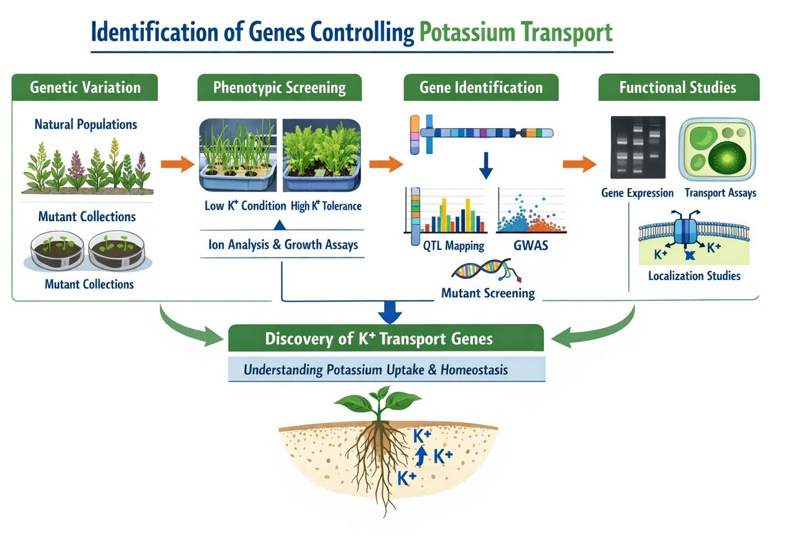
Figure 2.1: Identification of Genes Controlling Potassium Transport
2.2 Potassium in Phenotypic Expression
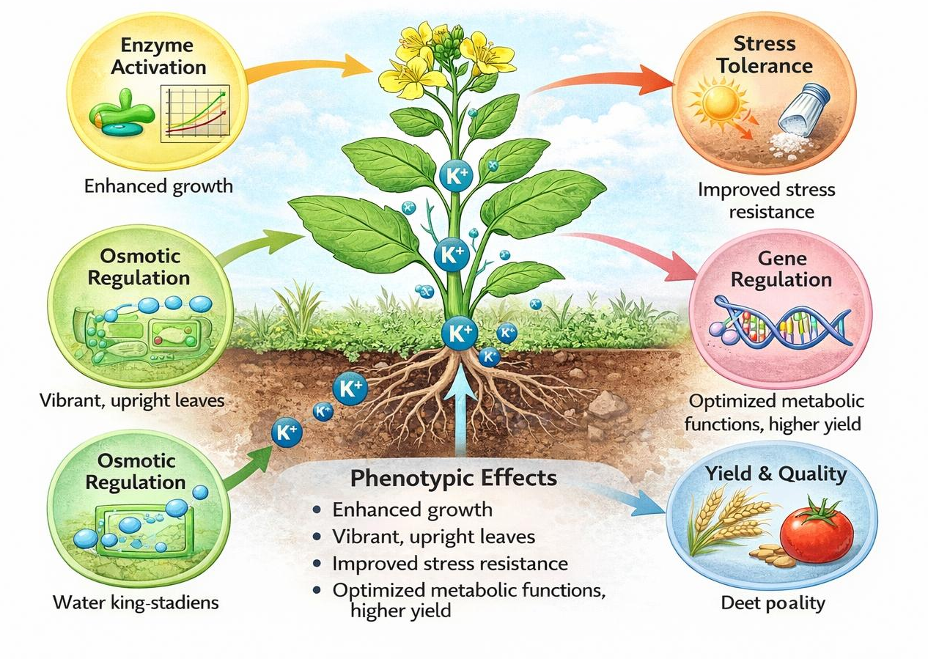
Potassium (K⁺) is plays a critical role in regulating phenotypic expression in plants, influencing traits such as growth rate, leaf morphology, stomatal behavior, yield, and stress tolerance. Unlike structural nutrients, potassium primarily functions as a regulatory ion, controlling enzymatic activities, osmotic balance, and signal transduction pathways that ultimately determine plant phenotype (Wang et al., 2013). One of the key roles of potassium in phenotypic expression is its involvement in enzyme activation and metabolic regulation. More than 60 enzymes involved in photosynthesis, protein synthesis, and carbohydrate metabolism require potassium for activation. Adequate potassium availability enhances chlorophyll synthesis and photosynthetic efficiency, leading to improved plant growth and visible phenotypic traits such as increased leaf size and biomass (Cakmak, 2005). Potassium also plays a vital role in stomatal regulation, which directly affects transpiration and gas exchange. Guard cells utilize potassium fluxes to control stomatal opening and closing, thereby influencing water use efficiency and photosynthetic activity. This process significantly impacts phenotypic traits like leaf turgidity and drought resistance (Véry & Sentenac, 2003). In addition, potassium is crucial for osmotic regulation and cell expansion, which determines cell size and overall plant morphology. High intracellular potassium concentration maintains turgor pressure, enabling cell elongation and tissue development. As a result, plants with sufficient potassium exhibit well-developed roots, thicker stems, and improved structural integrity (Pettigrew, 2008). Potassium further contributes to stress-induced phenotypic adaptations, especially under abiotic stresses such as drought, salinity, and temperature extremes. It regulates reactive oxygen species (ROS) detoxification and stabilizes cellular structures, thereby preventing damage and maintaining normal growth patterns. Potassium-deficient plants often show visible symptoms such as chlorosis, necrosis, and reduced growth, highlighting its importance in phenotype determination (Hasanuzzaman et al., 2018). Moreover, potassium influences gene expression and signaling pathways associated with plant development. It acts as a signaling molecule that modulates transcriptional responses under nutrient and environmental stress conditions. These regulatory mechanisms alter phenotypic expression by controlling growth patterns and adaptive responses (Ahmad & Hawkesford, 2014).

Figure 2.2: Role of Potassium in Phenotypic Expression
2.3 Potassium in Cellular Metabolism
Energy balance in cells refers to the tight regulation between ATP production (catabolism) and ATP utilization (anabolism). The intracellular ion potassium (K⁺) is essential for maintaining this balance by regulating enzyme activity, membrane potential, and mitochondrial function. Potassium is the most abundant intracellular cation, and its concentration gradient is crucial for sustaining metabolic energy flow and cellular homeostasis (Armstrong, 2003; Skou, 1957).
2.3.1 Energy Balance
Potassium (K⁺) plays a fundamental role in maintaining energy balance in cellular metabolism during plant adaptation by coordinating both energy production and utilization under normal and stress conditions. As the predominant intracellular cation, K⁺ activates more than 60 enzymes involved in key metabolic pathways, thereby supporting efficient ATP generation and utilization (Wang et al., 2013; Sardans & Peñuelas, 2021). In Photosynthesis, potassium regulates stomatal movement, enhances CO₂ assimilation, and activates enzymes of the Calvin cycle, ensuring sustained production of ATP and NADPH even under abiotic stresses such as drought and salinity (Cakmak, 2005). It also plays a crucial role in Cellular Respiration by activating enzymes of glycolysis and the tricarboxylic acid cycle, thereby maintaining continuous ATP supply required for cellular processes (Wang et al., 2013). During stress adaptation, K⁺ contributes to osmotic adjustment and turgor maintenance, optimizing water relations and preventing unnecessary energy expenditure (Shabala & Pottosin, 2014). Furthermore, potassium facilitates phloem loading and transport of photoassimilates, acting as a “potassium battery” that supports long-distance energy distribution within the plant (Gajdanowicz et al., 2011). It also enhances antioxidant defense systems, reducing reactive oxygen species and protecting cellular organelles, which improves overall energy-use efficiency under stress conditions (Sardans & Peñuelas, 2021). In contrast, potassium deficiency leads to reduced photosynthetic efficiency, impaired ATP production, disrupted assimilate transport, and increased oxidative damage, ultimately disturbing cellular energy homeostasis (Zörb et al., 2014). Therefore, potassium acts as a central regulator that maintains the balance between energy supply and demand, enabling plants to adapt effectively to changing environmental conditions.
2.3.2 Protein Synthesis
Potassium (K⁺) plays a fundamental and multifaceted role in protein synthesis, which is essential for plant growth, development, and especially adaptation to environmental stresses such as drought, salinity, and temperature extremes. It acts as a key regulator of the cellular translational machinery by maintaining the optimal ionic environment required for ribosomal structure, stability, and activity. Adequate intracellular K⁺ concentrations are necessary for proper ribosome assembly and function, ensuring efficient translation of mRNA into polypeptide chains (Wyn Jones & Pollard, 1983). In addition, potassium is involved in maintaining cytoplasmic pH and ionic balance, both of which are critical for enzymatic reactions associated with protein biosynthesis. Potassium also plays an important role in nitrogen metabolism, which is directly linked to protein synthesis. It activates enzymes such as nitrate reductase and enhances the assimilation of nitrogen into amino acids, thereby ensuring a steady supply of precursors required for protein formation (Wang et al., 2013). Furthermore, K⁺ facilitates the transport of amino acids through membranes and within the phloem, supporting their distribution to actively growing and stress-affected tissues. This efficient transport system is crucial during plant adaptation, where rapid synthesis of specific proteins is required. Under stress conditions, potassium significantly contributes to the synthesis of stress-responsive proteins, including antioxidant enzymes (such as superoxide dismutase and catalase), osmoprotective proteins, and heat-shock proteins. These proteins play vital roles in protecting cellular components, stabilizing membranes, detoxifying reactive oxygen species (ROS), and maintaining metabolic functions. Potassium enhances the expression and activity of these proteins, thereby improving plant tolerance to adverse environmental conditions (Cakmak, 2005; Sardans & Peñuelas, 2021). Additionally, K⁺ supports ATP-dependent steps of protein synthesis by ensuring adequate energy availability and efficient enzyme activation, linking protein biosynthesis with overall cellular energy balance. Another important aspect is the protective role of potassium in preventing oxidative damage to the protein synthesis machinery. By reducing ROS accumulation, K⁺ preserves ribosomal integrity and enzyme functionality, allowing continuous protein production even under stress. This is particularly important during adaptation, where sustained synthesis of protective and regulatory proteins determines plant survival. In contrast, potassium deficiency severely impairs protein synthesis by disrupting ribosomal activity, reducing amino acid incorporation, and inhibiting enzyme function. It also leads to poor nitrogen utilization and accumulation of toxic metabolites, resulting in reduced synthesis of essential and stress-related proteins. Consequently, plants exhibit stunted growth, decreased metabolic efficiency, and weakened stress tolerance (Zörb et al., 2014). Thus, potassium acts as a critical regulator of protein synthesis by supporting ribosomal function, nitrogen assimilation, amino acid transport, enzyme activation, and stress-protein production. Through these mechanisms, it enables plants to efficiently adapt to changing environmental conditions by ensuring the timely synthesis of proteins required for survival and metabolic stability.
2.3.3 Plant Hormones Regulation
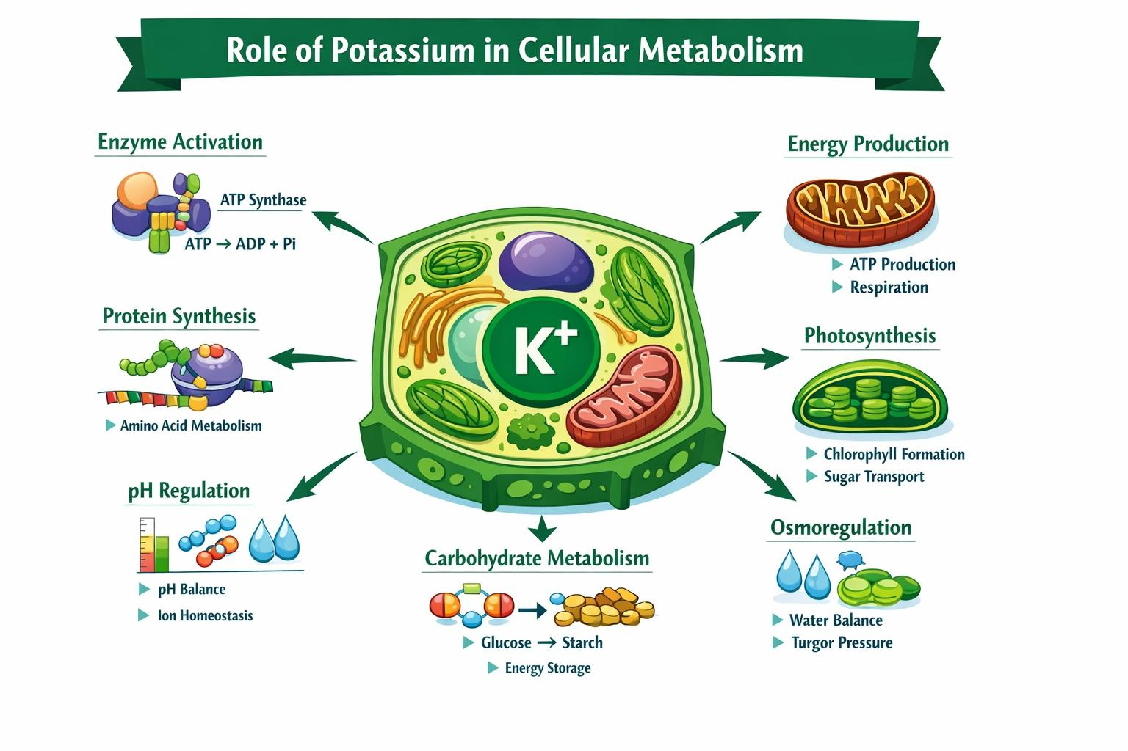
Plant adaptation to environmental stresses is primarily regulated by a complex network of plant hormones that coordinate growth, development, and defense responses. These hormones act as signaling molecules that integrate external stimuli such as drought, salinity, temperature fluctuations, and pathogen attack with internal metabolic processes. Among them, Abscisic Acid (ABA) plays a central role in abiotic stress adaptation, particularly under drought and salinity conditions. ABA accumulation induces stomatal closure, reducing transpiration and water loss, and activates stress-responsive gene expression, thereby enhancing plant tolerance (Cutler et al., 2010). Auxin is another key hormone involved in regulating plant adaptation by controlling root architecture and cell elongation. Under stress conditions, auxin distribution is modified to promote deeper and more extensive root systems, allowing better water and nutrient uptake (Zhao, 2010). In contrast, Cytokinin regulates cell division and delays senescence; however, its levels often decline during stress, enabling the plant to conserve energy and redirect resources toward survival rather than growth (Werner & Schmülling, 2009). Ethylene plays a dual role in plant adaptation by mediating responses to both abiotic and biotic stresses. It is involved in processes such as senescence, fruit ripening, and defense responses. Under flooding conditions, ethylene promotes the formation of aerenchyma tissues, which facilitate oxygen transport within the plant (Iqbal et al., 2017). Similarly, Gibberellin (GA) regulates growth and development, but its activity is often suppressed during stress conditions to conserve energy and enhance survival (Colebrook et al., 2014). In plant defense, Jasmonic Acid (JA) and Salicylic Acid (SA) play critical roles in resistance against pathogens and herbivores. JA is mainly associated with defense against necrotrophic pathogens and insect herbivory, while SA is involved in systemic acquired resistance against biotrophic pathogens. These hormones regulate the expression of defense-related genes and coordinate immune signaling pathways (Pieterse et al., 2012). Importantly, plant adaptation is governed not by individual hormones but by hormonal crosstalk, where multiple hormones interact synergistically or antagonistically. For example, ABA interacts with auxin and cytokinin to regulate growth under stress, while JA and SA coordinate defense responses. This integrated hormonal network allows plants to balance growth, development, and stress tolerance efficiently.
Figure 2.3: Schematic Representation of the Role of Potassium in Cellular Metabolism
2.4 Potassium in Nutrient Balance
Potassium also helps plants maintain a proper balance of nutrients inside their cells. Plants need several nutrients such as nitrogen, phosphorus, magnesium, and calcium to grow and develop properly. Potassium helps control how these nutrients move inside the plant (Marschner, 2012; Wang et al., 2013). When the plant has enough potassium, it can absorb and use other nutrients more effectively from the soil. Potassium also helps in transporting these nutrients to different parts of the plant where they are needed for growth. If potassium levels are too low, the balance of nutrients inside the plant may get disturbed. This can affect important processes such as growth, photosynthesis, and the formation of plant tissues (Cakmak, 2005; Wang et al., 2013).Therefore, potassium plays an important role in maintaining proper nutrient balance in plants. When potassium supply is adequate, plants are able to use nutrients efficiently, which leads to healthier growth and better development. Potassium also improves the uptake and assimilation of nitrogen, which is one of the most important nutrients for plant growth. Adequate potassium supply enhances nitrate uptake by roots and promotes the conversion of nitrate into amino acids and proteins. This process supports the formation of new tissues, leaves, and roots. In potassium-deficient plants, nitrogen may accumulate in unused forms, leading to inefficient growth and reduced biomass production (Wang et al., 2013). In addition, potassium helps regulate the transport of nutrients through the plant vascular system, especially through the phloem. Nutrients and photosynthates produced in the leaves are transported to growing tissues such as roots, fruits, and developing leaves. Potassium facilitates this transport by maintaining osmotic gradients that drive phloem loading and unloading. As a result, nutrients are distributed efficiently to different plant organs where they are required for growth and development.
Furthermore, potassium plays a protective role by reducing nutrient imbalances caused by environmental stress. Under conditions such as salinity or drought, plants may experience difficulties in absorbing essential nutrients. Adequate potassium supply helps maintain membrane integrity and improves the selectivity of nutrient transport systems in root cells. This ensures that essential nutrients continue to be absorbed even under unfavorable conditions. Overall, potassium is essential for maintaining the harmonious interaction among different plant nutrients. By regulating nutrient uptake, transport, and metabolic utilization, potassium ensures that plants maintain proper nutritional balance. Adequate potassium supply ensures efficient nutrient uptake, transport, and utilization, thereby maintaining proper nutrient balance in plants (Ahmad et al., 2016; Hawkesford et al., 2018).
2.5 Potassium in Plant Immunity and Disease Resistance
Potassium (K⁺) plays an important role in strengthening the immune system of plants and protecting them from various diseases caused by bacteria, fungi, and viruses. Adequate potassium nutrition improves plant vigor and overall physiological balance, which helps plants tolerate pathogen attacks more effectively. Potassium (K⁺) plays a vital and multifaceted role in enhancing plant immunity and disease resistance by regulating structural, biochemical, and molecular defense mechanisms. Adequate potassium nutrition strengthens the plant’s physical defense barriers by promoting cell wall thickening and lignification, which significantly restricts pathogen penetration and spread within plant tissues (Feng et al., 2020). In addition, potassium maintains cell membrane stability and integrity, reducing leakage of cellular solutes such as sugars and amino acids that could otherwise serve as nutrients for invading pathogens, thereby lowering infection susceptibility (Wang et al., 2013). At the biochemical level, potassium enhances the production of secondary metabolites including phenolics, flavonoids, and phytoalexins, all of which possess antimicrobial properties and contribute to strengthening plant defense responses. It also activates key defense-related enzymes such as peroxidase (POD), polyphenol oxidase (PPO), and phenylalanine ammonia-lyase (PAL), which are directly involved in pathogen resistance and synthesis of protective compounds (Sardans & Peñuelas, 2021). Furthermore, potassium plays a critical role in regulating reactive oxygen species (ROS) homeostasis during pathogen attack. While controlled ROS production functions as a signaling mechanism to trigger immune responses, excessive accumulation can damage cellular components. Potassium enhances antioxidant defense systems, including enzymes like superoxide dismutase and catalase, thereby maintaining a balance between ROS production and scavenging, which ensures effective defense signaling without cellular damage (Hasanuzzaman et al., 2018). Recent studies have also highlighted the involvement of potassium in molecular signaling pathways, where it influences the expression of defense-related genes and modulates important hormonal pathways such as salicylic acid (SA) and jasmonic acid (JA), which are essential for systemic acquired resistance and induced defense responses (Ragel et al., 2019). Additionally, potassium regulates stomatal movement, which can limit pathogen entry through leaf surfaces, thus contributing to early-stage defense mechanisms. Potassium also supports the plant’s energy status by enhancing photosynthesis and ATP production, ensuring that sufficient energy is available for energy-intensive defense responses. Plants supplied with adequate potassium exhibit reduced disease incidence and severity, improved recovery after infection, and better overall physiological health (Zörb et al., 2014). In contrast, potassium deficiency compromises plant immunity by weakening structural barriers, reducing enzyme activity, impairing synthesis of defense compounds, and increasing oxidative stress, ultimately leading to higher susceptibility to diseases. Therefore, potassium acts as a key integrator of plant defense systems by coordinating physical protection, metabolic regulation, antioxidant balance, and molecular signaling, enabling plants to effectively resist pathogen attack and maintain health under both normal and stress conditions.
2.6 Potassium in Stress Tolerance and Climate Resilience
Potassium (K⁺) plays a critical role in enhancing plant stress tolerance and climate resilience by regulating key physiological, biochemical, and molecular processes that enable plants to survive under adverse environmental conditions such as drought, salinity, heat, and oxidative stress. One of the primary mechanisms through which potassium improves stress tolerance is by maintaining osmotic balance and turgor pressure, which allows plants to retain water and sustain cell expansion during drought conditions. Adequate K⁺ supply regulates stomatal opening and closure, thereby reducing excessive transpiration and improving water-use efficiency under water-limited environments (Cakmak, 2005). Potassium is also essential for maintaining ionic homeostasis, particularly under salinity stress. High salt conditions lead to excessive accumulation of sodium ions (Na⁺), which can be toxic to plant cells. Potassium helps maintain a favorable K⁺/Na⁺ ratio by regulating ion transporters and preventing sodium toxicity, thereby protecting cellular functions and metabolic activities (Shabala & Pottosin, 2014). This selective ion regulation is crucial for sustaining enzyme activity and overall cellular metabolism under saline conditions. In addition, potassium enhances the plant’s antioxidant defense system, which is vital for combating oxidative stress caused by environmental extremes. Stress conditions often lead to the overproduction of reactive oxygen species (ROS), which can damage proteins, lipids, and nucleic acids. Potassium activates antioxidant enzymes such as superoxide dismutase, catalase, and peroxidase, thereby reducing oxidative damage and maintaining cellular integrity (Hasanuzzaman et al., 2018). Potassium further contributes to stress tolerance by improving photosynthetic efficiency and energy balance. It activates enzymes involved in Photosynthesis, enhances chlorophyll content, and supports ATP production, ensuring that plants have sufficient energy to sustain metabolic processes during stress (Wang et al., 2013). This is particularly important under climate change scenarios, where fluctuating environmental conditions demand efficient energy utilization. Moreover, potassium plays a significant role in regulating gene expression and stress signaling pathways. It influences the expression of stress-responsive genes and modulates signaling networks associated with plant hormones, thereby enabling plants to adapt to changing environmental conditions. Recent studies also indicate that potassium improves carbon assimilation and biomass production under stress, contributing to long-term climate resilience (Ragel et al., 2019). In contrast, potassium deficiency leads to impaired water regulation, disrupted ionic balance, reduced antioxidant capacity, and decreased photosynthetic efficiency, ultimately making plants more vulnerable to environmental stress. Therefore, adequate potassium nutrition is essential for enhancing plant resilience by integrating water regulation, ion homeostasis, antioxidant defense, and metabolic stability.
2.7 Development of Potassium-Efficient Crop Varieties and Improving Crop Quality
The development of potassium-efficient crop varieties and the role of potassium in improving crop quality are closely interconnected aspects of modern agriculture aimed at enhancing productivity, sustainability, and resilience under nutrient-limited and changing climatic conditions. Potassium-use efficiency (KUE) refers to the ability of plants to maintain optimal growth and yield even under low potassium availability by improving uptake, transport, and internal utilization of K⁺. Crop varieties with higher KUE exhibit enhanced expression of potassium transporters and channels, allowing efficient absorption of K⁺ from the soil, as well as improved root architecture that enables better exploration of soil nutrients (Ragel et al., 2019; Zörb et al., 2014). These traits not only improve nutrient acquisition but also contribute to better osmotic regulation, maintenance of cellular turgor, and higher tolerance to environmental stresses such as drought and salinity (Shabala & Pottosin, 2014). In addition to improving nutrient efficiency, potassium plays a crucial role in enhancing crop quality, which includes physical, nutritional, and commercial attributes. Adequate potassium supply improves photosynthetic activity and carbohydrate metabolism, leading to greater synthesis and accumulation of sugars and starch in plant organs such as fruits, grains, and tubers (Cakmak, 2005). This results in improved taste, texture, and overall quality of produce. Potassium also enhances nitrogen assimilation and protein synthesis, thereby increasing the nutritional value of crops through higher protein content and better amino acid composition (Wang et al., 2013). Furthermore, K⁺ regulates the synthesis of important secondary metabolites such as vitamins, phenolics, and antioxidants, which contribute to the health benefits and storage quality of crops (Sardans & Peñuelas, 2021). Potassium-efficient varieties are particularly advantageous in maintaining crop quality under stress conditions, as they are better able to sustain metabolic activities and nutrient balance. Potassium strengthens cell walls and maintains membrane integrity, which improves firmness, color development, and shelf life of agricultural produce while reducing susceptibility to mechanical damage and pathogen attack (Zörb et al., 2014). Additionally, potassium facilitates the efficient transport of photoassimilates through the phloem, ensuring proper distribution of nutrients to developing tissues, thereby supporting uniform growth and quality enhancement. Conversely, potassium deficiency leads to poor nutrient utilization, reduced carbohydrate accumulation, impaired protein synthesis, and weakened structural integrity, ultimately resulting in inferior crop quality and reduced yield. Therefore, the development of potassium-efficient crop varieties, combined with adequate potassium nutrition, is essential for achieving high-quality crop production, improving nutritional value, and ensuring sustainable agricultural systems under varying environmental conditions.
3. Conclusion
Potassium participates in many important physiological and biochemical processes, including enzyme activation, osmotic regulation, stomatal movement, and nutrient transport. These functions help maintain cellular balance and support normal plant metabolism. Potassium also enhances the ability of plants to tolerate various environmental stresses such as drought, salinity, and temperature changes. By improving water regulation, strengthening root development, and supporting efficient photosynthesis, potassium contributes significantly to the adaptive capacity of plants. Potassium is not only important for maintaining normal plant growth but also for enabling plants to adjust and survive under challenging environmental conditions. Therefore, an adequate supply of potassium is essential for improving plant health, stress tolerance, and overall productivity.
Acknowledgement
The author, V.K. is thankful to Head, Department of Botany, University of Lucknow, Lucknow India for providing the necessary facilities during the course of this study. Authors are highly grateful to the authorities of respective departments for support in doing this research.
Author contributions
V.K. conceived the study, developed the overall concept, drafted and designed the research framework. V.K. and Srishti wrote the main manuscript text and designed the figures. All authors read and approved the final version of the manuscript for publication.
Conflict of interest statement
The authors declare that they have no commercial or financial relationships that could be interpreted as a potential conflict of interest.
Ethical Approval
This article does not contain any studies with human participants or animals performed by any of the authors.
References
  - Ahmad, I., & Hawkesford, M. J. (2014). Nutrient use efficiency in plants: Concepts and approaches. Plant, Cell & Environment, 37(3), 589–601. https://doi.org/10.1111/pce.12208⁠
  - Ahmad, P., Jaleel, C. A., Salem, M. A., Nabi, G., & Sharma, S. (2016). Roles of potassium in plant adaptation to abiotic stresses. Journal of Plant Nutrition, 39(12), 1685–1699.
  - Ankit, A., Kumar, P., Singh, R., & Sharma, V. (2022). Genomic and structural diversity of potassium transport proteins in plants. International Journal of Biological Macromolecules, 208, 844-857. https://doi.org/10.1016/j.ijbiomac.2022.03.179⁠
  - Armstrong, C. M. (2003). The Na⁺/K⁺ pump and cellular energy. Proceedings of the National Academy of Sciences of the United States of America. https://doi.org/10.1073/pnas.0931278100⁠
  - Cakmak, I. (2005). The role of potassium in alleviating detrimental effects of abiotic stresses in plants. Journal of Plant Nutrition and Soil Science, 168(4), 521–530. https://doi.org/10.1002/jpln.200420485⁠
  - Colebrook, E. H., Thomas, S. G., Phillips, A. L., & Hedden, P. (2014). Gibberellin signaling and regulation.
  - Cutler, S. R., Rodriguez, P. L., Finkelstein, R. R., & Abrams, S. R. (2010). Abscisic acid: Emergence of a core signaling network. https://doi.org/10.1146/annurev-arplant-042809-112122⁠
  - Feng, J., Li, Y., Zhang, H., et al. (2020). Agronomy, 10(3), 320. https://doi.org/10.3390/agronomy10030320⁠
  - Gajdanowicz, P., Michard, E., Sandmann, M., et al. (2011). Potassium gradients serve as a mobile energy source in plants. https://doi.org/10.1073/pnas.1009777108⁠
  - Gierth, M., & Mäser, P. (2007). Potassium transporters in plants: Involvement in K⁺ acquisition, redistribution and homeostasis. FEBS Letters, 581(12), 2305–2312. https://doi.org/10.1016/j.febslet.2007.03.035⁠
  - Hasanuzzaman, M., Bhuyan, M. H. M. B., Nahar, K., et al. (2018). Potassium: A vital regulator of plant responses and tolerance to abiotic stresses. Agronomy, 8(3), 31. https://doi.org/10.3390/agronomy8030031⁠
  - Hasanuzzaman, M., Nahar, K., Alam, M. M., et al. (2018). In Plant Nutrients and Abiotic Stress Tolerance. https://doi.org/10.1007/978-981-10-9044-8_13⁠
  - Hawkesford, M. J., Horst, W. J., Kichey, T., et al. (2018). Improving nutrient use efficiency in crops: Potential for potassium. Plant, Cell & Environment, 41(8), 1767–1783. ⁠
  - Iqbal, N., Khan, N. A., Ferrante, A., et al. (2017). Ethylene role in plant growth and stress responses. https://doi.org/10.3389/fpls.2017.00475⁠
  - Khan, A., Li, S., Zhang, X., et al. (2023). Genome-wide identification of high-affinity potassium transporters in Phaseolus vulgaris. BMC Genomic Data, 24, 66. https://doi.org/10.1186/s12863-023-01163-0⁠
  - Marschner, P. (2012). Marschner’s Mineral Nutrition of Higher Plants (3rd ed.). Academic Press.
  - Pettigrew, W. T. (2008). Potassium influences on yield and quality production for maize, wheat, soybean and cotton. Physiologia Plantarum, 133(4), 670–681. https://doi.org/10.1111/j.1399-3054.2008.01073.x⁠
  - Pieterse, C. M. J., Van der Does, D., Zamioudis, C., et al. (2012). Hormonal modulation of plant immunity. https://doi.org/10.1146/annurev-cellbio-092910-154055⁠
  - Ragel, P., Raddatz, N., & Amtmann, A. (2019). Potassium in plant signaling and homeostasis. Trends in Plant Science, 24(2), 123–136. https://doi.org/10.1016/j.tplants.2018.10.003⁠
  - Sardans, J., & Peñuelas, J. (2021). Potassium in plant ecology and physiology. Plants, 10(2), 419. https://doi.org/10.3390/plants10020419⁠
  - Shabala, S., & Pottosin, I. (2014). Regulation of potassium transport in plants under hostile conditions: Implications for abiotic and biotic stress tolerance. Physiologia Plantarum, 151(3), 257–279. https://doi.org/10.1111/ppl.12145⁠
  - Véry, A. A., & Sentenac, H. (2003). Molecular mechanisms and regulation of K⁺ transport in higher plants. Annual Review of Plant Biology, 54, 575–603. https://doi.org/10.1146/annurev.arplant.54.031902.134831⁠
  - Wang, M., Zheng, Q., Shen, Q., & Guo, S. (2013). The critical role of potassium in plant stress response. International Journal of Molecular Sciences, 14(4), 7370–7390. https://doi.org/10.3390/ijms14047370⁠
  - Wang, T. T., Ren, Z. J., Liu, Z. Q., et al. (2014). SbHKT1;4, a member of the high-affinity potassium transporter gene family from Sorghum bicolor. Journal of Integrative Plant Biology, 56(3), 315–332. https://doi.org/10.1111/jipb.12144⁠
  - Waqas, M., Li, Y., Zhang, X., et al. (2025). Genome-wide identification of potassium transporters in Malus domestica. Scientific Reports, 15, 32872. https://doi.org/10.1038/s41598-025-18251-z⁠
  - Werner, T., & Schmülling, T. (2009). Cytokinin action in plant development. https://doi.org/10.1016/j.copbio.2009.10.012⁠
  - Wyn Jones, R. G., & Pollard, A. (1983). Inorganic Plant Nutrition.
  - Zhao, Y. (2010). Auxin biosynthesis and its role in plant development. https://doi.org/10.1146/annurev-arplant-042809-112308⁠
  - Zörb, C., Senbayram, M., & Peiter, E. (2014). Potassium in agriculture-status and perspectives. Journal of Experimental Botany, 65(3), 789–792. https://doi.org/10.1093/jxb/eru135⁠

