SOCIAL HEALTH IMPLICATIONS OF SKIN BLEACHING AMONG RESIDENTS OF NASARAWA STATE, NIGERIA
ABSTRACT
Complexion, beauty and good looks are yardsticks for defining social relationships, acceptance and approval in our society. This has lead old and young, rich and poor, male and female genders into changing their complexions, through bleaching. This research is anchored on four research questions as follows: Why do people bleach their skin? How do people perceive those who bleach their skin? What are the health hazards of skin bleaching? Which gender bleaches more? Both quantitative and qualitative techniques were used. The study used the community-based cross-sectional design. Both primary and secondary data were collected and analyzed. Yamane’s formula was used to determine the sample size of 204 respondents and administered questionnaires. In addition, purposive sampling was used to select 40 interviewees (5 per ward) for In-depth Interview (IDI). The study was situated in 2 theories: Rational Choice and Reasoned Action. Data were analyzed and findings revealed that skin bleaching has both negative and positive health implications on individuals and society, the female gender bleaches more than their male counterparts and those who do not engage in skin bleaching perceive those who bleach both negatively and positively. The study recommends health enlightenment programs on the health hazards of skin bleaching at Local, State and Federal Government levels by Health Personnel, Social Workers, Sociologists and Psychologist, to enhance the wellbeing of individuals and society.

Key words: Health, Skin-Bleaching, Complexion, Gender, Beauty

1.0 INTRODUCTION
Human beings can generally spend their last dime to look physically good and more attractive. Beauty ‘they say’ “lies in the eyes of the beholder”, and skin colour is often regarded as a criteria for defining beauty. Skin bleaching has been an age-long practice among the young and old in different parts of the World, Africa, Nigeria and Nasarawa State, which is our focus. This common practice is found among the wealthy, who can afford very expensive creams and soaps for bleaching; and the poor who use cheap and affordable chemicals, such as relaxers, and creams and soaps. The practice is not determined by age, as both the young and old engage in such practices, neither is it a product of level of education, as observation shows that both educated and uneducated bleach their skins. Also, gender does not define it, as it is observed to be a common practice among the male and female gender, especially in Nasarawa State. The hot weather in Nasarawa State tends to fast tract the skin bleaching process, bringing out the desired complexion within a short period of time, with less effort, compared to cold regions. We construe society differently, due to the fact that our feelings, thoughts, mind-set, imaginations, and all other mental processes are unique to us and differentiate us and our actions from that of others. This explains the fact that people have divergent views and actions about and towards those who bleach their skin.
Skin bleaching comes under names like skin-lightening or skin whitening. It involves using creams, soaps or pills to achieve a lighter skin tone. These practices are common amongst non-white populations and are triggered by cosmetics reasons proofed in low self-esteem considerations (Oluka, 2022). Both men and women bleach their skin, men who use bleaching creams, understand that most women like light-skinned men, so they bleach to attract them. Artificial pink lips commonly called “sexy pink lips”, is common among both men and women. The skin bleaching program has continued to grow into a multi-billion-dollar business worldwide, with millions of people in many countries using the products to alter their complexion, especially in Nigeria, in the name of organic soap and cream (Oluka, 2022). Nigerian women have been ranked as the highest users of skin bleaching creams in Africa (World Bank, Cited by Agbo, 2025).

Many reasons have been adduced as to why people bleach their skin, including self-identity, self-esteem, and the desire to look “more beautiful and more attractive in the eyes of their potential partners. Wives engage in bleaching in order to maintain their husbands out of fear that those ladies that bleach might snatch their spouse away. Hard earned income is therefore spent on harmful bleaching products (Usman, 2022). In Africa, there seem to have been a close association between lighter skin colour and beauty and attractiveness. In addition, the contribution of the transatlantic slave trade and colonialism is a motivation for skin bleachers (Barja, Berdeal & Vares, 2010). You rarely see an advert, billboard or poster for a beauty or skincare product with a dark- skinned-toned model. Light skin will always be seen as superior, especially with the way most brands portray it. In many African societies, lighter-skinned women are considered more successful and likely to find marriage. Fairness of the skin carries more advantage of being more confident, sexy and attractive to men (Oluka, 2022).
Nasarawa State is located in central Nigeria; it was created out of Plateau State on 1st October, 1996, by the Military government of General Sani Abacha. It is bounded in the north by Kaduna State, in the west by the Federal Capital Territory (Abuja), in the south by Kogi and Benue States and in the east by Taraba and Plateau States. The state has 13 Local Government Areas and these are: Awe, Akwanga, Doma, Karu, Keana, Keffi, Kokona, Lafia, Nasarawa, Nassarawa Eggon, Obi, Toto, and Wamba (nasarawastate.com.ng/29/10/2013).

1.1 Research Problem, Questions and Objectives
According to a World Bank document, a recent meta-analysis found that 27.1% of Africans practice skin bleaching. An analysis of 68 studies revealed that individuals aged 30 and under, had the highest skin bleaching prevalence in 55.9%, followed by those aged 31-49 and 25.9% (World Bank, Cited in Agbo, 2025). A research obtainable under the National Center for biotechnology (NCBI), a part of the United Nations National Library of Medicine (NLM) reveals that skin bleaching has been associated with a variety of known adverse health effects like dermatitis, exogenous ochronosis, steroid acne, kidney disorder and even cancer. These health conditions are linked to harmful active harmful ingredients found in most skin-lightening products. When a product containing harmful ingredients like hydroquinone is applied to the skin, it decreases the concentration of melanin in the skin .Melanin is a pigment that helps protect the skin from harmful ultra-violet rays. It also gives the skin its colour. When melanin production decrease, it reduces skin protection and puts the skin at a greater risk of developing certain skin cancers. Another active ingredient in skin lightening products is mercury, a toxic heavy metal. It may appear on products labels, under names like Hg, Mercury Oxide, Mercury Iodide, Ethyl Mercury, Mercurous Chloride, or Phenyl-Mercuric Salts (Oluka, 2022). One major focus of this research found out why people bleach their skin.
Medical News Today, a health Information Site in the United States, discloses that people who use mercury-containing products on their skin may develop skin rashes, skin discolouration anxiety, depression, phychosis, reduced resistance to skin infections, and kidney damage. This occurs with increased exposure, mecury can cause death. Worthy of note is the fact that not all manufacturers list their ingredients transparently. When a product label contains instructions to avoid contact with metal jewelries that can be a warning sign, indicating the presence of mercury (Oluka, 2022). This research focused on the social health effects of skin bleaching in Nasarawa State, Nigeria.
Whether from the perspectives of the Black folks or from those of whites, our communal voyeurism into skin bleaching tends to focus almost solely on the individuals who beach their skin, and not the global institutions that make skin bleaching a viable option. The value bestowed white skin in its presumed connection to whiteness reflects the extent to which the entire society continues to privileged whiteness (Team Ebony 2016). With our skin colour being the immutable mark of our Blackness, skin bleaching stands as the most egregious attack on our identity, the most literal champion of White supremacy. Most of these skin bleaching products are manufactured in Europe. Where the active ingredients have been banned from use, not manufacture (Team Ebony 2016). What are the social health hazards of skin bleaching?
Ghana banned skin bleaching products containing hydroquinone, but enforcement is low priority. Ghana Food and Drug Board already banned the import, distribution and use of products containing hydroquinone in excess of 2% concentration in 1995 and reviewed prohibition to 0% in 2005. Likewise the barn, in the United States. Chemical hair relaxers, products that include ingredients similar to the ingredients in many bleaching agents, are placed on our scalps, underneath which lie our brains. Could it be that we continue to seek social acceptance, based upon what it means to look “civilized” in the eyes if the rest of the “civilized” world? (Team Ebony, 2016). This research focused on skin bleaching in Nasarawa State, Nigeria.
A new skin-bleaching procedure that is catching on is the intravenous application of glutathione- a natural antioxidant produced by the liver which can also be obtained in the form of antioxidant supplements tablets. Skin care companies in some African countries are increasingly using glutathione to appeal to pregnant women, aiming to lighten the skin of their babies in the womb. This is the result of the growing demand for light skinned babies. Some come as injectable, which are all dangerous, because even the consumptions of the injectable are unknown (Oluka, 2022).
In Nigeria, skin lightening creams are not effectively regulated. A study from the international Journal of Women’s Dermatology published in CNN in January 2022 shows that in Africa, a staggering 75% of Nigerian women bleach their skin. This is closely followed by Senagal (60%), Mali 50% and Ghana 30%. The skin bleaching propaganda became so negative; the cosmetic industry players had to come up with “toning”, since “bleaching sounded too harsh”. Also, makers of skin –bleaching products have learnt to introduce the term “organic” on their labels (Oluka, 2022). This research unveils which gender bleaches more in Nasarawa State, Nigeria. Skin bleaching has many health implications. This study unveiled the reasons why people bleach their skin, the perception of others, towards people who engage in skin bleaching and about skin bleaching and how the social, physical and mental wellbeing of people can be affected as a result of skin bleaching. The following questions were therefore answered: 1. why do people bleach their skin? 2. How do people perceive those who bleach their skin? 3. What are the social health hazards of skin bleaching? 4. Which gender bleaches more?
Generally, this study found out the social health implications of skin bleaching among residents of Nasarawa State, Nigeria. Specifically, it: 1. inquired why people bleach their skin. 2. explained how people perceive those who bleach their skin 3. Identified the social health hazards of skin bleaching? 4. found out which gender bleaches more
2.0 THEORETICAL FRAMEWORK
2.1 Rational Choice
The rational choice theory will help explain why people make certain choices in life upon weighing costs, benefits, and risks. The theory further proposes all the choices made by people are rational due to the fact that they calculate the costs and benefits prior to making a decision even the irrational choices. Through this theory you can comprehend the client’s decision making process and what has motivated him or her to decide so and based on what rational preference the decisions have been made.
2.2 Theory of Reasoned Action (TRA)
The Theory of Reasoned Action (TRA) was first developed in the late 1960s by Martin Fishbein and revised and expanded by Fishbein and Icek Azjen (Fishbein and Ajzen, 1975) in the decades that followed. It is a theory that focuses on a person's intention to behave in a certain way. The aim of the TRA is to explain volitional behaviours. Its explanatory scope excludes a wide range of behaviours such as those that are spontaneous, impulsive, habitual, the result of cravings or simply scripted or mindless (Bentler & Specter, 1970; Langer, 1989). In 1935, Gordon W. Allport theorized that the attitude-behaviour relationship was not uni-dimensional as previously thought, but multi-dimensional. Attitudes were viewed as complex systems made up of the person’s beliefs about the object, his feelings toward the object and his action tendencies with respect to the object. Rosenberg and Hovland in 1960 theorized that a person’s attitude toward an object is filtered by their affect, cognition and behaviour. In 1969, Wicker conducted an extensive survey and literature review on the subject and he determined "it is considerably more likely that attitudes will be unrelated or only slightly related to overt behaviors than that attitude will be closely related to actions" (Ajzen & Fishbein, 1980:p.25).
As a result of these developments, Fishbein and Ajzen joined forces to explore ways to predict behaviours and outcomes. They assumed that individuals are usually quite rational and make systematic use of information available to them. “People consider the implications of their actions before they decide to engage or not engage in a given behaviour" (Ajzen & Fishbein, 1980:5). After reviewing all the studies, they developed a theory that could predict and understand behaviour and attitudes. Their framework, which has become known as the Theory of Reasoned Action, looks at behavioural intentions rather than attitudes as the main predictors of behaviours. As the Theory of Reasoned Action began to take hold in Social Sciences, Ajzen and other researchers realized that this theory was not adequate and had several limitations (Godin & Kok, 1996). One of the greatest limitations was with people who have little (or feel they have little) power over their behaviours and attitudes.
The Theory of Reasoned Action (TRA) questions the reasons behind behaviour. It is from behaviour that relationships are established, power is determined, hatred or love ensues. Issues of power differentials, where it is assumed that women should only be seen not heard, become obvious, even when both gender have the same moral capacity. The above theory has questioned the reasons behind actions and behaviours in gender relations, but since its explanatory scope excludes a wide range of behaviours such as those that are spontaneous, impulsive, habitual, the result of cravings or simply scripted or mindless, it did not clearly explain gender relations in terms of the patriarchal nature of the society, thus the need for another supporting theory to cover for its inadequacy.
3.0 METHODOLOGY
This study used the community-based cross-sectional design. These research designs were chosen because the researcher was interested in knowing and explaining the confidential details of a large number of people. Both quantitative and qualitative techniques were used. Both primary and secondary data were collected and analyzed. Yamane’s formula was used to determine the sample size of 204 respondents and administered questionnaires. In addition, purposive sampling was used to select 40 interviewees (5 per ward) for In-depth Interview (IDI). A self-administered questionnaire with a closed-ended format was utilized. It was divided into two sections: Part A collected demographic details such as name, gender, and age, while Part B addressed key topics related to the study. The questionnaires were completed by selected adults resident in each of the 13 LGAs. Data collected from the questionnaires were organized into frequency tables and analyzed using frequency distributions and percentages. Percentages were used to represent demographic statistics and response trends, with SPSS version 22 employed for the analysis. Qualitative data were examined through manual content analysis, highlighting the perspectives and insights shared by interviewees. The study prioritized the safety and well-being of all participants. Ethical principles such as honesty, objectivity, respect, caution, confidentiality, transparency, and non-discrimination were upheld. To ensure anonymity, respondents' names were not included in the questionnaires or interview records, and all documents were securely stored to prevent unauthorized access. Research assistants were responsible for obtaining participants' consent by clearly explaining the study's benefits to them.
The study was carried out in Lafia Local Government Area, one of the 13 Local Governments in Nasarawa State, Nigeria. It is the state capital, situated in the central part of Nasarawa State. It is bordered by Kokona LGA to the north, Akwanga LGA to the east, Doma and Keana LGAs to the south, and Nasarawa and Toto LGAs to the west. The wards include Lafia East, Lafia North, Lafia South, Lafia West, and others. The economy is predominantly agrarian, with farming being the primary occupation of the residents. Crops such as yam, maize, millet, cassava, and rice are cultivated in the area. Livestock rearing and trading also contribute to the local economy. Additionally, Lafia, as the state capital, has some commercial and administrative activities. It has basic infrastructure and services such as schools, healthcare facilities, markets, and road networks. The Lafia township area has more developed infrastructure compared to the rural areas within the LGA. The population of Lafia Local Government Area according to the 2024 population projection by NBS at 3.3% population growth per annum was 546,000. Out of this figure, 331,000 are from 18 years and above while 215,000 are below 18 years (NBS, 2024 population projection). Majority of this population is found in the semi-urban settlements of Lafia Local Government Area.
Yamane's (1967) formula for determining sample size was applied in this study. According to the formula, for a population exceeding 100,000, a sample size of 204 was appropriate at a ±0.07% significance level. The adult population of Lafia LGA was estimated at 215,000, with a precision level of ±7%.
Thus, see the formula below
$$n=\frac{N}{1+N(e)2}$$
Where:
n = sample size
N = Total population
(e)² = Margin of error (0.07)
1 = Unity (a constant)
Where:
N = 215,000‬
(e)² = 0.07%
n =?
Therefore
n = $\frac{ 215,000}{1+215,000 (0.07)2}$
n =$\frac{215,000 }{1+215,000x0.0049}$
n = $\frac{215,000 }{215,001 x 0.0049}$
n = $\frac{215,000}{1,053.5049}$
n =204
In addition to the 204 respondents, IDI was carried out with 40 interviewees (5 per ward). This brings the total population to 244 prticipants. A multi-stage sampling technique was applied in selection of respondents in this study. Lafia LGA consists of multiple wards, each with varying socio-economic characteristics. The first stage involved using cluster sampling to select a representative number of wards. Given the diverse population, five wards were selected using simple random sampling to ensure a fair representation of urban, semi-urban, and rural communities. This helped capture variations in the Perception of skin bleaching across different settings. Stage two included the selection of households; within the selected wards. After identifying households, the study focused on selecting respondents who met the study age criteria of 15 years and above. Since each selected political ward had a different population size, we determined the number of respondents from each political ward thus:
S/N | Political wards | Adult Population | Size | Total
1. | Zanwa | 19,000 | 19,000 x 204  93,000 1 | 42
2. | Shabu/kwandere | 24,000 | 24,000 x 204  93,000 1 | 53
3. | Gayam | 21,000 | 21,000 x 204  93,000 1 | 46
4. | Assakio | 13,000 | 13,000 x 204  93,000 1 | 28
5. | Bakin Rijiya/akurba/sarkin Pada | 16,000 | 16,000 x 204  93,000 1 | 35
 |  | Total. 93,000 |  | 204
Source: Author compilations 2025
A proportional sampling method was used to select 42 participants from Zanwa ward, 53 from Shabu/Kwandere, 46 from Gayam ward, 28 from Assakio ward, and 35 from Bakin Rijiya/Akurba/Sarkin Pada ward, totaling 204 respondents. The researcher engaged three research assistants and provided them with training on the study's subject matter. A recorder was used to document the interview sessions with permission from participants.
4.0 RESULTS AND DISCUSION OF FINDINGS
Out of 195 questionnaires administered, only one hundred and sixty five (165) were retrieved and properly filled. Therefore, the analysis is based on that, alongside the interview data.
SECTION A: SOCIO-DEMOGRAPHIC DATA OF RESPONDENTS
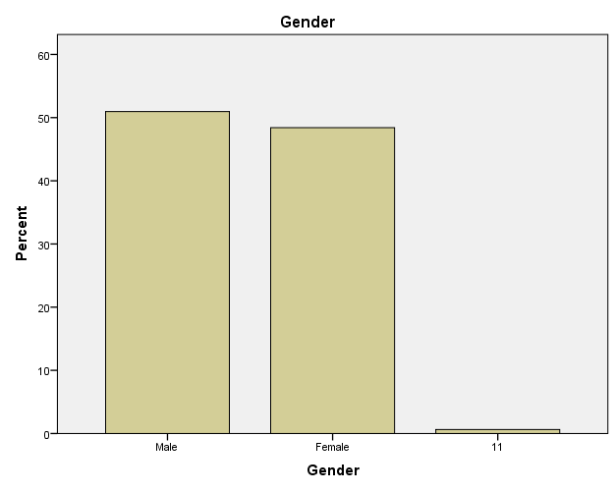
From the gender perspective, 50% are male respondents, while 47.5% were females. This implies that majority of the respondents were males, while majority of the interviewees were females, in order to have a gender balance.

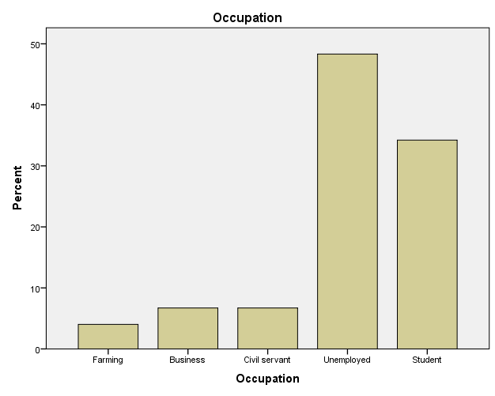
Majority of the respondents (45.0%) are unemployed, this shows the high rate of unemployment in the State. This was closely followed by a student population of 31.2% ,Civil Servants 6.3%, Business 6.3% and lastly faming (3.8) percent.
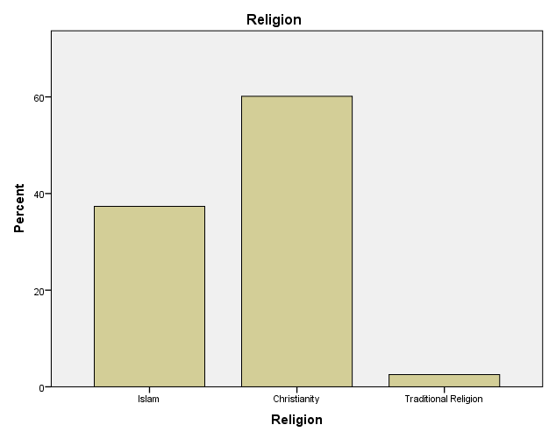
Majority of the respondents (59.4%) are Christians, while 36.9% are Muslims and 2.5% are traditional worshipers.

SECTION B: Why do People Bleach their Skin?
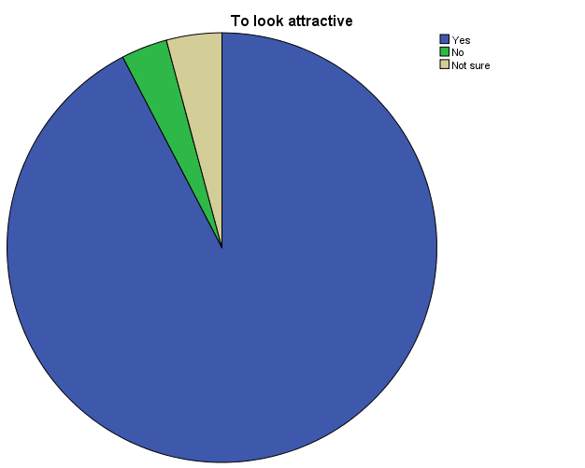
In response the question why do people bleach their skin, majority (83%) of the respondents opined that people bleach their skin in order to look attractive, 3.1 % disagreed, while 3.8% were not sure. This underscores the fact that many dark skinned people are dissatisfied with their complexion and want to be lighter in complexion. This also tells the fact that many people perceive light complexion as beautiful.
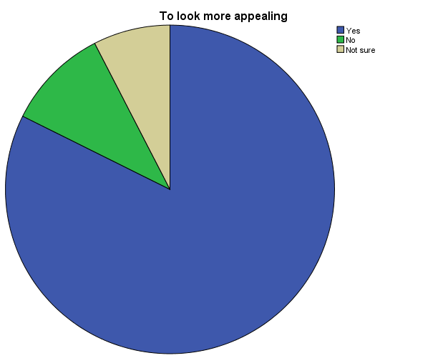
Majority of the respondents (61.3%) opined that people bleach their skin to look more appealing, while 7.5% of the respondents disagreed to that view. This explains the desire for acceptance in people. An interviewee opined in support of this that People bleach their skin just to have a fair complexion. Most people are not comfortable with the normal black skin given by God, they prefer to bleach it. (Female, 30 years). Another interviewee said: People bleach because they want to be fair to attract men/women, and to also look beautiful (Female, 36 years). Also, People bleach their skin because they want to look more attractive to their opposite sex (Male, 31 years).
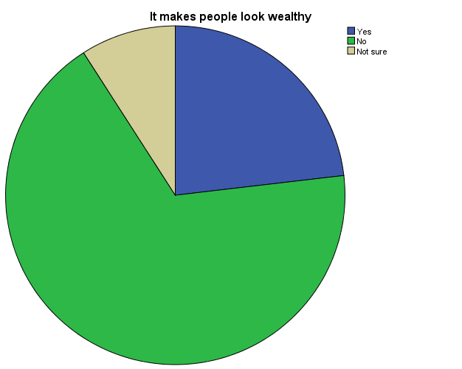
Majority of the respondents (51.3%) were of the view that skin bleaching does not make people look wealthy, while 17.5 opined that it makes people look wealthy and 6.9% were not sure. This tells that fair skin is not misconceived for wealth.
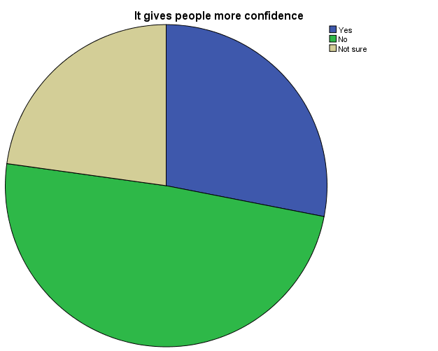
Also, majority of the respondents (35.0%) were of the view that skin bleaching gives people more confidence, while 20.0% of the respondent were of the view that it gives people more confidence and 16.3% were not sure. This explains that people who bleach their skin desire more attention. An interviewee supported this data, saying: People bleach their skin because of low self-esteem; they feel like they are not beautiful in their melanin skin (Female, 35 years).
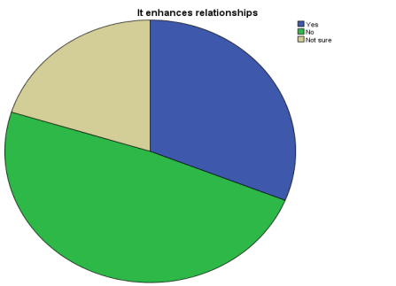
In addition, majority of the respondents (36.3%) opined that skin bleaching enhances relationships, 23.1% disagreed and 15.0% were not sure. This explains the reality that people who bleach does so to attract people to them. To support this data, an interviewee said: People bleach to change the colour of their skin from dark to fair, and also, those who are fair would like to maintain their skin and also to increase their fairness (Male, 36 years). Another said: People bleach because they want to be fair to attract men/women, and to also look beautiful (Female, 36 years).
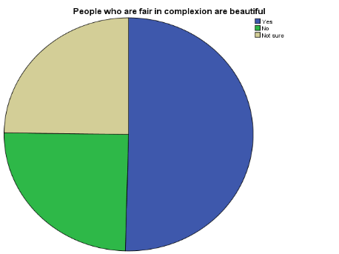
Furthermore, (36.9%) of the respondents opined that people who are fair in complexion are beautiful, while 18.1% objected, and 18.1% were not sure. This underscores the fact that fair skin if confused for beauty. People bleach their skin for the various reasons: one of the reasons is because they prefer to be fair in complexion. People bleach their skin due to peer influence and fashion. People bleach their skin especially ladies that like to be model because the fair complexion attracts the opposite sex. They like to look attractive (Male, 35 years).
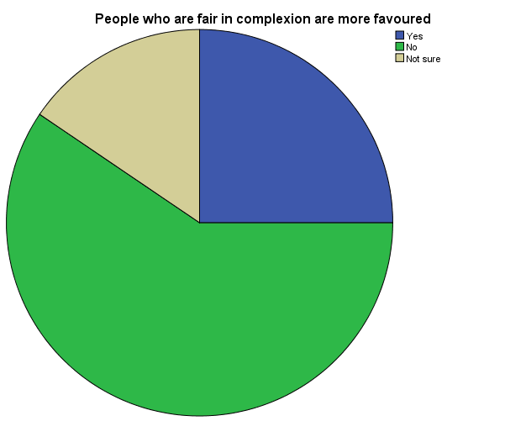
Majority of the respondents, (43.1%) disagree with the fact that People who are fair in complexion are more flavored. This unveils the fact that skin colour is not a good measure of favour. This finding disagrees with the findings of Oluka (2022), which states that in many African societies, lighter-skinned women are considered more successful and likely to find marriage (Oluka, C. 2022).
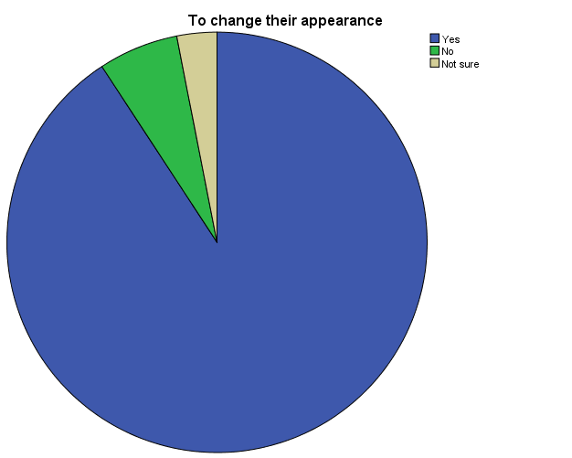
Majority of the respondents, (73%) agreed that people bleach to change their appearance. In other words, they want to look more attractive. In line with these findings, an interviewee said People bleach their skin or change the colour of their skin to fairer colour because they want to look brighter, they feel they have the money to take care of themselves at will, to look like their peers or groups, and ignorantly sometimes, they buy soaps and creams without knowing the chemical contents (Female, 48 years).
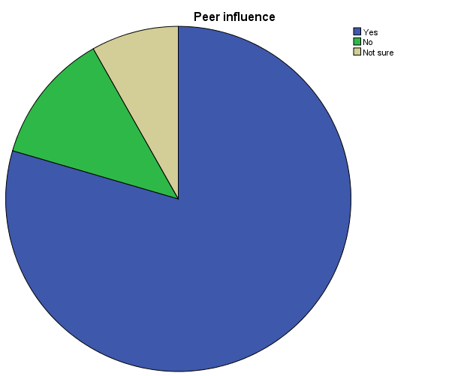
Majority of the respondents, (60.6%) agreed that people engage in skin bleaching as a result of peer influence. They may see their peers bleaching and want to be like them.
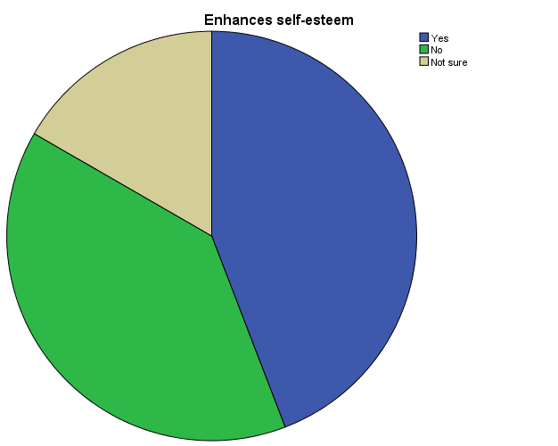
Majority of the respondents, (60.6%) agreed that skin bleaching enhances self-esteem. This implies that it gives them an unusual kind of confidence, knowing that they look attractive and beautiful. Some interviewees said: People bleach because of peer influence, fashion acceptance, to change their colour (Male, 40 years). Bleaching is mostly caused by low self-esteem. Other reasons are peer pressure, Aesthetic purposes, to be more attractive (Female, 29). This findings corroborates the findings of Oluka (2022), which stated that these practices are common amongst non-white populations and are triggered by cosmetics reasons proofed in low self-esteem considerations (Oluka, 2022). Fairness of the skin carries more advantage of being more confident, sexy and attractive to men (Oluka, C. 2022).
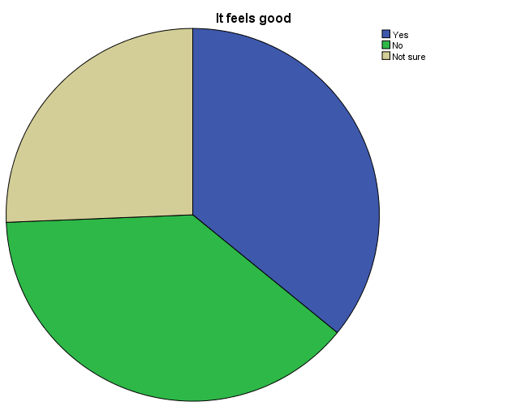
Majority of the respondents, (28.1%) disagreed that it feels good to bleach because of the known side effects and cost implications. This finding unfolds the fact that people have variant reasons for practicing skin bleaching. In line with this, an interviewee said people bleach because they want to be like white men (Male, 45 years). Other interviewees supported, saying:
People bleach their skin to look more beautiful (Female, 30 years). People bleach their skin to look like the foreigners (Male, 26 years). Some people bleach their skin to look attractive (Female, 42 years). To look attractive and enhance body beauty (Female, 46 years). For beautification (Female, 35 years). They want to look good (Males, 44). They want to beautify themselves (Male, 50 years). People bleach their skin to look better than they are already. It usually occurs among dark-skinned people who want to have a fair skin (Female, 29 years). Because they want to look beautiful, fair in complexion, and attract attention (Male, 39 years). People bleach their skin in order for their skin colour to become light in complexion. (Male, 29 years). People bleach their skin to get a fair looking skin type; People believe fair skin makes them look more beautiful (Female, 45 years). Most people bleach because they want to look fair or lighter than their normal skin colour. Some bleach because they want to be celebrated especially our celebrities. Skin bleaching is also a societal demand (Female, 30 years). People bleach their skin because they belief lighter skin persons attract people to themselves, especially affection love (Male, 32 years). People bleach to look more beautiful in order to improve their confidence (Female, 50 years). People bleach because they want to be fair to attract men/women, and to also look beautiful (Female, 36 years).
Section C: Perception of People Who Bleach their Skin
This section discussed the perception of people who are engaged in skin bleaching. It covers questions about what others think and feel and how they relate with people who engage in skin bleaching.
They look irritating
 |  | Frequency | Percent | Valid Percent | Cumulative Percent
Valid | Yes | 106 | 66.3 | 82.2 | 82.2
Valid | No | 7 | 4.4 | 5.4 | 87.6
Valid | Not sure | 16 | 10.0 | 12.4 | 100.0
Valid | Total | 129 | 80.6 | 100.0
Missing | System | 31 | 19.4
Total |  | 160 | 100.0
Majority of the respondents (66.3%) said people who bleach look irritating. This is due to the obvious damages caused to their skin.

Females who bleach their skin are prostitutes
 |  | Frequency | Percent | Valid Percent | Cumulative Percent
Valid | Yes | 24 | 15.0 | 20.2 | 20.2
Valid | No | 67 | 41.9 | 56.3 | 76.5
Valid | Not sure | 28 | 17.5 | 23.5 | 100.0
Valid | Total | 119 | 74.4 | 100.0
Missing | System | 41 | 25.6
Total |  | 160 | 100.0
Most of the respondents (66.3%) disagree that females who bleach their skin are prostitutes. This implies that skin bleaching is not a yardstick for measuring prostitution.
Males who bleach their skin are womanizers
 |  | Frequency | Percent | Valid Percent | Cumulative Percent
Valid | Yes | 39 | 24.4 | 33.6 | 33.6
Valid | No | 51 | 31.9 | 44.0 | 77.6
Valid | Not sure | 26 | 16.3 | 22.4 | 100.0
Valid | Total | 116 | 72.5 | 100.0
Missing | System | 44 | 27.5
Total |  | 160 | 100.0
Majority of the respondents (31.9 %) disagree that male who bleach their skin are womanizers. This implies that skin bleaching is not a yardstick for measuring promiscuity.

They do not look natural
 |  | Frequency | Percent | Valid Percent | Cumulative Percent
Valid | Yes | 116 | 72.5 | 91.3 | 91.3
Valid | No | 5 | 3.1 | 3.9 | 95.3
Valid | Not sure | 6 | 3.8 | 4.7 | 100.0
Valid | Total | 127 | 79.4 | 100.0
Missing | System | 33 | 20.6
Total |  | 160 | 100.0
Majority of the respondent (72.5%) were of the opinion that people who bleach their skin look fake. This implies that they wear an artificial deceptive look.
Lack contentment
 |  | Frequency | Percent | Valid Percent | Cumulative Percent
Valid | Yes | 103 | 64.4 | 79.2 | 79.2
Valid | No | 13 | 8.1 | 10.0 | 89.2
Valid | Not sure | 14 | 8.8 | 10.8 | 100.0
Valid | Total | 130 | 81.3 | 100.0
Missing | System | 30 | 18.8
Total |  | 160 | 100.0
Most of the respondents (64.4%) opined that people who bleach their skin lack contentment. This implies lack of gratitude and satisfaction of themselves; it also unveils the fact that they wish they were someone else.

Lack confidence
 |  | Frequency | Percent | Valid Percent | Cumulative Percent
Valid | Yes | 82 | 51.3 | 65.6 | 65.6
Valid | No | 24 | 15.0 | 19.2 | 84.8
Valid | Not sure | 19 | 11.9 | 15.2 | 100.0
Valid | Total | 125 | 78.1 | 100.0
Missing | System | 35 | 21.9
Total |  | 160 | 100.0
Majority of the respondents (51.3%) were of the view that people who bleach are lacking in self-confidence. This explains the fact that bleaching to look fair in complexion enhances their self-confidence.
Lack self-esteem
 |  | Frequency | Percent | Valid Percent | Cumulative Percent
Valid | Yes | 78 | 48.8 | 66.1 | 66.1
Valid | No | 16 | 10.0 | 13.6 | 79.7
Valid | Not sure | 24 | 15.0 | 20.3 | 100.0
Valid | Total | 118 | 73.8 | 100.0
Missing | System | 42 | 26.3
Total |  | 160 | 100.0
Majority of the respondents (48.8%) were of the view that people who bleach are lacking in self-esteem. This explains the fact that bleaching to look fair in complexion enhances their low self-esteem.

Look ugly
 |  | Frequency | Percent | Valid Percent | Cumulative Percent
Valid | Yes | 58 | 36.3 | 50.4 | 50.4
Valid | No | 36 | 22.5 | 31.3 | 81.7
Valid | Not sure | 21 | 13.1 | 18.3 | 100.0
Valid | Total | 115 | 71.9 | 100.0
Missing | System | 45 | 28.1
Total |  | 160 | 100.0
Majority of the respondents (36.3%) perceive people who bleach their skin as ugly. This implies that bleaching does not give people a naturally good look, but creates a false impression.
Look unserious
 |  | Frequency | Percent | Valid Percent | Cumulative Percent
Valid | Yes | 59 | 36.9 | 49.2 | 49.2
Valid | No | 38 | 23.8 | 31.7 | 80.8
Valid | Not sure | 23 | 14.4 | 19.2 | 100.0
Valid | Total | 120 | 75.0 | 100.0
Missing | System | 40 | 25.0
Total |  | 160 | 100.0
Also, majority of the respondents (36.9%) perceive people who bleach their skin as unserious people. This implies that they focus on things that are not important.
Are ignorant about nature
 |  | Frequency | Percent | Valid Percent | Cumulative Percent
Valid | Yes | 75 | 46.9 | 68.8 | 68.8
Valid | No | 20 | 12.5 | 18.3 | 87.2
Valid | Not sure | 14 | 8.8 | 12.8 | 100.0
Valid | Total | 109 | 68.1 | 100.0
Missing | System | 51 | 31.9
Total |  | 160 | 100.0
Majority of the respondents (46.9%) perceive people who bleach their skin as people who are ignorant about nature. This implies that real beauty comes is not measured by outward appearance.
Are pretenders
 |  | Frequency | Percent | Valid Percent | Cumulative Percent
Valid | Yes | 67 | 41.9 | 62.0 | 62.0
Valid | No | 21 | 13.1 | 19.4 | 81.5
Valid | Not sure | 20 | 12.5 | 18.5 | 100.0
Valid | Total | 108 | 67.5 | 100.0
Missing | System | 52 | 32.5
Total |  | 160 | 100.0
Majority of the respondents (41.9%) perceive people who bleach their skin as pretenders. This implies faking of personality and not being ones true self.
Are immoral
 |  | Frequency | Percent | Valid Percent | Cumulative Percent
Valid | Yes | 54 | 33.8 | 48.6 | 48.6
Valid | No | 31 | 19.4 | 27.9 | 76.6
Valid | Not sure | 26 | 16.3 | 23.4 | 100.0
Valid | Total | 111 | 69.4 | 100.0
Missing | System | 49 | 30.6
Total |  | 160 | 100.0
Majority of the respondents (33.8%) perceive people who bleach their skin as being immoral. This implies that they do not practice what is right.
Are childish
 |  | Frequency | Percent | Valid Percent | Cumulative Percent
Valid | Yes | 58 | 36.3 | 51.8 | 51.8
Valid | No | 31 | 19.4 | 27.7 | 79.5
Valid | Not sure | 23 | 14.4 | 20.5 | 100.0
Valid | Total | 112 | 70.0 | 100.0
Missing | System | 48 | 30.0
Total |  | 160 | 100.0
Majority of the respondents (36.3%) perceive people who bleach their skin as being childish. This implies that their minds are focused on unserious things.
To support the data on perception of people who bleach their skin, the key informants had these to say:
As good looking (female, 24 years). I perceive it as irritating, especially for men that bleach their skin (Female, 36 years). Some would like them as they bleach while others do not like them; I frown at such people because it is irritating. Some have a particular offensive odor (Male, 56 years). Their skin is not strong and can easily get injured (Male, 36 years). I perceive those that bleach their skin as womanizers or ashawo women because I believe they do that to attract each other for sex purposes (Male, 31 years). I consider those that bleach their skin as unnatural people, discontented, and those that want to be loved by others (Male, 32 years). I tell people who bleach that they have no sense of confidence about themselves and are very irritating (Female, 45 years). I see them as uneducated (Male, 62 years). Some of them are not religion conscious. Skin bleaching is also a waste of time. They mostly have body odour (Female, 30 years). I see it as social deviance (Female, 45 years). To attract the opposite sex, it irritates me (Male, 40 years). I perceive them as people with low self-esteem (Male, 29 years). I perceive those who bleach their skin as ugly (Female, 29). I see them as unserious women. (Male, 42 years). It causes damages to their physical wellbeing. It causes body odour and exposes such individual to skin cancer (Male, 46 years). Its result leads to social stigmatization (Male, 35 years). I am not comfortable with them (Males, 44). I perceive them as ignorant of nature, i.e. natural law (Male, 50 years). Personally, I find it irritating when people user cream to bleach their skin. (Male, 29 years). I perceive them as very irritating. Sometimes they smell bad as a result of chemical reaction associated with the lotion (Male, 39 years). I see them as pretenders and people faking it just to get the approval of the society (Female, 35 years). People who bleach their skin are people who force themselves to artificially look good whereas, natural beauty is better, if not the best. (Male, 26 years). Some people see them as ignorant people because bleaching is not good. Some of them are perceived as smelling especially the male counterparts. Their skins are very light and tough with wrinkles and dark patches when they grow older (Female, 48 years). I personally do not like it when I see people that have bleached their skin. Some do it to look more attractive (Female, 30 years). I perceive them as Immoral and childish (Male, 45 years).
Section D: What are the Social health hazards of skin bleaching?
This section explains the social health hazards of skin bleaching.
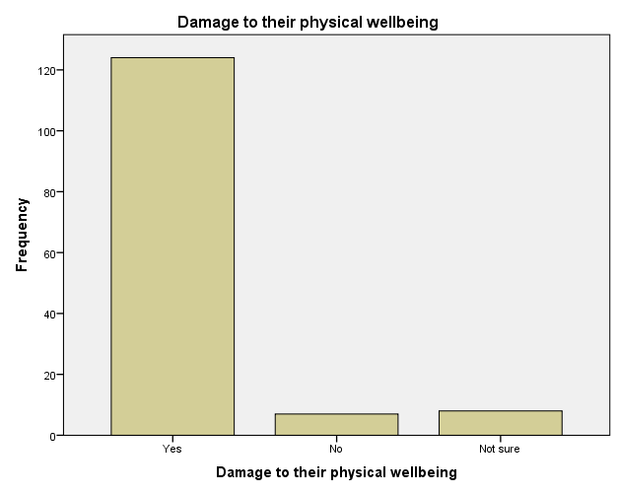

Majority of the respondents (77.5%) opined that skin bleaching damages physical wellbeing.
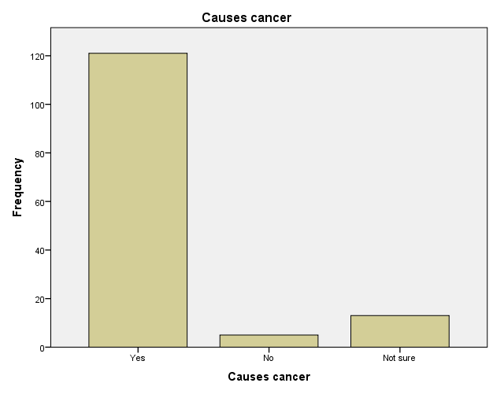
Most of the respondent (77.6%) said skin bleaching causes skin cancer.
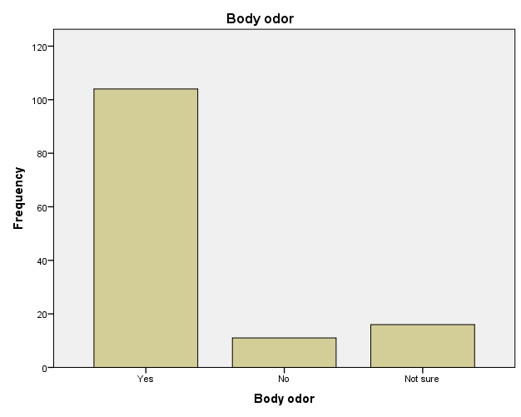
Majority of the respondents (65.0%) opined that skin bleaching causes body odor. This occurs as a result of the damages to the skin layers and wounds, which may take time to heal.
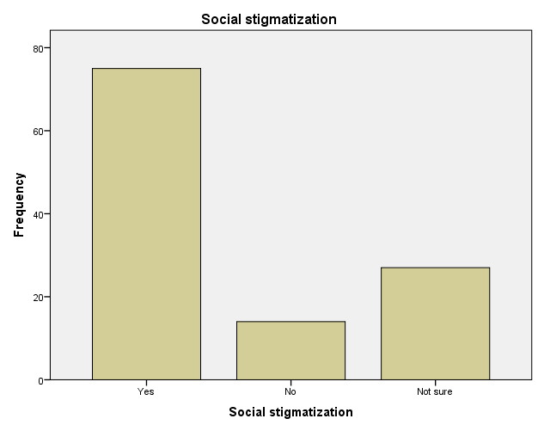

Majority of the respondents (46.9%) opined that people who skin bleach their skin are socially stigmatized.
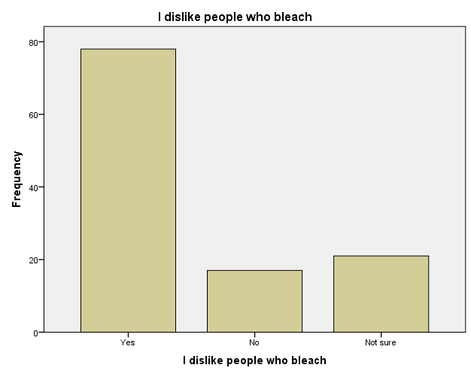
Most of the respondents (48.8%) dislike people who bleach their skin. This implies that skin bleaching negatively affects social relationships.
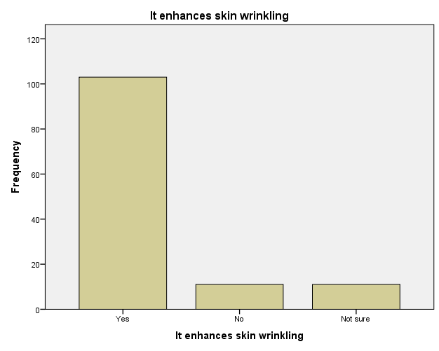
Most of the respondents (64.4. %) emphasize that skin bleaching enhances skin wrinkling, thus, speeds up the process of aging.
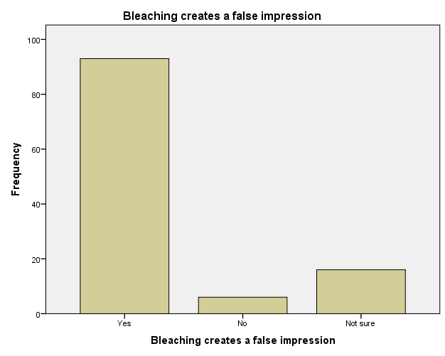
Majority of the respondents (58.1%) are of the view that skin bleaching creates a false impression. This because it gives an artificial skin colour, which is deceptive.
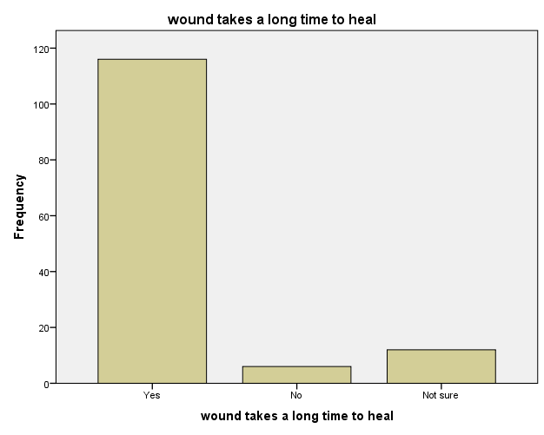
Majority of the respondents (72.5%) opined that skin bleaching causes slow recovery of wounds. This is because the chemicals weaken the skin layers.
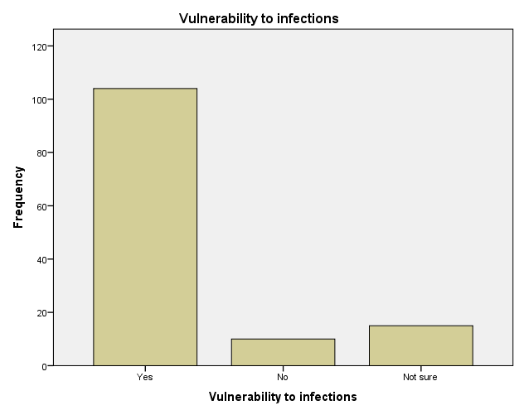
Majority of the respondents (65.0 %) were of the view that skin bleaching exposes the skin to infections. This is because it damages the protective layer of the skin.
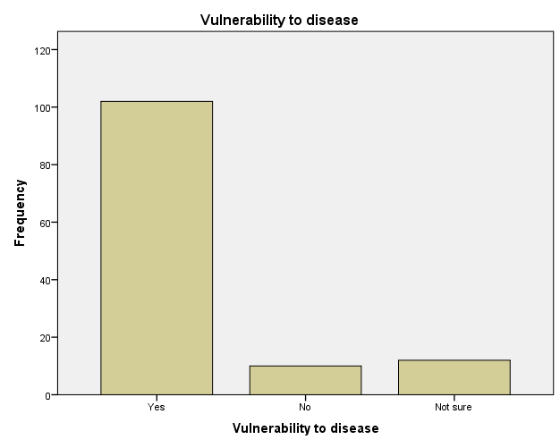
Majority of the respondents (63.8 %) were of the view that skin bleaching exposes those involved to diseases. In order to give deeper meaning to the quantitative data on health hazards of skin bleaching, the interviewees gave the following responses:
People who bleach age faster (Wrinkles), and they get acnes (Female, 72 years old).
Health-wise, bleaching is not good to the skin and health in general because it might cause cancer of the skin (Female, 36 years).
The health hazards include, increased chances to skin cancer, sun burns, it takes time for their skin that has sustained injury to heal in good time. It can make the skin very light and as such make it difficult for such person to undergo surgery when need arises (Male, 31 years).
Bleaching is bad and hazardous to the skin because it makes the skin to be soft and lighter which is dangerous to the body especially when surgery is needed to be done in the hospital; it makes the person to vulnerable to infections and diseases especially skin rashes because of the skin colour; It makes their immune system to be weak (Male, 35 years)
Bleaching of the skin can cause skin cancer; it is hard for wounds to heal in time of injuries; stigmatization from others that hate bleaching (Male, 32 years)

They are prone to skin cancer, fast aging, and allergies; they feel shameful to expose themselves, especially when physical damages begin to occur (Female, 45 years)

It can lead to skin rashes, eczemas, etc. It is difficult for them to be operated on because the real skin has been terminated (Female, 30 years)

It affects their skin and makes it lighter. That makes them prone to disease like cancer. It also affects the society interaction. They are prone to depression as the result of people not interacting with them cordially (Male, 40 years)

Skin disease, breakdown of the skin layer when they start aging (Male, 29 years)

Kidney failure, skin diseases, and skin discolouration (Female, 29).

It makes those who bleach have skin diseases such as eczema, dots, etc. Secondly, physically, their skin becomes damaged, so they feel ashamed. (Male, 42 years).

It affects social relations (Male, 46 years).

It damages and increase risks of skin cancer. It can cause low self-esteem. It can lead to uneven skin tone (Male, 35 years).

Skin decay and stigmatization (Males, 44)

It leads to skin cancer (Male, 50 years).

Skin bleaching causes skin cancer. It also makes people to feel that the skin bleachers have inferior complex, and may cause the person to be discriminated against on that basis. The person who bleaches their skin may find it difficult to associate with people especially when the bleaching affects their skin by leaving marks on their body (Male, 29 years).

Physical defects or irritation; psychological hazard as a result of experiencing negative changes in their skin; guilt and shame as a result of physical defects on their skin; stigmatization from the society; rejection from the society. (Male, 39 years).
It can lead to skin infection and also skin cancer because of the hard chemicals they use. (Female, 35 years).

It changes the natural structure of the human. It psychologically affects them as it changes their thinking of feeling superior to whoever does not bleach (Male, 26 years).

It causes skin cancer. It makes them nervous especially when some affected parts of their bodies are mistakenly exposed. This affects their social lives also. Spiritually, they are not comfortable to talk to others about skin bleaching. It affects them during surgeries. This is because it is difficult for stitches to be done on the affected areas may be as a result of accident or surgeries. It can cause gene mutation. Socially, they might be isolated. (Female, 48 years).

It spoils the skin that is a physical damage. Mentally, when your skin spoils, it can affect your mental health (Female, 30 years).

It leads to different skin diseases (Male, 45 years).

A key informant had this to say:
I have been using a particular cream and soap for the past three years that has given me a beautiful complexion; little did I know the side effects where deadly, until I had a major surgery, the stiches opened twice, because my skin was weak. It almost cost me my life that was when I painfully realized the health effects of skin bleaching. I have stopped, my skin is getting darker than before I started using the cream and soap, I am ashamed to go out of my house and relate with others (Female, 45 years).
Another key informant said I learnt from my neighbors personal experience, who died as a result of bleeding from injuries that that did not heal after a cesarean section (CS) (Female, 41 years).

Section E: Which gender bleaches more?
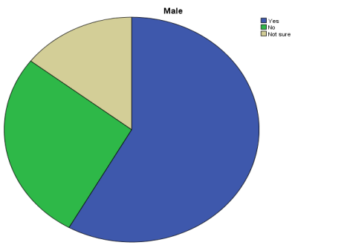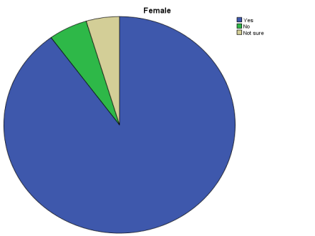
This section focuses on the gender that engages in skin bleaches more. The result indicates that the female gender (72.5%) bleach their skin more than the male gender (20%). This implies that the female gender is more concerned about their complexion than their male counterparts. From the results of the IDI, the following was unveiled:

Females bleach more than men (female, 67 years old). The female gender bleaches more than men (Female, 36 years). The female gender bleaches more, although the male gender bleaches well too (Male, 36 years)
Female gender bleach more (Male, 31 years)

Females, because they want to be attractive (Male, 32 years)

The female gender bleaches the more because they want to be attractive since they feel it makes them more beautiful (Female, 45 years)

Females, because almost all women and ladies want to be accepted and celebrated. (Female, 30 years)

The female genders bleach more. (Male, 40 years)

Females, because they believe men prefer light-skinned women. (Male, 29 years).

Females, because men prefer ladies with lighter skin.(Female, 29).

Females, because they want to look attractive to men (Male, 42 years).

Female, because they always concern with their outcome and to look attractive before the opposite gender (males) (Male, 46 years).

Female bleach more because of peer and social pressure, marketing and advertisement, economic factors, and societal beauty standards (Male, 35 years).

Females, they want to be admired (Males, 44).

The female gender (Male, 50 years).

Bleaching is common among females; however, the males also bleach. Women bleach because they want to be beautiful; they want their skin to glow (Male, 29 years).

Females (Male, 39 years).

Females tend to bleach more because of their needs and desperate want for approval from men. (Female, 35 years).

The female gender bleaches more because there is an adage that says, “Men mostly believe in what they see (sight), that’s why ladies apply makeup while women believe on what they hear, that’s why men lie a lot”. (Male, 26 years).

The female still bleaches more because they want to look more attractive. (Female, 30 years)

Females, because they like to win their boyfriends (Male, 45 years)

These findings are in agreement with World Bank, Cited by Agbo (2025) which stated that Nigerian women have been ranked as the highest users of skin bleaching creams in Africa (World Bank, Cited by Agbo, 2025).
SUMMARY CONCLUSION AND RECOMMNENDATIONS
Summary
Findings from question one: Why do people bleach their skin, unveiled the facts that every individual that engages in skin bleaching has his or her unique reasons, ranging from beauty, attractiveness, more appealing looks, gives more confidence, self-actualization, quest for belonging, attraction, psychological good feeling; to negative motives, as a result of peer-pressure, low/lack of self-esteem.

Findings from question two: How do people perceive those who bleach their skin? unveiled interesting facts. In summary, people have both negative and positive perception for those who bleach their skin. They are perceived: with disgust, irritation as prostitutes, fake, lack contentment, proud, lack confidence and self-esteem, do not know God, deviants, ugly, unserious, arrogant, artificial, pretenders, immoral and childish.
Which gender bleaches more?
Findings from objective three: What are the social health hazards of skin bleaching?
Unveils the following facts: damages to physical well-being, skin cancer, body odour, social stigmatization, social disproval, skin wrinkling, false impression
Conclusion
Skin bleaching has both negative and positive health implications on individuals and society, the female gender bleaches more than their male counterparts and those who do not engage in skin bleaching perceive those who bleach both negatively and positively.
Recommendations
The study recommends:
- Health enlightenment programs on the health hazards of skin bleaching at Local, State and Federal Government levels by health personnel, Social Workers, Medical Sociologists and Clinical Psychologist, to enhance the wellbeing of individuals and society.
- Community based enlightenment programs on the social perceptions of skin bleaching by Sociologists.
- Peer-education and mass media advocacy programs on healthy and natural beauty tips.

REFERENCES
References
Team Ebony (2016). Culture, News and Politics. Beayty and the bleached: This issue is
more than skin deep. Retrieved from https//www.eboney.com/skin-bleaching/05/13/2025

Oluka, C.(2022). Deep-seated skin bleahing culture in Nigeria. Retrieved from
https//grassrootsing/2023/11/03/deep-seated-skin bleahing -culture in- nigeria/05/13/2025

Agbo.L.(2025). Nigeria:Top 5 countries with the most skin bleaching population. The
Vanguard. https://allafrica.com/stories/05/13/2025.

Usman. U. (2022). Skin bleaching, a dangerous trend in kano. The Guardian.
Barja,J.M., Berdeal, M, Vares, M,(2010).Xeesal: Cosmetics skin whitening in Sub-Saharan
Africa. Actas Dermaosifiliogr.

