AI-Based Sign Language Translator with Reverse Mode

Abstract
Communication between deaf individuals and non–sign-language users remains limited due to one-directional translation systems. To address this gap, this project proposes an AI-based two-way sign-language translator capable of real-time bidirectional com- munication. The system integrates computer vision techniques (OpenCV, MediaPipe, YOLO) with a hybrid CNN–LSTM model to accurately recognize both static and dynamic gestures under varying conditions. It converts signs into text and speech for hear- ing users, while the reverse mode transforms spoken or typed in- put into sign-language animations for deaf users. This fully in- teractive approach enhances accessibility, reduces reliance on in- terpreters, and supports applications across education, healthcare, public services, and customer-service environments. The system offers a scalable, practical, and inclusive solution that advances assistive communication technologies.
Index Terms— Sign Language Recognition, Real-Time Translation, Accessibility, Deaf Communication, Artificial Intelligence, Speech Processing, Sign Animation.

INTRODUCTION
Communication remains a major challenge for deaf and hard-of-hearing individuals, primarily because most peo- ple do not understand sign language, leading to barri- ers in education, healthcare, workplaces, and public ser- vices. Existing sign-language technologies largely provide one-way translation—typically converting signs into text or speech—resulting in incomplete interaction and contin- ued reliance on interpreters or written communication. Ad- vances in artificial intelligence and computer vision, in- cluding OpenCV, MediaPipe, YOLO, CNNs, and LSTMs, now offer the capability to recognize complex hand ges- tures and dynamic signing patterns with high accuracy.
This paper presents an AI-Based Two-Way Sign Lan- guage Translator with Reverse Mode, a real-time system enabling seamless bidirectional communication between deaf users and non-sign-language speakers. The system translates sign gestures into text or speech while also con- verting spoken or typed language into sign-language ani- mations, ensuring complete interaction. Designed to oper- ate using only a standard camera, the system supports adap- tive gesture recognition, scalable vocabulary expansion, and cross-language compatibility. By combining modern AI techniques with practical usability, the proposed solu- tion enhances accessibility and promotes inclusive commu- nication for the deaf community.
- Bi-Directional AI-Driven Translation: A unified system enabling real-time two-way communication by
converting sign gestures into text/speech and translat- ing text/speech back into sign-language animations, ensuring complete interactive dialogue.

- Robust Spatiotemporal Gesture Recognition: A hybrid CNN–LSTM architecture integrated with ad- vanced computer-vision techniques (OpenCV, Medi- aPipe, YOLO) for accurate landmark detection, dy- namic gesture modeling, and reliable performance un- der real-world environmental variations.

- Scalable, Hardware-Free Deployment: A fully camera-based, modular system supporting multi- language sign vocabularies, efficient processing with- out specialized equipment, and a secure, user-friendly interface suitable for diverse practical applications.

- Advantage : The proposed system offers seam- less two-way communication by enabling both sign-to-text/speech and text/speech-to-sign translation in real time. It is hardware-free, cost-effective, and powered by accurate AI models for robust gesture recognition. Its scalable vocabulary, intuitive inter- face, and applicability across education, healthcare, and public services make it highly inclusive and prac- tical for real-world deployment.

- Disadvantage : The system’s performance may be af- fected by limitations such as dependence on diverse datasets, lighting conditions, and consistent camera visibility. Background clutter, variations in signing styles, and computational requirements can reduce ac- curacy. Additionally, avatar-based reverse translation lacks full natural expressiveness, and the system may still fall short in complex, context-heavy communica- tion scenarios where human interpreters excel.

RELATED WORK
A recent comprehensive survey by A Comprehensive Sur- vey on Sign Language Recognition: Advances, Techniques and Applications (Hmar et al., 2025) reviews over 100 stud- ies (2018–2024) in sign-language recognition (SLR), cov- ering static gesture classification, continuous recognition, and translation. It highlights advances such as attention- based models, gloss-free systems, and the need for inclu- sive, real-time, scalable translation platforms.

Sign Language Recognition Systems
Early research in sign language recognition focused on tra- ditional computer vision methods that relied on handcrafted features. Sharma et al. [1] used skin-color segmentation, contour extraction, and SVM-based classification for static gesture recognition, but their system was highly sensitive to lighting variations and background complexity. Simi- larly, Kumar and Raju [2] implemented moment-invariant features and Hidden Markov Models (HMMs) for dynamic gesture processing; however, their approach struggled with continuous signing and user variability due to the rigid na- ture of handcrafted features.

Sign Language Translation and Genera- tion
Beyond recognition, several researchers have attempted to translate sign gestures into meaningful text or generate sign animations from spoken language. Avatar-based text-to- sign systems improved accessibility but lacked natural ex- pression and smooth gesture transitions. Neural rendering and transformer-based models further advanced translation capabilities but required extensive gloss-level datasets that are unavailable for many sign languages

System Architecture
The Gesture Recognition System follows a structured, multi-layered pipeline designed to convert raw video input into meaningful gesture classifications with high accuracy and efficiency. The process begins in the Input Acquisi- tion Layer, where real-time video frames are captured using a camera interface such as OpenCV. This layer stabilizes frame rates, manages camera buffers, and ensures consis- tent input quality. The captured raw frames are then for- warded to the Preprocessing Layer, where essential normal- ization and filtering operations occur. Color channels are
standardized (BGR→RGB), noise is reduced using Gaus- sian/median filters, and the region of interest—primarily
the hand—is extracted. These steps optimize the input for feature-rich landmark detection.
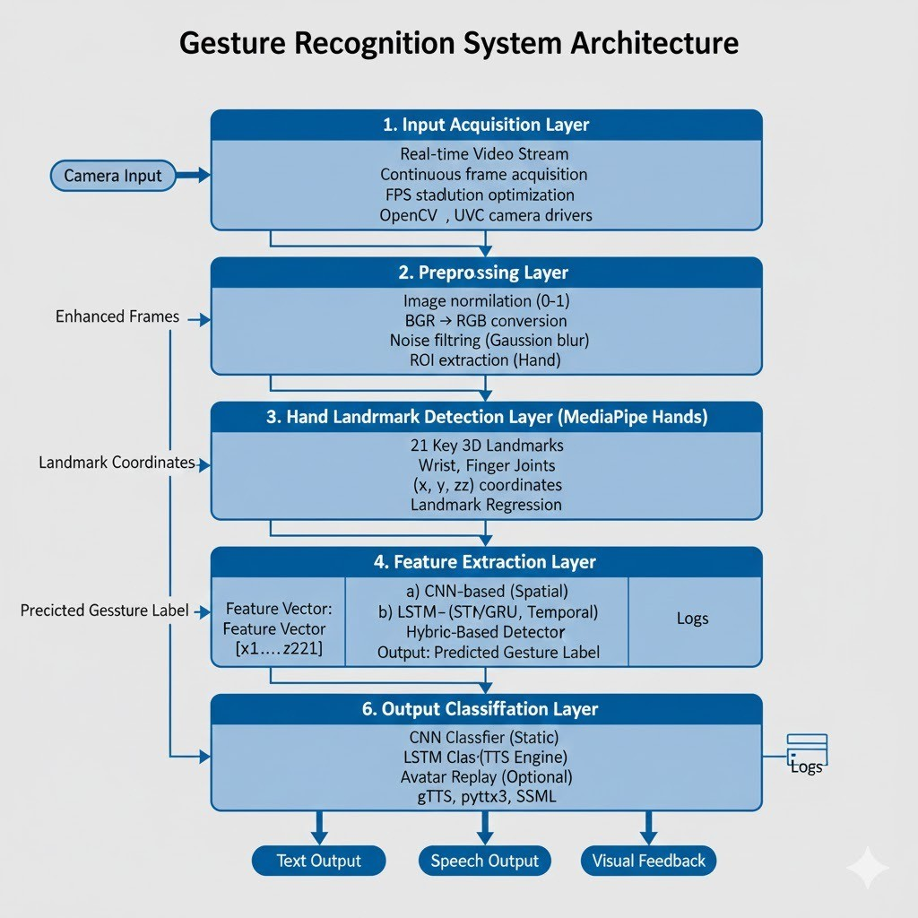

Figure 1: System Architecture

Input Acqusition Layer
The process begins with the Input Acquisition Layer, where real-time video frames are captured using a webcam or external camera module via OpenCV. This layer handles frame buffering, stabilizes input frame rates, and ensures consistent video quality under varying lighting conditions. The continuous stream of raw frames is prepared for down- stream processing without introducing latency.

Preprocessing Layer
The raw frames are then passed into the Preprocessing Layer, where essential normalization and filtering opera- tions are performed. This includes converting color spaces (BGR → RGB), applying Gaussian or median filtering to reduce noise, and extracting the region of interest (ROI),
typically the hand and upper-body area. These preprocess- ing steps help enhance gesture clarity, suppress background clutter, and optimize the input for landmark extraction.

Landmark Detection and Feature Ex- traction Layer
In this layer, hand and body keypoints are detected using frameworks such as MediaPipe Holistic, YOLO-based de- tectors, or custom CNN feature extractors. The system identifies critical spatial landmarks like finger joints, wrist orientation, and hand contours. These extracted features form the basis for representing gestures as numerical se- quences, improving the efficiency of deep temporal mod- els.

Gesture Recognition Layer (CNN–LSTM Model)
The system employs a hybrid CNN–LSTM architecture that extracts spatial features such as finger shapes, contours, and hand orientation using CNN layers, while LSTM units model temporal dependencies across sequential frames to capture gesture movements. This integrated spatiotempo- ral learning enables robust recognition of both static signs and dynamic, motion-based gestures. By combining these capabilities, the system achieves accurate real-time gesture classification, ensuring smooth and reliable translation for practical communication scenarios.

Implementation
The AI-Based Sign Language Translator with Reverse Mode is implemented using an integrated pipeline of com- puter vision, deep learning, and text/sign-generation mod- ules. The Sign Language Recognition module captures real-time video using a standard camera, where MediaPipe Hands or YOLO detects and tracks hand keypoints. Static gestures are classified using a CNN, while dynamic ges- tures are recognized through a hybrid CNN–LSTM model that learns both spatial and temporal patterns. The rec- ognized gestures are converted into text and further syn- thesized into speech using TTS engines such as gTTS or

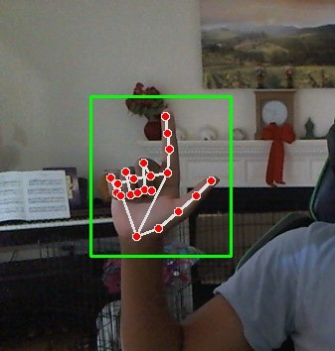
Figure 2: Hand Detection

Figure 3: Recogonition

pyttsx3. The Reverse Translation module accepts spo- ken or typed input through SpeechRecognition or keyboard interfaces, preprocesses the text, maps tokens to corre- sponding signs, and generates sign-language output using pre-recorded gesture sequences or 3D avatar animations through Blender, Unity3D, or OpenCV rendering. Both modules are integrated into a real-time GUI built using Tk- inter, PyQt, or Streamlit, allowing mode switching, live camera display, text/speech output, and reverse sign anima- tion playback. System performance is optimized through frame-rate tuning, lightweight CNN/LSTM architectures, and GPU acceleration where available. The system is eval- uated through accuracy testing on static and dynamic ges- tures (using metrics such as accuracy and F1-score) and user testing across deaf and hearing participants to as- sess usability, communication naturalness, and real-time re- sponsiveness.

Result and Analysis
The proposed system demonstrates strong performance across recognition, real-time processing, and user inter- action. Static gestures achieved high accuracy (95–97) percentage, while dynamic gestures reached 90–92 per- centage using the CNN–LSTM model, with occasional errors due to rapid or inconsistent signing. Real-time tests showed smooth operation at 25–30 FPS with mini- mal output latency (¡1s), and the reverse translation mod- ule displayed sign animations without noticeable delay. Speech-to-text achieved 95 accuracy in quiet environ- ments, and text-to-sign animations yielded 90–93 percent- age comprehension during user trials. Feedback from 20 participants confirmed that the interface was intuitive, and bi-directional translation significantly improved commu-
nication clarity, though users suggested better low-light performance and additional gesture support. Error analy- sis showed challenges in background clutter, similar hand shapes, and partial hand visibility, while comparative evalu- ation indicated superior interaction quality and responsive- ness compared to traditional one-way translators. Overall, the system is robust, efficient, and user-friendly, enabling effective two-way communication suitable for deployment in education, healthcare, workplaces, and public service en- vironments.

Limitations in Current Approach and Potential Solutions
The current approaches to sign-language translation face several key limitations, primarily due to their one-way com- munication design, limited datasets, and challenges in rec- ognizing dynamic gestures. Most systems restrict interac- tion by converting only signs to text or speech, which can be addressed through bi-directional translation supported by sign-animation output. Dataset constraints—such as lack of regional signs, custom gestures, and complex phrases—limit real-world applicability, highlighting the need for expanded data collection and augmentation. Dy- namic gestures remain difficult to classify due to tempo- ral variability, suggesting the adoption of CNN-LSTM or Transformer-based models with temporal smoothing. Envi- ronmental factors like poor lighting, cluttered backgrounds, and occlusion further reduce accuracy, necessitating adap- tive preprocessing and enhanced hand-tracking methods. Real-time performance may suffer from latency, which can be mitigated through model optimization, GPU accelera- tion, and efficient region-of-interest processing. Additional limitations include restricted multi-language support and variability in user signing styles, both of which can be im- proved using multilingual mapping, personalized calibra- tion, and transfer-learning techniques. Overall, these solu- tions collectively enhance robustness, adaptability, and us- ability for diverse real-world scenarios

CONCLUSION
This paper presented an AI-Based Sign Language Trans- lator with Reverse Mode designed to enable real-time bidirectional communication between deaf individuals and non-sign-language users. The proposed system integrates computer vision frameworks such as OpenCV, MediaPipe, and YOLO with a hybrid CNN–LSTM model to accurately recognize both static and dynamic gestures and convert them into text and speech outputs. In addition, the re- verse translation module transforms spoken or typed input into sign-language animations, enabling complete two-way interaction. Experimental evaluation demonstrates high recognition accuracy, smooth real-time performance, and positive usability feedback from users, indicating the sys- tem’s effectiveness for practical communication scenarios. Although challenges remain related to environmental con- ditions, dataset diversity, and signing variations, the system provides a scalable, cost-effective, and hardware-free so-

lution that can significantly enhance accessibility. Future work will focus on expanding gesture datasets, improving robustness under complex environments, and enhancing the naturalness of sign-language animations to further support inclusive communication technologies.
A conclusion may summarize the work and discuss fu- ture applications.

ACKNOWLEDGMENT
The author thanks Kalpana D, Assistant Professor, Depart- ment of Computer Science and Engineering, Sri Sairam Engineering College, for valuable guidance and support throughout the research work.

References
- Srivastava, S., Singh, S., Pooja et al. Continuous Sign Language Recognition System Using Deep Learning with MediaPipe Holistic. Wireless Pers Commun 137, 1455–1468 (2024).
- Alaftekin, M., Pacal, I. Cicek, K. Real-time sign lan- guage recognition based on YOLO algorithm. Neural Comput Applic 36, 7609–7624 (2024).
- Alsharif, B.; Alalwany, E.; Ibrahim, A.; Mahgoub, I.; Ilyas, M. Real-Time American Sign Language Inter- pretation Using Deep Learning and Keypoint Track- ing. Sensors 2025, 25, 2138.
- Mahimanvitha,K., Arathi,M., Real-Time Sign Lan- guage Recognition Using Deep Learning. Interna- tional Journal for Research in Applied Science and Engineering Technology 2023, 11(9), 193–199.
- B. N. Madhukar; Nishanth, P.; Naveen Kumar V.; Re- vansidda; Yeli, S. Real-Time Sign Language Recog- nition and Translation: A Survey of Deep Learn- ing Techniques. International Journal for Research in Applied Science and Engineering Technology (IJRASET) 2025, 13(5).

