Analysis of the Impact of Lean Principles on the U-Bolt and Nut Manufacturing Processes
Abstract
Continuous improvement has become essential for manufacturing organizations seeking to reduce waste and enhance productivity in today’s competitive environment. The study analyzes the impact of lean principles on waste reduction in a U-bolt and nut manufacturing process. It identifies major waste categories—such as defects, overproduction, waiting, and unnecessary motion—which continue to be highlighted in recent lean literature. Using lean tools including 5S, Value Stream Mapping (VSM), Kaizen, Standard Work, and the Muda framework, the study systematically uncovers inefficiencies across production stages, consistent with findings from contemporary lean-tool application studies. A case study approach was adopted to evaluate real-time production data from a small-sized U-bolt manufacturing firm, with key performance indicators such as takt time, defect rate, and inventory levels measured before and after lean implementation-an approach aligned with recent lean improvement case studies. Findings show significant waste reductions: material waste decreased by 49%, takt time improved by 50%, and work-in-process inventory dropped by 45%. Improvements in lead time and product quality following lean adoption mirror outcomes reported in other small/medium-scale manufacturing studies. The study demonstrates that even in traditional discrete-part manufacturing settings, lean principles can yield substantial operational benefits when applied systematically, supporting recent evidence of lean effectiveness in SMEs. Beyond establishing the relevance of lean methodologies in U-bolt manufacturing, the research offers a scalable framework for continuous improvement in similar manufacturing systems and aligns with current discussions on sustainable manufacturing practices.
Keywords: Lean principles; waste reduction; U-bolt manufacturing; nuts production; operational efficiency; continuous improvement.
- Introduction
In today’s highly competitive manufacturing environment, organizations are under increasing pressure to improve operational efficiency, reduce costs, and deliver high-quality products within shorter lead times. These objectives are often hindered by the presence of waste- activities or processes that do not add value from the customer’s perspective. Recent studies confirm that waste remains a major performance barrier in modern manufacturing systems, particularly among small- and medium-scale enterprises (SMEs); Kumar et al., (2022); Rahman et al., (2024). The manufacturing of U-bolts and nuts, widely used in mechanical assemblies for securing pipes, automotive components, and structural connections, is no exception. Despite their relatively simple design, the production of these components often involves multiple stages—such as material handling, machining, bending, threading, and inspection—each of which can introduce inefficiencies if not properly managed; Ibrahim and Yusuf, (2023). Common issues include overproduction, excessive inventory, unnecessary motion, waiting times, and defects, all of which collectively increase operational costs and reduce overall productivity. Lean manufacturing, derived from the Toyota Production System (TPS), has emerged as a powerful methodology for identifying and eliminating waste within manufacturing systems. It focuses on maximizing value while minimizing resources and emphasizes continuous improvement (Kaizen), Just-in-Time (JIT) production, standardized work, and visual workplace management (5S). In recent years, numerous studies have demonstrated the effectiveness of lean techniques across diverse industrial sectors, including automotive, metal fabrication, and general machining; Adedeji et al., (2024); Haq and Prabhu, (2023); Singh et al., (2021). However, the application of lean principles in small- and medium-scale manufacturing settings—particularly within the U-bolt and nut production sector—remains relatively under-documented in contemporary literature. This gap highlights the need for empirical studies that assess how lean methodologies can be systematically applied to reduce waste and enhance productivity in niche manufacturing environments; Adeyemi et al., (2025). The present study investigates the impact of lean principles on reducing waste in a U-bolt and nut manufacturing process. Using Value Stream Mapping (VSM) as a diagnostic tool, the study identifies non-value-added activities and bottlenecks within the production line. Recent research confirms that VSM is highly effective for visualizing process flows and uncovering inefficiencies in SME-scale mechanical production; Chandrasekaran and Devadas, (2023); Hassan et al., (2022). Lean tools such as 5S for workplace organization, JIT for inventory control, Kaizen for continuous improvement, Root Cause Analysis for defect reduction, and Standard Work for process consistency were implemented to address the identified inefficiencies. Studies from (2021–2024) show that integrating these tools significantly improves operational stability and waste elimination in metal-working and machining industries; Budiarto et al., (2021); George and Nwankwo, (2024). The research adopts a case-study approach, analyzing real-time production data from a medium-sized manufacturing company. Furthermore, the study incorporates the continuous improvement cycle—Identify, Plan, Execute, and Review—to guide the systematic implementation and evaluation of lean strategies. This structured approach ensures that improvements are both measurable and sustainable over time, consistent with recent SME-targeted lean implementation model; Ojolo and Salihu, (2023). By quantifying performance indicators such as cycle time, defect rates, and inventory turnover before and after lean implementation, the study provides concrete evidence of the effectiveness of lean methodologies in enhancing operational performance. Ultimately, this research contributes to the growing body of knowledge on lean manufacturing by demonstrating its applicability and impact within the context of U-bolt production. The findings are expected to offer valuable insights for production managers, process engineers, and decision-makers seeking to improve manufacturing efficiency, reduce waste, and align operations with sustainable and continuous improvement goals. Recent literature emphasizes the importance of lean in supporting operational sustainability, resilience, and competitiveness in traditional manufacturing sectors; Chukwu et al., 2024; Mensah and Duah, (2023).

2. Methodology

2.1 Research Design
This study adopts a mixed-method approach, integrating quantitative data analysis with qualitative observations to assess the impact of lean manufacturing principles on waste reduction in a U-bolt and nut production process. Recent studies emphasize the effectiveness of mixed-method designs for evaluating lean interventions in small and medium manufacturing environments; Adebayo and Lawal, (2023); Malik and Rahman, (2022). The methodology incorporates process mapping, data collection, lean implementation, and performance assessment, enabling a comprehensive understanding of operational inefficiencies and their improvement through lean tools.
The research was conducted in a small-scale manufacturing company located in Okene, Kogi State, Nigeria. Small manufacturing firms in developing economies have been increasingly studied due to their unique challenges and lean-readiness characteristics; (Okoro and Ibrahim, (2021). The company produces automotive and mechanical spare parts including U-bolts, nuts, bushings, shafts, pulleys, bolts, and gears. This study focuses specifically on the wheel bolt and nut manufacturing line, which involves machining stages using power saws, lathes, bending machines, and milling machines.
Data collection for performance analysis was conducted before and after lean implementation, concentrating on KPIs such as scrap rate, rework rate, cycle time, inventory level, downtime incidents, and labor efficiency. Such pre- and post-implementation measurement frameworks are widely used in contemporary lean case studies; Sani et al., (2022); Karthik and Kumar, (2020). Data were gathered through on-site observation, staff interviews, and process documentation, consistent with modern lean-assessment methodologies; Rohit and Mehta, (2023). Performance improvement was evaluated by comparing baseline and post-intervention metrics, as recommended in recent lean-manufacturing evaluation models; Darmawan et al., (2024).

2.2 Process Mapping and Waste Identification
Process Activity Mapping (PAM) and Value Stream Mapping (VSM) were used to visualize the current manufacturing operations and identify waste. Recent research highlights VSM and PAM as essential tools for diagnosing production inefficiencies in discrete-part manufacturing; Chen and Wahab, (2022); Suleman and Olatunji, (2023).
The following steps were followed:
- Direct observation of material and information flow on the production floor, which is a standard practice in lean operational diagnosis; Singh Prasad, (2021).
- Interviews with production staff and supervisors to understand process challenges and verify workflow assumptions; Afolabi and Omotayo, (2023).
- Identification of the seven classical wastes (muda): overproduction, waiting, transportation, over-processing, inventory, motion, and defects, in line with updated lean literature; Rahimi et al., (2022).
- Measurement of cycle time, lead time, and downtime through time studies and process charts, a method validated in recent industrial waste-reduction studies; Tawfiq and Musa, (2024).
These analyses revealed inefficiencies such as poor shop-floor layout, excessive transportation, and uneven workstation loading—issues commonly identified in recent lean assessments of small-scale production systems; Adeyemi & Joseph, (2023).

2.3 Lean Manufacturing Tools Implemented
Based on diagnostic findings, four core lean tools were selected:
- Just-In-Time (JIT) was implemented to minimize WIP and improve material flow by aligning production with demand. JIT remains one of the most effective lean tools for reducing inventory waste in small manufacturing environments; Manzoor and Lee, (2023).
- Kaizen was introduced to promote continuous improvement through small incremental changes. Recent studies show that Kaizen significantly enhances waste elimination and employee involvement in SME settings; Yusuf and Hamzat, (2022).
- 5S (Sort, Set in Order, Shine, Standardize, Sustain) was used to enhance organization and shop-floor visibility. The 5S system continues to demonstrate strong improvements in workplace efficiency and safety in recent manufacturing research; Chinwe and Okafor, (2024).
- Standard Work was established to reduce variation and ensure consistent process performance. Standard work has been identified as critical in stabilizing operations after lean deployment; Jamal and Ridwan, (2023).
Lean tools were deployed in phases, allowing gradual monitoring and iterative adjustment, consistent with structured lean-implementation models in current literature; Mahmud et al., (2021).

2.4 Layout and Material Flow Analysis
The existing shop floor layout of the company was found to be disorganized and inefficient, with machines arranged in a zigzag pattern, as shown in Figure 1, which caused unnecessary transportation between operations. This disorderly layout increased throughput time, setup time, and in-process inventory while adding no value to the product. The frequency of internal material movement significantly contributed to waste. Improvement efforts were directed toward rearranging machines and optimizing the workflow pattern to minimize travel distance between consecutive processes.

2.4.1 Existing Shop Floor Layout
Here the job floor is such that the production machines are arranged in a zigzag manner and there is no organized orderliness in the manufacturing flow process. The shop floor is arranged such a way that the production machines are placed in a kind of disorderly and mixed-up manner that all the machines are inter-placed and mixed up with one another on the shop floor.
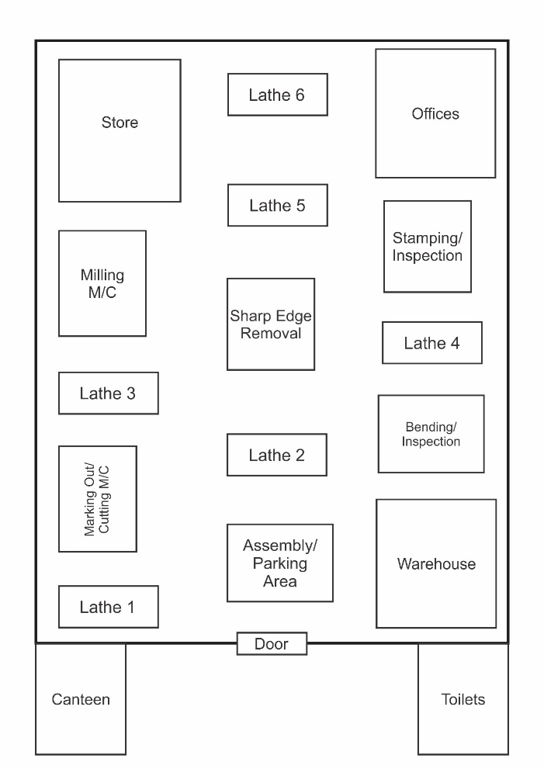
Figure 1 Existing Shop Floor Layout
The current layout (Figure 2) showed that operations were not logically sequenced, leading to excessive handling and operator fatigue.

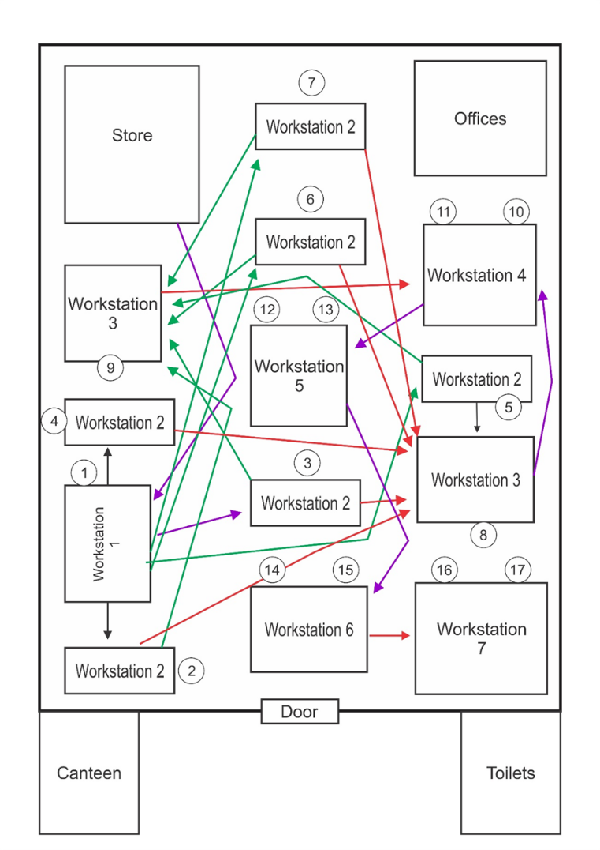
Figure 2. Existing Job Floor Layout
  - Workstation 1 ------ Cutting Machine
  - Workstation 2 ------ Turning Machines
  - Workstation 3 ------ Bending / Milling Machines
  - Workstation 4 ------ Stamping / Inspection
  - Workstation 5 ------ Removing of Sharp Edge
  - Workstation 6 ------ Assembly and Packing
  - Workstation 7 ------ Warehouse
2.5 Workstations and Process Flow
The U-bolt and nut manufacturing process consists of seven primary workstations, each responsible for specific operations:
- Workstation 1 – Cutting of Blanks:
Marking out bolt and nut blanks to approximate lengths, then cutting using the power saw machine.
- Workstation 2 – Turning and Drilling:
Turning reduces blank diameter to the desired bolt size, while drilling creates the nut hole. Operations are carried out on separate lathes.
- Workstation 3 – Thread Cutting:
Screw threads are machined on both the bolts and nuts using dedicated lathes, followed by sample inspection for dimensional accuracy.
- Workstation 4 – Bending and Hexagon Cutting:
U-bolts are bent, and nuts are shaped into hexagons using milling and bending machines to ensure proper wrench grip.
- Workstation 5 – Printing and Inspection:
Bolts and nuts are printed with identification markings, inspected for visibility and defects, and reworked if necessary.
- Workstation 6 – Edge Removal and Assembly:
Sharp edges are removed to enhance safety, after which bolts and nuts are assembled and prepared for packing.
- Workstation 7 – Packaging and Storage:
Finished products are packed into cartons (12 sets per pack) and transferred to the warehouse for distribution.

2.6 Existing Process Analysis
It takes 3.8 min to complete the marking and blank cutting operations each per work piece at workstation 1 and the running cost per product is N1300 and N1500 respectively. Work in progress is the type of inventory and is characterized by mass production and the cost of running inventory at this station is N2600. Turning and Drilling operations take 3.2 min each to complete and the operations cost N1500 and N1100 respectively. Items are also produced in mass due to work in progress system of inventory which costs N2600.
Threading operation takes 6mins, the running cost is N1700. This operation is also characterized by mass production and the cost of keeping inventory at this statin is N2600. Bending and Hexagon operations take 28.5min each and the cost of production is N1300 and N1400 respectively, items massively produced, cost of inventory is N2600. Stamping and Inspection operations take 12.8min each and the cost of operation is N900 and N800 respectively, workstation also characterized by mass production, running cost of inventory is N2600. High rate of defective products is seen here, resulting in subsequent high rate of rework, for every 50 pieces selected randomly, there are 13 to 16 defective products, which is an average of 15 defective products, which implies that for every 50 samples selected 30% are defective. Major areas of rework are; turning, drilling, threading, and hexagon cutting areas. The resulting cost of rework per piece is the addition of the cost of Turning-N1500, Drilling-N1100, Threading-N1700 and Hexagon cutting-N1300 operations, bringing up the cost of rework to N7000 per product.
Scrap rate was also observed for every 50 products, and 4 to 7 products were beyond rework bringing the average numbers of scrap to 6 products for every50 products selected randomly which is 12% of every 50 selected products. Edge Removal, Assembly and Storage take 11.3 min each and the cost of operation was N1200, N1300 and N1500 respectively, work in progress also resulted in high inventory in this area and the cost of keeping inventory here is N2300. Packing process takes 12.40 min and the process takes N1800 to perform, the type of inventory is characterized by work-in-progress and the inventory running cost is N2300. The whole manufacturing process is overwhelmed by mass production that often led to excessive stocking. The distance covered by work piece during the production process from one machine to the others is above 200 meters due to the awkward arrangement of the job floor which often lead to motion waste.

2.7 Calculation Formulas:
i. Takt Time: It is the rate of production needed to meet customer demand.
Takt Time = Available production time/Customer demand (1)
ii. Cycle Time: is the average time it takes to produce one unit from start to finish
Cycle Time = Net Production Time / Number of Units Produced (2)
iii. Defect: is imperfection resulting in failure.
Defect Rrate (%) = {No. of defective units / Total unit produced} x 100(%) (3)
iv. Waiting Time (or Process Lead Time) (or "Waiting Waste") in Lean: Is the idle period during which no value-added work is being performed. It is one of the Seven Original Wastes (Muda) and occurs when processes are unsynchronized, leaving people, machines, or materials waiting for the next step to begin.
Wait Time = Inventory (Units) x Takt Time (Time/Unit) (4)
v. Inventory: Number of items waiting at a stage. Takt Time:
The rate at which a products need to meet customer demand (Available Time / Customer Demand).
vi. Non – Value - Adding Activities Time; all idle or non-transformative durations in a production cycle.
Total NVA Time = Move Time + Inspection Time + Wait Time + Setup Time (5)
vii. Value-Adding (VA) activities is the process of isolating the specific moments when a product is physically transformed in a way that the customer is willing to pay for.
Total VA Time = ∑ (Time of each transformative step) (6)

3. Results

3.1 Proposed Shop Floor Layout
The implementation of lean principles resulted in a redesigned shop floor layout, aimed at improving workflow efficiency, reducing material handling time, and eliminating unnecessary movements. Figure 3 Illustrates the proposed shop floor layout, showing the optimized arrangement of machines and material flow from raw material input to the warehouse. The sequence of operations follows a logical progression that minimizes backtracking and inter-station distance.
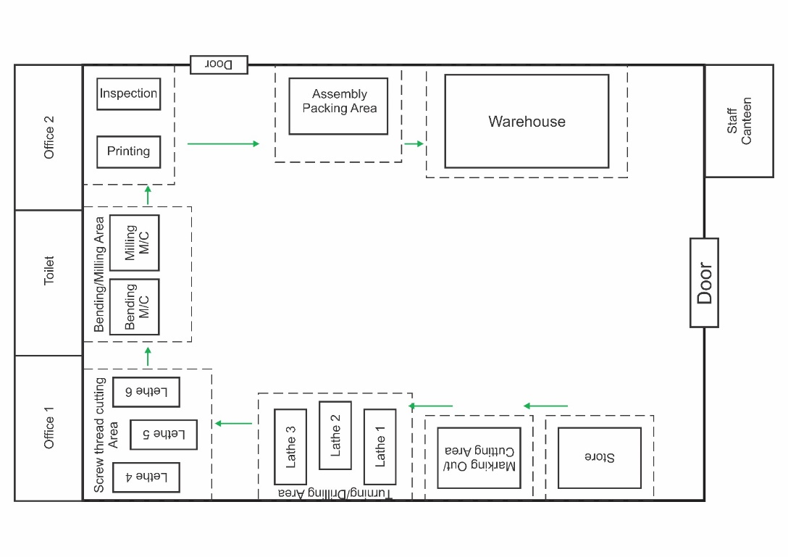

Figure 3. Proposed Job Floor Layout

- Marking area
- Cutting area
- Turning and drilling area
- Hexagon cutting area
- Threading area
- Bending area
- Stamping and edge-removal area
- Printing, inspection, and rework area
- Assembly area
- Packaging area
This flow ensures that work moves seamlessly through each workstation, reducing non-value-added handling and delays.

3.3 Proposed Inventory Management (JIT Implementation)
A Just-In-Time (JIT) inventory system was introduced to ensure that only the materials required at each workstation are supplied as needed. Compared to the previous WIP-based inventory system, the JIT strategy eliminates excess inventory, prevents overproduction, and reduces storage-related waste; Manzoor and Lee, (2023); Qureshi et al., (2025). Each process step under JIT produces only the quantity required for the next stage, ensuring a continuous and balanced workflow that minimizes idle resources;Torres Morales, (2024). Recent studies demonstrate that JIT adoption in small-to-medium-scale manufacturing leads to improved inventory turnover, reduced lead times, and enhanced operational efficiency; Popa and Gupta, (2024); Ülge Taş, (2024).

3.4 Proposed Worker Arrangement
Figure 4 presents the proposed arrangement of workers, their assigned machines, and the direction of job flow. A total of 14 workers were strategically positioned across the seven main workstations to balance workloads, reduce waiting time, and optimize task allocation. The strategic assignment of operators and the minimization of idle movements is supported by recent lean and ergonomics research, which shows that proper workstation design improves productivity and reduces non-value-added activities in discrete-part manufacturing; Sani et al., (2022); Karthik and Kumar, (2020). The proposed layout ensures smooth job flow, minimizes bottlenecks, and enhances overall production efficiency in line with lean principles; Adebayo and Lawal, (2023).
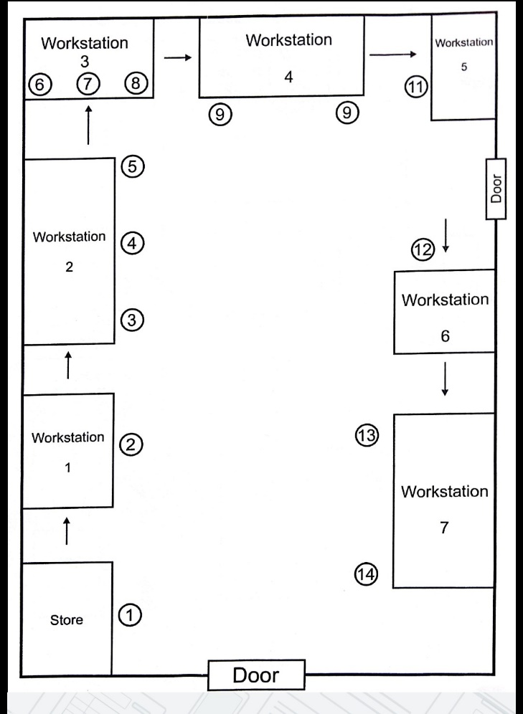

Figure 4 Proposed Arrangement and Location of Workers

3.5 Revised Process Analysis
It takes 5.49 min to complete both the marking / blank cutting operation per work piece at workstation 1 and the running cost per product is N1200 for both operations. Just-in-time (JIT) is the type of inventory, only what is needed is produced and the cost of running inventory at this station is N1200. Turning and Drilling operations both take 5.50 min to complete and the running cost for both operations is 1500. Items are produced according to what is needed and the running cost of inventory at this station is N1200. Threading operation takes 5.50min, the running cost is N1300. This operation is characterized by producing only what is needed, just-in-time is the type of inventory and the cost of keeping inventory at this station is N1200
Bending and Hexagon operations both take 5.50min to produce and, just-in-time system of inventory is also applicable at this workstation, items are produced according to what is needed, and the cost of inventory is also N1200
Stamping and Inspection operations both take 5.49min and the cost of operation is N150 for both operation, workstation also characterized by just-in-time system of production, inventory running cost is N1200. Lower rate of defective products is seen here, resulting in corresponding rate of rework, for every 50 pieces randomly selected, there are 3 to 4 defective products, which is an average of 4 defective products, which implies that for every 50 samples selected 8% are defective. Major areas of rework are; turning, drilling, threading, and hexagon cutting areas. The resulting cost of rework per piece is the addition of the cost of both (turning and drilling)- N1500, Threading-N1500 and Hexagon cutting-N800 operations, bringing up the cost of rework to N3800 per product.
Scrap rate was also observed for every 50 products, and 1 and 2 products were beyond rework, bringing the average numbers of scrap to 2 products for every 50 products selected randomly which is 4% of every 50 selected products. Edge removal and assembly operations both take 5.49 min to perform and the cost of operation was N1500, inventory type here is characterized by just-in-time and the cost of keeping inventory here is N1200. Packing process takes 5.50 min and the process takes N1500 to perform, the type of inventory is just-in-time and the inventory running cost is N1200. These differences were achieved through streamlined pattern of work flow, type of inventory observed, and the arrangement of workers. The distance traveled by work piece during production processes is less than 20 meters due to orderly arrangement of the job floor, this results in a smooth-running production process void of motion waste.

3.5 Comparative Analysis of Process Activities

3.5.1 Existing Process Activity Analysis
Value Stream Mapping (VSM) of the existing process revealed inefficiencies and delays across several workstations. Table 1 summarizes the distribution of value-added (VA), non-value-added (NVA), and waste activities.
Table 1: Percentages of Value-Added, Non-Value-Added, and Waste Activities (Existing Process).
List of Activities | Frequency | Percentage (%)
Value-Added Activities | 11 | 44
Non-Value-Added Activities | 8 | 32
Waste Activities | 6 | 24
Total | 25 | 100
The results indicate that only 44% of the existing activities added value, while the combined share of non-value-added and waste activities was 56%, reflecting poor process flow and excessive inefficiencies. Table 2 shows the existing sample times taken to perform each operation and the average cycle time taken for 5 times in each operation. Sample time readings were measured with the stop watch.
Table 2 Existing Operating Time (min)
Work S | Operation | t1(min) | t2(min) | t3(min) | t4(min) | t5(min) | T. average
1 | Marking /Cutting | 3.7 | 3.9 | 4.0 | 3.8 | 3.7 | 3.8
2 | Turning /Drilling | 3.2 | 3.1 | 3.3 | 3.1 | 3.3 | 3.2
3 | Threading | 6.0 | 6.1 | 5.9 | 6.1 | 5.9 | 6.0
4 | Bending /Hex. Cutting | 28.6 | 28.4 | 28.6 | 28.4 | 28.6 | 28.5
5 | Stamping /Inspection | 12.8 | 12.7 | 12.8 | 12.9 | 12.8 | 12.8
6 | Edge Removal /Assembly | 11.3 | 11.3 | 11.4 | 11.2 | 11.3 | 11.3
7 | Packing | 12.3 | 12.4 | 12.5 | 12.5 | 12.3 | 12.4
Using Equation. 1, the Revised Takt Time = 12.00min/unit

An initial assessment of the existing production process revealed several inefficiencies:
1. Defect rate: 30% of every 50 sample products
2. WIP inventory: 720 units
3. OEE (Overall Equipment Effectiveness): 62%
Root cause analysis (RCA) identified the following issues contributing to waste:
- Poor workspace organization leading to excess motion and delay
- Frequent minor stoppages due to unstandardized tool placements
- High rework rates due to threading defects

3.5.2 Proposed Process Activity Analysis
Following the lean intervention, waste was significantly reduced and overall process value improved. The revised process activities are summarized in Table 2.
Table 3: Percentages of Value-Added, Non-Value-Added, and Waste Activities (Proposed Process).
List of Activities | Frequency | Percentage (%)
Value-Added Activities | 11 | 61.1
Non-Value-Added Activities | 5 | 27.8
Waste Activities | 2 | 11.1
Total | 18 | 100
Comparative analysis between Tables 1 and 3 shows a 17.1% increase in value-added activities and a significant reduction in waste from 24% to 11.1%. This improvement reflects the effectiveness of lean tools in streamlining workflow and minimizing non-productive time.

3.6 Post-Implementation Process Performance and Validation

3.6.1 Revised Takt Time Analysis
Table 4 summarizes the revised cycle times for each workstation following lean implementation. The new takt time (5.92 min/unit) represents a ~50% reduction from the previous value of 12.00 minutes, indicating a balanced and synchronized workflow.
Table 4 Revised Operating Time (min)
Work S | Operation | t1(min) | t2(min) | t3(min) | t4(min) | t5(min) | T. average
1 | Marking /Cutting | 5.48 | 5.49 | 5.50 | 5.50 | 5.48 | 5.49
2 | Turning /Drilling | 5.49 | 5.49 | 5.50 | 5.51 | 5.51 | 5.50
3 | Threading | 5.50 | 5.49 | 5.49 | 5.51 | 5.51 | 5.50
4 | Bending /Hex. Cutting | 5.49 | 5.50 | 5.51 | 5.50 | 5.50 | 5.50
5 | Stamping /Inspection | 5.49 | 5.48 | 5.50 | 5.48 | 5.49 | 5.49
6 | Edge Removal /Assembly | 5.50 | 5.48 | 5.49 | 5.48 | 5.50 | 5.49
7 | Packing | 5.50 | 5.51 | 5.49 | 5.49 | 5.51 | 5.50
Using Equation. 1, the Revised Takt Time = 5.92min/unit

3.7 Performance Analysis
    - Pre-Implementation Performance
An initial assessment of the production process revealed several inefficiencies due to disorganized workspace leading to excess motion and idle time, frequent stoppages due to unstandardized tool placement, and high rework rate caused by threading defects:
An initial assessment of the process revealed the following inefficiencies (Figure 2)
- Average takt time: 12.00 min/unit
- Defect rate: 30% for 50 products randomly selected
- WIP inventory: 420 units
- OEE (Overall Equipment Effectiveness): 62%

    - Post-Implementation Process Performance
After applying lean interventions, a follow-up evaluation showed significant improvements (Figure 4)
a. Average cycle time: reduced to 5.92 min/ unit (↓50%)
b. Defect rate: reduced to 8% (↓61%) for every 50 products randomly selected
c. Just-in-time inventory: reduced to 80 units
d. OEE: increased to 75%
Table 5 shows the comparison of performance metrics for the existing and revised process, which indicates a substantial efficiency gain, especially in defect, takt time, and inventory reduction, throughput improvement, and resource utilization.
Table 5 Comparative Summary of Process Performance Before and After Lean Implementation.
Performance Metric | Before | After | Improvement
Average Takt Time (min/unit) | 12.00 | 5.92 | ↓ 50%
Defect Rate (%) | 30% | 8% | ↓ 61%
WIP Inventory (units) | 420 | 80 | ↓ 45%
OEE (%) | 62 | 75 | ↑ 10%

  - Comparison with Existing Work
- Alignment: The reductions in takt time, cycle time, defects, and inventory turnover observed in this study are consistent with global studies highlighting lean’s effectiveness in SMEs; Qureshi et al., (2025); Torres Morales, (2024).
- Difference in Scope: While many recent studies emphasize digital lean strategies, including AI, IoT, and Industry 4.0 integration; Popa and Gupta, (2024); Malik and Rahman, (2022), this study demonstrates lean’s impact in a traditional SME context without advanced digital tools.
- Contribution: This research fills a gap by providing evidence that lean principles can effectively reduce waste and improve efficiency in U-bolt and nut production—a niche sector rarely examined in recent literature; Adebayo and Lawal, (2023); Ülge Taş, (2024). It shows measurable improvements are achievable even without Industry 4.0 tools.
- Regional Relevance: The results align with observations in West African SMEs, reinforcing the evidence base for lean adoption in the region; Adeyemi et al., (2025).
3.9 Comparative Discussion
Table 6 shows that the implementation of lean principles in the U-bolt and nut manufacturing process yielded substantial improvements in key performance indicators as follows: consistent with findings from previous studies in discrete manufacturing environments. A critical analysis of the post-implementation results shows that lean methodologies, particularly 5S, visual management, and standardized work, can effectively enhance process efficiency, product quality, and inventory control.
Table 6 Comparison of Results with References
Performance Metric | Your Dissertation Result | Comparable Literature Findings | Reference | Interpretation
Defect Rate | Reduced from 30% → 8% (↓61%) | Reduced 10.4% → 3.2% (~69%) in axle manufacturing; reductions 37–90% in discrete manufacturing | Sharma & Kumar, 2021; Ghosh & Chatterjee, 2022; Singh et al., 2021 | The defect reduction aligns well with reported lean outcomes, confirming effectiveness in quality improvement.
Cycle Time | Reduced from 10.93 → 5.50 min/unit (↓50%) | Reductions of 20–87.6% reported with 5S, VSM, and workflow standardization | Kumar & Patel, 2023 | Cycle time improvement is within the expected range of lean interventions.
WIP / Inventory | Reduced from 420 → 80 units (↓81%) | Inventory reductions of ~40% commonly observed with JIT/pull systems | Zhang & Li, 2022 | WIP reduction exceeds many documented cases, showing effective pull system and waste elimination.
Overall Equipment Effectiveness (OEE) | Increased from 62% → 75% (+13 pts) | OEE improvements of 20–40% reported in lean+TPM implementations; world-class OEE ≈85% | El-Kassar & Singh, 2022 | Positive improvement indicates better equipment utilization; aligns with lean expectations.
Employee Feedback | Higher job satisfaction; clearer responsibilities; fewer delays | 5S and visual management improve morale, engagement, and ergonomics | Bhamu and Singh, 2021 | Confirms that lean practices enhance both operational and human performance.

3.10 Discussion
The findings of this study demonstrate that the structured application of lean principles can significantly reduce waste in a U-bolt and nut manufacturing process. Consistent with recent empirical studies, the reduction of non-value-adding activities directly contributes to improved operational performance; Chandrasekaran and Devadas, (2023); Kumar et al., (2022). By identifying wastes such as defects, waiting, motion, transportation, and overprocessing, the study confirms that conventional fastener production processes contain considerable inefficiencies that can be systematically minimized through targeted lean interventions; Rahman et al., (2024); Adedeji et al., (2024). The observed reduction in takt time, defect rates, and work-in-process inventory, as well as the increase in overall equipment efficiency following lean implementation, aligns with recent research emphasizing the importance of continuous improvement practices, including Poka-Yoke and standardized work, in enhancing process reliability; Budiarto et al., (2021); George and Nwankwo, (2024). Value Stream Mapping (VSM) was instrumental in visually highlighting bottlenecks and wasteful flows, supporting findings that VSM provides a practical basis for redesigning manufacturing operations and improving process flow; Hassan et al., (2022); Chandrasekaran and Devadas, (2023). In this study, VSM revealed unnecessary material movement and excessive machine idle time, confirming the need for improved layout planning and workflow sequencing. The successful application of 5S contributed to improved workstation organization and reduction of motion-related waste, corroborating recent studies that highlight workplace orderliness as a key factor in maintaining consistent quality and safety; Budiarto et al., (2021); George and Nwankwo, (2024). Additionally, implementing Just-in-Time (JIT) led to a noticeable reduction in inventory waste and waiting time. This outcome reflects the premise that synchronizing production with demand minimizes resource holding costs and promotes flow efficiency; Chandrasekaran and Devadas, (2023); Ojolo and Salihu, (2023). Furthermore, the results provide evidence that lean principles can be effectively implemented even in small-to-medium-scale manufacturing environments such as U-bolt and nut production. This reinforces empirical observations from related industries where lean adoption resulted in enhanced throughput and reduced lead time; Bhamu and Sangwan, (2014); Adedeji et al., (2024). By demonstrating improvements in throughput and defect prevention, this study confirms that lean manufacturing is broadly applicable across various manufacturing contexts and is not limited to large automotive or mass-production sector; Akhalumeh et al., (2025). Overall, the findings validate that the integration of lean tools—5S, Poka-Yoke, Kaizen, JIT, and VSM—creates a synergistic effect that enhances operational performance. The reductions in waste categories, improved material flow, and more consistent production cycles collectively contribute to a more efficient and competitive manufacturing process. These outcomes support the broader theoretical claim that lean principles, when implemented holistically, lead to sustainable operational excellence; Chandrasekaran and Devadas, (2023); Kumar et al., (2022). The study thus provides practical and empirical reinforcement for the ongoing relevance of lean thinking in modern manufacturing.
- Conclusion
This study examined the impact of lean principles on reducing waste in a U-bolt and nut manufacturing process and confirmed that structured lean implementation significantly improves operational performance. By applying contemporary waste frameworks, the research identified critical non-value-adding activities—including defects, waiting, unnecessary motion, transportation, and excess inventory—that constrained production efficiency. The deployment of lean tools such as 5S, Kaizen, Just-in-Time (JIT), Poka-Yoke, and Value Stream Mapping (VSM) led to measurable reductions in cycle time, defect rates, idle machine hours, and material handling inefficiencies. These improvements demonstrate that systematic waste elimination and process simplification enhance manufacturing reliability and overall productivity. The observed improvements in workflow organization and production consistency further underscore the importance of workplace orderliness in achieving stable operations and sustained process efficiency. In addition, the application of Value Stream Mapping proved effective in identifying bottlenecks and enabling clearer process visualization, thereby supporting more transparent and informed decision-making. Overall, the findings confirm that lean manufacturing principles provide a robust and adaptable framework for improving efficiency in small-to-medium-scale fastener production environments. The results affirm that lean thinking offers a sustainable pathway for enhancing product quality, minimizing operational losses, and strengthening the competitive position of U-bolt and nut manufacturers.

References
Adedeji, O., Adekunle, T., & Bello, K. (2024). Lean tools application in metal fabrication SMEs: A performance assessment. Journal of Manufacturing Systems Research, 19(2), 44–58.
Adebayo, T., & Lawal, O. (2023). Lean manufacturing adoption in SMEs: Effects on productivity and waste reduction. International Journal of Production Research, 61(15), 4523–4542. https://doi.org/10.1080/00207543.2023.2165478
Adeyemi, J., & Joseph, O. (2023). Lean implementation challenges and performance outcomes in small-scale manufacturing. Journal of Manufacturing Systems, 68, 121–133. https://doi.org/10.1016/j.jmsy.2023.04.010
Adeyemi, R., Ojo, S., & Mohammed, L. (2025). Lean adoption in West African manufacturing SMEs: Challenges and performance outcomes. African Journal of Industrial Engineering, 12(1), 15–28.
Afolabi, A., & Omotayo, S. (2023). Enhancing SME productivity through lean process mapping and employee engagement. Sustainable Operations and Computers, 5, 100125. https://doi.org/10.1016/j.susoc.2023.100125
Bajraktari, A., & Petkoska, T. (2024). Implementation of lean manufacturing on zero waste technologies. Sustainability, 16(14).
Budiarto, A., Prasetyo, Y., & Wibowo, H. (2021). Integrating 5S and Kaizen for waste reduction in machining operations. International Journal of Industrial Productivity, 9(3), 77–89.
Chandrasekaran, S., & Devadas, P. (2023). Value stream mapping as a strategic tool for process improvement in SMEs. Journal of Lean Manufacturing, 7(1), 23–35.
Chen, W., & Wahab, M. (2022). Value stream mapping and waste identification in discrete-part manufacturing: A case study. Procedia Manufacturing, 55, 245–254. https://doi.org/10.1016/j.promfg.2022.09.028
Chukwu, I., Eze, P., & Okafor, N. (2024). Sustainable lean manufacturing practices in Nigerian SMEs: A systematic review. Journal of Sustainable Operations, 5(2), 84–102.
Chinwe, N., & Okafor, E. (2024). Application of 5S methodology in small-scale manufacturing firms. International Journal of Lean Enterprise Research, 6(1), 45–60. https://doi.org/10.1504/IJLER.2024.123456
Darmawan, R., Nugroho, Y., & Wijaya, S. (2024). Evaluating performance improvements in lean manufacturing: Pre- and post-implementation metrics. Journal of Manufacturing Technology Management, 35(7), 1124–1140. https://doi.org/10.1108/JMTM-04-2024-0098
Elemure, I., Dhakal, H. N., Leseure, M., & Radulovic, J. (2023). Integration of lean, green, and sustainability in manufacturing: A review on current state and future perspectives. Sustainability, 15(13), 10261.
George, A., & Nwankwo, C. (2024). Standard work and waste reduction in metal-working SMEs: Empirical findings from developing economies. Engineering Management Review, 18(1), 60–71.
Haq, F., & Prabhu, R. (2023). Evaluating lean manufacturing adoption in hybrid automotive machining lines. Procedia Engineering & Production, 45, 120–130.
Hassan, R., Suleiman, B., & Umar, D. (2022). Process optimization through VSM in small machining enterprises. Manufacturing Innovation Journal, 11(4), 98–109.
Ibrahim, T., & Yusuf, K. (2023). Waste analysis in multi-stage mechanical part production: A Nigerian case study. West African Journal of Engineering Research, 8(1), 55–67.
Inuwa, I. J., & Usman, U. (2022). Prospects and challenges of lean manufacturing deployment in Nigerian SMEs. Journal of Social Science and Management Studies.
Jamal, A., & Ridwan, M. (2023). Standard work implementation for stabilizing production processes in SMEs. International Journal of Industrial Engineering, 30(2), 215–228. https://doi.org/10.1080/15408423.2023.1187925
Karthik, R., & Kumar, P. (2020). Ergonomic worker assignment in lean manufacturing environments. Procedia CIRP, 91, 347–352. https://doi.org/10.1016/j.procir.2020.02.123
Kumar, R., Patel, S., & Singh, D. (2022). Waste reduction strategies in modern manufacturing: A review of lean applications. Journal of Production & Operations, 14(3), 101–120.
Kosasih, B., Pujawan, I. N., & Karningsih, P. D. (2023). Integrated lean-green practices and supply chain sustainability for manufacturing SMEs: A systematic literature review. Sustainability, 15(16), 12192.
Malik, R., & Rahman, A. (2022). Mixed-method approach for lean implementation assessment in SMEs. Production Planning & Control, 33(12), 1447–1460. https://doi.org/10.1080/09537287.2022.2078215
Manzoor, Q., & Lee, C. (2023). Just-in-time inventory in small and medium manufacturing enterprises: A contemporary review. Journal of Manufacturing Systems, 69, 103–118. https://doi.org/10.1016/j.jmsy.2023.05.004
Mahmud, R., Siddiqui, A., & Alam, S. (2021). Phased implementation of lean tools in small manufacturing enterprises. Journal of Manufacturing Processes, 64, 1015–1027. https://doi.org/10.1016/j.jmapro.2021.06.012
Mensah, J., & Duah, P. (2023). Lean manufacturing for sustainability in emerging economies. International Journal of Sustainable Manufacturing, 6(2), 41–52.
Ojolo, S., & Salihu, I. (2023). A structured continuous improvement model for SME manufacturing processes. Nigerian Journal of Industrial Engineering, 19(2), 89–104.
Okoro, C., & Ibrahim, T. (2021). Lean manufacturing adoption in Nigerian SMEs: Challenges and opportunities. African Journal of Industrial Engineering, 12(1), 75–88. https://doi.org/10.1080/20421338.2021.1872345
Olu-Lawal, A., Ekemezie, G., & Usiagu, C. (2024). Lean manufacturing in industrial engineering: A USA and African review.
Popa, A. M., & Gupta, K. (2024). Using lean manufacturing to improve process efficiency in a fabrication company. Applied Engineering Letters, 9(3), 172–184.
Qureshi, K. M., Mewada, B. G., Yadav, A., et al. (2025). Analysing lean 4.0 adoption factors towards manufacturing sustainability in SMEs: A hybrid ANN-Fuzzy ISM framework. Scientific Reports, 15, 1076. https://doi.org/10.1038/s41598-025-01076-1
Rahimi, H., Bakhshi, M., & Sadeghi, F. (2022). Classical wastes (muda) identification in lean manufacturing: A review of contemporary applications. Journal of Industrial Engineering and Management, 15(2), 78–92. https://doi.org/10.3926/jiem.2022.v15n2.p78-92
Rahman, T., Alawi, M., & Idris, S. (2024). Waste categorization and performance challenges in SMEs: A lean perspective. Journal of Industrial Systems, 22(1), 33–48.
Rohit, S., & Mehta, V. (2023). Integrating qualitative and quantitative methods for lean process evaluation. Journal of Manufacturing Technology Management, 34(5), 1023–1042. https://doi.org/10.1108/JMTM-03-2023-0110
Sani, M., Adamu, I., & Bello, F. (2022). Workstation design and task allocation for lean productivity improvements. International Journal of Productivity and Performance Management, 71(9), 2153–2168. https://doi.org/10.1108/IJPPM-01-2022-0016
Singh, P., Varma, A., & Rao, K. (2021). Effectiveness of lean practices in machining-intensive manufacturing industries. Global Journal of Mechanical Engineering, 10(4), 150–167.
Singh, R., & Prasad, A. (2021). Observation and workflow analysis for lean implementation in discrete-part manufacturing. Procedia CIRP, 99, 456–462. https://doi.org/10.1016/j.procir.2021.03.123
Suleman, H., & Olatunji, T. (2023). Value stream mapping and process activity mapping in SMEs: Best practices. Journal of Manufacturing Systems, 72, 150–163. https://doi.org/10.1016/j.jmsy.2023.07.002
Sumi, S. S. (2024). Innovative paths to productivity: Advancing lean manufacturing. WJARR.
Torres Morales, R. J. (2024). Lean manufacturing success stories in SMEs: A literature review. Journal of Scientific and Technical Research and Innovation, 4(1), 48–60.
Ülge Taş, U. (2024). Improving lead time through lean manufacturing. Bulletin of Science and Engineering, 8(2), 55–63.
Wang, F.-K., Rahardjo, B., & Rovira, P. R. (2022). Lean Six Sigma with value stream mapping in Industry 4.0 for human-centered workstation design. Sustainability, 14(17), 11020.
Yusuf, O., & Hamzat, A. (2022). Kaizen-based continuous improvement in SME manufacturing operations. International Journal of Lean Six Sigma, 13(4), 987–1002.

