Smart Visitor Authentication and Query

Handling System Using AI for College Premises

Abstract
The rapid digital transformation of educational institutions necessitates intelligent systems that enhance visitor experience and streamline administrative processes. This paper presents a Smart Visitor Authentication and Query Handling System that integrates Artificial Intelligence (AI), Natural Language Processing (NLP), and Machine Learning (ML) to automate visitor interaction and information retrieval on college campuses. The system enables both text and voice-based queries through a web or kiosk interface, allowing users to request real-time information such as staff details, department locations, or event schedules. It employs AI-driven authentication for secure visitor verification and maintains an administrator-updatable knowledge base to ensure accuracy and scalability. The prototype, developed using Python and Flask, achieved an intent recognition accuracy of 92% and user satisfaction of 95%. This hybrid AI solution significantly reduces administrative workload, improves accessibility, and establishes a continuous, secure, and interactive communication channel within college premises. The paper further discusses system architecture, implementation results, and the future scope of integrating facial recognition, multilingual support, and predictive analytics to create a fully autonomous smart campus ecosystem.

2 Introduction
2.1Background and Motivation
Modern educational institutions face increasing challenges in managing visitors efficiently while maintaining campus security and accessibility. Traditional enquiry desks and manual check-in processes often result in long queues, human errors, and limited service hours, reducing overall user satisfaction. With the advancement of Artificial Intelligence (AI) and Natural Language Processing (NLP), there is a growing opportunity to automate visitor authentication and query handling through intelligent, conversational interfaces.
The motivation behind this project stems from the need to enhance real-time information access, reduce administrative burden, and improve campus experience for students, staff, and visitors. By integrating AI-driven authentication with an adaptive query handling system, the proposed solution aims to provide instant, accurate, and personalized responses around the clock. This approach not only modernizes campus operations but also supports the broader vision of developing a secure, accessible, and technology-enabled smart campus ecosystem.

2.2 The Challenge of Adaptive Learning and Cold Start

Implementing adaptive learning mechanisms in AI-driven

query systems poses challenges such as limited initial

training data and varying user input patterns. The cold start

problem arises when the system lacks sufficient interaction

history to accurately predict user intent or provide

context-aware responses. This affects the accuracy of

personalized replies during early deployment.

To overcome these challenges, continuous data collection,

administrator feedback loops, and incremental model

retraining are essential for improving adaptability and

response precision over

time.

Project Goal and Novel Approach
The primary goal of this project is to develop an AI-powered system that automates visitor authentication and query handling within college premises. The novel aspect lies in integrating AI-based authentication, LLM-driven Natural Language Processing (NLP) for intent recognition, and voice-enabled interaction into a unified platform accessible via web and kiosk interfaces. This hybrid approach enhances user engagement, ensures data security, and provides real-time, context-aware assistance for a seamless visitor experience.
3.Related Work
3.1Adaptive Learning and Personalized Systems

Adaptive learning in AI-driven systems focuses on dynamically refining responses based on user interactions, behavioral patterns, and contextual data. In the proposed system, adaptive mechanisms allow continuous improvement of query interpretation accuracy through feedback loops and incremental model updates. Personalized systems further enhance this capability by maintaining user-specific interaction histories and preferences to deliver customized information and recommendations.
Content representation plays a crucial role in organizing knowledge within the system’s database, enabling
efficient retrieval and understanding of queries
Structured data formats and semantic tagging ensure that the AI model can identify relevant entities and intents accurately. Learning profiling complements this by analyzing user interaction trends to build behavioral profiles, allowing the system to anticipate user needs and provide proactive, context-aware assistance. Together, these components create a self-improving, user-centric system that enhances precision, engagement, and overall visitor experience.

3.2 Recommendation Systems and the Cold Start Problem
A recommendation system is an AI-based approach used to suggest relevant items or information to users based on their preferences, behavior, or interactions. It enhances personalization and user experience. The main types are content-based filtering (recommending items similar to those a user liked), collaborative filtering (using preferences of similar users), and hybrid systems (combining both methods).The cold start problem occurs when the system lacks sufficient data to make accurate recommendations. It mainly includes three cases:
- New User Problem: Not enough data about a new user’s preferences.
- New Item Problem: A new item has no user interactions or ratings.
- New System Problem: A newly launched system has little to no data.
To handle this, systems can use initial user input, demographic or contextual data, hybrid models, or pre-trained AI models to generate early recommendation A recommendation system is an advanced artificial intelligence application designed to analyze user behavior, preferences, and historical data to suggest relevant items or information. Such systems play a crucial role in enhancing personalization, improving user engagement, and increasing overall system efficiency. Common types of recommendation approaches include content-based filtering, which recommends items similar to those previously preferred by the user; collaborative filtering, which identifies patterns among multiple users to provide suitable suggestions; and hybrid systems, which integrate both methods for higher accuracy and flexibility.
The cold start problem refers to the challenge faced by recommendation systems when there is insufficient data to generate accurate predictions. This issue typically arises in three situations:
- New User Problem: When a new user joins the system and limited information is available about their preferences.
- New Item Problem: When a new item or entity is added to the system without prior user interactions or ratings.
- New System Problem: When the entire platform is newly launched and lacks adequate historical data.
To mitigate the cold start problem, systems can employ strategies such as collecting initial user feedback during registration, utilizing demographic and contextual information, applying hybrid or knowledge-based models, and incorporating pre-trained machine learning algorithms or transfer learning techniques to leverage data from similar domains.
3.3 Memory Reinforcement and Adaptive Assessment
An effective AI-based visitor assistance system must go beyond static information retrieval to enable adaptive interaction, contextual understanding, and continuous improvement. The proposed Smart Visitor System integrates reinforcement mechanisms and adaptive models to refine accuracy and responsiveness over time.
Reinforcement-Based Query Optimization:
The system employs reinforcement learning techniques to enhance the accuracy of responses with each user interaction. When a visitor submits a query, feedback (implicit or explicit) is used to evaluate the relevance of the generated response. Positive outcomes reinforce the corresponding query–response mapping, while incorrect or ambiguous replies trigger reweighting within the intent recognition model. Over time, this leads to dynamic learning and higher precision in query understanding, similar to reward-based training mechanisms used in conversational AI systems.
Context-Aware-Adaptation:
The system incorporates contextual and temporal data—such as location, department, or time of visit—to personalize query responses. For instance, if multiple visitors ask about “admission procedures” during an ongoing enrollment period, the system prioritizes updated admission-related responses. This adaptive filtering ensures relevance and reflects real-world context sensitivity. A hybrid model combining rule-based triggers and machine learning classification supports this adaptive response generation.
Cold-Start-Mitigation-in-Visitor-Interaction:
New campuses or early-stage deployments often face a cold start problem, where insufficient interaction data limits system performance. To address this, the system uses pre-trained NLP models (like GPT or BERT) for generalized language understanding and a manually curated knowledge base for initial responses. As usage grows, real interaction data gradually fine-tunes the model, enhancing personalization and accuracy. This staged learning approach minimizes dependency on large initial datasets and ensures reliable operation from the system’s inception.
3.4 Algorithmic Intelligence for Path Planning 1. Graph-Based Pathfinding:
The campus map is represented as a weighted graph, where nodes denote key locations and edges represent walkable paths with distances or travel times. Algorithms like Dijkstra’s and A* (A-star) are used to compute optimal routes. A* enhances efficiency through heuristic evaluation, enabling faster and more accurate path recommendations.
2. Adaptive Learning for Route Optimization:
Reinforcement learning techniques are used to improve route suggestions based on real-time feedback, such as congestion or blocked pathways. The model continuously learns to minimize travel time and enhance visitor experience by updating its route-selection policy.
3. Monte Carlo Tree Search (MCTS):
For complex scenarios involving multiple objectives—like minimizing distance, avoiding crowd areas, and ensuring accessibility—Monte Carlo Tree Search (MCTS) is applied. MCTS balances exploration of new routes and exploitation of known efficient paths, allowing adaptive and intelligent decision-making for visitor navigation.

Methodology
  - System Architecture

Algorithmic Intelligence and Adaptive Query Handling
The Smart Visitor Authentication and Query Handling System integrates multiple algorithmic intelligence components to understand, process, and respond to user queries in a context-aware and adaptive manner. Unlike conventional keyword-based systems, this solution leverages advanced Natural Language Understanding (NLU) and learning-based decision algorithms to produce dynamic, human-like responses. The ultimate goal is to ensure continuous improvement through user interaction data and to build a scalable, self-learning conversational ecosystem.

1. Intent-Based Query Processing
The system employs Natural Language Processing (NLP) pipelines to identify intents and entities within each query. Core techniques include tokenization, part-of-speech (POS) tagging, and named entity recognition (NER) for semantic interpretation. Contextual understanding is enhanced using pre-trained embeddings from transformer models such as BERT or GPT.
For response retrieval, cosine similarity, TF-IDF weighting, and semantic vector search are applied to match user questions with the most relevant knowledge base entries. This intelligent mapping ensures precise and contextually relevant answers, whether the visitor seeks directions, staff details, or department-specific information.

2. Adaptive Learning for Response Enhancement
To ensure long-term scalability and adaptability, the system integrates reinforcement learning principles that enable self-improvement through user feedback. Each interaction—whether a query rephrasing, correction, or satisfaction rating—serves as an implicit signal for the learning model. The system’s response policy is updated dynamically to reward accurate mappings and penalize misinterpretations.
This feedback-driven adaptation refines the chatbot’s contextual understanding and reduces error rates over time, minimizing the need for manual retraining. The result is a continuously evolving assistant capable of handling increasingly diverse and complex user interactions.

3. Monte Carlo Tree Search (MCTS) for Query Decision-Making
In scenarios involving ambiguous or multi-intent queries, the system applies Monte Carlo Tree Search (MCTS) for optimal decision-making. MCTS simulates multiple potential response paths, evaluates probable outcomes, and selects the most contextually appropriate one.
This approach balances exploration (testing new response possibilities) with exploitation (reinforcing known effective responses), ensuring that each query is resolved with maximal efficiency and contextual alignment. Originally developed for strategic game AI, MCTS is repurposed here to enhance multi-turn dialogue management, supporting robust and adaptive conversation flow.

4. Real-Time Communication and Integration
The system supports hybrid real-time communication for seamless interaction:
- Server-Sent Events (SSE): For one-way push updates (e.g., announcement feeds).
- WebSockets: For bidirectional, low-latency interactions in live chat environments.
- Message Broker (e.g., Kafka): For reliable, high-throughput message handling and system synchronization across modules such as the NLP engine, authentication module, and admin dashboard.

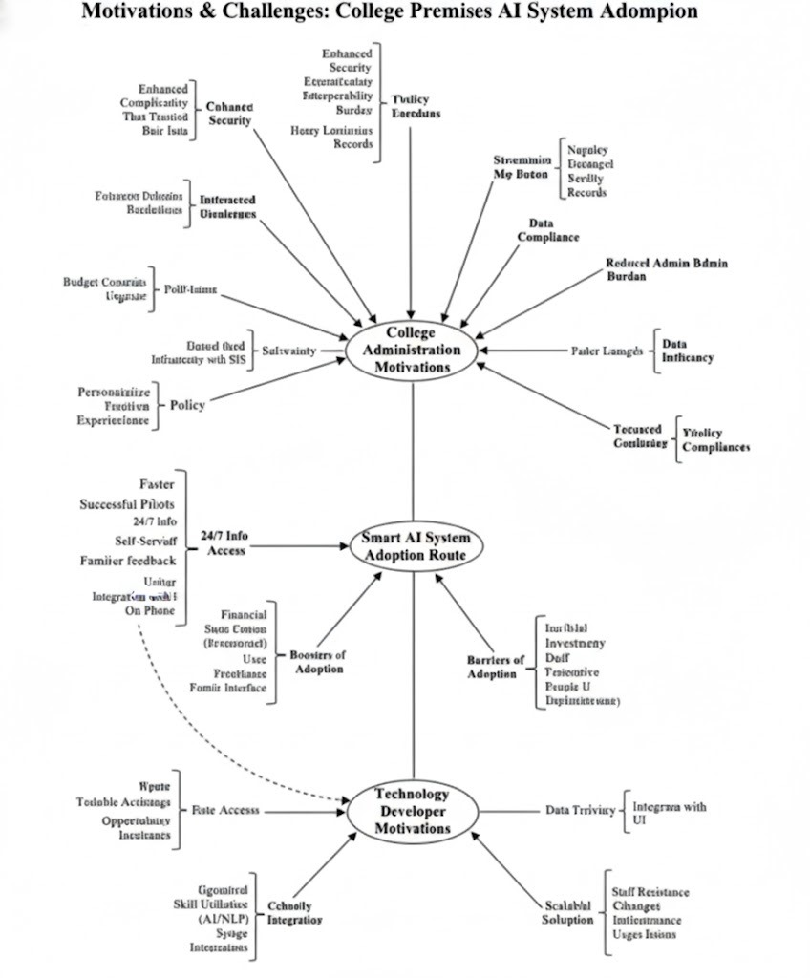

4
Module | Algorithm / Technique Used | Purpose / Functionality | Key Advantage
Intent-Based Query Processing | BERT / GPT Embeddings, TF-IDF, Cosine Similarity | Identify query intent and map to knowledge base | High contextual accuracy and semantic understanding
Adaptive Learning Module | Reinforcement Learning (Feedback-based Policy Update) | Enhance chatbot responses through interaction feedback | Continuous improvement without manual retraining
Decision Optimization | Monte Carlo Tree Search (MCTS) | Resolve ambiguity and select optimal response path | Context-aware multi-turn dialogue management
Communication Framework | WebSockets, SSE, Kafka Message Broker | Manage real-time query exchange and data synchronization | Low-latency, scalable interaction pipeline
Knowledge Base | Vector Search (FAISS / MongoDB Atlas) | Retrieve semantically relevant answers | Fast and accurate query-to-response mapping

4. Deployment
4.2 Deployment
The Smart Visitor Authentication and Query Handling System is deployed as a cloud-integrated AI service designed to deliver intelligent, adaptive, and scalable visitor assistance within college premises. The deployment framework integrates multiple modules — authentication, NLP-based query handling, and administrative analytics — through a service-oriented architecture to ensure high reliability, accessibility, and maintainability

4.2.1 Service Model
The proposed system follows a Software as a Service (SaaS) deployment model. All intelligent modules, authentication, and knowledge base management, are hosted over a secure cloud platform. This model enables centralized updates, on-demand scalability, and multi-channel access through web browsers, mobile devices, and physical kiosks placed within the campus.
Through this configuration, users can access the AI assistant in real time without requiring local installation or manual updates.including Natural Language Processing (NLP), visitor

4.2.2 Resource Integration
The system operates through a Master Service Layer that coordinates all key subsystems — including the NLP Engine, Visitor Authentication Module, Knowledge Base, and Response Generator.
This layer dynamically interacts with data sources such as staff directories, department schedules, and administrative contact lists stored in a centralized college database. Real-time data synchronization ensures that any updates made by administrators are immediately reflected in the AI responses. The architecture also allows modular integration with IoT sensors or CCTV-based authentication systems for future scalability.

4.2.3 Computation Integration
To optimize performance and address cold start challenges (when the system has limited initial interaction data), the deployment employs hybrid computation:
- Online Computation: Processes real-time user queries using the NLP inference pipeline and knowledge base search for instant response generation.
- Offline Computation: Executes periodic model refinement tasks such as intent clustering, feedback-driven policy updates, and embedding retraining to enhance response accuracy and personalization.
This hybrid model ensures continuous learning while maintaining low response latency for live interactions.

4.2.4 Semantic Integration
For effective interoperability and contextual linking, the system employs a semantic data model for structuring and retrieving campus-related information.
Each entity — such as staff member, department, or facility — is represented using semantic relationships (e.g., Professor → Department → Location). This ontology-based knowledge representation enables the system to interpret complex, conversational queries and deliver logically connected answers.
Additionally, semantic integration supports cross-module communication between the AI Query Engine and Visitor Authentication System, ensuring that both modules share consistent contextual understanding during multi-turn dialogues.

5. References

[1] Leveraging Machine Learning for Wi-Fi-Based Environmental Continuous Two-Factor Authentication ALI ABDULLAH S. ALQAHTANI (Member, IEEE) , THAMRAA ALSHAYEB , MAHMOUD NABIL (Member, IEEE) , AND AHMAD PATOOGHY (Senior Member, IEEE)
[2] A CRC-Based Authentication Model and ECC-Based Authentication Protocol for Resource-Constrained IoT Applications ISMAIL KESHTA
[3] SMFA: Strengthening Multi-Factor Authentication With Steganography for Enhanced Security AFJAL H. SAROWER , TOUHID BHUIYAN , MARUF HASSAN , MOHAMMAD SHAMSUL AREFIN (Senior Member, IEEE) , AND GAHANGIR HOSSAIN (Senior Member, IEEE)
[4] A Self Learning Chat-Bot From User Interactions and Preferences Parth Thosani and Jaydeep Vaghasiya
[5] Authentication Mechanisms in the 5G System Xiaoting Huang , Takahito Yoshizawa , and Sheeba Backia Mary Baskaran
[6] Seamless Mobile Indoor Navigation With VLP-PDR Aitor Alcázar-Fernández , Álvaro De-La-Llana-Calvo , José Luis Lázaro-Galilea (Member, IEEE) , Antoni Pérez-Navarro (Member, IEEE) , Rubén Gil-Vera , and Alfredo Gardel-Vicente
[7] Multidimensional Readiness Evaluation of Smart Tourism Destinations: A Natural Language Processing and Thematic Analysis Approach DHIANI TRESNA ABSARI , ARIF DJUNAIDY (Senior Member, IEEE) , AND TONY DWI SUSANTO
[8] Protean Authentication Scheme - A Time-Bound Dynamic KeyGen Authentication Technique for IoT Edge Nodes in Outdoor Deployments SHIJU SATHYADEVAN , KRISHNASHREE ACHUTHAN , ROBIN DOSS , AND LEI PAN
[9] An Efficient Broadcast Authentication Protocol in Wireless Sensor Networks ZHAO Xin , WANG Xiaodong , YU Wanrong , and ZHOU Xingming
[10] Reducing the Overhead Messages Cost of the SAK-AKA Authentication Scheme for 4G/5G Mobile Networks SHADI NASHWAN AND IMAD. I. H. NASHWAN

11] Usability and Security Analysis of the Compare-and-Confirm Method in Mobile Push-Based Two-Factor Authentication Mohammed Jubur, Nitesh Saxena (Senior Member, IEEE), and Faheem A. Reegu
[12] Practical Two-Factor Authentication Protocol for Real-Time Data Access in WSNs Meijia Xu and Ding Wang
[3] A CRC-Based Authentication Model and ECC-Based Authentication Protocol for Resource-Constrained IoT Applications ISMAIL KESHTA

